B.Sc. Computer science and Engineering
Departmental Activities

- REPORT ON HANDS-ON WORKSHOP ON CYBER SECURITY-2023
The Department of B.Sc Computer Science and Engineering has organized a hands-on workshop on Cyber Security on 10th July to 12th July 2023 in collaboration with Supraja Technologies. The resources person for three days were Mr.Ragava,Mr.Vishnu, Mr.Siddhartha from Supraja Technologies,Vijayawada. Overall 220 students from various colleges of twin cities participated.
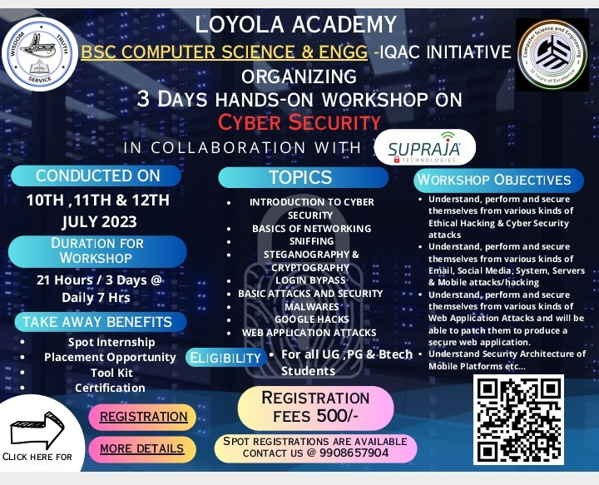
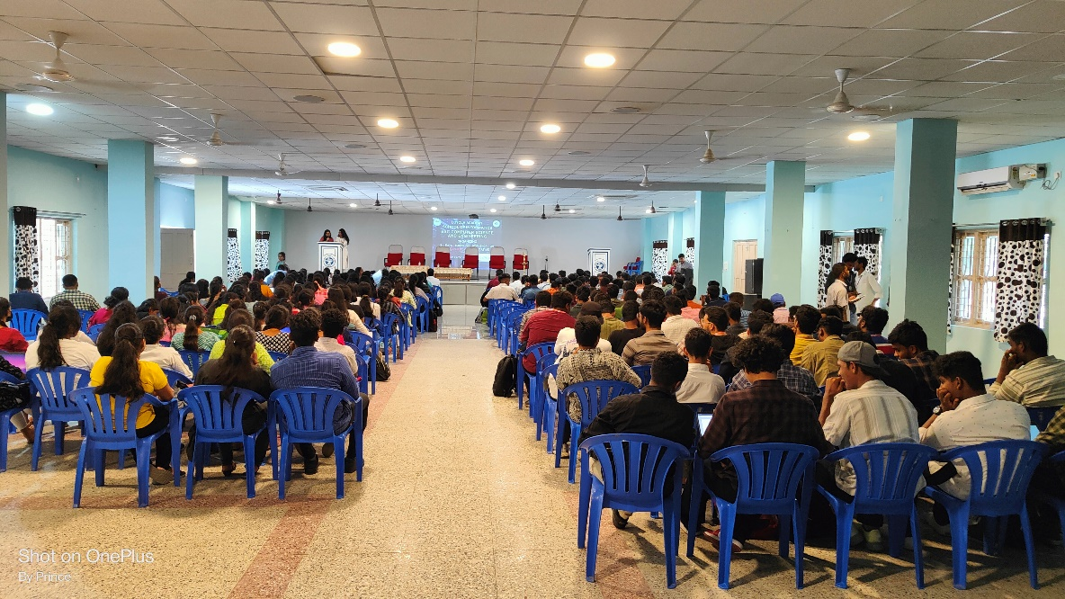
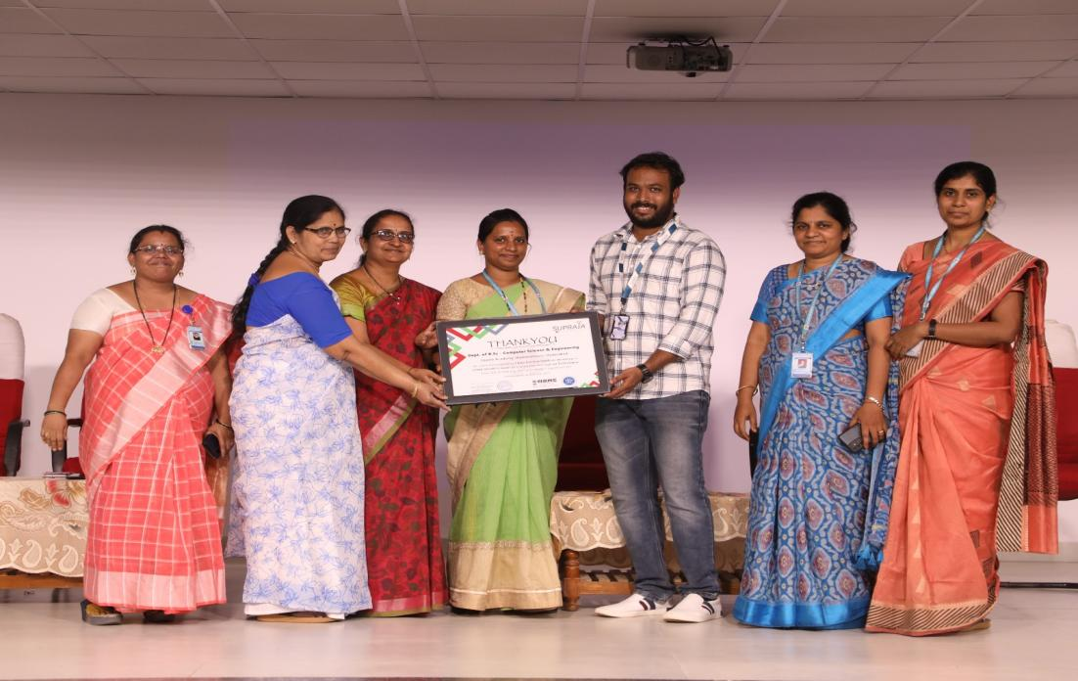

- REPORT ON ONE DAY WORKSHOP -INTELLEXUS -2023

The Department of B.Sc Computer Science and Engineering has organized a technical seminar on foundational courses on AI&ML for the department students in collaboration with Knowvation Learnings on 22nd September 2023 in Loyola Hall. The resources person was Swathi Rusheetha Founder, CEO, Knowvation Learning Pvt LTD. Overall 160 students from the department and 40 students from various other departments participated. The main objective of the workshop is the launchpad ‘Alpha’: To learn basics of the technologies along with insights into the startup world.

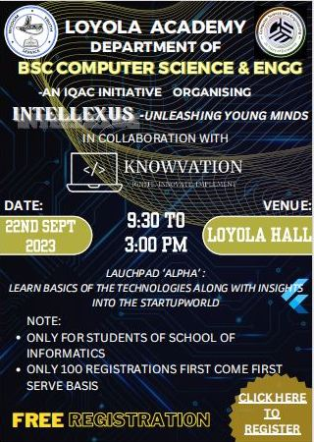
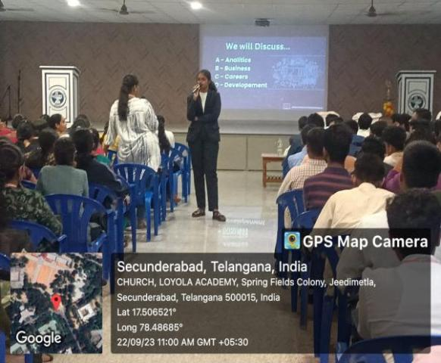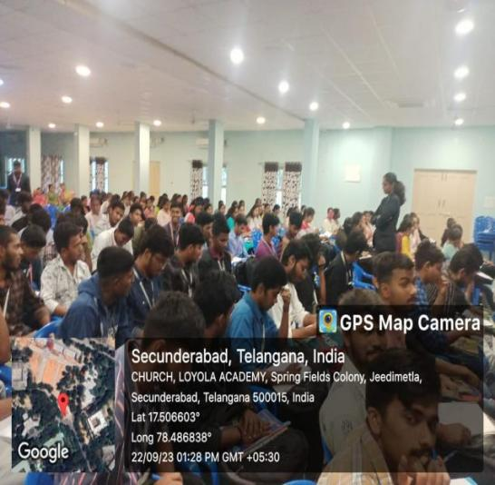

- Report on Outreach Activity to Mahabodhi Vidyalaya , Venkatapuram , Alwal , Secunderabad

Date: January 20, 2024
Department of B.Sc Computer Science and Engineering students from Loyola Academy, Secunderabad,organized an outreach activity on January 20, 2024. Their active participation and expertise contributed significantly to the success of the program.
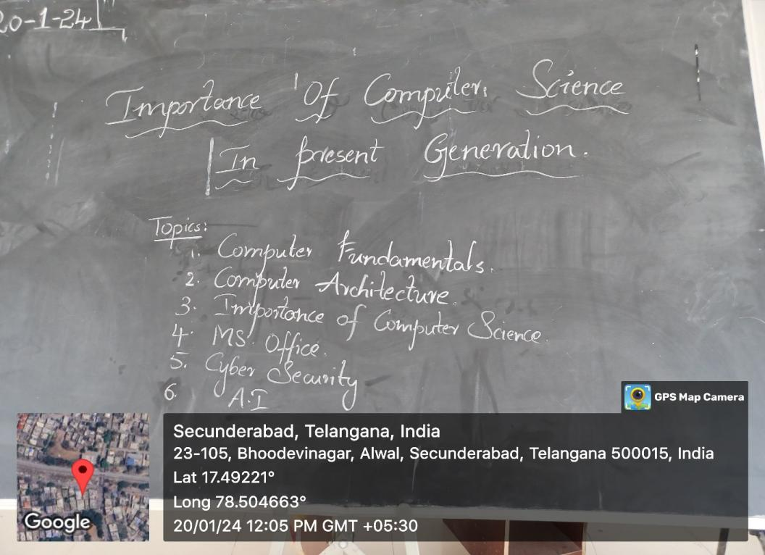
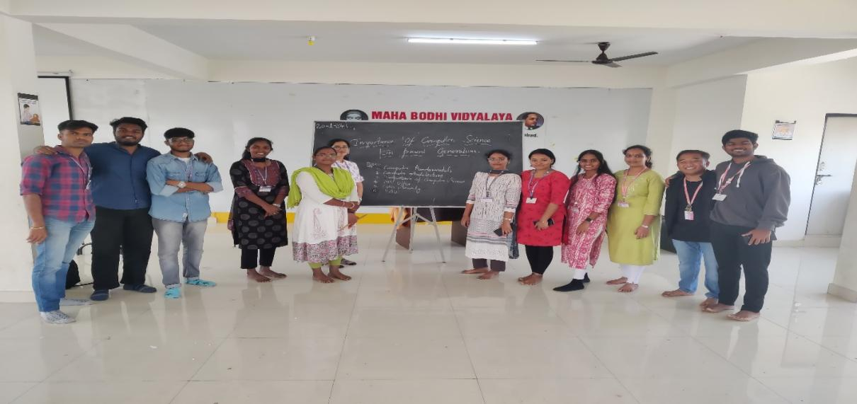
Objective:
The outreach program at Mahabodhi Vidyalaya on January 20, 2024, aimed to disseminating knowledge about upcoming computer technologies, fostering digital literacy, and inspiring students towards the field of computer science and engineering.

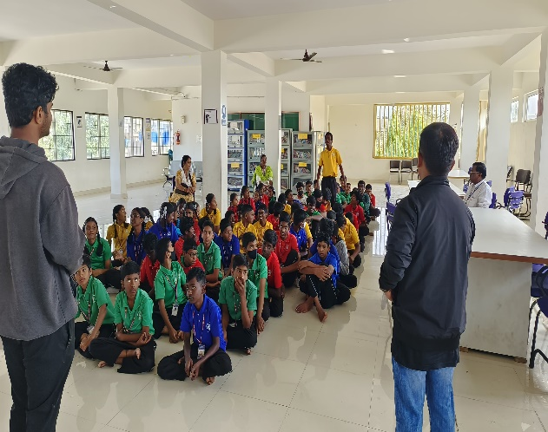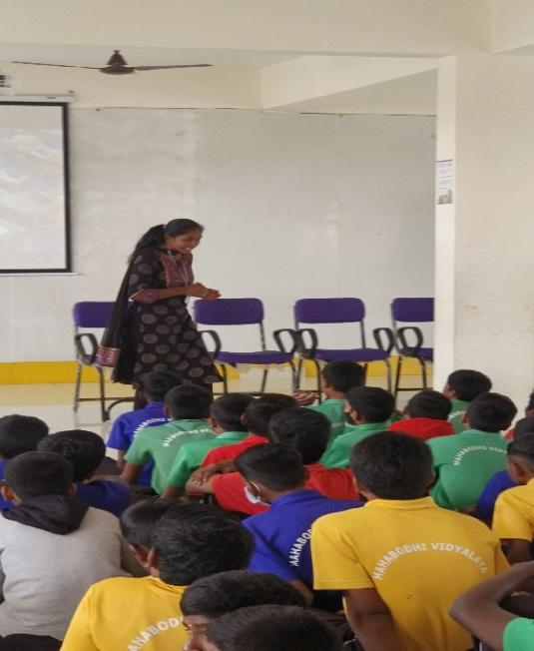

As a part of the holistic educational experience, the outreach on January 20, 2024, also included a brief overview of the Indian Armed Forces. This aimed to instill a broader understanding of national security and technological advancements, showcasing the synergy between computer
technologies and defense capabilities.
