- Mrs.S.Lakshmi,Ms. ChTeja Sriya,Mrs. M.Sai Chitra, Mrs.Dr. K.Vijaya Lakshmi had published a paper on :Deep Learning Based Water Feature Mapping using Sentinel 2 a satellite Image with ISBN Number:2278-4632 and Impact Factor:6.625.

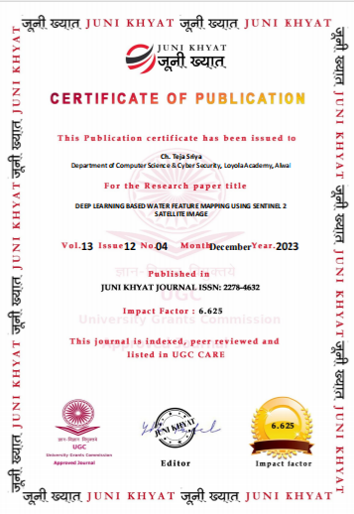
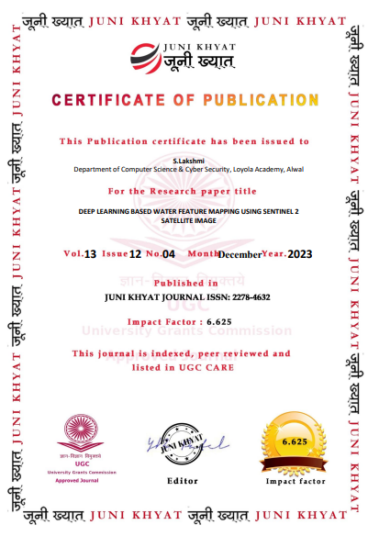
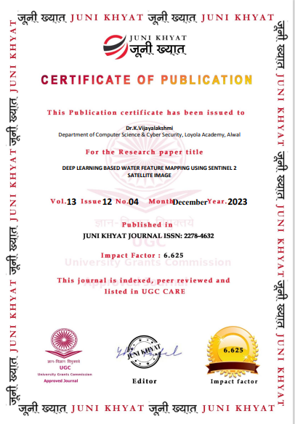
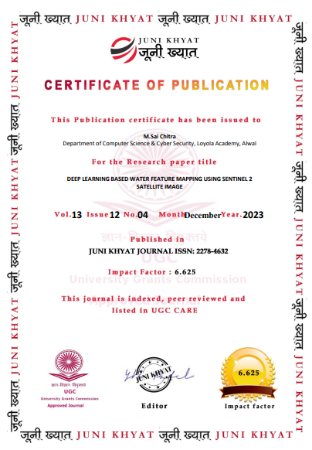
- Ms. ChTeja Sriya had published a paper on “cashless society:managing privacy and security in the technological age using python” with ISBN Number:2278-4632 and Impact Factor:6.625.
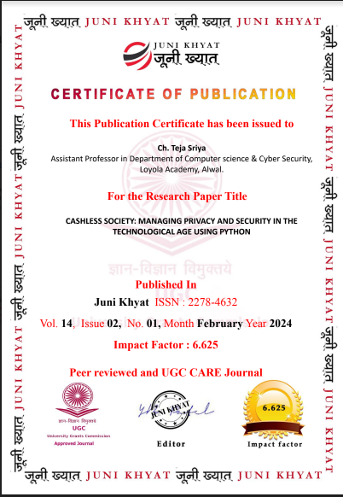
- Mrs.S.Lakshmi,Ms. ChTeja Sriya,Mrs. N.Manisha had published a book on Object-Oriented programming with CPP with ISBN No:978-81-958852-8-7, Vedashree publishers,Hyderabad.

