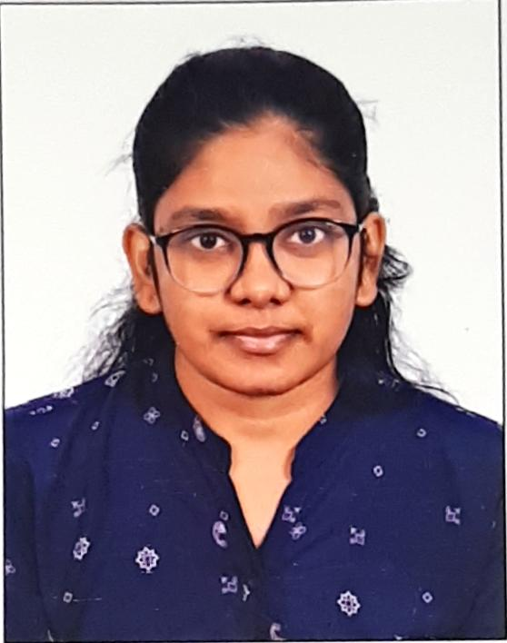
Name of the faculty: Y.J.M. Sowmya
Photo
Gender (Male / Female) : female
Date of Joining in Loyola Academy (DD/MM/YYYY) : 01-07-2025
Education Qualification : MBA, B.E
Faculty Type : Un-Aided
Name of the Department: MBA
Designation : Assistant Professor
EMP ID No (Staff ID): 25224

Teaching Experience (in Loyola Academy): Nil
Other Experience : None
Email – ID : sowmya_mba@loyolaacademy.edu.in
Any Other Honors / Responsibilities : None

Books Published: None

Journal/Articles Published : None

Research papers: None

Conferences/Seminar/Workshop/Training Programs attended: FDP organized by Dept. of MBA, Loyola Academy, Two-day online workshop on AI in Academia

