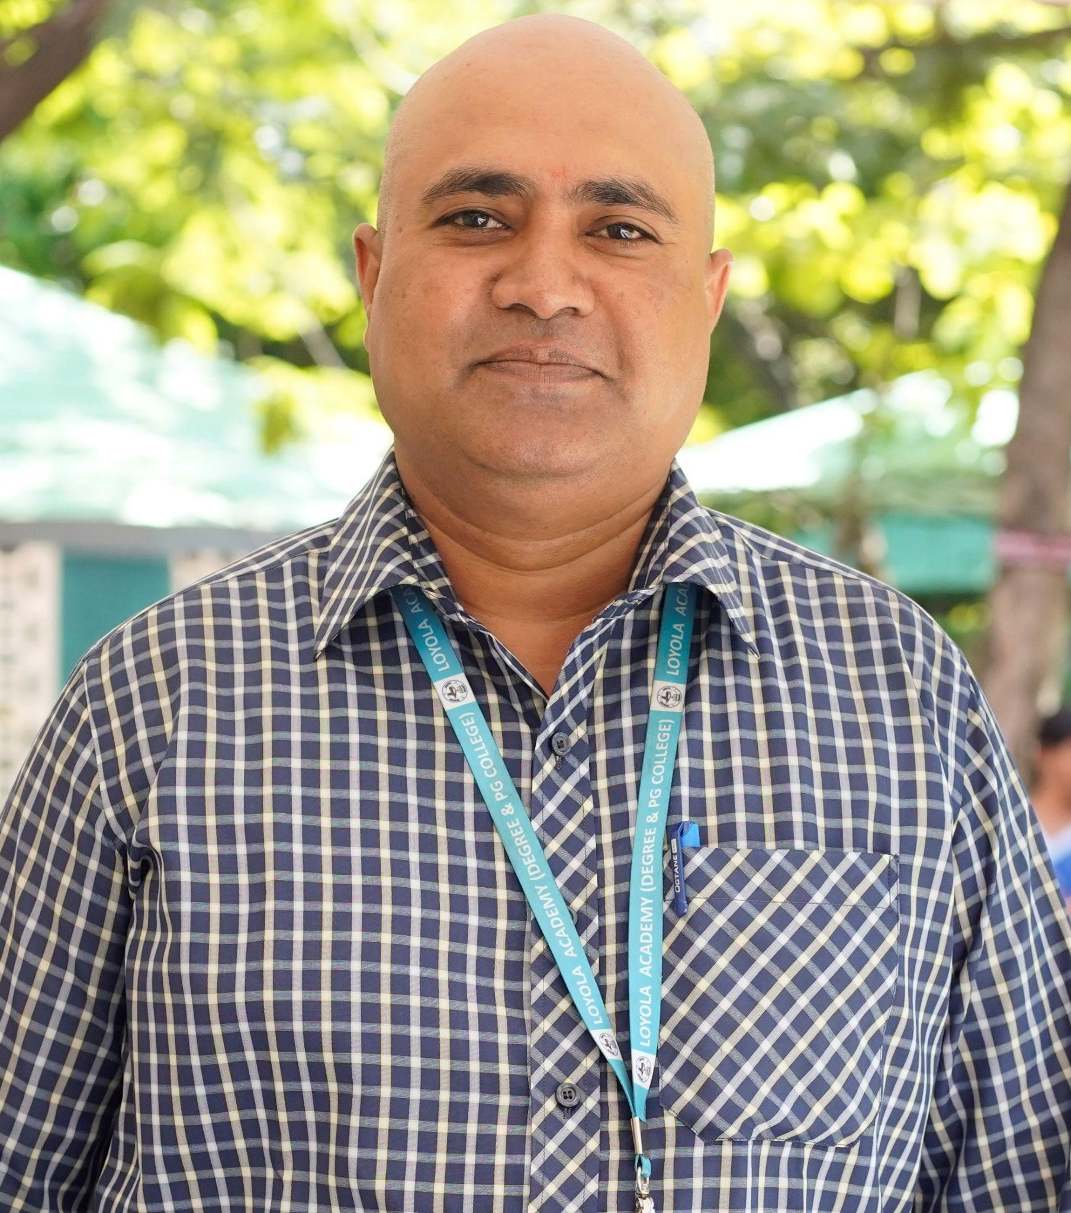
Mr. S. BALACHANDAR
Gender: Male
Date of Joining in Loyola Academy: 6/07/2019
Education Qualification: M.Sc., MTech. (Ph.D.) DNHE
Faculty Type: Un-Aided
Name of the Department: Environmental Science
Designation: Assistant Professor&HOD
ERP ID No (Staff ID): 19105

Teaching Experience (in Loyola Academy): 7 Years
Teaching Experience (Outside Loyola Academy) :15 Years

Any Other Honors / Responsibilities: Coordinator Green Club, Swachh Abhiyan

Email – ID (Official): soorabala@loyolaacademy.edu.in
EDUCATIONAL QUALIFICATIONS:
- Pursuing PhD in Environmental Science &Technology from JNTUHyderabad (2016 Batch)
- Qualified UGC-NET Assistant Professorship in Environmental Sciences (July2018)
- Qualified Telangana-SET in Environmental Sciences (July2018)
- Master of Technology in Environmental Management with 1st Class from JNTUHyderabad (March 2004)
- Master of Science in Environmental Science with1st Class from Kakatiya University, Warangal. (October 2000)
- Diploma in Nutrition and Health Education from IGNOU, New Delhi.
- Diploma in Industrial Safety from NILEM, Chennai.
- Certificate in Geographical Information Systems and applications from JNTUHyderabad.
PUBLICATIONS
- FloodDisasterManagementinIndia–ACaseStudyonChennaiFloodsShankarNeeraj1, S. B alachandar2andB.VivekReddy3 JournalofCivilEngineeringandEnvironmentalTechnologyp-ISSN:2349-8404; e-ISSN:2349- 79 X; Volume4, Issue2; April-June,2017, pp.166-170

- APPLICATION OF MUNICIPAL SOLID WASTE FOR BIOGAS PRODUCTION IN INDIA: A
REVIEW Soora Balachandar1, Dr. Seshikala Durisetti2, Dr.V. Venkateshwara Reddy3 1Research Scholar, Centre for Environment IST, JNTUH. Hyderabad & Assistant Professor, Loyola Academy Degree and PG College, old Alwal, Secunderabad. 2Assistant Professor, Dept of Environmental Sciences, Osmania University, Hyderabad 3Professor of Civil Engineering, JNTUH, Hyderabad International journal of engineering research and applications ISSN: 2248-9622, Vol. 13, Issue 5, May 2023
Conference Attended

CHEMISTRY AGAINST COVID-19 | Dr.D.S.SHARADA IIT HYDERABAD | LFDC-UPPAL HYDERABAD
SIGNALLING NETWORKS IN CANCER | REV.Fr.Dr.L. JOJI REDDY SJ VICE PRINCIPAL(PG)  LOYOLA ACADEMY | LFDC-UPPAL HYDERABAD
MICROBIAL  TRANSFORMATION OF WASTE FOR RENEWBLE CHEMICALS FUELS&METERIAL | DrNARESH KUMAR A YONSEI  UNIVERSITY SOUTH KOREA | LFDC-UPPAL HYDERABAD
ONLINE SOFTWARETOOLS FOR REMOTE TEACHING & LEARNING | Dr.D. LAKSHMI VISHNU  EDUCATIONAL DEVOLOPMENT & INNOVATIVE  CENTRE | ADC  HYDERABAD
POST COVID19 ENVIRONMENTAL SUSTAINABILITY CHALLENGES & OPPERTUNITIES | Mr. MAHESH RAMKY ENVIRO  ENGINEERS | GREEN CORPS  LOYOLA ACADEMY
E-CERTIFICATE COURSE ON RENEWBLE ENERGY THE  DEMAND OF FUTURE | Dr. POONAM AGARWAL  Dr. ANJALI SANGO | SHRI R.L.T COLLEGE OF SCIENCE AKOLA
DIGITAL TECHNOLOGY & DATA A CURSE OR BOON? | Mr. RAMU MENTOR  DIRECTION&SCRIP  T WRITING | LOYOLA ACADEMY
TECHNO SCIENCE -2020 | Dr.B. VENKATA  SARADA SCIENTIST ARCI  Dr.G. SWARNA BALA SOM  PHYTOPHARMA Dr.M. UDAY KIRAN SCIENTIST NCL  PUNE Prof  R. VENKATANADH GITAM BENGULURU | LOYOLA ACADEMY
RECENT TRENDS IN ONLINE TEACHING&DATA IN  TECHNOLOGY | Dr. AVIRAL SHARMA GNL RAVITEJA | LOYOLA ACADEMY
IMPACT OF COVID 19 ON BIODIVERSITY&UNEP TIDE | Mrs. FARIDA TAMPAL DIRECTOR | ST. PIOUS X DEGREE COLLEGE FOR WOMEN

TURNERS PLASTIC  CHALLENGE | WWF-HYDERABAD  OFFICE
THE ROLE OF ONLINE WEB RESOURCES: PRESENT&POS T COVID-19 | Mr. RAJESH MINDI CEO MINDI  PRODUCTIONS | LOYOLA ACADEMY
THE CHANGING ROLES OF SOCIAL WORK POST COVID-19 DIFFERENT  PERSPECTIVES | Dr. ESTHER GLORY RYERSON  UNIVERSITY  CANADA | ST. FRANCIS COLLEGE FOR WOMEN
INDIAS WAR AGAINST  COVID-19: APPROACH AND GENDER DYNAMICS | Prof.REKHA PANDE Prof.E.VENKATESU UOH HYDERABAD | OSMANIA UNIVERSITY
MAINTAINING QUALITY IN ONLINE TEACHING  -OPPERTUNITIES AND CHALLENGES | Dr.G. JANARDHAN NITTTR CHENNAI | ST. FRANCIS COLLEGE FOR WOMEN
ROLE OF SCIENCE AND  TECHNOLOGY IN MITIGATING COVID 19 | Dr.CH.RAJI REDDY Sr. PRINCIPAL SCIENTIST IICT  HYDERABAD | LFDC-UPPAL HYDERABAD

