1. Departmental Activities
    - Technical Seminar on Navigating the Frontiers of Emerging Technologies

The Department of B.Sc Computer Science and Engineering has organized a Technical seminar on navigating the Frontiers of Emerging Technologies on JULY 27, 2024 in Loyola Academy. The resource person was Dr.G.N.R. Prasad, Associate Professor, CBIT
Objectives: The “Navigating the Frontiers of Emerging Technologies” seminar brought together leading experts, researchers, and industry leaders to explore and discuss the latest advancements in technology. The seminar highlighted key areas of innovation, including artificial intelligence, and advanced materials.
Outcomes: All the 3 years department students participated and gained insights into the current trends, challenges, and future directions in these rapidly evolving fields.
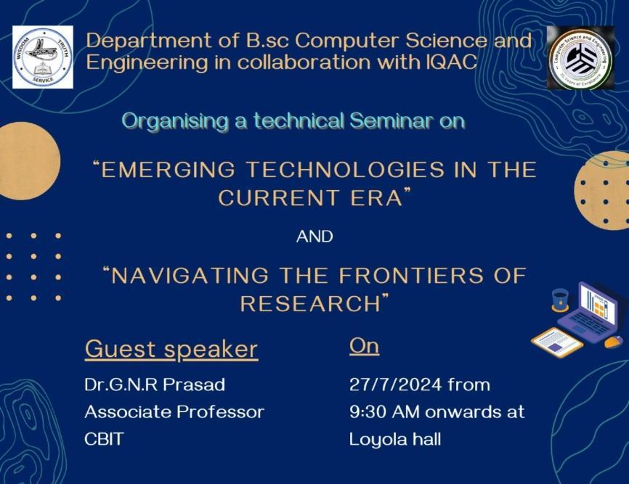
Key Highlights of Seminar:
Narrow AI (or Specialized AI)
Broad AI (or General AI)
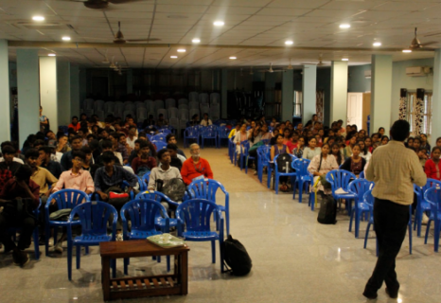
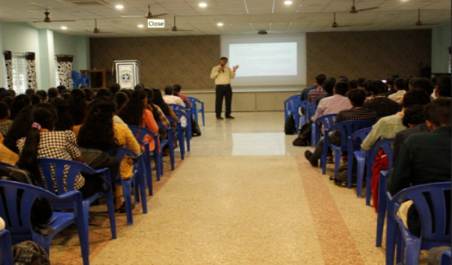
Generative AI

2. Organized a Debate competition on the title “From Ideas to Impact: Protecting Intellectual Property for Competitive Startups.”

The Department of BSc Computer Science and Engineering of Loyola Academy Degree and PG College, in collaboration with Institution Innovation Council(IIC) of Loyola Academy and Andhra Pradesh Productivity Council(APPC) and an Initiative of IQAC hosted the event "From Ideas to Impact: Protecting Intellectual Property for Startups," on occasion of National Productivity Week-2025, focusing on educating startups about the importance of intellectual property (IP) protection.” On 11th February 2025, 9:30 A.M to 3:00 P.M in PG Seminar Hall-I, PG Block, Loyola Academy. Overall 23 students participate from various departments.

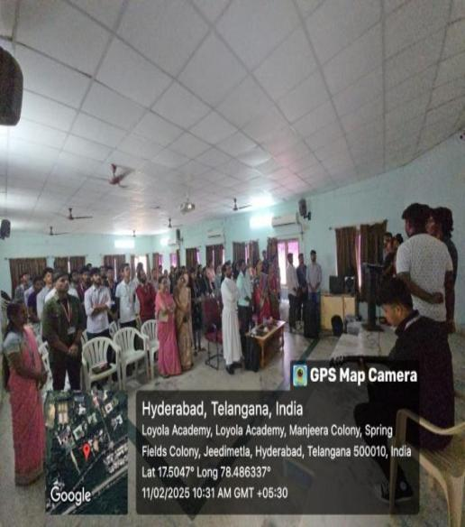
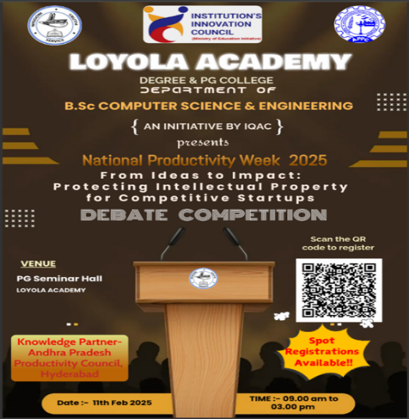

Objective: The event aims to educate startups on intellectual property protection, enhance productivity, provide funding guidance, and foster networking opportunities to support innovation and commercialization. It helped in fostering the young talents with great Startup Ideas and how to secure their Startup using IPR.
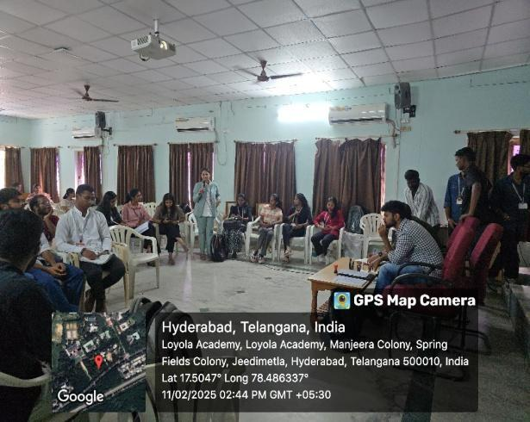

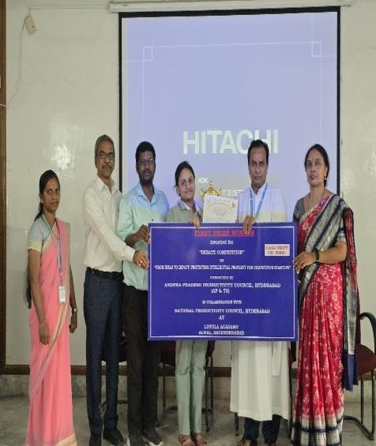
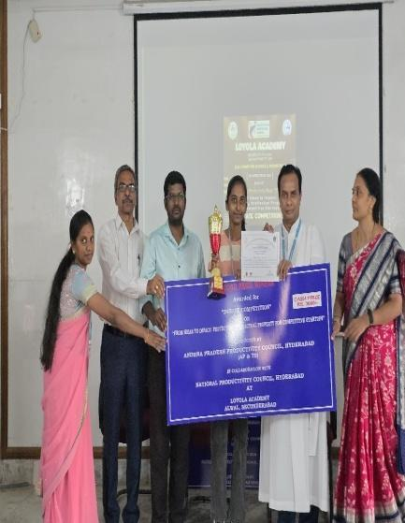
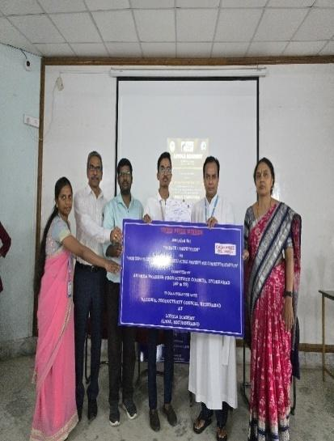
Outcomes:The event concluded with a prestigious award ceremony, recognizing the top three winners from different departments for their outstanding performance. The winners were honored with trophies, certificates, and cash prizes, with the first-place winner receiving ₹5000, the second-place winner ₹3000, and the third-place winner ₹2000.

3. Organized a 3-day Hackathon as Code Fusion the Department of B.Sc Computer Science and Engineering has organized a 3-day Hackathon as Code Fusion in Loyola Academy on 18th,19th,20th Feburary 2025. The theme for the event was Innovate, Code, Compete.

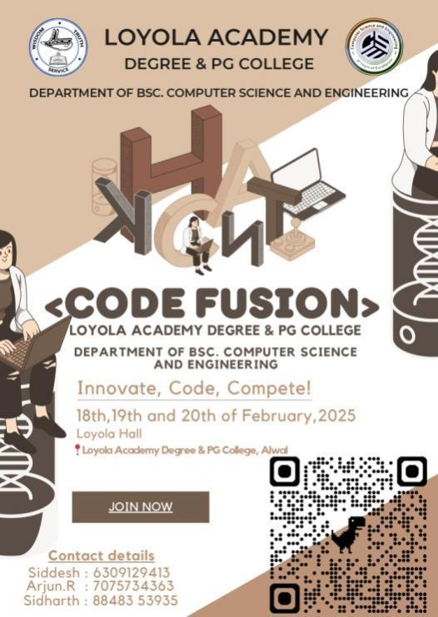

DAY – 1
Objective: Assess individual and team skills to qualify for the main event.
Level 1 - Debugging & Optimization
Level 2: Problem-Solving Challenge
Outcome:
Registrations: 63 teams consisting of 3-5 members each registered for the hackathon.
Level 1 Elimination: After the first round, 11 teams were eliminated.
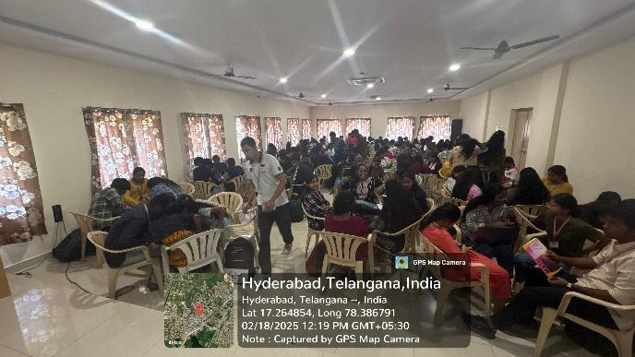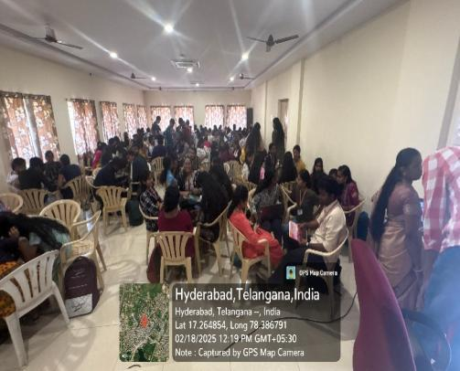
DAY – 2
Objective: Develop a functional prototype based on a chosen theme.
Full Stack Java Seminar by Sai Kumar Pabboju
The Full Stack Java seminar provided an in-depth understanding of both front-end and back-end development. It covered essential technologies such as HTML, CSS, JavaScript, Angular, and React.js for front-end and Spring Boot, Hibernate, and RESTful APIs for back-end development.
Outcomes:
- Students learned essential technologies like HTML, CSS, JavaScript, and frameworks like Angular and React.js for the front-end. They also learned about cloud deployment, DevOps practices, and microservices architecture.
- The seminar helped students become skilled in building complete web applications, from creating the user interface to handling the back-end and deploying the app to the cloud.

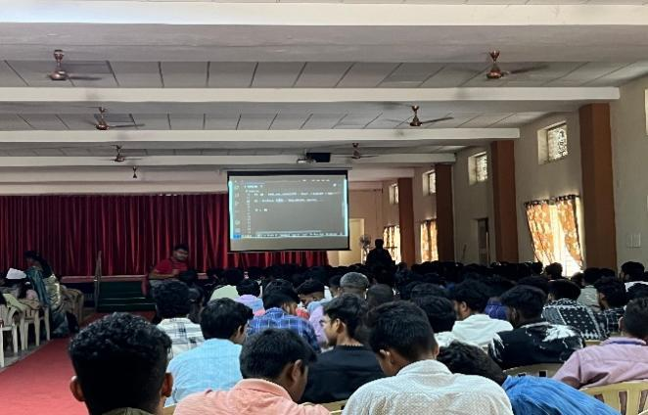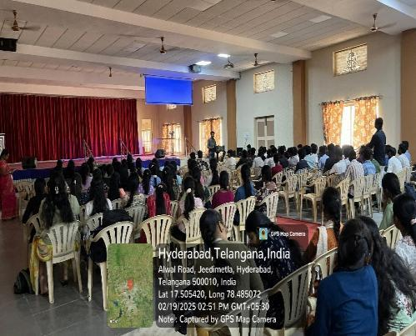

DAY – 3
Objective: Showcase solutions & assess teamwork and creativity.
Outcome:
The final day of Code Fusion concluded with an inspiring closing ceremony, where the judges shared their insights and provided valuable feedback on the projects. Winners were announced, and trophies, certificates, and prizes were distributed to the top-performing teams. Participants reflected on their experiences, emphasizing teamwork, creativity, and problem-solving. The event ended on a high note with a heartfelt speech from the organizers, thanking the sponsors, faculty, and volunteers who contributed to its success. A group photo marked the event’s conclusion, with students and mentors looking forward to future editions of Code Fusion, fostering more innovation and collaboration.
