Department of B.Sc. Computer Science and Engineering, Loyola Academy

Departmental activities:
- Name of the Event : Student Exchange Program
Department of B.Sc. Computer Science and Engineering, Loyola Academy In collaboration with Nirmala Memorial Foundation College, Mumbai organized a Student Exchange Program on 16th December to 18th December 2026. The objective of the event was to promote academic and cultural exchange between students of different institutions. To bridge the gap between theoretical learning and real-world industry practices.

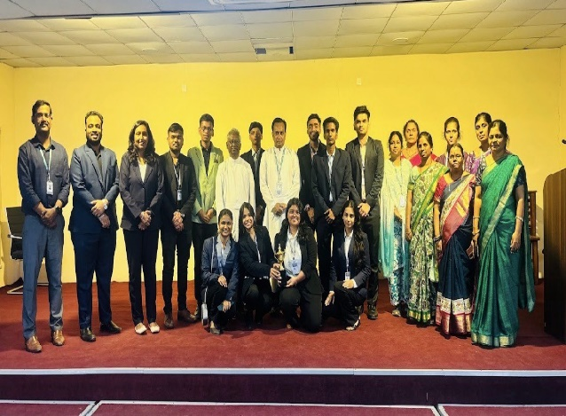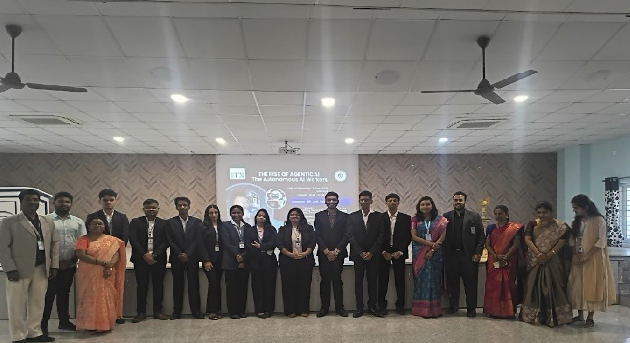
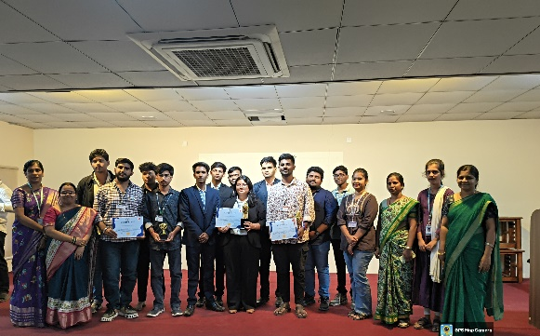
- Name of the Activity: Balance & Bliss: Stress-Free Living on 26th July 2025, 10:30 AM to 12:15 PM. To help students understand the psychological and emotional causes of stress and how it affects their daily life and performance.
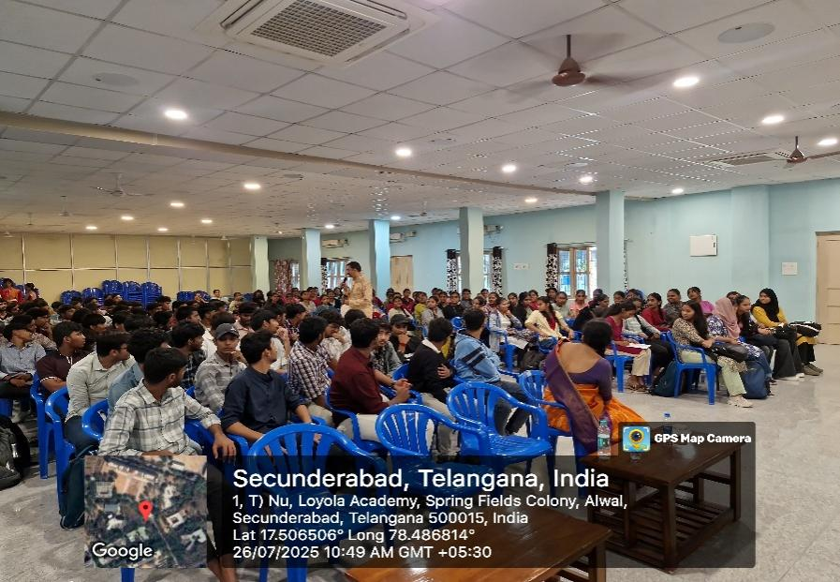

- Workshop on Python essentials and HTML & CSS3 conducted on 18th August 2025 to 23th August 2025
The main objective of the Python workshop was to provide students with a strong foundation in programming concepts using Python language. It aimed to make students familiar with basic topics such as variables, data types, operators, and input-output operations.
