ANNUAL RECORD
2024 - 2025

INDEX
SNO. | EVENT NAME | DATE
1. | TSC PRACTICE | 20th March,2024
2. | IDSSC PRACTICE | 22nd March,2024
3. | PASSING OUT OF PARADE | 4th June,2024
4. | INTERNATIONAL DAY OF YOGA | 21st June,2024
5. | INTERNATIONAL YOGA DAY | 21st June,2024
6. | NCC ‘B’ CERTIFICATE COLLECTION | 10th July,2024
7. | YOUTH SKILLS DAY | 15th July,2024
8. | DDG VISIT | 18th July,2024
9. | NCC ENROLLMENT | 23rd July,2024
10. | KARGIL VIJAY DIWAS | 26th July,2024
11. | KARGIL VIJAY DIWAS (Nukad Natak) | 27th July,2024
12. | RDC SELECTION | 12th August,2024
13. | INDEPENDENCE DAY | 15th August,2024
14. | HAR GHAR TIRANGA | 15th August,2024
15. | FIT INDIA MOVEMENT | 14th September,2024
16. | EK PED MAA KE NAAM | 01st October,2024
17. | CM CUP 2024 | 03rd October,2024
18. | EKTHA DIWAS( Nukad Natak) | 29th October,2024
19. | NCC ‘C’ CERTIFICATE COLLECTION | 11th December,2024

TSC PRACTICE
EVENT: TSC PRACTICE
DATE: 20th March 2024
VENUE: LOYOLA ACADEMY
The That Sainik Camp (TSC) Practice session conducted at Loyola Academy was aimed at preparing cadets for giving their best in the camp by having their physical fitness, tactical skills and theoretical knowledge. Cadets from other colleges also attended the practice. The practice included essential services /activities such as tent pitching, obstacle training (OT), firing drills and theoretical classes facilitated by the Pl Staff.
Tent Pitching: Cadets were trained in the proper techniques of tent pitching, emphasizing speed, precision and teamwork. They learned to quickly set up and dismantle tents.
Obstacle Training (OT): The OT segment simulated real life combat scenarios with a series of physical obstacles and challenges. The OT includes obstacles such as straight balance, clear jump, ramp, high wall, zig-zag balance etc.
Firing Drills: Underthe supervision of experienced instructors, cadets engaged in firing which took place at Loyola Academy itself. They practiced shooting techniques target acquisition and weapon safety protocols to become proficient with firearms.
Theory classes by PI Staff: Theoretical classes conducted by PI Staff covered a range & topics including judging distance, health and hygiene, and map reading. Cadets received comprehensive. instructions on theoretical concepts.
The TSC practice session at Loyola Academy played a crucial role in preparing the Cadets for their camp by providing them with comprehensive training in physical fitness, tactical skills and theoretical knowledge. Through a combination of practical exercises and theoretical instructions, cadets acquired the essential competencies and mindset.
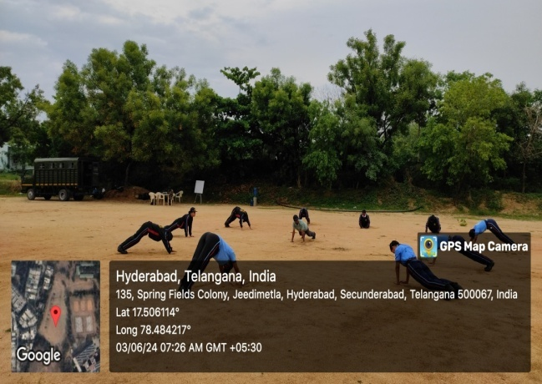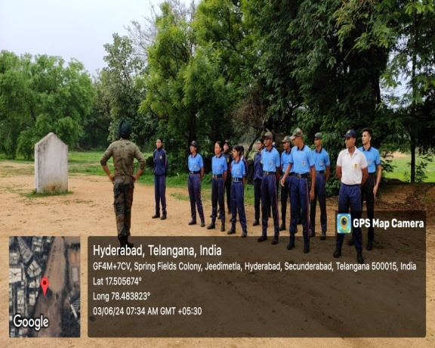

IDSSC PRACTICE

Date : 22nd March,2024.

Venue : Loyola Academy.
The Inter-Directorate Sports Shooting Championship (IDSSC) practice session was held on 22nd March at Loyola Academy.

Event Summary
The practice session for the IDSSC witnessed enthusiastic participation from NCC cadets, who demonstrated their shooting skills with precision and determination. The event aimed to prepare the cadets for the championship by honing their focus, technique, and consistency.
The session was conducted in a structured manner, with cadets undergoing drills to improve their stance, aim, and shooting accuracy. Senior instructors provided valuable guidance, helping participants refine their techniques and enhance their performance under competitive conditions.
Cadets showcased remarkable talent during the practice, hitting targets with impressive accuracy and displaying exceptional discipline. The event highlighted their commitment to excellence and their potential to excel in the upcoming championship.
The practice session concluded on a high note, with participants motivated to continue their rigorous preparation for IDSSC. The event not only served as a platform to showcase shooting skills but also fostered a sense of teamwork and competitive spirit among the cadets.
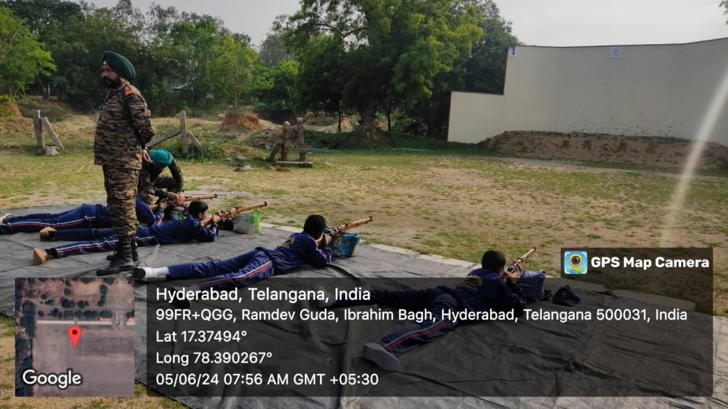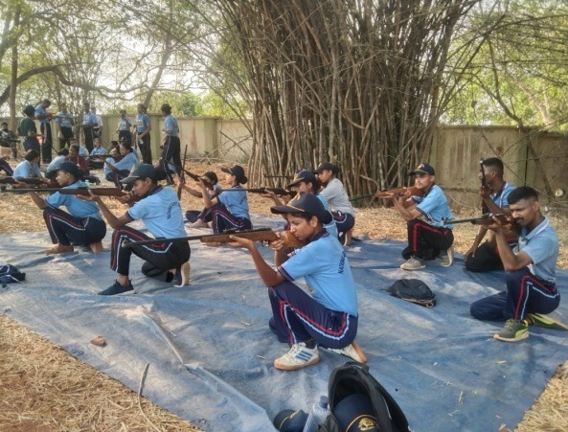

PASSING OUT OF PARADE
EVENT: PASSING OUT OF PARADE PROGRAM.
DATE: 4th June,2024
VENUE: Artillery Training Center, Golconda.
This program was conducted in Artillery Training Center, Golconda. This was the third batch which was graduated from Artillery Center Golconda on 4th June 2024.
The reporting time was 5:00 am. The army vehicle was provided to be dropped at the location. We reached the location at 7:30 am and we were provided space to be seated.
AGNIVEER PARADE:
The programme started at 8:00 am. The parade began with the arrival of Lieutenant General Rahul R Singh who was the chief guest of the event. Witnessing the parade ignited motivation within all of us. During the parade, we took a moment to show our respect for the artillery stationed nearby. After the passing out parade, the Agniveers took an oath after which the chief guest gave a speech served as a source of motivation for the Agniveers as well as the NCC Cadets. After the address we were given a demonstration of the weapons tanks and artillery which was followed by refreshments. Later, we had an engaging interactive session concluded with the Agniveers that left us all motivated.
Once the interactive session concluded, we were dropped off at Bison Training Grounds (BTG) at 11:30 am by the army staff. 5 SDs from Loyola Academy attended the Passing Out Parade.

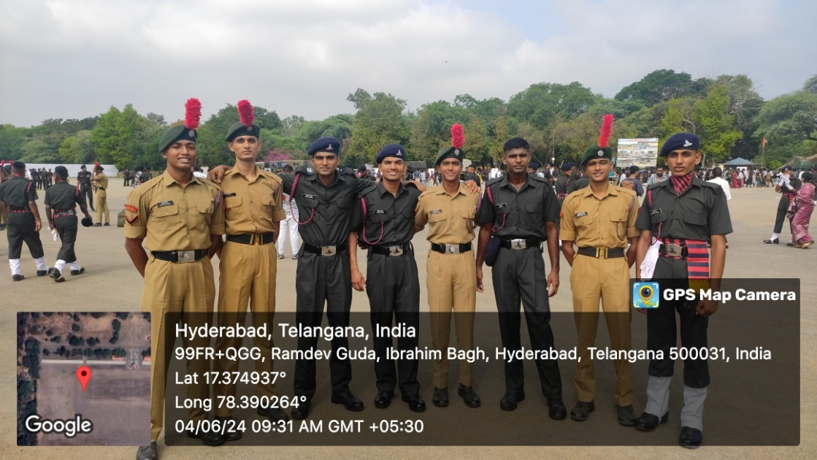

INTERNATIONAL DAY OF YOGA
EVENT: INTERNATIONAL DAY OF YOGA
DATE: 21st June 2024
On International Yoga Day, 4(T) BN NCC organized a special program in which the NCC cadets participated actively. The event was hosted at Loyola Academy, Alwal.
The event featured a yoga master who led the participants through a series of yoga exercises, promoting physical well-being. She guided the cadets through various yoga asanas, including Trikonasana, Tadasana, Dhanurasana, etc. Her guidance was appreciated by all, and she was later felicitated by the ANOs and CTOs in a small ceremony. Following the yoga session, a group photo was taken to commemorate the event, and refreshments were provided to all the cadets. The program was a great success, and it highlighted the importance of yoga in daily life.
A total of 15 institutions joined the event, resulting in a total strength of 854.
SD’s – ___ , SW’s - ___& JD’s - ___ , JW’s - ___
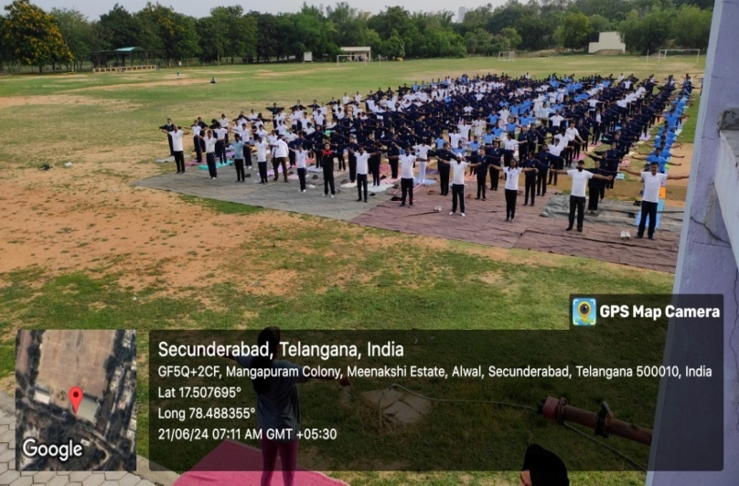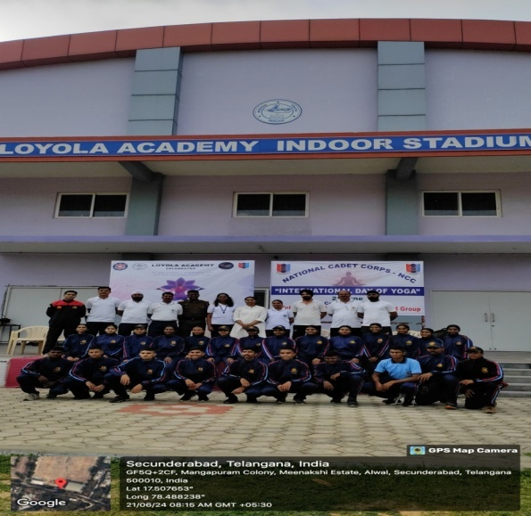

INTERNATIONAL YOGA DAY
EVENT:FREE CAMP on INTERNATIONAL YOGA DAY, 2024
DATE: 21st June 2024
Loyola Academy in collaboration with IQAC Cell, Srikara Hospitals and Isha Foundation organized a free yoga camp on account of International Yoga Day, 2024. The event revolved around the theme for this year “Yoga for self and society.” The event started with a prayer which was followed by the lighting of a lamp.Rev fr Dr. L. Joji Reddy, Principal,addressed the gathering on the importance of yoga and how it helps in improving both physical as well as mental health. Ms. Veena, a volunteer from the Isha Foundation, led us in performing yoga. The session began with meditation followed by breathing exercises for naadishuddhi and cycles of Surya namaskar. Participants from various student bodies such as Student Council, MAGIC Youth, AICUF, NSS and NCC attended the session along with faculty members.
A total of ___ students and cadets participated in the event.
SD’s - ___ , SW’s - ___ and others - ___

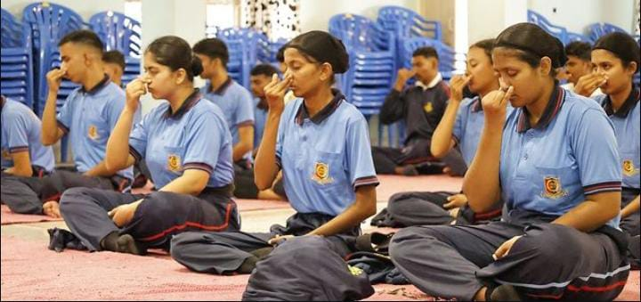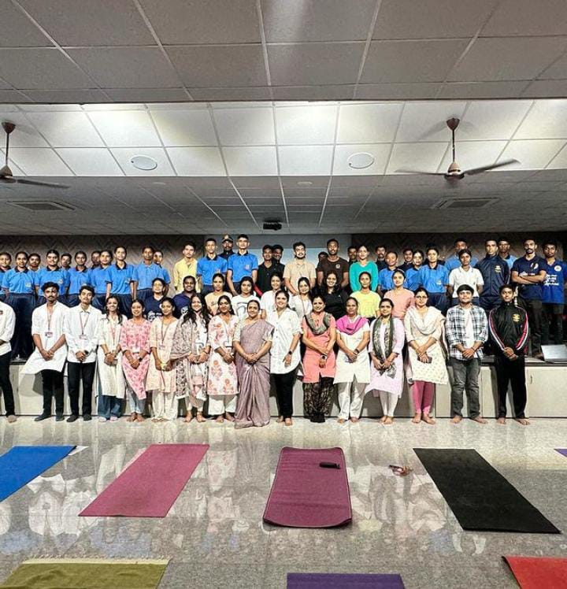

NCC 'B' CERTIFICATE
EVENT: Collection of 'B' Certificate.
DATE: 10 July 2024
VENUE: 4(T) BN NCC Unit Office
The cadets received their NCC 'B' Certificate on July 10, 2024, at the 4(T) BN Unit Office. This event marked the culmination of months of hard work and dedication by the cadets. The ceremony was honored by the presence of CO Col Ashish Tripathi, AO Ashutosh Gupta and Chief Training Officer (CTO) V Sirisha, who awarded the certificates to the successful cadets.
Col Ashish Tripathi emphasized the importance of the 'B' Certificate in the cadets' NCC journey and future career opportunities. He praised the cadets for their dedication and encouraged them to continue striving for excellence and provided valuable feedback on the cadets' performance and motivated them to uphold the values and principles of the NCC.
The event concluded with a sense of pride and accomplishment, reinforcing the commitment of the cadets to the values and principles of the NCC. The ceremony not only recognized the hard work of the cadets but also motivated them to continue their journey with renewed vigor and determination.
A total of 37 Cadets attended the event.
SD's - 18, SW's - 19.
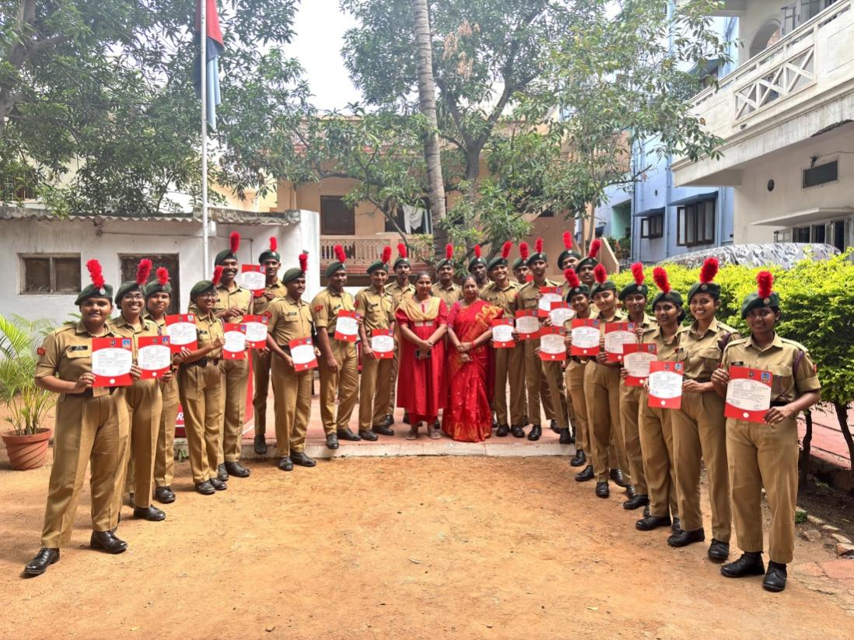

YOUTH SKILLS DAY
EVENT: SEMINAR ON YOUTH SKILLS DAY
DATE: 15TH July 2024
World Youth Skills Day is celebrated on July 15 every year. On this occasion, Loyola NCC Army wing and the IQAC Cell of Loyola Academy organized a seminar to emphasize the importance of communication skills and mental health in youth development. The event began with an opening address by CTO Ma'am, followed by a speaker covering three key topics. The session highlighted effective communication skills, including verbal and non-verbal cues, active listening, and clarity. It also showed how strong communication enhances leadership, teamwork, and conflict resolution. The mental health segment addressed common challenges and stress management. The cadets found the seminar insightful and appreciated the knowledge and tools gained, which they believe will benefit their NCC activities as well as their future. The event successfully underscored the significance of communication skills and mental health in youth development, empowering the cadets for their personal and professional growth.
A total of 70 cadets attended the seminar.
SD’s - 38 , SW’s –32
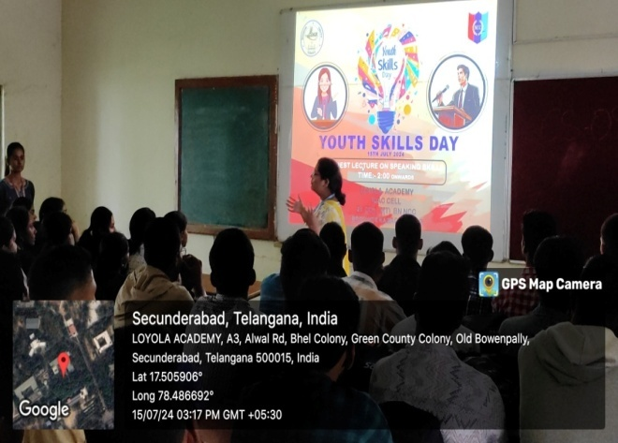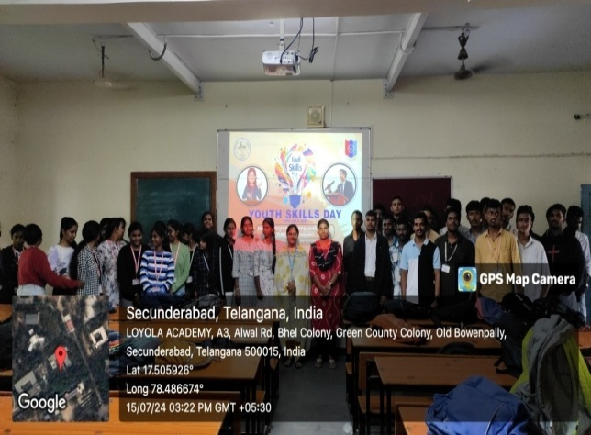

DDG Visit

Date: 18th July,2024.

Venue : 4(T) BN NCC, UNIT OFFICE.
The Deputy Director General (DDG), V.M. Reddy, graced the unit with his presence, marking a momentous event for the cadets and staff. The event was meticulously planned to showcase the discipline and dedication of the unit.
The cadets actively participated in a range of ceremonial activities, including piloting and the Guard of Honour, to extend a warm and respectful welcome to DDG V.M. Reddy. The Guard of Honour was performed with precision, reflecting the rigorous training and commitment of the cadets.
During the visit, DDG V.M. Reddy interacted with the cadets and appreciated their efforts, commending their enthusiasm and performance. This interaction served as a motivational moment for all present, encouraging them to strive for excellence in their NCC journey.
The event concluded with a formal address by DDG V.M. Reddy, highlighting the importance of NCC in building leadership qualities and discipline among youth. The visit was a significant milestone, leaving a lasting impression on the unit and its cadets.
SD’s : SW’s:
Total :

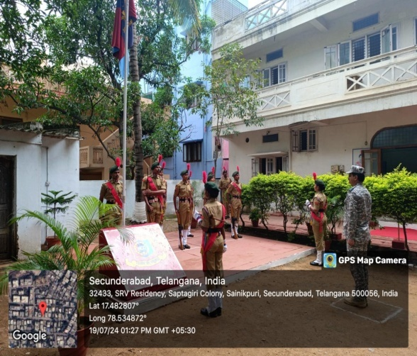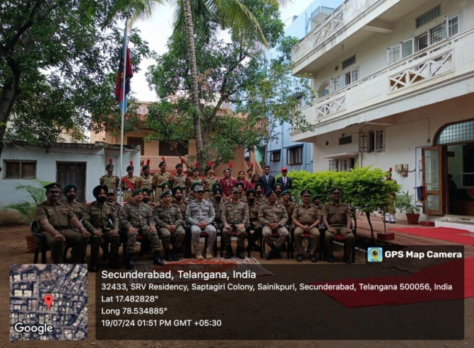

NCC ENROLLMENT

ELIGIBITY ASSESSMENT ANS PHYSICAL ATTRIBUTE CHECK:
In the initial stage of selection process, candidates underwent a thorough assessment to determine the eligibility for further consideration. This phase involved a rigorous evaluation of key factors such as body postures, height, weight and other required for participation in NCC. This initial assessment palyed a crucial role in applicants to those in narrowing down the pool of applicants to those who possessed the basic attribute essential for the potential NCC Cadets.

PHYSICAL FITNESS EVALUTION
After Medical check up, the candidates underwent a physical evaluation. In this phase, candidates were required to run within a time limit and to do certain number of push ups and crunches to assess their endurance and physical readiness, which were essential qualities for any NCC Cadets.

WRITTEN EXAMINATION
The candidates moved on to written examination. This test was designed to evaluate knowledge about NCC and Defense related topics of the candidates.

PERSONAL INTERVIEW:
In the final phase, candidates who successfully cleared the previous rounds, underwent a personal interview by CO Ashish Tripathi and AO Asutosh Gupta. This interview aimed to assess their suitability, attitude and the alignment with the NCC values.

Thus, the 2024 NCC cadet enrollment process was rigorous and thorough, selecting only the most deserving candidates. This ensures that the new cadets are well prepared and dedicated to upholding the values and responsibilities of the NCC.
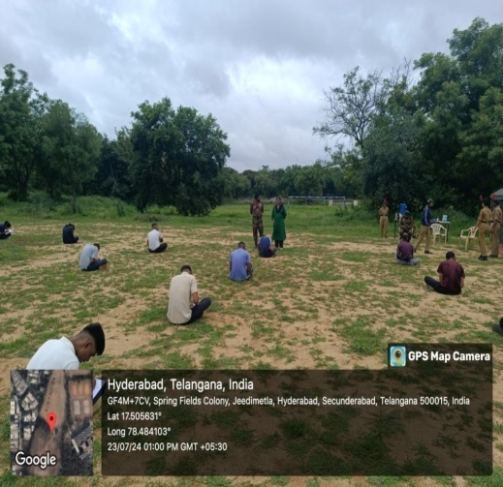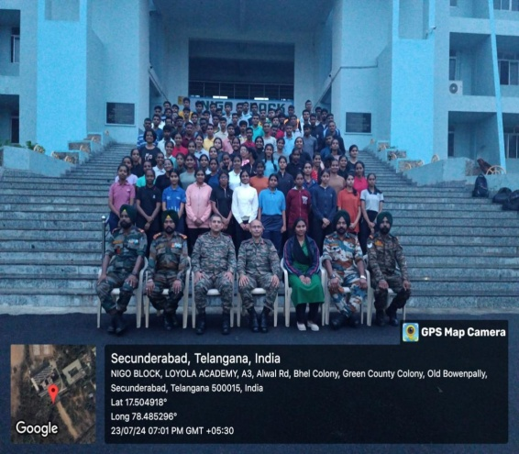

KARGIL VIJAY DIWAS
DATE: 26 July 2024
VENUE: RASTRAPATI NILAYAM, SECUNDERABAD.

Kargil Vijay Diwas, observed annually on July 26, commemorates India's victory in the Kargil War against Pakistan. The ceremony began at 10 a.m. in the Rastrapati Nilayam in Secunderabad, with a variety of events and ceremonies honoring the gallantry of the Indian Armed Forces.
Opening Ceremony:
The celebration began with a gathering of students and Cadets from different colleges and schools. These young brains discussed the Kargil War, showing appreciation and respect for the heroes who fought heroically. Their addresses focused on the significance of the day and the sacrifices made by the military services.
Documentary Screening:
Following the speeches, a documentary on the Kargil War was screened. The documentary offered a complete history of the fight, focusing on how the Indian Army took up the Operation Vijay on other hand Indian Navy took up Operation Talwar, and Indian Air Force took up Operation Safed Sagar and worked together to defeat the Pakistan Army.
CHIEF GUESTS OF THE EVENT:
The event was graced by several esteemed guests:
Major General Akhilesh Kumar, SM
Air Commodore Pankaj Jayanji and Mrs. Anita Jayanji
K. Rajni Priya, State Manager of Telangana
The chief guests delivered enlightening speeches, sharing their insights related to the Kargil War. They motivated the students and cadets, emphasizing the importance of patriotism, bravery, and dedication to the nation.

Additional Documentary:
Another documentary was screened, focusing on the events and activities which were held at the Rastrapati Nilayam. This film highlighted the various competitions and programs organized in the Rastrapati Nilayam.

Prize Distribution:
The event concluded with a prize distribution ceremony, recognizing the winners of various competitions held at the Rastrapati Nilayam. The awards were presented by the chief guests, adding a sense of accomplishment and pride among the participants.
Conclusion:
The Kargil Vijay Diwas celebration at the Rastrapati Nilayam was a fitting tribute to the heroes of the Kargil War. Through speeches, documentaries, and cultural performances, the event not only honored the past but also inspired the younger generation to uphold the values of courage and patriotism. At the end Cadets and Students were aslo provided with refreshments.
Total: 49
SD’s :23, SW’s : 26.
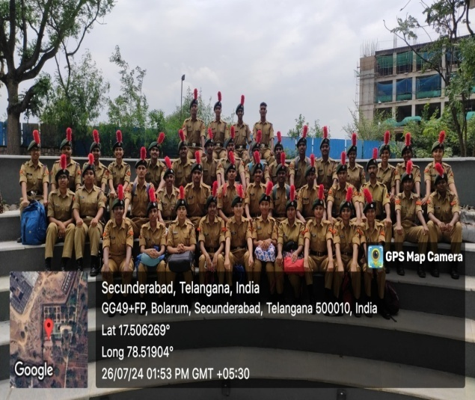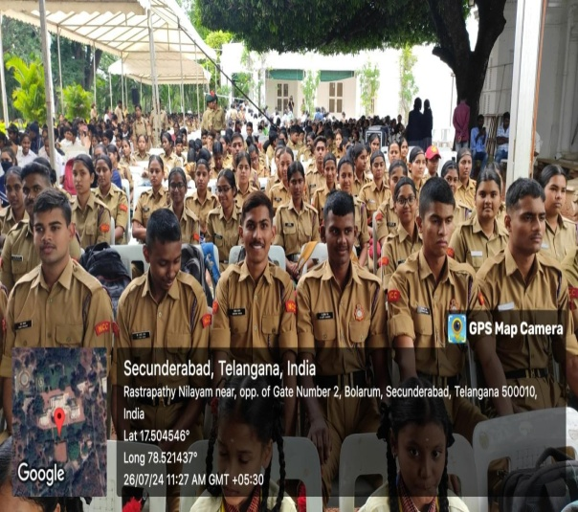

KARGIL VIJAY DIWAS
DATE: 27 July 2024
VENUE: In front of PG Block, LOYOLA ACADEMY
TIME: 12:20 PM
Kargil Vijay Diwas is observed on July 26th every year in India. A day dedicated aside to remember the nation's victory over Pakistan in the 1999 Kargil War. The day pays tribute to the Indian Armed Forces' bravery and sacrifice made during the fighting.
The conflict began in early May when Pakistani soldiers and militants infiltrated into Indian territory in the Kargil district of Jammu and Kashmir. The war lasted for about two months, culminating in India's victory on July 26, 1999, which is now celebrated as Kargil Vijay Diwas
EVENT:
On the auspicious occasion of Kargil Vijay Diwas, the National Cadet Corps (NCC) of Army Wing organized a Nukkad Natak to honor the valor and sacrifice of the Indian Armed Forces during the Kargil War of 1999. The play captivated the audience, telling the inspiring story of a young child's journey to become an army officer, participating bravely in the war, and contributing to India's victory. The cadets performed in front of the PG Block.

SCENE 1: The Dream:
The play opened with a scene depicting a young boy, f dreams of becoming an army officer and serving his country. The scene beautifully portrayed the innocence and determination of a child's dream.
SCENE 2: The Journey:
The second act showcased the journey of rigorous training and the challenges he faces at the National Defense Academy (NDA).
SCENE 3: The War:
The final act depicted a young army officer leading his troops during the Kargil War. The climax showed his team reclaiming the peaks, with the audience erupting in applause as they raised the Indian flag.
Conclusion:
The NCC cadets' performance on Kargil Vijay Diwas was not just a tribute to the heroes of 1999 but also an inspiring reminder of the spirit of patriotism that lives on in the younger generation.

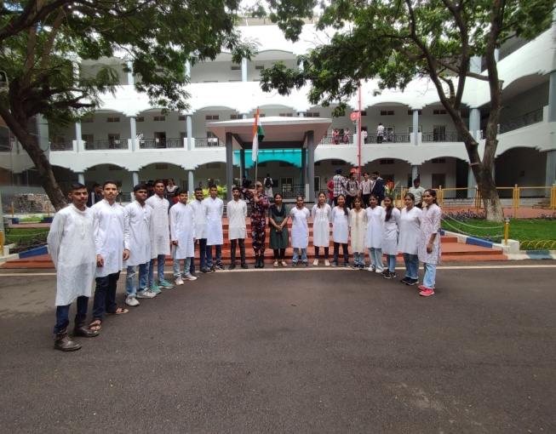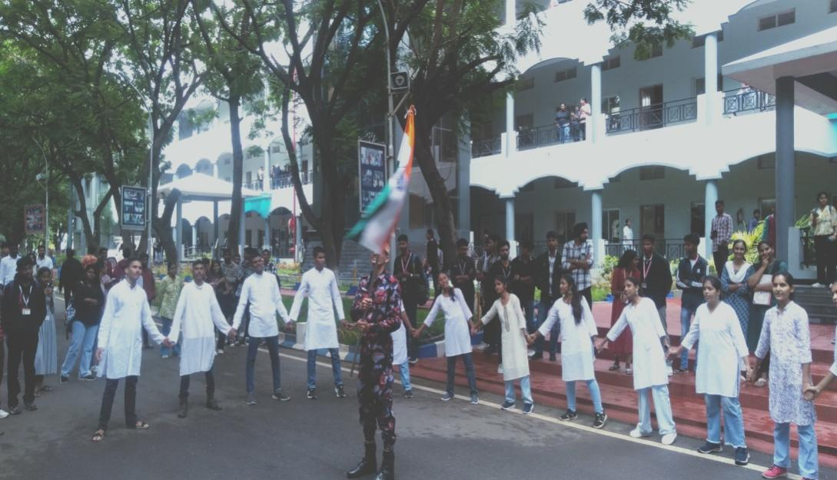

RDC SELECTION

Date : 12th August,2024.
Venue : Campus B, Loyola Academy.

The RDC camp selection for NCC cadets was conducted at Loyola Academy Campus B in the presence of Commanding Officer (CO) Col Ashish Tripathi and Administrative Officer (AO) Ashutosh.
The selection process for the Republic Day Camp (RDC) began with an enthusiastic turnout of NCC cadets aspiring to represent their unit. The event was meticulously organized to identify cadets with exceptional discipline, endurance, and leadership qualities, critical for participation in RDC.
CO Col Ashish Tripathi and AO Ashutosh supervised the selection process, ensuring it was conducted fairly and efficiently. The cadets underwent a rigorous evaluation that included drill performance, and personal interviews to assess their readiness and capabilities.
During the event, Col Ashish Tripathi addressed the cadets, emphasizing the significance of RDC in instilling patriotism and fostering a spirit of unity among young leaders. AO Ashutosh highlighted the importance of determination and teamwork, encouraging cadets to give their best.
SD’s : SW’s:
Total:

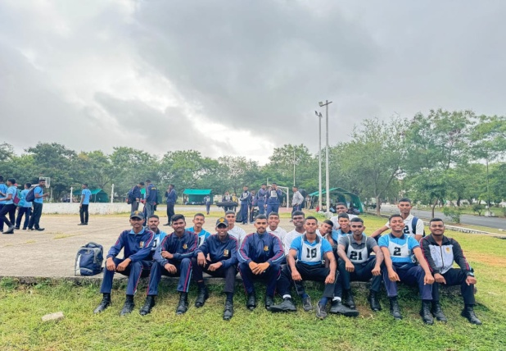

INDEPENDENCE DAY
Event: 78th Independence Day.
Date: 15 August 2024.
Report: The 78th Independence Day at Loyola Academy cited a marvelous celebration at the forecourt of Inigo Block.
Chief Guest: Sir EatalaRajander Garu, honorable Member of Parliament, Malkajgiri Constituency graced the occasion with his presence.
The Guests was escorted by the piloting team led by the piloting commander LCPL Alankritha Desai followed by the guard team led by the Guard Commander CDT P. Vishnu Varma and Sentry CDT Sujit Chandra.
The flag hoisting ceremony, led by Shir Eatala Rajendra Garu, was an illustrious moment followed by an inspiring speech by Prof. Rev. fr. Dr. L. Joji Reddy SJ Principal, Loyola Academy.

Followed by the contingent which was led by the Contingent commander LCPL Mukesh Kumar, flag bearer LCPL Geetha Goyal bearing Loyola Academy Flag, flag bearer LCPL Hari Krishna bearing Indian Flag, flag bearer LCPL Sri Chand bearing NCC flag. The kartavyapath Contingent led by the karthavyapathCommander CDTB.Sai Vamshi and CDT Jayanth Kumar holding the Indian Army Flag.
Thereafter, the new Rank holders of the year 2024-25 were facilitated by the Chief.
The Speech was then delivered by our chief guest. The event was ended with the vote of thanks from CDT Alankritha Desai, followed by group photo.
A total of 110 Cadets witnessed the event.
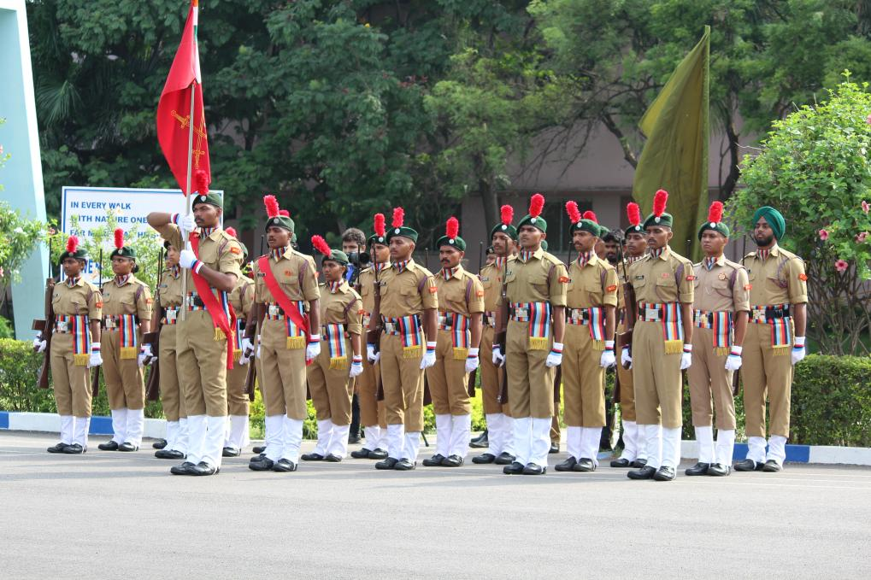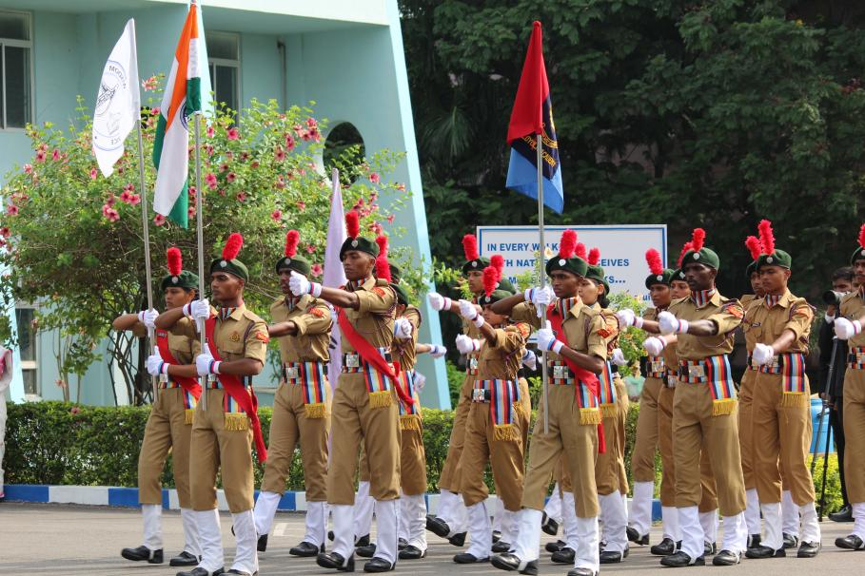

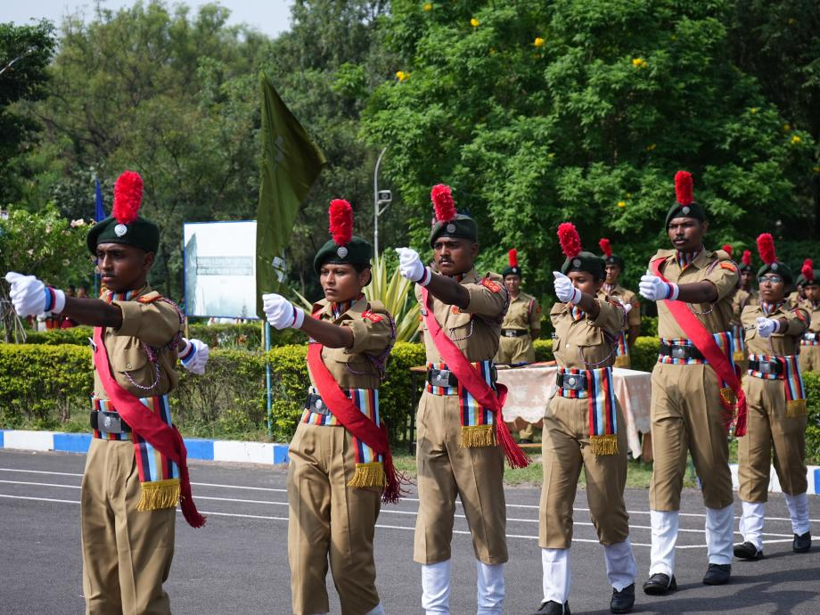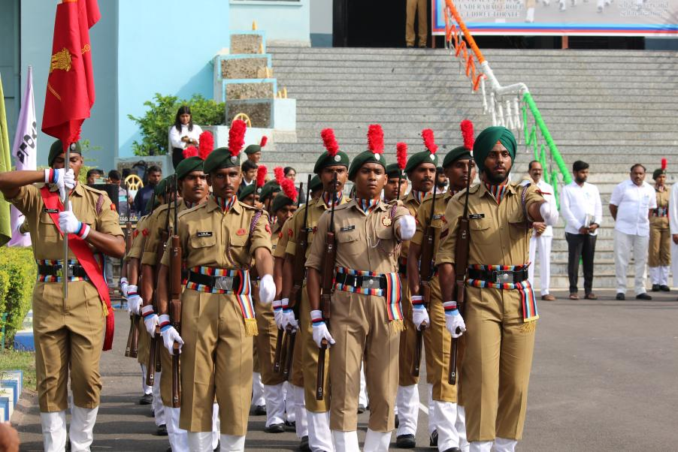

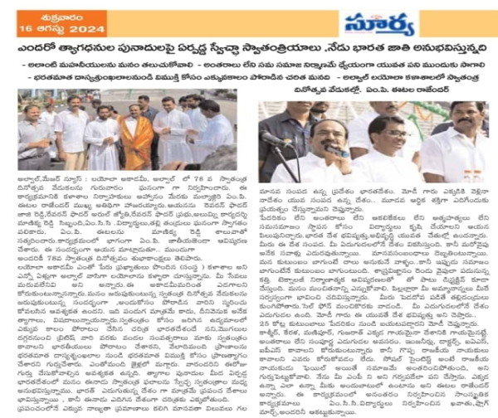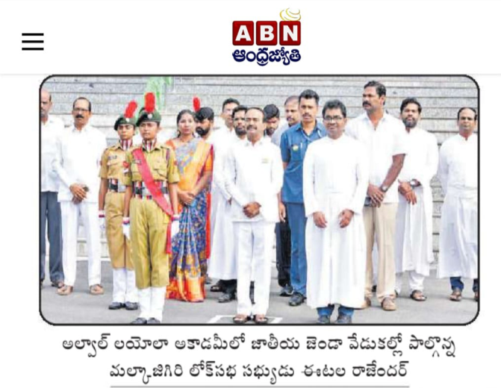

HAR GHAR TIRANGA

Event Details
Title of the Event: Har Ghar Tiranga .

Campaign - Bike Rally by NCC Cadets and Distribution of 100 Indian flags to community members

Date: 15th August 2024
Organizer/Coordinator: 25 COY Loyola Academy, 4(T) BN NCC and IQSC.
Target Audience: Local residents, students, NCC cadets, and community members

2. Objectives of the Event
- To celebrate India's Independence Day and promote the "Har Ghar Tiranga" initiative by encouraging citizens to display the national flag at their homes.
- To spread the message of patriotism, unity, and national pride among the local communities through an engaging bike rally.
- To foster a sense of collective responsibility and respect for the national symbol by distributing Indian flags to local households.

3. Participant Details
Total Participants: 150
Demographics: NCC cadets, students, faculty members, and local residents from various neighborhoods.
Attendance Percentage: 95 %

4. Content Evaluation
Relevance of the Topic: Extremely Relevant (aligned with the national campaign to celebrate India's independence and foster a sense of patriotism).
Depth of Knowledge Delivered: Excellent (participants understood the significance of the national flag and its role in uniting the country).
Engagement of Participants: Highly Engaged (the bike rally saw enthusiastic participation, and the distribution of flags created positive interactions within the community).

5. Learning Outcomes
Were the Learning Outcomes Met?: Yes
Key Takeaways for Participants:
- The significance of the national flag and its representation of India's unity and independence.
- The importance of promoting national pride and the "Har Ghar Tiranga" initiative.
- Active participation in community-driven activities that foster a sense of patriotism.
Skills/Knowledge Gained: Participants gained an improved understanding of the national campaign, learned about the proper handling and display of the national flag, and developed a deeper sense of connection to their country's heritage.

6. Feedback Analysis
Method of Feedback Collection: Verbal feedback during the event
Key Feedback from Participants:
- The bike rally was a great way to spread the message of patriotism.
- The event was highly interactive and engaging, with cadets leading the initiative to distribute flags.
- Participants appreciated the energy and enthusiasm shown by the NCC cadets.
Rating on a scale of 1-5:
- Content Quality: 4.6/5
- Participant Engagement: 4.8/5
- Presentation Style: 4.7/5

7. Impact on Community Engagement
Impact on Local Community:
- The event successfully instilled a sense of patriotism in the local residents. Many participants expressed interest in taking part in future patriotic events and campaigns.
- The distribution of flags encouraged several families to proudly hoist the national flag at their homes, contributing to the national campaign.

8. Quantitative Analysis
Pre- and Post-Event Assessment:
An informal survey was conducted before and after the rally to measure the participants' awareness of the "Har Ghar Tiranga" initiative.
- Pre-Event Awareness: 65% of participants were familiar with the campaign.
- Post-Event Awareness: 95% of participants expressed a clear understanding of the initiative and its significance.
Performance Improvement: The event led to a significant increase in awareness, with 85% of participants indicating they would participate in future patriotic campaigns.

9. Recommendations
Suggestions for Future Events:
- Collaborate with local schools and organizations to organize flag-hoisting ceremonies and workshops on the importance of national symbols.
Recommended Topics for Future Events:
- Events focused on educating the youth about the history and significance of India's national symbols.
- Activities highlighting India's freedom fighters and their contributions to the nation's independence.
Potential for Recurrence of the Event:
Yes, it is recommended to organize the "Har Ghar Tiranga" rally annually, especially during national holidays like Independence Day and Republic Day, to keep the spirit of patriotism alive within the community.

10. Conclusion
The "Har Ghar Tiranga" Bike Rally by NCC Cadets was a highly successful event, achieving its primary objectives of promoting patriotism, unity, and national pride. The participation of the community, combined with the enthusiasm of the cadets, made the event memorable and impactful. The initiative not only spread the message of the national campaign but also fostered a collective spirit of belonging and respect for the Indian national flag.

Attachments:
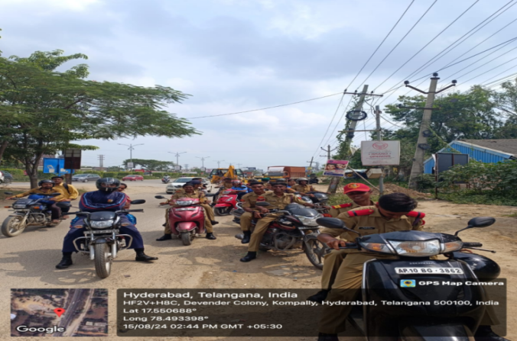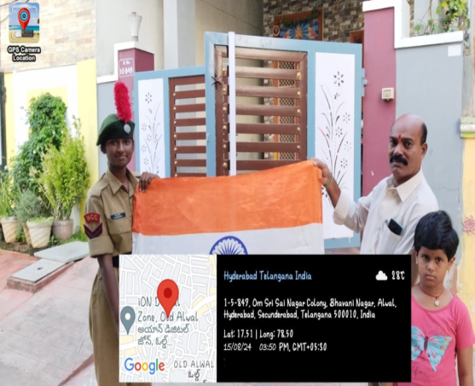
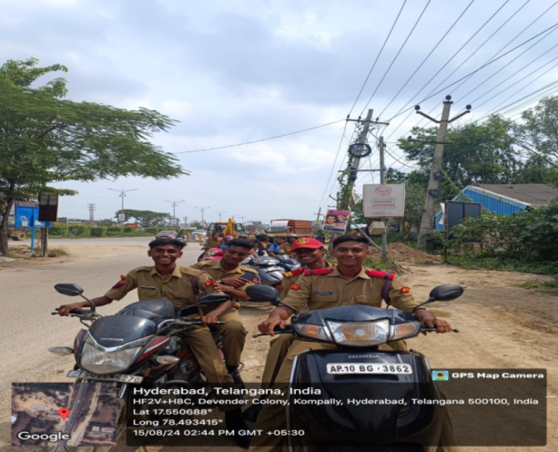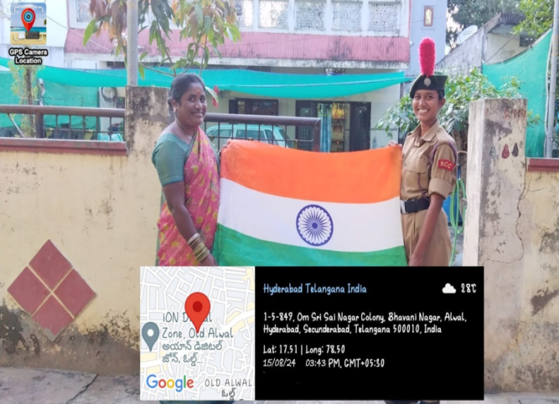

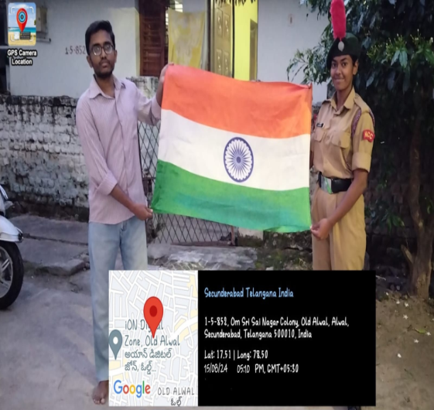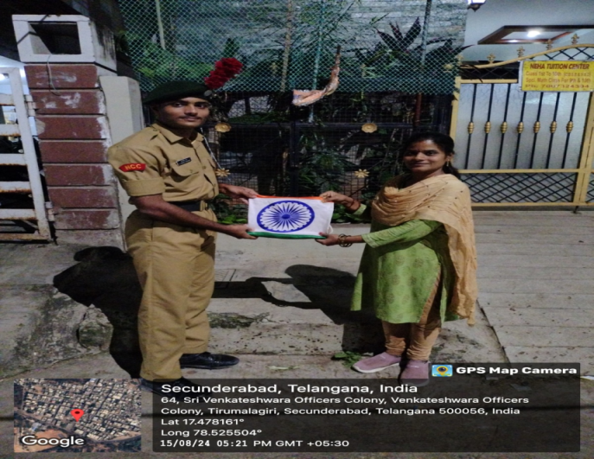

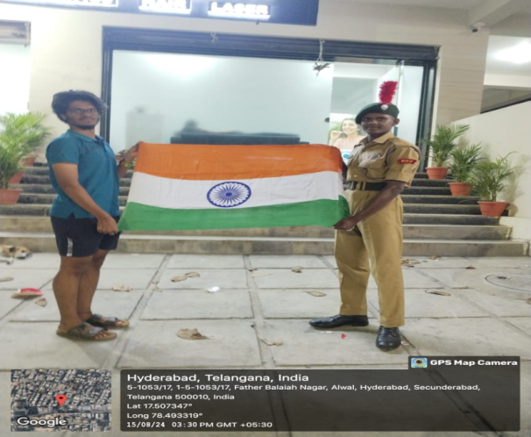

FIT INDIA MOVEMENT

EVENT : FIT INDIA MOVEMENT
DATE : 14th September 2024

The Fit India initiative is a significant movement aimed at encouraging citizens to adopt a healthier and more active lifestyle. This program promotes various physical activities and sports to enhance fitness levels across the nation.
The recent Fit India event saw active participation from cadets and the students of magic youth, Aicuf, student council, NSS and NCC navy wing. A total of several engaging events were held, including:
- Tug of War
- Cycling
- Push-ups
- Freestyle Football
- 5K Run
The event commenced with an inspiring inauguration speech delivered by the Father Arul Jyoti and the Chief Of Examination (COE) Father Thomas . They highlighted the importance of physical fitness, urging everyone to make health a priority in their daily routines. Their words set a motivational tone for the day, encouraging all participants to engage wholeheartedly in the activities.
Following the inauguration, cadets took part in a *5K run, demonstrating enthusiasm and commitment to fitness. This was followed by the highly competitive Tug of War, where teams from SDS and SWS showcased their strength and teamwork.
Achievements:
Both teams secured the 2nd place, earning the title of runners-up.
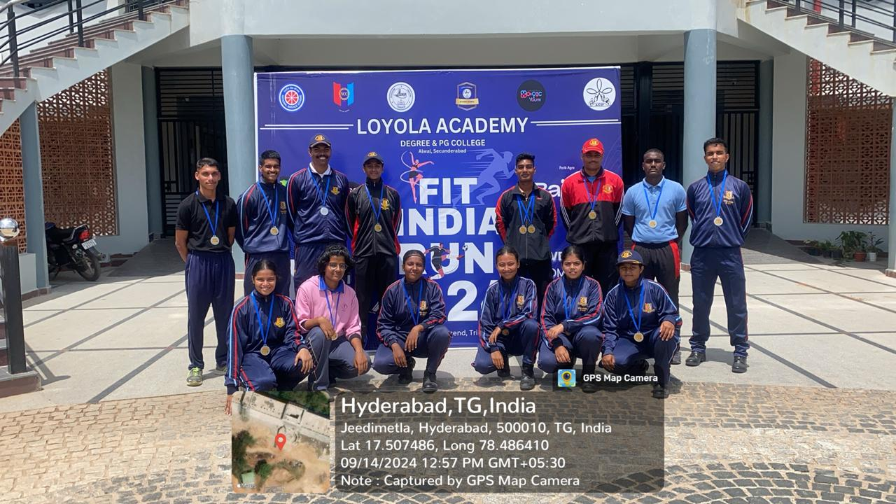

REPORT FOR “EK PED MAA KE NAAM”
- Event Details
  - Title of the Event: Ek Ped Maa Ke Naam
  - Date:1st October 2024
  - Venue:NCC Grounds
  - Organizer/Coordinator:NCC
  - Special Guest: Rev. Fr Joseph, Vice Principal
  - Participants:Cadets, faculty, and administrative staff
- Objectives of the Event
  - To promote environmental sustainability by encouraging tree plantation as a tribute to mothers.
  - To raise awareness about environmental protection through the art of street theatre (Nukkad Natak).
  - To instill a sense of responsibility among the participants toward nurturing nature.
- Participant Details
  - Total Participants:80
- Content Evaluation
  - Relevance of the Event: Highly Relevant as the urgency of addressing environmental issues and creating eco-consciousness is important.
  - Engagement of Participants: Actively Engaged - participants were involved in both tree plantation and interactive discussions post the Nukkad Natak.
- Learning Outcomes
  - Key Takeaways for Participants:
    - The importance of trees in sustaining life and paying tribute to mothers through meaningful actions.
    - Awareness of the environmental crisis and ways to contribute to nature preservation.
    - The role of community engagement in promoting environmental conservation.
    - Enhanced understanding of the need for tree plantation, practical knowledge of nurturing saplings.
- Impact on Curriculum or Future Practices
  - The event contributed to increased environmental awareness, which can be integrated into classroom discussions on sustainability.
- Conclusion
The "Ek Ped Maa Ke Naam" event was successful in achieving its objectives. It brought together the college community to raise environmental awareness and encouraged participants to take small, but impactful, actions for the environment. The event’s success was marked by an engaging Nukkad Natak, practical learning through tree plantation, and insightful discussions.
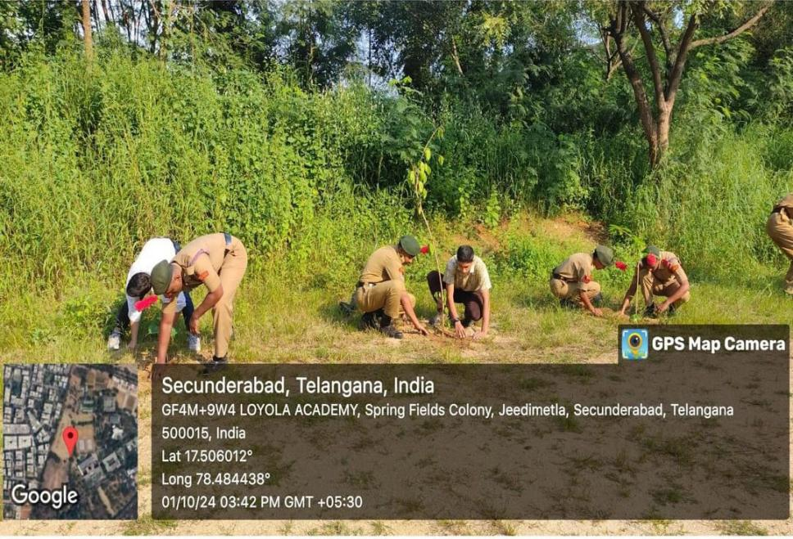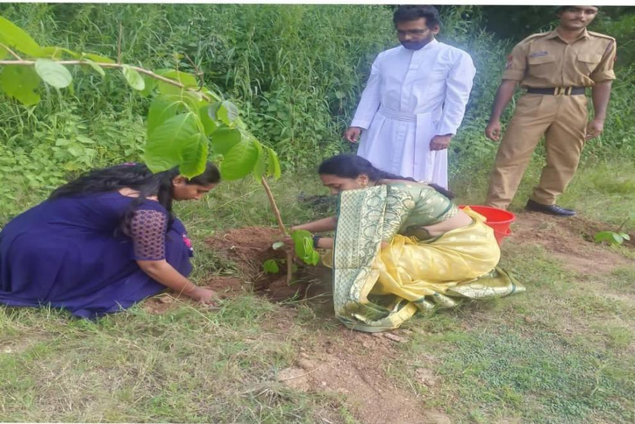

CM Cup 2024

Event Name: CM Cup 2024
Location: Hyderabad
Date: 03-10-2024
Chief Guest: CM Revanth Reddy
Overview:
The Telangana government organized the CM Cup 2024 to promote sports culture, particularly in rural areas. This event aimed to encourage youth participation in sports and foster a sense of teamwork and discipline among them. It also served as a platform to honor the AITSC (All India Thal Sainik Camp) Cadets of 2024, recognizing their hard work and commitment to national service.
Loyola Academy Representation:
Among the attendees was SUO Janet Mary, the only cadet from Loyola Academy. She was recognized for her leadership skills and outstanding performance during the TSC training. Her participation highlights the academy's commitment to developing future leaders.
Highlights:
- Chief Minister Revanth Reddy delivered an inspiring speech, praising the cadets for their dedication and emphasizing the importance of sports in building character and community.
- A memento was presented to the overall directorate in recognition of their efforts in organizing the event and supporting the cadets' development.

This event not only celebrated the cadets but also strengthened the ties between sports and community development in Telangana.

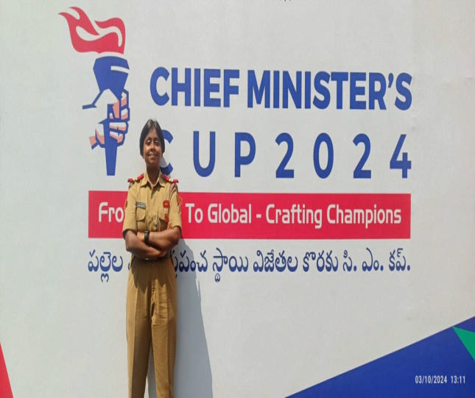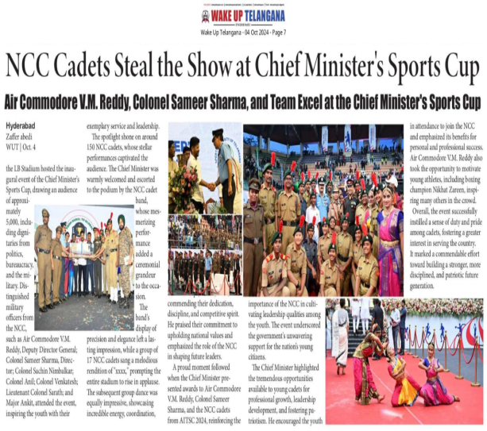

"Ektha Divas" - Nukkad Natak

1. Event Details
Title of the Event: Ektha Divas – Nukkad Natak
Date: 29th October 2024
Venue: Forecourt of PG Block
Organizer/Coordinator: NCC – army wing
Special Guests: Rev. Fr Joseph, Vice Principal, V Shirisha, CTO of the Army Wing and coordinators of other student bodies
Participants:
NCC Cadets, students and faculty.

2. Objectives of the Event
To foster a sense of unity and environmental responsibility by promoting unity among everyone. o Motivating cadets to take on civic responsibilities, reinforcing values like duty, respect for the country, and community service.
Creating opportunities for cadets to work as a team, developing skills in leadership, organization, and public communication through performance and event coordination.

3. Participant Details
Total Participants: 25 cadets (Sds-7, Sws-18)
4. Content Evaluation
Relevance of the Event: The event was highly relevant, emphasizing the critical importance of addressing society issues and fostering consciousness among the citizens.
Engagement of Participants: Actively Engaged – participants enjoyed the performance and took a pledge.

5. Learning Outcomes
1. Enhanced Understanding of Unity and Patriotism
2. Inspiration for Social Responsibility
3. Practical Leadership and Teamwork Experience

6. Impact on Curriculum or Future Practices
• The event highlighted the importance of unity, civic responsibility, and environmental awareness, which can be further incorporated into curriculum discussions. The following pledge was taken by everyone, which was initiated by Rev. Fr Joseph, Vice Principal.
I solemnly pledge that I dedicate myself to preserve the unity, integrity and security of the nation and strive hard to spread this message among my fellow county men. I take this pledge for the spirit of unification of my country which was made possible by the vision and actions of Sardar Vallabhai Patel. I also solemnly resolve to make my own contribution to ensure the internal security of my country.

7. Conclusion
The "Ektha Divas" Nukkad Natak event was a resounding success, meeting its objectives by uniting the college community in raising awareness and promoting responsible actions. The lively Nukkad Natak performance allowed for practical and emotional engagement, marking this celebration as both memorable and impactful.

EVENT PHOTOS:

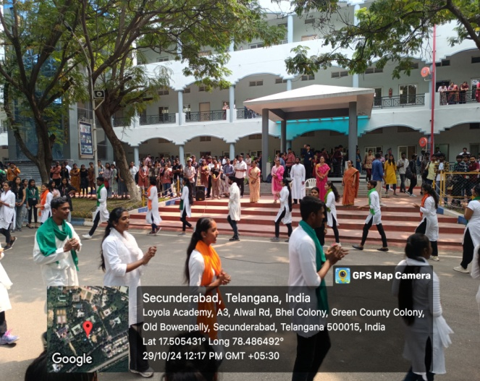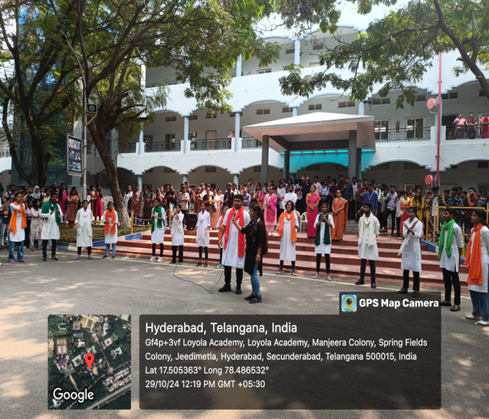

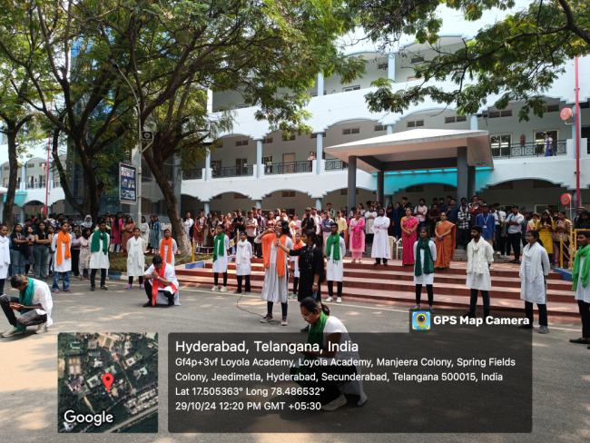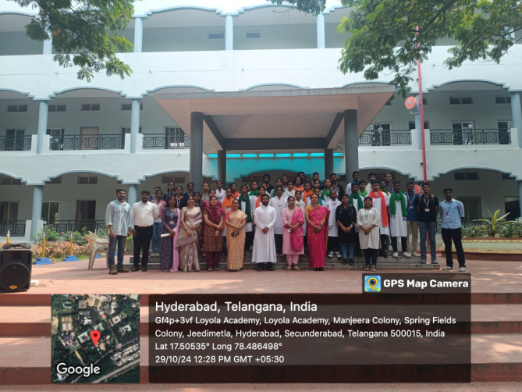

NCC 'C' CERTIFICATE
EVENT: Collection of 'C' Certificate.
DATE: 11th December, 2024
VENUE: 4(T) BN NCC Unit Office
The cadets received their NCC 'C' Certificate on 11th December, 2024, at the 4(T) BN Unit Office. This event marked the culmination of months of hard work and dedication by the cadets. The ceremony was honored by the presence of Suberdar Gurjit Singh and Chief Training Officer (CTO) V Sirisha, who awarded the certificates to the successful cadets.
The cadets emphasized on the importance of the 'C' Certificate in the cadets' NCC journey and future career opportunities. He praised the cadets for their dedication and encouraged them to continue striving for excellence and provided valuable feedback on the cadets' performance and motivated them to uphold the values and principles of the NCC.
The event concluded with a sense of pride and accomplishment, reinforcing the commitment of the cadets to the values and principles of the NCC. The ceremony not only recognized the hard work of the cadets but also motivated them to continue their journey with renewed vigor and determination.
A total of __ Cadets attended the event.
SD's - __SW's - __

CAMP RECORD
24-25

SNO | NAME OF THE CAMP | DATES
1 | ATC | 1st May 2024 to 10th May 2024
2 | IGC-IDSSC | 3rd May 2024 to 14th May 2024
3 | EBSB | 14TH May 2024 to 25th May 2024
4 | TRG-I IDSSC | 15thMay 2024 to 24thMay 2024
5 | TRG-II IDSSC | 29thMay 2024 to 7thJune 2024
6 | TRG-III IDSSC | 8th June 2024 to 17th June 2024
7 | LAUNCH | 18th June 2024 to 27th June 2024
8 | TSC IGC | 1ST July 2024 to 10th July 2024
9 | TSC TRG 1 | 1st Aug 2024 to 10thAug 2024
10 | TSC TRG 2 | 11th Aug 2024 to 20thAug 2024
11 | ARMY ATTACHMENT CAMP | 19th Aug 2024 to 28th Aug 2024
12 | TSC TRG 3 | 21st Aug 2024 to 30th Aug 2024
13 | AITSC | 1st Sept 2024 to 10th Sept 2024
14 | CATC-VIII Camp | 1st Sept 2024 to 10th Sept 2024
15 | KERALA TREK | 10th Sept 2024 to 17th Sept 2024
16 | AITSC DEKITTING | 11th Sept 2024 to 20th Sept 2024
17 | ARMY ATTACHMENT CAMP | 26th Sep 2024 to 4th Oct 2024
18 | RDC IGC | 17TH Oct 2024 to 26th Oct 2024
19 | PRE RDC 1 | 17th Nov 2024 to 26th Nov 2024
20 | PRE RDC 2 | 27th Nov 2024 to 6th Dec 2024
21 | ROCK CLIMBING AND TREKKING CAMP | 28th Nov 2024 to 7th Dec 2024
22 | PRE RDC 3 | 7th Dec 2024 to 16th Dec 2024
23 | SNIC | 11th Dec 2024 to 22nd Dec 2024
24 | LAUNCH | 17th Dec 2024 to 26thDec 2024

ATC
CAMP NAME:Annual Training Camp-II
CAMP LOCATION:Pallavi Model High School, alwal
CAMP DURATION:1st May 2024 to 10th May 2024
NO.OF CADETS: 59
C - SD’s
Cdt T Jayanth
Cdt Rohith Sai Vardhan
Cdt A R Siddharth
Cdt G Hari goud.
Cdt Nishanth.
Cdt Pawan Kumar.
Cdt P Kalyan Yadav.
Cdt G Vinay Kumar.
Cdt AkshayPavanesh.
Cdt Bharath.
Cdt Syed Mudassir
Cdt Mallikarjun
C - SW’S
SUO SahityaMalligari
Cdt Sharanya
Cdt Laharika
Cdt M Gowreshwari
Cdt M Vaishnavi
Cdt P Keerthi Reddy
Cdt SagarSabitha
Cdt ThanmayJayana
Cdt V Pravallika
Cdt Nisha Yadav
Cdt Ramandeep Kaur
Cdt DeepaliGoyal
B - SD’S
Cdt Manikanta
Cdt Tarun
Cdt SampathVirat
Cdt AkshayGoud
Cdt Ashutosh
Cdt Shanu Kumar
Cdt Kaushik
Cdt K Dinesh Kumar
Cdt C Giridhar
Cdt D S Harshavardhan
Cdt Clement Abraham
Cdt K Gopi Krishna
Cdt ManjitMinal Singh
Cdt Mohammad Amrit Nihal Ansari
Cdt V Nikhil
Cdt Ram Kumar
CdtLaxman Kumar
Cdt G Ravi
Cdt Roshan Raj
CdtSagar Kumar
Cdt V Sairam
Cdt Sravan Kumar Reddy
Cdt Uday Kiran
Cdt M Vijay
B - SW’S
Cdt Prasanna
Cdt Akshitha
Cdt Rashmitha
Cdt MahekSoni
Cdt P Keerthi
Cdt K.Hemalatha
Cdt M R Sowmya
Cdt Sathvika
Cdt Pramani Naidu
Cdt M Varsha
Cdt Sharmishta Vatyam

ACHIEVEMENTS:

- SUO Sahithya won two medals for her remarkable contribution as camp senior and company senior
- CDT Rohit had received medal for company senior
- CDT Mahek Soni placed 2nd in solo singing
- CDT Nisha Yadav secured 3rd place in solo dance
- CDT Deepali was placed 3rd for Best cadet competition
- Loyola Academy bagged trophy in drill competition (runner up)
- Loyola Academy won 1st place in volley ball

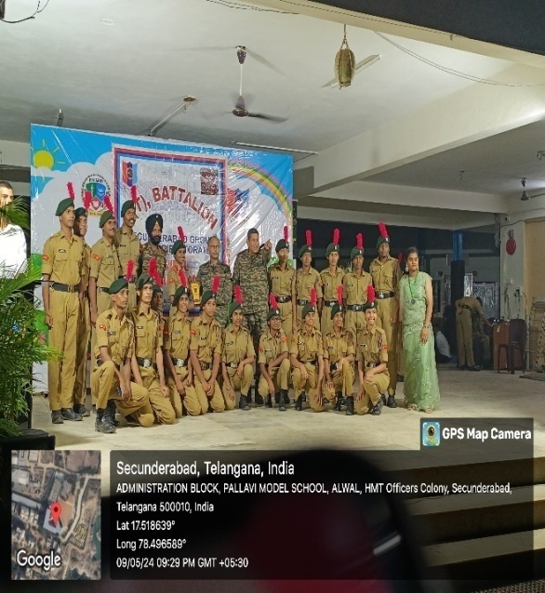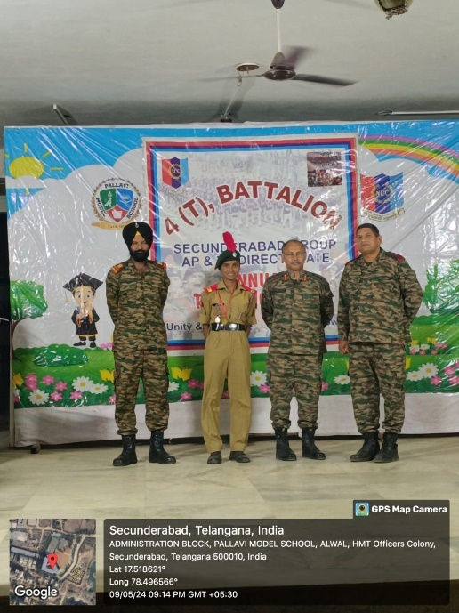

IGC-IDSSC -2024
CAMP NAME: Inter Directorate Sport Shooting Competition
CAMP LOCATION: JVN peddapuram,Kakinada
CAMP DURATION: 3rd May 2024 to 14th May 2024
NO.OF CADETS: 03
SD
1.LCPLMukesh Kumar
2.CDT Narshima
SW
1.LCPL Janet Mary
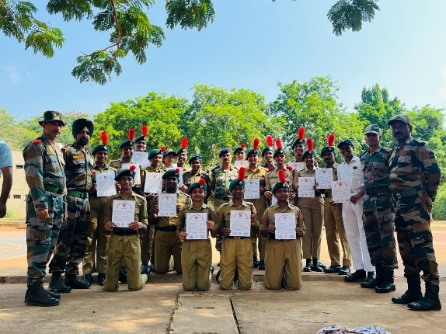
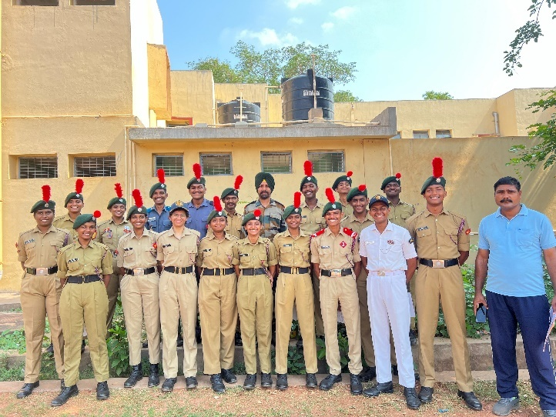
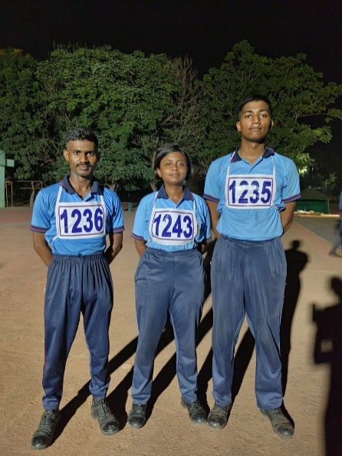

EBSB-1
CAMP NAME: Ek Bharat Shrestha Bharat-I
CAMP LOCATION: CMR College ,Medchal, Telangana
CAMP DURATION: 14TH May 2024 to 25th May 2024
NO.OF CADETS: 03
SD’S
1.CDT VAMSHI
2.CDT ADA JAYENDRA
SW’S
1.LCPL ALANKRITHA DESAI
ACHIEVEMENTS:

- LCPL Alankritha Desai and CDT Jayendra took part in NIAP (National Integration Awareness Program) representing Andhra Pradesh dteand stood 1st place.
- CDT Vamshi stood 1st place in volley ball and 2nd place in basketball
- CDT Jayendra received gold medal for piloting

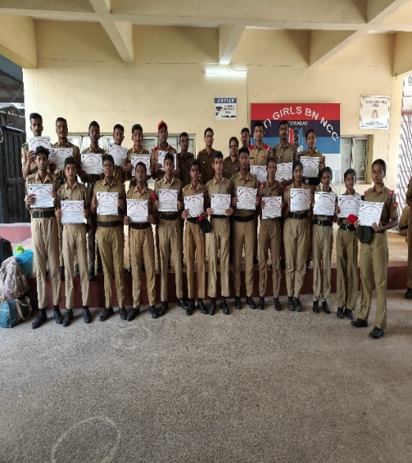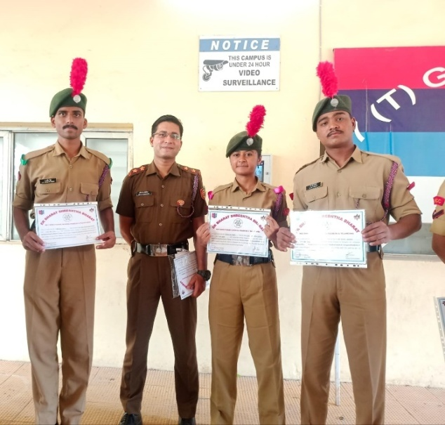

TRG-I IDSSC 2024
CAMP NAME: Training camp-I
CAMP LOCATION: JVN peddapuram,Kakinada
CAMP DURATION: 15th may 2024 to 24th may 2024
NO.OF CADETS: 01
SW
1.LCPL Janet mary

TRG-II IDSSC 2024
CAMP NAME: Training camp-II
CAMP LOCATION: Kakinada , JVN peddapuram
CAMP DURATION: 29THMay 2024 to 7th June 2024
NO.OF CADETS: 01
SW
- LCPL JANET MARY
TRG-III IDSSC
CAMP NAME: Training camp-III
CAMP LOCATION: Kakinada , JVN peddapuram
CAMP DURATION: 8th June 2024 to 17th June 2024
NO.OF CADETS: 01
SW
- LCPL JANET MARY

IDSSC LAUNCH
CAMP NAME: Launching camp
CAMP LOCATION: Kakinada , JVN peddapuram
CAMP DURATION: 18th June 2024 to 27th June 2024
NO.OF CADETS: 01
SW
- LCPL JANET MARY

TSC IGC

CAMP NAME: ThalSainik Camp- Inter Group Competition
CAMP LOCATION: Ananthapur
CAMP DURATION:1st July 2024 to 10th July 2024
NO.OF CADETS:8
- LCPL PHANI KUMAR REDDY
- LCPL JANET MARY
- CDT G NARSIMHA
- CDT GURUGUBELLI VISHNU VARDHAN
- CDT PRIYANKA NEWAR
- CDT G YUGANDHAR
- CDT VISHNU VARMA POTTURI
- CDT EPPAKAYALA SUJITH CHANDRA

TSC TRG-1
CAMP NAME: ThalSainik Camp- Training camp
CAMP LOCATION: Ananthapur
CAMP DURATION:1st Aug 2024 to 10th Aug 2024
NO.OF CADETS:5
- LCPL PHANI KUMAR REDDY
- LCPL JANET MARY
- CDT G NARSIMHA
- CDT GURUGUBELLI VISHNU VARDHAN
- CDT PRIYANKA NEWAR

TSC TRG-2
CAMP NAME: ThalSainik Camp- Training camp
CAMP LOCATION: Ananthapur
CAMP DURATION:11th August 2024 to 20th August 2024
NO.OF CADETS:5
- LCPL PHANI KUMAR REDDY
- LCPL JANET MARY
- CDT G NARSIMHA
- CDT GURUGUBELLI VISHNU VARDHAN
- CDT PRIYANKA NEWAR

ARMY ATTACHMENT CAMP
Location: 13 Dogra regiment, 47 infbde, Mehdipatnamgrassion.
Duration: 19th August 2024 to 28th August 2024.
No of cadets: 10
- JUO JITU SINGH SAGAR
- CSM L. HARI KRISHNA
- CQMS MUKESH KUMAR
- CPL E PAWAN KUMAR
- CPL GANDHAM VINAY KUMAR
- CPL A. R. SIDDARTH
- CPL S. ROHITH SAI VARDHAN
- CDT S MALLIKARJUNA
- CDT P. KALYAN YADAV
- CDT G ABHISHEK
Achievements: -
1. JUO JITU SINGH SAGAR was the overall senior of 4T BN NCC.
2. CSM L HARI KRISHNA and CQMS MUKESH KUMAR participated in the dance.
3. CPL E PAWAN KUMAR participated in the singing.
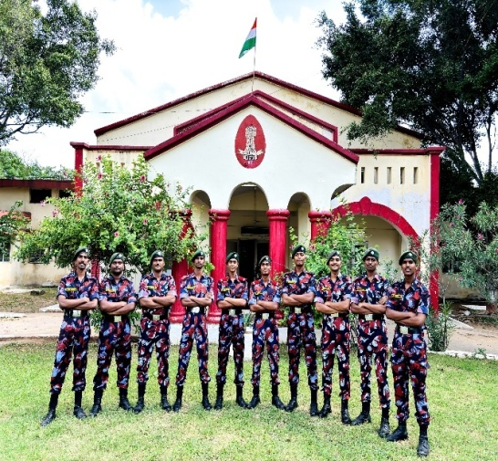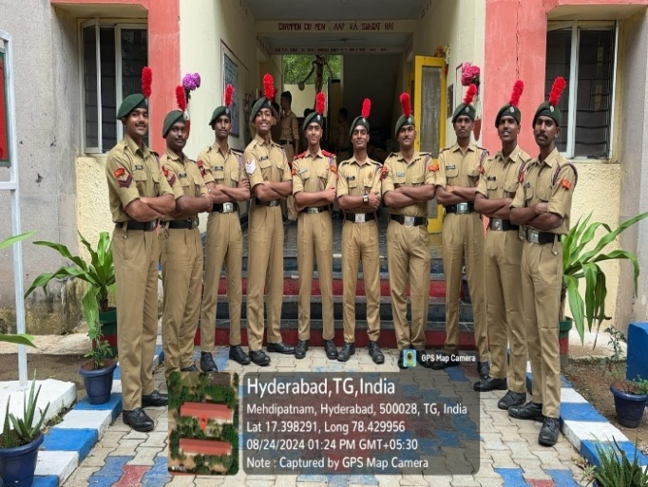

TSC TRG-3
CAMP NAME: ThalSainik Camp- Training camp
CAMP LOCATION: Ananthapur
CAMP DURATION:21st August 2024 to 30th August 2024
NOOF CADETS:3
- JUO JANET MARY
- LCPL GURUGUBELLI VISHNU VARDHAN
- LCPL PRIYANKA NEWAR

AITSC
CAMP NAME: All India ThalSainik Camp
CAMP LOCATION:New Delhi
CAMP DURATION: 1st Sept 2024 to 10th Sept 2024
NOOF CADETS: 1
- JUO JANET MARY

CATC-VIII Camp

CAMP NAME: Combined Annual Training Camp
DURATION: 01st Sep 2024 to 10th Sep 2024
CAMP LOCATION: Bison Training Grounds, Sec-bad
NO OF CADETS :33

C SDS
- SGT B. SRICHAND
- CPL BHAVJEET SINGH
- CDT DEBJEET ROY

C SWS
- SGT KANDURI JAHNAVI
- SGT M.GOWRESHWARI
- CDT P GANGOTHRI
- CDT KARINA BISHNOI
- CDT TITISHA SAHA
- CDT YENNI VANDANA
- CDT MADANU GRACY PRECIUA
- CDT HRISHA NATH
- CDT RITHIKA KUMARI
- CDT ARPANPREET KAUR

B2 SDs
- LCPL JUZER YOUSUF MITHAIWALA
- CDT SAYYAD SHOKAT TAJODDIN
- CDT YELKA KISHORE
- CDT KOLTHUR DINESH KUMAR
- CDT M ASHER EMMANUEL
- CDT ALLAM RAJU SAMPATH VIRAT
- CDT PENDAM LAXMIKANTH
- CDT GOVULA RAVI
- CDT CHIMMA GIRIDHAR
- CDT NALLAMASA AKSHAY GOUD
- CDT MADASU SAI CHARAN
- CDT NAND PRAKASH
- CDT PALLATI DARPAN
- CDT THARUN TEJA
- CDT MUSAPETA UDAY KIRAN

B2 SWS

- LCPL VEESHNAPURAM BHARGAVI
- CDT P PRAMANI
- CDT DIVYA SRI U
- CDT CHANDANI PANDEY
- CDT MAY BALA SANDHYA RANI

KERALA TREK-I

CAMP NAME: All India Trekking Expedition – Kerala Trek-I
CAMP LOCATION: JawaharNavodayaVidyalayaKulamavu, Idukki, Kerala
CAMP DURATION:10th Sept 2024 to 17th Sept 2024
NO OF CADETS: 1

- SGT GEETHA GOYAL

ARMY ATTACHMENT CAMP

CAMP NAME:Army attachment camp
CAMP LOCATION: 1 EME Training Center, Kowkur
CAMP DURATION: 26th Sept 2024 to 4th Oct 2024
NO OF CADETS: 1

- SGTTANNIRU JAYANTH KUMAR
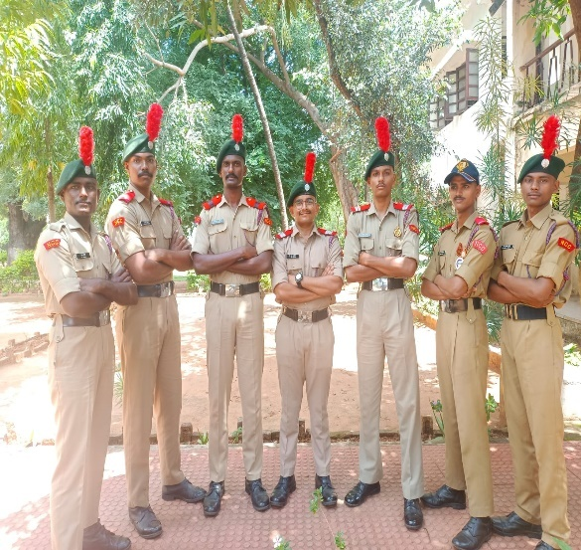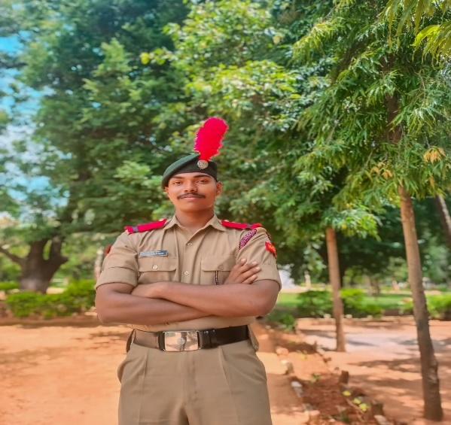

RDC IGC

CAMP NAME: Republic Day Camp- Inter Group Competition
CAMP LOCATION: Mehdipatnam Military Garrison
DURATION: 17th Oct 2024 26th Oct 2024
NO OF CADETS: 5
- CQMS MUKESH KUMAR
- SGT B.SAI VAMSHI
- LCPL VISHNU VARMA POTTURI
- CPL DEEPALI GOYAL
- CDT ALANKRITHA DESAI
PRE RDC 1
CAMP NAME:Pre RDC-I
CAMP LOCATION:Mehdipatnam Military Garrison
DURATION:17th Nov 2024 to 26th Nov 2024
NO OF CADETS: 3
- CQMS MUKESH KUMAR
- LCPL VISHNU VARMA POTTURI
- CDT ALANKRITHA DESAI

PRE RDC 2
CAMP NAME: Pre RDC-II
CAMP LOCATION:Mehdipatnam Military Garrison
DURATION: 27th Nov 2024 to 06th Dec 2024
NO OF CADETS: 3
- CQMS MUKESH KUMAR
- LCPL VISHNU VARMA POTTURI
- CDT ALANKRITHA DESAI

ROCK CLIMBING AND TREKKING CAMP

CAMP NAME: Rock Climbing and Trekking Camp
CAMP LOCATION: Junagadh, Gujarat
CAMP DURATION: 28th Nov 2024 to 7th Dec 2024
NO OF CADETS: 1
- SGT B. SRICHAND

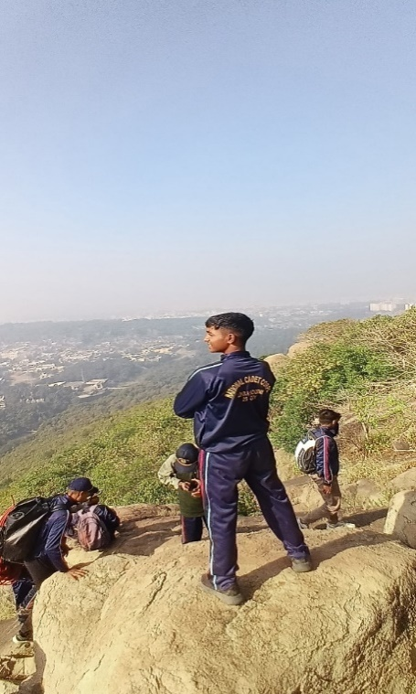
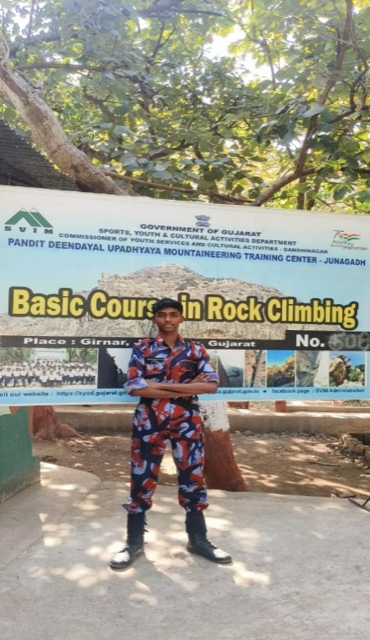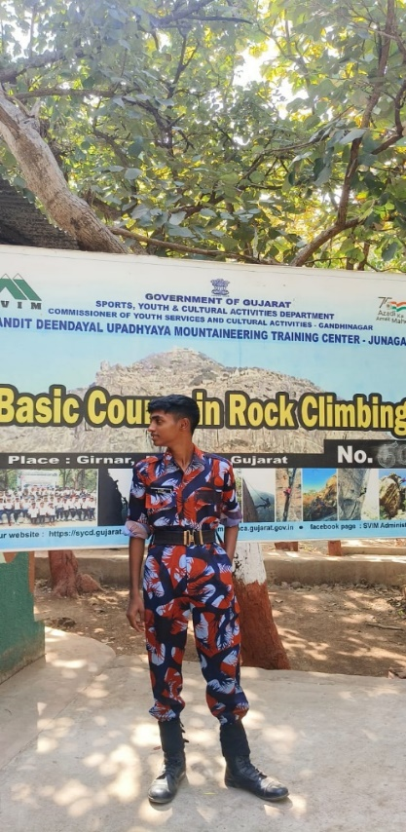

PRE RDC 3

CAMP NAME: Pre RDC-III
CAMP LOCATION:Mehdipatnam Military Garrison
CAMP DURATION: 7th Dec 2024 to 16th Dec 2024
NO OF CADETS: 3
- CQMS MUKESH KUMAR
- LCPL VISHNU VARMA POTTURI
- CDT ALANKRITHA DESAI

SNIC

CAMP NAME:Special National Integration Camp
CAMP LOCATION:Wokha, Nagaland
CAMP DURATION: 11th Dec 2024 to 22nd Dec 2024
NO OF CADETS:2
- LCPL GURUGUBELLI VISHNU VARDHAN
- LCPL PRIYANKA NEWAR
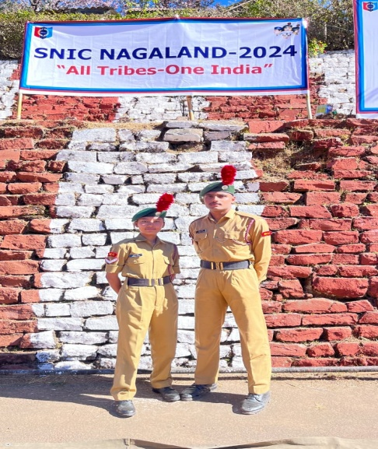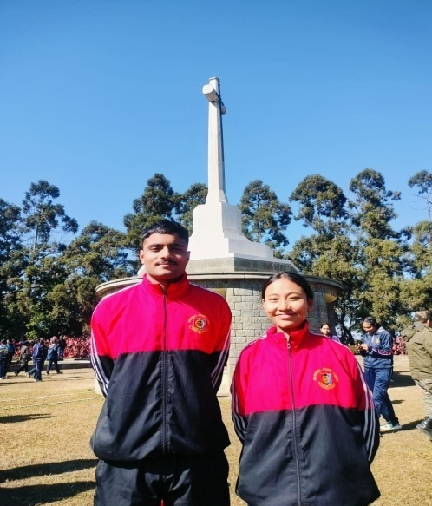

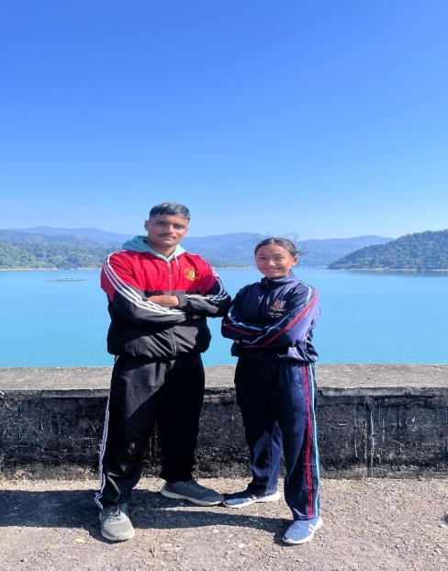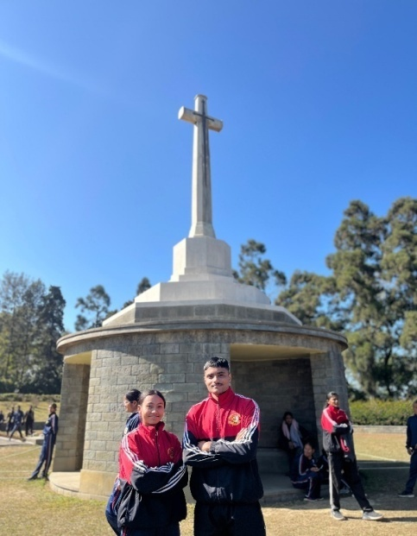

LAUNCH
CAMP NAME:Launching Camp
CAMP LOCATION:Mehdipatnam Military Garrison
CAMP DURATION: 17th Dec 2024 to 26thDec 2024
NO OF CADETS:2
- CQMS MUKESH KUMAR
- LCPL VISHNU VARMA POTTURI

