
ALUMNI MEET 2023-2024
REPORT


11th November 2023
LOYOLA ACADEMY
DEGREE & PG COLLEGE, ALWAL

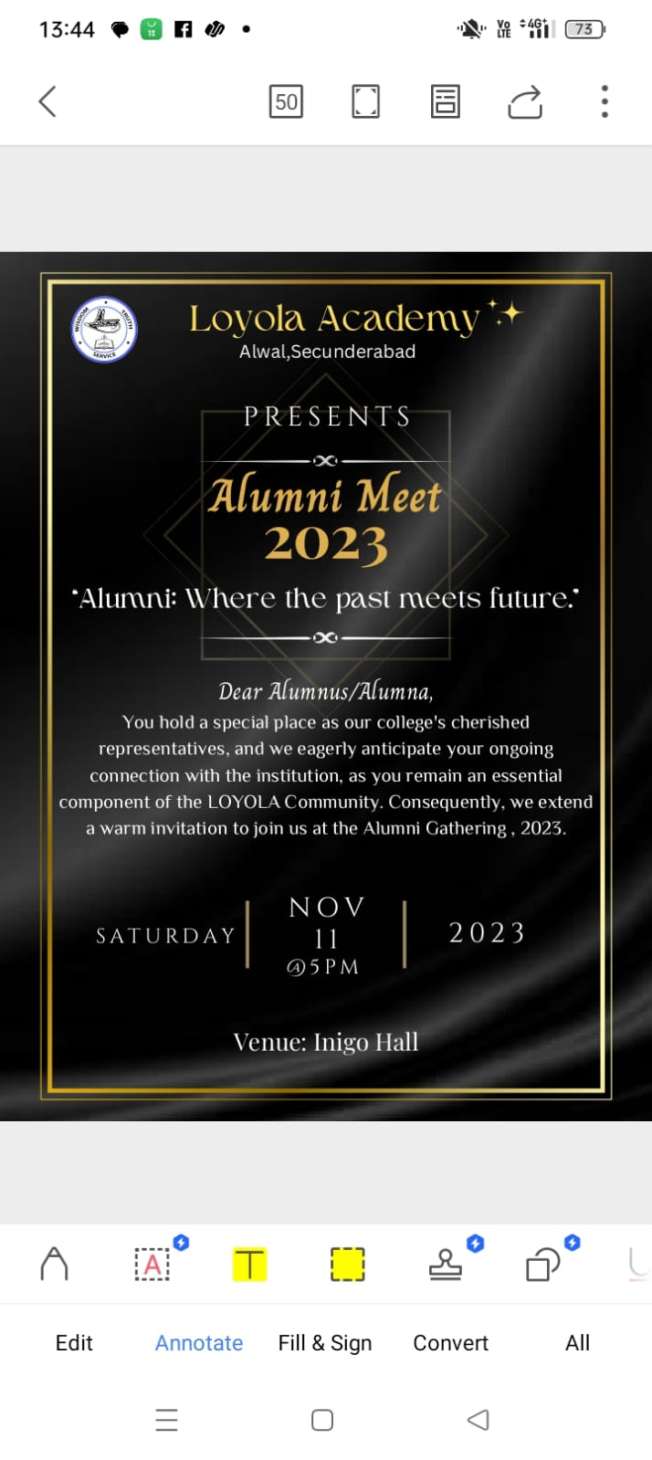
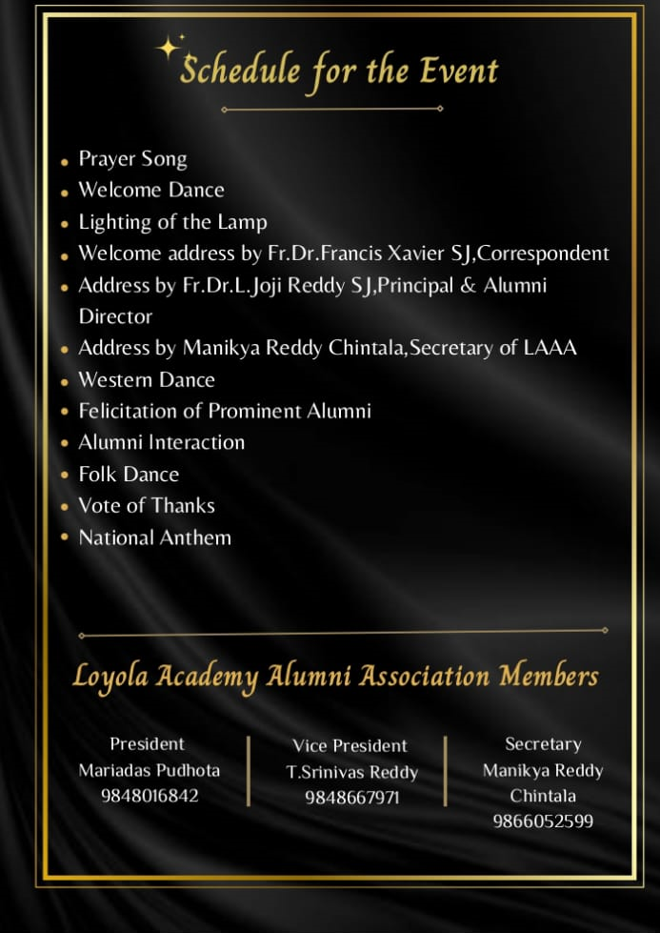

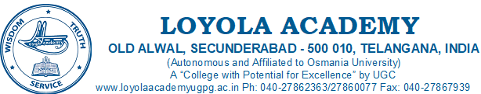
Schedule | Time
Prayer Song | 05:30 PM – 05:35 PM
Welcome Dance | 05:35 PM – 05:40 PM
Lighting of the Lamp | 05:40 PM – 05:50 PM
Welcome Address by Rev. Fr. Dr. Francis Xavier SJ, Rector & Correspondent | 05:50 PM – 06:10 PM
Address by Rev Fr. Dr. L. Joji Reddy SJ, Principal | 06:10 PM – 06:20 PM
Address by Mr. Manikya Reddy  Secretary of LAAA | 06:20 PM - 06.25 PM
Address by T.Srinivas Reddy,  Vice-President of LAAA | 06:25 PM - 06.30 PM
Folk Dance | 06:30 PM – 06:35 PM
Felicitation of Prominent Alumnus | 06:35 PM – 06:55 PM
Alumni/Ae Interaction | 06:55 PM – 07:05 PM
Western Dance | 07:05 PM – 07:10 PM
Vote of thanks | 07:10 PM – 07:15 PM
National Anthem
11th November 2023

(Principal)

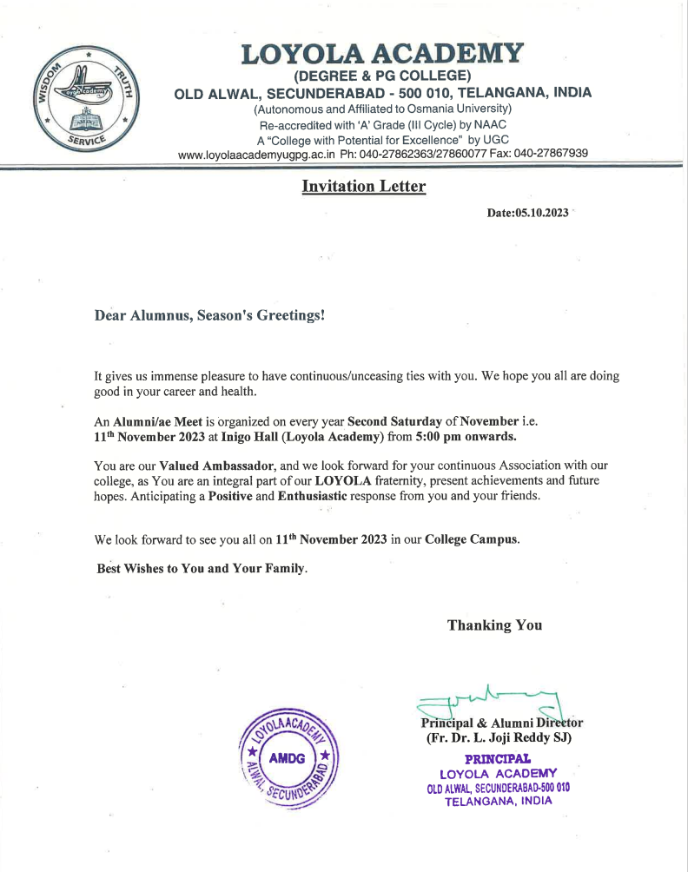

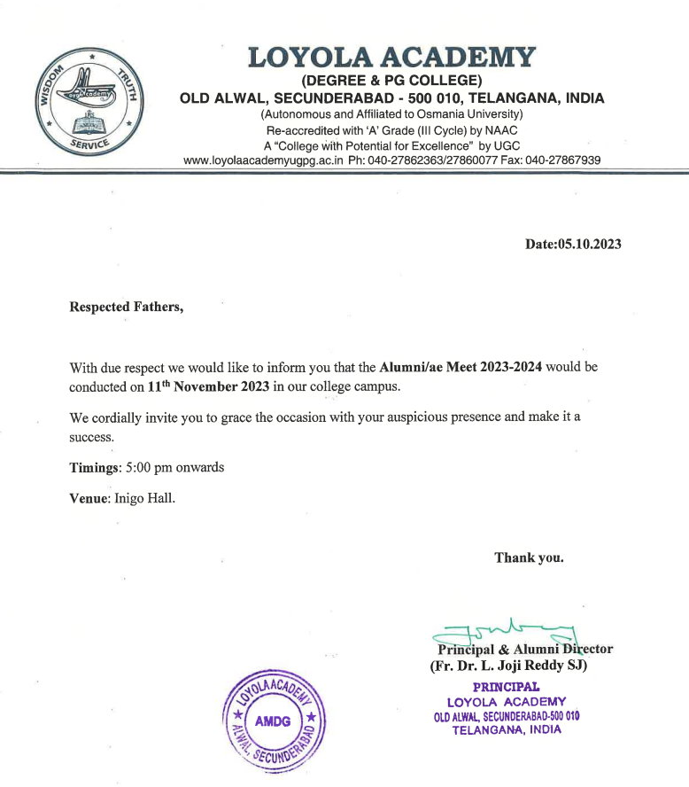

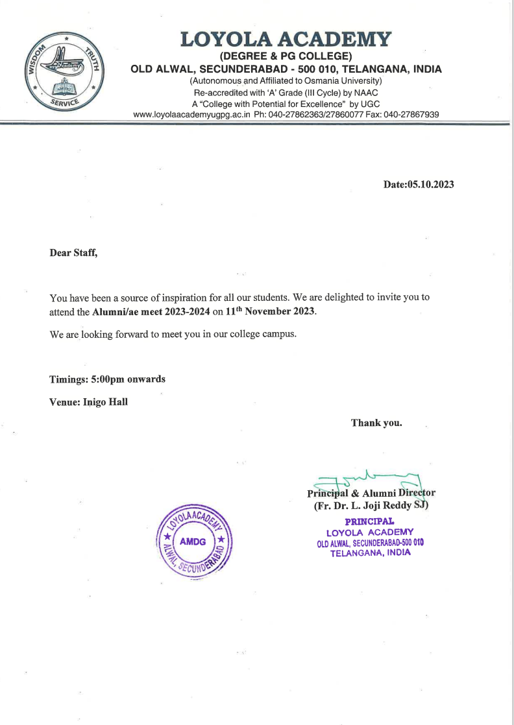

Alumni Meet 2023
Date: 11-11-2023
Venue: Inigo hall
Time: 5:00 pm to 7:00 pm
Objective: Bridging the past with present.
Report:
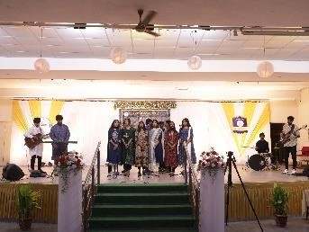
Loyola Academy in collaboration with the student council hosted the Alumni Meet 2023. The college choir Ignis Sanctus’ harmonious voices filled the room with a sense of reverence as they commenced the Alumni meet with a soulful prayer song followed by a classical dance by the college dance team, enchanting everyone with its timeless beauty. Rev. Fr. Dr. L Joji Reddy SJ, Principal Loyola Academy, President Xavier’s Board, Mr. Manikya Reddy Chintala, Secretary of Loyola Academy Alumni Association and T. Srinivas Reddy, Vice president of Alumni Association were
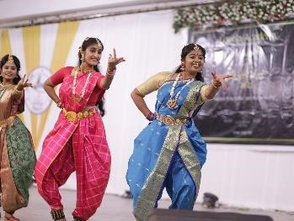
among the dignitaries from the college administration who performed the lighting of the lamp with the esteemed alumni chief guests Mr. Daram Muralidhar Reddy and Mr. M. Naga Raju. Rev. Fr. Dr. L Joji Reddy SJ, Principal Loyola Academy then addressed the gathering and extended his gratitude to all the alumni for making it to the event. Rev. Fr. Dr L Joji Reddy SJ, Principal Loyola Academy in his speech unveiled the new establishments aimed at the enhancement of the students, to the alumni and shared the values and beliefs that Loyola Academy was built on as he quoted a
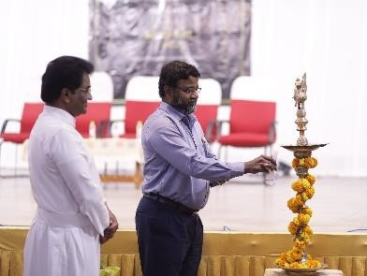
Sanskrit shloka, “Hastasya Bhushanam Danam” that instilled an important life lesson of, one can only embellish their arm through charity, truth and kindness. Mr. Manikya Reddy Chintala, Secretary of Loyola Academy Alumni Association welcomed the alumni reminiscing in the history of Loyola Academy and shared the significant milestones of the institute with an increase in the student body, with the current enrolment being more than 6000 students. Mr. Daram
Muralidhar Reddy our chief guest shared his experiences as
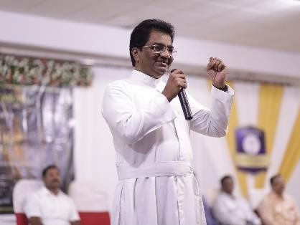
student from the batch of 1980-83. Sir shared the principles like discipline, value-based education and progressive educational methods that Loyola Academy had accepted for the growth of their students. Mr. M. Naga Raju, an alumni from the batch of 1989-92 extended his sincere gratitude to the management for inviting him to the alumni meet as a chief guest. Sir is a successful agripreneur and owes his success to the institute for the values and ethics instilled in him by the institute. Sir also bestowed upon Loyola Academy the honor of being recognised as a brand in the realm of education. Mrs. G. Sirisha, Asst. Controller of Examination and Tressurer of
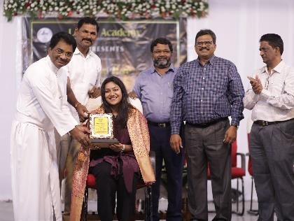
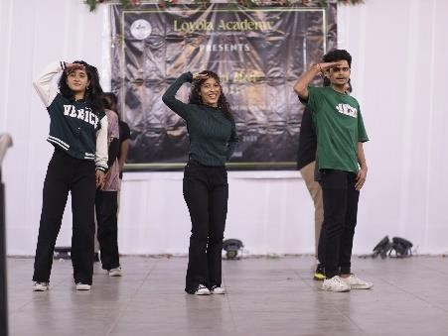
Loyola Academy Alumni Association was then invited onto the dais to carry forward the falicitation program of our esteemed chief guests. Rev. Fr. Dr L Joji Reddy SJ, Principal Loyola Academy was invited to felicitate our chief guests and other prominent alumni with a shawl and a momento, as a token of gratitude. The RJ heads then had an interactive session with the alumni that created a platform for fruitful exchanges, offered an opportunity for current students to gain valuable insights and guidance from the experiences of our prominent alumni. It was a session where alumni cherished their friendships,
the memories made and their experiences in the college. Rev. Fr. Dr. L Joji Reddy SJ, Principal Loyola Academy, shared how proud it made him to see his students and alumni to have grown in life and become an inspiration to others. The stage then came alive with a mesmerizing blend of cultures featuring two stellar dance performances, the first celebrating our Indian culture, followed by a dynamic western dance by the college dance team. The college management then set up a photo booth and a bonfire where the alumni spent the rest of their time interacting and reminiscing in their old memories they made in the college.

Outcome: An event that marked the significant moment of reconnection, celebration and networking of our esteemed alumni, faculty and current students.

You Tube Live Streaming Link:
https://youtube.com/live/9fg_uW0dmQo?feature=share

