


MONTHLY EVENT DOCUMENT

EQUAL OPPORTUNITY CELL

Name of the Department: Equal Opportunity Cell

Sl. No | Month & Date | Title of the Event | Report | Budget | Submitted to
 |  |  |  |  | Department | Dean | IQAC
1 | 20th December  2023 | Elocution | Yes | – | – | – | Yes
2 | 12th January  2024 | Cricket Match – National Youth Day | Yes | – | – | – | Yes

Kindly Note: Report should contain the following points:
- Title
- Objective of the Event
- Resource person’s Credentials
- Resource Person’s message relevant to the title.
- Outcome of the Event from student’s point of view
- Geo tagged Photo & Video (Do not drag the photo or resize it)

EQUAL OPPORTUNITY CELL
REPORT
Title: "Enhancing Democracy: An Analysis of the Constitutional Laws Awareness Programme."

Introduction:
Date : 20-12-2023
Venue: Seminar Hall , Commerce Block
In today's world, where democracy is a dominant force, it's essential to understand the fundamental principles that form the basis of our constitutional laws. This report explores the results and influence of the "Enhancing Democracy" awareness program, which is a collective effort to promote awareness and provide insight into the complex nature of constitutional laws to a diverse audience.
The primary objective of this awareness program was to equip citizens with the knowledge and understanding of constitutional laws, fostering a sense of civic responsibility and active participation. By providing a comprehensive overview of our constitutional framework, the program aimed to bridge the gap between legal complexities and the everyday lives of individuals.
Throughout this report, we will delve into the key elements of the awareness program, emphasizing the methodologies employed, participant engagement, and the overall impact on public comprehension. The journey towards constitutional enlightenment embarked upon during this program has the potential to reshape the civic landscape, transforming each citizen into an informed and engaged contributor to our democratic society.
It is our sincere hope that the findings of this report not only demonstrate the success of the awareness program but also inspire ongoing endeavors to strengthen the foundation of our democracy through constitutional literacy.
We appreciate your presence in this intellectual exploration, where the power of knowledge converges with the guiding principles of our nation's democratic spirit.

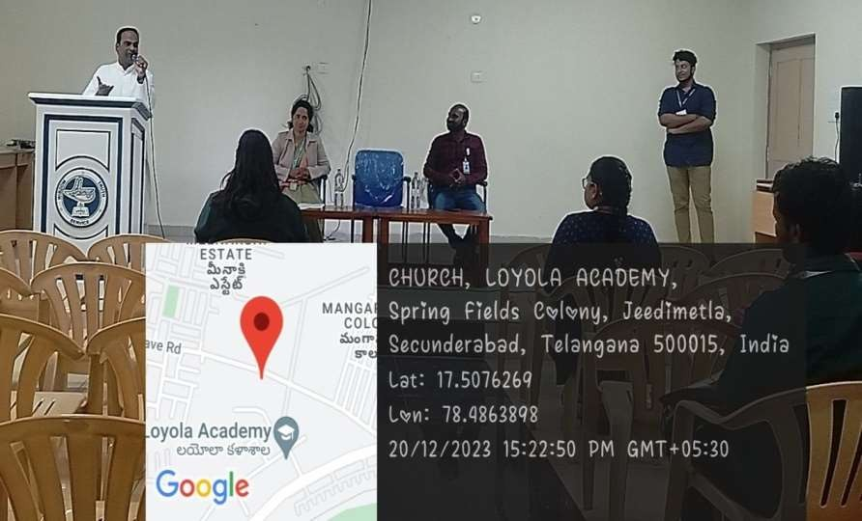

Objectives:
The college program on constitutional amendment laws aimed to enhance awareness about key legal changes. Distinguished speakers discussed amendments and their implications and engaged in insightful ǪCA sessions. Students gained valuable insights into the evolving legal landscape, fostering a deeper understanding of constitutional dynamics. The event successfully promoted legal literacy within the college community.

Event Details:
Dr. P. Mahendar, the coordinator of the Equal Opportunity Cell, is conducting an election program for "Constitutional Awareness" for all the students at the Common Block Seminar Hall. The program is scheduled to take place on 20-12-2023, from 3 PM to 4 PM. Students are required to speak for 2-3 minutes on any of the topics mentioned below:
- Fundamental Rights and Duties
- Dr. BR Ambedkar's Autobiography
- Article 370
- Role of Judiciary
- Role of Parliament in India
Please note that there is no registration

Program Highlight:

To improve people's understanding of constitutional law, there are several things you can do. For instance, you can invite legal experts to speak at seminars, create instructional videos and tutorials, and develop engaging social media content. Collaborating with law schools and organizations can also

help facilitate discussions on crucial constitutional issues and educate a wider audience. This approach will enable you to increase public engagement and knowledge of the subject while providing expert guidance and support.

Audience response:
It is crucial to understand the level of awareness students have about constitutional law, and we can do this by conducting surveys that are specifically targeted at them. We understand that students' opinions matter and we value their feedback about the relevance of the information we provide and the effectiveness of our teaching methods. We also want to know whether we are successfully helping students to gain a better understanding of constitutional law. Apart from surveys, we pay attention to participation levels in related events or discussions among students to assess the impact on their awareness and engagement with constitutional law topics. We are committed to creating a learning environment that fosters a deep understanding and appreciation of this essential subject, and we appreciate your input.
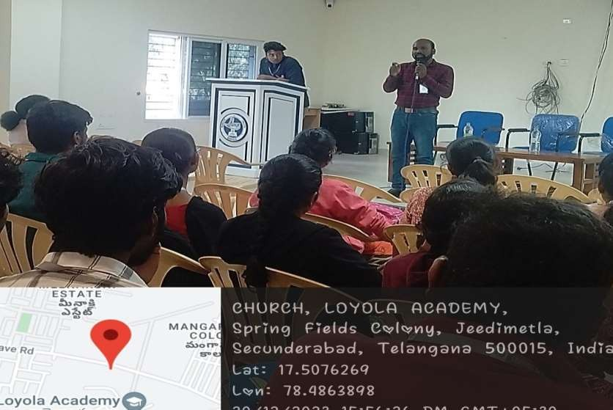

EQUAL OPPORTUNITY CELL

National Youth Day Cricket Match Report

Date : January 12, 2024
Venue : B-Campus, Loyola Academy

On the auspicious occasion of National Youth Day, the Equal Opportunity Cell of Loyola Academy organized a spirited cricket match, fostering camaraderie among the teaching and non-teaching staff. The esteemed presence of Fr. Dr. L. Joji Reddy SJ, Principal; Fr. Dr. Francis Xavier SJ, Correspondent; Fr. Dr. A. M. Joseph Kumar SJ, Vice Principal - School of Management; and Fr. M. Arul Jothi SJ, Vice Principal - School of Commerce, added grandeur to the event.
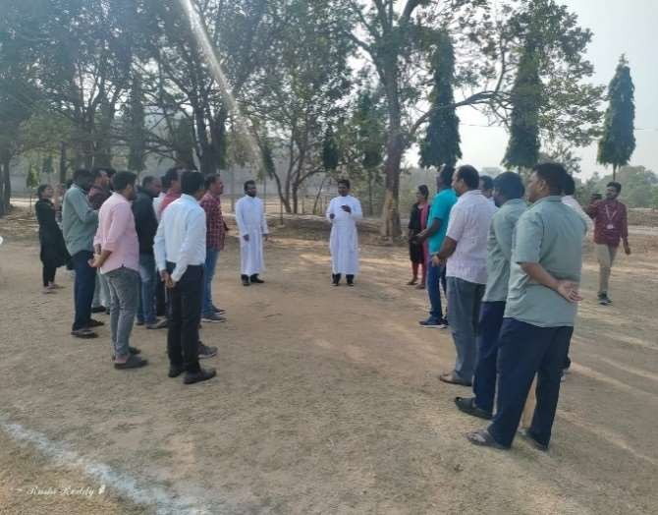
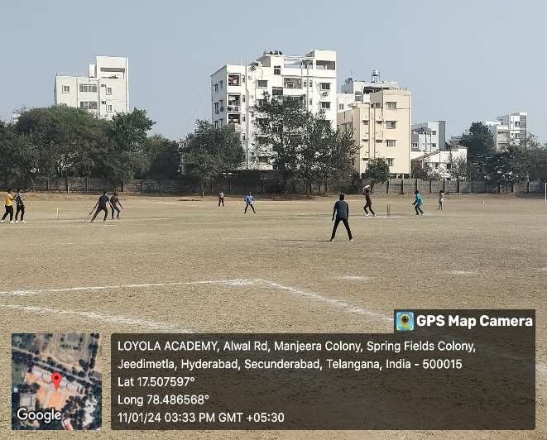

The enthusiastic match unfolded between Team A and Team B, echoing cheers and sportsmanship. Team A emerged victorious, clinching the win with a commendable 86 runs. The cricket ground resonated with encouragement, entertainment, and energy, creating a memorable day for everyone involved.
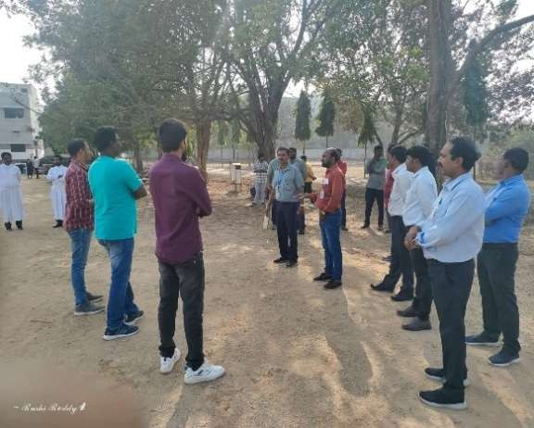
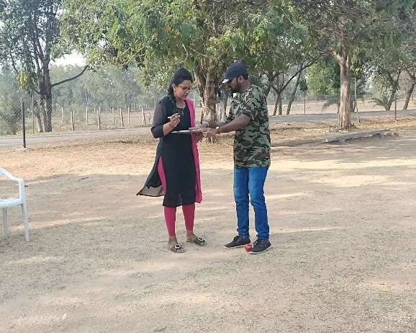

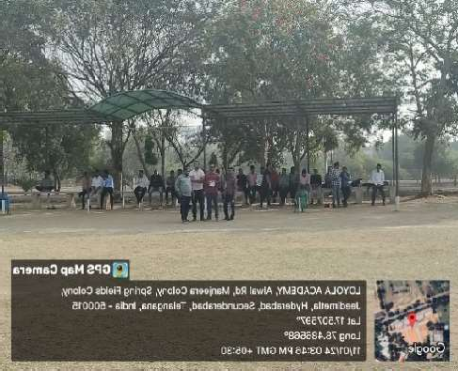
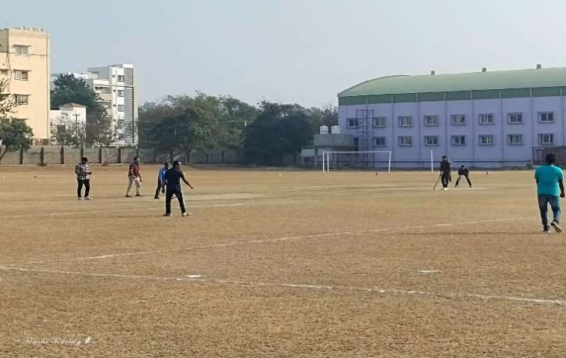

Conclusion

The participation of the dignitaries, including Fr.Dr. L. Joji Reddy SJ, Fr. Dr. Francis Xavier SJ, Fr. Dr. A. M. Joseph Kumar SJ, and Fr. M. Arul Jothi SJ, exemplified the unity and zeal that define the spirit of National Youth Day. The event not only celebrated sportsmanship but also reinforced the sense of community within Loyola Academy.

