MONTHLY EVENT DOCUMENT

Name of the Department: B. Sc. COMPUTER SCIENCE & INTERNET OF THINGS

S. No | Month & Date | Title of the event | Report | Budget | Submitted to
 |  |  |  |  | Department | Dean | IQAC
1 | January, 2024 | Student In – House Projects | yes | - | yes | yes | yes
2 | 5th, 6th & 7th February 2024 | Faculty Training on Designing of IOT System | yes | - | yes | yes | yes
3 | 21st, 22nd, 23rd & 24th February, 2024 | Student Training on Mobile App Development | yes | - | yes | yes | yes

INCUBATION CELL

DEPARTMENTAL ACTIVITIES

2023-2024

REPORT ON INNOVATIVE PROJECTS

Name of the Event: In-house Projects
Date of Event: January 2024
Time: 3:00 PM to 4:30 PM
Location: Incubation Cell, Loyola Academy
Faculty In – Charge: Dr C. Santhi
Number of Students participated: 25
Number of faculty participated: 05.

Introduction:
The In-house Projects in Incubation Cell report encapsulates the progress, achievements, and future prospects of the projects currently incubating within the incubation cell. This report provides an overview of the projects, their objectives, milestones achieved, challenges encountered, and the support provided by the incubation cell.
The Incubation Center is a hub for fostering creativity and innovation, supporting startups in developing groundbreaking projects. Through tailored mentorship, access to resources, and collaborative environments, the center empowers entrepreneurs to bring their ideas to life. Innovative projects address pressing societal challenges while leveraging cutting-edge technologies and novel approaches. The Incubation Center serves as a catalyst for driving economic growth and positive social impact through entrepreneurship and innovation.

Future Plans:
- Project Expansion: Explore opportunities to scale up existing projects and explore new market segments.
- Collaborations: Foster partnerships with industry stakeholders and academia to enhance project viability.
- Resource Allocation: Allocate additional resources and funding to projects showing significant potential for growth.
- Mentorship Programs: Enhance mentorship programs to provide personalized guidance and support to project teams.

Conclusion:
The In-house Projects in Incubation Cell report highlights the diverse range of innovative projects currently undergoing incubation. Despite encountering challenges, the projects have made significant progress towards achieving their objectives. With continued support from the incubation cell, these projects are poised for success and have the potential to make a meaningful impact in their respective industries. Looking ahead, the focus will be on nurturing these projects, fostering collaborations, and maximizing their potential for commercialization and societal benefit.

REPORT OF FACULTY TRAINING ON DESIGNING OF IOT SYSTEM

Name of the Event: Training on Designing of IOT System
Date of Event: 5th, 6th & 7th February 2024
Time: 9:30 A. M. to 3:30 P.M.
Location: Idea Lab, Gokaraju Rangaraju Institute of Engineering & Technology, Hyderabad
Number of faculty participated: 04.
Name of Resource Person: Mr. Radhanand, GRIET, Hyderabad

Objective:
- To familiarize faculty members with the fundamentals of IoT architecture and components.
- To provide insights into the design principles and best practices for developing IoT systems.
- To impart knowledge on various communication technologies and security considerations.
- To engage participants in practical sessions for hands-on experience in IoT system design and implementation.
- To encourage collaboration and networking among faculty members for future research and educational initiatives in IoT.

Introduction:
The Training on Designing of IoT System was organized to empower faculty members with the knowledge and skills required to effectively design and implement Internet of Things (IoT) solutions. Held over three days, the event aimed to equip participants with practical insights into IoT system architecture, protocols, and design considerations.
The Internet of Things (IoT) has revolutionized the way we interact with technology, and its impact has been felt in nearly every industry. One area where IoT systems have been particularly transformative is in the design of train systems. In this report, we will explore the various components and considerations involved in designing an IoT system for trains.
One of the key aspects of designing an IoT system for trains is the integration of sensors and actuators. Sensors can be used to monitor various parameters such as temperature, speed, and vibration, while actuators can be used to control various systems such as brakes and doors. These sensors and actuators are connected to a network, allowing for real-time monitoring and control of the train's various systems.

Day 1: February 5th, 2024
The first day of the training commenced with an introduction to IoT concepts and applications. Faculty members gained an understanding of the significance of IoT in various domains. Subsequent sessions delved into IoT architecture, emphasizing the components involved. Practical exercises were conducted to set up development environments for hands-on learning.

Day 2: February 6th, 2024
On the second day, the training covered a range of IoT communication technologies including Wi-Fi, Bluetooth, Zigbee. Faculty members engaged in a practical exercise focused on developing a basic IoT application using sensors and actuators.
Participants were introduced to prominent IoT platforms and frameworks such as Google Cloud IoT. Real-world case studies were presented to illustrate successful IoT implementations. The training concluded with group projects, where faculty members collaborated to design and present innovative IoT solutions.

Day 3: February 7th, 2024
The final day of the training focused on designing of mobile app development of IoT systems. The mobile app is developed for various real time applications such as canvas designing, games design and robot operation.

Feedback:
Feedback from the 4 participating faculty members was positive, with appreciation for the comprehensive coverage of IoT topics and the opportunity for hands-on learning. Participants expressed eagerness to integrate the knowledge gained into their teaching curriculum and research endeavors.

Conclusion:
The Training on Designing of IoT System successfully equipped faculty members with the necessary knowledge and skills to navigate the complexities of IoT system design. By fostering practical learning experiences and facilitating collaboration among educators, the event contributed to the enhancement of IoT education and research at Gokaraju Rangaraju Institute of Engineering & Technology and beyond.

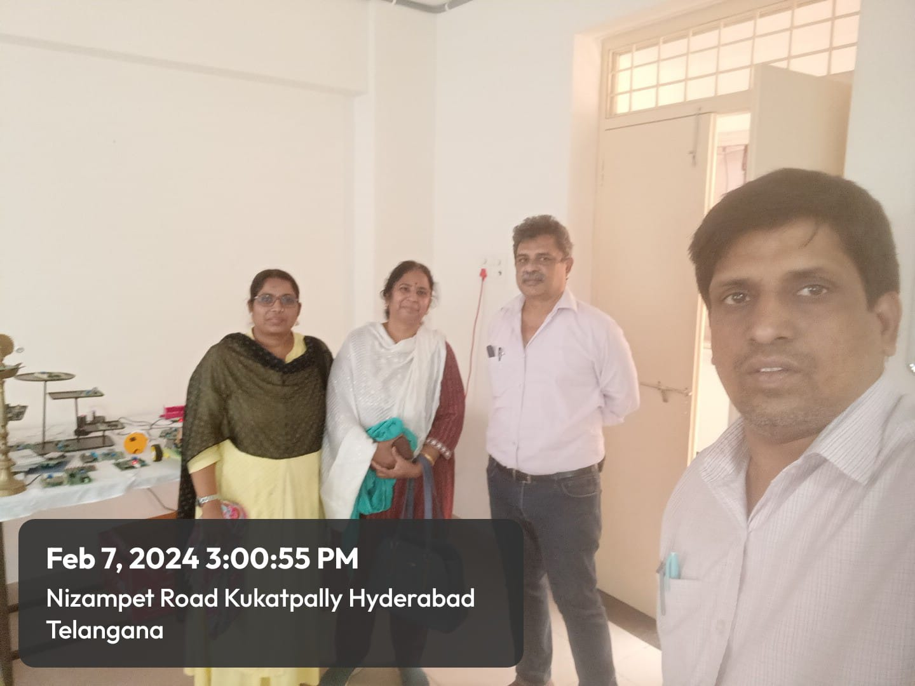

Report of Student Training on Mobile App Development

Training Topic: Mobile App Development for Companion App
Date: 21st, 22nd, 23rd & 24th February, 2024
Duration: 3.00 PM to 4.30 PM
Location: Loyola Academy
Number of Students Participated: 10
Resource Persons: Dr C. Santhi & Mr Shaik Abdul Khadar

Objectives:
- To introduce students to the fundamentals of mobile app development.
- To familiarize students with the concept of companion apps and their significance.
- To provide hands-on experience in designing and developing companion apps for different platforms.
- To empower students with the skills to create intuitive user interfaces and seamless user experiences.
- To encourage creativity and innovation in the development of companion apps.

Introduction:
The Student Training on Mobile App Development for Companion App was organized to equip students with the skills and knowledge necessary to develop companion applications for various platforms. The training aimed to provide practical insights into mobile app development, focusing on creating companion apps that enhance user experiences and complement existing products or services.

Day 1: Introduction to Mobile App Development
- Overview of mobile app development platforms and technologies.
- Introduction to popular mobile app development frameworks.

Day 2: Understanding Companion Apps
- Definition and importance of companion apps.
- Examples and case studies of successful companion apps.
- Identifying features and functionalities of companion apps.

Day 3: Hands-on Development
- Setting up development environments for Android platforms.
- Practical sessions on coding and designing companion apps.
- Testing and debugging companion apps.

Day 4: Project Showcase and Conclusion
- Presentation of student projects.
- Feedback and discussion on the learning experience.

Feedback:
Feedback from the participating students was overwhelmingly positive. They appreciated the hands-on approach to learning and found the practical sessions particularly beneficial. Many students expressed confidence in their ability to develop companion apps independently after completing the training.

Conclusion:
The Student Training on Mobile App Development for Companion App was a resounding success, achieving its objectives of empowering students with the skills and knowledge required to develop innovative companion applications. By combining theoretical learning with practical hands-on experience, the training effectively prepared students to tackle real-world challenges in mobile app development. The enthusiasm and creativity demonstrated by the students throughout the training underscored the potential for future advancements in this field.

Mobile Apps Developed By Students as Case Studies:

