LOYOLA ACADEMY
25 COY, 4(T)BN
NCC
ANNUAL EVENT RECORD
2023-24

EVENT RECORD
INDEX
Sr no | EVENT
1 | World environment day
2 | International yoga day
3 | B Certificate collection event
4 | Enrollment 2023
5 | C Certificate collection event
6 | Defence talk
7 | Kargil vijay diwas
8 | 77th Independence day
9 | voter’s day awareness
10 | khadi walk
11 | world habitat day
12 | world habitat day (rally)
13 | Rastriya ektha diwas
14 | A Swachh Bharat Mission
15 | Graduation day
16 | Veera Madrasi Guard of Honor Competition
17 | National Youth Day
18 | Republic Day
19 | B-Cerificate Practical And Written Examiniation
20 | CPR Training Session

01.World Environment Day Celebration at Loyola Academy

Introduction
The celebration of World Environment Day on 5th June 2023 at Loyola Academy by NCC students was an impactful event aimed at raising awareness about environmental issues and promoting sustainable practices.
Raise Environmental Awareness
The primary objective of the event was to raise awareness among students and the wider community about pressing environmental issues. By engaging NCC students, known for their discipline and commitment, we aimed to effectively communicate the importance of environmental conservation and encourage individuals to take action.
The event sought to promote sustainable practices that can contribute to a healthier environment. Through the rally and nukkad natak, NCC students aimed to inspire behavior change, such as reducing plastic usage, conserving energy and water, practicing waste management, and adopting eco-friendly habits. The event aimed to encourage active participation among students and create a sense of ownership in environmental conservation. The students were encouraged to be proactive in spreading the message and engaging with the audience, fostering a sense of responsibility for environmental stewardship.
The event was meticulously planned and organized by the college's NCC unit in collaboration with the Environmental Club. The NCC students formed teams to coordinate the logistics, design banners and posters, and prepare for the rally and nukkad natak. Rehearsals were conducted to ensure effective communication of the environmental message.
Rally
The NCC students led a vibrant rally within the college campus and surrounding areas, holding placards and banners with environmental slogans and messages. The rally aimed to grab attention, attract bystanders, and raise awareness about environmental issues.
Nukkad Natak (Street Play)
A nukkad natak was performed by the NCC students at Administrative Block in the college premises. The play highlighted environmental challenges, such as pollution, deforestation, and climate change, while also showcasing sustainable solutions and individual actions that can make a difference. The interactive nature of the street play encouraged audience participation and sparked conversations about environmental concerns.
A total of 77 cadets participated in the event of which 39 SD’s and 38 SW’s .

Photos During The Session
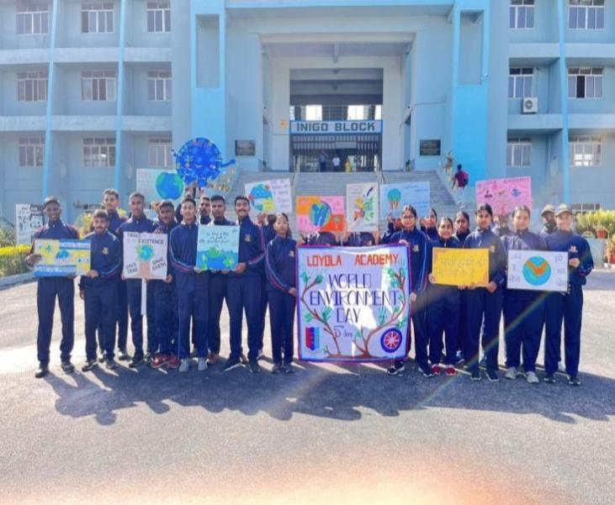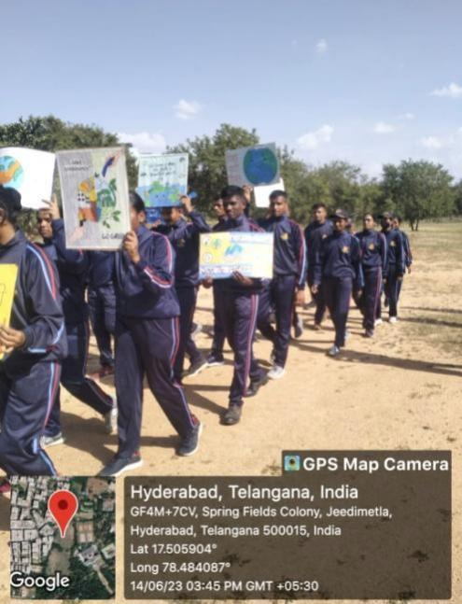

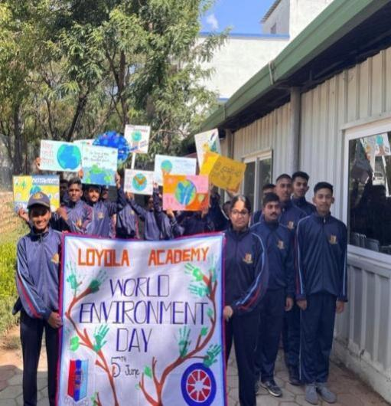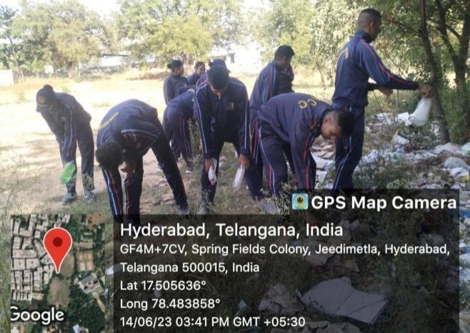

02. International Yoga Day Celebration in Collaboration with NCC Students: Promoting Health and Harmony

1. Introduction
The celebration of International Yoga Day in collaboration with National Cadet Corps (NCC) students at Loyola Academy was an inspiring event that aimed to promote health, well-being, and unity among the college community.
Date: 21st June 2023
Time: 8:00Am to 9:30 Am
Venue: Yoga center (Loyola Academy)

2. Objectives
Promote Awareness and Understanding of Yoga
The primary objective of the event was to raise awareness about the benefits of yoga and enhance the understanding of its principles and practices among the college community. By engaging NCC students, Staff of the college who are known for their discipline and commitment, we aimed to encourage a greater appreciation for yoga as a holistic approach to well-being.
Foster Physical Fitness and Mental Well-being
Through the collaboration with NCC students, we sought to promote physical fitness and mental well-being among the participants. Yoga asanas, pranayama, and meditation were practiced to enhance physical flexibility, strength, and balance, while also promoting stress relief, relaxation, and mental clarity.
Yoga Sessions and Demonstrations
On International Yoga Day, the college campus buzzed with energy as Ms. Priya Thakur , A certified yoga trainer led yoga sessions and demonstrations. A series of yoga asanas, pranayama, and relaxation techniques were practiced .The sessions catered to participants of varying skill levels, ensuring inclusivity and accessibility for all.
A total of 65 cadets participated in the event of which 32 SD’s and 33 SW’s.
A separate session was conducted for faculty members and a number of --- participated in the event.

Photos during the session:
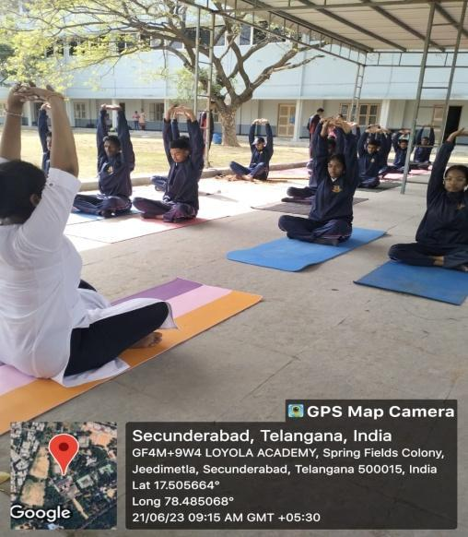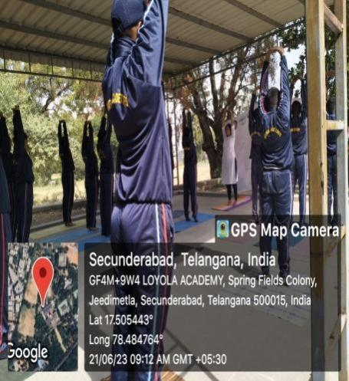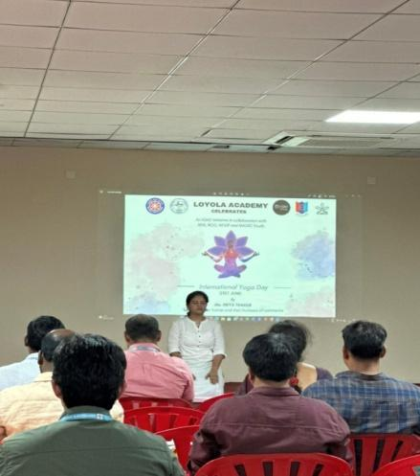

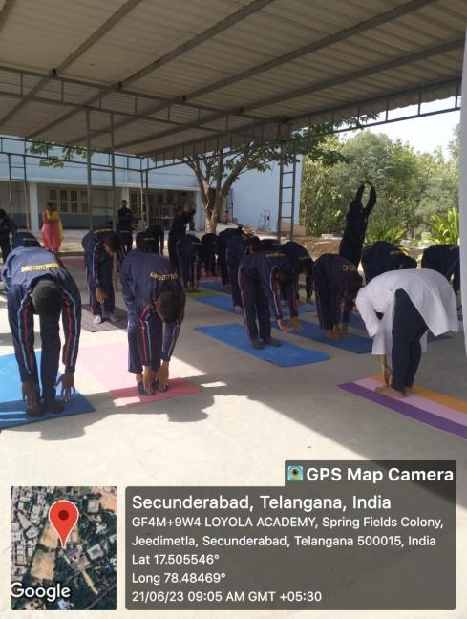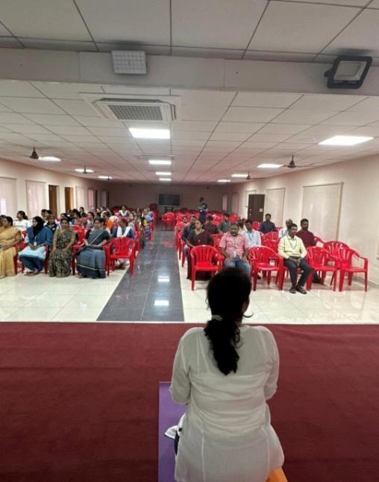

03. B CERTIFICATE COLLECTION EVENT
On June 27, 2023, a group of NCC students from Loyola Academy visited the 4(T) BT (HQ) facility to collect their NCC C certificates. The event was organized to distribute certificates to students who had participated in various NCC activities and passed the exam under the guidance of col. ASHISH TRIPATHI and AO. P.MAGENDRAN.
A total of 40 cadets participated in the certificate collection. The purpose of the event was to recognize and celebrate the achievements of these students who have successfully completed their c certificate exam.
The certificate collection process was well-coordinated. Students were organized into groups based on their units and divisions. COL. ASHISH TRIPATHI and AO. P. MAGENDRAN were present to distribute the certificates to Each student individually and appreciated their success.
The event was conducted smoothly, with students expressing their gratitude for the opportunity to collect their certificates in person. The involvement of COL. ASHISH TRIPATHI and AO P. MAGENDRAN added a sense of importance and official recognition to the certificates.
The success of this event highlights Loyola Academy's commitment to fostering a strong NCC program and acknowledging the efforts of its students. It also reinforces the bond between the academy and the 4(T) Battalion, showcasing a collaborative effort towards the development of young talents.
Overall, the NCC certificate collection event on June 27, 2023, was a positive experience for the participating students. It served as a memorable occasion that recognized their hard work and dedication to the NCC activities at Loyola Academy.
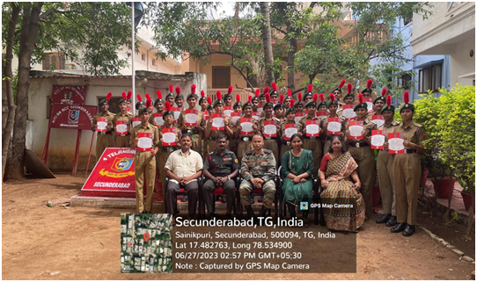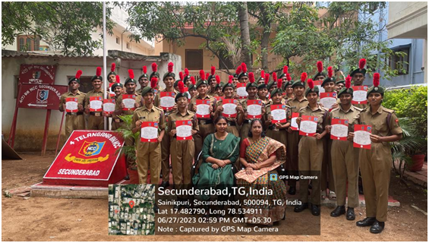

04. ENROLLMENT 2023
The NCC B1 Enrolment for the year 2023 took place on the 14th of July at the NCC Parade Ground within the premises of Loyola Academy. The event was overseen by esteemed personnel including Col. Ashish Tripathi, AO P. Magendran, SM Sukhdev Singh, Sub. VinayakPawar, Hal. Gurdeep Singh, and Hal. Jarnail Singh. Throughout the day, various tests, discussions, and activities took place with the aim of identifying individuals who exemplify the core values of the NCC: discipline, service, and leadership. These activities helped uncover candidates who are well-suited to carry forward the NCC's principles and contribute positively to its mission.
The selection process had several tough stages, each serving to evaluate different aspects of the candidates potential to be a good NCC Cadet
I.Eligibility Assessment and Physical Attributes Check
During the first phase of the selection process, candidates went through a comprehensive assessment that aimed to determine their eligibility for further consideration. This stage involved a strict examination of several key factors, including body posture, height, and the presence of any visible tattoos. The goal was to ensure that candidates met the fundamental physical criteria necessary for participation in the NCC program. This initial round played a crucial role in narrowing down the pool of applicants to those who possessed the basic attributes essential for potential NCC cadets.
II.Physical Fitness Evaluation
In the following phase, they focused on the candidates' physical fitness. They asked the candidates to run within a time limit and observed how well they could do it. This was like a test to understand if the candidates had good endurance and could run without getting too tired. It helped them identify who was physically strong and could keep up with the demands of NCC activities. Those who successfully completed the run within the stipulated time demonstrated their physical readiness and aptitude for forthcoming challenges.
III.Written Examination
In the next phase, the focus shifted to evaluating candidates understanding of the NCC and defence related matters. They gave them a written test to see if they knew about the NCC's goals, structure, and its importance in teaching discipline and leadership. They also checked if the candidates knew about defence concepts like national security and the role of armed forces. This part helped them find candidates who not only had physical fitness but also knew a lot about the NCC's purpose and its connection to defence.

IV.Personal Interview
In the concluding stage, candidates who had successfully cleared the preceding rounds underwent a personal interview. This interview aimed to assess their suitability, attitude, and alignment with the NCC's values. Through these conversations, their communication skills, confidence, and compatibility with the NCC's principles were evaluated. This phase played a crucial role in the final selection, ensuring that candidates who met both physical and personal criteria were chosen to uphold the NCC's legacy.
The NCC B1 Enrolment 2023 event was a rigorous yet fair process that aimed to identify the most deserving candidates for the NCC Army Wing. Through comprehensive evaluations of physical fitness, knowledge, and personal attributes, the event successfully identified individuals who were not only physically capable but also possessed the right mind-set and dedication to excel in the NCC program.
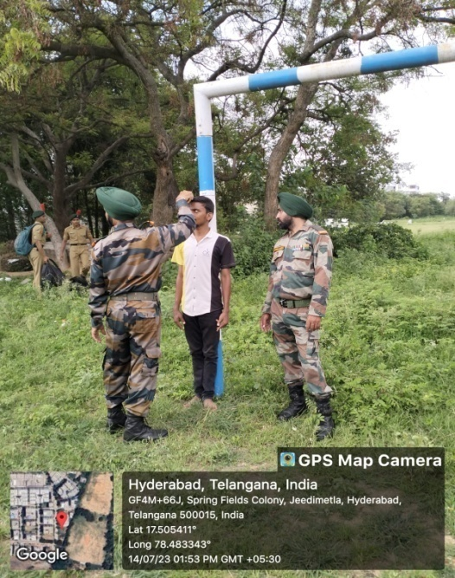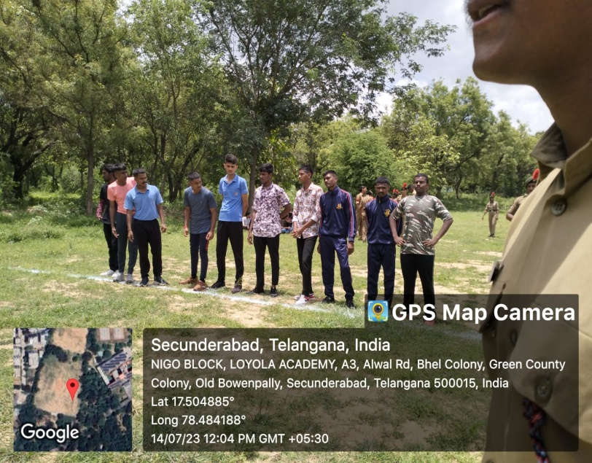
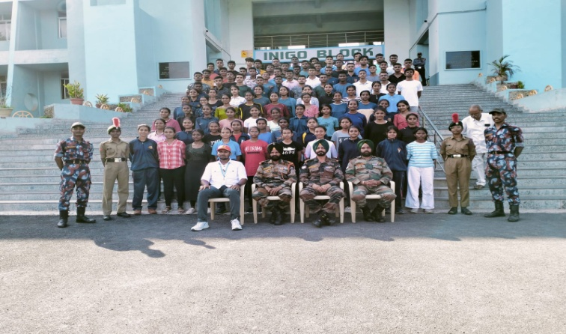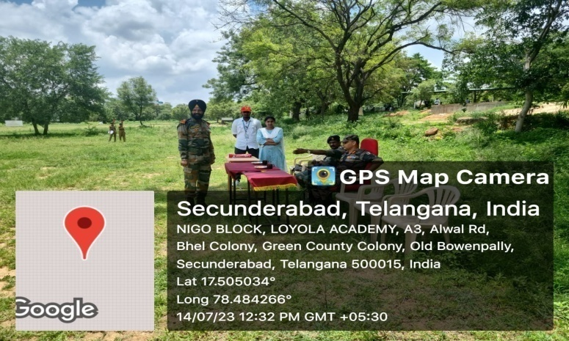

05. C CERTIFICATE COLLECTION EVENT
On July 15, 2023, a group of NCC students from Loyola Academy visited the 4(T) BN (HQ) facility to collect their NCC ‘C’ certificates. The event was organized to distribute certificates to students who had participated in various NCC activities and passed the exam under the guidance of col. ASHISH TRIPATHI and AO. P.MAGENDRAN.
A total of 30 cadets participated in the certificate collection. The purpose of the event was to recognize and celebrate the achievements of these students who have successfully completed their C certificate exam.
The certificate collection process was well-coordinated. Students were organized into groups based on their units and divisions. COL. ASHISH TRIPATHI and AO. P. MAGENDRAN were present to distribute the certificates to Each student individually and appreciated their success.
The event was conducted smoothly, with students expressing their gratitude for the opportunity to collect their certificates in person. The involvement of COL. ASHISH TRIPATHI and AO P. MAGENDRAN added a sense of importance and official recognition to the certificates.
The success of this event highlights Loyola Academy's commitment to fostering a strong NCC program and acknowledging the efforts of its students. It also reinforces the bond between the academy and the 4(T) Battalion, showcasing a collaborative effort towards the development of young talents.
Overall, the NCC certificate collection event on June 15, 2023, was a positive experience for the participating students. It served as a memorable occasion that recognized their hard work and dedication to the NCC activities at Loyola Academy.
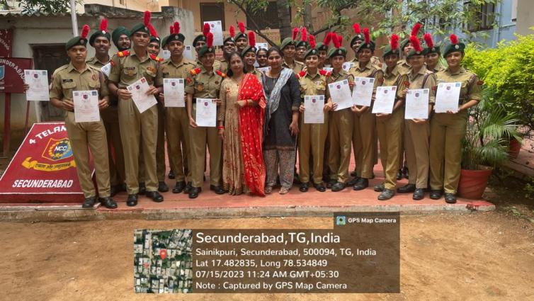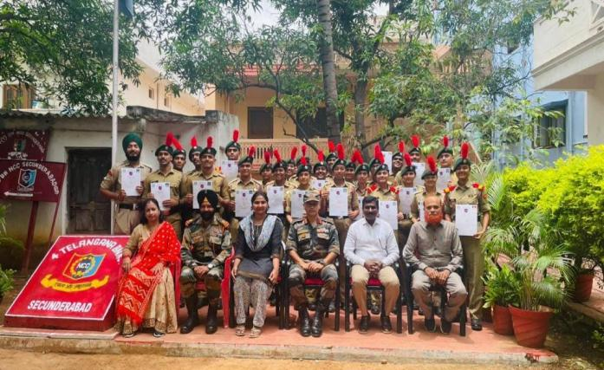

06. DEFENSE TALK
In today’s changing world many people are interested in choosing their career in the Indian Defence sector. The NCC unit and IQAC of Loyola Academy organized a special event focused on exploring “Indian Defence as a Career Option “. The event was held with the aim of enlightening and inspiring students about the vast opportunities that lie in the Indian Defence sector. The highlight of the was the presence of Major Manoj Basera, a highly respected individual in the defence field, who attended as the esteemed guest speaker. The following are the topics explained by Major Manoj Basera:-
I.WHY DEFENSE AS A CAREER
During the event, Major Basera passionately shared his views on why choosing Defence as a career can be deeply fulfilling and patriotic choice. He emphasized the immense pride and sense of purpose that comes with serving the nation and contributing to its security and well-being. His motivational talk left a lasting impact on the students, encouraging them to seriously consider career in Defence.
II.BENEFITS
In addition to discussing the sense of pride associated with the profession, Major Basera also shed light on the various benefits that come with a career in Defence. One of the key advantages he highlighted was the array of opportunities for higher education and specialized training. Serving in the defence forces provides individuals with continuous opportunities to enhance their knowledge and skills, leading to personal and professional growth.
III.FACILITIES
Furthermore, Major Basera emphasized the comprehensive facilities and support provided to Defence personnel. This includes comfortable living arrangements, access to quality medical facilities, and exciting adventure activities that make the career appealing to young aspirants. He stressed the importance of caring for the physical and mental well-being of those who dedicate themselves to protecting the nation.
IV.PERSONALITY DEVELOPMENT
Moreover, the Major highlighted how a career in Defence can significantly impact an individual's personality and lifestyle development. The rigorous training and discipline instilled in Defence professionals play a vital role in honing attributes such as leadership, resilience, and teamwork. These qualities prove invaluable not only in a professional capacity but also in various aspects of life.
V.JAM SESSION
The event concluded with an interactive and lively question-and-answer session. During this segment, the enthusiastic cadets enthusiastically posed their questions to Major Basera, seeking more insights into the life of a Defence professional. Major Basera provided informative and inspiring responses, addressing their queries and further motivating the young audience. The session fostered a sense of curiosity and determination among the cadets to explore the potential of serving their nation in the Defence sector.
A total of 165 Cadets participated in the event of which 84 SD’s and 81 SW’s.
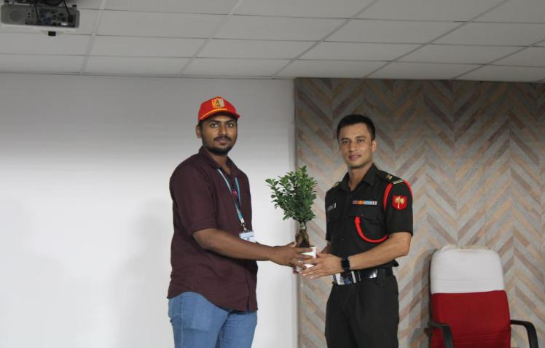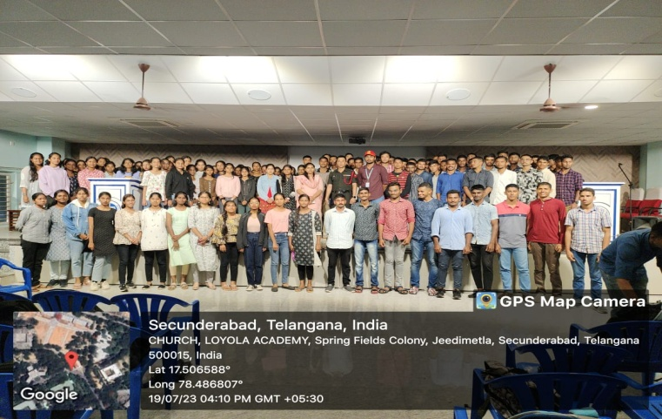

07. KARGIL VIJAY DIWAS
On the 31st of July, a grand celebration of Kargil Vijay Diwas took place at RashtrapatiNilayam. The event was meticulously organized by dedicated employees and was graced by the esteemed presence of the chief guest, Lt General JS Sidana, Commandant MCME. The occasion witnessed enthusiastic participation from various organizations, including the NCC units from both the Army and Navy wing, as well as the NSS unit of Loyola Academy. Additionally, numerous schools and colleges also joined in to pay their respects. This commemoration served as a fitting tribute to the bravery and sacrifices of our valiant soldiers who fought courageously during the Kargil conflict. It provided an opportunity for the community to come together and honor the indomitable spirit of our armed forces, who selflessly protect the nation. The event highlighted the importance of remembering and acknowledging the sacrifices made by our soldiers, ensuring that their heroism is not forgotten and their legacy lives on.
I.GROUP PHOTOGRAPH
At RashtrapatiNilayam, a heartwarming celebration of Kargil Vijay Diwas took place. Dedicated employees, along with NCC units (Army and Navy wing) and the NSS unit of Loyola Academy, joined by many schools and colleges, came together in unity and gratitude. A stunning group photograph, with fluttering tricolor and posters, immortalized this tribute to our brave soldiers, symbolizing our nation's unwavering commitment to honor their valor.

II.DISPLAY OF JAI HIND LETTERS BY STUDENTS
During the celebration, the students joyfully stood inside the enormous "JAI HIND" letters, beaming with colorful expressions of love for their nation and its brave defenders. Their enthusiastic cheer filled the air, fostering a sense of unity and pride among everyone present. This heartfelt display highlighted the young generation's fervent patriotism and emphasized how "JAI HIND" unites us in gratitude and admiration for the soldiers' courage. The sight of the students surrounded by the powerful message served as a heartwarming reminder of the unwavering spirit that binds our country together.
III.TRIBUTE WALL : THANK YOU MESSAGE TO SOLDIERS
During the celebration, the tribute wall became one of the most touching moments. Attendees filled it with heartfelt thank-you messages, expressing gratitude to our brave soldiers for their unwavering dedication in safeguarding our nation. The wall served as a beautiful display of love and respect, reminding us of the deep bond between citizens and defenders, and touching the hearts of everyone present. Each message became a poignant reminder of the immense gratitude we feel towards our courageous soldiers for their sacrifices in ensuring our safety and freedom.
IV.SHARING THOUGHTS ON THE DAY THROUGH RANGOLIS
Participants expressed their emotions through beautiful rangolis, showcasing their creativity and love for the nation. Intricate designs depicted scenes from the Kargil war, paying tribute to the bravery of our soldiers. The vibrant colors and meaningful patterns conveyed gratitude and appreciation for our valiant defenders. Each rangoli was a heartfelt ode to the indomitable spirit of our armed forces and a touching gesture of honor towards the heroes who safeguard our nation's freedom.
V.SPEECH BY CHIEF GUEST
During the celebration, the Chief Guest, Lt General JS Sidana, Commandant MCME, delivered a heartfelt speech that touched everyone's hearts. He shared a moving story about his friend who had bravely sacrificed his life during the Kargil war. Lt General Sidana's emotional words reminded everyone of the true meaning of the day - to honor and remember the courageous soldiers who protect our nation. His touching speech inspired all to carry forward their legacy with pride and gratitude.
VI.SINGING OF NATIONAL ANTHEM
The celebration concluded on a powerful note with everyone standing together to sing the national anthem. The atmosphere brimmed with respect and patriotism as participants passionately sang the anthem, reaffirming their strong commitment to the nation. The echoes of their unified voices resonated, leaving a lasting impression of unity and pride in the hearts of all. It was a poignant moment that symbolized the collective love and dedication we hold for our country and the deep respect we have for those who protect it.
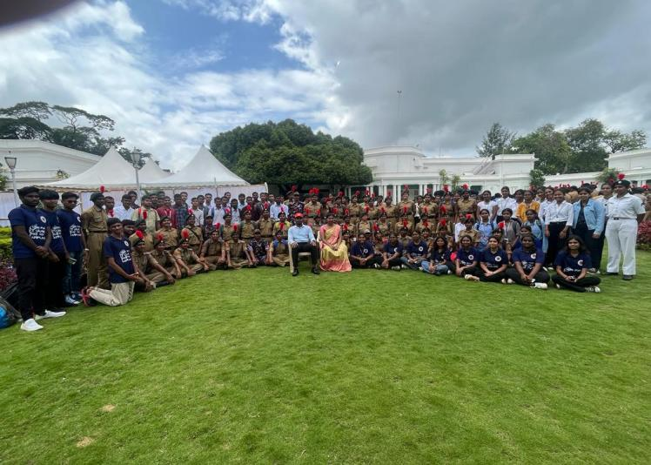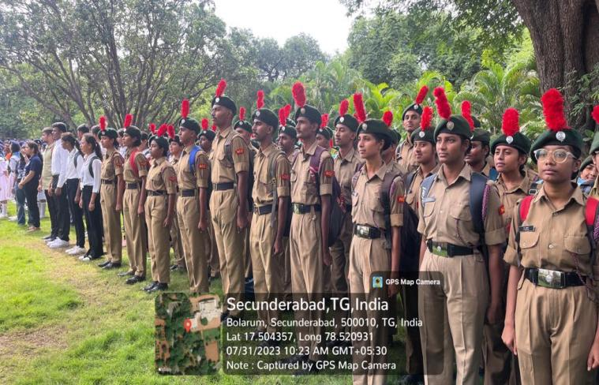
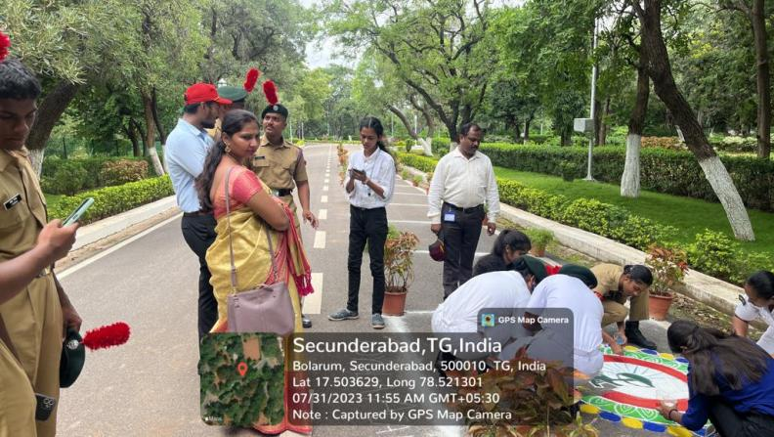
08. 77th INDEPENDENCE DAY
On August 15 1947, India got her freedom and finally broke from the shackles of slavery. Our college Loyola Academy celebrated this auspicious day with great enthusiasm and proudness on 15th August 2023.
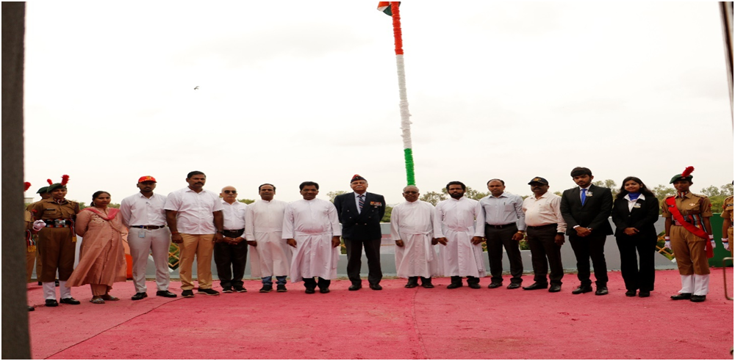
Chief guests for the event:
1.Rtd. Lt.Gen. K Ramachandra Rao AVSM, PVSM, Vsm
2. Guest of Honour: Mr. P Krishna Prasad
3. Principle- Rev.Fr.Dr. L. Joji Reddy SJ
4.Correspondent of Loyola Academy- Rev.Fr.Dr.A. Francis Xavier SJ
5. Vice Principle- PGRev.Fr.Dr. A.M Joseph Kumar SJ
6. Vice Principle- UGRev.Fr.Arul Jothi SJ
7. Cadet training officers_ Mrs. V. Shirisha and Mr. N. Ashfaq ( Army Wing)
8. Cadet training officer- Mr. Dheeraj Kumar Saho ( Naval Wing)
9.Sport incharge- Sandeep
The guest was escorted by the Piloting Team led by the Piloting commander LCPL Suchita followed by the Guard led by the Guard commander LCPL Rama Shankar and Sentry LCPL I Aaron. The national flag was hoisted with pride by our chief guest Rtd.Lt.Gen. K Ramachandra Rao AVSM, PVSM, VSM. The
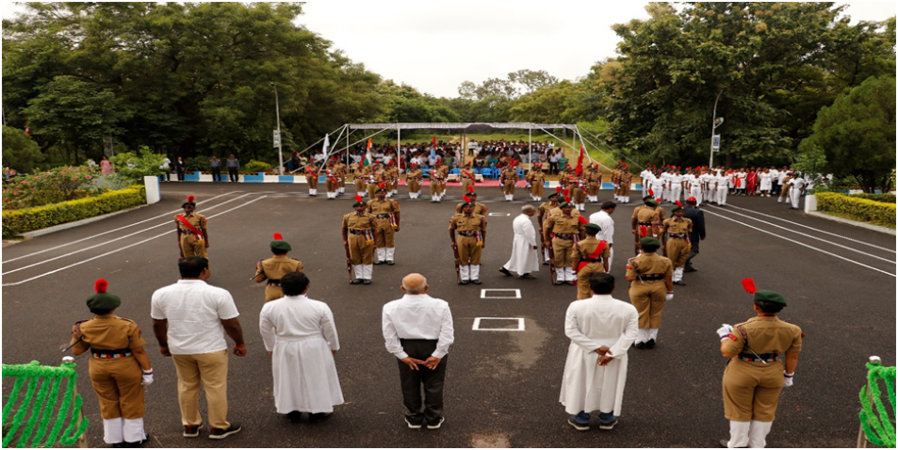
‘Rashtriya’ salute was esteemed to the national flag during the national anthem.
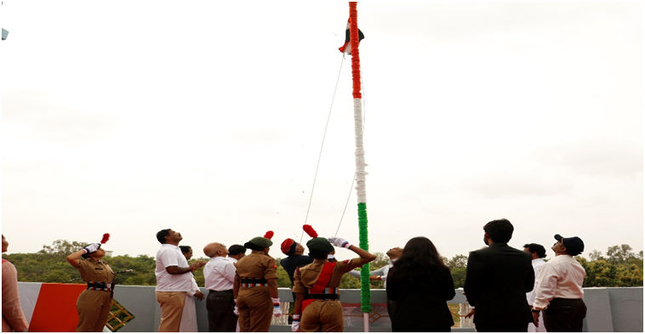
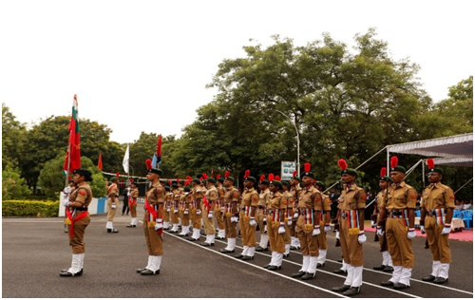

The Nirikshan, followed by the contingent which was led by the contingent commander LCPL K. Aakarsh, Flag bearer LCPL Shikha Phulsunge holding the Indian Flag, Flag bearer CDT Itihas holding the NCC flag and Flag bearer CDT Shaik Afreen holding the Loyola Academy Flag. The Kartavya Path contingent led by the contingent commander LCPL Aman saraswath And LCPL Gunjan Soni holding the Indian Army Flag.
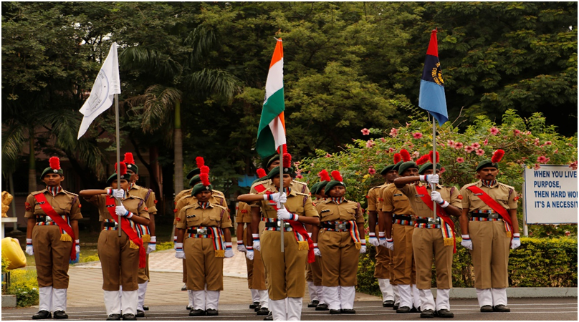
The Chief guest Rtd. LT.Gen. K Ramachandra Rao AVSM, PVSM, VSM was honoured by Shawl and by Portrait. Our Guest of honour Mr. P Krishna Prasad was also honoured by Shwal.
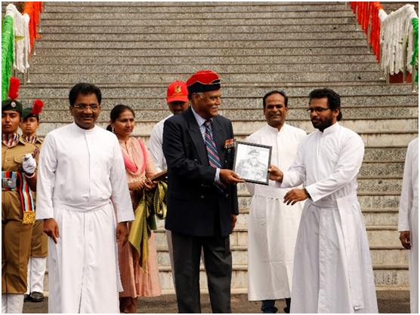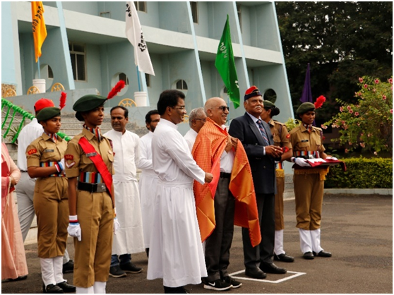
Therefore, the new Rank holders of the year 2023-2024 were felicitated by the chief.
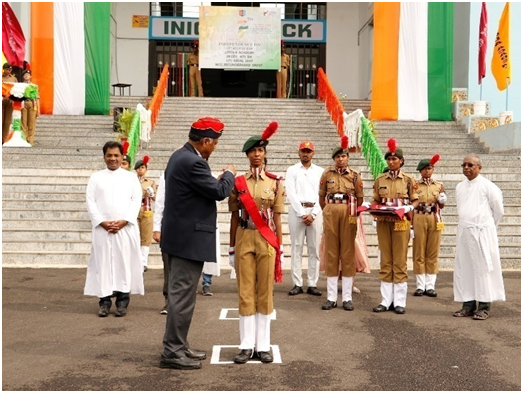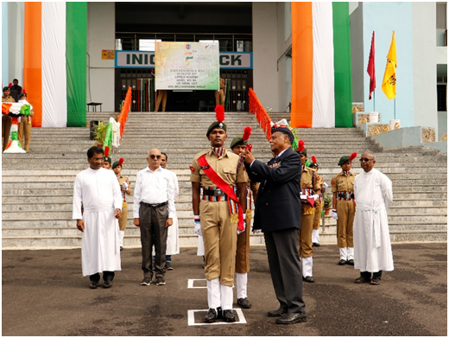
The speech was then delivered by our Chief guest Rtd.Lt.Gen. K Ramachandra Rao AVSM, PVSM, VSM enlightened the students and empower the students.
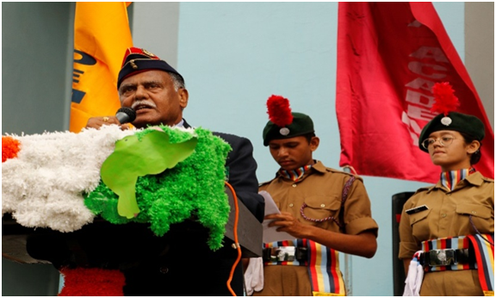
Then the cultural session the college student council, NSS, and NCC performed dance, singing and drama. The cultural session also conveyed message about our freedom fighters.
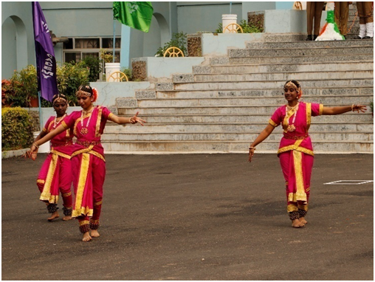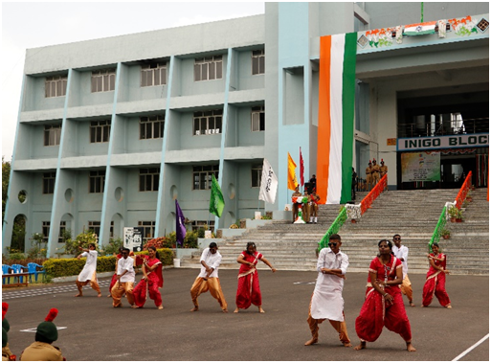

The event ended with the vote thanks from Head Boy Tanya Singh, followed by Group Photo.
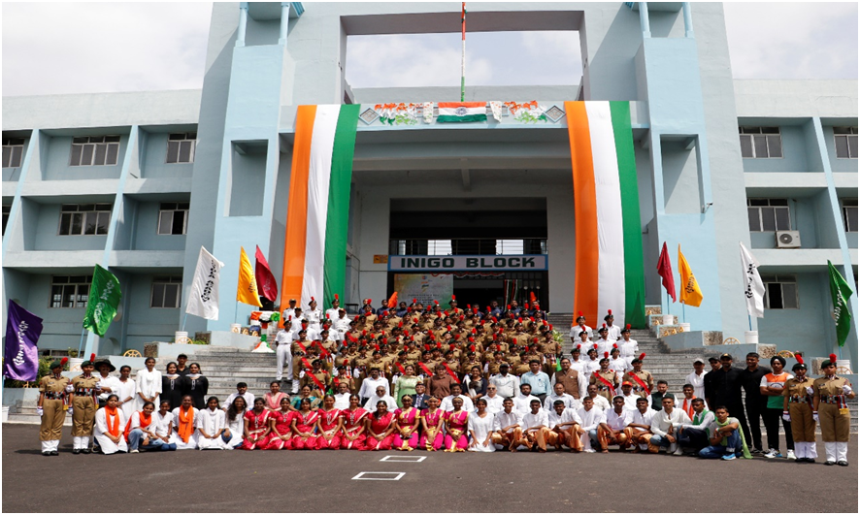

09. VOTERS AWARENESS DAY

In September 6th we the students of Loyola Academy in collaboration with SWEEP conducted a Voter awareness. talk at 1pm. Various student bodies such as the student concil, NCC, NSS were invited to the talk.

The quest speaker Mr. Suresh Reddy and Mr. Shekhar. "The vote is precious. It is the most non-violent tool we have in a democratic society and we must use it. They spoke on how to apply Voter ID both online. They mainly emphasized on the point that says people who are born on before October 1st 2005 will have the right to vote. Later, they spoke about the need for youngsters to vote and how is it important for the people of this generation voting rights accordingly instead of being irresponsible. They also emphasizes youngsters of bring irresponsible. on how : there's a on how there's a need for.

with the help of this event we were able to create awareness, showcase our creativity and gain courage to stand with a banner outside of our houses. this was surely a sucessful event which focused on growth as well as personal growth. while the right to vote is widely recognized as the fundamental right, citizens vote for leaders to represent them and their ideas, By not voting we might actually encourage the wrong candidate to from the talk to the people present there were highly encouraged and motivated by the words of the speakers. It was truly a notable experience.
A total of 200 students and cadets participated in the event. sd’s - 38 and sws-32 and others 130.

10. KHADI WALK AND BAPU’S TRIBUTARY: “A LIFE IN VISUAL.

On 2nd October we the students of loyola Academy in Collaboration with Council, Magic youth, AICUF, and NCC Conducted a khadi walk.

On the auspicious occasion of Gandhi jayanti, the Extension Activities Heads of loyola Academy joined hands with the khadi and Village Industries Commission to organize the inspiring event " Khadi walk". -on 2nd, 2023. Dr. Manoj lanka, state Director of KVIC, graced us as the chief guest, while shri vunnam Venkateshwarlu & Shri kondaveeti Radhakrishna, esteemed freedom fighters, were our guests of honor.

"Over '200 passionate students and KVIC officials marched together to the Mahatma gandhi statue at kompally, spreading the timeless message of khadi.

Magic youth added to the tribute with a captivating photo exhibition titled " Bapu's tributary: A life in Visual's". Our heartfelt gratitude to the Government of India for recognizing this remarkable rally.

RALLY: The Rally included motivational slogans and art pieces made in the poster. The event was meticulously planned & organized.
Over '200' passionate students and KVIC officials. marched together. SDS-57 SW’S-41 and 102 Others.
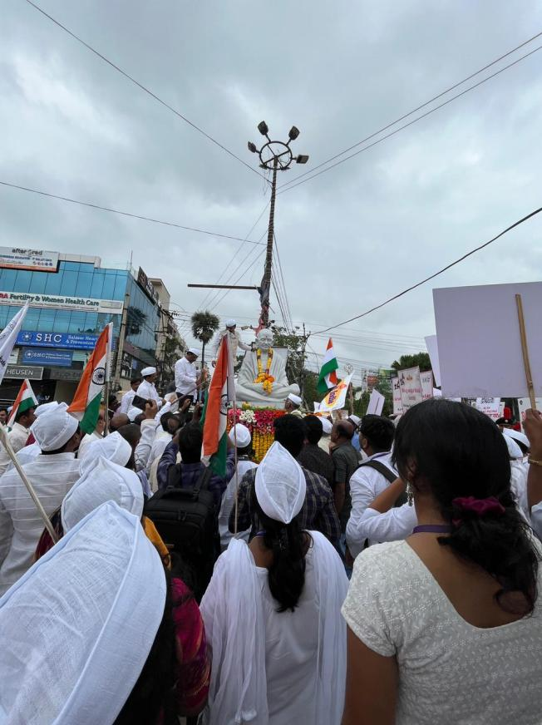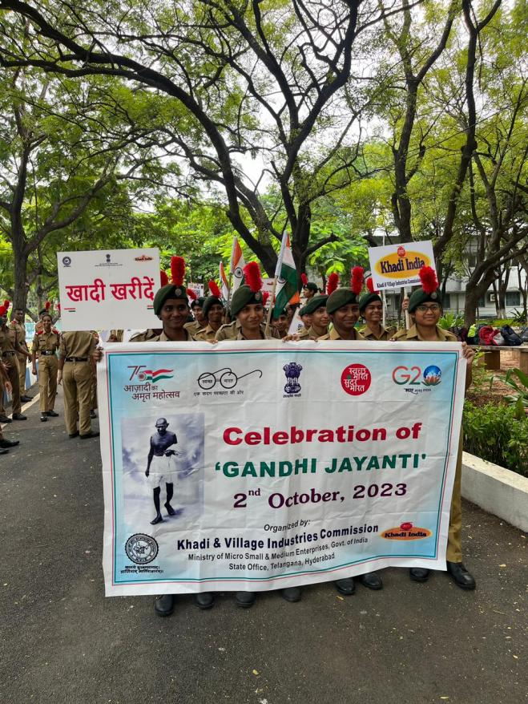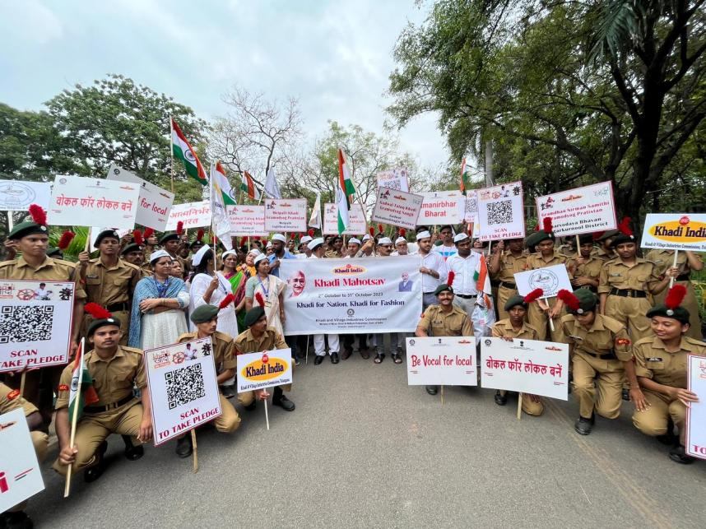

11. WORLD HABITAT DAY
On the occasion of World Habitat Day an event was conducted by the college NCC. it was celebrated on October 5th, 2023 with the theme of Resilient Urban Economies-cities on drivers of growth and recovery the NCC cadets of Loyola Academy, Keshav Memorial Institute of Commerce and Science and other schools, and colleges Came together to raise awareness of the ideas to reflect on the state of our towns and cities and the basic light of all to adequate shelter.
The Guest of honour was co Yasasvi malaka sir, the event started with the lighting - of lamp continued with a warm welcome

address by sree Gauri, vice principal - DPS, Continued with the pledge taken by cadets. and concluded with an incredible awareness march-rally Rally included motivational slogans.
Over '200' Students, NCC. Cadets of different Colleges and School marched together. SDS-6/SWS-14, others 180.
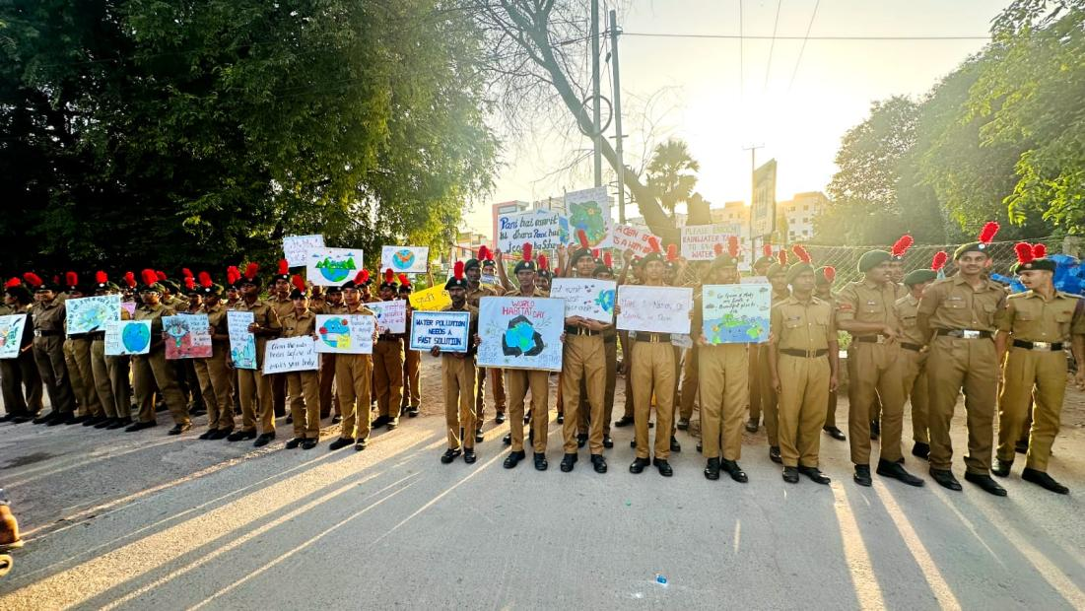
12. WORLD HABITAT DAY (RALLY)
On occasion of world habitat day Rally was conducted by the college NCC. The Rally was impactful aimed at raising Rally awareness about environment issues-and promoting sustainable practices. Rally was conducted by NCC students in kumar Basthi.
The Main objective of the Rally was to raise awareness of environment issues.
NCC students aimed to inspire behavior changes, such as reducing plastic bags usages, Conserving and encouraging individuals among students and Create a sense of owership in spreading the message. The rally was meticulously planned and well organized. The NCC students led a vibrant rally within the college in kumar basthi and also Surrounding areas holding placards and banners with World habitat Day Slogans and messages.
The Rally was aimed to grab attention, attract bystanders, and raise awareness about Environment issues. Over 71 NCC Cadets marched together. SDS-37 SW’S-34.
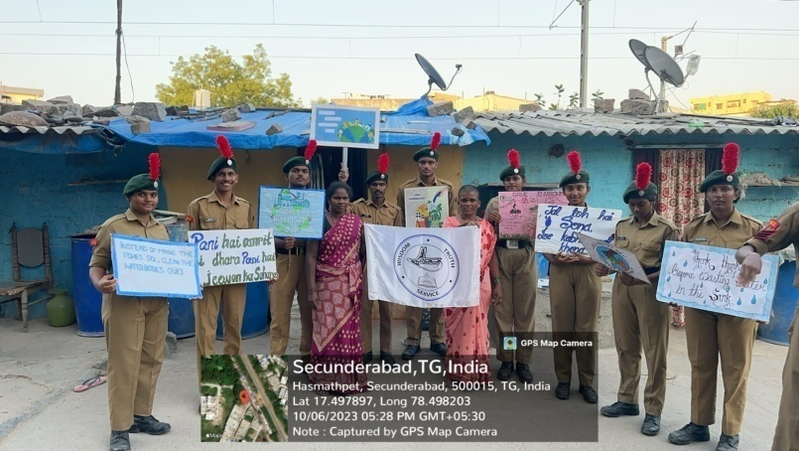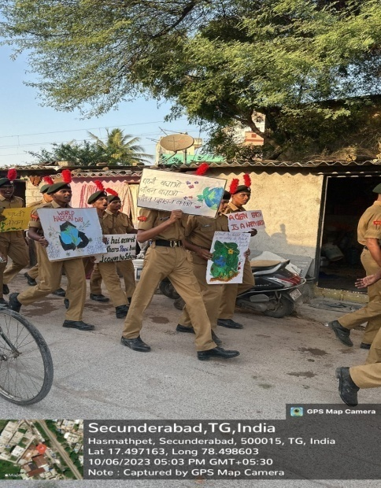
13. RASHTRIYA EKTA DIWAS
Ekta diwas, also known as National Unity Day, is celebrated on October 31st every year to commemorate the birth anniversary of Sardar Vallabhbai patel. He was known as the Iron Man of India. Head boy Tanay Singh-took charge of Ektha divas, commencing with an welcome to the esteemed dignitaries - Rev fr Dr. L. Joji Reddy, Principal, Rev Fr Arul Jyoti, Rev Fr Dr Joseph Kumar, Rev Fr Anthony prabhu, Dr Maria Das, Dr CH Sirisha, Lay VPs Rev Fr Dr L. Joji Reddy SJ, principal, addressed the gathering with a warm welcome and emphasized the Significant of Rashtriya Ekta Diwas. He spoke about Patel's efforts to unite the princely state into a single nation. Father also spoke about every individual will transform from one stage to another stage but at last all should work for unity. It is followed by a pledge. lead by. Rev Fr Dr L. Joji Reddy-SJ.
TSC
All India Thal Sainik Camp is one. of the most prestigious camp in NCC Army wing. Inspired from Indian Army, Cadets compete in events like Obstacle training, firing, map reading, drill etc.
Rev. Fr. Dr. L. Joji Reddy and Head of the department of B.com. Computer applications Mrs. Sahithya felicitated LCPL Sahithya with the momentum accompanied by her parents.
The vote of thanks - was delivered by head girl, Shanaya D'Cruz. National Anthem marked the end of this event.
Outcome: Rashtriya Ekta Diwas was celebrated and the winners of various competitions were felicitated by the College administration. SDS-51 Sws-46

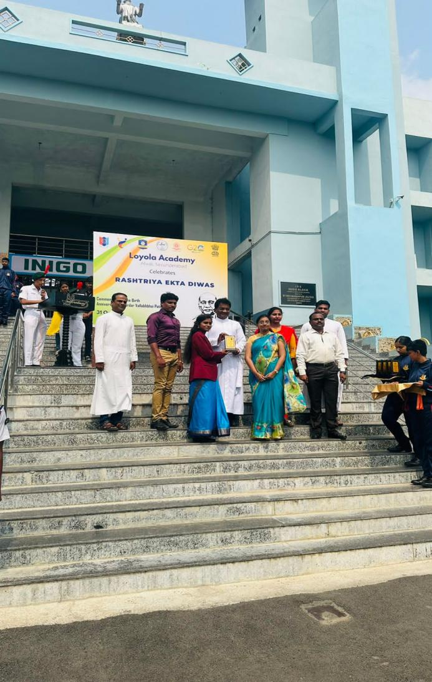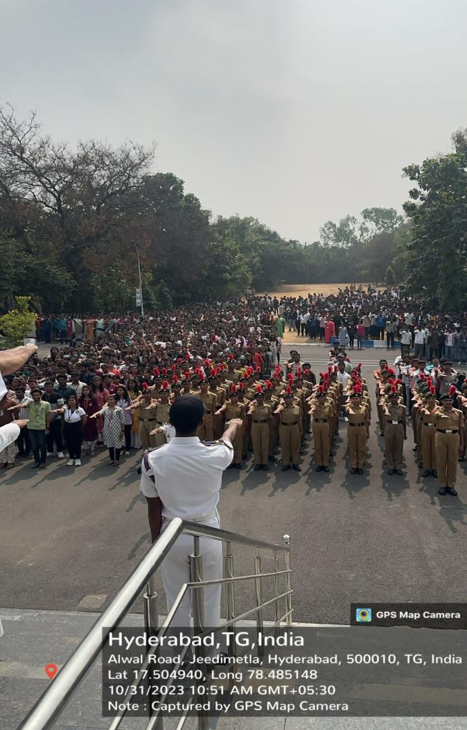

A SWACHH BHARAT MISSION INTIATIVE
Introduction: Shramdaan, an integral part of the Swachh Bharat Mission, epitomizes the spirit of volunteerism and collective action towards achieving a cleaner and healthier India. A recent Shramdaan event organized as part of the Swachh Bharat Mission showcased the power of community engagement and active participation in promoting cleanliness and sanitation.
Key Highlights:
- Community Mobilization:
  - The Shramdaan initiative brought together volunteers from various walks of life, including students, professionals, local residents, and government officials, united by a common goal of contributing to Swachh Bharat.
  - Community mobilization efforts, including door-to-door campaigns, social media outreach, and coordination with local authorities, played a crucial role in rallying support and participation for the event.
- Hands-On Cleanliness Drive:
  - The Shramdaan event commenced with a hands-on cleanliness drive encompassing various activities such as sweeping streets, collecting litter, and cleaning public spaces.
  - Volunteers enthusiastically participated in the cleanup activities, demonstrating their commitment to making a tangible difference in their surroundings.
- Awareness and Education:
  - In addition to physical cleanup efforts, the Shramdaan event also focused on raising awareness and promoting behavioral change regarding cleanliness and sanitation practices.
  - Interactive sessions, workshops, and skits were organized to educate participants about the importance of waste segregation, proper waste disposal, and personal hygiene.
- Impact and Outcomes:
  - The Shramdaan initiative yielded significant impact and tangible outcomes, including the removal of tons of waste, beautification of public spaces, and instilling a sense of civic pride among participants.
  - Beyond the immediate results, the event served as a catalyst for long-term behavior change, inspiring individuals and communities to adopt sustainable cleanliness practices in their daily lives.
- Recognition and Appreciation:
  - The efforts of volunteers and organizers involved in the Shramdaan initiative were duly recognized and appreciated by local authorities, community leaders, and stakeholders.
  - Certificates of appreciation, mementos, and public acknowledgment were extended to individuals and organizations for their exemplary contributions towards Swachh Bharat.
Conclusion: The Shramdaan initiative exemplifies the transformative power of collective action and grassroots mobilization in realizing the vision of Swachh Bharat. By fostering a culture of volunteerism, civic responsibility, and community ownership, initiatives like Shramdaan play a pivotal role in driving sustainable change and building a cleaner, healthier, and more prosperous nation. As we continue our journey towards a Swachh Bharat, let us draw inspiration from the spirit of Shramdaan and redouble our efforts to create a cleaner and brighter future for all.
The event concluded on a positive note, with participants reaffirming their commitment to ongoing efforts towards Swachh Bharat and pledging to be ambassadors of cleanliness in their respective communities.

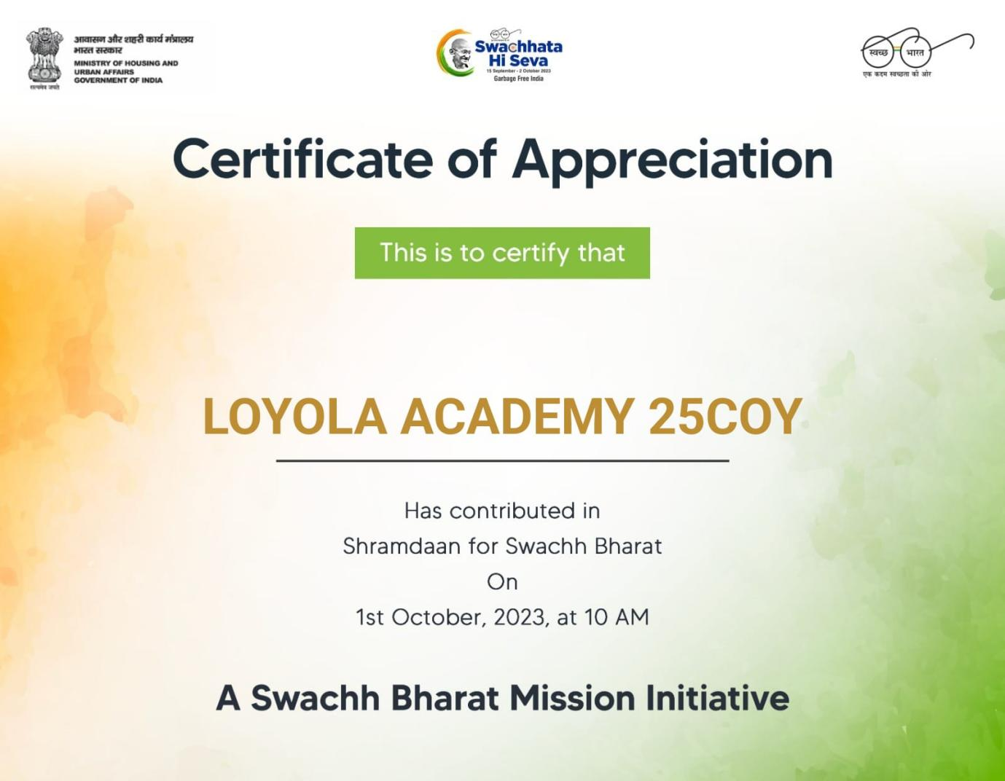

Graduation Day
Event: 8th Graduation Day of UG and PG Students
Date: 11.11.2023
Convocation day is a joyous occasion celebrating academic achievements. It typically involves a formal ceremony, awarding of degrees, speeches and often a sense of achievement and pride among graduates and their families.
Loyola Academy celebrated its convocation day on 11th November with a distinguished gathering, graced by esteemed chief guests Nawab Mir Nasir Ali Khan, the Honorary Consulate of the Republic of Kazakhstan for Telangana and Andhra Pradesh, alongside Smt. A. Sridevasena, IPS. Dr. Ashish Chauhan and Prof. M Ramulu were honored guests adding further prestige to the event.
The ceremony glowed with the significance of academic excellence as gold medals were awarded, acknowledging the outstanding achievement and excellence of deserving students.
Furthermore, the solemn occasion saw the conferral of degree upon the graduates making the culmination of their academic journey and the beginning of new endeavors.
Veera Madrasi Guard of Honor Competition

Event: Veera Madrasi Guard of Honor Competition
Date: 06.01.2024
The 1st Veera Madrasi South Zone Inter Collegiate Guard of Honor Competition held on 6th January 2024, organized by Tamil Nadu Dr. Ambedkar Law University (TN BTY NCC & 1(TN)R&V SQN NCC, CHENNAI – A). We represented Loyola Academy, Telangana in the Veera Madrasi Inter Collegiate Guard of Honor Competition among 35 other colleges. After the opening ceremony which started at 9 in the morning, we were given slots. Two drill instructed served as judge for the competition. There were two teams from our college designated as team A and team B. Team A was led by CQMS Rama Shankar and SGT Harshavardhan was the Santri. SGT Gunjan Soni led th team B where CMS Harshith Singh was the Santri.
Following the conclusions of all colleges, the competition was followed by the winner’s announcement at the closing event.
Loyola Academy secured 3rd position in the competition.
SD’s-10, SW’s-05, total-15.

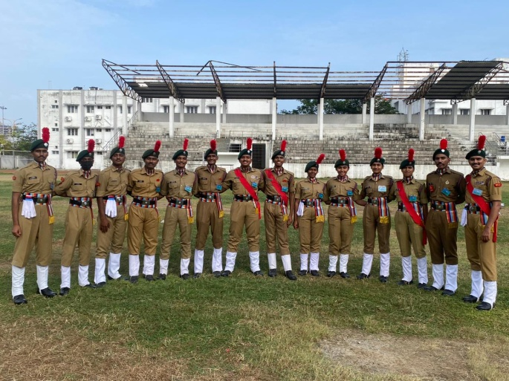
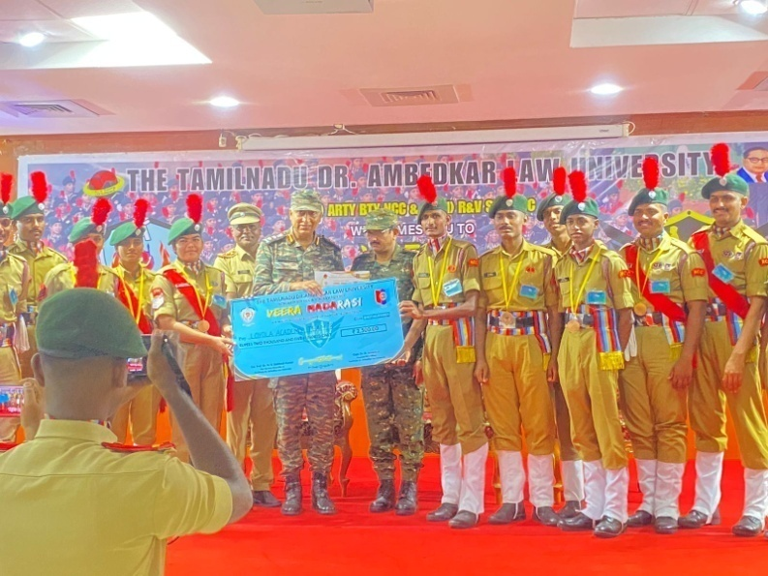
NATIONAL YOUTH DAY
Event: Visit to Raj Bhavan
Date: 12.01.2024

On 12th January, grand rally took place near 125 – FT Ambedkar Statue on the occasion of “Swamy Vivekananda Day”. Swamy Vivekananda who was a prominent Indian monk and philosopher who played a key role in introducing Indian Philosophies of Vedanta and Yoga to the Western World.
He is best known for his address at the World’s Parliament of Religions in Chicago in 1893, where he spoke about the tolerance, universal acceptance and the importance of religion harmony. The teachings continue to inspire people around the world. The event started with rally. The rally included motivational slogans.
RALLY: The rally included motivational slogans and art pieces made in the posters.
The event was meticulously planned and organized.
Over 200 passionate students marched together.
SD’s – 05, SW’s – 05 and others – 190.

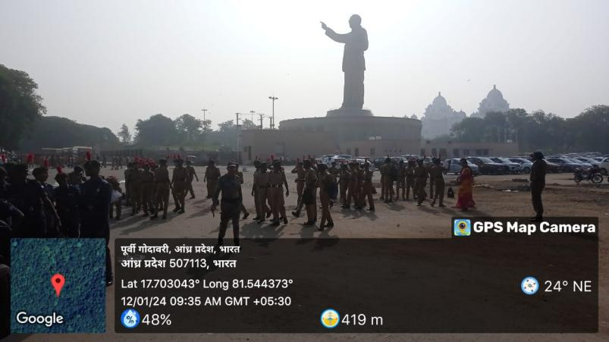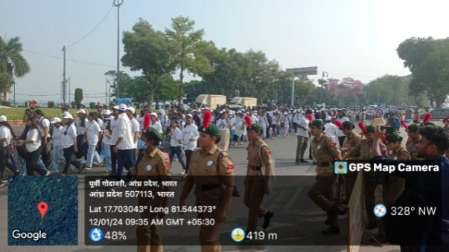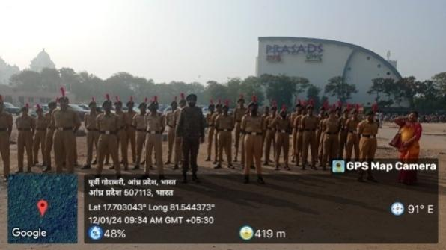

Republic Day

Event: Republic Day
Date: 26.01.2024
The new constitution of free India came into force with effect from this day. As the nation celebrates 75th Republic day, everyone was cordially invited to the glorious celebration of Republic Day of Republic Day at Loyola Academy.
Our Chief Guest for 26th January was Mrs. C Vijaya Shanthi Reddy (Corporal Alwal Constituency).
Republic Day is not just a date on the calendar but it’s the celebration of values that breathe life into the soul of our democracy.
The guests were escorted by the Piloting team led by the Piloting commander SGT K Jaya Krishna, the national flag was hoisted with pride by Mrs. C Vijaya Shanthi Reddy. The Rashtriya Salute was esteemed to the national flag during the national anthem.
The Nirikshan followed by the Contingent was led by the Contingent Commander JUO I Aaron, Flag Bearer CSM Harshith Singh holding the Indian Flag and Flag Bearer CPL R Sri Vidhya holding the Indian Army Flag.
Flag Bearer CPL B Sai Pavan holding the NCC Flag and Flag Bearer CPL P Pravalika holding the Loyola Academy Flag.
The NCC Song was sung by everyone after the contingent arrived.
Prize Distribution: Best in academics and Best in overalls were felicitated to the cadets.
Speech: Speech was delivered by Mrs. C Vijaya Shanthi Reddy with her words of wisdom.
Cultural Session: The session comprised of classical dance, drama and dance by NSS. The cultural session was enlightening and entertaining the audience and it inspired them as well.
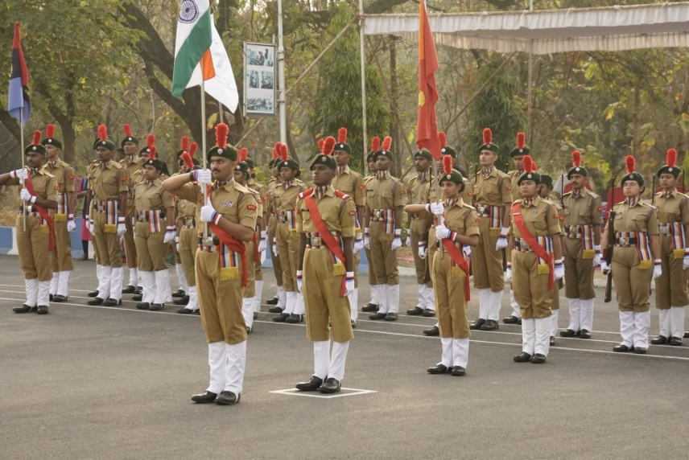
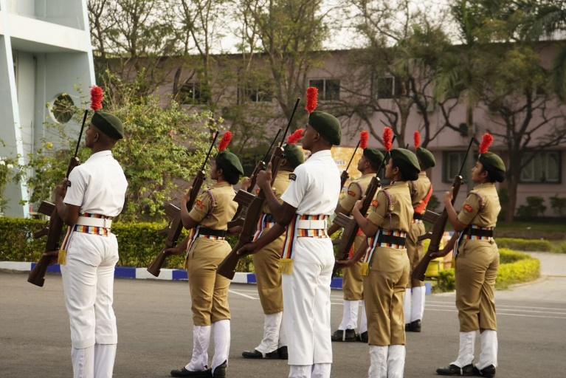
Event ended with a vote of thanks from SUO K Aakarsh, followed by the photo session.

B-CERIFICATE PRACTICAL AND WRITTEN EXAMINIATION

Introduction: The B-Certificate practical examination, conducted at BTG-Ground [4t], is a pivotal assessment aimed at evaluating the proficiency and competence of candidates in various practical and theoretical aspects. A recent B-Certificate examination comprising both practical and written components provided an opportunity for candidates to demonstrate their knowledge, skills, and understanding in the subject matter.
Key Highlights:
- Practical Examination:
  - The practical examination segment of the B-Certificate assessment evaluated candidates' hands-on skills and application of theoretical knowledge in real-world scenarios.
  - Candidates were assessed on a range of practical tasks, including laboratory experiments, fieldwork, technical demonstrations, or hands-on exercises relevant to the subject.
  - The practical examination provided candidates with an opportunity to showcase their ability to apply concepts learned in the classroom to practical situations, fostering critical thinking and problem-solving skills.
- Written Examination:[Kasthuraba girls degree and pg college]
  - The written examination component assessed candidates' understanding of theoretical concepts, principles, and methodologies relevant to the subject area.
  - Candidates were tested on their knowledge through a series of objective and/or subjective questions, covering various topics outlined in the curriculum.
  - The written examination aimed to assess candidates' comprehension, analytical abilities, and communication skills in conveying their understanding of the subject matter effectively.
- Examination Process and Administration:
  - The B-Certificate examination was conducted in accordance with established guidelines and protocols to ensure fairness, transparency, and integrity in the assessment process.
  - Examination venues were equipped with necessary facilities, resources, and invigilators to facilitate a smooth and orderly conduct of the examination.
  - Stringent measures were implemented to prevent malpractice or irregularities, safeguarding the credibility and validity of the examination results.
- Performance Evaluation and Feedback:
  - Following the completion of the examination, candidate responses were meticulously evaluated, graded, and analyzed to determine their performance levels.
  - Candidates received feedback on their performance, highlighting areas of strength and areas needing improvement, to aid in their ongoing learning and development.
  - The examination results were communicated to candidates in a timely manner, enabling them to assess their progress and plan their future academic pursuits accordingly.
Conclusion: The B-Certificate examination, comprising both practical and written components, serves as a comprehensive assessment tool to evaluate candidates' proficiency and competency in the subject area. By providing candidates with opportunities to demonstrate their practical skills and theoretical knowledge, the examination aims to foster holistic learning outcomes and prepare individuals for future academic and professional endeavors. As candidates await their results, it is imperative to acknowledge their dedication, effort, and commitment to excellence demonstrated throughout the examination process.
The successful conduct of the B-Certificate examination underscores [Insert Organization or Institution]'s commitment to promoting academic rigor, quality education, and continuous learning opportunities for students. Looking ahead, [Insert Organization or Institution] remains dedicated to further enhancing the assessment process and supporting candidates in their pursuit of academic excellence and personal growth.

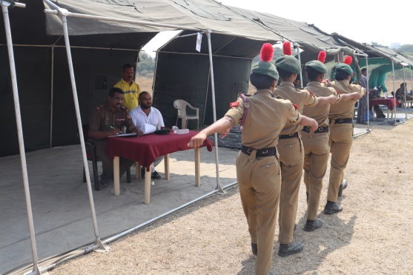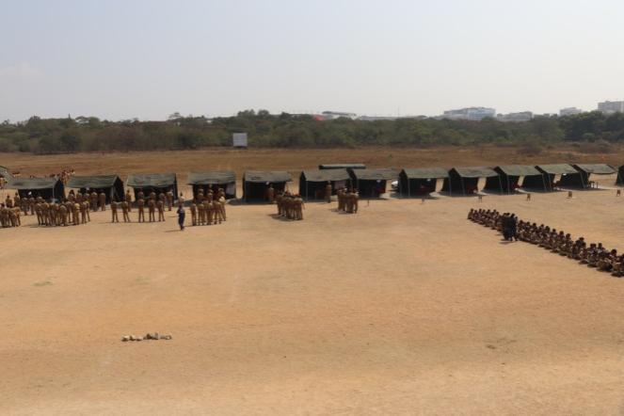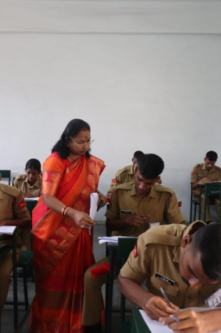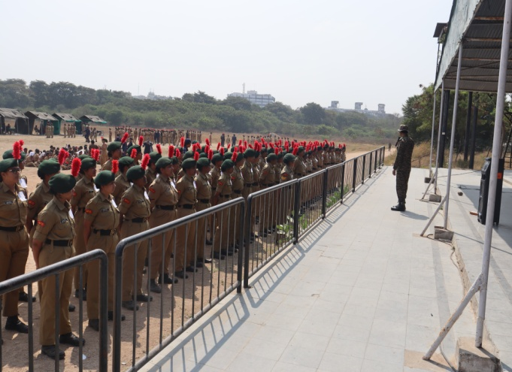

CPR Training Session
Introduction: On 10th Feb 2024, [Gandhi medical campus ], a free CPR (Cardiopulmonary Resuscitation) class was conducted for NCC (National Cadet Corps) cadets. The initiative aimed to equip the cadets with essential life-saving skills and knowledge.
Purpose: The primary objective of the CPR class was to educate NCC cadets on the proper techniques of CPR, enabling them to respond effectively in emergency situations such as cardiac arrest or drowning.
Organization: The event was organized by [Gandhi medical college alumni association ] .Experienced CPR instructors led the training session, ensuring comprehensive coverage of theoretical concepts and practical demonstrations.
Representation : Loyola NCC cadets participated in the CPR class. They attended the session and showed enthusiasm and dedication throughout the training.
Session contained : The CPR class encompassed the following key topics:
- Introduction to CPR: Understanding the importance of CPR in saving lives and its role as a first response to cardiac emergencies.
- Basic Anatomy and Physiology: Brief overview of the human heart and lungs to provide context for CPR techniques.
- CPR Techniques: Step-by-step guidance on performing chest compressions and rescue breaths, including demonstrations and hands-on practice.
- AED (Automated External Defibrillator) Usage: Introduction to AED devices and instructions on their safe and effective utilization in conjunction with CPR.
- Choking Relief: Instruction on the Heimlich maneuver for aiding choking victims, emphasizing proper technique and precautions.
Hands-on Practice: Cadets actively participated in hands-on practice sessions under the supervision of instructors. They practiced CPR techniques on training manikins, allowing them to develop proficiency and confidence in executing chest compressions and rescue breaths.
Certification: Upon successful completion of the CPR class, participants received certificates acknowledging their attendance and basic competency in CPR. The certification serves as a testament to their readiness to respond to medical emergencies.
Conclusion: The free CPR class attended by NCC cadets proved to be a valuable learning experience, empowering them with life-saving skills that can make a significant difference in critical situations. By equipping cadets with CPR knowledge, the initiative contributes to building a more resilient and prepared community.
Acknowledgments: We extend our gratitude to [Name of organization or institution] and [Name of CPR training provider] for their efforts in organizing the CPR class and facilitating an enriching learning experience for NCC cadets.
This report serves to highlight the importance of initiatives aimed at educating individuals, especially youth organizations like the NCC, on essential life-saving techniques such as CPR.

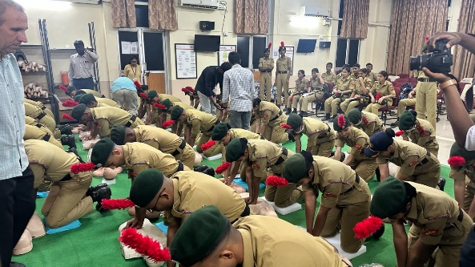

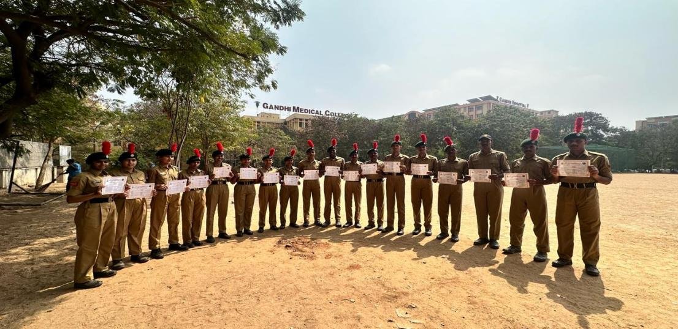

CAMP RECORD

Index
Sr no. | Name
1 | EBSB- I – Malerkotla , Punjab
2 | TSC-IUC
3 | CATC-II
4 | ALC-II
5 | AAC-2023
6 | TSC-IGC-2023
7 | TSC-TRG-I 2023
8 | CATC-IV
9 | TSC-TRG-II 2023
10 | TSC - 2023
11 | SNIC
12 | EBSB
13 | IGC-RDC
14 | TREKKING CAMP-II
15 | PRE RDC - I
16 | PRE RDC - II
17 | IMA ATTACHMENT
18 | SNIC- LAKSHADWEEP
19 | RDC-2024

EBSB – I

Camp Name: Ek Bharat Sherashtha Bharat – 1
Camp Location: Malerkotla, Punjab
Duration: 08/06/2023 – 23/06/2023
No. Of Cadets: 2
1. LCPL Aman Saraswat
2. LCPL Suchitha
Achievements:
1. LCPL Aman Saraswat and LCPL Suchitha Participated in NIAP Compition and Secured 2nd Position
2. LCPL Aman Saraswat took part in Group Dance.

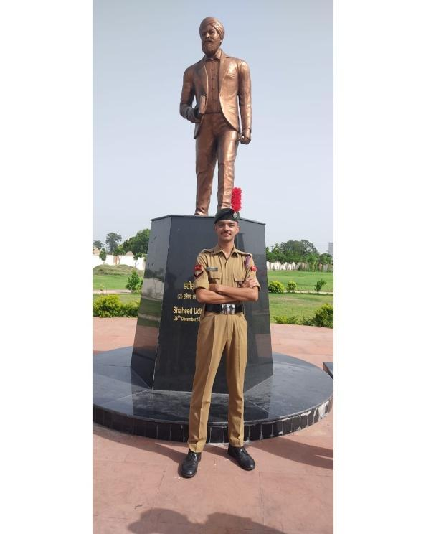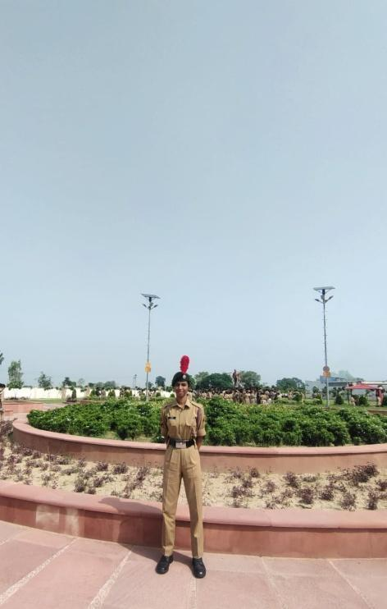

TSC- IUC -2023
The TSC Camp 2023 was held at 1 EME center Yapral,Secunderabad.For 10 days i.e from 13 June 2023 (Tuesday) to 22 June 2023(Thursday). Total 12 cadets from Loyola Academy have been to the camp .
C-SD’S
Lcpl I.Aaron
Lcpl JayaKrishna
Cdt Dheeraj Singh
B2-SD’S
Cdt Sri chand
Cdt Phani kumar Reddy
Cdt L.Hari Krishna
C-SW’S
Lcpl Shikha Pulsungey
Cdt Afreen
B2-SW’S
Cdt Sahithya Malligari
Cdt Geetha
Cdt Deepali
Cdt Gangothri
EVENTS AND ACHIEVEMENTS
- The 1st day i.e on 13th June 2023 ,started off with high josh practicing for TSC events by SD’S and SW’S .
- On 14th June 2023 Obstacle Training ( Final Competition) for SD’S was conducted where Cdt Hari Krishna and Cdt Phani Kumar Reddy took part in the event .
- The Final Competition for Obstacle Training which took place at 1(T) for SW’s was held on 15th June 2023 ,Lcpl Shikha was conducted, Cdt Afreen and Cdt Sahithya took part in the event where the 1st prize was secured by Cdt Sahithya among all the SW’s from different unit. The exam was conducted on Health and Hygiene .
- On 16th of June 2023 the practice for tent pitching and Judging distance and field signals was held for both SD’S and SW’S .
- The Map Reading practical was held on 17th June 2023 at Keesaragutta for both SD’S and SW’S. Lcpl Shikha Phulsungey ,Cdt Afreen , Cdt Sahithya , Lcpl Jaya Krishna and Cdt Hari Krishna took part in the event .
- On 18th June 2023 the Finals for Map Reading (written), Judging Distance ,Field Signals and Tent Pitching for SW’S was conducted, the participants of the event were Lcpl Shikha Phulsungey , Cdt Afreen and Cdt Sahithya .The Finals for Judging Distance and Field Signals and Tent Pitching took place for SD’S where Lcpl Jaya Krishna ,Cdt Phani Kumar Reddy and Cdt Hari Krishna took part in the events ,Map Reading (written) was also held along with other two events were Lcpl Jayakrishna and Cdt Hari Krishna participated. Along with all these events, Firing(finals) was also held for SD’S and SW’S. Lcpl I.Aaron , Cdt Dheeraj Singh , Cdt Srichand , Cdt Deepali ,Cdt Geetha and Cdt Gangothri took part in the competition and 3rd place was secured by Lcpl I.Aaron, Cdt Dheeraj singh in ( SD’S)and Cdt Geetha (SW)
- On 19th June 2023 SD’S and SW’S were taken to Infantry weapons display continued by drill practice .
- The Closing ceremony was held on 21st June 2023 in presence of COL. Ashish Tripati.
- For the obstacle training,Cdt Sahithya was presented Gold medal among all the SW’S
- The camp finally came to an end on 22nd June 2023 .
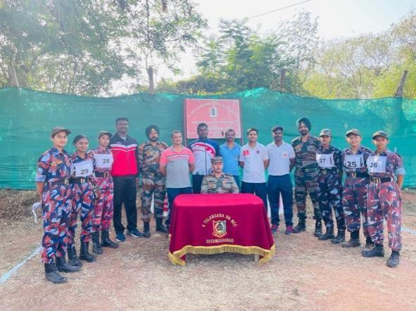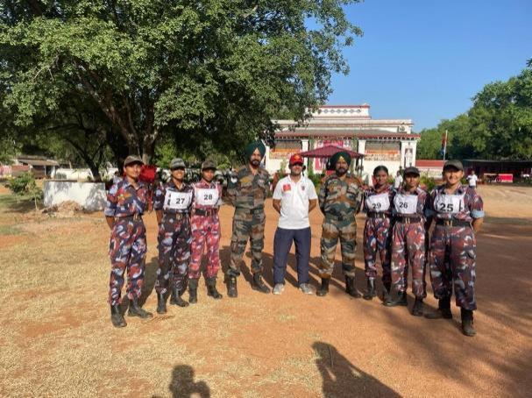

CATC – II

The CATC-II (2023) camp had been held by 4(T)BN at 1 EME Centre Yapral, Secunderabad.For 10 days i.e from 13 June 2023 (Tuesday)to 22 June 2023(Thursday).Total 20 Cadets from Loyola Academy have been to the camp .
C-SD’S
Lcpl I.Aaron
Lcpl Jaya Krishna
Cdt Dheeraj Singh
Cdt Manda saishankar Yadav

C-SW’S
Lcpl Shikha Phulsungey Yadav
Cdt Afreen
Cdt Pravallika
Cdt Sri Vidhya

B2-SD’S
Cdt B.Srichand
Cdt L.Hari Krishna
Cdt Phanikumar Reddy
Cdt Jitu Singh
Cdt T. Jayanth kumar

B2-SW’S
Cdt Karina
Cdt SheetalShringari
Cdt Alankritha Desai
Cdt Deepali
Cdt Gangothri
Cdt Sahithya
Cdt Geetha Goyal

ACHIEVEMENTS
- The opening ceremony was held on 21stJune 2023 in presence of COL.Ashish Tripati.
- Lcpl Shikha Phulsungey and Cdt Afreen were presented with medals for best piloting.
- On 20th June 2023 Loyola Academy was bestowed the 2nd prize in Drill competition.
- Loyola Academy NCC Cadets secured 2nd place in the Cultural activity for group dance, held on 21st June 2023.

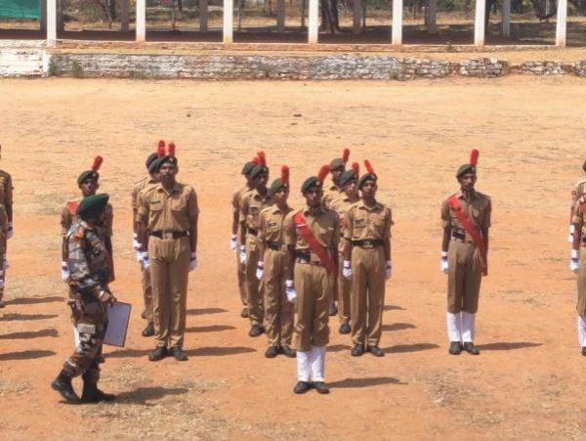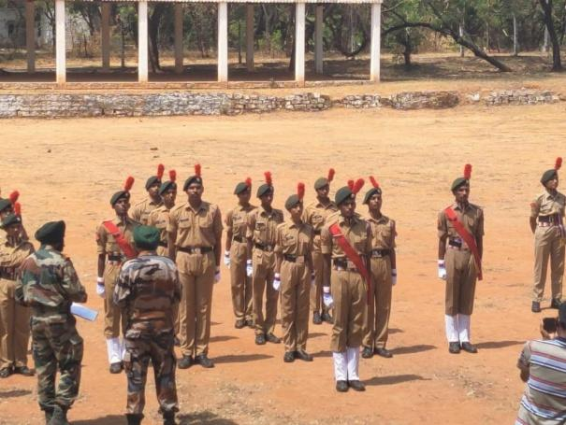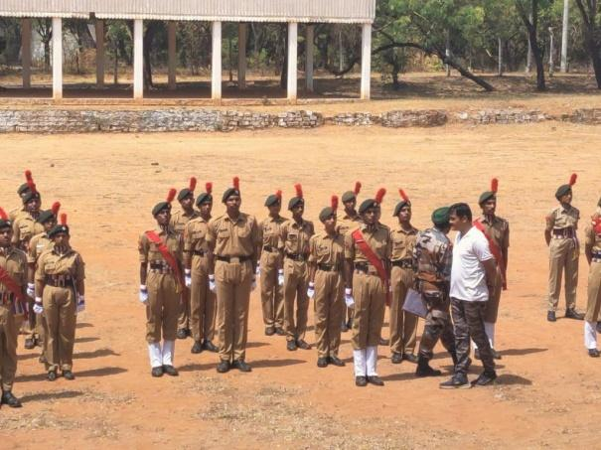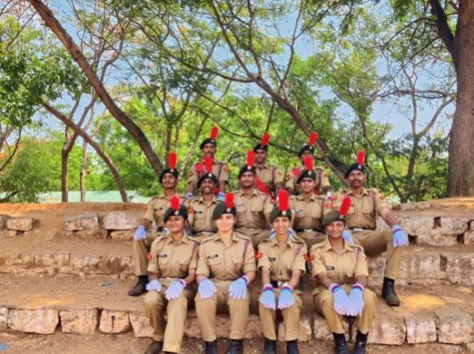

ALC-II
CAMP NAME : Advance leadership camp-II
CAMP LOCATION: police CTC ,jankampet,Nizamabad.
DURATION: 06th July 2023 to 17th July 2023
NO.OF CADETS: 01
C-SW:
1.Lcpl Gunjan soni
EXPERIENCE:
Experience and lessons learnt at Advance leadership camp-II at Nizamabad
NCC EXCHANGE PARTICIPANT ASSOCIATION(EXPA)
Program shaped our leadership skills and personality also boasting our confidence in life SSB training program in the camp was a rigorous test to challenge us mentally and physically .I am greatful for getting the opportunity to attend this camp. Cadets from different states (Madhya Pradesh, Chattisgarh, and Odisha ) and training staff were all friendly ,their brilliant mind enriched all of us ,exposure to this camp developed my leadership qualities very much .

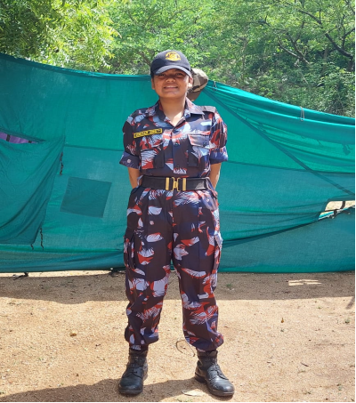

AAC-2023
CAMP NAME: Army Attachment camp
CAMP LOCATION: Mehdipatnam Garrison
DURATION: 24th July 2023 to 2th August 2023
NO.OF CADETS: 06 SD’D
SD’D
- Lcpl Aakasrh
- Lcpl Harshith singh
- Cdt sai pavan
- Cdt itihas
- Cdt sashant
- Cdt mastan
EXPERIENCE:
Participating in an Army attachment camp as a cadet in the National Cadet Corps (NCC) made me transformative and gave me educational experience.
- Orientation: The camp usually begins with an orientation session, where cadets are briefed about the camp's schedule, rules, and expectations. Cadets are often divided into squads or platoons and assigned to a specific instructor or officer.
- Physical Fitness Training: Physical fitness is a fundamental aspect of military life. Cadets typically start their day with morning physical training (PT) sessions that include exercises like running, push-ups, and drills to improve strength and endurance.
- Weapon Handling: Cadets may receive basic training in handling and disassembling rifles or other weapons, emphasizing safety and proper technique. However, live ammunition is rarely used in NCC training.
- Fieldcraft: Cadets are taught essential fieldcraft skills, such as map reading, navigation, camouflage, and how to build and maintain a shelter in the field.
- Drills and Marching: Learning military drills and marching in formation is a key aspect of NCC training. Cadets practice various drill movements to improve coordination and discipline.
- Tactical Training: Depending on the camp's duration and focus, cadets might receive basic tactical training, which could include learning about patrolling, ambushes, and small-unit tactics.
- Leadership and Teamwork: NCC camps emphasize leadership development and teamwork. Cadets often take turns leading their squads or platoons during various activities, fostering leadership skills.
- Cultural Activities: Camps may include cultural and recreational activities, such as campfires, talent shows, and cultural exchanges between cadets from different regions or units.
- Social Responsibility: The NCC also places a strong emphasis on social responsibility and community service. Cadets may participate in activities like tree planting, cleanliness drives, or helping in disaster relief efforts.
- Confidence Building: NCC camps are designed to build self-confidence and resilience in cadets. They are often pushed out of their comfort zones, which can help them grow as individuals.
- Discipline and Routine: The military-style discipline and daily routine help instill a sense of responsibility and time management in cadets.
- Physical and Mental Challenges: Camps can be physically demanding and mentally challenging. Cadets may face adverse weather conditions and sleep in tents or open fields, experiencing the hardships of outdoor living.

Overall, the Army attachment camp in the NCC is an opportunity for young individuals to gain exposure to military life, develop important life skills, and foster a sense of patriotism and discipline. It can be a memorable and character-building experience for those who participate.

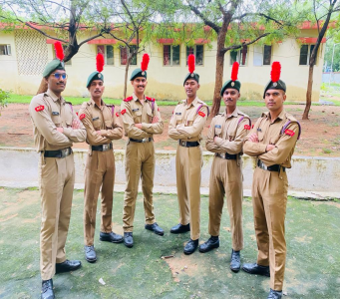

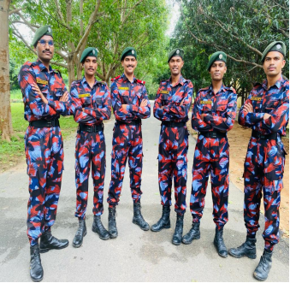
TSC -IGC -2023
CAMP NAME: Thal sainik camp (inter group competition)
CAMP LOCATION: Tirupati,Andhra pradesh
DURATION: 9th August 2023 to 19th August 2023
NO.OF CADETS: 05
SW’S
1.Lcpl sahithya malligari
SD’S
1.JUO Dheeraj singh
2.SGT Jayakrishna
3.LCPL Phani kumar reddy
4.LCPL Harikrishna
EXPERIENCE: Participating in the Thal Sainik Camp at the Inter Group level in the National Cadet Corps (NCC) gave me a memorable and rewarding experience.Thal Sainik Camp is an important event in the NCC calendar, focusing on land-based military training and competitions.
- Rigorous Training: Thal Sainik Camp involves intensive training in various military skills, including drill, weapon handling, map reading, and physical fitness. This training is designed to enhance the cadets' overall discipline and military knowledge.
- Competitive Spirit: The camp typically includes various competitions and challenges, both physical and intellectual. Cadets from different groups compete against each other, fostering a healthy spirit of competition and camaraderie.
- Exposure to Military Life: During the camp, cadets often get a glimpse of military life, including staying in military-style tents or barracks, following a regimented daily schedule, and learning from experienced military personnel.
- Leadership Opportunities: NCC encourages leadership development, and cadets may have the chance to take on leadership roles within their groups or in specific activities during the camp.
- Cultural Exchange: Inter Group Thal Sainik Camps often bring together cadets from diverse backgrounds and regions, providing an opportunity to learn about different cultures, languages, and traditions.
- Physical Fitness: The camp emphasizes physical fitness and often includes activities like obstacle courses, long marches, and other physically demanding exercises.
- Networking: I had the chance to interact with fellow NCC members from different parts of the country, building a network of friends and contacts that can be valuable in the future.
- Overall Growth: Participation in such camps lead me to personal growth in terms of confidence, teamwork, and a better understanding of military values and discipline

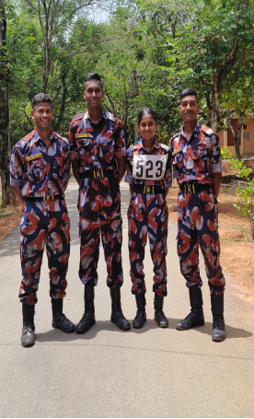

TSC -TRG-I 2023
CAMP NAME: Thal sainik camp – training ground
CAMP LOCATION: Kakinada-Andhra Pradesh [SD]
Tirupati-Andhra Pradesh [SW]
DURATION: 30TH August 2023 to 9th August 2023
NO.OF CADETS: 2
SD’S
1.JUO Dheeraj singh
SW’S
1.LCPL Sahithya malligari
EXPERIENCE : Participation in the Thal Sainik Camp at the TRG level was a valuable experience for me as a NCC cadets, as it helps to develop physical fitness, discipline, leadership skills, and a better understanding of military life. This camp also serves as a platform for cadets to test their abilities and excel in various activities.
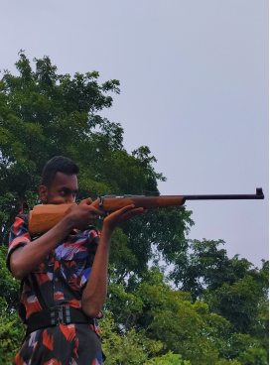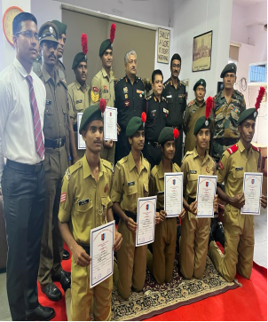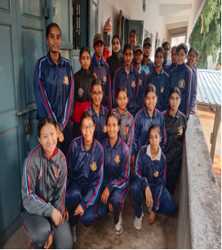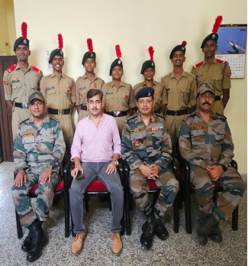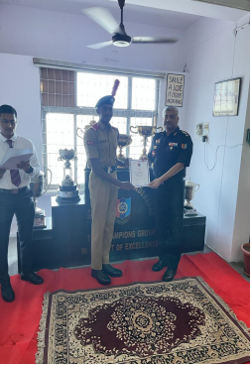

CATC-IV
CAMP NAME: Combined Annual Training Camp
CAMP LOCATION: 1 EME Center yapral,secunderabad
DURATION: 11th September 2023 to 20th September 2023
NO.OF CADETS: 55
C-SW’S
1.Cpl manaswini rath
2.Cpl Rajeshwari
3.Cdt Shravani
4.Cdt Nishitha Bhongir
5.Cdt M.Pavani
6.Mounika Shetty
7.Cdt Jahnavi Reddy
8.Cdt Sree Harshini
9.Cdt Ch.soni
10.Cdt sukhmanjeet
11. Cdt Haritha suresh
12.Cdt G.Vaishnavi
13.Cdt Anna Karen D’souza
C-SD’S
1.CQMS Ramashankar
2.SGT Ithihas goud
3.Cdt Siddharath Reddy
4.Cdt Prasad levi
5.Cdt Niranjan kumar
6. Cdt Akhil kumar
7.Cdt Shiva kumar
8.Cdt Justin Jacob
B2-SW’S
1.Lcpl Alankritha Desai
2. Lcpl Janet Mary
3.Cdt Arwa
4.Cdt Gowreshwari
5.Cdt Sharanya
6. Cdt Thanmai
7. Cdt Sagar sabitha
8. Cdt K.Jahnavi
9.Cdt Laharika
10.Cdt Ramandeep kaur
11. Cdt Keerthi Reddy
12. Cdt V.Pravallika
13. Cdt Nisha Yadav
14.Cdt Deepali goyal
15.Cdt M.Vaishnavi

B2-SD’S
1.Lcpl Phani kumar reddy
2. Lcpl L.Harikrishna
3.Lcpl srichand
4.Lcpl Mukesh kumar
5.Cdt Rohit sai Vardhan
6.Cdt Syed muddasir
7.Cdt S.Mallikarjun
8.Cdt P.kalyan
9.Cdt Tharun Teja
10.Cdt G.Harikrishna
11.Cdt G.Abhishek
12.Cdt Vinay kumar
13.Cdt E.Pawan
14.Cdt M.Bharath
15.Cdt Akshay pavanesh
16.Cdt Ada jayendhar
17.Cdt Sai Vamshi
ACHIEVEMENTS:
- On 16th September 203 Loyola Academy won the 1st prize in tug of war
- On 17th September 2023 CDT Jahnavi secured 2nd place in running competition
- CPL Manaswini Rath, LCPL Alankritha Desai and CDT Ada jayendhar were presented with medals for best piloting
- We secured 2nd place in the cultural activity, under group dance on 19th September 2023
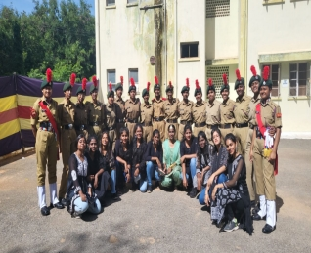
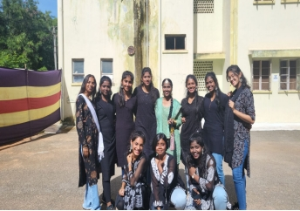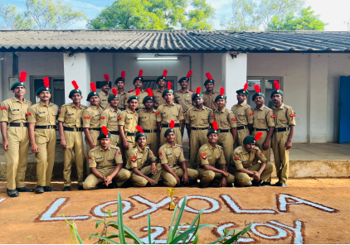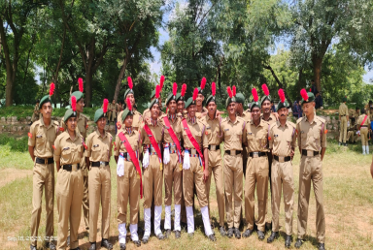

TSC-TRG-II 2023
CAMP NAME: Thal sainik camp -Training ground
CAMP LOCATION: Tirupati, Andhra pradesh
DURATION: 10TH September 2023 to 17th September 2023
NO.OF CADETS: 01
SW’S
1.LCPL Sahithya malligari

EXPERIENCE:
TRG-2 camp was so hard because this camp was the last step to reach my dream and I was extremely stressed ,because of the selections which was done done by the officers after many practices . among all the cadets from different directorates only 8 cadets were having chance to get selected for Delhi. I got selected in 2 events ,tent pitching and obstacles. I feel proud of myself and I thank myself for not giving up and working hard .

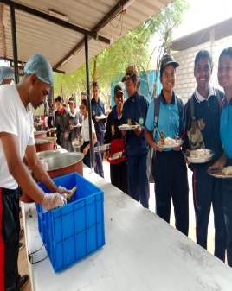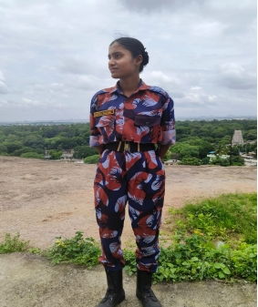

TSC - 2023

LOCATION : NEW DELHI, INDIA
DURATION : 29th August to 30th September
NO. OF CADETS : 1. LCPL Sahithya Malligari
ACHIEVEMENTS : LCPL Sahithya has Recieved ALL INDIA THAL SAINIK CAMP Certificate from DG NCC
EXPERIENCE :
My TSC journey is an unforgettable and life changing experience. At first I started this journey as any other person simply just to experience but after participating in different events it made me realise that my dream is more than what it seems, then I started working on it everyday .Taking a first step was very hard but when you have a goal to reach, everything will be possible. After many practices I got to participate in IUC(Inter Unit Competition) where I learned hard work is the secret of success and won Gold Medal in IUC. Then after, this achievement made me more enthusiastic towards my journey and got selected for PRE-IGC where we got only 1 main event to choose. While everyone were confused about what to choose , I was certain about my main event OT (Obstacle Training ) and after getting selected for IGC (Inter Group Competition), I was excited but the reality hit me hard when I did not getting a medal in IGC. It made me hopeless but later on I realized that 'life is full of twists and turns', so I worked hard even more and made progress and got selected for TRG-1 (Training GroundGrounds - 1). This camp made me more stronger . I defeated the cadets who defeated me in the past through out my journey. After that I got selected for TRG-2 (Training Grounds - 2). I gave my 100% to get selected for Delhi by not giving up in any situation , where only 8 cadets had the opportunity to participate in 2 events ,while everyone was relying on their luck, I trusted myself and believed that I can only achieve this through my hard work. Finally I got selected for AITSC DELHI (All India Thal Sainik Camp) in two events, Obstacle Course and Tent Pitching . I took part in events with my sincere efforts where the whole India, that is 17 directorates participated. I was proud that I got appreciation for my work in tent pitching from all the officers among the all the participants , which made me forget all my struggles that I had been through . "It was hard yet a beautiful life changing journey which brought the best in me" and also it made me realise that , "The Journey Might Be Challenging But It Was Not Impossible.”

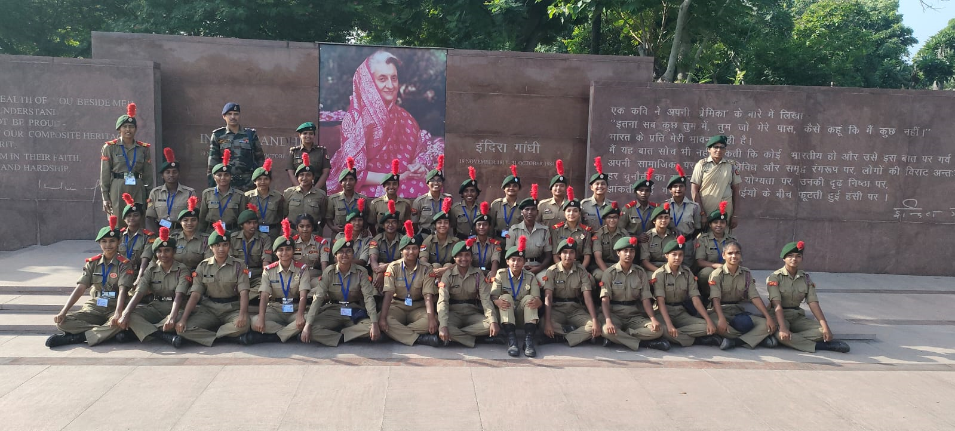

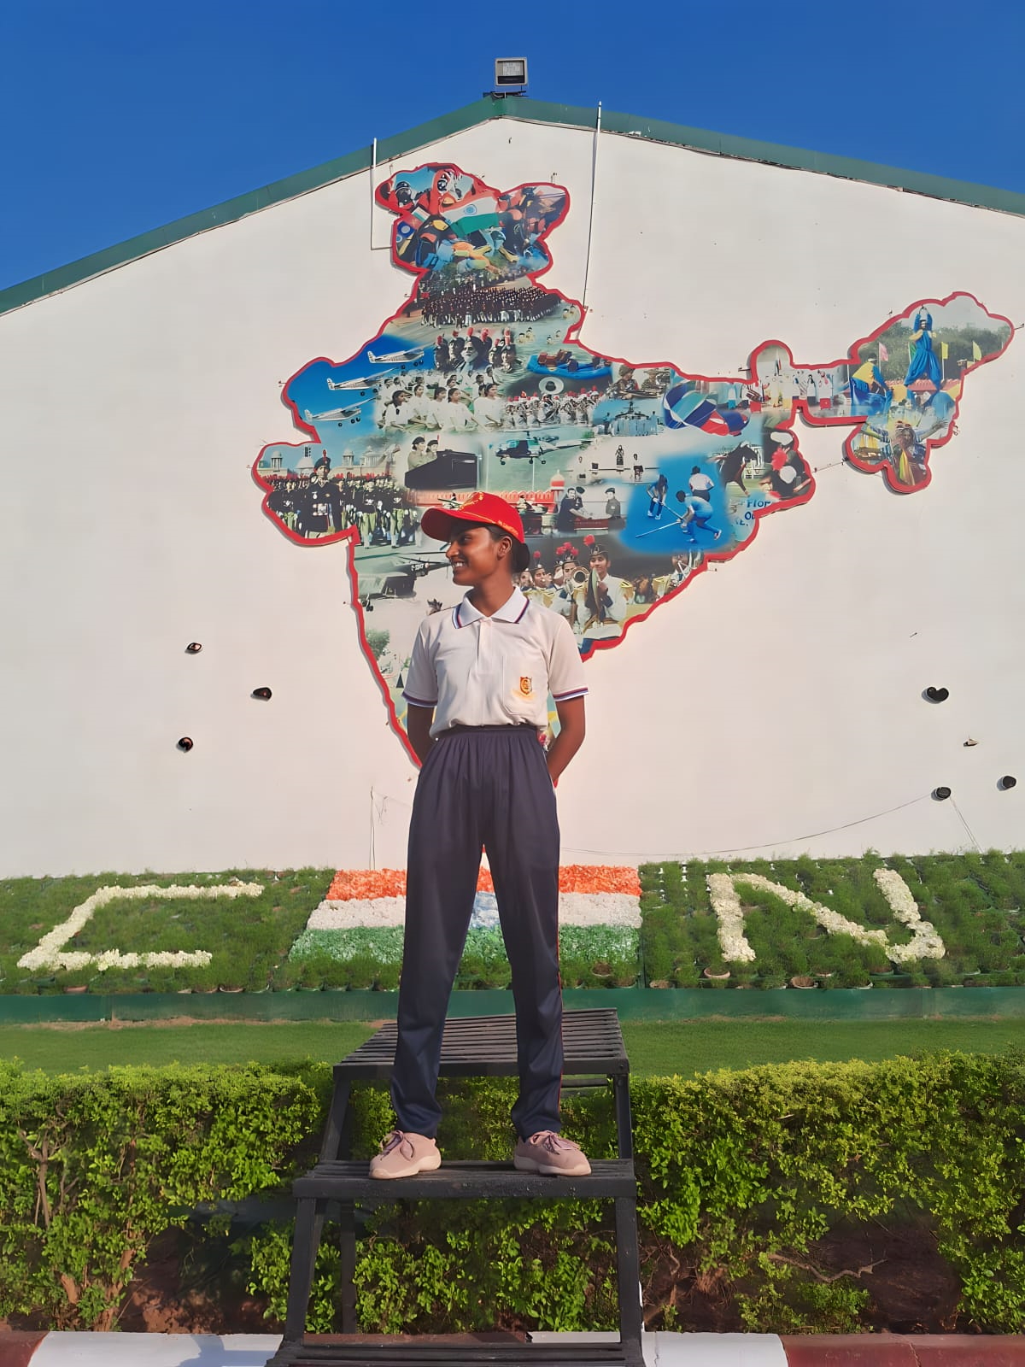

SNIC
CAMP NAME : Special National Integration camp
CAMP LOCATION: Gajwel, Govt Degree college Boys Hub
DURATION: 12th Oct 2023 to 23th Oct 2023
NO.OF CADETS: 01
SD’S
- CPL Manda sai shankar Yadav
EXPERIENCE :
Camp was conducted by 33(T) NCC sangareddy Nizamabad group .
SNIC are conducted to make cadets understand and value the rich heritage of cultures that forge unity despite the diverse language, traditions and religions of our country.
We also got to visit
- Tank bund ,necklace ,shilparamam
- OFD Medak
- Arty centre , Golconda
- Ramoji film city
- Airforce station ,HakimpetI participated In “NATIONAL INTEGRATION AWARENESS PROGRAM (NIAP) We have represented our AP&T Directorate
I participated In “NATIONAL INTEGRATION AWARENESS PROGRAM (NIAP) We have represented our AP&T Directorate

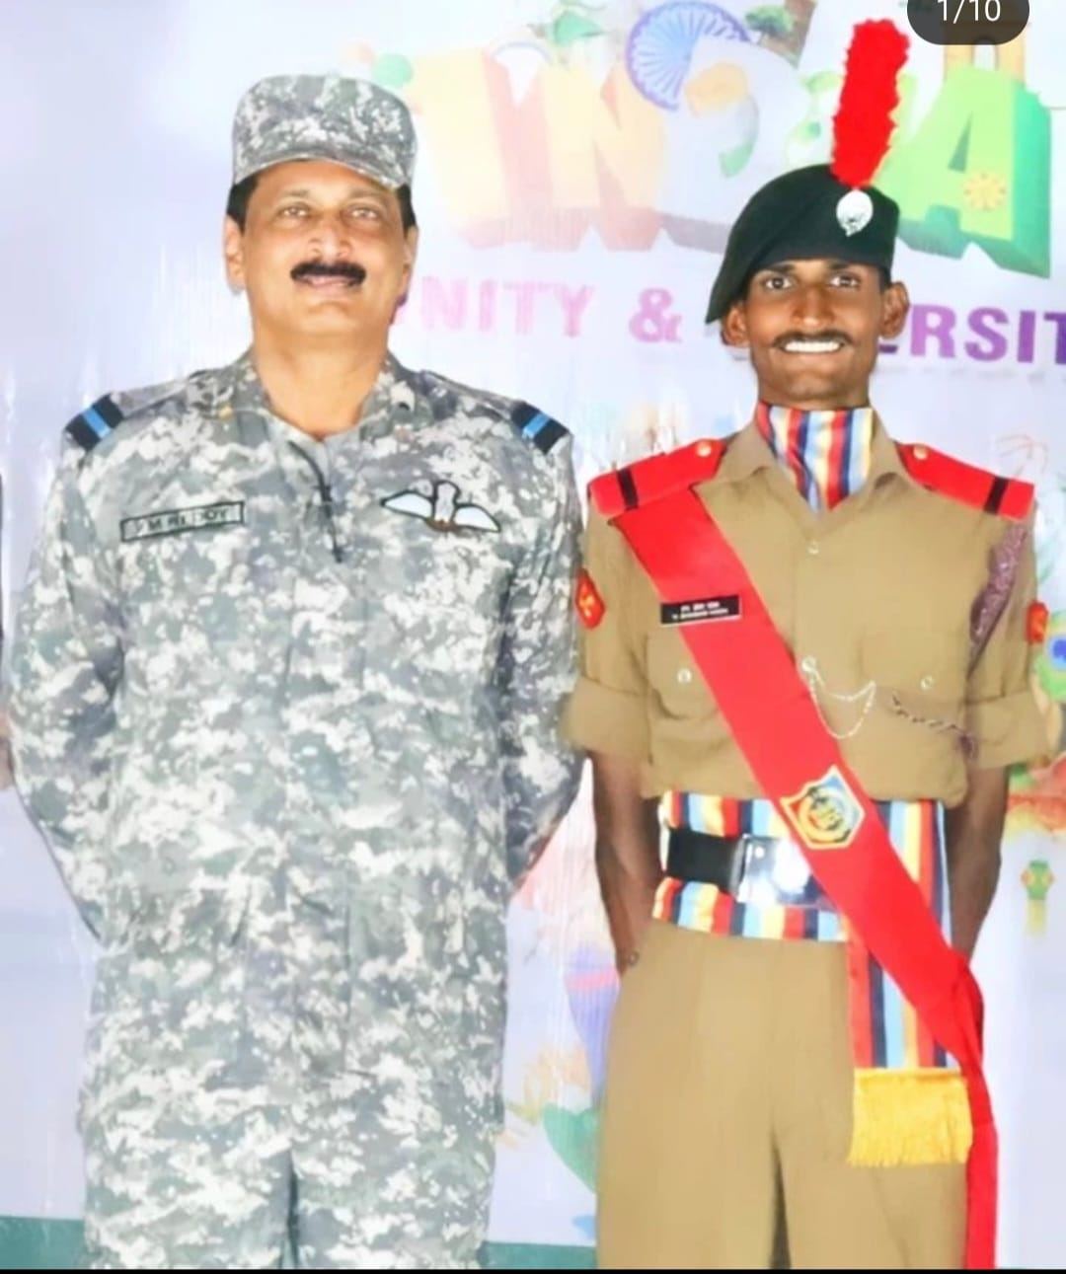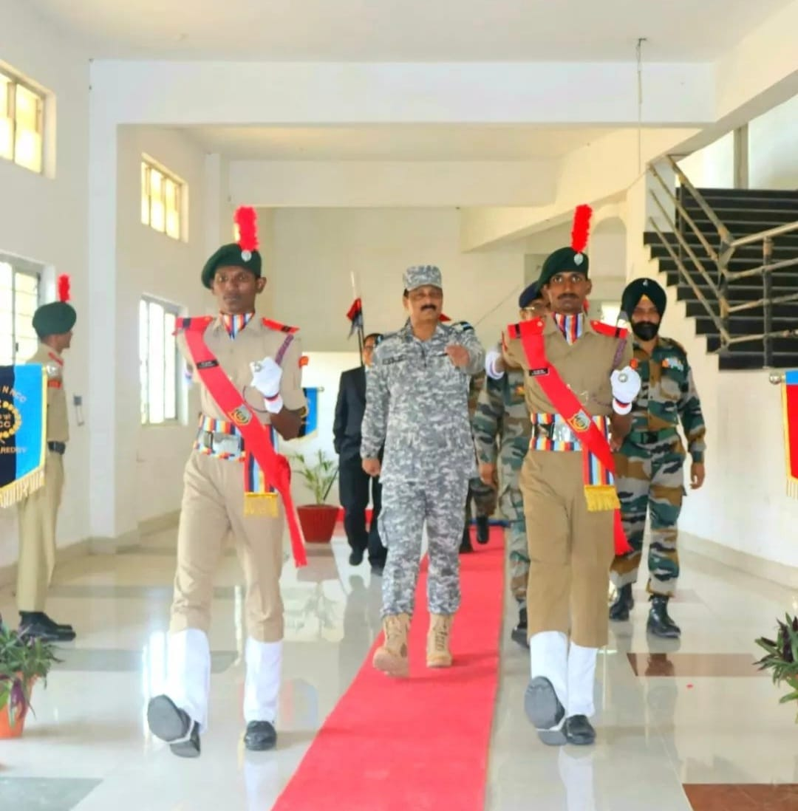

EBSB
CAMP NAME : Ek Bharat Shrestha Bharat
CAMP LOCATION: shamshabad , Vardhan college of Engineering
DURATION: 23th Oct 2023 to 1st Nov 2023
NO.OF CADETS : 02
- SGT Harsha Vardhan
- CPL Om Prakash
EXPERIENCE:
Being a Ncc Cadet it was my utmost privilege and pleasure to be a part of EBSB .It was totally a memorable one and the best camp I have attended till date . In the cultural programs we got to know their tradition, their heavy jewelleries and lehengas were all worth watching . 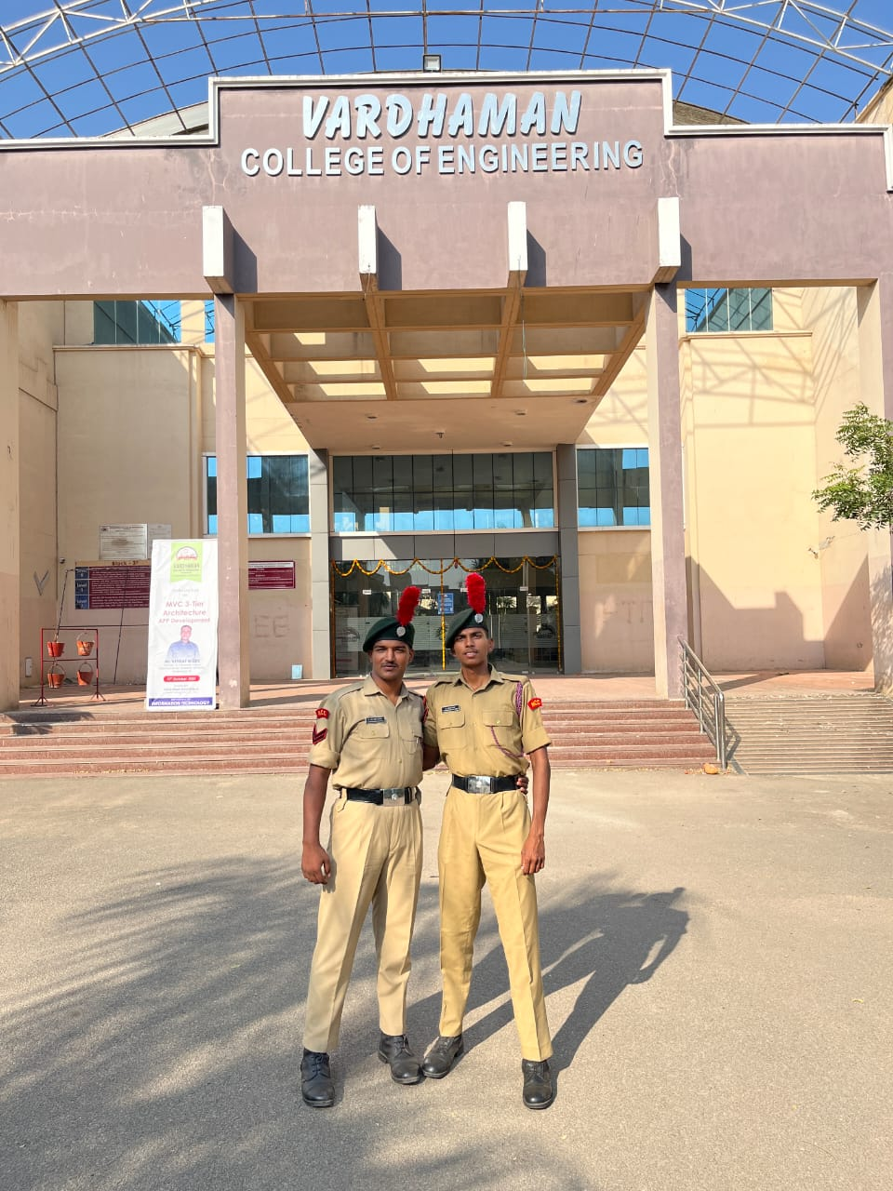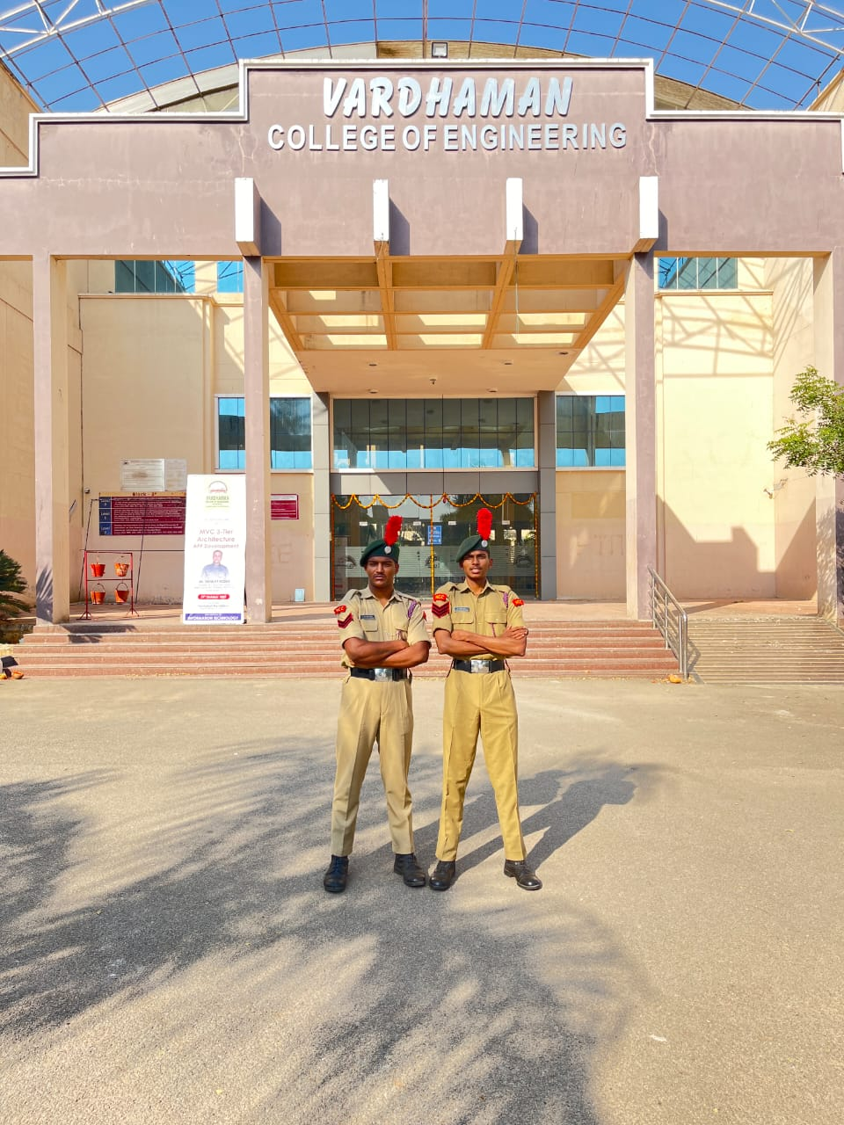

IGC-RDC
CAMP NAME : Inter Group Competition-RDC
CAMP LOCATION: Mehdipatnam Garrison
DURATION:27th Oct 2023 to 5th Nov 2023
NO.OF CADETS: 04
SD'S:
- JUO Dheeraj Singh
- JUO I.Aaron
SW'S:
- JUO D.Suchitha
- CPL Pravalika
ACHIEVEMENTS:
- Secunderabad Group secured 2nd position in Guard of Honour under SUO Dheeraj Singh as Guard Commander .
- JUO I.Aaron secured 3rd position as Best cadet
- In PM Rally JUO D.Suchita secured 3rd position
- In Kartavya path JUO D.Suchita and CPL Pravalika were given 4th position
- In Kartavya path JUO D.Suchita and CPL Pravalika weregiven4^{t}posit
- 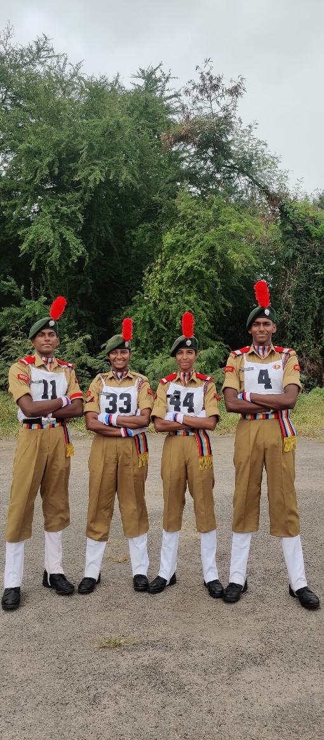

CAMP NAME : Sardar Narmada Patel Trekking Camp -II
CAMP LOCATION: Rajpipla,Gujarat
DURATION: 27th Nov 2023 to 7th Dec 2023
NO.OF CADETS: 02
SD'S
- CQMS. A Rama Shankar
- CSM Harshith Singh
EXPERIENCE:
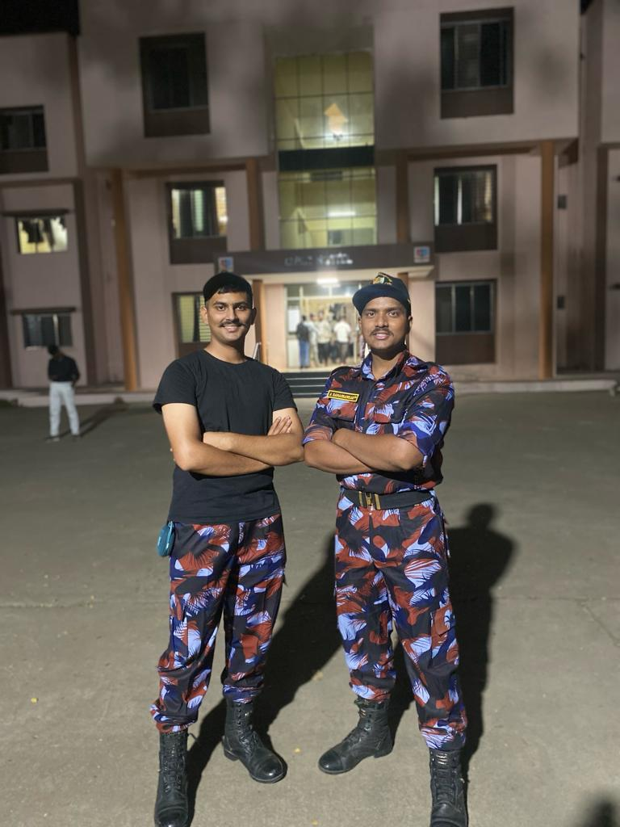
Our Camp started with opening ceremony on 29th Nov 2023 . On 30th Nov 2023 we went for Junaraj Dam on 1st Dec 2023 we went for sundarpura trekking and on 2th Dec we went for Karan trekk .on 3rd and 4th Dec all the cadets attended Expa cadet program . Closing ceremony was held on 5th Dec 2023

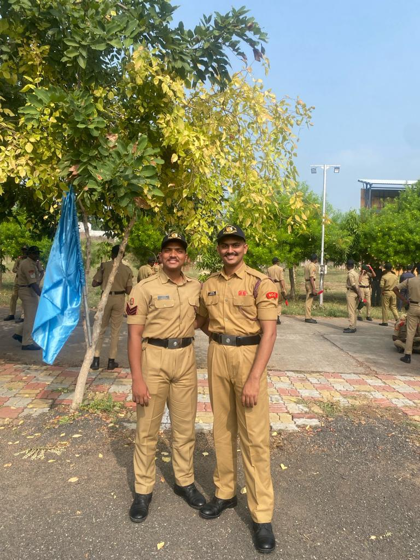

PRE RDC -I
CAMP NAME : PRE RDC -1
CAMP LOCATION: Mehdipatnam,Garrison
DURATION:18th Nov 2023 to 27th Nov 2023
NO.OF CADETS : 02
SD’S
- SUO Dheeraj singh
- JUO I Aaron
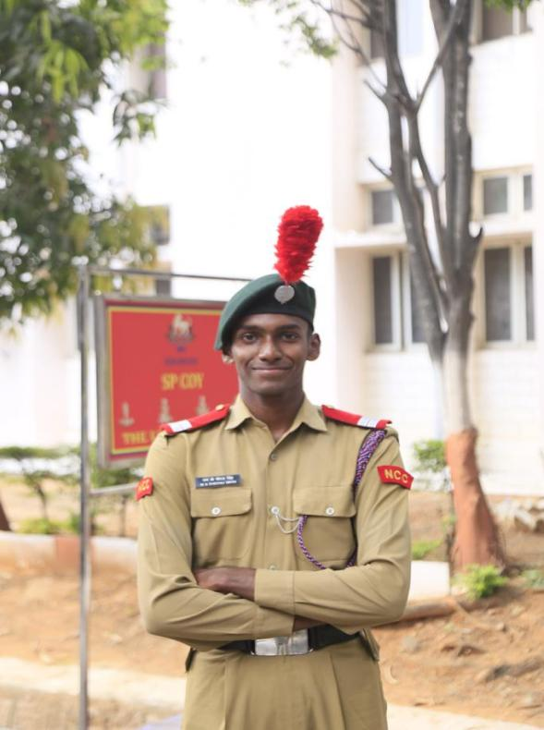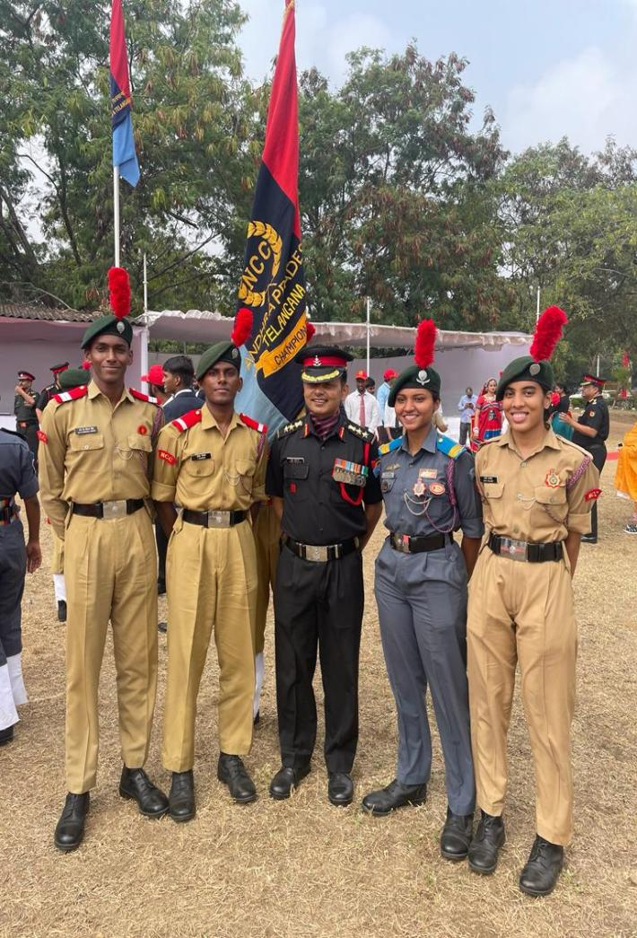

PRE RDC-II
CAMP NAME: PRE RDC-II
CAMP LOCATION: Mehdipatnam,Garrison
DURATION:7th Dec 2023 to 17th Dec 2023
NO.OF CADETS:02
SD’S
- SUO Dheeraj singh
- JUO I Aaron
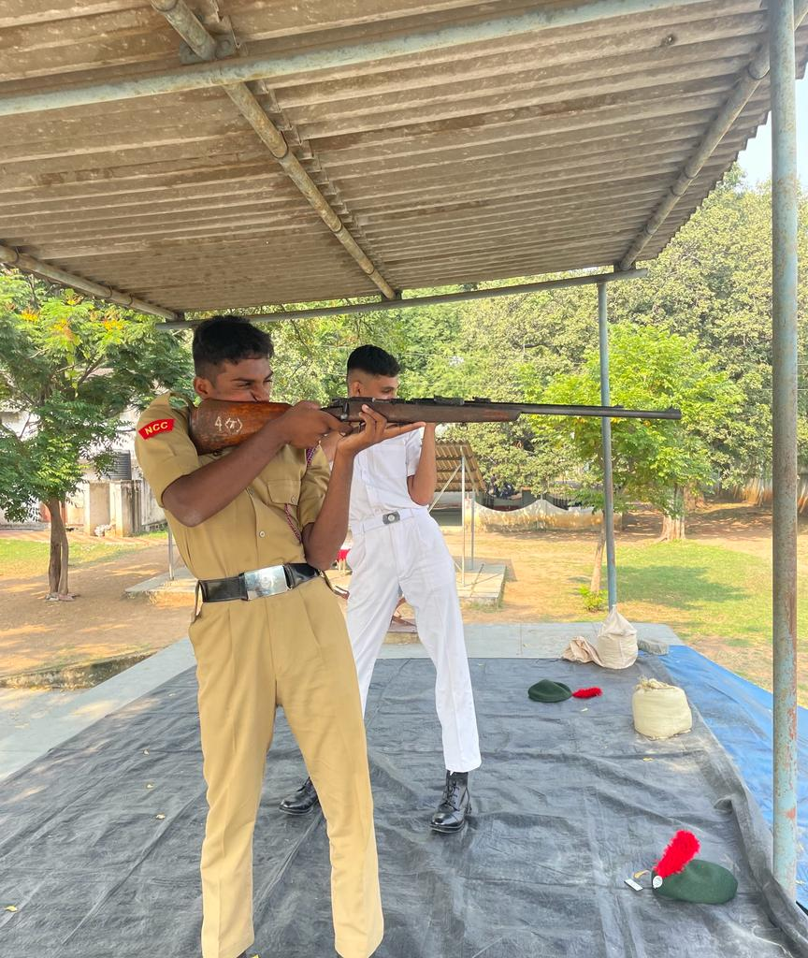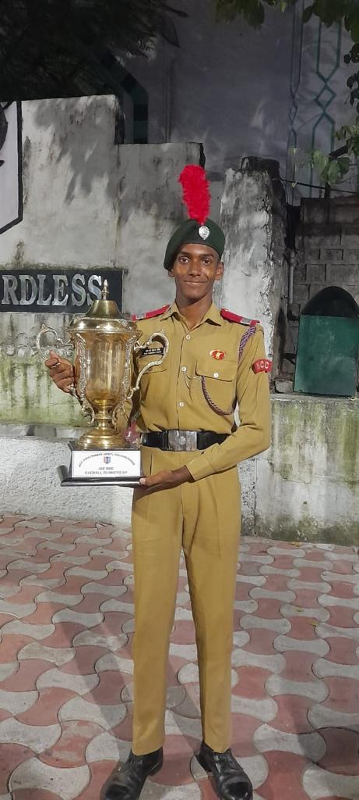

IMA ATTACHMENT
CAMP NAME: Indian Military Academy Attachment Camp
CAMP LOCATION: Dehradun,uttarkhand
DURATION: 17th Dec 2023 to 28th Dec 2023
NO.OF CADETS: 01
SD’S
- SGT K.Jaya krishna
- 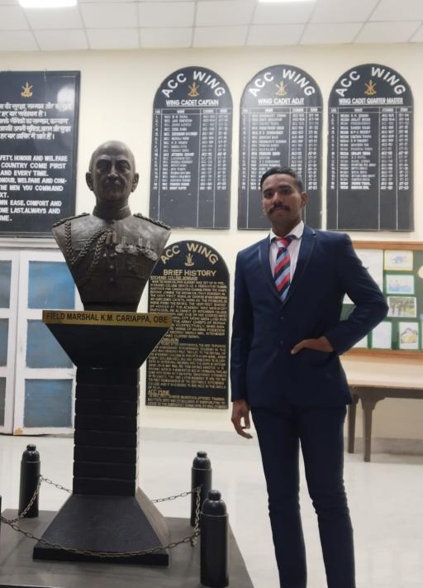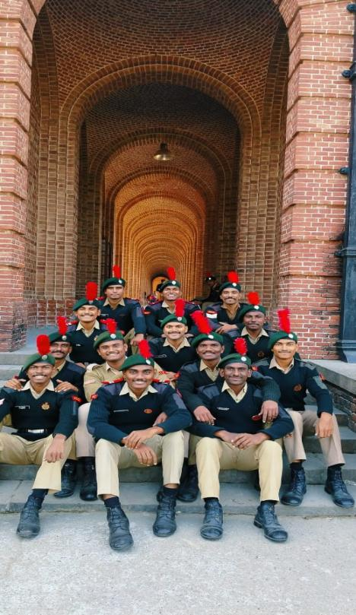
SNIC
CAMP NAME: Special National Integration Camp
CAMP LOCATION: Kavaratti,Lakshadweep
DURATION: 23th Dec 2023 to 02nd Jan 2024
NO.OF CADETS: 01
SD’S
- SUO Kapila Aakarsh
- 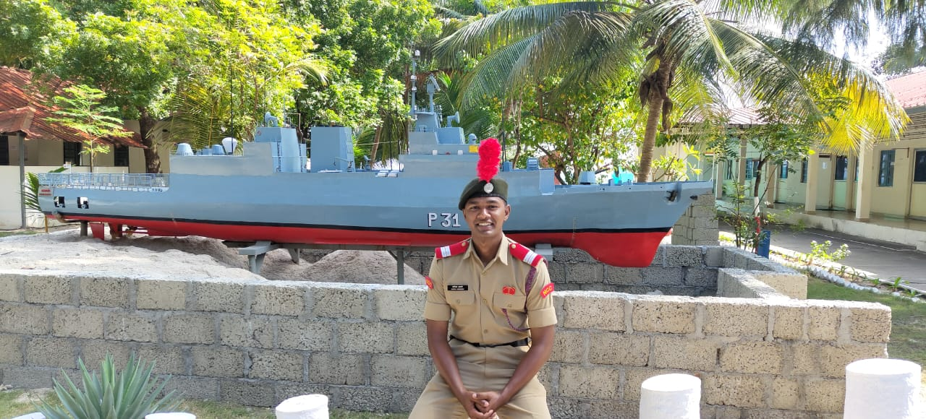
RDC-2024
CAMP NAME: Republic Day Camp -2024
CAMP LOCATION: New Delhi, India
DURATION: 01st Jan 2024 to 30th Jan 2024
NO.OF CADETS: 01
SD’S
- SUO Dheeraj singh
EXPERIENCE:
RDC is the most glorious camp for an Ncc cadet. Representing your directorate in national level gives you enough power and confidence .we have to burn ourselves to reach our goals. The cadets undergone rigorous training in three pre-RD camps and many selection procedures. Waking up early in the morning and the PT followed by continuous practicing was the bitterest part. The memories in Cariappa ground are unforgettable . The best thing about practicing in Cariappa was the “Aatmanirbhar Bharat” song that we hear standing behind the cultural cadets who dance for the song after each practice . The overall camp was a beautiful experience. Being the part of such a camp itself is a lesson, we make friends, see people from different parts of the country and share their culture and tradition , also learnt that winning and losing is part of a competition, all you have to do is focus on your goal and move on .The Republic Day camp is a tough road towards priceless experience .
