
EQUAL OPPORTUNITY CELL [EOC]
REPORT
Essay Writing Competition In Observance Of World Population Day
Introduction
The Equal Opportunity Cell (EOC) of Loyola Academy organized an essay writing competition to commemorate World Population Day on Thursday, June 11th, 2024. The event aimed to raise awareness about the challenges of population growth and its impact on sustainable development.
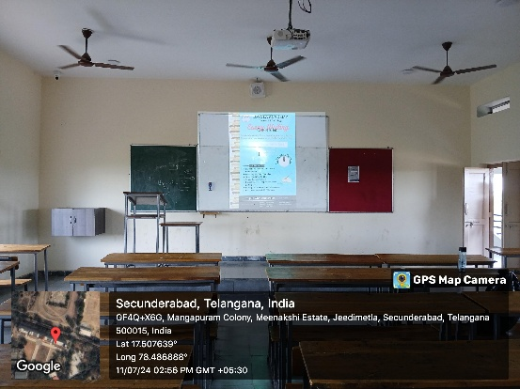

Event Details
The event began with an inspiring speech by Rev. Fr Arul Jothi, followed by an address from the EOC coordinator, Dr.Palle Mahender. The competition saw participation from a total of 37 students, comprising 18 female students and 19 male students, indicating a balanced interest in the topic across genders.
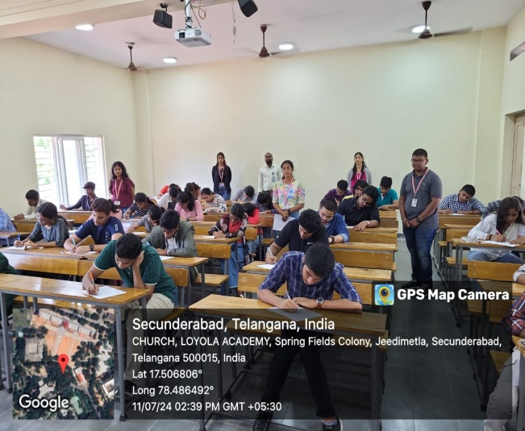
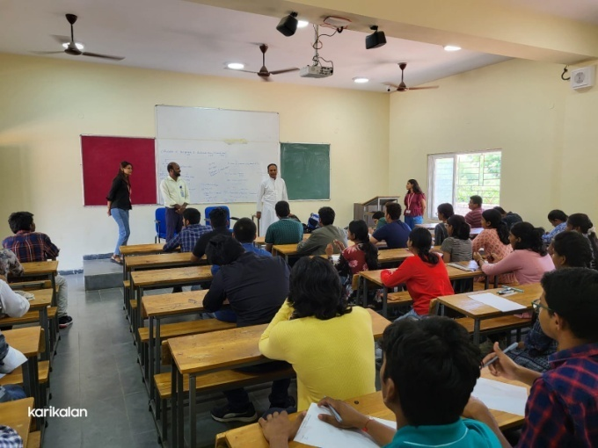
Organization and Participation
The competition was held in the Commerce Block of Loyola Academy from 2:30 PM to 3:30 PM, with participants required to be present by 2:00 PM. The event was meticulously organized by coordinators Harshini, Nithya, Sudipta, Medha, Rushi Reddy, and Aayush, who were instrumental in creating the pamphlet and encouraging student participation.
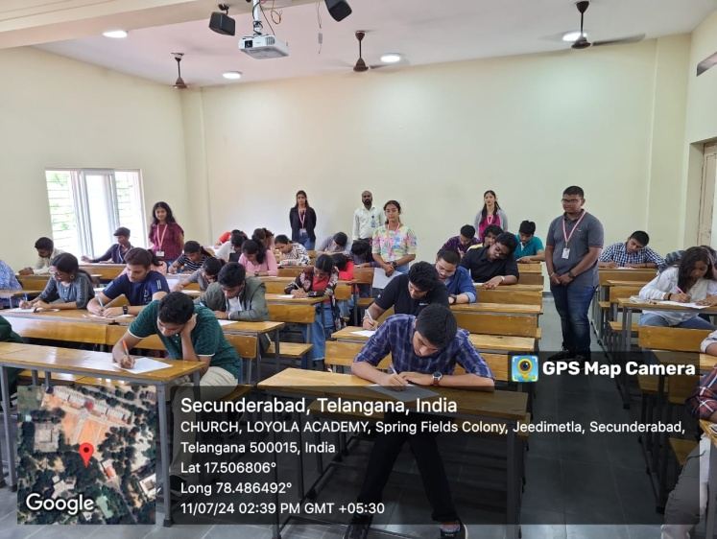
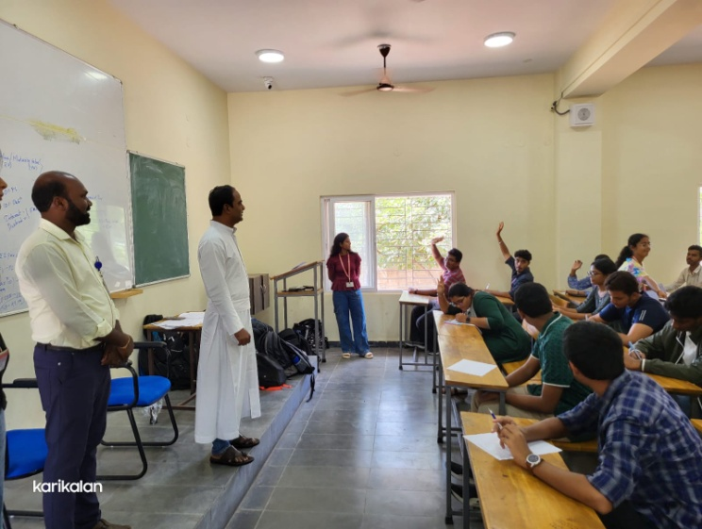
Most of the participants were first-year students, which was a surprising yet encouraging trend, showing a strong interest in population and sustainable development issues among the newcomers. Additionally, there were many spot registrations, further highlighting the enthusiasm for the competition.

Outcomes and Achievements
All participants were awarded e-certificates, recognizing their contributions and efforts. The competition successfully raised awareness about the importance of population control and sustainable development. The substantial participation from both male and female students underscored a growing interest in these crucial issues.

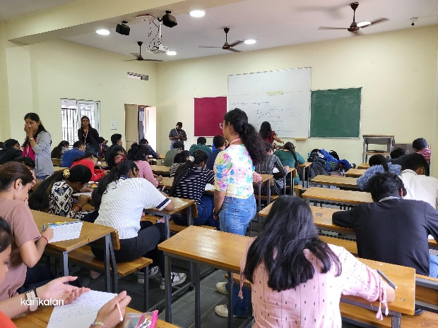
Conclusion
The essay writing competition on "Population and Sustainable Development" was a resounding success. It provided a platform for students to express their views and insights on how population dynamics affect various aspects of our lives and the planet. The event not only highlighted the importance of these issues but also fostered a sense of responsibility and awareness among the students of Loyola Academy.

Acknowledgements
Special thanks to Rev. Fr Arul Jothi for his motivational speech and to Dr.Palle Mahender for his insightful address. The efforts of coordinators Harshini, Nithya, Sudipta, Medha, Rushi Reddy, and Aayush were invaluable in the success of the event. Their dedication to organizing and promoting the competition ensured high participation and engagement from the student body.

ATTENDEES LIST
The Following are the List of Attendees who have registered online.
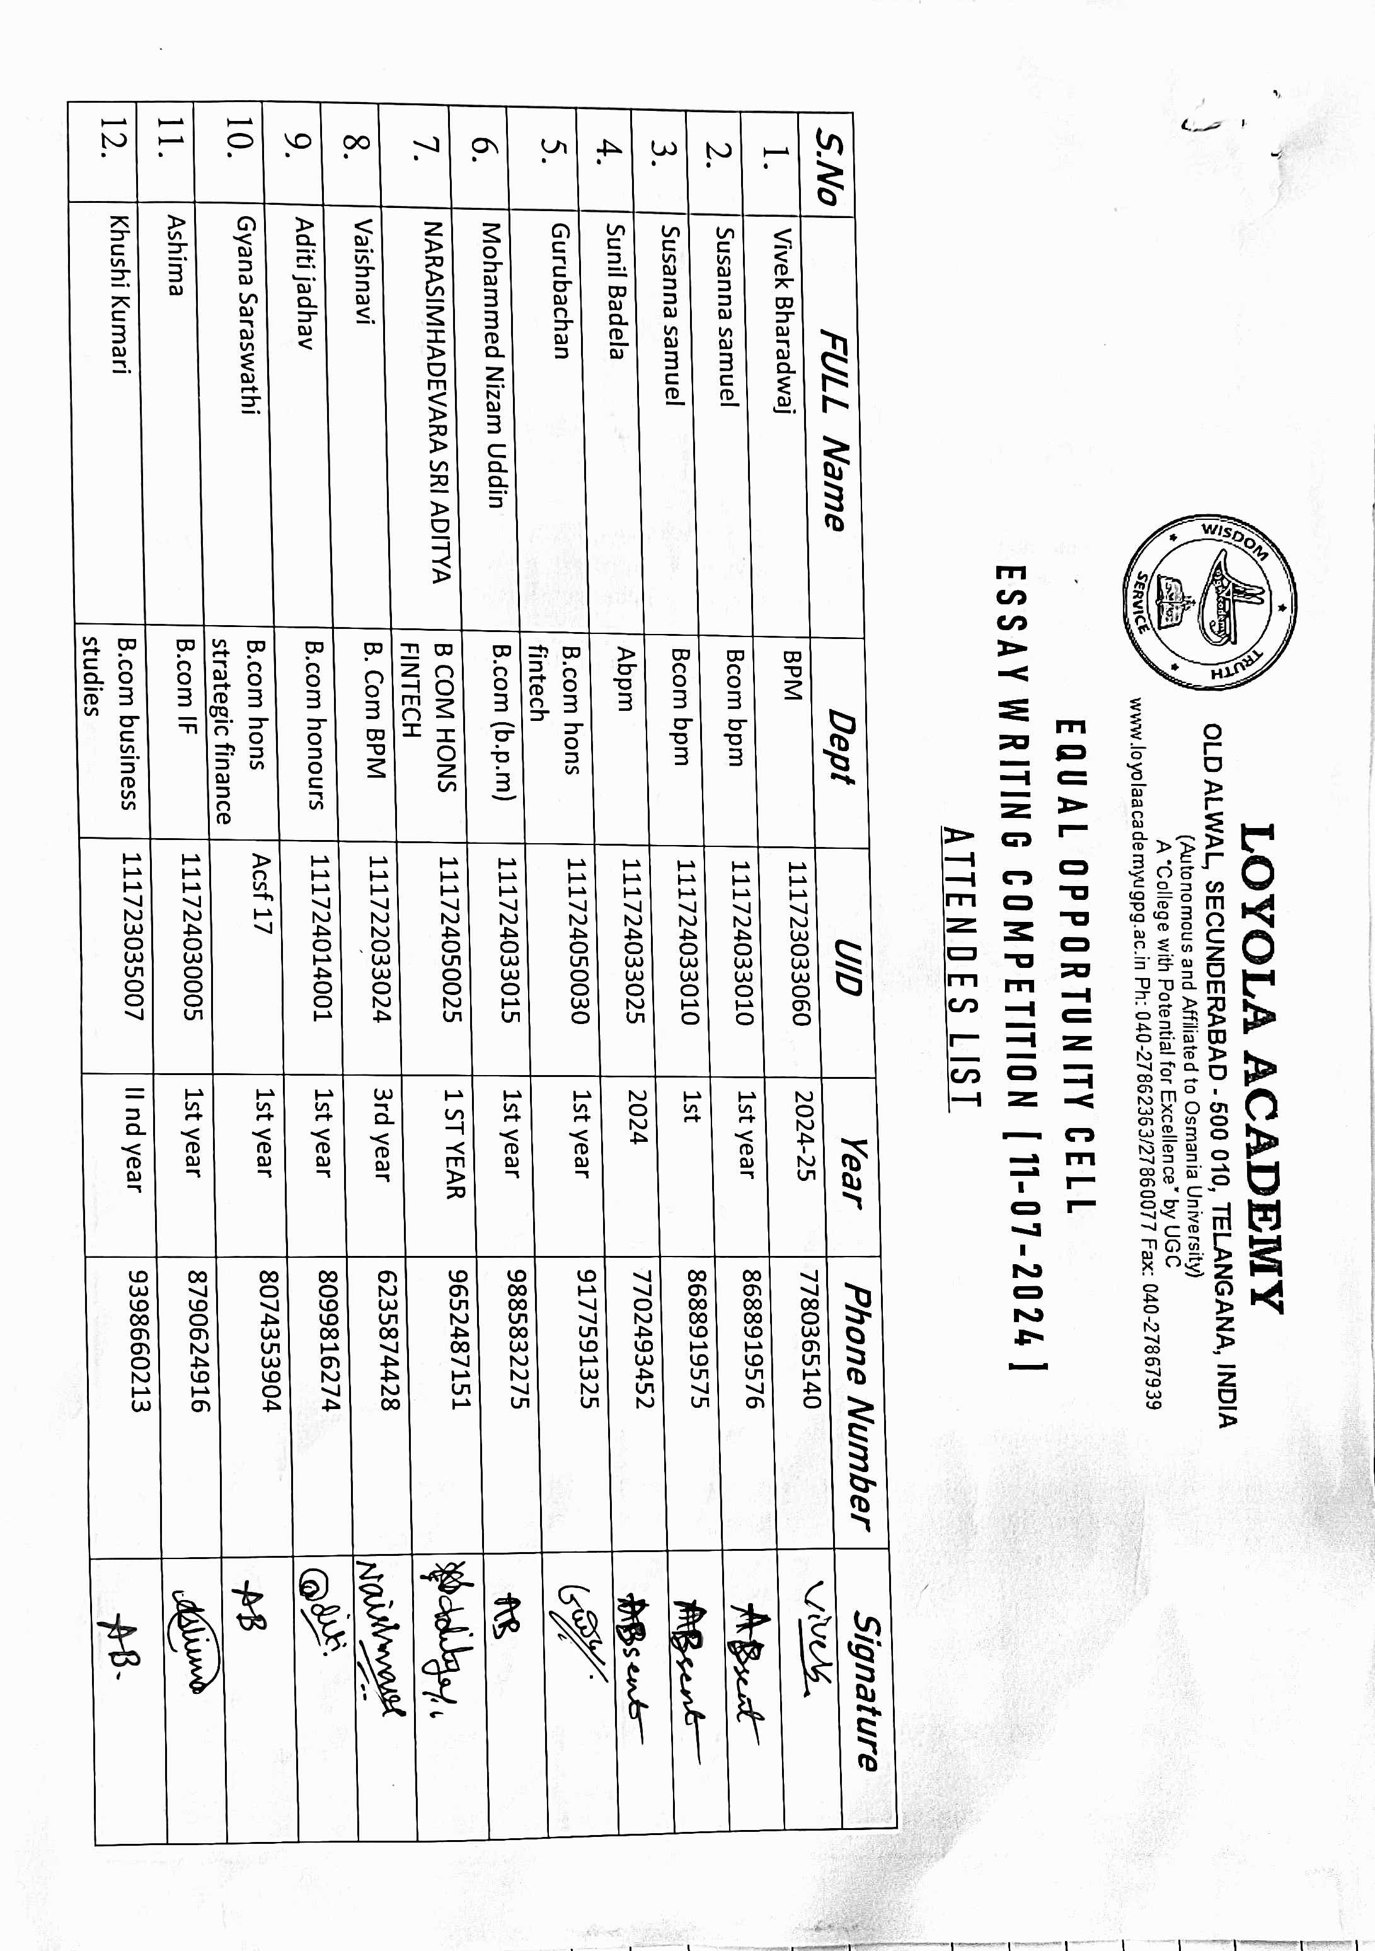
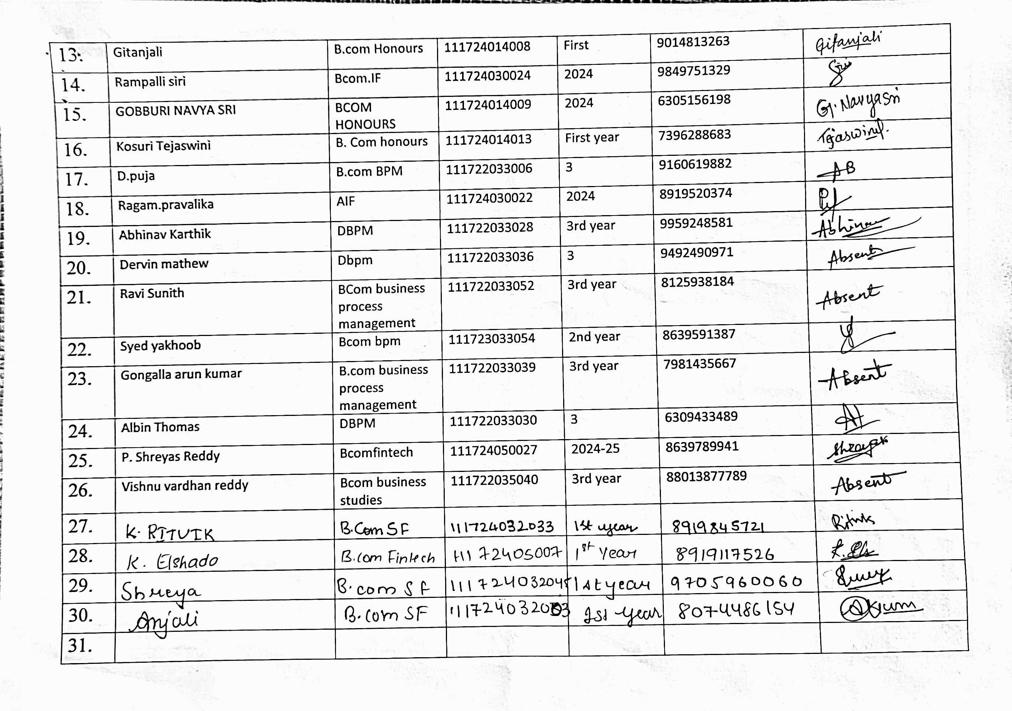

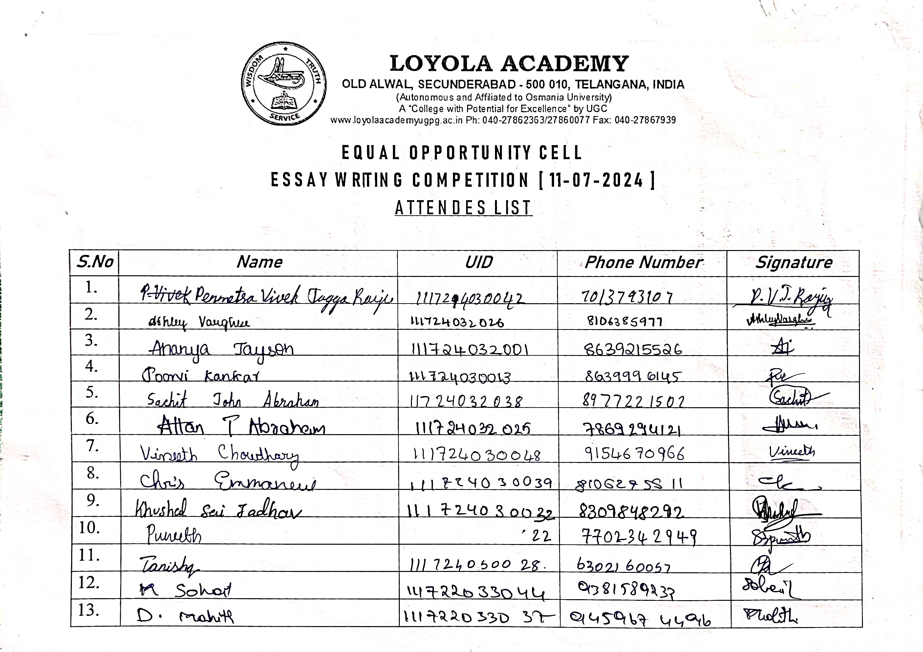
The Following are the List of Attendees who has registered on spot.
