N.C.C NAVY WING - REPORT (2024-25)

Special Yatching Training Camp:
Cadet Hoshang attended Special Yatching training camp from april 2nd – april 9th . in the camp cadets were taught sailing and rigging in the E-P boat. There were several other activites conducted to teach cadets different aspects of sailing and rigging the ropes for sailing.
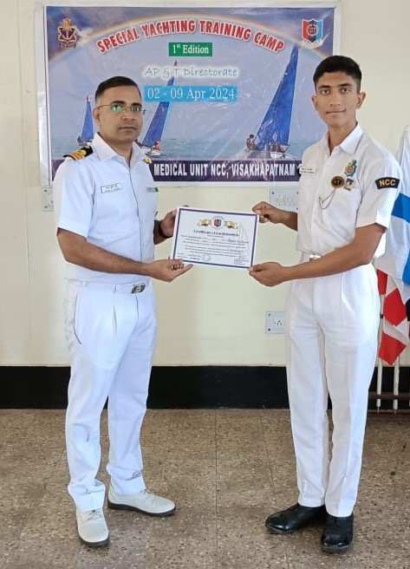

SHIP ATTACHMENT CAMP:

Leading Cadet Y Venkata Sai Eshwar Reddy participated in Ship Attachment camp in Mumbai during September 2024. Cadets were accommodated and trained in the warships of the Indian Navy.

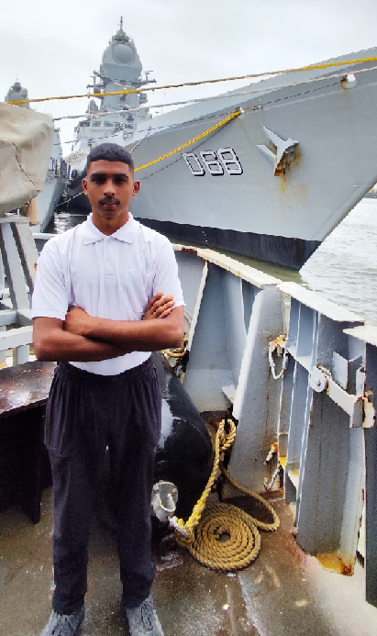

ANNUAL TRAINING CAMP- (VII)

Annual Training Camp (ATC-vii) scheduled from 01-06-2024 To 02-06-2024, AT TSWRS SHAIKPET. L.A NAVAL CADETS achieved RUNNER UP MEDALS IN TUG OF WAR,THROWBALL, LINE AREA.
Annual Training Camp is a platform where cadets get chance to learn various subjects such as drill, weapon training, map reading, first aid, adventure, self-defence, military history, physical fitness, field craft and battle craft.Drill is an integral and important part for NCC cadets. In the training camp cadets learn drill from drill instructor and learn all the subjects and training from trained instructors.
The whole experience is a bundle of activities which helps to inculcate Leadership
Qualities in a cadet and provide lifelong skills and developmental changes in perspective and way of living of the cadets. In ATC camps cadets learn about NCC, armed forces and other paramilitary forces of the country through various interactive sessions and activities. Cadets also get a chance to learn about Weapons and various safety drills and procedures. Many competition and quizzes are also conducted to increase cadet’s knowledge and make them feel competitive so that they can give their best in every field.
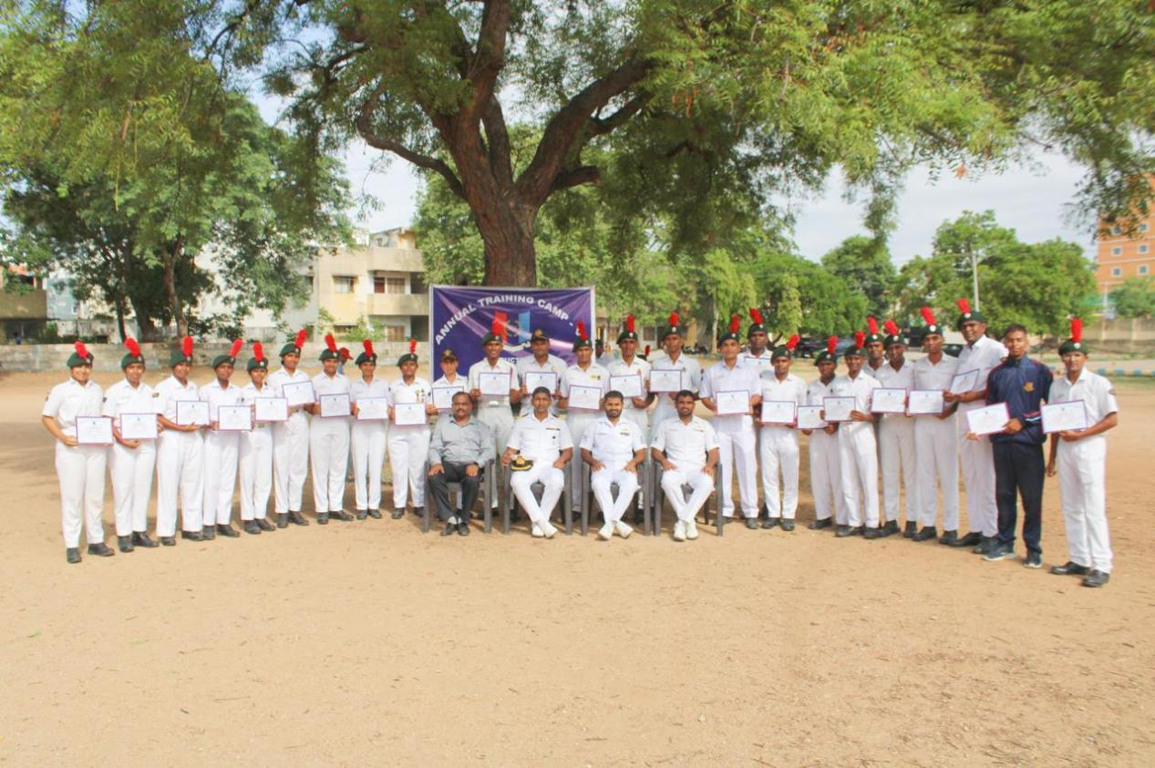

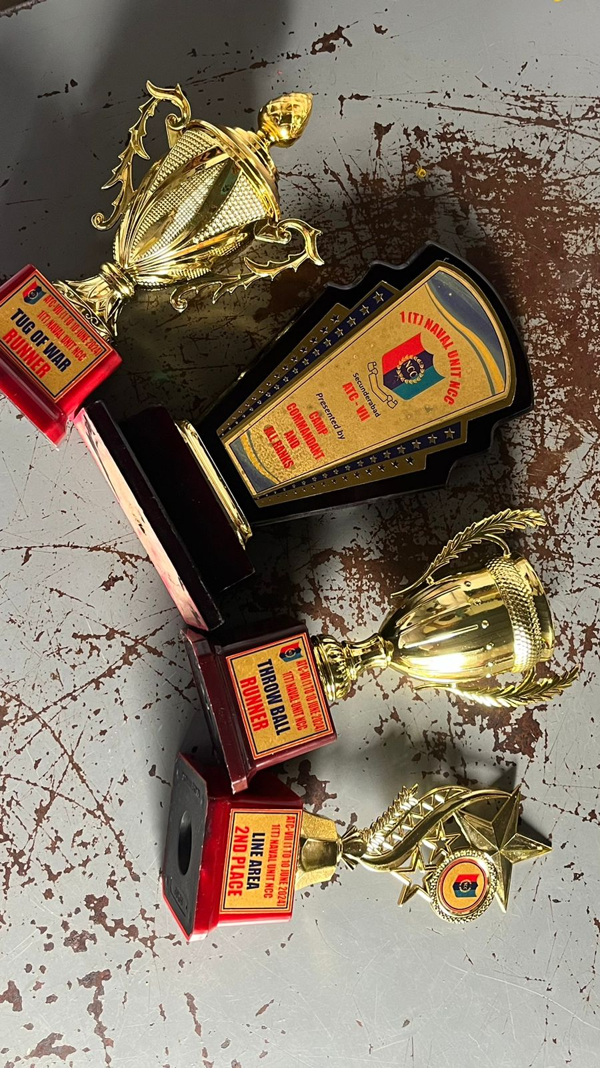 ALL INDIA NAU SAINIK CAMP IGC-2024

On 7TH JULY 2024 a total of 45 naval cadets from 1(T)Naval unit attended A.I.N.S.C
Inter group competitions held at INS Vishwakarma, Vishakapatnam conducted by
4 (A) Naval medical Unit. Leading cadet Farheen begum and cadet Aswath secured bronze medals in Health and Hygiene. Leading cadet Sachin yadav, Leading cadet Farheen begum , cadet K.Ankith, cadet Aswath secured gold and silver medals in boat pulling,rigging and drill competitions respectively. Cadet Karthik secured gold medal in sailing competitions and made his way to A.I.Y.R Camp. All of the cadets gave their best into competitons to get further into the national camp. Only 5 cadets went further up to through the competitions till launching .
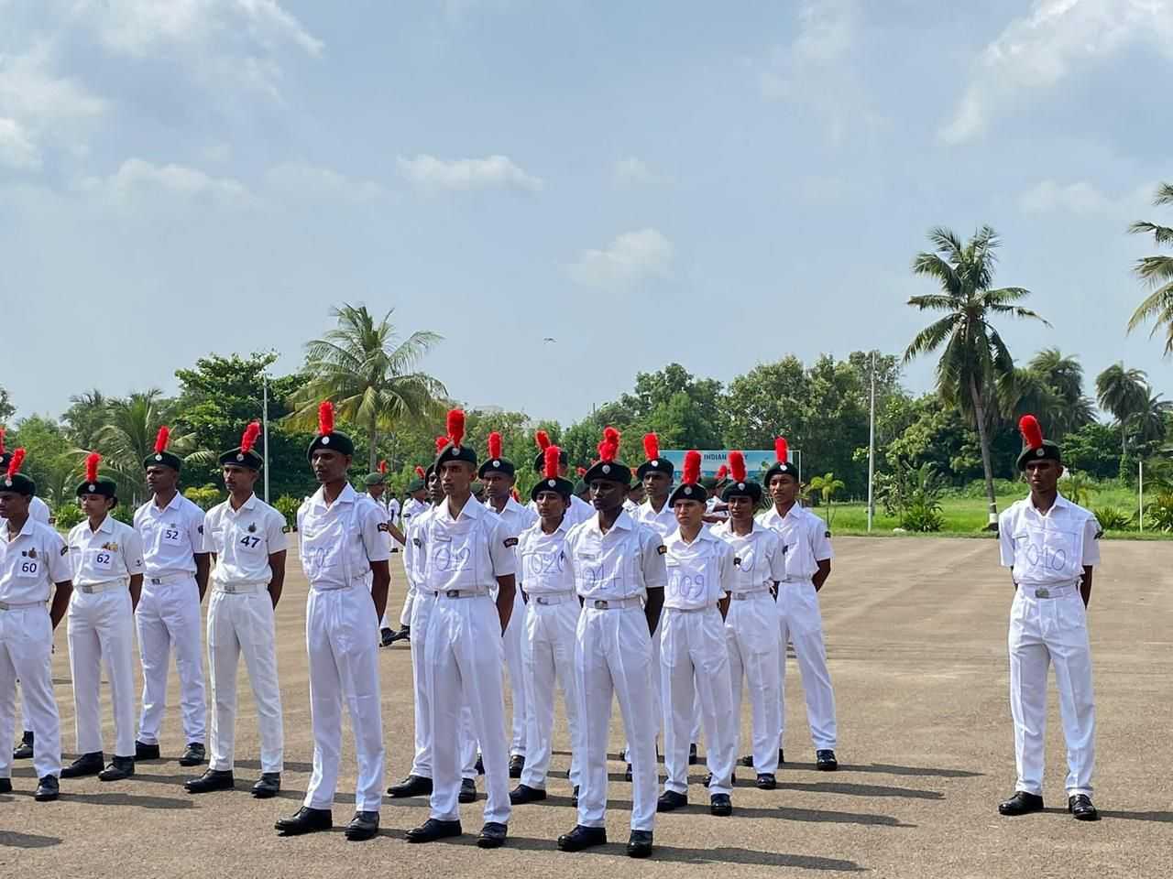

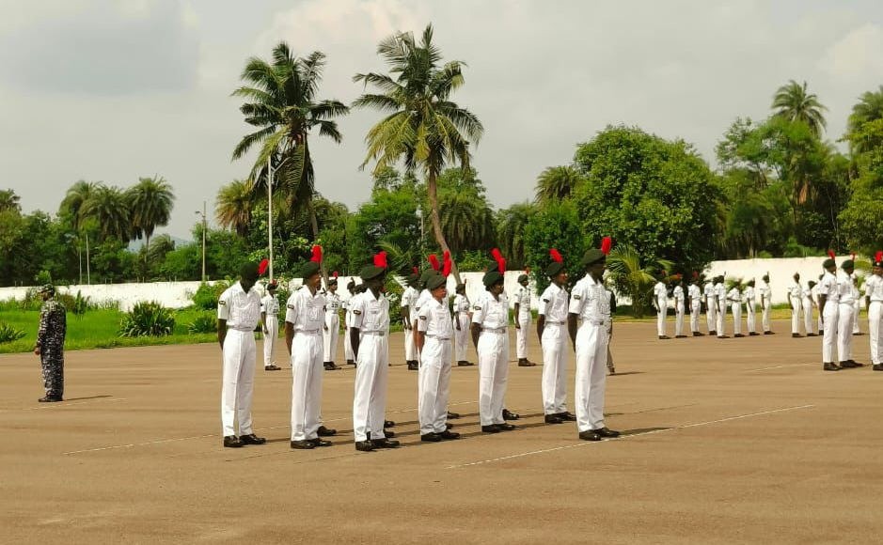

ALL.INDIA.NAU.SAINIC. Training-3 camp
(Launching)

On 13th august 2024 Leading cadet Sachin yadav,Leading cadet Farheen begum,cadet Ankith,cadet Hoshang,cadet Tymon attended A.I.N.S.C launching camp conducted at INS CIRCAARS,VISAKHAPTANAM in which they were provided with necessary training and kitting for A.I.N.S.C 2024. Their hardwork paved their way through IGC(AINSC) giving their best in each and every examination proving themselves better at the respective events. Launching camp ended on 23rd august 2024 from where 4 cadets were sent to AINSC conducted at INS SHIVAJI in Lonavala.
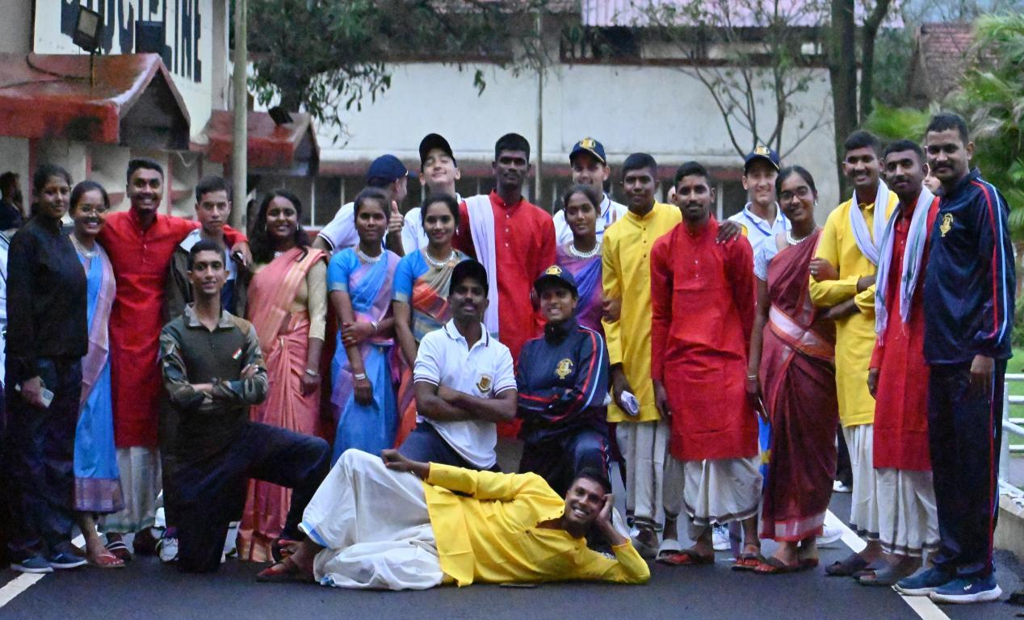

ALL INDIA NAU SAINIC CAMP -2024

Leading Cadet Sachin yadav ,Leading cadet Farheen begum, cadet Ankith,cadet Hoshang finally attended the ALL INDIA NAU SAINIC CAMP on 24th august 2024 conducted at INS SHIVAJI,Lonavala. Leading cadet Farheen begum and cadet Aswath won bronze medals in the event Health and Hygiene. Cadets of AP&T directorate got an opportunity to have dinner with Director General of N.C.C Lt.Gen Gurbirpal Singh AVSM,VSM.

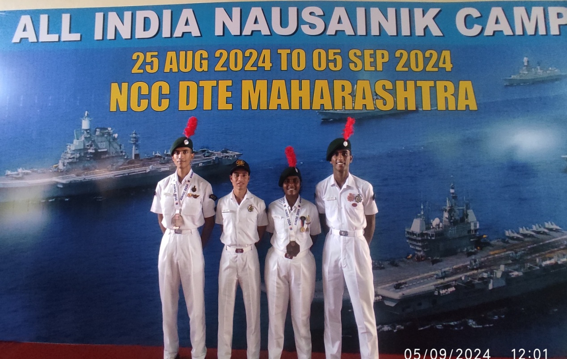

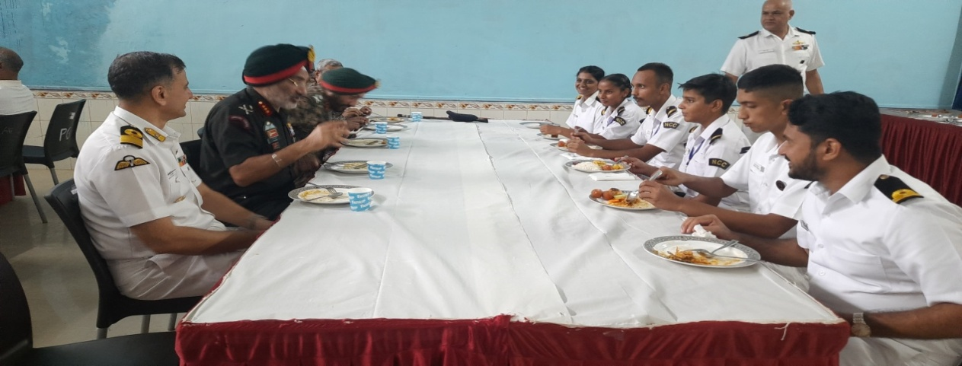

ALL INDIA TREKKING CAMP KERALA 2024

Cadet Poorna sai Pravallika attended All INDIA Trekking camp conducted by 18 k battalion in Jawahar Navodaya Vidyalaya kulamavu in Idukki district of kerala from 10th september to 17th september. 510 cadets from 5 directorates participated in this national camp.The main activity of the camp, trekking was conducted through four different routes including 2 educatonal treks and 2 treks to tourist places.primary objective of this camp was to instill self confidence in cadets and prepare them to face challenges in any environment.

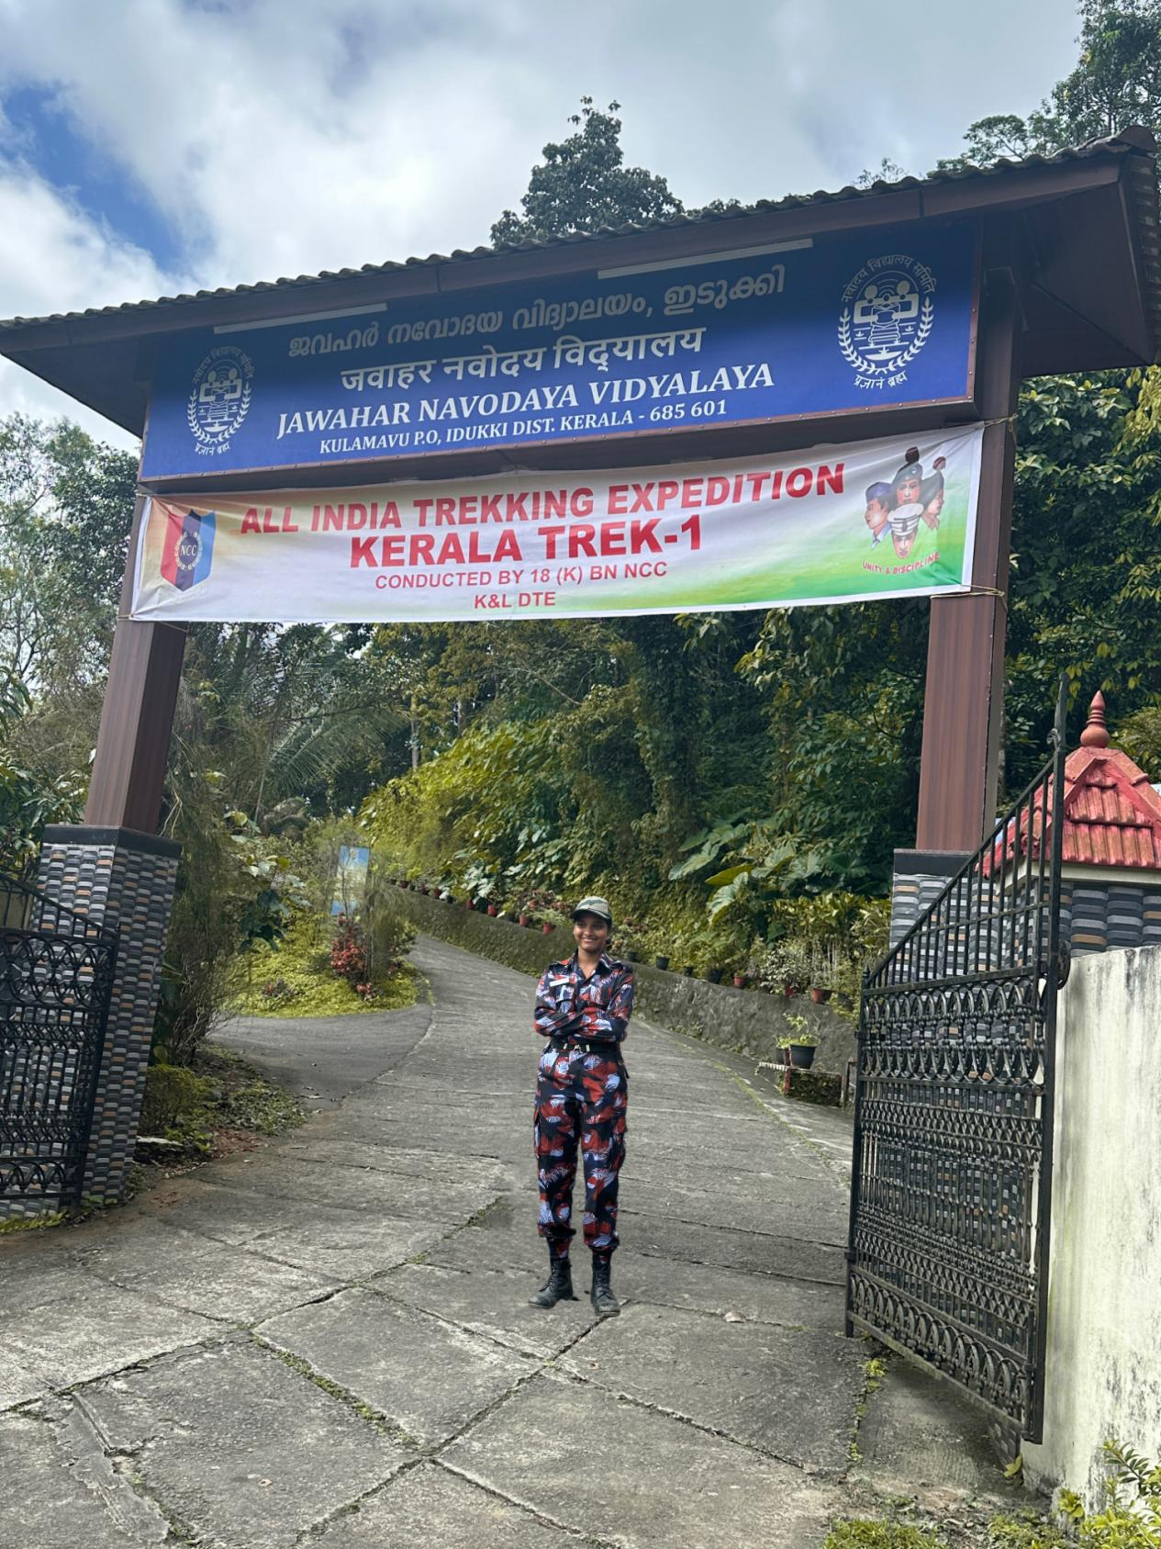

COMBINED ANNUAL TRAINING CAMP-IX

Cadet Rohith and Cadet vaishnavi attended combined annual training camp conducted at Bison training grounds in secunderabad group from 15th september 2024 to 24 september 2024. Where all the cadets from the 3 wings of Army,Navy and Airforce participated in. Here all the cadets were given training and basic lessons were taught by PI STAFF and ANO’S which were very similar to that of the Annual Training Camp.This CATC camp was conducted by 1 (T) EME Unit NCC.
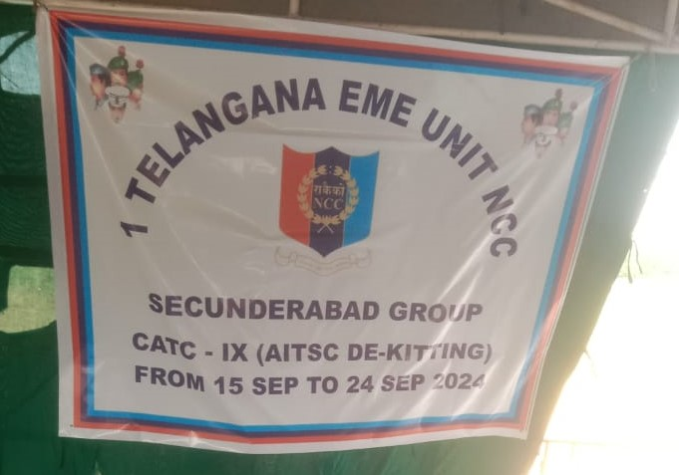

RDC- IUC 2024

Cadet venkat, cadet Akhil,cadet Karthik, cadet Hasitha got selected for the republic day camp where the cadets were given drill training at bison training grounds by frill ustaad and were further filtered for the upcoming IGC and launching camps.The camp was conducted by 4 (T) battalion Army NCC being supervised by PI STAFF AND ANO’S,COMMANDING OFFICERS of different units.
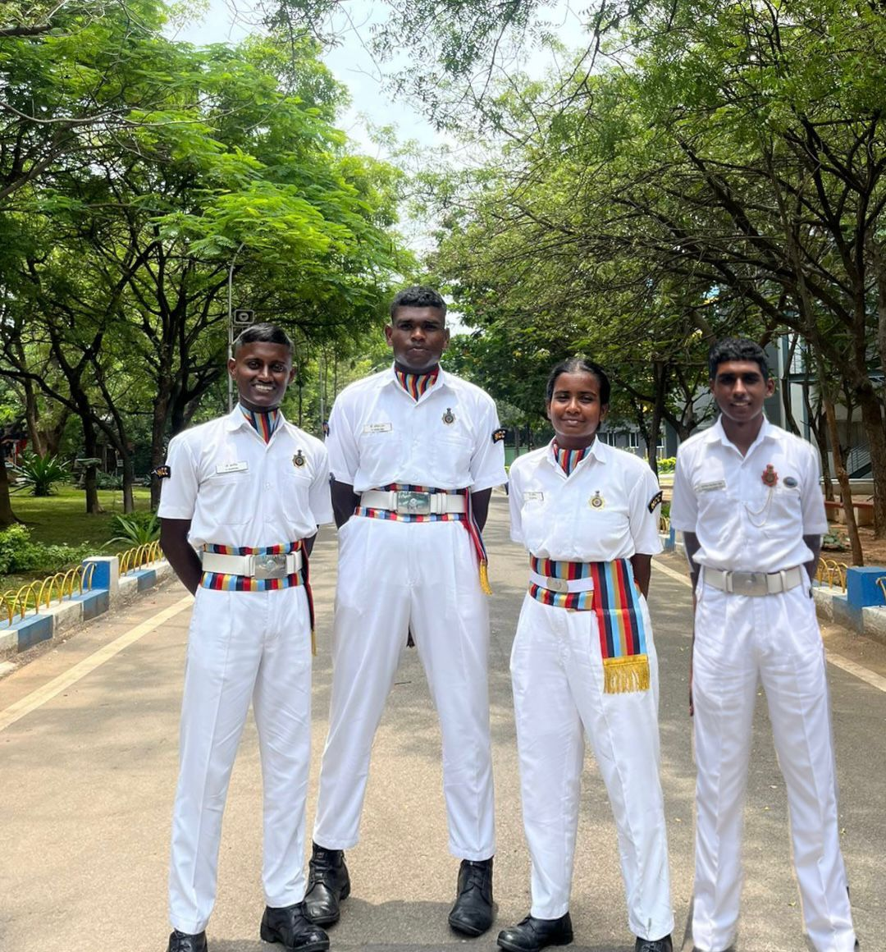

Parasailing camp 2024

On 8th of october 2024 cadet shiva, cadet osteen and cadet sneha attended parasailing camp at A.O.C Grounds by 2(T) air squadron which was supervised by 2(T) air sqn PI staff and 1 (T)girls Bn NCC.cadets were given experience and instructions on what is parasailing and how is the activity done in a right manner with safety protocols. Cadets from Army, Air force also participated in this
camp.

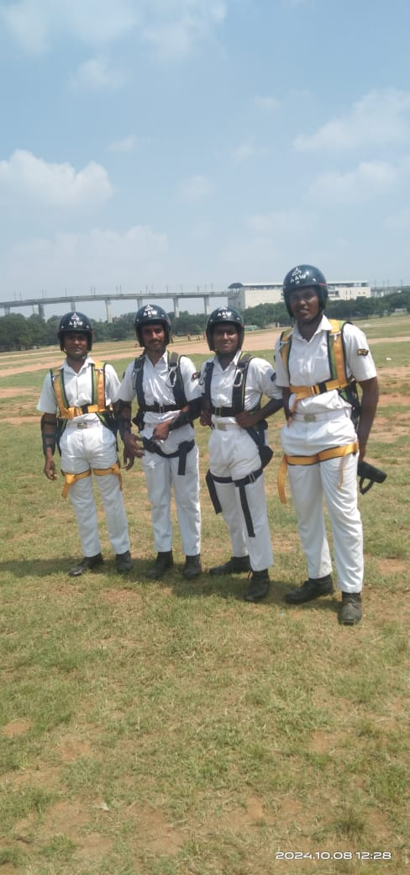

Sailing expedition -2024

Sailing Expedition, MENU CAMP, Chilka Lake, Odisha conducted by 7 A Naval Unit, Narsapur at INS Chilka, Balugaon District of Odisha from 25th September to 4th October 2024. The camp consisted of 105 cadets from AP&T consisting of
1 T Naval Unit
3 A Naval Unit
4 A Naval Medical Unit
6 A Naval Unit
7 A Naval Unit
8 A Naval Unit &
10 A naval unit.

The whaler boats will sail from INS Chilka as a base point with sailing trips to various waypoints around the coast line of the Chilka Lake such as Ma Kalijai Temple, Kalijai Island, Rambha Town, Gupteshwar Island, Indraprastha & Krushnaprasad Island covering approximately 220 KM, over a period of 10 days from 25 Sep - 04 Oct 24.

The sailing expedition is planned to expose the Naval Cadets to the art of sailing without propulsion in Sea/rivers and train them in various facets of sailing.

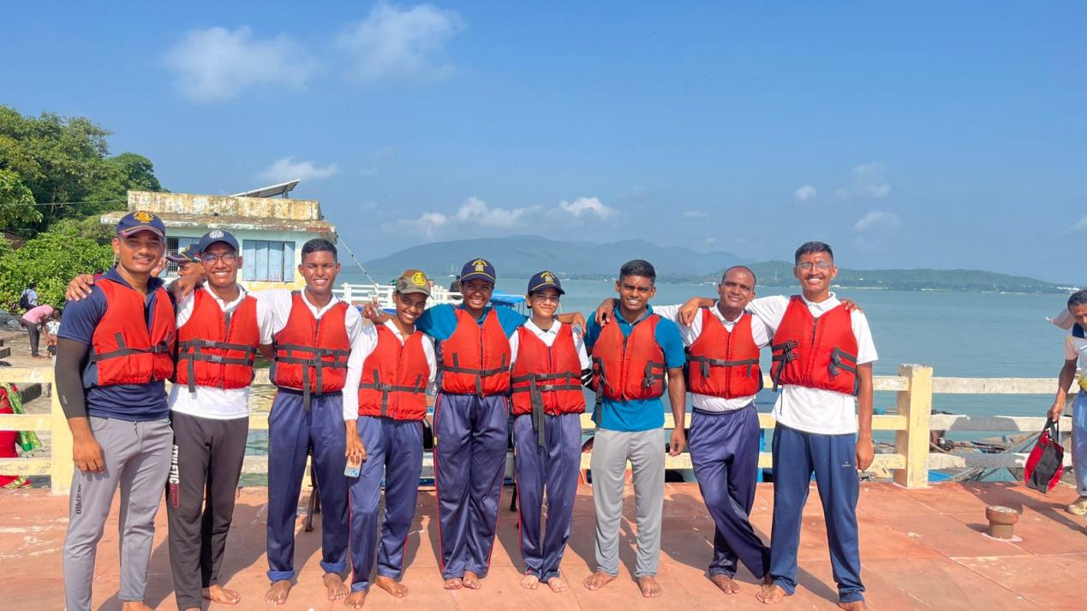

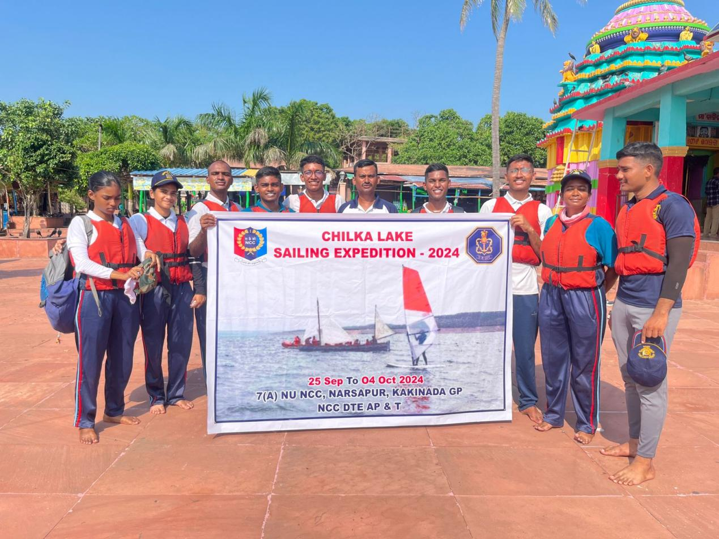

R.D.C I.G.C Camp 2024

Cadet Akhil participated in the Inter Group Competitions held at the bison training ground, Mehedipatnam. Here cadets were given training on various events such as drill,Best cadet etc. Cadet Akhil participated in the drill event where he was taught rifle drill and marching.

Pre R.D.C I
Cadet Akhil attended the further training camp of R.D.C by performing excellently through the drill tests throughout his I.G.C. This camp had many cadets filtered from the I.G.C where cadets are put to the utmost training to excel their drill. The tests were supervisioned by the Adjutant Director General of N.C.C Colonel Sanjay Gupta.

Pre R.D.C II
Cadet Nikhil & Cadet Pravallika attended the further training camp of pre R.D.C II by performing excellently through the drill tests conducted. Camp was conducted at the Army Garrison,Mehedipatnam. This camp had many cadets filtered from the Pre R.D.C where cadets were put to the utmost training to excel their drill. The tests were supervisioned by the higher officials of the camp.
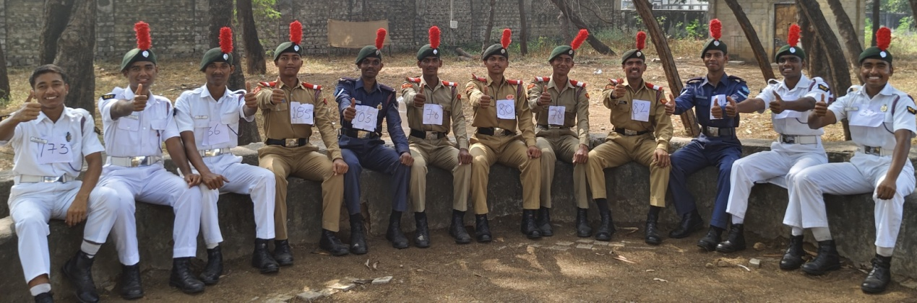

ALL INDIA YATCHING REGATTA 2024
All India Yatching Regatta is conducted every year at INS Chilka , Odisha cadets from 17 directorates compete against each other. Cadet C Karthik from Loyola Academy participated and came in the 8th position overall.Cadet C Karthik made his way into A.I.Y.R through achieving gold medal in sailing of I.G.C NAU SAINIK conducted at Visakhapatnam.
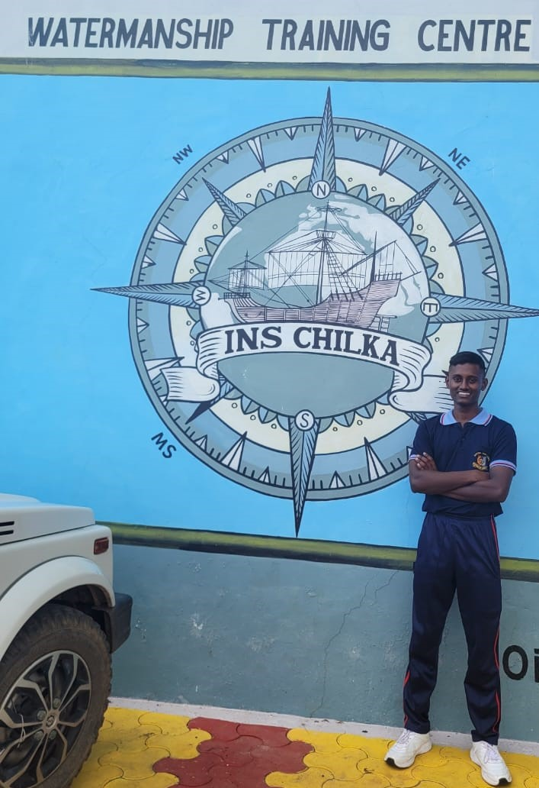

OVERSEAS DEPLOYMENT 2024
Overseas deployment is an international camp for naval wing cadets where they travel in Indian Navy or Indian Coast Guard ships across various countries. Cadet Aswath participated and traveled across Iran, UAE,Kuwait and Behrein. Cadet K.Aswath made his way through the preliminary rounds by acheiving 5 medals (2 gold, 3 silver) in the I.G.C Nau Sainic camp in different events such as drill,semaphore,dk whaler rigging and several other activities.
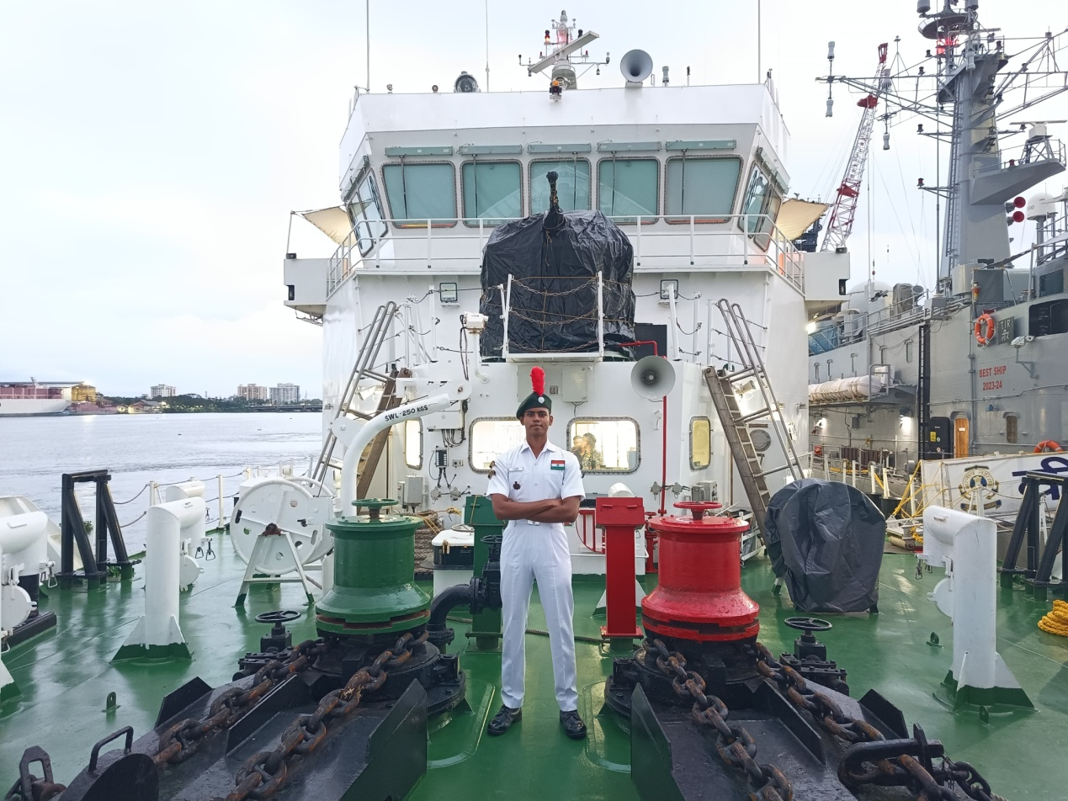

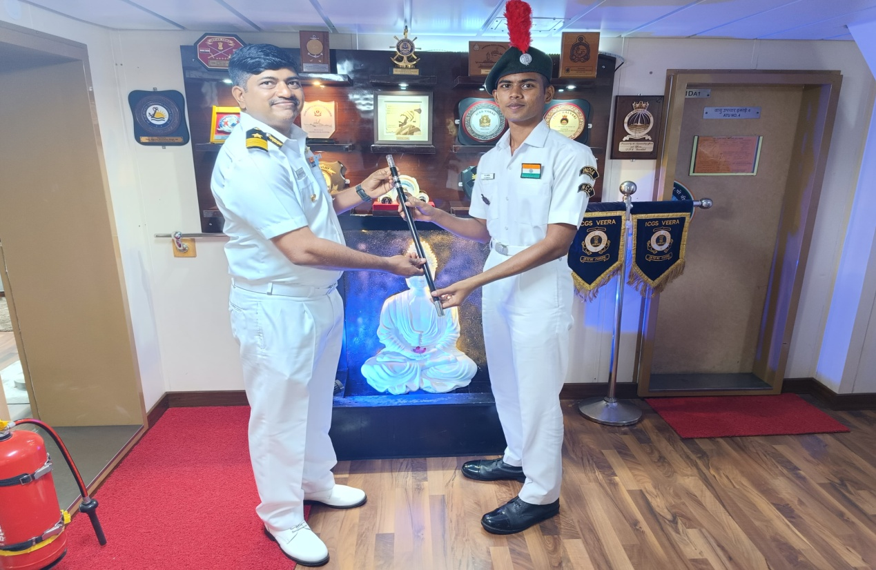

Special Yatching Training Camp:
Cadet P.S.Shiva kumar attended Special Yatching training camp from December 6th – December 13th . In the camp cadets were taught sailing and rigging in the E-P boat. There were several other activites conducted to teach cadets different aspects of sailing and rigging the ropes for sailing.
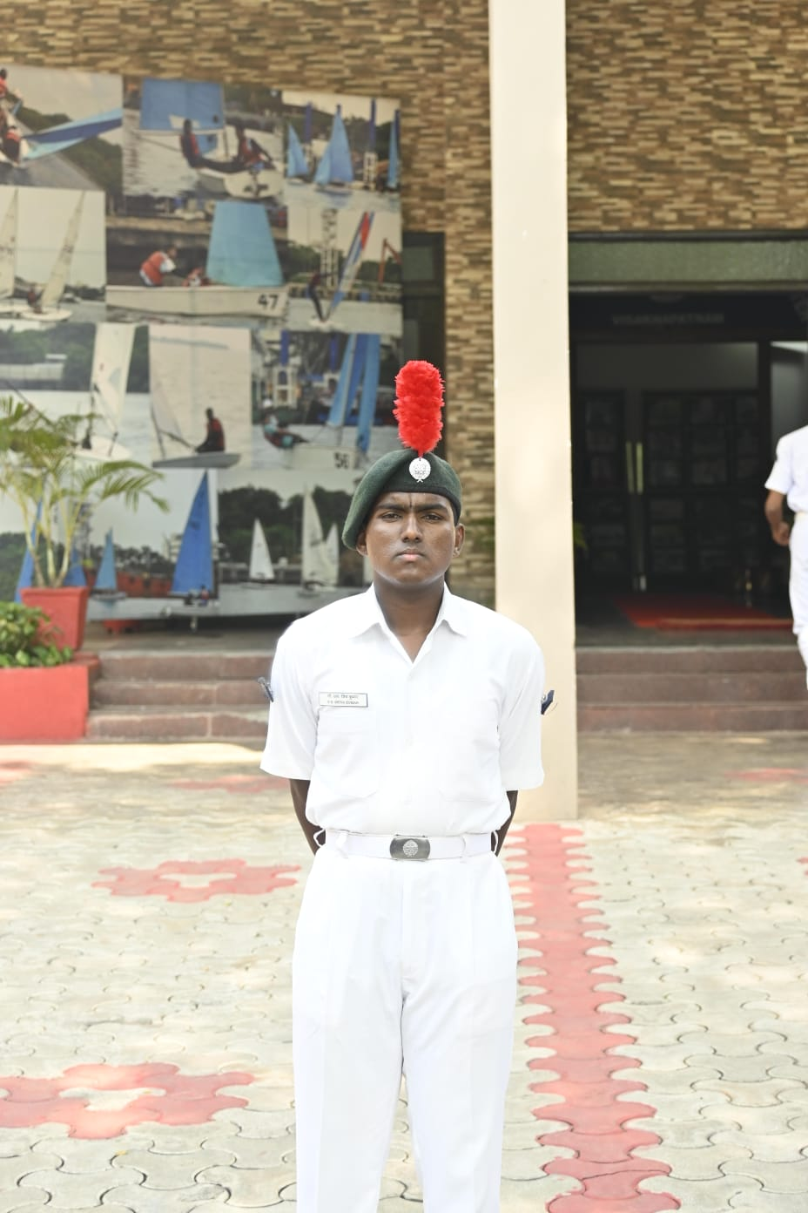

Special National Integration camp

Cadet Tymon attended the S.N.I.C conducted (SNIC) was held in Wokha, Nagaland, from December 11th to December 22nd, 2024, with 2 cadets participating. Cadets were taken to a visit to the kohima memorial and doyang hydro project. There were several other ativities like singing,tug of war,volleyball. Cadet Tymon won a cup in singing competition.

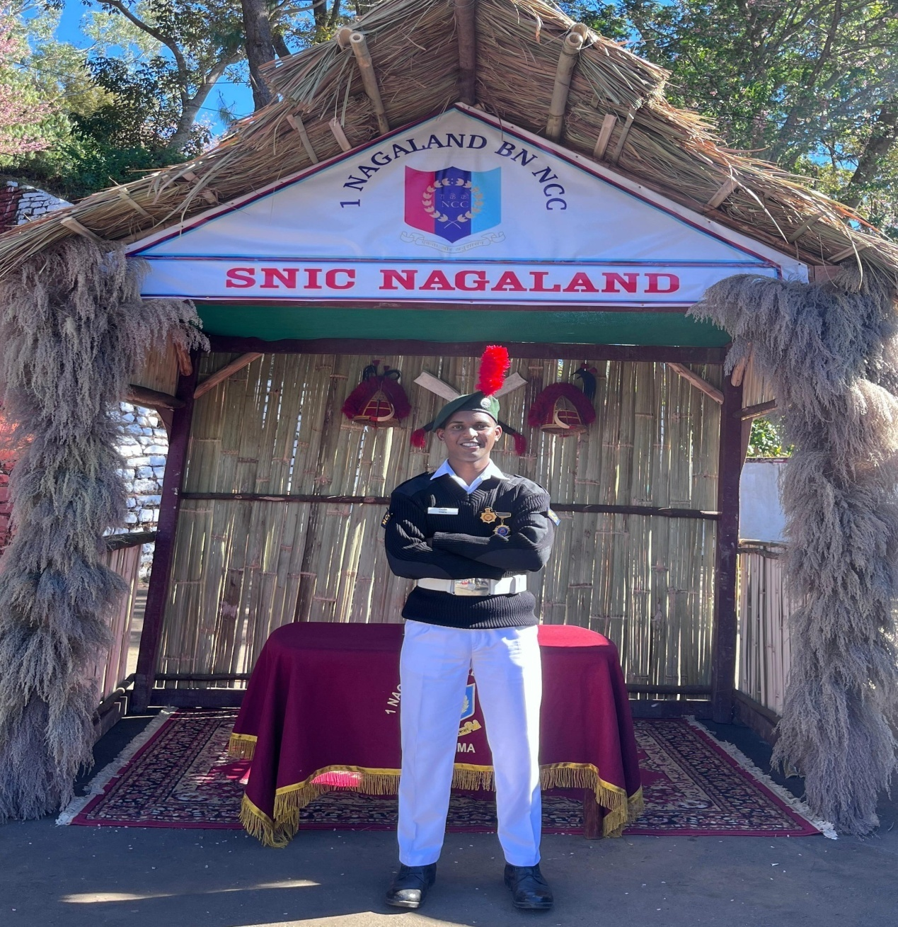

Scuba diving camp
Leading cadet Farheen Begum & Cadet Gopichand,Cadet Osteen,Cadet C karthik attended the scuba diving camp held at Visakhapatnam from 15th Dec-24th Dec. Cadets were taught about the basics of scuba diving by the professional divers of Indian Navy. They were well versed with the equipment needed for the divng and the basic rules to be followed while doing the activity.
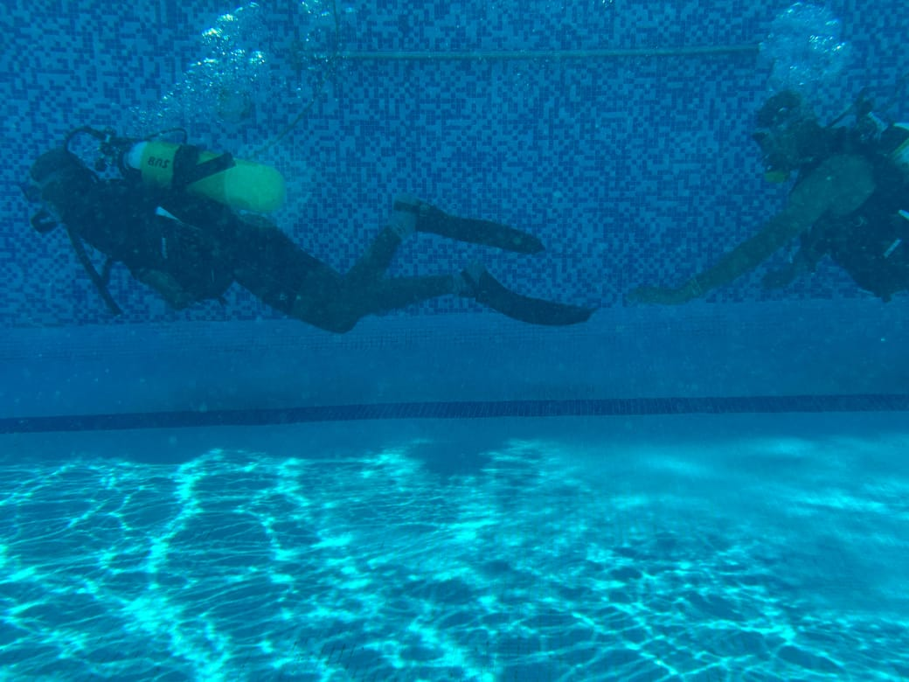

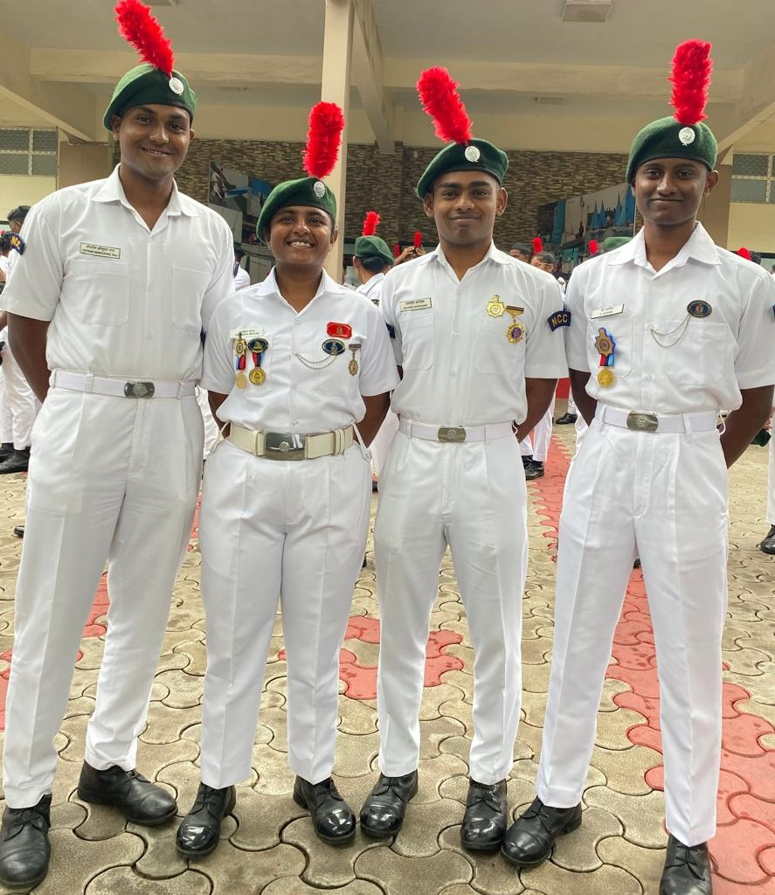

EK BHARAT SHRESHT BHARAT
Leading Cadet G.Vamshi Krishna & cadet sneha attended E.B.S.B camp at BTG in AP&T Directorate. Cadets interact with each other and explain each other about cultures of their respective directorates and enjoy the cultural programs of different backgrounds. The camp was conducted at Udaipur,Rajasthan.cadets were allowed to visit several historical places and were taught the importance of the monuments.

