

TITLE OF THE EVENT | Inside Out: A Self-Understanding Session
DATE | 24th February, 2026
VENUE | Commerce Block-NCBS
ORGANIZER, COORDINATOR | Counselling Cell, Ms. Sahithya Guduru
SPEAKERS/ RESOURCE PERSONS | Ms. Sahithya Guduru
TARGET AUDIENCE | Students
OBJECTIVES OF THE EVENT:
To help participants understand their self perception and emotions
PARTICIPANTS DETAILS:
TOTAL PARTICIPANTS |  | 28
DEMOGRAPHICS |  | Students
ATTENDANCE PERCENTAGE |  | 58%
CONTENT EVALUATION:
RELEVANCE OF THE TOPIC:
To equip students with more knowledge about themselves and their interpersonal orientation.

DEPTH OF KNOWLEDGE DELIVERED:
Conceptual and experiential understanding of self-awareness, emphasizing reflection and personal meaning rather than technical interpretation. We have conducted a draw-a-person test to make them understand themselves better, with the help of the resource person, it was later interpreted.

ENGAGEMENT OF PARTICIPANTS:
The students were encouraged to reflect about their interpersonal orientation and self exploration
LEARNING OUTCOMES:
- Develop basic self-awareness through guided reflection.
- Identify personal emotions, thoughts, or patterns that emerged during the activity.
- Engage in reflective thinking about self-image and emotional expression.
- Recognize art-based activities as tools for emotional expression and insight.
- Initiate self-reflection without judgment or pressure.

KEY TAKEAWAYS FOR PARTICIPANTS:
- Awareness of one’s thoughts and feelings is the first step toward emotional well-being.
- Creative activities can support insight without requiring artistic skill.
- Understanding oneself is a gradual and personal process.

SKILLS/KNOWLEDGE GAINED:
- Ability to engage in guided self-reflection.
- Improved emotional awareness through experiential learning.
- Enhanced expressive skills using creative media.
- Development of introspective and reflective thinking.
FEEDBACK ANALYSIS:
METHOD OF FEEDBACK COLLECTION: Offline

POSITIVES:
- Boosted Mood & Positivity
- Self-Reflection & Awareness
- Encouragement & Motivation
- Sense of Connection & Agreement
- Emotional Impact & Meaningful Experience
RATING ON A SCALE of 1-5:4 CONTENT QUALITY: 4
SPEAKER EFFECTIVENESS: 4
PRESENTATION STYLE: 4
QUANTITATIVE ANALYSIS AND FUTURE PRACTICES:

SUGGESTIONS FOR FUTURE EVENTS:
- Better Crowd Management
- Enhance Engagement & Fun Activities
- Include more hands-on activities or mini role-plays.
EVENT PHOTOS:

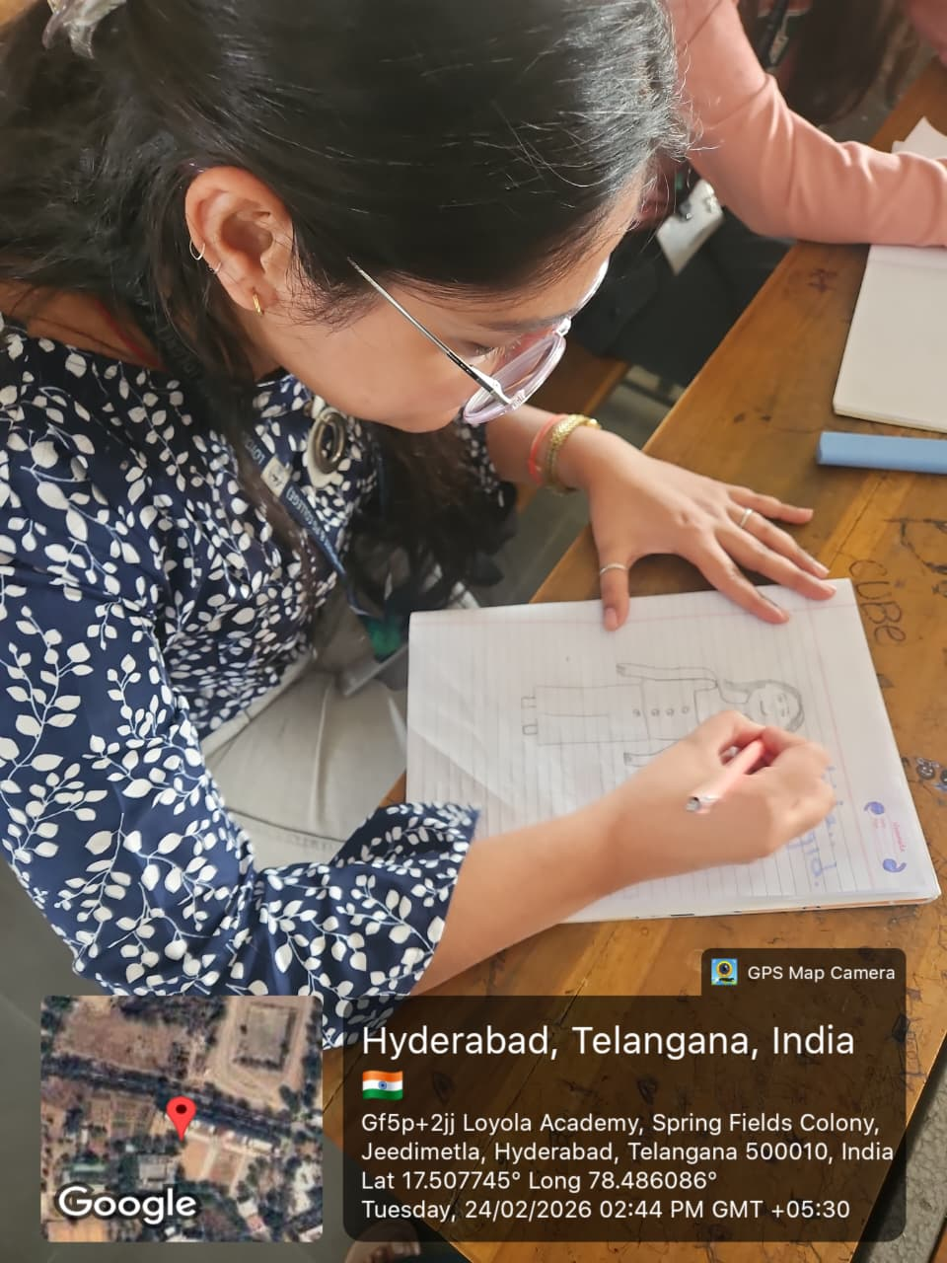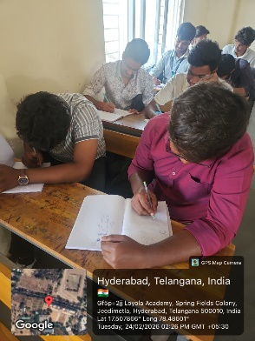

Offline Feedback

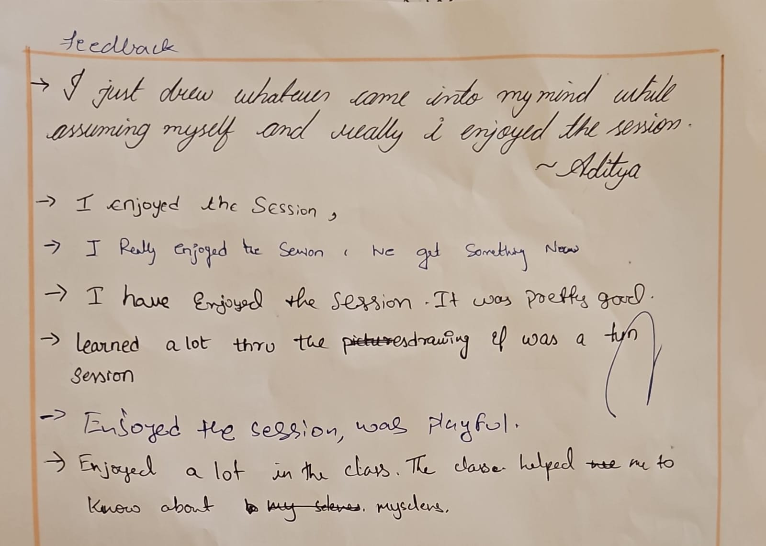

ATTENDANCE SHEET:

