
TITLE OF THE EVENT | Alumni Day 2025  Timeless Threads: Weaving 50 Years of Loyola’s Legacy.
DATE | 8th November 2025
VENUE | Inigo Hall
ORGANIZER, COORDINATOR | - Ms G Sirisha, Coordinator, Loyola Academy Alumni Association.  - Ms N Rajeshwari, Asst Coordinator, Loyola Academy Alumni Association.
SPEAKERS/ RESOURCE PERSONS | - Rev. Fr. Dr. A. Francis Xavier, SJ, Correspondent.  - Rev. Fr. Dr. N.B. Babu, SJ, Principal.  - Rev. Fr. J. Vijayakumar Reddy, SJ, Principal, Loyola Academy Junior College.  - CHIEF GUEST - Dr Satyanarayana V Nandury, Ph.D (CSE) IIT Khargapur, MBA XLRI, Consultant, R&D Projects & Technology, Scaleup Operations.  - Mr Mariadas Pudhota, President, Loyola Academy Alumni Association  - Mr Kaushik Kathuri, Presidents, Loyola Academy Junior College Alumni.  - Mr Manikya Reddy Chintala, Secretary, Loyola Academy Alumni Association.
OBJECTIVES OF THE EVENT:
To reminisce and recall cherished memories with former students, celebrate their achievements, reconnect and network with old friends and faculty and explore new opportunities.
PARTICIPANTS DETAILS:
Members of the Management, Alumni Association, Alumni from 1980s to 2020s, faculty, non-teaching staff, coordinators and members of the student council.
TOTAL PARTICIPANTS |  | 500
ATTENDANCE PERCENTAGE |  | 96%
DETAILS OF THE ACTIVITY:
Since its inception in 1976, Loyola Academy has recorded unforgettable memories of its students and their achievements throughout its semicentennial journey. Alumni Day 2025 witnessed a gargantuan gathering of alumni from across the nation - bringing together the students who had crossed the portals decades ago with those students who had recently bid farewell to their alma mater. The fascinating evening recalled, recorded and rejoiced in the echoes of the familiar voices from years past. Rev. Fr. Dr N Francis Xavier, SJ, Correspondent warmly welcomed the former pupils. In his address, he emphasised that this alumni meet was not merely a gathering, but a platform to commemorate the success stories of the Loyolites, who have crossed oceans to create a brand of their own. He expressed that every alumnus is living proof of Loyola Academy’s vision, mission and joy. Rev. Fr. Dr. N.B. Babu, SJ, Principal commended the contributions of the alumni stating that the present stature of Loyola Academy was achieved through countless students excellence. He reflected that a reunion is more than an exchange of stories - it is about a walk down the memory lane where every echo feels fresh and alive.
Rev. Fr. J Vijay Kumar Reddy, Principal, Loyola Academy Junior College, reflected on Loyola’s journey, shared how the founders dreamed of an institution driven by purpose and passion - a dream now alive in its classrooms, playing fields and every corner of the campus. Quoting ‘We make a living by what we get, but we make a life by what we give’, he inspired everyone to continue the Loyola legacy. Dr Satyanarayana V Nandury, Consultant, R & D Projects & Technology, Scaleup Operations, chief guest for the occasion, fondly recalled his student days. He expressed his gratitude to his teachers for shaping him into who he is today and conveyed his delight at being invited as Chief Guest to the institution where his journey once began.
Mr Maria Das Pudhota, President, Loyola Academy Alumni Association expressed immense joy in welcoming everyone to this Golden Jubilee year Alumni Day. He recalled how fifty years ago, the seed planted by Rev. Fr. Balaih, SJ had grown into a vast tree with branches spread across the globe. He proudly highlighted the achievements of Loyola alumni who transformed from leaders into changemakers, leaving their mark in diverse fields. Mr Kaushik Kathuri, President, Loyola Academy Junior College Alumni Relations, emphasised that alumni associations are a wonderful way to reconnect with one’s roots and witness how the new generation continues to carry the Loyola spirit forward.
Mr Manikya Reddy, Secretary of Alumni Association shared the anecdotes from his Loyola days and urged everyone to reconnect, collaborate and cherish the laughter in the corridors, the lessons in classrooms and the friendships that have stood the test of time. Mr Sudheer Surasani, Executive Director, Manchester Global School, Mr Lakkaraju Phani Prakash, Director Solutions & Sales, Baarez Technology Solutions Dubai, UAE and Dr T Chakradhar, Programme Policy Officer, Climate Resilient Agriculture at UN World Food Programme, (Batch of 1994-1997 batch) announced scholarships for meritorious students. The cultural programmes, interactions and memory wall captured the most appealing moments of the day. The echoes of laughter, joyful recollections and shared stories of funny times added warmth and beauty to the celebrations.
OUTCOME:
As many of the alumni expressed, it is not just a day of reunion but a day of reflection and recollection. Regardless of the distances they had traveled - crossing oceans and boundaries - they came to meet their beloved faculty and friends rejoicing in shared memories. Current students were delighted to see sexagenarian and septuagenarian alumni walking through the campus reminiscing about their college days.
FEEDBACK ANALYSIS:
The alumni were overjoyed to return to their alma mater. Though many wished for more time on campus, they suggested that future programmes be held outdoors and include more interactive sessions rather than a purely structured format.
METHOD OF FEEDBACK COLLECTION: Online
RATING ON A SCALE of 1-5:
ORGANIZATION OF THE EVENT :3.76
FEEDBACK FORMS LINK:
https://docs.google.com/spreadsheets/d/1xRnoihxtJTCPt37jfysbx3L4N5rAfrKwp5D7RCPhjrc/edit?resourcekey=&gid=2077171704#gid=2077171704
YOUTUBE LINK:
https://youtube.com/live/Xacj_UB7Nlc?feature=share
EVENT PHOTOS:
NOTICE

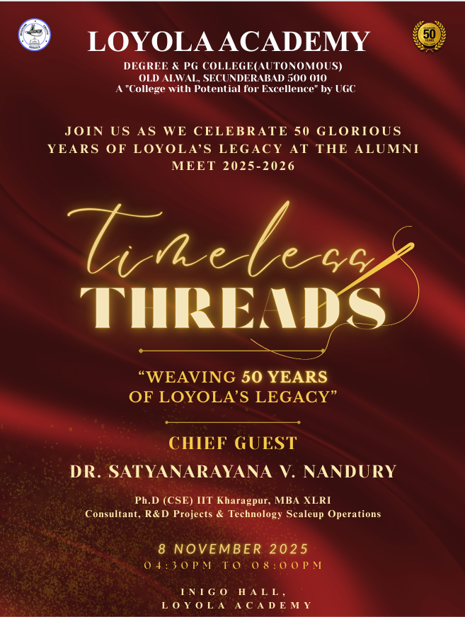 |  | 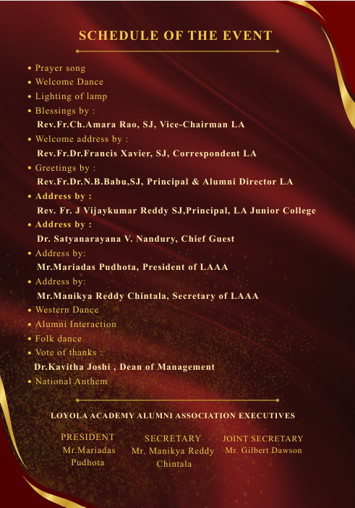
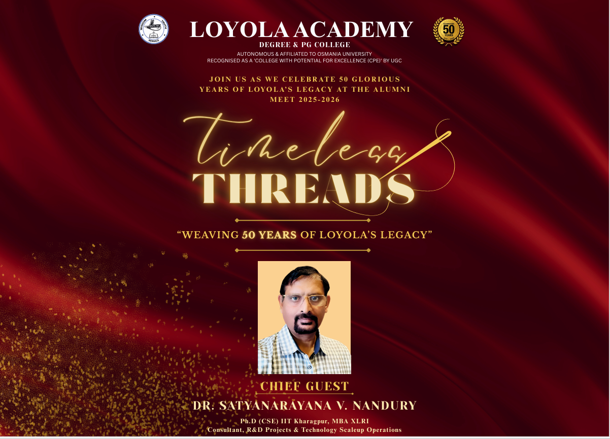
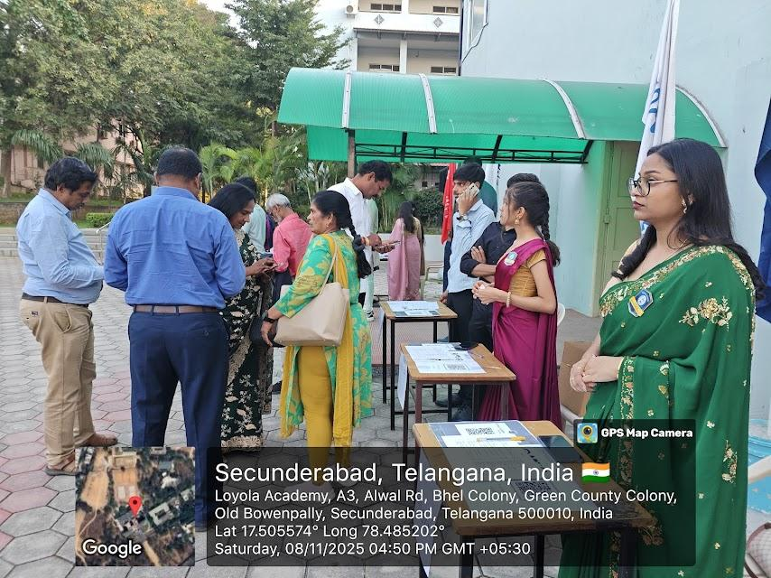 |  | 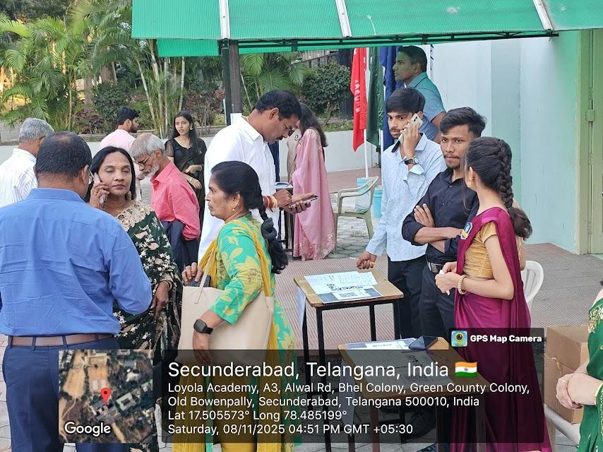
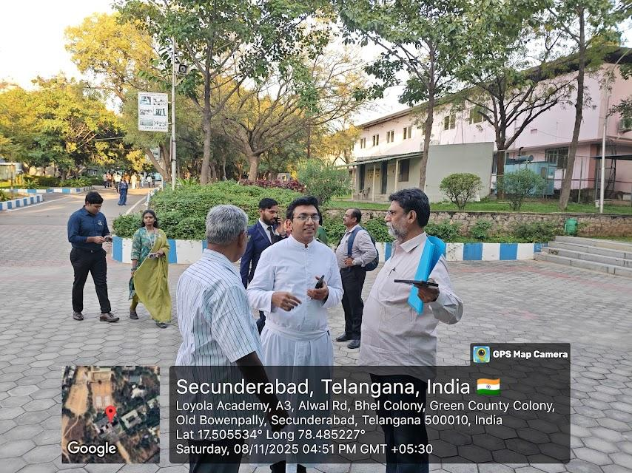 |  | 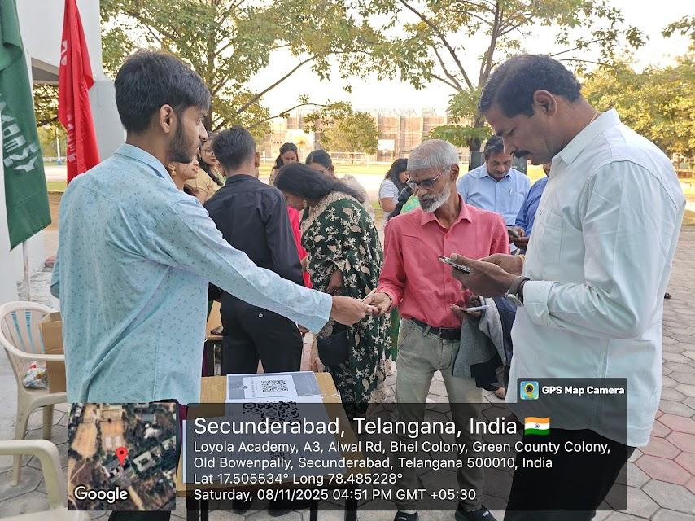
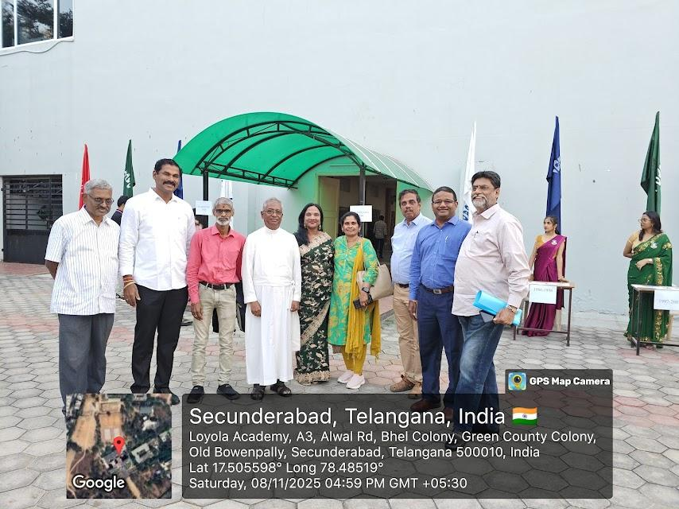 |  | 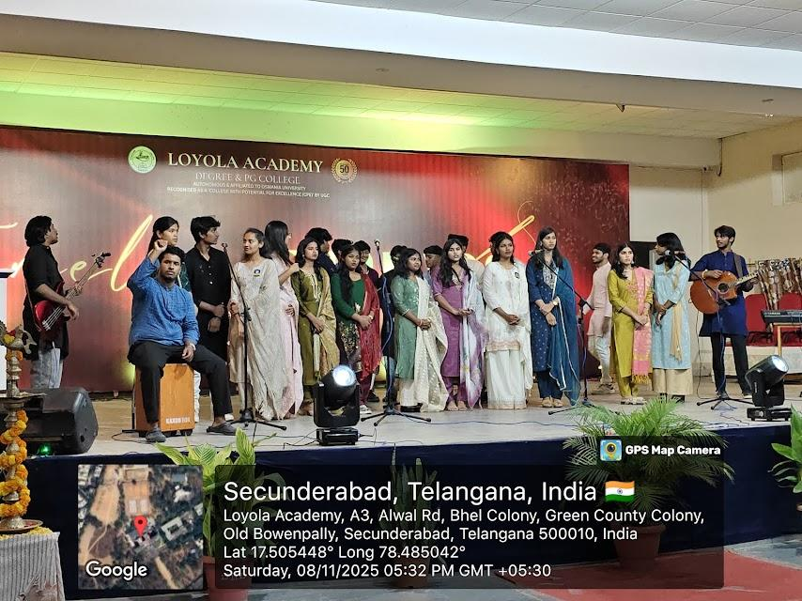
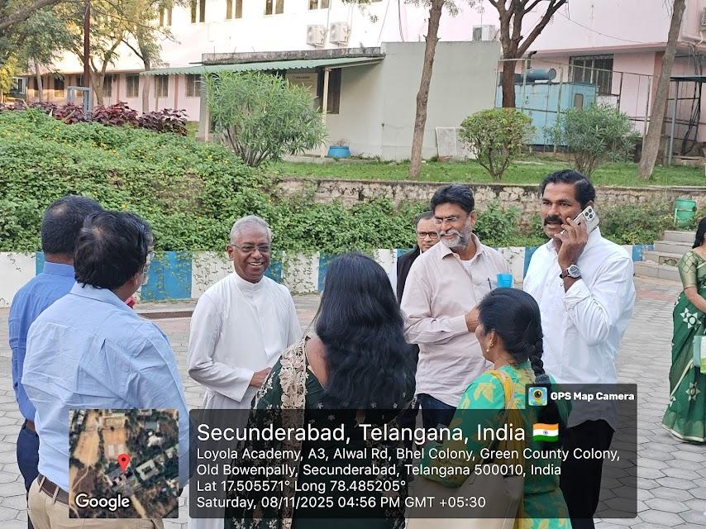
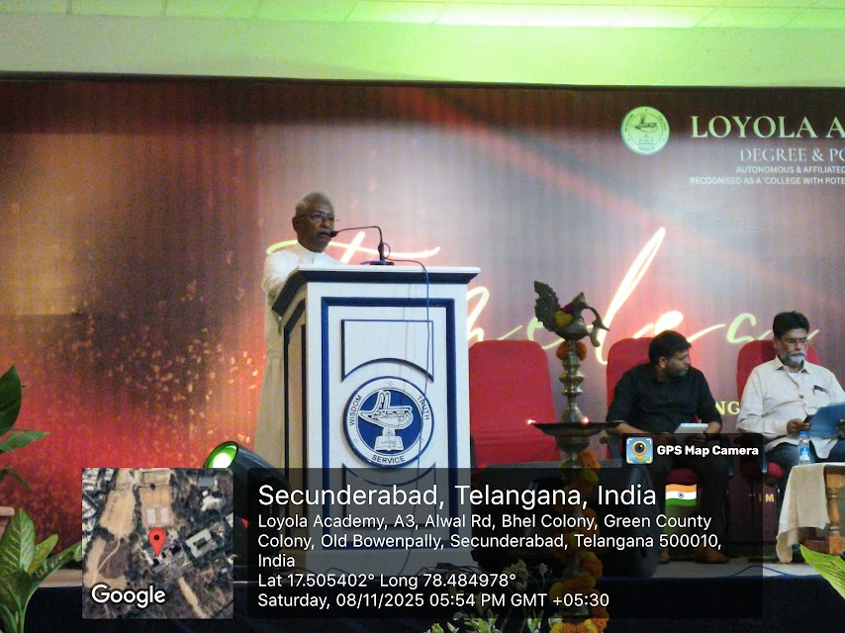 |  | 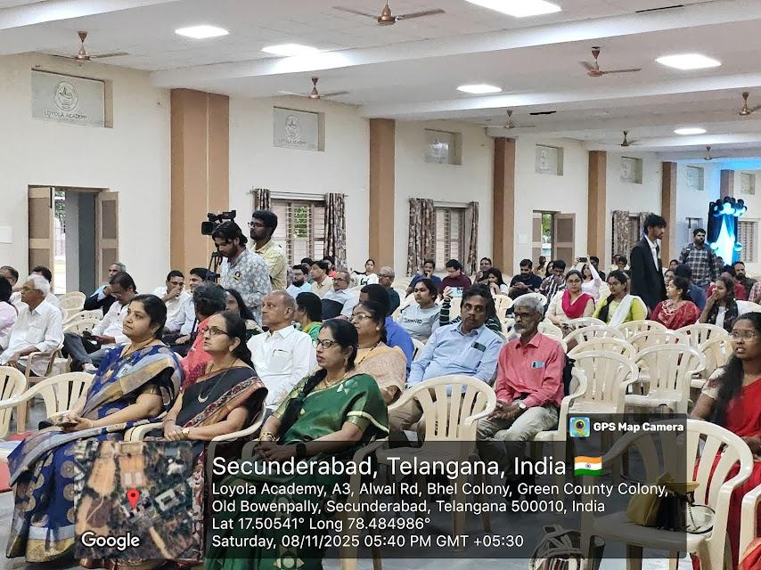
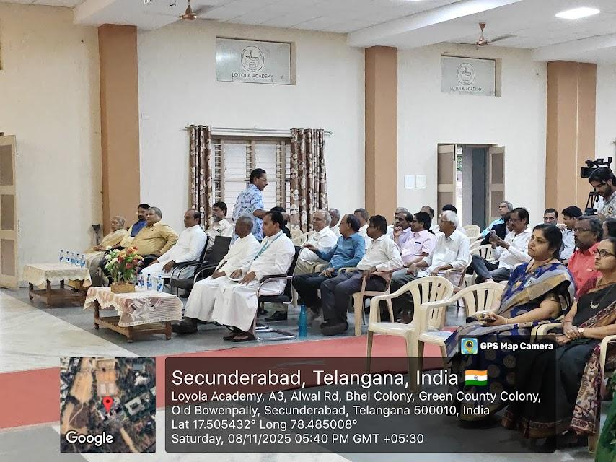 |  | 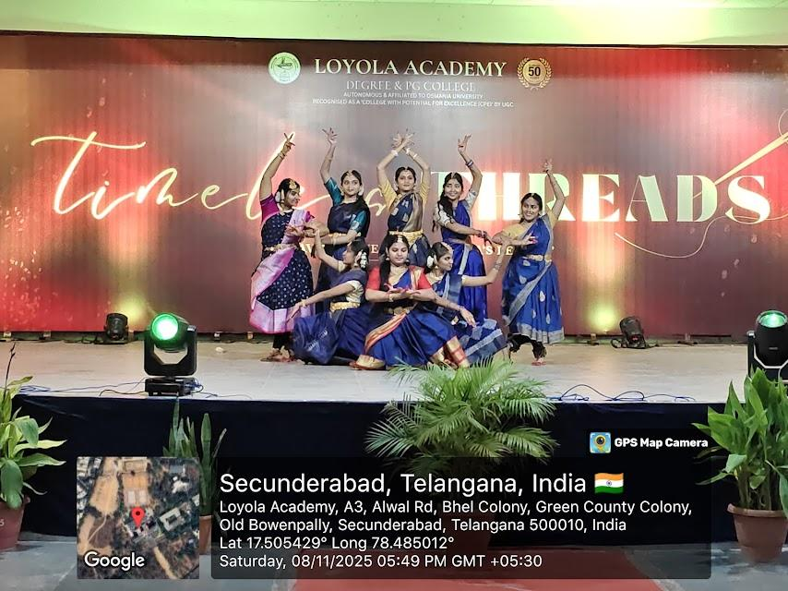
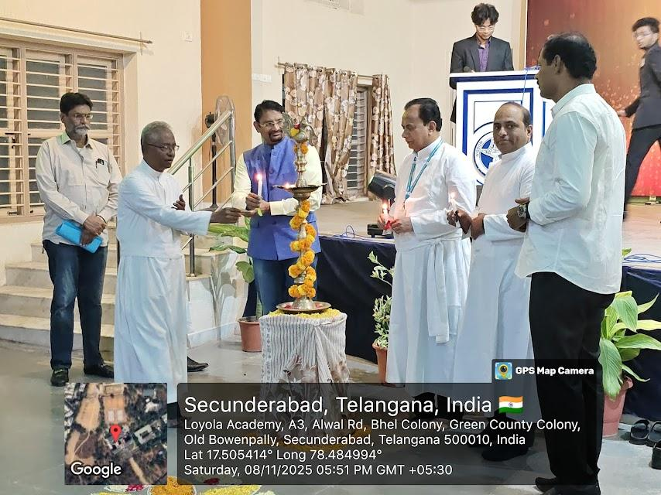 |  | 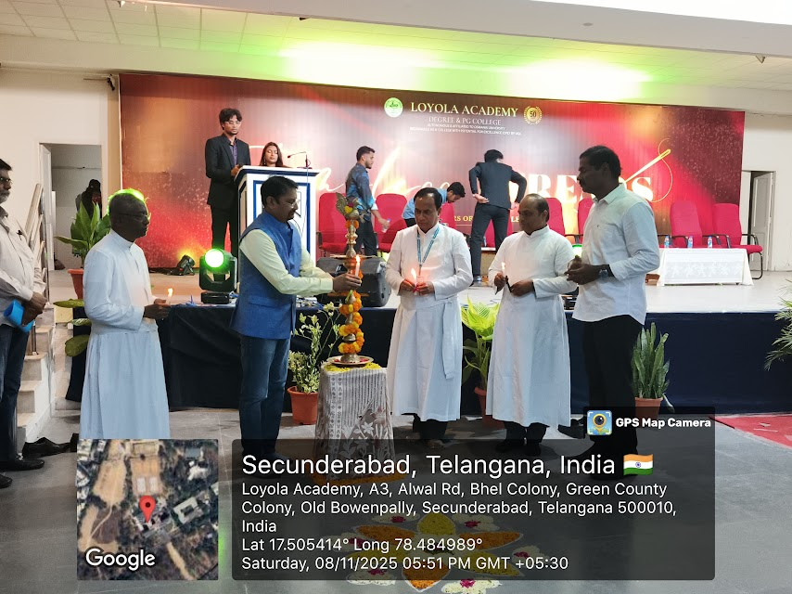
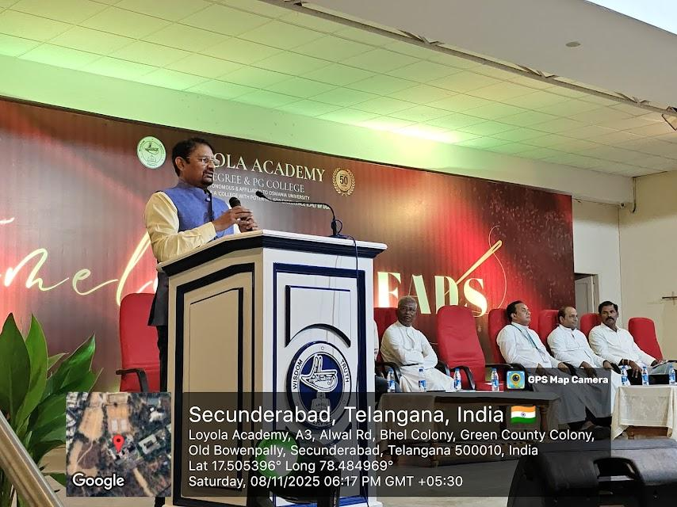 |  | 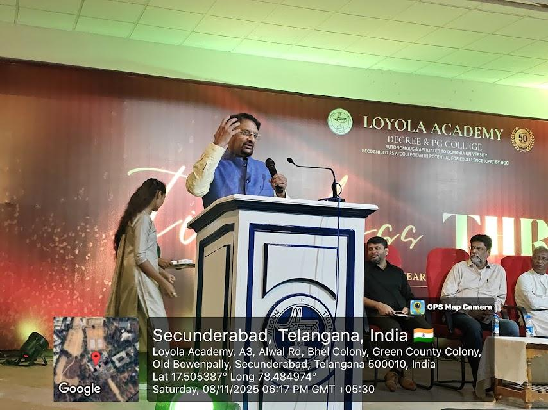
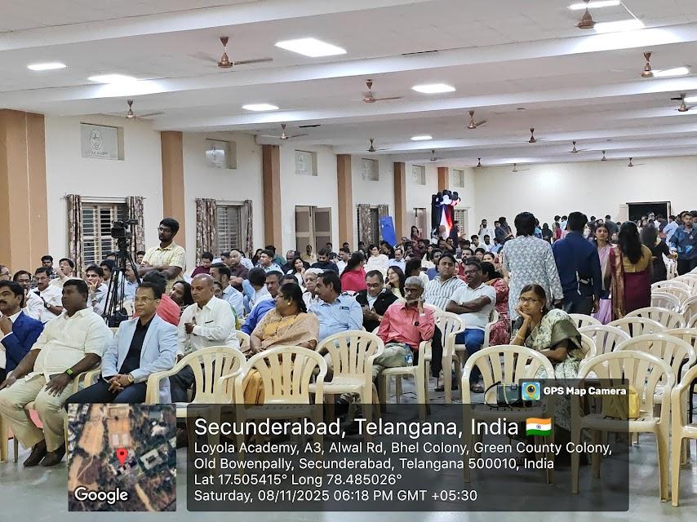 |  | 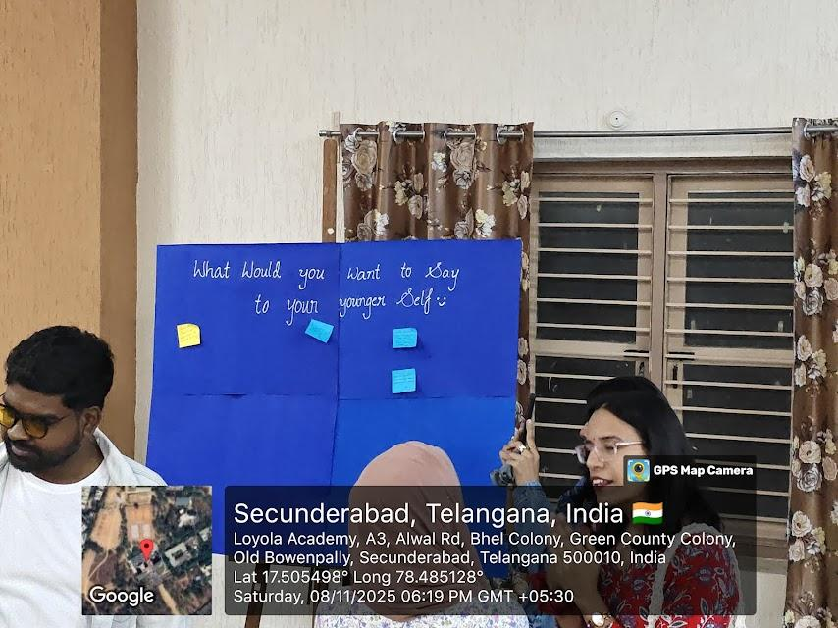
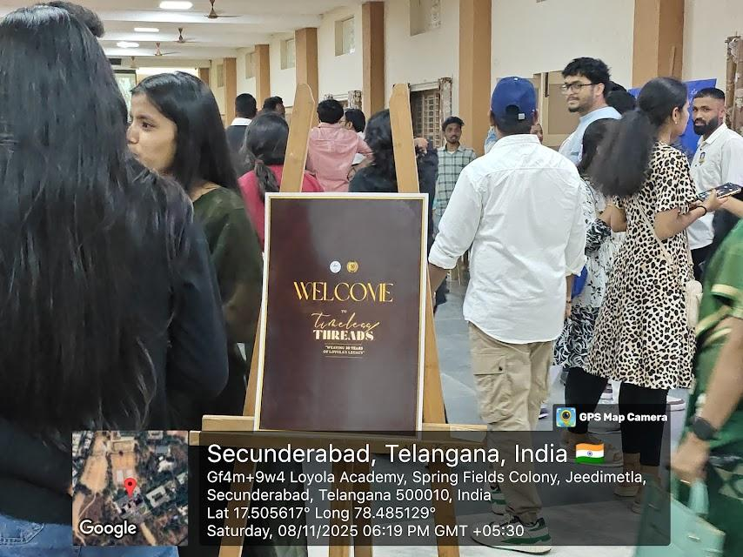 |  | 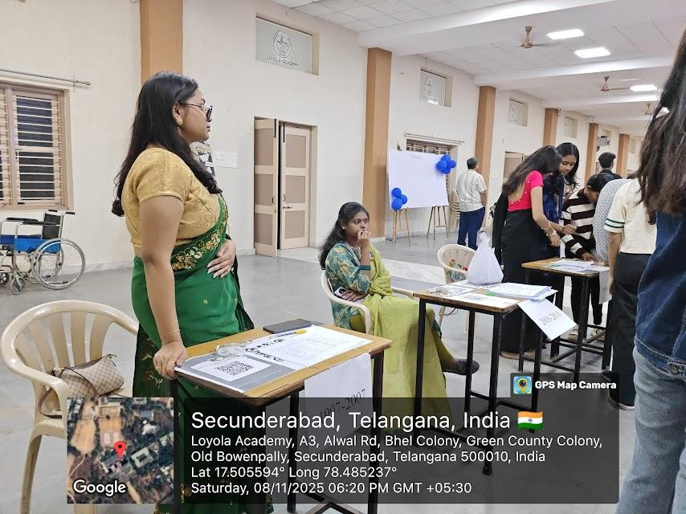
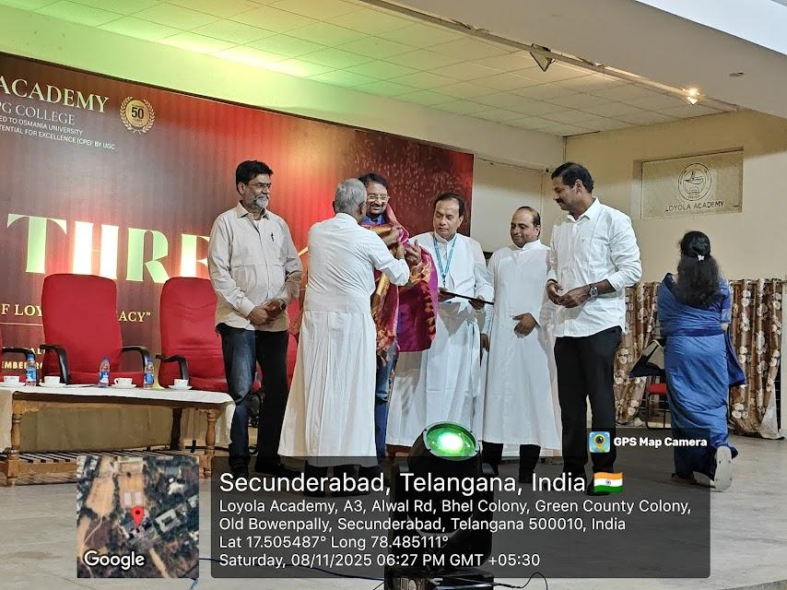 |  | 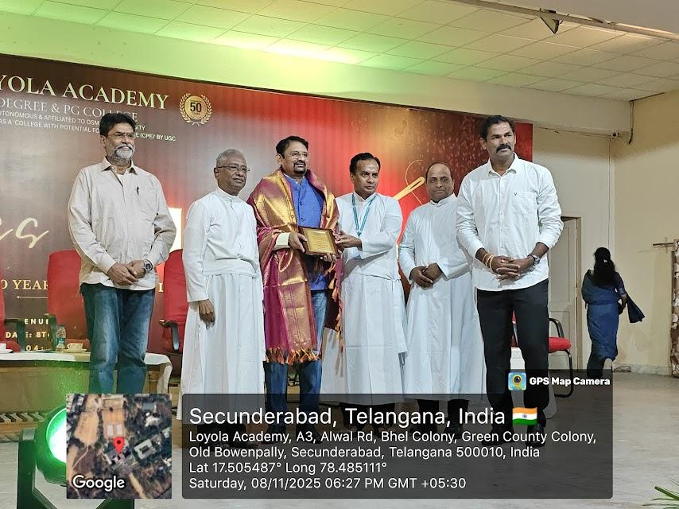
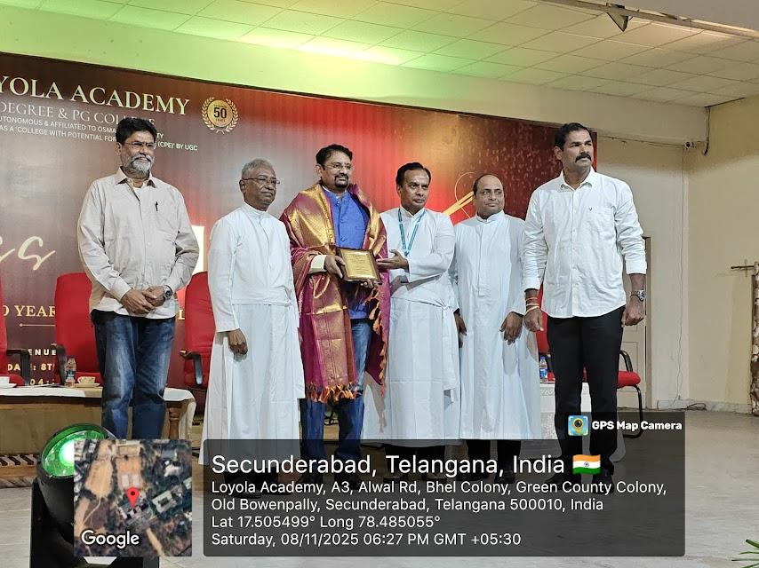 |  | 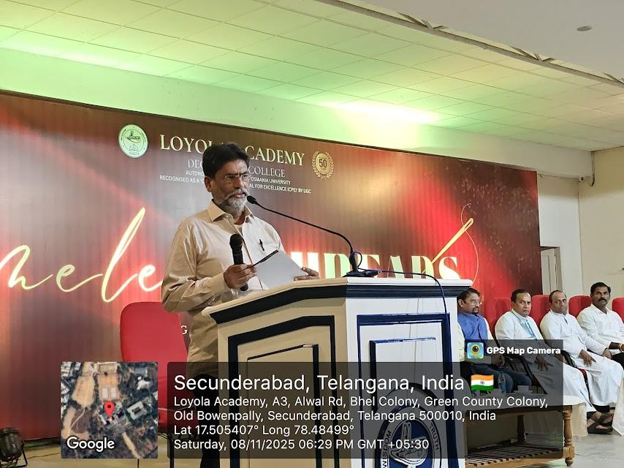
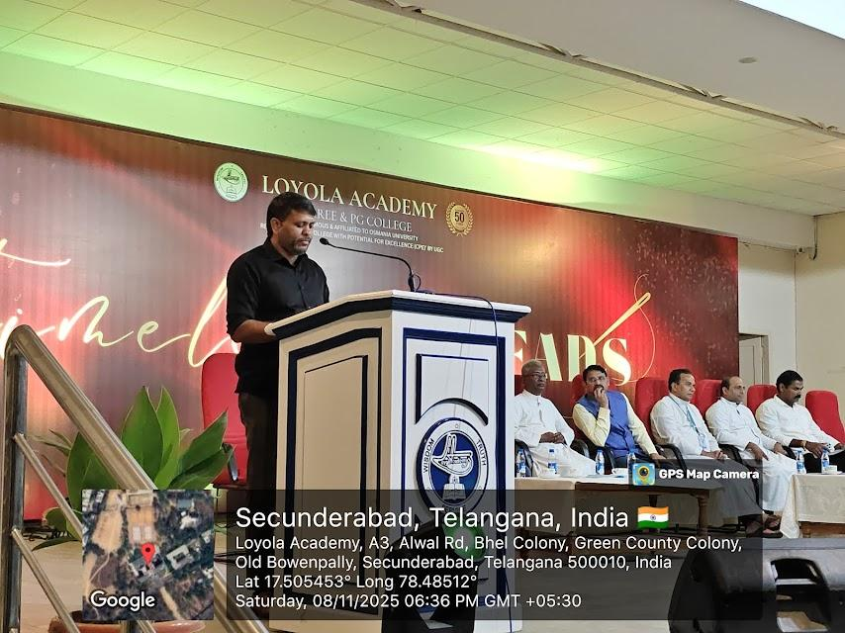 |  | 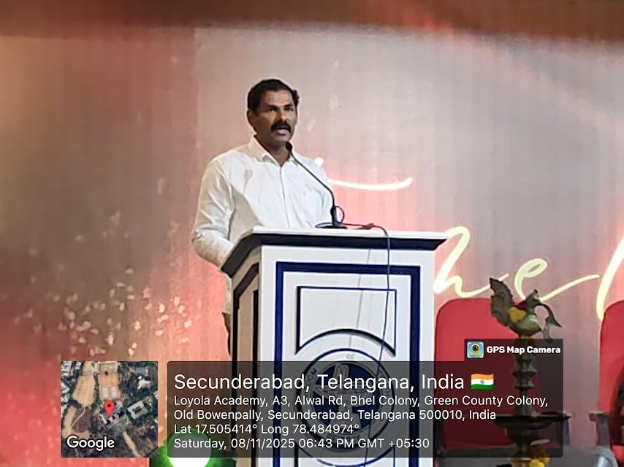
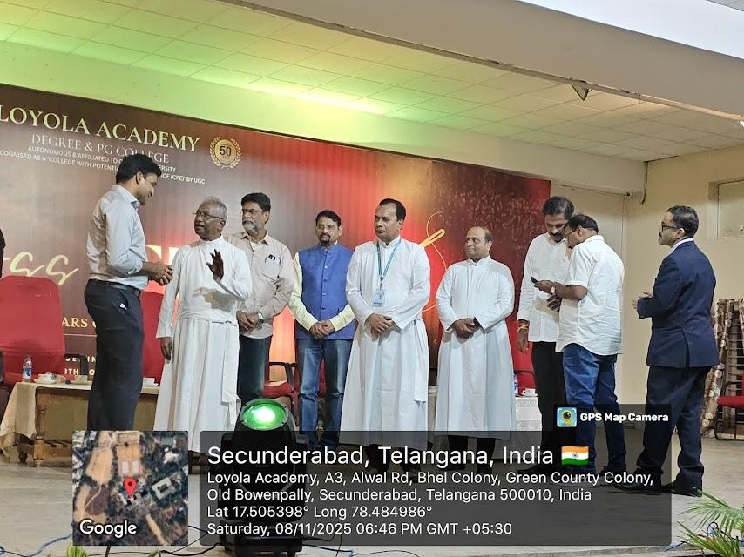 |  | 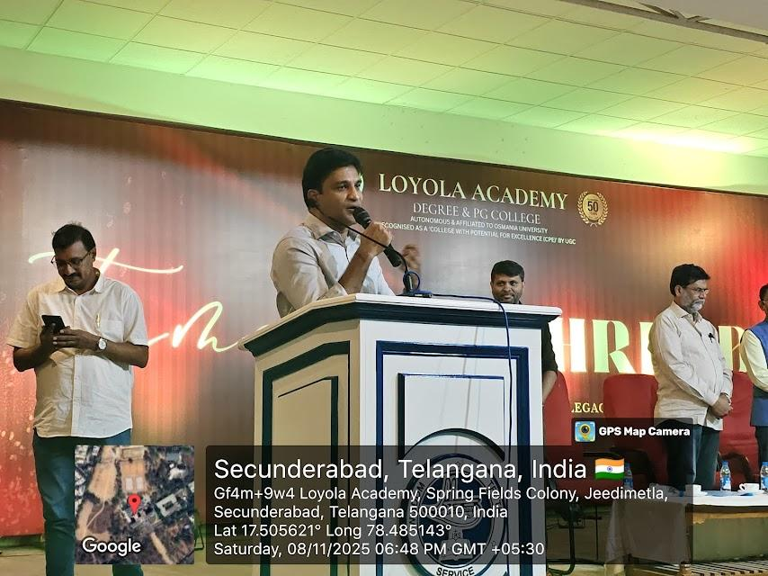
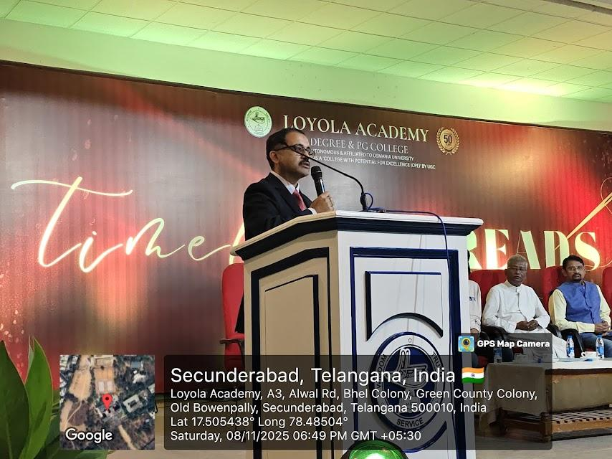 |  | 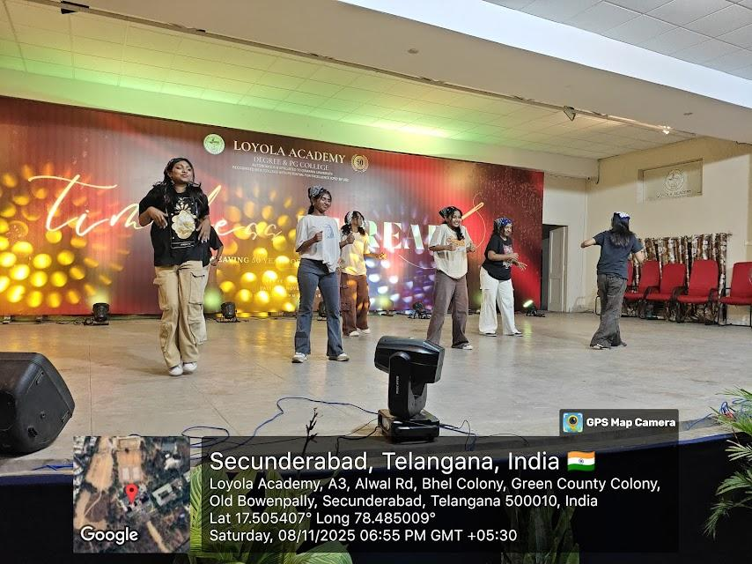
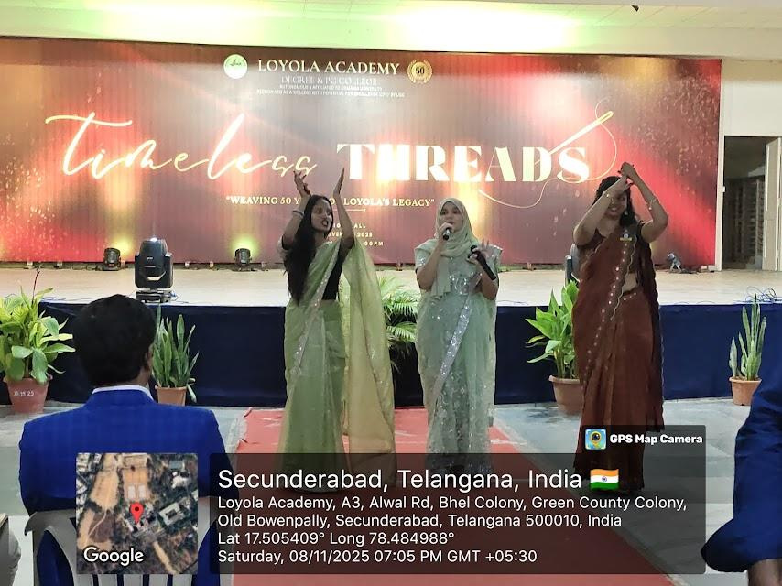 |  | 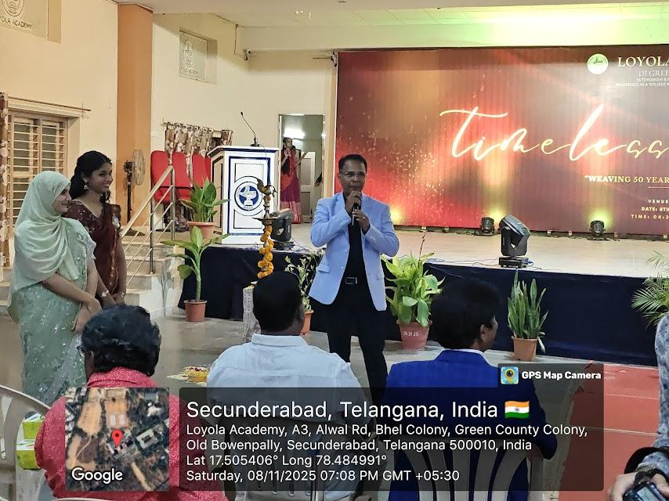
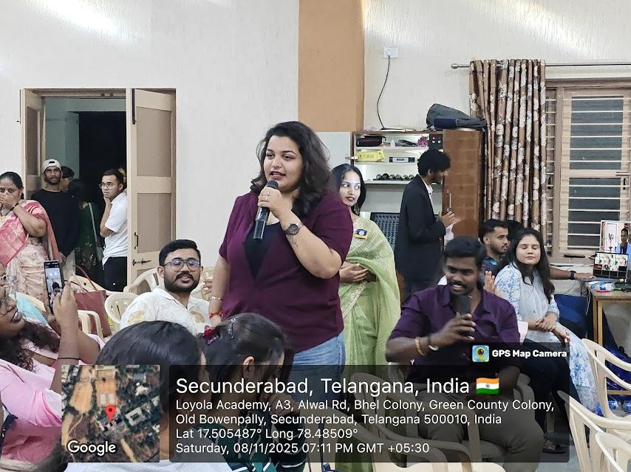 |  | 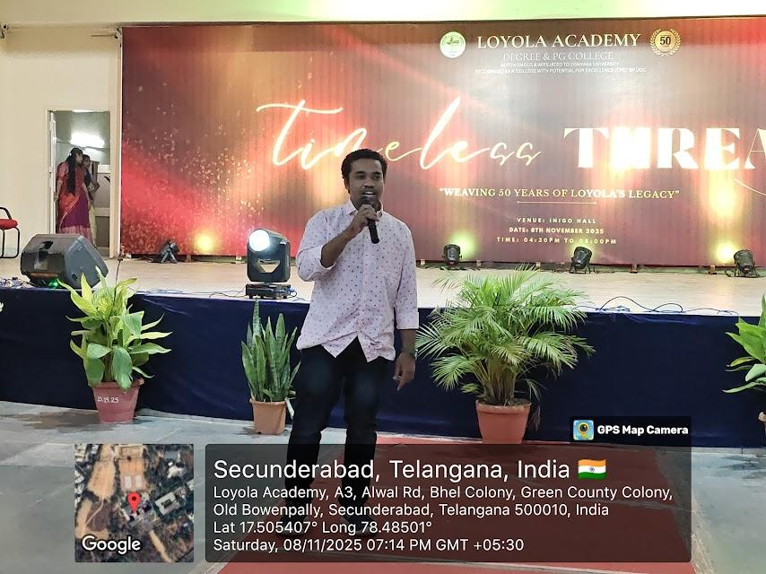
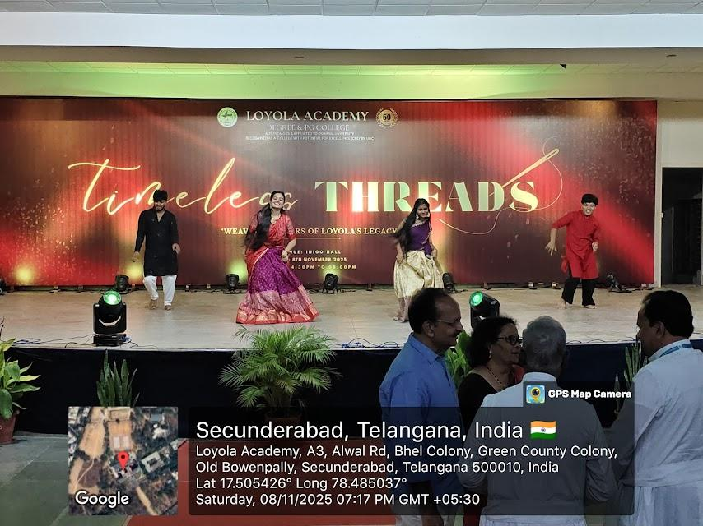 |  | 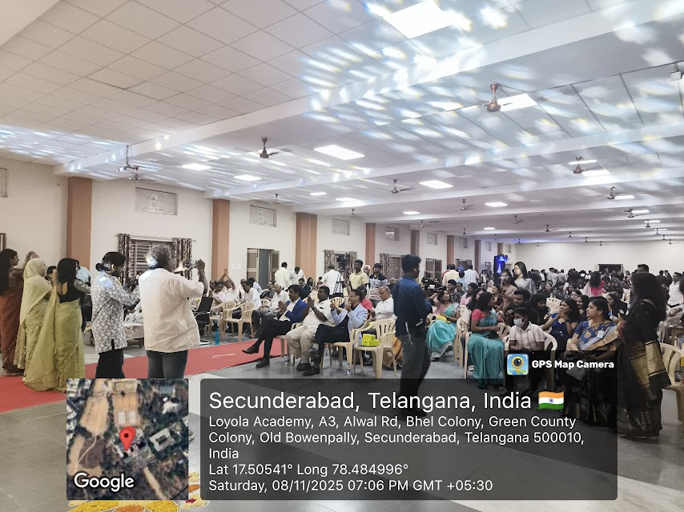
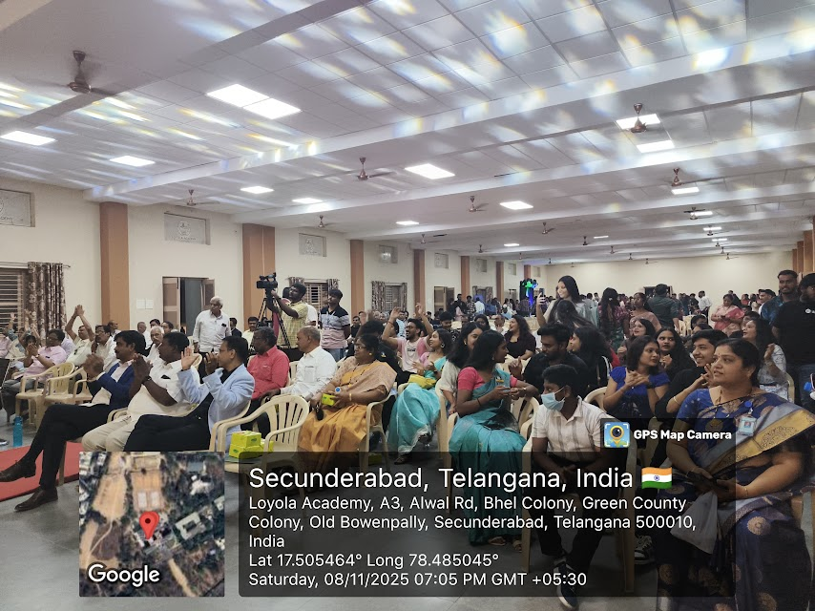 |  | 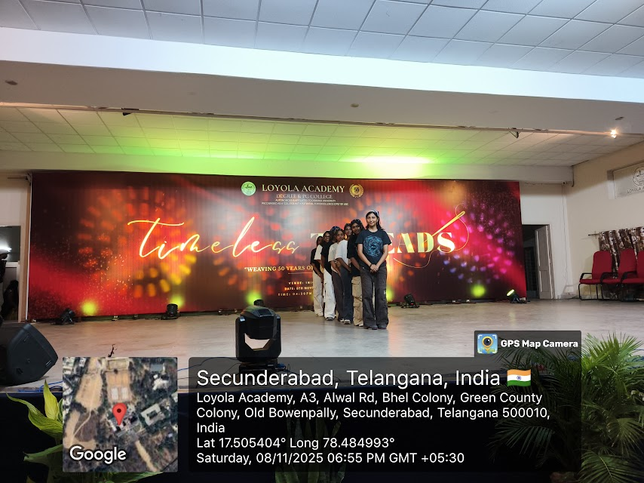
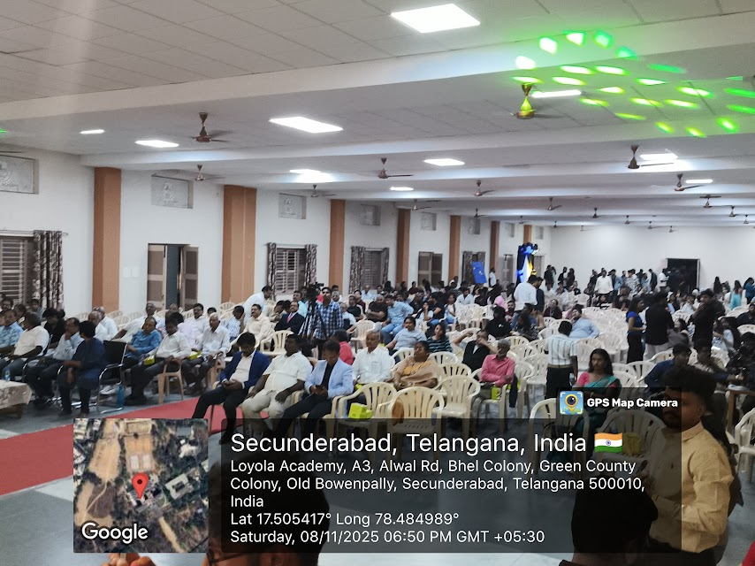 |  | 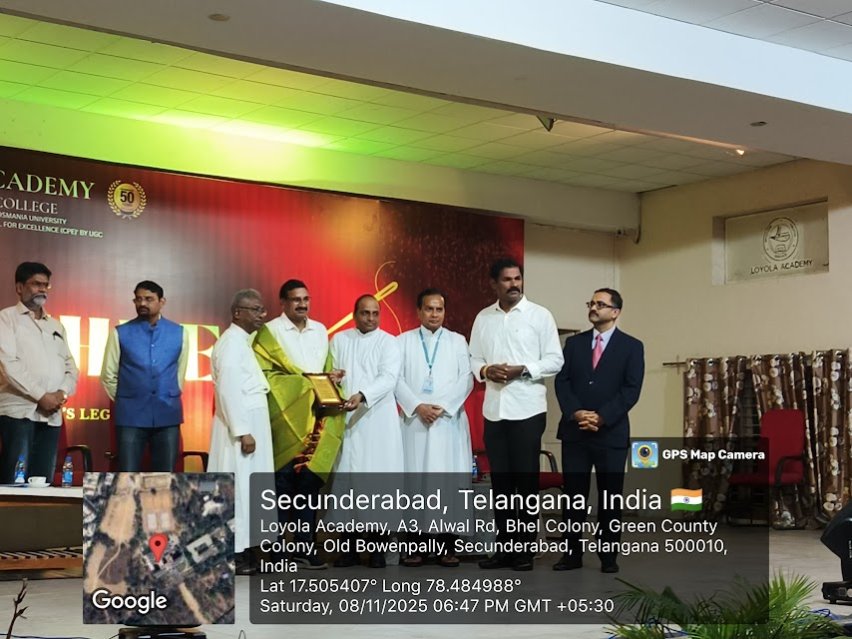
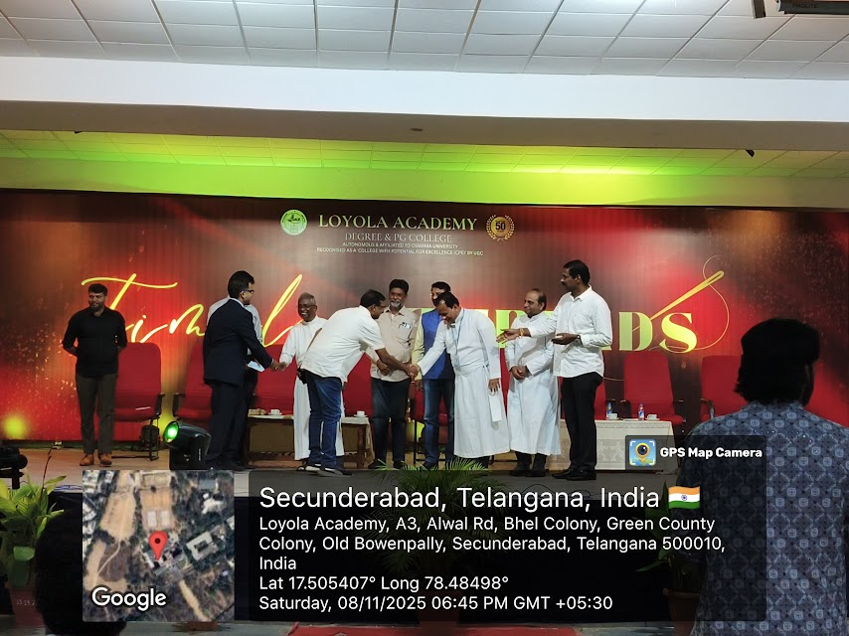 |  | 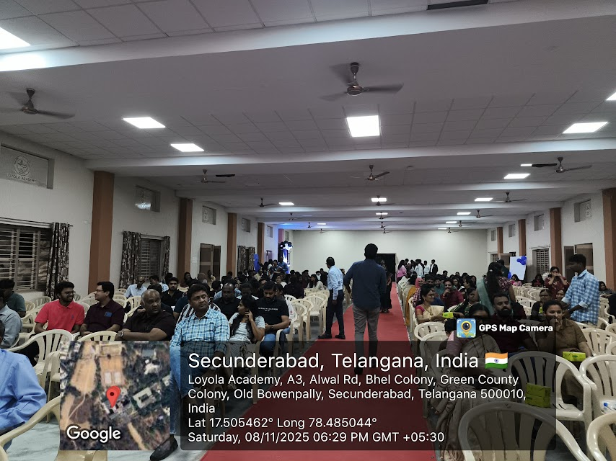
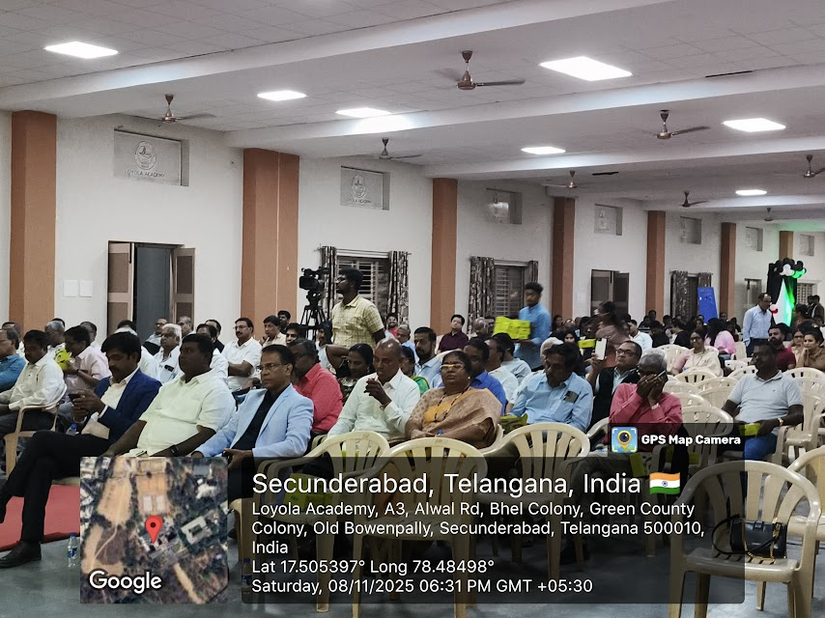 |  | 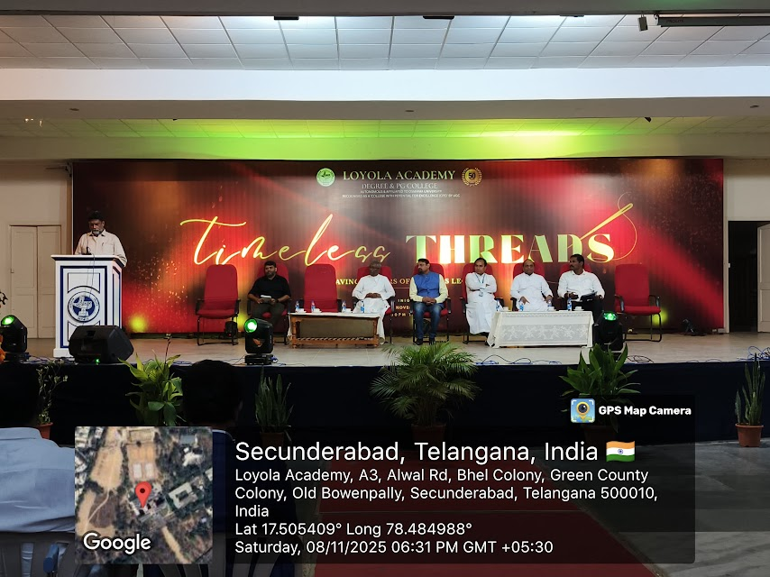
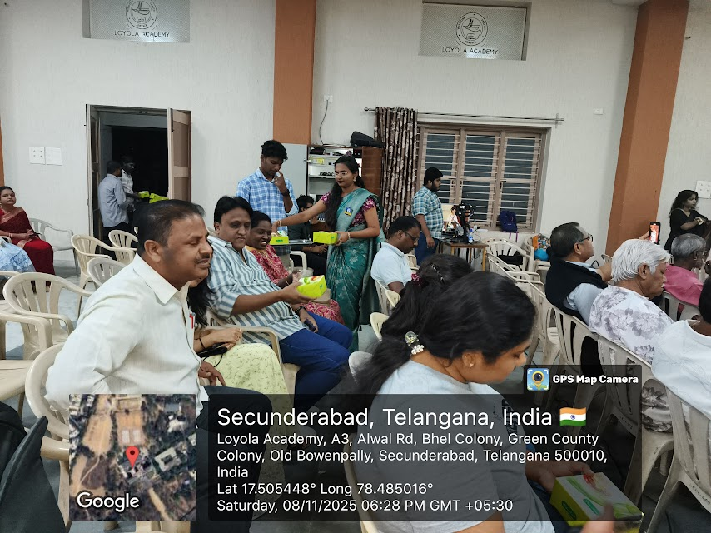 |  | 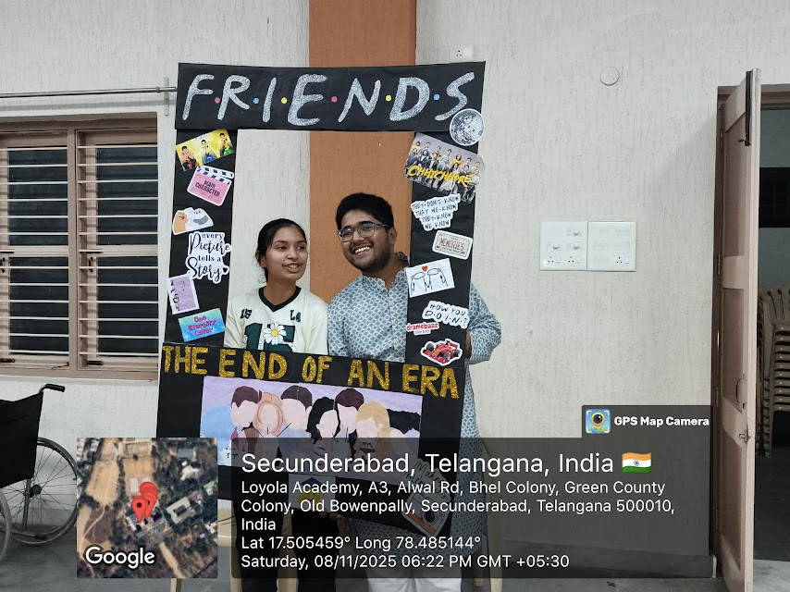
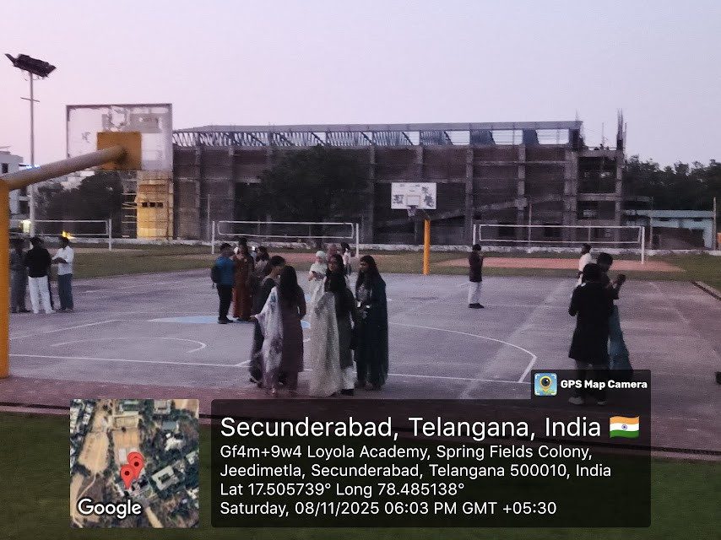 |  | 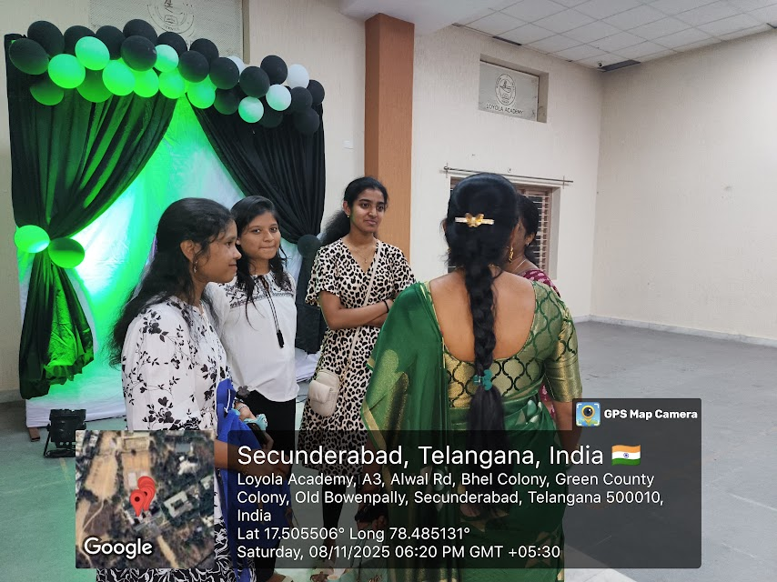
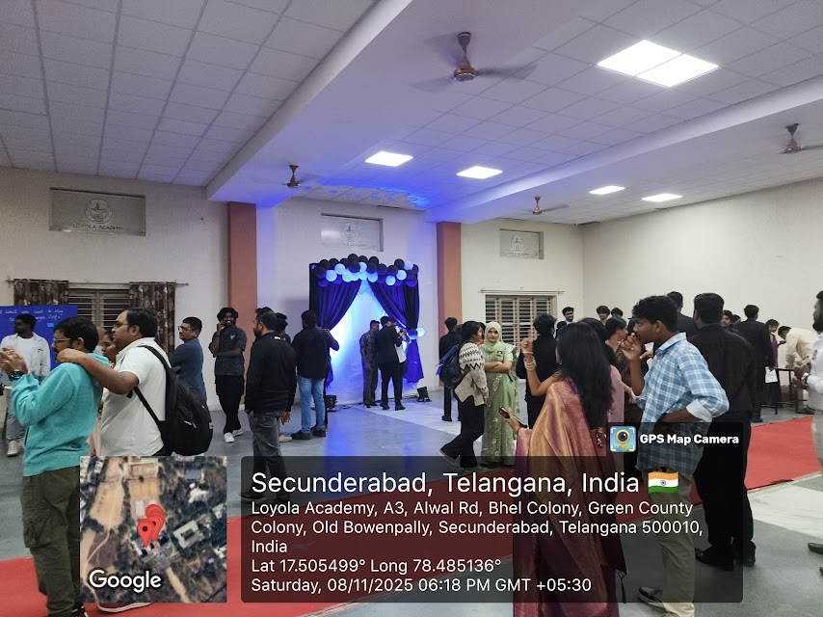 |  | 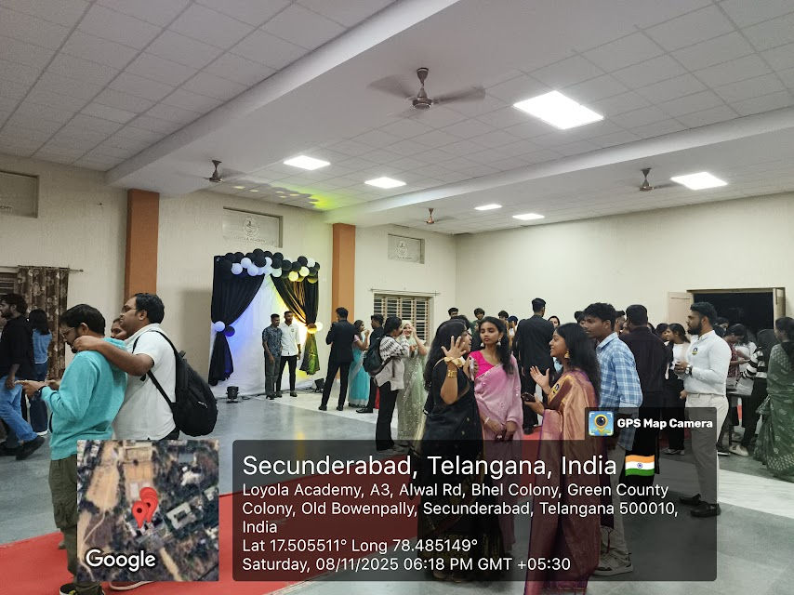
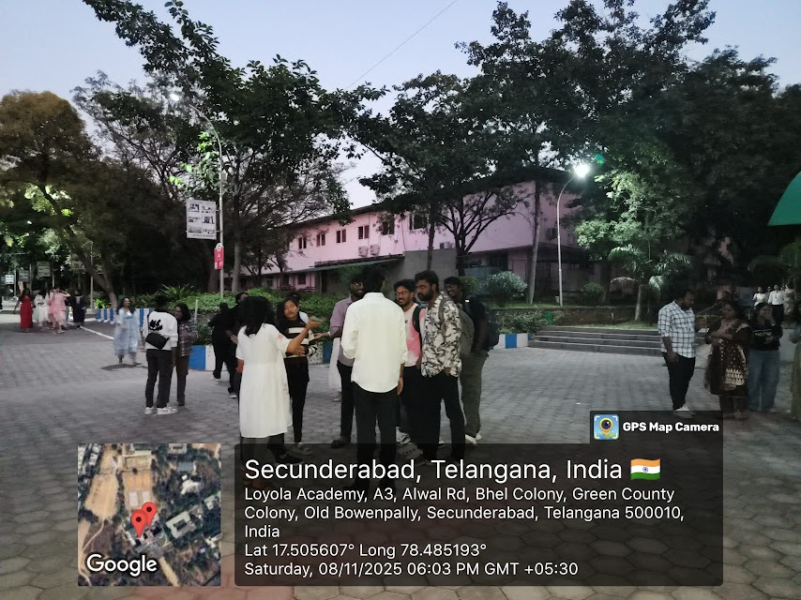 |  | 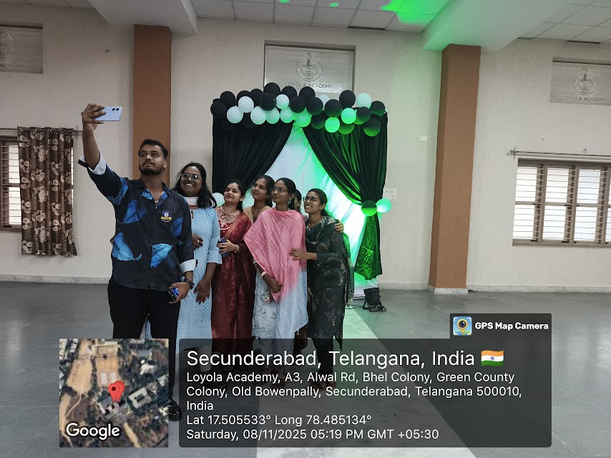
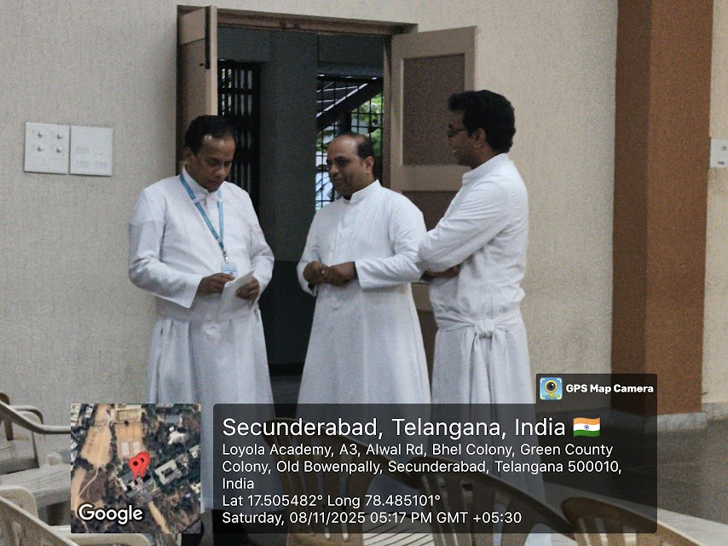 |  | 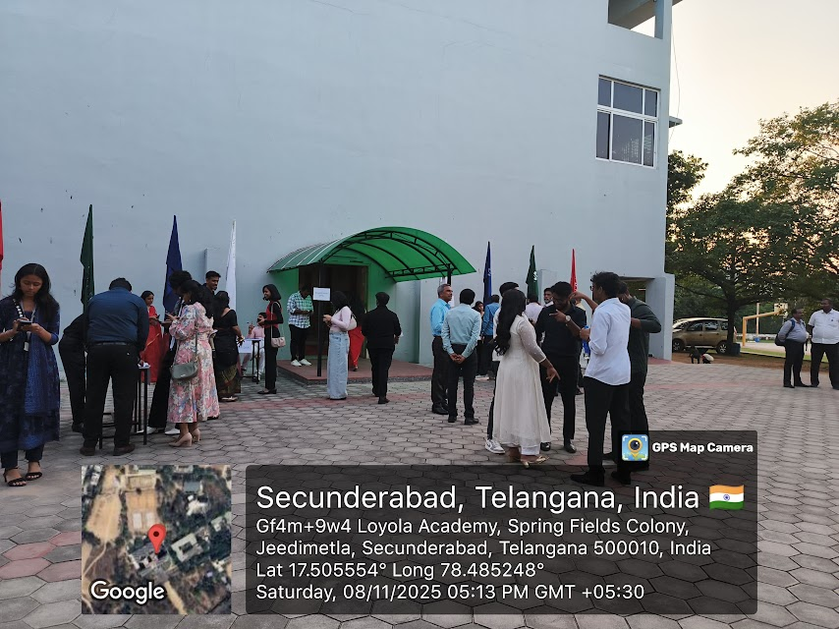
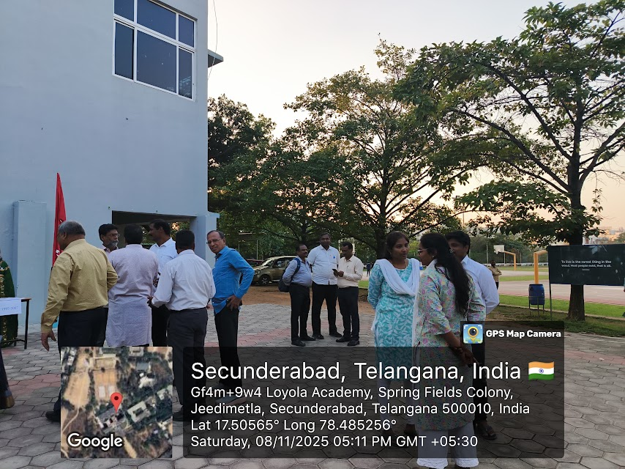 |  | 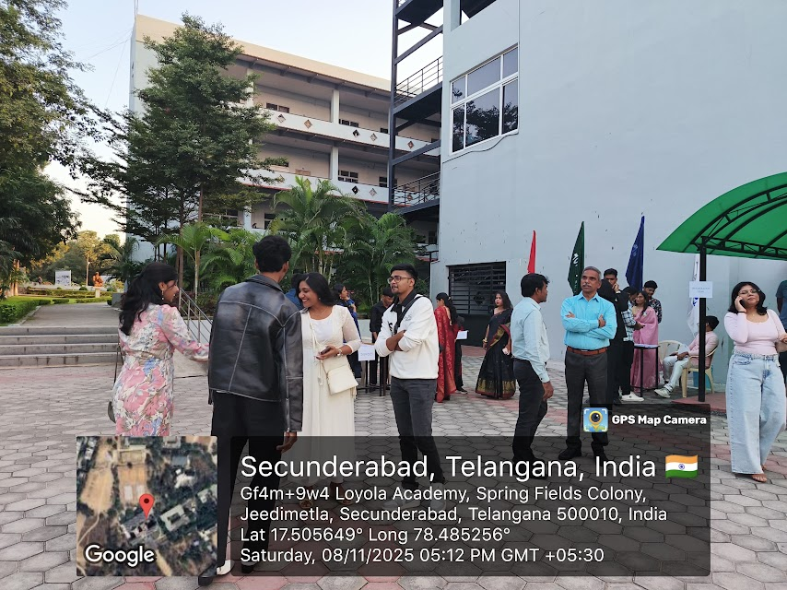
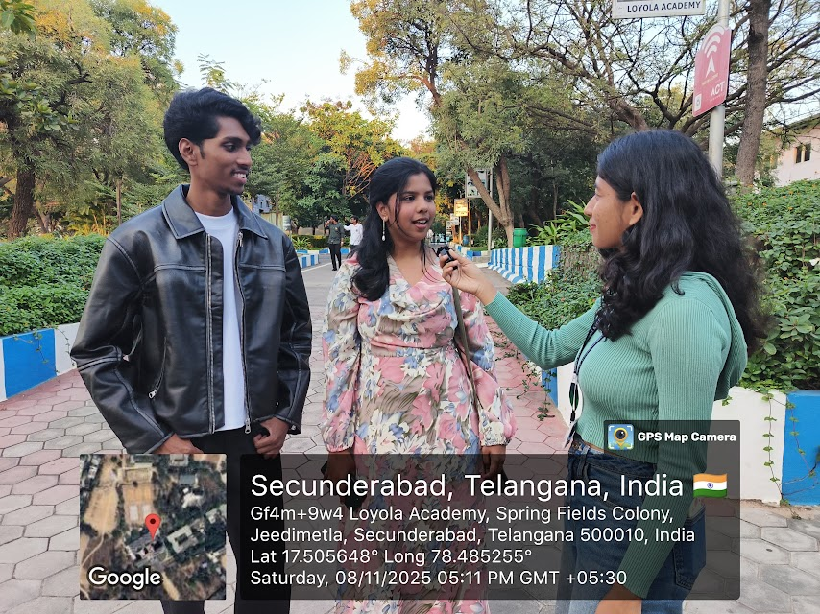 |  | 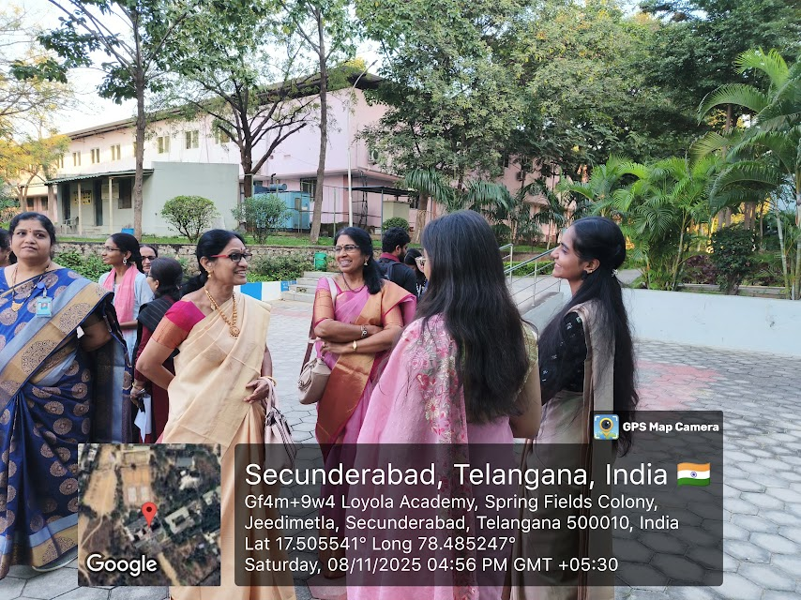
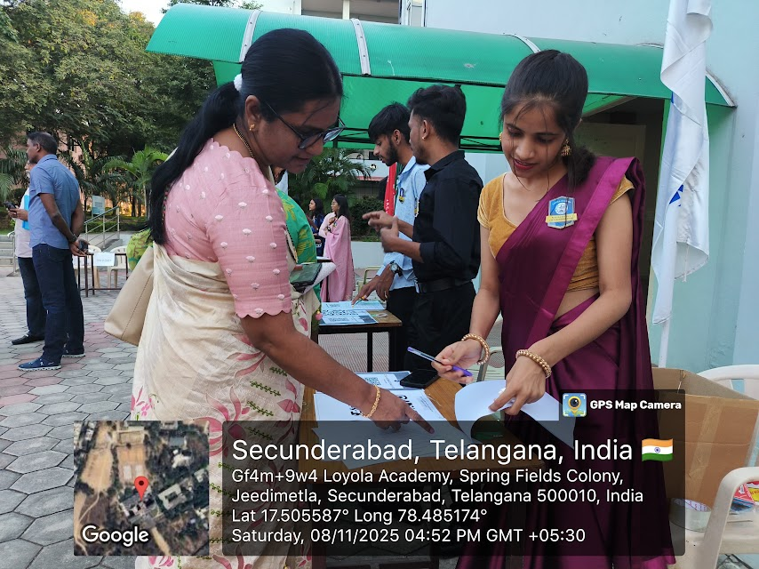 |  | 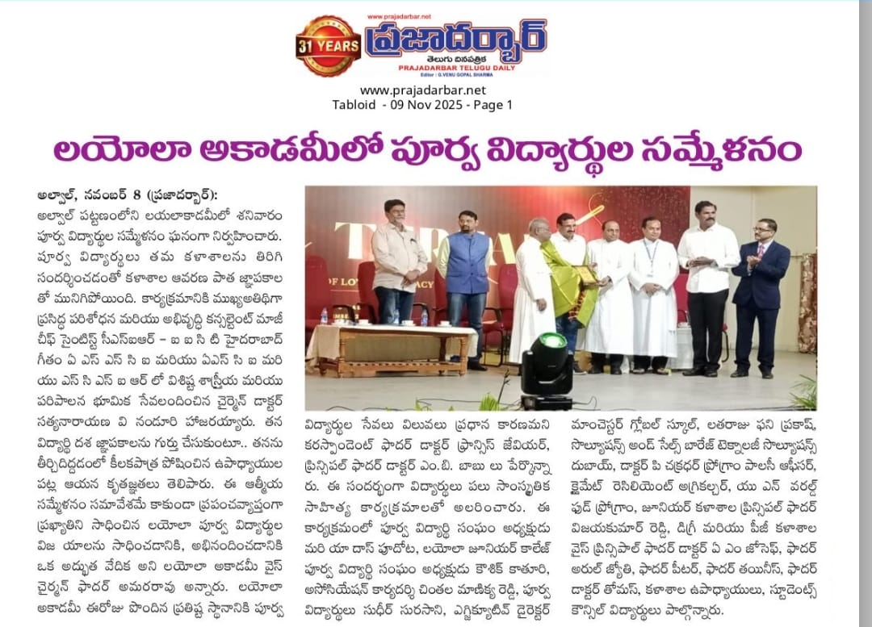
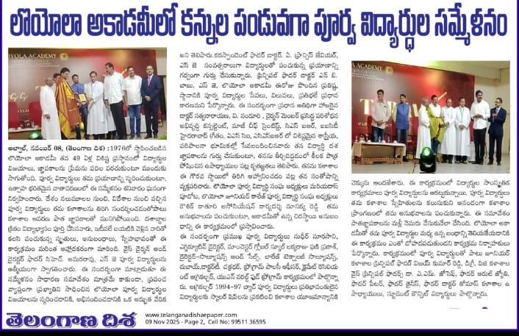 |  | 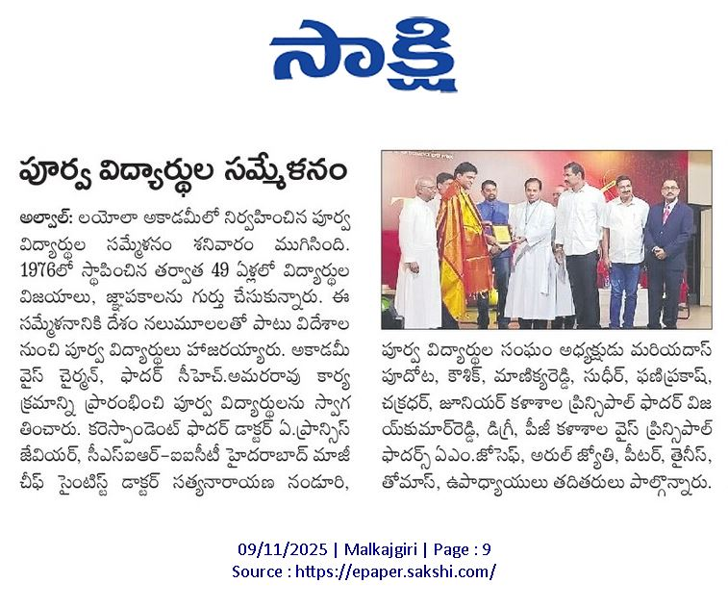
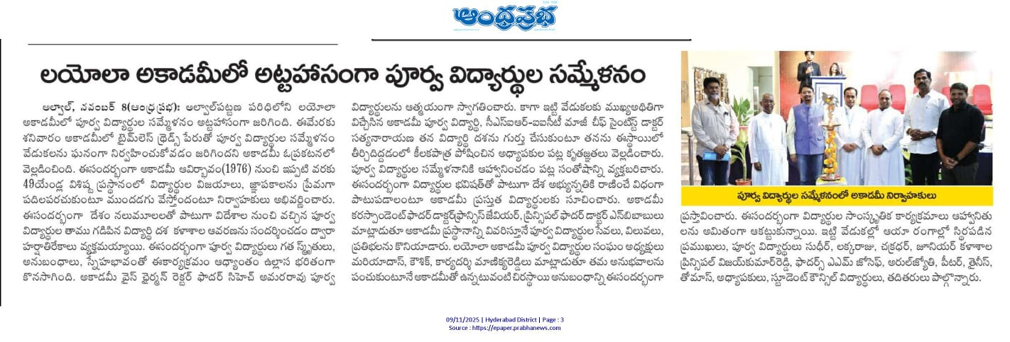
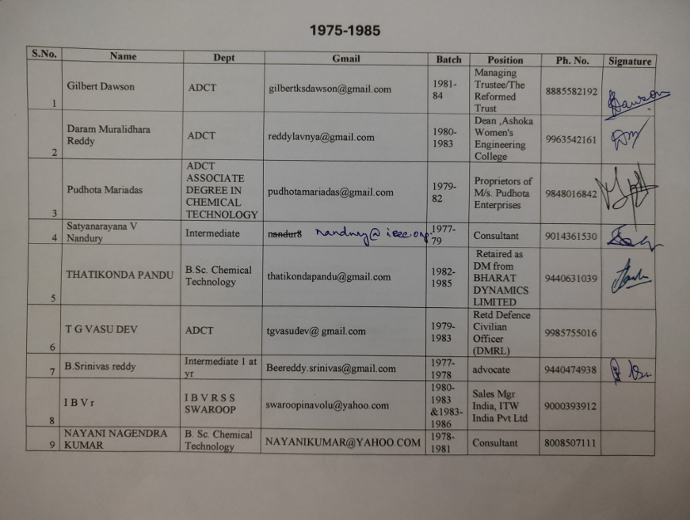 |  | 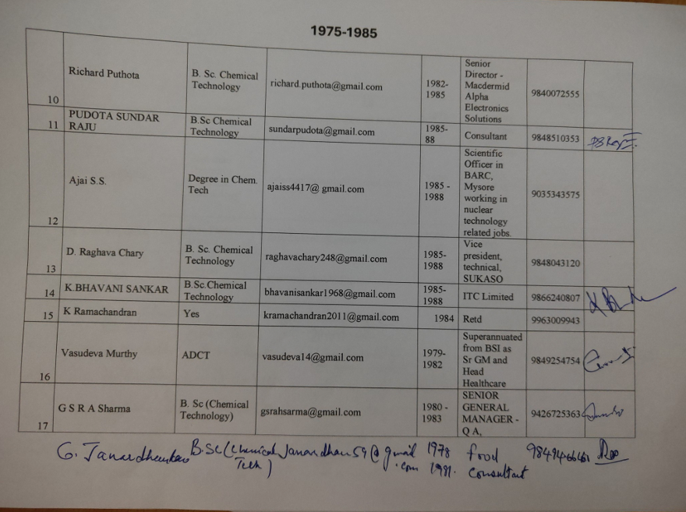
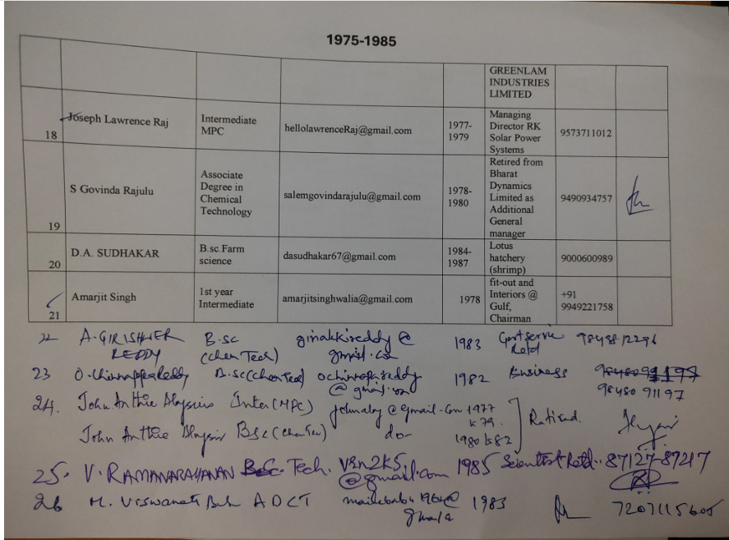 |  | 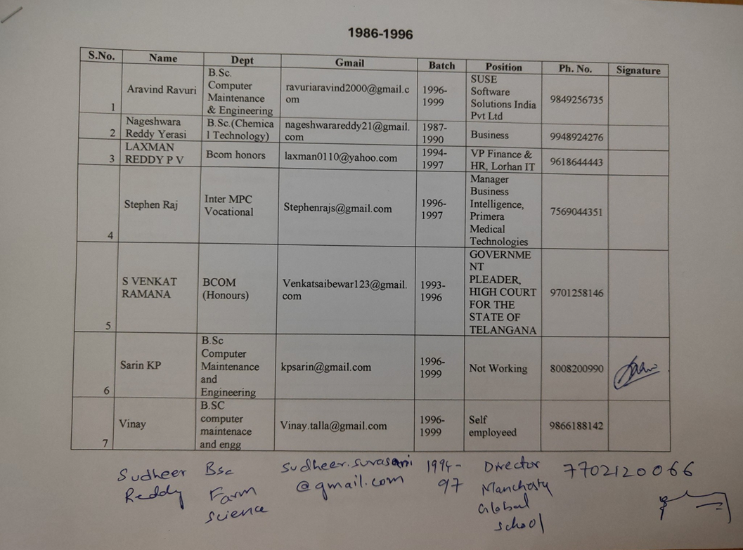
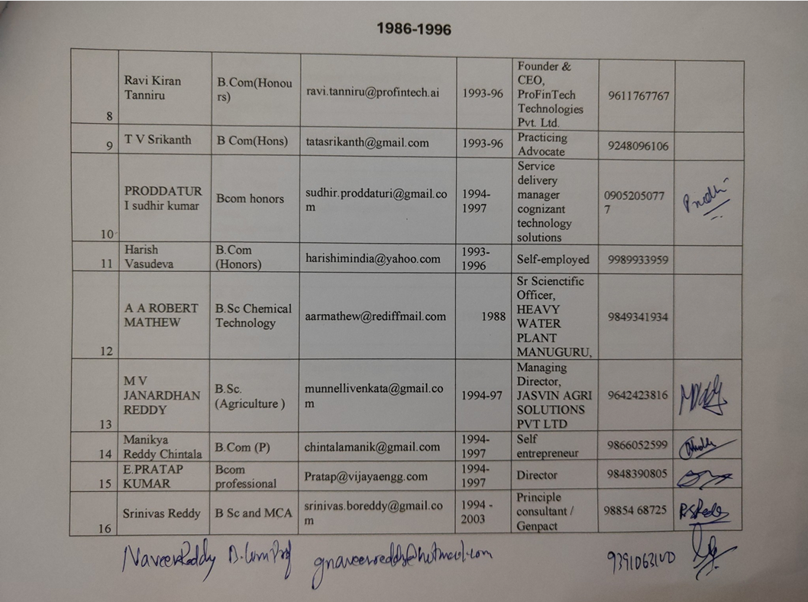 |  | 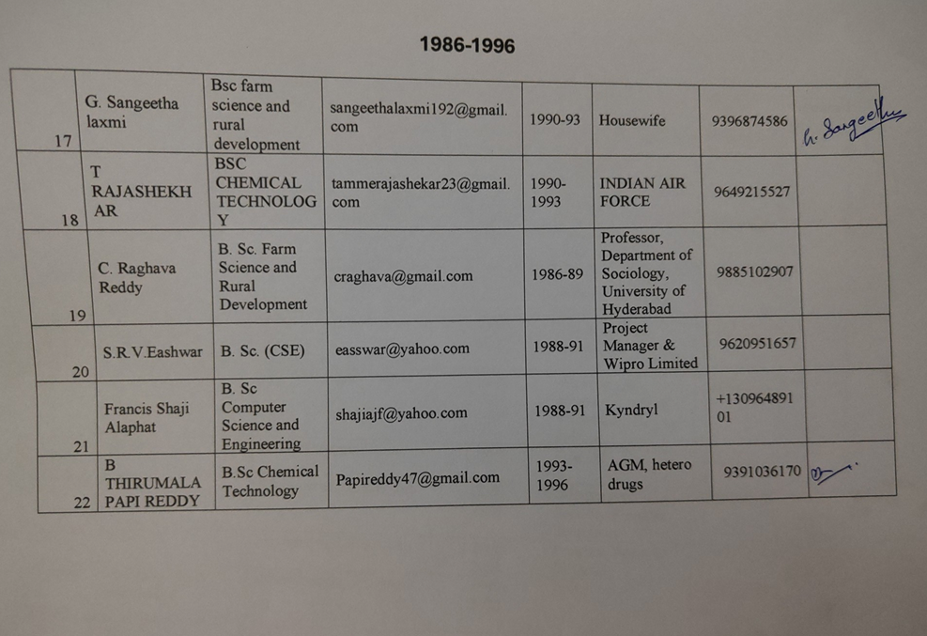
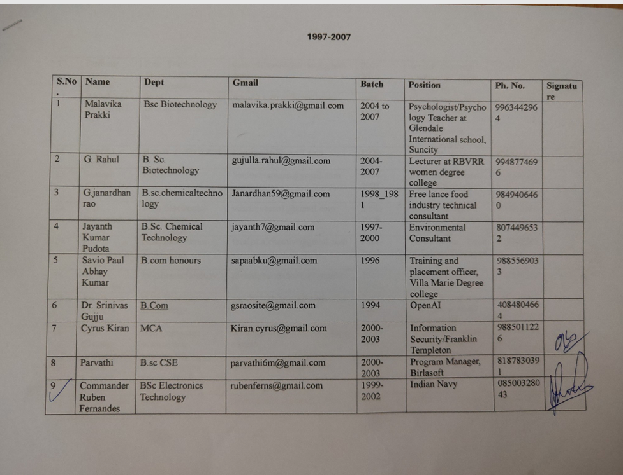 |  | 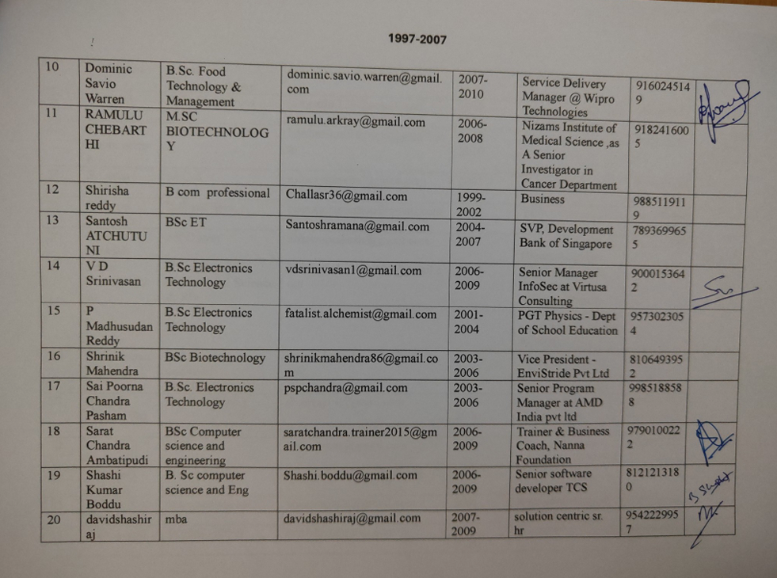
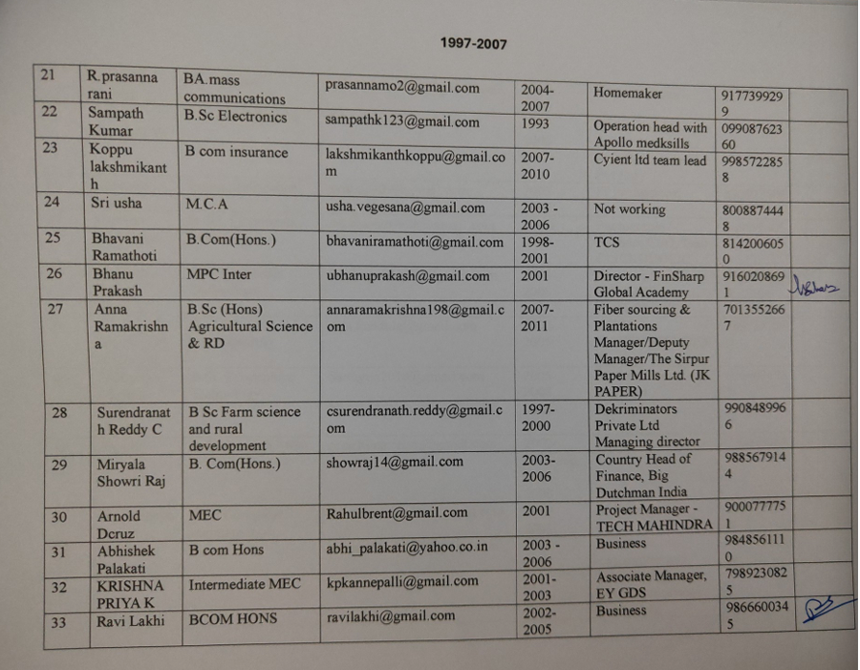 |  | 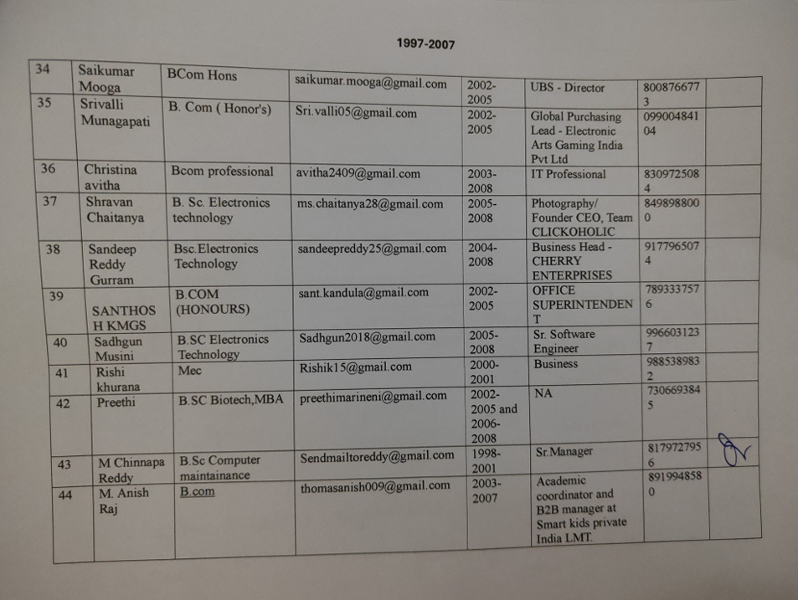
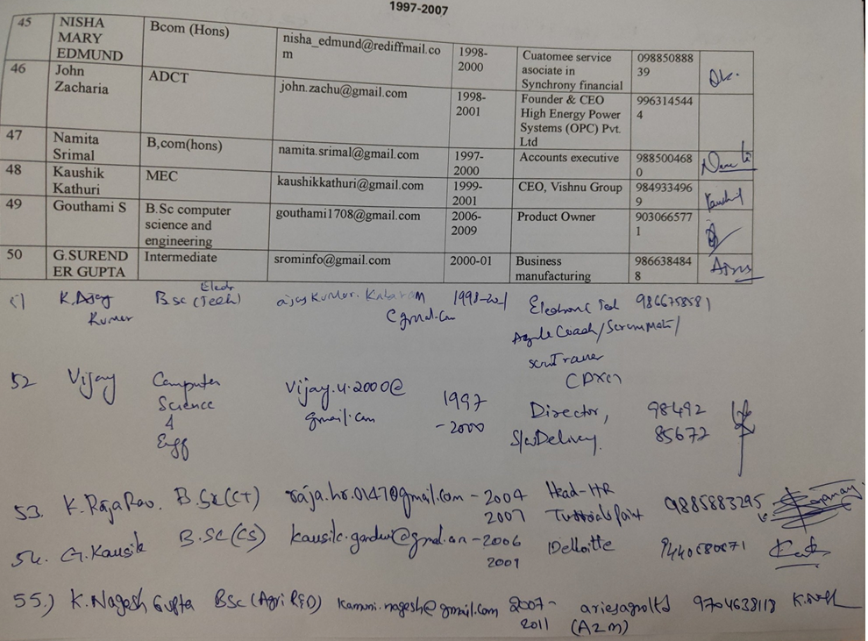 |  | 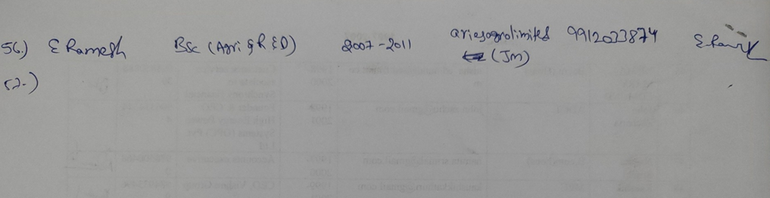
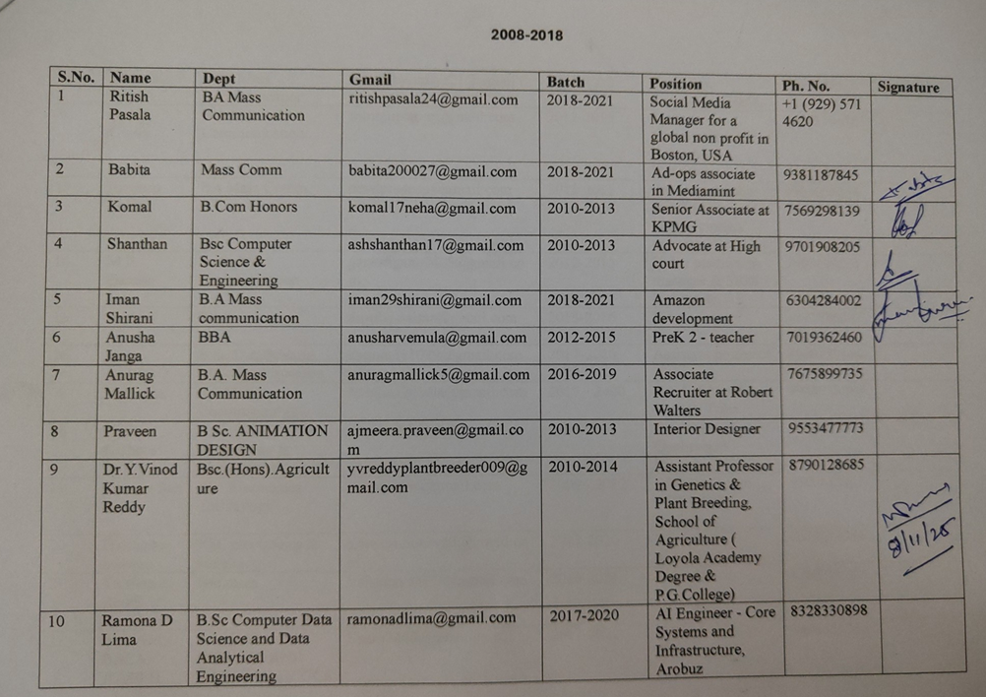 |  | 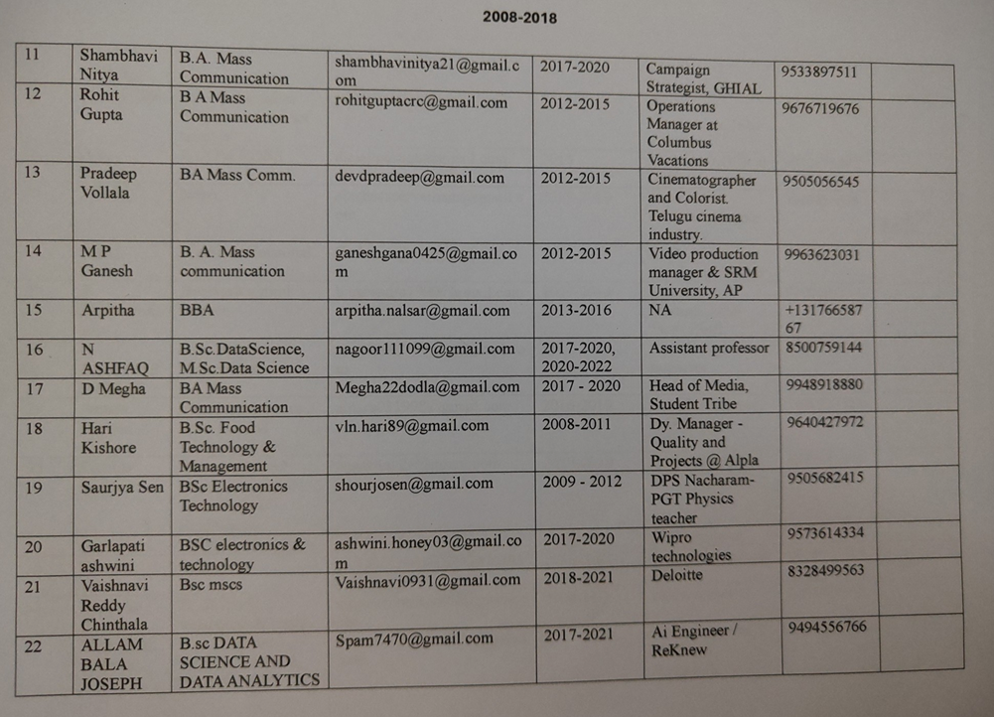
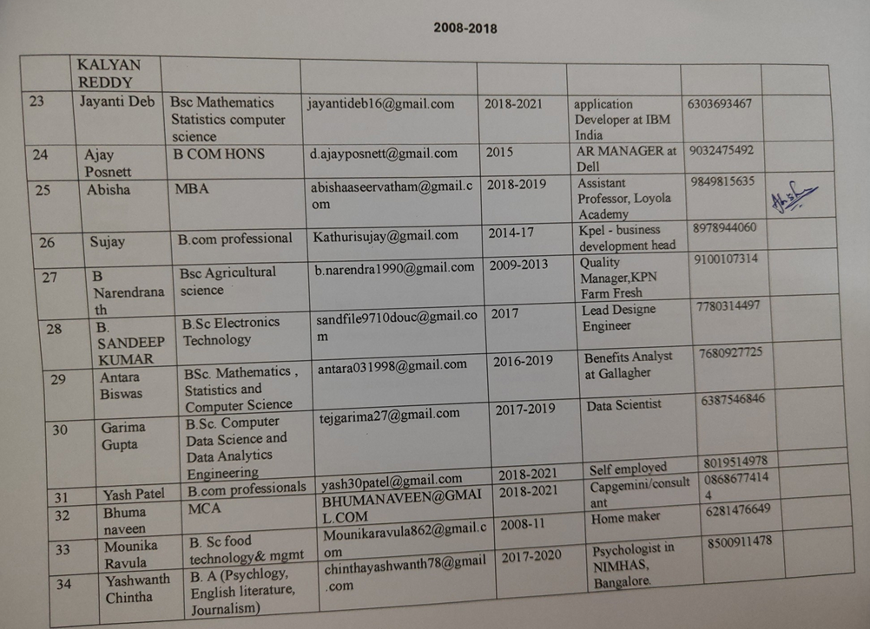 |  | 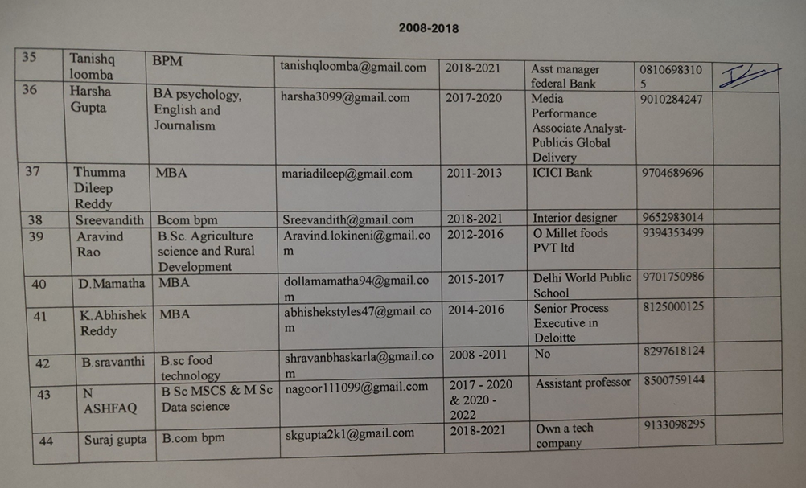
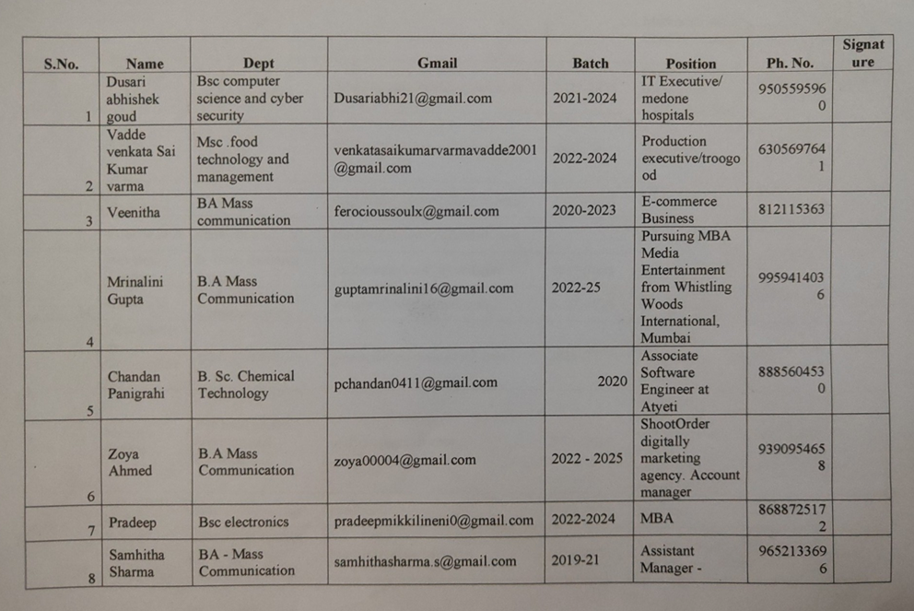 |  | 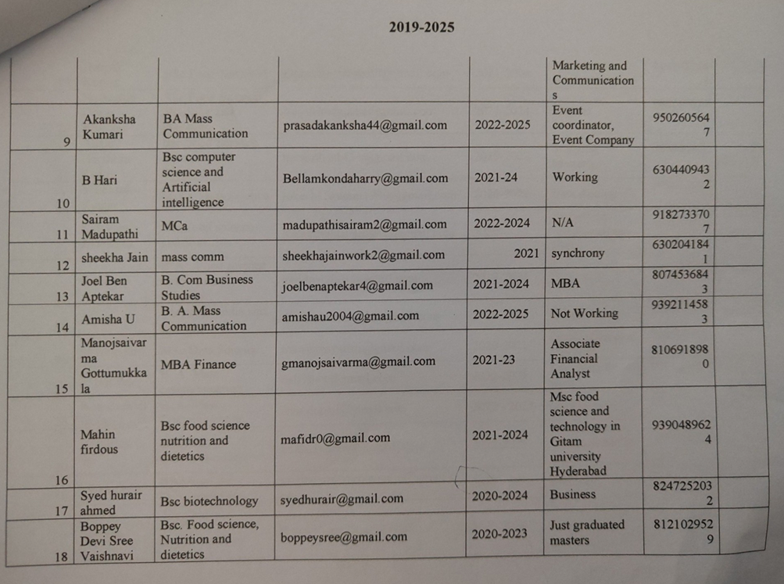
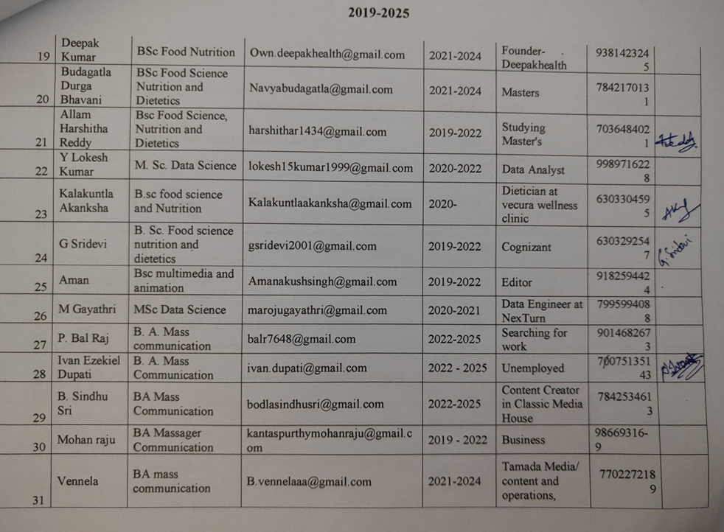 |  | 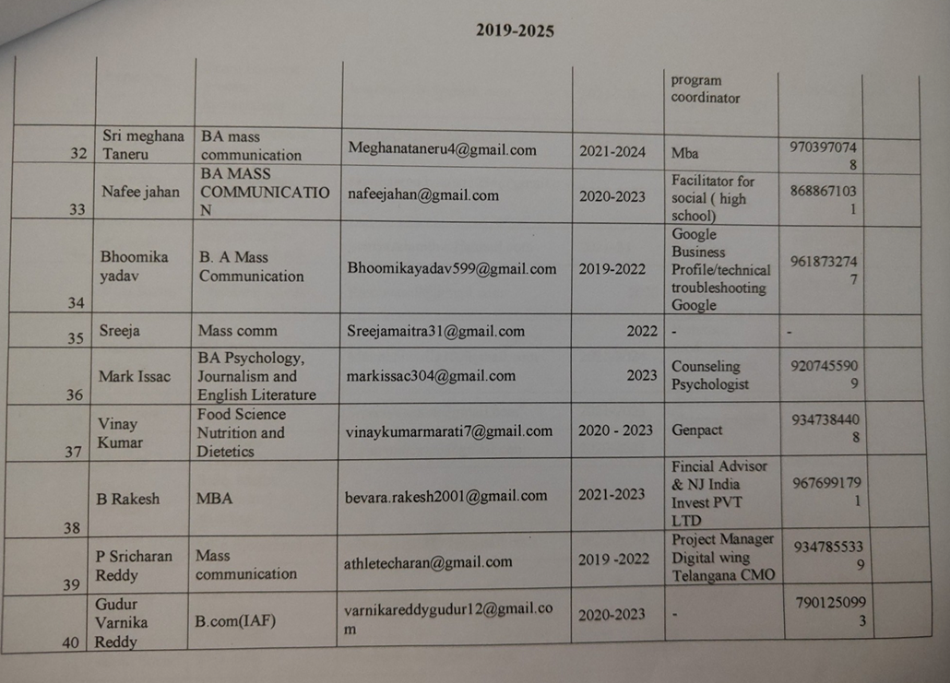
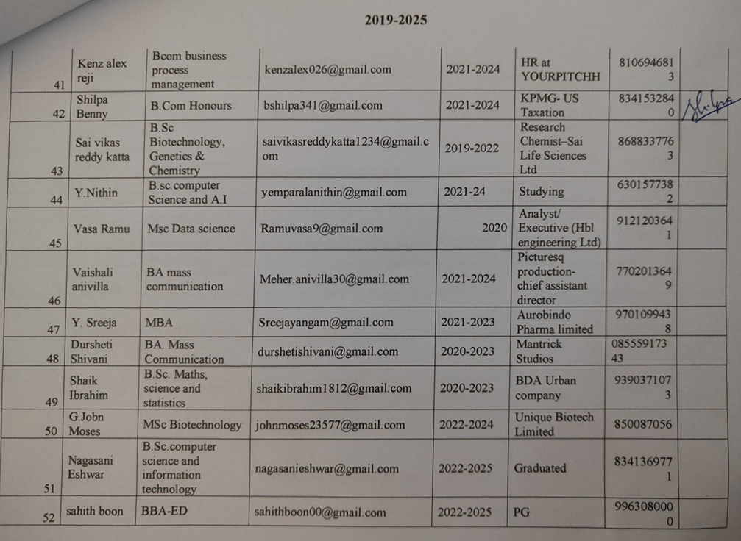 |  | 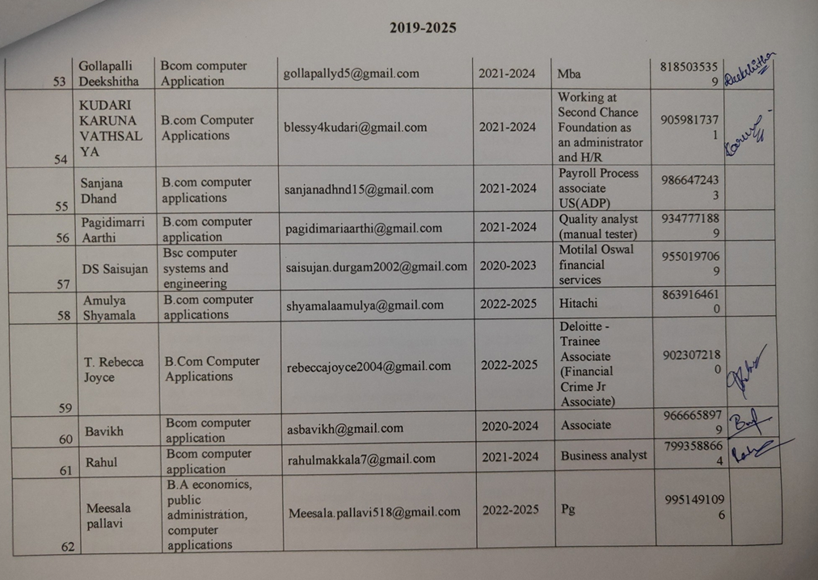
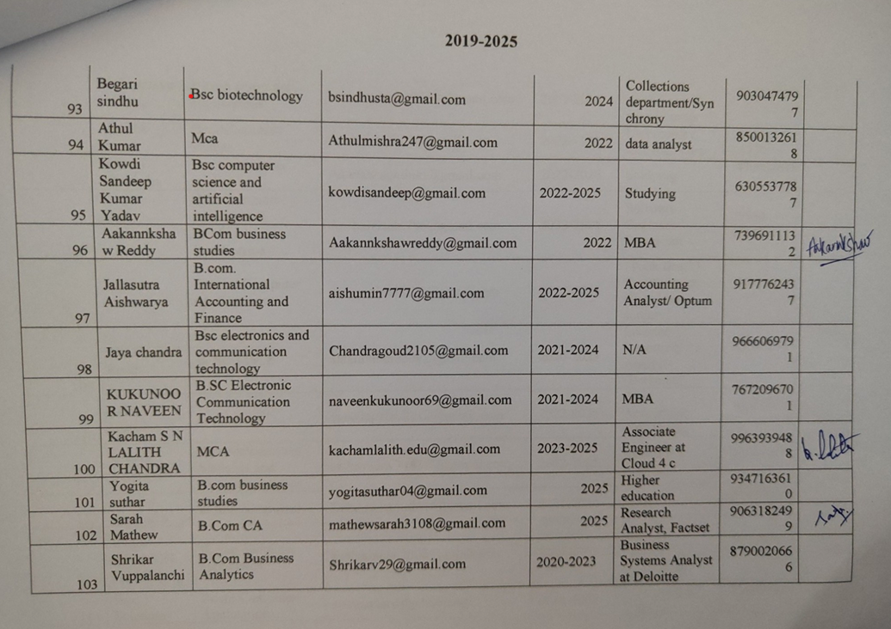 |  | 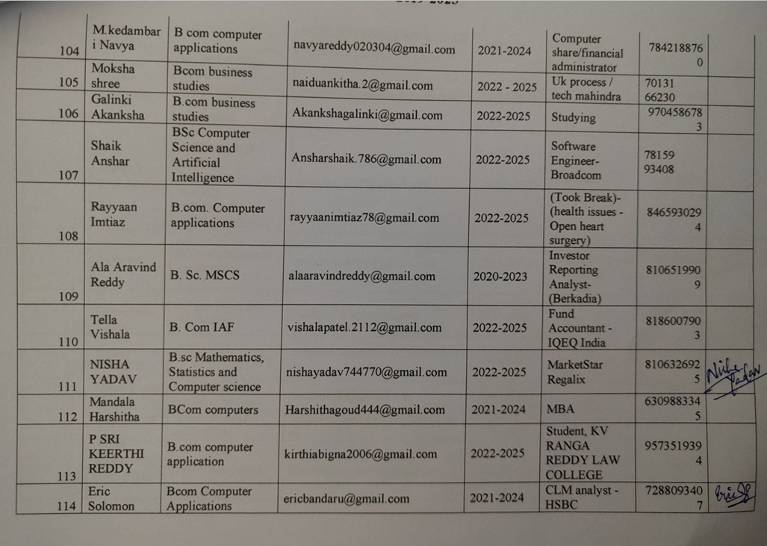
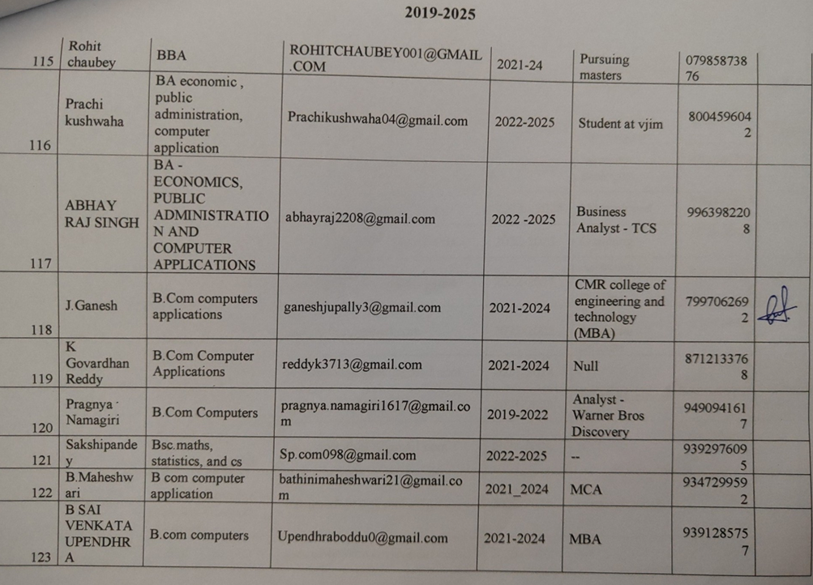 |  | 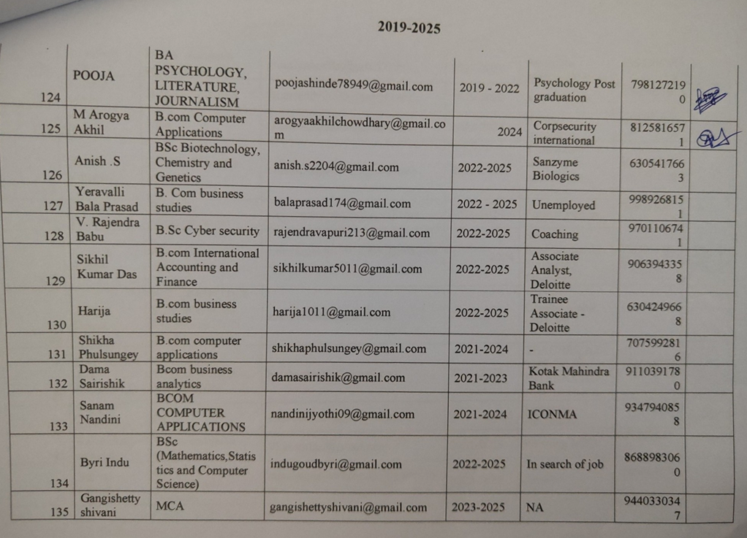
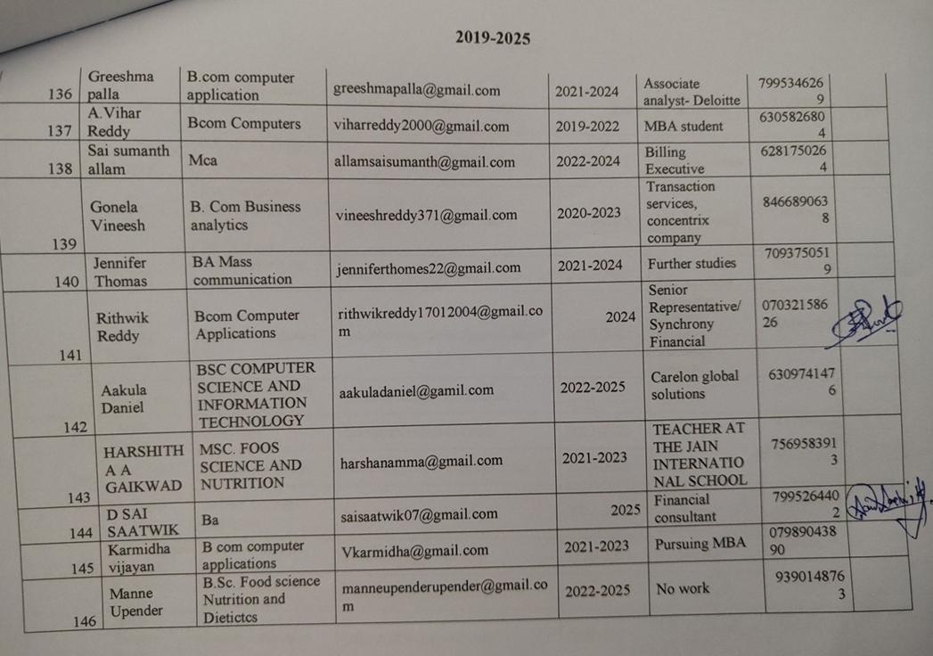 |  | 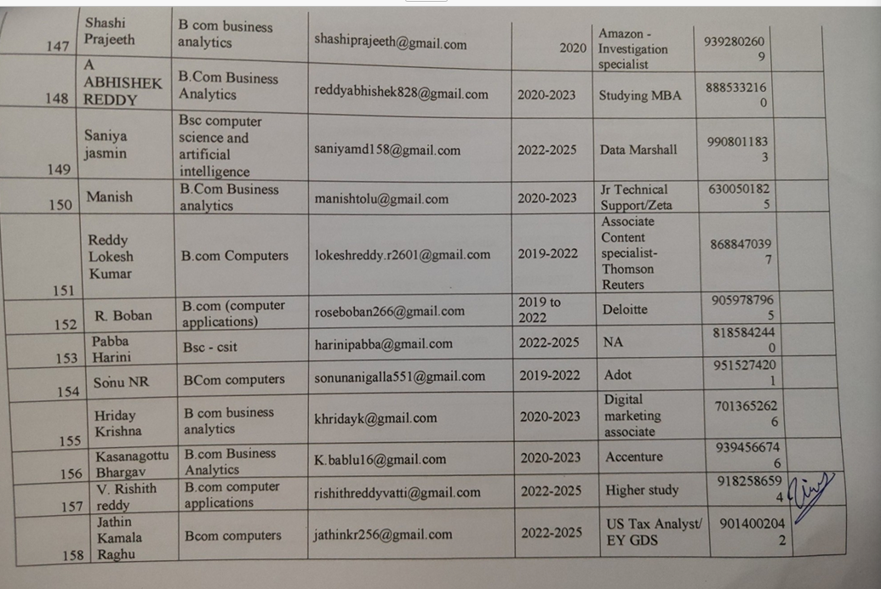
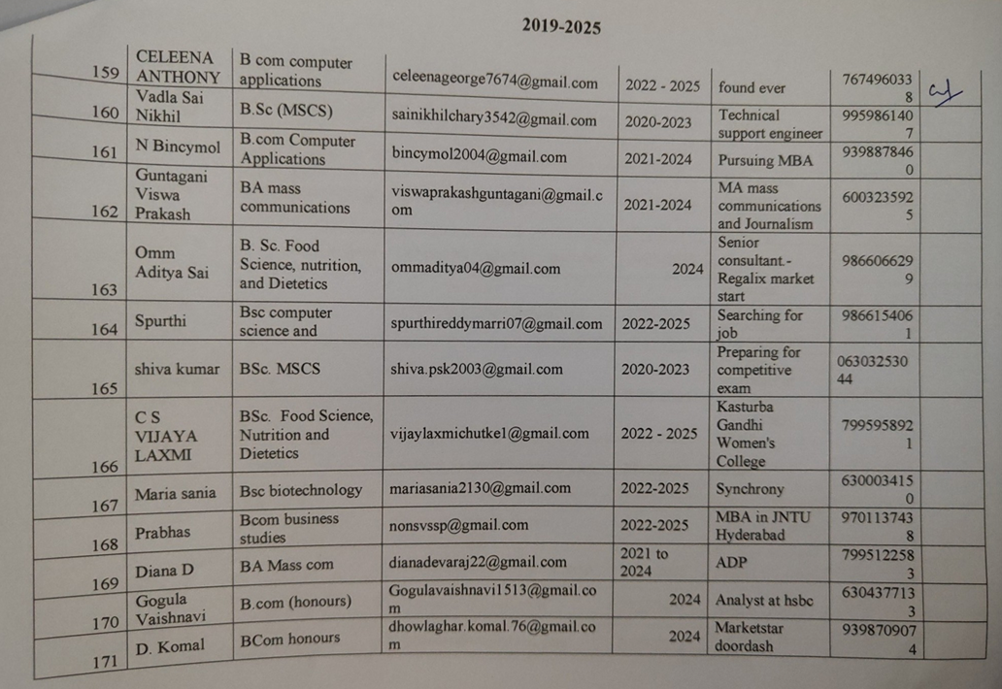 |  | 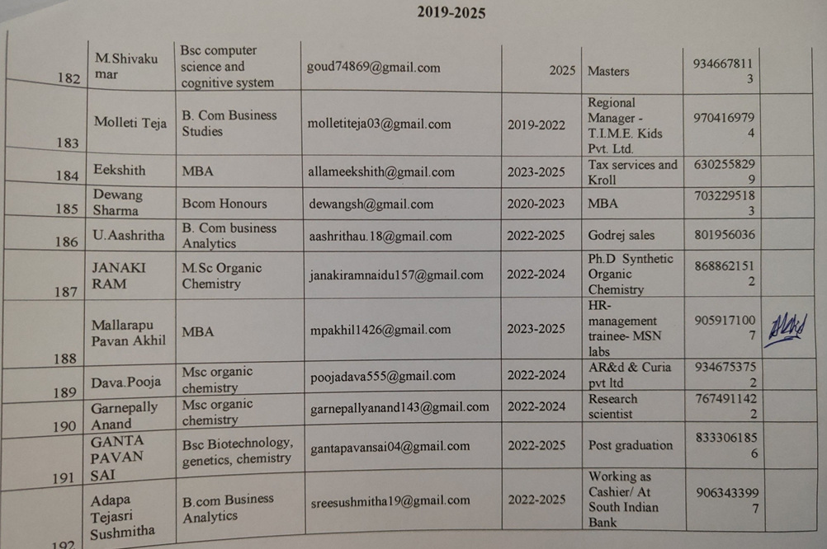
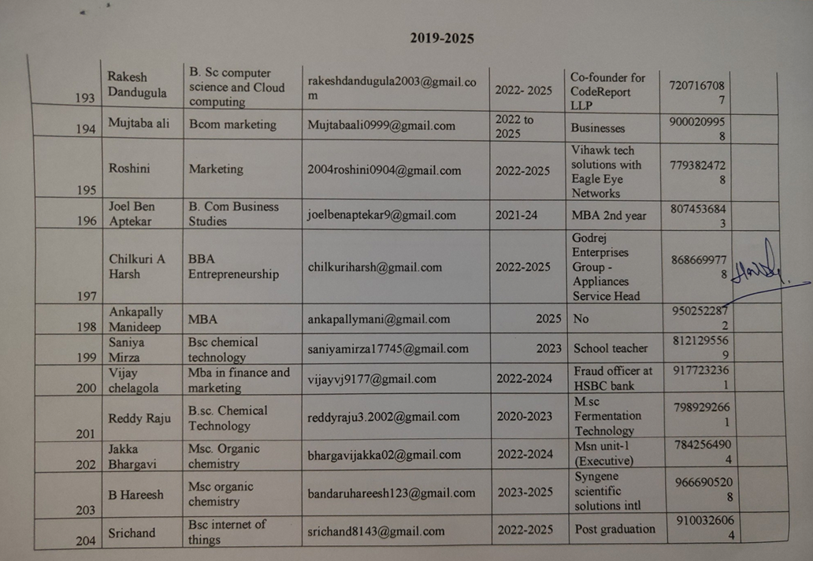 |  | 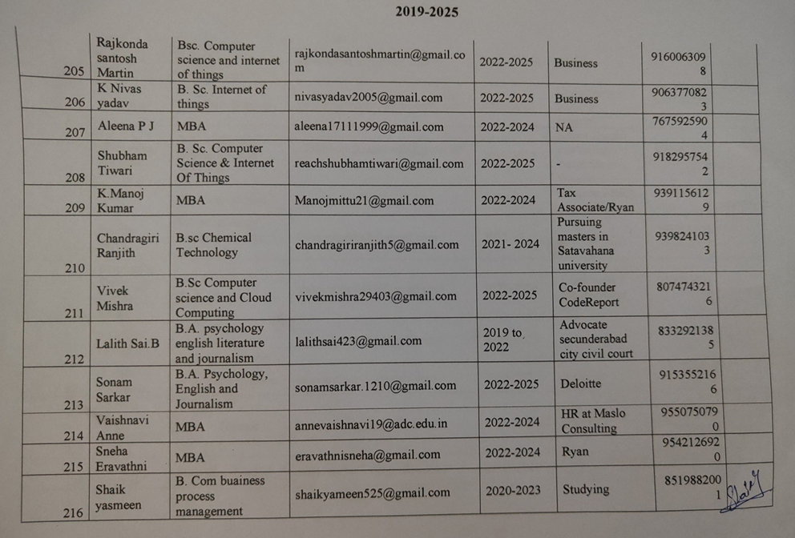
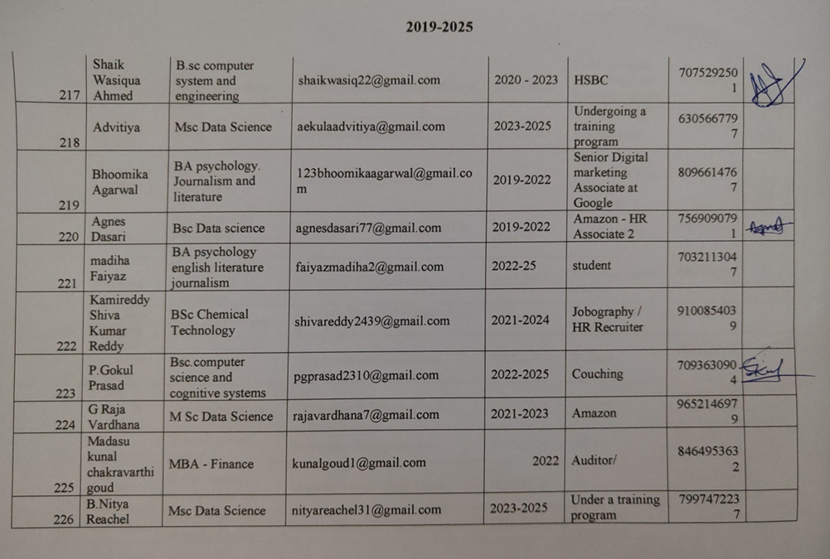 |  | 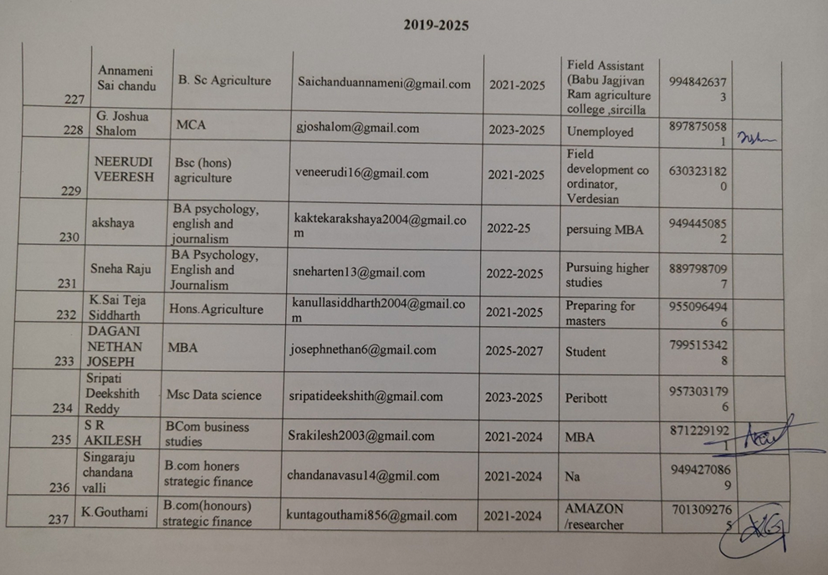
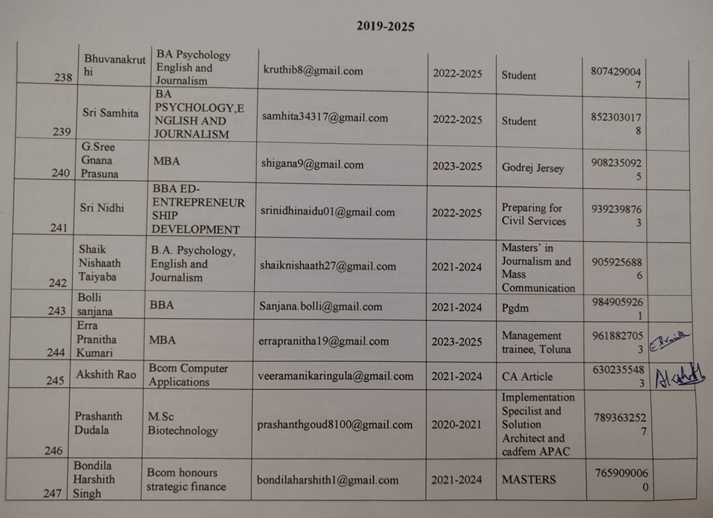 |  | 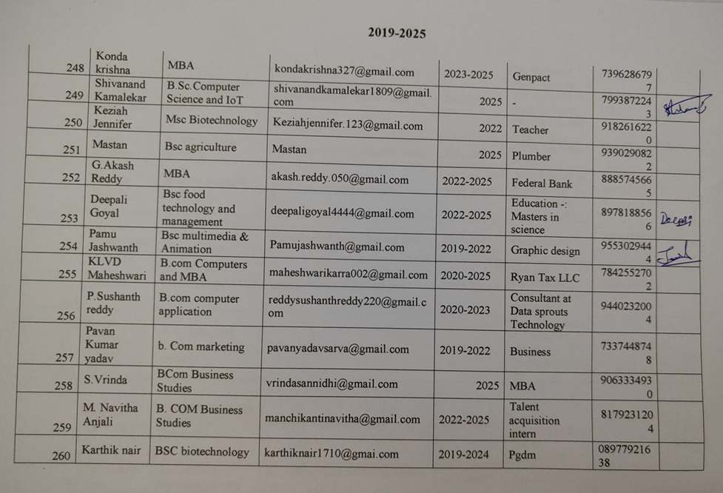
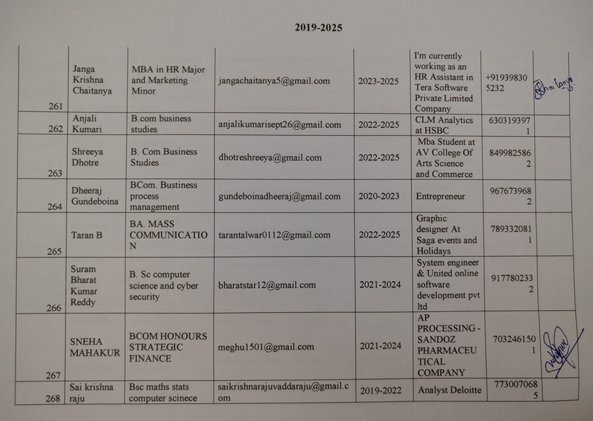 |  | 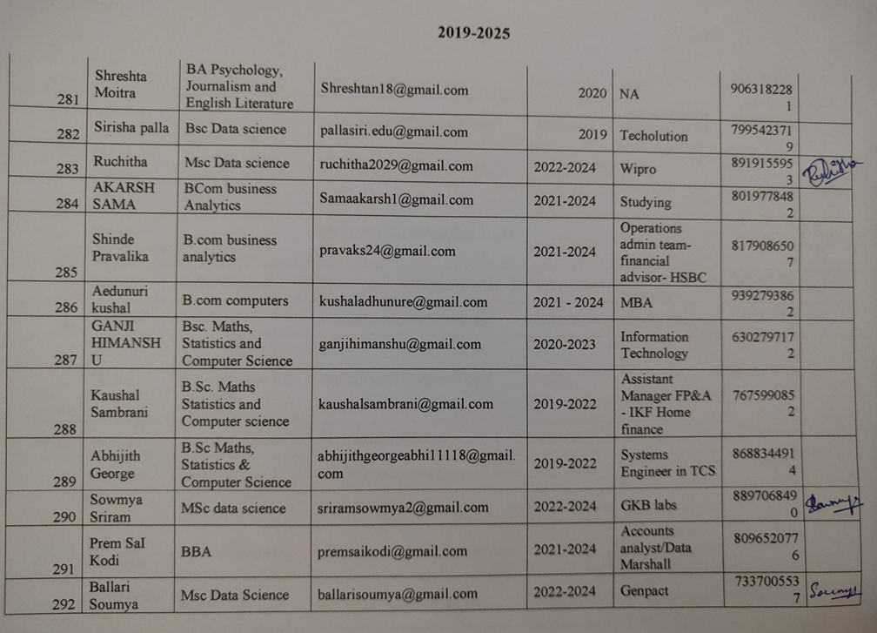
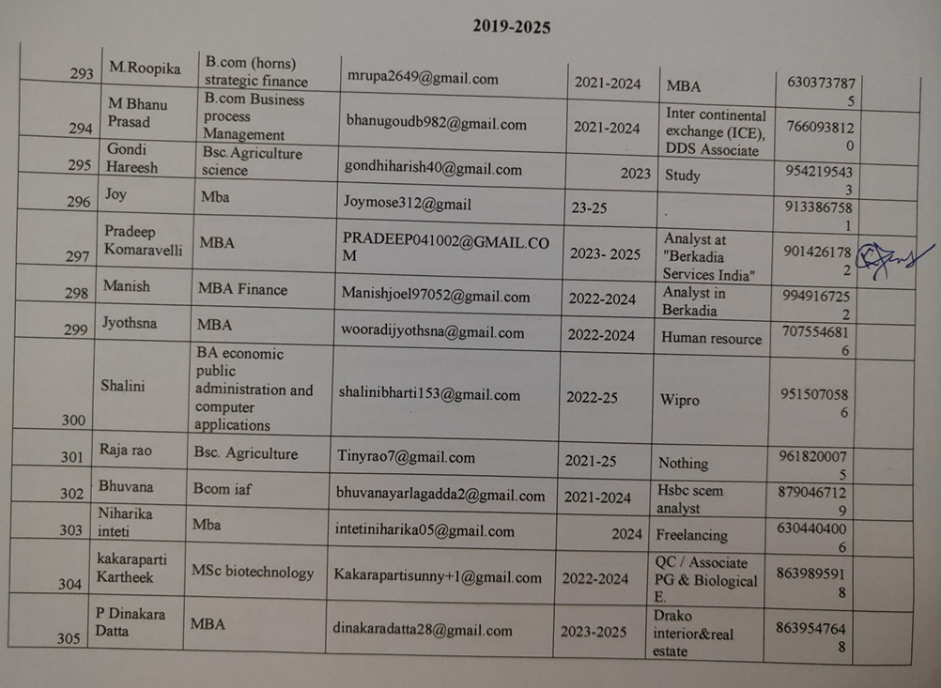 |  | 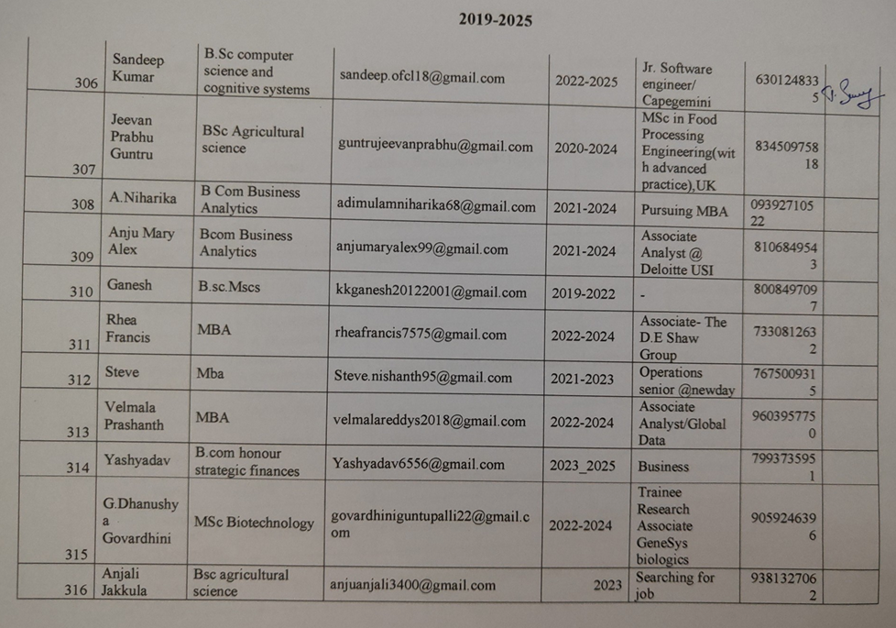
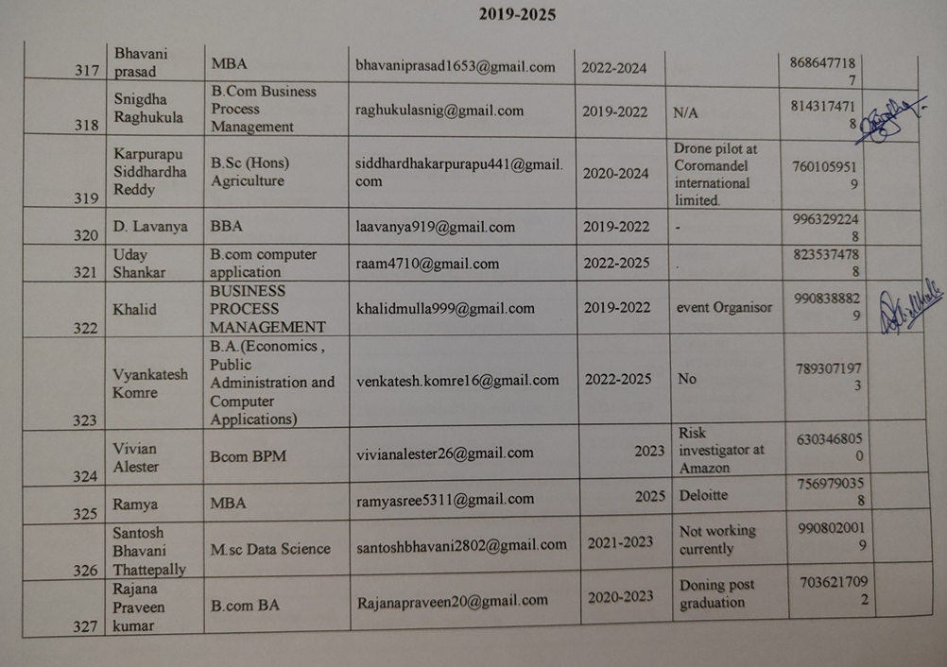 |  | 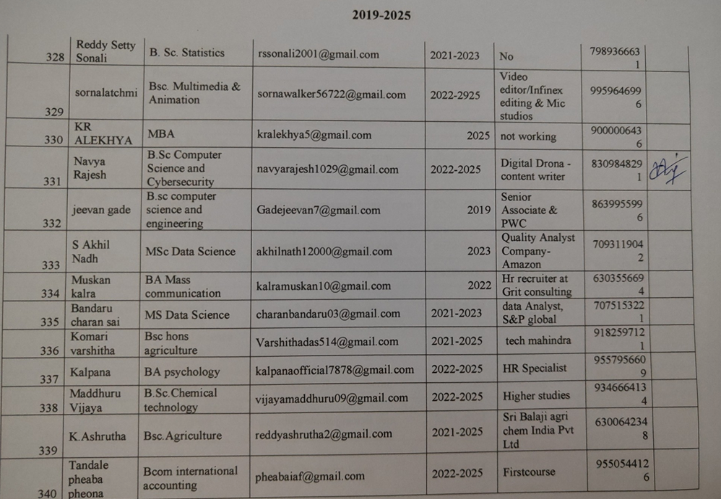
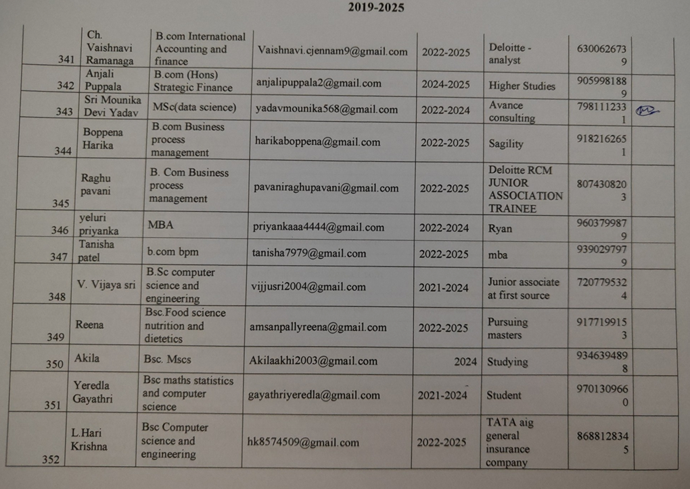 |  | 