

TITLE OF THE EVENT | Mental Health Wellness Session
DATE | 5th January, 2026
VENUE | Commerce Block – NCBS
ORGANIZER, COORDINATOR | Counselling Cell, Ms. Sahithya Guduru
SPEAKERS/ RESOURCE PERSONS | Ms. Sahithya Guduru
TARGET AUDIENCE | Students
OBJECTIVES OF THE EVENT:
To promote positivity , self-love and mental wellness within our community.
PARTICIPANTS DETAILS:
TOTAL PARTICIPANTS |  | 24 students
DEMOGRAPHICS |  | Students
ATTENDANCE PERCENTAGE |  | 46%
CONTENT EVALUATION:
RELEVANCE OF THE TOPIC:
To provide students with more knowledge on mental health and the measures that they can take in case of an emergency.

DEPTH OF KNOWLEDGE DELIVERED:
We started the session with a self-reflection ice-breaking activity, past that we discussed about mental health and what is mental health to them and what are the problems they face regarding that. Students were taught how manage their emotions, stress and anxiety by using techniques like box breathing, 5-4-3-2-1 activity.

ENGAGEMENT OF PARTICIPANTS:
The students were encouraged to talk about the regular mental health challenges that they face like anxiety, peer pressure, academic stress.
LEARNING OUTCOMES:
Students learned practical calming techniques like grounding and box breathing to manage stress. They also gained a better understanding of their everyday struggles and how to respond to them in healthier ways.
KEY TAKEAWAYS FOR PARTICIPANTS:
- Learned quick calming tools like grounding and box breathing
- Understood their daily stressors better and feel heard
- Gained practical ways to manage overwhelming moments

SKILLS/KNOWLEDGE GAINED:
- Grounding techniques

- Emotional Well-being
- Self-Awareness & Mindfulness
- Supportive Community & Growth
FEEDBACK ANALYSIS:
METHOD OF FEEDBACK COLLECTION: Offline

POSITIVES:
- Boosted Mood & Positivity
- Self-Reflection & Awareness
- Encouragement & Motivation
- Sense of Connection & Agreement
- Emotional Impact & Meaningful Experience
QUANTITATIVE ANALYSIS AND FUTURE PRACTICES:

SUGGESTIONS FOR FUTURE EVENTS:
- Offer a follow-up session to reinforce the skills
- Add more interactive activities and real life examples
FEEDBACK FORMS:
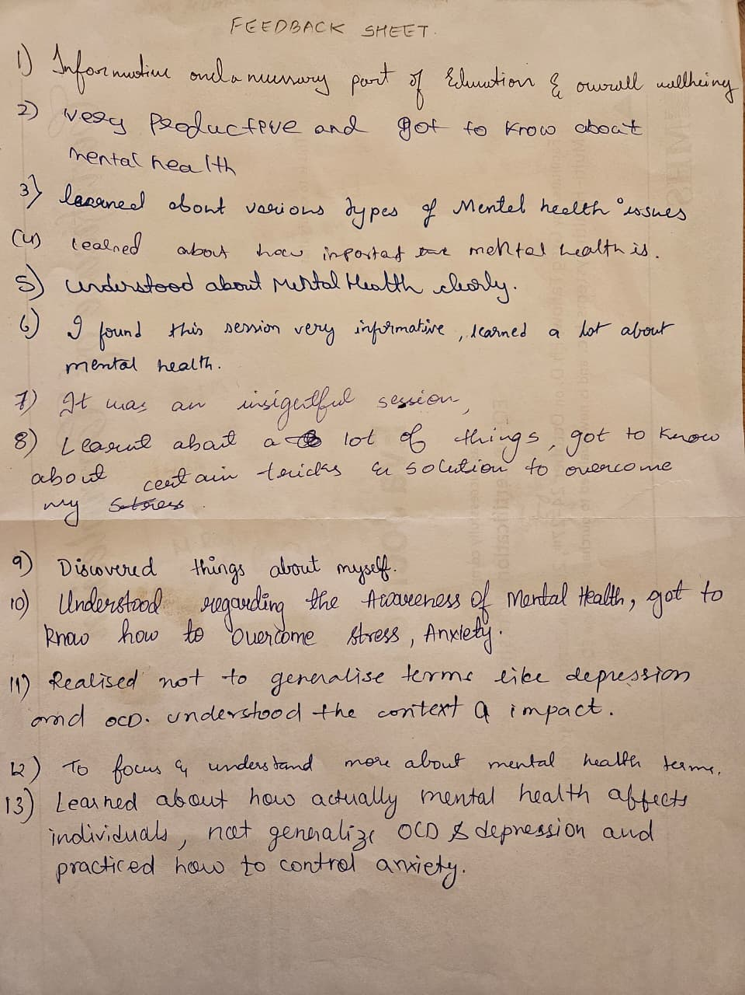
EVENT PHOTOS:

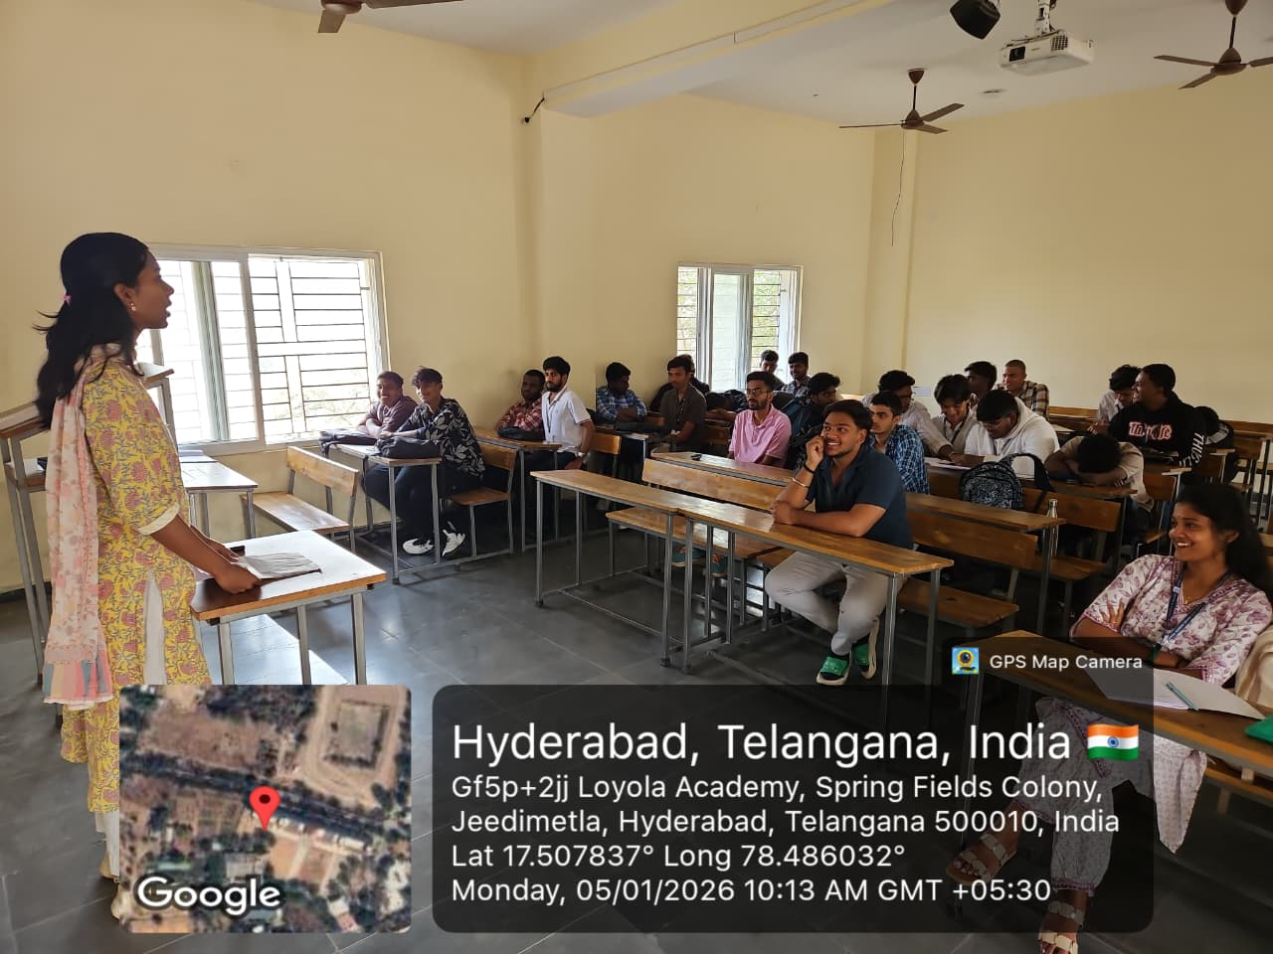
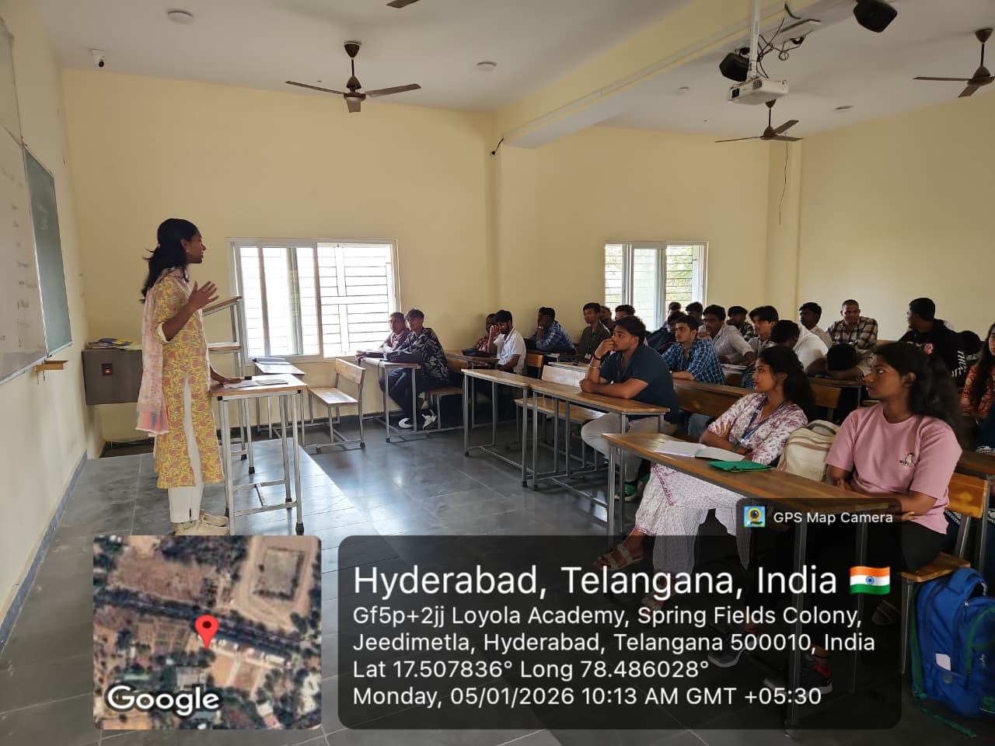

ATTENDANCE SHEET:

