LOYOLA ACADEMY

ALWAL, SECUNDERABAD 500 010 TS
(Autonomous and affiliated to Osmania University)
A “College with Potential for Excellence” by UGC
www.loyolaacademyugpg.ac.in Ph: 040-27862363 /27860077

DEPARTMENT
OF
B.COM INTERNATIONAL FINANCE

DEPARTMENTAL ACTIVITIES REPORT
2025-2026

INDEX

SL.NO | CONTENTS | PAGE
1 | Departmental Common Activities
 | 1.1 ACCA Orientation Program | 2
 | 1.2 Alumni Report | 6
 | 1.3 Report on Bridge Course | 8
 | 1.4 ACCA Guest Lectures -
 | Performance Management | 12
 | Financial Reporting | 15
 | Audit and Assurance | 17
 | Financial Management | 19
 | Strategic Business Leader | 22
 | Advanced Audit and Assurance | 24
 | Strategic Business Reporting | 26
 | Advanced Performance Management | 28
 | 1.5 Report on Add-on course | 30
 | 1.6 Report on Self-Study course | 32
 | 1.7 Fiducia 7.O – a Two-Day Commerce Summit | 33
 | 1.8 Seminar on Career Advancement | 39
2 | Industrial visit | 41
3 | Parent Teacher Meeting | 43
4 | ACCA Achievements | 45
5 | Placements and Internships | 46
6 | External Achievements | 47
7 | NPTEL | 49

I. Faculty:
Sl.no | Particulars | No.
01 | No. visiting faculty in the current academic year (2024-2025) | NIL
02 | No of visiting faculty with more than 10 years of teaching experience | NIL
03 | No of visiting faculty with more than 10 years of industry experience | NIL
04 | Total number of faculty training programs/FDP held in | NIL
05 | How many faculties participated in any FDP in your college | NIL
06 | How many faculties participated in any FDP outside your college | NIL
07 | Total number of faculty participating in foreign exchange programs | NIL
08 | Total number of seminars conducted by the college
09 | Total number of national seminars attended by permanent faculty | NIL
10 | Total number of international seminars attended by permanent faculty | NIL
11 | Total number of workshops & conferences attended by permanent faculty | NIL
12 | Total no. of guest speakers from the industry | NIL
13 | List of faculty exchange programs along with a copy of Memorandum of Understanding (MoU) | NIL
14 | Percentage of faculty of the college sent abroad through a faculty exchange program | NIL
15 | Number of faculty on Corporate Boards | NIL
16 | Number of live projects undertaken by faculty | NIL
II. Students:
Sl.no | Particulars | No.
01 | No. of events/workshops conducted by the college to develop students professional ethics | 02
02 | No. of students involved in research and consultancy undertaken by the college | NIL
03 | Total number of student foreign exchange programs | NIL
04 | Percentage of student sent abroad through student foreign exchange program- | NIL
05 | Percentage of foreign students came to your college through student foreign exchange program | NIL
06 | Number of stress management training program (like Art-of-living, etc.) conducted | NIL
07 | Number of students’ societies in your college | NIL
08 | No. of student workshops/ training programs apart from internships- | 01
09 | Number of events/ workshops attended by students
10 | Number of events/ workshops attended by other college students | NIL
11 | Number of events/ workshops attended by our college students outside the campus
12 | Number of fests organized by your college students | NIL
13 | Number of B.A. /B.Com./BBA/B.Sc. students involved in the research undertaken by the college in the last 1 year | 55
14 | How many voluntary or charity programs are your institute associated | NIL
15 | Total number of students who opted for entrepreneurship for the batch that passed | NIL
16 | List of student exchange programs along with a copy of Memorandum of Understanding (MoU) | NIL
17 | Memorandum of Understanding (MoU) with international university | NIL
18 | Number of corporate or industry visits conducted for students | NIL

1.DEPARTMENTAL COMMON ACTIVITIES

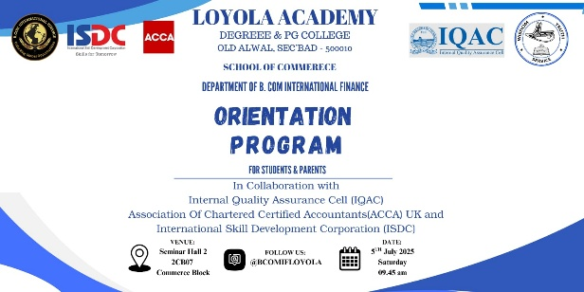
  - ACCA ORIENTATION PROGRAM
Date: 5th July 2025
Place: Seminar Hall - 2 (2CB07), Commerce Block, Loyola Academy.
Purpose: To introduce and inform first-year students and their parents about the opportunities and specifics of the ACCA program.
Report:
The Department of B. Com International Finance successfully conducted its annual orientation program for the newly admitted first-year students and their parents on Saturday, 5th July 2025, at Seminar Hall 2 (2CB07), Commerce Block, Loyola Academy. The program was organised to warmly welcome the new students and their families, introduce them to the department’s ACCA-integrated curriculum, and build confidence for the academic journey ahead.

The event began with a warm welcome by the Masters of Ceremony, Ms. Jullianne (3rd Year) and Ms. Angita (2nd Year), who hosted the program smoothly and confidently. The session opened with a soulful prayer song, seeking blessings for the academic year ahead and setting a positive tone for the day.

The Principal, Fr. Dr. A. M. Joseph Kumar SJ, delivered an inspiring inaugural address, highlighting Loyola Academy’s commitment to holistic education, discipline, and excellence. He encouraged the students to make the best use of the opportunities offered, to utilise the resources provided by the college effectively, and to uphold the institution’s strong values at every step.
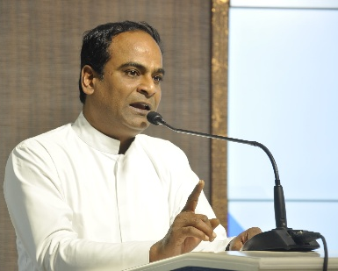
Fr. M. Arul Jothi SJ Vice Principal then addressed the gathering, emphasising the importance of integrity, discipline, and balance in student life. He reminded students that college is not just about academics but also about building character, friendships, and life skills that shape their future. He urged parents to stay actively connected with their wards and the institution, ensuring that students remain focused and responsible during these crucial years.
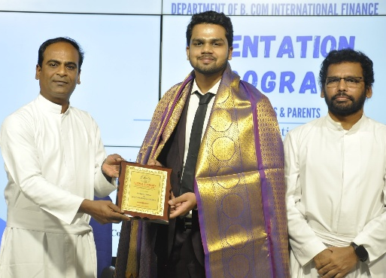
A felicitation ceremony then took place, where the college dignitaries — Fr. Dr. A. M. Joseph Kumar SJ, Fr. M. Arul Jothi SJ, Ms. K. Raama, Dr. Veera Swamy, Dean of Commerce Block, and the Head of the Department — honoured the esteemed guests Mr. Akhil Agarwal, Regional Manager (Andhra Pradesh & Telangana) at ISDC, and Ms. Preeti, Operations Associate at ISDC, for their valuable presence and contribution in strengthening the ACCA collaboration with Loyola Academy..
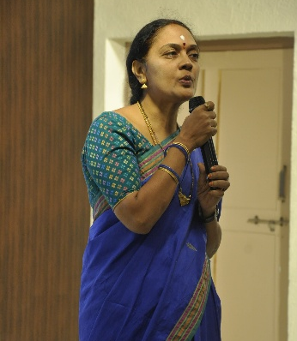
Following Fr. Arul Jothi SJ’s address, Ms. K. Rama Devi, IQAC Coordinator, spoke to the gathering about the importance of maintaining academic quality and standards. She highlighted Loyola Academy’s continuous efforts to ensure excellence through regular academic reviews, feedback systems, and student support initiatives. She encouraged students to engage actively in all opportunities and reassured parents of the college’s commitment to providing a safe, disciplined, and quality learning environment.

Next, Ms. Hari Sree took the stage to give a detailed department introduction. She warmly welcomed the new students and parents and provided an overview of the B. Com International Finance department. She highlighted the department’s vision, structure, and commitment to delivering globally relevant education through its ACCA integration. She also proudly presented the department’s key achievements over the years, including academic results, student placements, professional certifications, and various accolades earned by students and faculty. Her presentation gave the new students and parents a clear understanding of the department’s standards and the opportunities that lie ahead.

The ACCA session was then led by Mr. Akhil Agarwal, who delivered an engaging and in-depth presentation about the ACCA qualification. He explained its global relevance, detailed structure, the step-by-step process to become ACCA qualified, and how the program is seamlessly integrated with the B. Com International Finance course at Loyola Academy. Mr. Akhil’s clear explanations, real-world examples, and practical insights helped students and parents understand the value of ACCA in shaping strong careers in finance and accounting. He emphasised the commitment required to complete the professional qualification successfully and shared inspiring success stories of past students.

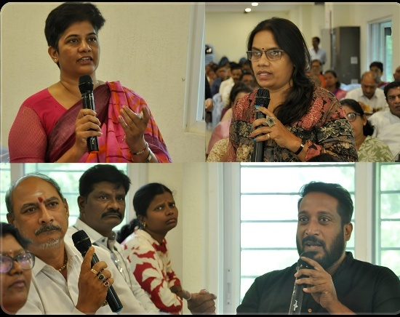
Mr. Akhil also conducted an interactive Q&A session with parents and students, addressing their queries and clarifying all doubts with patience and clarity. The Head of the Department actively assisted Mr. Akhil during the Q&A, providing additional clarifications wherever needed to reassure parents and students. Ms. Preeti was present alongside Mr. Akhil, providing coordination support to ensure the session went smoothly.
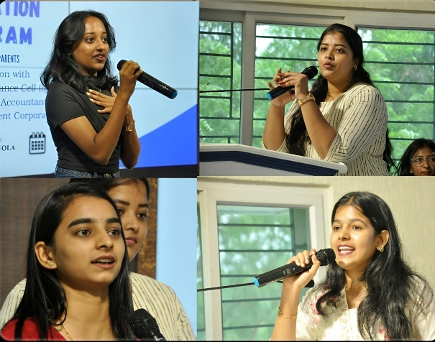
Following the Q&A session, a special alumni sharing segment was held. Recent graduates CH. Vaishnavi, J. Tejaswini, T. Vishala, E. Vaishnavi, Pallavi, and M. Kruthika — all 2025 pass-outs from the B. Com International Finance department — addressed the gathering. They shared their personal experiences of preparing for ACCA exams alongside their degree coursework, the challenges they overcame, and the strategies that helped them succeed. They also spoke about their memorable journey at Loyola Academy, highlighting the faculty’s constant support, the importance of discipline, and the vibrant campus culture. Each alumnus emphasised how they effectively utilised the resources provided by the department — from mentorship and study materials to mock tests and placement guidance — which played a crucial role in their academic and professional development. Their words inspired the new students and reassured parents about the practical outcomes and success stories that the department nurtures every year.
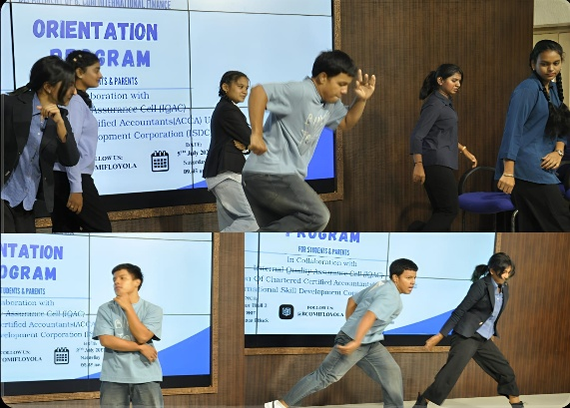
To add a lively touch to the program, an energetic dance performance was presented right after the alumni speeches. Ankit Gurung (3rd Year), Jullianne (3rd Year), Poorvi (2nd Year), Shravani (2nd Year), and Shivani (2nd Year) showcased their talent and enthusiasm through a vibrant dance, which lifted everyone’s spirits and added a festive atmosphere to the day.
The orientation program was well-received and set a positive tone for the academic year ahead, leaving students motivated and parents reassured as they embark on an enriching journey with the Department of B. Com International Finance, Loyola Academy

The event concluded with a warm Vote of Thanks delivered by ADITHYA DEVERSHETTY (3rd Year), who expressed gratitude to the Principal, Fr. Arul Jothi SJ, Ms. Raama ma’am, Dr. Veera Swamy, Hari Sree, the ACCA panel, the HoD, all the alumni speakers, the talented student performers, faculty members, parents, and students for their presence and enthusiastic participation. Special thanks were extended to the organising committee and student volunteers, whose dedication and behind-the-scenes efforts ensured the smooth and successful conduct of the program.
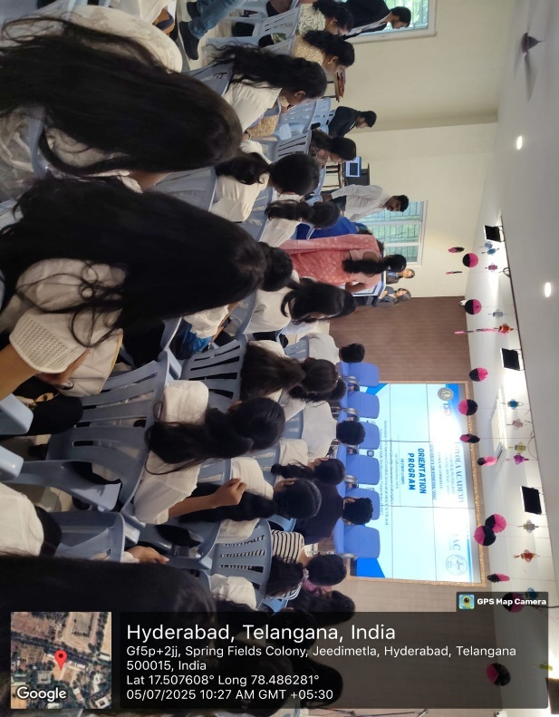
Finally, the program concluded with the National Anthem, bringing the event to a respectful and patriotic close.
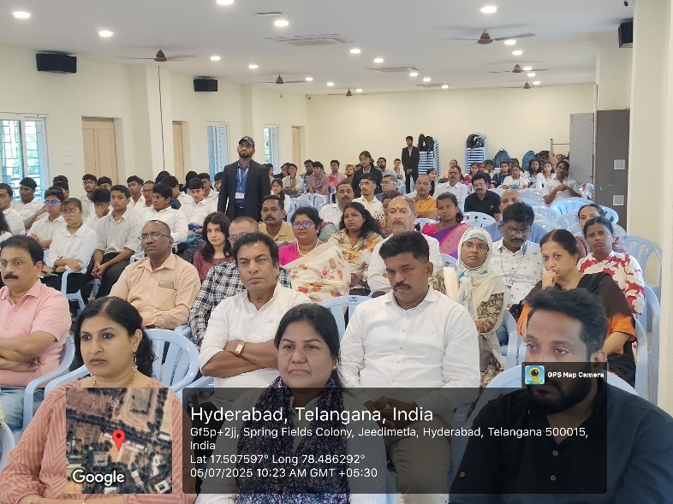
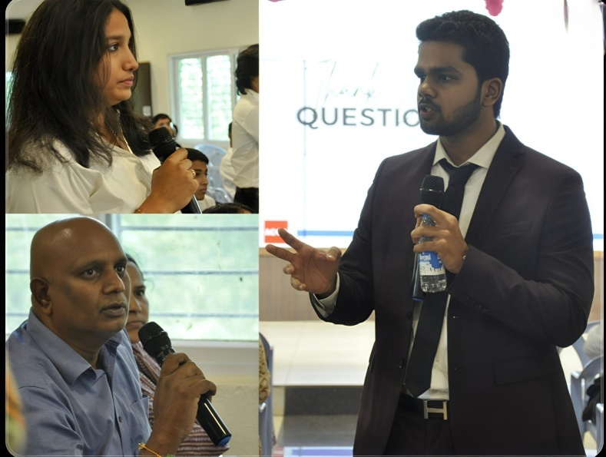
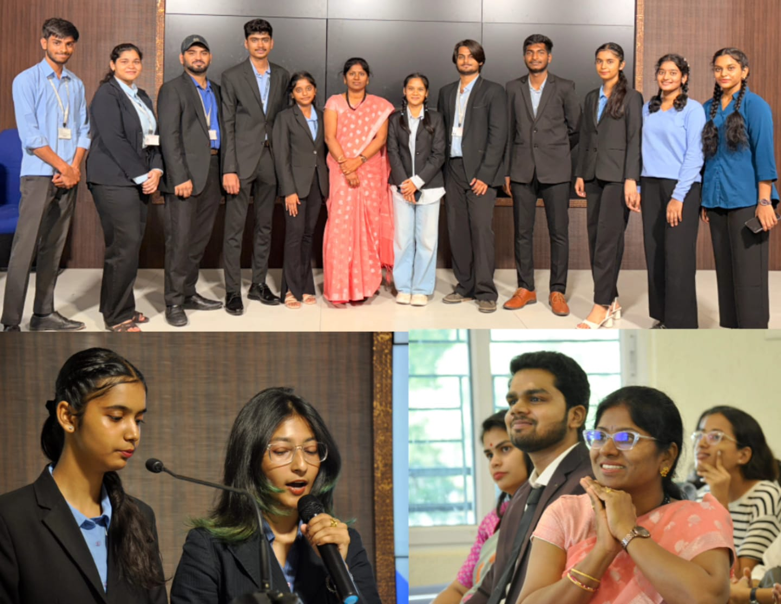

  - ALUMNI REPORT

Date: 27th June 2025
Venue: 3CB08
Time: 10.00 AM
Alum Details:
Name: Aaron Thomas Abraham
Contact: +91 9656186104, aaronthomas9035@gmail.com
A Student of B. Com International Accounting & Finance (2021-2024), Loyola Academy. Currently enrolled in International Exchange MBA partnership with Rajgiri Business School Kochi, Kerala, India and Virginia Commonwealth University, Richmond, Virginia, USA , Pursuing Master in Decision Analytics with a concentration of Financial Analytics (2024-2026)
Report:
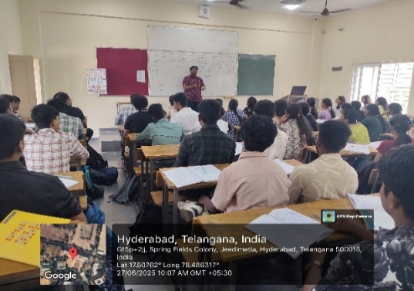
An alumni interaction session was organized on 27th June 2025 for the first-year B. Com International Finance students. The session was graced by Aaron Thomas Abraham, an alum from the batch of 2024.
Aaron Thomas Abraham shared his valuable insights about the B. Com International Finance course, the ACCA pathway, and the various opportunities available to students during and after the course. He spoke about his own journey, highlighting the importance of dedication, time management, and smart planning.
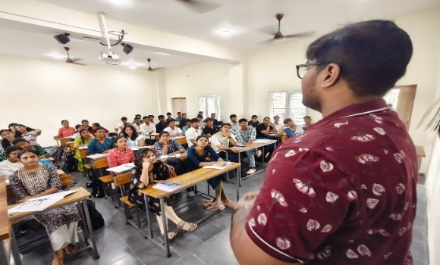
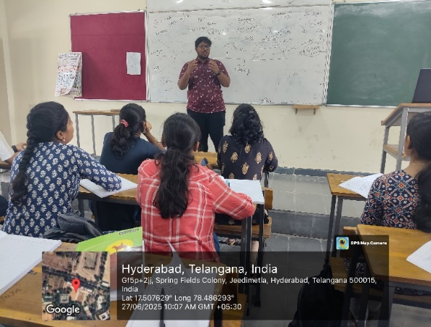
He encouraged students to actively participate in all the academic and co-curricular activities conducted by the department, and to make the best use of the faculty guidance, study resources, and placement support. He addressed several queries from the students related to internships, professional exams, industry expectations, and future career prospects.

Aaron also advised the students to build strong networks, stay updated with current industry trends, and develop relevant skills alongside their academics. He stressed the importance of using the resources provided by the department effectively to shape a strong foundation for their careers.
The session was highly interactive and motivating. It gave the students much-needed clarity and confidence to plan their next steps and make the most of their time in the department.

  - Report on Bridge Course:
A bridge course is a specialized educational program designed to assist incoming college freshmen in developing a foundational understanding of Accounting Principles and Concepts. It serves as a vital stepping stone to help Students with a science and mathematics background who may have limited exposure to commerce-related subjects and seek to bridge the knowledge gap by providing a foundational understanding of key concepts.
Course Components:
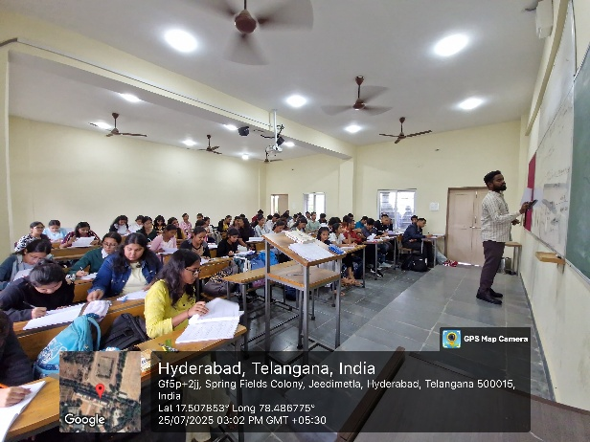
- To Introduction Commerce: The course begins with an overview of commerce as a field of study. It introduces students to the fundamental concepts, terminologies, and principles that underpin commerce-related disciplines
- Financial Literacy: Understanding financial concepts is crucial for anyone pursuing commerce courses. The bridge course covers basic financial literacy topics, including budgeting, personal finance, and financial planning.
- Accounting Principles: An introduction to accounting principles and practices, including topics such as bookkeeping, financial statements, and basic accounting entries.
- Economics Basics: The course provides an overview of economic principles and theories, focusing on concepts like supply and demand, market structures, and economic indicators.
- Business Fundamentals: Students learn about the basics of business operations, including different types of organizations, business structures, and the principles of entrepreneurship.

Objectives of the Bridge Course:
- Foundation Building: To provide students with a foundational understanding of commerce-related subjects, ensuring they are well-prepared for more advanced coursework.
- Confidence Building: To boost students' confidence in their ability to excel in commerce and business-related subjects.
- Smooth Transition: To ease the transition from a science and mathematics background to commerce and related fields at the college level.
- Skills Development: To equip students with the necessary skills, knowledge, and terminology required to succeed in commerce courses.
- Interest Cultivation: To stimulate interest and curiosity in commerce and business-related subjects, encouraging students to explore and pursue these fields further.
Course outcomes:
Before conducting the bridge course, the students were not good with their fundamentals in accounting. After the bridge course, students gained knowledge of the fundamentals of accounting and basic terms used in accounting, the scope of accounting, and knowledge about the accounting cycle.
Brief look of Bridge course (Financial Accounting):

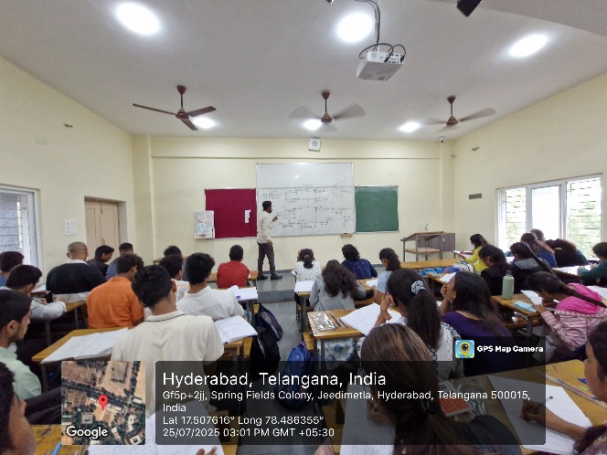
The Financial Accounting bridge course commenced with an air of anticipation and enthusiasm among the students, drawing them into the world of accounting with great curiosity. The sessions proved to be captivating, inspiring active participation and igniting a genuine interest in the subject. As this fresh iteration of the bridge course unfolded, students were introduced to the vibrant atmosphere of the department, setting the stage for an exciting learning journey. To enrich the experience of the current bridge course, the organizing committee diligently planned to engage expert faculty members and foster an environment of activity-based learning.

Distinguished Faculty:
Mr. A. Pashupatinath, an esteemed Assistant Professor, took the stage to impart valuable insights into the realm of financial accounting. With expertise and enthusiasm, he elucidated the significance of Financial Accounting Principles, shedding light on key applications like Bookkeeping and Golden Rule of Accounting. His engaging lecture not only educated students but also motivated them to explore the intricacies of financial accounting further.
Subject: Financial Accounting
(BRIDGE COURSE)

No. of Hours : 15
No. of Students Attended : 54
Outcomes: Students would have a better understanding of Accounting Concepts, Conventions, Accounting Equations, Classifications of Accounts, and Rules of Double Entry System Journalizing.

The Bridge Course was held from 16th July 2024 to 08th August 2024 from 3:00 PM to 4:00 PM in 3CB07 in the Commerce block A test was conducted for 50 marks before starting the bridge course and after completion of the bridge course.

Department of b. Com international finance
Bridge Course Syllabus
FINANCIAL ACCOUNTING - I
Unit– 1
Introduction to Accounting 3 Hrs
Introduction to Accounting 1
Need for Accounting and Definition 1
Meaning, Features, Objectives of Accounting 1

Unit– 2
Scope & Branches of Accounting 3 Hrs
Functions, Systems, Bases, and Scope of Accounting. 1
Bookkeeping and Accounting 1
Branches of accounting and advantages and Limitations. 1

Unit– 3
Accounting Terminology & Concepts 3 Hrs
Basic Terminology in Accounting 1
Accounting Concepts and Conventions 1
Accounting Equation 1

Unit– 4
Books of Journal 3 Hrs
Classifications of Accounts 1
Rules of Double Entry System 1
Journalizing 1

Unit– 5
Ledger Accounts 3 Hrs
Introduction 1
Posting to Ledgers 1
Balancing of Ledgers. 1

Essential Readings:

1)Financial Accounting - S.P. Jain and K.L. Narang. - Kalyani Publishers.
2) Financial Accounting -Kaplan Publishing.
3) Accounting - ICAI

  - GUEST LECTURES
→ Guest lecture on PERFORMANCE MANAGEMENT:
Title: Guest Lecture Report on Performance Management by Mr. Karthik Chandra
Venue: Commerce Block
Class: NIF (3CB 07)
Date: 22nd July, 2024 to 30th July, 2024.

Introduction
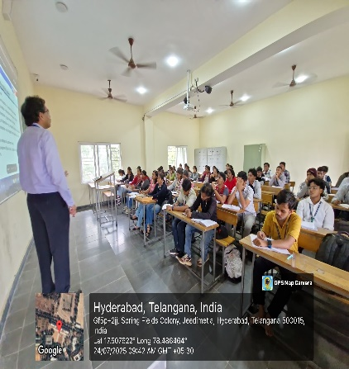
Performance Management is one of the F- level papers in ACCA. So, the department of BCOM IF has organized a guest lecture for the subject of Performance Management for the ACCA aspirants to deal with the subject and clear this paper with ease.
This session commenced in the months of August and September. The students were guided on how to plan and schedule for the exam. The guest lecture on performance management by the ACCA (Association of Chartered Certified Accountants) faculty was a valuable opportunity to gain insights into the latest trends and best practices in the field of performance management.
Speaker Background
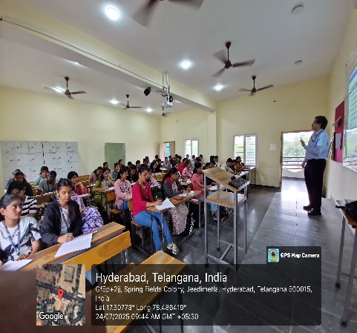
Karthik is a Chartered Accountant working as a Faculty with ISDC and is passionate about Teaching. Prior to joining ISDC, he has nearly 14 years of post-qualification work experience with Deloitte in External (Statutory) Audit and Internal Audit roles, served globally large Clients, maintained Client relationships and ensured high quality and regulatory compliant Client deliverable standards. With strong business, regulatory and risk background, served clients across multiple industries. Wide experience in managing the end-to-end engagement lifecycle from planning to reporting in Indian GAAP (Generally Accepted Accounting Principles), US GAAP and IFRS (International Financial Reporting Standards). Actively involved in conducting technical training programs, talent recruitment and other Firm initiatives.
Recognized for excellent project management abilities, effective collaboration skills and deep technical competencies serving Clients both in India and abroad
Key Topics Covered
1.Sustainability Reporting and Performance Management:
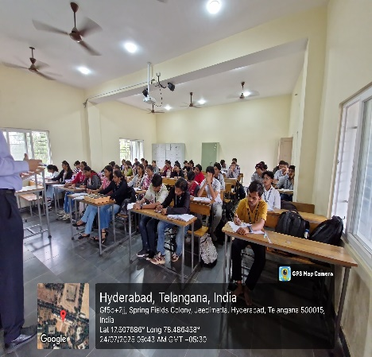
The lecture may have touched upon the significance of integrating social, environmental and economic sustainability into performance management processes, as well as the implications for university policy makers and regulators.
2. Management Accounting in the Curriculum:
The rising importance of management accounting in the context of technological advances and its role as a strategic partner in decision-making may have been discussed.
3. Strategic Models & Performance Management:
This encompasses understanding finance, performance management and ethics
4. Productivity, Quality and Accountability:
There is a strong emphasis on increased productivity, quality and accountability in performance management in higher education.
5. Management Accounting Techniques:
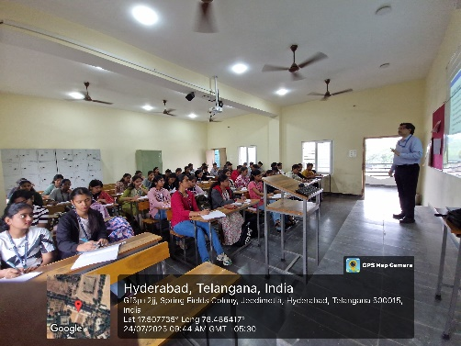
The application of management accounting techniques to make decisions, perform evaluations and to control is a key area of focus in performance management.
6. Continuous Communication and Clarification:
Performance management in an ongoing, continuous process of communication and clarifying job responsibilities, priorities, performance expectations and development planning

Key Takeaways
The lecture provided valuable insights into the practical application of performance management concepts, the importance of sustainability reporting, and the evolving role of management accountants in today's business landscape.
Conclusion
In conclusion, the guest lecture by the ACCA faculty offered a comprehensive understanding of performance management, equipping the audience with practical knowledge and insights that are highly relevant in the contemporary business environment.
While the specific details of the lecture are not available, this report outlines the potential content and key takeaways that may have been covered during the guest lecture on performance
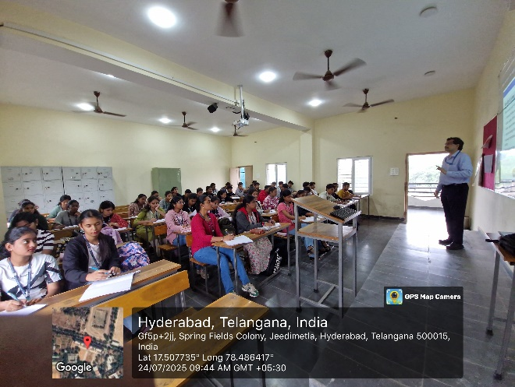
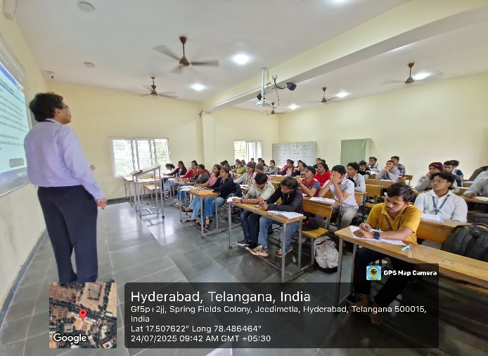
management by an ACCA faculty.

→Guest lecture on FINANCIAL REPORTING
Title: Guest Lecture Report on Financial Reporting by Ms. Manisha Darla
Venue: Commerce Block
Class: NIF (3CB 07)
Date: 7th August, 2025 to 2nd September, 2025

Introduction
Financial Reporting is one of the F- level papers in ACCA. So, the department of BCOM IF has organized a guest lecture for the subject of Financial Reporting for the ACCA aspirants to deal with the subject and clear this paper with ease.
This session commenced in the months of August and September. The students were guided on how to plan and schedule for the exam. The guest lecture on Financial Reporting by the ACCA (Association of Chartered Certified Accountants) faculty was a valuable opportunity to gain insights into the latest trends and best practices in the field of Financial Reporting.
Speaker Background
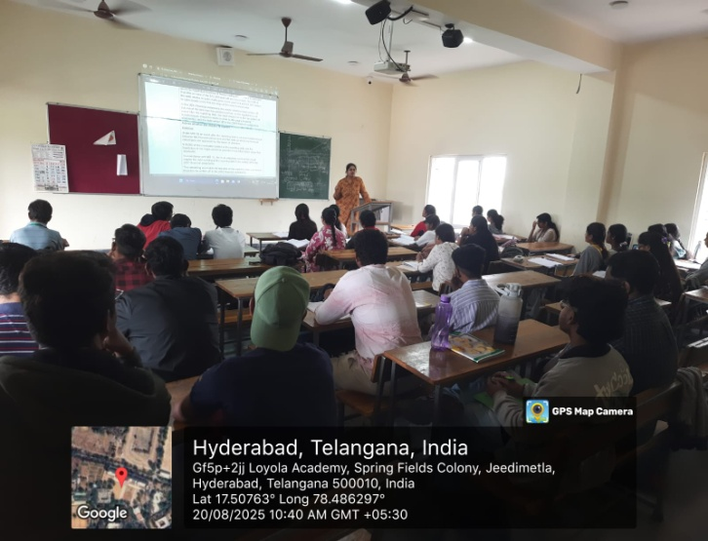
Manisha Darla is a Faculty member at ISDC, delivering training in the Association of Chartered Certified Accountants (ACCA) professional qualification. She is passionate about teaching and committed to helping students succeed in the field of accounting and finance. Prior to joining ISDC, Manisha accumulated over 5.4 years of experience in the field of audit, accounting, and team management while working as an Assistant Manager at a Chartered Accountancy firm. During this time, she led audit engagements, managed client deliverables, and oversaw audit teams to ensure timely and quality outcomes..With a sound understanding of audit practices and regulatory compliance, Manisha has hands-on experience in statutory and internal audits, financial reporting, and team leadership. She has worked with Indian GAAP and while also holding a B.Com degree and currently pursuing M.Com. Manisha is also known for her ability to effectively communicate complex concepts in a simplified manner, making her a highly effective educator.
Her exposure to professional practice, combined with academic training, enables her to bridge the gap between theory and real-world application in the classroom.
Key Topics Covered
- Conceptual Framework for Financial Reporting
- International Financial Reporting Standards (IFRS)
- Financial Statements Preparation
- Revenue Recognition
- Financial Instruments
- Property, Plant, and Equipment (PPE)
- Leases
- Provisions, Contingent Liabilities, and Contingent Assets
- Income Taxes
- Earnings Per Share (EPS)
- Business Combinations and Consolidation
- Events After the Reporting Period
- Financial Reporting in Specialized Industries
- Analysis of Financial Statements

These topics provide a solid foundation for understanding financial reporting at a professional level and are critical for ACCA candidates preparing for their examinations.

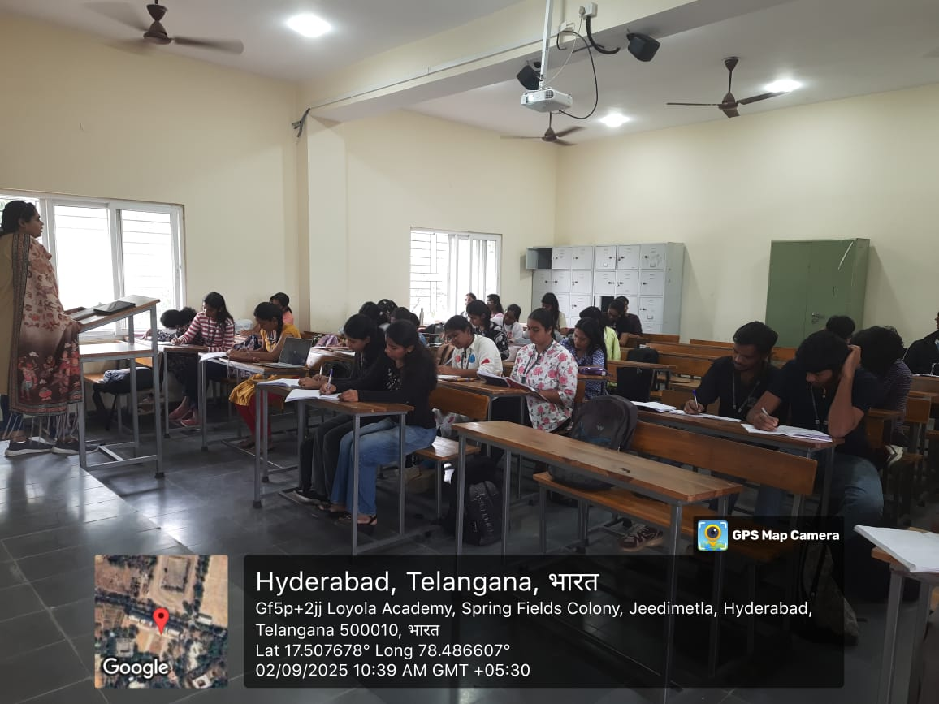
Key Takeaways
The lecture provided valuable insights into the practical application of Financial Reporting concepts, he also provided a solid grasp of International Financial Reporting Standards (IFRS) to ensure compliance and consistency in preparing and presenting financial statements.

Conclusion
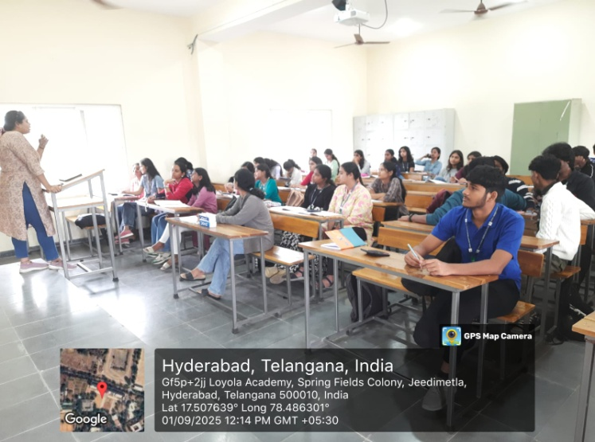
In conclusion, the guest lecture on Financial Reporting provided invaluable insights into the complexities of International Financial Reporting Standards (IFRS) and their practical applications. The session highlighted the importance of accurate financial reporting in fostering transparency and trust in financial markets. Participants gained a deeper understanding of key concepts, including revenue recognition, lease accounting, and the preparation of consolidated financial statements. Ultimately, the lecture emphasized that mastering these principles not only enhances professional competence but also supports ethical practices in the accounting profession. This knowledge is essential for effective decision-making and contributes to the overall integrity of financial reporting.

→ Guest lecture on AUDIT AND ASSSURANCE:
Title: Guest Lecture Report on Audit and Assurance by Mr. Sai Charan
Venue: Commerce Block
Class: NIF (3CB 07)
Date: 9th September, 2025 to 10th October, 2025
Introduction
Audit and Assurance is one of the F- level papers in ACCA. So, the department of BCOM IF has organized a guest lecture for the subject of Audit and Assurance for the ACCA aspirants to deal with the subject and clear this paper with ease.
This session commenced in the months of September and October. The students were guided on how to plan and schedule for the exam. The guest lecture on Audit and Assurance by the ACCA (Association of Chartered Certified Accountants) faculty was a valuable opportunity to gain insights into the latest trends and best practices in the field of Audit and Assurance.
Speaker Background
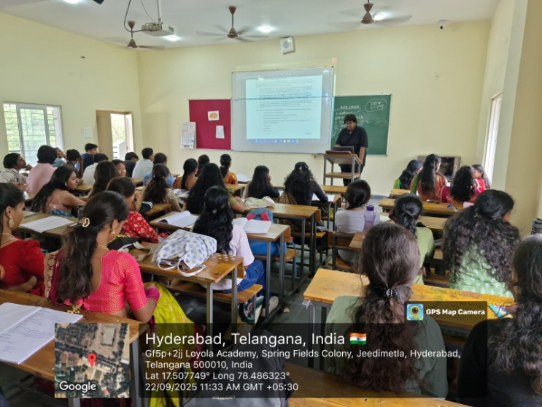
Charan is a seasoned accounting professional and ACCA Trainer at ISDC Global who brings a wealth of international expertise from his work across India, Ireland, and the UK. With a career rooted in the belief that financial data should tell a clear story, he has managed end-to-end financial operations—including multi-location reconciliations, VAT filings and payroll—utilizing enterprise platforms such as SAP, Oracle, and QuickBooks. A prolific educator, Charan has trained and mentored over 1,000 students across 25+ prestigious universities, delivering high-impact sessions on Financial Reporting, Audit, Taxation, and Strategic Business Leadership. He is highly regarded for his ability to simplify "rocket science" concepts into practical double-entry solutions, combining deep technical competency with a passion for making complex financial frameworks accessible, useful, and engaging for the next generation of global professionals.
Key Topics Covered
Here are six key topics in Audit and Assurance for ACCA:
- Audit and Assurance Concepts – Types of audits, objectives, and assurance levels.
- Regulatory Framework – ISAs, ethical standards, and corporate governance.
- Audit Planning & Risk Assessment – Risk-based approach, materiality, and audit strategies.
- Internal Controls & Testing – Importance of internal controls, testing, and reporting deficiencies.
- Audit Evidence & Procedures – Types of evidence, audit techniques, and sampling.
- Audit Reporting – Types of audit opinions, report structure, and addressing going concern issues.

These topics give a broad understanding of the responsibilities and practices involved in providing audit and assurance services. The subject also emphasizes practical application in various business contexts.
Key Takeaways
The key takeaway from Audit and Assurance is that auditors provide independent, objective assessments of financial statements to enhance the credibility of financial reporting, ensuring stakeholders can make informed decisions based on reliable information.
Conclusion
In conclusion, the guest lecture from ACCA on Audit and Assurance has provided invaluable insights into the critical role auditors play in safeguarding financial integrity and accountability. Through understanding audit concepts, regulatory frameworks, and ethical responsibilities, we've deepened our knowledge of how auditors contribute to enhancing trust in financial reporting. The practical examples and real-world perspectives shared today highlight the evolving challenges and opportunities within the field, preparing us to approach our future roles with professional scepticism, competence, and a commitment to ethical conduct.
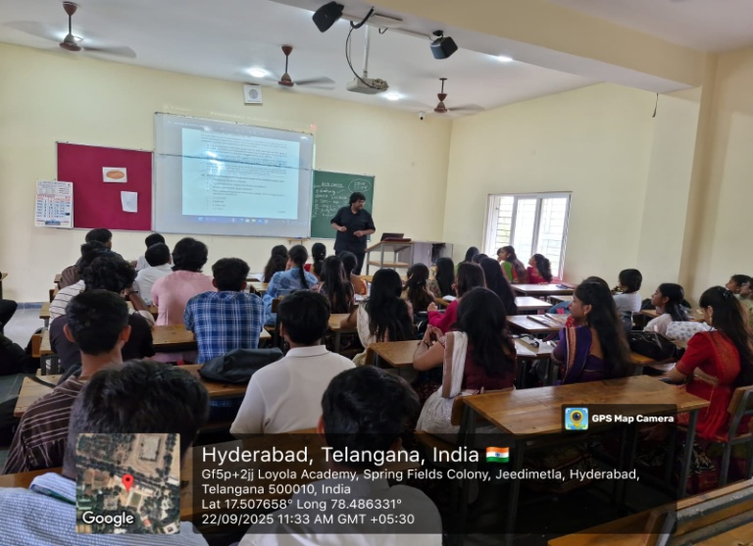
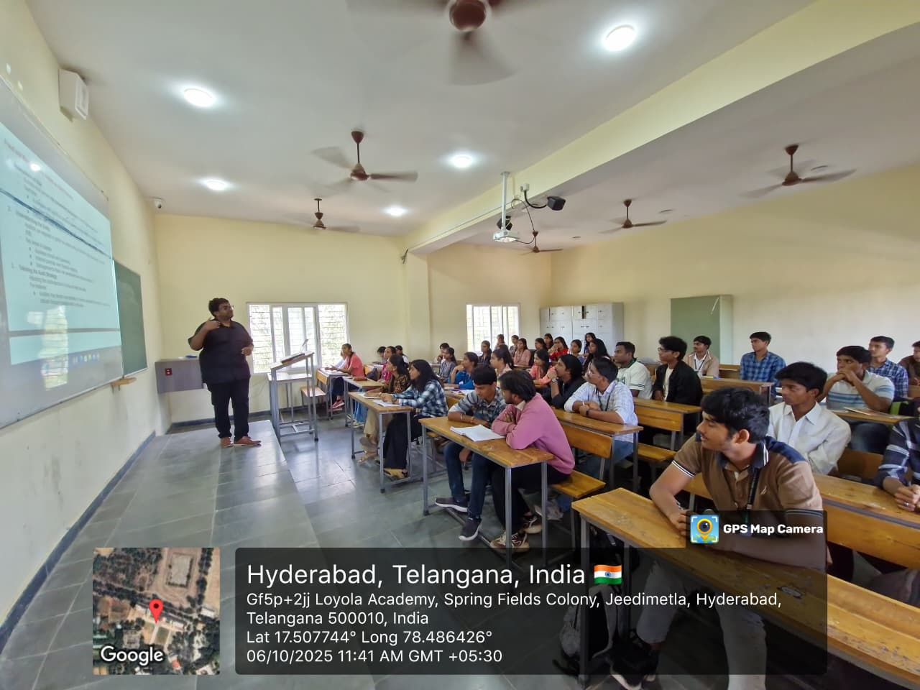

→ Guest lecture on FINANCIAL MANAGEMENT:
Title: Guest Lecture Report on Financial management by Karthik Chandra sir
Venue: Commerce Block
Class: NIF (3CB 07)
Date: 3rd February,2026 to 27th February, 2026
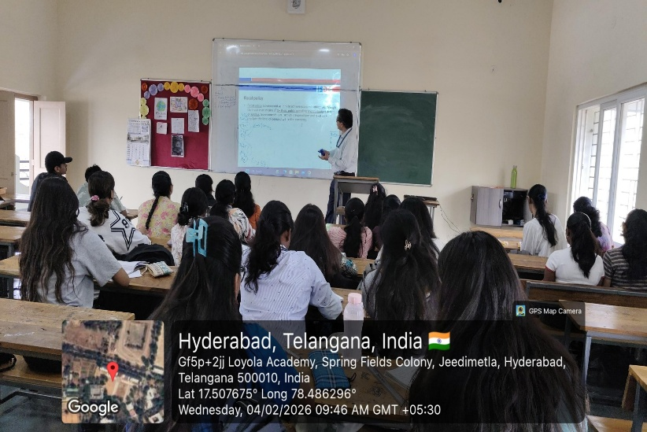
Introduction
Financial Management is one of the core F-level papers in the ACCA curriculum. To support ACCA aspirants and strengthen their understanding of the subject, the Department of B.Com International Finance organised a guest lecture on Financial Management. The session aimed to help students build strong conceptual clarity and develop effective strategies to approach the examination with confidence.
The lecture, conducted in the month of February, focused on guiding students in planning their preparation and designing an effective study schedule. The session provided valuable insights into exam techniques, practical application of concepts, and current financial practices, making it a highly beneficial academic experience for students preparing for ACCA.
Speaker Background
The session was delivered by Mr. Karthik Chandra, a Chartered Accountant and faculty member at ISDC, who is passionate about teaching. He brings with him nearly 14 years of professional experience with Deloitte, where he worked in external (statutory) audit and internal audit roles.
He has worked with large global clients across multiple industries and has extensive experience in managing engagements from planning to reporting under Indian GAAP, US GAAP, and IFRS. He has also been actively involved in technical training, recruitment, and professional development initiatives. His strong background in business, regulatory compliance, and risk management, combined with his practical industry exposure, added great value to the session.
Key Topics Covered
The lecture covered important areas of Financial Management relevant to ACCA students, including:
- Financial Management Concepts – Objectives of financial management, stakeholder interests, and agency issues
- Financial Markets & Environment – Role of financial institutions, money markets, and capital markets
- Investment Appraisal Techniques – Payback Period, NPV, IRR, and Profitability Index
- Cash Flow & Working Capital Management – Cash budgeting, liquidity management, and operating cycles
- Risk and Return – Risk measurement, diversification, and CAPM
- Cost of Capital & Capital Structure – Cost of equity, cost of debt, and WACC
- Financial Performance Analysis – Ratio analysis and interpretation
- Business Valuation – Dividend valuation and asset-based approaches
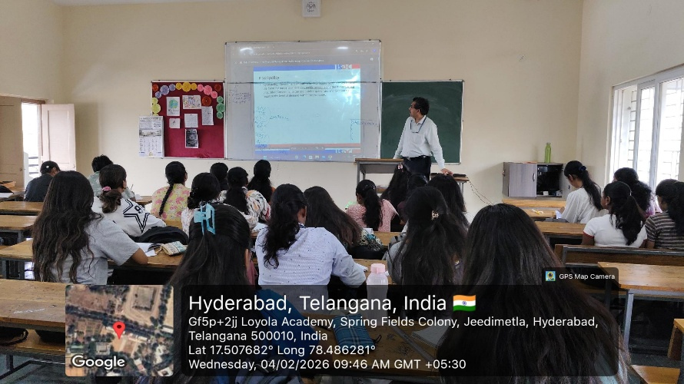
These topics provided students with a well-rounded understanding of financial decision-making and strategic financial planning in real business scenarios.

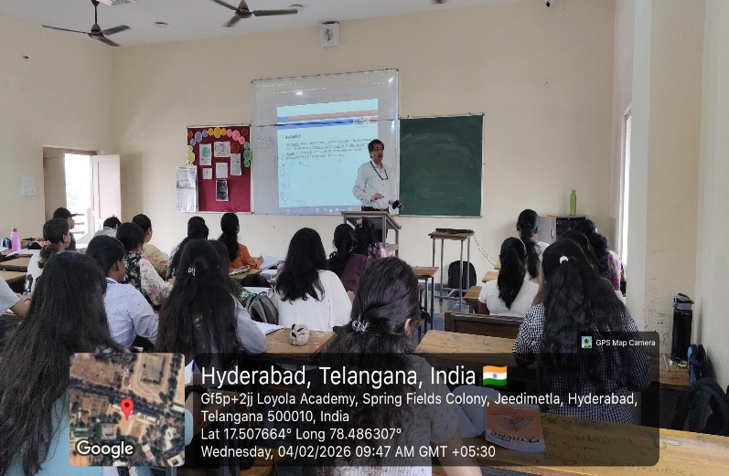
Key Takeaways
The session highlighted that Financial Management equips students with essential skills to make effective financial decisions and maximise shareholder value. Students learned how to evaluate investments, analyse financial performance, manage risks, and optimise working capital and capital structure.
The lecture also emphasised the importance of applying financial theories in practical business situations, enabling students to make informed strategic decisions in their future careers.
Conclusion
Overall, the session enhanced students’ confidence, analytical ability, and preparedness for the ACCA examination, while also equipping them with the skills required for future professional roles in finance.
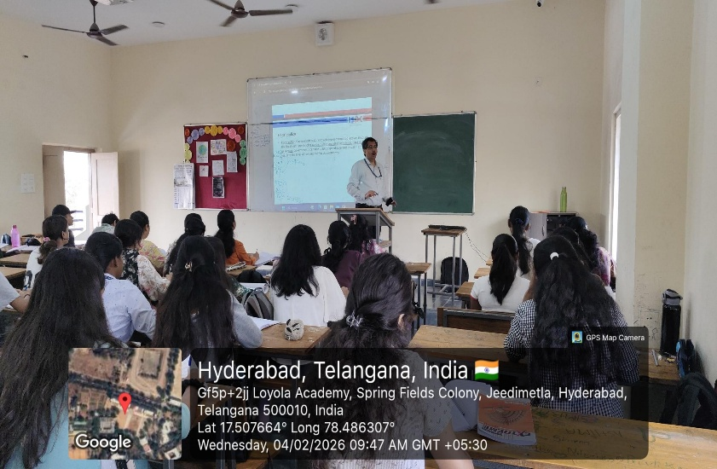

→Guest Lecture on STRATEGIC BUSINESS LEADER :-
Title: Guest Lecture report on Strategic Business Leader by Mr. Karthik Chandra
Venue: Commerce Block
Class: DIF – 3cb04
Date: 1st August 2025 to 3rd September 2025
Introduction:
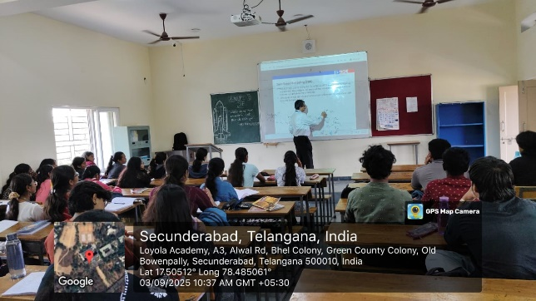
The Department of B.Com International Finance organized a guest lecture on the subject Strategic Business Leaders for the benefit of ACCA aspirants. The session was conducted for third-year students (Semester V) from 1st August 2025 to 3rd September 2025. This initiative was aimed at enhancing students’ understanding of Strategic Business Leader, one of the Professional-level papers of ACCA.
The Strategic Business Leader exam is designed to evaluate an organization’s strategic position. Candidates are required to analyse, assess, and conclude on the strategic options available, while also gaining knowledge of strategy implementation and developing the professional skills expected of a Strategic Business Leader.
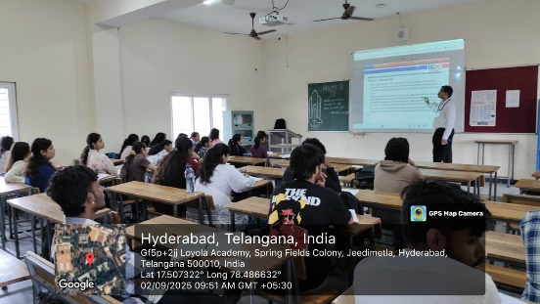
Speaker Background
Mr. Karthik Chandra is a highly respected authority in the realm of Strategic Business Leader. He possesses extensive experience in both academic research and practical application of Strategic Business Leaders tactics. With a background in commerce profession having completed Chartered Accountancy from Institute of Charted Accountants of India.
Key Topics Covered
Here is a brief about the key topics covered :
- Professional and Ethical Competence – professional skills, leadership, and ethics.
- Corporate Governance and Reporting – governance frameworks, board responsibilities, and reporting practices.
- Strategy and Decision-Making – strategic analysis, competitive forces, and corporate strategy.
- Risk and Control – risk management, internal controls, audit, and data analytics.
- Financial and Organizational Management – financial analysis, budgeting, organizational structures, and project leadership.
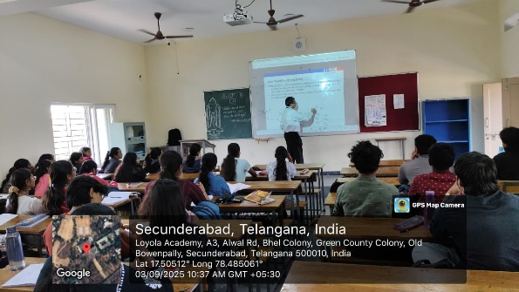
The lecturer facilitated student learning by explaining each concept with relevant examples and case studies, thereby making the subject easier to understand and retain. The sessions were conducted in an engaging manner, creating an interactive learning environment. In addition, the lecturer incorporated discussions on current real-life cases and issues faced by organizations and within the ACCA context, further enriching the students’ understanding.
Key Takeaways
The key takeaway from Strategic Business Leader is the ability to analyse an organization’s strategic position, recommend appropriate strategic options, guide their implementation, and ultimately emerge as an effective leader.
Conclusion
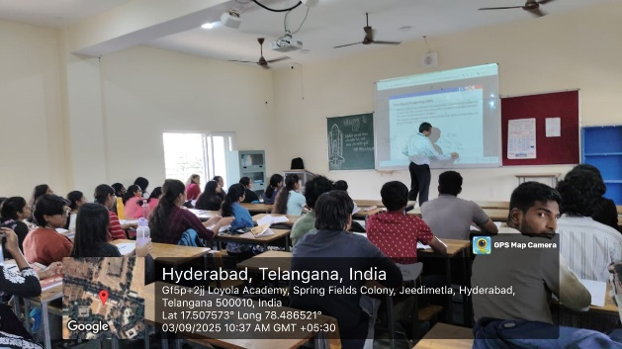
In conclusion, the guest lecture on Strategic Business Leader provided students with valuable analytical insights and a deeper understanding of assessing and evaluating organizations. The session equipped students with knowledge on understanding and implementing strategies required to help organizations effectively and inspired them to develop qualities required to excel at being a Strategic Business Leader.

→Guest Lecture on ADVANCED AUDIT AND ASSURANCE :-
Title: Guest Lecture report on Advanced Audit and Assurance by Mr. Karthik Chandra
Venue: Commerce Block
Class: DIF – 3cb04
Date: 8th September 2025 to 10th October 2025
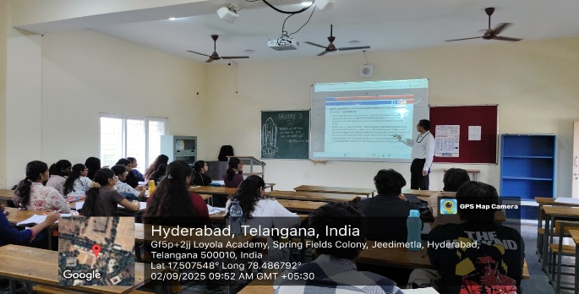
Introduction:
The Department of B.Com International Finance organized a guest lecture on the subject Advanced Audit and Assurance for the benefit of ACCA aspirants. The session was conducted for third-year students (Semester V) from 8th September 2025 to 10th October 2025. This initiative was aimed at enhancing students’ understanding of Advanced Audit and Assurance, one of the Professional-level papers of ACCA.
The Advanced Audit and Assurance exam is designed as an extension to the foundation level skill-based paper Audit and Assurance that builds the ability to evaluate the risk and ethical concerns while developing strategies and recommendations of controls for the operations at the organisation that guides them in a better management of finance and operations.
Speaker Background
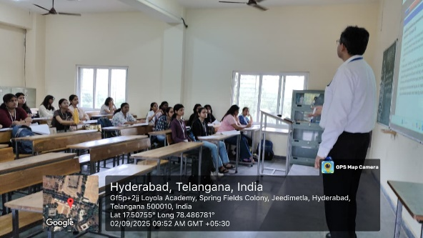
Mr. Karthik Chandra is a highly respected experience in the realm of Advanced Audit and Assurance. He possesses extensive experience in both academic research and practical application of Advanced Audit and Assurance tactics. With a background in commerce profession having completed Chartered Accountancy from Institute of Charted Accountants of India.
Key Topics Covered
Here is a brief about the key topics covered :
- Professional and Ethical Competence – professional skills, leadership, and ethics.
- Corporate Governance and Reporting – governance frameworks, board responsibilities, and reporting practices.
- Risk and Control – risk management, internal controls, audit, and data analytics.
- Financial and Organizational Management – financial analysis, budgeting, organizational structures, and project leadership.
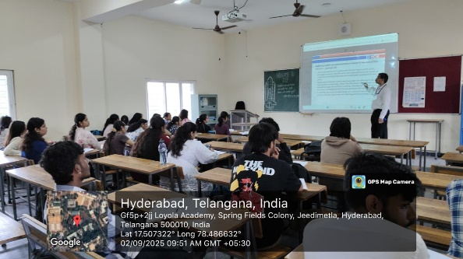
The lecturer facilitated student learning by explaining each concept with relevant examples and case studies, thereby making the subject easier to understand and retain. The sessions were conducted in an engaging manner, creating an interactive learning environment. In addition, the lecturer incorporated discussions on current real-life cases and issues faced by organizations and within the ACCA context, further enriching the students’ understanding.

Key Takeaways
The key takeaway from Advanced Audit and Assurance is the ability to evaluate the risk and ethical concerns while developing strategies and recommendations of controls for the operations at the organisation that guides them in a better management of finance and operations.
Conclusion
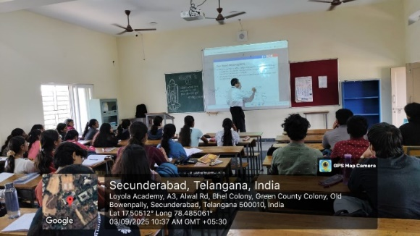
In conclusion, the guest lecture on Advanced Audit and Assurance provided students with valuable analytical insights and a deeper understanding of Audit work in real-world companies. The session equipped students with knowledge on understanding and implementing strategies required to help organizations effectively and inspired them to develop qualities required to excel at being an Auditor.

→ Guest Lecture on STRATEGIC BUSINESS REPORT
Title: Guest Lecture Report on Strategic Business Report by Mr. Santosh Reddy
Venue: Commerce Block
Class: DIF (3CB 04)
Date: 19th January, 2026 to 24th February, 2026
Introduction
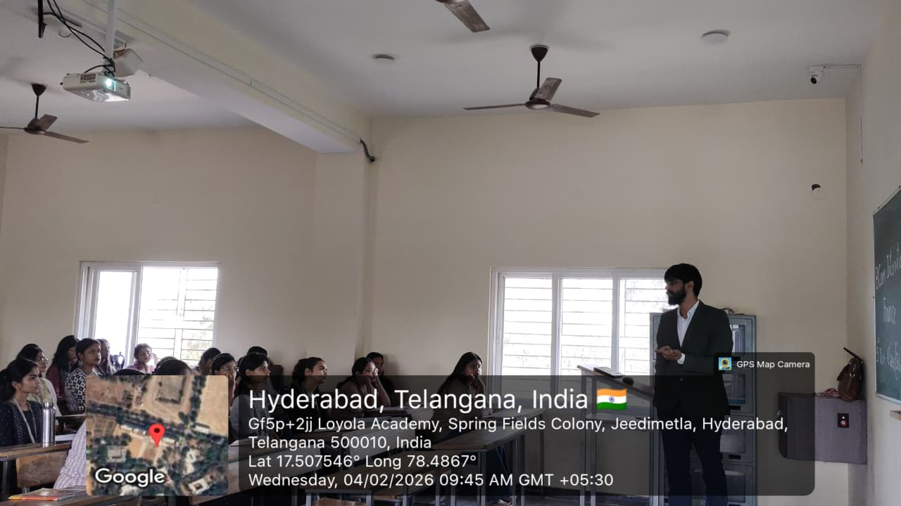
Strategic Business Reporting (SBR) is a core professional-level paper of the Association of Chartered Certified Accountants (ACCA). The paper focuses on developing a deep understanding of financial reporting within a strategic business context and emphasizes the application of International Financial Reporting Standards (IFRS) using professional judgment, ethical awareness, and critical analysis.
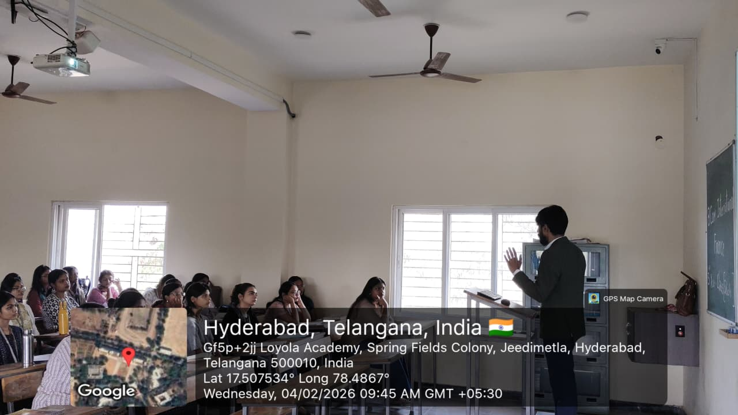
This session commenced on January and continued through February. Through the guest lecture, students gained clarity on how SBR strengthens their analytical skills, professional judgment, and strategic thinking. The session highlighted how the subject prepares students to interpret complex financial information, understand the business implications of reporting decisions, and respond to practical challenges faced by professional accountants. As a result, students were able to connect theoretical knowledge with real-life applications, making the subject more understandable and relevant.
Speaker Background:
CA Santhosh Reddy is a Chartered Accountant and an experienced faculty member specializing in Advanced Accounting. He has over five years of teaching experience, having trained more than 3,000 students through CA Foundation and CA Intermediate batches across reputed institutes including the Institute of Chartered Accountants of India (Hyderabad), Aviansh College of Commerce, and Yeshas Academy, Bangalore. Alongside his academic career, he is the Managing Partner at M/s Patlola Santhosh Reddy & Co, with professional expertise in statutory and internal audits, international taxation, and financial reporting. Recognized for his clarity in teaching and practical insights, he continues to inspire and mentor aspiring Chartered Accountants.

Key Topics Covered
Here are key topics in Strategic Business Reporting for ACCA:
- Conceptual and Regulatory Frameworks – Understanding the objectives of financial reporting, the role of accounting frameworks, and the importance of consistency, comparability, and transparency in financial statements.
- Professional and Ethical Responsibilities – Application of ethical principles, professional judgment, and accountability of accountants in preparing and presenting financial information to stakeholders.
- Performance Reporting and Analysis – Evaluation of financial performance through performance reporting, segment reporting, related party disclosures, and analysis and interpretation of financial statements.
- Financial Reporting of Core Business Areas – Practical application of accounting standards relating to revenue, non-current assets, leases, financial instruments, employee benefits, taxation, provisions, and contingencies.
- Group Accounting and Foreign Currency Reporting – Preparation and interpretation of consolidated financial statements, including changes in group structure and the impact of foreign currency transactions and operations.
- Developments in Financial Reporting – Adoption of new accounting standards, reporting requirements for small and medium entities, and awareness of recent changes and developments in financial reporting practices.
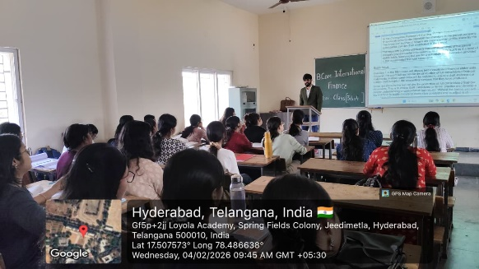
The topics covered in the guest lecture provided students with a broad understanding of the principles and practices of Strategic Business Reporting. They helped students understand the application of accounting frameworks, ethical responsibilities, and key financial reporting standards in a business context. Overall, the session strengthened students’ ability to analyse, interpret, and report financial information professionally.
Key Takeaways
The guest lecture provided students with a deeper and more practical understanding of Strategic Business Reporting by explaining how financial reporting principles are applied in real business scenarios. Through real-life examples and professional experiences shared during the session, students were able to understand the importance of applying International Financial Reporting Standards using sound professional judgment, particularly in complex and judgment-based areas of reporting.
Conclusion
The guest lecture on Strategic Business Reporting proved to be highly effective in enhancing students’ understanding of the subject and its practical relevance. It helped students bridge the gap between academic learning and professional application by improving their analytical ability, ethical awareness, and confidence in applying financial reporting standards.

→ Guest Lecture on ADVANCED PERFORMANCE MANAGEMENT

Title: Guest Lecture Report on Strategic Business Report by Ms. Manisha Darla
Venue: Commerce Block
Class: DIF (3CB 04)
Date: 9th February 2026 to
Introduction
Advanced Performance Management (APM) is a core professional-level paper of the Association of Chartered Certified Accountants (ACCA). It develops the ability to apply strategic management accounting techniques to complex business scenarios, focusing on performance evaluation, planning, and decision-making. The paper emphasizes aligning management accounting with organizational strategy, using both financial and non-financial measures, and integrating modern developments such as digital transformation and sustainability. Candidates are expected to demonstrate professional judgment, critical analysis, and ethical awareness in applying advanced performance management tools.
Speaker Background:
Manisha Darla is a faculty member at ISDC, delivering training in the Association of Chartered Certified Accountants (ACCA) professional qualification. She is passionate about teaching and committed to helping students succeed in the field of accounting and finance. Prior to joining ISDC, Manisha accumulated over 5.4 years of experience in the field of audit, accounting, and team management while working as an Assistant Manager at a Chartered Accountancy firm. During this time, she led audit engagements, managed client deliverables, and oversaw audit teams to ensure timely and quality outcomes. With a sound understanding of audit practices and regulatory compliance, Manisha has hands-on experience in statutory and internal audits, financial reporting, and team leadership. She has worked with Indian GAAP and while also holding a B. Com degree and currently pursuing M.Com. Manisha is also known for her ability to effectively communicate complex concepts in a simplified manner, making her a highly effective educator.
Her exposure to professional practice, combined with academic training, enables her to bridge the gap between theory and real-world application in the classroom.
Key Points Discussed:
1.The Evolution of Performance Management:
Ms. Manisha began her lecture by providing a historical perspective on performance management, emphasizing how it has evolved from traditional annual reviews to a dynamic and continuous process.
2. Advanced Metrics and Key Performance Indicators (KPIs):
The speaker highlighted the importance of advanced metrics and KPIs beyond the usual financial indicators. She discussed the value of incorporating non-financial metrics, such as customer satisfaction, employee engagement, and sustainability, to provide a more comprehensive view of performance.
3. Leveraging Data and Technology:
Ms. Manisha emphasized the role of data analytics and technology in modern performance management. She discussed how organizations can harness the power of data-driven insights to make informed decisions, identify trends, and drive performance improvements.

4. Performance Management in Remote Work Environments:
In recognition of the changing work landscape, Ms. Manisha addressed the challenges and opportunities of managing performance in remote and hybrid work settings. She provided practical strategies for ensuring that performance management remains effective in such contexts.
5. Continuous Feedback and Coaching:
The lecture stressed the importance of continuous feedback and coaching in advanced performance management. Ms. Manisha shared strategies for creating a culture of ongoing development and improvement within organizations.
6. Alignment with Strategic Goals:
Ms. Manisha underscored the need for performance management systems to align seamlessly with an organization's strategic objectives. She provided insights into how performance management can serve as a strategic tool to drive organizational growth.
7. Empowering Employees:
The lecture discussed methods for empowering employees to take ownership of their performance. Ms. Manisha emphasized that empowered employees are more likely to contribute to the overall success of the organization.
8. Overcoming Challenges:
Ms. Manisha addressed common challenges faced in implementing advanced performance management practices, such as data privacy concerns and resistance to change. She provided practical solutions and recommendations for overcoming these obstacles.

Conclusion:
Ms. Manisha’s guest lecture on "Advanced Performance Management" was a highly informative and thought-provoking session. Attendees gained valuable insights into the evolving landscape of performance management and its pivotal role in achieving organizational excellence.
The lecture underscored the importance of adaptability and advancement in performance management approaches to remain competitive and responsive in today's dynamic business environment.
  - Report on ADD-ON COURSE
Class: DIF
Class Strength : DIF –55,
Name of Course: Mutual Funds
Faculty Coordinator: Mr. Mahinder
Purpose: To provide students with in-depth knowledge of Mutual Funds and investment strategies beyond the prescribed syllabus.

Report:
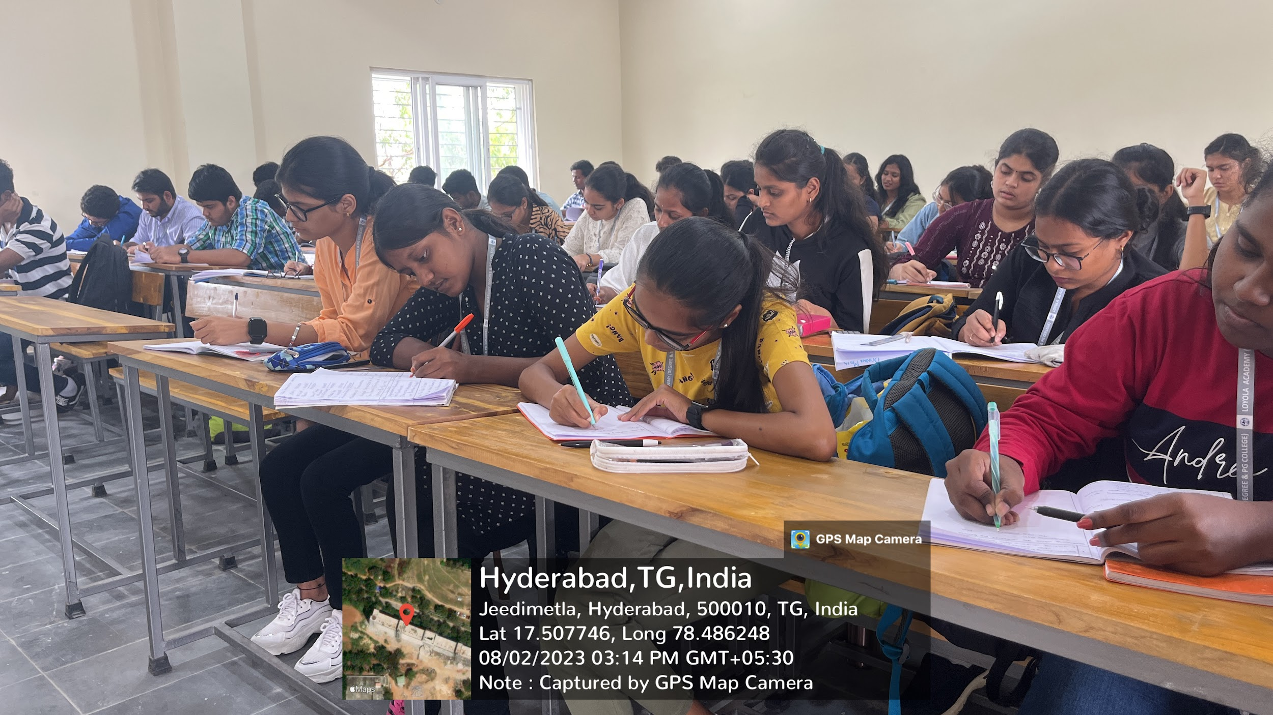
The Department of B.Com International Finance (DIF) organized an Add-On Course on “Mutual Funds” for the students of Final Year during the academic year 2025-2026.
The objective of the course was to enhance students’ understanding of investment avenues, particularly mutual funds, and to develop practical knowledge of financial markets. The course was conducted over a duration of 30 hours.
At the beginning of the course, students were introduced to the objectives, syllabus, and expected learning outcomes. Mr. Mahinder handled the sessions and provided comprehensive insights into the functioning of mutual funds, supported by practical examples and current market trends.
The course covered the following topics:
- Introduction to Mutual Funds and their importance
- Structure and Types of Mutual Fund Schemes
- NAV Calculation and Portfolio Management
- Role of Asset Management Companies (AMCs)
- Systematic Investment Plan (SIP) and Lump Sum Investment
- Risk and Return Analysis
- Regulatory Framework and Investor Protection
- Taxation Benefits of Mutual Funds

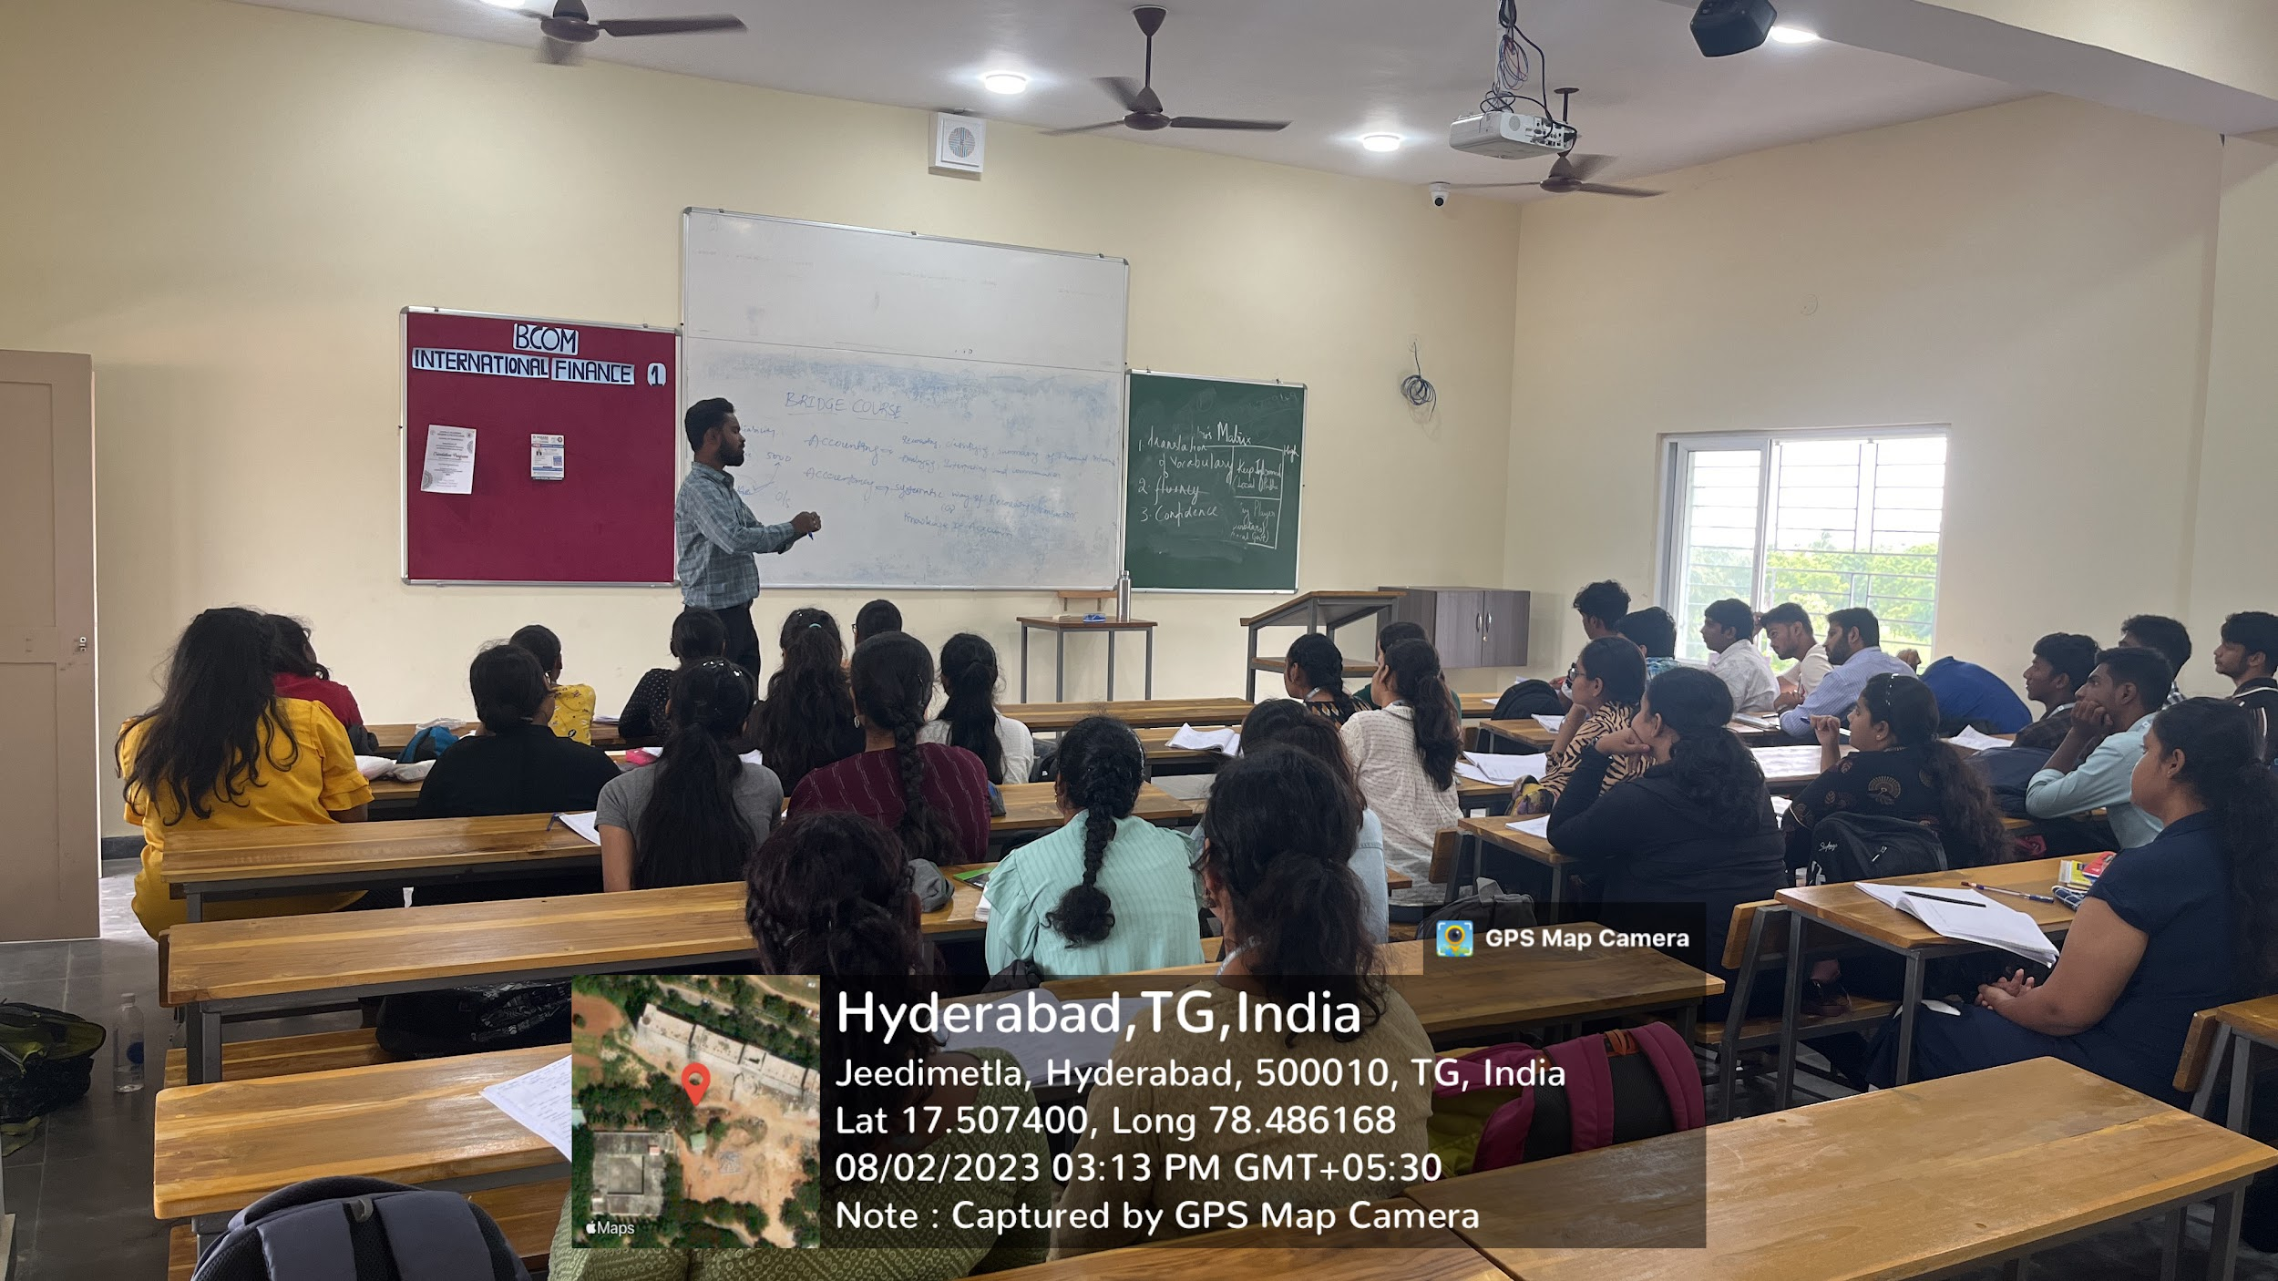
Interactive sessions, case studies, and real-time examples were used to help students understand market performance and investment decision-making.
At the end of the course, an assessment was conducted in offline mode to evaluate the students’ understanding of the concepts. Certificates were issued to students who successfully completed the course.

Learning Outcome
After completing the Add-On Course on Mutual Funds, students were able to:
- Understand the concept and structure of mutual funds.
- Analyze different types of mutual fund schemes.
- Calculate and interpret Net Asset Value (NAV).
- Evaluate risk and return of investment options.
- Gain practical knowledge of SIP and portfolio diversification.
- Understand taxation and regulatory aspects of mutual funds.
Overall, the Add-On Course significantly enhanced students’ financial literacy and investment awareness, preparing them for careers in finance and investment management.

  - Report on SELF-STUDY
Class: NIF
Class Strength: 52
Name of the Course: Risk Management and Principles of Insurance
Purpose: - To make the students to learn the risk management and principles of Insurance
Report: -
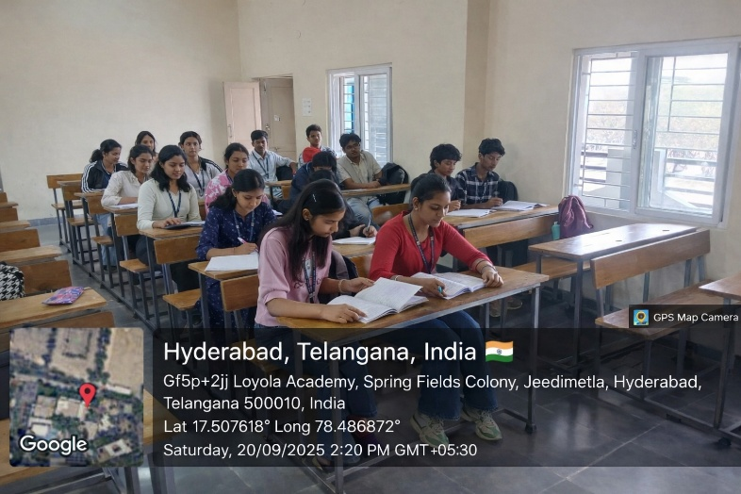
Mr. Naveen Reddy conducted a Self-Study course titled “Risk Management and Principles of Insurance” for second-year of the B.Com International Finance program during the 3rd semester. At the commencement of the course, students were briefed on the syllabus, course objectives, learning outcomes, and prescribed learning resources. The total duration of the course was 30 hours.
The classes were conducted as per schedule, and the syllabus was covered comprehensively. Students were introduced to the fundamentals of Insurance and its significance in managing financial risks. Special emphasis was given to key examination topics, including Risk Management, Types of Risk, and Principles of Insurance to help students prepare effectively.
An examination was conducted by Mr. Naveen Reddy on 20th September for a duration of one hour in offline mode. The exam was held exclusively for second-year students to assess their understanding of the subject.
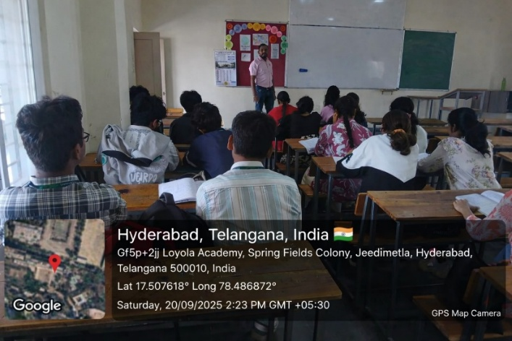
Learning Outcome:
The sessions enabled students to gain a clear understanding of Risk Management concepts, various Types of Risks, and the core Principles of Insurance. Additionally, students were guided on Insurance Policies, various types of insurance, Claims Settlement procedures, Financial Planning, strengthening their overall conceptual knowledge and application skills.

  - FIDUCIA 7.O
Date: 5th and 6th February 2026
Place: Loyola Hall
Purpose: 2 Day commerce summit – “Where Commerce Meets Opportunity”
Introduction
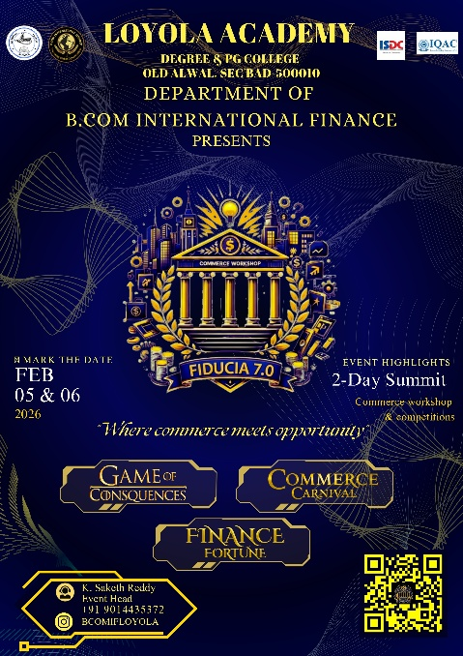
Fiducia is an eagerly anticipated Commerce Summit organized by the Department of B.Com International Finance on 5th and 6th February 2026. Representing the pinnacle of academic and cultural synergy, Fiducia serves as a dynamic platform for students to showcase their talents, engage in intellectual exchange, and celebrate vibrant diversity.

The event offers a well-balanced blend of academic discussions, competitive events, and cultural performances, creating an enriching environment that promotes both learning and enjoyment. With its seventh edition, Fiducia aspires to surpass previous milestones by providing participants with a memorable experience that transcends the boundaries of conventional academic events.
Fiducia strives to exceed previous achievements by delivering an exceptional experience that goes beyond conventional academic events. This summit gave students a chance to present their talents, interact with industry perspectives, and learn beyond the classroom. The event also helped build a sense of unity.
DAY 01:
Commencement and Inauguration:
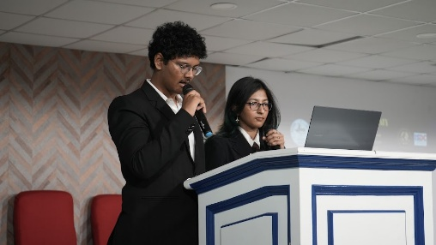
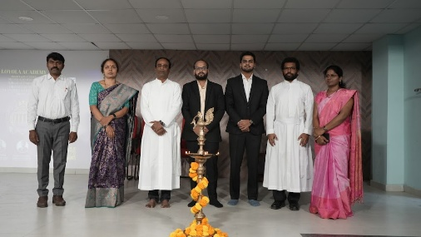
The first day commenced with the arrival of the dignitaries, followed by the formal inaugural session. A prayer song was rendered, creating a harmonious tone and respectful atmosphere. The ceremonial lighting of the lamp marked the official inauguration of Fiducia 7.O by distinguished dignitaries Rev. Fr. A M Joseph Kumar SJ, Vice-Principal, School of Management, Rev. Fr. M Arul Jyothi SJ, Vice Principal, School of Commerce, IQAC Coordinator, K. Rama, Head of the Department, P.Y. Radhika, and the keynote speaker, Satish Ladda. This symbolic act marked the formal beginning of the two-day event.
Department Introduction and Speeches:
An informative introduction to the Department of B.Com International Finance was delivered by Hari Sree, highlighting the department’s academic strengths and initiatives. This was followed by the screening of a departmental video that showcased its journey, achievements, and future vision. Subsequently, Rev. Fr. M Joseph Kumar SJ, Vice Principal, School of Management, Rev. Fr. M Arul Jothi SJ, Vice Principal, School of Commerce, and K. Rama, IQAC Coordinator delivered inspiring speeches, addressing the students with words of encouragement and motivation. Their speeches enlightened the audience and emphasized the significance of dedication, discipline and perseverance.
Speaker Introduction and Addressal:
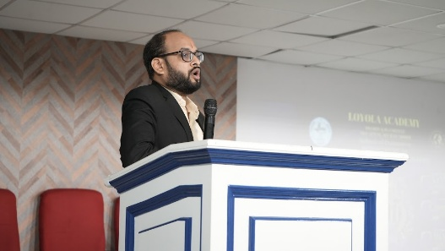
Mr. Satish Ladda is a qualified chartered accountant with 12 plus years of post-qualification experience in Business Ethics & Compliance, Corporate Fraud Investigations, Risk Management & Assessments and Compliance Monitoring. The engaging session lasted for two hours and provided students with valuable insights on savings and investments .The session was interactive, allowing students to clarify doubts and expand their understanding of the subject.
Competitive Events and Student Participation:
Following the keynote session, students were given a break for lunch. Post lunch, participants engaged in three competitive events:
- Game of consequences
- Commerce carnival
- Finance fortune
The events recorded vibrant participation, with students displaying remarkable enthusiasm while showcasing their intellectual acumen, problem-solving abilities, and strategic expertise.
Game Of Consequences-Decisions define outcomes. Consequences define winners. Game of Consequences offers a realistic simulation of real-world financial and business decision-making, where every choice has an impact and every action leads to consequences—some expected, others not. It is a high-intensity, multi-round strategy event designed to test how participants think, adapt, and decide under uncertainty. Rather than focusing on theoretical knowledge, the event challenges teams to manage virtual resources, respond to evolving situations, and navigate unexpected outcomes in a fast-paced competitive environment. It challenges you to think fast, adapt smart, and face the impact of every choice in an unpredictable strategy showdown.
Commerce Carnival
Commerce Carnival is where business knowledge meets speed and strategy. This interactive competition challenges you and your team through multiple rounds that test commerce fundamentals, brand awareness, and real-world business thinking. Each round raises the Intensity — from a Business Quiz that checks your core commerce and general business knowledge, to an exciting Brand Challenge involving logos and taglines, and finally a high-pressure Rapid-Fire Round where quick, accurate answers decide the winners. This isn’t about memorizing facts; it’s about how fast you think, how well you work as a team, and how you perform when the clock is ticking.
FINANCE FORTUNE
Finance Fortune is a high-stakes card-bases business simulation for teams of four. Compete to build the highest net worth by navigating a volatile Market where smart strategy meets the luck of the draw. Test your investment strategy, decision-making under uncertainty, and Teamwork skills while navigating surprises and twists that mirror real world business challenges.
The intellectually stimulating competitions provided students with an opportunity to showcase their financial expertise and teamwork capabilities. The first day concluded on a vibrant and accomplished note with the successful completion of these events.
Day 02:
Recap and Introduction of Keynote Speaker:
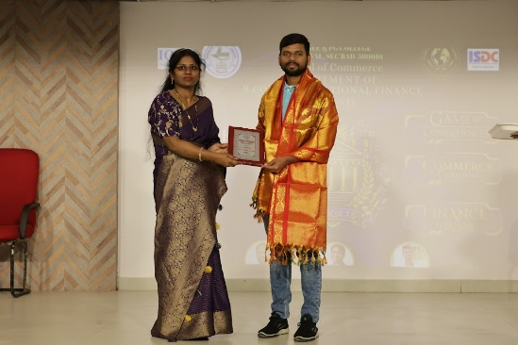
The second day commenced with a brief recap of the proceedings and key takeaways from Day 01, helping participants reconnect with the learning outcomes and activities conducted previously. This was followed by the introduction and felicitation of the guest speaker.
Speaker Introduction
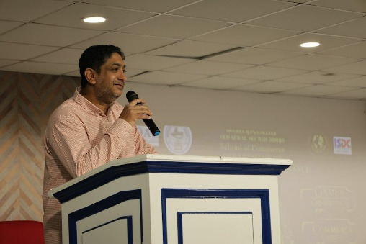
Mr. Sarath Garimella, founder and director of Kompass Junior College, holds a PhD and MBA from Osmania University with over two decades of education industry experience as faculty, trainer, career counsellor, administrator, and mentor. He is passionate about mentoring school graduates for making objective career choices. Additionally, he advises for Ambitions Career Counsellors and teaches diverse subjects in leading business schools, emphasizing continuous learning and practical teaching methods. His teaching philosophy lies in 3 D’s - Deliberate, Debate and Demonstrate the various academic theories learnt in the school.
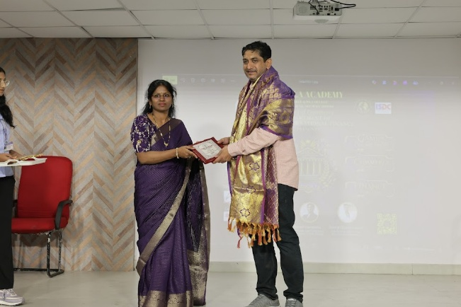
Keynote Session: higher education-career growth :
Before the session commenced, the Head of the Department, P.Y. Radhika, presented a memento to Mr. Sarath Garimella as a token of appreciation. His session on “higher education career growth” was highly insightful and particularly relevant for students aspiring to pursue higher education and professional advancement. He elaborated on the essential skills required for academic and professional success, including effective communication, adaptability, critical thinking, and professional networking.
The three-hour higher education session was interactive and engaging, enabling students to gain a clear understanding of academic expectations, career pathways, and personal development strategies, thereby enhancing their readiness for future academic and professional pursuits.
Post lunch session:
After an enriching session, students were provided with lunch arranged by the department. The final segment of the workshop was the valedictory ceremony, where Vice Principal, Dean of Commerce, faculty members, and students gathered to conclude the event. The Vice Principal delivered an inspiring speech, reflecting on the workshop’s success and the importance of continuous learning. His words motivated students to apply their newfound knowledge in practical scenarios.

Keynote Session: on entrepreneurship and growth along with past experiences in Loyola academy degree and PG college.

Before the session commenced, the Head of the Department, P.Y. Radhika, presented a memento to Mr. Anoop Chandra Ganti as token of appreciation. His session on “Entrepreneurship and growth mostly along with past experience with Loyola. Anoop Chandra Ganti is an entrepreneur, taking over a 17-year-old firm named SIRI EICHER with a Turnover of 15 Cr. per annum. He has started a new division in the firm named TAFE in the year 2024 and scaled it up to contribute 1.5 Cr. Turnover per annum to the firm within a year of establishment. He is dedicated to driving growth and innovation in the dynamic landscape of automotive distribution. He leads marketing team ensuring strategies alignment with the business objectives while enhancing brand visibility and customer engagement.
Prize and memento Distribution:
The valedictory ceremony also featured the announcement of winners from the three competitive events conducted on the first day of the workshop. Participants who demonstrated exceptional performance in commerce carnival, game of consequences and Finance fortune were honored with prizes in recognition of their outstanding achievements.
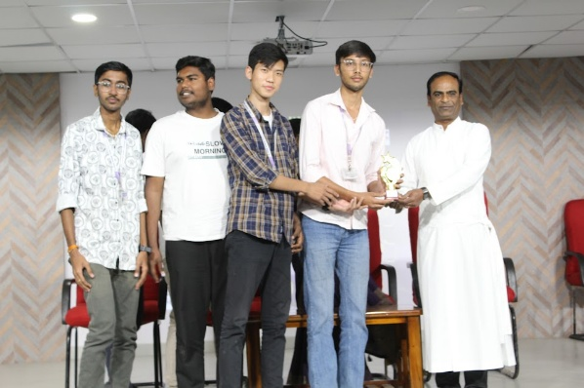
Furthermore, students who successfully completed the ACCA examinations along with department committee students, were awarded mementoes by the esteemed dignitaries, acknowledging and celebrating their academic excellence and professional commitment. Faculty members were also felicitated for their unwavering dedication, guidance, and significant role in ensuring the successful execution of the workshop.
Acknowledgments and Performances:
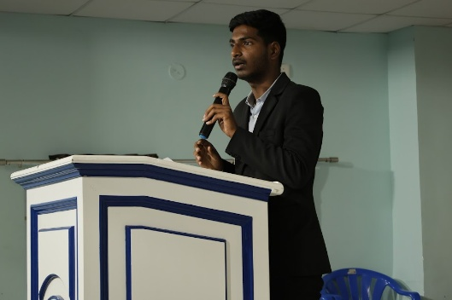
As part of the concluding segment of the workshop, a lively dance performance by students of the department added energy and celebration to the event, showcasing their talent and team spirit. The formal proceedings were then brought to a close with a Vote of Thanks delivered by Saketh Reddy, who expressed gratitude to the management, faculty, guest speakers, organisers, and participants for their contributions to the success of the programme. The event concluded on a respectful note with the rendition of the National Anthem.
Conclusion
Overall, Fiducia 7.O was a highly successful and meticulously organised event that offered students meaningful learning opportunities and valuable exposure to academic and professional perspectives. The summit enabled students to enhance their confidence, acquire practical insights, and build connections with peers, faculty, and industry professionals.
The workshop truly embodied its theme, “Where Commerce Meets Opportunity,” by equipping participants with the knowledge, skills, and motivation required to navigate their future academic pursuits and professional careers with confidence and competence.

Event Photos:
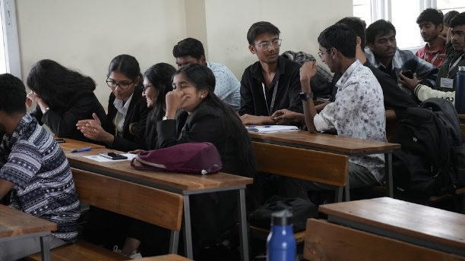
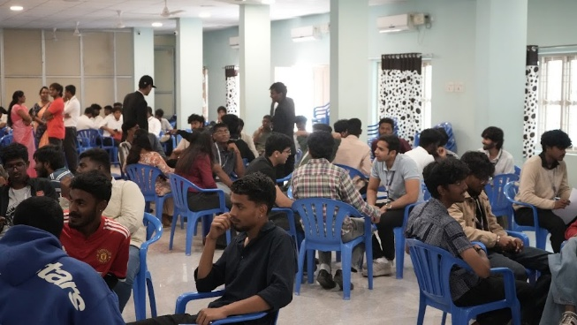

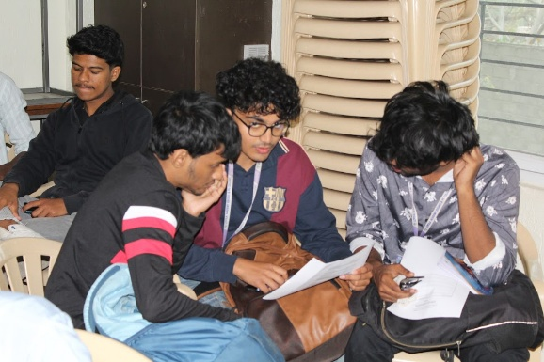
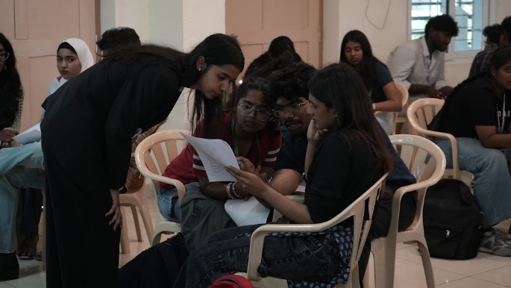

  - Seminar on CAREER ADVANCEMENT
Organised by: StudyIn
Hosted by: Department of B.Com International Finance
Venue: (Insert venue)
Date: (Insert date)

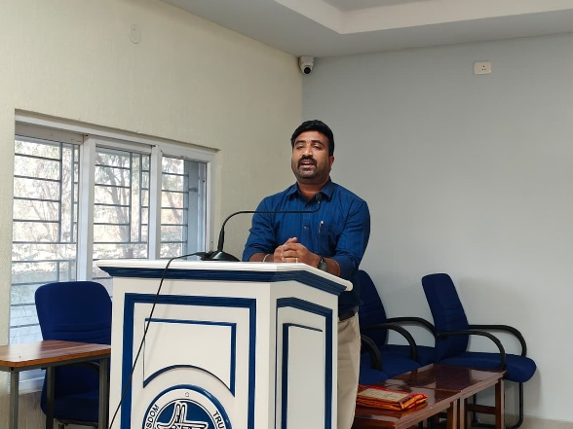
Introduction
The Department of B.Com International Finance organised a seminar in collaboration with StudyIn on career advancement and studying abroad after graduation. The session aimed to guide students on higher education opportunities overseas and help them plan their careers with a global perspective.

Overview of the Session
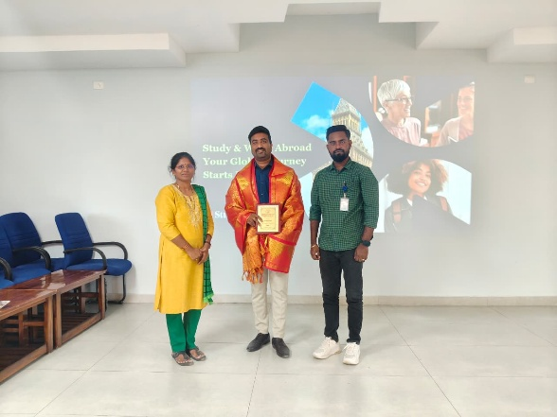
The seminar began with an introduction to StudyIn and its services in assisting students with international education. The speaker highlighted the importance of global exposure in today’s competitive job market and explained how studying abroad can improve career prospects.
Students were introduced to popular study destinations such as Australia, the UK, Canada, and Europe, along with the benefits of international education, including quality learning, industry exposure, networking opportunities, and post-study work options.

Key Topics Covered
The session provided guidance on the following key areas:
- Course and Country Selection: Choosing suitable courses based on career goals and selecting countries based on cost, job opportunities, and visa policies.
- Admission Process: Application procedures, documentation, and timelines for university admissions.
- Entrance Requirements: Exams such as IELTS/PTE and academic eligibility criteria.
- Scholarships & Financial Planning: Available scholarships, education loans, and cost management strategies.
- Visa Process: Steps involved in applying for a student visa and required documentation.
- Career Opportunities: Post-study work options and global career prospects for commerce students.

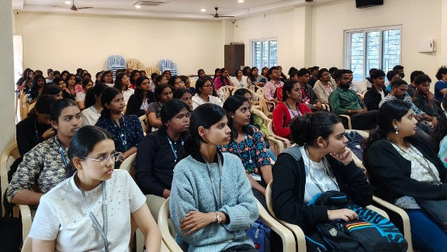
Student Interaction
An interactive Q&A session allowed students to clarify doubts regarding courses, countries, financial requirements, and job opportunities. This helped students gain clarity and confidence in planning their higher education.

Conclusion
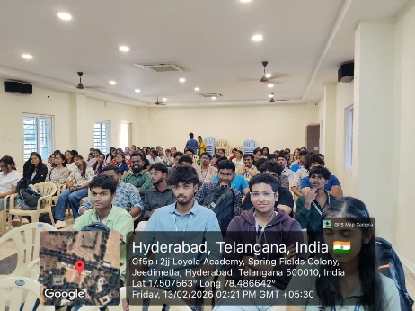
The seminar was highly informative and provided valuable insights into studying abroad and career advancement. It helped students understand the available opportunities, required preparation, and future career benefits.
Overall, the session broadened students’ perspectives and encouraged them to explore global education pathways with better awareness and confidence.

- Report on INDUSTRIAL VISIT
Date: 6th January 2026
Place: Gayathri Sugars Ltd.
Organised by: Department of B.Com International Finance
Introduction

As part of our academic curriculum and to gain practical exposure to industrial operations, an industrial visit to Gayathri Sugars Ltd. was organised by the Department of B.Com International Finance. The objective of this visit was to help students understand the production process of sugar, observe supply chain operations, and gain insights into large-scale manufacturing and waste management practices.
Overview of the Industry
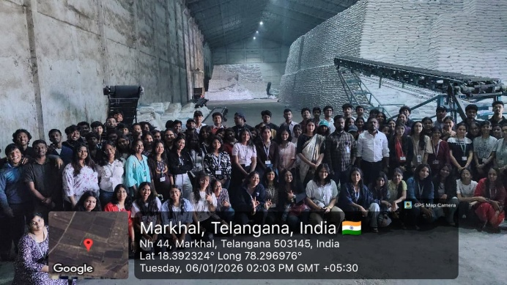
Gayathri Sugars Ltd. is engaged in the processing of sugarcane and the production of sugar and related by-products. The company operates seasonally, with active production taking place between November and March, depending on the availability of sugarcane. During the remaining months, the company focuses mainly on packaging, storage, and supply operations.
Production Process Observed
During the visit, students were given a walkthrough of the entire production cycle, from raw material handling to final product dispatch.
- Drying of Sugarcane
The harvested sugarcane is first spread out and dried under sunlight. This helps reduce moisture content and prepares the cane for further processing.
- Conversion into Jaggery
The dried sugarcane is then crushed and processed to produce jaggery (unrefined sugar) as an intermediate stage.
- Processing into Sugar
The jaggery undergoes further refining and crystallisation processes to produce refined sugar suitable for commercial distribution.
- Packaging and Distribution
The final sugar product is packaged and stored, after which it is supplied to markets and distributors.
Waste Management Practices

One of the key observations during the visit was the efficient handling of waste materials. The by-products and residual waste generated during production are collected, processed, and safely disposed or sent for further use, ensuring minimal environmental impact and better resource utilisation.
Conclusion

The industrial visit to Gayathri Sugars Ltd. was highly informative and enriching. It gave students a clear understanding of how raw agricultural produce is transformed into a finished commercial product through a structured industrial process. The visit also highlighted the importance of efficiency, planning, and sustainability in manufacturing industries.

Overall, the experience enhanced students’ practical knowledge and provided valuable exposure to real-world business operations, making it a meaningful addition to their academic learning.

- Report on PARENT-TEACHER MEETING
Department: B.Com International Finance
Date: 14th February 2026
Venue: 3CB04, 3CB07, 3CB08

Introduction
The Department of B.Com International Finance organised a Parent–Teacher Meeting on 14th February 2026 for students of all three years. The meeting was conducted to strengthen communication between parents and faculty and to provide an update on students’ academic progress, attendance, and overall development.

Objectives of the Meeting
The main objectives of the meeting were:
- To inform parents about their child’s academic performance and attendance
- To discuss students’ behaviour, participation, and progress
- To address any academic or personal concerns
- To create a supportive partnership between parents and the institution for student development

Proceedings of the Meeting
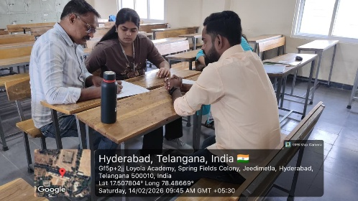
The meeting began with a brief welcome and introduction by the department faculty. Parents were informed about the academic structure of the course, internal assessments, examination patterns, and attendance requirements.
Faculty members interacted individually with parents to discuss each student’s performance, strengths, and areas that require improvement. Guidance was provided on study habits, time management, and preparation strategies for upcoming examinations.
Parents were also briefed about departmental activities such as workshops, seminars, industrial visits, and co-curricular opportunities that contribute to students’ holistic development.

Parent Interaction and Feedback

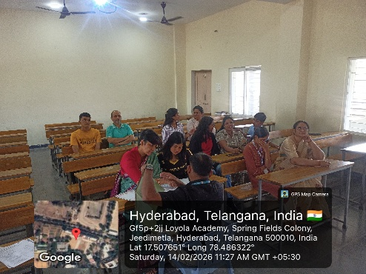
The session provided an open platform for parents to share their concerns and suggestions. Parents appreciated the regular academic monitoring and expressed satisfaction with the department’s efforts in supporting students’ academic and personal growth.
Constructive feedback received from parents was noted by the faculty for further improvement in teaching methods, communication, and student support systems.

Outcome of the Meeting
The Parent–Teacher Meeting helped in:
- Strengthening parent–faculty communication
- Creating better awareness of student performance and expectations
- Identifying areas where students need additional academic support
- Encouraging parents to actively participate in their child’s educational journey

Conclusion
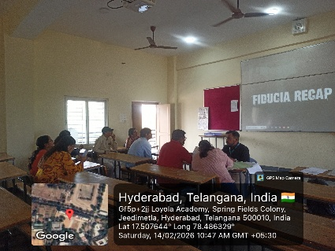
The Parent–Teacher Meeting conducted on 14th February 2026 was successful in building a strong connection between parents and the institution. It created a positive environment for discussion and collaboration, ensuring that students receive consistent guidance both at home and in college.
Overall, the meeting contributed to improving student support systems and promoting academic success and personal development among B.Com International Finance students.

4.ACCA ACHEIVEMENTS
SL. No | Name | UID | Subject
DIF
Mar-25
1 | G. Vandana Varma | 111723030016 | Audit and Assurance (F8/AA)
2 | Tarini Dittakavi | 111723030034 | Audit and Assurance (F8/AA)
3 | Vidya Saigal | 111723030037 | Audit and Assurance (F8/AA)
Sep-25
4 | D. Sai Manogyna | 111723030008 | Audit and Assurance (F8/AA)
5 | D. Hari Sree | 111723030009 | Audit and Assurance (F8/AA)
6 | G. Kavya | 111723030014 | Audit and Assurance (F8/AA)
7 | Julianne Prardhana | 111723030020 | Audit and Assurance (F8/AA)
8 | Sharon Elsa Daniel | 111723030030 | Audit and Assurance (F8/AA)
9 | Syed Zenia | 111723030033 | Audit and Assurance (F8/AA)
10 | Tarini Dittakavi | 111723030034 | Financial Management (F9/FM)
11 | G. Gowtham | 111723030048 | Audit and Assurance (F8/AA)
12 | K. Saketh Reddy | 111723030051 | Audit and Assurance (F8/AA)
13 | R. Akshith | 111723030054 | Audit and Assurance (F8/AA)
14 | Savithru Kulkarni | 111723030057 | Audit and Assurance (F8/AA)
NIF
Sep-25
15 | Angitha Das | 111724030002 | Audit and Assurance(F8/AA)
16 | Vineeth Choudhary | 111724030048 | Audit and Assurance(F8/AA)
17 | V. Saharsh | 111724030054 | Audit and Assurance(F8/AA)

- PLACEMENTS AND INTERNSHIPS
Placements:
S.no | UID | Name | Organization | Remuneration | Link
DIF
1 | 111723030014 | Gandhe Kavya | Deloitte -USI | 4.23 lakhs per annum | Link
2 | 111723030021 | Lavanya D Revanaki | Deloitte USI | 4.23 lakhs per annum | Link
3 | 111723030051 | K. Saketh Reddy | Deloitte USI | 4.23 lakhs per annum | Link
4 | 111723030054 | Ravula Akshith | Deloitte USI | 4.25 lakhs per annum | Link
Internship:
S.no | UID | Name | Duration of Internship | Paid (Amount) / Unpaid | Link
DIF
1 | 111723030002 | Ananya Chauhan | 6 months | Paid – 20,000 p.m. | Link
2 | 111723030003 | Anisa Bitty | 130 Days | Paid – 20,000 p.m. | Link
3 | 111723030009 | D. Hari Sree | 6 months | Paid – 25,000 p.m. | Link
4 | 111723030014 | Gandhe Kavya | 1.5 years | Paid – 6500 p.m. | Link
5 | 111723030027 | Purna Dhar | 18 Days | Paid – 6300 | Link
6 | 111723030027 | Purna Dhar | 18 Days | Paid – 6300 | Link
7 | 111723030027 | Purna Dhar | 69 Days | Paid – 1000 | Link
8 | 111723030027 | Purna Dhar | 1 Month | Unpaid | Link
9 | 111723030027 | Purna Dhar | 36 Days | Unpaid | Link
10 | 111723030027 | Purna Dhar | 92 Days | Paid – 1000 | Link
11 | 111723030027 | Purna Dhar | 45 Days | Paid – 5500 | Link
12 | 111723030027 | Purna Dhar | 10 months | Paid – 4000 | Link
13 | 111723030035 | Uditi Saraf | 30 Daya | Paid – 30,000 p.m. | Link
14 | 111723030051 | K. Saketh Reddy | 180 days | Paid – 20,000 p.m. | Link
NIF
15 | 111724030015 | K.Ashvitha |  | Unpaid | Link
16 | 111723030051 | Vanshika Patel Tirumani | 7 days | Paid – 1000 | Link
AIF
17 | 111725030001 | Akshita Budakoti | 16 days | Paid - 6500 | Link
18 | 111722030033 | Tandale pheaba pheona | 30 days | Unpaid | Link
19 | 111722030036 | Zufshan Khanam | 30 days | Paid - 700 | Link

- EXTERNAL ACHIEVEMENTS
ODD Sem:
S.No | Class | UID | Name | Achievement | LINK
1 | DIF | 111723030009 | hari sree | PwC Audit Simulation | Link
2 | DIF | 111723030009 | hari sree | mutual funds management | Link
3 | DIF | 111723030016 | vandana varma | Mutual Funds Management | Link
4 | DIF | 111723030016 | vandana varma | PwC Audit Simulation | Link
5 | DIF | 111723030027 | Purna Dhar | Supraja Technologies - Cyber Security workshop | Link
6 | AIF | 111725030055 | S Charitardh | Certificate course from ORACLE UNIVERSITY on Oracle Cloud Infrastructure | Link
7 | DIF | 111723030033 | Syed Zenia | Participated in national games in beach volleyball in 2025 feb held at Uttarakhand. | Link
8 | DIF | 111723030033 | Syed zenia | Participated in khelo India beach games 1st edition in beach volleyball in may held at Daman and Diu | Link
9 | DIF | 111723030033 | Syed zenia | Secured 1st place in senior state meet in volleyball. | Link
10 | DIF | 111723030033 | Syed zenia | Secured 1st place in 3 aside volleyball nationals held at Chhattisgarh. | Link
11 | DIF | 111723030033 | Syed zenia | Secured 2nd placed in father Balaiah memorial invitation tournament held in Loyola in volleyball. | Link

EVEN SEM:
S.No | Class | UID | Name | Achievement | LINK
1 | DIF | 111723030012 | Gaddam Saanvi | My Bharat Budget Quest 2026 | Link
2 | DIF | 111723030029 | Samara Fernandez | Battle of Bands | Link
3 | NIF | 111724030012 | Venkata Satya Sravya | Recognised as an effective contribution to department B.Com International Finance | Link
4 | DIF | 111723030033 | Syed Zenia | Secured 1st place in volleyball intercollege. | Link
5 | DIF | 111723030033 | Syed Zenia | Secured 1st place in 100m relay and 3r place in javelin throw in Osmania university athletics intercollege tournament. | Link
6 | DIF | 111723030033 | Syed Zenia | Participated in south zone inter university tournament for volleyball held in Chennai. | Link
7 | DIF | 111723030013 | Angelina Gajula | Group event 2nd place in Resonance Battle of Bands | Link
8 | NIF | 111724030037 | Nicol Moses | Department band- 2nd place in Resonance Battle of Bands;2nd place in solo instrumental | Link
9 | DIF | 111723030029 | Samara Fernandez | Department band- 2nd place in Resonance Battle of Bands | Link
10 | NIF | 111724030017 | Angelina Joseph | Solo Singing - 1st prize ; Department band- 2nd place in Resonance Battle of Bands | Link
11 | NIF | 111724030041 | Joshua Robert | 3rd place in solo instrumental; Department band- 2nd place in Resonance Battle of Bands | Link
12 | AIF | 111725030029 | Noya Daniela | Department band- 2nd place in Resonance Battle of Bands | Link
13 | AIF | 111725030060 | Zidane | Department band- 2nd place in Resonance Battle of Bands | Link
14 | NIF | 111724030031 | Arvin Joseph | Department band- 2nd place in Resonance Battle of Bands | Link

- NPTEL
S.No. | Class | UID | Name |  | LINK
DIF
1 | DIF | 111723030005 | Asritha Nair | NPTEL | Link
2 | DIF | 111723030025 | Nitya Nair | NPTEL | Link
3 | DIF | 111723030026 | Priyanka Newar | NPTEL | Link
NIF
1 | NIF | 111724030001 | Aksitha gauri | NPTEL | Link
2 | NIF | 111724030002 | Angita Das | NPTEL | Link
3 | NIF | 111724030008 | Charula thekhathil Rincy shiju | NPTEL | Link
4 | NIF | 111724030009 | Chinthapalli Raja sree | NPTEL | Link
5 | NIF | 111724030011 | Endla Pravalika | NPTEL | Link
6 | NIF | 111724030013 | Poorvi | NPTEL | Link
7 | NIF | 111724030024 | Rampalli Siri | NPTEL | Link
8 | NIF | 111724030027 | A.Sharanya | NPTEL | Link
9 | NIF | 111724030028 | Simran kumari | NPTEL | Link
10 | NIF | 111724030033 | B V Sumeeth Anand | NPTEL | Link
11 | NIF | 111724030035 | Debojyoti Nath | NPTEL | Link
12 | NIF | 111724030036 | Dhandabouina Manojkumar | NPTEL | Link
13 | NIF | 111724030045 | S.Jaimitran | NPTEL | Link
14 | NIF | 111724030048 | Vineeth Choudhary | NPTEL | Link
15 | NIF | 111724030049 | Vinod sirvi | NPTEL | Link
AIF
 | AIF | 111725030001 | Akshita Budakoti | NPTEL | Link
 | AIF | 111725030002 | Aleena Ann Thomas | NPTEL | Link
 | AIF | 111725030003 | Ann Mary Saju | NPTEL | Link
 | AIF | 111725030004 | Bhavana Choudhary | NPTEL | Link
 | AIF | 111725030005 | Chehak kanodia | NPTEL | Link
 | AIF | 111725030006 | C J Thanishka | NPTEL | Link
 | AIF | 111725030007 | Edulakante Nithya Reddy | NPTEL | Link
 | AIF | 111725030017 | Kotakonda Nandika | NPTEL | Link
 | AIF | 111725030018 | Marian Fiona Agnello | NPTEL | Link
 | AIF | 111725030022 | Pragati Jain | NPTEL | Link
 | AIF | 111725030023 | Rathlavath purnasri nayak | NPTEL | Link
 | AIF | 111725030024 | R Tanya Martin | NPTEL | Link
 | AIF | 111725030026 | S Tulajha Bhavani | NPTEL | Link
 | AIF | 111725030028 | Talamenchi Mahalaxmi | NPTEL | Link
 | AIF | 111725030029 | Noya Daniela | NPTEL | Link
 | AIF | 111725030030 | Spandana T | NPTEL | Link
 | AIF | 111725030031 | Thiriyarpur pushpa | NPTEL | Link
 | AIF | 111725030032 | V.Tanvi | NPTEL | Link
 | AIF | 111725030033 | Yampalla Anjali | NPTEL | Link
 | AIF | 111725030034 | A ROHITH GOUD | NPTEL | Link
 | AIF | 111725030036 | Andrew Amit Jacob | NPTEL | Link
 | AIF | 111725030038 | Arpit kumar dubey | NPTEL | Link
 | AIF | 111725030040 | Atharva Chandra | NPTEL | Link
 | AIF | 111725030041 | Awaru Shreyas | NPTEL | Link
 | AIF | 111725030043 | Dileep seervi | NPTEL | Link
 | AIF | 111725030044 | Gadiyanka sampath goud | NPTEL | Link
 | AIF | 111725030048 | Justin Pravin Nalla | NPTEL | Link
 | AIF | 111725030050 | Melvin majo | NPTEL | Link
 | AIF | 111725030051 | Mir Misbaah Ul Haque | NPTEL | Link
 | AIF | 111725030052 | Pola Vaibhav | NPTEL | Link
 | AIF | 111725030054 | SAMALA RUPIN REDDY | NPTEL | Link
 | AIF | 111725030055 | S Charitardh | NPTEL | Link
 | AIF | 111725030056 | Sai Sunder | NPTEL | Link
 | AIF | 111725030057 | T. Dhruv | NPTEL | Link
 | AIF | 111725030059 | Saharsh | NPTEL | Link

