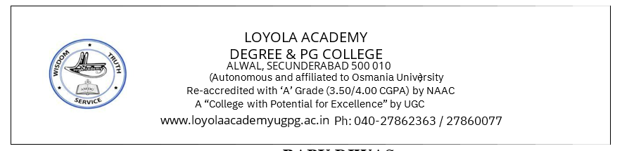
TITLE OF THE EVENT | Guided meditation session (Counselling cell initiative- BBA- Tourism)
DATE | 08-12-2025, 11:18 AM
VENUE | Management Block (LH-17)
ORGANIZER, COORDINATOR | Ms. Sandhria Thomas A (Assistant Professor in Psychology & Student Counsellor).
SPEAKERS/ RESOURCE PERSONS | Ms. Sandhria Thomas A (Assistant Professor in Psychology & Student Counsellor).
TARGET AUDIENCE | First Year Students of BBA- Tourism
OBJECTIVES OF THE EVENT:
The seminar aimed to equip students with practical knowledge of stress management strategies to help them cope with academic workload, digital fatigue, and the pressures of cyber security studies. It focused on enhancing resilience, balancing academic and personal responsibilities, and developing healthy coping techniques suitable for undergraduate students

PARTICIPANTS DETAILS:
TOTAL PARTICIPANTS |  | 54 First Year Students of BBA- Tourism
DEMOGRAPHICS |  | First Year Students of BBA- Tourism
ATTENDANCE PERCENTAGE |  | 95%
CONTENT EVALUATION:
Session Highlights:
RELEVANCE OF THE TOPIC
The Guided Meditation Session was designed to promote emotional well-being, improve concentration, and enhance students’ capacity to manage academic and personal stress. The session aimed to introduce foundational mindfulness practices, foster self-awareness, and encourage learners to adopt meditation as a sustainable mental wellness tool. The programme also sought to cultivate a calm learning environment conducive to improved academic performance and interpersonal effectiveness.
DEPTH OF KNOWLEDGE DELIVERED
The resource person provided a structured and comprehensive understanding of meditation practices, including:
- Theoretical foundations of mindfulness and guided meditation
- The mind–body connection and its relevance to stress reduction
- Step-by-step experiential meditation techniques
- Practical strategies for integrating mindfulness into daily routines
- Importance of breath work, grounding, and sensory awareness
The content delivered was conceptually rich, evidence-informed, and aligned with holistic wellness models recommended in higher education.
ENGAGEMENT OF PARTICIPANTS
Participants remained highly attentive and actively engaged throughout the session. Students demonstrated interest through their reflective participation, willingness to attempt each meditation exercise, and responsive interaction during the discussion segment. The serene ambience and structured facilitation promoted deep involvement and meaningful learning.
LEARNING OUTCOMES:
At the end of the session, participants were able to:
- Understand the core principles and purpose of guided meditation.
- Identify personal stressors and apply grounding techniques to manage them.
- Practice mindful breathing and focused awareness independently.
- Recognize the benefits of meditation for emotional stability and cognitive clarity.
- Integrate short meditation breaks into their academic schedules to enhance productivity.
.
.
KEY TAKEAWAY FOR PARTICIPANTS:
- Importance of daily mindfulness for mental and emotional balance
- Enhanced ability to regulate stress and maintain calmness
- Awareness of personal thoughts, emotions, and bodily cues
- Practical tools for improving focus, patience, and decision-making
- Encouragement to adopt meditation as a long-term wellness practice

SKILLS/ KNOWLEDGE GAINED
Participants gained both practical and conceptual competencies, including:
- Stress-management techniques
- Mindful breathing and relaxation skills
- Cognitive clarity and improved attention span
- Emotional regulation strategies
- Understanding of the scientific basis of meditation

FEEDBACK ANALYSIS:

METHOD OF FEEDBACK COLLECTION: Google form (https://docs.google.com/spreadsheets/d/1xLfnMl-L5mi4qpdwKRcQDvf7qbq5hzHgyyk2BiPY0Yk/edit?usp=sharing)

POSITIVES:
- The session was calming, structured, and easy to follow.
- Facilitation was clear, engaging, and thoughtfully paced.
- Students appreciated the practical demonstrations and hands-on practice.
- The environment created during the session enhanced relaxation and learning.
RATING ON A SCALE of 1-5
CONTENT QUALITY: 4.6/5
SPEAKER EFFECTIVENESS: 4.8/5
PRESENTATION STYLE : 4.6/5
QUANTITATIVE ANALYSIS AND FUTURE PRACTICES:

SUGGESTIONS FOR FUTURE EVENTS:
- Periodic follow-up sessions.
- Providing handouts and digital resources for self-practice.

EVENT PHOTOS:

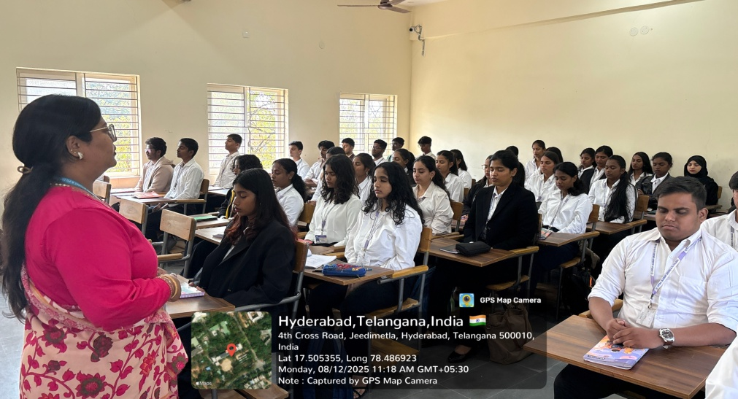

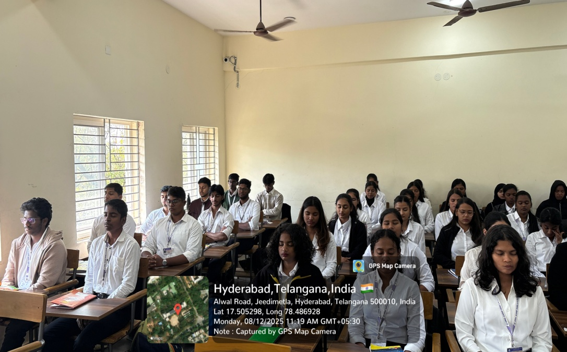

ATTENDANCE SHEET :

