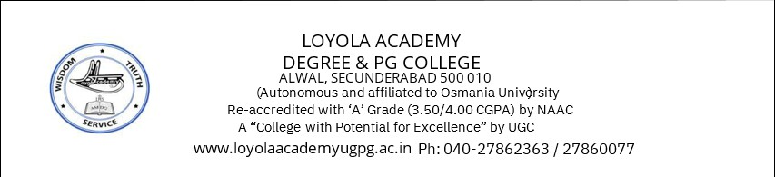

TITLE OF THE EVENT | Mind Matters- A journey to mental wellness
DATE | 8th December, 2025
VENUE | Computer Science Block- DCDS
ORGANIZER, COORDINATOR | Counselling Cell, Ms. Sahithya Guduru
SPEAKERS/ RESOURCE PERSONS | Ms. Sahithya Guduru
TARGET AUDIENCE | Students
OBJECTIVES OF THE EVENT:
To promote mental health wellness in our community and provide mental health tools to deal with their mental health
PARTICIPANTS DETAILS:
TOTAL PARTICIPANTS |  | 30 students
DEMOGRAPHICS |  | Students
ATTENDANCE PERCENTAGE |  | 60%
CONTENT EVALUATION:
RELEVANCE OF THE TOPIC:
To equip students with more knowledge on mental health and the measures that they can take in case of an emergency.

DEPTH OF KNOWLEDGE DELIVERED:
After an ice breaking activity with the students, I enquired about what all issues students these days face. It started from fear of rejection to academic stress- we have covered it all. Imparted knowledge about what and how to deal with issues like that.
I walked the students through simple techniques they can use when they feel overwhelmed, like the 5-4-3-2-1 grounding method and box breathing. The goal was to help them understand what they’re feeling and give them a few practical tools they can use anywhere, anytime.

ENGAGEMENT OF PARTICIPANTS:
The students were encouraged to talk about the regular mental health challenges that they face like anxiety, peer pressure, academic stress, Fear of rejection, etc
LEARNING OUTCOMES:
Students learned practical calming techniques like grounding and box breathing to manage stress. They also gained a better understanding of their everyday struggles and how to respond to them in healthier ways.
KEY TAKEAWAYS FOR PARTICIPANTS:
- Learned quick calming tools like grounding and box breathing
- Understood their daily stressors better and feel heard
- Gained practical ways to manage overwhelming moments

SKILLS/KNOWLEDGE GAINED:
- Grounding techniques

- Emotional Well-being & Stress Management
- Self-Awareness & Mindfulness
- Supportive Community & Growth
FEEDBACK ANALYSIS:
METHOD OF FEEDBACK COLLECTION: Offline

POSITIVES:
- Boosted Mood & Positivity
- Self-Reflection & Awareness
- Encouragement & Motivation
- Sense of Connection & Agreement
- Emotional Impact & Meaningful Experience

QUANTITATIVE ANALYSIS AND FUTURE PRACTICES:

SUGGESTIONS FOR FUTURE EVENTS:
- Enhance Engagement & Fun Activities
- Include more hands-on activities or mini role-plays.
- Offer a follow-up session to reinforce the skills
- Add more interactive activities and real life examples
FEEDBACK:
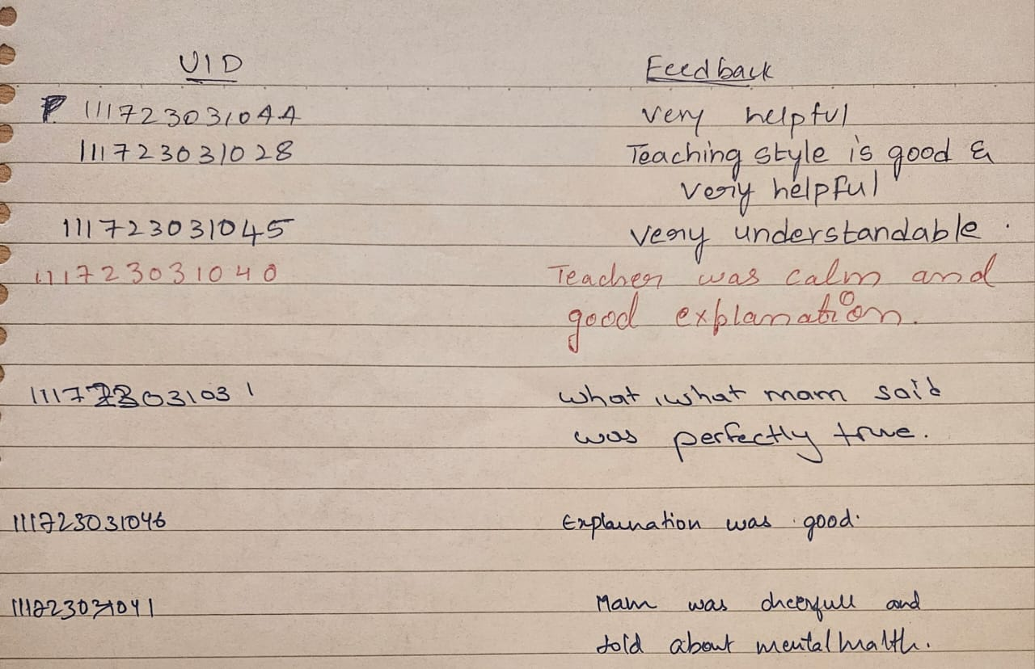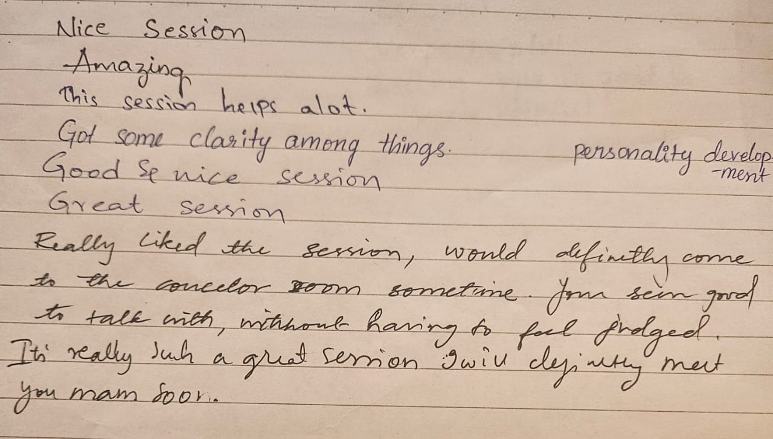
EVENT PHOTOS:
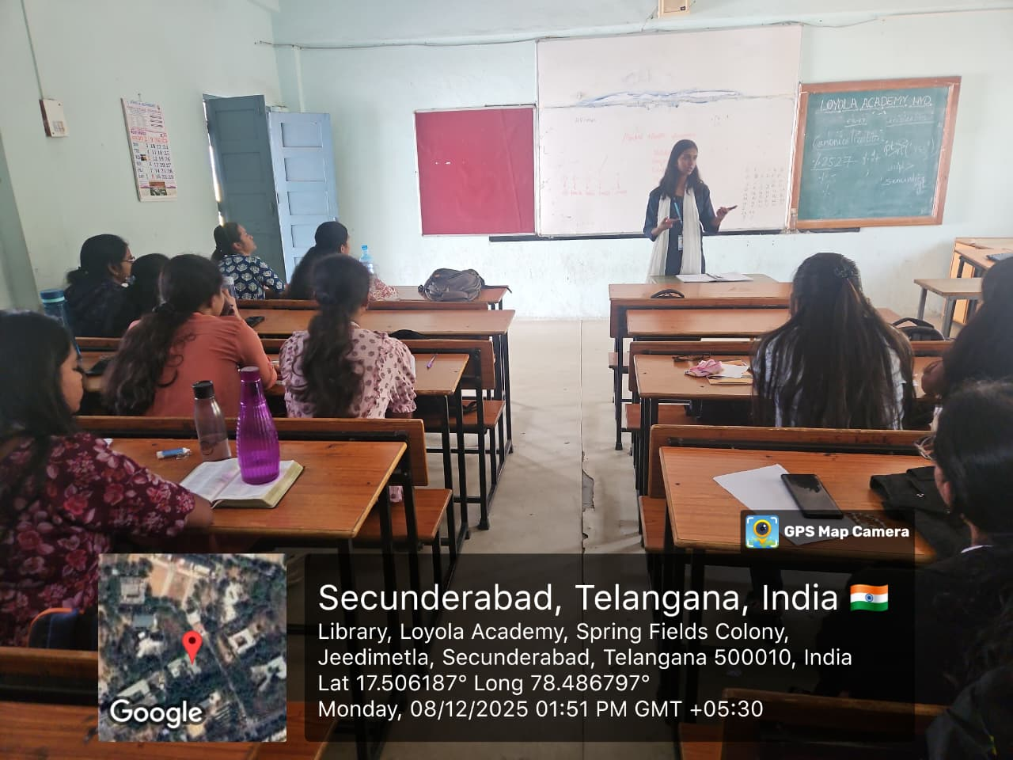

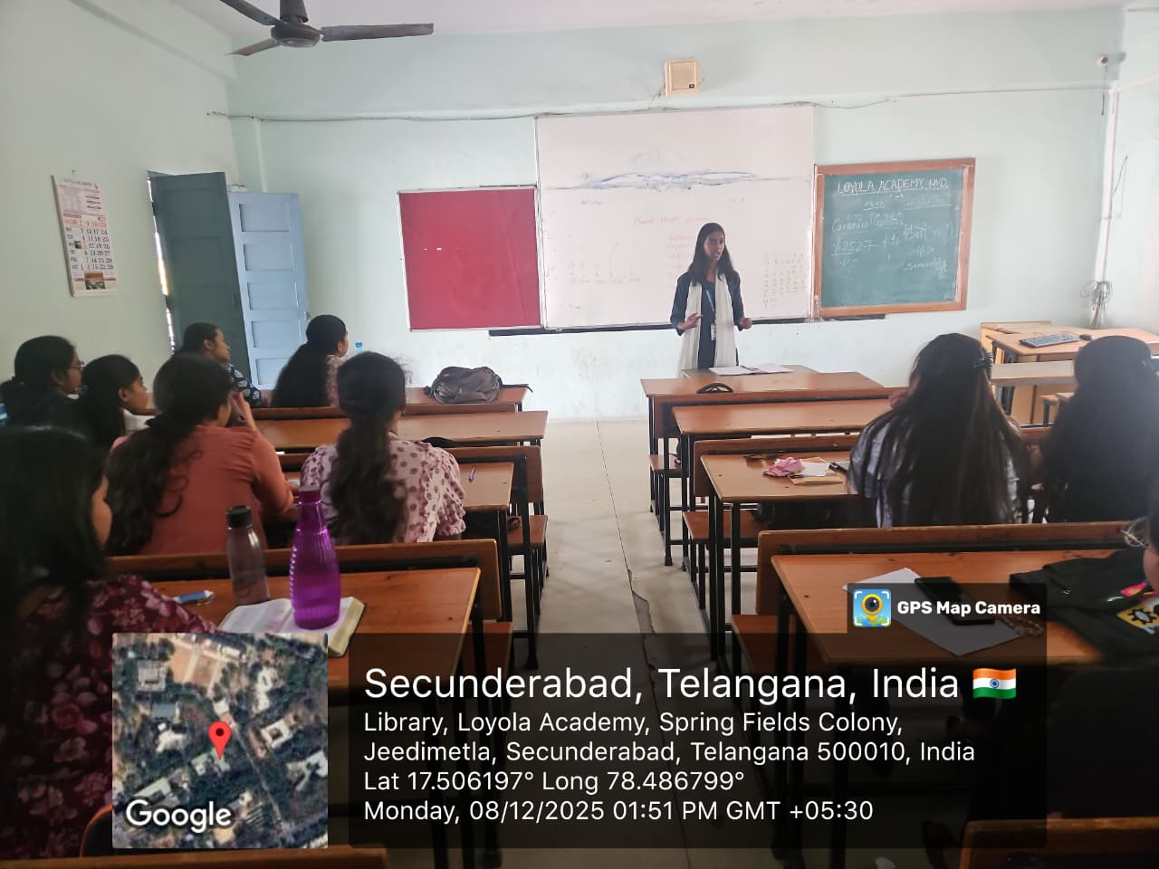

ATTENDANCE SHEET:

