ARTILLIGENZIA 3.0 – The AI Day
July 16, 2025
Department of Computer Science & Artificial Intelligence, Loyola Academy
Venue: Inigo Hall, Loyola Academy
OBJECTIVES OF THE EVENT:
- To celebrate International AI Day by promoting awareness of Artificial Intelligence and its real-world applications.
- To equip students with knowledge on emerging AI trends, specifically Agentic AI and automation using n8n tools.
- To encourage creativity and critical thinking through competitive events like Quiz and AIdea Hackathon.
BROUCHER & INVITATION:
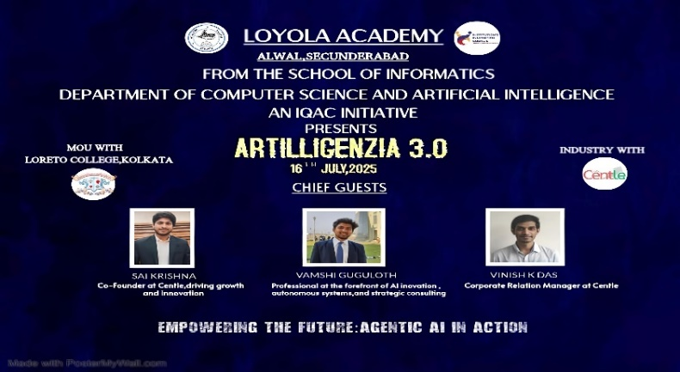
ACTIVITIES CONDUCTED:
The event was structured as a one-day celebration filled with intellectual sessions and competitive activities:
INAUGURAL SESSION:
The day began with a formal inauguration, graced by the presence of the Principal, Vice Principals, Deans, Heads of Departments, faculty, and students. The program commenced with an opening address by the emcees, followed by a prayer song by the choir, setting a serene and positive tone for the day. A Welcome Dance performance beautifully combined tradition with technology, symbolizing the harmony between art and AI. The Lighting of the Lamp ceremony was held, marking the auspicious beginning of the event and emphasizing knowledge and enlightenment. The Department Report Presentation was delivered by Mrs. Ruchika Murthy Asst. Professor in Computer Science & Artificial Intelligence, showcasing the department’s achievements and initiatives. Principal’s Address and Vice Principal’s remarks followed, inspiring the audience with their words of wisdom and encouragement.
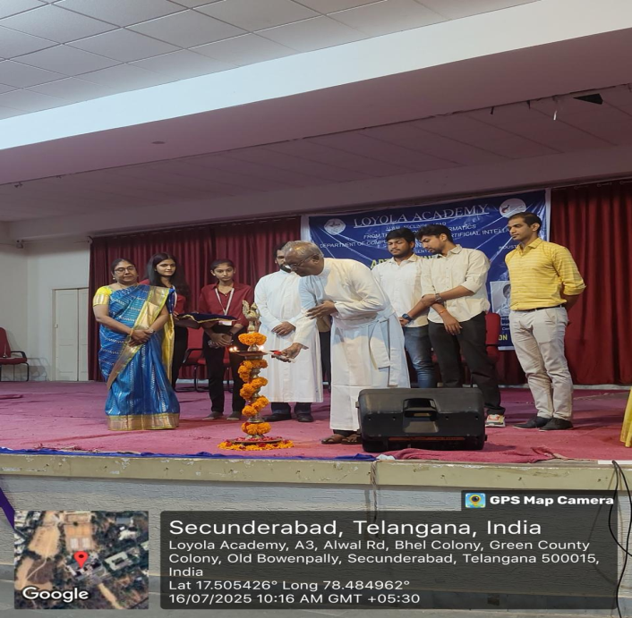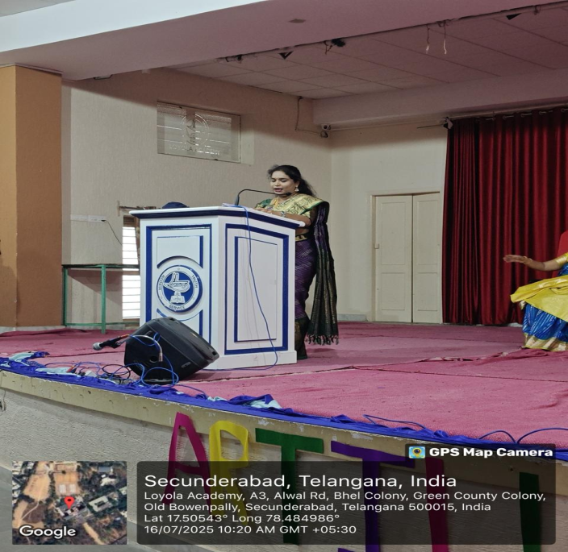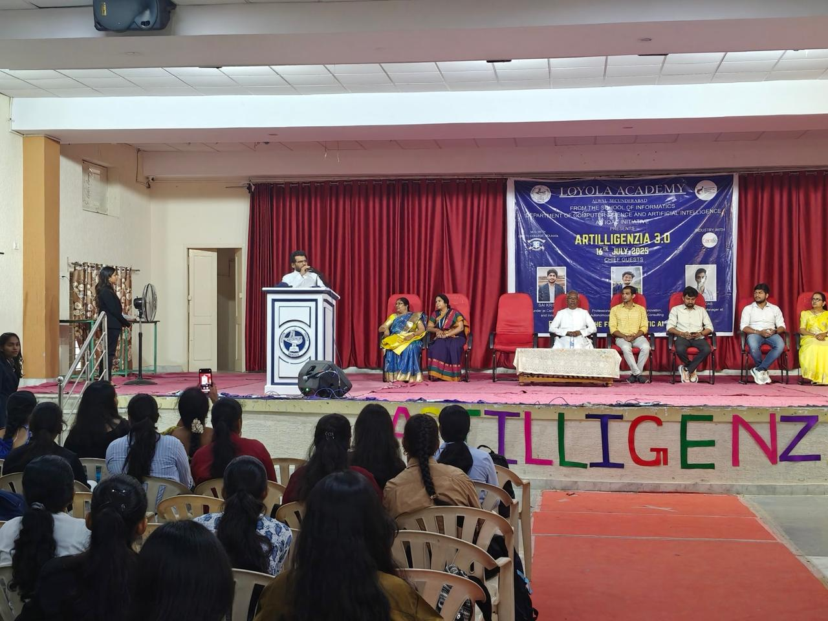

MORNING SESSION
A Guest Lecturer on “Agentic AI using n8n Tools” was conducted by Guest Lecturers from Centle India, Hyderabad, introducing participants to cutting-edge automation workflows, open-source tools, and real-world applications of AI in agentic systems.
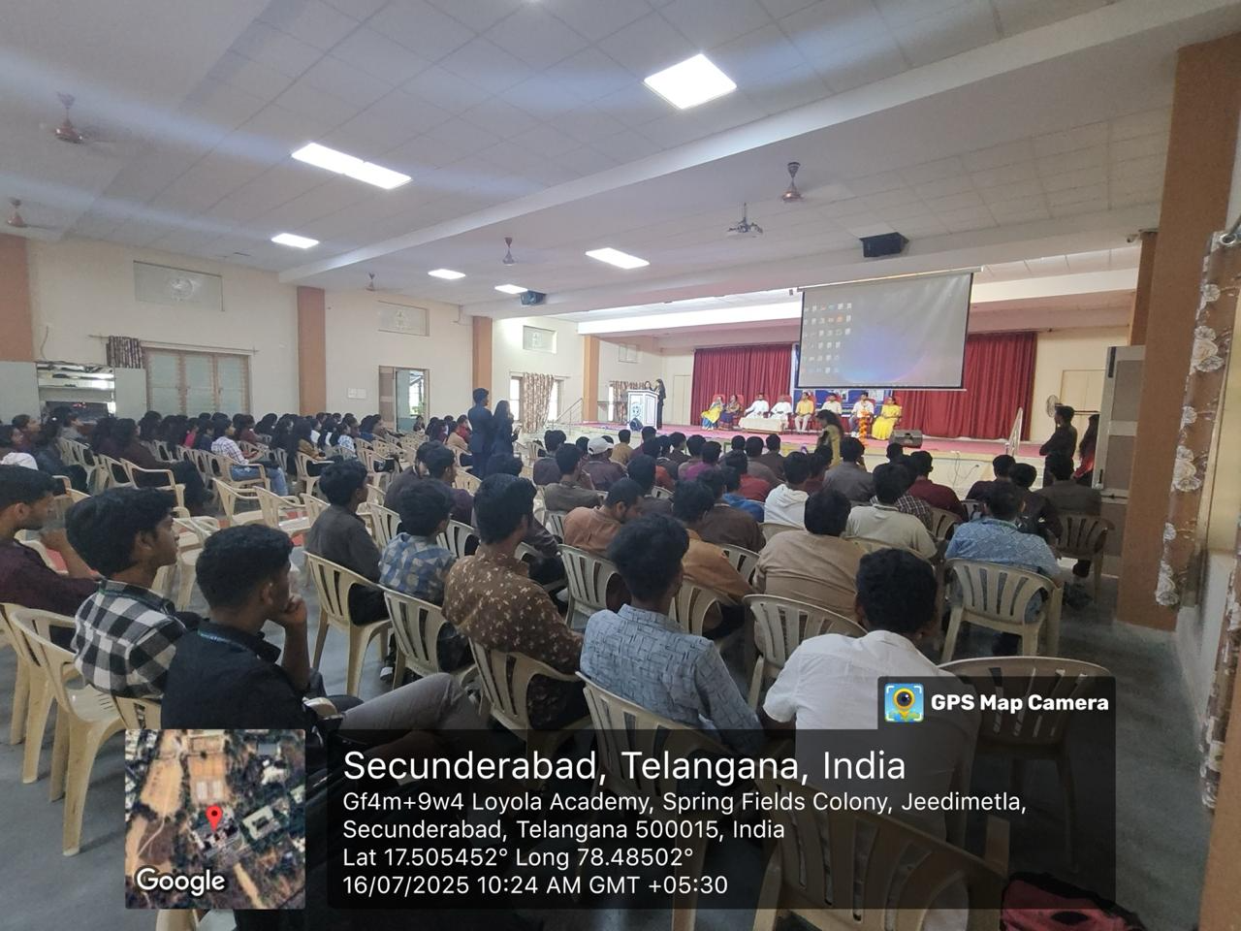

Guest Lecture :
Guest Speakers
1. [Sai Krishna, Co-Founder of Centle,Hyderabad, Driving growth and Innovation]
2. [Vamshi Guguloth, Professional of the forefront of AI innovation,Strategic consulting at Centle,Hyderabad]
3.[Vinish K.Das Corporate Relation Manager at Centle,Hyderabad]
Topic: Agentic AI using n8n Tools:
The Guest Lecture on Agentic AI provided practical insights into next-gen AI automation workflows using n8n, enabling students to think beyond traditional AI models like :
Creation of Chatbot :
Building a chatbot with n8n, an open-source automation tool, is surprisingly easy—even if you’re not a coding expert. With its simple visual interface, you can create workflows by connecting different blocks that handle messages, logic, and API requests. By linking platforms like Telegram or Slack, your chatbot can listen to users, respond based on set conditions, and pull information from other services. This makes n8n perfect for automating things like customer support or gathering leads. Plus, it’s super flexible with tons of integrations, so you can build smart, scalable chatbots that fit your exact needs—all without needing a big development team.
Creating portfolio using Bolt.new /Base44 tool:
To create a portfolio using ChatGPT and Bolt.new/Base44, start by using ChatGPT to generate content ideas, project descriptions, and engaging summaries that highlight your skills and achievements. Then, use Bolt.new/ Base44, a no-code platform, to design and build your portfolio website visually with customizable templates and drag-and-drop features. Integrate the content generated by ChatGPT into Bolt.new’s/ Base44 interface to create a professional, personalized portfolio quickly. This combination streamlines the process, requiring minimal technical skills while ensuring your portfolio is clear, well-written, and visually appealing—perfect for showcasing your work and attracting opportunities.
example reference: https://app--venkatesh-portfolio-1edc0555.base44.app
Participation Details:
Number of Participants: Over 150 students actively participated in both the seminar and competitive events. Students from other allied streams with an interest in AI and emerging technologies also participated.
AFTERNOON SESSION:
Two engaging activities were organized to encourage participation and creativity:
Quiz Competition: A knowledge-testing event based on AI concepts, trends, and innovations.
AIdea Hackathon: A brainstorming and prototyping competition where students proposed AI-driven solutions to real-world challenges, showcasing innovation and problem-solving skills.
Project Presentation:
Neo, the AI Desktop Assistant:
Neo appears to be a compact, interactive robot designed to assist with tasks, display emotions or information via an OLED screen, and perform physical movements using servo motors. The project likely leverages the XIAO RA4M1 microcontroller for processing, the SSD1306 OLED for visual feedback, and the SG90 servos for arm movements, all powered via a USB connection with a capacitor for power stability. Python code, likely running on a connected laptop, handles the AI logic, possibly integrating speech recognition, text-to-speech, and servo control to make Neo responsive and engaging.
A similar project described on Instructables, titled "Neo, an AI Desktop Assistant," uses an Arduino Nano, two SG90 servos, an SSD1306 OLED, and Google’s Gemini 8B Large Language Model with PiperTTS and RealTimeSTT for natural language interaction. While your setup uses the XIAO RA4M1 instead of an Arduino Nano, the core concept aligns closely, suggesting Neo combines physical expressiveness with AI-driven conversation or task assistance.
Fire Fighting Robot With SMS And Call Alert System:
Fire accidents can cause huge damage to life and property. Traditional fire-fighting methods risk human life. This project introduces a Fire Fighting Robot that automatically detects and extinguishes fires. It also sends an to the concerned person using a GSM module.
The flame sensors continuously scan for fire. On detection, the robot moves toward the flame using a motor driver module. It uses an ultrasonic sensor to avoid obstacles. Upon reaching the flame source, it turns on the water pump and extinguishes the fire. Simultaneously, it sends an SMS and initiates a call using a GSM module.
House Price Prediction using ML:
In India’s rapidly evolving rental and housing market, predicting house prices is a challenging task due to multiple influencing factors such as locality, amenities, BHK, furnishing status, and size. Traditional methods for estimating house or rental prices are manual, time-consuming, biased, and not scalable.
A Multiple Linear Regression (MLR) model was trained using key features such as size, bathroom, bhk, floor_number, area_type, furnishing_status, and tenant_preferred. The model was evaluated using standard regression metrics on both training and testing datasets. The R² Score of 0.65 on training data and 0.35 on test data suggests that while the model captures trends, it may not generalize well to unseen data
Virtual Mouse Using Hand Gestures:
To create a system that allows users to move the mouse cursor, perform clicks, and minimize windows using simple hand gestures captured through a webcam. The project aims to provide a contactless and intuitive way to interact with the computer using hand movements and finger positions.
The system captures video from a webcam and uses MediaPipe to track 21 hand landmarks in real-time. The index finger controls the cursor, a pinch gesture (thumb + index) triggers a left click, and a closed fist minimizes the window. All movements and gestures are handled using Python libraries.
Vizag Bus Mate:
Vizag Bus Mate is a web-based application designed to help users find city bus routes in Visakhapatnam (Vizag).
Users can search for:
Bus routes by bus number
Available buses between two locations (From – To)
Indirect (interchangeable) routes (future feature)
The app is built with a clean, mobile-friendly UI, supports Add to Home Screen (PWA), and uses real-time data stored in MongoDB Atlas.
AutoExpiry AI Alert System:
Many people forget to check expiry dates on the products they buy.
By the time they notice, the product is already expired, leading to wastage of money.
If they don’t notice at all and use expired products, it may cause health problems such as: Food poisoning, Skin rashes, Ineffective medicines.
AI Interview Coach (#38):
Enables features like saving interview history, AI feedback, and user progress, we've transformed it into a full-stack application by introducing a dedicated backend server and connecting it to a database.
Currency Detection:
We can easily find the remaining bank balance after detecting the money, speeds up transactions. We can use this project for detecting the money, Check the bank balance, We can use this in the apps like phonepay and Gpay.
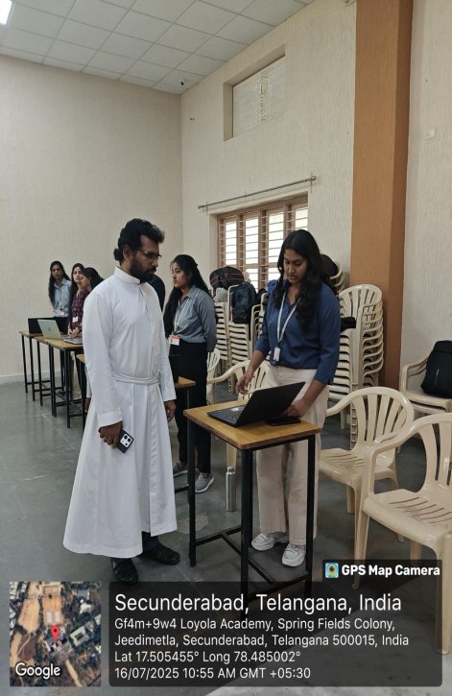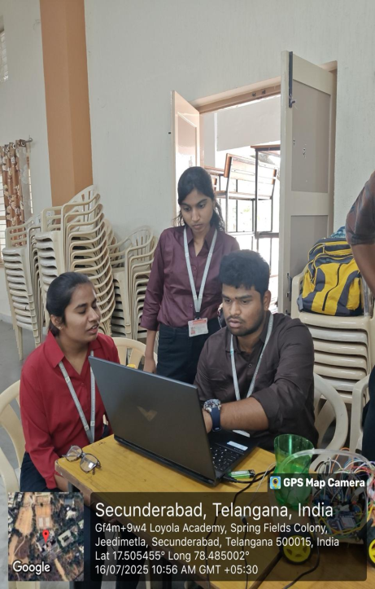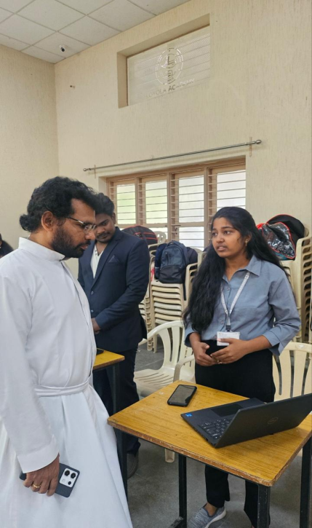
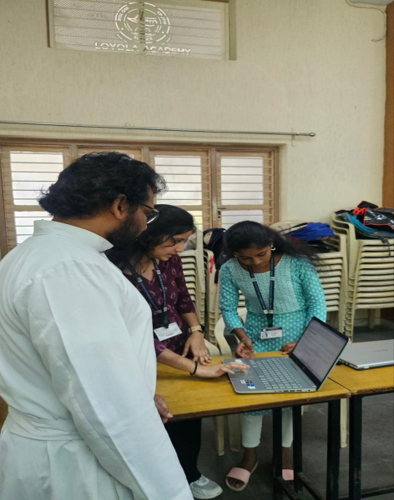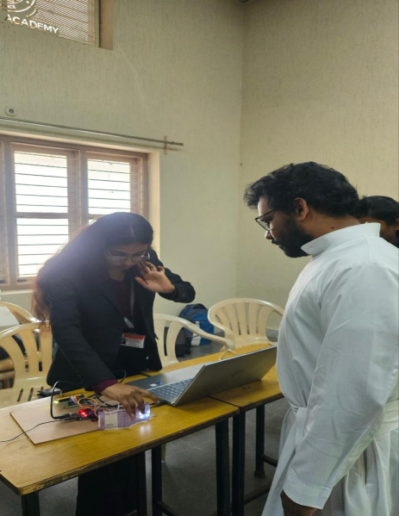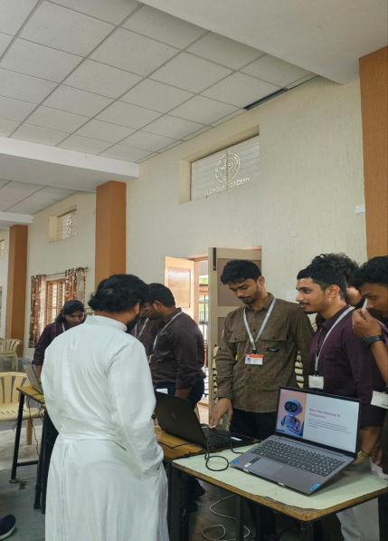

Highlights of the Event:
- The Guest Lecture on Agentic AI provided practical insights into next-gen AI automation workflows using n8n, enabling students to think beyond traditional AI models.
- The AIdea Hackathon stood out as a platform for innovation, where students demonstrated creativity through unique AI-driven solutions.
- The Quiz Competition kept the spirit of healthy competition alive, testing participants’ technical knowledge in a fun and engaging way.
- The event also featured formal proceedings and cultural performances that added elegance and vibrancy to the celebration.
Outcomes
- Students acquired valuable knowledge of agentic AI concepts and open-source automation tools, which are highly relevant in the evolving tech landscape.
- The event nurtured collaboration, critical thinking, and problem-solving skills among students through competitive activities.
- Strengthened industry-readiness by exposing students to practical applications of AI beyond theoretical concepts.
Vote of Thanks
The day concluded with the Prize Distribution Ceremony, where winners of the Quiz and AIdea Hackathon were felicitated for their outstanding performance.
Mrs. Bindu Babu, Assistant Professor in Mathematics, delivered the Vote of Thanks, expressing gratitude to the Principal, Vice Principals, faculty members, coordinators, student volunteers, and all participants for their wholehearted support and contribution to making ARTILLIGENZIA 3.0 a grand success.
The event was a perfect blend of knowledge, creativity, and celebration, leaving every participant inspired and motivated to explore the vast horizons of Artificial Intelligence.

