Alumini Interaction
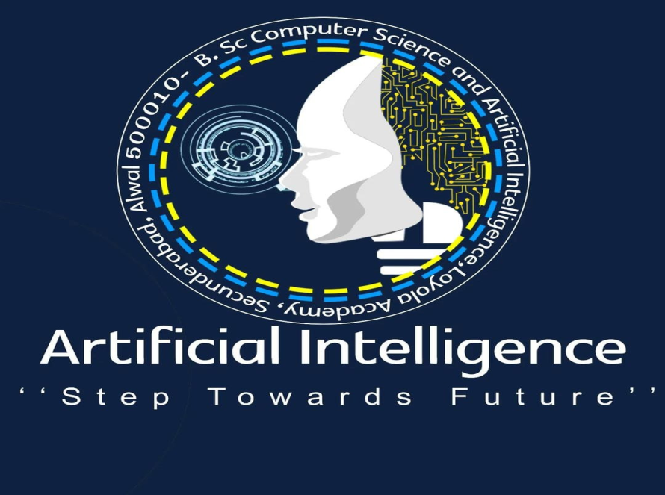
Event details:
DATE: 18/07/2025
VENUE: Loyola Academy Degree and PG College
ORGANIZED BY: B.Sc. Computer Science and Artificial Intelligence Department, Loyola Academy Degree and PG College
RESOURCE PERSON: Mr.Maram Reddy Sagar Joseph Reddy, student of University of Hertfordshire in MSc Artificial Intelligence and Robotics, United Kindom
TARGET AUDIENCE: Students and faculty members of Loyola Academy Degree and PG College, particularly those enrolled in the B.Sc. Computer Science and Artificial Intelligence.
OBJECTIVES OF THE EVENT:
The main objective of the alumni interaction was to create awareness among students about higher education opportunities abroad and various job opportunities available in the IT industry. It also helped students understand the skills required to succeed in their careers.
PARTICIPANT DETAILS:
TOTAL PARTICIPANTS: 50
DEMOGRAPHICS: Students and faculty members of Loyola Academy Degree and PG College.
ATTENDANCE PERCENTAGE: 96%
Introduction
An Alumni Interaction Program was organized for the students to provide guidance about higher education and career opportunities. The guest speaker was an alumnus of the college who is currently studying in Abroad. The session aimed to motivate students and help them understand the opportunities available after graduation.
Information on Higher Education Abroad
During the session, the alumnus explained the different opportunities for pursuing higher education in foreign countries. He discussed popular destinations such as the United States, Canada, the United Kingdom, and Australia. He also explained the importance of preparing for entrance examinations such as GRE, IELTS, and TOEFL.
He guided students on how to select universities, apply for scholarships, and manage the application process. The speaker also highlighted the advantages of studying abroad, including exposure to advanced technology, global learning environments, and better career prospects.
Job Opportunities in the IT Field
The alumnus also shared valuable information about various job roles in the IT sector. He explained that the IT field offers many opportunities such as Software Developer, Data Analyst, Web Developer, Cybersecurity Specialist, and Artificial Intelligence Engineer.
He emphasized the importance of developing technical skills such as programming, database management, and problem-solving abilities. The speaker also encouraged students to participate in internships, online courses, and certification programs to improve their skills and employability.
Interaction with Students
The session was interactive, and students actively participated by asking questions about higher studies, required skills, and career paths in the IT industry. The alumnus patiently answered all the queries and provided useful suggestions for career development.
Conclusion
The Alumni Interaction Program was very informative and inspiring. It helped students gain a clear understanding of higher education opportunities abroad and career options in the IT sector. The session motivated students to focus on skill development and plan their future careers effectively.
