
ALUMNI MEET 2024-2025
REPORT


09th November 2024
LOYOLA ACADEMY
DEGREE & PG COLLEGE, ALWAL

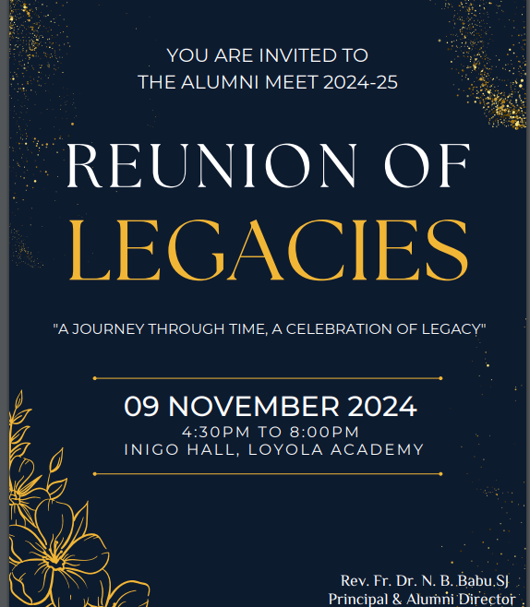
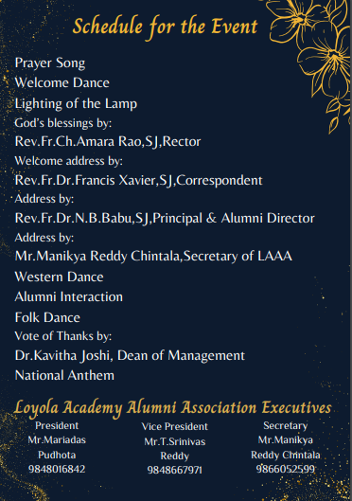

ALUMNI MEET-24-25 REPORT
TITLE OF THE EVENT | Reunion of Legacies - Alumni Meet 2024-25
DATE | 09 November 2024
VENUE | Inigo Hall, Loyola Academy
SPEAKERS/ RESOURCE PERSONS | - Rev. Fr. Ch. Amara Rao, SJ, Rector  - Rev. Fr. Dr. Francis Xavier, SJ, Correspondent  - Rev. Fr. Dr. N. B. Babu, SJ, Principal & Alumni Director  - Mr. Manikya Reddy Chintala, Secretary of Loyola Academy Alumni Association (LAAA)  - Dr. Kavitha Joshi, Dean of Management
TARGET AUDIENCE | Alumni of Loyola Academy, faculty, and current Student Council 2024-25
OBJECTIVES OF THE EVENT:
To celebrate the rich history and legacy of Loyola Academy by bringing together alumni, faculty, and current students. It aimed to foster a sense of belonging and pride among former students, acknowledging their achievements and contributions. The event sought to enhance connections within the Loyola community, creating opportunities for networking and engagement. Through meaningful interactions and shared experiences, the event aspired to inspire and strengthen the bond between the academy and its alumni.

PARTICIPANTS DETAILS:
TOTAL PARTICIPANTS |  | 300
DEMOGRAPHICS |  | Alumni from various batches, faculty, and Student Council
ATTENDANCE PERCENTAGE |  | 85%
CONTENT EVALUATION
RELEVANCE OF THE TOPIC:
The event was relevant to fostering connections between past and present members of Loyola Academy, emphasizing legacy and continued engagement.
DEPTH OF KNOWLEDGE DELIVERED:
The addresses and interactions highlighted historical insights, institutional developments, and future visions.
ENGAGEMENT OF PARTICIPANTS
Interactive sessions, performances, and personal reflections kept participants involved throughout the event.
LEARNING OUTCOMES:
- Enhanced understanding of the growth and achievements of the academy.
- Renewed inspiration among alumni and current students.
- Strengthened bonds within the alumni network.

KEY TAKEAWAYS FOR PARTICIPANTS:
- Deepened appreciation for Loyola Academy's history and impact.
- Renewed motivation to contribute to future institutional growth.
- Expanded personal and professional connections.
SKILLS/KNOWLEDGE GAINED:
- Insight into leadership and alumni contributions.
- Networking opportunities and potential mentorship links.

FEEDBACK ANALYSIS:
METHOD OF FEEDBACK COLLECTION:
Feedback forms were distributed at the end of the event and collected from participants.
POSITIVES:
- Well-organized event with smooth transitions between segments.
- High quality of speeches and performances.
- Meaningful alumni interaction opportunities.

AREAS OF IMPROVEMENT:
- Longer networking sessions could be added.
- Include more interactive activities for better engagement.

RATING ON A SCALE of 1-5:
CONTENT QUALITY : 4.5
SPEAKER EFFECTIVENESS: 5.0
PRESENTATION STYLE : 4.0

IMPACT ON CURRICULUM OR FUTURE PRACTICES:
INTEGRATION INTO TEACHING PRACTICES:
- Insights shared during the event may inspire curricular additions focused on alumni success stories and career development.
SUGGESTIONS FOR FUTURE EVENTS:
- Incorporate breakout sessions for smaller group discussions.
- Panel discussions featuring alumni across different industries.

QUANTITATIVE ANALYSIS:
- Data on attendance and participation will be compiled for future reference.
FUTURE IMPROVEMENTS:
- Consider live streaming the event for alumni who are unable to attend.
- Enhanced social media coverage for broader engagement.

RECOMMENDED TOPICS FOR FUTURE:
- Career development workshops by notable alumni.
- Industry-specific panels and discussions.

POTENTIAL RECURRENCE OF THE EVENT:
- The success of this event suggests it should be an annual occurrence to strengthen alumni relations.
RECOMMENDATIONS:
Continue fostering alumni networks with more frequent interactions and collaborative events.

ATTACHMENTS:
FEEDBACK FORMS: https://docs.google.com/forms/d/e/1FAIpQLSeDa7DJnnjwBiY-w2SU3N7XAx2iM1n3xy6_ApZ4fCQcKHmGkg/viewform?usp=pp_url

EVENT PHOTOS:
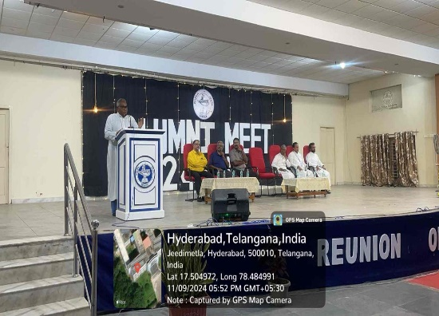 |  | 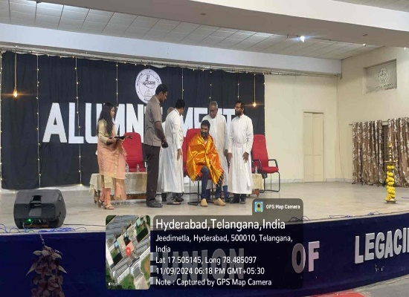
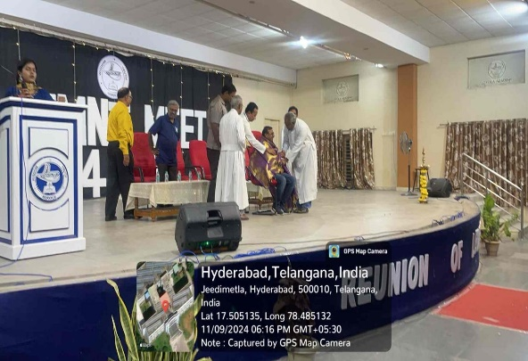 |  | 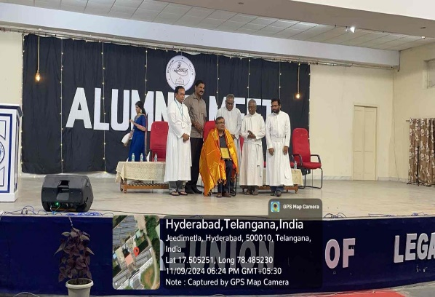
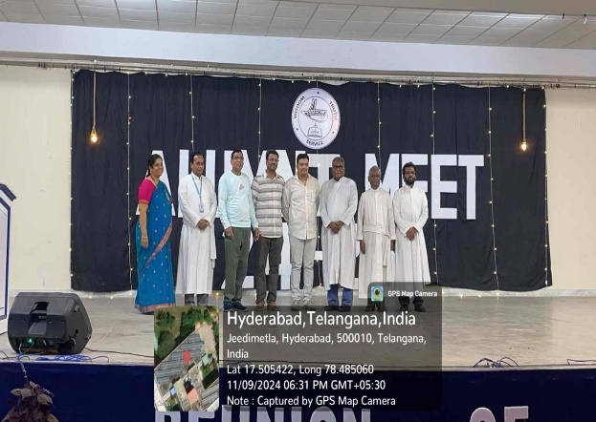

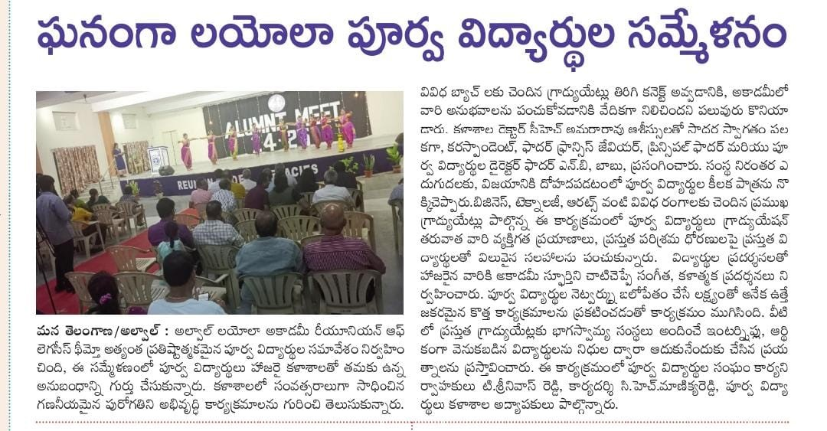

Principal

