B.SC COMPUTER DATA SCIENCE AND DATA ANALYTICS ENGINEERING

INDUSTRIAL VISITS(25-26)

- INDUSTRIAL VISIT (DCDS):

Date of Visit: 6th February 2026
Locations: Pochampally Handlooms, Apiculture Unit near Ramoji Film City, Pottery Unit
Faculty Accompanied: Sai Priya Ma’am & Tejaswini Ma’am

Introduction
As a part of our curriculum, an industrial visit was organized on 6th February 2025. The visit aimed to provide students with practical exposure to traditional crafts and rural industries. We visited Pochampally Handlooms, an apiculture unit, and a pottery unit near Ramoji Film City.

Factory / Industry Overview

Pochampally Handlooms
At Pochampally, we were introduced to the traditional method of handloom weaving used for sarees and other textiles. The artisans demonstrated the weaving techniques and explained the history and cultural importance of Pochampally Ikat. We understood the effort, skill, and time required to produce each fabric.

Apiculture Unit
During the visit to the apiculture unit, we learned about beekeeping and honey production. The staff explained the life cycle of bees, honey extraction methods, and the importance of bees in agriculture and the ecosystem. We were also given honey samples to taste.

Pottery Unit
At the pottery unit, we observed how various items are made using clay. The craftsmen demonstrated the shaping techniques on the wheel and guided us in making our own clay models. This hands-on experience helped us appreciate the creativity and patience involved in pottery.

Learning Outcomes
- Understanding the process of handloom weaving.
- Learning the basics of apiculture and honey extraction.
- Experiencing practical pottery-making techniques.
- Appreciating the importance of traditional industries and rural livelihoods.

Conclusion
The industrial visit was an informative and enjoyable experience for the students. It helped us connect theoretical knowledge with real-world practices and understand the hard work behind handmade products. The visit was enriching and memorable for everyone.

Photographs:
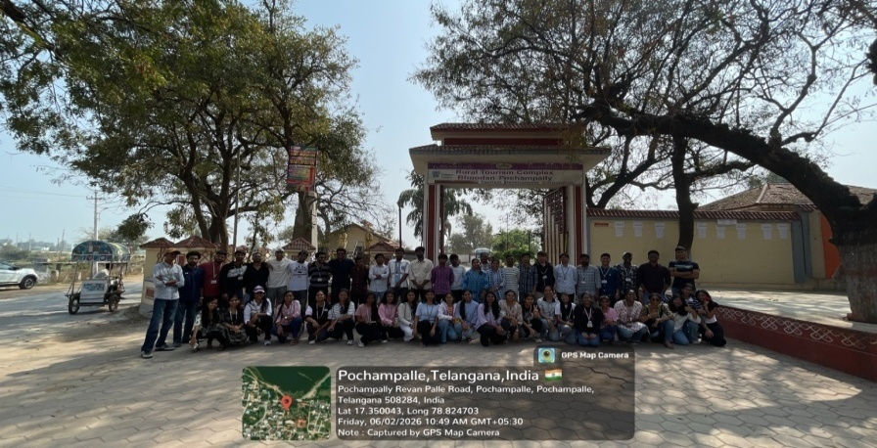

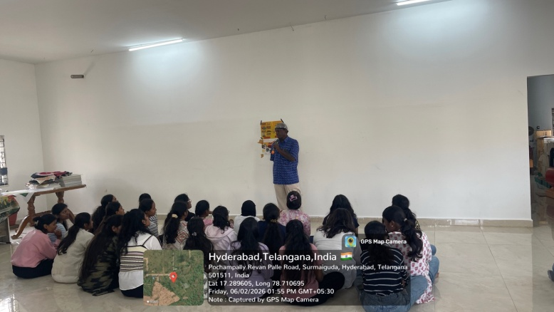

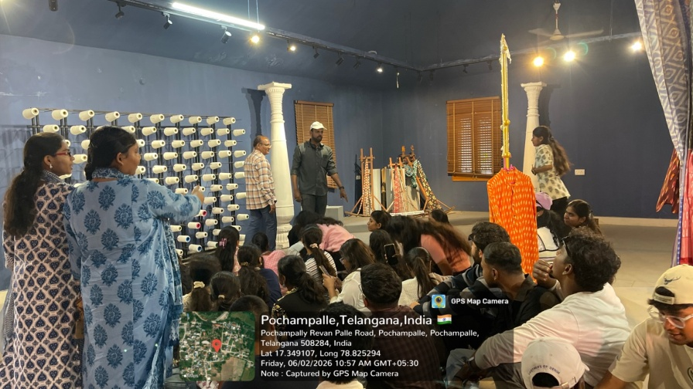

      - INDUSTRIAL VISIT (NCDS):

Class: NCDS
Date of Visit: 9th February 2026
Location: CDFD- Centre for DNA & Fingerprint Daignostics, Apiculture Unit ( honey bee farm)
near Ramoji Film City, Pottery Unit
Faculty Accompanied: Sowmya Ma’am and sahitya Ma’am

Introduction
As a part of our curriculum, an industrial visit was organized on 9th February 2025. The visit aimed to provide students with practical exposure to premier research institute. We visited CDFD , an apiculture unit( honey bee farm), and a pottery unit near Ramoji Film City.

Overview for visit:

CDFD
Our visit to CDFD, honey bee farm, pottery unit to give practical exposure to science, biotechnology. To learn about DNA analysis and its role in medical and data science. It focuses on DNA fingerprinting, genetic research ,molecular diagnostics, and disease studies. overall, enhancing practical knowledge and insights into different career paths.

HONEY BEE FARM
During the visit to the apiculture unit, we learned about beekeeping and honey production. The staff explained the life cycle of bees, honey extraction methods, and the importance of bees in agriculture and the ecosystem. We were also given honey samples to taste.

POTTERY UNIT
At the pottery unit, we observed how various items are made using clay. The craftsmen demonstrated the shaping techniques on the wheel and guided us in making our own clay models. This hands-on experience helped us appreciate the creativity and patience involved in pottery.

Learning Outcomes
- Gained practical knowledge about DNA analysis and biotechnology applications at CDFD.
- Understood process of honey extraction and production, importance of bees in agriculture and pollination.
- Learned basic techniques of pottery making, including clay preparation and shaping.
- Developed awareness about career opportunities in research institutes, agriculture-based industries, and traditional crafts

Conclusion
The industrial visit was an informative and enjoyable experience for the students. It helped us connect theoretical knowledge with real-world practices and understand the hard work behind handmade products. The visit was enriching and memorable for everyone.

Photos-

