B.SC COMPUTER DATA SCIENCE AND DATA ANALYTICS ENGINEERING

STUDENTS ACTIVITIES & ACHIEVEMENTS(25-26)

- Banda Srija – 111723031003 , Tamada Likhitha Sai - 111723031023(DCDS)

Ms. Srija and Ms. Likhitha sai has received a certificate of achievement for securing 1st prize in Nationwide Quiz Contest on Official Statistics (ANVESHA 2.0) held as a part of NSS (National Sample Survey) 2025-26

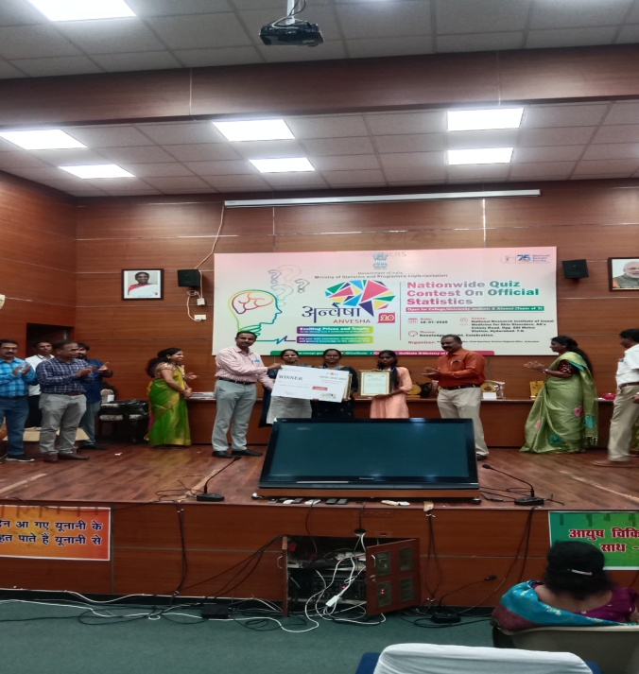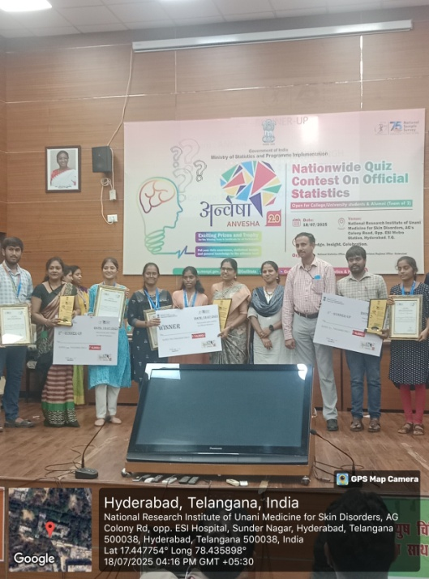
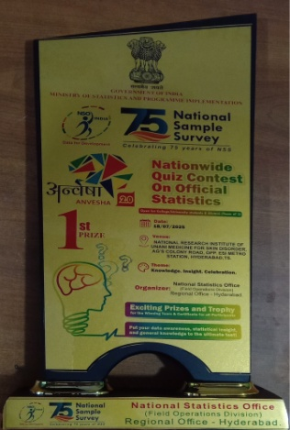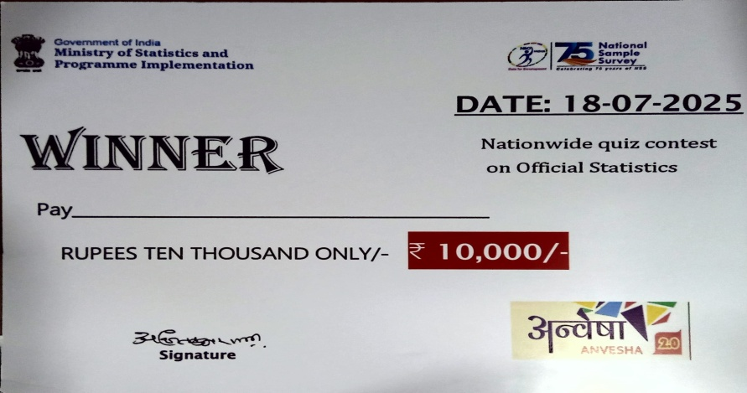
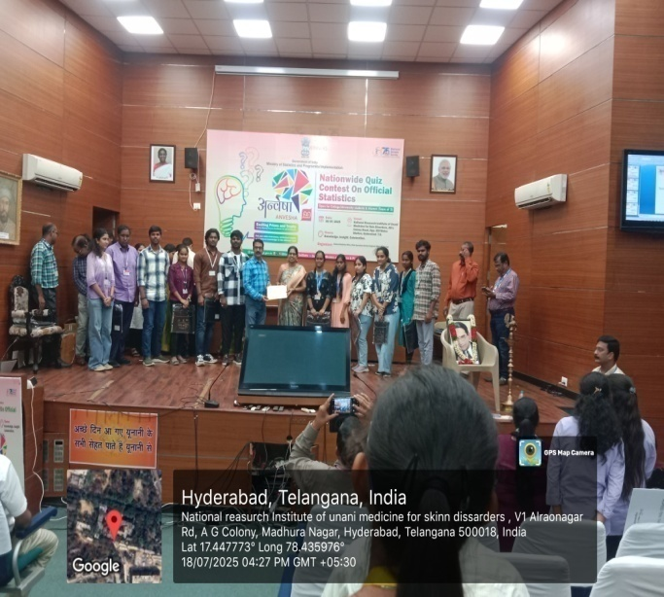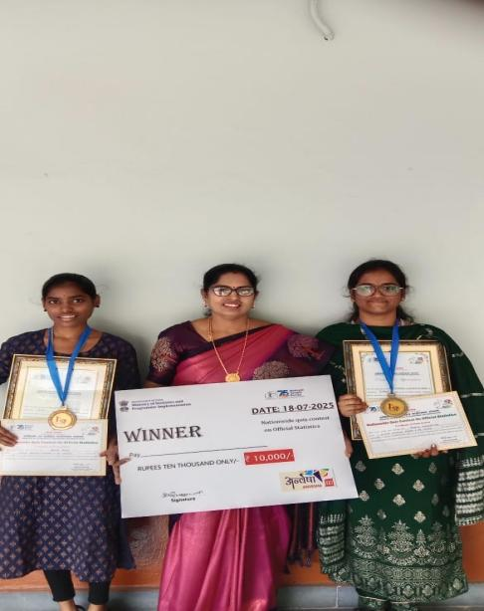
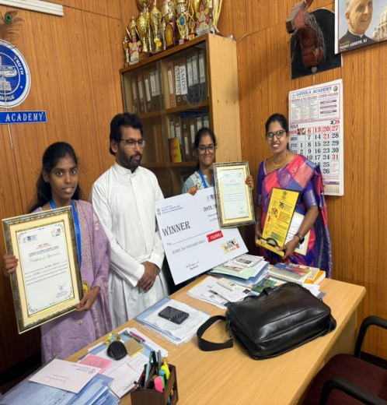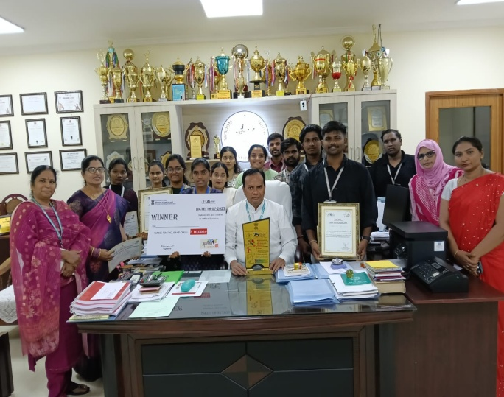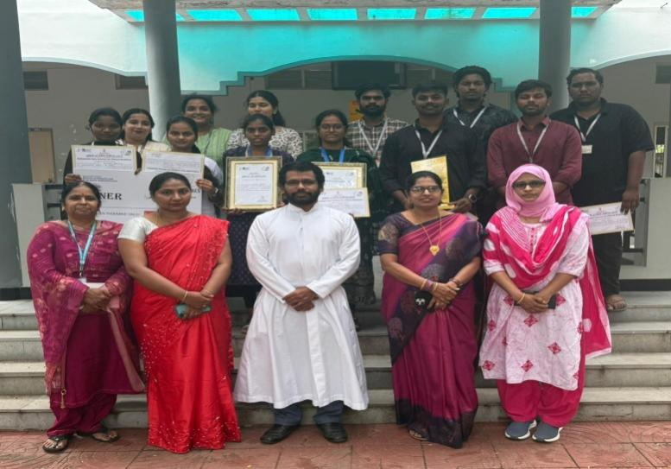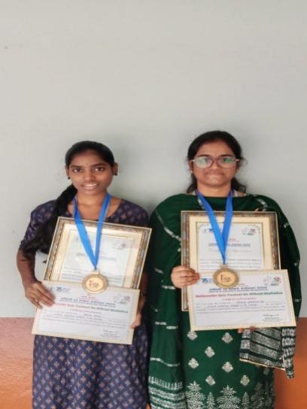
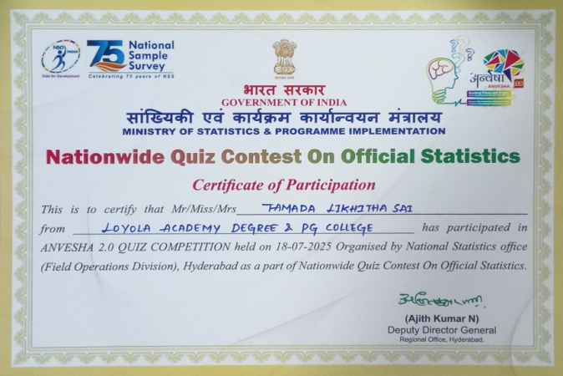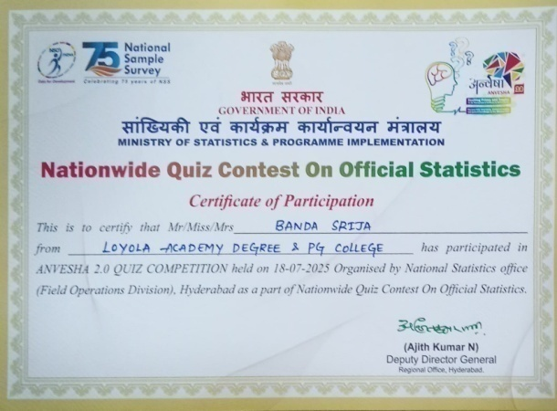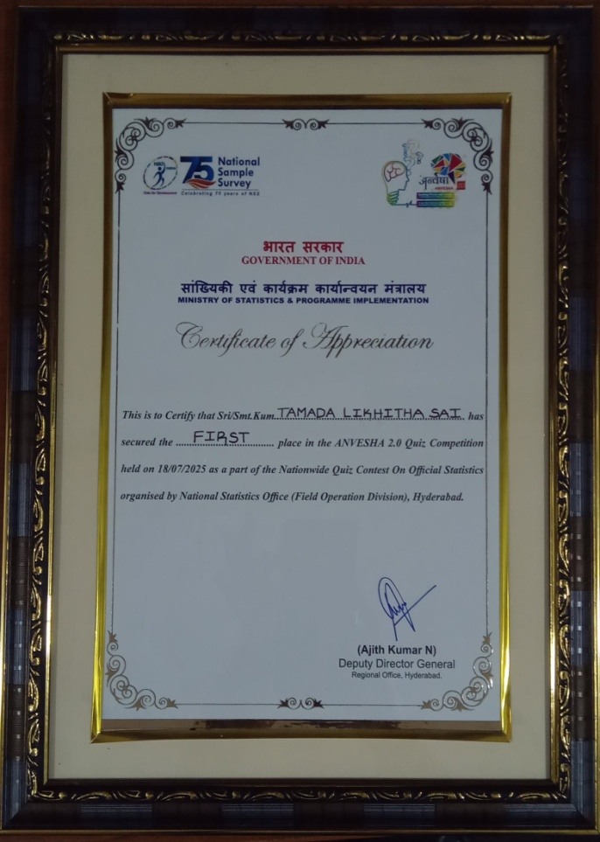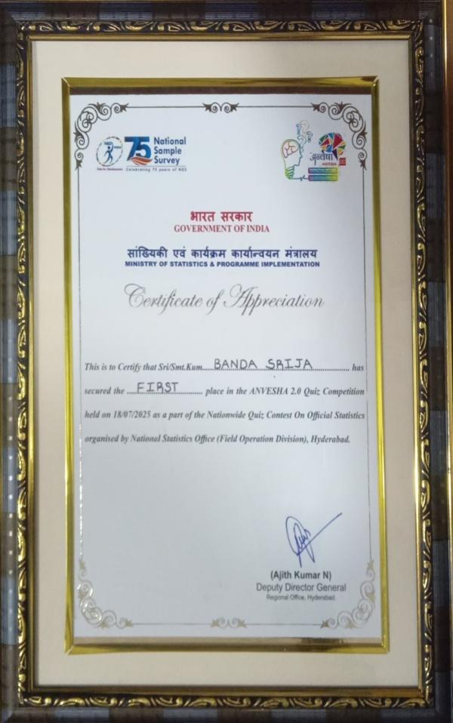

- T. Mahathi - 111723031025(DCDS)
Ms. T Mahathi has received a certificate of achievement for securing The Best Research Paper for Comparative Analysis of Machine Learning and Deep Learning Models for Multiclass Anemia Prediction in Telangana in the International Conference on Emerging Trends in Science and Technology (ICETSAT-2025) held from 28th July to 30th July 2025 organized by the department of Physical Science, Little Flower Degree College, Uppal, Hyderabad.

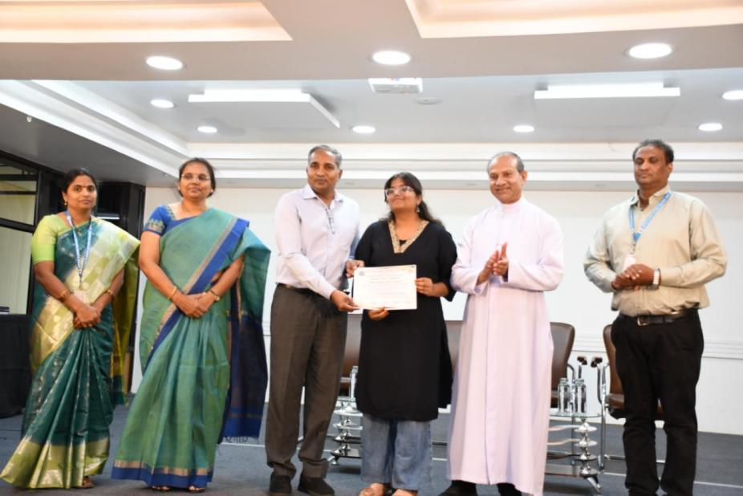

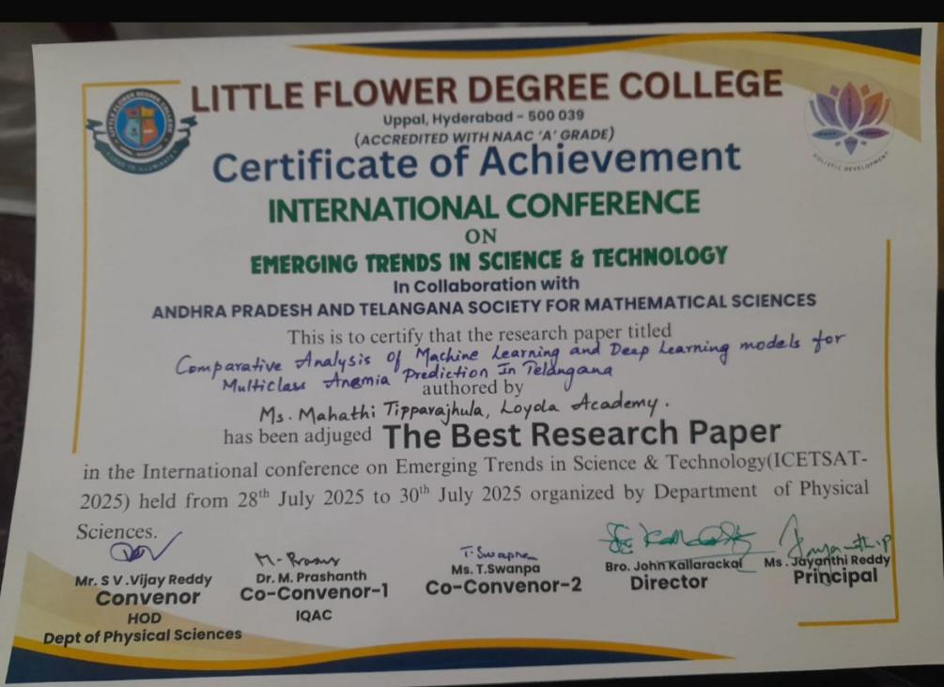

3.Niveta V - 111723031016 & K.Hima Bindu - 111723031012
Ms. Niveta V and Ms K. Hima Bindu has received a certificate of achievement for securing 2nd prize in Event: AIQ(QUIZ) of ATILLIGENZIA 2025 - The AI Day organized by the department of B.Sc. Computer Science and Artificial Intelligence held on 16th July 2025.

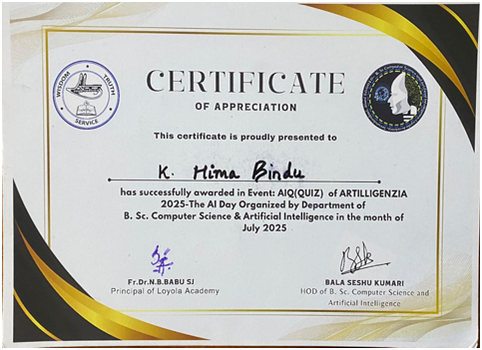

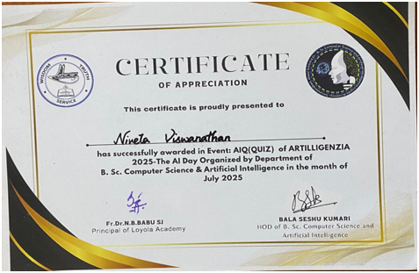

4. Mr. Etienne Sequeira 111723031035

Mr. Etienne Sequeira had participated in Battle of Bands in National Institute of Fashion Technology (NIFT) and won 2nd place for the same. The finals had been conducted on 28th Feb 2026 organized by National Institute of Fashion Technology (NIFT), Silicon Valley, HITEC City, Hyderabad, Telangana 500081

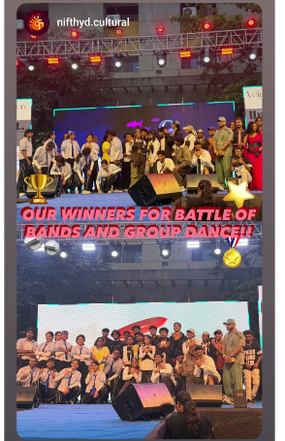

5.M.Thanushwi-111725031020

M.Thanushwi secured first place in prompt to poster at algofest 2026 organized by Dept. of computer science and machine learning

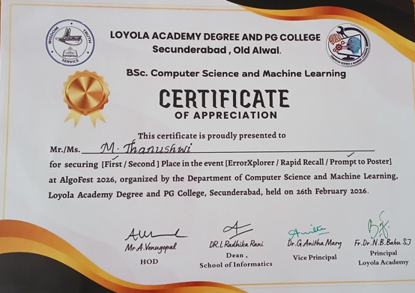

6.Ayesha Begum-111725031002

Ayesha Begum secured Second place in ErrorXplorer at Algofest 2026 organized by Dept. of computer science and machine learning
