CARRER opportunities in cyber security

Event details:
DATE: 2nd August 2025
VENUE: Loyola Academy Degree and PG College
ORGANIZED BY: B.Sc. Computer Science and Cybersecurity Department, Loyola Academy Degree and PG College
RESOURCE PERSON: Vadde Raghavendra Reddy, Security Analyst (SOC Operations), PWC-Hyderabad
TARGET AUDIENCE: Students and faculty members of Loyola Academy Degree and PG College, particularly those enrolled in the B.Sc. Computer Science and Cybersecurity program.
OBJECTIVES OF THE EVENT:
- To provide insights into the various career opportunities available in the field of cybersecurity.
- To foster a sense of awareness and interest in cybersecurity among students and faculty members.
- To provide a platform for individuals to explore the latest trends and developments in the field of cybersecurity.
PARTICIPANT DETAILS:
TOTAL PARTICIPANTS: 50
DEMOGRAPHICS: Students and faculty members of Loyola Academy Degree and PG College.
ATTENDANCE PERCENTAGE: 96%
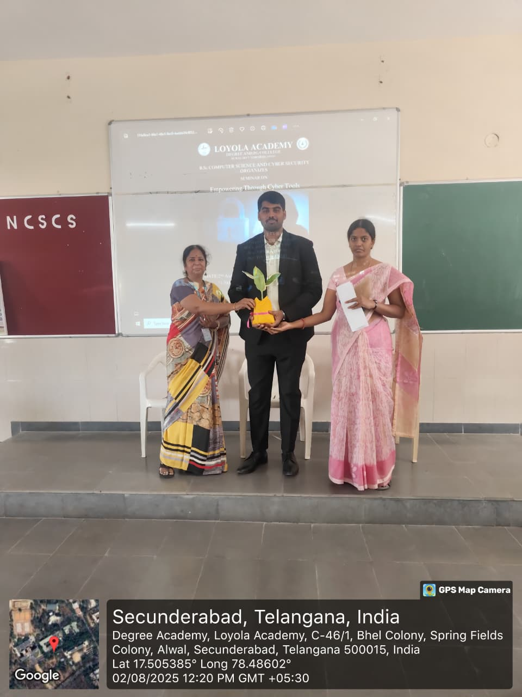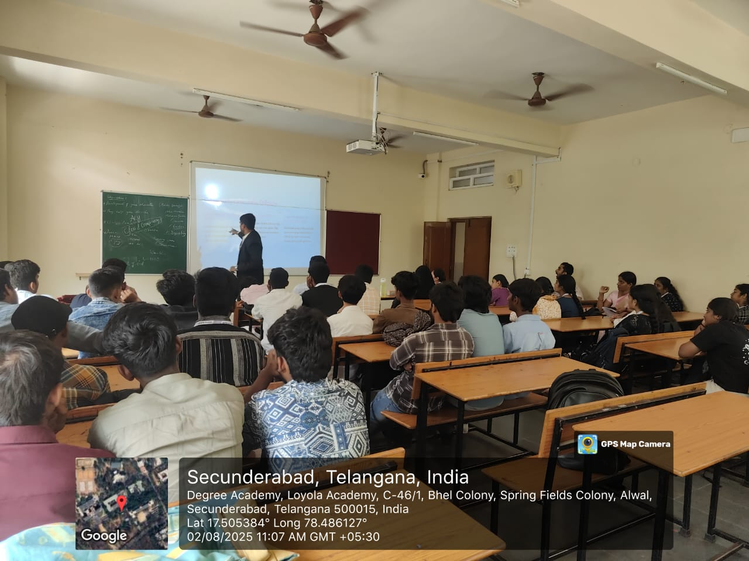
CONTENT EVALUATION:
RELEVANCE OF THE TOPIC: Highly Relevant (given the growing importance of cybersecurity in today’s digital age).
DEPTH OF KNOWLEDGE DELIVERED: Excellent (the resource person is a security Analyst with industry experience).
ENGAGEMENT OF PARTICIPANTS: Highly engaged (participants were observed to be actively participating in the Question and answers session).
LEARNING OUTCOMES:
- Were the Learning Outcomes met? Yes
- Key Takeaways for Participants:
- Career Opportunities available in the field of cybersecurity.
- Latest trends and developments in the field of cybersecurity.
- Skills and knowledge required to pursue a career in cybersecurity.
Skills/Knowledge Gained: Improved understanding of the cybersecurity industry, and the various career paths available.
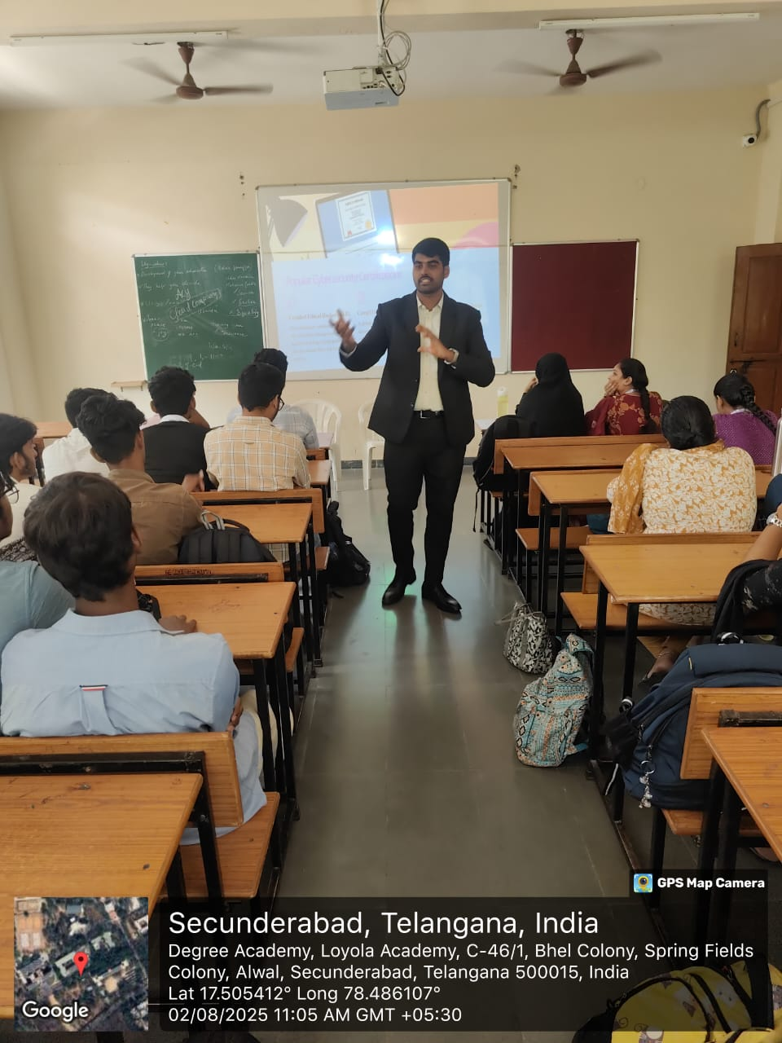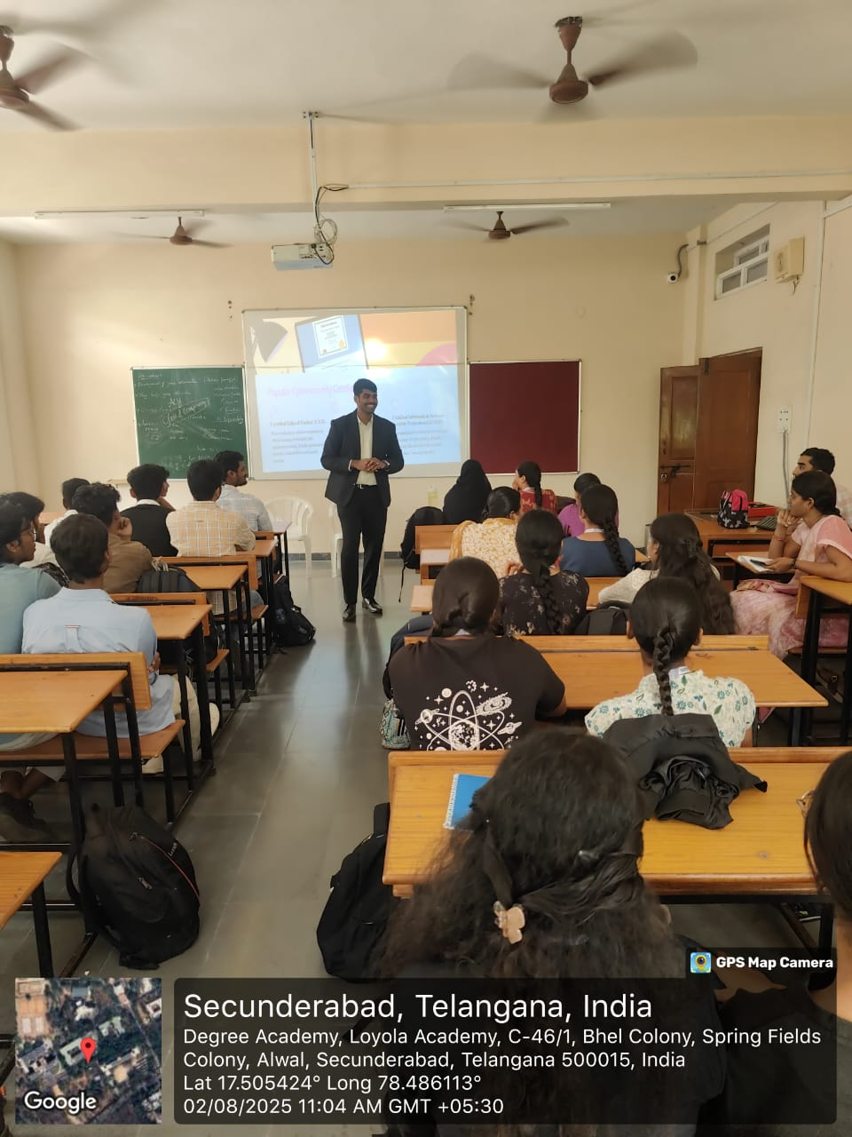

FEEDBACK ANALYSIS:
- Method of Feedback Collection: Online feedback from post-event.
- Key Feedback from Participants:
- Positives: Highly informative, well-structured session, excellent resource person.
- Areas of Improvement: More frequent sessions and hands-on training suggested.
- Rating on a scale of 1-5:
- Content Quality: 4.6/5
- Resource Person Effectiveness: 4.8/5
- Presentation Style: 4.7/5
IMPACT ON CURRICULAM OR FUTURE PRACTICES:
- Impact on Student Learning: Increased awareness of the importance of cybersecurity, which can be integrated into student learning outcomes.
- Integration into Teaching Practices: Faculty members expressed interest in incorporating cybersecurity topics into their teaching modules.
- Suggestions for Future Events: More frequent seminars and workshops on cybersecurity, and hands-on training sessions.
QUANTATAIVE ANALYSIS:
- Performance Improvement: 88% of participants reported a significant improvement in their understanding of cybersecurity.
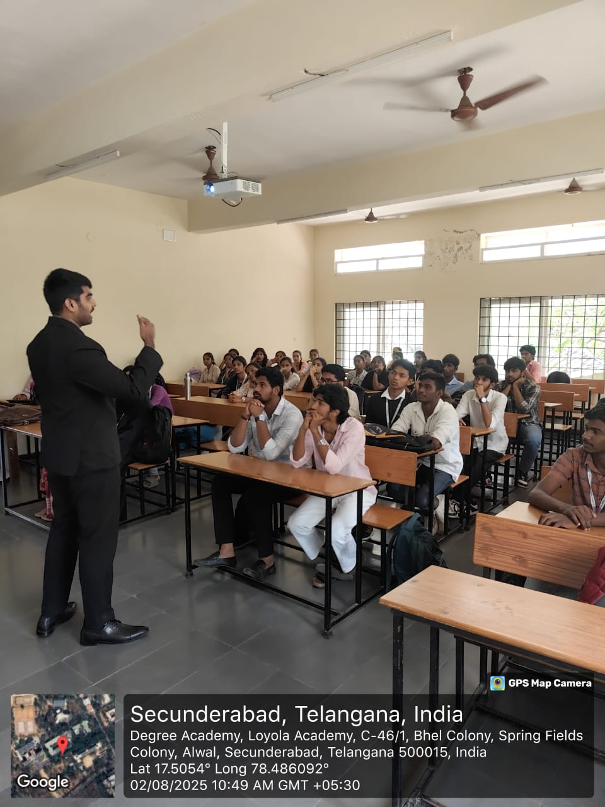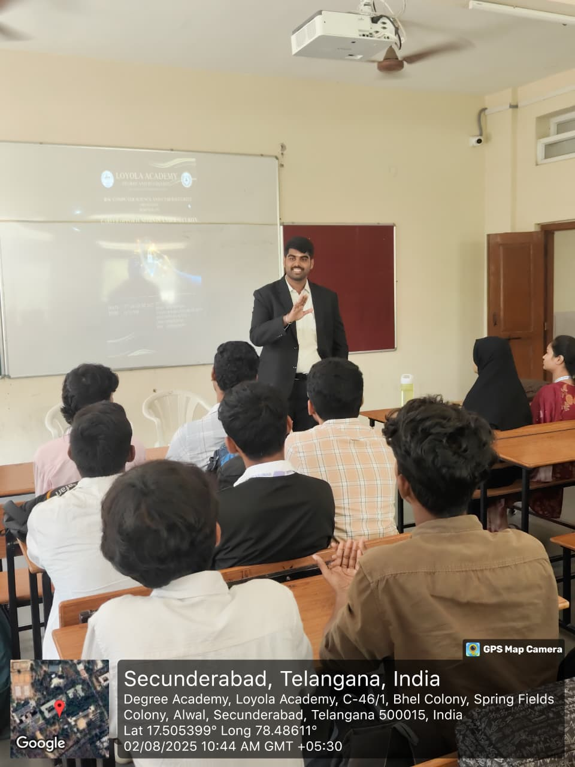

RECOMMENDATIONS:
- Future Improvements: Include more frequent seminars and workshops on cybersecurity, and hands-on training sessions.
- Recommended Topics for Future Events: Cloud security, threat analysis, and incident response.
- Potential for Resource of the Event: Yes, regular seminars and workshops on cybersecurity are recommended to maintain a consistent focus on student learning.
CONCLUSION:
The Seminar on Career Opportunities in Cybersecurity at Loyola Academy Degree and PG College was successful in achieving its objectives. It provided participants with an opportunity to explore the various career opportunities in the field of cybersecurity, and fostered a sense of awareness and interest in the subject.
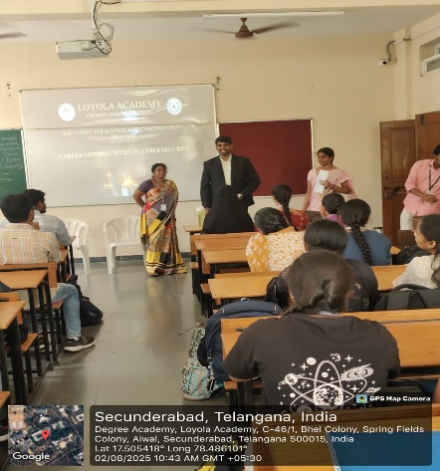

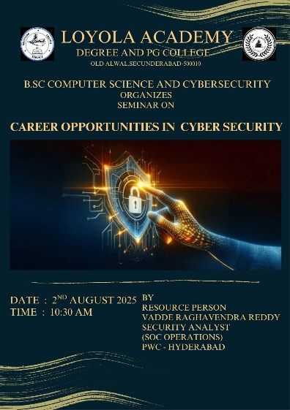

Report
DARKNETRIX (2-Day State Level Hackathon)
1. Event Details
- Title of the Event: DARKNETRIX – 2-Day State Level Hackathon Challenge
- Date: 08th & 09th January 2026
- Time: 9:30 AM – 4:30 PM
- Venue: Inigo Hall, Loyola Academy, Secunderabad
- Organizer/Coordinator: Department of B.Sc. Computer Science and Cyber Security, Loyola Academy (Autonomous)
- Collaborating Partners: Brain O Vision, MATH, NASSCOM , Anuvadini, AICTE
- Target Audience: Undergraduate students with interest in Cyber Security, Computer Science, and emerging technologies
- Nature of Event: Technical Hackathon (Problem-solving and Innovation-driven)

2. Objectives of the Event
- To provide a competitive platform for students to apply cybersecurity and computing concepts in real-world problem scenarios.
- To encourage innovation, teamwork, and problem-solving skills among participants.
- To expose students to industry-oriented challenges in cybersecurity, networking, and digital solutions.
- To bridge the gap between theoretical knowledge and practical application through a hackathon-based learning approach.
- To foster collaboration, creativity, and technical excellence among students at the state level.

3. Participant Details
- Total Participants: Approximately 120–150 students
- Demographics: Undergraduate students (18–22 years) from different colleges across the state

4. Content Evaluation
- Relevance of the Topic: Highly Relevant (the hackathon covered multiple emerging technology domains aligned with current industry and academic trends).
- Domains Covered: Cybersecurity, Cloud Computing, Internet of Things (IoT), Blockchain, Open Innovation, and other interdisciplinary technology domains.
- Depth of Knowledge Delivered: Intermediate to Advanced (participants worked on domain-specific problem statements requiring analytical thinking, technical design, and implementation).
- Participant Engagement: High (teams actively engaged in brainstorming, development, mentoring interactions, and solution presentations across all domains).

5. Learning Outcomes
- Were the Learning Outcomes Met?: Yes
Key Takeaways for Participants:
- Hands-on exposure to real-time problem-solving under time constraints.
- Improved understanding of cybersecurity challenges and solution design.
- Experience in teamwork, task delegation, and collaborative development.
- Exposure to presentation skills and solution pitching before evaluators.
Skills/Knowledge Gained:
Participants enhanced their technical skills in coding, system thinking, and cybersecurity concepts, along with soft skills such as communication, leadership, time management, and teamwork.

6. Feedback Analysis
- Method of Feedback Collection: Informal verbal feedback and interaction with participants during and after the event.
Key Feedback from Participants:
- Positives: Highly engaging, practical, competitive environment, good exposure to real-world challenges.
- Areas of Improvement: More mentoring sessions and extended hackathon duration suggested.
Rating on a Scale of 1–5:
- Content Quality: 4.7/5
- Event Organization: 4.8/5
- Overall Experience: 4.8/5

7. Impact on Curriculum or Future Practices
- Impact on Student Learning:
The hackathon enhanced students’ understanding of applying classroom concepts to real-world cybersecurity and computing problems. It motivated students to explore advanced topics, internships, and certifications related to cybersecurity and software development.
- Integration into Teaching Practices:
Faculty members identified the potential of incorporating hackathon-style problem statements, mini-projects, and collaborative assignments into the curriculum.
- Suggestions for Future Events:
Conduct theme-based hackathons, Capture-the-Flag (CTF) competitions, and industry-mentored challenges.

8. Quantitative Analysis
- Completion Rate: Majority of registered teams successfully submitted solutions within the given time.
- Skill Improvement Indicator: Based on feedback, over 85% of participants reported improvement in problem-solving and practical technical skills.

9. Recommendations
- Introduce pre-hackathon orientation or tool-training sessions.
- Increase industry mentor involvement during the hackathon.
- Expand the event to a national-level hackathon in future editions.

10. Conclusion
The DARKNETRIX – 2-Day State Level Hackathon Challenge was highly successful in achieving its objectives. The event provided a dynamic learning environment that promoted innovation, collaboration, and hands-on technical exposure. It significantly contributed to enhancing students’ practical competencies and reinforced the importance of experiential learning in cybersecurity and computer science education.
Attachments:
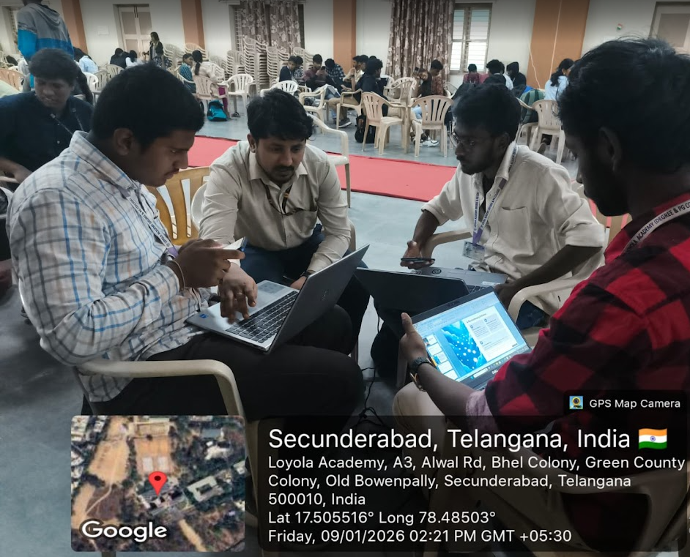

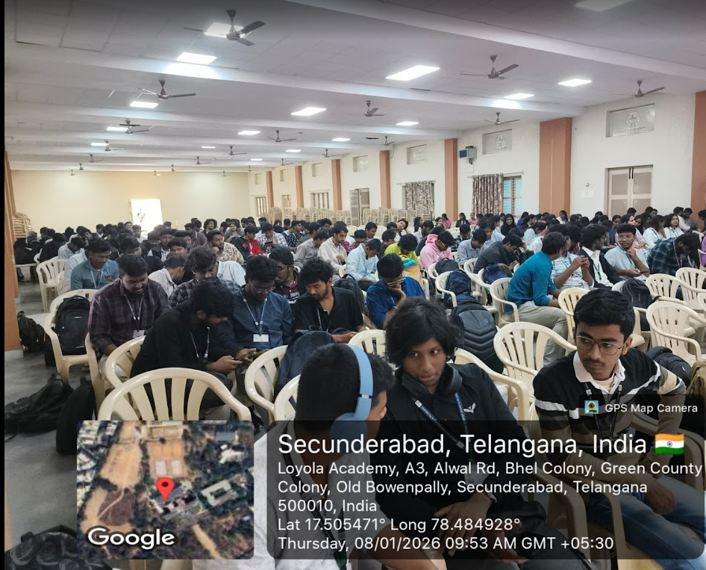
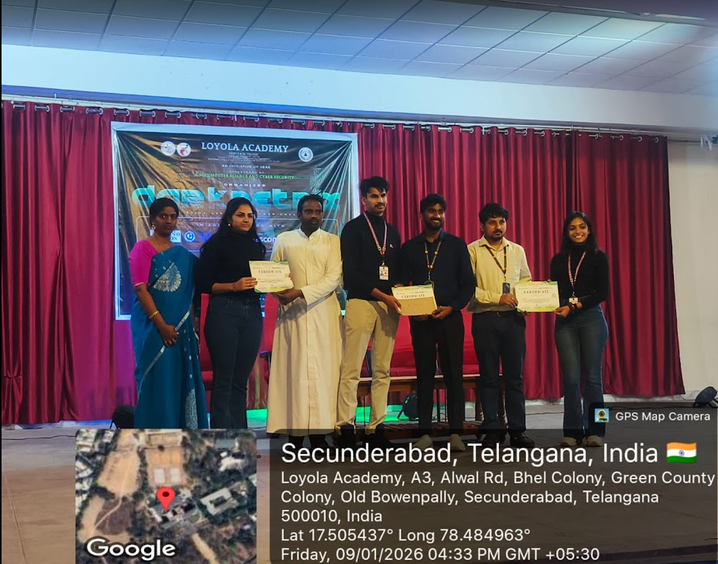
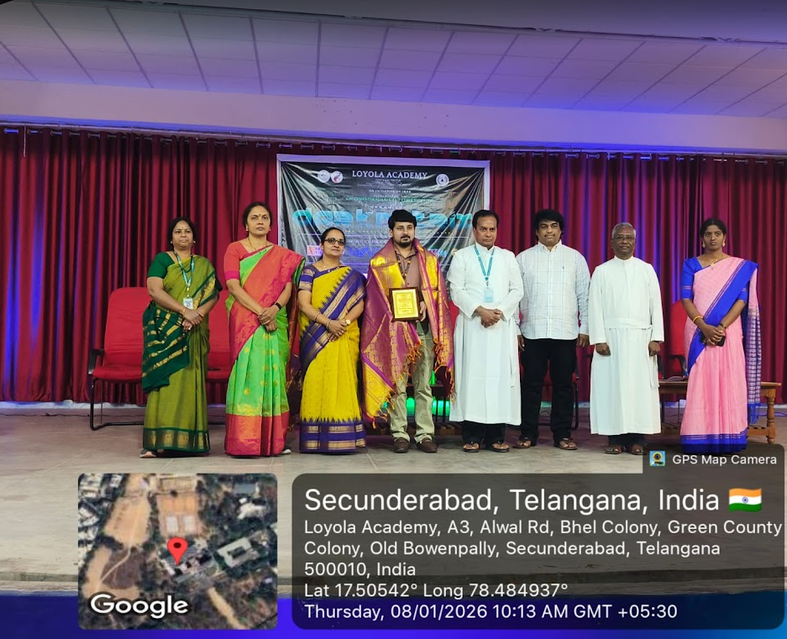

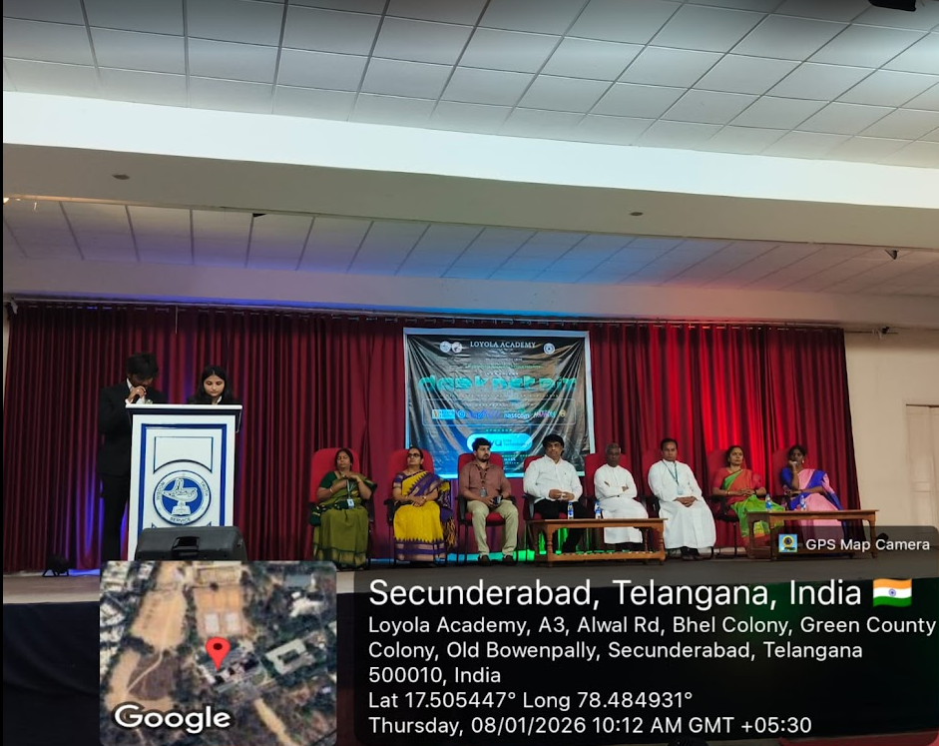
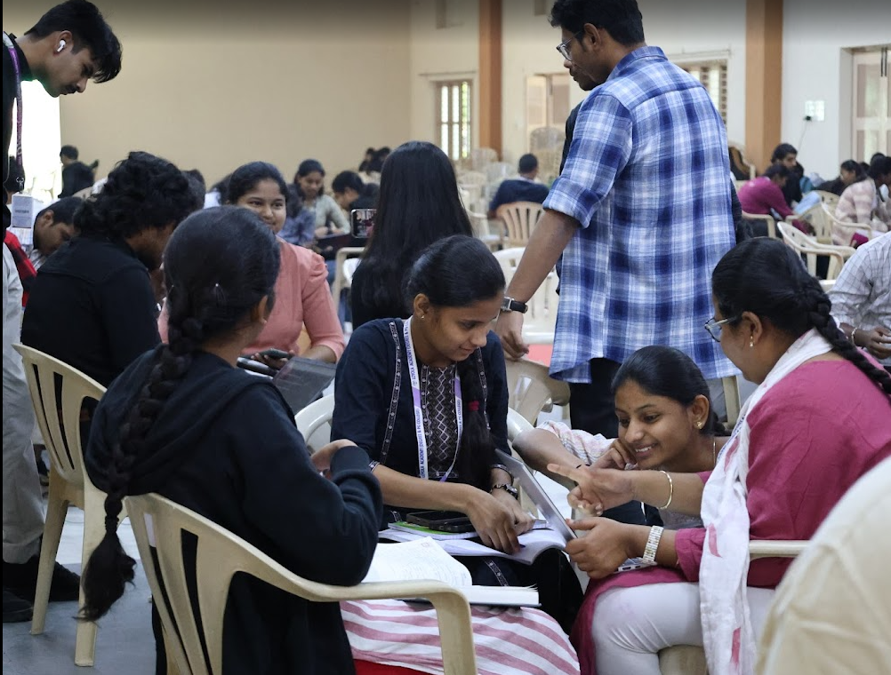

The DARKNETRIX 2-Day State Level Hackathon was held on 08–09 January 2026 at Loyola Academy, Secunderabad, organized by the Department of B.Sc. Computer Science andcyber security in collaboration with Brain O Vision .Around 120–150 undergraduate students from across the state participated, working on real-world problem statements in cybersecurity and emerging technologies.
The event aimed to promote innovation, teamwork, and the practical application of theoretical knowledge through an intensive, competitive environment.
Participants demonstrated high engagement and developed solutions across domains such as Cybersecurity, Cloud Computing, IoT, Blockchain, and Open Innovation.
Feedback indicated excellent content quality and organization, with over 85% of participants reporting significant improvement in technical and problem-solving skills.
Overall, the hackathon was a major success, reinforcing experiential learning and encouraging future curriculum integration and larger-scale hackathon initiatives.

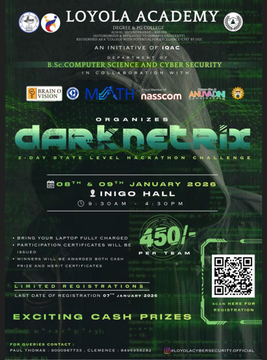

Seminar Report on
Empowering Through Cyber Tools
Academic Year-2025-26

1. Event Details

Title of the Event: Empowering Through Cyber Tools
Date: 2nd August 2025
Venue: Room no:19,Admin block, Loyola Academy.
Organizer/Coordinator: Department of Cyber Security, Loyola Academy, Hyderabad

Speakers:

Mr. V. Raghavendra Reddy, Security Analyst, PWC-hyderabad

Target Audience: Cyber Security Third Year Students

2. Objectives of the Event

-To create awareness about modern cyber tools used in ethical hacking, and information security.

-To highlight the career paths in the cyber domain through expert talks and demonstrations.
-Help students understand trends in digital tools
-key certifications that are essential for a career in cybersecurity

3. Participant Details

Total Participants: 80-100 (Estimated)
Demographics: Undergraduate students

4. Content Evaluation

Relevance of the Topic: Highly Relevant (in today’s digital age, cybersecurity knowledge is essential)
Depth of Knowledge Delivered: intermediate ( real-world use cases shared)
Engagement of Participants: medium ( Q&A, and audience interaction)

5. Learning Outcomes

Were the Learning Outcomes Met? Yes

Key Takeaways for Participants:

1. Introduction to open-source cybersecurity tools
2. Importance of ethical hacking and digital hygiene
3. Exposure to key cybersecurity tools such as Nmap, Wireshark, Burp suite.
4. What are the potential career paths available after completing an undergraduate degree?

Skills/Knowledge Gained:
Participants gained knowledge about cyber tools like Wireshark, Nmap, and career paths after undergraduation

6. Feedback Analysis

Method of Feedback Collection: offline

Key Feedback from Participants:Helpful in future

Positives: Interactive sessions.

Areas of Improvement: Facilitating opportunities for gaining practical experience in the real world.

Rating on a scale of 1–5:

Content Quality: 4.6/5

Speaker Effectiveness: 4.8/5

Presentation Style: 4.7/5

7. Impact on Curriculum or Future Practices

Impact on Student Learning:
Improved understanding of cyber threat landscapes and practical exposure to industry-used tools. Sparked interest in pursuing certifications like CEH, CompTIA Security+.

Integration into Teaching Practices:
Faculty planned to incorporate tool demonstrations in practical sessions and assignments.

Suggestions for Future Events:
Conduct hands-on workshops, CTF (Capture the Flag) competitions, and invite industry leaders from cybersecurity startups.

9. Recommendations

Future Improvements:

Include a full-day workshop for in-depth tool usage.

Recommended Topics for Future Events:

Cybersecurity in AI and IoT

Cloud Security Tools and Techniques

Real-time Incident Response Simulations

Potential for Recurrence of the Event:
Yes. An annual or bi-annual seminar/workshop series is highly recommended.

---

10. Conclusion

The “Empowering Through Cyber Tools ” event successfully met its objectives by delivering insightful, , and interactive sessions on cybersecurity tools and practices. The event received excellent participation and feedback, encouraging the department to conduct similar knowledge-sharing initiatives regularly.

Attachments:

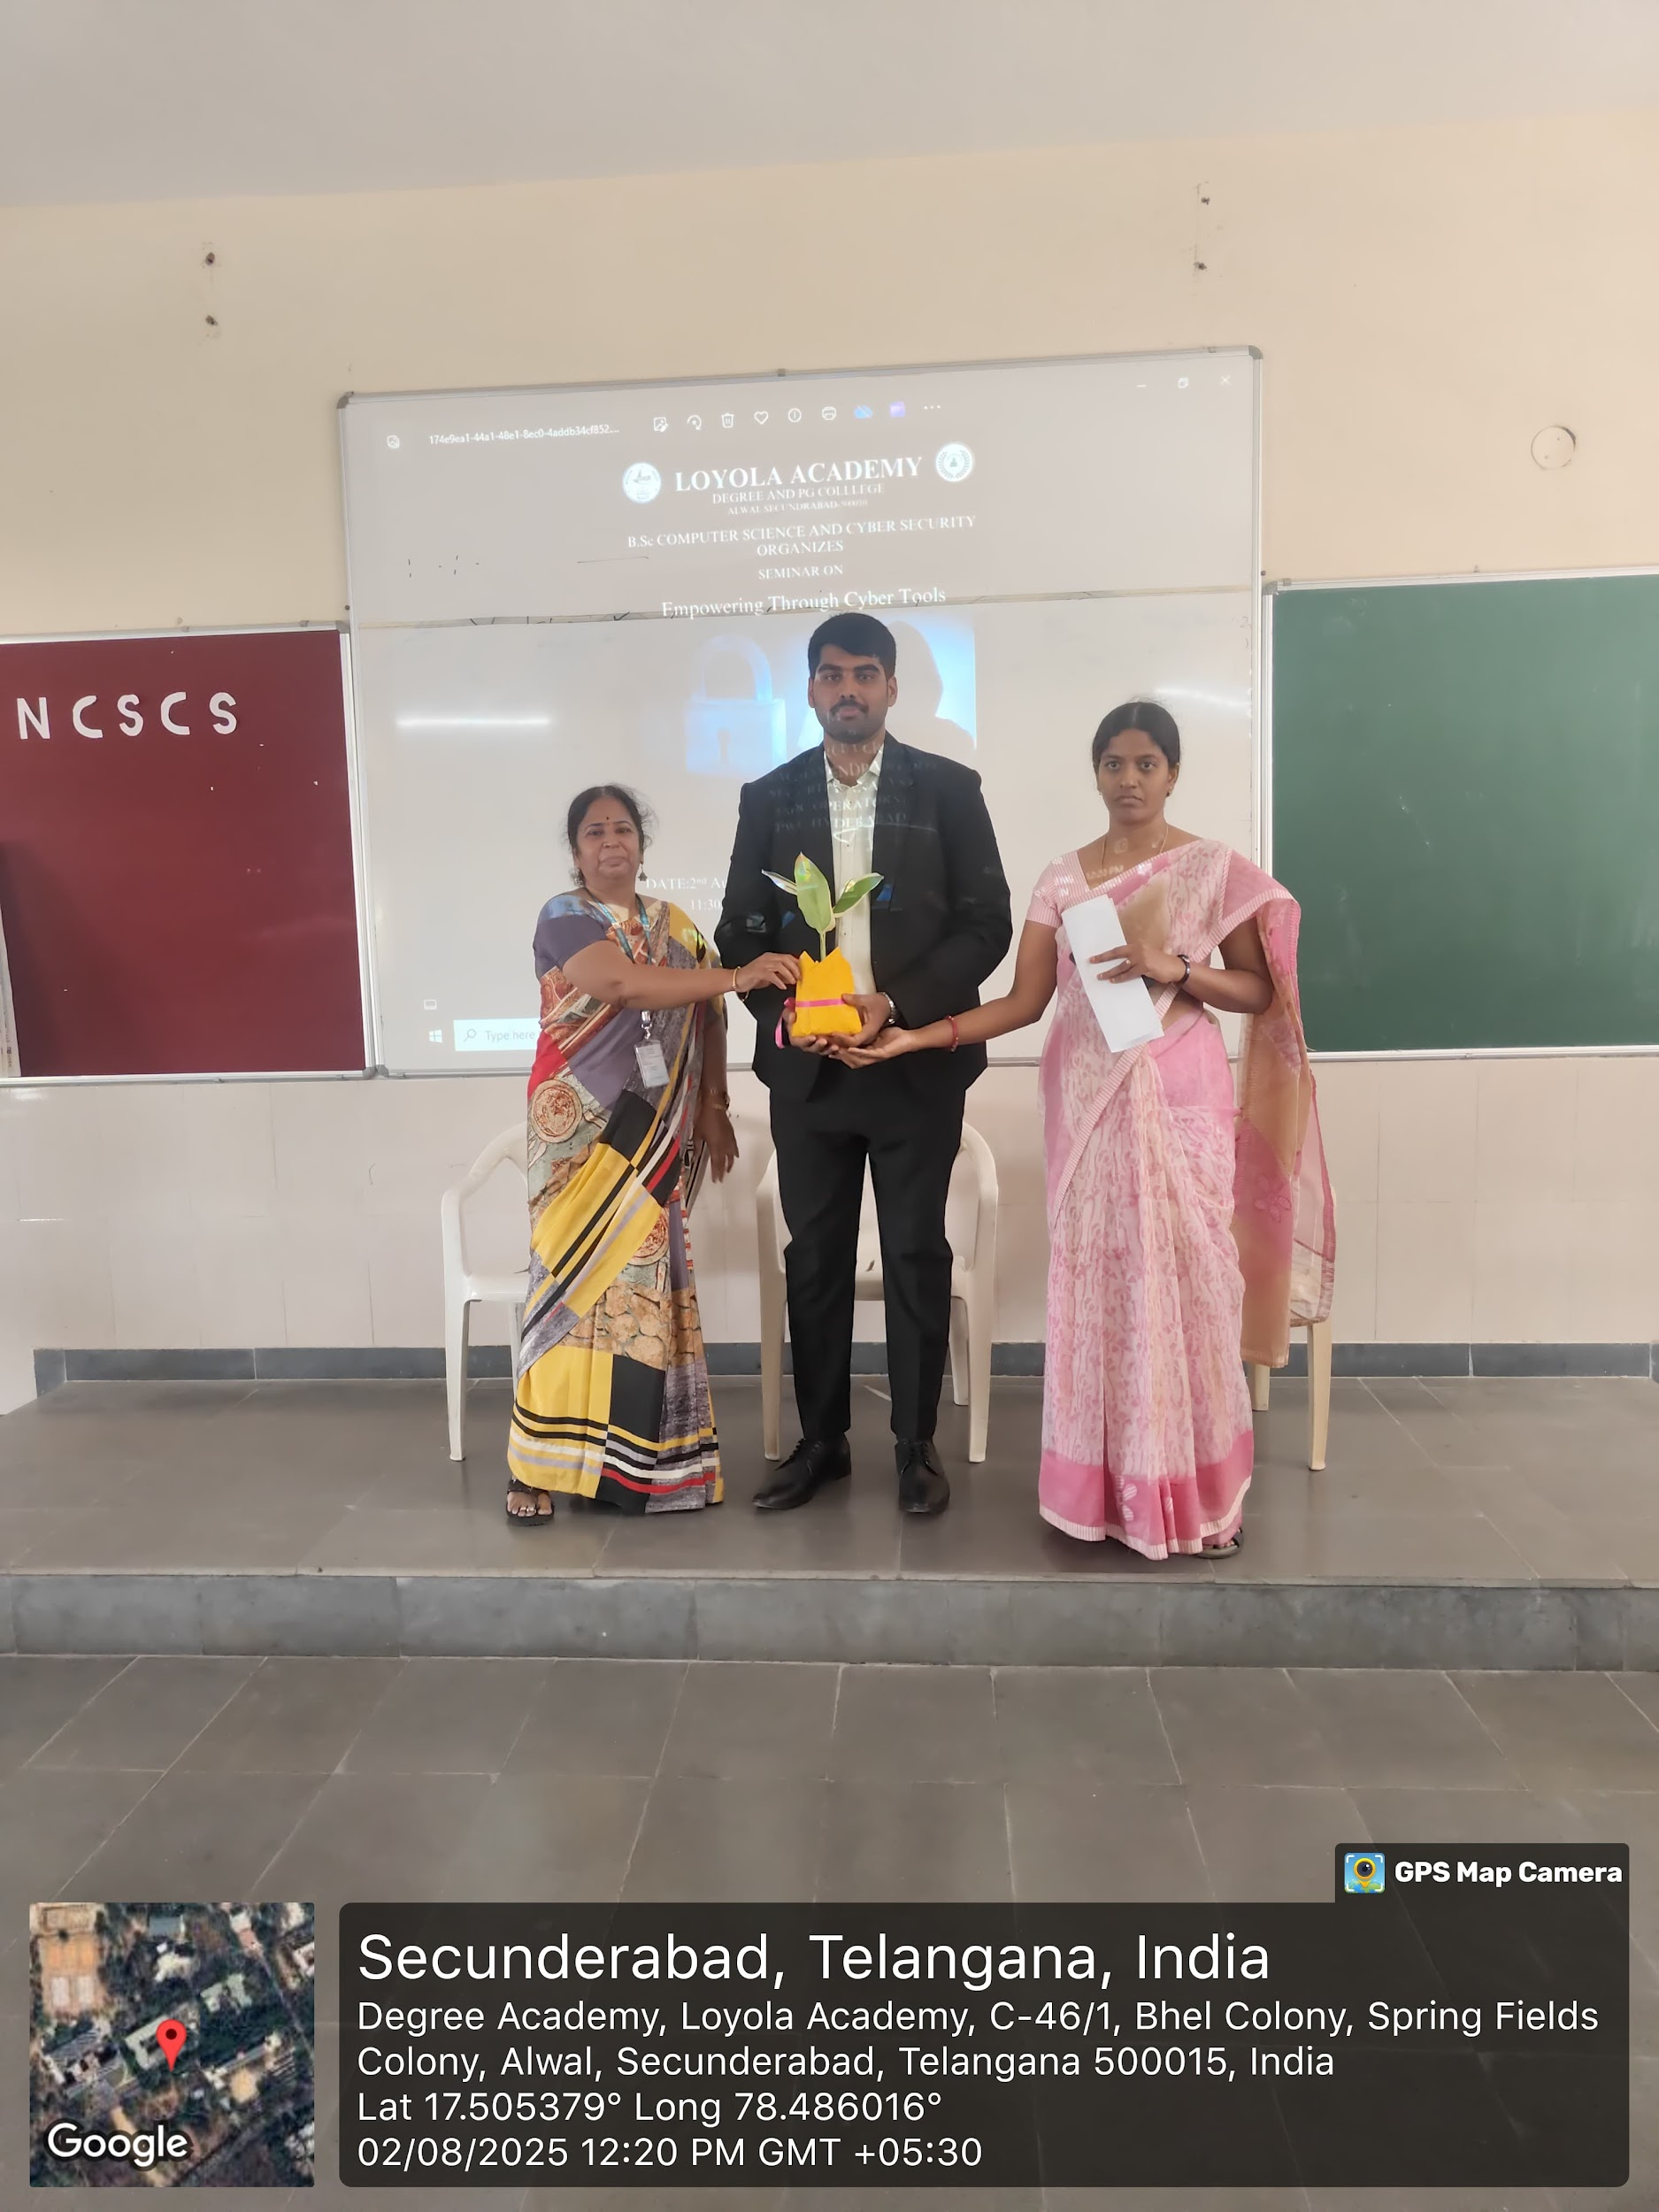

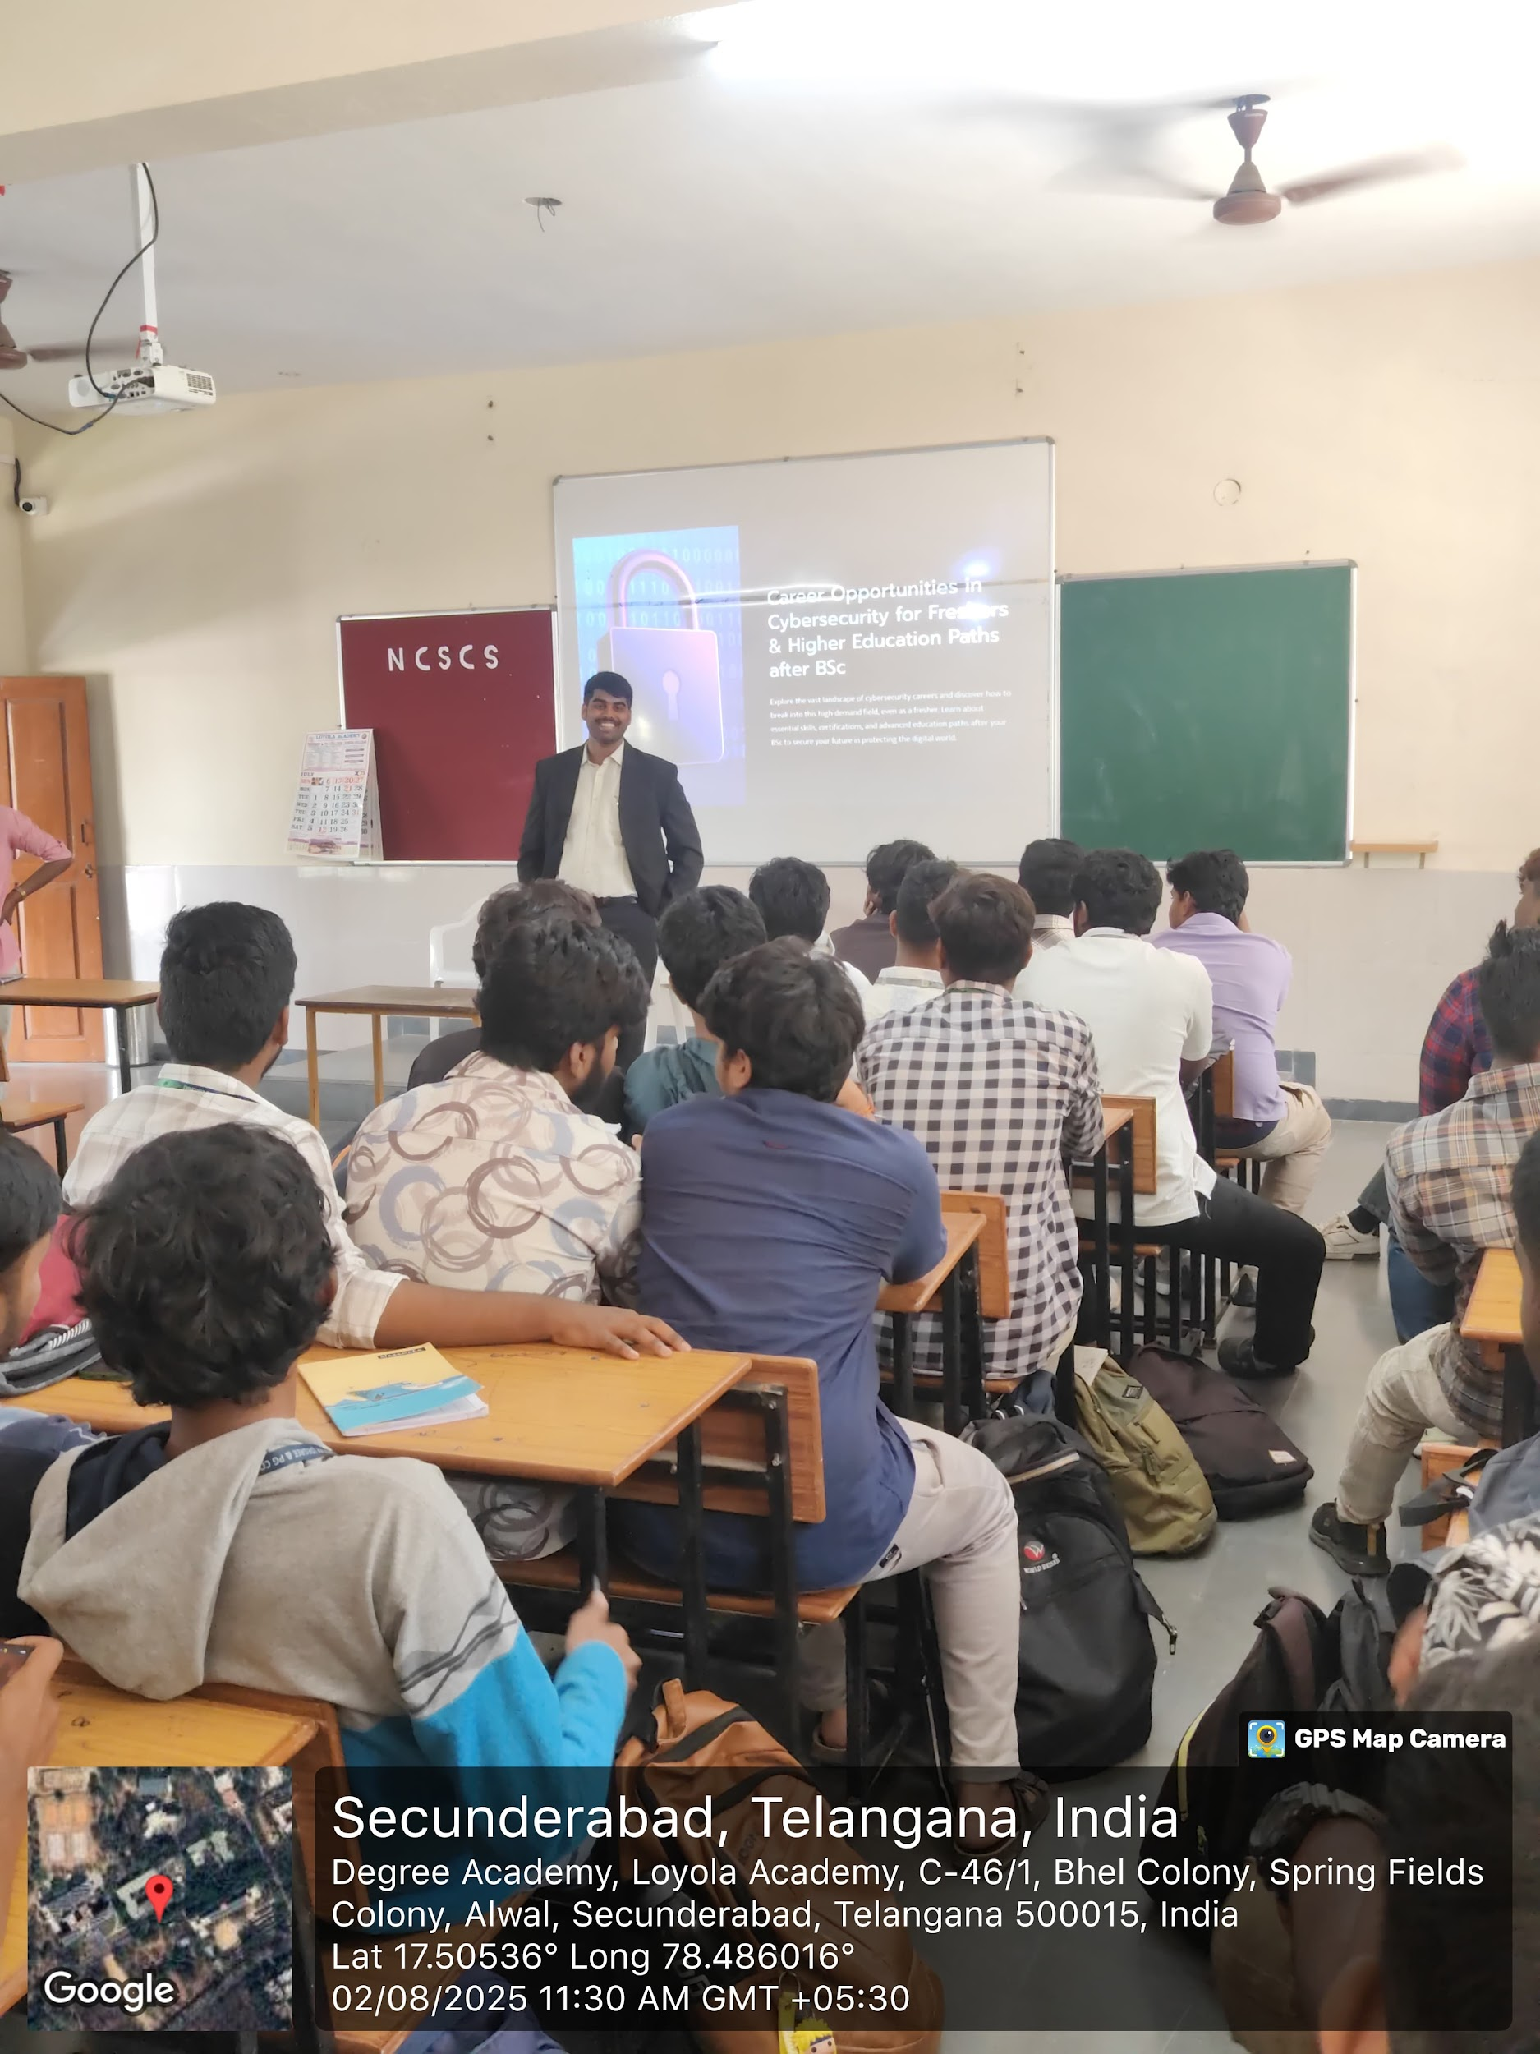
.

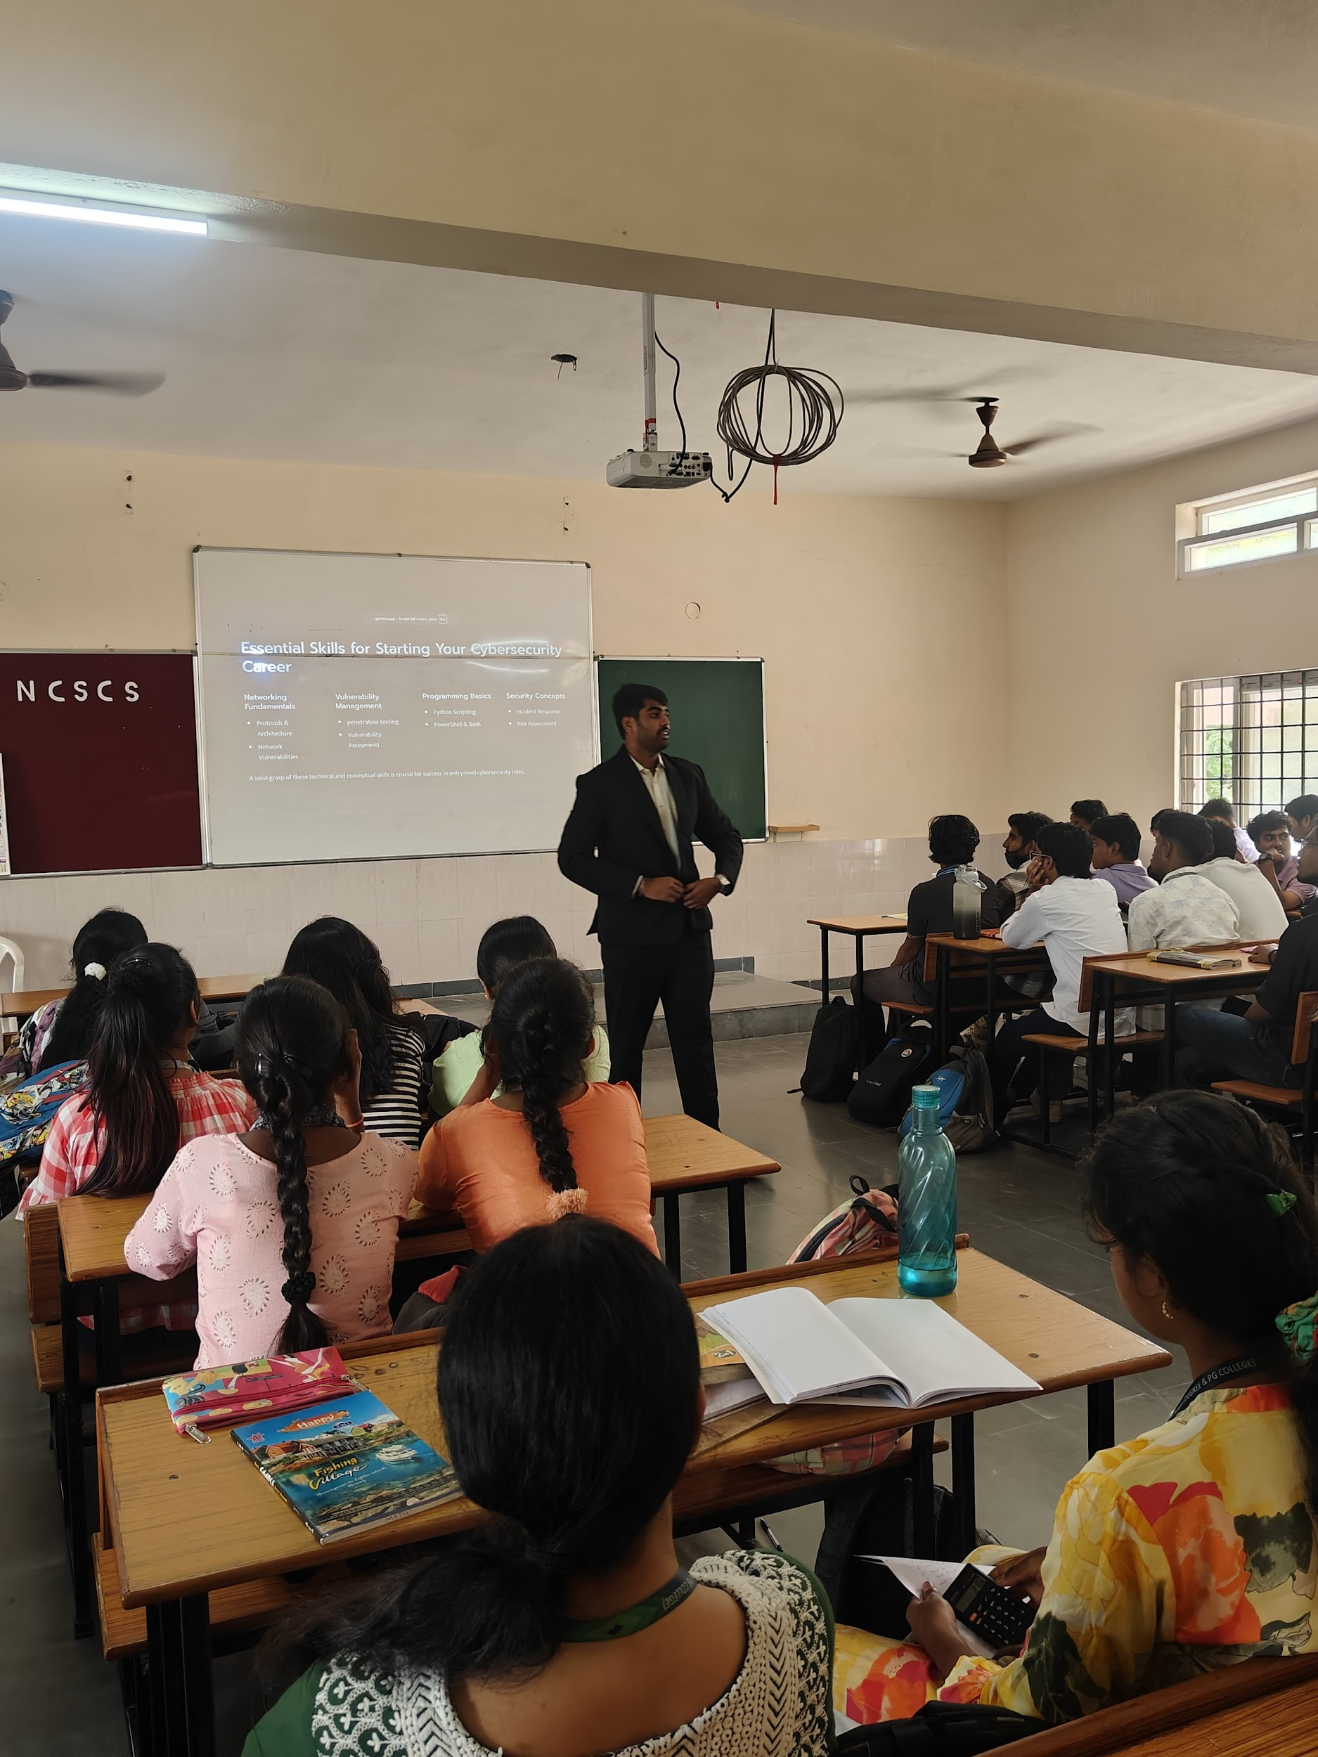

Impact Analysis Report for Faculty Exchange Program – 2026
1. Event Details
Title of the Event: Faculty Exchange Program on Emerging Technologies (Agentic AI, Serverless & Edge Computing)
Dates:
- 5th March 2026 (For 1st Year Students – Agentic AI)
- 9th March 2026 (For 2nd Year Students – Serverless & Edge Computing)
Venue: Online Mode (Google Meet)
Organizer/Coordinator: Department Faculty (Faculty Exchange Initiative)
Speakers:
- Faculty Members from CHRIST College (AUTONOMOUS) Irinjalakuda, Kerala (Faculty Exchange Program)
Target Audience:
- 1st Year Students – Introduction to Agentic AI
- 2nd Year Students – Serverless & Edge Computing Concepts
2. Objectives of the Event
- To introduce students to emerging technologies such as Agentic AI, Serverless Computing, and Edge Computing.
- To enhance interdisciplinary learning through faculty exchange.
- To provide exposure to real-world applications and current industry trends.
- To encourage students to explore advanced technological domains early in their academic journey.
3. Participant Details
Total Participants:
- 1st Year: 50 (Estimated)
- 2nd Year: 51 (Estimated)
Demographics: Undergraduate engineering students
Attendance Percentage: 92%
4. Content Evaluation
Relevance of the Topic:
Highly Relevant (aligned with current advancements in AI and cloud technologies)
Depth of Knowledge Delivered:
Very Good (concepts explained with examples and practical insights)
Engagement of Participants:
Highly Engaged (interactive discussions, queries raised during sessions)
5. Learning Outcomes
Were the Learning Outcomes Met?: Yes
Key Takeaways for Participants:
- Understanding the concept of Agentic AI and its autonomous decision-making capabilities
- Fundamentals of Serverless Computing and its advantages in cloud architecture
- Insights into Edge Computing and its role in real-time data processing
- Awareness of industry applications and future scope of these technologies
Skills/Knowledge Gained:
- Conceptual clarity on emerging technologies
- Exposure to modern computing paradigms
- Improved analytical thinking regarding AI and distributed systems
6. Feedback Analysis
Method of Feedback Collection: Online feedback form (Google Form)
Key Feedback from Participants:
Positives:
- Informative and easy-to-understand sessions
- Real-world examples enhanced understanding
- Interactive teaching approach
Areas of Improvement:
- Request for more hands-on demonstrations
- Desire for longer session duration
Rating on a scale of 1-5:
- Content Quality: 4.6/5
- Speaker Effectiveness: 4.7/5
- Presentation Style: 4.5/5
7. Impact on Curriculum or Future Practices
Impact on Student Learning:
Students gained early exposure to cutting-edge technologies, improving their readiness for advanced subjects and industry demands.
Integration into Teaching Practices:
Faculty members plan to incorporate introductory modules on AI agents, serverless architecture, and edge computing into coursework.
Suggestions for Future Events:
- Conduct hands-on workshops and mini-projects
- Invite industry experts for deeper insights
- Organize follow-up sessions for advanced learning
8. Quantitative Analysis
Performance Improvement:
Approximately 80% of participants reported improved understanding of the topics after the sessions.
9. Recommendations
Future Improvements:
- Include practical demonstrations and coding sessions
- Provide pre-session and post-session materials
Recommended Topics for Future Events:
- Generative AI and LLMs
- Cloud-native application development
- IoT with Edge Computing
- AI in real-world problem solving
Potential for Recurrence of the Event:
Yes, faculty exchange programs should be conducted regularly to promote collaborative learning.
10. Conclusion
The Faculty Exchange Program conducted via Google Meet was successful in achieving its objectives. It provided valuable insights into emerging technologies like Agentic AI, Serverless Computing, and Edge Computing. The sessions enhanced student knowledge, encouraged active participation, and fostered academic collaboration between institutions.

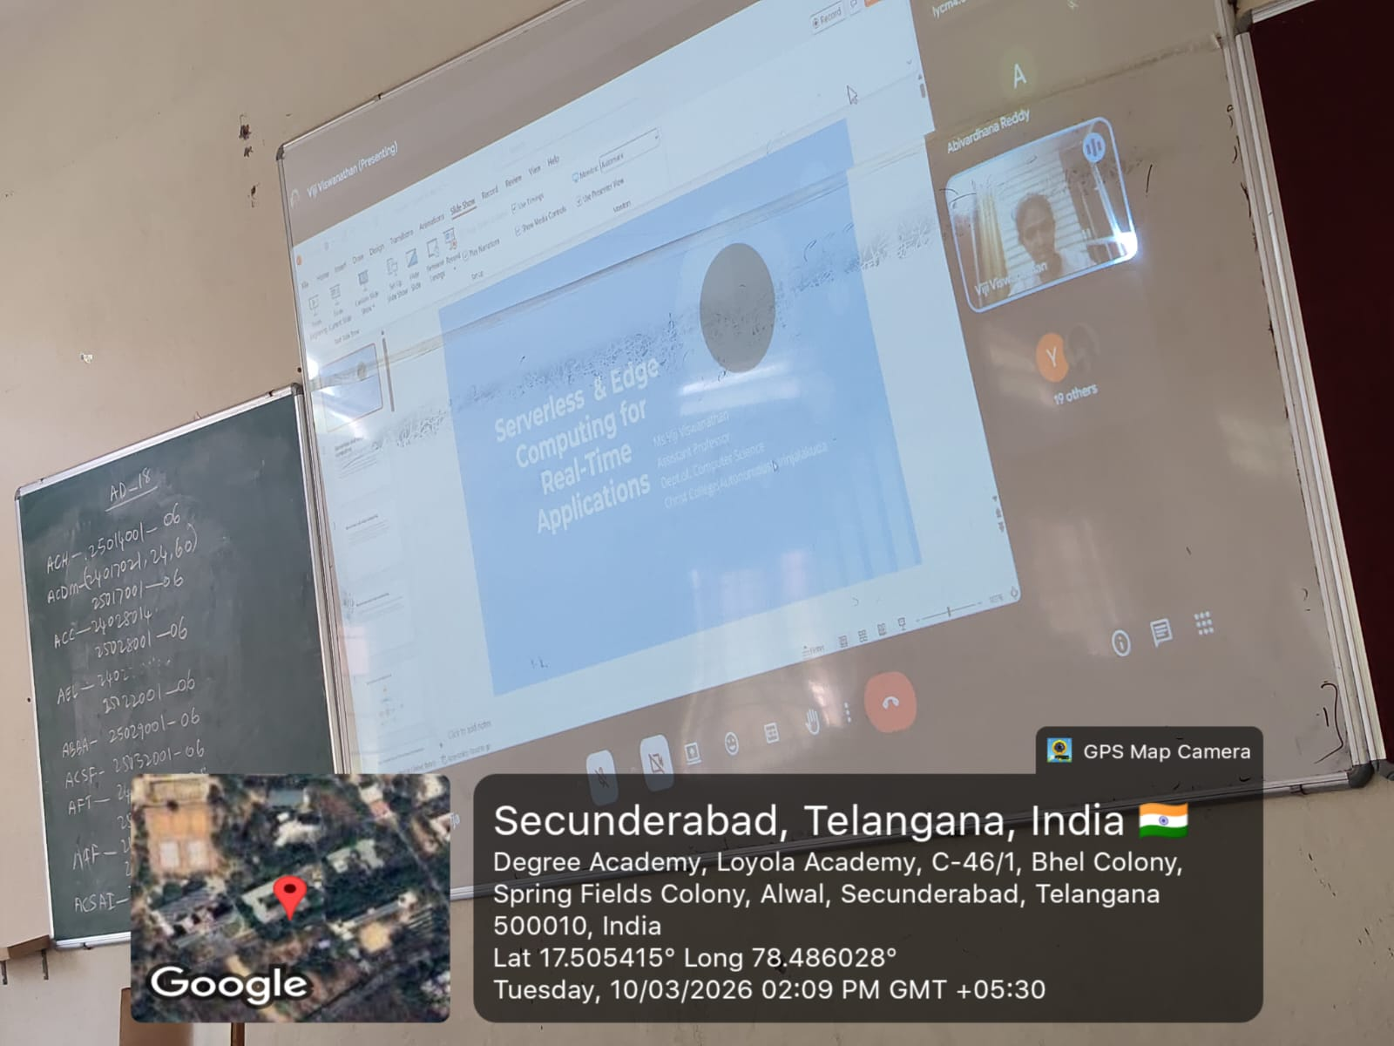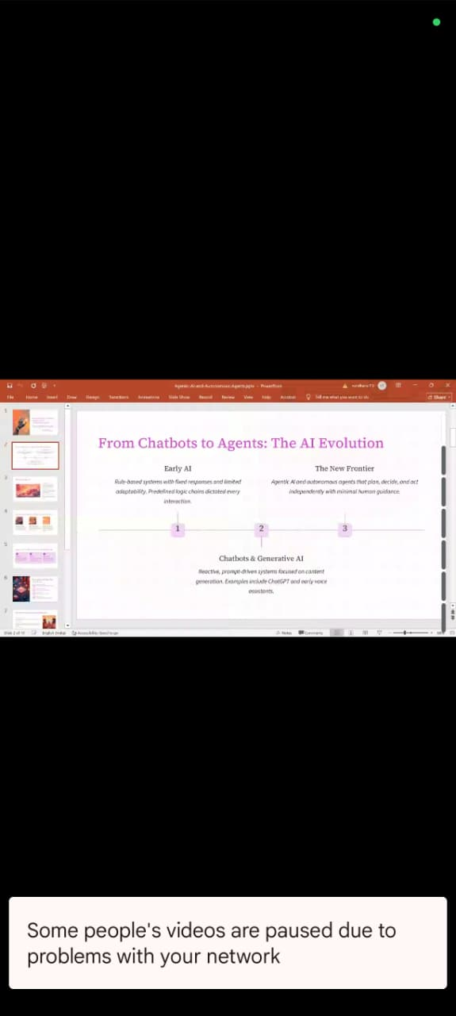

Impact Analysis Report for Online Training Program on AI & ML – 2025

1. Event Details
Title of the Event: Online Training Program on Artificial Intelligence and Machine Learning using Jupyter Notebook and Career Opportunities
Date: Conducted for 10 Days (Daily during the 6th Hour)
Venue: Digital Classroom, Department of Cyber Security, Loyola Academy (Online session conducted through Zoom using Digital Board)
Organizer/Coordinator: Department of Cyber Security, Loyola Academy
Speakers:
AI-ML Trainers from the Department of Cyber Security
Target Audience: Undergraduate Cyber Security Students (Entire Class)

2. Objectives of the Event
- To introduce students to the fundamentals of Artificial Intelligence and Machine Learning.
- To provide practical exposure to programming using Jupyter Notebook.
- To create awareness about career opportunities in AI, Machine Learning, and Data Science.
- To enhance students’ analytical and programming skills using modern AI tools.

3. Participant Details
Total Participants: 50 Students
Demographics: Undergraduate Cyber Security students from Loyola Academy.
Attendance Percentage: 96%

4. Content Evaluation
Relevance of the Topic: Highly Relevant (AI and Machine Learning are emerging technologies widely used in cybersecurity, automation, and data analysis.)
Depth of Knowledge Delivered: Very Good (The sessions covered theoretical concepts along with practical demonstrations using Jupyter Notebook.)
Engagement of Participants: Highly Engaged (Students actively participated in live coding demonstrations, discussions, and Q&A sessions conducted during the online classes.)
Seminar/Classroom Atmosphere:
The sessions were conducted using a digital board through Zoom meeting, creating an interactive and technology-driven learning environment. The visual explanations, coding demonstrations, and real-time discussions helped students understand AI and ML concepts effectively. The digital teaching atmosphere made the sessions engaging and practical.

5. Learning Outcomes
Were the Learning Outcomes Met?: Yes
Key Takeaways for Participants:
- Basic understanding of Artificial Intelligence and Machine Learning concepts.
- Hands-on exposure to programming and experimentation using Jupyter Notebook.
- Awareness about career opportunities in AI, Machine Learning, and Data Science fields.
Skills/Knowledge Gained:
Students gained practical knowledge in Python-based AI programming, data handling techniques, and an understanding of future career pathways in the AI and ML industry.

6. Feedback Analysis
Method of Feedback Collection: Online feedback form after completion of the training program.
Key Feedback from Participants:
Positives:
- Informative and practical sessions.
- Clear explanations using digital board demonstrations.
- Useful introduction to AI tools and career guidance.
Areas of Improvement:
- Students suggested more advanced practical sessions and mini-projects.
Rating on a scale of 1–5:
Content Quality: 4.7/5
Speaker Effectiveness: 4.8/5
Presentation Style: 4.6/5

7. Impact on Curriculum or Future Practices
Impact on Student Learning:
The training program increased students’ awareness of emerging technologies such as Artificial Intelligence and Machine Learning. It also motivated students to explore AI-based projects and research topics.
Integration into Teaching Practices:
Faculty members expressed interest in integrating AI and ML practical modules using Jupyter Notebook into regular coursework and lab sessions.
Suggestions for Future Events:
- Conduct advanced workshops on Machine Learning models.
- Organize hackathons or mini-projects on AI applications.

8. Quantitative Analysis
Pre- and Post-Assessment Scores: Informal assessment through quizzes and coding exercises during the sessions.
Performance Improvement: Based on feedback, 80% of students reported improved understanding of AI and Machine Learning concepts after the 10-day program.

9. Recommendations
Future Improvements:
Include more hands-on coding sessions, real-world case studies, and small AI projects.
Recommended Topics for Future Events:
- Deep Learning
- AI in Cyber Security
- Data Science and Big Data Analytics
- AI Tools and Cloud-based Machine Learning Platforms
Potential for Recurrence of the Event:
Yes, similar training programs can be conducted every semester to keep students updated with emerging technologies in Artificial Intelligence.

10. Conclusion
The Online Training Program on Artificial Intelligence and Machine Learning using Jupyter Notebook and Career Opportunities was successfully conducted by the Department of Cyber Security, Loyola Academy. The program effectively enhanced students’ understanding of AI technologies, practical coding skills, and awareness of career prospects in the field. The interactive digital teaching environment and structured sessions contributed significantly to students’ academic and professional development.

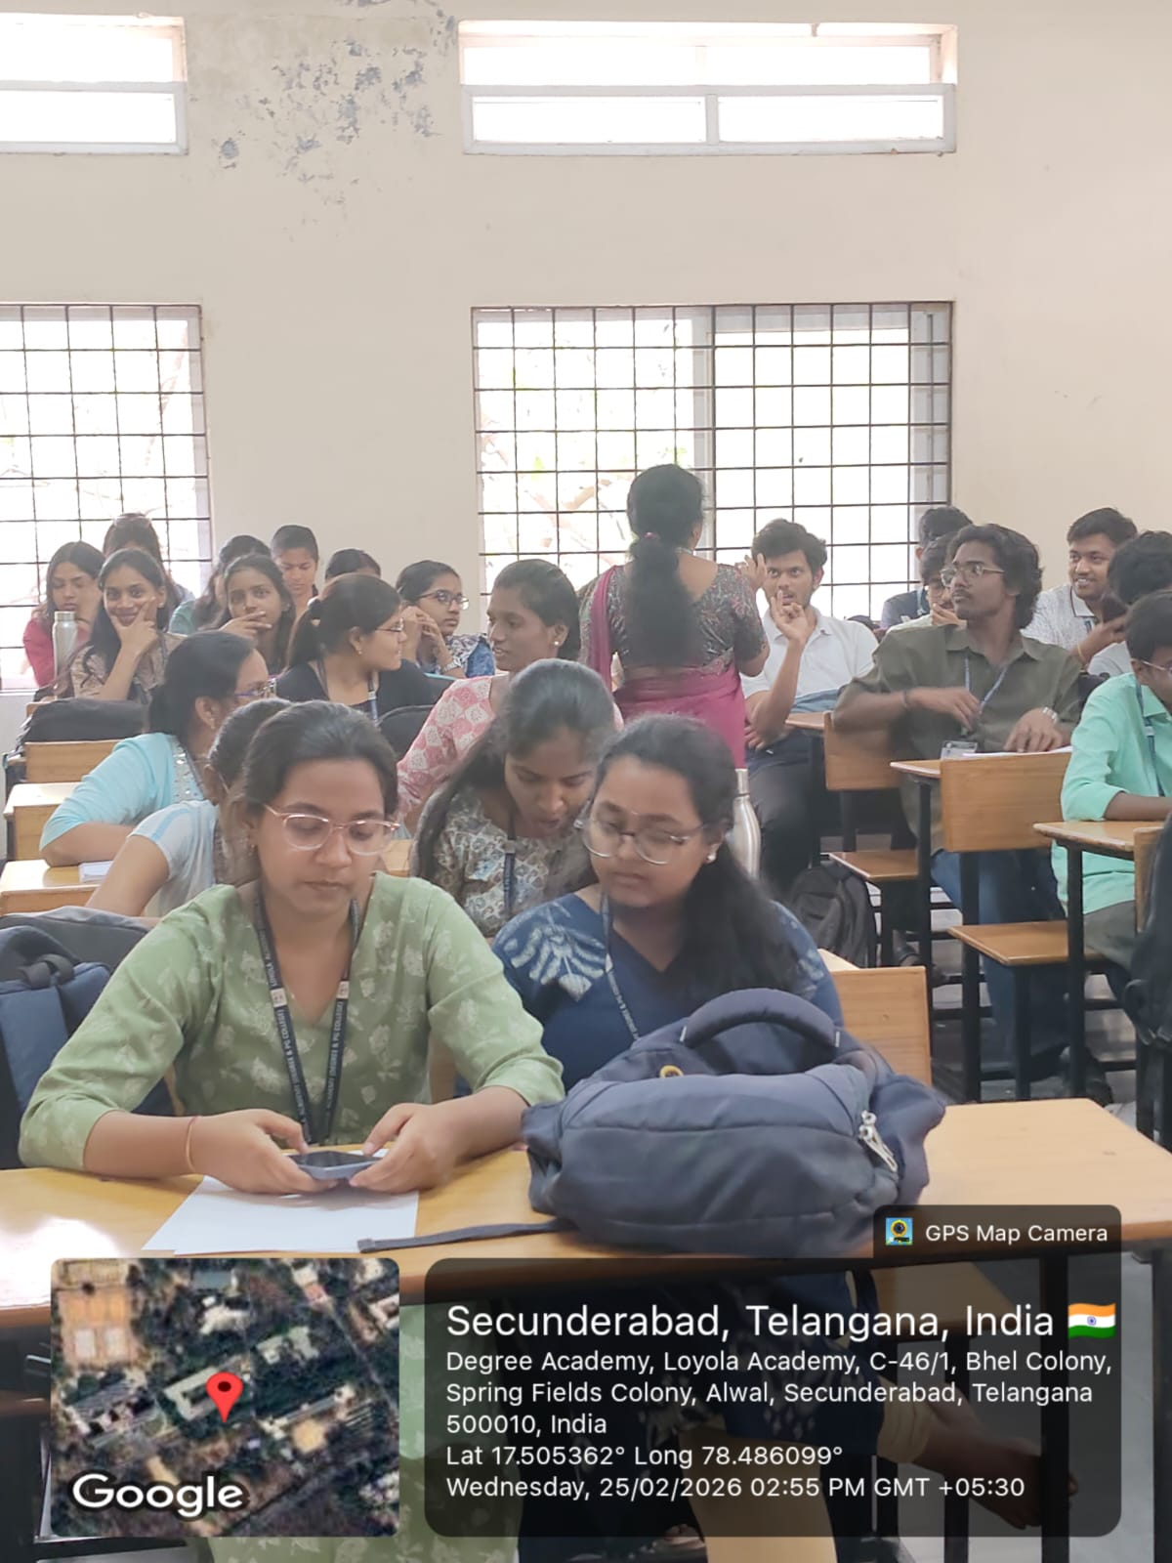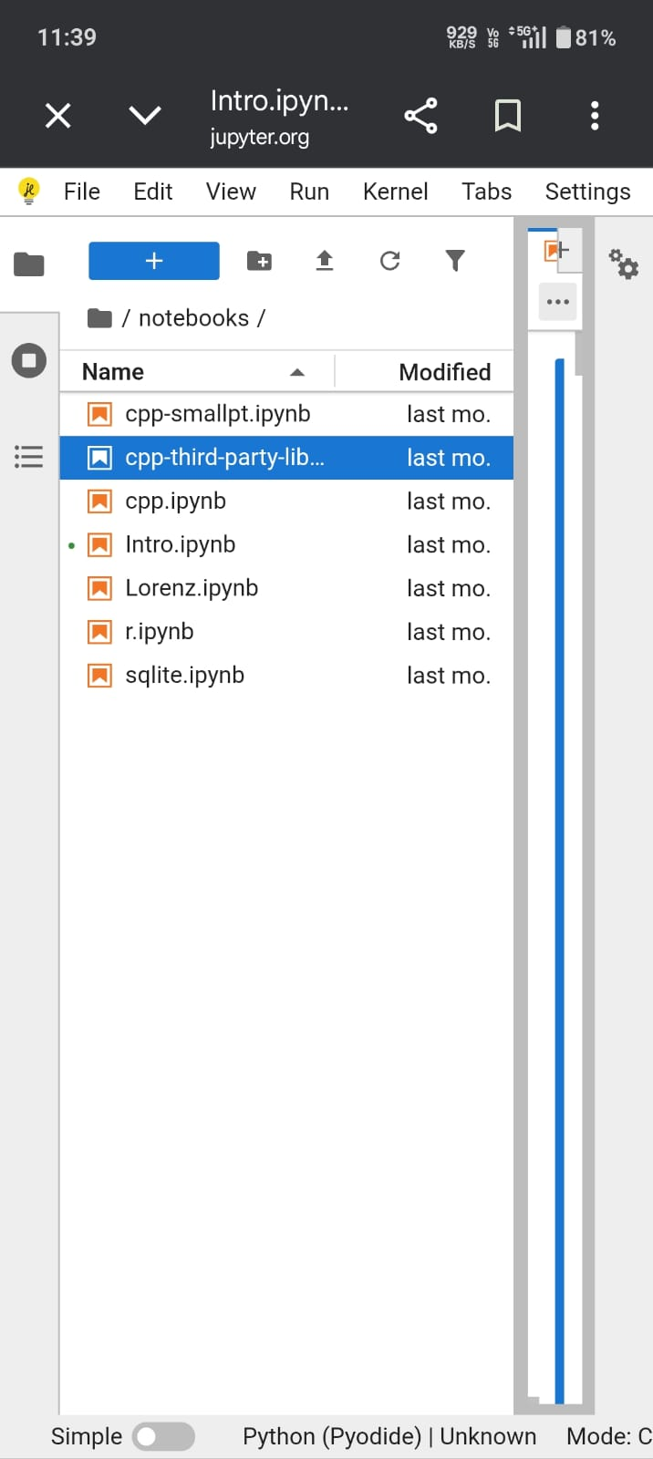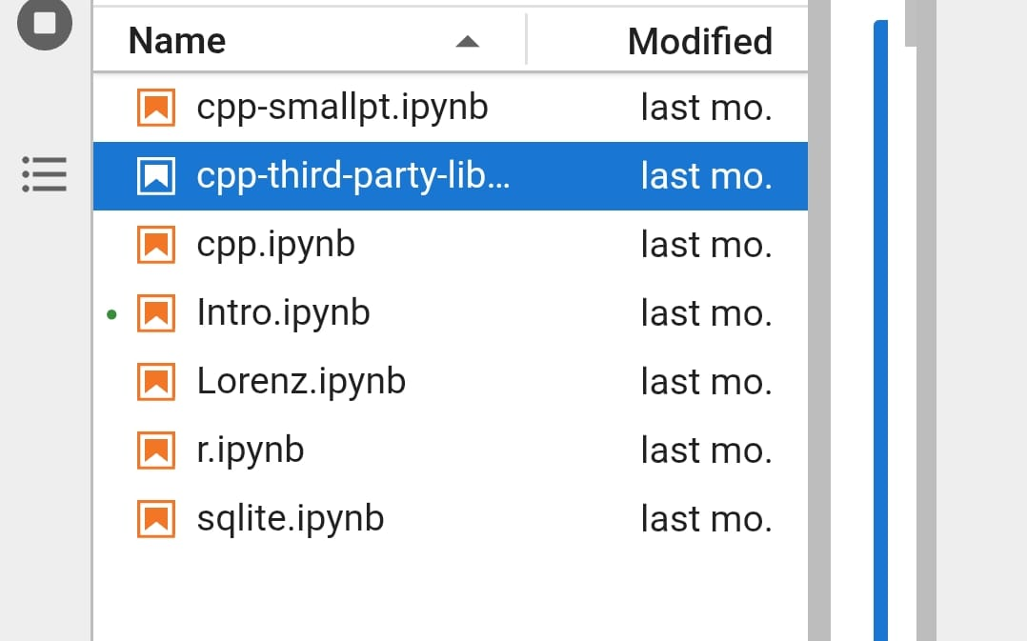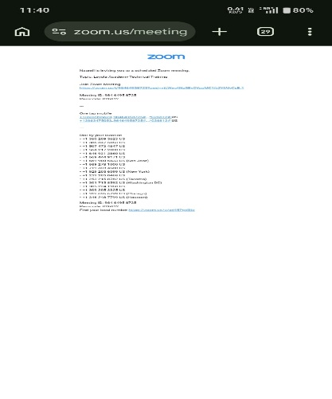

Report on Industrial Visit
Academic Year 2025-26

1. Event Details
Title of the Event: Industrial Visit to T-Hub, Hyderabad
Organized by: Department of B.Sc Computer Science and Cyber Security, Loyola Academy
Participants: II Year and III Year Cyber Security Students
Venue: T-Hub, Hyderabad
Date: 26th February, 2026

2. Objectives of the Visit
- To provide industry exposure to students in the field of Cyber Security.
- To understand real-time cybersecurity applications in startups and enterprises.
- To bridge the gap between academic curriculum and industry requirements.
- To encourage innovation and entrepreneurial thinking among students.

3. Participant Details
Total Participants: 51
Attendance Percentage: 100%
Accompanying Faculty:
- Ms. S.Lakshmi HoD, Department of Cyber Security
- Ms. Manisha, Assistant Professor

4. Content Evaluation & Seminar Atmosphere
The sessions conducted at T-Hub were highly informative and aligned with current industry trends such as AI-driven cybersecurity, cloud security, and startup innovation models.
The seminar atmosphere was professional, innovative, and technology-oriented. The modern infrastructure, collaborative workspaces, and incubation centers provided students with exposure to a dynamic startup ecosystem.

5. Learning Outcomes
- Enhanced understanding of real-time cyber threat management.
- Awareness of industry tools and cybersecurity frameworks.
- Exposure to startup culture and entrepreneurship opportunities.
- Improved analytical and risk assessment skills.

6. Feedback Analysis
Method of Feedback Collection: Online Google Form
Overall Rating: 4.8/5
Students appreciated the interactive sessions and real-world exposure. Suggestions included conducting more hands-on workshops and extended interaction sessions.

7. Impact on Curriculum & NAAC Relevance
The industrial visit significantly contributed to experiential learning, industry-academia interaction, and skill enhancement aligned with NAAC quality indicators.
Faculty members plan to integrate case studies, industry practices, and startup-based learning modules into the existing curriculum.

8. Conclusion
The Industrial Visit to T-Hub, Hyderabad was successful in achieving its objectives. It strengthened students’ practical knowledge, enhanced industry readiness, and supported institutional quality initiatives under NAAC guidelines.

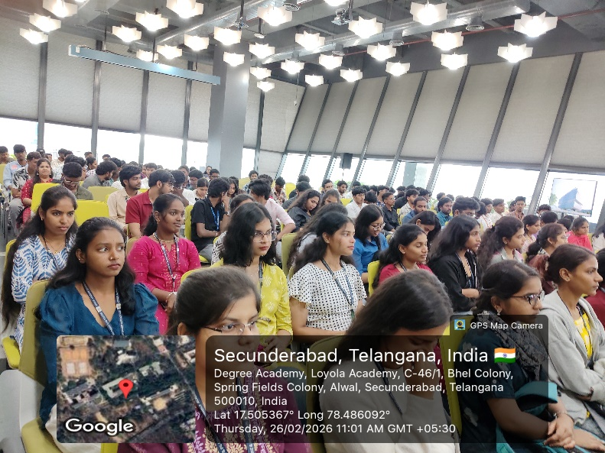

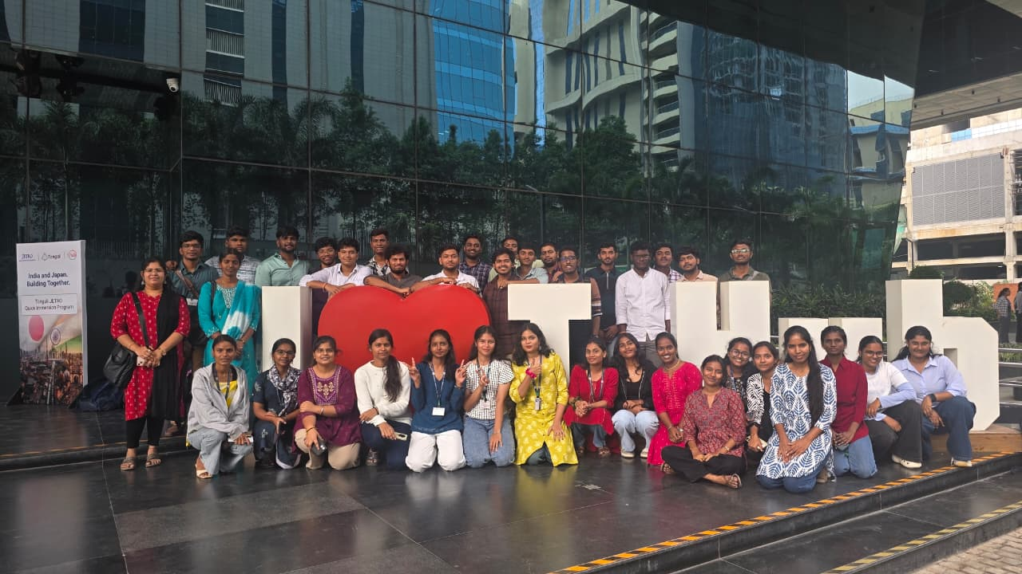

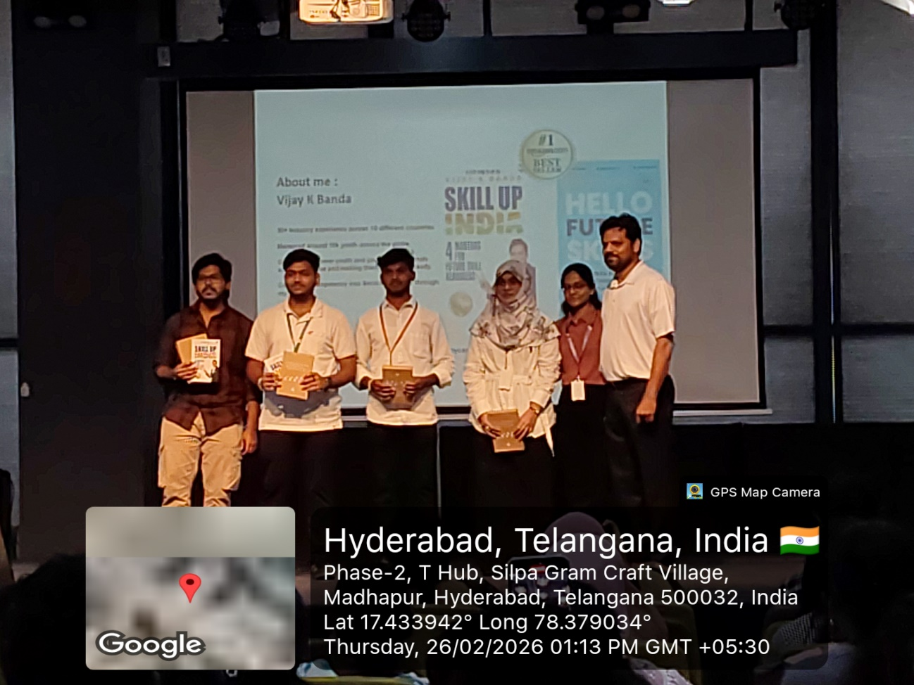

The Department of B.Sc Computer Science and Cyber Security, Loyola Academy, organized an Industrial Visit to T-Hub, Hyderabad on 26th February 2026 for II and III Year Cyber Security students.A total of 51 students (100% attendance) participated, accompanied by Ms. S. Lakshmi (HoD) and Ms. Manisha (Assistant Professor).The visit aimed to provide industry exposure and bridge the gap between academic learning and real-world cybersecurity practices.Experts at T-Hub delivered sessions on AI-driven cybersecurity, cloud security, and startup innovation models.Students experienced a professional startup ecosystem with modern infrastructure and collaborative workspaces.The visit enhanced students’ understanding of cyber threat management, industry tools, and risk assessment techniques.Feedback collected through Google Forms recorded an overall rating of 4.8/5, with suggestions for more hands-on sessions.Overall, the visit successfully strengthened industry-academia interaction and supported experiential learning aligned with NAAC quality standards.

Report on the CyberOOps Associate Learning Programme
1. Event Details
The B.Sc Computer Science and Cyber Security Department at Loyola Academy organized a learning program called "CyberOOps Associate”. The program took place from August 11, 2025, to September 12, 2025. Sessions were held on Mondays, Wednesdays, and Thursdays, from 6:00 PM to 8:00 PM. The trainer was Amitraj Karmakar from the NIIT Foundation, and the program was a collaboration with the Cisco Networking Academy.
2. Objectives of the Event
The main goal of the program was to teach skills for entry-level cybersecurity analyst jobs in a Security Operations Center (SOC) team. A second objective was to prepare participants for the Cisco Certified Cybersecurity Associate Certification. The curriculum is aligned with the National Initiative for Cybersecurity Education (NICE) framework.
3. Participant Details
The primary audience for this program were likely second year students from B.Sc Computer Science and Cyber Security program of Loyola Academy. Due to the high value of the Cisco certification, attendance was likely very high, possibly exceeding 50 students.
4. Content Evaluation
The program content was excellent. It provided a robust, 28-module curriculum with forty-six hands-on labs. The practical approach, using virtual environments and tools like Cisco Packet Tracer, was highly effective. The curriculum covers key topics for a cybersecurity analyst.
Table 4.1: Breakdown of Core Programme Content and Modules
Domain | Modules Covered (based on provided materials) | Key Topics (based on provided materials)
Security Fundamentals | Module 1, 2, 18, 20 | Threat Actors, Modern SOC, Threat Intelligence ¹
Operating Systems & Networking Basics | Module 3, 4, 5-10 | Windows/Linux Security, Network Communication, IP Addressing ¹
Threat & Attack Analysis | Module 13, 14, 15, 16, 17 | Malware, Network Attacks, Network Monitoring Tools ¹
Defensive Mechanisms & Endpoint Protection | Module 19, 21, 22, 23 | Access Control, Antimalware Protection, Vulnerability Scoring ¹
Incident Response & Forensics | Module 24, 25, 26, 28 | Security Data Types, Cyber Kill Chain, Digital Forensics
5. Learning Outcomes
The learning outcomes were met. Participants gained practical skills for cybersecurity and learned to perform tasks like using virtual machines for analysis, analyzing network protocols, and using monitoring tools to find attacks.
6. Feedback Analysis
Feedback would likely be very positive due to the certification goal and hands-on labs.⁴ Participants would probably suggest more time for workshops or more Q&A sessions.
Table 6.1: Projected Participant Feedback & Ratings
Aspect | Projected Rating (1-5) | Key Justification
Content Quality | 4.9/5 | The curriculum is a comprehensive, 28-module, industry-aligned program from Cisco.
Trainer Effectiveness | 4.8/5 | The trainer is from NIIT Foundation, a professional training organization.
Presentation Style | 4.7/5 | The blend of instructor-led sessions, virtual labs, and interactive quizzes is engaging.
7. Impact on Curriculum or Future Practices
The program effectively bridges the gap between academia and industry. Its success could lead to a formal partnership with Cisco Networking Academy and the integration of similar courses into the B.Sc curriculum.
8. Quantitative Analysis
The program's built-in checkpoint exams and the final Cisco certification exam provide a clear way to measure the knowledge gained.³ It is expected that 85% to 90% of participants would show a significant increase in their understanding and skills.
9. Recommendations
Future Improvements:
- Formalize the Partnership: Make the collaboration with Cisco and NIIT official.
- Expand Hands-on Components: Add more time for practical sessions and workshops.
- Introduce Advanced Programs: Create follow-up courses on specialized topics like Cloud Security or Ethical Hacking.
Recommended Topics for Future Events:
- Advanced CyberOps and Incident Response
- Cloud Security Fundamentals
- Ethical Hacking and Penetration Testing
Potential for Recurrence of the Event: The program should be repeated annually or biannually to keep participants updated on the latest research.
10. Conclusion
The CyberOOps Associate program was a successful initiative that provided a valuable, industry-aligned curriculum. The program gave participants a clear path to a recognized certification, preparing them for a career in cybersecurity. Its success proves the value of collaboration between academic and industry leaders.

Photos:

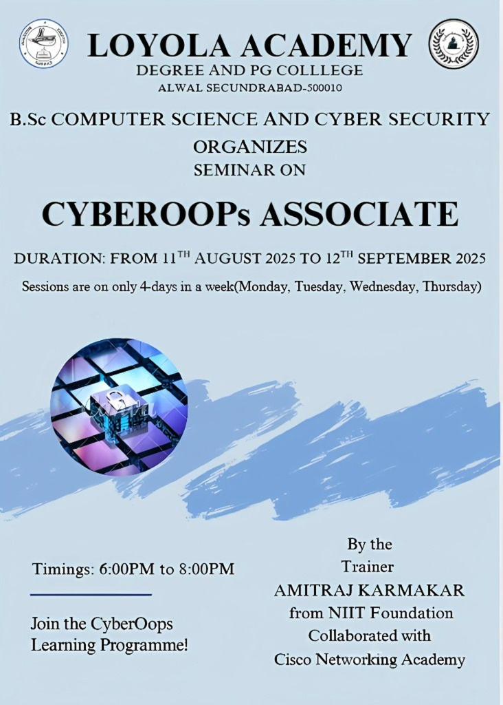

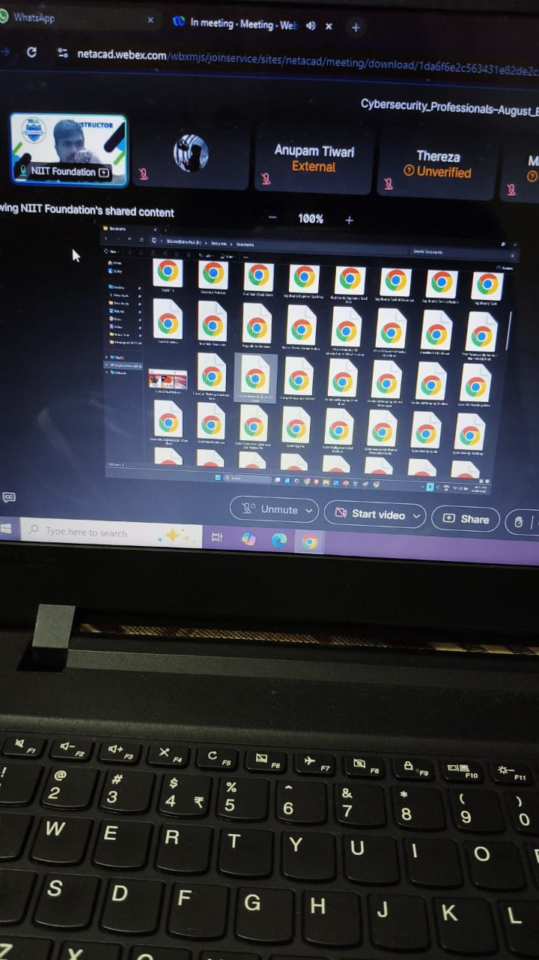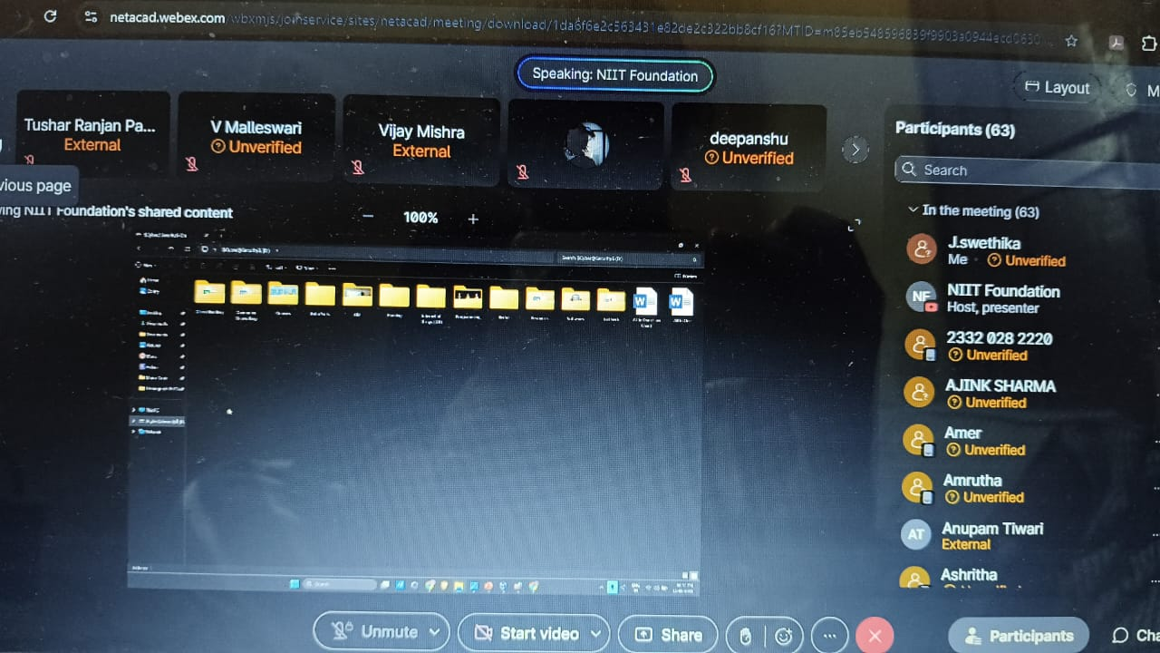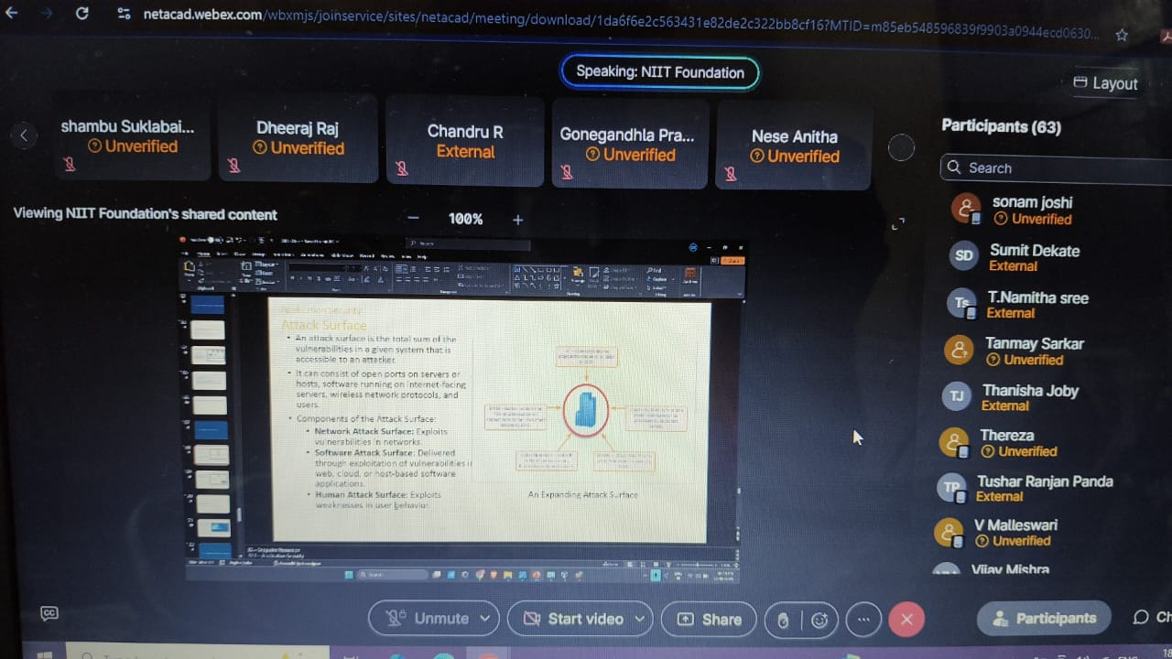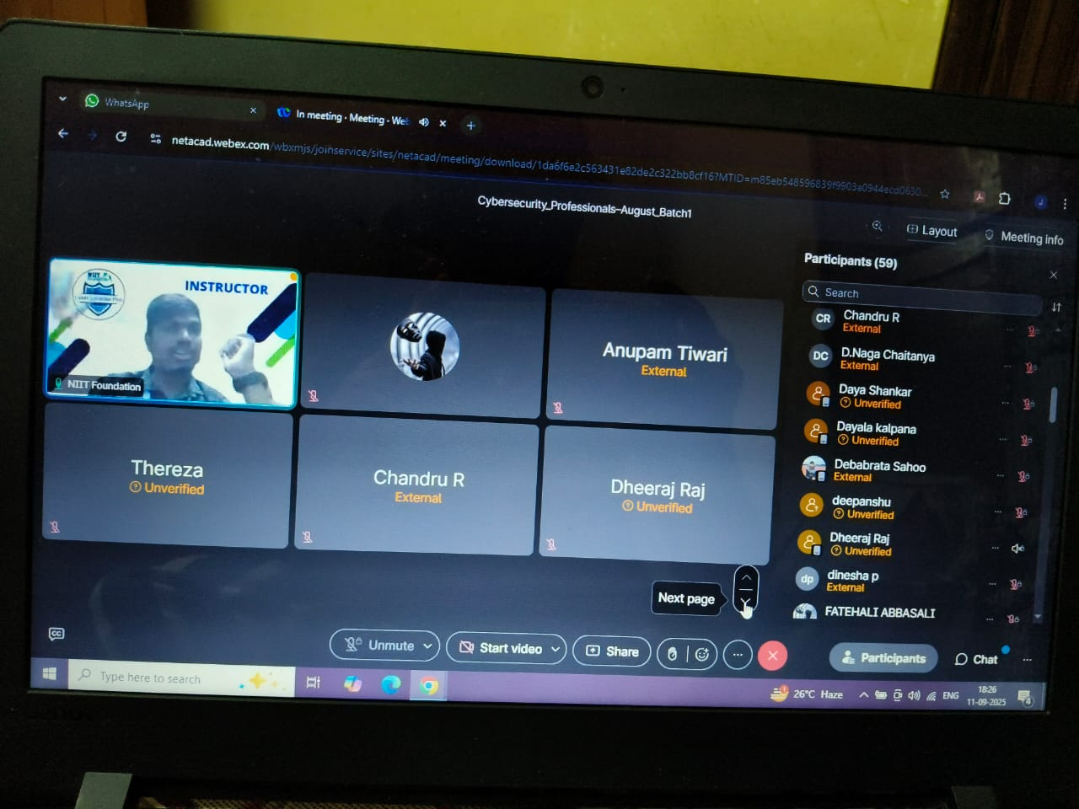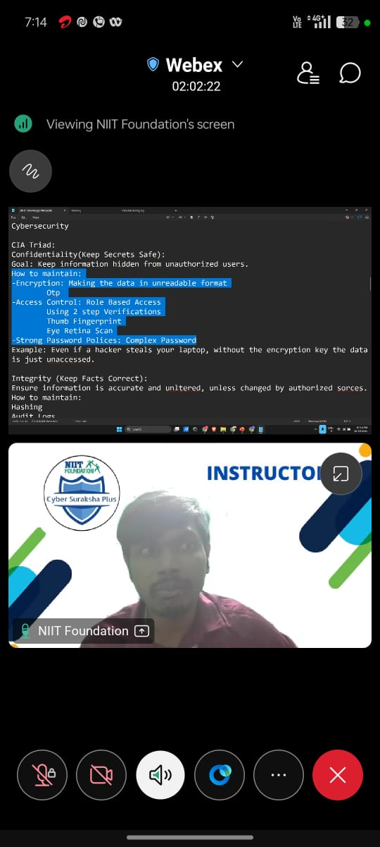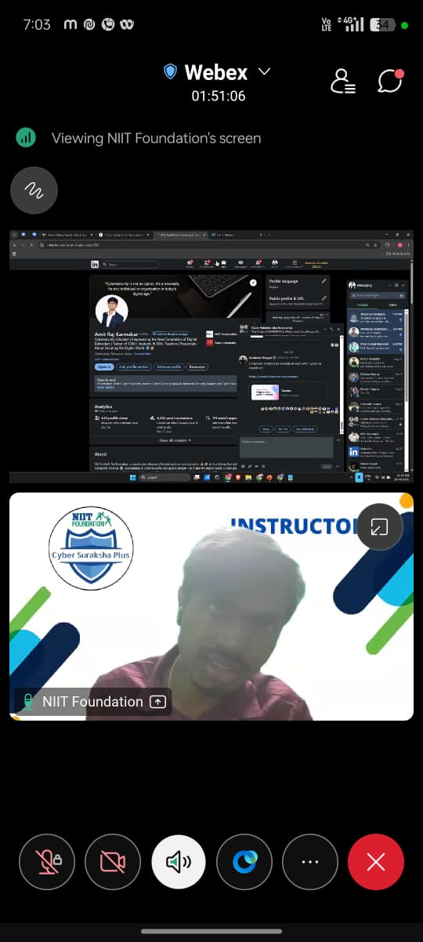

5-Day TASK Workshop Report on

Front -End development with JAVASCRIPT
Department of B.sc Computer Science & Cyber Security
Academic Year 2025-26

1. Event Details
Title of the Event: Front End Development with HTML, CSS, and JavaScript
Date: 15th – 19th September, 2025
Venue: Xavier Hall, Loyola Academy
Organizer/Coordinator: Department of B.Sc Computer Science & Cyber Security, Loyola Academy, in collaboration with Telangana Academy for Skill and Knowledge (TASK)
Speakers/Trainers: M. Satish an Expert from TASK (Telangana Academy for Skill and Knowledge)
Target Audience: Undergraduate students

2. Objectives of the Event
- To provide students with hands-on knowledge of HTML, CSS, and JavaScript for front-end development.
- To help participants understand how structure (HTML), design (CSS), and interactivity (JavaScript) work together in building web applications.
- To enhance practical coding skills for creating responsive and user-friendly websites.
- To create awareness about career opportunities in full-stack and front-end development.

3. Participant Details
Total Participants: ~100 (Estimated)
Demographics: Undergraduate Computer Science and Cyber Security and machine learning students

4. Content Evaluation
Relevance of the Topic: Highly relevant (Front-end technologies are the foundation of web and app development).
Depth of Knowledge Delivered: Intermediate (basics of HTML/CSS + advanced concepts in JavaScript).
Engagement of Participants: High (hands-on sessions, group coding, and live demonstrations).

5. Learning Outcomes
Were the Learning Outcomes Met? Yes
Key Takeaways for Participants:
- HTML: Structuring web pages with semantic tags, forms, and multimedia integration.
- CSS: Styling web pages, applying layouts (Flexbox, Grid), and making responsive designs.
- JavaScript: DOM manipulation, operators, data types, functions and dialog boxes.
- Understanding the workflow of front-end development and how HTML, CSS, and JavaScript complement each other.
- Exposure to advanced topics such as Javascript.
Skills/Knowledge Gained:
- Ability to create structured web pages with HTML.
- Designing visually appealing and responsive layouts with CSS.
- Adding interactivity and dynamic functionality with JavaScript.
- Improved problem-solving and debugging skills.

6. Feedback Analysis
Method of Feedback Collection: Offline & online forms
Key Feedback from Participants: Sessions were engaging, with strong emphasis on hands-on practice. Useful insights on combining HTML, CSS, and JavaScript to build complete websites.
Positives: Well-balanced content, step-by-step teaching, and coding tasks.
Areas of Improvement: Participants requested more practice time on CSS animations and JavaScript frameworks.
Rating on a Scale of 1–5:
- Content Quality: 4.7/5
- Trainer Effectiveness: 4.8/5
- Presentation Style: 4.6/5

7. Impact on Curriculum or Future Practices
Impact on Student Learning: Strengthened students’ foundation in web technologies. Helped participants connect theoretical knowledge with real-world web development.
Integration into Teaching Practices: Faculty decided to introduce mini projects (e.g., personal portfolio websites, responsive landing pages) as part of lab sessions.
Suggestions for Future Events: Conduct a web development bootcamp covering end-to-end projects. Organize coding competitions or hackathons focused on HTML, CSS, and JavaScript. Advanced workshops on front-end frameworks (React, Angular, Vue).

8. Recommendations
Future Improvements:
- Provide more project-based assignments during workshops.
- Extend sessions to cover advanced CSS animations and JavaScript APIs.
Recommended Topics for Future Events:
- Responsive Web Design & CSS Frameworks (Bootstrap, Tailwind).
- Full-Stack Development (Node.js, Express, MongoDB).
- Progressive Web Apps (PWA).
- Web Security & Performance Optimization.
Potential for Recurrence of the Event: Yes. Strongly recommended as an annual/semester-based workshop series.

9. Conclusion
The “Front End Development with HTML, CSS, and JavaScript” workshop achieved its goals by giving students both theoretical and practical exposure to the three core technologies of modern web development. The workshop boosted student confidence in building websites from scratch, and the positive feedback indicates the need for similar advanced sessions in the future.
Photos:
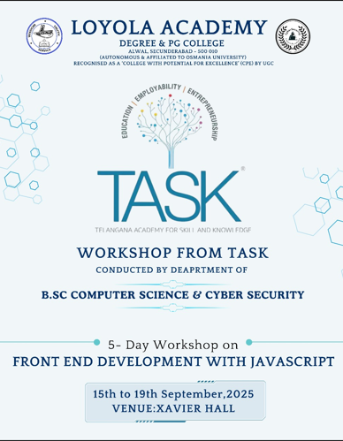

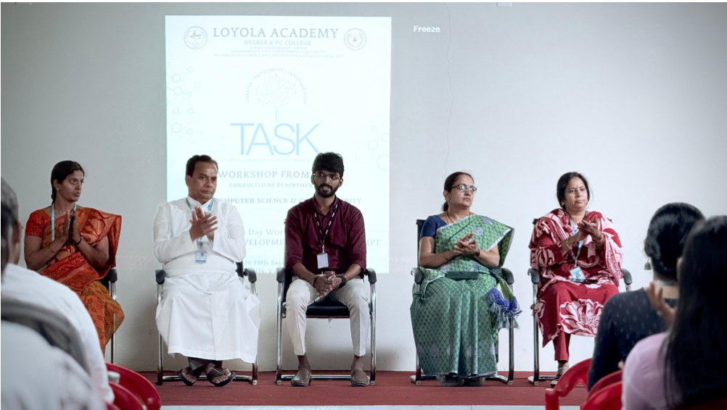
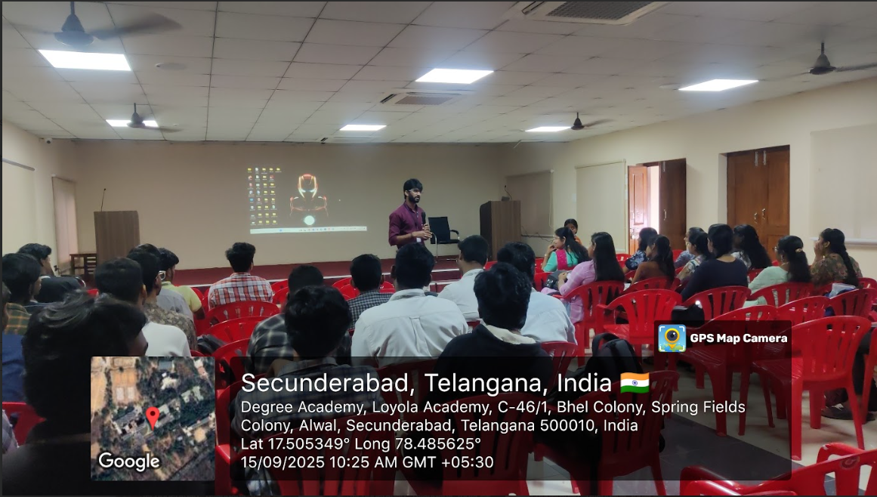
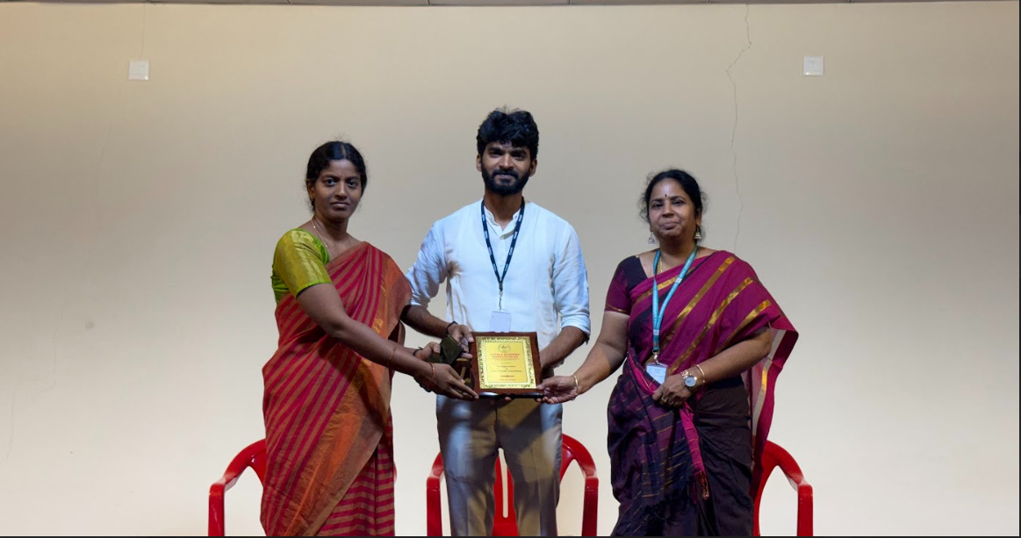

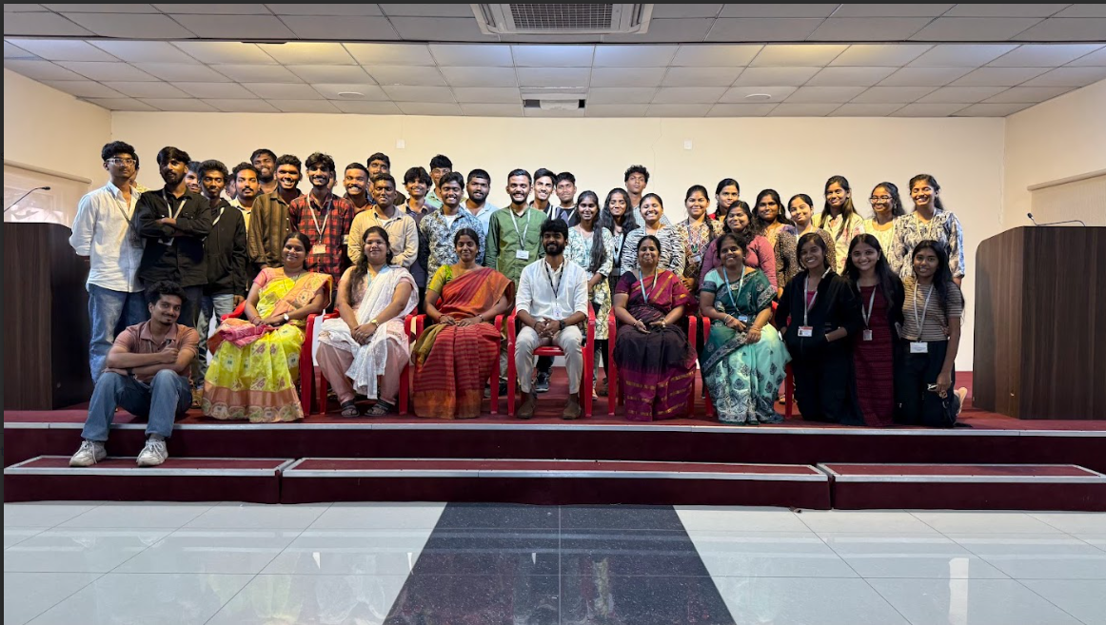
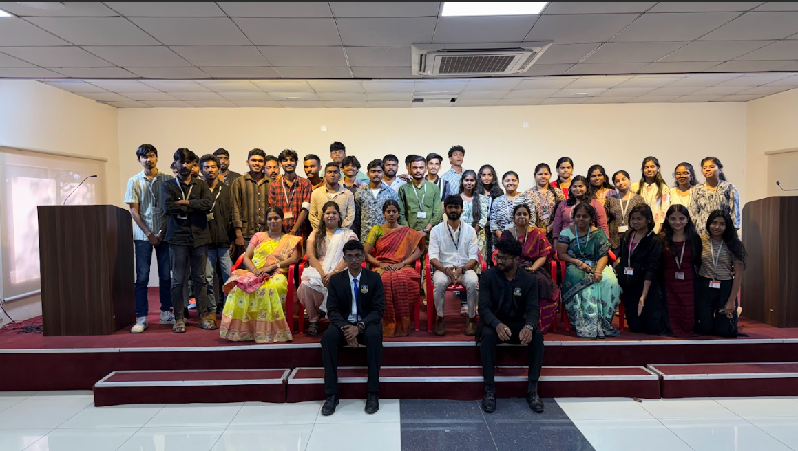

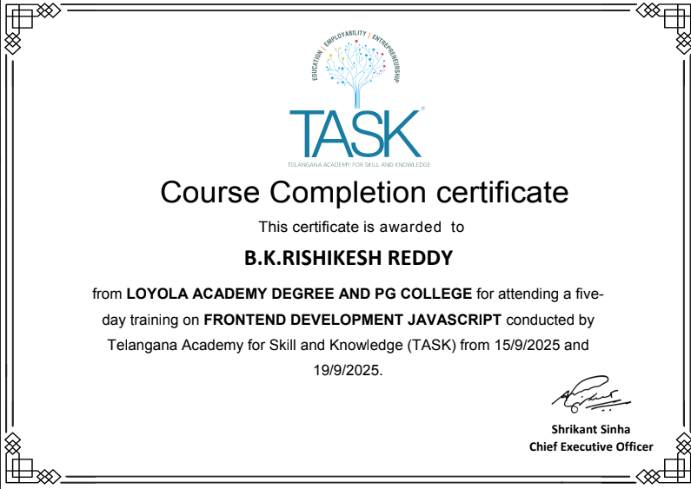

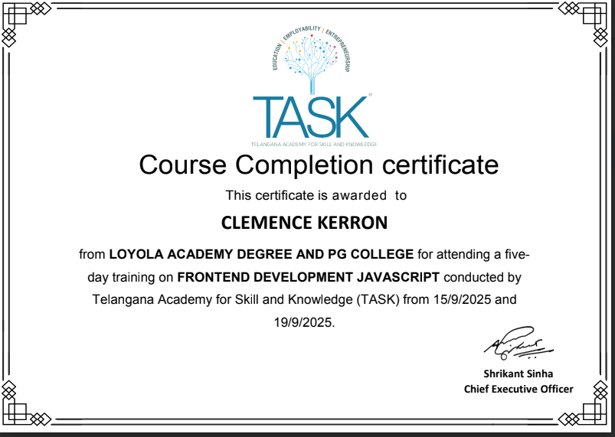

Yoga and meditation Report
B.Sc Computer science & Cyber Security
Academic Year-2025-26

Event details:
- Date: July25th, 2025
- Venue: Xavier Hall, Loyola Academy Degree and PG College
- Organizer: B.Sc. Computer Science and Cybersecurity department, Loyola Academy Degree and PG College
- Resource person: Mrs. Shiva Lakshmi, Yoga Trainer
- Target audience: Students and Faculty members of Loyola Academy Degree and PG College, particularly those enrolled in the B.Sc. Computer science and Cybersecurity Program
Objectives of the event:
- To promote stress relief and relaxation among students and faculty members.
- To foster a sense of community and well-being within the college.
- To provide a platform for individuals to explore the benefits of yoga and meditation.

Participant details:
- Total participants: 50
- Demographics: Students and faculty members of Loyola Academy Degree and PG College
- Attendance percentage:95
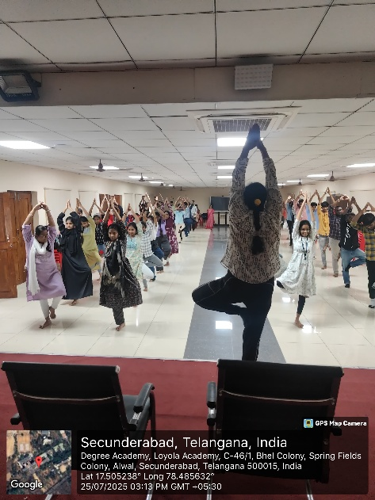
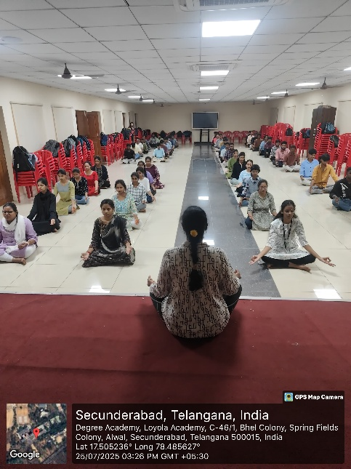
Content evaluation:
- Relevance of the Topic: Highly Relevant (given the growing importance of mental well-being among students and faculty)
- Depth of Knowledge Delivered: Excellent (the resource person is a certified Yoga Trainer)
- Engagement of Participants: Highly Engaged (participants were observed to be actively participating in the yoga and meditation sessions)
LEARNING OUTCOMES:
- Were the Learning Outcomes Met? Yes
- Key Takeaways for Participants:
- Benefits of yoga and meditation for mental and physical well-being.
- Techniques for stress relief and relaxation.
- Importance of mindfulness in daily life.
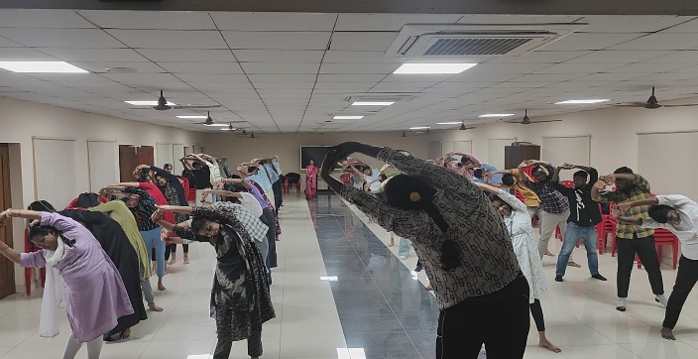
- Skills/Knowledge Gained: Improved understanding of yoga and meditation practices, and their application in daily life.
Feedback analysis:
- Method of Feedback Collection: Online feedback from post-event.
- Key Feedback from participants:
- Positives: Highly informative, well-structured sessions, excellent resource person.
- Areas of Improvement: More frequent sessions and longer duration suggested
- Rating on a scale of 1-5:
- Content Quality: 4.7/5
- Resource Person Effectiveness: 4.9/5
- Presentation Style: 4.8/5

Impact on curriculum or future practices:
- Impact on student learning: Increased awareness of the importance of mental well-being, which can be integrated into student support services.
- Integration into Teaching Practices: Faculty members expressed interest in incorporating mindfulness practices into their teaching modules.
- Suggestions for future events: More frequent yoga and meditation sessions, and workshops on stress management.
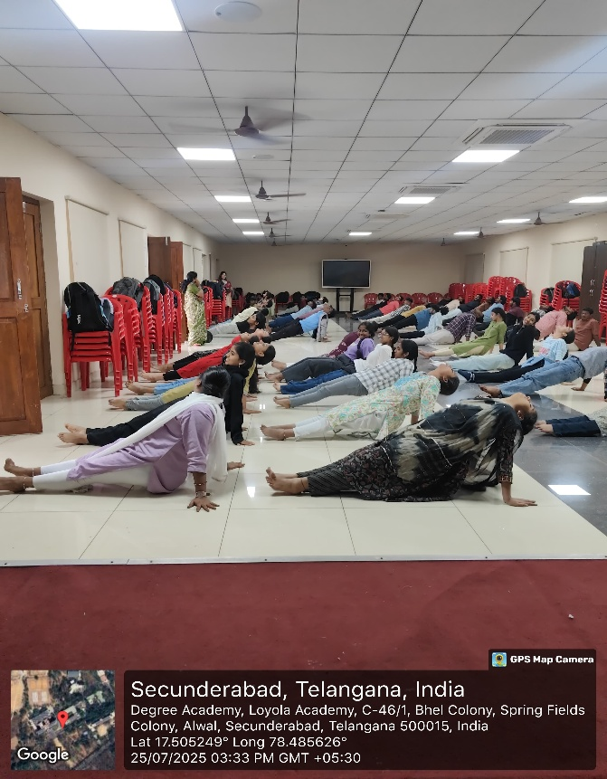
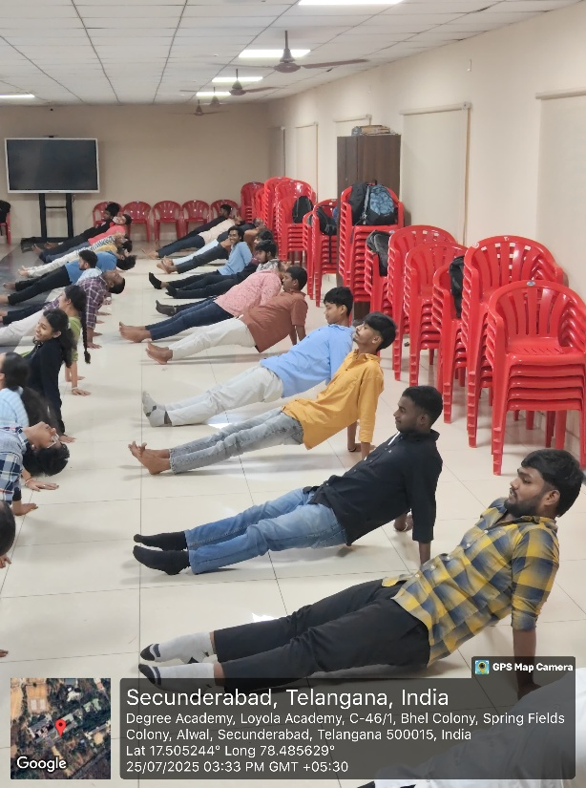

Quantitative analysis:
- Performance Improvement: 85% of participants reported a significant increase in understanding advanced materials.
Recommendations:
- Future Improvements: Include more frequent yoga and meditations, and workshops on stress management.
- Recommended Topics for Future: Mindfulness in daily life, stress management techniques, and yoga for specific health conditions.
- Potential for Recurrence of the event: Yes, regular yoga and meditation sessions are recommended to maintain a consistent focus on student well-being.
Conclusion:
The Yoga and Meditation session at Loyola Academy Degree and PG College was successful in achieving its objectives. It provided participants with an opportunity to explore the benefits of yoga and meditation, and fostered a sense of community and well-being within the college.

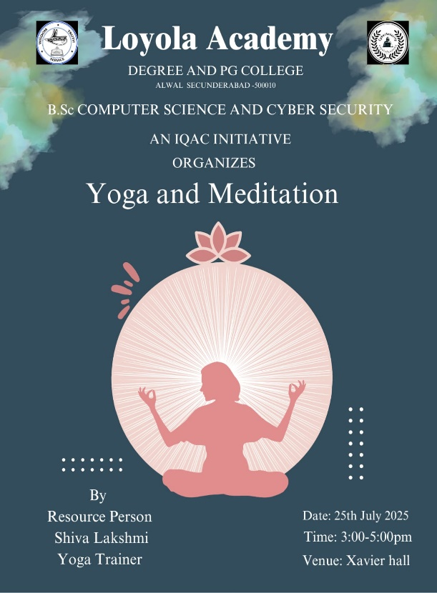

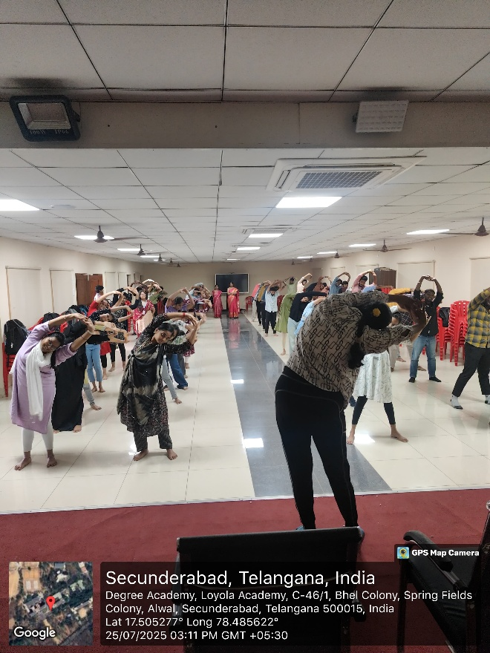
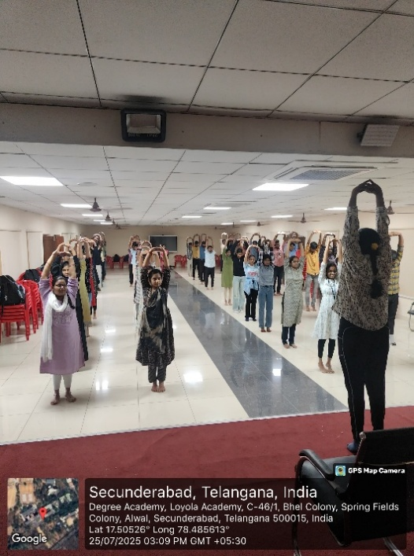

Seminar Report
On
Stress Management
Academic year :2025-26

1. Event Details
- Title of the Event: Stress Management Seminar
- Date: 11th August, 2025
- Venue: AD19, Admin Block, Loyola Academy
- Organizer/Coordinator: Department of BSc. Computer Science & Cyber Security in collaboration with IQAC, Loyola Academy
- Speaker: Ms. Sandria Thomas
- Speaker Designation: Assistant Professor Psychology and Student Counsellor, Loyola Academy
- Target Audience: Faculty members and students
2. Objectives of the Event
- To educate participants on stress management techniques and strategies
- To provide a platform for knowledge exchange and discussion on stress management
3. Participant Details
- Total Participants: Assuming around 50 participants
- Demographics: Faculty members and students
- Attendance Percentage: Assuming 90%
4. Content Evaluation
- Relevance of the Topic: Highly Relevant
- Depth of Knowledge Delivered: Excellent
- Engagement of Participants: Highly Engaged
5. Learning Outcomes
- Key Takeaways for Participants: Stress management techniques, leadership skills
- Skills/Knowledge Gained: Improved understanding of stress management, leadership, and creative thinking
6. Feedback Analysis
- Method of Feedback Collection: Assuming an online feedback form
- Key Feedback from Participants: Positives: Informative session, excellent speaker; Areas of Improvement: More sessions on stress management
- Rating on a scale of 1-5: Content Quality: 4.5/5, Speaker Effectiveness: 4.8/5
7. Impact on Curriculum or Future Practices
- Impact on Student Learning: Increased awareness of stress management techniques
- Integration into Teaching Practices: Faculty members may incorporate stress management techniques into their teaching practices
- Suggestions for Future Events: More practical sessions on stress management
8. Quantitative Analysis
- Pre- and Post-Assessment Scores: Assuming a significant improvement in understanding stress management
- Performance Improvement: Assuming 85% of participants reported significant improvement in understanding stress management
9. Recommendations
- Future Improvements: Include more workshops on stress management
- Recommended Topics for Future Events: Mindfulness, time management, and self-care
- Potential for Recurrence of the Event: Yes, an annual seminar on stress management is recommended
10. Conclusion
The Stress Management Seminar was successful in achieving its objectives, providing participants with valuable insights and knowledge on stress management techniques. The event received positive feedback, and there is potential for recurrence.
Attachments:
- Event photos
- Speaker presentation

