

LOYOLA ACADEMY DEGREE & PG COLLEGE

M.Sc. FOOD TECHNOLOGY AND MANAGEMENT

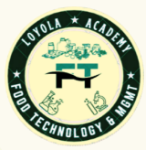

DEPARTMENT REPORT



Academic Year: 2023-2024

INDEX

S.NO | Particulars of Department | Page number
 | Vision & Mission of the department | 2
 | List of Faculty | 5
 | List of Students | 7
 | Departmental Activities | 10
 | Guest Lecture | 11
 | International Conference | 15
 | Industrial Visit | 20
 | Educational Tour | 25
 | Food Expo | 27
 | Planet Program | 29
 | Earn While You Learn | 32
 | MSME- Training Program | 34
 | Faculty Development Program | 37
 | Career Development Program | 40
 | Faculty Achievements | 44
 | Student Achievements | 56
 | Parent-Teacher Meeting Report | 60
 | Mentor-Mentee List | 63
 | Student Scholarship | 67
 | NPTEL Data | 69
 | Placements | 74
 | Higher Education | 76

VISION
AND
MISSION
OF THE
DEPARTMENT

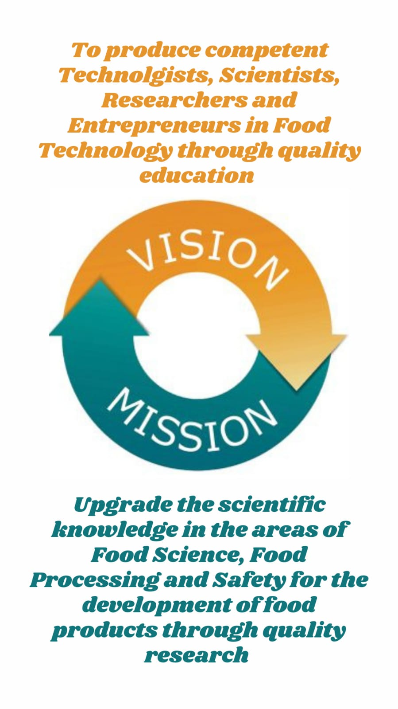
ABOUT THE DEPARTMENT
M.Sc. Food Technology and Management was set up in the academic year 2013, is solely aimed at training students to be expert as food technologist and entrepreneurs. Our department covers every aspect of food production, from manufacturing, preservation packaging and management, marketing, and entrepreneurship of food products. It involves an amalgamation of physical, chemical, or microbiological process and techniques of raw ingredients transformation into food and also other forms in Food Processing Industry. The popularity of our food department arises from the hands-on experience we give our students throughout. The highlight of our department which has laboratories and manufacturing plants, aided by the ministry of Food Processing Industries, Government of India, New Delhi and the UGC support. The main objective of the Food Technology Department is to create learned and skilled human resources to meet to the needs of the rapidly growing Food Processing Sector. There is a good scope of food technology which offers numerous Job Opportunities in various areas. Students learn skills such as food packaging, baking, confectionery, milling production through first-hand experience. Students manufacture as well as market chocolates, biscuits, ice creams, etc. The students prepare various products in these pilot plants and sell them in the college premises during break hours so that they not only gain hands-on experience but also earn money while they learn. This is one of the best practices adopted by the department which highlights the practical skills of the students. Students are allotted Industrial Projects in different companies like Coco Cola, Carlsberg, PepsiCo, etc. Our Food Technology Department is big on innovation and even bigger on initiative. The department shall organize guest lectures, seminars, and certificate programs on Internal Auditing in Food Industries and FSSAI to disseminate and gain knowledge in various competitions . Our department establishes sugar confectionary and manufacturing unit with CPE Grant. The well-being and productivity of the nation through the knowledge of the students.

LIST OF
FACULTY

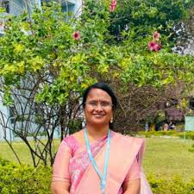
Dr. P. Kiran Kumari
Assistant Professor &
Head of Department
M.Sc., M. Tech, Ph.D
EMP ID: 22152
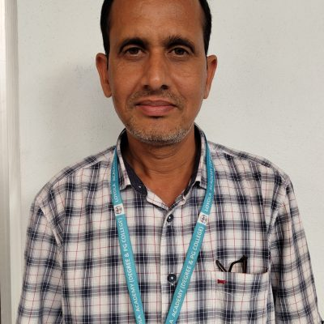
Dr. A. Ravinder
Assistant Professor
M. Tech, Ph.D
EMP ID: 04102

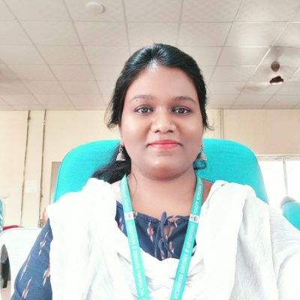
MRS. S. Jemmy Evangeline
Assistant Professor
M.Sc. (Ph.D)
EMP ID: 15207

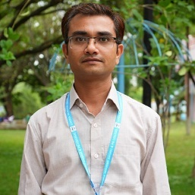
Dr. Sukhveer Singh
Assistant Professor
M.Sc. Ph. D
EMP ID: 22152

Mrs. K. Tejaeswini
Assistant Professor
M.Sc.
EMP ID: 23149

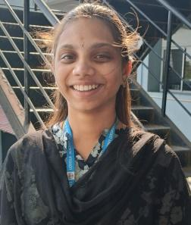


LIST OF STUDENTS

Academic Year: 2023-2024 (Student List)
Class: AMFT
S.No | UID | Students name
1. | 111723620001 | S. Vaishnvi
2. | 111722620002 | S. Akhila
3. | 111722620003 | C. Pooja
4. | 111722620004 | C. Pradeep
5. | 111722620005 | A. Pravallika
6. | 111722620006 | S. Gopal Sharma
7. | 111722620007 | Thanam Marysona
8. | 111722620008 | Alisha Hossain
9. | 111722620009 | T Pooja
10. | 111722620010 | C. Elanor Christopher
11. | 111722620011 | S. Imam Basha
12. | 111722620012 | Mohit Valtati
13. | 111722620013 | R. Pooja
14. | 111722620014 | D. Mukesh
15. | 111722620015 | B. Christopher
16. | 111722620016 | U. Prathibha
17. | 111722620017 | M. Sai Venkata Sowjanya
18. | 111722620018 | Madasu Sravyasri
19. | 111722620020 | Bavu Rani
20. | 111722620021 | C. Nikitha
21. | 111722620022 | P. Venkateswaran
22. | 111722620023 | Tanisha Patangay
23. | 111722620024 | K. Roshini
24. | 111722620025 | Nerella Sathwika
25. | 111722620026 | O. Shiva Pavani
26. | 111722620027 | M. Nazeer Ahmad
27. | 111722620028 | Dusari Papa Nikitha
28. | 111722620030 | D Sreedhar Jukanti
29. | 111722620031 | G. Vaisnavi
30. | 111722620032 | Mamidi Divya
31. | 111722620033 | C. Harsha Vardhan Reddy
32. | 111722620034 | Abdul Nadeem
33. | 111722620035 | Devella Akshya
34. | 111722620036 | S. Swapna
35. | 111723620036 | Habeeba
36. | 111723620019 | Faizan Zaid Khan

Class : NMFT
S.No | UID | Students name
1. | 111723620001 | Vadala Shravya Chary
2. | 111723620002 | Gaddala Anirudh
3. | 111723620003 | Kollimalla Bindurani
4. | 111723620004 | Diviti Divyanandini
5. | 111723620005 | Yelamanchili Anuradha
6. | 111723620006 | Ramaraju Srinidhi
7. | 111723620007 | Bondaladinne Havilah Joy
8. | 111723620008 | Muskan Thakur
9. | 111723620009 | G A Nissi Krupa
10. | 111723620011 | Chenna Amulya
11. | 111723620012 | Dandu Preethi
12. | 111723620013 | Ankannagari Pravalika Reddy
13. | 111723620014 | Nirni Vaishnavi
14. | 111723620015 | Ganghadhari Sravani Kalyani
15. | 111723620016 | Lavidiya Lalitha bai
16. | 111723620017 | Vanam Mounika
17. | 111723620018 | Gaddam Bhanu Chandu Priya
18. | 111723620019 | Chittaluri Vinay Varma
19. | 111723620020 | Magapu Leela Sai Sri Alekhya
20. | 111723620021 | Rentala Suchitha
21. | 111723620022 | Vannekuti Manoj Kumar
22. | 111723620023 | Vadde venkata Sai Kumar Varma
23. | 111723620024 | Allam Mary Nikhitha
24. | 111723620025 | Rathod Praneetha
25. | 111723620026 | Deshpande Shraddha
26. | 111723620027 | Renukuntla Sai Suma
27. | 111723620028 | Sathinapalli Josh Hycinth
28. | 111723620029 | Gannamaneni Prathyusha
29. | 111723620030 | Nellalam Jahnavi
30. | 111723620031 | Umme Habeeba
31. | 111723620032 | Akshaya Manoj
32. | 111723620033 | Marupaka Rekha
33. | 111723620034 | Zadda Blessy Prasidhi

DEPARTMENTAL ACTIVITIES



GUEST
LECTURE

Guest Lecture on Ready to Eat Foods

- Concept:
Guest Lecture was organized by Loyola Academy for M. Sc. Food Technology and Management (1st year) on 18th August 2023. To impart knowledge on the processing and advancements in the food industry.

- Purpose:
The main motto of this program is to enlighten and educate students about the processing and advancements in the food industry.

- Report:
Dr S V N VIJAYENDRA, Microbiology and fermentation Technology Department, who hails from the CENTRAL FOOD TECHNOLOGICAL RESEARCH INSTITUTE, Mysore was the speaker. The lecture includes about the processing of products such as animal, bakery, and cereal products; convenience foods, usage of food machinery and its advances over the last decades and its impact on the marketing, distribution of food products, shelf life of food products. He explained about the conducts of CFTRI and programmes offered by the institutes and the scholarship provided for the students to pursue their career in the field of masters in food technology and management. The students were enlightened about the career guidance in the area of food technology.
- Review:
Students found this lecture very informative and inspired to excel in the field of food technology.

- Photos:

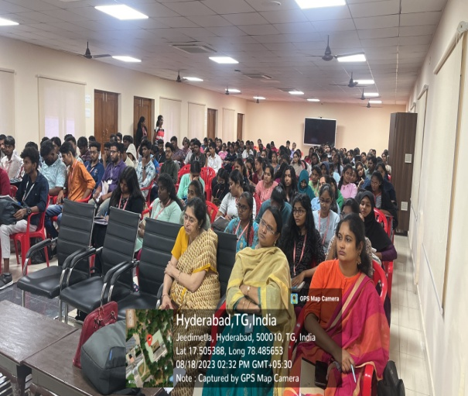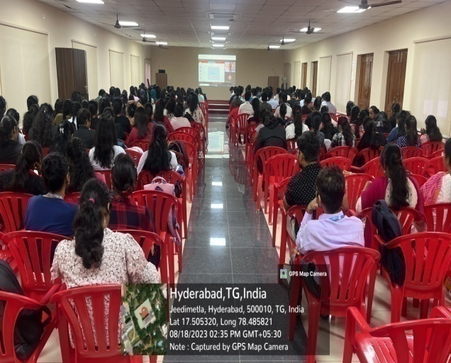

Guest Lecture on Role of water in Food Safety and Security

- Concept:
Guest Lecture was organized by Loyola Academy for M. Sc. Food Technology and Management (I & II year) on 16th October 2023. To impart knowledge about water quality in the food industry.

- Purpose:
The main motto of this program is to enlighten and educate students about the water, quality and its sustainability.

- Report:
Dr.VEERACHANDRA KRANTI YEMMIREDDY, Asst. professor Food safety and microbiology who hails from the University of Texas Rio Grande valley was the speaker. The lecture includes about role of water in food safety and security. The speaker mainly focused on the sustainable development goals, importance of water quality and food safety, types of water treatment and he also highlighted the level of water stress caused due to the agricultural sector. The students were enlightened about the role of water in every stage of the food supply chain, from agricultural practices to consumer use.
- Review:
Students found this lecture very informative on role of water quality and sustainable development goals and its effective usage in food processing.

- Photos:

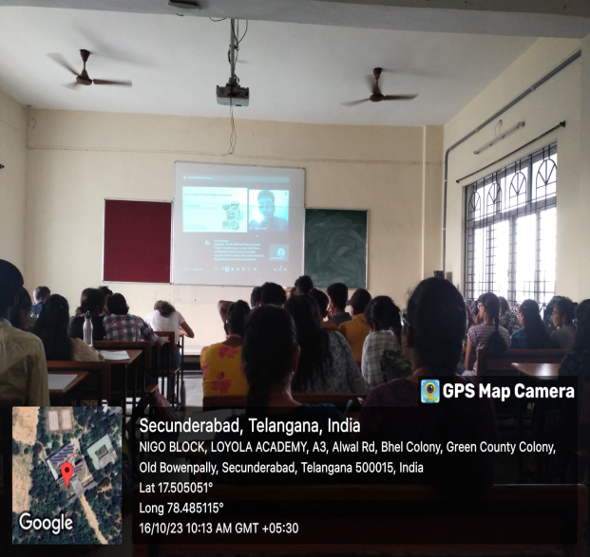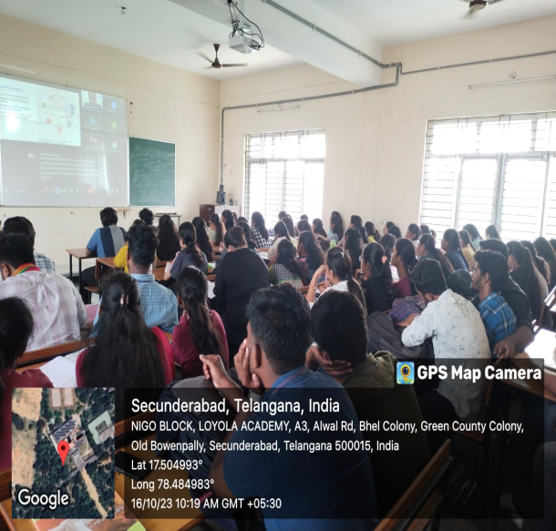

Guest Lecture on Entrepreneurship

a. Concept:
M.Sc. Food Technology and Management organised guest lecture on entrepreneurship for the students of I & II years on 20th FEBRUARY 2024.

b. Purpose:
The main motto of this program is to enlighten and educate students about the entrepreneurial opportunities.

c. Report:
Ms. Shakeera, Assistant Professor at Osmania University and the esteemed founder of SWAYUM brand, specializing in ready-to-eat chutney mix, was the speaker and emphasized the pivotal aspects of embarking on a career in entrepreneurship. She highlighted the importance of market analysis, idea generation, internships, and the process of new product development, provided insights into government subsidies available for budding entrepreneurs, enabling students to navigate and leverage available resources effectively.
She also elucidated on the requirements, standards concerning packaging and nutritional labelling in compliance with regulatory frameworks and detailed discussions were held on Food Safety and Standards Authority of India (FSSAI) rules and regulations, emphasizing the significance of adhering to quality control measures in food production.

d. Review:
Students found this lecture very delightful and gained immense knowledge on entrepreneurship. This session helps budding entrepreneurs to set up their own firm.

e. Photos:

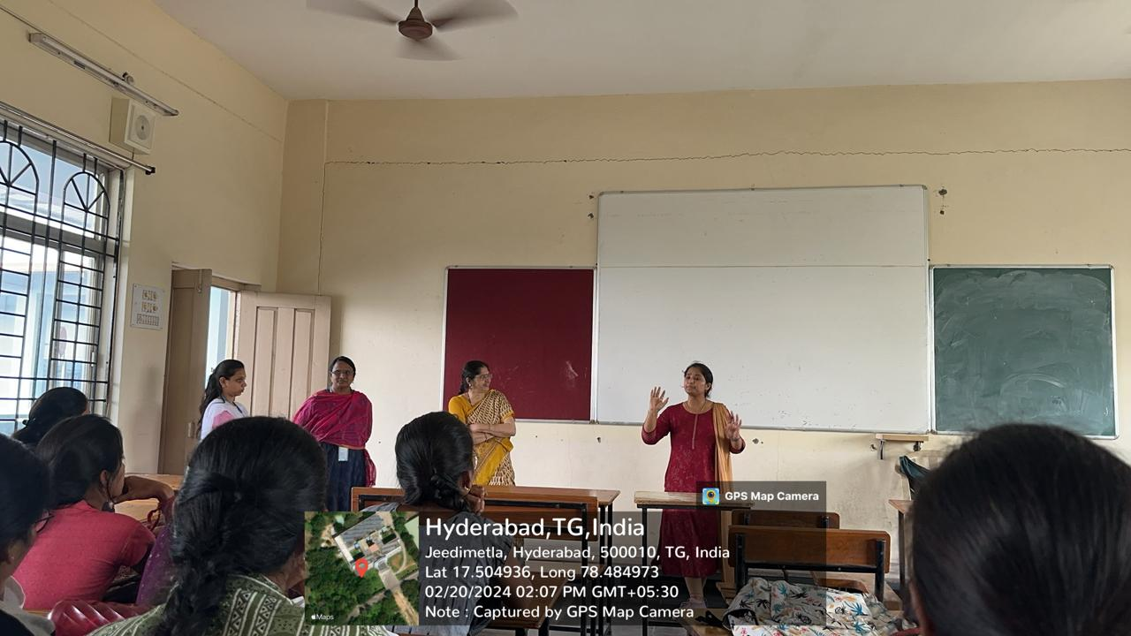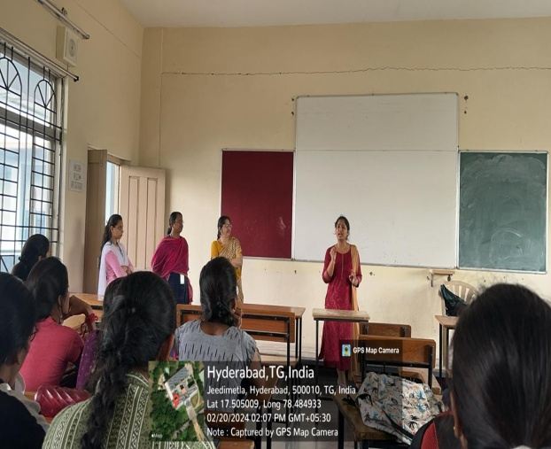



International Conference

ICAATAS (International Conference on Advances in Agriculture Technology & Allied Sciences)
- Concept:
ICAATAS- 2023 (3day programme) combinely organized by Loyola academy, Hyderabad, Society of Agricultural research and Social Development ,New Delhi was held at Loyola Academy on 19th to 21st June 2023. To enlighten , advances and improvements in agriculture and allied sciences.
b. Purpose:
The main motto of this program is to enlighten and educate students about the new technologies and advancements in agriculture and allied sciences.

c. Report:

Day 1 - Sri. Raghunandhan Rao, I.A.S, addressed the gathering and enlightened students on improvements in agriculture sector and in quality of life of Telangana State Farmers post bifurcation. Padma Sri. Chintala Venkat Reddy, the pioneer to work in incorporation of vitamin D in paddy, stressed on importance of natural farming. Dr. C. Thara Satyavathy Director, IIMR, limelighted on importance of millets in human diet.
Dr. Ashish Chauhan and Dr. Sahadev Singh shared their research findings with the students. International speakers From Israel and Japan have also addressed gathering by online mode. The inaugural ceremony has also been graced by Rev. Fr. Francis Xavier Correspondent, Rev. Fr. Dr. L. Joji Reddy, principal, Loyola Academy. Oral and poster presentation along with technical session were carried out during the conference.
Day 2 - Various competitions like quiz, debate, poster presentation were organized by organizers to encourage active participation of students and to display their Research findings.
Day 3 - The valedictory ceremony was held for the conference at Loyola Academy in which the winners of various competitions are awarded with momentos by guest of Honour, Prof. Krishankumar, Head, P.V Narasimha Rao veterinary University who was Honoured with Life time Achievement Award by the Organising committee.
- Review: Students found this lecture very informative and inspired to excel in the field of food technology.

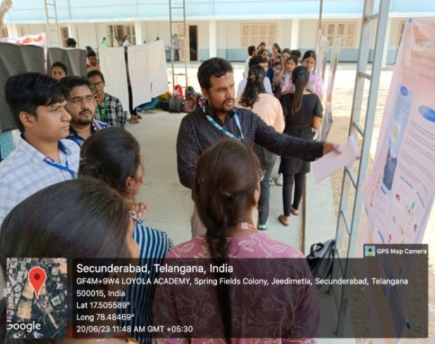
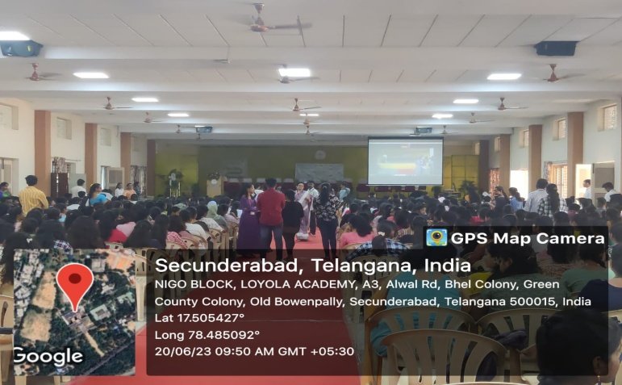
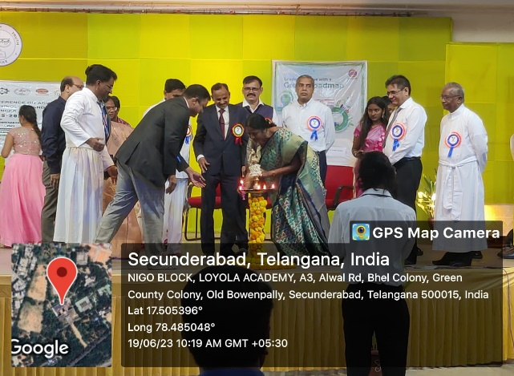
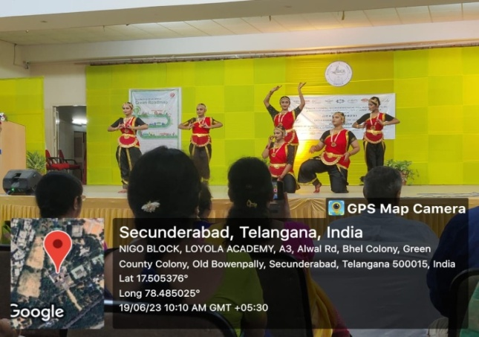
- Photos:
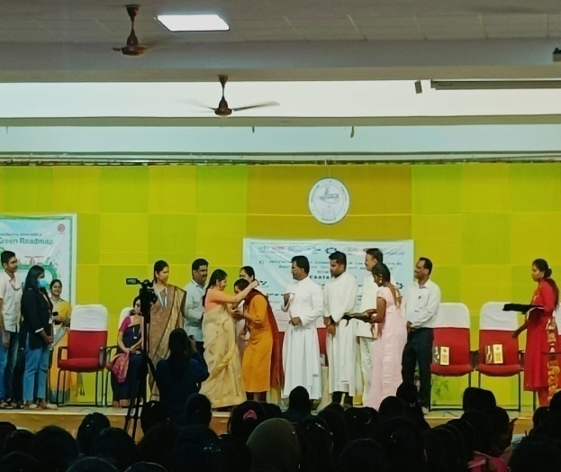
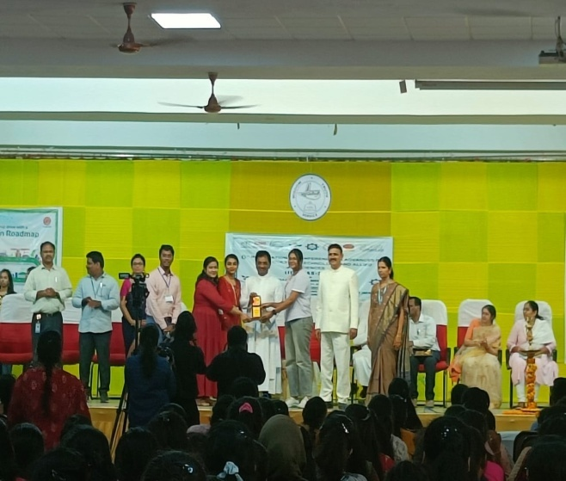

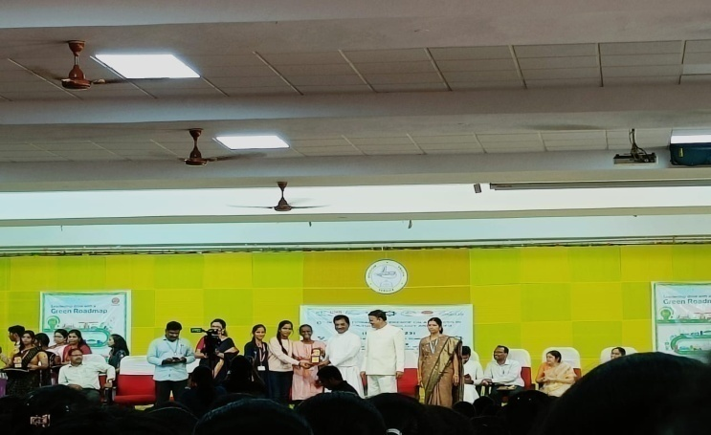

ICIFPTN (International Conference on Innovations in Food Processing Technology
and Nutrition)

a.Concept:
ICIFPTN (3day programme) combinely organized by School of Food Technology and Nutrition, Loyola academy, Hyderabad & Department of Biosciences and Technology, School of Sciences and Environmental Studies, Dr.VishwanathKarad MIT World Peace University, Pune was held virtually on 22nd to 24th January 2024. To enlighten, advances, innovations, improvements and sustainable practices in food processing industry.

- Purpose:
The main motive of this program is to enlighten and educate students about the new technologies and advancements in food processing.

c. Report:
Day 1 - The inaugural ceremony of the International Conference on Innovations in Food Processing Technology and Nutrition commenced with a sense of anticipation and enthusiasm by the lighting of the lamp. The programme commenced with the warm welcome addressed by Rev. Fr. Dr. L. Joji Reddy SJ(Principal),President, Xavier Board of Higher Education, Loyola Academy, Hyderabad followed by Rev. Fr. Prabhu Das Vice Principle UG, Loyola Academy.
After the offline session the virtual meeting commenced with the warm welcome addressed by
Dr. Anup Kale, Associate Dean, School of Science and Environmental Studies, MIT World Peace University, Pune.
Followed by Prof.Milind Pande Pro-VC, MIT World Peace University, Pune.
The keynote speech was delivered by the chief guest Prof.Rajeswar Santayya Matche Chief Scientist, CSIR- Central Food Technology Research Institute on emerging trends, challenges, and opportunities in food processing technology and nutrition. Oral and poster presentations along with technical sessions were carried out during the conference for two thematic areas - Food bio-processing and Fermentation & Food processing, preservation, and packaging in two break out rooms.
Day 2 - Session started with insightful keynote addresses delivered by distinguished speakers. First, Dr. Ashok Giri, Chief Scientist and Former Chair of the Biochemical Sciences Division at CSIR-National Chemical Laboratory 2. With his wealth of experience and expertise, Dr.Giri shared valuable insights into the subject matter, enriching the audience's understanding. Followed by Dr.RuchikaKaul-Ghanekar, representing Symbiosis Centre for Research & Innovation at Symbiosis International (Deemed University), delivered Keynote Address on emerging trends, innovations, gut microbiome, sustainable agricultural practices.
Lead talks were given by Dr.Priyanka Trivedi, Dr.AhammedShabeer TP, Prof.Dr.Pierlugi Caboni, Dr. A. Uma, Professor, Dr.Hameeda Bee and Dr.Sreekanth VK on thematic areas of Food Bioprocessing and Fermentation, Food processing, Packaging and Preservation, Gut microbiome engineering, diet related diseases and health, Omics for Food, Medicine and Nutrition, AI/ML for the food industry, Sustainable Agriculture.
Oral and poster presentations, Quiz were carried out during the conference for three thematic areas - Omics for food, nutrition, and medicine and AI/ML for food industry, Gut microbiome engineering, diet related diseases and health, Sustainable Agriculture in two break out rooms.
Day 3 - Session started with insightful keynote address delivered by Dr.VasudhaShirishKeskar, Vice-President of ICUMSA at MAARC Labs Pvt Ltd. On Entreprenurship, innovative ideas and quality standards of different foods.
Lead talks were given by Dr.VeerachandraKrantiYemmireddy, Dr.Harikanth Porika, Sri Konda Laxman, Dr. S G Dalvi on thematic areas of Food Bioprocessing and Fermentation, Omics for Food, Medicine and Nutrition, Sustainable Agriculture.
The valedictory ceremony was held for the conference in which the winners of competitions are mentioned and prize money was announced.
The whole event was concluded by Dr. P. KiranKumari, Head of the Department of Food Technology & Management, Loyola Academy and expressed gratitude in the vote of thanks, marking the conclusion of the eventful session.
- Review: Students found this lecture very informative and inspired to excel in the field of food technology
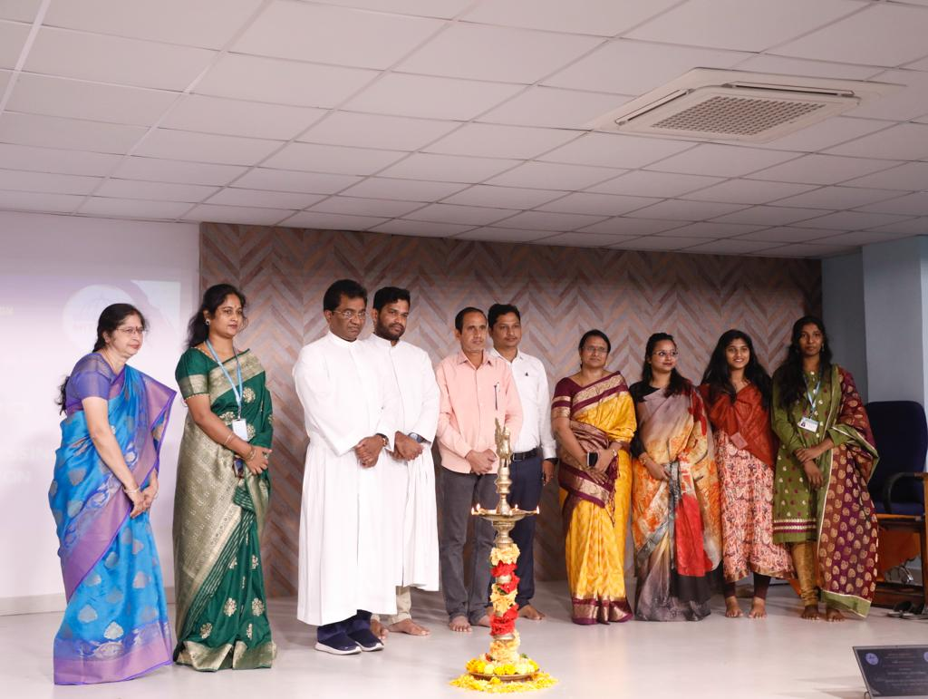
- Photos:
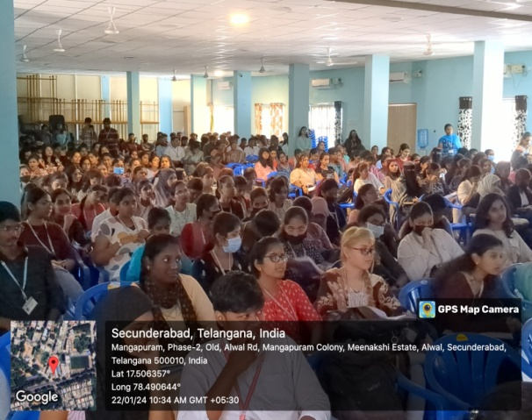
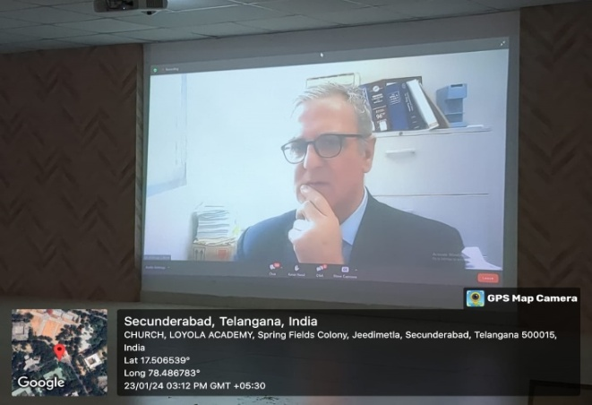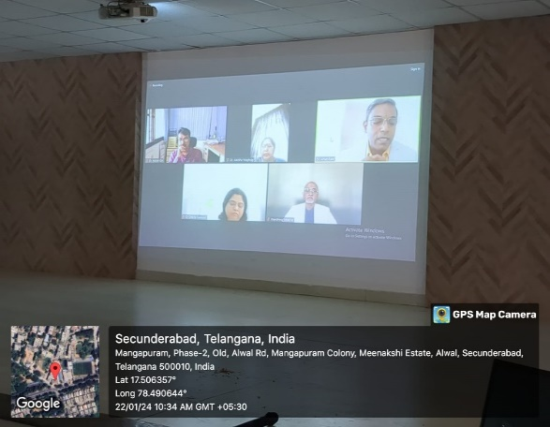

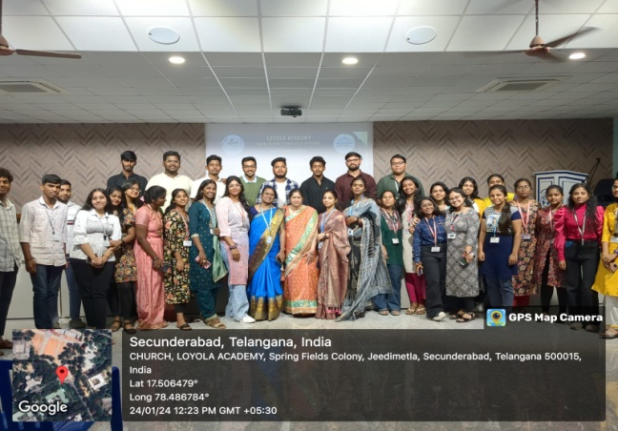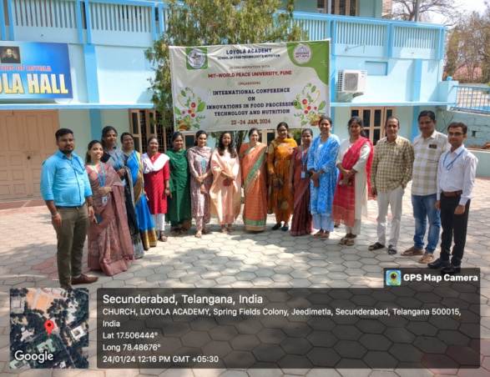


INDUSTRIAL
VISITS

A. SRI SRINIVASA DAIRY PRODUCTS PVT LTD (SCOOPS)

- Concept:
M.Sc. Food Technology and Management (1st YEAR) have visited SRI SRINIVASA DAIRY PRODUCTS PVT LTD (SCOOPS), Hyderabad, an ice- cream manufacturing industry along with the faculty on Saturday 15th July2023, as a part of curriculum.

b. Purpose:
To understand and learn technical aspects employed in manufacturing of ice-cream.
c. Report:
This Visit had helped students to equip knowledge in processing, instrumentation and quality aspects in processing of varied varieties of ICE-CREAM. It was an industrial trip which enlightened the students immensely

d. Review:
Students have equipped wider understanding about different processing techniques, equipment related to it, packaging of Ice-creams.

e. Photos:
First Year students of Batch 2022-2024

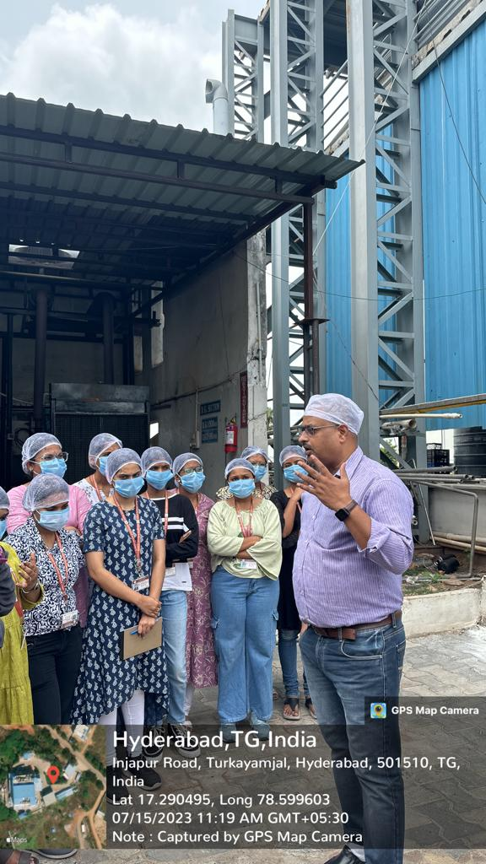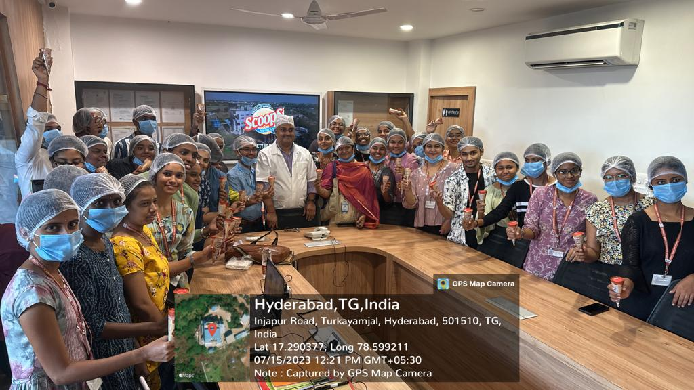

B. AMUL DAIRY

- Concept:
M.Sc.Food Technology and Management (I year) have visited “AMUL DAIRY” located in Hayat Nagar, Hyderabad, along with the faculty on 27-01-2024.
b. Purpose:
It helped to learn technical aspects employed to process and maintain proper hygienic conditions in the industry during production of different dairy products.
c. Report:
This Visit had helped students to equip knowledge in processing, instrumentation, and quality aspects in the processing of milk and milk products like curd, cheese, flavored drinks etc
It was an industrial trip that enlightened the students immensely
d. Review:
Students have equipped wider understanding about different processing techniques, equipment related to it, packaging of dairy products.
e. Photos:
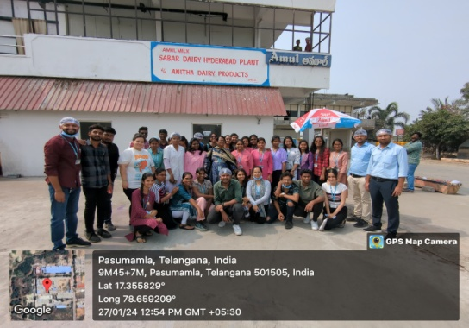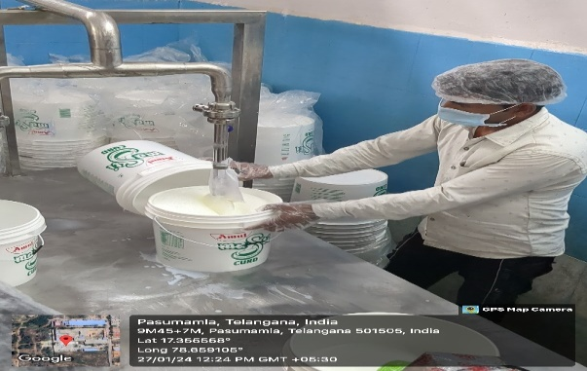

C.NSL Krishnaveni Sugars Ltd

- Concept:
M.Sc. Food Technology and Management have visited NSL Krishnaveni Sugars Ltd, Hyderabad, a sugar manufacturing industry along with the faculty on 18th March 2024, as a part of curriculum.

b. Purpose:
It helped to learn technical aspects employed to process different grades of Sugar from Sugar cane.

c. Report:
This Visit had helped students to equip knowledge in processing, instrumentation and quality aspects in processing of varied varieties of Sugar
It was an industrial trip which enlightened the students immensely

d. Review:
Students have equipped wider understanding about different processing techniques, equipment related to it, packaging and sorting of Sugar Grades.

e. Photos:
First Year students of Batch 2023-2025

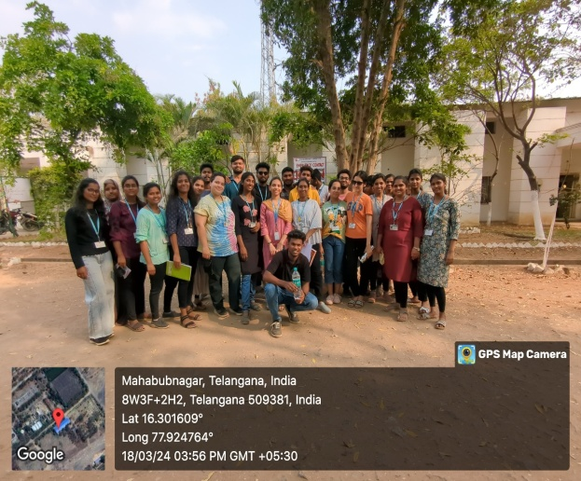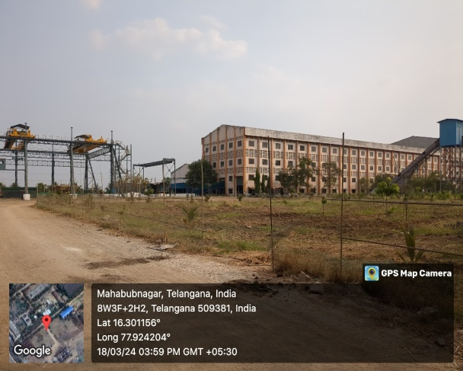

Institutional Visit
Centre for Cellular and Molecular Biology (CCMB)
- Concept:
M.Sc. Food Technology and Management (1st year) have visited Centre for Cellular and Molecular Biology (CCMB), located in Habsiguda, Hyderabad, along with the faculty on Thursday, 3rd Aug, 2023

- Purpose:
The main motto of this program is to enlighten and educate students about the instrumentation, understanding the methods, procedures that were used for the analysis of bio-molecules and isolation of certain genetic materials.

- Report:
This Visit had helped students to equip knowledge in instrumentation and different projects, models and posters on modern biology. Information was provided on various methods, procedures that were used for the analysis of bio-molecules and isolation of certain genetic materials.
- Review:
Students found this visit very informative and inspired by different laboratory techniques in modern biology

- Photos:
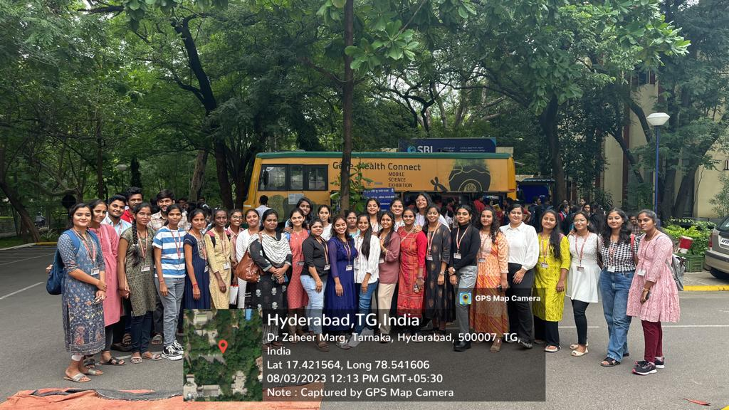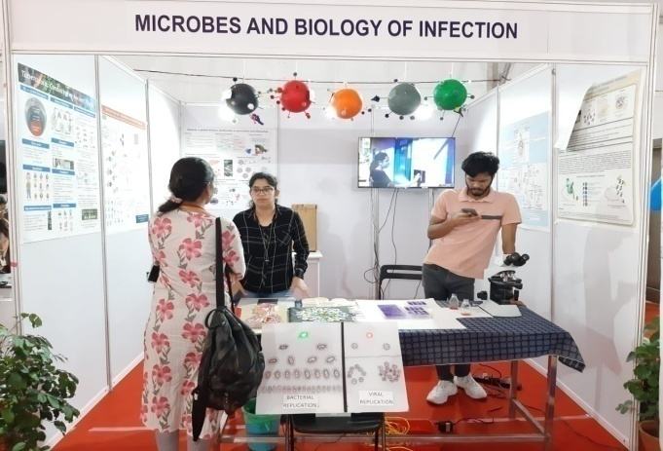
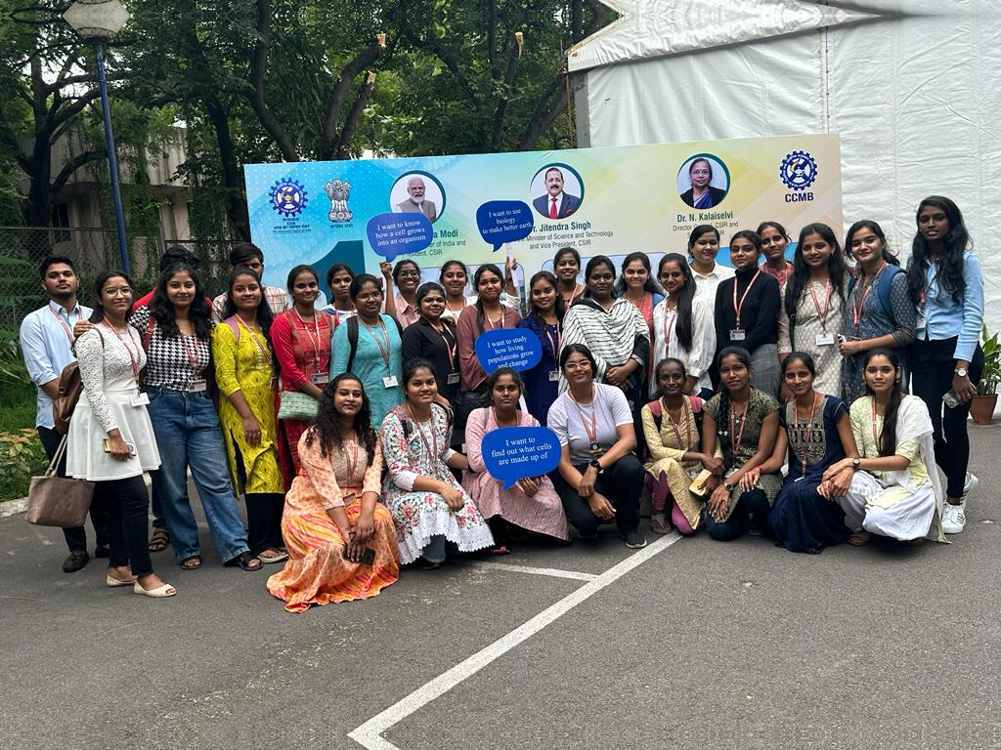

EDUCATIONAL
TOUR

EDUCATIONAL TOUR

  - Concept:
The students of M.Sc. Food Technology and Management, second year students went to educational tour from 3rd October to 7th October,2023. Places Visited: Bangalore, Coorg and Mysore.
  - Purpose:
Educational tour is a part of academic activity organized to enlighten students by visiting different food industries located in different states along with site viewing. This is one of the key step to help students understand and know about different food industries, their role and functions. This is indeed considered as fun learning technique to expand their knowledge.
  - Report:
The students escorted by the staff visited Coffee Plantation and Spice Cultivation located in Coorg. The manager of the industry escorted the staff and students to various production units around the industry and gave a detailed report about various manufacturing and production units.
  - Review:
Students have equipped wider knowledge in the production and processing of Coffee, Spice cultivation and quality aspects are maintained in industry.
  - Photos:

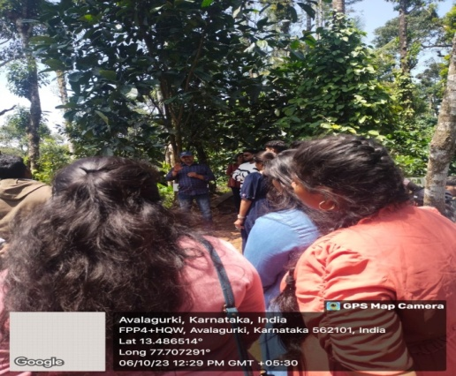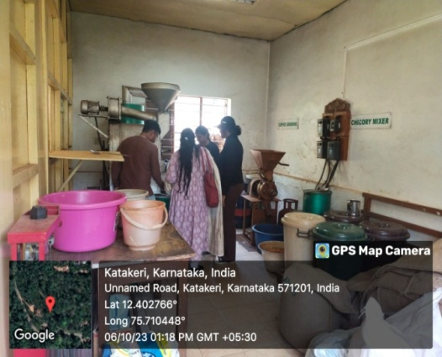
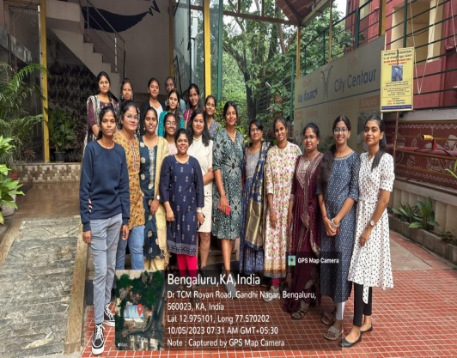
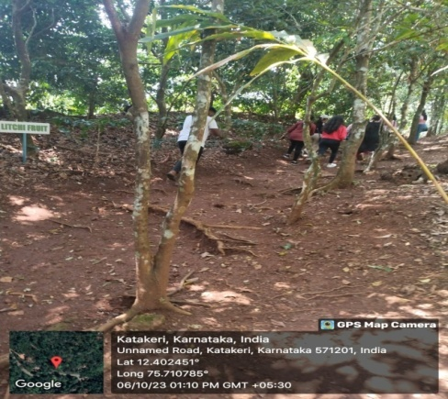


FOOD EXPO

FOOD EXPO
a. Concept:
M.Sc. Food Technology and Management & B.Sc. Food Technology and Management conducted a Food Expo i.e. “Food Utopia” on 12th& 13th of OCTOBER 2023.

b. Purpose:
The main motto of this program is to enlighten and educate students about the importance of community, health, and environmental stewardship, aiming to create a harmonious relationship between humans and the food they consume
c. Report:
This Visit had helped students to equip knowledge in instrumentation and different projects, models with engaging workshops, and interactive demonstrations showcasing the models. Attendees enjoyed hands-on activities and culinary delights from the local vendors.
d. Review:
Students found this platform very delightful to share and celebrate the vibrant world of food.

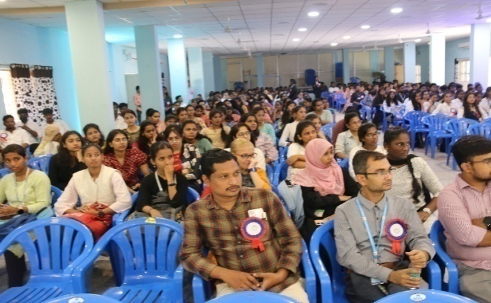
e. Photos:
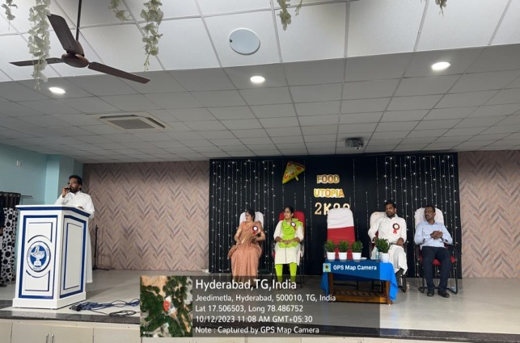

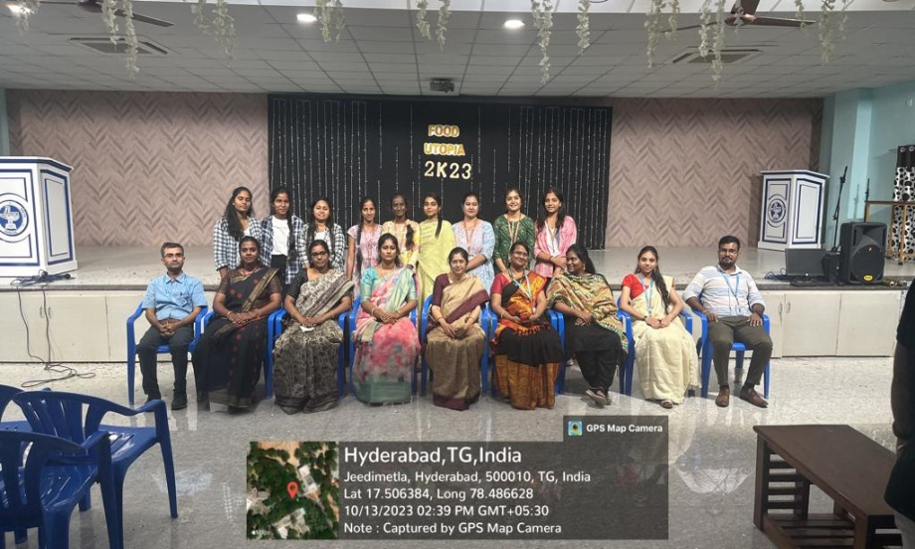

PLANET PROGRAM

HOME FOR DISABLED

- Concept:
As a part of social service outreach program organized by Loyola Academy, II year students of the department of M.Sc. Food Technology & Management have actively participated in extending their heartful care and support to the needy and socially deprived people.
- Purpose:
To encourage, and build confidence among the group of socially, psychologically deprived and physically challenged people and assure hope in them with utmost care and love
- Report:
On 3rd November, 2023, M.Sc Food Technology students visited Home for disabled located at Mudhuchintalapally, Medchal, Hyderabad, as per educational requirement with the supervision of Stephen Ashirvadam. The objective of this programme is to inculcate in students the spirit of social responsibility, besides academic excellence and spiritual growth.
The intimates were very hospitable and friendly and they welcomed us with their beautiful smiles. To break the monotony of their lives we presented few songs, played games and counseled them.
- Review:
It was a beautiful experience to all the students who have taken active participation in this social welfare activity, students were able to experience and know the problems of the deprived community and support them by creating friendly atmosphere and by intruding hope in their hearts.
- Photos:
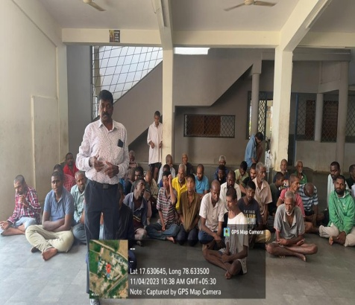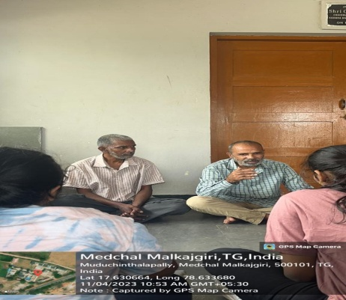
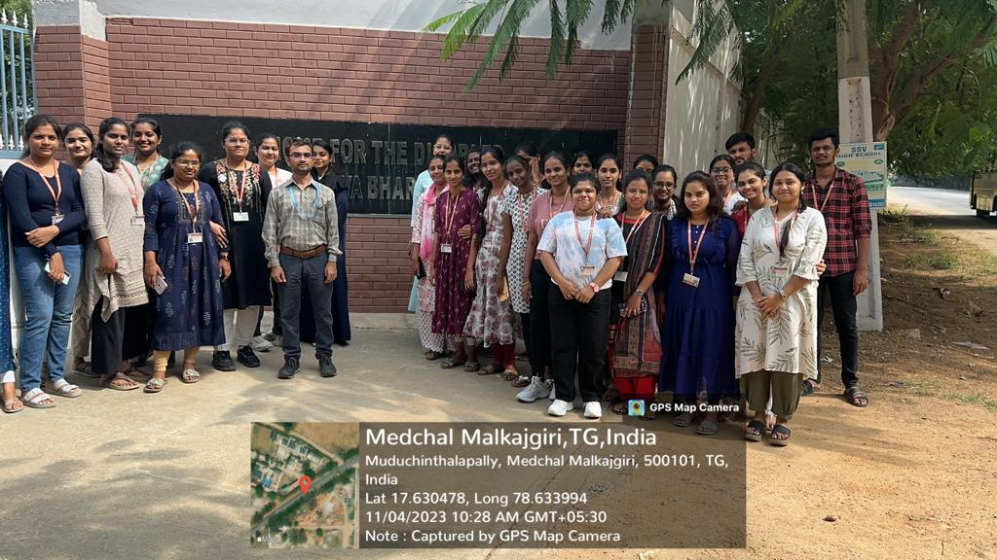
PLANET: SOCIAL SERVICE OUT-REACH PROGRAM

  - Concept:
As a part of social service outreach program organized by Loyola Academy, I year students of the department of M.Sc. Food Technology & Management On 29th January, 2024 have actively participated in extending their heartful care and support to the needy and socially deprived people.
  - Purpose:
To educate the rehabilitated, juvenile offenders and assure hope in them with utmost care and love.
  - Report:
On 29th January, 2024, M.Sc Food Technology students visited juvenile justice board, Saidabad, Hyderabad, as per educational requirements with the supervision of Stephen Ashirvadam. The objective of this program is to inculcate in students the spirit of social responsibility, besides academic excellence and spiritual growth.
The intimates were very hospitable and friendly and they welcomed us with their beautiful smiles. To break the monotony of their lives we presented few songs, played games and counseled them.
  - Review:
It was a beautiful experience to all the students who have taken active participation in this social welfare activity, students were able to experience and know the problems of the deprived community and support them by creating friendly atmosphere and by intruding hope in their hearts.
  - Photos:
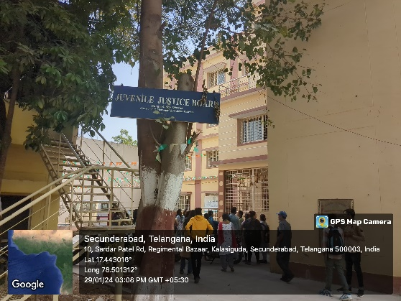
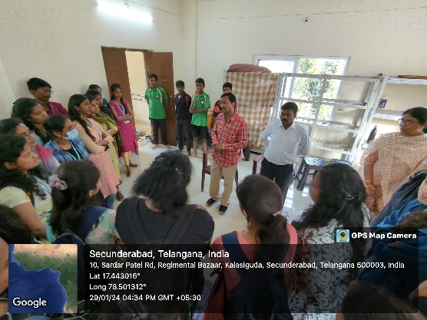

EARN WHILE YOU LEARN

EARN WHILE YOU LEARN PROGRAM
- Concept:
The students of M.Sc. Food Technology and Management have actively took a part in the event and initiated the “Earn While you Learn Program” on 10th November 2023, which gave hands on experience and confidence to the students to innovate, introduce and create new products formulated on own.

- Purpose:
To provide a platform to the students to have hands on experience to develop new and innovative products and sell them in the market. This is a step to provide a positive impact in students with respect to facing the market and being an entrepreneur in the field of their study.
- Report:
It gave hands-on experience and confidence to the students to innovate, introduce and create new products formulated on own and showcased in the event. This had created a positive impact on students to face the consumers with confidence and enabled them to face new challenges in the area of consumer acceptability of new products.

- Review:
Students and faculty had very good experience and had an opportunity to enlighten them in developing new products and sell them at market level.

- Photos:
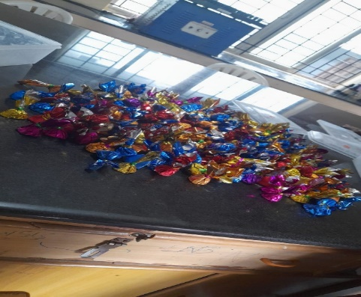
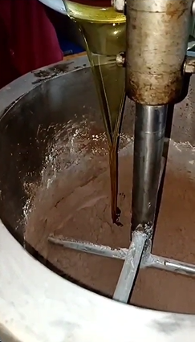
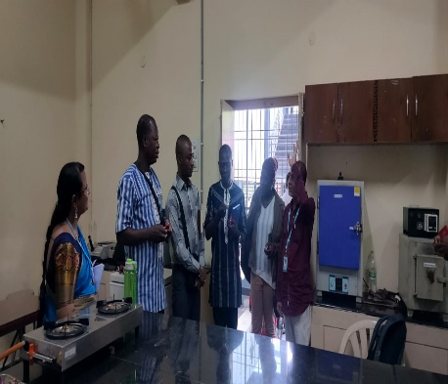

MSME – TRAINING PROGRAM

ENTREPRENEURSHIP DEVELOPMENT PROGRAM

a. Concept:
The Department of M.Sc. Food Technology and Management has actively participated in a TWO Entrepreneurship Development program on “ Craft Bakers ” organized my MSME- Ministry of small and Medium scale Enterprises in Yousufguda, Hyderabad for 240 hours between November 23th, 2022 to January 20th,2023.another course for 39 days 195 hrs

b. Purpose:
To Impart knowledge in the field of Baking Science & Technology, and to encourage students to be an entrepreneur. This EDP is designed to help students to gain understanding about innovative and advanced processing techniques to manufacture various baked products with commercial importance.

c. Report:
The department of Food Technology and Management has actively participated in the Entrepreneurship Development program organized by MSME, on “ Baking Technology”, educating students to understand the commercial importance and also the production of several baked products. This program also provided guidance to the students on how to start a small scale enterprise and about the government bodies that provide funds/loans for the same.

d. Review:
Students and faculty had very good experience and had an opportunity to enlighten themselves in the new technologies in the field of baking. Students also learnt about processing of a variety of commercially important bakery products. Over all the training was very informative and helpful.

e. Photos:
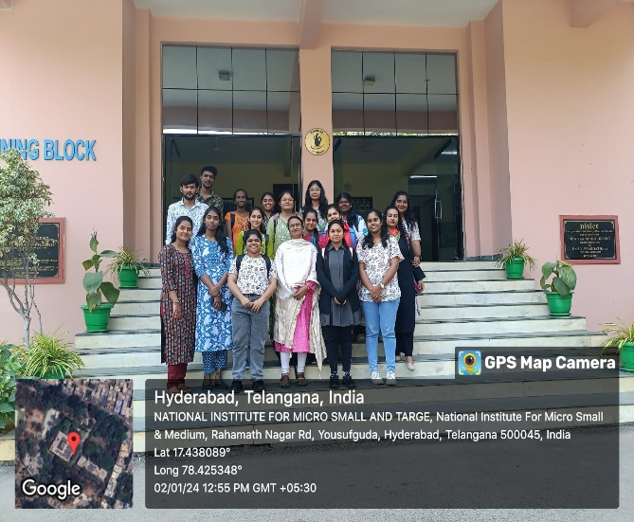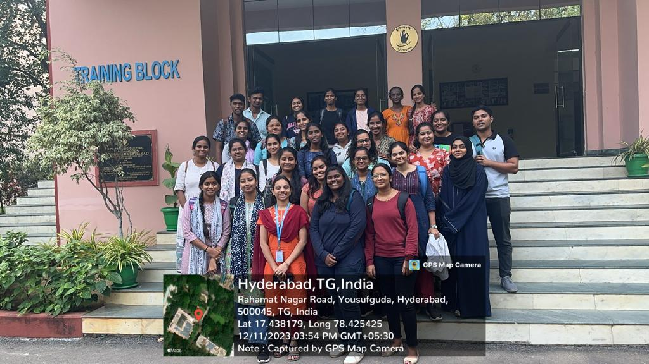
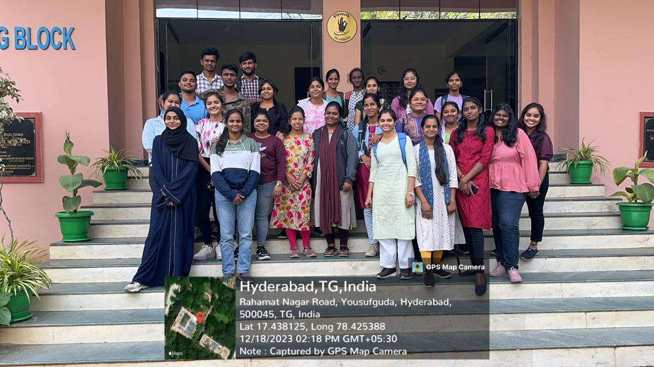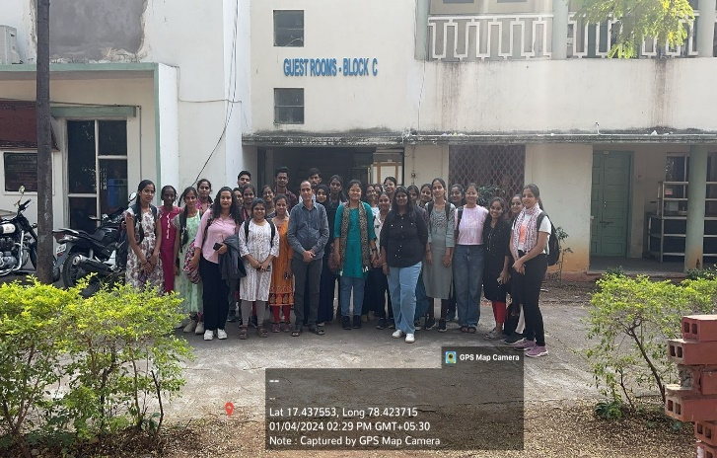
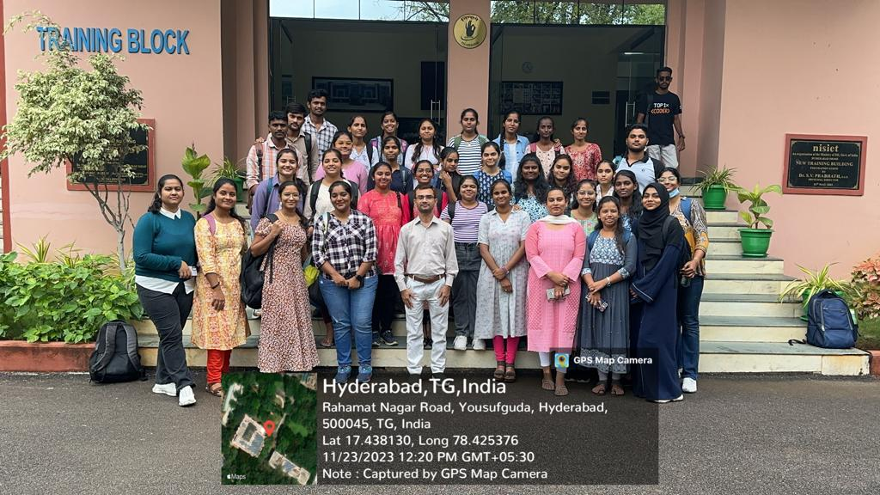

FACULTY DEVELOPMENT PROGRAM

Faculty Development Programme
- Concept:
Management Development Programme on “QUALITY MANGEMNET PRACTICES FOR MICRO, SMALL AND MEDIUM ENTERPRISES” (MSME) sector organized in collaboration with school of Food Technology and Nutrition & school of Management Loyola academy, Hyderabad, on 18th to 22ndDecember 2023. To provide knowledge on quality concepts with the faculty.
- Purpose:
The main motto of this program is to enlighten and enhance quality management skills and practices among the faculty.
- Report:

Day 1 – The programme was started with the lightening of the lamp, signifying the illumination of the knowledge and wisdom. The lecture was delivered by CV RAMANA (senior faculty- QCFI HQ* Hyderabad) on the significance of quality in every aspect of organizational operations, measuring performances through engaging discussions and practical examples.
Day 2 – Lecture was delivered by “GADDAM SUDARSHAN”( founder & CEO m/s SHASHRITH INFOTEC Pvt Ltd) on institutional networks and heir significane in fostering professional growth and development, and advancements of management education and practice.
Day 3 - The lecture was delivered by CV RAMANA (senior faculty- QCFI HQ* Hyderabad) on 5S and key pillars of 5S ( SEIRI, SEITON, SEISO, SEIKETSU, and SHITSUKE) and fostering a culture of continuous improvement and excellence.
Day 4 - H.V RAMANA MURTHY delivered lecture on mistake – proofing, also known as poka-yoke.
Focus on minimizing errors and enhancing quality, driving efficiency and reliability in their work
processes.
Day 5 – Final day lecture was given by V. SWAPNA (In charge of training programs (ESDP- scheme) on MSME Sustainable ZED certification. Session highlighted importance of sustainability in the micro, small and medium enterprises & significance of ZED (Zero Defect Zero Effect Certification in promoting sustainable practices and enhancing competitiveness.
- Review: FDP culminated a transformative journey of learning, growth and inspiration. Each session equipped attendees with the tools and knowledge needed to excel in their roles and drive organizational success.

- Photos:
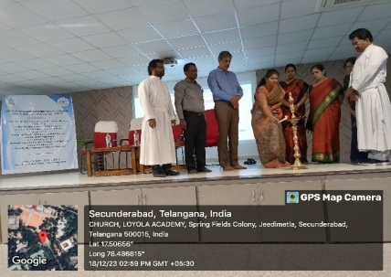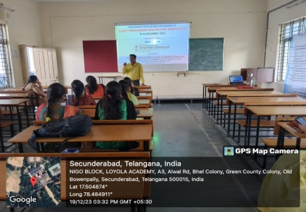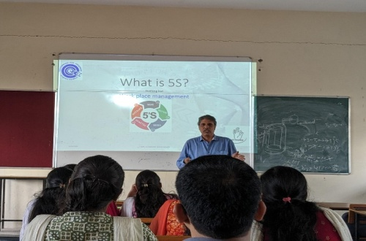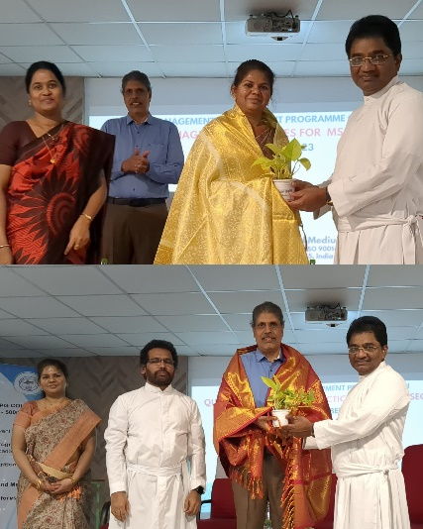
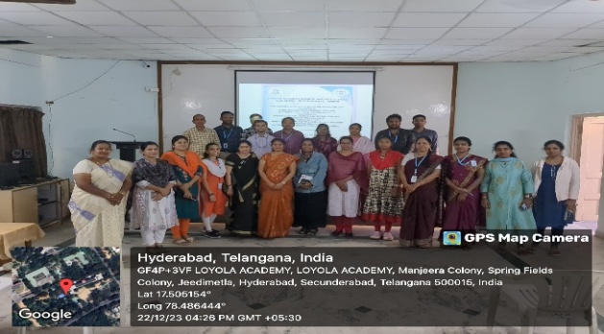

CAREER
DEVELOPMENT PROGRAM

Educational counselling “Educog”-Career development program
- Concept:
Career guidance programme was conducted under collaboration overseas educational counselling “Educog” organized by Loyola Academy for M.Sc. Food Technology and Management (I year) on 24th June 2023. To provide information to pursue their career in abroad. Sandeep Reddy Nagireddy, specialist in Educog was the speaker of the programme

- Purpose:
The main motto of this program is to enlighten and educate students about the courses for pursuing Master’s in abroad and excel in their career.

- Report:
Sandeep Reddy Nagireddy, specialist in Educog was the speaker of the programme. He has provided students about the list of universities regarding Food technology related courses, entrance exams for different countries and marks to be scored for getting admission, the eligibility criteria, fee structure, scholarship, documents required, loan assistance for pursuing masters in abroad. The educog provide educational counselling, visa processing support and post course completion support for students.

- Review:
Students found this program very informative and inspired to pursue masters in abroad and excel in the field of food technology.

- Photos:

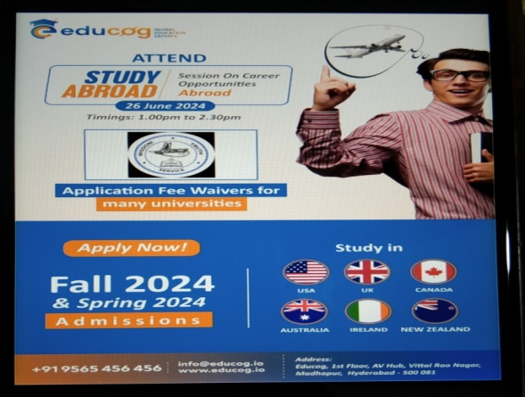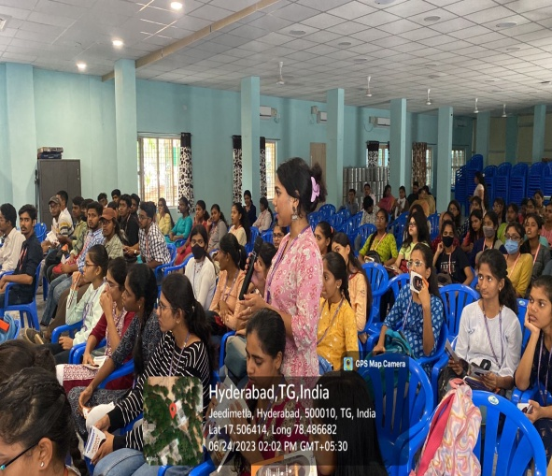
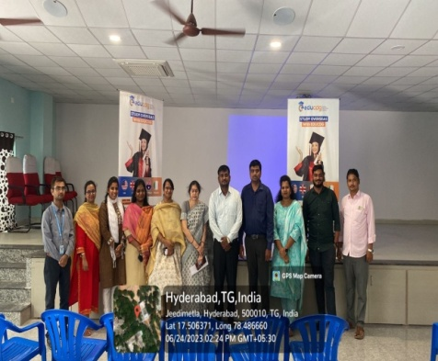
KADHI VILLAGE INDUSTRIES COMMISSION
a. Concept:
The Kadhi Village Industries Commission (KVIC) recently held an event at the Nampallly Exhibition Grounds in Hyderabad, Telangana on 9th March 2024. The event showcased various aspects of Khadi and Village Industries, offering visitors a chance to learn about the traditional Indian handicrafts and support local artisans.
b. Purpose: “KVIC is empowering the artisans by connecting them with PM Modi's “Viksit & Aatmanirbhar Bharat” campaign” - Chairman KVIC
• Under the leadership of Hon’ble Prime Minister, Shri Narendra Modi, distribution of 800 Bee Boxes, 100 Electric Pottery Wheels and 120 Waste wood Toolkits was done during Chairman KVIC’s Telangana visit.
• Artisans were inspired by distributing 80 Turn wood machines, 60 Tamarind Processing Machines and 40 Agarbatti Machines as well.

c. Report:
Students gained knowledge about the government schemes and its benefits, how to use different tools for entrepreneurship.
d. Reviews:
It is useful for the development of students entrepreneur skills .

e.Photos:

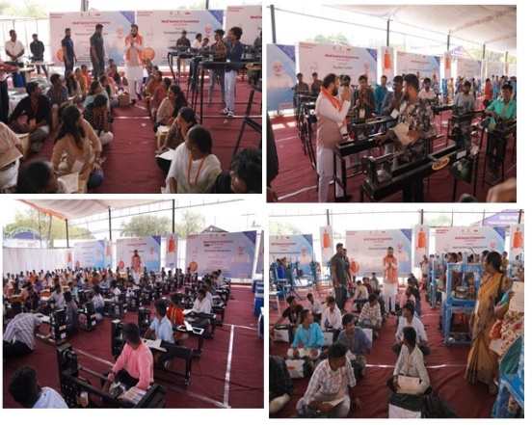

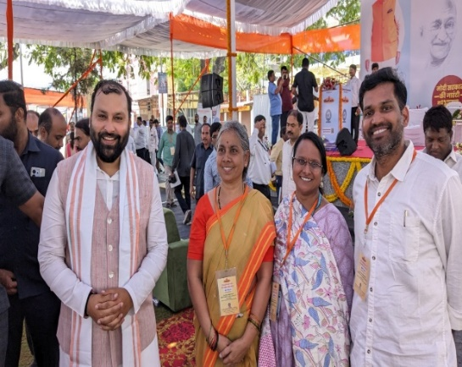

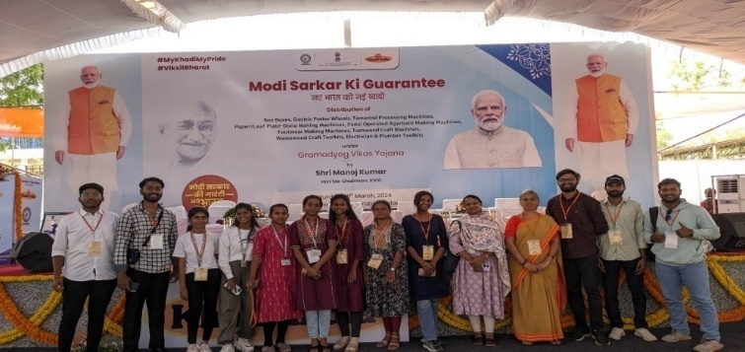

FACULTY
ACHIEVEMENTS

Dr. P. Kiran Kumari:
Invited speaker:
S.No | Talk delivered on | organized | Month/Year | Presented /participated | Proof
1 | Nanotechnologies in Food Science Applications, Recent Trends and Future Perspectives | By Samath Global Food Consultants and supported by ANGRAU and the Ministry of Agriculture and Farmers Welfare | May 23rd 2024 | Keynote Speaker | 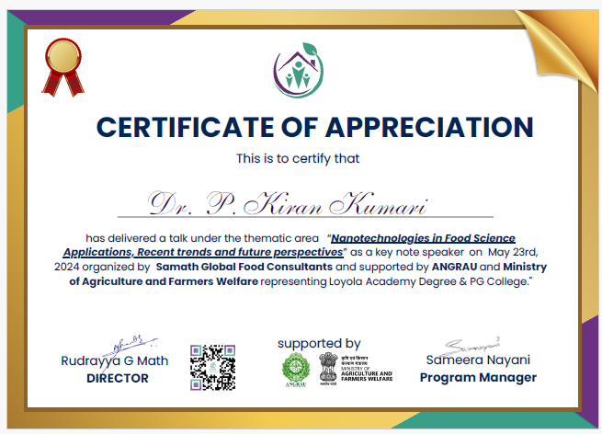
Patents:
Application no: | Date of filing | Title of Invention | Publication date | Proof
202441004762 | 23/01/2024 | A method for biodegradation of Chlorantraniliprole Pesticide using Staphylococcus Hemolyticus | 9/2/2024 | 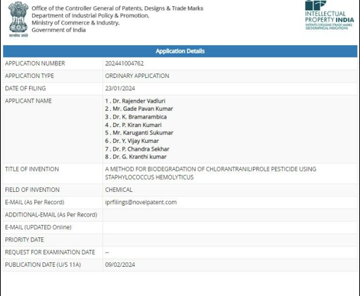
FDP attended
S.no | Title | Organization | Month/year | Participated/presented | Proof
1 | Emergeinnovate: empowering faculty for entrepreneurial research development | Mahaguru Institute of Technology | 9th April- 13th April 2024 | Participated | 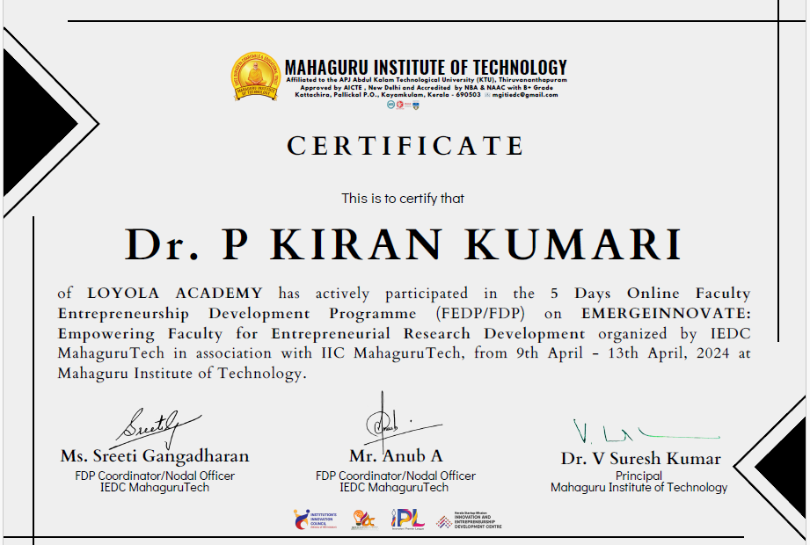
2 | National Level Faculty Development Program (FDP) | Atal Incubation Centre ALEAP WEHUB, Hyderabad in association with Directorate of Entrepreneurship | 19th -21st February 2024 | Participated | 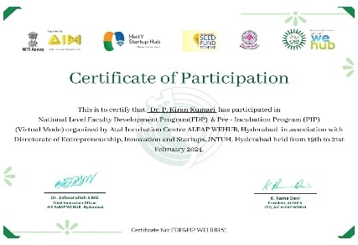
3 | Current Science and Developments in Nanobiotechnology” | Department of Biotechnology, Chaitanya Bharathi Institute of Technology (Autonomous) in association with Microbiologists Society India (MBSI) | 29th January to 2nd February 2024 | participated | 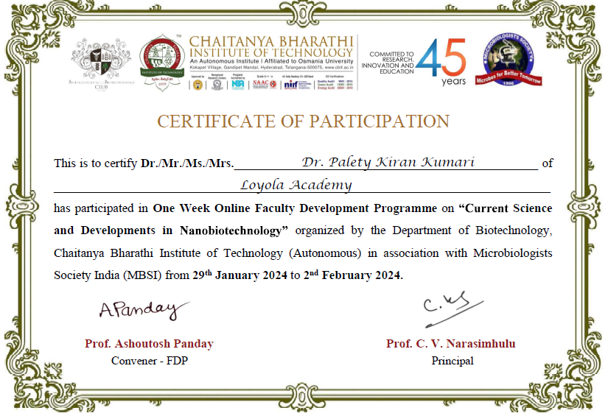
4 | Faculty Excellence in Teaching &Scholarships (FETS) Worshop | Loyola Academy, Secunderabad-Telangana in collaboration with ALL INDIA ASSOCIATION FOR CHRISTIAN HIGHER EDUCATION (AIACHE)&ASIA NETWORK OF UNITED STATES. | 18th &19th October2023 | Participated | 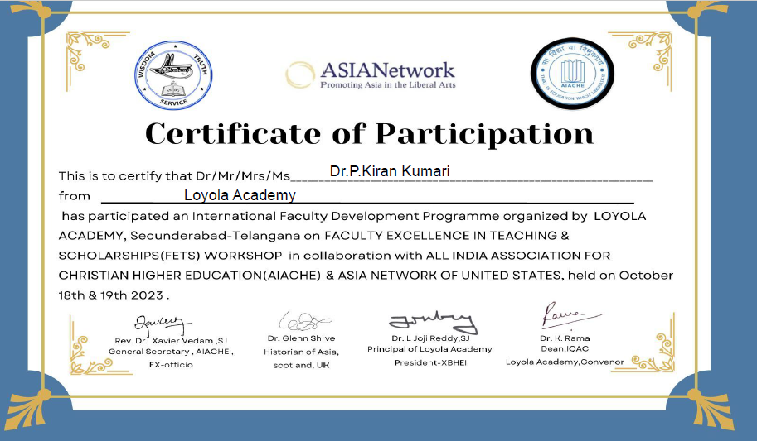
5 | To Develop Skill Panorama on Research Methodology-Based Data Analysis Using R” | B Bhau Rao – Devras Shodh Peeth, University of Lucknow & Science Tech Institute, Lucknow | 21st August  -27th  August 2023 | Participated | 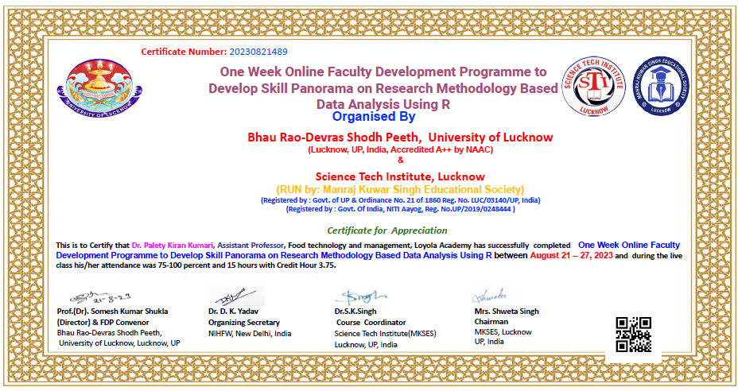
6 | Writing Successful Research Papers and Projects Proposals For Funding Agencies” | Department of Food Science and Technology, School of Agricultural Sciences, Malla Reddy, University of & Science Tech Institute, Lucknow | 23rd June- 29th June 2023. | Participated | 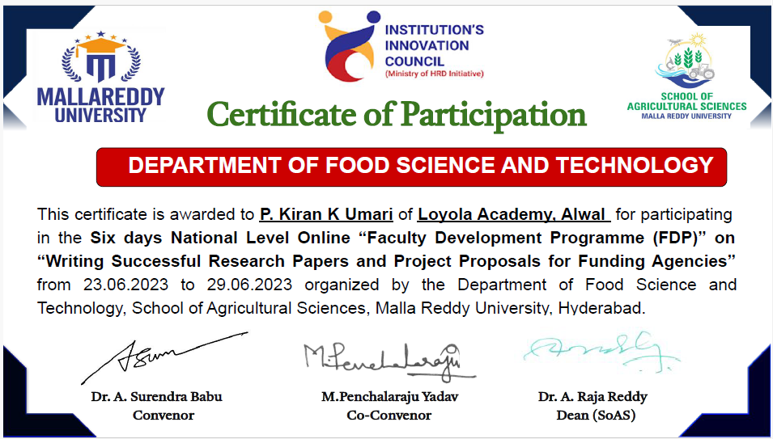
Skill Enhancement course
1 | 10 days Skill enhancement course on “ Artificial Intelligence and Machine Learning” | Rashtriya Uchchatar Shiksha Abhiyan (RUSA) -RUSA Sponsored Skill Enhancement Course | August 24th -September 4th 2023 |  | 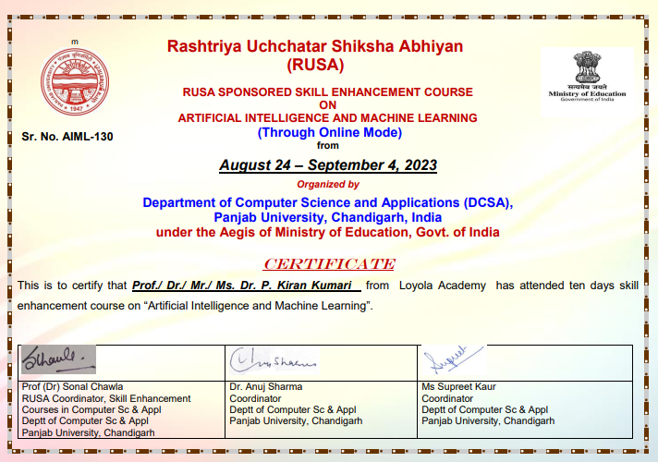
Entrepreneurship Development Program
1. | Entrepreneurship Development Program (Food Processing & Food Safety) | organized by MSME Technology Center Sitarganj, Ministry of MSME, Government of India | 27th July – 31st  July 2023 | Participated | 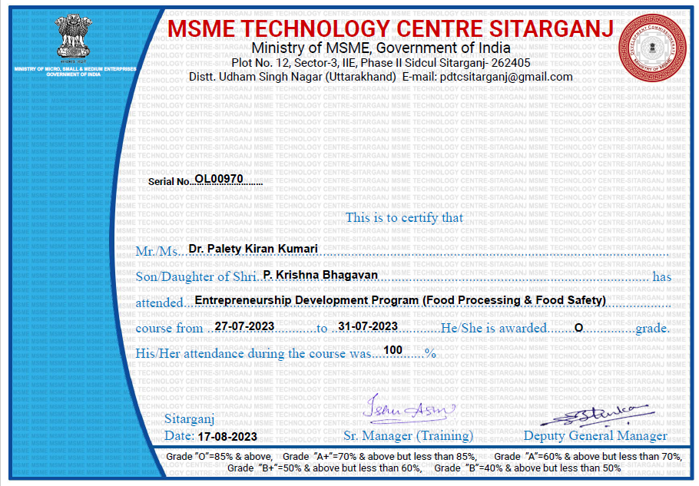
Conferences
1 | International Conference on Innovations in Food Processing Technology | School of Food Technology & Nutrition in collaboration with MIT World Peace University | 22nd -24th January 2024 | Co-convener | 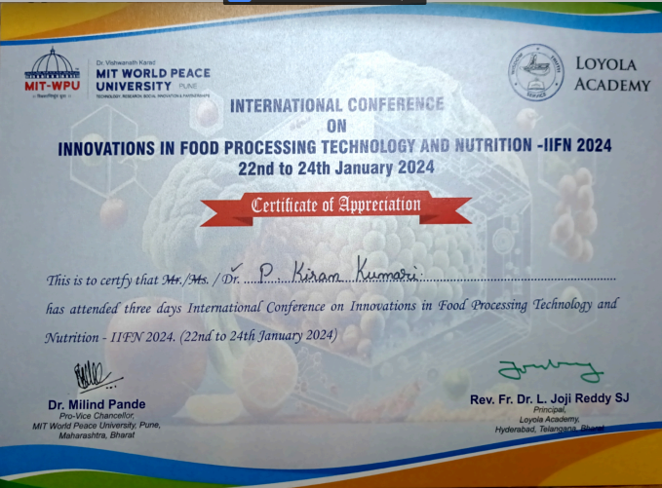
2 | 6th International Conference on advances in agriculture technology and allied sciences(icaatas-2023) | Loyola Academy, Secunderabad, Telangana-500010 | 19th -21st June | Organising committee member | 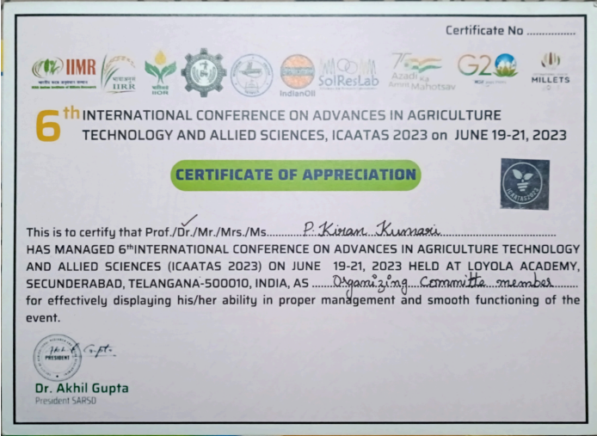
Webinar
1. | “SAMBHAV”-Sustainable Advancements for Modernizing Bharat’s Food Processing Vision | National Institute of Food Technology Entrepreneurship and Management, Kundli (NIFTEM-K) | 28th March 2024 | Participated | 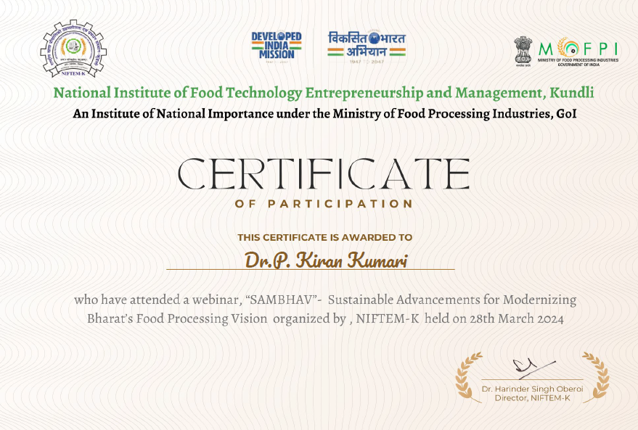
2. | “Harnessing Traditional Knowledge and Emerging Food Processing Technologies for Viksit Bharat” | National Institute of Food Technology, Entrepreneurship and Management-Thanjavur( NIFTEM-T) | 20th March 2024 | Participated | 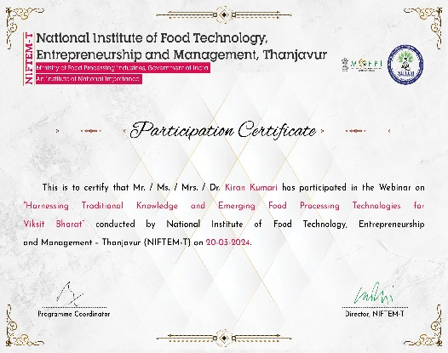
3 | Orientation Program on NAAC Accreditation and Documentation | Accredition Rankings and Certification Network of India (ACRNET India) and CliMed Research Solutions ,India | 25th October 2023 | Participated | 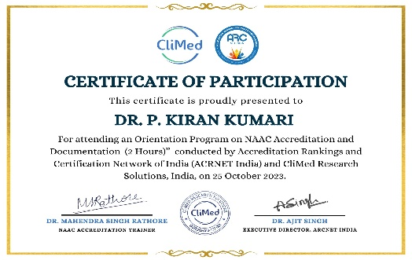
 | Workshop/Seminar
1 | NEP-2020(National Education Policy) on “ NPTEL Awareness” | UNIVERSITY GRANTS COMMISSION (UGC)-Dr. Babasaheb Ambedkar Marathwada University,Chhatrapati Sambhajinagar | 13th March, 2024 | Participated | 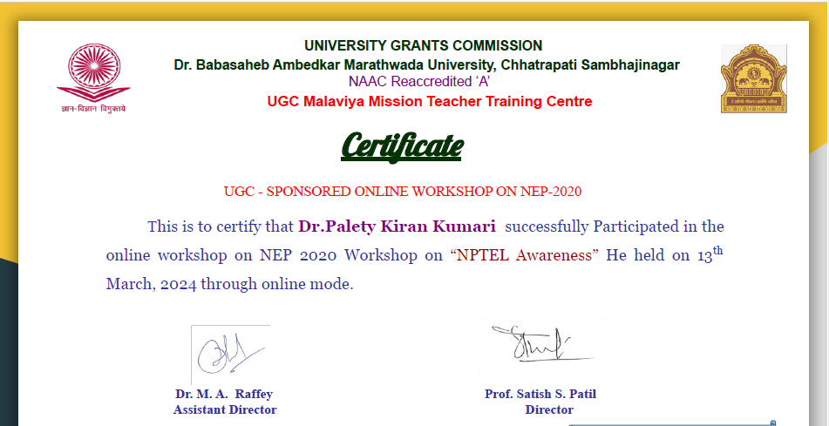
2 | Eat Right Awareness Programme | Food Safety and Standards Authority of India (FSSAI), Hyderabad. | 22nd March 2024 | Organized and participated | 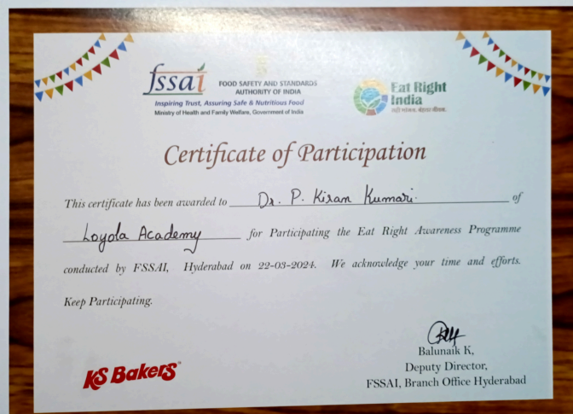
 | NPTEL
1 | Dairy and Food Process and Product Technology |  | July-December 2023 | Mentor | 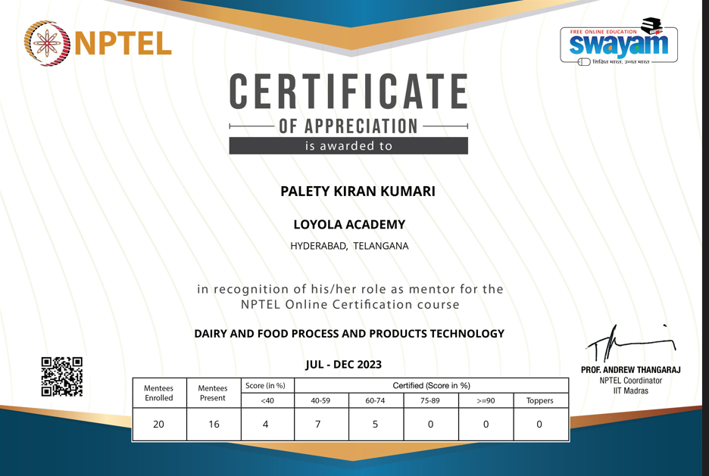

Dr. A. Ravinder
S.no | Theme | Place | International/National | Month/year | Participated/presented | Proof
1 |  | Satavahana university Karimnagar- 5050001 | - | 15/03/2022 | External Examiner | 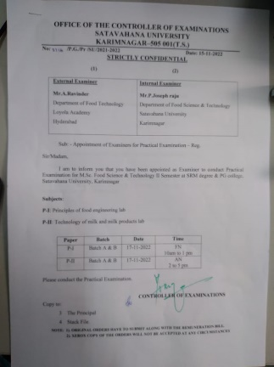
2 |  | Satavahana university Karimnagar- 5050001 | - | 22/03/2024 | External Examiner | 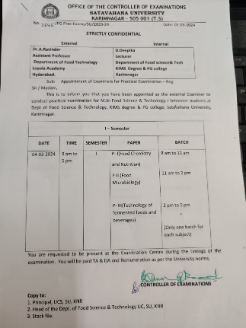
3 |  | Satavahana university Karimnagar- 5050001 | - | 05/03/2024 | External Examiner | 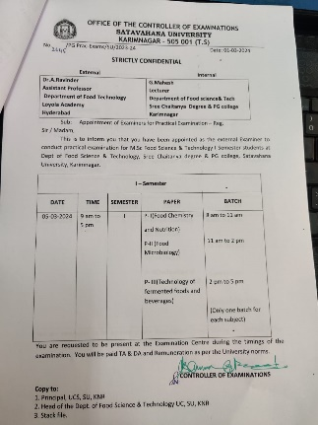
4 |  | Satavahana university Karimnagar- 5050001 | - | 13/03/2024 | External Examiner | 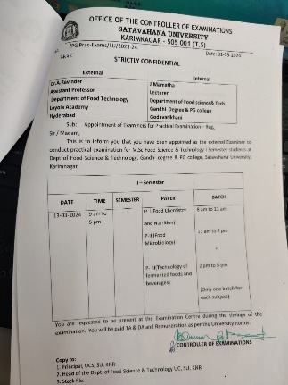
5 |  | Satavahana university Karimnagar- 5050001 | - | 14/03/2024 | External Examiner | 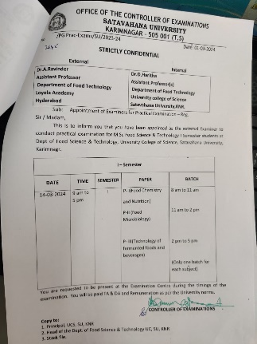
6 |  | Satavahana university Karimnagar- 5050001 | - | 15/03/2024 | External Examiner | 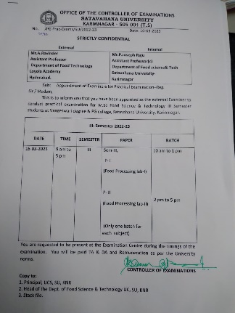
7 |  | Satavahana university Karimnagar- 5050001 | - | 11/03/2024 | External Examiner | 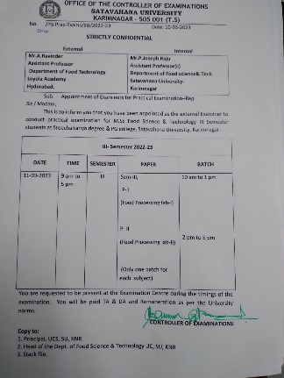
8 |  | Satavahana university Karimnagar- 5050001 | - | 21/03/2024 | External Examiner | 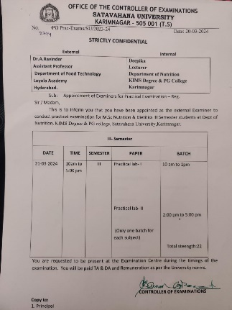
9 |  | Satavahana university Karimnagar- 5050001 | - | 22/03/2024 | External Examiner | 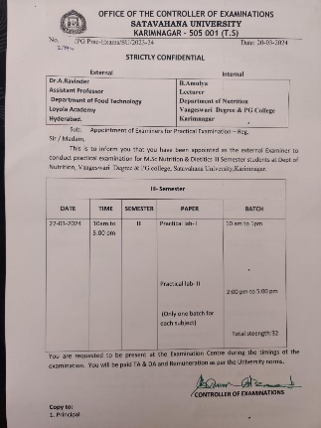
10 |  | Satavahana university Karimnagar- 5050001 | - | 27/03/2024 | External Examiner | 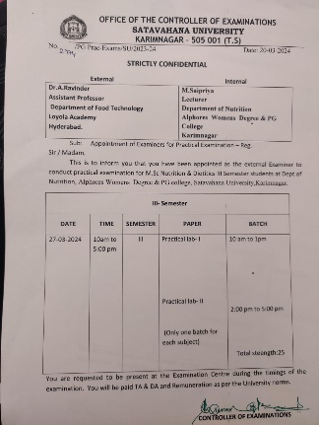

Mrs. S. Jemmy Evangeline

S.NO | NAME OF THE EVENT | THEME | ORGANIZED BY | MONTH/  YEAR | PLACE | PROOF
1. | TOT(Training of Trainer) | Leadership skills | IQAC ( Internal quality assurance cell) Loyola Academy. | June,  2023 | Loyola Academy, Old Alwal, Secunderabad | 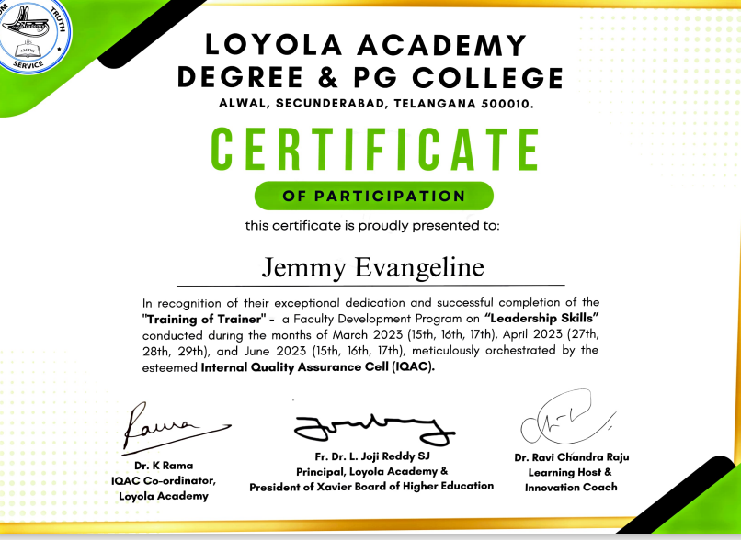
2 | National Webinar | Harnessing Traditional Knowledge & Emerging Food Processing Technologies for Viksit Bharat | NIFTEM (National Institute of Food technology, Entrepreneurship and Management) | March,  2024 | Tanjavur,  Tamil Nadu | 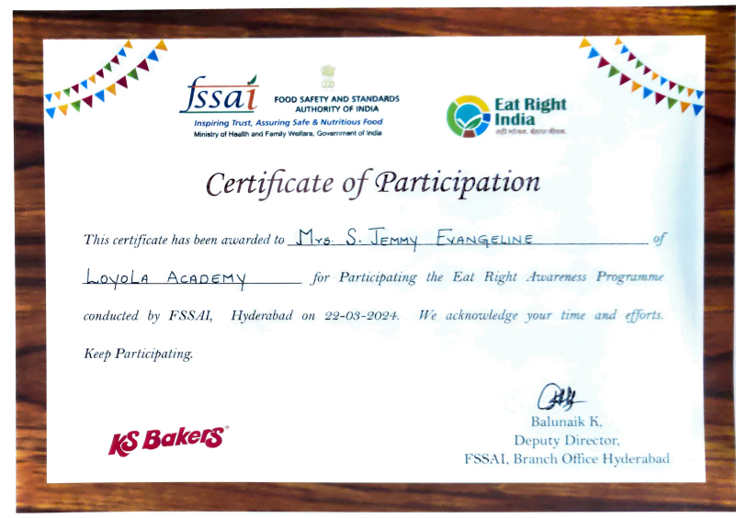
3 | International Conference (Online) | Innovations In Food Processing Technology And Nutrition -IIFN 2024 | Loyola Academy,Hyderabad & MIT World Peace University,Pune | January,  2024 | Hyderabad & Pune | 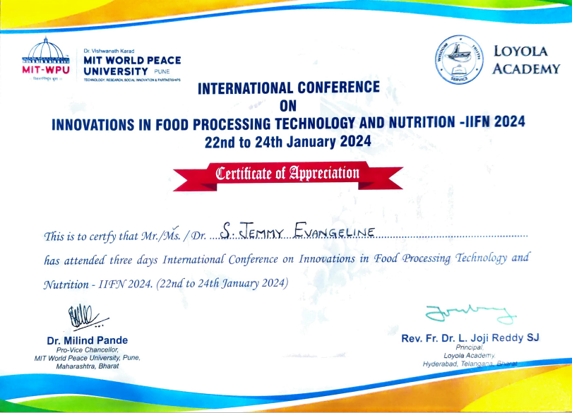
4 | 6th International Conference | Advances in Agriculture Technology and Allied Sciences (ICAATAS-2023) | Loyola Academy & IIMR | June,  2023 | Hyderabad | 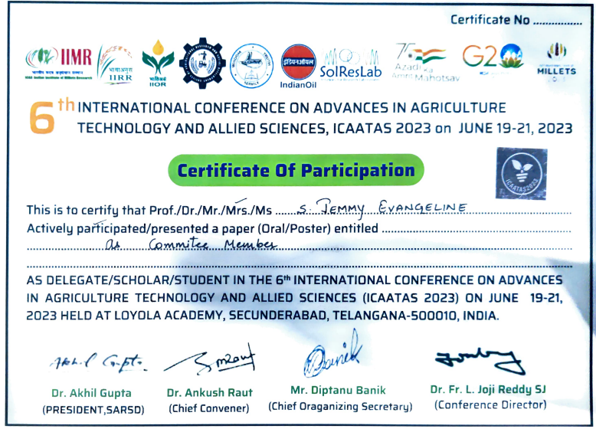
5 | Awareness Program | Eat Right India | FSSAI (Food Safety & Standards Authority of India) | March,  2024 | Hyderabad | 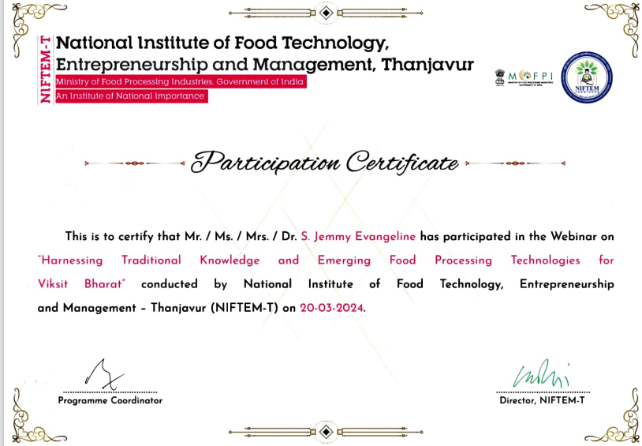

Dr. Sukh Veer Singh
Sr. No. | Themes |  | Place | National/International/state | Year | Enclosures
A. | Attended FDPs
1. | Quality management practices for MSME sector was hosted by National institute for micro, small and medium enterprises |  | Loyola academy Secunderabad | National | Dec 18-22, 2023 | 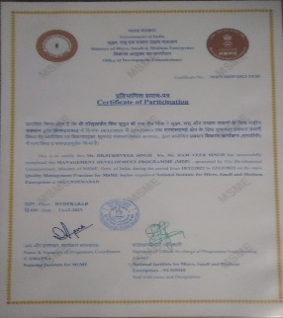
2. | Opportunities and challenges in entrepreneurship were hosted by NSTEDB, Department of science and technology, Govt. of India. |  | Online | National | Jan 3-19, 2024 | 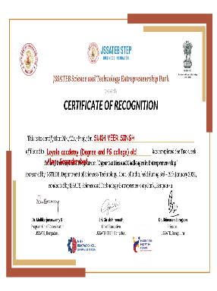
B. | Attended Conferences
1. | International conference on advances in agriculture and technology and allied sciences. |  | Loyola academy Secunderabad | International | June 19-22, 2023 | 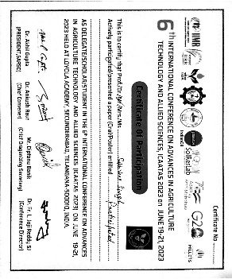
2. | International conference on Innovations in Food Processing Technology and Nutrition |  | Loyola academy Secunderabad in collaboration with MIT world peace university | international | January 22 to 24, 2024 | 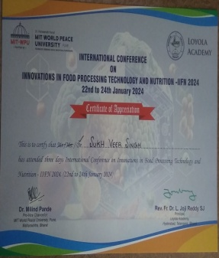
C. | Abstract published
1. | Food and Nutritional Security through Climate-Smart and Nutrient Rich Sorghum Millets. |  | Ranchi | 3rd National Conference on Livelihood and Food Security through Agriculture and Applied Sciences (LFSAAS) on | November, 2023 | 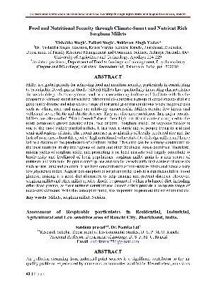
D. | Published articles
1. | Formulation, Process Optimization, and Biochemical Characterization of Cereal-Based Sweet Potato and Mulberry Instant Beverage. Pp 1-11. https://doi.org/10.1155/2024/9230592. | Journal of Food Quality. |  | International journal  (Impact factor-3.3) | April 9, 2024 | 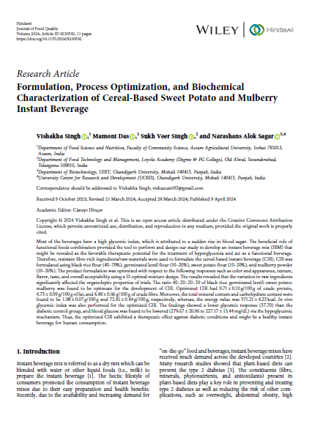
2. | Bioactive compounds in Pyrus pashia, their Bioactivities, and Associated Health Benefits: A Review. | Journal of Food Chemistry & Nanotechnology. |  | International journal | March 15, 2024 | 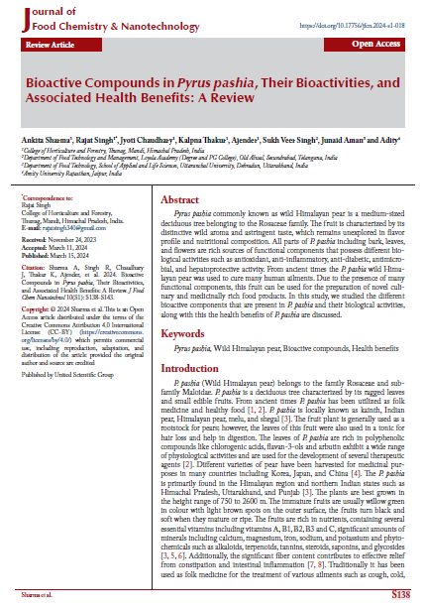

Mrs. K Tejaeswini
 | THEME | PLACE | INTERNATIONAL/NATIONAL/STATE | YEAR | RESOURCE/  PAPER | CERTIFICATE
1. | Quality Management Practices for MSME Sector. | Loyola College | FDP | 2023 | Participated | 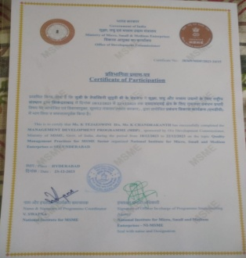
2. | Innovations in Food Processing Technology And Nutrition | Online | International  Seminar | 2023 | Participated in Oral Presentation | 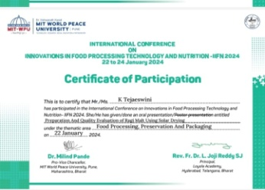

STUDENT ACHIEVEMENTS

ICATAAS 2023 - Winners & Runners

S.No | UID no | Name | Winners | Runners
1 | 111722620009 | MUSKHAN TAKUR | 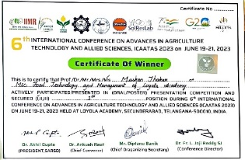 | __
2 | 111722620010 | G A NISSI KRUPA | 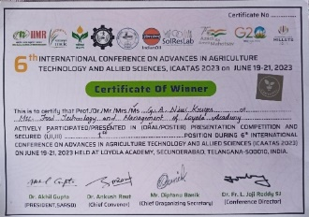 | __
3 | 111722620013 | A. PRAVALIKA REDDY | __ | 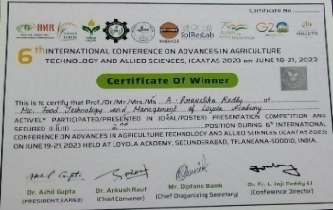
4 | 111722620015 | G. SHRAVANI KALYANI | __ | 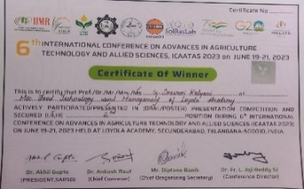
5 | 111722620019 | FAIZAN | 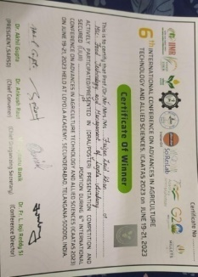
6 | 111722620033 | UMME HABEEBA | 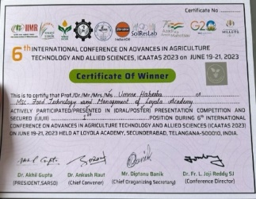

 | Programme | Specialization | UID | Name of the student | Name of the Event | State / National / International level | Achivements
1 | Eat Right Awareness Programme | 3rd prize (Group) | 111723620001 | S.Vaishnavi | FSSAI (Eat Right India) | National Level | 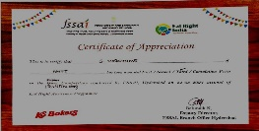
2 | Eat Right Awareness Programme | Consolation Prize (Group) | 111723620006 | Shrinivas Sharma | FSSAI (Eat Right India) | National Level | 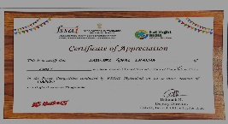
3 | Eat Right Awareness Programme | Consolation Prize (Group) | 111723620008 | Alisha | FSSAI (Eat Right India) | National Level | 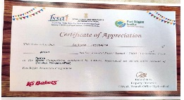
4 | Eat Right Awareness Programme | Consolation Prize (Group) | 111723620009 | T Pooja | FSSAI (Eat Right India) | National Level | 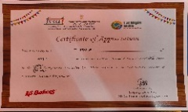
5 | Eat Right Awareness Programme | Consolation Prize (Group) | 111723620011 | Elanor Connor | FSSAI (Eat Right India) | National Level | 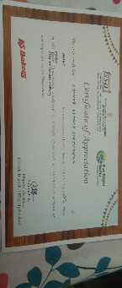
6 | Eat Right Awareness Programme | Consolation Prize (Group) | 111723620013 | Mohit | FSSAI (Eat Right India) | National Level | 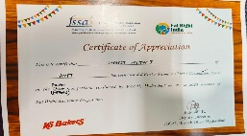
7 | Eat Right Awareness Programme | 3rd prize (Group) | 111723620015 | Mukesh | FSSAI (Eat Right India) | National Level | 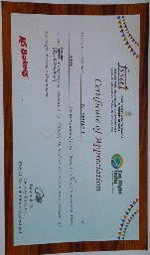
8 | Eat Right Awareness Programme | 2nd Prize (Group) | 111723620017 | Prathibha | FSSAI (Eat Right India) | National Level | 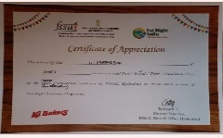
9 | Eat Right Awareness Programme | 3rd prize (Group) | 111723620019 | Sravya sri | FSSAI (Eat Right India) | National Level | 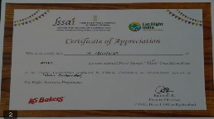
10 | Eat Right Awareness Programme | 3rd prize (Group) | 111723620020 | Rani | FSSAI (Eat Right India) | National Level | 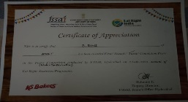
11 | Eat Right Awareness Programme | 2nd Prize (Group) | 111723620021 | CH.Nikitha | FSSAI (Eat Right India) | National Level | 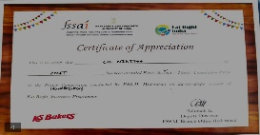
12 | Eat Right Awareness Programme | Consolation Prize (Group) | 111723620023 | Tanisha | FSSAI (Eat Right India) | National Level | 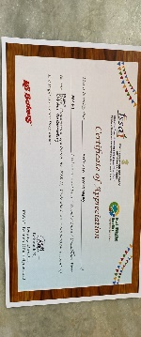
13 | Eat Right Awareness Programme | 3rd prize (Group) | 111723620029 | Dakshayini | FSSAI (Eat Right India) | National Level | 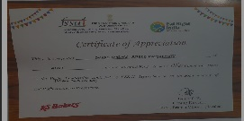
14 | Eat Right Awareness Programme | 2nd Prize (Group) | 111723620030 | G.Vaishnavi | FSSAI (Eat Right India) | National Level | 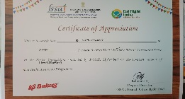
15 | Eat Right Awareness Programme | 2nd Prize (Group) | 111723620031 | Divya | FSSAI (Eat Right India) | National Level | 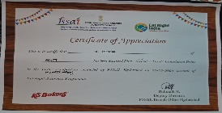

PARENT-TEACHER MEETING REPORT

PARENT-TEACHER MEETING
a. Concept:
Parent Teacher Meeting for M.Sc. I year and II year students was conducted on 6th January 2024.
- Purpose:
To interact with parents and give feedback of the students and also get suggestions from them for the improvement of the department
- Report:
Parents and students met all the staff members on one to one basis.
- Reviews:
It is useful for the improvement of the students.

Agenda of the meeting:
- Interaction between parents and teachers to create a healthy teaching environment.
- To refresh the rules and regulations of Loyola Academy.
- To inform parents regarding detain Rules and Attendance Rules.
- To check and improve the academic performance of students.
- To improve the results of students by taking various actions.
- Feedback will be given by parents.
Highlights of Meeting:
- Parents are familiar with rules and Regulations of Loyola Academy.
- Parents have checked attendance and academic performance of their ward.
- Parents were known about their wards behaviour, Discipline and responsibility.
- Contact numbers of department faculties are provided to parents for better communication.
Suggestions given by the parents:

- Apart from teaching curriculum lecturers have to provide the information regarding the course and its importance.
- Department need to organise internships and projects to the students to improve the practical knowledge.
Feedback given by the parents:
Parents expressed their gratification towards the institution in enhancing the personality of the students under the able guidance of Principal. They also appreciated the efforts being made by the college for the overall development of their ward. Parents were very happy regarding the activities going on in the college.

Few of the student parents were not available for the meeting so for them an online session is being done. Proof for the following online session
e. Photos:

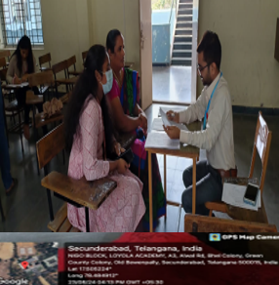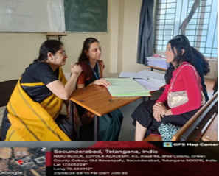

MENTOR-MENTEE LIST

MENTOR-MENTEE LIST 2023-24
S. No | Name of the Faculty | Class/No. of Students | UID. No. | Name of students | Total no of Students
1 | Dr. Palety Kiran Kumari | NMFT-7 | 111722620001 to 07 | 1. DIYA SANJANA PEDAGADA  2. VADLA SHRAVYA CHARY  3. GADDALA ANIRUDH  4. KOLLIMALLA BINDURANI  5. DIVITI DIVYANANDINI  6. YELAMANCHILI ANURADHA  7.RAMARAJU SRINIDHI | 14
1 | Dr. Palety Kiran Kumari | AMFT-7 | 8 to 14 | 8. ALISHA HOSSAIN  9. T. POOJA  10. MAHATI ADURTHI  11. C. ELANOR CHRISTOPHER  12. S. IMAM BASHA  13. MOHIT VALTATI  14. R. POOJA | 14
2 | Dr. A. Ravinder | NMFT-7 | 111722620008 to 14 | 8.BONDALADINNE HAVILAH JOY  9. MUSKAN THAKUR  10. G A NISSI KRUPA  11.CHENNA AMULYA  12.DANDU PREETHI  13. A. PRAVALIKA REDDY  14. NIRNI VAISNAVI | 14
2 | Dr. A. Ravinder | AMFT-7 | 1 to 7 | 1.S. VAISHNVI  2. S. AKHILA  3. C. POOJA  4. C. PRADEEP  5. A. PRAVALLIKA  6. S. GOPAL SHARMA  7. THANAM MARYSONA | 14
3 | S. Jemmy Evangeline | NMFT-7 | 111722620015 to 22 | 15. G. SRAVANI KALYANI  16. L. LALITHA BAI  17. V. MOUNIKA  18. G.BHANU CHANDU PRIYA  20. C. VINAY VARMA  21.M. L. SAI SRI ALEKHYA  22. R. SUCHITA | 14
3 | S. Jemmy Evangeline | AMFT-7 | 22 to 28 | 22. P. VENKATESWARAN  23. TANISHA PATANGAY  24. K. ROSHINI  25. NERELLA SATHWIKA  26. O. SHIVA PAVANI  27. M. NAZEER AHMAD  28. DUSARI PAPA NIKITHA | 14
4 | Dr. Sukh Veer Singh | NMFT-7 | 111722620023 to 29 | 23. V. MANOJ KUMAR  24. V. VENKATA SAI KUMAR VERMA  25. ALLAM MARY NIKITHA  26. R. PRANEETHA  27. D. SHRADDHA  28. R. SAI SUMA  29. C. LAXMI PRASANNA | 14
4 | Dr. Sukh Veer Singh | AMFT-7 | 29 to 35 | 29. D SREEDHAR JUKANTI  30. BADALA SRUTHI  31. L. MEGHANA YADAV  32. C. HARSHA VARDHAN REDDY  33. ABDUL NADEEM  34. DEVELLA AKSHYA  35. S. SWAPNA | 14
5. | Ms. K Tejaeswini | NMFT- 7 | 111722620030 to 36 | 30. S. JOSH HYCINTH  31. G. PRATHYUSHA  32. N. JAHNAVI  33. UMME HABEEBA  34. AKSHAYA MANOJ  35. M. REKHA  36. Z. BLESSY PRASIDHI | 14
5. | Ms. K Tejaeswini | AMFT- 7 | - o 21 | 15. D. MUKESH  16. B. CRISHTOPHER  17. U. PRATHIBHA  18. M. SAI VENKATA SOWJANYA  19. MADASU SRAVYASRI  20. BAVU RANI  21. C. NIKITHA | 14
Total Strength |  |  |  |  | 70

STUDENT SCHOLARSHIP

S.no | Uid no. | Name of the candidate | Name of the acc holder (parent) | Proposed amount
1. | 111723620021 | Chekkera Nikihitha | Chekkera Seetha Ramireddy | 10000
2 | 11172362007 | Thanam Mary Sona | Manju Thanam | 7500
3 | 111723620014 | Rathod Pooja | Rathod Gokul | 3000
4 | 111723620036 | Habeeba | Hazibaba | 7500
5 | 111723620019 | M. sravya Sri | M. Sujatha | 5000
6 | 111723620002 | Sudiga Akhila | Sudiga Lingaiah | 5000
7 | 111723620012 | Shaik. Imam Basha | Shaik Mahaboob Basha | 5000
8 | 111723620028 | Dusari Papa Nikitha | Dusari Bhasker | 5000
9 | 111723620003 | CH. Pooja | Bala Murali Krishna Reddy | 5000
10 | 111723620024 | Kompelli Roshini | Kompelli Ramesh | 10000
11 | 111723620004 | CH. Pradeep | C. Shekar | 10000
12 | 111723620009 | T.Pooja | T. Rukmini Bhai | 5000

NPTEL DATA

S.NO | UID | NPTEL Roll No | Name of Student | Title of the Course | No of Weeks | Percentage | Certiicates
1 | 111722620005 | NPTEL23AG18S637403554 | DIVITI DIVYANANDINI | Dairy And Food Process and Products Technology | 12 | 71% | 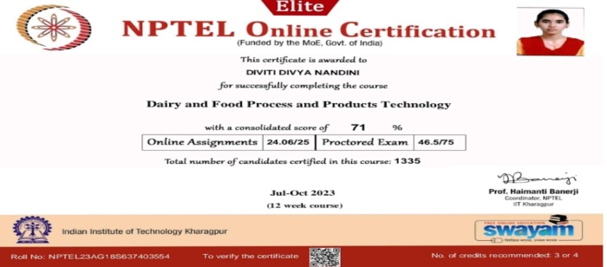
2 | 111722620007 | NPTEL23AG18S537402754 | RAMARAJU SRINIDHI | Dairy And Food Process and Products Technology | 12 | 57% | 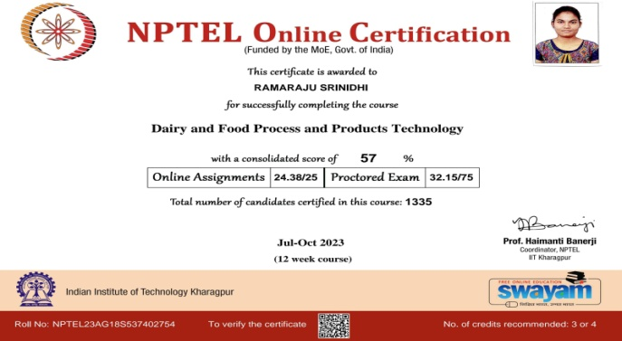
3 | 111722620008 | NPTEL23AG18S637403627 | BONDALADINNE HAVILAH JOY | Dairy And Food Process and Products Technology | 12 | 52% | 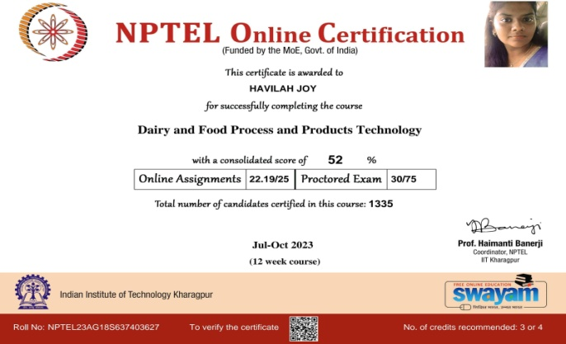
4 | 111722620011 | NPTEL23AG18S637403334 | CHENNA AMULYA | Dairy And Food Process and Products Technology | 12 | 62% | 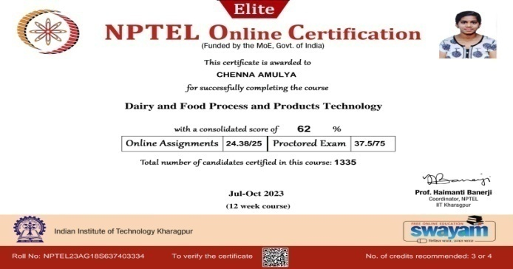
5 | 111722620013 | NPTEL23AG18S537402165 | ANKANNAGARI PRAVALIKA REDDY | Dairy And Food Process and Products Technology | 12 | 54% | 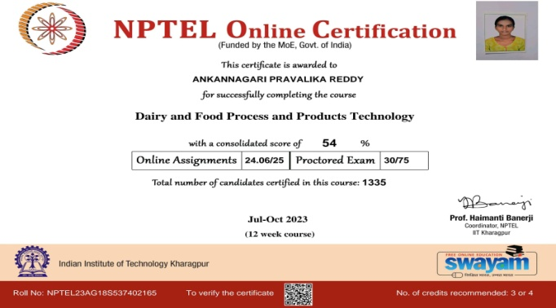
6 | 111722620015 | NPTEL23AG18S537402679 | GANGADHARI SRAVVANI KALYANI | Dairy And Food Process and Products Technology | 12 | 54% | 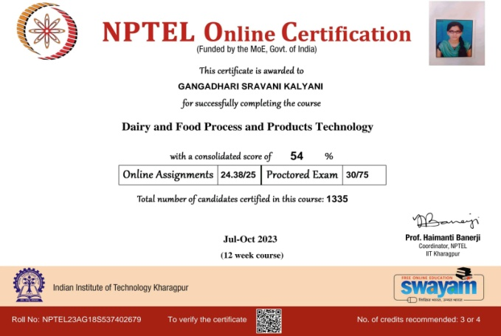
7 | 111722620018 | NPTEL23AG18S637403190 | GADDAM BHANU CHANDU PRIYA | Dairy And Food Process and Products Technology | 12 | 55% | 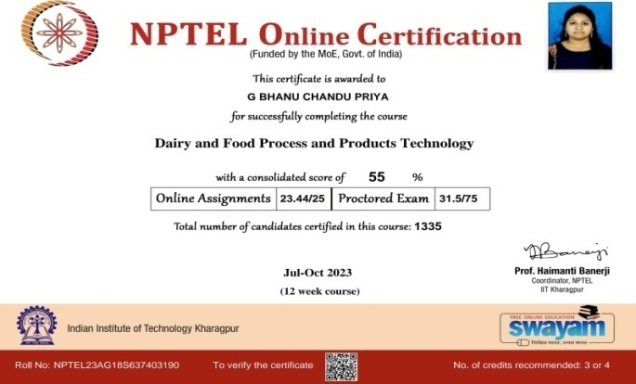
8 | 111722620021 | NPTEL23AG18S637403914 | MAGAPU LEELA SAI SRI ALEKHYA | Dairy And Food Process and Products Technology | 12 | 54% | 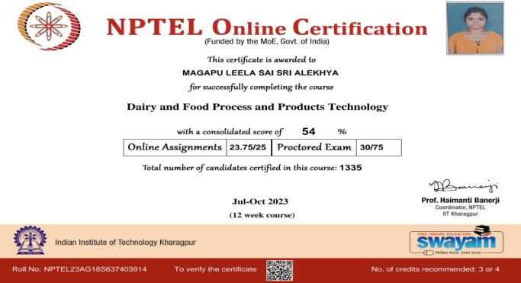
9 | 111722620022 | NPTEL23AG18S639200279 | RENTALA SUCHITHA | Dairy And Food Process and Products Technology | 12 | 67% | 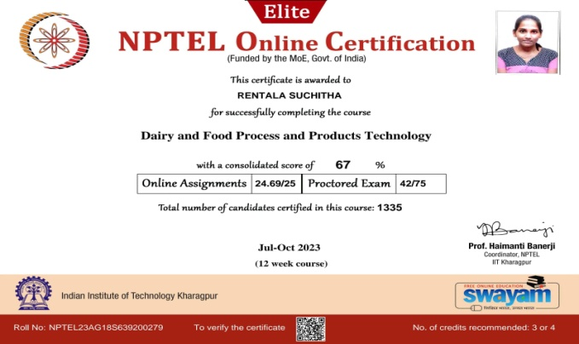
10 | 111722620024 | NPTEL23AG18S537402982 | VADDE VENKATA SAI KUMAR VARMA | Dairy And Food Process and Products Technology | 12 | 53% | 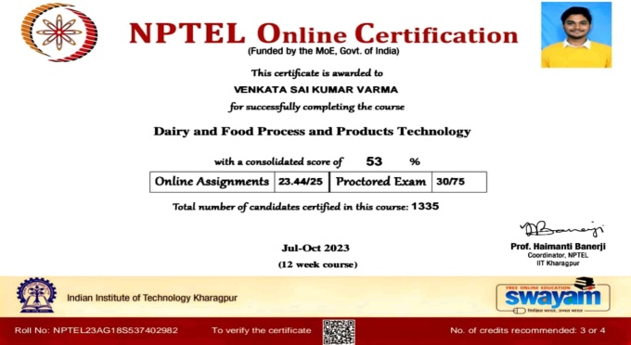
11 | 111722620025 | NPTEL23AG18S637405885 | ALLAM MARY NIKHITHA | Dairy And Food Process and Products Technology | 12 | 66% | 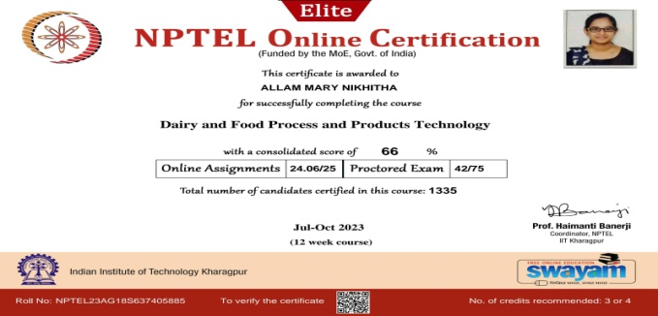
12 | 111722620027 | NPTEL23AG18S537402531 | DESHPANDE SHRADDHA | Dairy And Food Process and Products Technology | 12 | 58% | 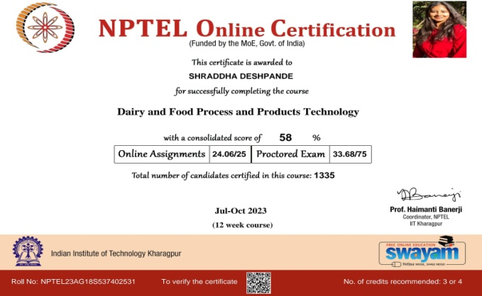
13 | 111722620028 | NPTEL23AG18S537402238 | RENUKUNTLA SAI SUMA | Dairy And Food Process and Products Technology | 12 | 61% | 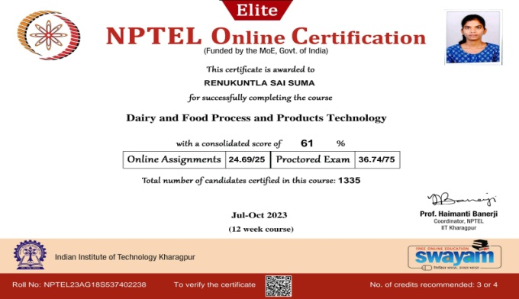
14 | 111722620030 | NPTEL23AG18S637403698 | SATHINAPALLI JOSH HYCINTH | Dairy And Food Process and Products Technology | 12 | 63% | 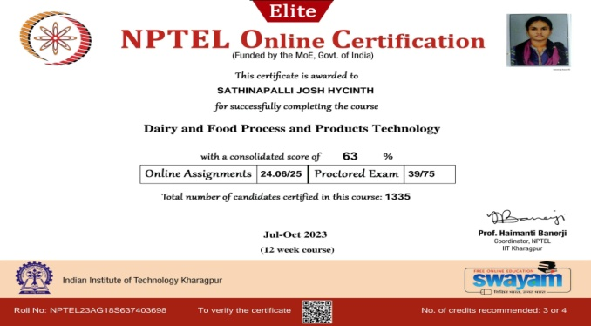
15 | 111722620032 | NPTEL23AG18S537402019 | NEELAM JAHNAVI | Dairy And Food Process and Products Technology | 12 | 63% | 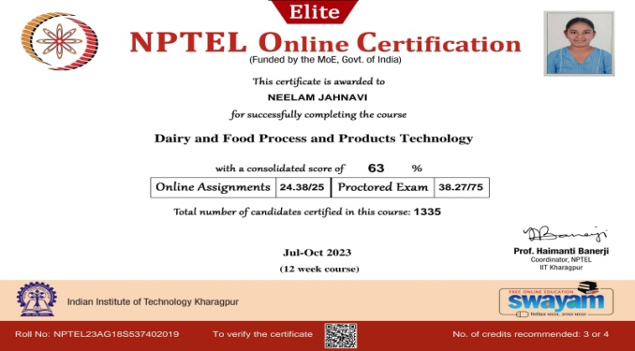
16 | 111722620033 | NPTEL23AG18S537402910 | UMME HABEEBA | Dairy And Food Process and Products Technology | 12 | 61% | 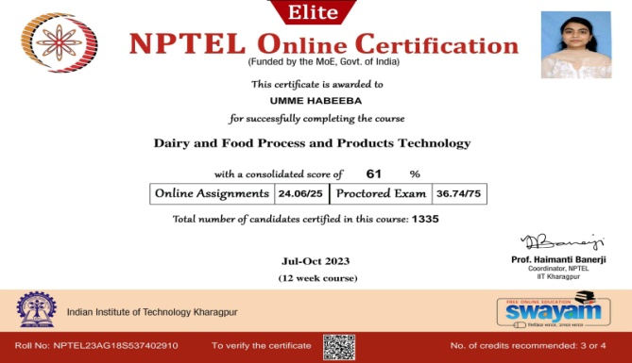
17 | 111722620034 | NPTEL23AG18S637403119 | AKSHAYA MANOJ | Dairy And Food Process and Products Technology | 12 | 47% | 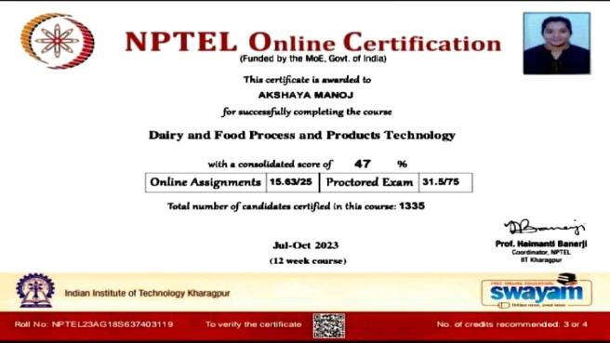
18 | 111722620035 | NPTEL23AG18S637403985 | MARUPAKA REKHA | Dairy And Food Process and Products Technology | 12 | 60% | 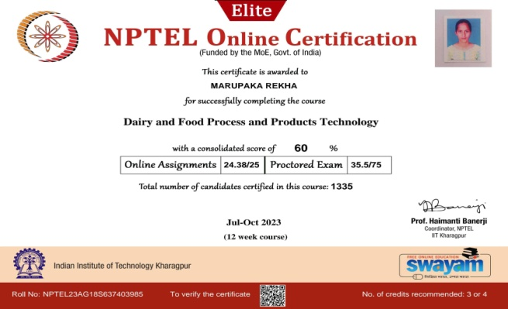
19 | 111722620036 | NPTEL23AG18S637403263 | ZADDA BLESSY PRASIDHI | Dairy And Food Process and Products Technology | 12 | 50% | 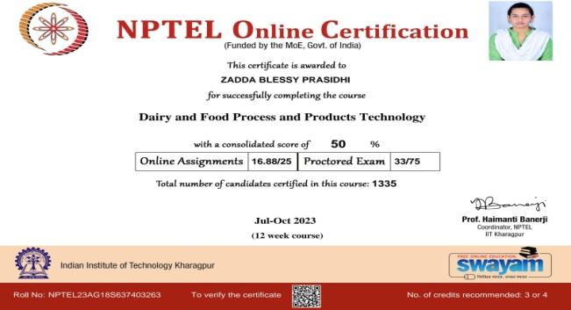

S.NO | NAME | UID | COURSE NAME | CERTIFICATE
1 | Elanor Connor | 1117236200011 | Modern Food packaging technologies: Regulatory aspects and global trends | 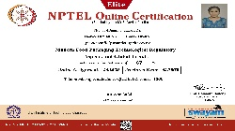
2 | Dakshyayini | 111723620029 | Modern Food packaging technologies: Regulatory aspects and global trends | 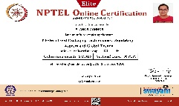

PLACEMENT

S.No | Name of the student | Programme | Specialization | UID | Male/Female | Contact No of the student | Company placed | Contact details company | Pay package (LPA) | On/Off | Proof
1 | Uppuluri Naga Krishna Sai | M.Sc | Food Technology and Management | 1.11722E+11 | Male | 9966271413 | Bakewell Industries pvt.ltd | HR-Veerababu-9347196342 | 1,80,000 | Off | https://drive.google.com/file/d/10kbfOQ8bp6L5iR4xOwTJjYj3yYkTCyIt/view?usp=sharing
2 | Aguru Bala Veera srinivas | M.Sc | Food Technology and Management | 1.11722E+11 | Male | 703221283 | Bakewell Industries pvt.ltd | HR-Veerababu-9347196342 | 1,80,000 | Off | https://drive.google.com/file/d/1a0qayZjHUc7z0No55b2zxwB38rP7FRKO/view?usp=sharing
3 | Alshil Pramod | M.Sc | Food Technology and Management | 1.11722E+11 | Male | 7842316367 | Sid's Farm | Nagurvali HR-8309080683 | 2,72,811 | Off | https://drive.google.com/file/d/18DhLdbdNydmWvbcN56x9U-1cyh7PLdhS/view?usp=sharing
4 | B.Thanu Deekshitha | M.Sc | Food Technology and Management | 1.11722E+11 | Female | 9502337052 | Anjali hotels Pvt.Ltd | Srinivas Mantha-HR | 2,57,569 | Off | https://drive.google.com/file/d/14TqNgZoqzwsFdvUky6YRGvd0OHTTwML_/view?usp=sharing
5 | K.Bhavana Bai | M.Sc | Food Technology and Management | 1.11722E+11 | Female | 7995227798 | Food Safety India Pvt Ltd | Probation period | 1,20,000 | 0ff | https://drive.google.com/file/d/108EXuHxqIGd55prDzjwNygsF-_K80erQ/view?usp=sharing
6 | Dasari Angelina | M.Sc | food Technology and Management | 1.11722E+11 | Female | 8688801953 | SEED | R.Shyamala-Gen.Secretary | 1,80,000 | Off | https://drive.google.com/file/d/1LWYCLLVh9f9oGiy0goUkrQyBJGaOm2Ib/view?usp=sharing

HIGHER EDUCATION

S.NO | Programme Graduated From | Department Graduated From | UID | Name of the Student | Name of the institution Joined | Nameof the programme admittedm into | Admission letter/ID
1 | M.Sc | Food Technology & management | 111721620008 | MALIREDDY SIVA JOSHNI | Rochester Institute of technology | MS in Packaging Science | https://drive.google.com/file/d/1nqfeKcuwDCrtEe8aIZVRG7F-bxpidaPy/view?usp=sharing

