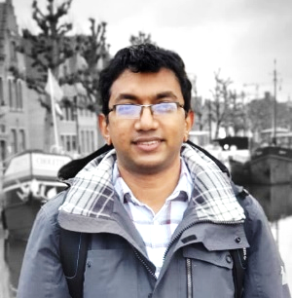

Fr. Dr. Thomas Lourdu Madanu, SJ is a Jesuit priest and a scholar in Chemistry with a strong commitment to higher education, research, and student formation. He holds a Doctor of Sciences (PhD) in Chemistry from the University of Namur, Belgium, where his research focussed on photonic structures and their applications in photocatalysis for solar energy conversion. His academic formation integrates science, philosophy, and theology, reflecting the Jesuit tradition of holistic education.
Fr. Thomas has several years of experience in teaching, academic administration, and student mentoring in Jesuit institutions. His research work has resulted in nine publications in international peer-reviewed journals and presentations at about ten international conferences across Europe, the United States, and China. Since 2024, he has been serving as Controller of Examinations besides working as Assistant Professor in the department of MSc Organic Chemistry.

