
TITLE OF THE EVENT | Session on Thriving one day at a time
DATE | 7-02-2026, 9:30-10:25AM
VENUE | IG Block -309
ORGANIZER, COORDINATOR | Farheen Asif
SPEAKERS/ RESOURCE PERSONS | Ms. Sandhria Thomas A (Assistant Professor in Psychology & Student Counsellor).
TARGET AUDIENCE | First Year Students of MSC- biotechnology
OBJECTIVES OF THE EVENT:

STUDENTS DETAILS:
TOTAL STUDENTS |  | 32
DEMOGRAPHICS |  | Students of MSC- biotechnology
ATTENDANCE PERCENTAGE |  | 95%
CONTENT EVALUATION:
Session Highlights:
RELEVANCE OF THE TOPIC
The session titled “Thriving One Day at a Time” was designed specifically to address stress management among postgraduate students, who often face heightened academic demands, career-related uncertainty, and personal responsibilities. The theme was timely and meaningful, as it focused on helping students understand stress as a manageable experience rather than an overwhelming condition, thereby promoting mental well-being within the academic environment.
DEPTH OF KNOWLEDGE DELIVERED
The session offered a comprehensive understanding of stress, including its causes, manifestations, and impact on mental and emotional health. Psychological concepts related to stress response, coping mechanisms, and resilience were presented in a structured and accessible manner. The content balanced theoretical understanding with practical relevance, enabling students to connect concepts to their everyday academic and personal experiences.

ENGAGEMENT OF STUDENTS

Active engagement was observed throughout the session. Students were encouraged to reflect on their own stress patterns, share perspectives, and participate in guided discussions. The interactive nature of the session helped sustain attention, encouraged openness, and fostered a sense of shared learning among postgraduate students.
LEARNING OUTCOMES:

. At the conclusion of the session, students demonstrated:
- Enhanced awareness of personal and academic stressors
- Improved understanding of how stress affects mental and emotional functioning
- Knowledge of simple, effective strategies to manage daily stress
- Greater confidence in adopting healthier coping practices

KEY TAKEAWAY FOR STUDENTS:

Managing stress is a gradual and ongoing process. Progress lies in taking small, intentional steps toward well-being each day, rather than striving for immediate or unrealistic change.

SKILLS/ KNOWLEDGE GAINED
Through the session, students developed:
- Practical skills to recognize and manage stress proactively
- Emotional regulation and self-monitoring techniques
- Knowledge of maintaining balance between academic demands and personal health
- An understanding of resilience as a skill that can be developed over time

FEEDBACK ANALYSIS:
Method of Feedback Collection: Feedback was gathered in person from postgraduate students immediately after the completion of the session.

Positives
- The session content was perceived as relevant to current student challenges
- Explanations were clear, structured, and easy to understand
- The delivery style encouraged comfort and active participation
- Students valued the practical focus of the session
RATING ON A SCALE of 1-5
CONTENT QUALITY: 4.6/5
SPEAKER EFFECTIVENESS: 4.8/5
PRESENTATION STYLE : 4.6/5
QUANTITATIVE ANALYSIS AND FUTURE PRACTICES:
The consistently high ratings reflect the effectiveness of the session in addressing student needs. The positive feedback highlights the importance of continued mental health initiatives for postgraduate students. Future practices may involve regular mental health sessions, skill-based workshops, and structured support programs to promote long-term well-being.

SUGGESTIONS FOR FUTURE EVENTS:
- Organizing follow-up sessions focusing on specific stress-related themes
- Incorporating experiential activities such as relaxation or mindfulness practices
- Providing take-home resources for continued self-practice
- Conducting periodic mental health programs for postgraduate students

EVENT PHOTOS:
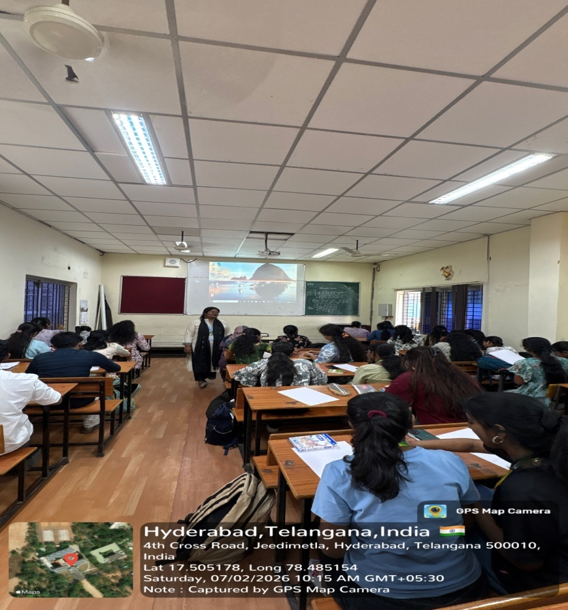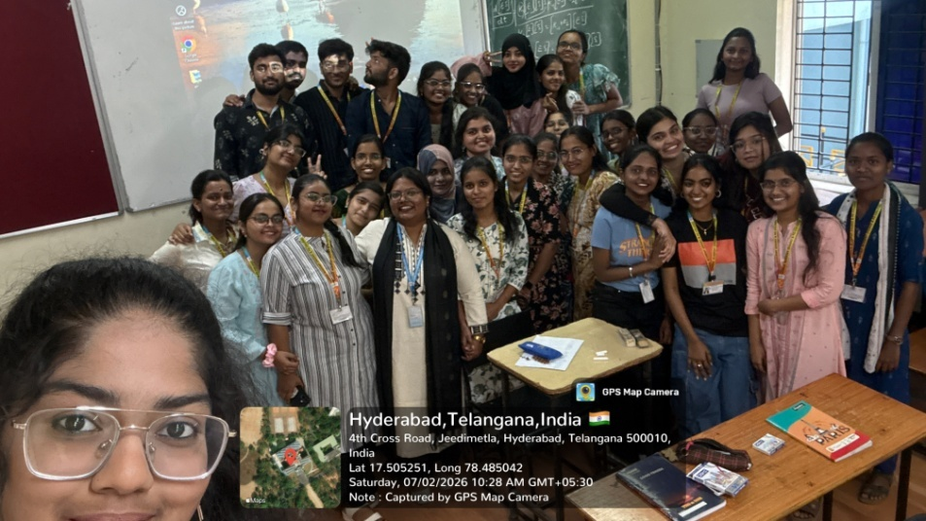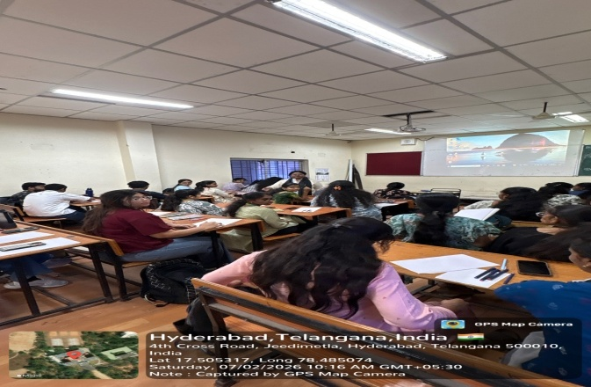

ATTENDANCE SHEET :

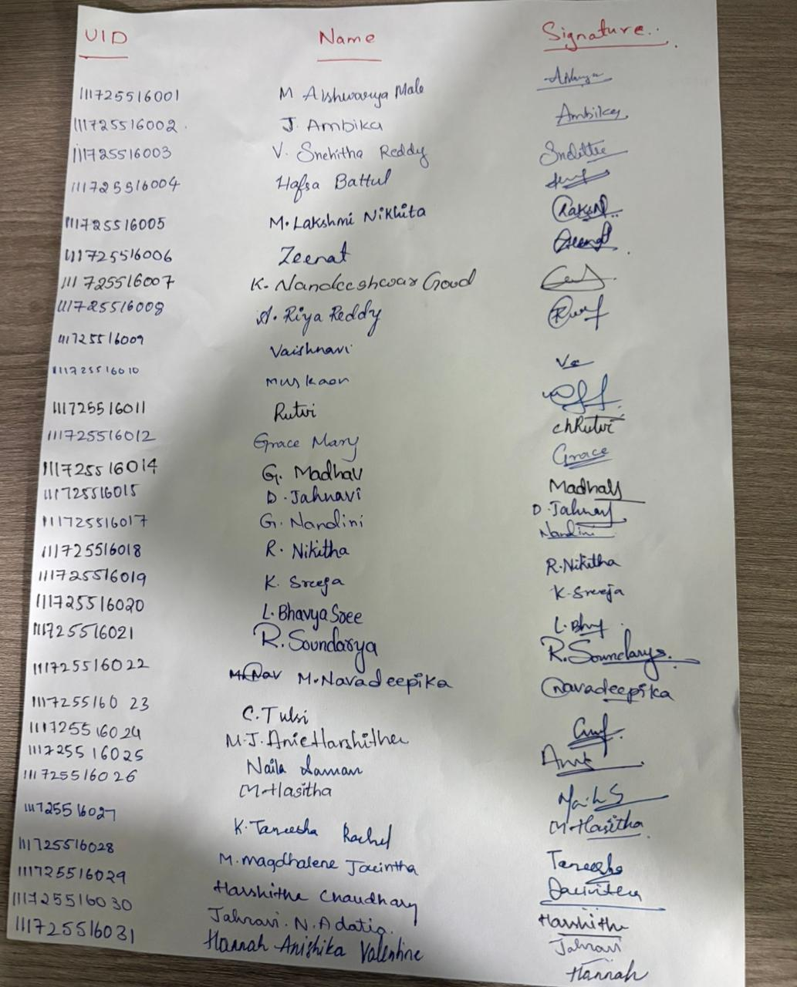

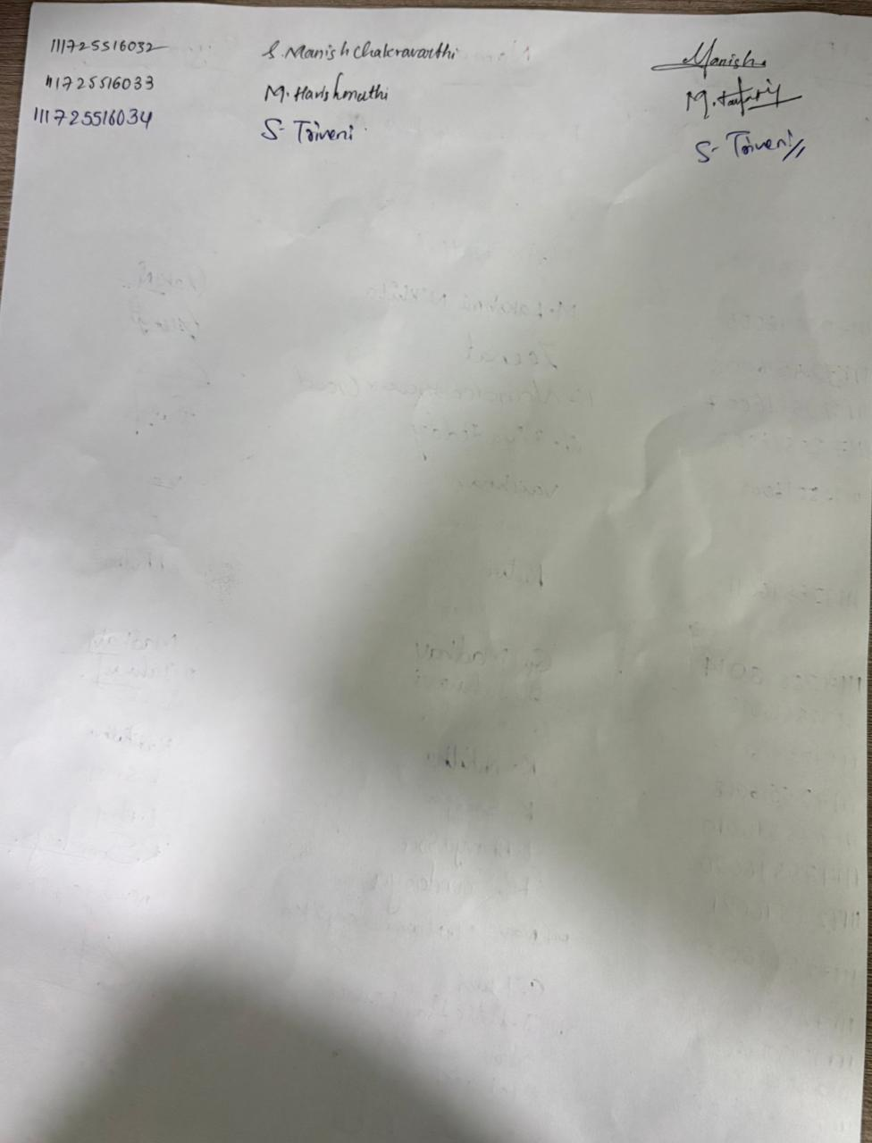

FEEDBACK:
