NCC
ANNUAL RECORD
2022-23

EVENT RECORD
INDEX
Sr no | EVENT
1 | World environment day
2 | International yoga day
3 | Azadi ka Amrit Mahotsav
4 | 76thIndependence day
5 | Hyderabad Liberation day
6 | Fit India
7 | B certificate completion
8 | B1 enrollment
9 | Guard to 1st cardinal of Telangana
10 | Rashtriya Ekta Diwas
11 | Puneeth Sagar Abhiyan
12 | National Constitution Day
13 | Guard to Vice Chancellor
14 | 74th Republic Day
15 | CPR Training Session
- WORLD ENVIRONMENT DAY

On the occasion of World Environment Day, 5th June 2022, an Event was conducted by Rev Fr. Dr L.Joji Reddy gave a speech, Dr N Maria Das and Vice Principals the college NCC and NSS units. The program was successful in bringing up awareness about the Environment through the coordination of both NCC, NSS students, and Lecturers participated actively.
Students actively participated in various events conducted:
- CLEANING UP THE LOCAL AREA:
Cleaning and organizing are a Practice, not an Event, students exerted themselves in cleaning up the college premises by brooming and picking up the paper and plastic litter.
- BEST OUT OF WASTE:
The waste materials found in the college surroundings were picked by the Cadets to make the best out of them, this was quite interesting for participants and judges as well.
- POSTER MAKING:
Poster making was based on the Theme – ONLY ONE EARTH.
NCC, NSS, and also the Lecturers took part, making the event much special.
- RALLY:
The Rally included motivational slogans and art pieces made in the poster-making competition.

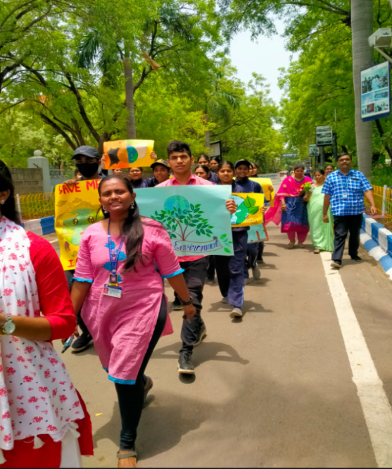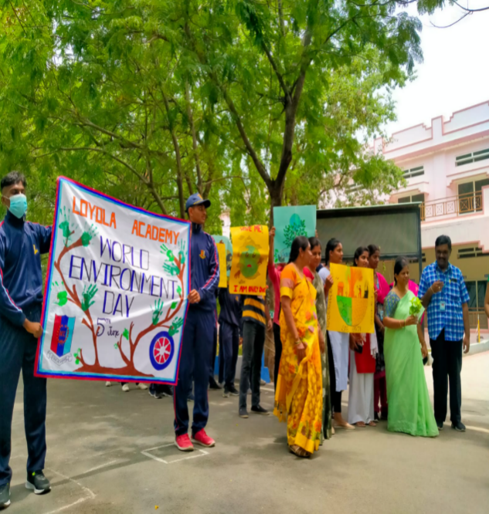
COMPETITIONS:

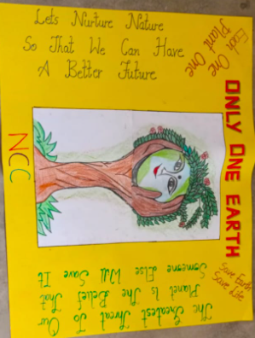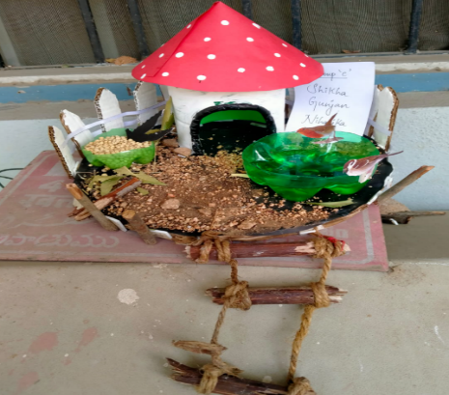
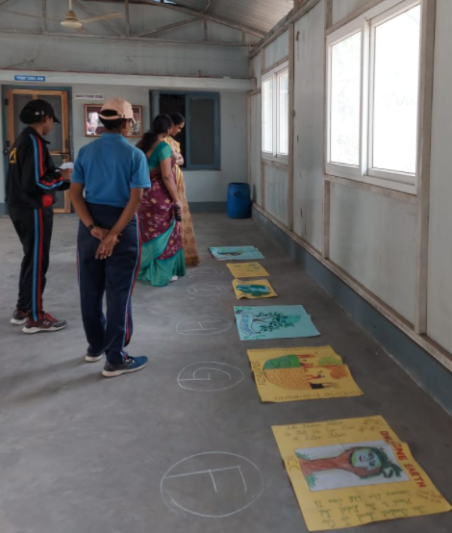

KEEPING PREMISES CLEAN:

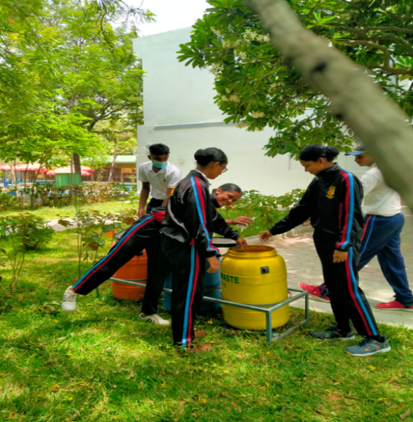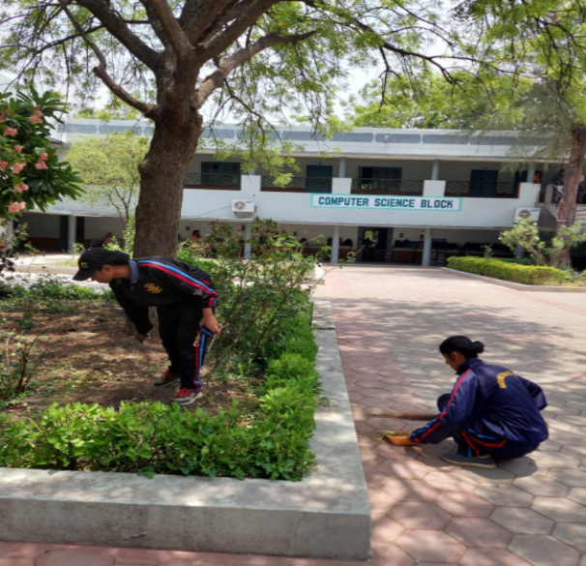
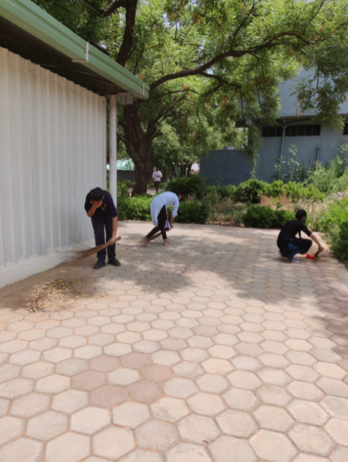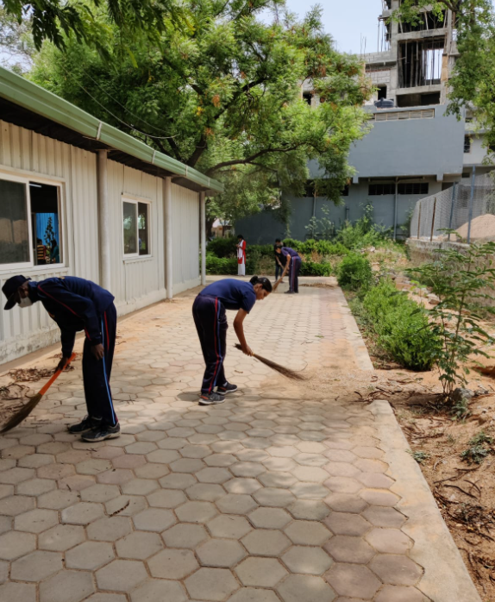

EVENT: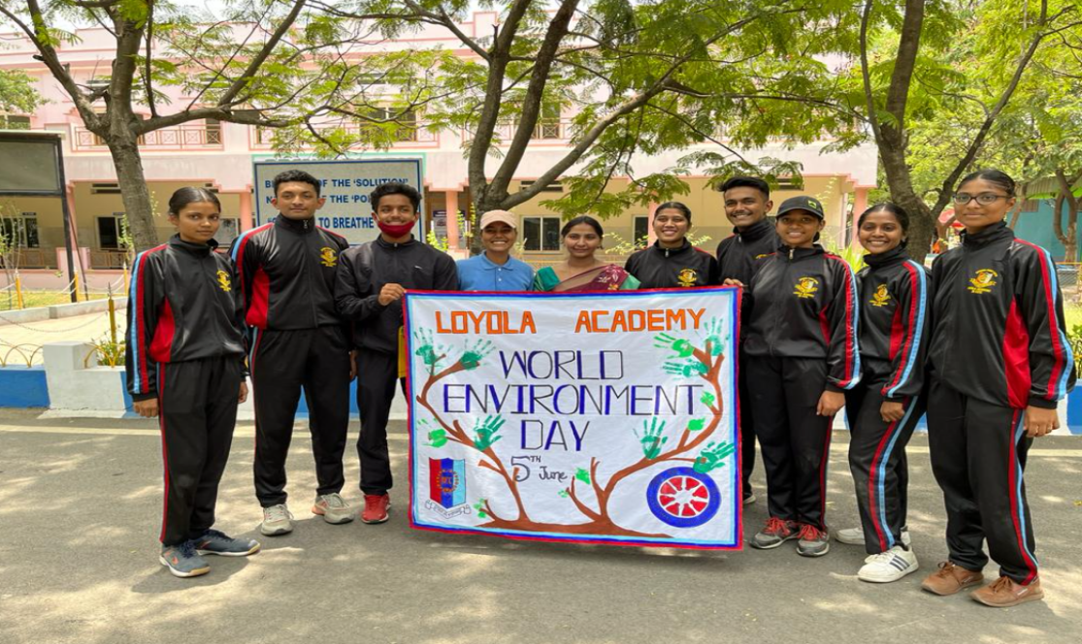
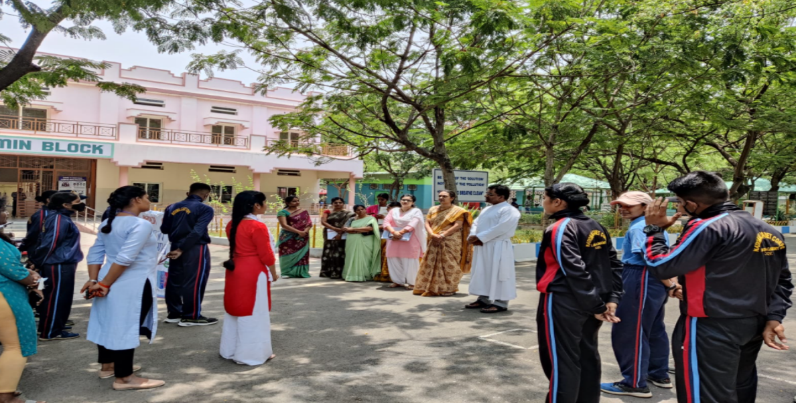

2.INTERNATIONAL YOGA DAY
On the occasion of International Yoga Dayon 21st June 2022, an event was conducted by the college NCC and NSS units. The program was successful in bringing up awareness about the importance of yoga and mental health.
Dr.L.Joji Reddy SJ, Principal and Dr.N.Maria Das, Vice principal ,and other teaching staff actively participated along with students. Led by the Yoga instructors.
.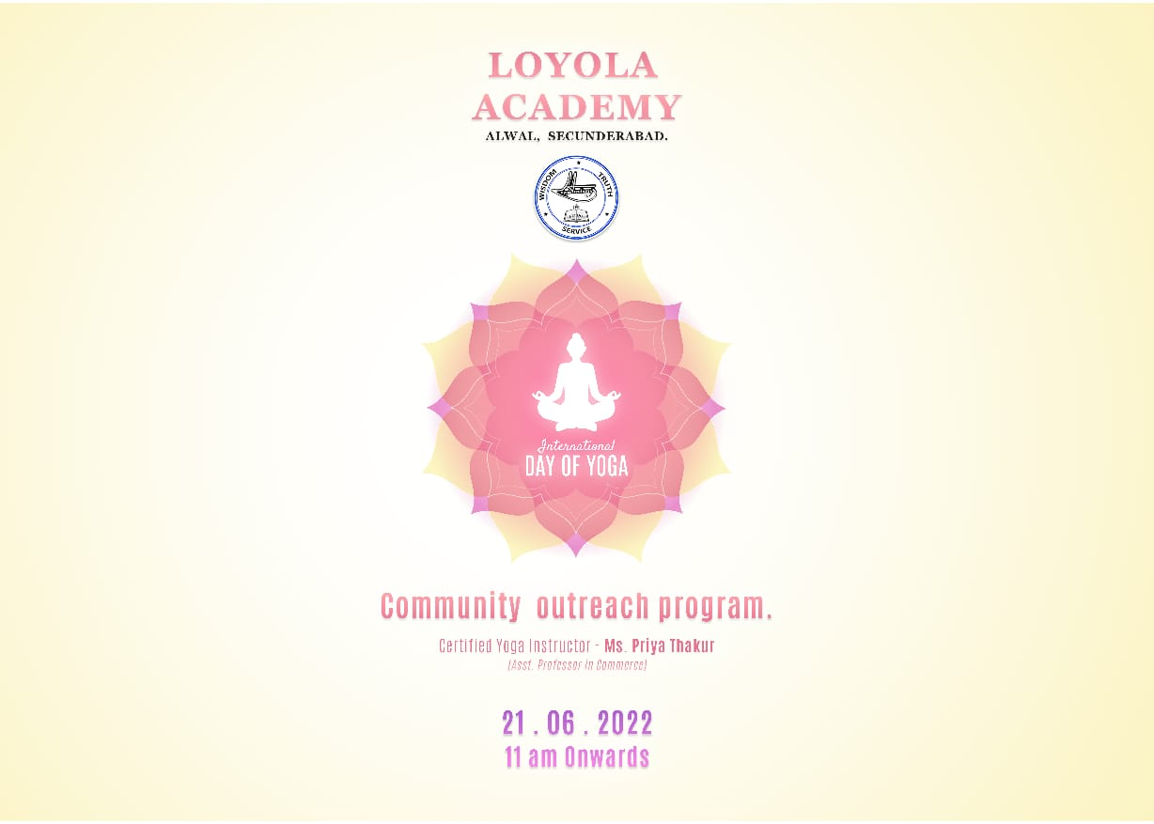

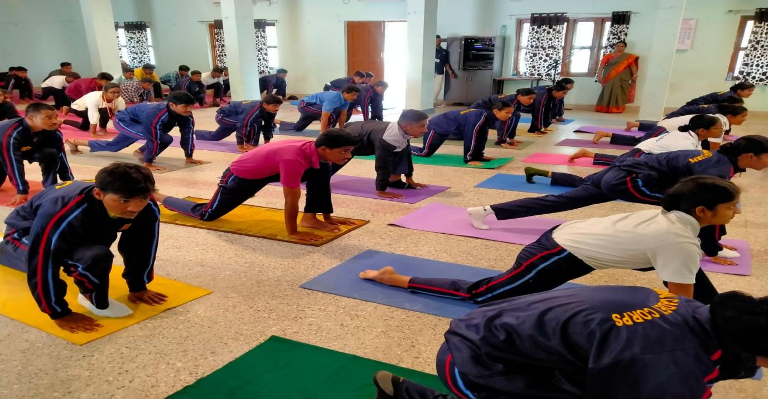
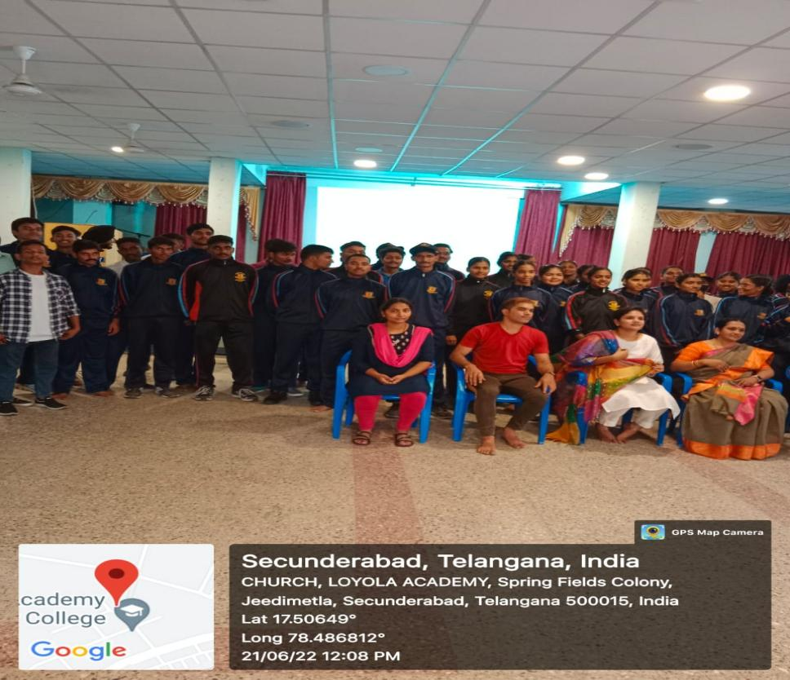
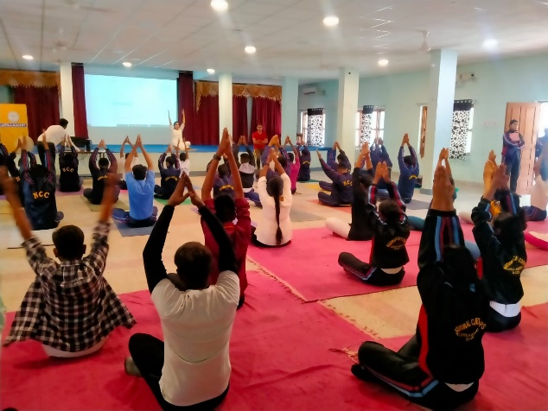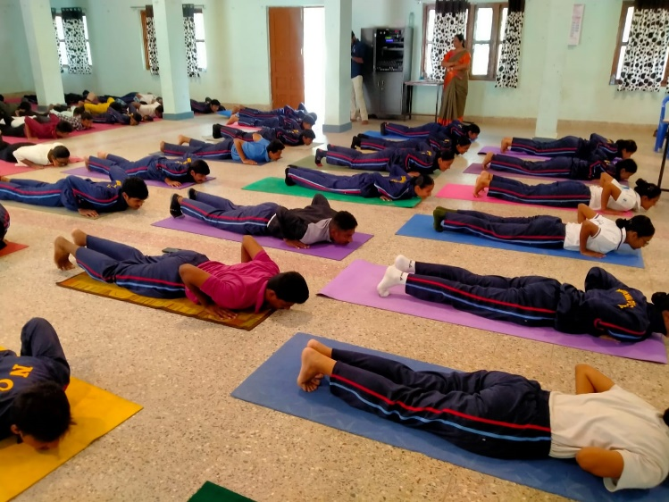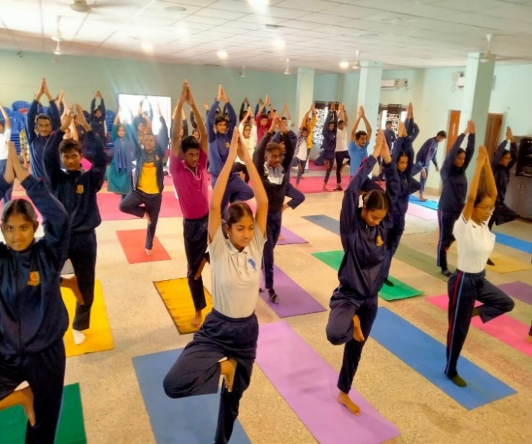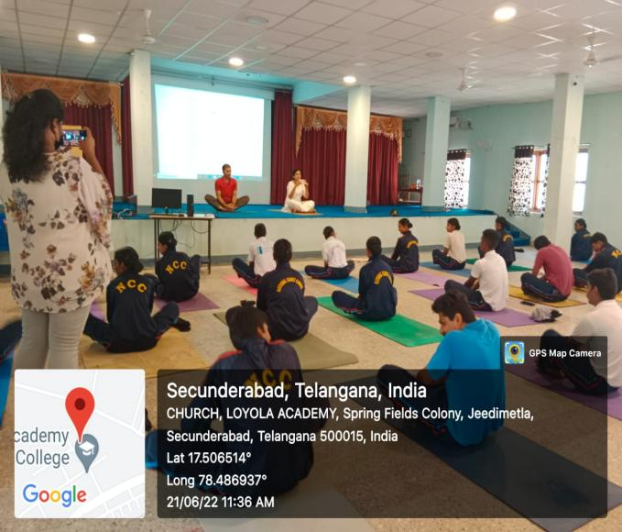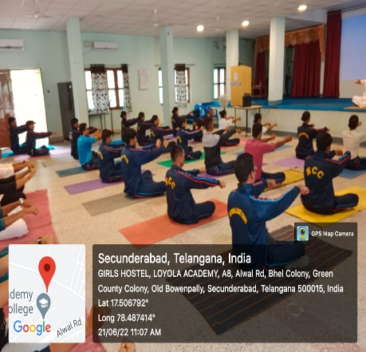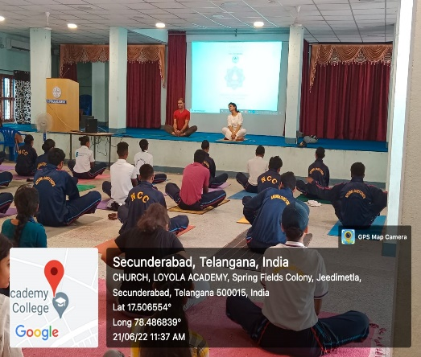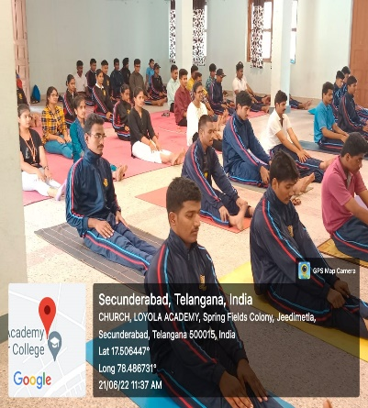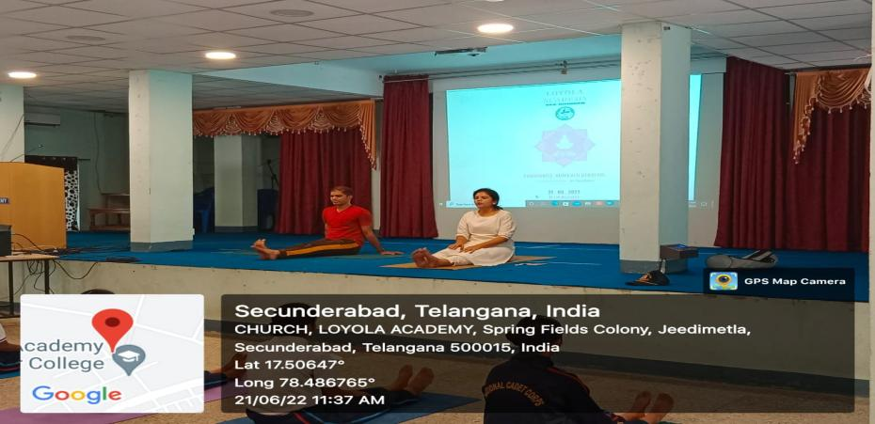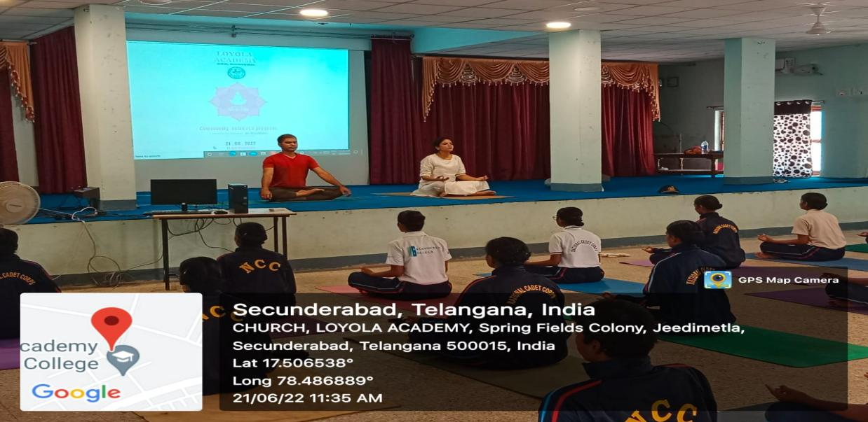Community workers/ non – teaching staff
34 SWs and 30 SDs with a count of a total of 64 cadets attended the session enthusiastically.
3. AZADI KA AMRUT MAHOTSAV
The event continued for 5 consecutive days celebrating the 75 glorious years of India’s Independence, the college NCC unit, NSS unit, and the STUDENT_COUNCIL have coordinated together to celebrate the AZADI KA AMRUT MAHOTSAV!!
AIM AND OBJECTIVE-
Allow students to explore their talents, and bravery, gain knowledge and work on social reform and celebrate the festive season of the 76th Independence Day.

DAY 1
- Flag hoisting –
The guests were escorted by the Piloting commander JUO. Akul Joshi. The Flag was hoisted briskly, by The Principal. Rev. Fr Dr. L. Joji Reddy S J, the college stood in silence with respect and pride
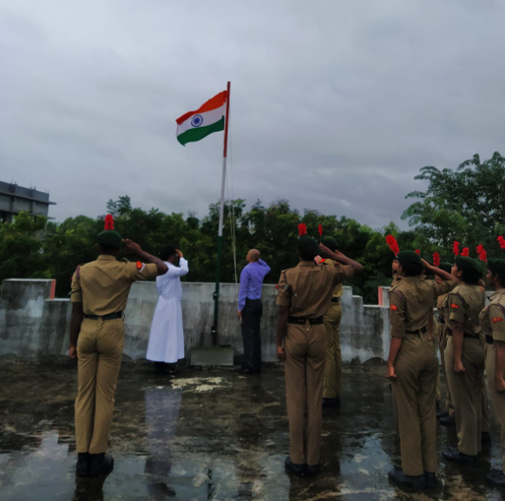
- Guard –
The Rashtra Salute to the Tiranga was esteemed by the guard, led by Guard Commander- CDT Chandu Meghana. T and Sentry – LCPL Varshitha. G 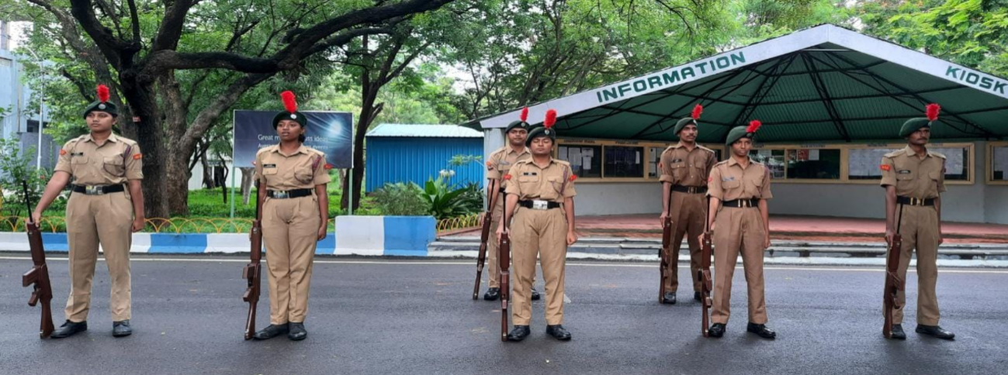
ShurveronkiVarnamala –The cadets presented the varnamala of the freedom fighters, led by LCPL Harish Choudhary
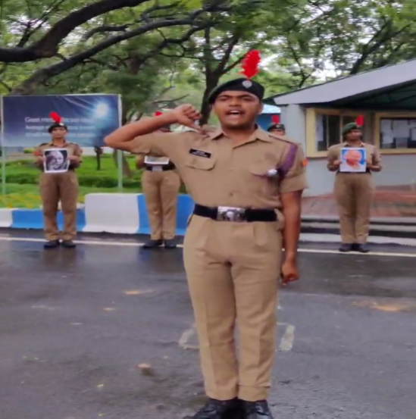..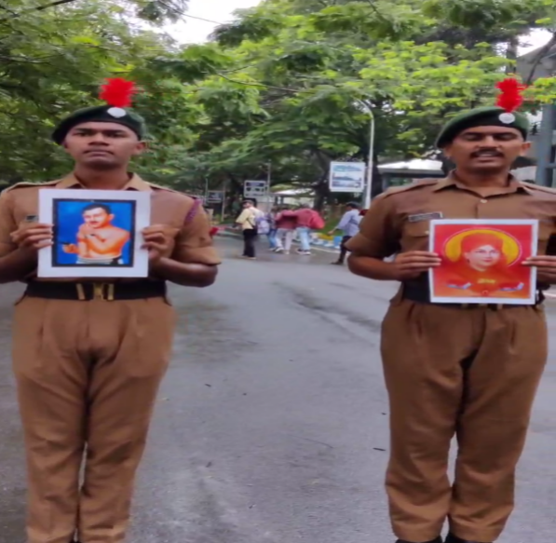
- Independence Day Quiz
The event Independence Day Quiz was organized on 8th August, the quiz was conducted on the topics related to Independence and the winners were given coupons worth rupees 10, 15, 20 which can be used in the college canteen.
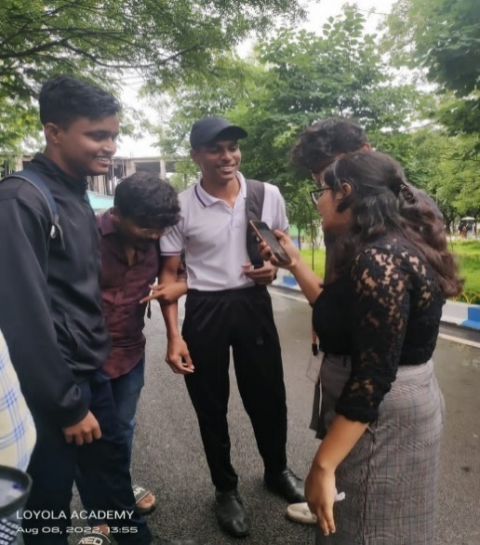
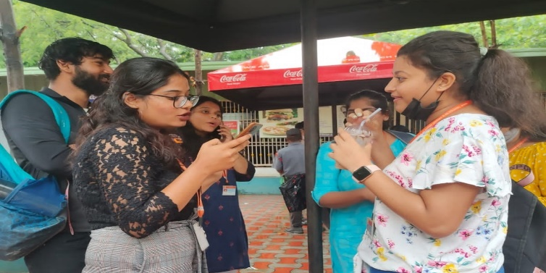
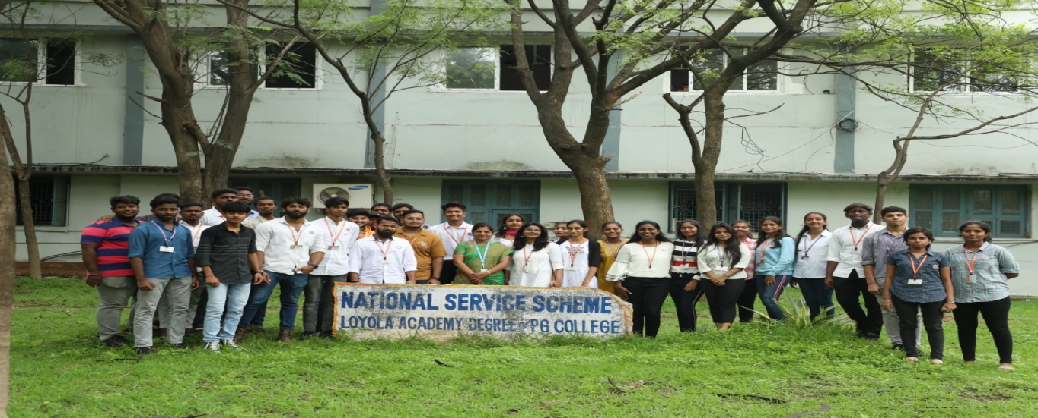
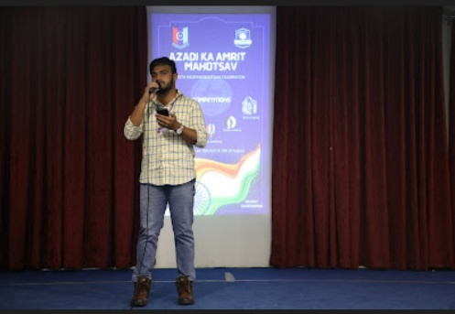
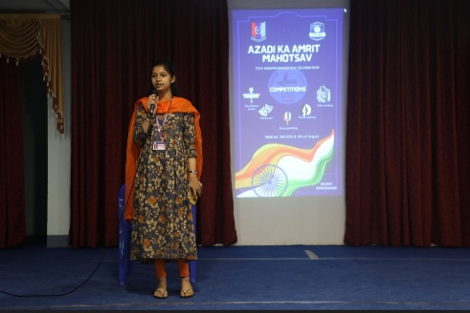
- Solo singing competition-
The solo singing competition was conducted on 8th of the August, on account of Azadi ka Mahotsav by the student council, the theme of the competition was patriotism, and students were instructed to sing any song which had the essence of patriotism in it. Students participated with a new zeal and competed with each other enthusiastically. The first prize was taken up by Surya Laxmi from DMSCS and the second prize was taken by Emmanuel from NCSC and the third prize was taken by Aparna DIAF.
DAY 2
- Flag hoisting-
The national flag was hoisted at the Boy’s and girl’s hostel Loyola academy by respective Fathers esteemed, followed by the flag hoisting at the UG principal’s residence – Rev. Fr. 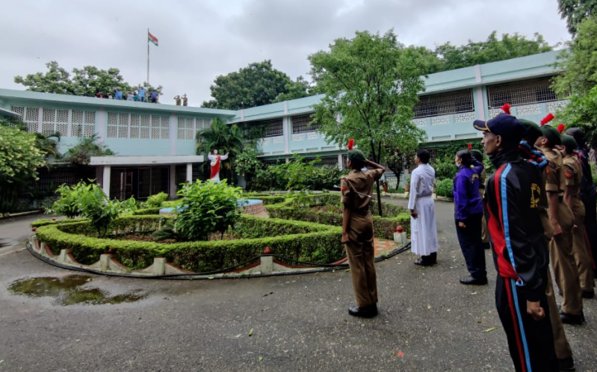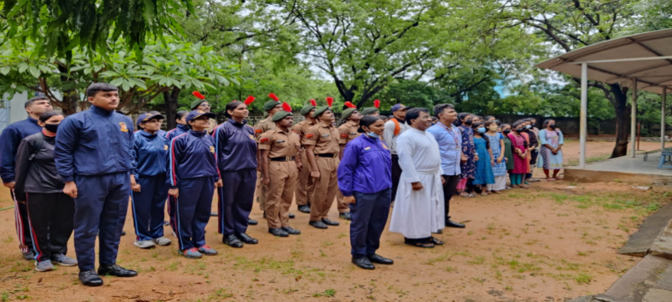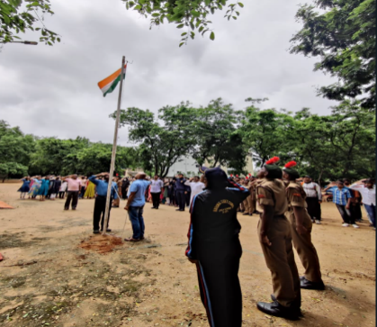
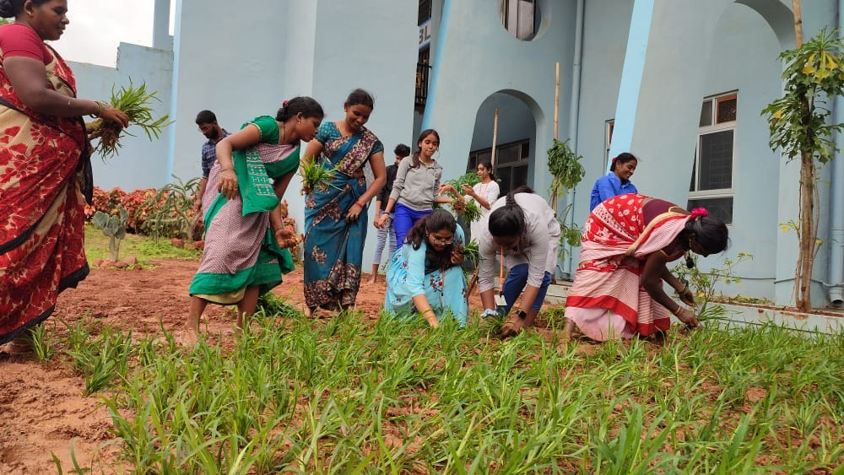
- Clean and Green Program
The event Clean and green Program was organized on the 9th of August.
The plan was to clean the college premises and plant the samplings. Participation of NSS leads and volunteers made the event a grand success.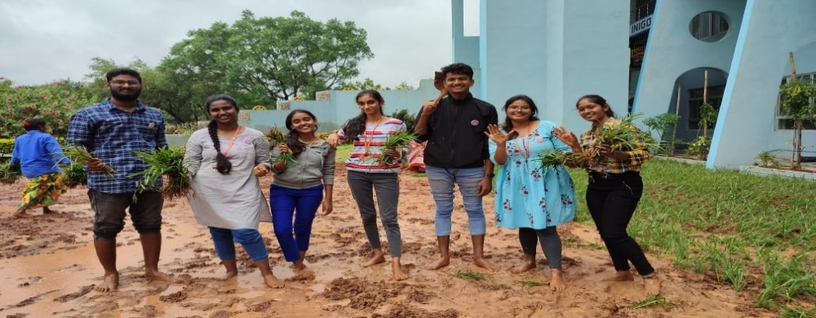
- Poster making-
The poster-making competition was conducted on the theme of nationalism and patriotism. Students were instructed to make the poster and submit them by 10-08-22. Poster-making competition brought a new spectrum of colors that depicted the creativity of students. The winners of the event were Meghana from NFSN who bagged the first prize, Pratyusha from MBI who took the second place, and the third prize was shared by Navya from NBBA and Kalyani from NCSC.
DAY 3
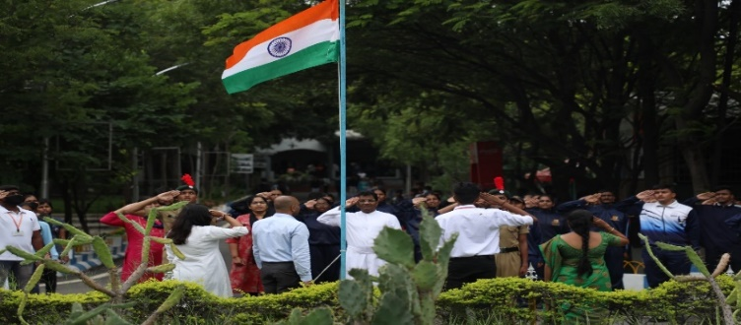
- Tug of war-
An extravagant Tug of war competition between the Student Council and the NCC. The competition was the supreme attention seeker, in which the college NCC unit won, followed by flag hoisting at the Computer science block and Library forecourt followed by a Flash mob by the cadets.
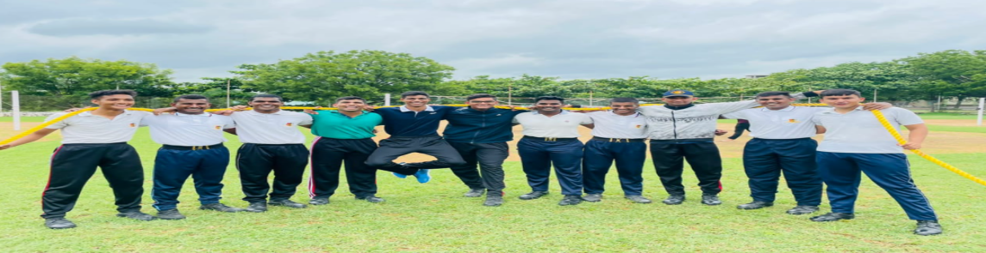
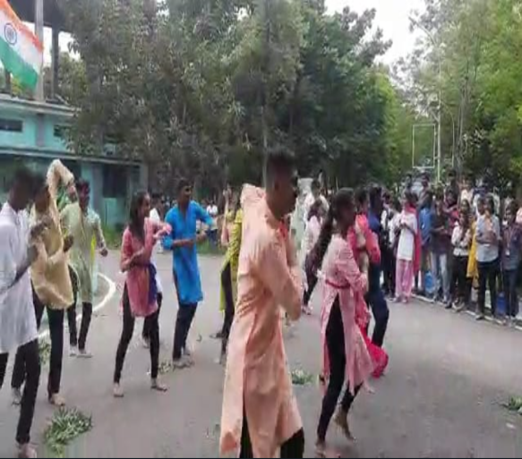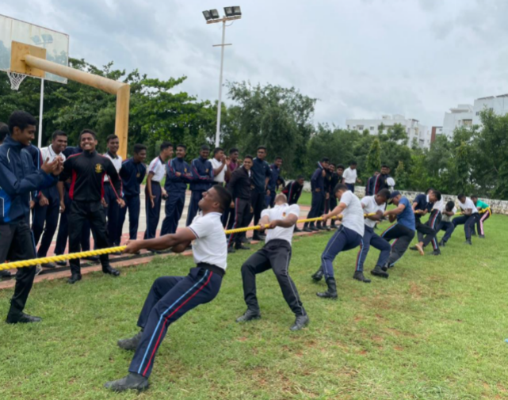
The National Flag was hoisted by Rev Fr Dr. L. Joji Reddy SJ at CS Block and College Library. The event was organized under the supervision of NSS unit program officer Mrs. K Anitha, and Cadet training Officer Mrs.V. Shirisha (Army wing).
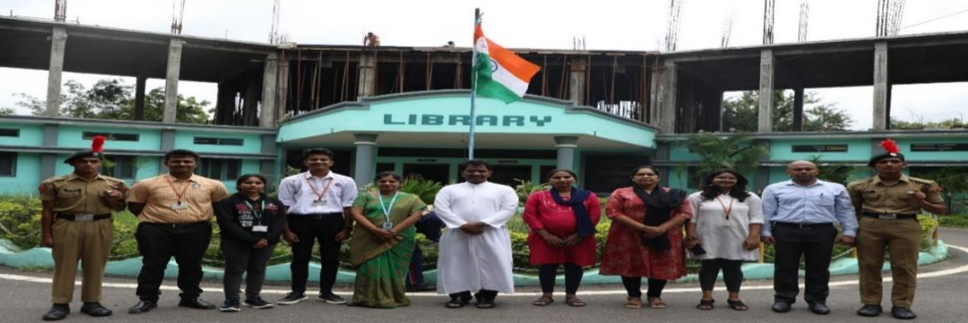
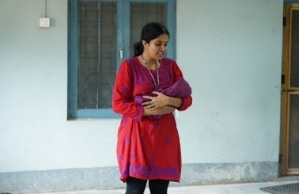
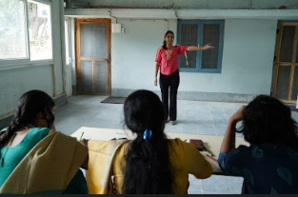
- Mono act-
The mono act was conducted on the 10th of august in the common room where students from various departments had participated in the competition. Students had come up with new stories about their acts that depicted their talent in acting.
The winners of the event were Vaishnavi from NMA who takes the first position, Gaaayatri from DEL who takes the second place and the third position is taken by Anuhya from NBT.

DAY 4
- Flag hoisting
Cadets were invited for flag hoisting at Commanding Officer Col.AmitPurty's residence as a part of Azadi ka Amrit Mahotsav; then, addressed by Col.AmitPurty and Mrs.AnjuPurty.
The Rashtriya salute was extended to the National flag and the event was concluded with a closing address.

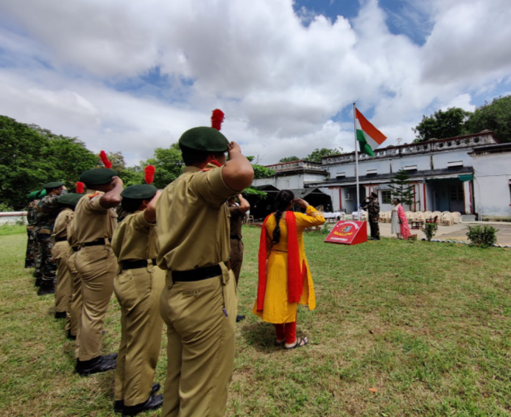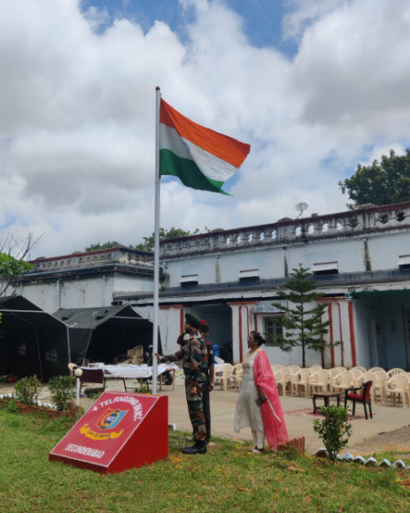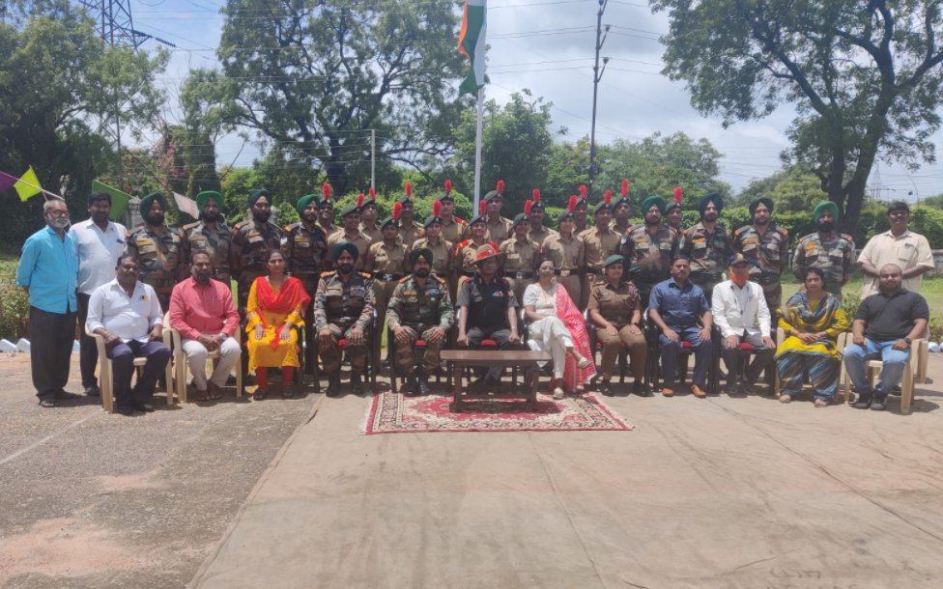
- Rakhi making-
Rakhi making competition was organized on 11th August. This event was organized by the NSS, and the leads gave their best effort to make it a happening event. The winners were awarded.
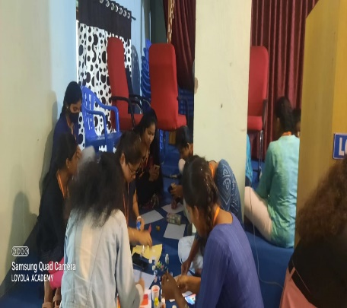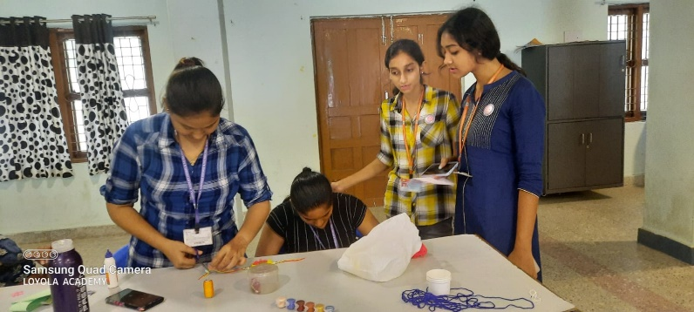
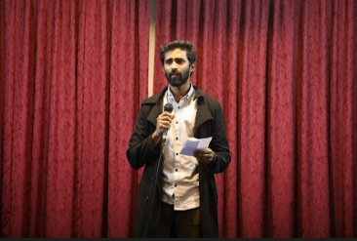
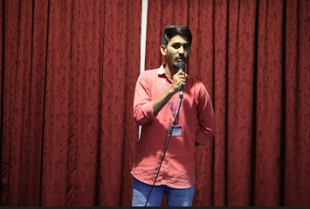
- Slam poetry-
Poetry is an expression of oneself through the power of language students from different departments participated in the competition where the theme was patriotism and the winner were Aashreya from DEL, and Roshni from DCSC who takes the second place and Sadia Sayeed from DEL had taken the third place.
DAY 5
NCC cadets of 25coy, 4(T) BN NCC took part in the Rally conducted by GHMC as a part of the Azadi ka Amrit Mahotsav celebrations.
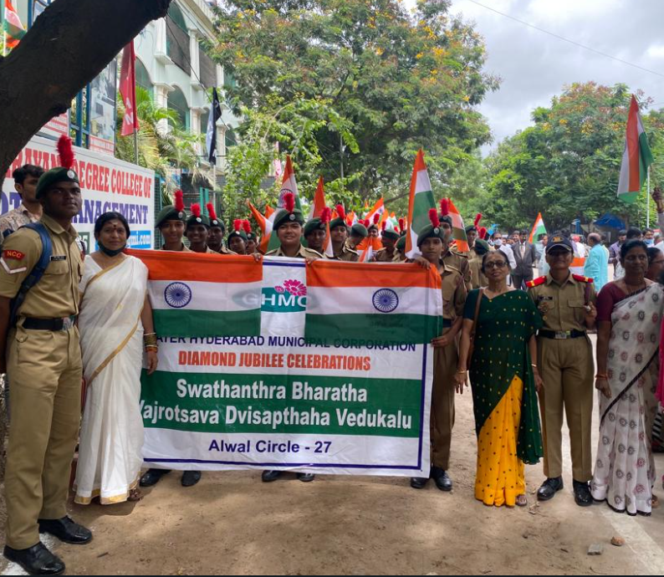
The Flag was hoisted by MLA Mynampally Hanumanth Rao, cadets kept their josh high and actively participated in waving the tricolor.
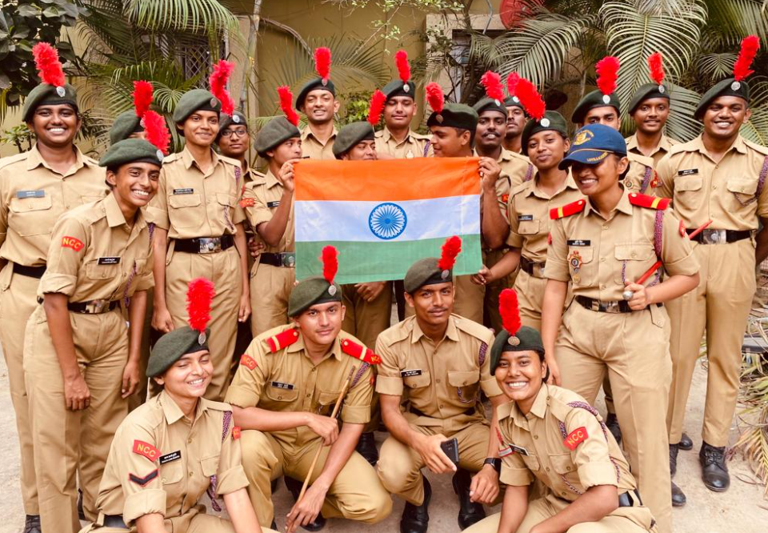

- Face painting-
The student council had even organized the face painting competition on the 11th of August where the theme of the competition was patriotism. Students were instructed that the competition would continue for an hour, and they are supposed to finish the painting in the given time. Students had competitive spirits and actively participated. Greeshma and Srivallika from AMBT had taken the first position, Harish and Atul from AMCA had taken the second position and the third position was taken by Yeshwari and Soumya from AMCA
OUTCOME-
The AZADI KA AMRUT MAHOTSAV events added shine to the Patriotism within the Cadets, unlike all the vigorous practices cadets enjoyed their participation in cultural events, ‘tug of war to be mentioned!
National Flag was hoisted with pride and esteem, everyone got to know about the various facts about Independence and the struggle behind it, the importance of the trees, and cleanliness.
Students were allowed to avail themselves where they could portray their talents and explore themselves, the theme of all the events conducted was patriotism this even allowed the students to know the essence of patriotism and explore a new world through this perception. These competitions greatly influenced the students and motivated them too.
4. 76TH INDEPENDENCE DAY
Nectar of Great Celebration, The “AZADI KA AMRUT MAHOTSAV”—
- As the nation celebrates 75 glorious years of Independence, everyone was welcomed to this extravagant celebration of Independence Day at Loyola academy.
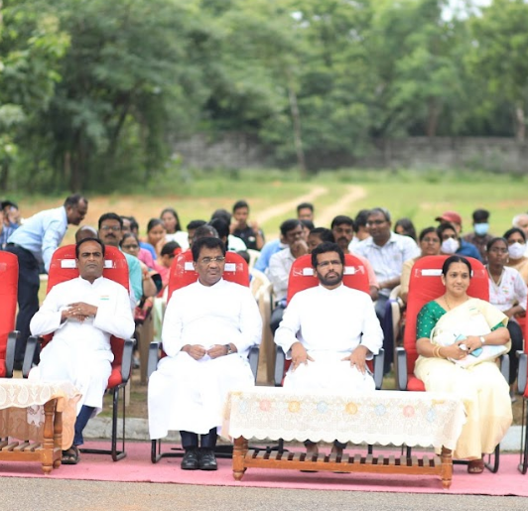
- Chief guests for the event:
1. Principal_Rev.Fr.Dr. L. Joji Reddy SJ
2. Rector & Correspondent_Rev.Fr.Ch. Amar Rao SJ
3. Vice Principal PG_Rev.Fr.AMJ Kumar SJ
4. Vice Principal UG_Rev.Fr. Arul Jyothi SJ
5. Treasurer_Rev. Fr.T. Lourdu SJ
6. Principal of junior college_Rev.Fr.U. Antony
7. Dean of Student Affairs_Mrs. Saras Chandra
8. Cadet Training Officer_ Mrs. V. Shirisha (Army wing)
9. Cadet Training Officer_Mr. Dheeraj Kumar Saho (Naval wing)
10. Sports Incharge_Mr. Sandeep
- The guests were escorted by the piloting Team led by the Piloting commander JUO. Shruti Singh, followed by the Guard led by the Guard commander SUO. Karthika Thota and Sentry SGT. Anson Daniel.
The National flag was hoisted with pride by the Principal_Rev.Fr.Dr. L. Joji Reddy SJ,
The ‘Rashtriya’ salute was esteemed to the national flag during the national anthem.
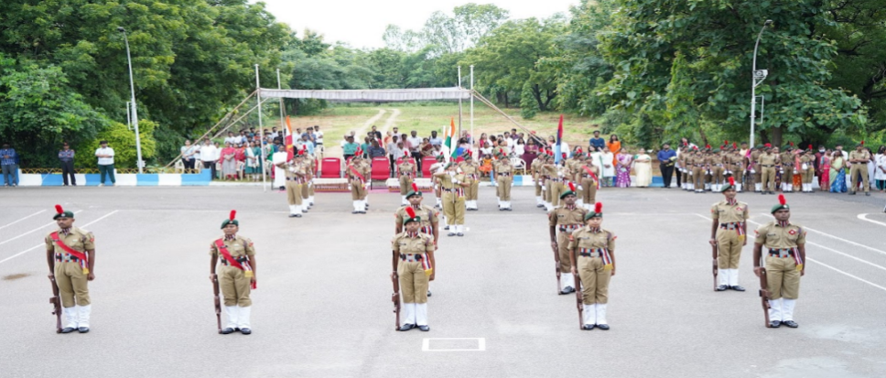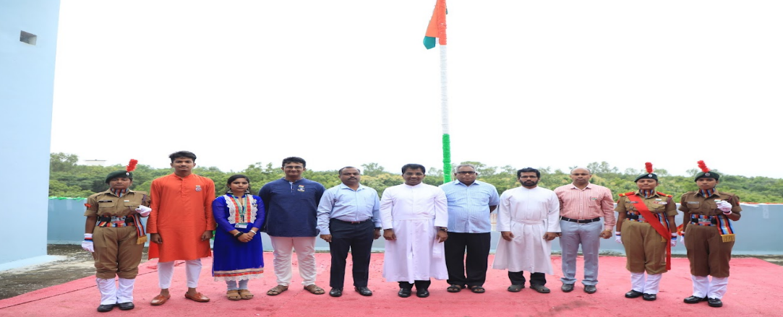
- The Nirikshan, followed by the contingent which was led by the contingent commander CQMS Harish Choudhary,
Flag bearer, JUO Akul Joshi holding the INDIAN FLAG
Flag bearer, JUO Aaron Purty holding the INDIAN ARMY FLAG
Flag bearer, CSM Sai Naik holding the NCC FLAG
Flag bearer, CDT Raghavendhra holding the INDIAN NAVY FLAG, the NCC song was sung by everyone after the contingent arrived.
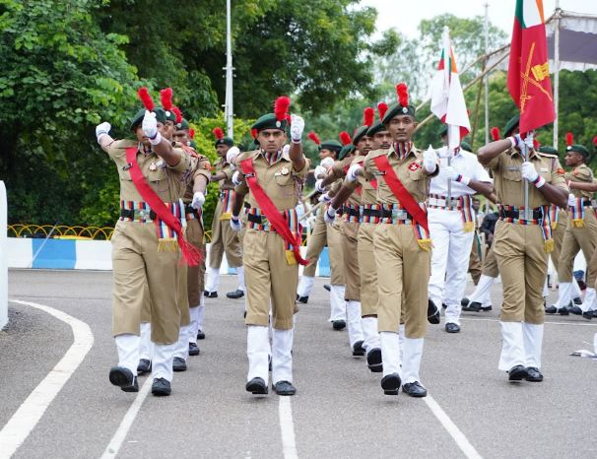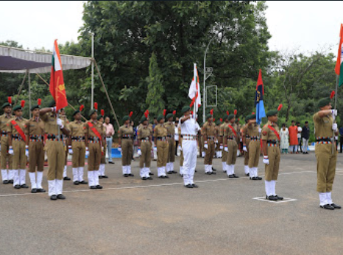
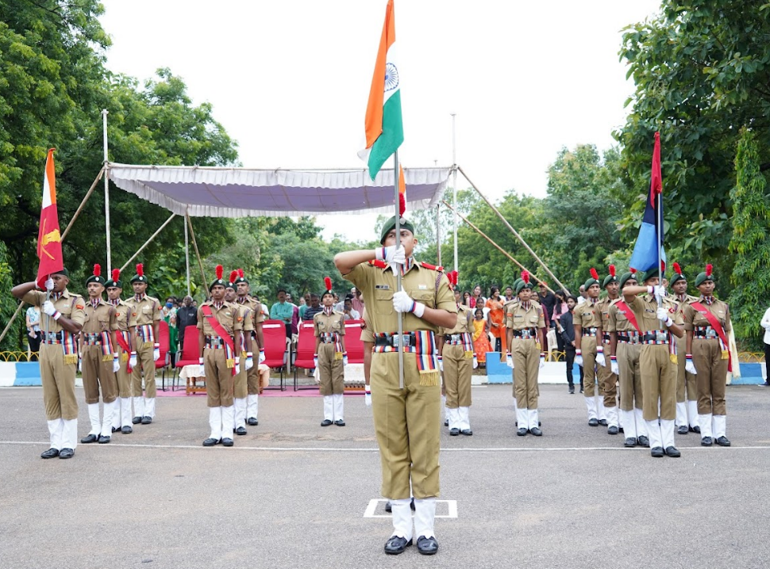
- Thereafter the new Rank holders of the year 2022-2023 were felicitated by the chief guests
- 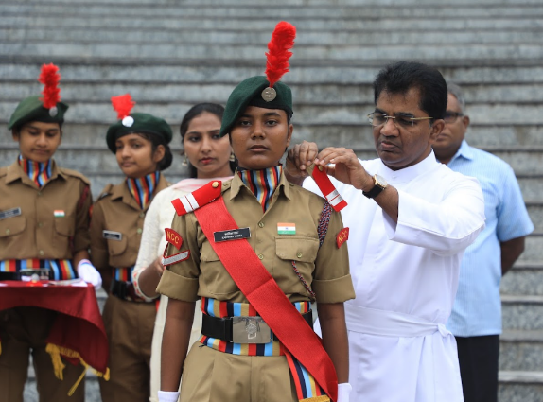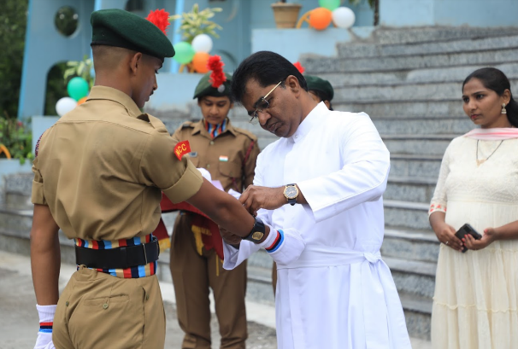
The speech was delivered by a few newly elected members of the student council and Principal_Rev.Fr.Dr. L. Joji Reddy SJ enlightened the students with his words of wisdom
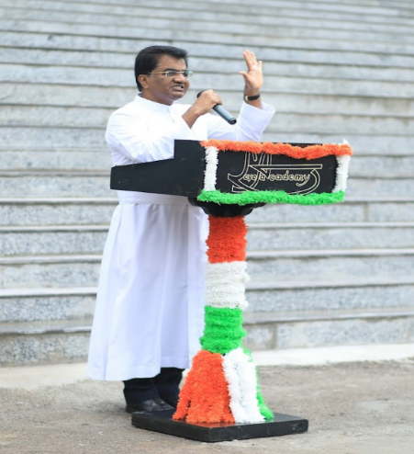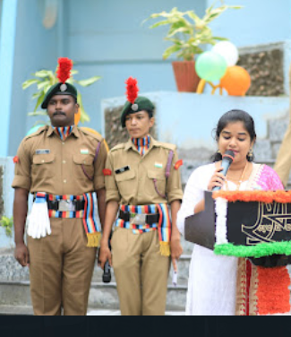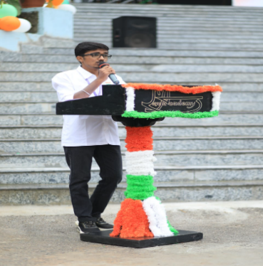
- Then started the cultural session the college Student council, NSS, and NCC performed well, entertaining the audience, and conveying inspiring messages as well.
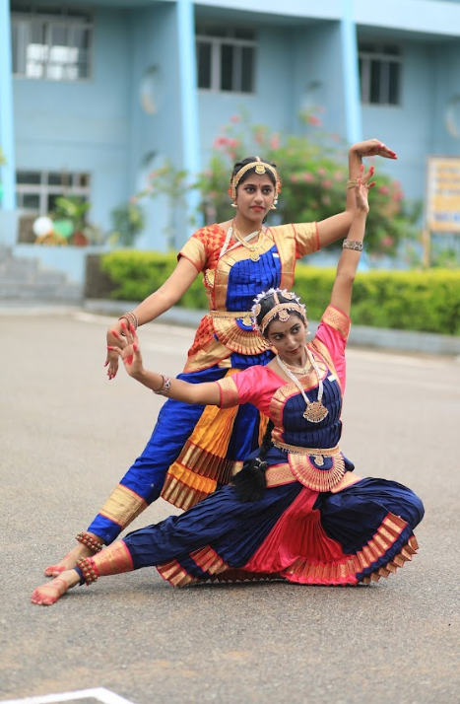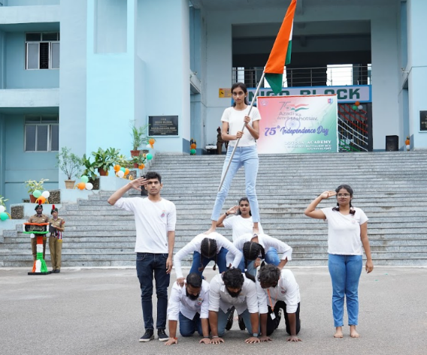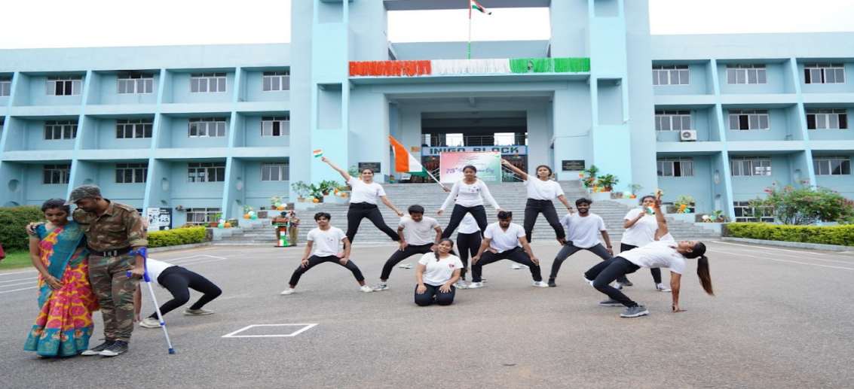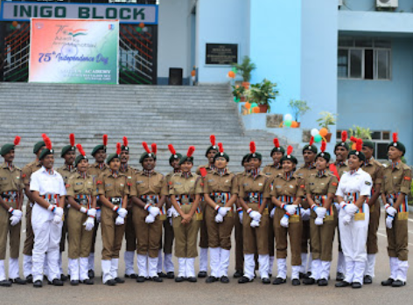
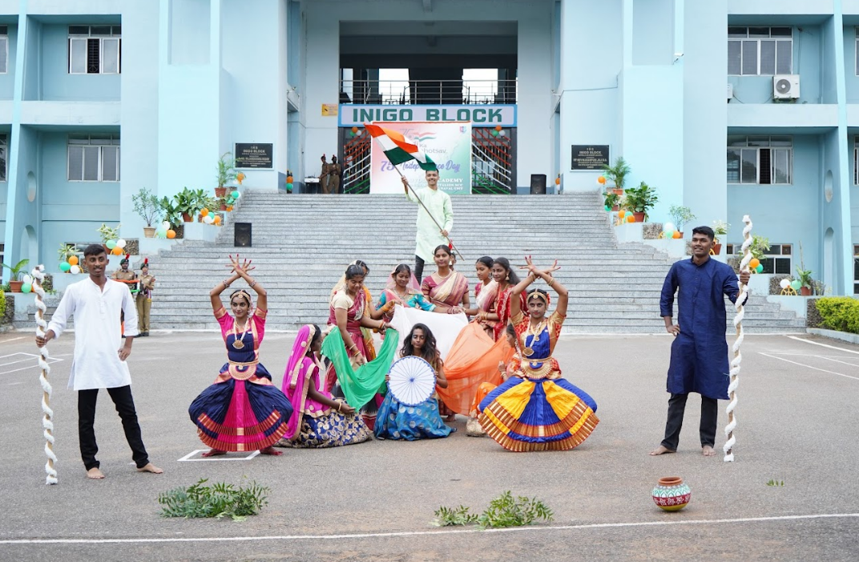
The event ended with a vote of thanks from SGT. Chandu Meghana.T, followed by the photo session.

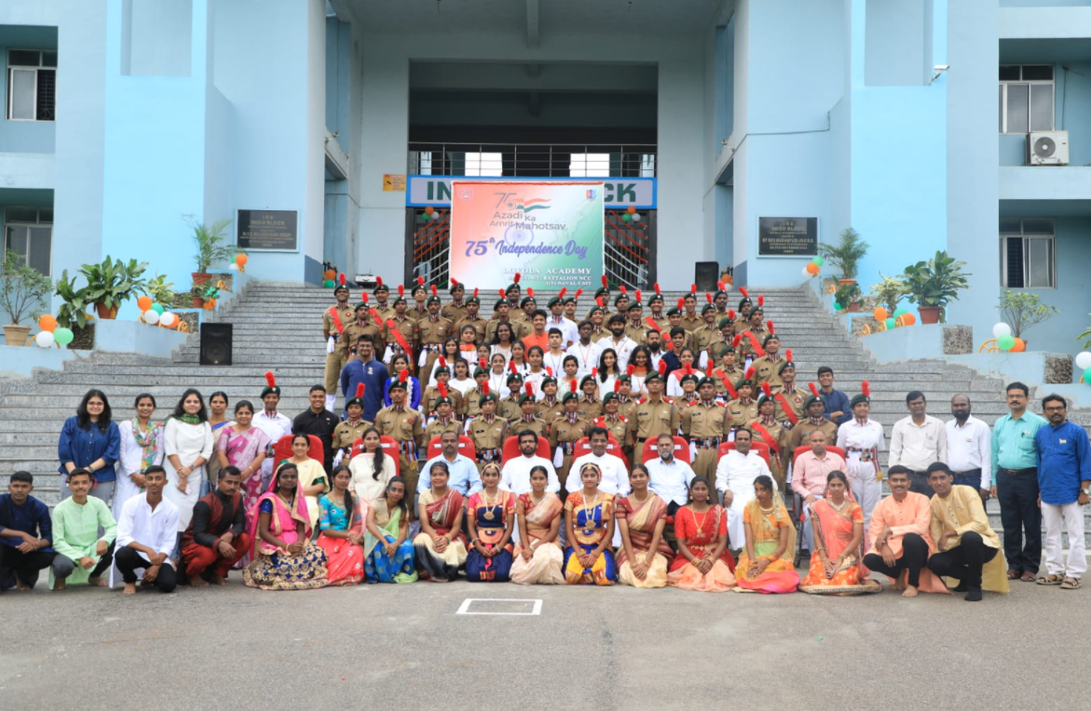

5. HYDERABAD LIBERATION DAY
Hyderabad Liberation Day is being celebrated today to mark the historic accession of the princely state of Hyderabad into the Indian Union. ‘Operation Polo’, as the famous “Police Action” was codenamed, brought down the curtains on an oppressive Nizam’s rule on this day in 1948.
The National flag was hoisted in remembrance of this historic day,
The piloting team, led by the piloting commander SGT. Roshan Hussain escorted the Principal Loyola academy- Rev.Fr.Dr.L. Joji Reddy SJ
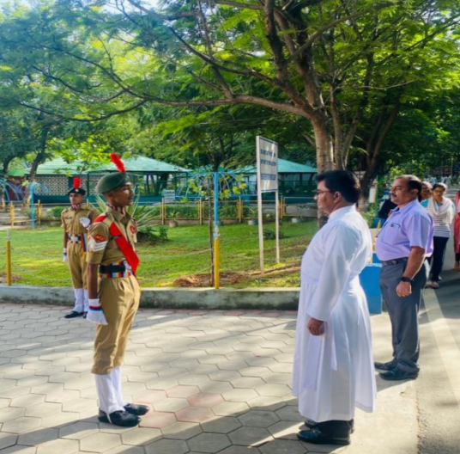
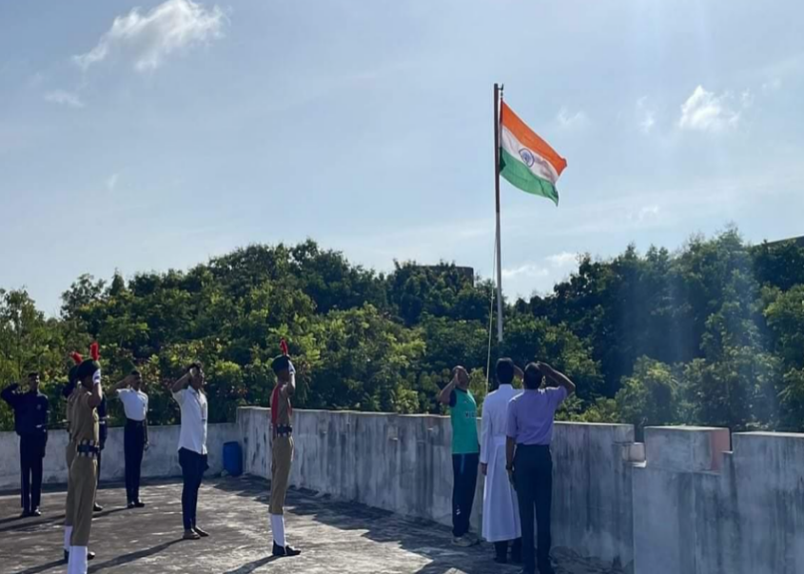
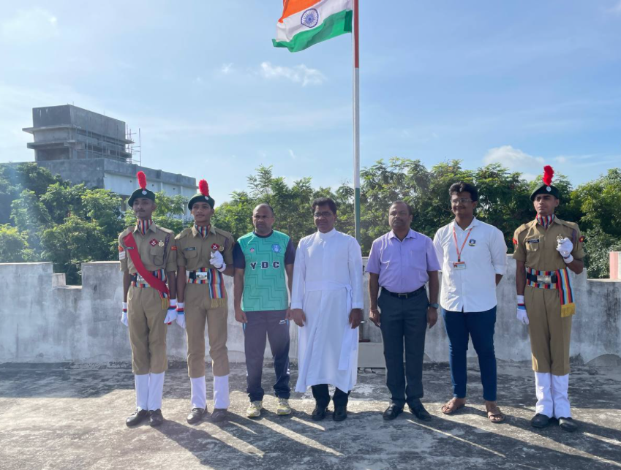
The principal appreciated the students who boldly came up to speak about the day.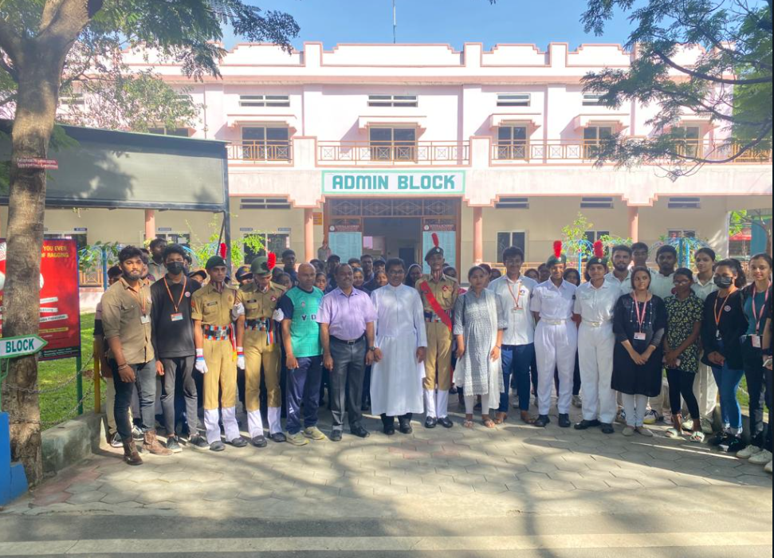
The college NCC, NSS & the Student Council have coordinated together in making this event successful, the event ended up with a photo session.
6. FIT INDIA
FIT INDIA Movement was launched on 29th August 2019 by the Honourable Prime Minister to make fitness an integral part of our daily lives. The mission of the Movement is to bring about behavioral changes and move toward a more physically active lifestyle.
Towards achieving this mission, the college initiated a 5K run in which the Cadets of NCC, Students of NSS, and members of the Student council passionately took part 5K run.
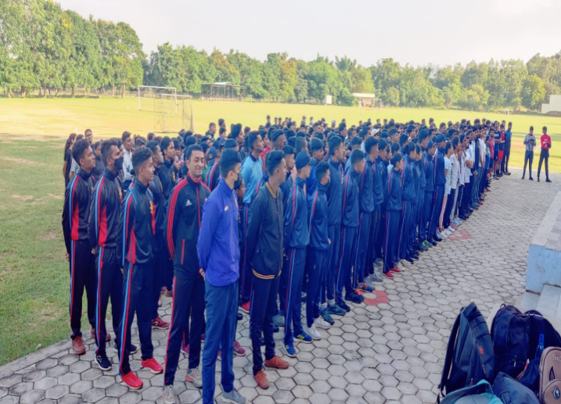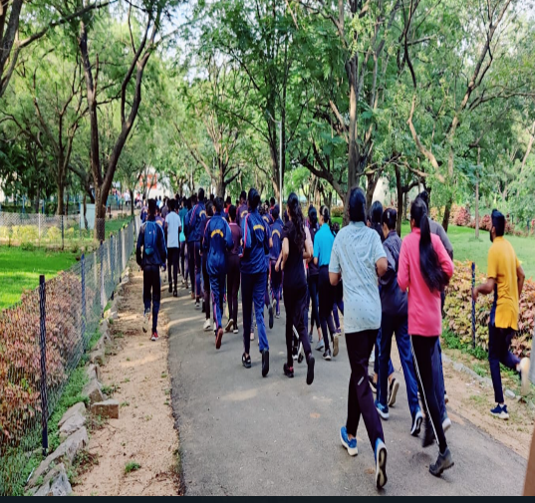
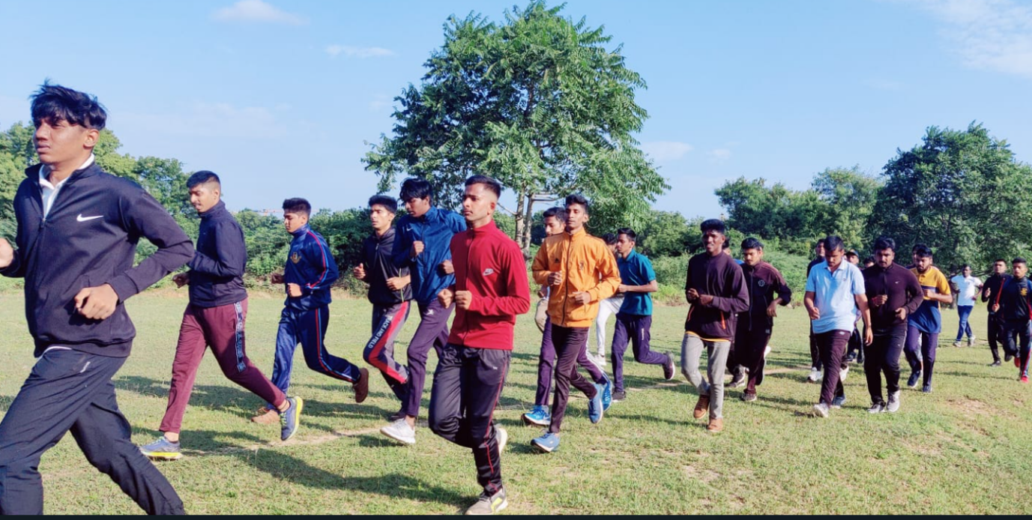

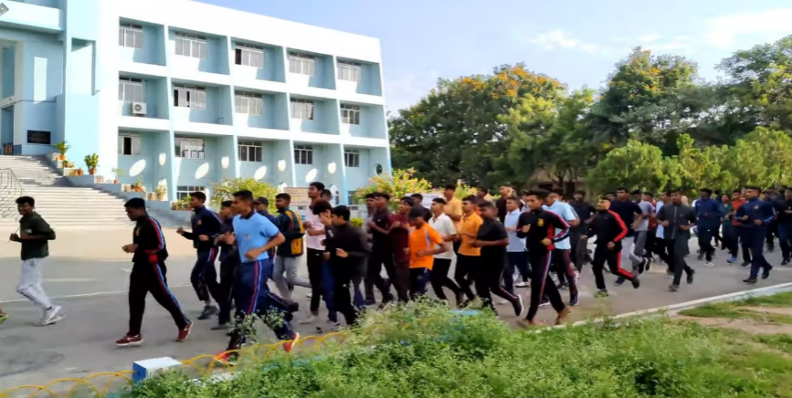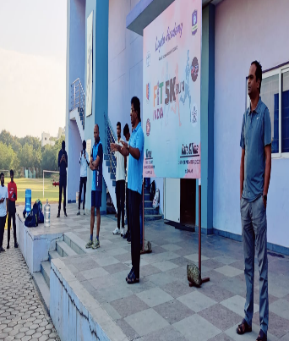
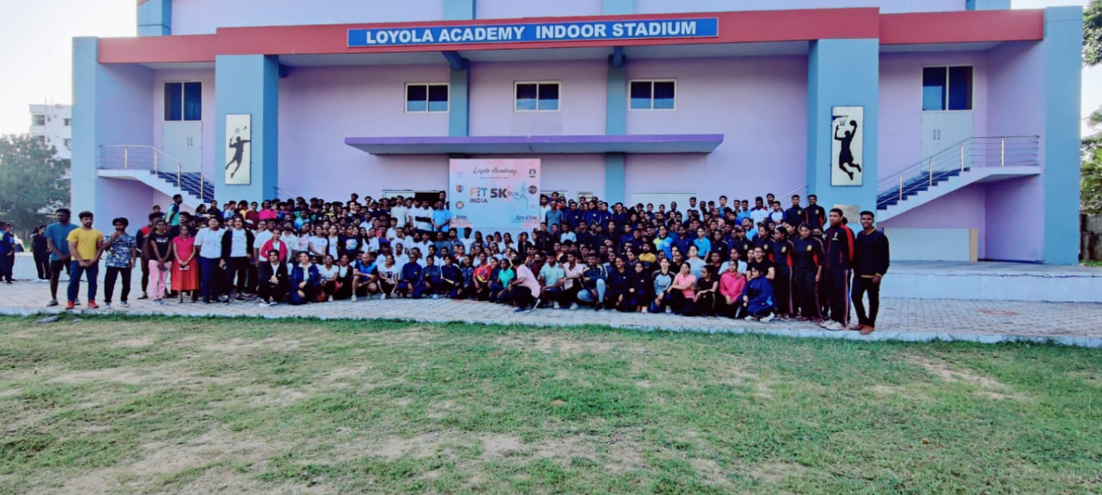
The early day’s run included the Campus_A(UG, PG), Intermediate College, Campus_B – 400 Meter track of Loyola Academy fulfilling the 5k run!!
The day’s schedule continued with the Enrolment selection of the next batch of NCC, in which the
x cadet of NCC, Loyola came forth to address.
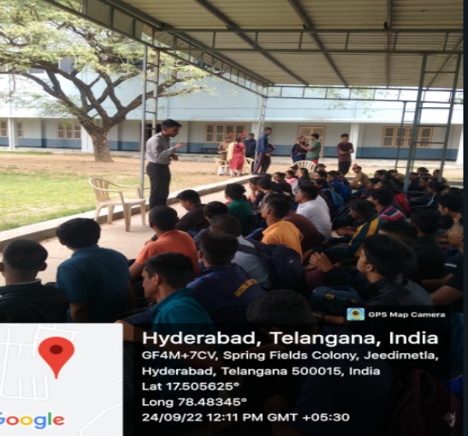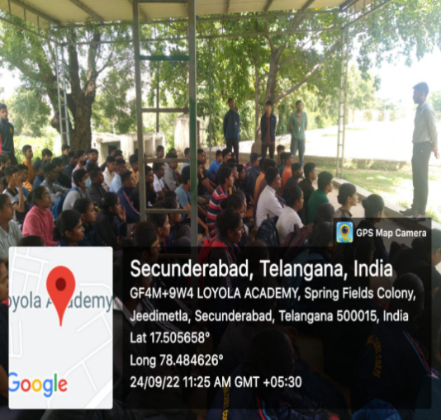
ANKITH.P from the Dept- B.com computers, batch 2016-2019 (NCC)
The 1st NCC Cadet who got recommended from Loyola academy
Joining the Officers Training Academy on 3rd October 2022.
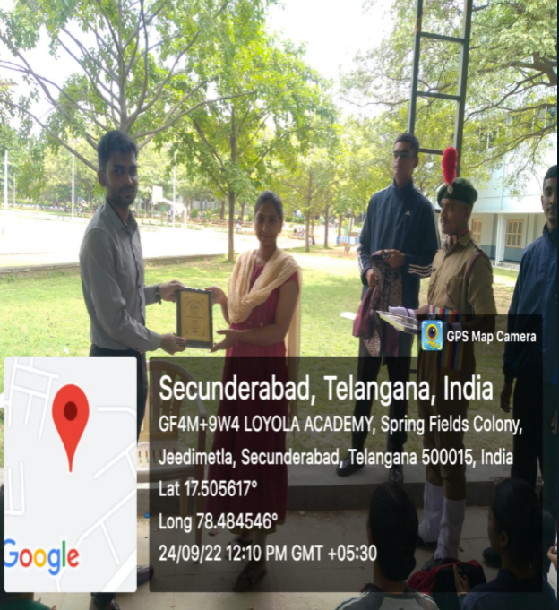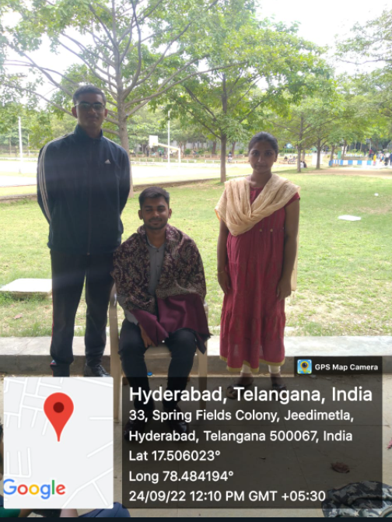
The Guest was felicitated by CTO. Mrs. V. Shirisha for gracing the day with his presence and words of enlightenment.Loyola NCC, Congratulates and wishes good luck to Mr. P. Ankith for his achievement and future endeavors.
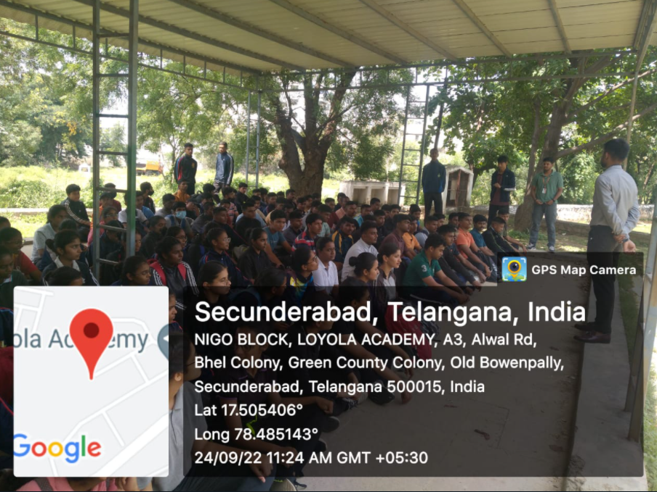
7. ‘B' CERTIFICATE COMPLETION Year- 2022
Batch 2020- 2023 on the completion of NCC ‘B’ certificate.
Exam was conducted under Secunderabad group in the month of February (2022) which included both Practical and Theory.
Qualified Cadets were certified with the completion certificate of ‘B' on 21st Oct’22 under the guidance of COL. Amit Purty ....
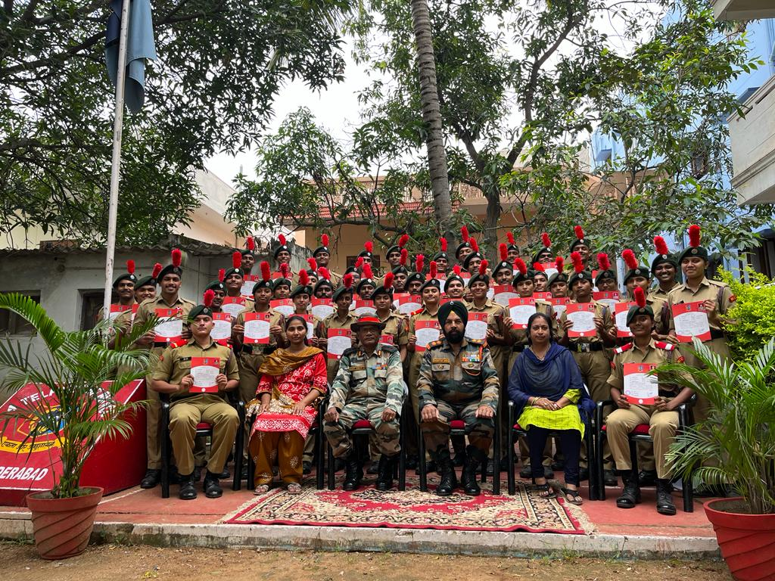
TS20SDA103802 | AKUL JOSHI
TS20SDA103809 | B.NIKHIL
TS20SWA103861 | KARTHIKA THOTA
TS20SDA103824 | HARISH CHOUDHARY
TS20SDA103834 | NIKHIL PANTH
TS20SWA103863 | KUSHBU CHOUDHARY
TS20SWA103850 | CH.MADHAVI
TS20SWA103871 | SHRUTI SINGH
TS20SWA103874 | K. TEJASWINI
TS20SDA103888 | LEMUEL SAVIO
TS20SDA103815 | DAVAN KAUSTHUB
TS20SDA103891 | NENAVATH SAI KUMAR
TS20SWA103849 | BHAGYA LAXMI BUDHORI
TS20SWA103852 | C. SHANTHI PRIYA
TS20SDA103838 | ROOSHAN HUSSAIN
TS20SWA103854 | D KAJAL
TS20SWA103857 | G VARSHITA
TS20SDA103842 | PEDDA SHASHANK
TS20SDA103807 | BADAKURAVA KARTHIK
TS20SDA103817 | E.V. SARANG
TS20SDA103805 | ANSON DANIEL
TS20SWA103865 | K MANJUSHA
TS20SWA103860 | JANANI S
TS20SWA103851 | CHANDU MEGHANA.T
TS20SWA103848 | AVANTIKA
TS20SWA103858 | GAAAYATRI BATTULA
TS20SDA103810 | B. ABHIRAM
TS20SWA103875 | TULA SAI MANJU
TS20SDA103830 | LOKESH CHOUDHARY
TS20SDA103814 | CHETAN SHARMA
TS20SDA103812 | CH VARUN
TS20SDA103839 | S C V SAI CHARAN
TS20SDA103818 | G SAI SUMANTH
TS20SDA103801 | AARON A PURTY
TS20SDA103826 | JAMES ABRAHAM OJHA
TS20SDA103829 | K. HARINATH SAI
TS20SDA103889 | ANKIT KUMAR TIWARI
TS20SWA103856 | GOUTI LIKITHA
TS20SDA103890 | NIRAJ SINGH
TS20SDA103837 | RISHAB SIVADAS NAIR
8. B1 ENROLLMENT Year-2022
The enrolment selection process continued for couple of days which included written, physical tests and screening
The final Event of selection was held on 30 OCT’22 to which 103 students have attended.
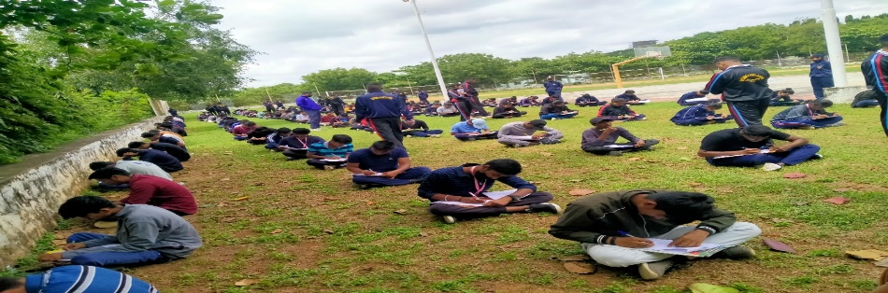
All the tests were refined under the supervision of Sub Vinayak pawar and Hawaldar Sunil singh.
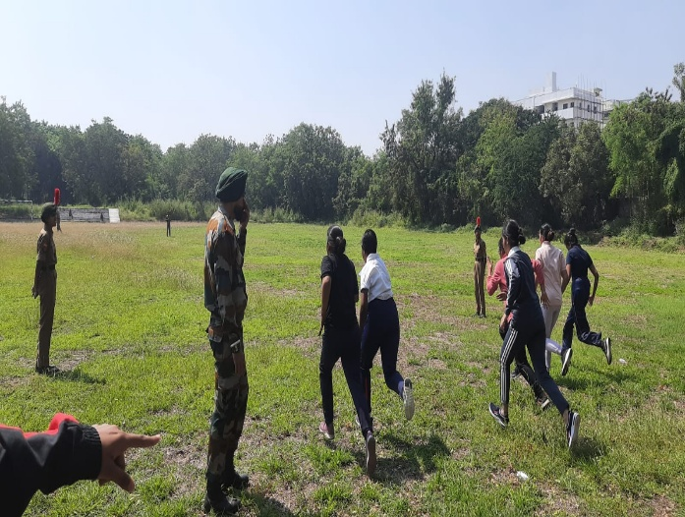
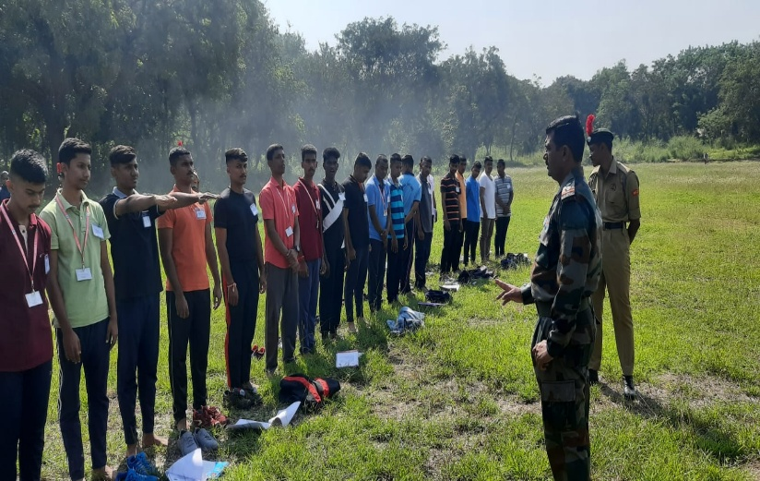

9. Guard of honour to the first cardinal of Telangana
Welcome to the first Cardinal of the state Telangana, It’s indeed a pleasure to the Loyola NCC to invite the chief guest. The piloting team escorted the chief guest to Inigo hall, led by piloting commander JUO Aaron A Purty and the pilots CPL Sumanth and CDT James Abraham Ohja.
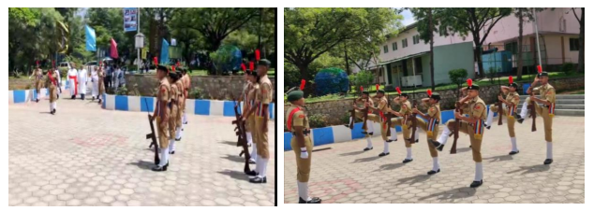
The guard team commanded by guard commander SGT Sai Charan ,Sentry SGT Anson Daniel , Guard team – CQMS Harish Choudhary, CPL Avantika, SGT Bhagyalaxmi Bhoduri, SGT Rooshanhussain, SGT Chandu Meghana T, SGT Varshitha .

10. RASHTRIYA EKTA DIWAS
AIM- Commemoration of SARDAR VALLABAI PATEL, marking the 147th birth anniversary of The Iron man of India – NATIONAL UNITY DAY.

REPORT- The Student bodies NCC, NSS & Student Council of Loyola Academy, Alwal, Secundrabad have aligned in bringing up this Successful Event which was organized on 31st OCT’22.
The momentous event started with the ‘Photo exhibition’, a ‘Slideshow’ followed by the ‘Oath’ and an ‘extravagant performance on Unity in Diversity’ by the NCC Cadets.
- Photo exhibition – The Photo exhibition was put on a show in Admin Block_rm20, the 1st year students of the Commerce and Science departments were a part of this.
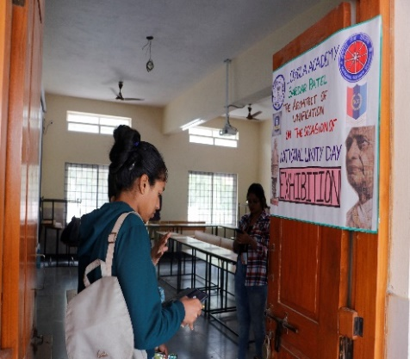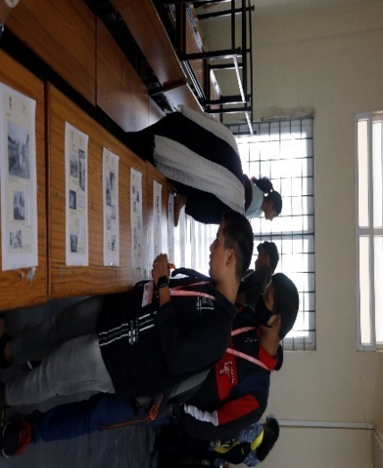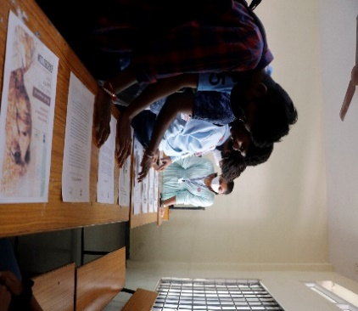
*Lecturers were at the inspection guiding the students.
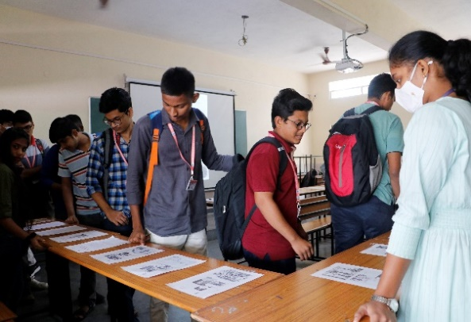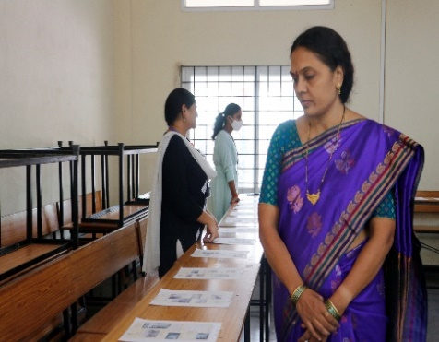
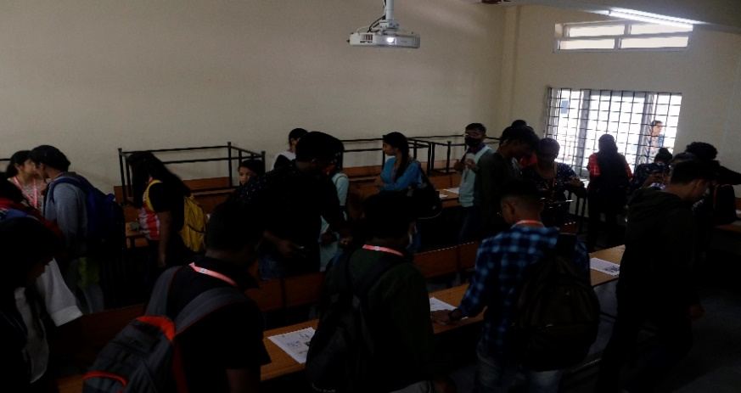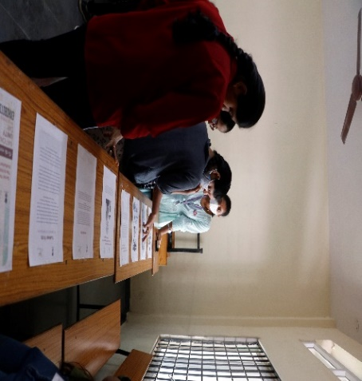

- Slideshow– The slideshow included exceptional details about SARDAR, the Man’s life journey, birth, schooling, being President of the Gujarat Provincial Conference, President of Ahmedabad Municipal Corporation, led the Bardoli Satyagraha (1928), the title ‘Sardar’, 9 years of imprisonment during the freedom struggle, Political journey and much more…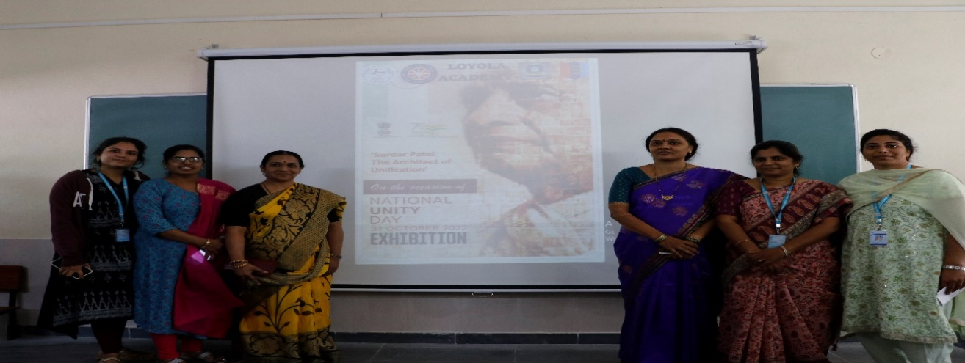
Ms. Priya Thakur_Asst. Professor in Commerce, Mrs. Sailaja_Asst. Professor in Statistics,
Mrs. K. Saraschandra_Dean of Student Affairs, Dr. Rama_IQAC Coordinator, Mrs. Anitha_NSS Coordinator, Ms. Ketana_Asst. Prof. In Statistics.
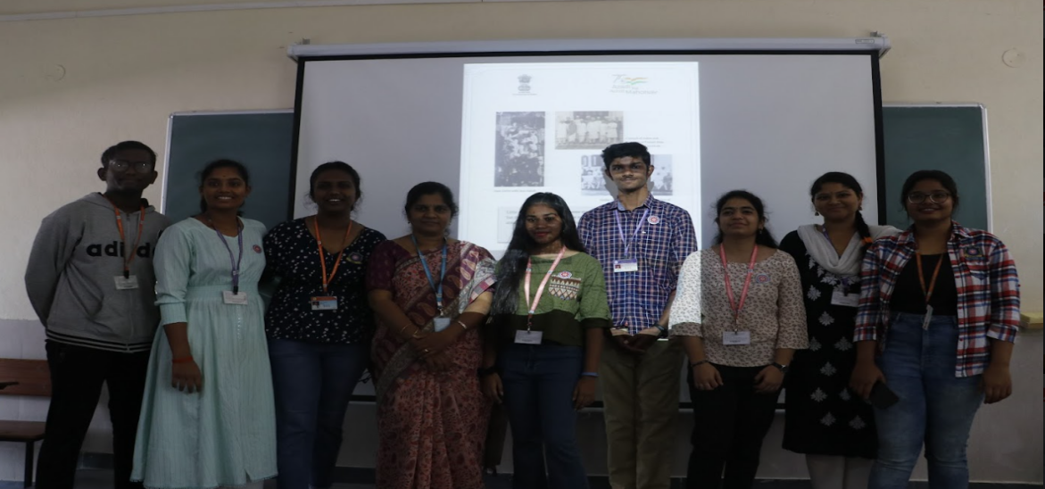
The NSS wing_LA
*Sardar’s brilliance as Deputy Prime Minister and Home Minister, his determination in bringing up and reorganizing new administration for 565 princely states under one India.
Insights of the Slideshow-
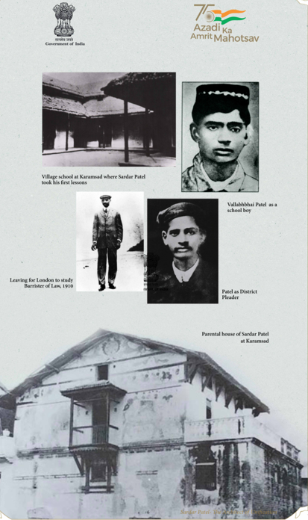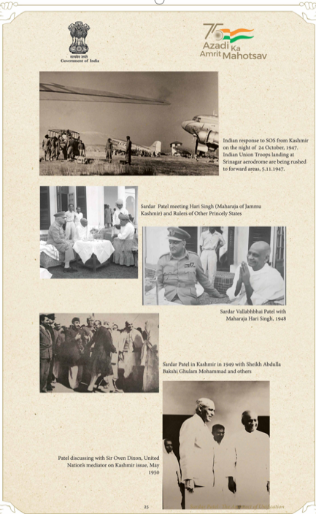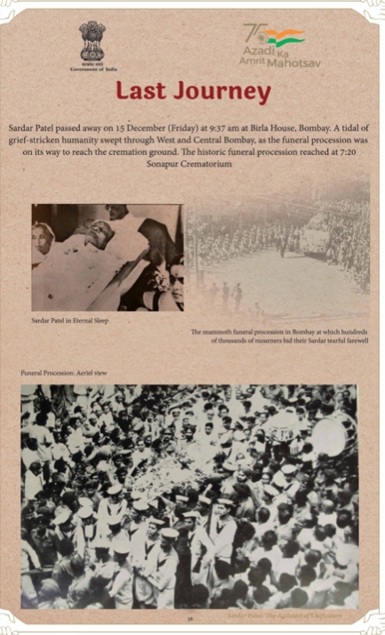

- Oath – Loyolites solemnly pledged to contribute, to ensure internal security and preserve Unity, Integrity, and Security in the spirit of Unification which was possible by Sardar.
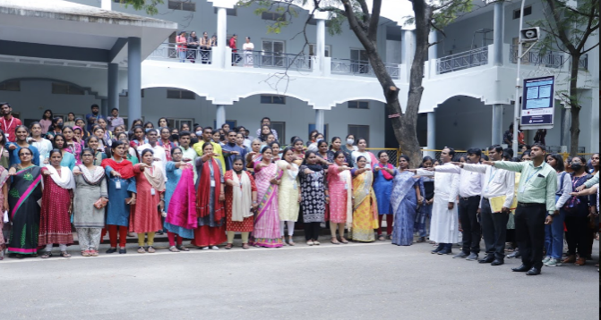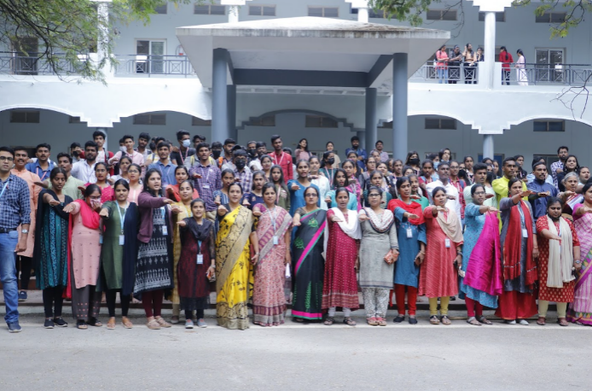
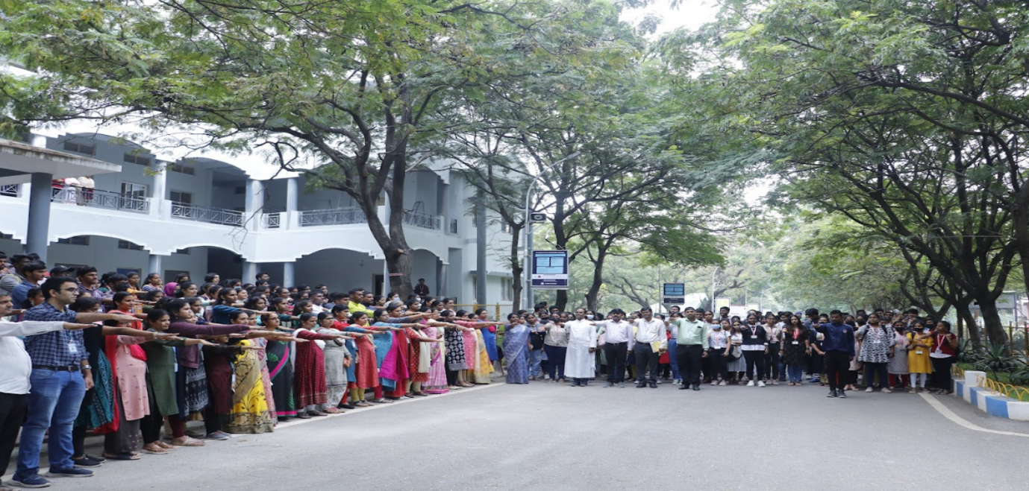
- Performance – The choreo was on the ‘Unity in Diversity’ an admiring Indian elevation, the performance depicted Indian states and it was a captivating show.
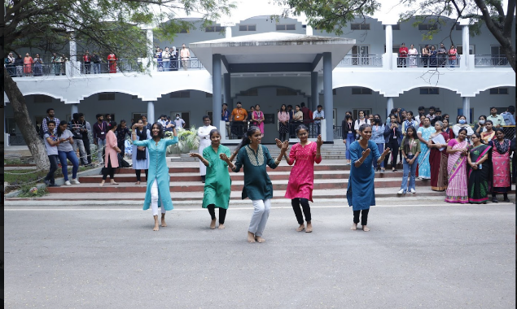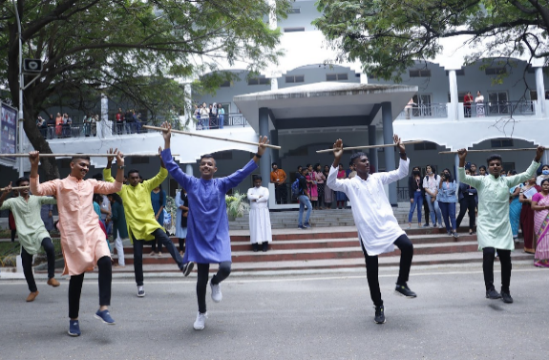
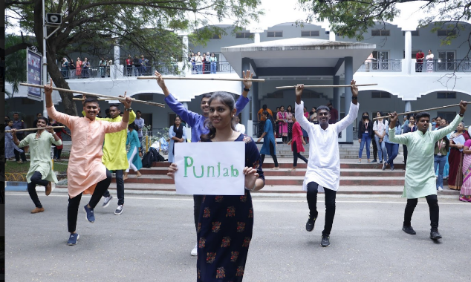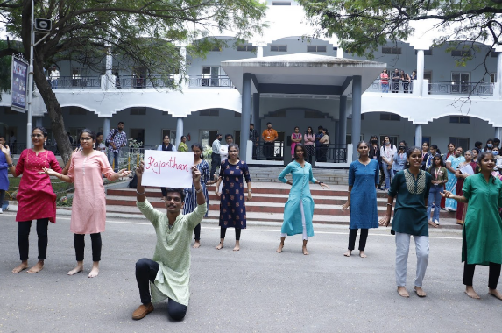
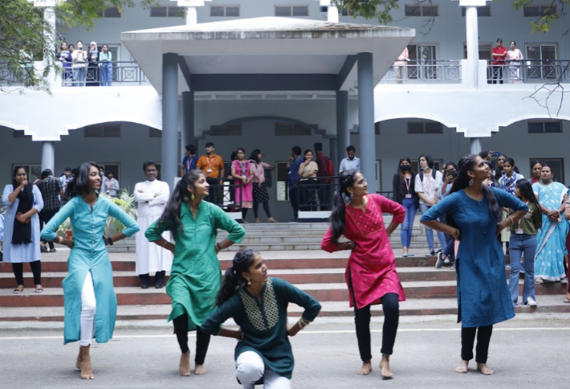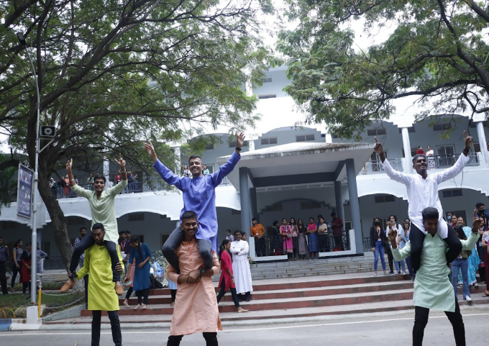
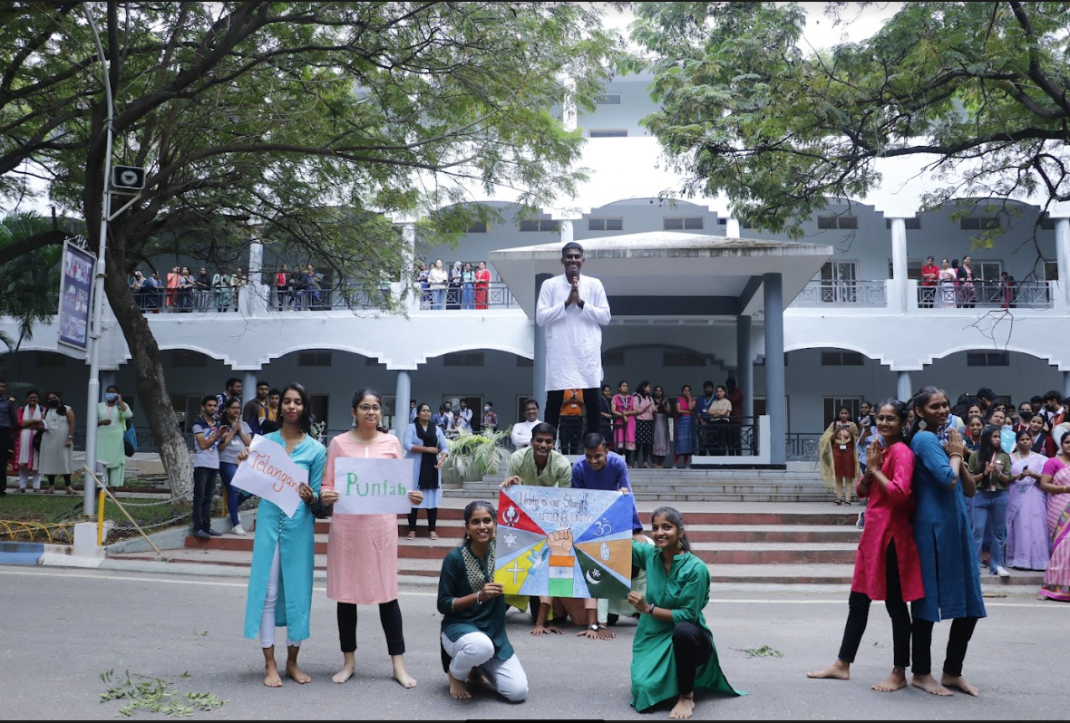

OUTCOME – Students understood the importance of “National Unity Day”, gained knowledge about the life of SARDAR VALLABAI PATEL, a member of 1st parliament session in Independent India, and how great were his contributions towards the Indian freedom struggle and the united INDIA.
*Students also pledged solemnly to contribute in ensuring the internal security of the country, followed by the Dance in which students could grasp India’s Unity in its Diversity.

11. PUNEET SAGARABHIYAN
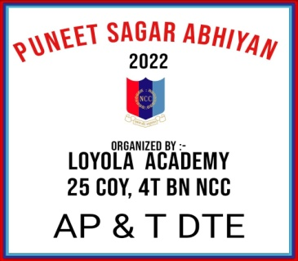
AIM:To tackle the issue of plastic pollution and achieve the universal goal of clean water bodies through ‘Puneet Sagar Abhiyan’
DURATION: 21-11-22 to 27-11-22
REPORT: NCC & UNEP sign MoU in the presence of Raksha Mantri Shri Rajnath Singh to synergize efforts to achieve the universal goal of clean water bodies.
On this esteemed ideology the NCC Cadets of Loyola academy,25 COY,4T(BN) NCC, Secunderabad group have organized and successfully brought up the following events for 5 days:
DAY 1
I. POSTER MAKING: Poster-making pictographs the clean water bodies, quotes addressing the issues of plastic, pollution and thereby achieving a clean and green territory which was conducted on 21st of November 2022
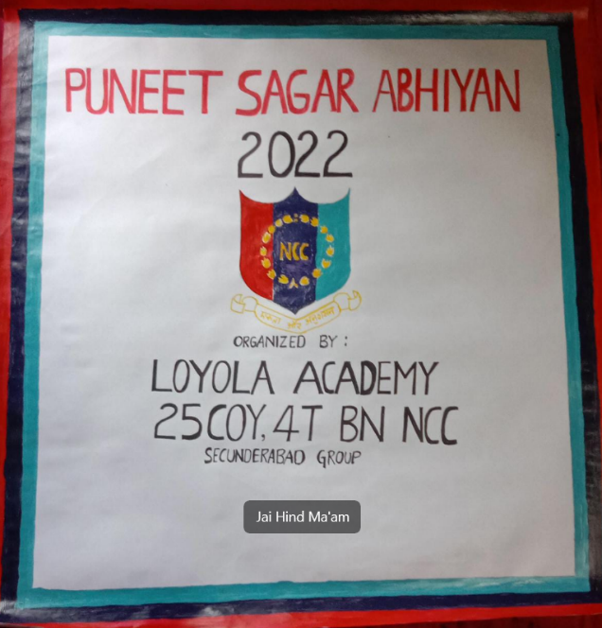
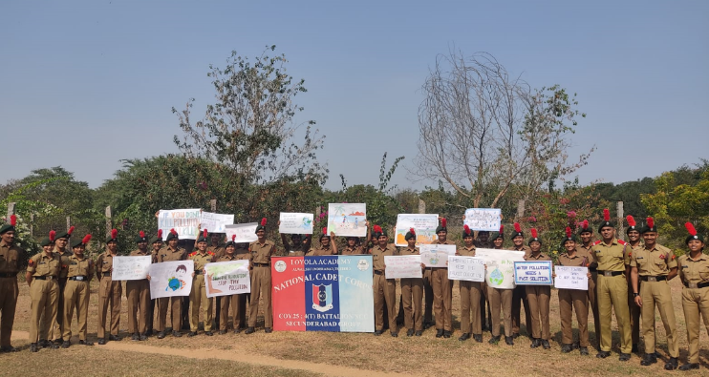
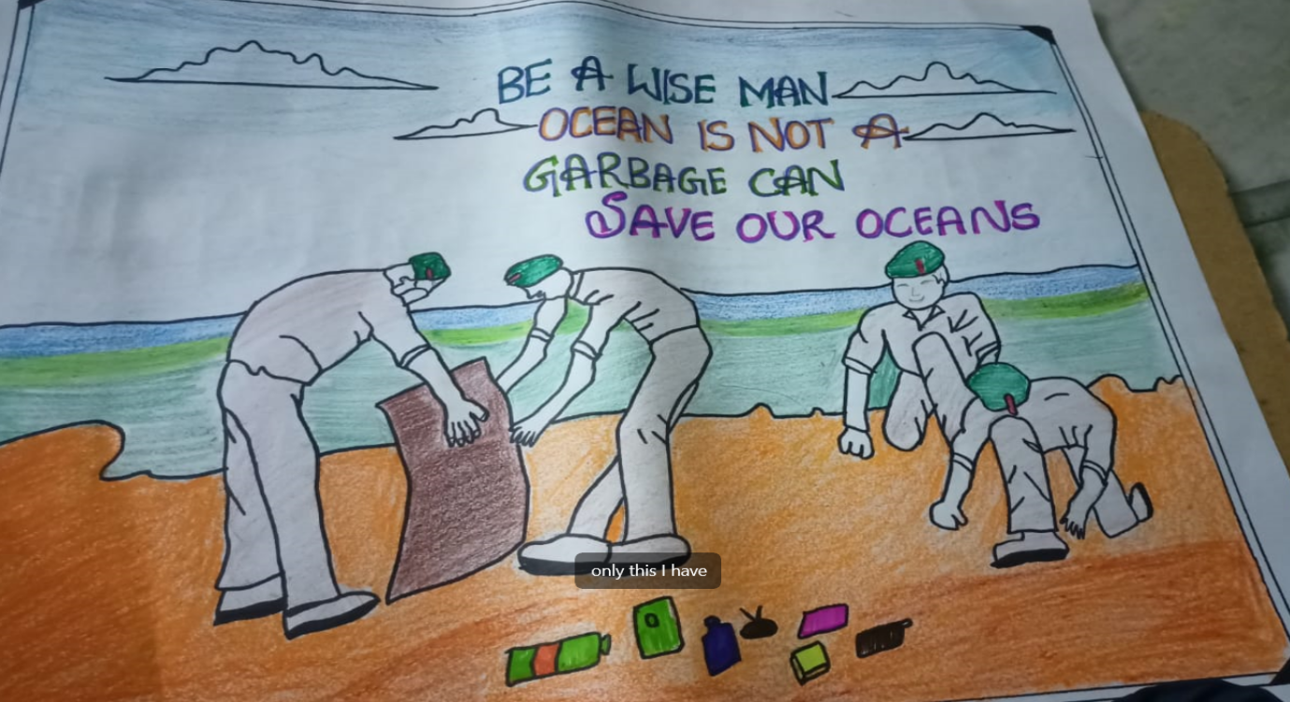
DAY 2
ii. RALLY: The rally included Campus_A(UG, PG), and Campus_B in which the Cadets kept their josh high throughout, and the posters made were used as placards in the rally which was held on 22nd of November 2022
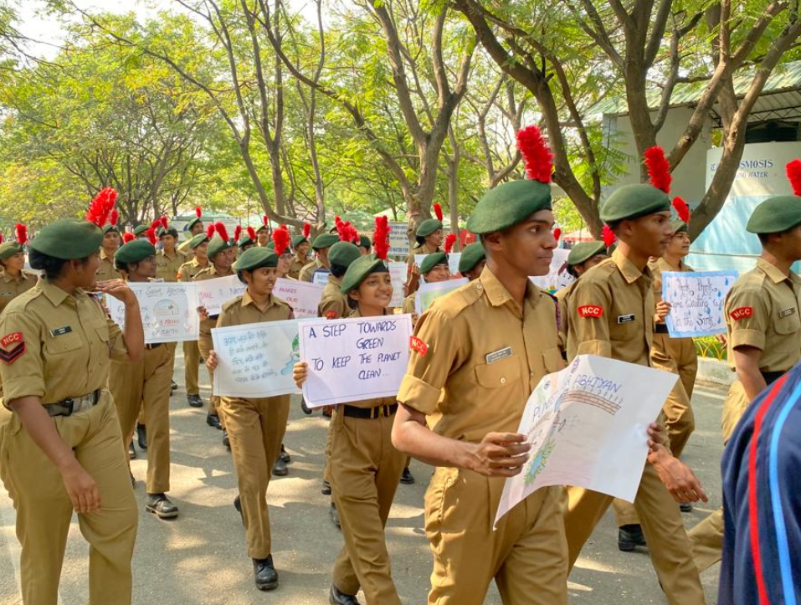
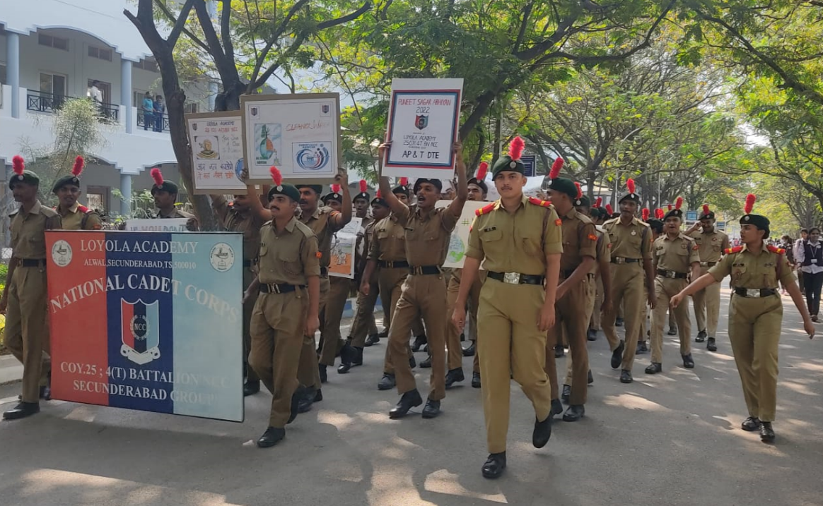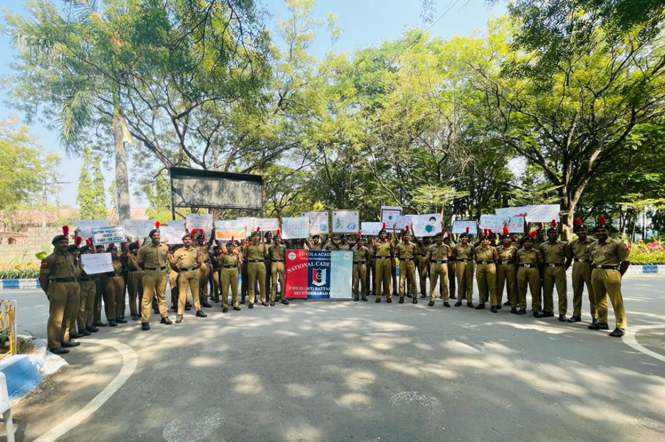
DAY 3
iii. FOOT POLISHING: Cleaning and organizing are a practice, not an event, Cadets exerted themselves in cleaning up the college premises by brooming, and picking up, the paper and plastic litter on 23November 2022
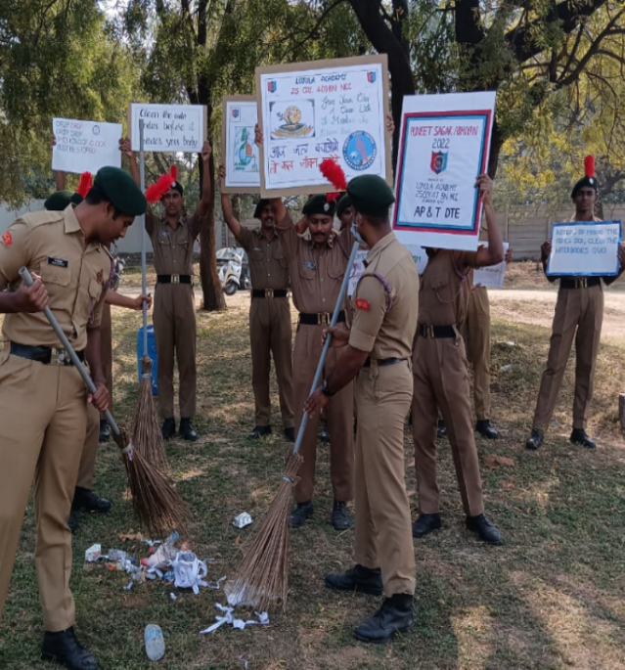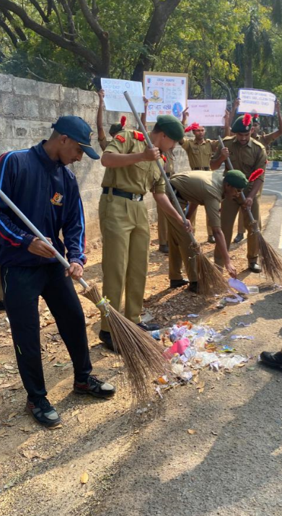

DAY 4
v. MOTORCYCLE RALLY: On the 25th of November 2022, a Motorcycle Rally was conducted which covered a distance of 2km, surrounding the outer campus territory of Loyola Academy.
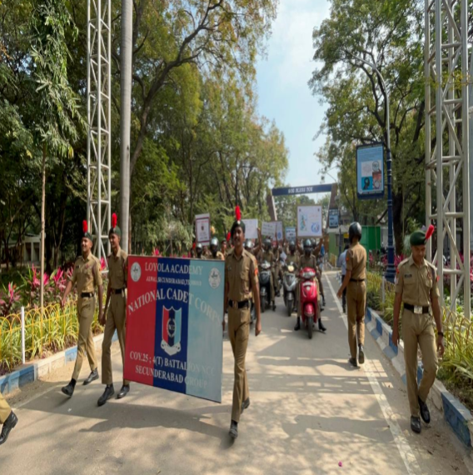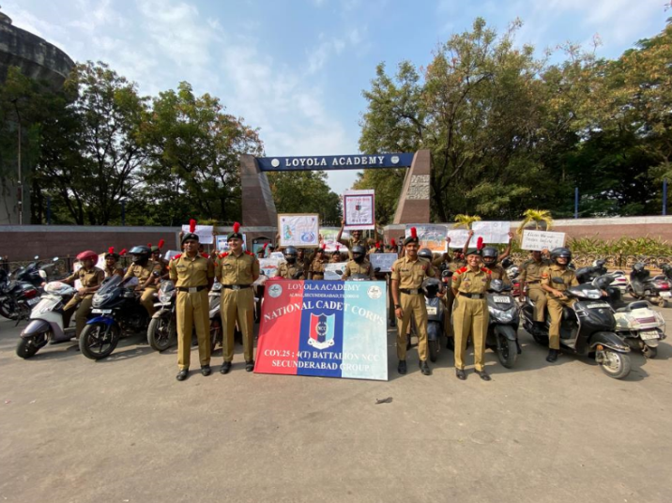
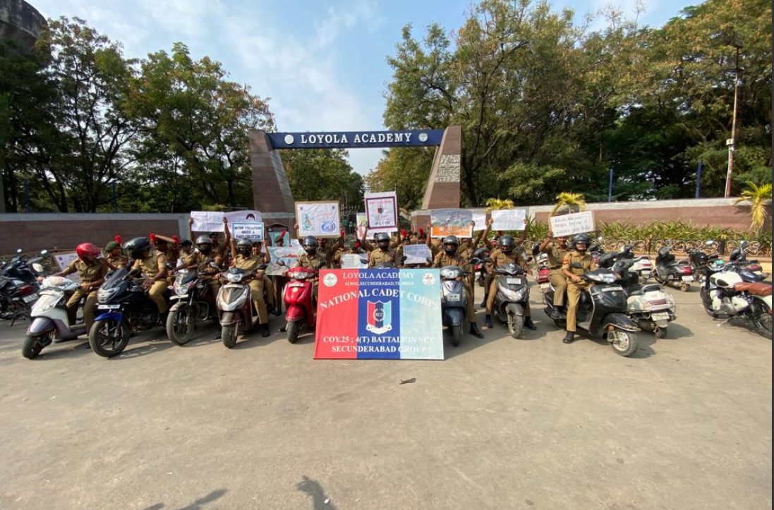
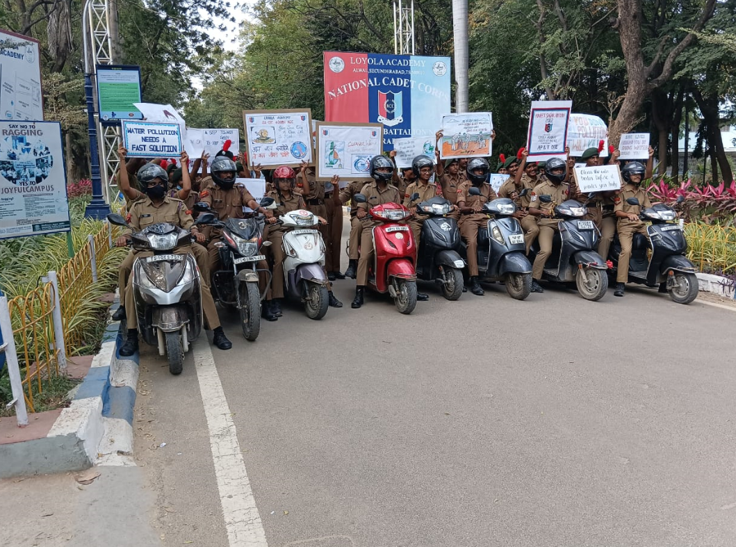

DAY 5-
iv. CLEANING WATER BODIES: To co-ordinate this noblest initiative, the percolation tank of CAMPUS_B of Loyola Academy was cleaned, picking the litter on 26th of November 2022
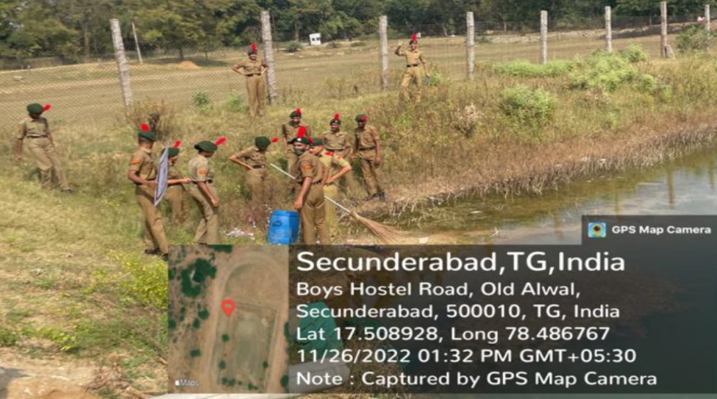
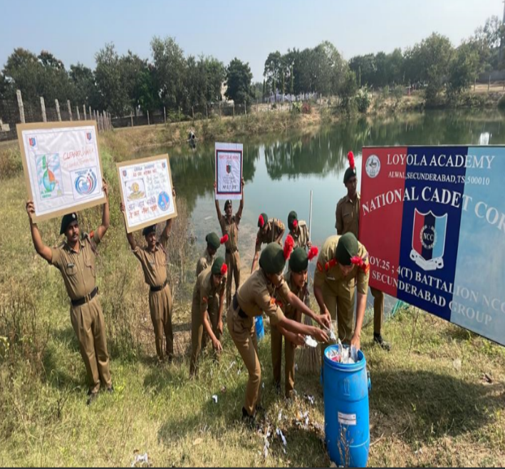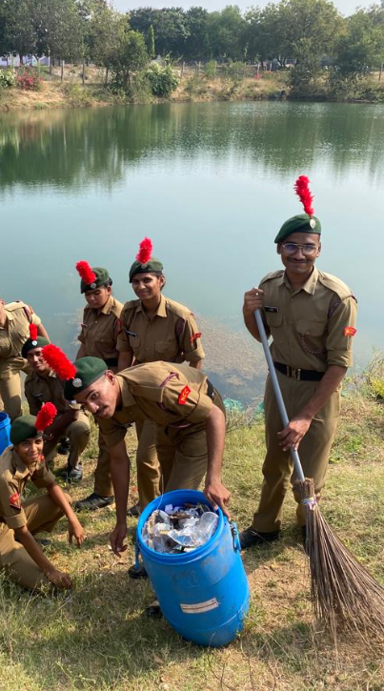
CONCLUSION: An effective chunk of the nationwide campaign ‘Puneet Sagar Abhiyan’ in Loyola academy was successful to clean the plastic waste & other waste along the nearby waterbody, rallies increased awareness about the importance of keeping our seas/lakes etc free from plastic waste. The campaign 5 days aimed to propagate the message of the importance of ‘clean water bodies amongst the local population and future generations.
12. NATIONAL CONSTITUTION DAY
AIM: Celebration of National Constitution day on the occasion of 131st birthday of Dr. B. R. Ambedkar.

REPORT: The Student bodies, NCC, NSS, Student council, Magic youth and AICUF of Loyola Academy, Alwal staged a wonderful event which was organised on 26 November 2022.

The prominent event was started with the speech of Father Dr. L Joji Reddy SJ, Principal of Loyola Academy and President of Xavier Board. Dr.G.Ratna Vani shared her knowledge about the Fundamental rights and The Preamble followed by the pledge was taken up by Dr.N.Maria Das,Vice principal, the NCC, NSS, Student council, magic youth of Loyola Academy, Alwal, Secunderabad.
There was also a radical drama performed by the Student council of Loyola Academy depicting the First assembly on journey of Constitution making.
The Cadets maintained the decorum of the event and were enlightened by the speeches.

13. GUARD OF HONOR GIVEN TO PROF D. RAVINDER

Loyola academy cordially invites PROF. D. RAVINDER, Vice chancellor, Osmania University, Hyderabad to the Let us dream community conference Hyderabad.
The chief guests were escorted by the piloting commander LCPL Aakarsh with the pilots LCPL Niharika and LCPL Jayakrishna.

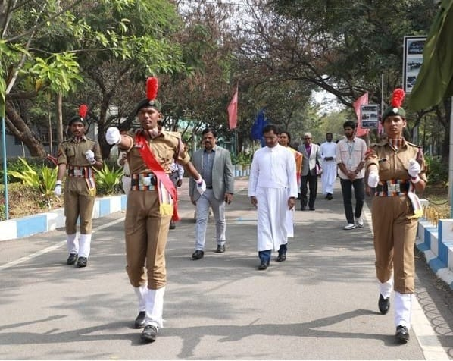

The guard of honor was led by guard commander CDT. Dheeraj and sentry LCPL I. Aaron with LCPL Aman Saraswat, LCPL Gunjan Soni, LCPL Suchita, LCPL Shikha Phulsungey, LCPL Ramashankar, CDT. Harshavardhan, CDT Sai Shankar Yadav, CDT Afreen Shaik.

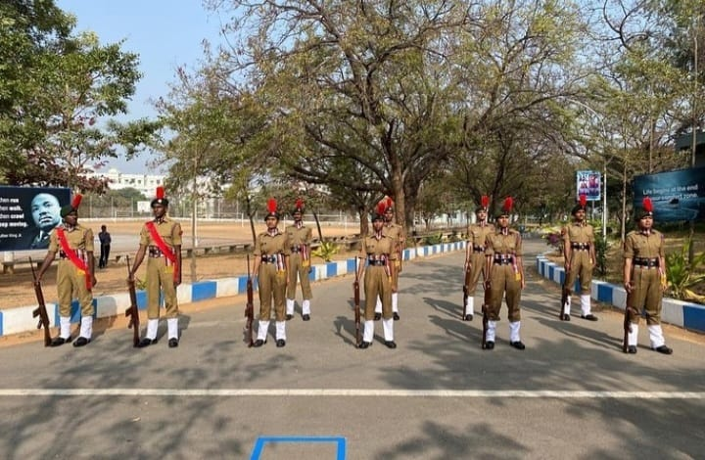

CHIEF GUEST FOR THE DAY -
PROF. D. RAVINDER (VICE CHANCELLOR, OU, HYD).

He has over 30 years of teaching, research and administrative experience ever since he joined the political science department in Osmania University as a member of the faculty.

FR. XAVIER JOHN BOSCO SJ.
He attended a focus on leadership, spirituality program in Denver, USA and specialized in ( NLP) Neuro linguistic programming under Fr. Dick Mchugh SJ in Washington DC

PADAMASRI RAVI KUMAR NARRA,
FR. LIJO THOMAS,
SRI T. VIJAY KUMAR, IAS,
RAJEEV YSR.

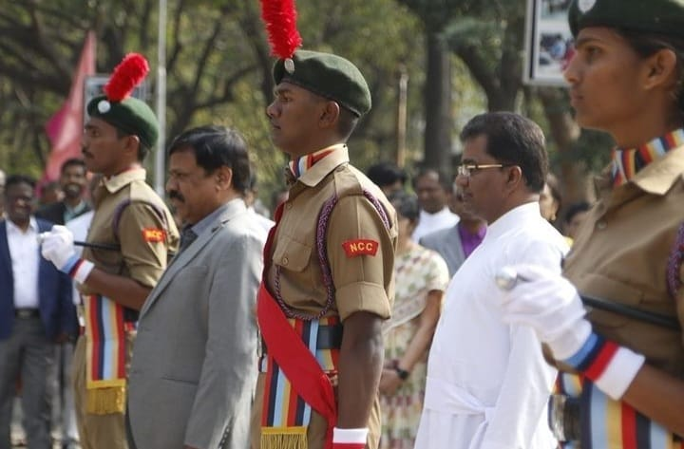

REPORT
The Let us dream conference was established to create better networking and collaboration among volunteers, potential volunteers, philanthropists and community organizations; thereby empowering them in their diverse community improvement programs.
The conference also introduces different community service possibilities and intervention models among younger and older generations to promote their volunteerism. The conference is committed to bringing together the knowledge from both researchers and practitioners on the same platform.
The Event was of great learning and was a splendid moment for the NCC cadets, NSS members and CRS and ACRS to attend the conference.

14. 74TH REPUBLIC DAY

The new constitution of free INDIA came into force with effect from this day. As the nation celebrates 74th republic day, everyone was cordially invited to the glorious celebration of republic day at Loyola academy.
CHIEF GUESTS FOR THE DAY.
- Bro M. Xavier Amal SJ.
- Rev Fr. Arul jotting SJ - Vice principal
- Rev Fr. A M Joseph Kumar SJ - vice principal.
- Dr.N.Maria Das-vice principal
- Rev Fr. Anthony prabhu - Agriculture block and campus ministry in charge.
- Cadet training officer Naval wing - Mr. Dheeraj Kumar Sahu.
- Cadet training officer Army wing - Mr. N Ashfaq

- The guests were escorted by the piloting team by piloting commander SGT Rooshan Hussain with the pilots LCPL Aakarsh and LCPL Jaya Krishna.

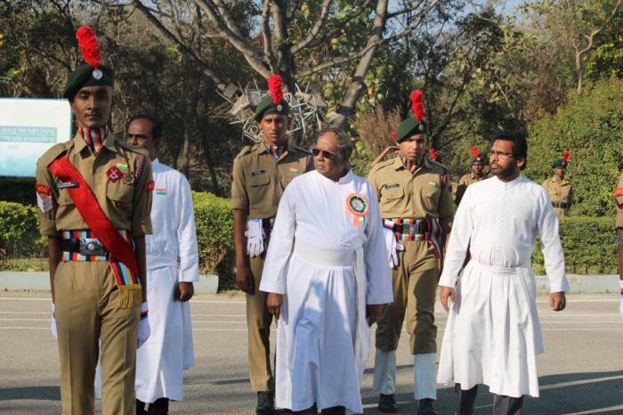

- The National flag was hoisted with the pride by the Bro M. Xavier Amal SJ.
The Rashtriya salute was esteemed to the national flag during the national anthem.

- The nirikshan, followed by the contingent which was led by the contingent commander CPL Chetan Sharma.
Flag bearer JUO Akul Joshi holding the Indian flag.
Flag bearer Company quarter master Sergeant Harish Choudhary holding the Indian army flag.
Flag bearer JUO Shruthi Singh holding the NCC flag.
Flag bearer SGT Anson Daniel holding the Loyola Academy flag.

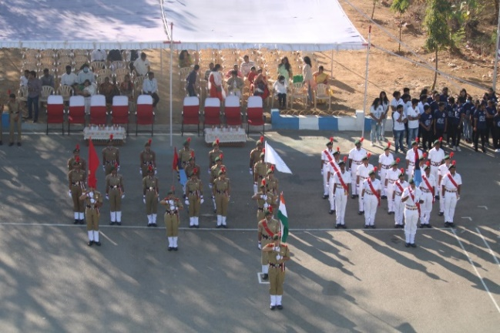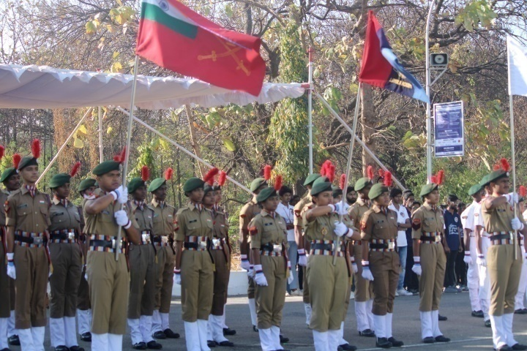

- The NCC song was sung by everyone after the contingent arrived.

- Prize distribution.
- Best in academics and best in overall were felicitated to the cadets.

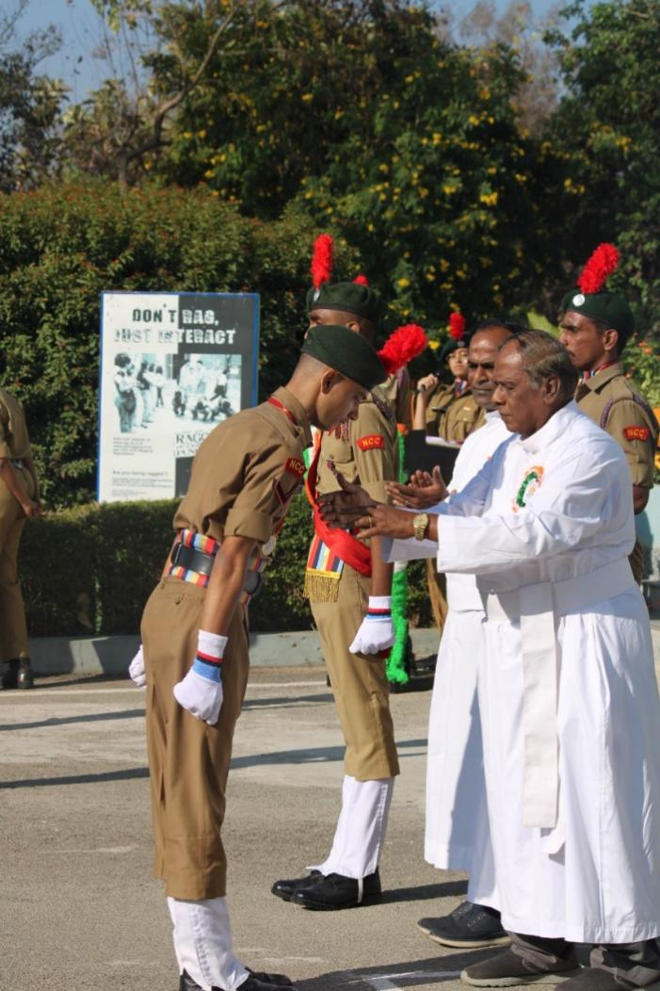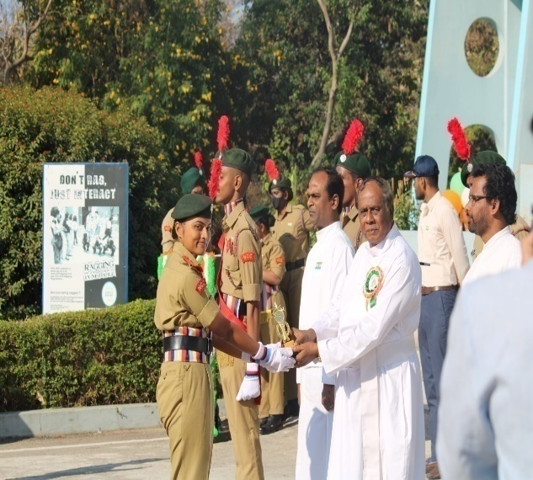

- Speech -
The speech was delivered by Bro M. Xavier Amal SJ. With his words of wisdom.

- Cultural session
This session comprised of classical dance, drama and dance by NSS. The cultural performance was enlightening and entertaining the audience as well as inspiring them.

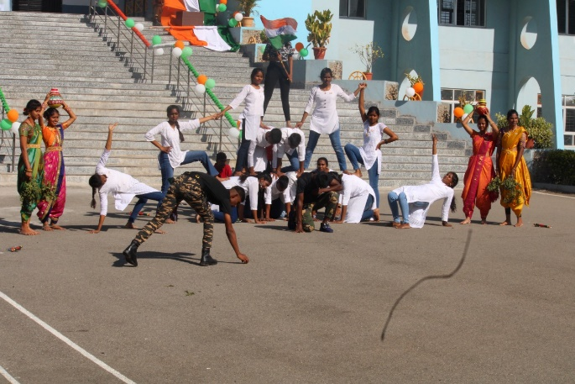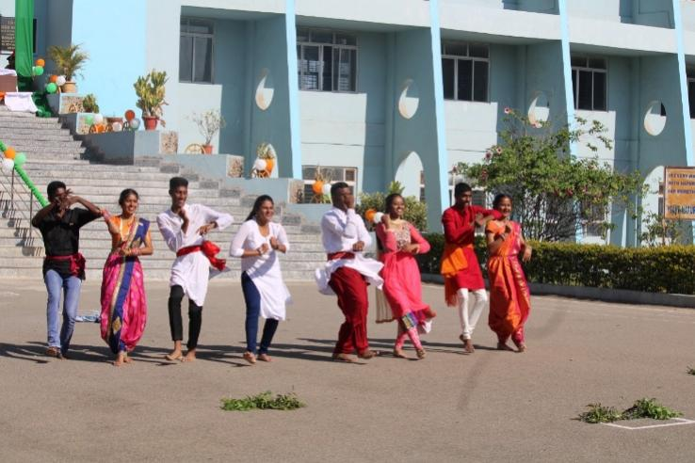

Event ended with a vote of thanks from JUO Shruthi Singh, followed by the photo session.

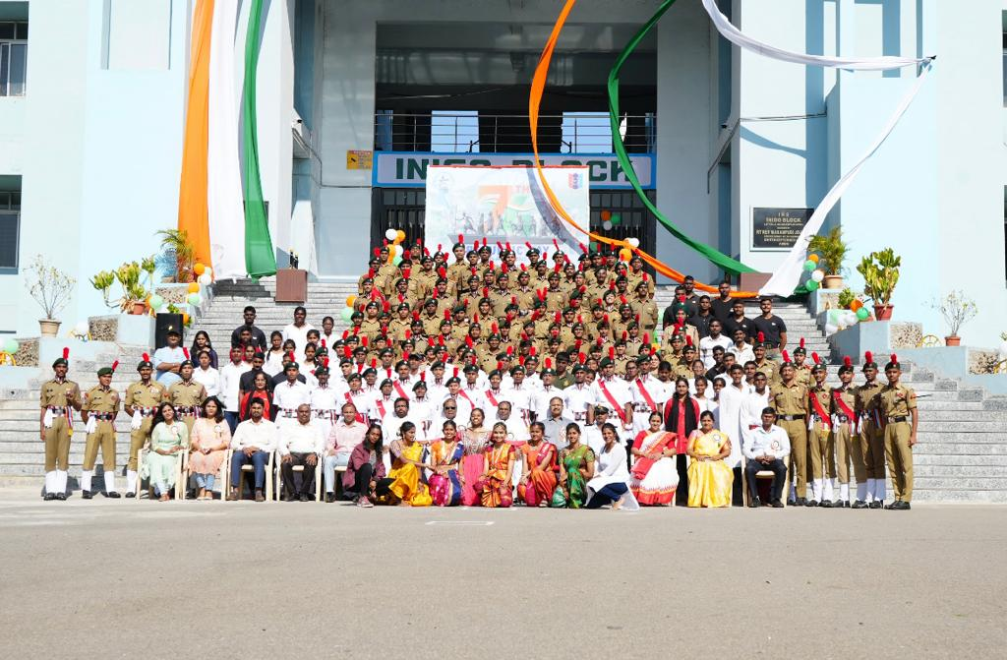

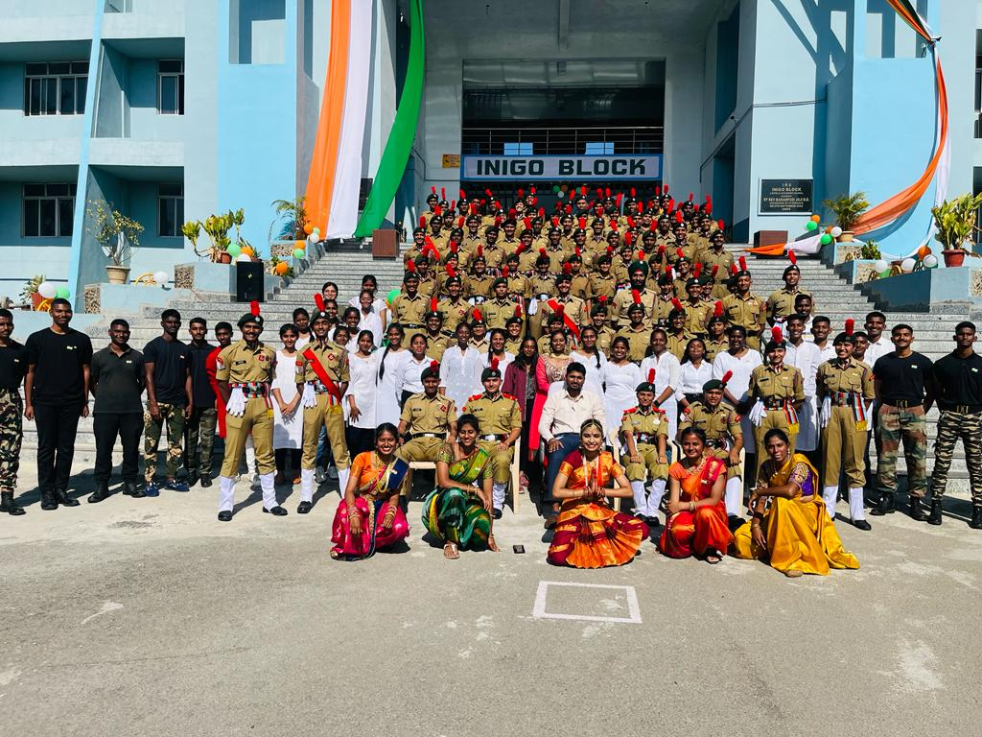

15. CPR TRAINING SESSION

AIM:Cardiopulmonary resuscitation training session.
DATE: 28 Jan 2023

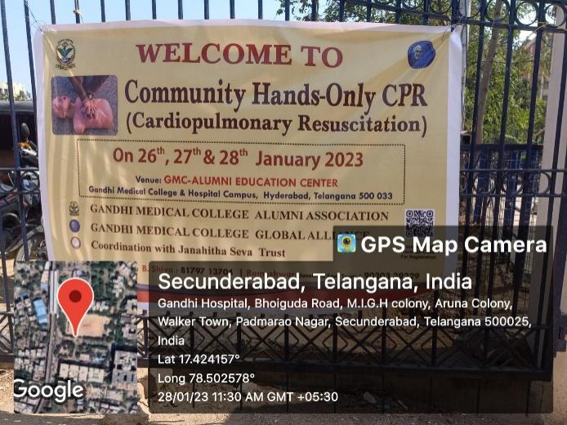

REPORT: The session took place at Gandhi hospital, Secunderabad. Under the guidance of Havaldar Jarnail Singh, 4 cadets attended the session. The session was all about educating the cadets on how to react in any emergency situation.

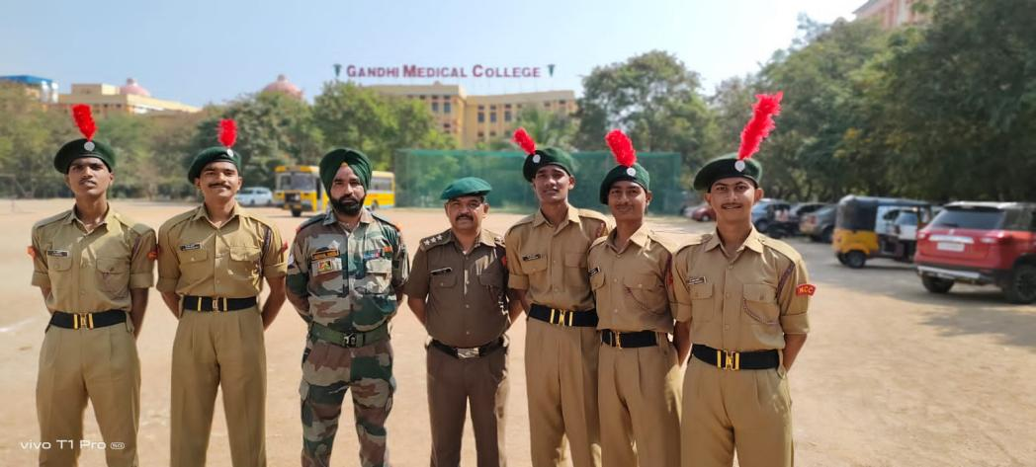
The session comprised of 2 phases, one was lecture and another was practical.
First, Introduction were given to the cadets regarding how to perform CPR and then they were also made to perform a practical on a dummy body under the guidance of doctors present there.

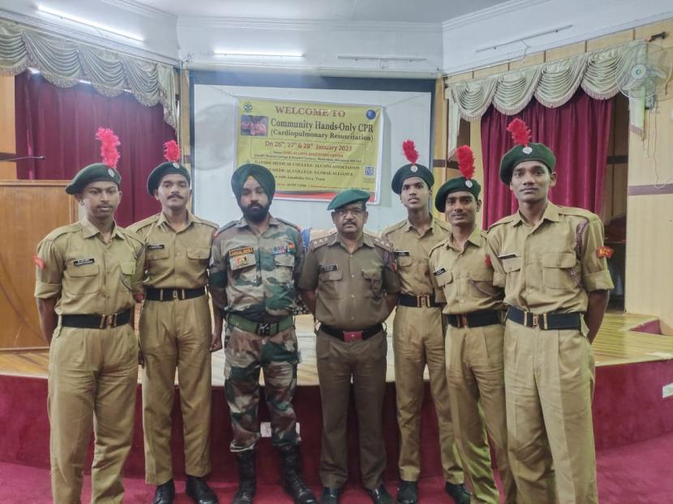

The session was very helpful to the cadets as they got to learn and know about how actually a CPR is performed.
The cadets can now help any person in emergency by performing basic CPR.

The session ended with distribution of refreshments.

CAMP RECORD

Index
Sr no. | Name
1. | EBSB
2. | AITC
3. | Rock Climbing Camp
4. | Shivaji Trail Trek
5. | IGC-RDC
6. | RDC
7. | CATC – II
8. | IDSSC
9. | Army Attachment Camp
10. | CATC – III
11. | SNIC
12. | Kerala Trek

- EBSB

Camp Name:Ek Bharat Shreshth Bharat
Camp Location: Online
Duration: 18/10/2021 – 23/10/2021
No. of Cadets: 1
- CDT James Abraham Ojha
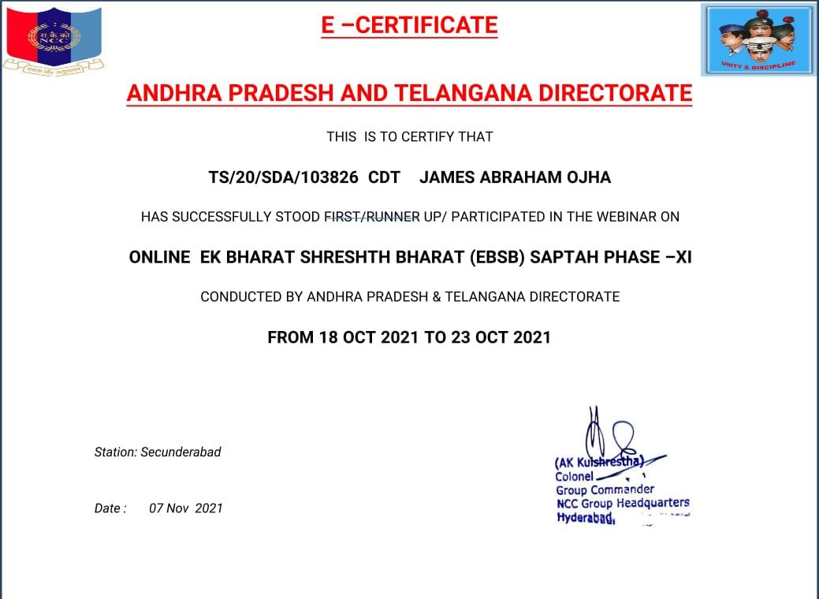

2. AITC

Camp Name:All India SD Trekking Expedition
Camp Location: Tirupati, Andhra Pradesh.
Duration: 12/11/2021 – 19/11/2021
No. of Cadets: 1
- CDT Chetan Sharma
Achievements:
- He was awarded as the 2nd Best Cadet representing Secunderabad group.
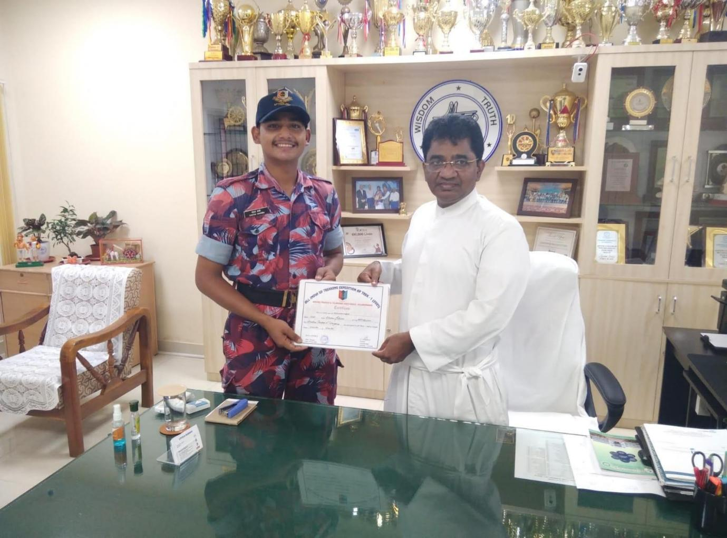
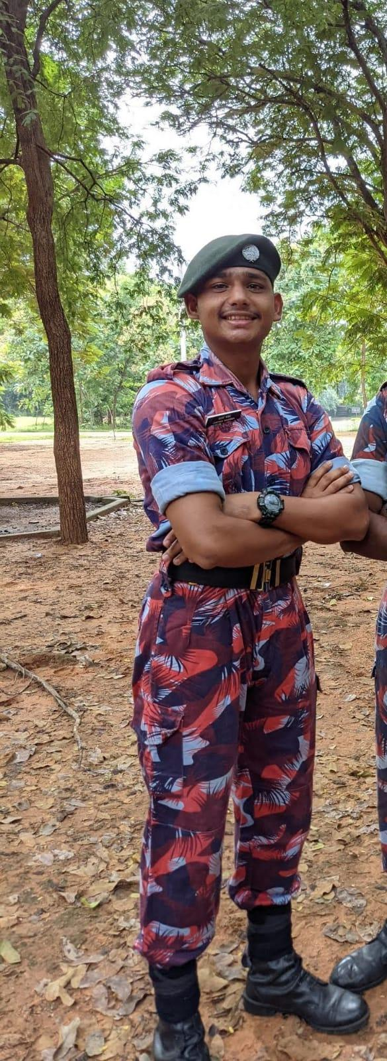
3.ROCK CLIMBING CAMP

Camp Name:Rock Climbing Training Camp
Camp Location: Gwalior, Madhya Pradesh.
Duration: 10/11/2021 – 28/11/2021
No. of Cadets: 2
- L/CPL Aaron A Purty
- CDT B Akash
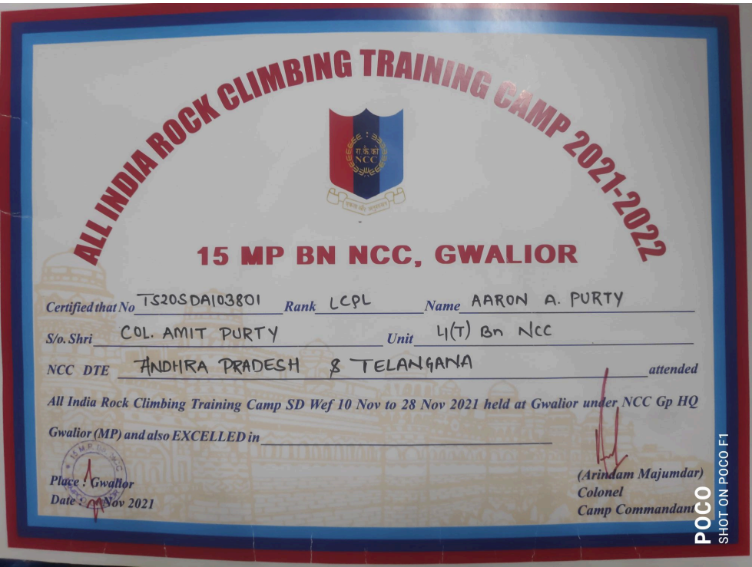
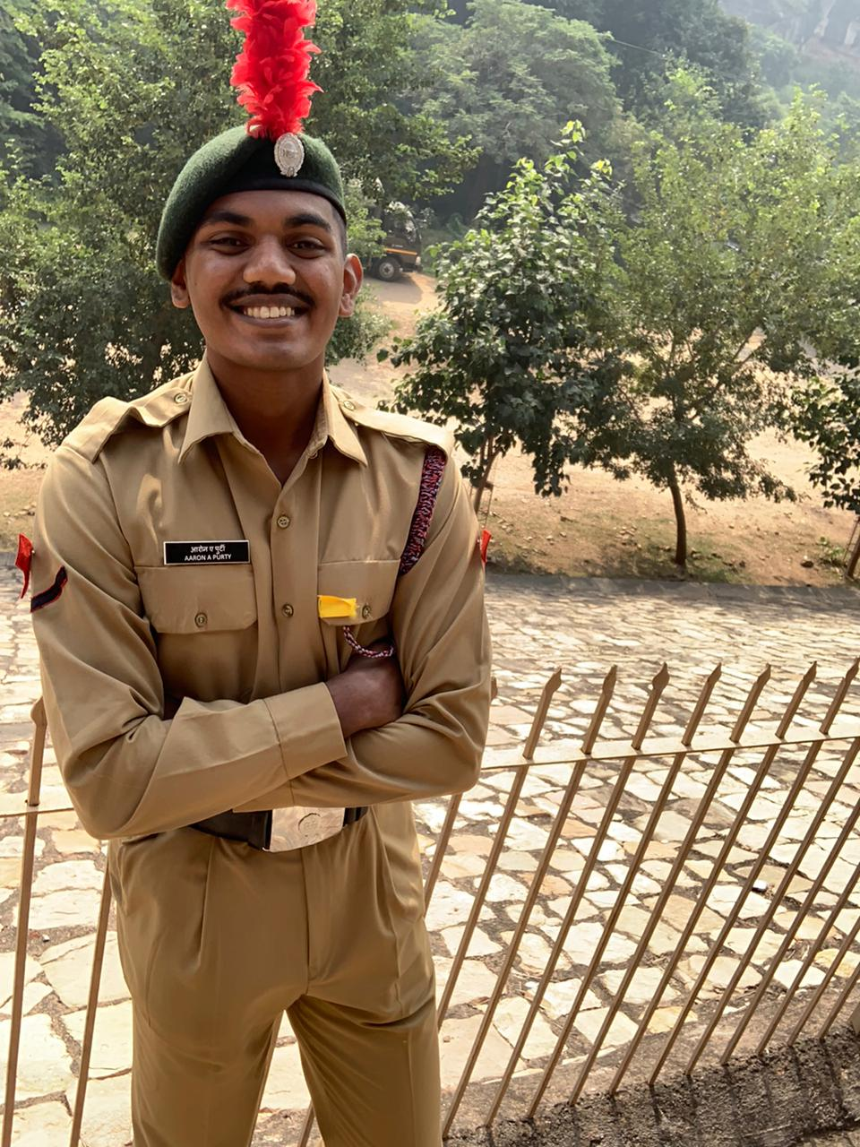

  - SHIVAJI TRAIL TREK

Camp Name:Shivaji Trail Trek
Camp Location: Kolhapur, Maharashtra.
Duration: 27/11/2021 – 07/12/2021
No. of Cadets: 1
- CDT Pedda Shashank

5. IGC-RDC

Camp Name:Inter Group Competition (RDC)
Camp Location: Tirupathi, Andhra Pradesh.
Duration: 17/10/2021 – 26/10/2021
No. of Cadets: 9
SW’s SD’s
C C
- JUO Ananya Sridhar 1. SUO Adarsh
- JUO Neha Vyas 2. SGT Kalyan
B B
- L/CPL Shruthi Singh 1. CDT Akul Joshi
- L/CPL Karthika Thota 2. CDT Ankit Kumar Tiwari
- CDT Gouti Likitha

Achievements:
- Secunderabad Group scored the first prize in Overall Championship.
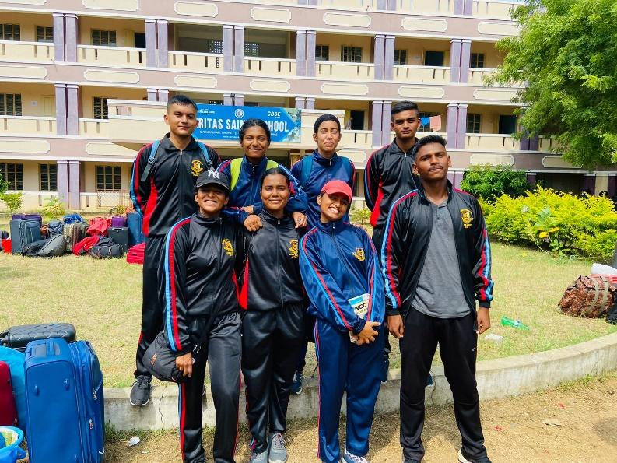


6. RDC

Camp Name:Republic Day Camp
Camp Location: New Delhi.
Duration: 16/12/2021 – 04/02/2022
No. of Cadets: 3
SW’s SD’s
C C
- JUO Ananya Sridhar 1. SUO Adarsh
B
- L/CPL Shruthi Singh

Achievements:
- L/CPL Shruthi Singh Represented Andhra Pradesh and Telangana Directorate as Best Cadet.
- She secured All India 4th rank in All India Best Cadet Competition.
- She participated in PM RALLY 2022 and got selected for Central MC, was also a part of Flag area Mural Making
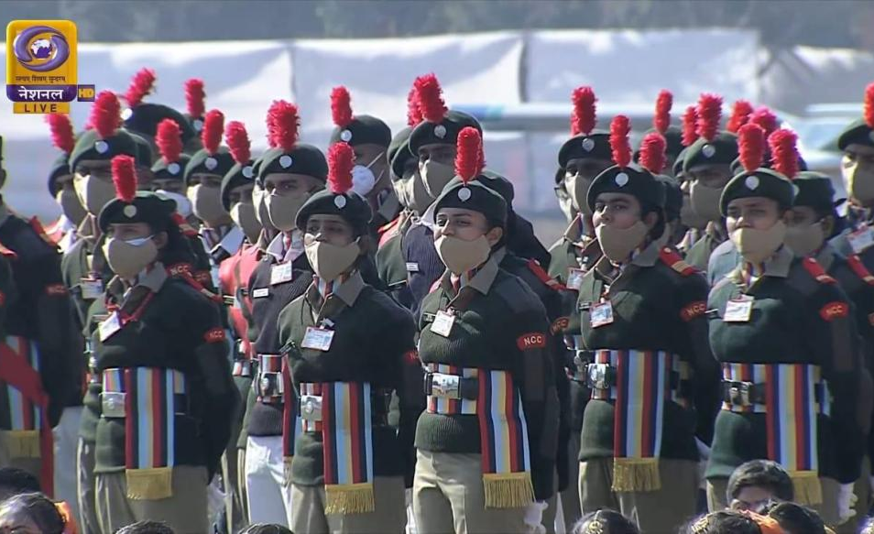

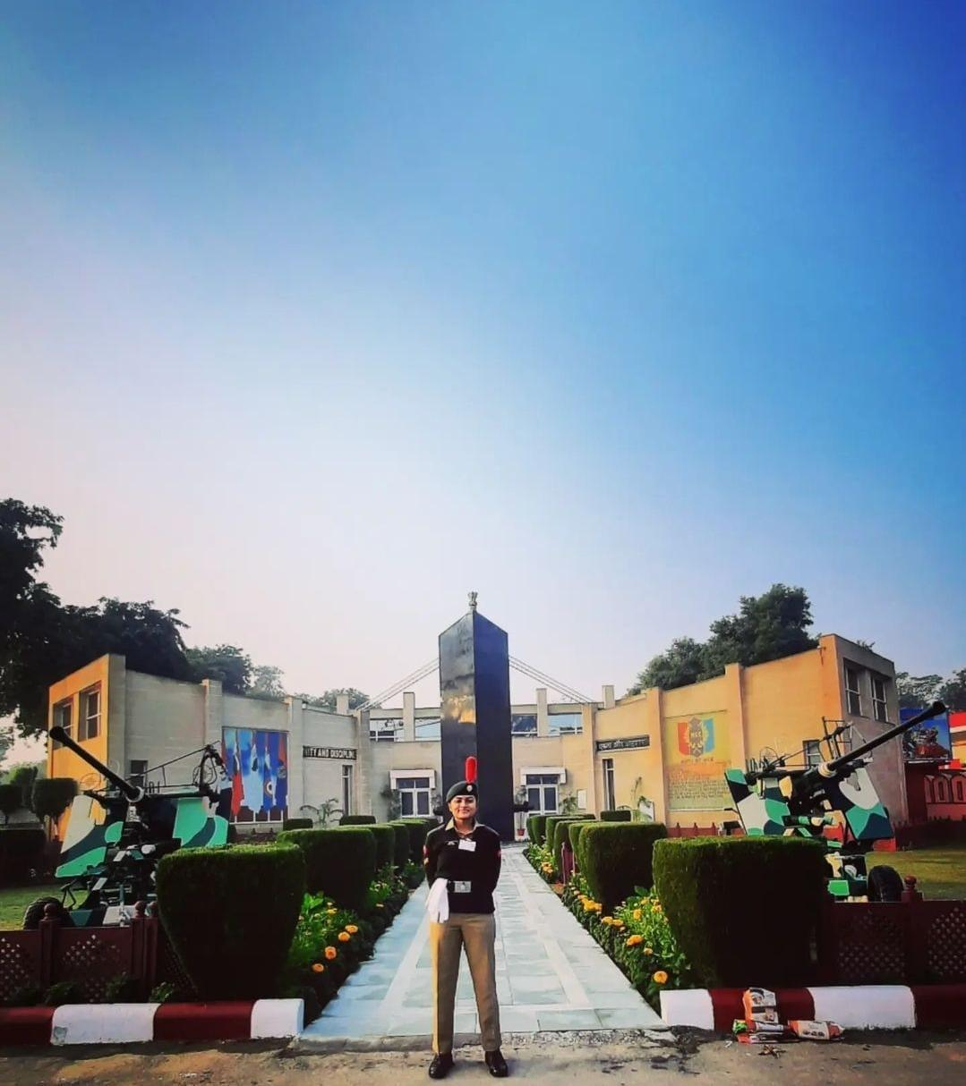

7. CATC -II

- CAMP NAME: Combined Annual Training Camp - II
- CAMP LOCATION: Mumtaz Degree & PG College, Malakpet
- DURATION: 23/6/2022- 2/7/2022
- No.OF CADETS:55
SW’S SD’S
C C
- CDT Chandu meghana.T 30. LCPL Sai Charan
- CDT Janani.S 31. LCPL Aaron purty
- CDT Gaaayatri Battula 32. CDT E.V Sarang
- CDT Tula saimanju
- CDT Manjusha
B B
- CDT Suchitha 33. CDT Jaya krishna
- CDT Gunjan Soni 34. CDT Rama shankar
- CDT Shika Phulsungey 35. CDT I.Aaron
- CDT Y.Shruthi 36. CDT Adarsh chetty
- CDT Challa Chandana 37. CDT Akarsh
- CDT Sri vidya 38. CDT Akhil
- CDT Pravalika 39. CDT Arnold
- CDT Bhashitha 40. CDT Barath
- CDT Sree Harshini 41. CDT Harsha vardhan
- CDT Shaik Afreen 42. CDT Harshith singh
- CDT Nishitha 43. CDT Lokesh
- CDT Shravani 44. CDT Mastan
- CDT Ragini Raj 45. CDT Niranjan
- CDT Shravya 46. CDT Om prakash
- CDT Jahnavi Reddy 47. CDT Pawan
- CDT Neelam 48. CDT Prasad levi
- CDT Neeraja 49. CDT Revanth
- CDT Pavani 50. CDT Sai shankar
- CDT Y.Meghana 51. CDT sandeepreddy
- CDT J.Shruthi 52. CDT Santhosh kumar
- CDT B.Akshitha 53. CDT Sidharth
- CDT Mounika Shetty 54. CDT Srinu
- CDT A.Niharika 55. CDT Sai srujanyadav
- CDT G.Rajeshwari
- ACHIEVEMENTS:
1. Best contingent
2.Thug of war (1st place)
3. Cultural

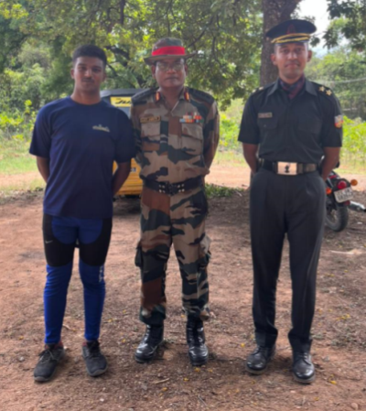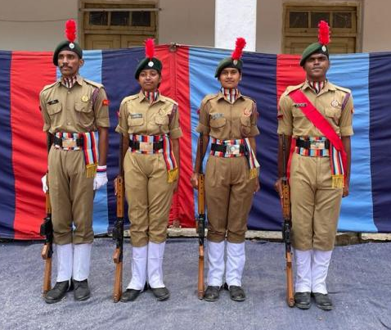
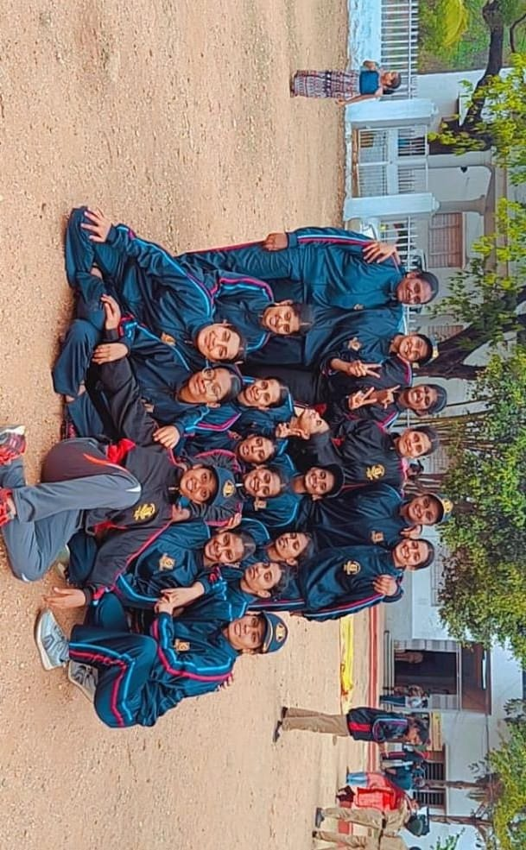

8. IDSSC

Camp Name:Inter Directorate Sports Shooting Championship.
Camp Location:NCC Academy, Rupnagar, Chandigarh, Punjab.
Duration:02/06/2022 – 13/06/2022
No. of Cadets:2
- JUO Shruthi Singh
- JUO Akul Joshi
Achievements:
- JUO Akul Joshi got 6th rank in 3 positions .22 Deluxe Rifle and got qualified for G V Mavlankar.
- JUO Shruthi secured 12th rank in 3 positions .22 Deluxe Rifle.

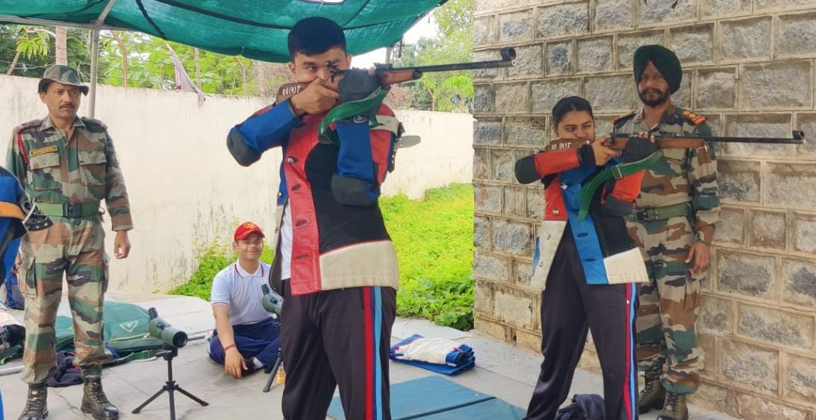
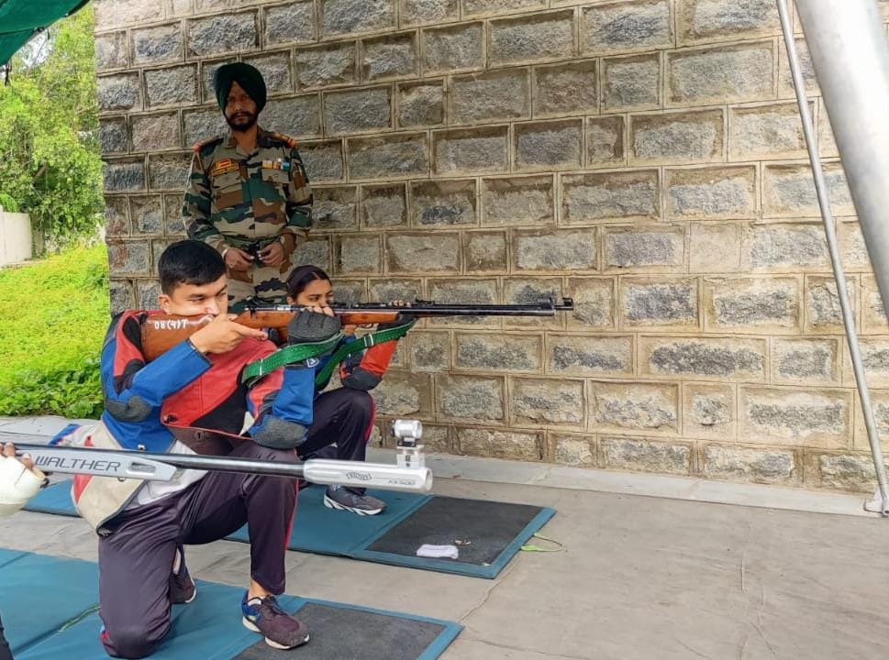

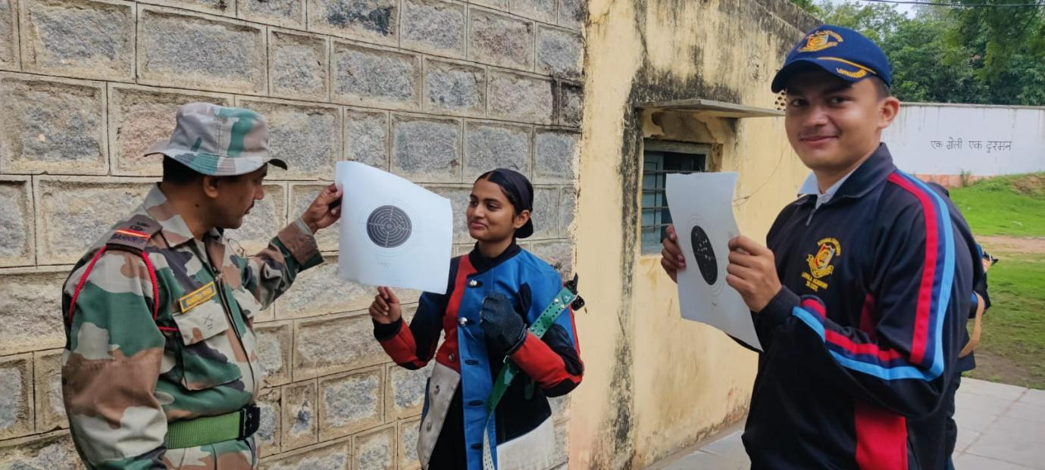

9. ARMY ATTACHMENT CAMP

Camp Name:Army Attachment Camp
Camp Location: Mehdipatnam Garrison, Secunderabad.
Duration: 22/07/2022 – 31/07/2022
No. of Cadets: 8
- L/CPL Sai Charan
- CDT Harish Chaudhary
- CDT Sai Kumar
- L/CPL Anson Daniel
- CDT B. Nikhil
- CDT Nikhil Panth
- CDT Sai Sumanth
- CDT Rooshan Hussain
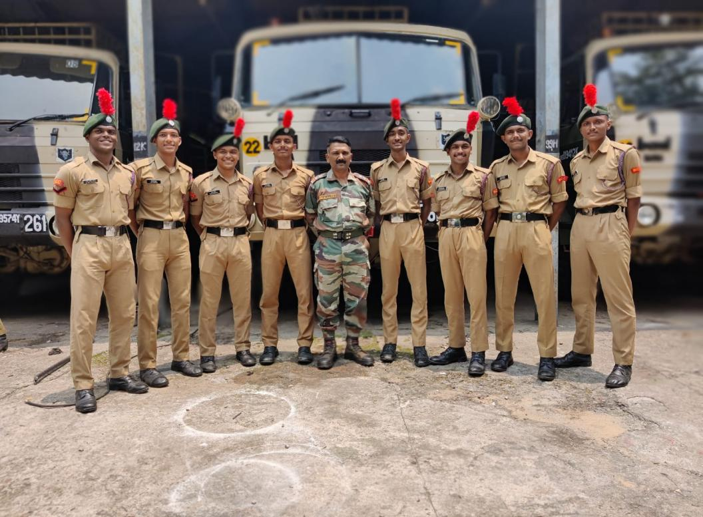
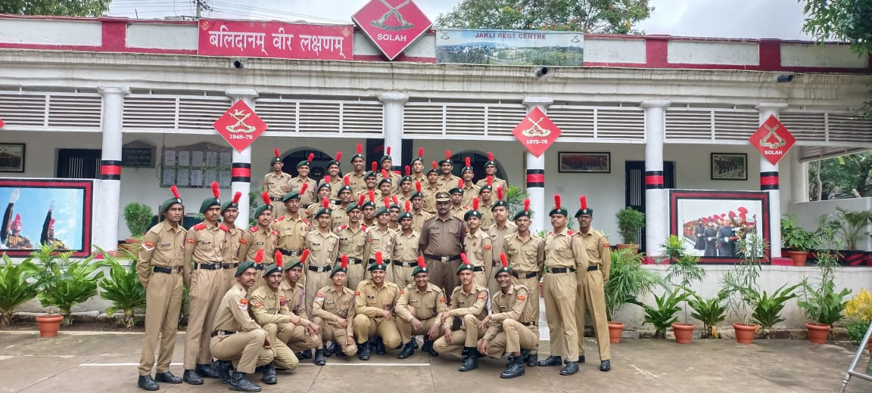

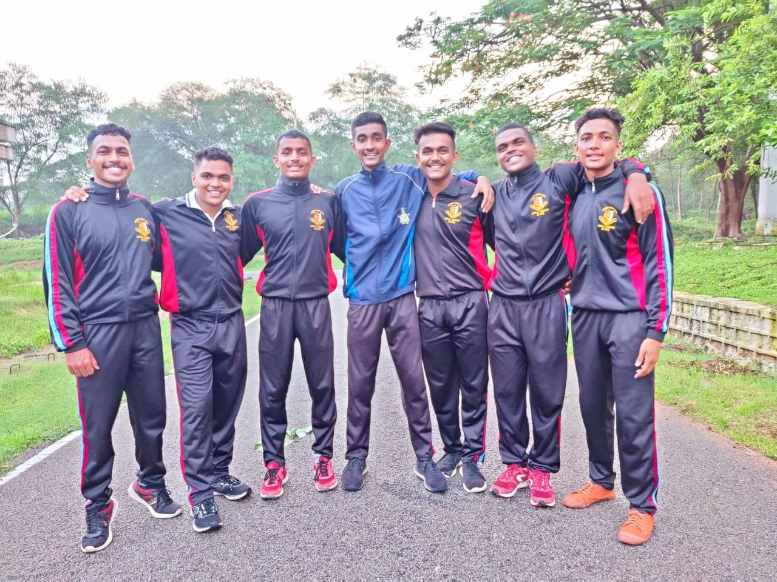

10. CATC III

Camp Name:Combined Annual Training Camp III
Camp Location: Malla Reddy Engineering College, Dhulapally, Secunderabad.
Duration: 27/09/2022 – 04/10/2022
No. of Cadets:20
SW’s SD’s
C C
- L/CPL G. Varshita 1. CDT Abhiram
- L/CPL Bhagya Laxmi Budhori
- CDT Kushbu Choudhary
- CDT Kajal
- CDT Shanti Priya
- CDT Tejaswini
- CDT Madhavi

BB
- CDT Manaswini 1. L/CPL Rama Shankar
- CDT Soni 2. CDT Justin George
- CDT Rachana 3. CDT Koushik
4. CDT Shiva
5. CDT Badulla
6. CDT Pulkit
7. CDT Revanth
8. CDT Samuel
9. CDT Praveen

Achievements:
- CDT Madhavi scored 1st prize in Running.
- L/CPL Bhagya Laxmi Budhori won 1st prize in Dance competition.
- L/CPL G. Varshita and CDT Rachana did Piloting in the closing ceremony of the camp.

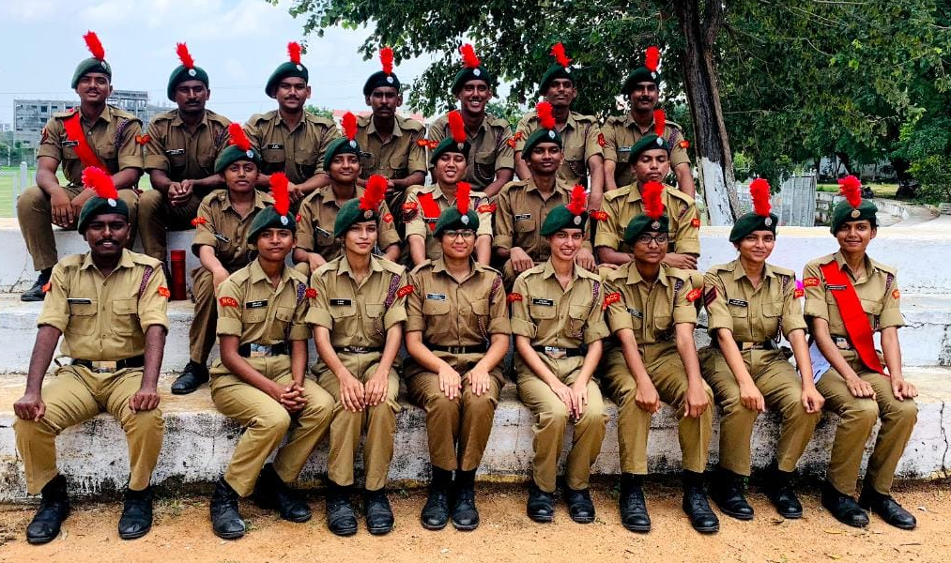
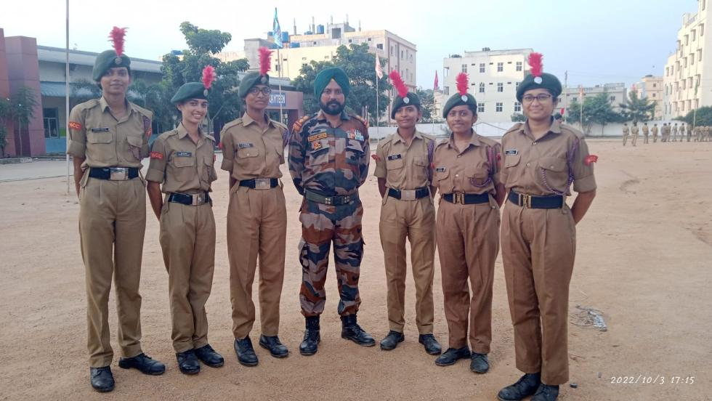
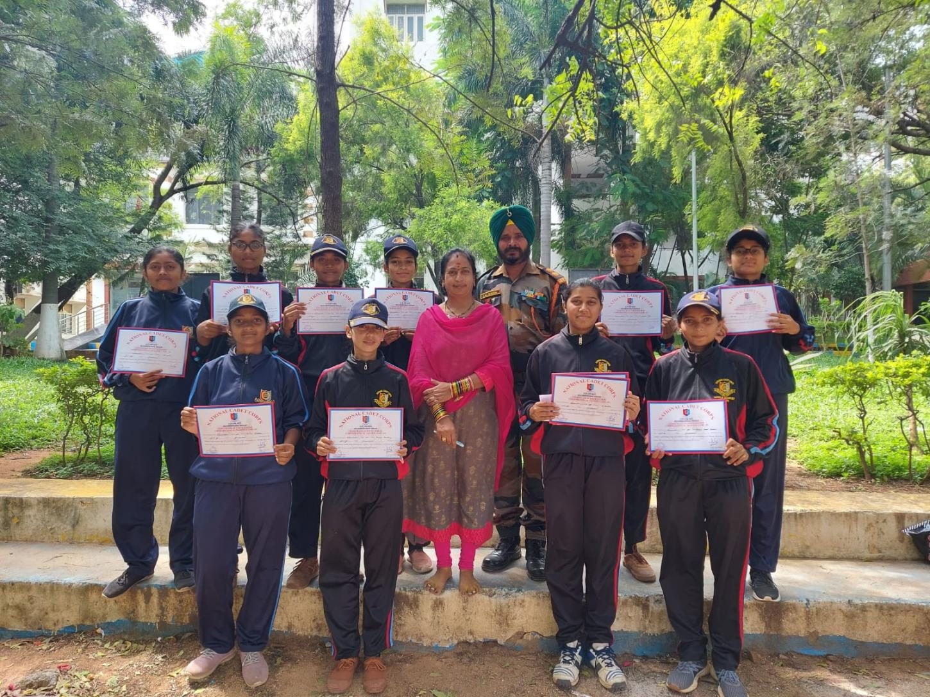

11. SNIC

Camp Name:Special National Integration Camp
Camp Location: Sri Prakash Vidyaniketan, Rajamandravaram, Andhra Pradesh.
Duration: 30/09/2022 – 09/10/2022
No. of Cadets: 1
- CDT Lemuel Savio Michael
Achievements:
- He took part in 100m race, 10 km run.
- He participated in Volleyball.
- He was also in group dance competition.
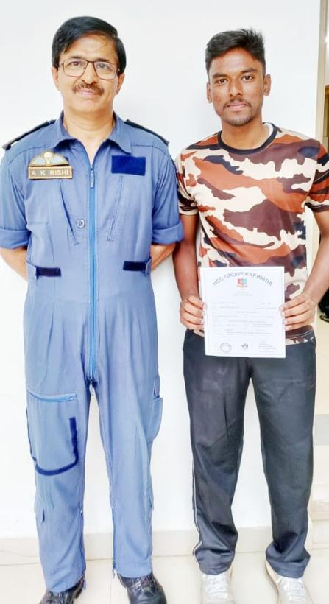
12. KERALA TREK

Camp Name:Kerala Trek
Camp Location: JNV Kulamavu, Idukki district, Kerala.
Duration:06/10/2022 – 13/10/2022
No. of Cadets: 1
- CDT CH Varun

