Industrial visit to NRSC ISRO

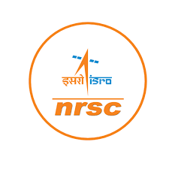

Event details:
DATE: 7th January 2025
VENUE: NRSC ISRO
ORGANIZED BY: B.Sc. Computer Science and Cybersecurity Department, Loyola Academy Degree and PG College
RESOURCE PERSON: Educators of NRSC
TARGET AUDIENCE: Students and faculty members of Loyola Academy Degree and PG College, particularly those enrolled in the B.Sc. Computer Science and Cybersecurity program.
OBJECTIVES OF THE EVENT:
- To provide hands on
- exposure to space technology and applications.
- To understand the working of NRSC ISRO and its contributions to space research.
PARTICIPANT DETAILS:
TOTAL PARTICIPANTS: 52
DEMOGRAPHICS: Students and faculty members of Loyola Academy Degree and PG College.
ATTENDANCE PERCENTAGE: 98%
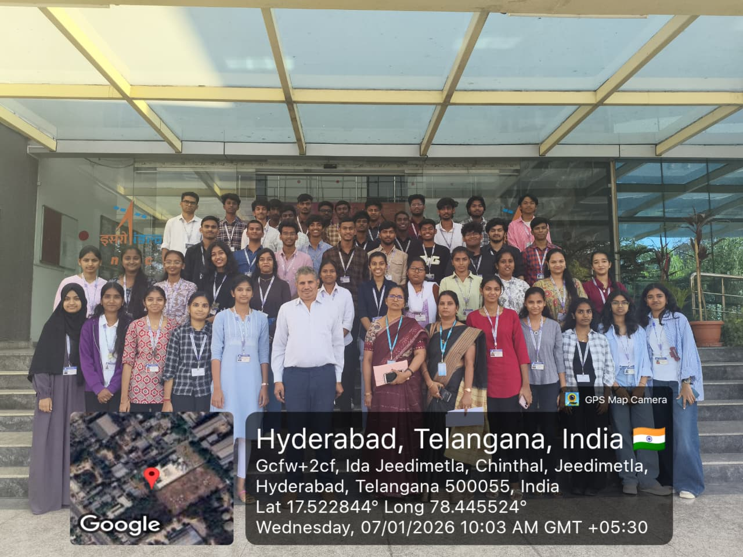
CONTENT EVALUATION:
RELEVANCE OF THE TOPIC: Highly Relevant.
DEPTH OF KNOWLEDGE DELIVERED: Excellent
ENGAGEMENT OF PARTICIPANTS: Highly engaged
LEARNING OUTCOMES:
- Were the Learning Outcomes met?Yes
- Key Takeaways for Participants:
- Understanding of rockets, satellites, and space applications
- Insights into ISRO's work and research
Skills/Knowledge Gained: Practical knowledge of space technology and applications
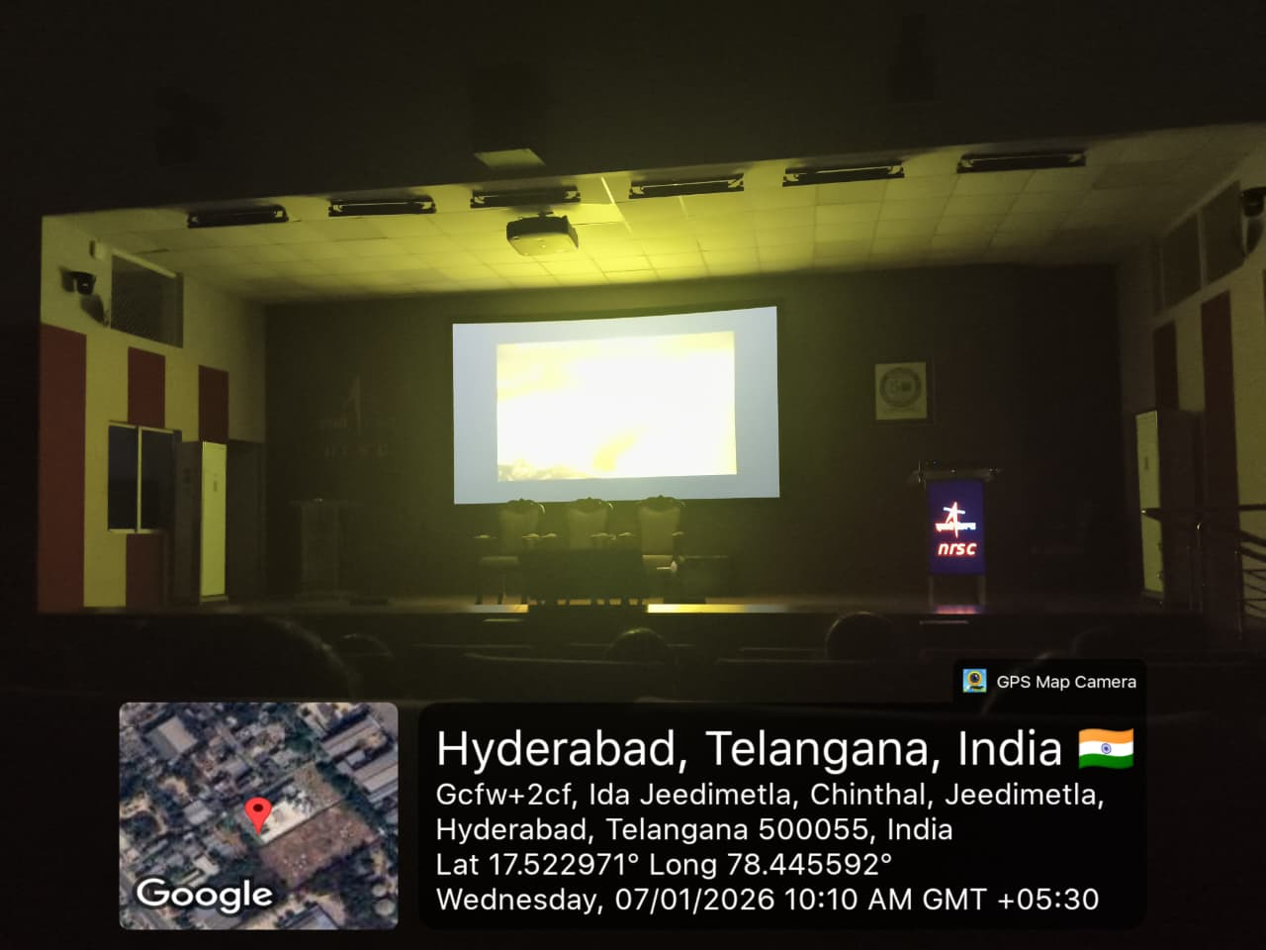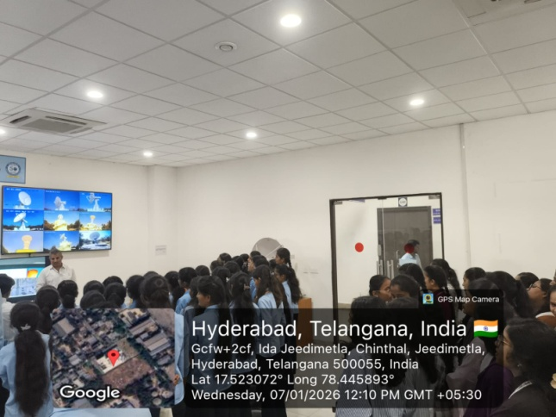

FEEDBACK ANALYSIS:
- Method of Feedback Collection: Oral feedback post-event
- Key Feedback from Participants:
- Positives: Interactive sessions, informative exhibition
- Areas of Improvement: More hands-on activities suggested
- Rating on a scale of 1-5:
- Content Quality:4.6/5
- Resource Person Effectiveness: 4.8/5
- Presentation Style: 4.7/5
IMPACT ON CURRICULAM OR FUTURE PRACTICES:
- Impact on Student Learning: Enhanced understanding of space technology, applicable to projects and academics.
- Integration into Teaching Practices: Faculty members can incorporate space tech concepts into teaching..
QUANTATAIVE ANALYSIS:
- Performance Improvement:90% of participants reported increased understanding of space applications.
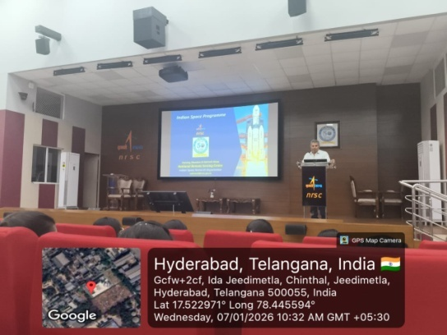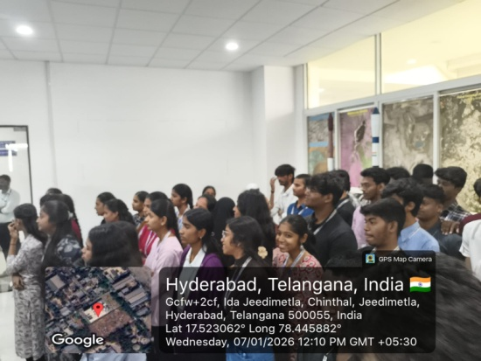

RECOMMENDATIONS:
- Future Improvements: Include more interactive sessions and hands-on activities. Recommended Topics for Future Events: Cloud security, threat analysis, and incident response.
- Potential for Resource of the Event: Yes, recommended for future batches. CONCLUSION:
The industrial visit to NRSC ISRO was a success, providing valuable insights into space technology and applications.

