MONTHLY EVENT DOCUMENT
Name of the Department: NSS UNIT
Sl.  No | Month & Date | Title of the Event | Report | Budget | Submitted to
 |  |  |  |  | Dept | Dean | IQAC
1 | 22nd June 2023 | International Yoga Day | Yes | NA |  |  | Yes
2 | 14th July 2023 | Meri Mati Mera Desh Orientation Programme | Yes | NA |  |  | Yes
3 | 31st Aug 2023 | Kargil Divas | Yes | NA |  |  | Yes
4 | 3rd Aug 2023 | Health Camp (Orthopedic Health Camp) | Yes | 6000 |  |  | Yes
5 | 12^{Tth} Aug 2023 | Fit India 2023 | Yes | NA |  |  | Yes
6 | 15th Aug 2023 | Independence Day | Yes | NA |  |  | Yes
7 | 29th Aug 2023 | Telugu Bhasha Dinotsavam | Yes | NA |  |  | Yes
8 | 06 Sept 2023 | Voter Awareness Program | Yes | NA |  |  | Yes
9 | 13th ,14th Sept 2023 | Workshop On Legal Literacy | Yes | NA |  |  | Yes
10 | 15th Sept 2023 | Swachhata Pakhwada | Yes | NA |  |  | Yes
11 | 23rd Sept 2023 | Free Dental Health Camp | Yes | Sponsored By Nss Student-17,000/-(Spent 15k For Nss Day Celebrations) |  |  | Yes
12 | 27th Sept 2023 | NSS Day Celebration And Orientation | Yes | 15,000/- |  |  | Yes
13 | 2nd Oct 2023 | Gram Sabha Visit | Yes | NA |  |  | Yes
14 | 23rd Dec 2023 | Season Of Sharing Charity Fair - Christmas Celebrations | Yes | Fund Collected By Nss Students-25,000/-(Spent 20k And 5k On Health Camp) |  |  | Yes
15 | 26th Jan 2024 | Republic Day | Yes | NA |  |  | Yes
16 | 16th Feb 2024 | Blood Donation Camp | Yes | Sponsored By Blood Bank(25,000/-)Deposited In Bank |  |  | Yes

Kindly Note: Report should contain the following points:
Title:
Objective of the Event
Resource person’s Credentials
Resource Person’s message relevant to the title.
Outcome of the Event from student’s point of view
Geo tagged Photo & Video (Do not drag the photo or resize it)

NSS ACTIVITIES REPORT 2023-2024

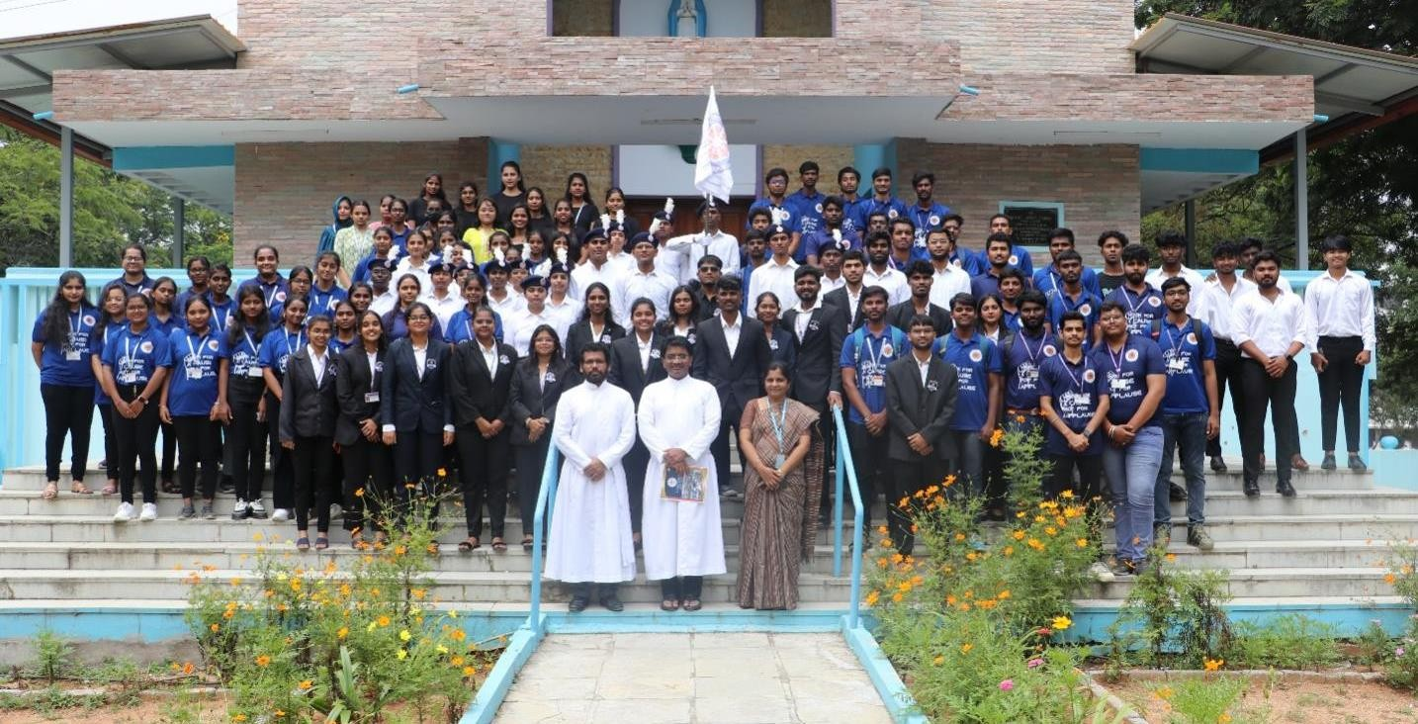

- Title: INTERNATIONAL YOGA DAY 2023 (June 22^{nd,} 2023)

Objective of the Event
On June 22nd, from 2:50 PM to 3:30 PM, Loyola Academy's National Service Scheme (NSS) unit orchestrated a serene and enlightening celebration of International Yoga Day. The event was graced by the presence of the talented yoga instructor, Priya Thakur, hailing from Loyola Academy itself. The day commenced with a sense of anticipation as volunteers gathered in a peaceful setting, ready to embark on a journey of self-discovery and holistic well-being. Priya Thakur, an expert in yoga, led the proceedings with grace and expertise.
The highlight of the event was a guided meditation session led by Priya Thakur. As participants closed their eyes and followed her soothing voice, a collective sense of tranquility enveloped the venue. It was a powerful moment of mindfulness, allowing attendees to connect with their inner selves and find inner peace.
Following the meditation, Priya Thakur shared a small yet profound note on yoga and its myriad benefits. Her insights were both informative and inspiring, shedding light on how yoga can enhance physical health, reduce stress, and promote mental clarity.
She also provided valuable instructions on the fundamentals of yoga, encouraging participants to incorporate this ancient practice into their daily lives.
The event at Loyola Academy was a beautiful ode to the International Yoga Day, emphasizing the importance of yoga as a path to holistic well-being. The NSS unit's meticulous planning and Priya Thakur's guidance made this celebration a resounding success, leaving everyone with a sense of inner calm and a deeper understanding of the transformative power of yoga.
Instagram Post Link: https://www.instagram.com/p/Ct1a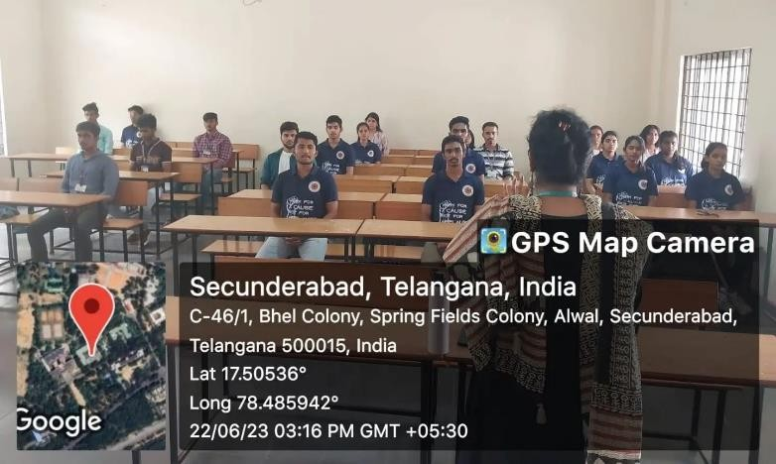0YUJn6o/?igsh=MTJuZGd2bDFzNG15eQ==

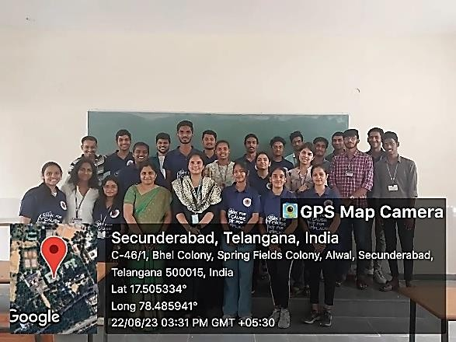
- Title: MERI MATI MERA DESH ORIENTATION PROGRAMME (14th July 2023)
Objective of the Event
This report provides an overview of the Meri Mati Mera Desh orientation programme and preparatory event that was organized at colleges and schools from 10th to 13th July 2023, as per the directions of the Director. The purpose of this report is to document the progress and ensure compliance with the established timeline.
Meeting Minutes:
The meeting minutes form, as per the attached template, was required to be filled in by all institutions. These minutes were collected by the respective Regional Directors (RDs) after the completion of the preparatory orientation meetings at each institution. The filled-in minutes of the meeting are to be sent to the Directorate of NSS in New Delhi for further processing and record-keeping
Meri Mati Mera Desh Programme Gram Panchayat Level Minutes of Meeting
1. Location of Meeting | Name of Gram Panchayat- Name of Block:  Name of District:  Name of State
2. Date of Meeting
3. Convenor of the Meeting
4. Contact Details of Convenor
5. Names of people who participated in
meeting
6. Whether those present are willing to

participate in Meri Mati Mera Desh
Program and to share their mobile number with organisers for program
Sapling Plantation
7. Identified Location for planting 75 saplings preferably single cluster to create
one grove/Vatika (वाटिका/क¸ुं ज).
8. Date on which grove planting activity will
be held
9. Species of Saplings to be planted. Mix of
species should be identified. Species indigenous to village should be identified.
Special Attributes of the Gram Panchayat
10. Is there an Amrit Sarovar.
11. Person/s of Eminence of Gram Panchayat
who have worked for the nation now or in past
12. Location/s of Historical Importance for
Gram Panchayat
Programme Organizing Committee Details
13. Are the contact numbers of the Non- Official Committee Members and Contact
Person, correct?
14. Are the members of committee willing to
extend all support for the programme of village development?
Yuva Portal
15. Was the Yuva Portal briefed during the  meeting? | (Yes/No)
16. Number of people registered on the Yuva

Name and Signature of the Convenor of the Meeting-
Portal during the meeting?
17. Brief Minutes of the Meeting (Issues Discussed, Strategy of the programme to be conducted)
In bullet points
18. Date of Gram Panchayat Programme
Date -
Preparatory Orientation Meetings:
The preparatory orientation meetings were conducted at every college and school from 10th to 13th July 2023. These meetings were organized to provide guidance and information regarding the Meri Mati Mera Desh programme. It was mandatory for all institutions to arrange these meetings without fail and ensure the completion of the minutes of the meeting forms.Action Required:

In light of the time-bound nature of the programme, immediate action is necessary. It is essential for all Student Nodal Officers (SNOs), Programme Coordinators, and Programme Officers to promptly arrange meetings at their respective colleges and schools, ensuring the filling up of the minutes of the meeting forms.
Meri Mati Mera Desh Main Program:
Following the completion of the preparatory orientation meetings, NSS volunteers are requested to attend the Meri Mati Mera Desh main program, which will be held at the Panchayat from 26th July to 2nd August. Further details regarding the main program will be communicated separately to the concerned parties.
Conclusion:
The Meri Mati Mera Desh orientation programme and preparatory event have been successfully conducted at colleges and schools from 10th to 13th July 2023. The minutes of the meeting, filled in by all institutions, will be collected by the RDs and forwarded to the Directorate of NSS, New Delhi. The subsequent step involves the participation of NSS volunteers in the main program at the Panchayat, scheduled from 26th July to 2nd August. It is crucial for SNOs, Programme Coordinators, and Programme Officers to adhere to the timeline and complete the necessary actions promptly.
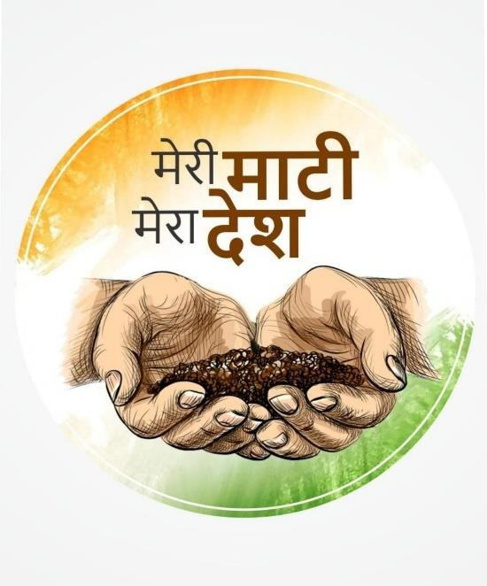

- Title: KARGIL DIVAS 2023 (31st August)
Objective of the Event
On July 31st, in commemoration of Kargil Vijay Diwas, the National Service Scheme (NSS) unit, along with the Army and Navy wing of NCC cadets, visited Rashtrapati Nilayam. This event was organized to honor the sacrifices made by our armed forces during the Kargil war and to remember the victory of India over Pakistan in 1999.
The event commenced with a gathering of cadets and officials, with Lt. Gen JS Sidana, Commandant of MCEME, Secunderabad, gracing the occasion as the chief guest. Lt. Gen Sidana delivered an insightful talk highlighting India's triumph over Pakistan in the Kargil war. He elaborated on the strategic maneuvers employed by the Indian army to reclaim the positions on the mountain tops of the northern Kargil district in Ladakh, emphasizing the valor and dedication exhibited by our soldiers during the conflict.
Apart from the enlightening speech, the event featured a series of activities and competitions aimed at fostering a spirit of patriotism and remembrance among the participants. These included rangoli competitions, tribute message writing, and various cultural activities. The enthusiastic participation of students in these events added vibrancy and fervor to the commemoration.
The occasion provided an excellent platform for the youth to pay homage to the brave soldiers who laid down their lives for the nation's integrity and sovereignty. It also served as a reminder of the importance of unity and resilience in the face of adversity.
We extend our heartfelt gratitude to Rashtrapati Nilayam for hosting this event and providing us with the opportunity to commemorate Kargil Vijay Diwas in a meaningful and dignified manner.
The NSS volunteers who attended the Kargil Vijay Diwas commemoration at Rashtrapati Nilayam found it deeply educational and inspiring. Lt. Gen JS Sidana's address provided valuable insights into the bravery and sacrifices of the armed forces. Engaging in various activities, such as rangoli competitions and tribute message writing, fostered a sense of pride and

patriotism. Witnessing the dedication of the armed forces left a lasting impact, inspiring the volunteers to uphold their legacy and contribute to the nation's welfare.
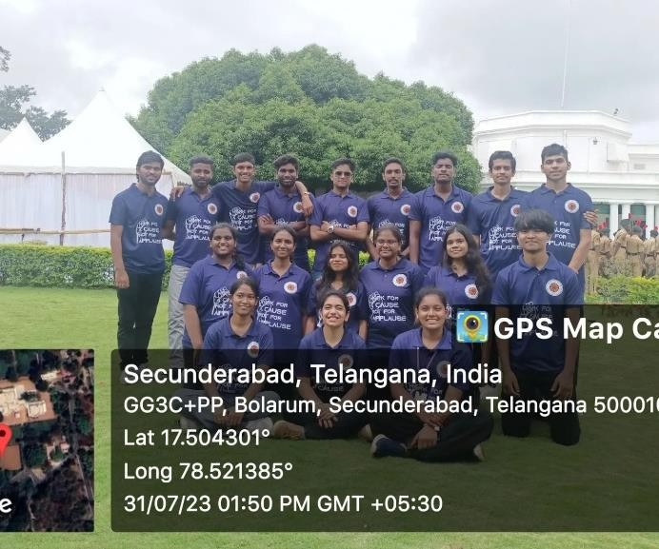

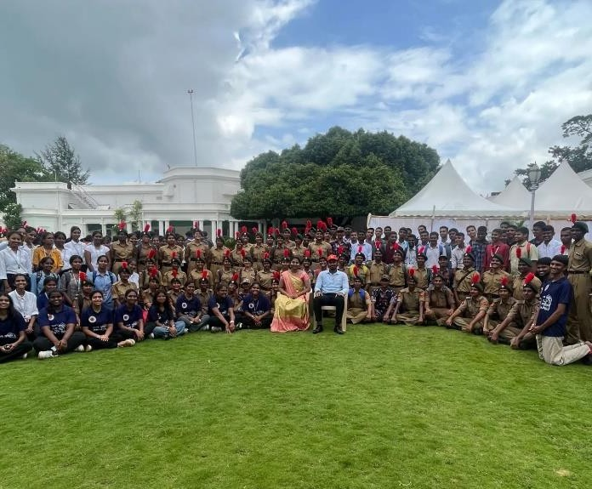

INSTAGRAM POST LINK: https://www.instagram.com/p/CvbwP3Tp4w-
/?igsh=MTV3OWQxbXNycXRqYQ==

- Title: HEALTH CAMP (ORTHOPEDIC HEALTH CAMP) 3rd Aug
Date: 3rd August 2023
Time: 9:00 AM - 4:00 PM
Venue: Loyola Academy, Old Alwal
Objective of the Event
The NSS (National Service Scheme) unit of Loyola Academy, in collaboration with Srikara Hospitals, organized a free Orthopedic Health Camp on 3rd August 2023. The event aimed to provide valuable health services to the teaching and non-teaching staff of Loyola Academy and the parents of its students. The camp was an opportunity for individuals to undergo various health tests and receive consultations from medical professionals, contributing to their overall well-being.
Event Overview:
The Orthopedic Health Camp commenced at 9:00 AM in the Loyola Hall of Loyola Academy, Old Alwal. The camp offered a diverse range of health services, with a special focus on bone health. One of the notable highlights of the camp was the Bone Mineral Density (BMD) test, which is typically valued at Rs. 2000. However, this test was provided free of cost to the attendees, allowing them to assess the strength and density of their bones.
Apart from the BMD test, the camp also provided tests for blood parameters, blood pressure, and a comprehensive full-body check-up. These tests collectively aimed to offer a holistic assessment of the participants' health and detect any potential underlying issues. Approximately 150 individuals availed themselves of these health services throughout the day.
Benefits of the Camp:
The Orthopedic Health Camp proved to be highly beneficial for the participants. By undergoing the BMD test and other health evaluations, individuals gained insights into the state of their bone health and overall well-being. The event provided an opportunity for early detection of any health concerns, enabling timely medical interventions.

Furthermore, the attendees had the privilege of interacting with Dr. T.V. Suresh, an experienced medical professional with credentials including MBBS and DNB. Dr. Suresh shared valuable insights and recommendations on maintaining optimal bone health. The interaction session, held at Xavier Hall at 3:00PM, proved to be informative and engaging.
Key Outcomes:
Awareness: The camp raised awareness among the participants about the importance of bone health and regular health check-ups.
Preventive Measures: Attendees received guidance from medical experts on preventive measures to maintain good bone health, including diet, exercise, and lifestyle changes.
Early Intervention: Health tests helped in the early detection of any underlying health issues, enabling prompt medical intervention if necessary.
Medical Consultation: Participants had the opportunity to consult with medical professionals, receive personalized advice, and obtain prescriptions for necessary medications.
Conclusion:
The Free Orthopedic Health Camp organized by Loyola Academy's NSS unit in collaboration with Srikara Hospitals was a significant success, benefiting around 150 participants. The event promoted bone health awareness, early intervention, and expert medical consultation, including with renowned surgeon Dr. T.V. Suresh. Srikara Hospitals extended their support by offering discount vouchers for Loyola staff and parents, further enhancing the value of this initiative. A heartfelt thank you to Srikara Hospitals for their valuable collaboration in fostering community well-being. The free health services provided, including the Bone Mineral Density test, comprehensive health check-ups, and the informative interaction session with Dr. T.V. Suresh, made the camp a valuable and enriching experience for all attendees. This collaborative effort further demonstrates the commitment of Loyola Academy and Srikara Hospitals to the health and welfare of their community members.
INSTAGRAM POST LINK:
https://www.instagram.com/p/CvfZiPPPsdp/?igsh=MXhiMDV4dXprcGdrNw==

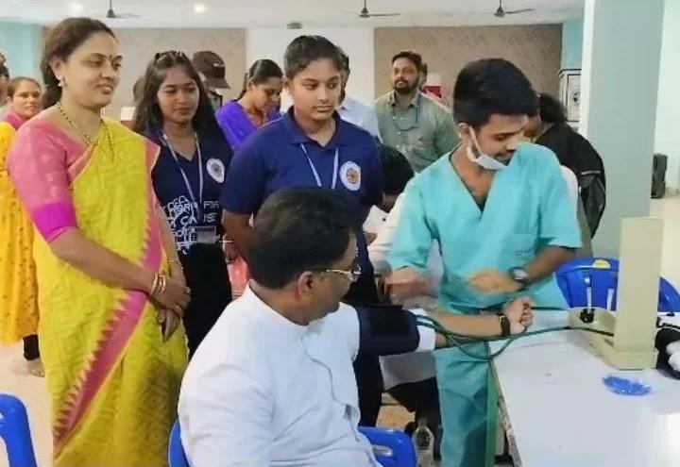
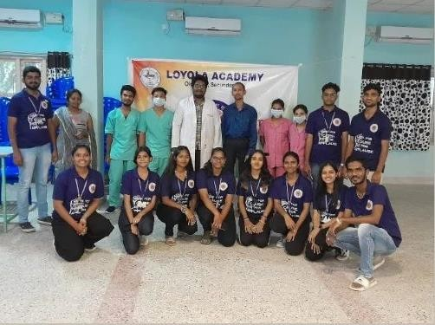
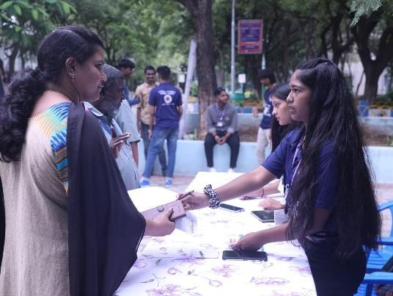
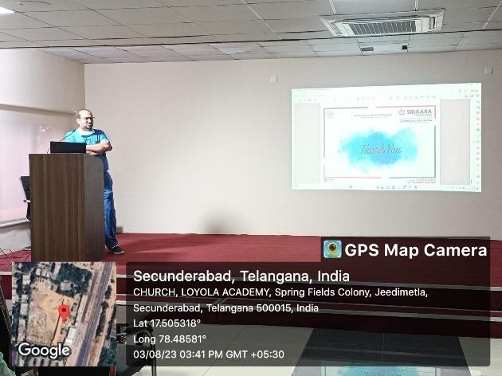
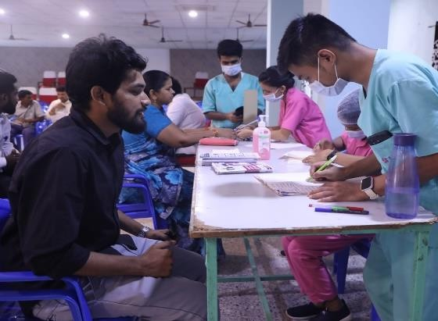

- Title: FIT INDIA 2023 (12th August 2023)
Objective of the Event
We, the NSS unit of Loyola Academy, are pleased to report on the successful organization of a 5K run as part of the FIT INDIA campaign. This event was a collaborative effort between various student bodies including the NCC cadets, Students Council, Magic Youth, and AICUF.
The run, held on 12th August 2023, aimed to promote fitness and wellness among students and the community at large. We are grateful to our esteemed Rev. Fr. Dr. L. Joji Reddy, Principal of Loyola Academy, and Fr. Arul Jyothi, Vice Principal, for their unwavering support and active participation in the event.
The management and students of Loyola Academy demonstrated tremendous enthusiasm and commitment, actively participating in the run and making it a resounding success. Their dedication and spirit contributed significantly to the positive atmosphere and energy of the event.
The 5K run not only encouraged physical activity but also fostered a sense of unity and camaraderie among participants. It was heartening to see students from different backgrounds come together to promote the importance of leading a healthy lifestyle.
We extend our gratitude to everyone who contributed to the success of the event, including the organizing committee, volunteers, and participants. The overwhelming support received underscores the collective commitment of Loyola Academy towards promoting fitness and well- being in our community.
Instagram post link :
https://www.instagram.com/p/Cv4AnfpQQ3/?igsh=MWxnNWY0YWMzcmpqZg==

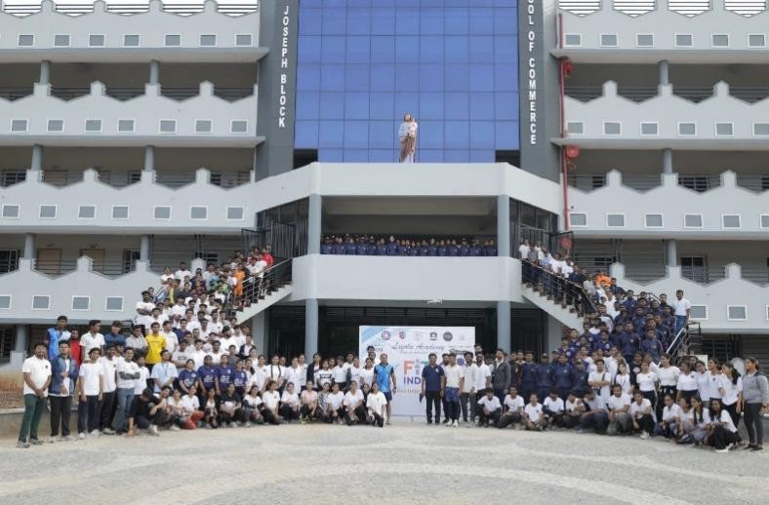

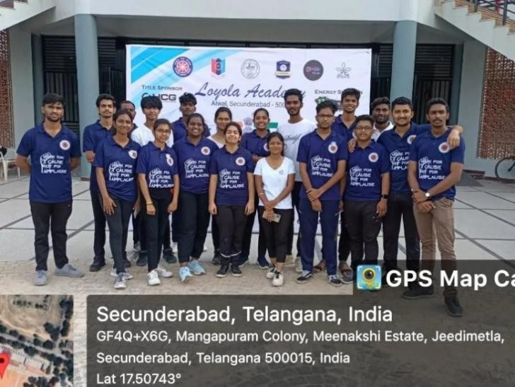

- Title: INDEPENDENCE DAY (15th August 2023)
Objective of the Event
The NSS unit of Loyola Academy, in collaboration with the Student Council, NCC, Magic Youth, and AICUF, came together to celebrate Independence Day with great fervor and enthusiasm. The event was graced by esteemed guests, Rtd. Lt. Gen. K. Ramachandra Rao and Mr. P. Krishna Prasad, who shared their experiences and imparted wisdom to the gathering.
The celebration commenced with a dignified flag-raising ceremony, symbolizing our cherished freedom and echoing the spirit of our nation's history. Our NSS volunteers stood proudly during the national anthem, embodying patriotism and reverence for our country.
Throughout the event, various performances unfolded, showcasing the artistic talent and deep emotion of the participants. Each act, whether it be dance, song, or spoken word, depicted the struggles and sacrifices endured for our nation's independence. Our NSS volunteers actively participated, emphasizing the significance of our journey towards freedom.
The presence of Rtd. Lt. Gen. K. Ramachandra Rao and Mr. P. Krishna Prasad added a special dimension to the celebration, as they shared their insights and inspired everyone with their words of wisdom. Their presence reinforced the importance of honoring our history and cherishing our hard-earned freedom.
By the end of the celebration, a sense of unity and pride permeated the atmosphere, transcending age and background. The collective embrace of gratitude and reverence towards our nation was palpable, reflecting the essence of our journey as a united community.
The Independence Day celebration at Loyola Academy was more than just an event; it was a poignant reminder of the sacrifices made by our forefathers and a celebration of the enduring spirit of our country's liberty. Through unity, patriotism, and reverence, we reaffirmed our commitment to upholding the values of freedom and democracy.
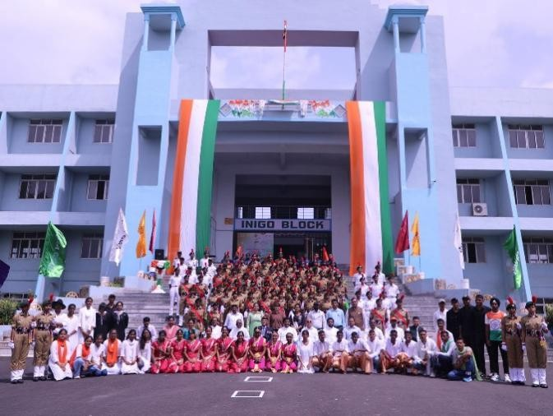

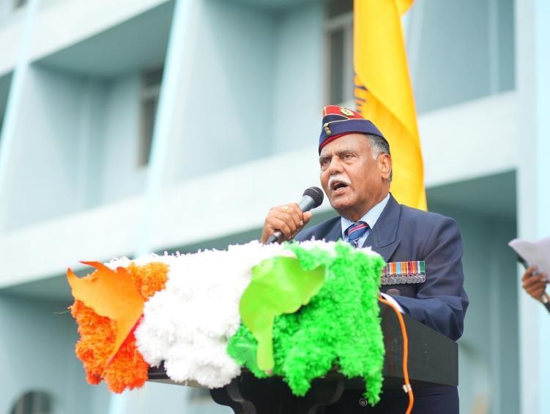

- Title: TELUGU BHASHA DINOTSAVAM (29th August 2023)
Objective of the Event
The NSS unit of Loyola Academy, in collaboration with staff members and enthusiastic volunteers, celebrated the National Telugu Language Day on 29th August. This day holds immense significance in honoring the contributions of Telugu language and literature, coinciding with the birthday of esteemed Telugu poet Gidugu Venkata Ramamurthy garu.
EVENT HIGHLIGHTS:
Slam Poetry Competition: Students showcased their linguistic skills and creativity through slam poetry performances, expressing their love for Telugu language and its cultural richness.
Fun Activities: Translating English to Telugu: Audience engagement was fostered through interactive activities, encouraging participants to translate English phrases into Telugu, thereby promoting language proficiency.
Ekapaathrabhinayam (Monologue): Students presented monologues in Telugu, portraying diverse themes and narratives, reflecting the depth and versatility of the language.
Distinguished Presence:
Rev. Fr. Arul Jyothi, accompanied by dedicated staff members, graced the occasion with their active participation, emphasizing the importance of preserving linguistic diversity and cultural heritage.
Community Participation:
Staff, students, and NSS volunteers enthusiastically participated in the event, demonstrating their commitment to promoting and preserving the Telugu language. Their collective efforts underscored the significance of linguistic and cultural diversity in fostering unity and understanding.
Key Takeaways:
Heightened Awareness: Participants gained a deeper understanding of the importance of Telugu language and literature in shaping our cultural identity.
Enhanced Linguistic Skills: Engaging in activities such as translation and monologue performances contributed to the development of linguistic proficiency among participants.
Strengthened Cultural Pride: The celebration instilled a sense of pride and appreciation for our cultural heritage, reinforcing the importance of celebrating linguistic diversity.
Conclusion:
The National Telugu Language Day celebration at Loyola Academy served as a platform for honoring the rich legacy of Telugu language and literature. Through engaging activities and enthusiastic participation, the event reaffirmed our collective commitment to promoting and preserving our linguistic and cultural heritage. Moving forward, the NSS unit and the Loyola Academy community remain dedicated to fostering greater appreciation and celebration of linguistic diversity..

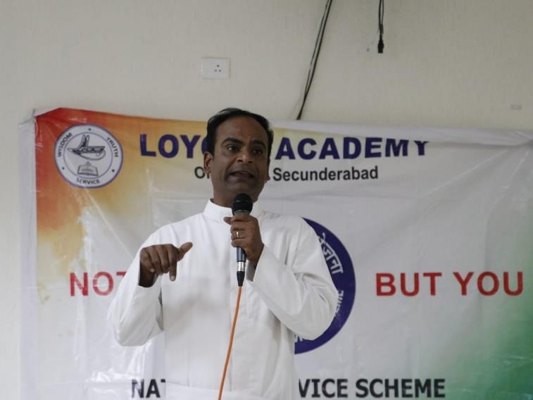
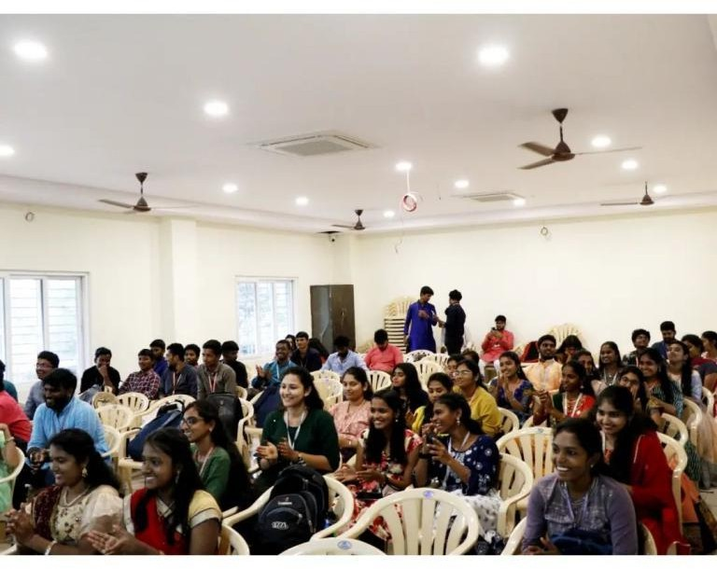

- Title: VOTER AWARENESS PROGRAM (6^{th,} September 2023)
Date: September 6th, 2023
Time: 1:00 PM to 3:00 PM
Location: Loyola Hall
Objective of the Event
On September 6th, 2023, Loyola Academy organized a Voter Awareness Program as part of our commitment to civic engagement and social responsibility. This initiative aimed to empower individuals with knowledge and information about the electoral process, reinforcing the importance of voting and encouraging active participation in the democratic process. The program was a resounding success, achieving its core objectives and fostering a sense of civic responsibility among the community. The NSS unit along with student council, magic youth and AICUF took part in the program.
Program Highlights:
Educational Workshops: - The program began with a series of educational workshops led by experts in the field of politics and elections. These workshops provided attendees with valuable insights into the electoral process, the significance of their vote, and how to make informed choices on Election Day.
Guest Speakers: - We were honored to have distinguished guest speakers, including election officials, who shared their experiences and insights. Their speeches emphasized the impact of voting on shaping our nation's future.
Interactive Sessions: - Interactive sessions were organized, where participants had the opportunity to ask questions, engage in discussions, and share their concerns. These activities fostered a sense of involvement and encouraged active participation in the democratic process.
Achievements and Impact:
The Voter Awareness Program at Loyola Academy was a tremendous success, evident by several key achievements:
Increased Voter Awareness:
The program significantly increased awareness about the electoral process and the importance of voting among attendees.
Civic Responsibility:
Attendees left the program with a stronger sense of civic responsibility and a better understanding of their role in shaping the future of our nation.
Conclusion:
The Voter Awareness Program organized by Loyola Academy on September 6th, 2023, reaffirmed our commitment to nurturing responsible and engaged citizens. By empowering individuals with knowledge about the electoral process and instilling a sense of duty towards building a stronger and more inclusive society, we have taken a significant step toward fostering a more informed and responsible citizenry.
we would like to express its gratitude to all the participants, guest speakers, and volunteers who made this program a success. We look forward to continuing our efforts to encourage active participation in the democratic process and shaping a brighter future for our nation.
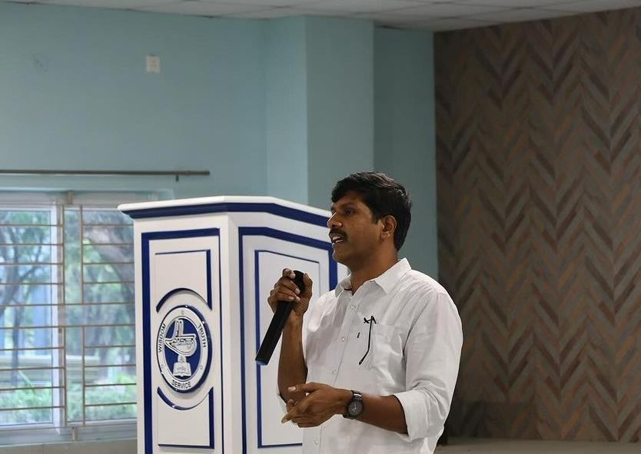
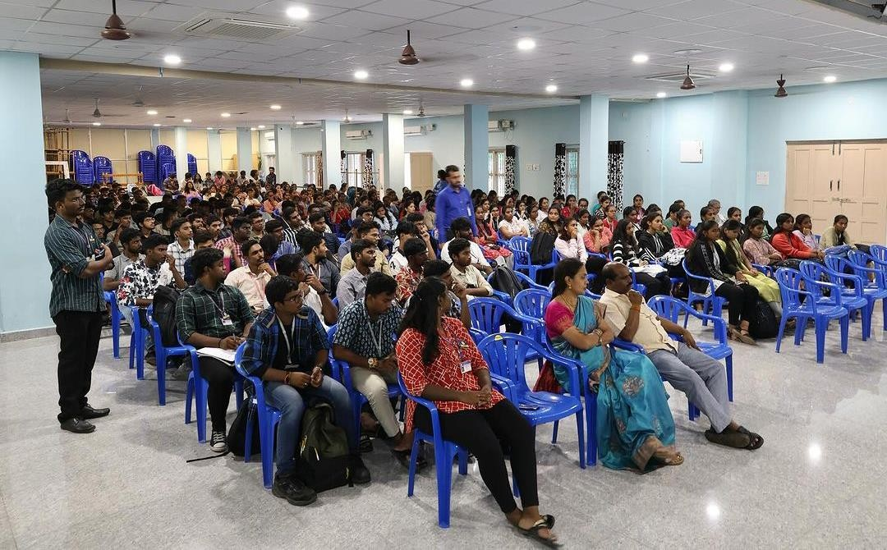
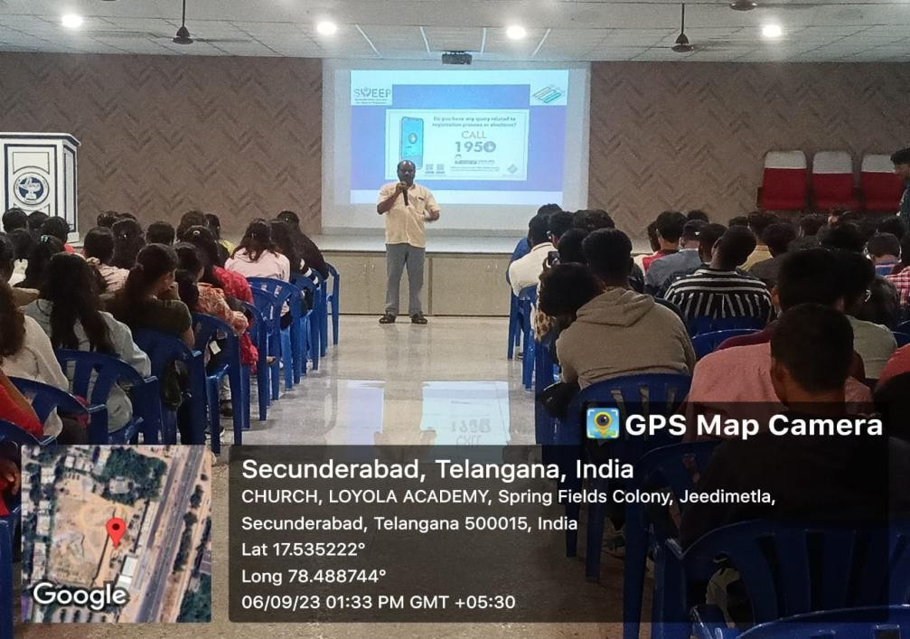
- Title: WORKSHOP ON LEGAL LITERACY (13th,14th September 2023)
Objective of the Event
We, the NSS unit of Loyola Academy, in collaboration with the Student Council and IQAC, organized a two-day workshop on Legal Literacy held on 13th and 14th September 2023. The aim was to educate students about citizens' legal rights and responsibilities. The workshop featured esteemed speakers who shed light on various aspects related to migrant laborers in India.
Rev. Fr. Selvaraj Arunathan SJ, Director of ISI, commenced the workshop by providing an insightful overview of the history of migration in India, contrasting it with the current scenario. He elaborated on the challenges faced by migrant laborers in contemporary times, setting the stage for deeper discussions.
Ms. Priya Singh, the second speaker, focused on financial inclusion initiatives and methods employed for migrants in India, offering practical insights into addressing their financial needs.
Rev. Fr. Yesu Ratnam SJ spoke passionately about the tribulations faced by migrant laborers, emphasizing the importance of sensitivity in managerial theories related to their work. His talk resonated with the audience, sparking thoughtful discussions.
Renowned speaker Mr. Jagadeesh and retired District Judge Mr. Nerella Malyadri shared real- life examples, reinforcing the importance of understanding citizens' rights and responsibilities.
Mr. Sarath Babu, District Probation Officer, Visakhapatnam, concluded the workshop by suggesting practical ways to engage with government officials to safeguard the interests of migrant workers.
Throughout the workshop, NSS volunteers actively participated in open discussions, raising doubts and engaging with the speakers. Their enthusiasm and eagerness to learn contributed significantly to the success of the event.
The workshop served as a platform for students to gain valuable insights into legal literacy and the challenges faced by migrant labourers. It encouraged critical thinking and empowered students to advocate for social justice and equality in society.
The Legal Literacy workshop organized by the NSS unit of Loyola Academy, in collaboration with the Student Council and IQAC, was a resounding success, leaving a lasting impact on all participants.
Furthermore, the active participation of NSS volunteers demonstrated their commitment to social causes and their eagerness to contribute positively to society. By fostering open discussions and encouraging critical thinking, the workshop empowered students to become agents of change in their communities.
Moving forward, it is imperative to build upon the momentum generated by this workshop and continue to advocate for the rights of migrant workers and marginalized communities. By leveraging the knowledge and insights gained, students can actively engage in initiatives aimed at promoting inclusivity, equality, and social justice.
The success of this workshop serves as a testament to the collective efforts of the NSS unit, the Student Council, and IQAC in promoting awareness and fostering a culture of legal literacy and social responsibility within Loyola Academy and beyond. Through such collaborative endeavors, we can strive towards creating a more equitable and just society for all.
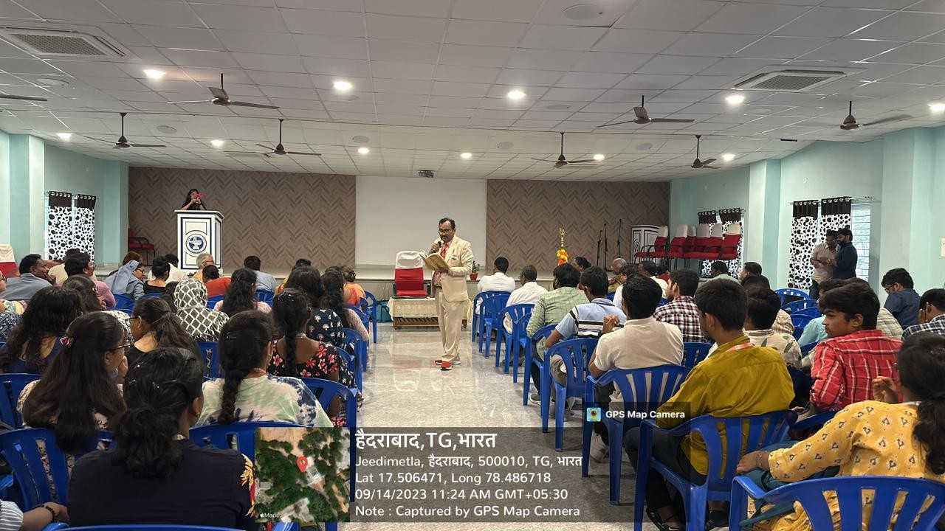

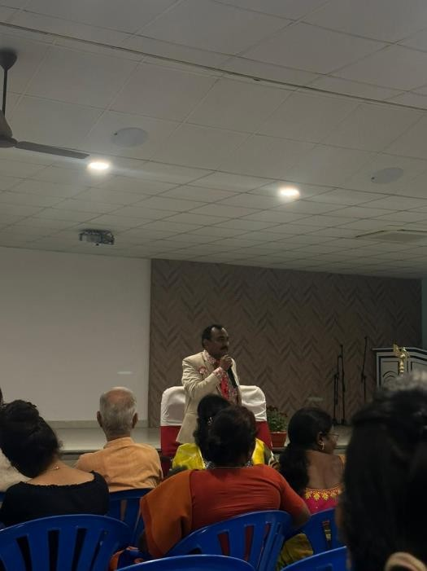

- Title: SWACHHATA PAKHWADA 15th, (September 2023)
Date: September 15th, 2023
Objective of the Event
We National Service Scheme (NSS) Unit of Loyola Academy are in collaboration with the Green Club Loyola and the Student Council organised "Swachhata Pakhwada" clean-up campaign that took place from September 1st to September 15th, 2023. This campaign was conducted to promote cleanliness, hygiene, and environmental awareness within our campus.
Campaign Activities
Rally: The campaign commenced with an energetic rally within the campus on September 15th
. NSS volunteers, alongside members of the Green Club and the Student Council, actively participated in this event. During the rally, we chanted slogans to emphasize the importance of cleanliness and its impact on our lives. And also conveyed this message through posters and pamplets
Campus Clean-Up Drives: Over the course of 15 days, our NSS volunteers engaged in daily campus clean-up drives during lunch hours. Equipped with gloves, trash bags, and brooms, our volunteers diligently cleaned various areas of the campus. These clean-up drives contributed significantly to the overall cleanliness of our educational environment.
Awareness Sessions: To educate students and create awareness, we conducted informative sessions during the campaign. Topics included proper waste disposal, hygiene, and the significance of maintaining a clean campus. These sessions aimed to instill a sense of responsibility and civic duty among the students.
PLEADGE & Speeches by Rev. Fr. Arul Jyothi and Rev. Fr. Joseph
During the campaign, we were honored to have Rev. Fr. Arul Jyothi and Rev. Fr. Joseph address our students, shedding light on the importance of cleanliness and environmental conservation.
Rev. Fr. Arul Jyothi: In his speech, Rev. Fr. Arul Jyothi emphasized that the environment can only be kept clean if we, the students, realize its significance and practice cleanliness everywhere. He spoke passionately about the role each of us plays in maintaining a clean and
healthy environment. He urged us to carry the lessons learned during this campaign beyond the campus and into our daily lives.
Rev. Fr. Joseph: Rev. Fr. Joseph led a pledge on keeping our environment clean and making the future green. He highlighted the responsibility we all share in preserving our planet for future generations. The pledge was a solemn commitment to do our part in ensuring a cleaner, greener, and more sustainable world.
Achievements and Impact
The "Swachhata Pakhwada" campaign, yielded several noteworthy outcomes:
A substantial improvement in the cleanliness and hygiene of our campus, fostering a healthier and more pleasant atmosphere for all.

Increased awareness among students about the importance of cleanliness, proper waste management, and their roles in maintaining a clean environment.
Enhanced leadership and teamwork skills among NSS volunteers who actively participated in the clean-up drives.
Positive feedback from students and faculty, indicating a growing commitment to maintaining cleanliness and hygiene in our campus.
Recognition of our NSS unit's dedication to community service and its contribution to the institution's mission.
Conclusion
In conclusion, the "Swachhata Pakhwada" campaign, organized by the NSS Unit of Loyola Academy in collaboration with the Green Club and Student Council, was a resounding success. It not only improved the cleanliness of our campus but also instilled a sense of responsibility and awareness among our students. We extend our gratitude to everyone who supported and participated in this campaign, and we remain committed to furthering the cause of cleanliness and community service in our institution.
INSTAGRAM POST LINK: https://www.instagram.com/reel/CxYVDx9pbHN/?igshid=MzRlODBiNWFlZA==

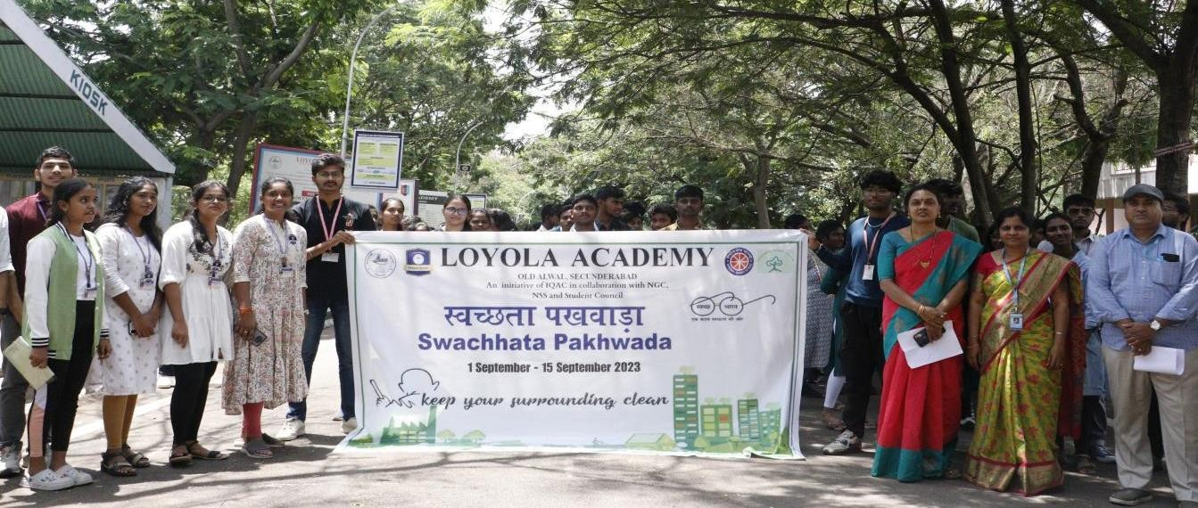
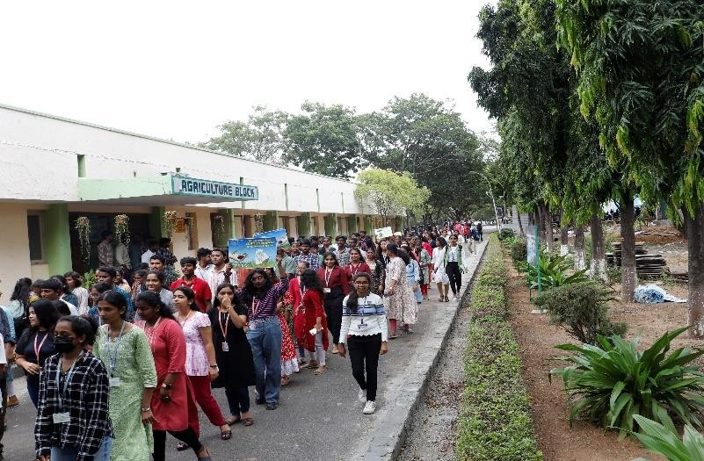
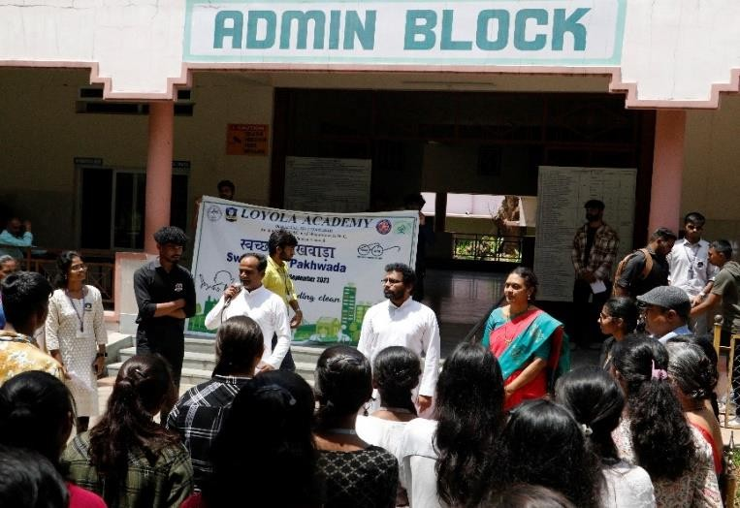
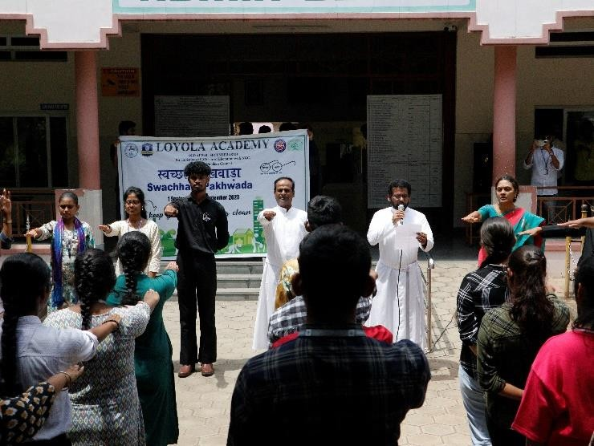
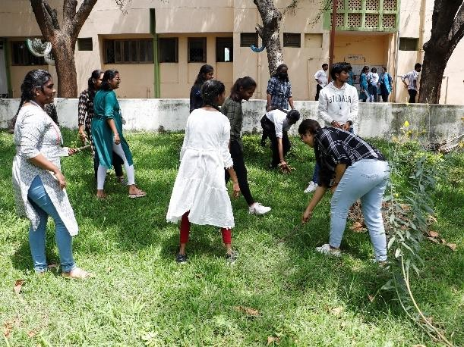

- FREE DENTAL HEALTH CAMP (23rd, September 2023)
Date: September 23, 2023
Objective of the Event
The NSS Unit and IQAC Cell of Loyola Academy, in partnership with Elite Dental Care, organized a commendable initiative - a Free Oral Health Awareness Drive on September 23, 2023. This event aimed to promote oral health awareness and provide free comprehensive dental check-ups and consultations to the faculty, administrative staff, students, and
Organized by: NSS Unit and IQAC Cell of Loyola Academy in collaboration with Elite Dental Care
Event Timing: 9:30 AM - 4:30 PM
Introduction:
parents associated with Loyola Academy.
Event Highlights:
Comprehensive Dental Check-ups and Consultations: The core focus of the event was to provide high-quality dental care to the Loyola Academy community. Experienced dental professionals from Elite Dental Care conducted thorough check-ups and offered expert consultations to address oral health concerns.
Inclusivity: The event welcomed all members of the Loyola Academy community, including faculty, administrative staff, students, and parents. This inclusivity ensured that everyone associated with Loyola had access to essential dental care services.
Presence of Distinguished Guests: The event was honored by the presence of Rev. Fr. Arul Jyothi SJ and Rev. Fr. AM Joseph Kumar SJ, whose support and encouragement added significance to the initiative.
Awareness Campaign: In addition to the dental services, an informative oral health awareness campaign was conducted. Participants were educated about the importance of oral hygiene, regular dental check-ups, and preventative measures to maintain good oral health.

Active Participation of NSS Volunteers: A crucial factor contributing to the event's success was the active involvement of NSS volunteers. These dedicated volunteers played a pivotal role in organizing and managing various aspects of the event, including registration, guiding participants, and ensuring a smooth flow of activities.
Impact:
The Free Oral Health Awareness Drive had a significant impact on the Loyola Academy community:
A total of 270 individuals availed the free dental check-ups and consultations, addressing their oral health concerns.
Participants gained valuable insights into oral health, enabling them to make informed decisions about their dental care.
The presence of esteemed guests, Rev. Fr. Arul Jyothi SJ and Rev. Fr. AM Joseph Kumar SJ, demonstrated the institution's commitment to community welfare and healthcare initiatives.
Conclusion:
The Free Oral Health Awareness Drive organized by the NSS Unit and IQAC Cell of Loyola Academy in collaboration with Elite Dental Care on September 23, 2023, was a resounding success. It not only provided crucial dental care services but also raised awareness about oral health among the Loyola community. This initiative reflects the institution's dedication to the well-being of its members and its commitment to fostering a healthier, more informed community.
We extend our gratitude to all the participants, dental professionals, and esteemed guests who made this event possible and look forward to future initiatives that promote the welfare of our Loyola Academy family.
Instagram post: https://www.instagram.com/p/Cx2a43Jpnj1/?igshid=MzRlODBiNWFlZA==
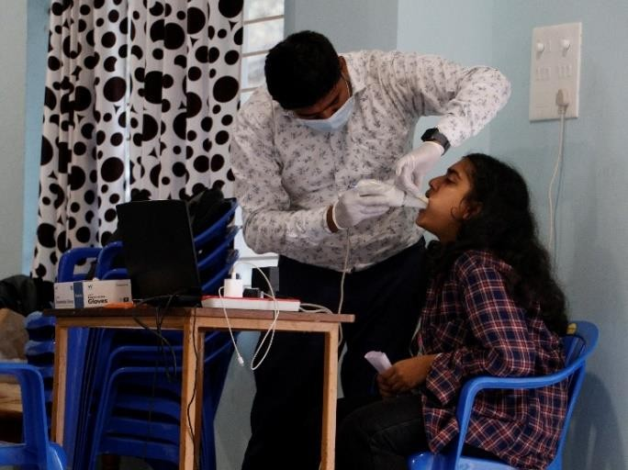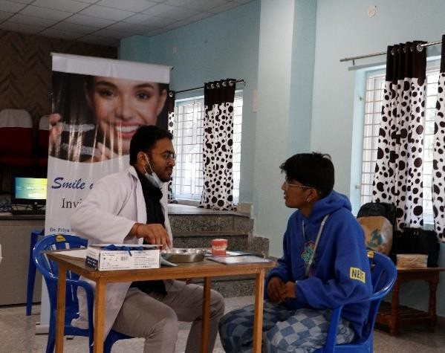
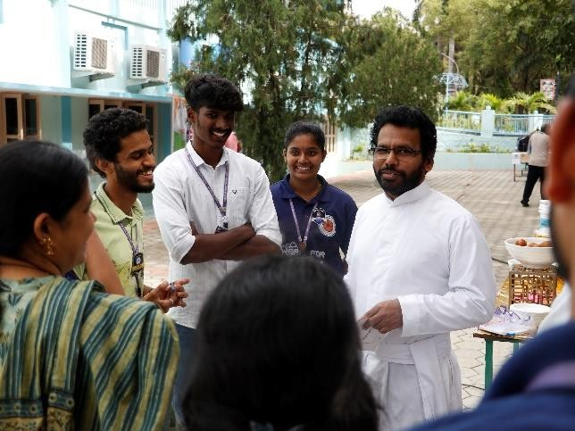
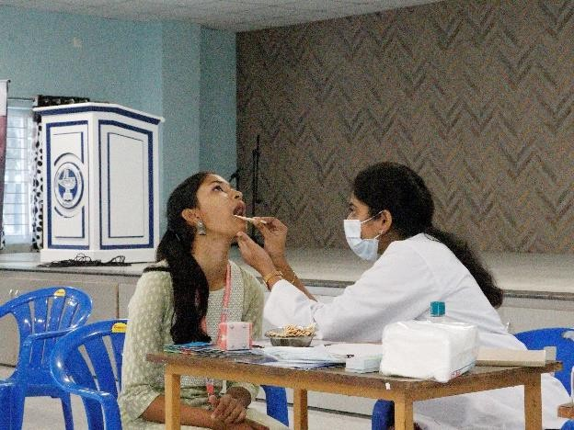
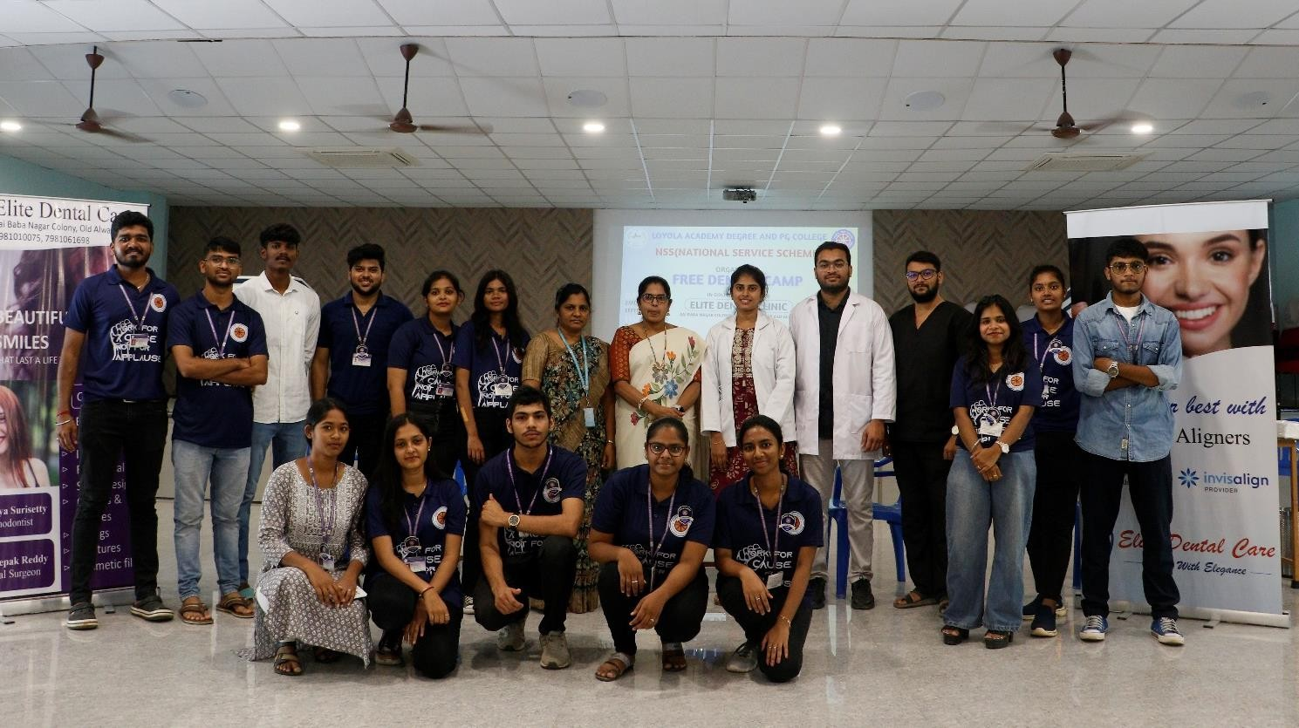

- Title: NSS DAY CELEBRATION AND ORIENTATION (27^{th,} September 2023)
Date: September 27, 2023
Time: 12:45 PM - 3:00 PM
Objective of the Event
The NSS Unit of Loyola Academy celebrated NSS Day on September 27, 2023, and conducted an NSS orientation program with the theme "Not Me, But You." The event was a resounding success and included various key highlights and dignitaries.
Event Highlights:
Flag Hoisting and Parade:
The event commenced with a parade team of NSS volunteers marching towards the NSS flag hoisting ceremony in front of the library. The flag was hoisted by Principal Rev. Fr. Dr. L. Joji Reddy SJ, in the presence of Rev. Fr. A M Joseph Kumar (NSS Incharge), and Mrs. K Anitha (Programme Officer of NSS Unit). NSS volunteers and leads also attended this prestigious moment. The NSS anthem resonated in the air as the flag was hoisted.
Group Photo:
Following the flag hoisting, all participants gathered near Loyola Hall for a group photo, capturing the spirit of unity and service.
Guest Welcome:
The event proceeded with a warm welcome extended to the distinguished guests, including Rev. Fr. Dr. L. Joji Reddy SJ, Rev. Fr. A M Joseph Kumar, and Mrs. Rama (IQAC Coordinator).
Interfaith Scripture Reading:
A beautiful interfaith scripture reading took place, with passages from the Bhagavad Gita, Quran, and the Holy Bible, emphasizing the importance of unity and service.
Choir and Welcome Dance:
The Choir team of NSS Unit set a spiritual tone with a mesmerizing prayer song. This was followed by an enchanting welcome dance performance that added vibrancy to the program.
Inspirational Speech:
Rev. Fr. Dr. L. Joji Reddy SJ delivered an inspirational speech that resonated deeply with the audience. He spoke about the core values of the NSS, emphasizing the importance of selfless service and the role each NSS volunteer plays in shaping a better society. Rev. Fr. Joji Reddy shared personal anecdotes and stories of successful NSS projects, underscoring the positive impact that dedicated volunteers can have on their communities. He encouraged volunteers to approach their work with empathy, dedication, and a strong sense of responsibility, reminding them that their efforts could bring about meaningful change.
Introduction of NSS Leads:
The introduction of NSS leads for the academic year 2023-2024 was a moment of pride and responsibility. Each lead was invited on stage and presented with their portfolios and roles within the NSS Unit. This allowed the audience to get acquainted with the diverse leadership team that would guide and coordinate various community service projects. The introductions included brief profiles of each lead, highlighting their previous service experiences and their vision for the year ahead.
NSS Pledge and Commitment:

Following the introductions, Rev. Fr. A M Joseph Kumar led the NSS pledge, and it was taken solemnly by all the leads. This pledge served as a public commitment to the principles of the NSS, reinforcing their dedication to service, community development, and social responsibility. The pledge also reiterated the core values of the NSS, such as fostering a spirit of volunteerism, promoting unity, and working towards the betterment of society.
Badging Ceremony:
The Badging ceremony was a symbol of trust and responsibility. NSS leads Abhishek and Satya, who had been selected to lead various service initiatives, received their badges from distinguished guests, including Mrs. Rama, Mrs. Anitha, and Rev. Fr. A M Joseph Kumar. The act of pinning the badges on their uniforms signified their official roles as leaders within the NSS Unit and marked the beginning of their journey to inspire and guide their fellow volunteers.
Introduction to NSS Loyola Academy:
An introduction to the NSS Unit at Loyola Academy was provided, giving a glimpse into the unit's history, its founding principles, and its past achievements. This introduction emphasized the unit's commitment to community service, highlighting previous successful projects and the unit's dedication to making a positive impact in the local community and beyond.
Roles and Responsibilities Clarification:
To ensure transparency and effective teamwork, the roles and responsibilities of each lead within the NSS Unit were presented in detail. This segment clarified how each lead's specific portfolio contributed to the unit's overall mission. Furthermore, the rules and regulations governing the conduct of all volunteers were outlined, creating a clear framework for cooperation and adherence to ethical standards within the NSS Unit.
NSS Activities AV Presentation:
The audiovisual (AV) presentation showcasing the various NSS activities of the Loyola Academy NSS Unit was a comprehensive and insightful overview. The AV featured a montage of images, videos, and testimonials from past service initiatives. It not only highlighted the diversity of projects undertaken by the NSS Unit but also provided real-life examples of the positive impact these initiatives had on the community.
The presentation delved into specific projects, such as cleanliness drives, health camps, educational outreach programs, and environmental conservation efforts. It showcased before- and-after images, illustrating how these initiatives transformed local neighborhoods and improved the lives of the less fortunate. The testimonials from beneficiaries of NSS projects added a human touch, giving a voice to those whose lives had been positively affected.
Energetic Dance Performance:
The dance team of NSS Unit wowed the audience with an electrifying Western dance performance.
Expressing Gratitude:
At the end of the event, heartfelt gratitude was extended to all participants, including fathers, deans, faculty, volunteers, and guests. This segment allowed for a moment of reflection and acknowledgment of the collective effort that made the event successful. The organizers expressed their sincere thanks to everyone who had contributed to the event's planning and execution.
This expression of gratitude wasn't just a formality; it was a genuine recognition of the invaluable support and collaboration that had gone into making the NSS Day celebration and orientation program a memorable and impactful event.
National Anthem :
The event concluded on a patriotic note with the playing of the national anthem. This moment symbolized the unity, pride, and commitment to the nation that the NSS community holds dear. As the national anthem filled the air, it resonated with the sense of purpose and service that had been at the core of the entire event.
With the strains of the national anthem still echoing, participants left with a sense of pride and inspiration, ready to embark on their NSS journey with renewed energy and dedication. The event was not just a celebration but a call to action, reminding all attendees that they were part of something larger than themselves—the noble mission of the National Service Scheme.
Conclusion:
The NSS Day celebration and orientation program aimed to not only commemorate NSS Day but also to welcome and inspire new volunteers to join the noble cause of service. The event was a true reflection of the NSS motto, "Not Me, But You," emphasizing the spirit of selfless service and community engagement. The NSS Day Celebration and Orientation Program at Loyola Academy served as a powerful reminder of the central role played by NSS volunteers. Their commitment to selflessness, unity, and community betterment is the driving force behind every successful initiative. As we concluded the event, we celebrated not just a day but a commitment to a future where these volunteers, inspired and impassioned, continue to make a lasting impact on society, one act of service at a time. The motto, "Not Me, But You," is not just words but a profound call to action that echoes through the hearts and actions of NSS volunteers, shaping a better world for all.
Instagram post link: https://www.instagram.com/p/Cx2nKunJjJO/?igshid=MzRlODBiNWFlZA==
Instagram reel link: https://www.instagram.com/reel/Cx2tnjpJLJy/?igshid=MzRlODBiNWFlZA==
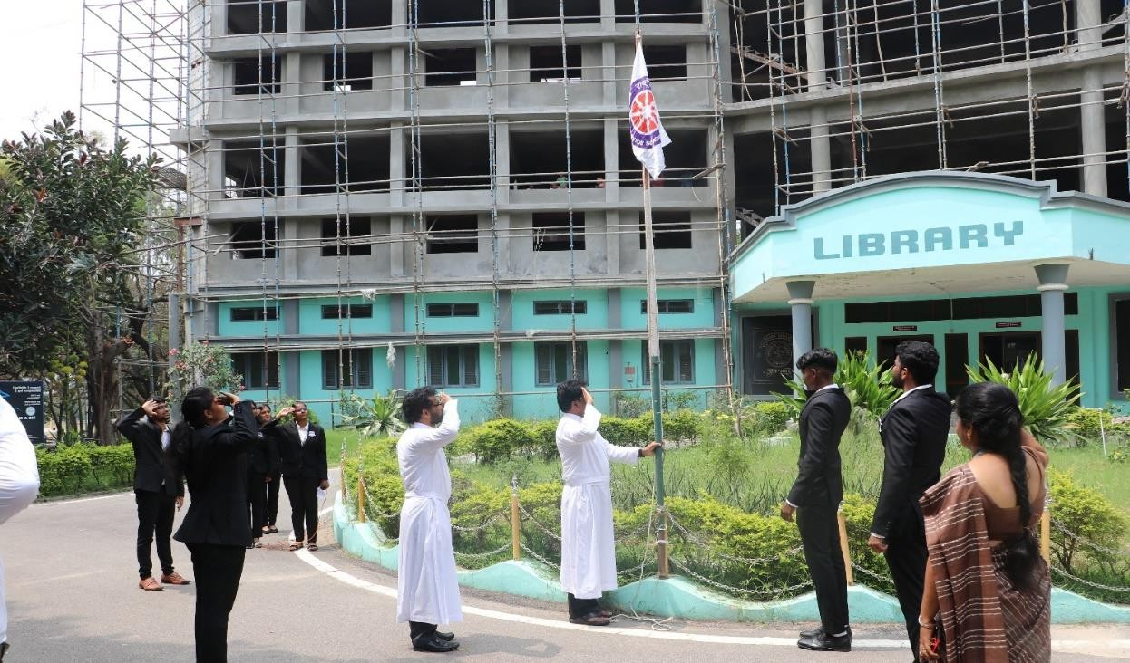
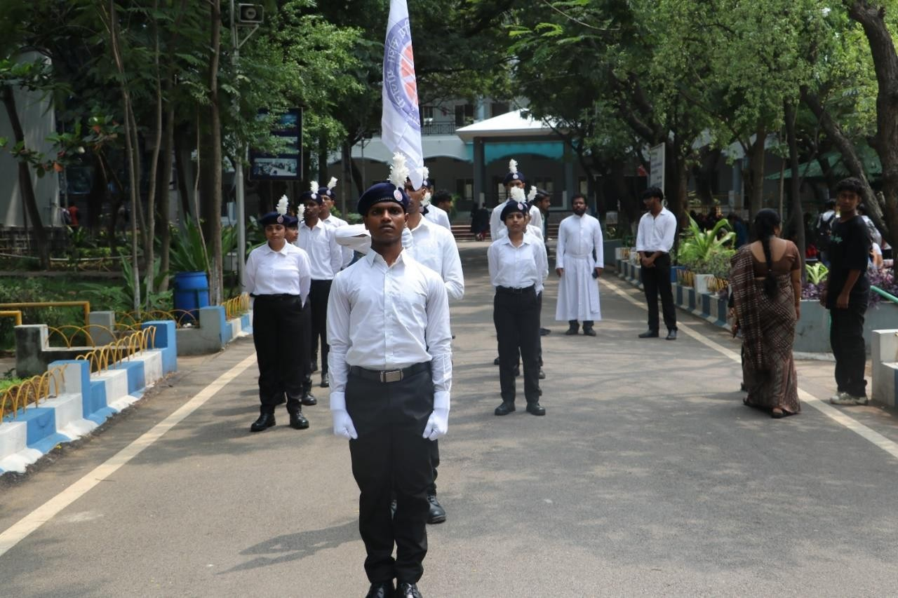

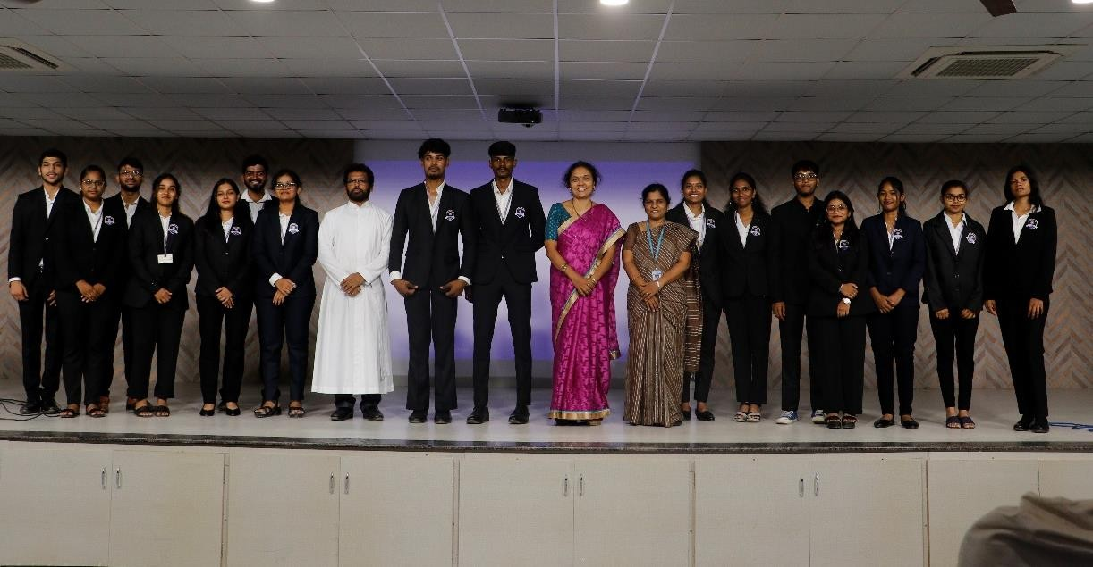

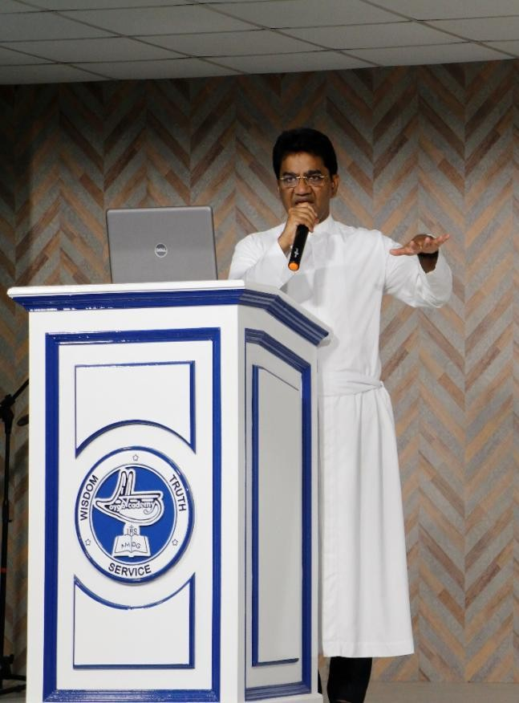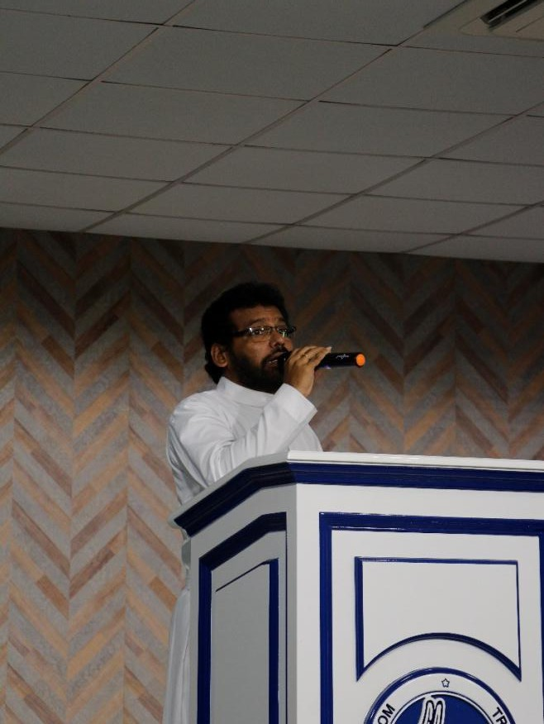

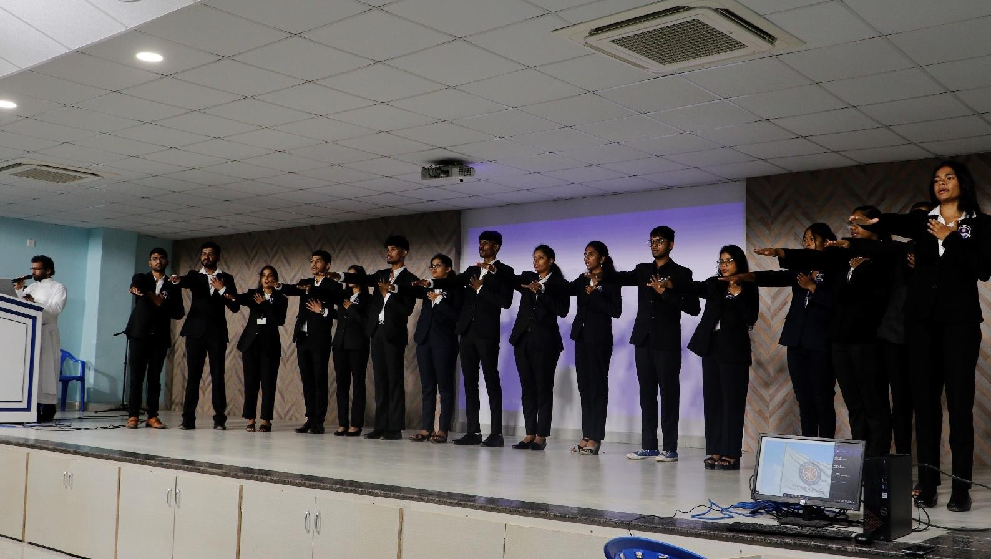

- Title: NSS UNIT GRAM SABHA VISIT (2nd October 2023)
DATE OF VISIT: October 2nd, 2023
TIME: 8:30 AM to 2:00 pm
Locations Visited: Kanakunta, Nuthankal, Lingapur-Barmajiguda, Bandamadharam
Objective of the Event
Loyola Academy, in its commitment to rural development and community engagement, has undertaken the responsibility of adopting five villages under the Unnat Bharat Abhiyan (UBA) initiative. As part of this initiative, the NSS unit, the Student Council of Loyola Academy, and NSS volunteers visited these villages to participate in the Gram Sabhas and interact with the villagers. The visit took place on October 2nd, 2023, and aimed to understand the development needs of these villages and establish meaningful connections with the communities we serve.
Village: Kanakunta Sarpanch Name: Nani Rao Problems Faced by Villagers:
Lack of proper water supply infrastructure.
Hostel management issues, including inadequate security and food supply.
Modifications required in Anganwadi.
Lack of proper equipment in the village hospital.
Need for a last journey vehicle for the graveyard.
Village: Nuthankal
Sarpanch Name: Chinnula Kavitha Jeevan
Problems Faced by Villagers:
Absence of a police station, necessitating trips to Medchal to file complaints.
Some villagers did not receive government crop loans.
Overpricing by hospitals and clinics for minor injuries.
Issues related to the Dalita Bandhu scheme.
Village: Lingapur-Barmajiguda Sarpanch Name: Bairi Lakshmi Sanjeevaiah Population: 262 houses (1081 members) Problems Faced by Villagers:
Concerns about theft and women's safety.
Insufficient street lighting.
Challenges in providing wages to workers.
Lack of proper school infrastructure and faculty.
Limited access to purified drinking water.
Inadequate government schemes for students.Village: Bandamadharam
Sarpanch Name: Prabhakar Reddy, Shyamala Population: 1500 (240 houses)
Problems Faced by Villagers:
Lack of transportation facilities.
Need for improvements in government school infrastructure.
Requirement of a proper drainage system.
Reconstruction of uneven roads.
Introduction of middle and secondary education for students.
Issues with budget allocation and passage.
Achievements and Impact of the Village Visit:
Raised Awareness:The village visits helped raise awareness among the students, NSS volunteers, and the Student Council members about the real-life challenges faced by rural communities. It provided a firsthand understanding of the issues affecting these villages.
Identification of Key Problems: Through interactions with the villagers, we identified critical problems such as the lack of proper infrastructure, inadequate access to education and healthcare, and transportation challenges. This information is invaluable in planning future initiatives.
Community Engagement: The visit allowed for meaningful engagement with the villagers, creating a bridge between Loyola Academy and the adopted communities. It established a sense of trust and cooperation that is essential for the success of any development project.
Learning Opportunity: The visit served as a valuable learning opportunity for the NSS volunteers. They were able to observe and understand the practical challenges faced by rural communities, which is an essential part of their educational and service-oriented experience.
Empowerment: By interacting with the villagers and understanding their needs, Loyola Academy and its student bodies are better equipped to initiate projects and programs that directly address the specific issues faced by these communities. This empowerment is vital in ensuring sustainable development.
Future Initiatives: The information gathered during the visit will serve as a foundation for planning and implementing future projects. It will guide the allocation of resources and efforts to make a positive impact on the lives of the villagers.

Community Involvement: The village visit also encouraged the villagers to voice their concerns and needs. It was an opportunity for them to express their challenges and expectations, making them an active part of the development process.
In summary, the village visit achieved a significant impact by creating awareness, understanding problems, building relationships, and empowering both the visiting team and the villagers. This visit marked the first step towards a brighter and more sustainable future for the adopted villages, with Loyola Academy playing an active role in their development.
Conclusion:
The visit to these five adopted villages was a crucial step in our commitment to rural development. It allowed us to gain firsthand insights into the problems faced by the villagers, and it reaffirmed our dedication to making a positive impact on their lives. The interaction with the villagers during the Gram Sabhas was a valuable experience for all those involved.

We would like to express our gratitude to the villagers for welcoming us and sharing their concerns and aspirations. Loyola Academy, in collaboration with the NSS unit, Student Council, and NSS volunteers, will continue to work towards addressing these issues and fostering a brighter future for these communities. We look forward to implementing various development initiatives in collaboration with the villagers in the near future.
Instagram postlink:
https://www.instagram.com/p/Cx_DYQSP8Z0/?igshid=MzRlODBiNWFlZA==

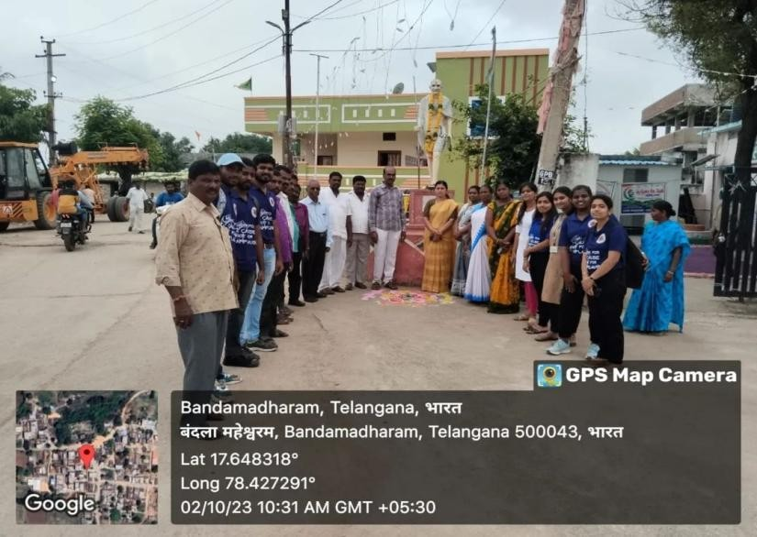
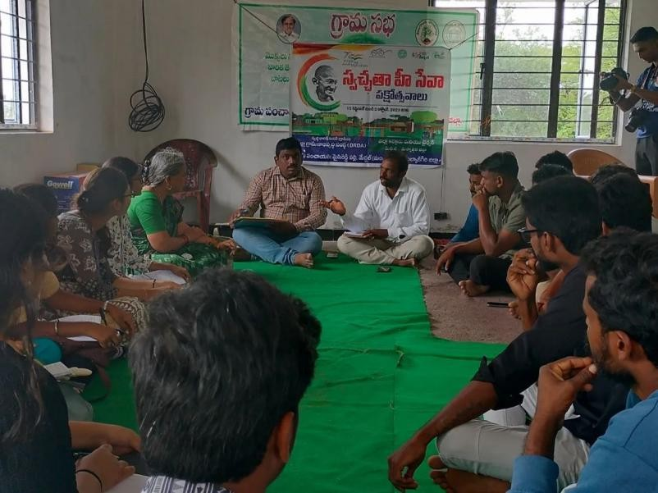

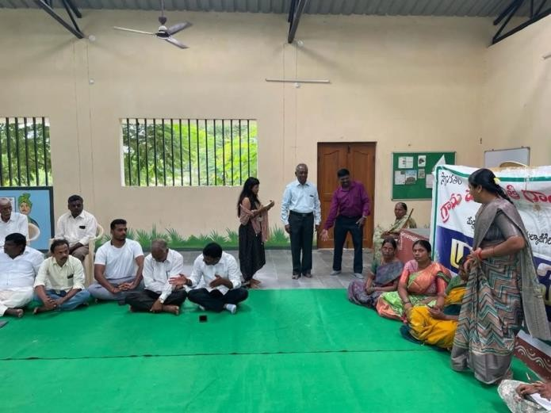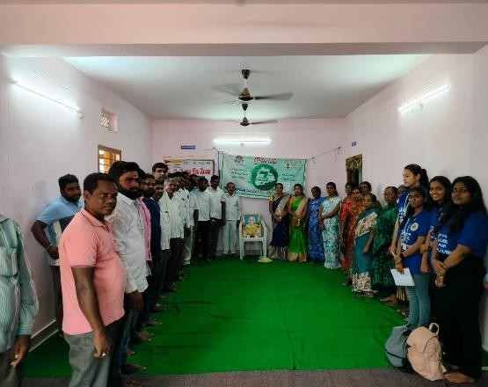
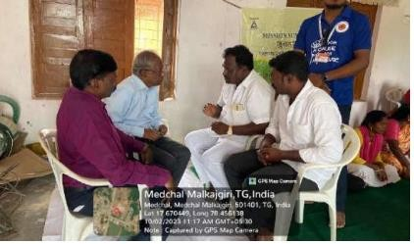
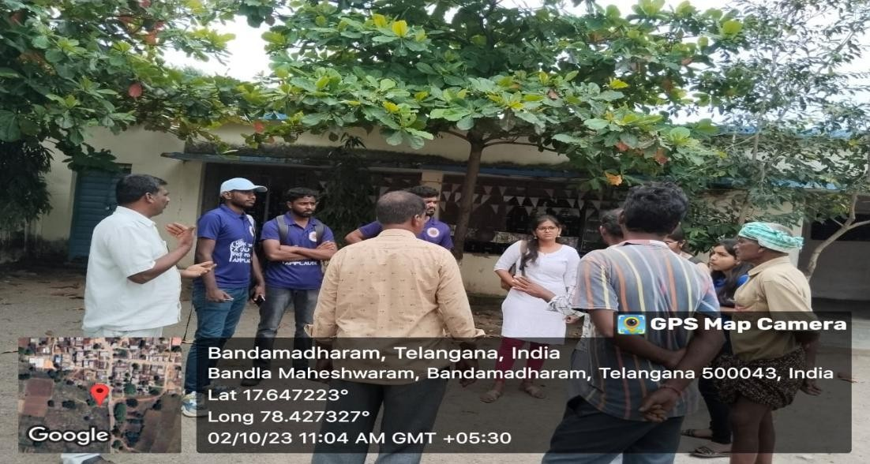

- Title: SEASON OF SHARING CHARITY FAIR ORGANIZED BY NSS UNIT
Objective of the Event
The NSS unit at Loyola Academy organized a charitable event titled "Season of Sharing" from December 14th to 20th, embracing the Christmas spirit by extending help to orphaned children. The event aimed to spread joy and make a positive impact by conducting various activities and donation drives.
Event Highlights:
Clothing and Stationery Donation Drives: Students and faculty members actively participated in donation drives, contributing clothing and stationery items for orphaned children in need.
Carol Singing and Fun Activities: The festive atmosphere was enhanced with carol singing sessions and fun activities organized during lunch and post-college hours, fostering a sense of community and joyous celebration.
Fundraising Efforts: Every rupee raised during the charity fair was dedicated to supporting Trailblazers, a girl’s orphanage. The fundraising activities aimed to provide financial assistance for the welfare and development of the orphanage.
Community Engagement:
On December 22nd, members of the NSS unit visited the orphanage and donated essential items purchased with the funds raised during the charity fair. Beyond material donations, students spent the day with the orphaned children, interacting with them and celebrating Christmas together in the evening.
Outcome:
The Season of Sharing charity fair yielded significant results, both in terms of fundraising and impact on the lives of orphaned children. Not only did the event successfully raise a considerable amount of money for Trailblazers orphanage, but it also provided a day of love, joy, and companionship for the children. The interaction with the orphaned children left an indelible mark on the lives of the volunteers, fostering a sense of empathy and gratitude.
Conclusion:
The NSS unit at Loyola Academy demonstrated the spirit of compassion and generosity through the Season of Sharing charity fair. By organizing donation drives, fundraising activities, and spending quality time with orphaned children, the event exemplified the true essence of Christmas - spreading love and kindness to those in need. The success of the charity fair not only benefited the orphanage but also inspired students to actively participate in meaningful causes and contribute towards building a compassionate society.
INSTAGRAM POSTS LINKS:

https://www.instagram.com/p/C1Pjyz2JEB9/?igsh=NmZxbmZzMHB6b3Rv https://www.instagram.com/p/C1Q3Yp5pKiK/?igsh=amhhdHBmNm56a3Bq
https://www.instagram.com/reel/C1XeudNPiJR/?igsh=Z29mdG94aGNhazdw

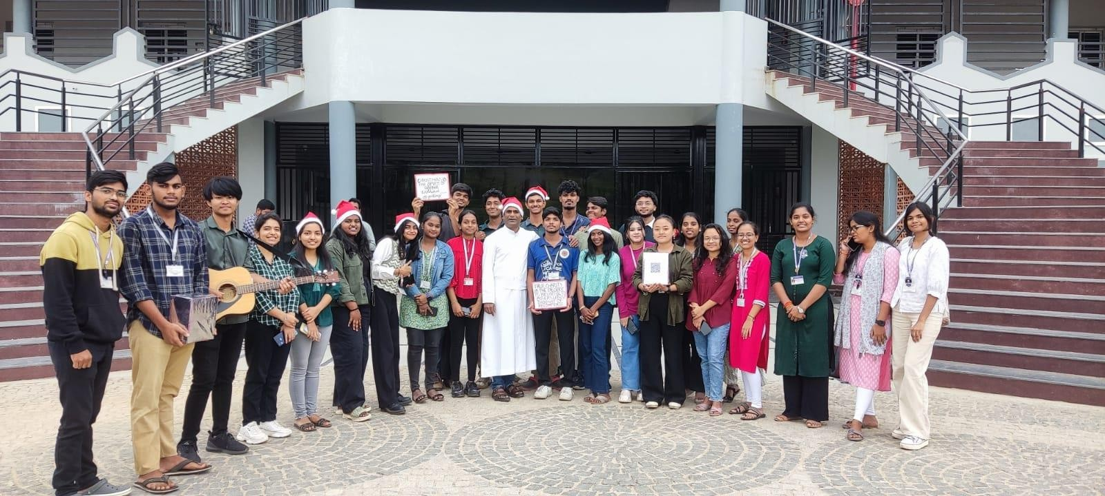

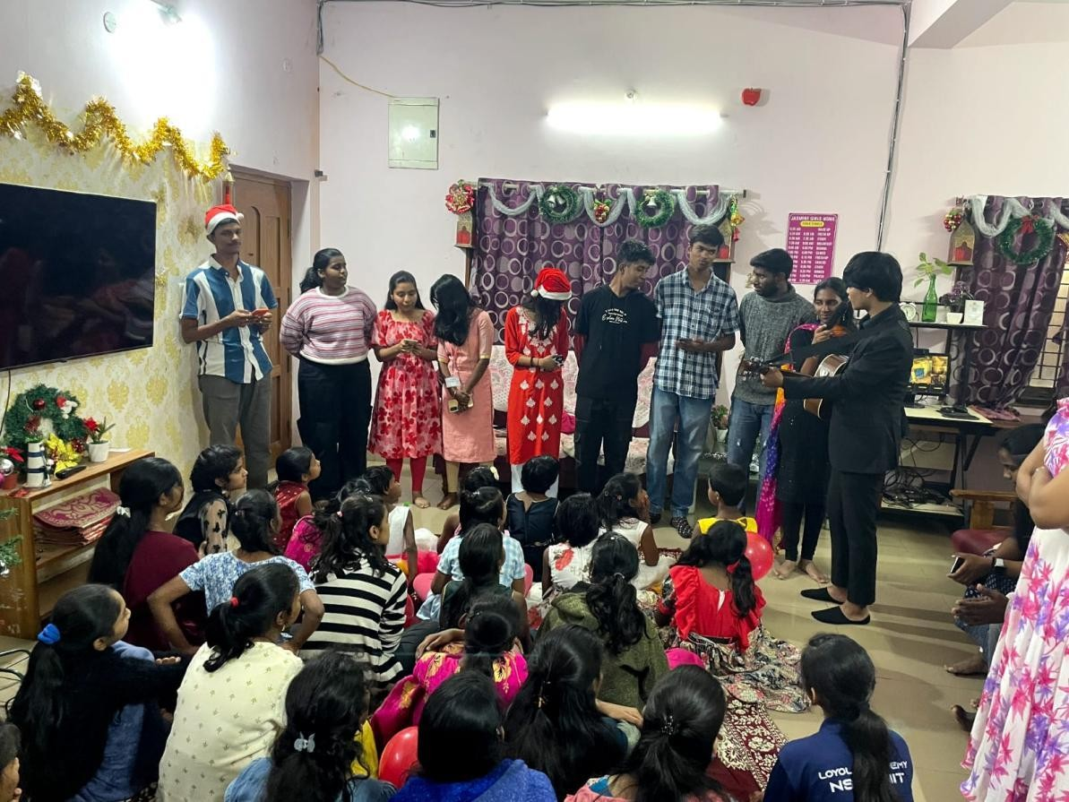

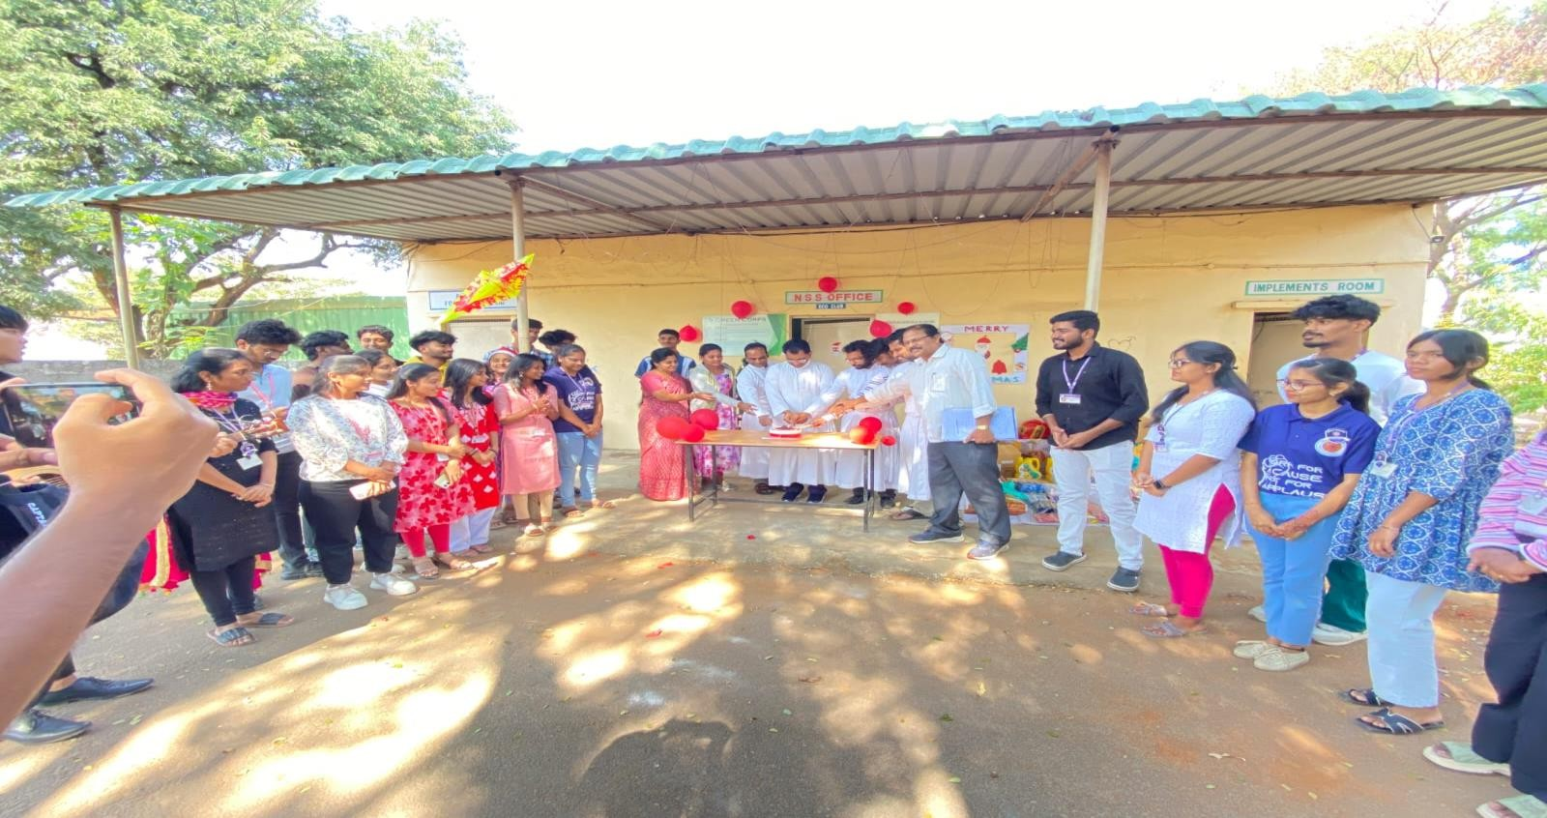

- Title: REPUBLIC DAY (26th January 2024)
Date: 26th January 2024
Venue: Loyola Academy, Alwal
Chief Guest: Mrs. C. Vijay Santhi Reddy, Corporator of Alwal Constituency
Objective of the Event
The NSS Unit of Loyola Academy, in conjunction with the Student Council and NCC, proudly organized the Republic Day celebrations on the 26th of January 2024. The event was graced by the esteemed presence of Mrs. C. Vijay Santhi Reddy, the Corporator of Alwal Constituency, who honored us as the Chief Guest for the occasion.
The celebration commenced with a sense of unity and patriotism as our NSS volunteers actively participated in every aspect of the event. From the initial preparations to the concluding moments, their dedication and enthusiasm were evident, reflecting a deep-seated love for our nation.
One of the highlights of the celebration was the participation of NSS members in a thematic dance performance, which encapsulated the essence of the Republic Day spirit. Through their graceful movements and synchronized choreography, they conveyed a message of unity, diversity, and national pride.
The ceremony reached its pinnacle with the solemn hoisting of the national flag, a moment that filled the hearts of all present with reverence and pride. The rendition of the National Anthem echoed through the surroundings, serving as a reminder of the sacrifices made by our forefathers to secure the sovereignty of our nation.
Furthermore, the event featured various cultural performances that showcased the rich heritage and diversity of our country. From traditional dances to musical renditions, each performance added to the festive atmosphere and reinforced the spirit of unity among the attendees.
The Republic Day celebration at Loyola Academy served as a platform for fostering a deeper sense of patriotism and national consciousness among the students and staff. It was a testament to our commitment to uphold the principles enshrined in the Constitution and to contribute positively to the growth and development of our nation.
CONCLUSION
we extend our heartfelt gratitude to Mrs. C. Vijay Santhi Reddy for gracing the occasion with her presence and inspiring words. We also commend the efforts of all the organizers, volunteers, and participants who made this event a resounding success. May the spirit of patriotism ignited on this day continue to guide us in our endeavors towards a brighter future for our beloved country.
Instagram Post Link: https://www.instagram.com/reel/C2ocjavBxp5/?igsh=dWZoejgyeDgxa2Rn
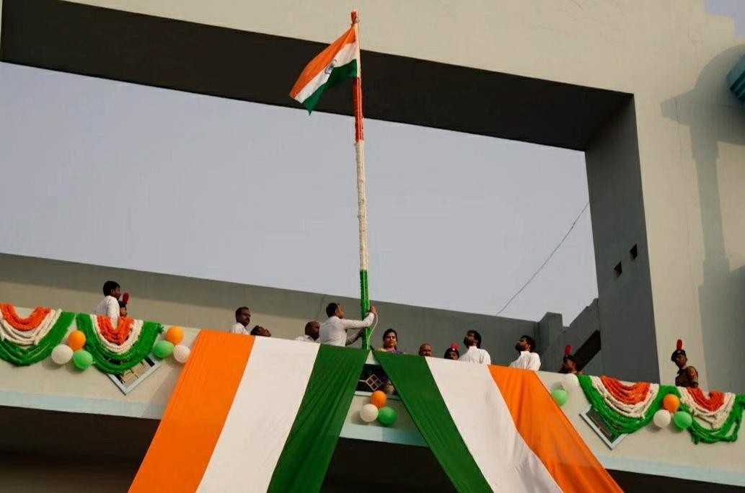
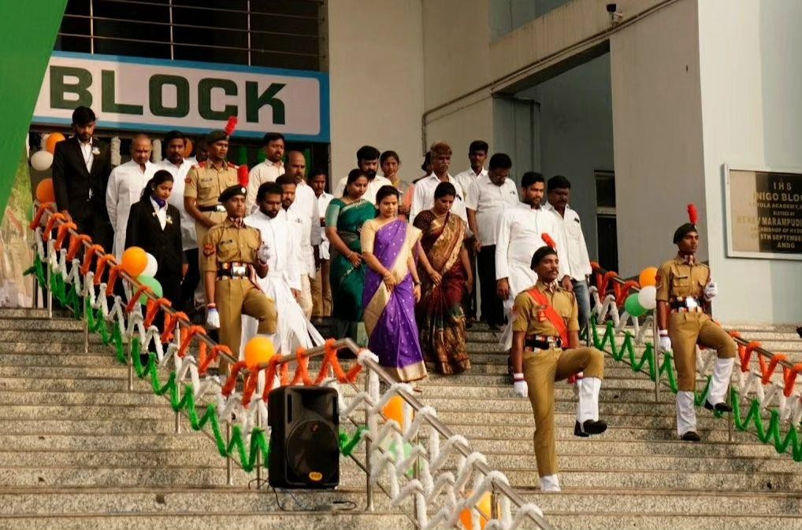

16. Title: NSS UNIT BLOOD DONATION CAMP (16th February 2024)
Date: 16th February 2024 (Friday) Venue: Inigo Hall, Loyola Academy
Introduction:
The National Service Scheme (NSS) unit of Loyola Academy, in collaboration with Rudhira Health Organization, organized a blood donation camp on 16th February 2024. The event aimed to raise awareness about the importance of blood donation and to contribute to the noble cause of saving lives.
Event Details:
Date and Time: The blood donation camp took place on Friday, 16th February 2024, from 9:30 am to 4:00 pm.
Venue: The camp was held at Inigo Hall, a central location within Loyola Academy, conducive to hosting such events.
Participants: The camp witnessed active participation from various segments of the Loyola Academy community, including college students, teaching staff, non-teaching staff, and parents of college students.
Awareness Campaign: Throughout the event, we conducted awareness campaigns highlighting the significance of blood donation in saving lives. Information was provided on the importance of regular blood donations and the impact it has on society.
Safety Measures: In adherence to guidelines, utmost care was taken to ensure the safety and well-being of donors. Medical professionals were present to screen donors for eligibility and to aid throughout the donation process. Sanitization stations were set up, and social distancing measures were implemented to mitigate any health risks.
Participation of NSS Volunteers: NSS volunteers and leads played an integral role in organizing and managing the camp. They actively engaged with donors, assisted in registration, and facilitated the donation process. Notably, many NSS volunteers also participated by donating blood themselves, setting a commendable example for others.
Total Number of Blood Donations: The blood donation camp witnessed a remarkable response, with a total of 150 donors generously contributing to the cause.
Special Guests: We were honored to have Rev. Fr. L. Joji Reddy, Principal of Loyola Academy, and Rev. Fr. Joseph Kumar SJ, Vice Principal, grace the event with their presence. Both dignitaries shared a few words of encouragement and appreciation for the noble cause, further motivating the participants.
Donor Recognition: Donors were appreciated and recognized for their invaluable contribution to the cause. Each donor received a blood donation certificate as a token of appreciation. Additionally, to replenish their energy post-donation, donors were provided with fruits.

Conclusion:
The blood donation camp organized by the NSS unit of Loyola Academy, in collaboration with Rudhira Health Organization, was a resounding success. Through collective efforts and community participation, we were able to make a significant contribution to addressing the ongoing need for blood donations. The event not only raised awareness but also fostered a sense of social responsibility among the participants. We extend our gratitude to all donors, volunteers, special guests, and collaborators for their unwavering support and commitment to this noble cause.
Instagram postlink:
https://www.instagram.com/p/C4vQ005vvk2/?igsh=MWp0czdwdTNtdTVrcQ==
