LOYOLA ACADEMY DEGREE & PG COLLEGE
NSS UNIT ANNUAL REPORT FOR THE ACADEMIC YEAR 2024 – 25

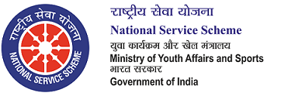
National Service Scheme (NSS) was introduced in 1969 with the primary objective of developing the personality and character of the student youth through voluntary community service. ‘Education through Service’ is the purpose of the NSS. The ideological orientation of the NSS is inspired by the ideals of Mahatma Gandhi. Very appropriately, the motto of NSS is “NOT ME, BUT YOU”. An NSS volunteer places the ‘community’ before ‘self’.
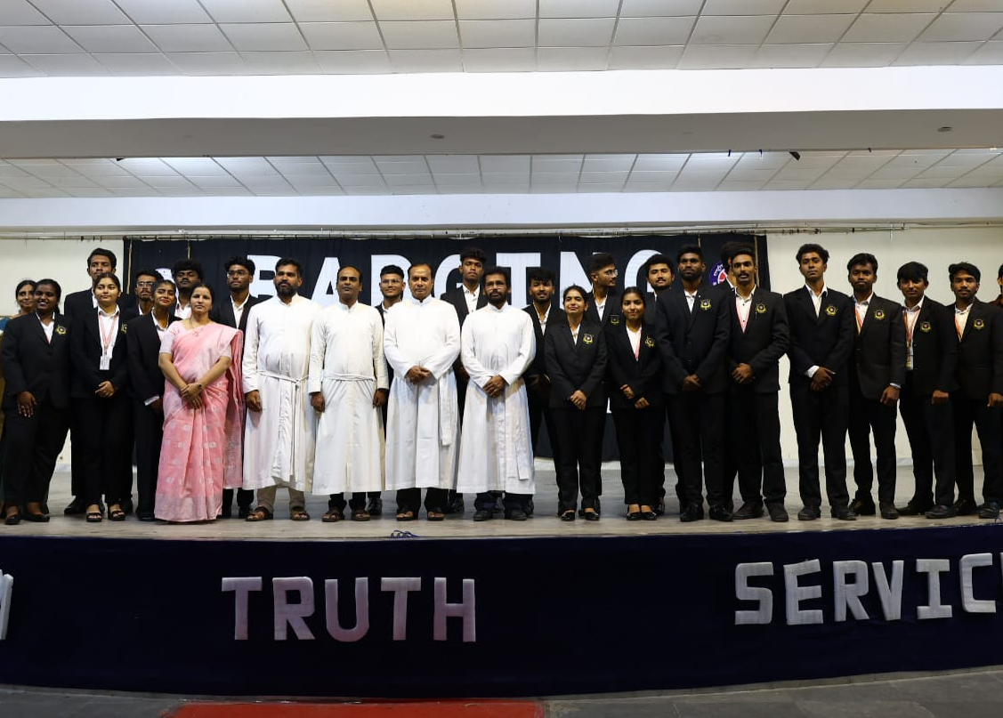
- Yoga Day
Purpose: An event to address the importance of Yoga.
Report: The NSS unit of Loyola Academy actively participated in Yoga Day event organized by Student Council, engaging in various Yogasanaas under the guidance of experienced instructors. The session focused on both physical postures and breathing exercises, helping participants improve flexibility, strength, and mental clarity. It was an inspiring experience as the volunteers embraced the ancient practice, reflecting on its holistic benefits. The event not only promoted physical well-being but also emphasized the importance of mental peace in daily life. The Yoga Day served as a reminder of the powerful connection between body and mind.
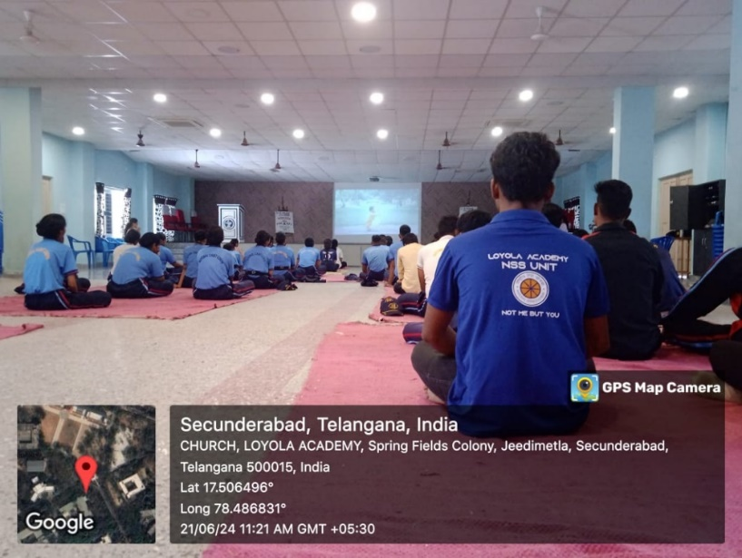

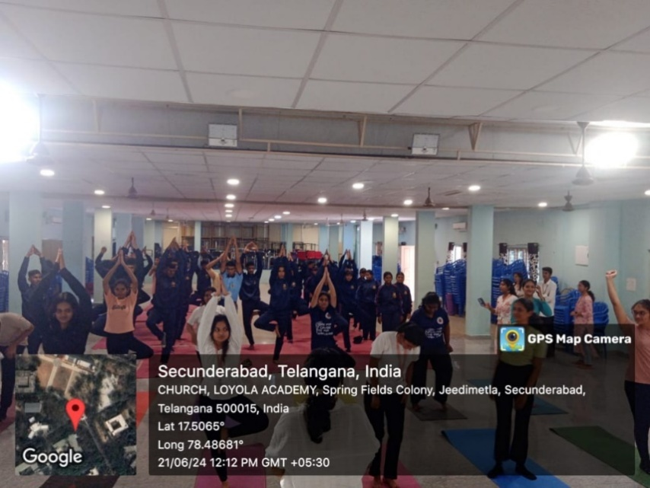
Review:The session went well and the NSS volunteers learnt about various Yogasanaas.
- Anti-Drug Event
Purpose: An event for creating awareness about avoiding the usage of substances.
Report:NSS Unit of Loyola Academy hosted a powerful anti-drug event, commencing with an impactful awareness rally that saw students marching and chanting slogans against substance abuse. Following the rally, a compelling skit was performed, vividly portraying the devastating consequences of drug addiction on individuals and families. The skit highlighted the deceptive allure of drugs and the long-term repercussions on physical and mental health. Students actively participated, demonstrating their commitment to a drug-free environment.
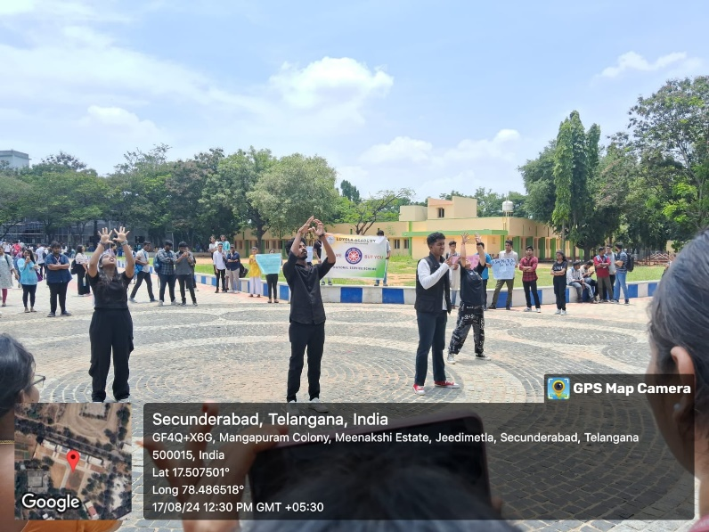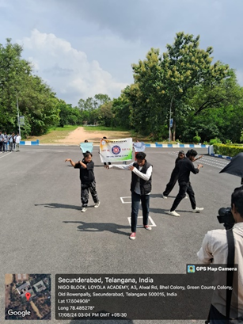
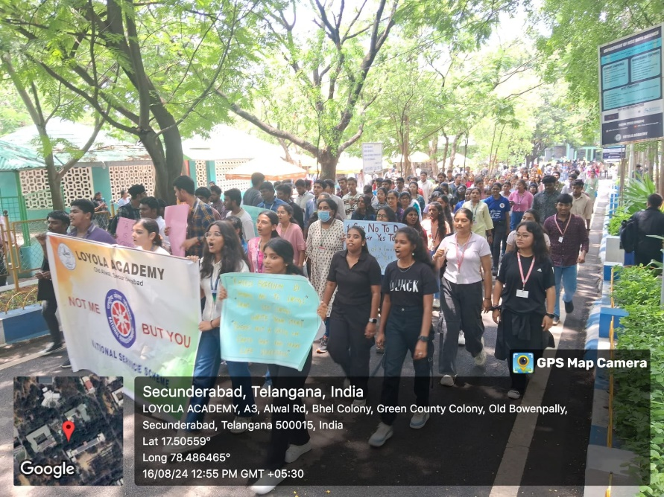
Review: Created awareness about the importance of anti-drug.

- Independence Day
Purpose: An event about National flag hoisting and patriotic singing by NSS volunteers at college and at adopted villages.
Report: On Independence Day morning, NSS Volunteers spirited renditions of national songs, filling the campus with a sense of unity.
Also, few student volunteers embarked on visits to nearby adopted villages of Loyola Academy, where they participated in flag-hoisting ceremonies and focused on empowering villagers with employment opportunities. The day's events transitioned into a celebration of cultural diversity, with students showcasing their talents through captivating dance performances, theatrical skits, and musical presentations. The atmosphere was charged with a palpable sense of national pride and a commitment to social responsibility.
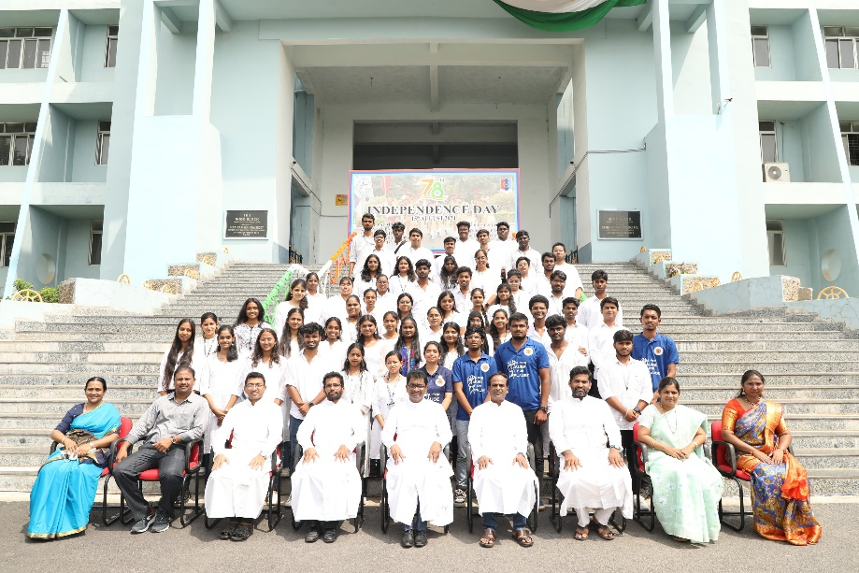
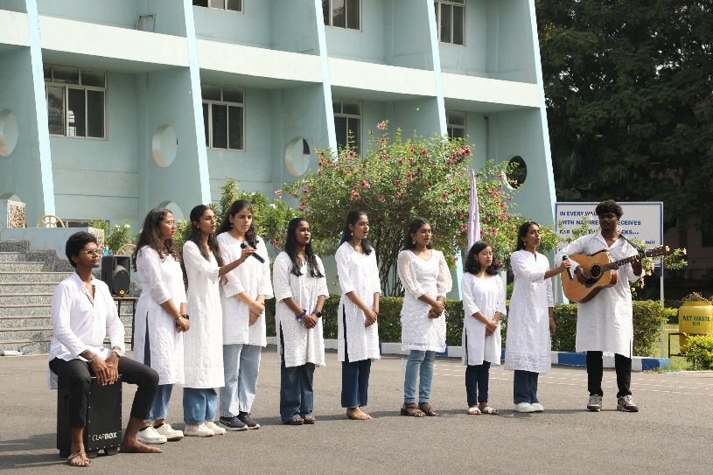

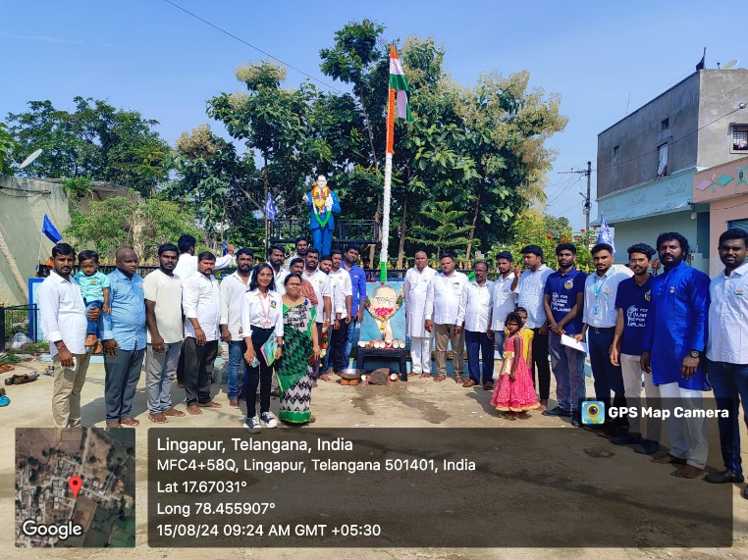
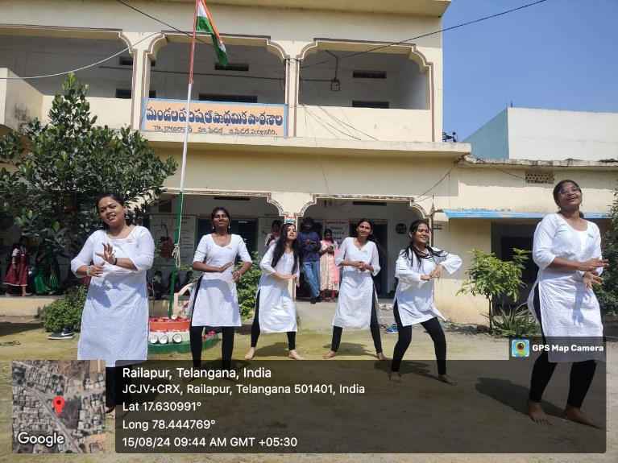
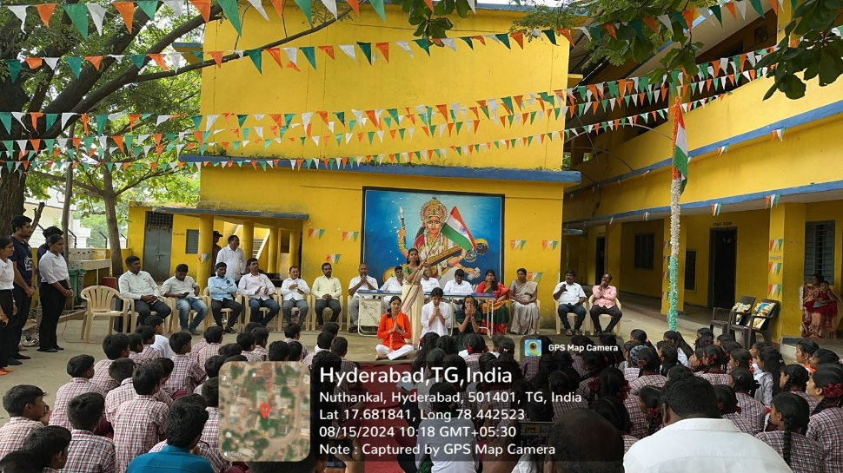
Review: Cultural performances of the NSS volunteers was entertaining and highlight during the events.

- Health Camp ( Dental and Eye camp)
Purpose: An eye and dental checkup camps were conducted in the college.
Report: A health camp was organized by the NSS Unit, Loyola Academy, in collaboration with Srikara Hospitals and Clove Dental, brought essential services to the community, focusing on both vision and oral health. Skilled ophthalmologists conducted thorough eye examinations, identifying refractive errors and potential eye diseases. Simultaneously, experienced dentists performed detailed dental checkups, addressing concerns like cavities and gum health. Educational sessions were held, emphasizing the importance of preventative care for both eyes and teeth. Participants received personalized advice and, where needed, referrals for further treatment.

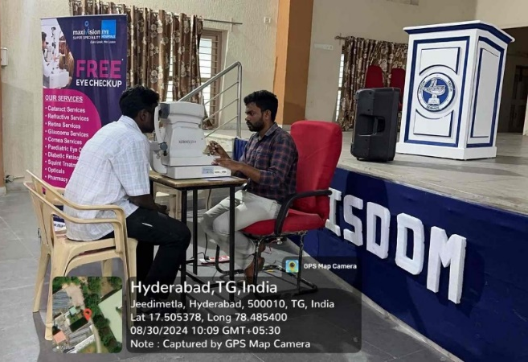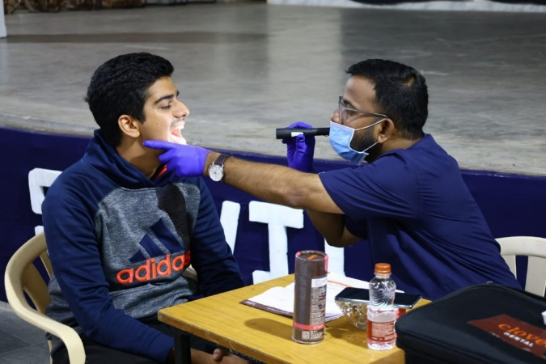

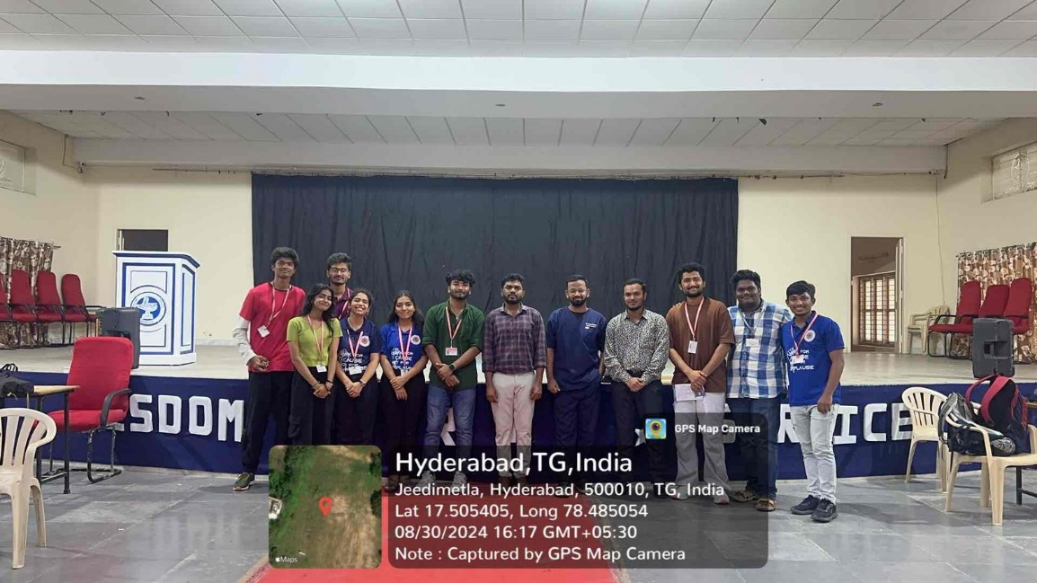
Review:Eye and Dental care tips were knownto the students, volunteers and staff.
- RRC Programme with TSACS
Purpose: To spread awareness about HIV/AIDS.
Report: The NSS volunteers of Loyola Academy, participated in a poster-making competition organized by NSS Cell OU through RRC programme in collaboration with Telangana State AIDS Control Society. The competition was a resounding success, with the NSS volunteers showcasing their creativity and dedication to raising awareness about HIV/AIDS prevention. The judges were impressed by the quality of the posters, which featured eye-catching designs and informative messages. In a testament to their talent and hard work, the NSS volunteers were awarded both the first and second prizes in the competition. This achievement is a source of pride for the college and a testament to the commitment of the NSS volunteers to making a positive impact on society.
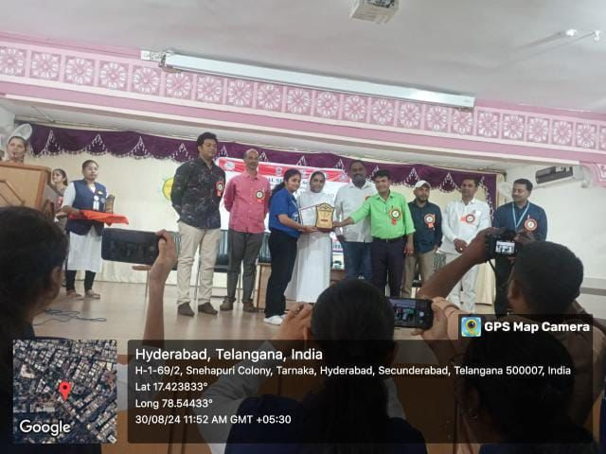
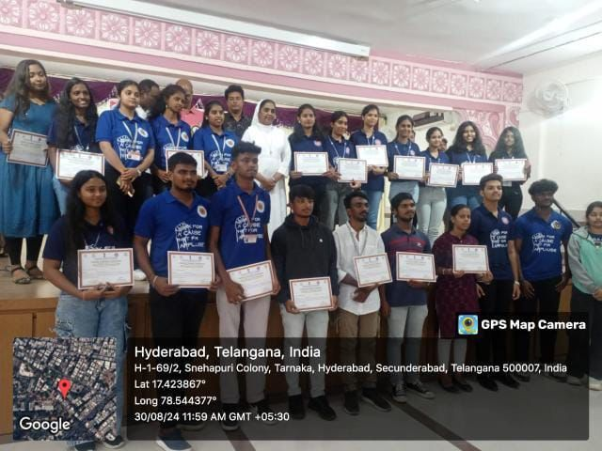
Review: Awareness about HIV/AIDS was communicated through the posters made by the volunteers
- Badging Ceremony of NSS Leads
Purpose: To badge the elected volunteers as NSS Leads for the year 2024-2025.
Report:The college held a badging ceremony for the newly appointed NSS leads, Magic Youth, and AICUF committee members. The ceremony was a grand affair, with the college principal and other dignitaries in attendance. The newly appointed leaders were given their badges and certificates, and they were also given a warm welcome to their new roles. The ceremony was followed by a motivational speech by the college principal, who encouraged the leaders to work hard and make a difference in the college community
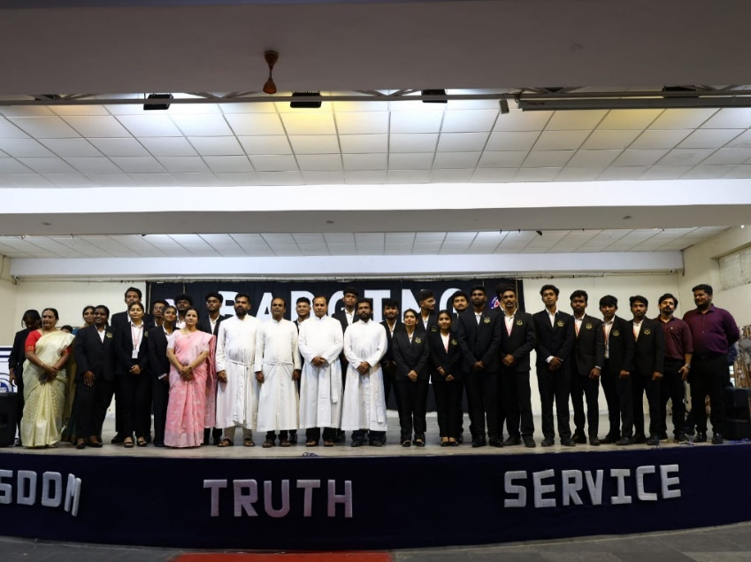
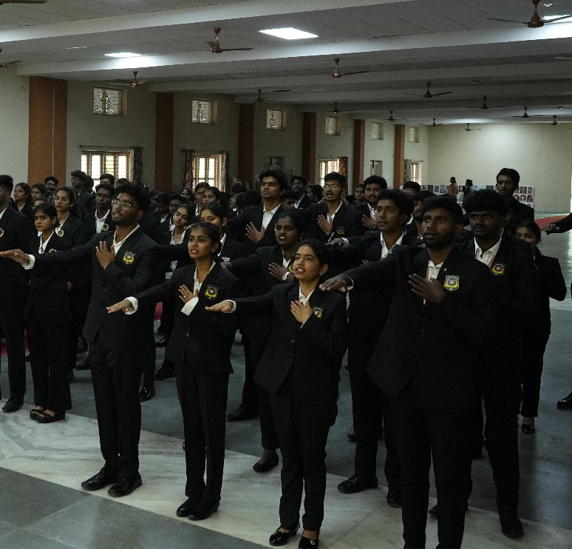
Review:Newly elected leads for the year 2024-2025 were badged and their responsibilities & duties were explained.
- Fit India 5K Run
Purpose:To promote physical fitness and to popularize the culture of sports and fitness in the country.
Report:The Fit India Run, organized by Student council of Loyola Academy was a resounding success, with NSS volunteers enthusiastically participating in a variety of activities. The 5k run was a highlight, with participants of all ages and fitness levels coming together to promote health and fitness. The cycling contest showcased the agility and skill of cyclists, while the tug-of-war matches were filled with excitement. Other sports events added to the festive atmosphere, creating a fun and engaging experience for everyone involved. The volunteers' dedication and enthusiasm were instrumental in making the Fit India Run a memorable event that inspired the community to embrace a healthy and active lifestyle.
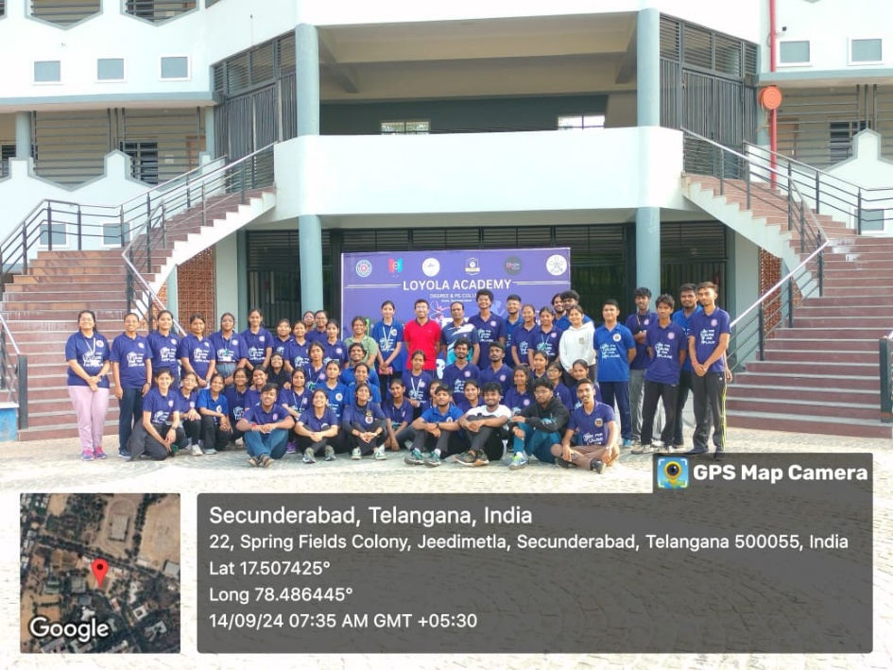

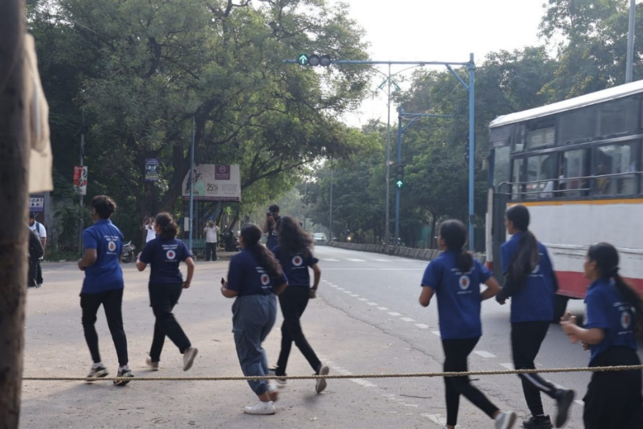
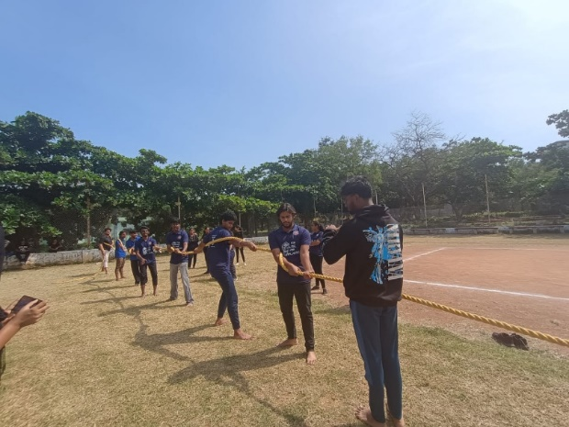
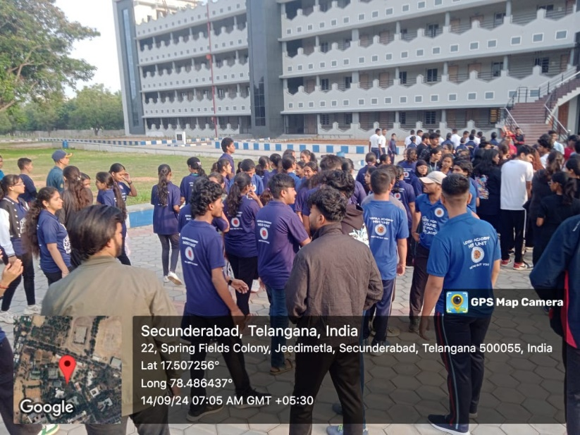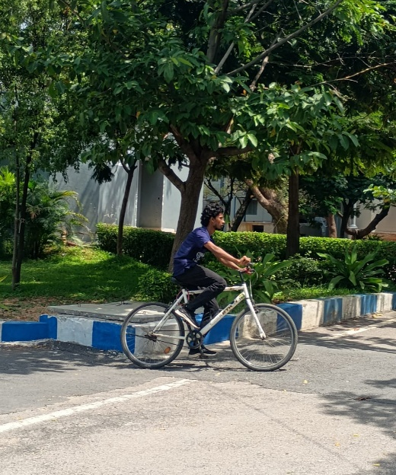
Review:Physical fitness of the volunteers was tested and few of them won in various competitions.

8. NSS Day and Orientation
.
Purpose:To introduce new volunteers to the NSS program, its objectives, activities, and the importance of community service, fostering a sense of purpose and commitment to social work.
Report:The NSS unit's orientation event commenced with a vibrant parade, culminating at the flag hoisting venue. The NSS national anthem filled the air, followed by a prayer song and captivating dance performances. The event highlighted the introduction and achievements of the NSS unit, introducing the esteemed NSS leads to the enthusiastic volunteers. The orientation concluded with inspiring speeches from the college dignitaries, setting the stage for a year of impactful service and growth.
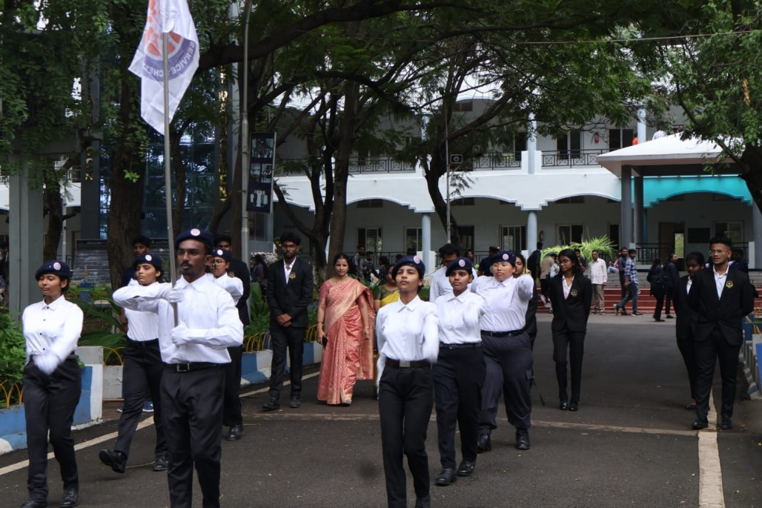
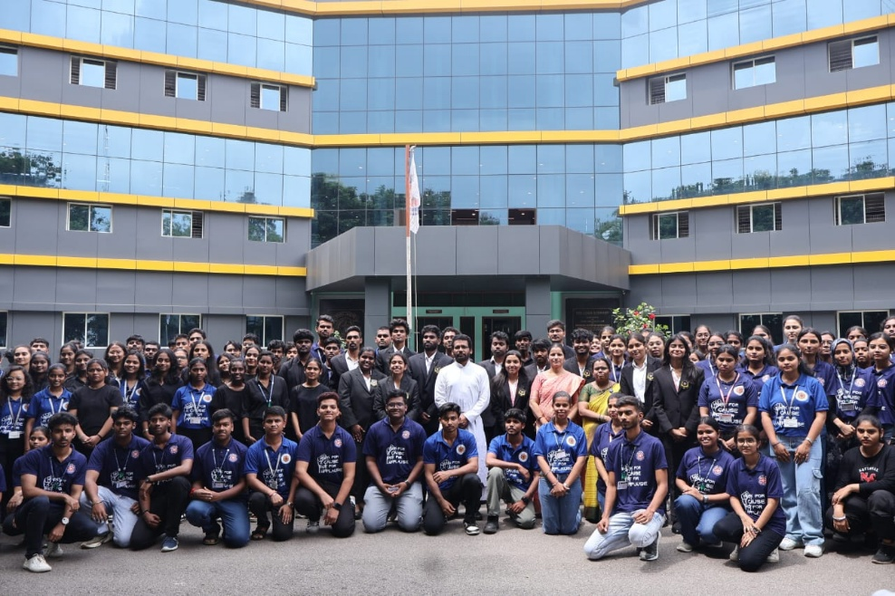
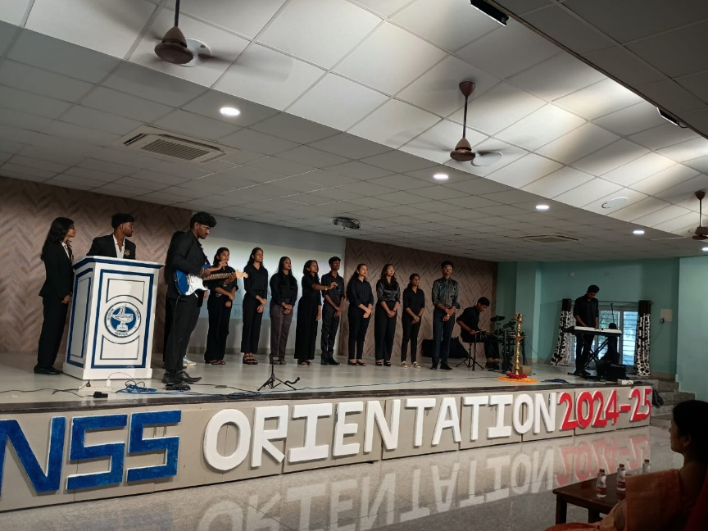
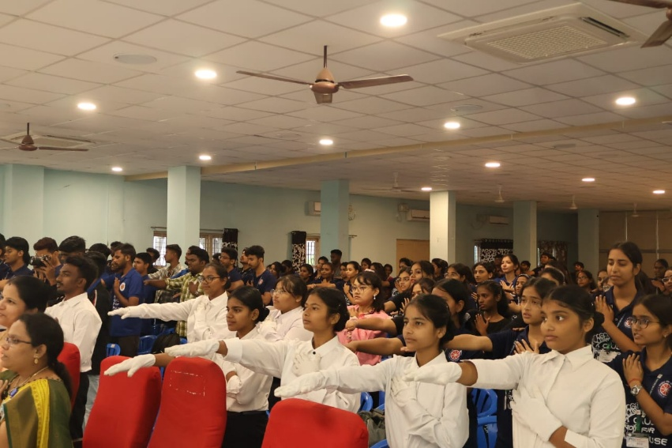
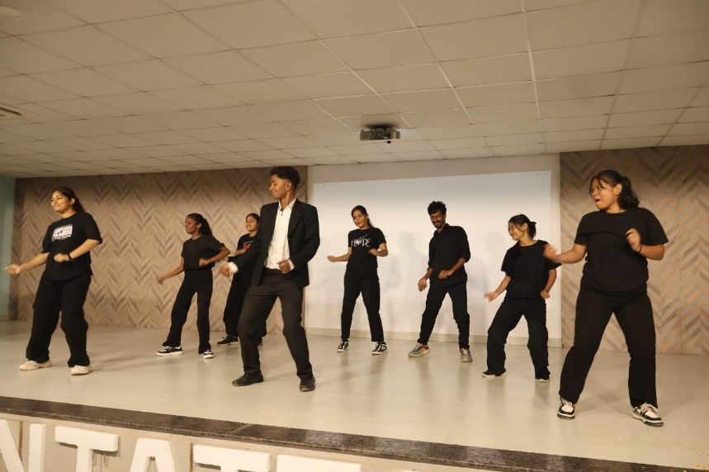
Review:NSS flag was hoisted and newly recruited volunteers were introduced about NSS and pledged to serve.

- General Health Camp
Purpose: To facilitate general checkup opportunities to the staff and students.
Report: The NSS unit organized a comprehensive general health camp, in collaboration with Amvi Clinic, offering vital checkups for blood pressure and diabetes to both staff and students. The camp provided a valuable platform for early detection and preventive care, promoting a proactive approach to health management within the college community. The event was a resounding success, with numerous participants benefiting from the accessible healthcare services offered by the dedicated NSS volunteers.
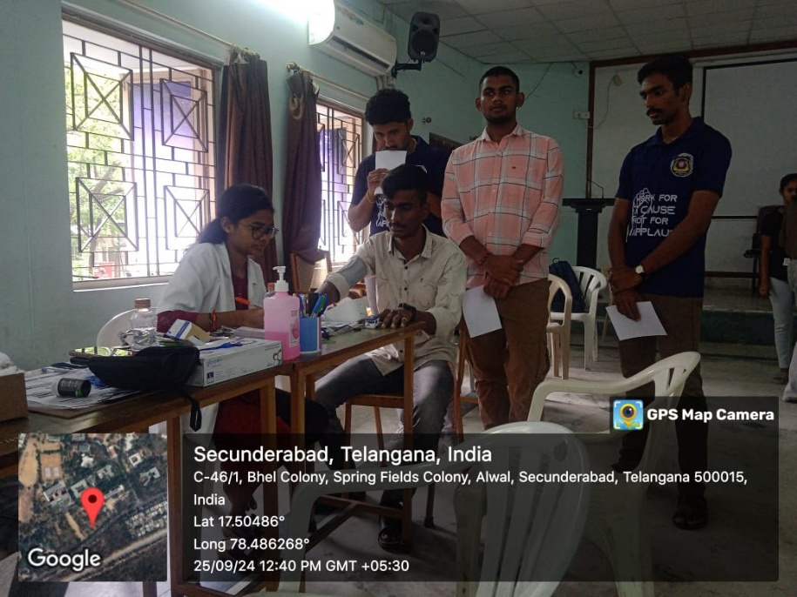
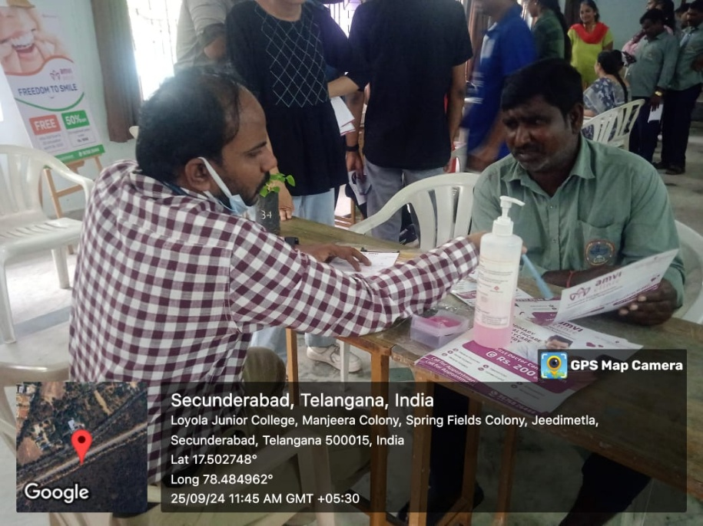

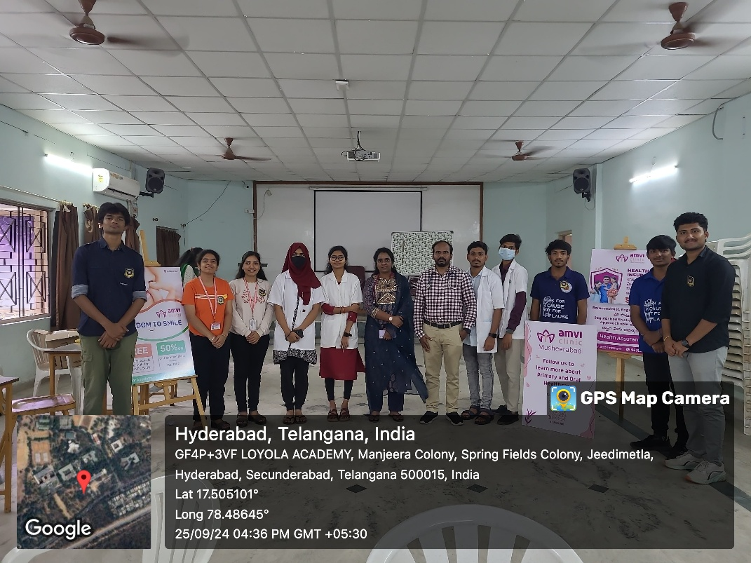
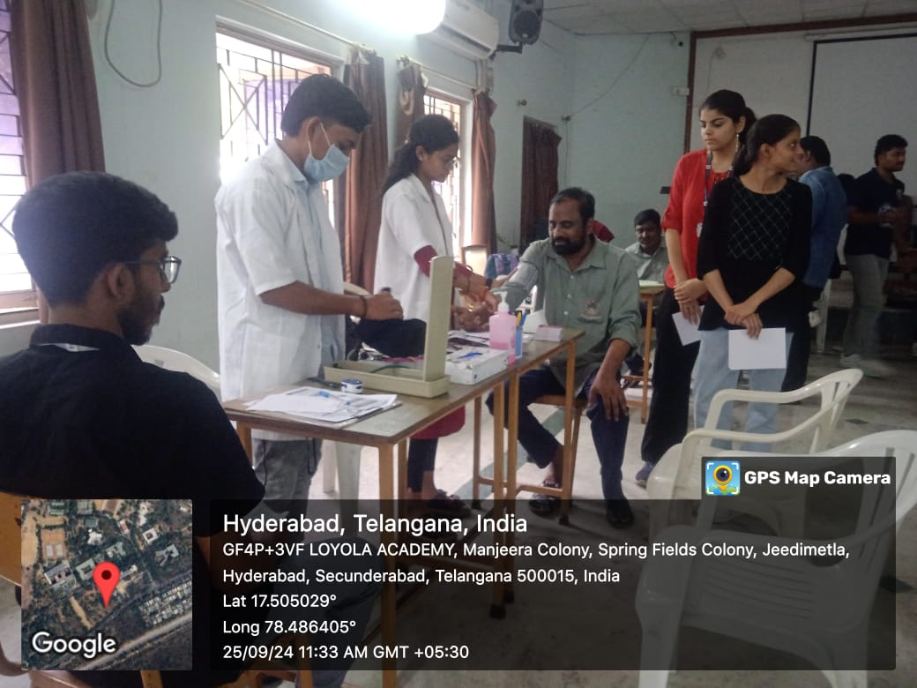
Review:The diabetes and bold pressure checkups were conducted and precautions, measures were instructed to the attendees.

- Outreach event to Adopted Villages
Purpose: To promote Khadi clothes and self-employment opportunities for the adopted villagers.
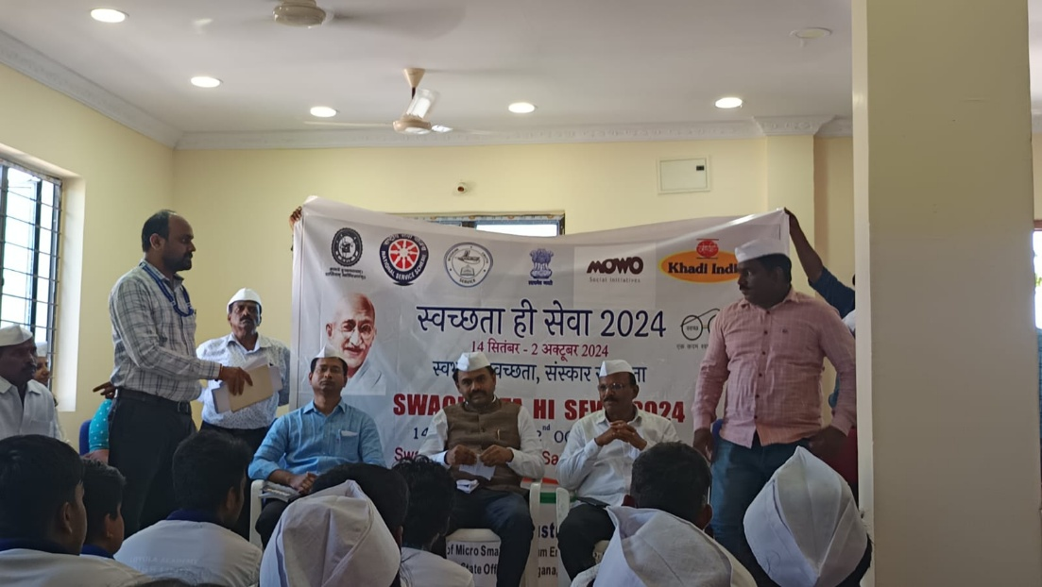
Report: The NSS unit collaborated with the KVIC organization on Gandhi Jayanti to reach out to adopted villages and distribute tool kits under the GVY initiative. Additionally, the unit partnered with Ms. Jai Bharathi of MOWO organization to empower women auto drivers, providing them with essential tools to enhance their livelihoods. This outreach initiative showcased the NSS unit's dedication to community development and social empowerment.

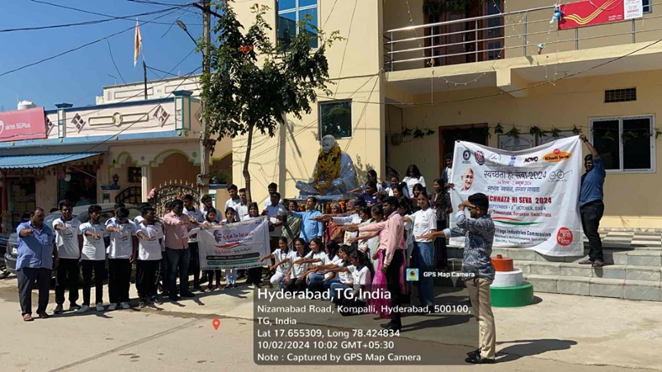
Review: Importance of Khadi clothes and empowerment towards employment wad communicated.
- Diwali Celebrations
Purpose:To spread the joyfulness of the festival of lights.
Report: The NSS unit organized a Diwali visit to Sannihita Children Society and Caring Center for Boys, bringing the spirit of the festival to the young students. The volunteers conducted a fun-filled diya painting session, guiding the children in decorating diyas with vibrant colors and creative designs. The classroom buzzed with excitement as the children enthusiastically painted their diyas, adding their unique touch to the traditional symbol of light. After the painting session, the volunteers engaged the children in a series of lively games, fostering a sense of camaraderie and laughter. The highlight of the visit was the collective burning of crackers, creating a visual spectacle of light and sound that filled the children's eyes with wonder and excitement. The NSS unit's Diwali visit left a lasting impression on the young students, spreading joy and cheer throughout the school.
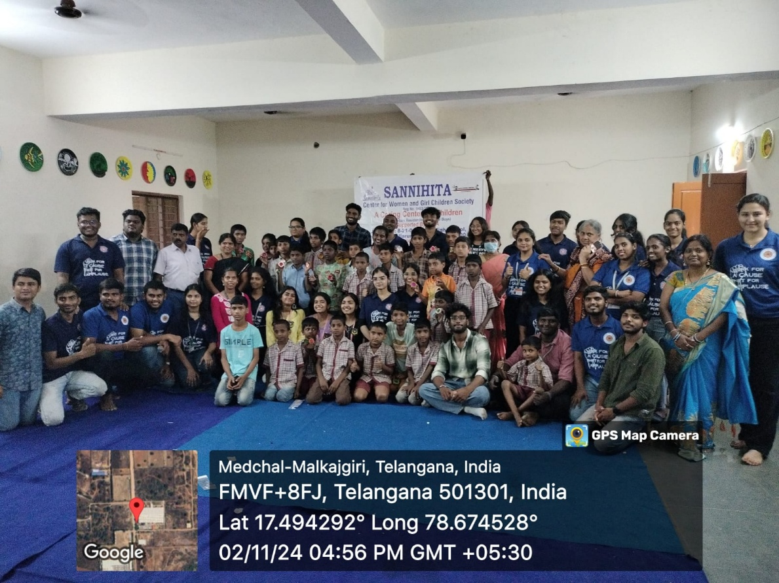

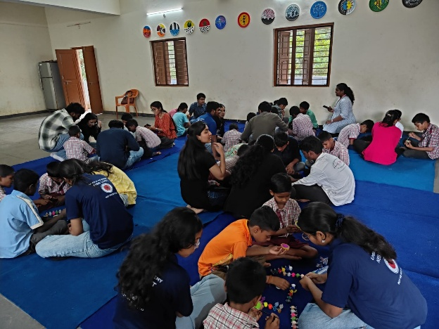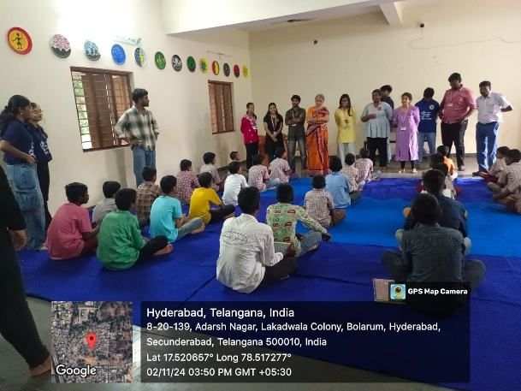
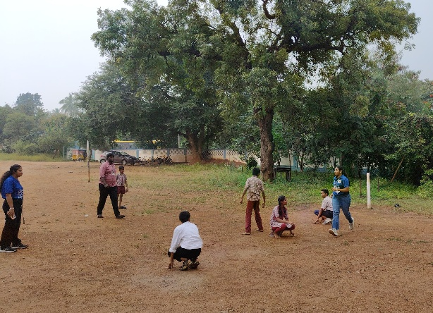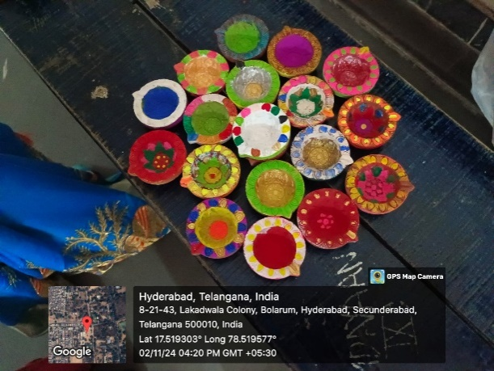
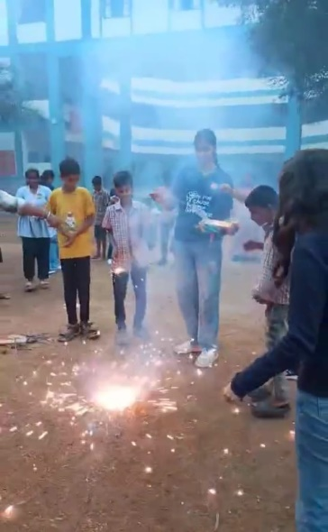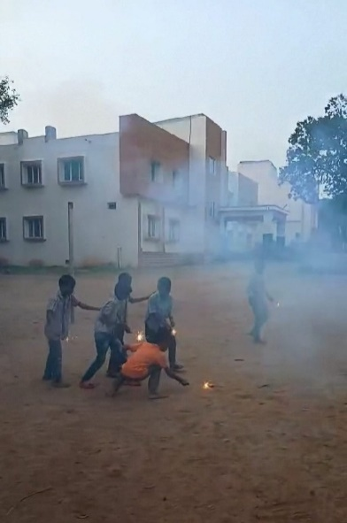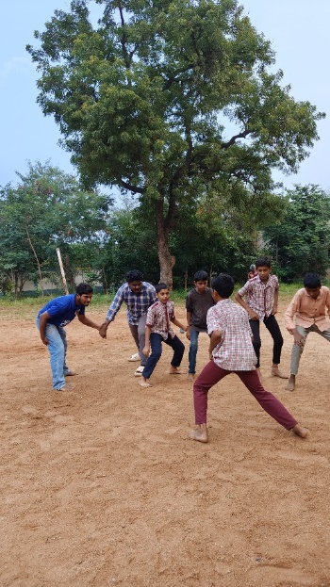

Review:The children felt happy about the celebration them and interaction of the volunteers marked a sense of connection.

- National Ayurveda Day
Purpose:To spread the importance of Ayurveda.
Report: The NSS unit celebrated Ayurveda Day with a series of online events that highlighted the importance of traditional medicine. The day began with an online poster-making competition, where participants showcased their creativity and knowledge of Ayurveda through visually appealing posters.
The event also featured engaging online jam sessions, where participants spoke about the importance of Ayurveda in our lives
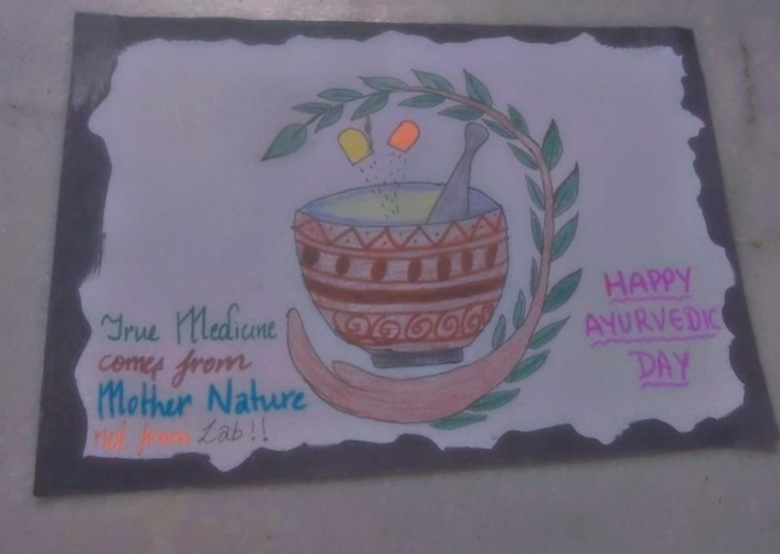
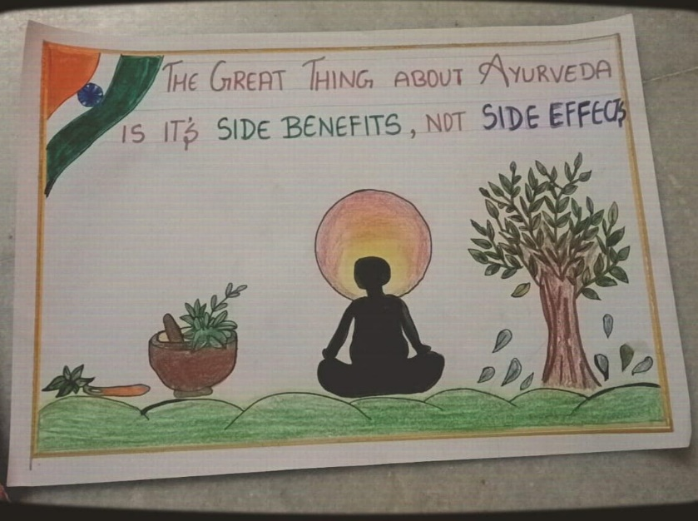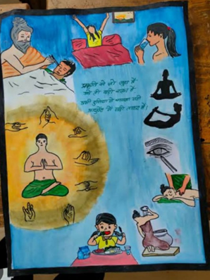
Review: Theimportance and usefulness of Ayurveda was known to the NSS volunteers.

- World Human Rights Day
Purpose:To spread the importance of the Human Rights to all the citizens.
Report: The NSS unit of Loyola Academy commemorated World Human Rights Day with a series of events aimed at raising awareness about human rights and promoting respect for individual dignity. The Afternoon began with a vibrant rally, where students marched through the campus chanting slogans emphasizing the importance of human rights. The NSS volunteers also organized a creative chart-making activity, where they designed eye-catching charts highlighting different human rights principles.
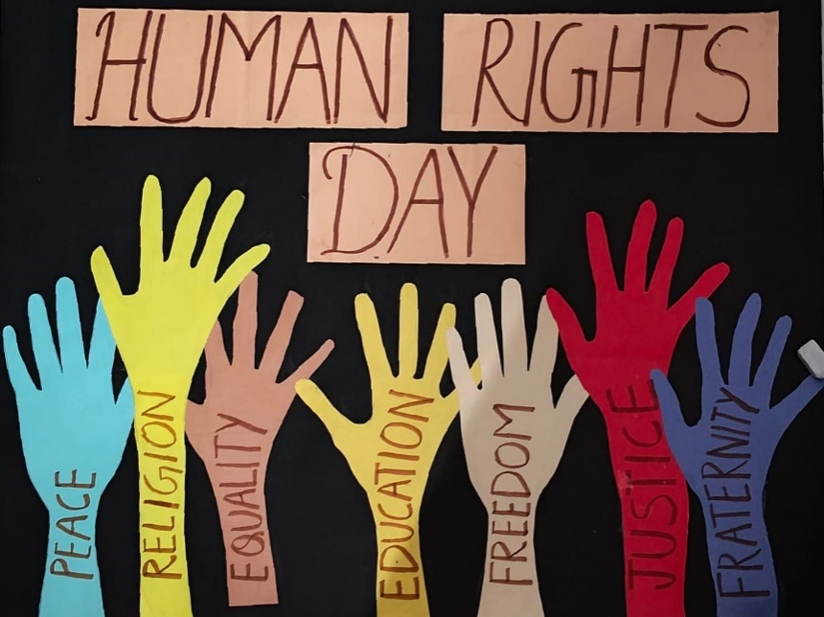
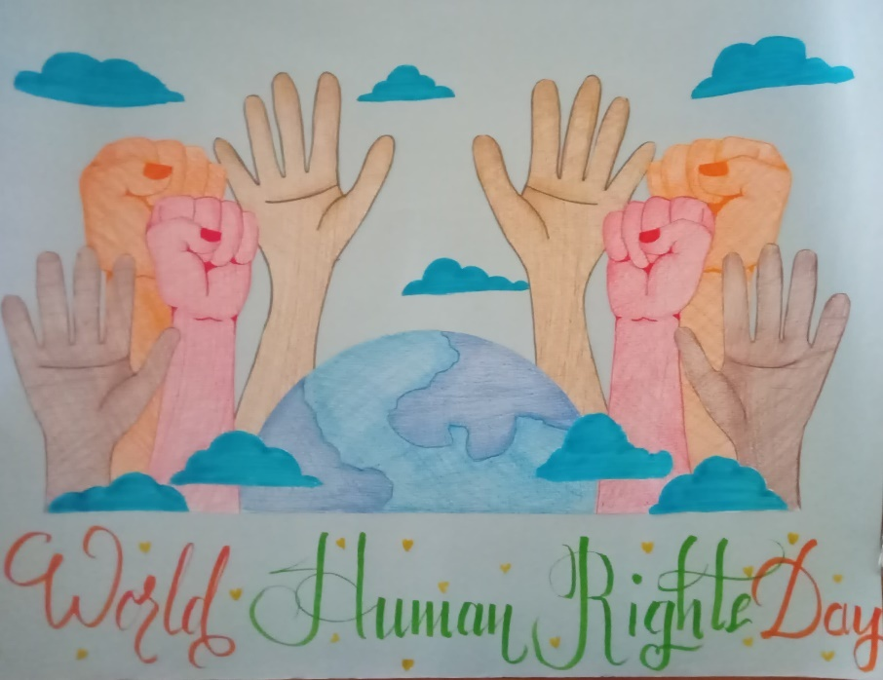

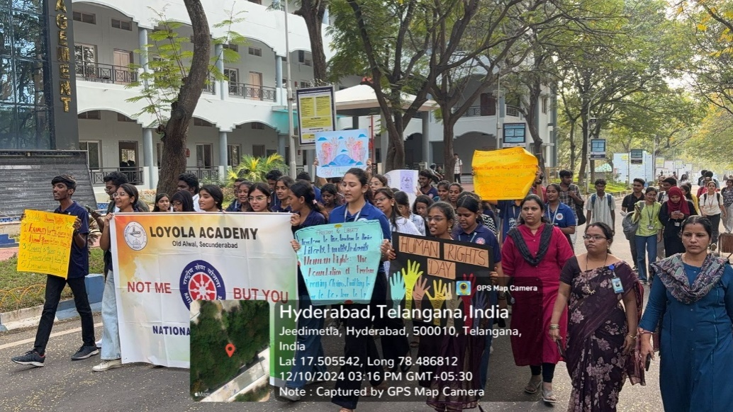
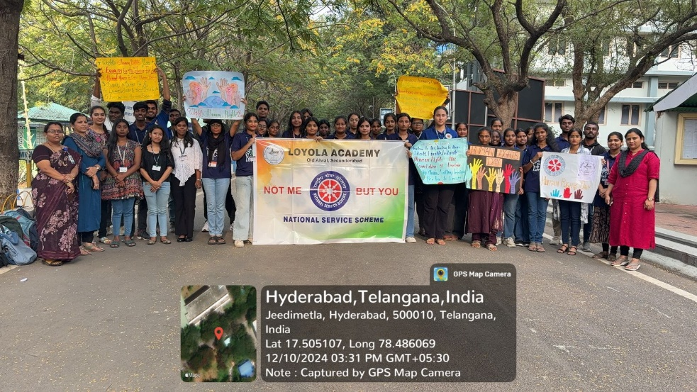
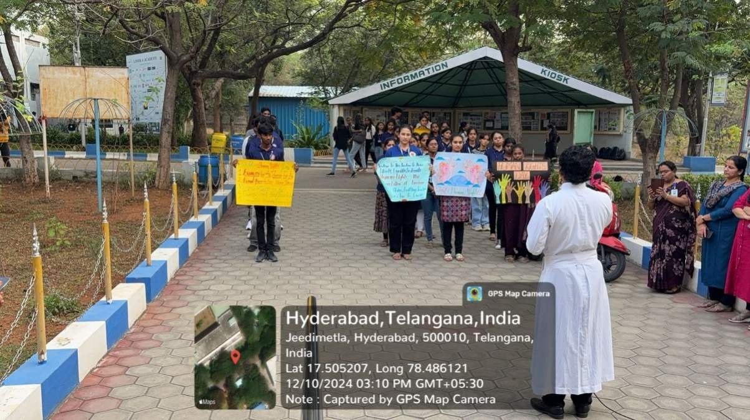
Review:Various rights and their importance were known to the students and staff.

- Season of Sharing
Purpose:To spread the Christmas Eve feels among the girls of the orphanage.
Report: The NSS Unit of Loyola Academy organized a Christmas visit to Trailblazers Jasmine Girls Home, an orphanage located in the heart of the city. The volunteers collected donations from college staff and students through a series of heartwarming action songs and prayer songs, emphasizing the spirit of giving and sharing during the festive season. The collected donations were used to purchase gifts and groceries, which the NSS volunteers lovingly presented to the orphan girls, bringing smiles and joy to their faces. The celebration culminated in a heartwarming cake-cutting ceremony and a heartfelt prayer, creating a memorable Christmas experience for the children at Trailblazers Jasmine Girls Home. The NSS Unit's initiative showcased the true spirit of Christmas, spreading love, kindness, and hope to those in need.
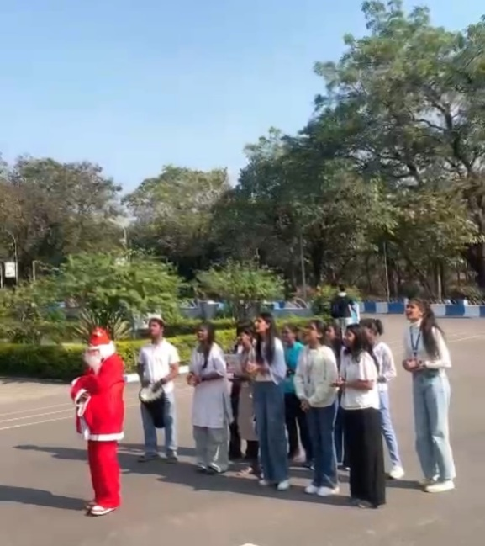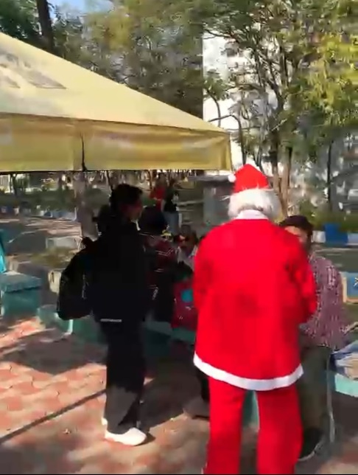
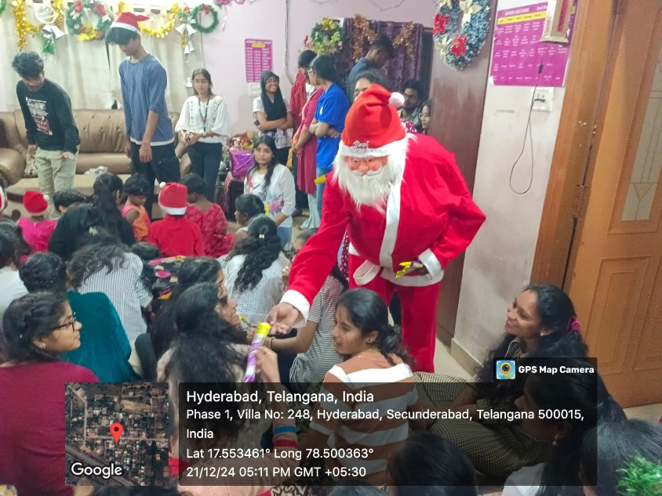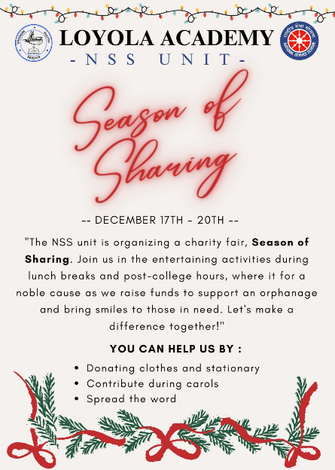
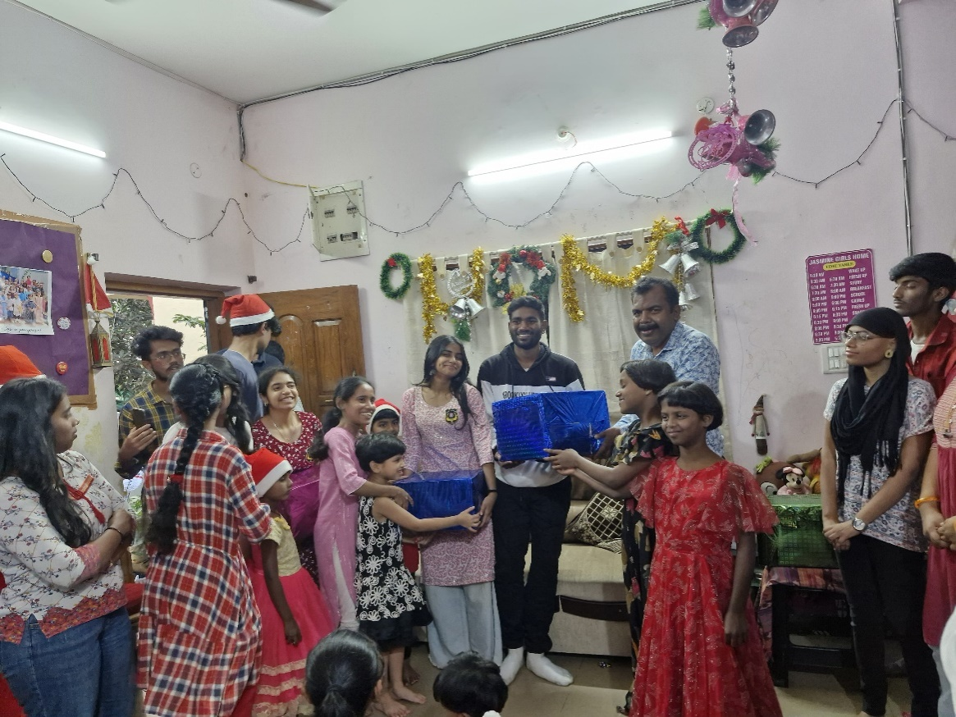
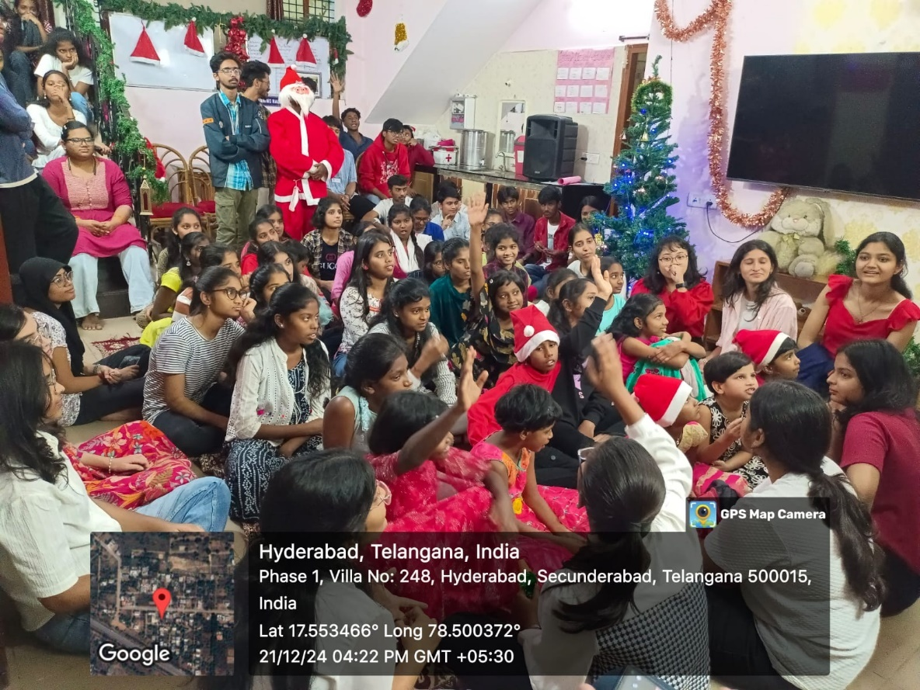
Review: Engaging activities and gifts were given to the girls and the joyfulness of the Christmas was seen promptly.

- National Youth Day
Purpose:To encourage and empower youth towards success.
Report:The NSS Unit of Loyola Academy organized a series of events to commemorate National Youth Day, focusing on empowering and inspiring young minds. The day kicked off with an informative session by Mrs. Larissa Sequeria on the importance of youth empowerment and the various opportunities available to young individuals. This was followed by a lively debate on contemporary youth topics, encouraging students to express their views and engage in critical thinking. The NSS volunteers also conducted awareness campaigns on the significance of National Youth Day, promoting the spirit of youth leadership and social responsibility.

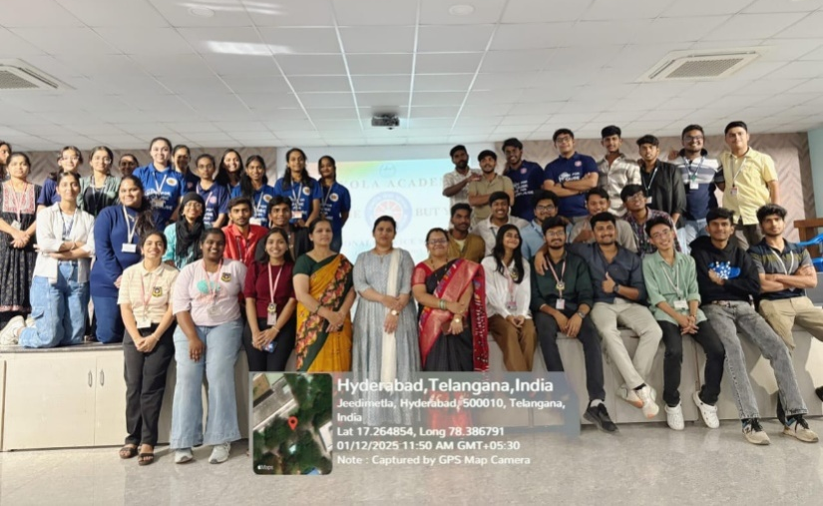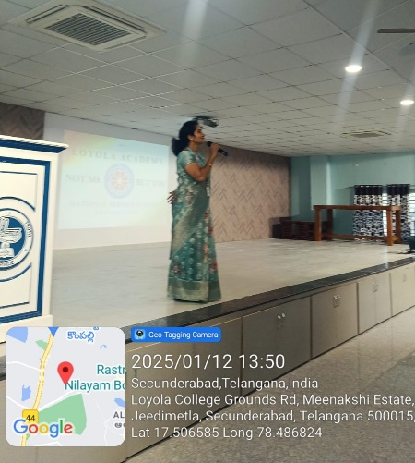

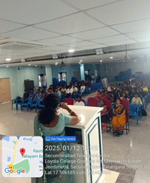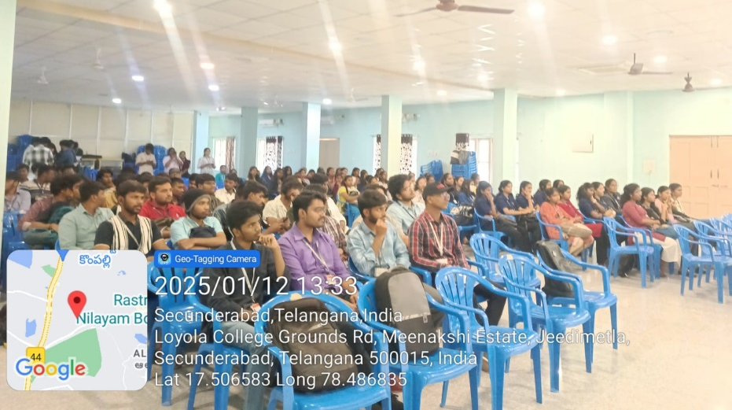
Review:NSS volunteers were empowered and motivated to work hard towards their set goals in future.

- Udyan Utsav
Purpose:To know the importance of the gardening and farming.
Report: A group of NSS volunteers from Loyola Academy recently had the opportunity to explore the Udyan Utsav at Rashtrapati Bhavan. This annual event, showcasing the lush gardens and vibrant floral displays, offered the volunteers a chance to immerse themselves in nature’s beauty while learning about the rich history of the gardens. The volunteers participated in various engaging activities and events, gaining firsthand experience of the cultural significance of this prestigious occasion. They also enjoyed interacting with experts who explained the horticultural practices that go into maintaining the gardens.
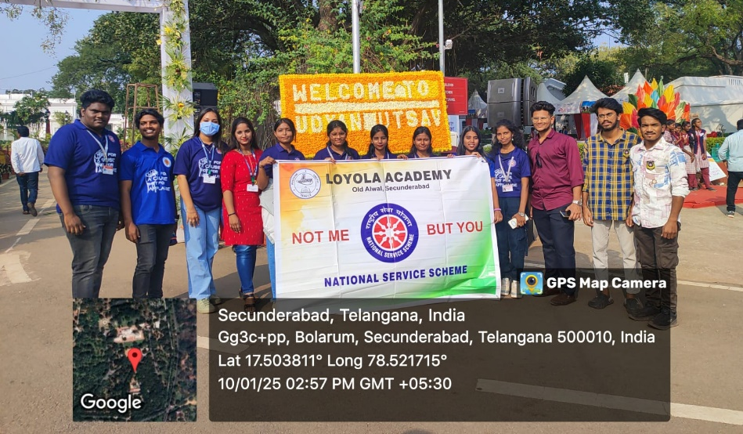
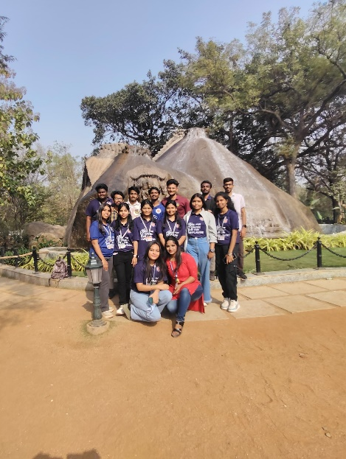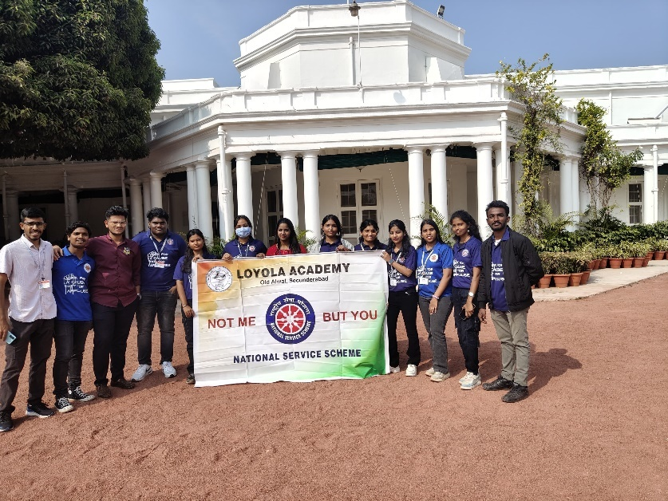
Review: Types of gardening and farming techniques were informed to the volunteers.

- National Voter’s Day
Purpose: To promote the value of a vote to the citizens.
Report:The NSS Unit of Loyola Academy organized a series of events to commemorate National Voters Day, emphasizing the importance of responsible and informed voting. The Afternoon began with a vibrant rally, where students marched through the campus chanting slogans promoting voter awareness and participation. The rally was followed by informative sessions on the electoral process and the significance of exercising one's right to vote. The NSS volunteers also organized a creative poster-making competition, where students designed attractive posters highlighting the importance of voting.
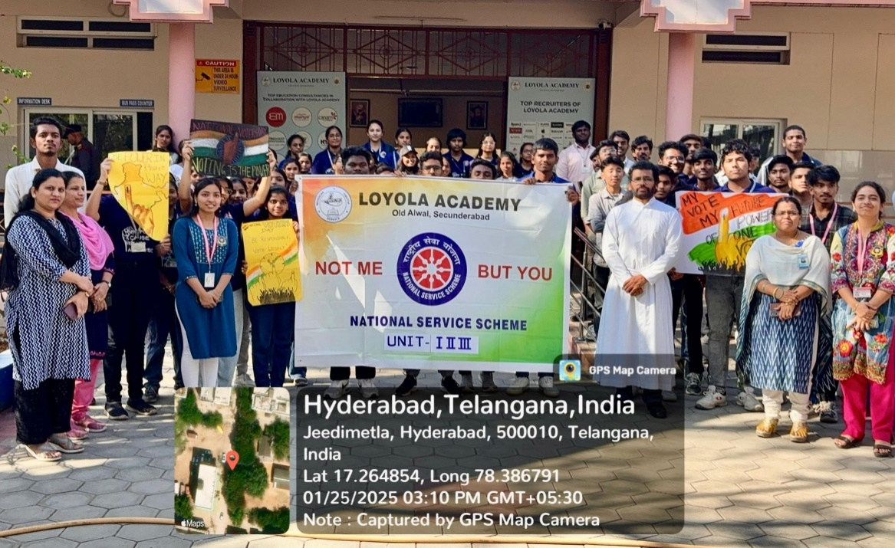
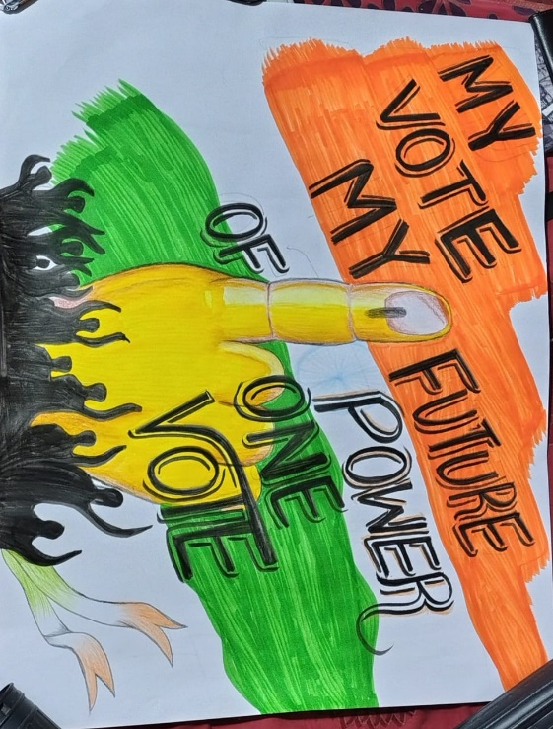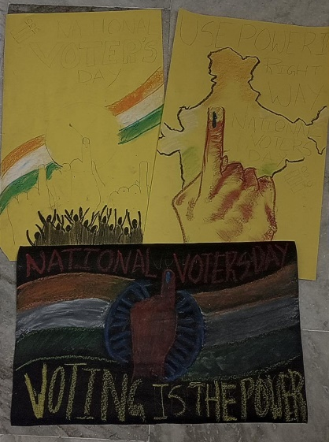
Review:Importance of voting rights and power of voting were known.

18. Republic Day Celebrations
Purpose:To promote a sense of unity in diversity.
Report: The NSS Unit, NCC and Student Council of Loyola Academy organized a grand celebration to commemorate Republic Day. The event commenced with a flag hoisting ceremony, followed by a series of cultural events that showcased the rich diversity and unity of India. The highlight of the celebration was a captivating drama performed by the NSS volunteers, depicting the essence of unity in diversity. The drama beautifully portrayed the harmonious coexistence of various cultures, religions, and languages, leaving a lasting impression on the audience. The Republic Day celebration at Loyola Academy was a resounding success, fostering a sense of national pride and unity among the students.
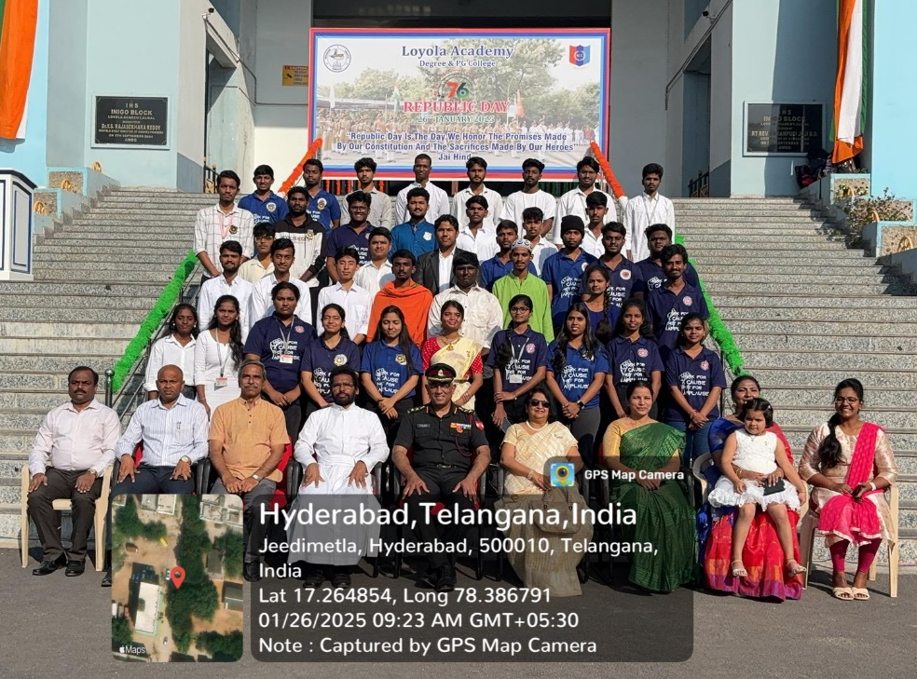
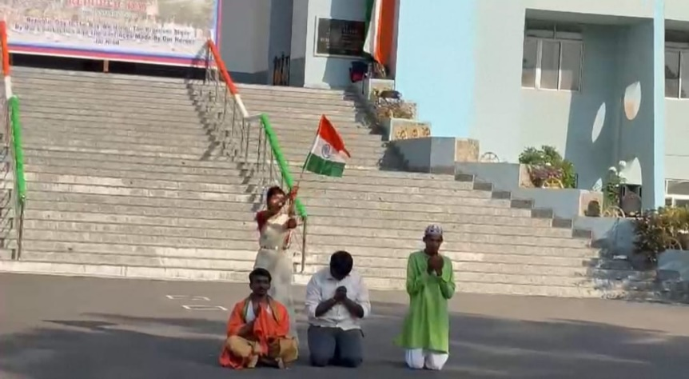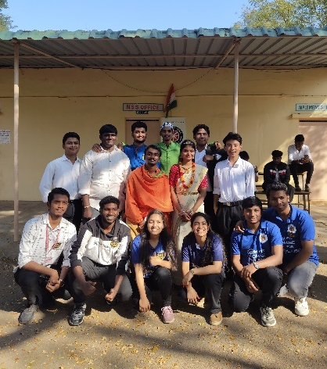
Review:The drama performance by the volunteers captivated the sense of unity in diversity to the audience.
- Blood Donation and Dental Camp
Purpose:To promote the sense of donating blood and regular dental checkups.
Report:The NSS Unit of Loyola Academy, in collaboration with Rudhira Voluntary Blood Centre and Elite Dental Care, organized a blood donation and dental camp for both staff and students. The blood donation drive aimed to encourage students and faculty to contribute to saving lives through this noble act. Simultaneously, the dental camp provided essential dental checkups and consultations to promote oral health awareness. The event was well-received, with many volunteers participating in the blood donation drive and taking advantage of the dental services.
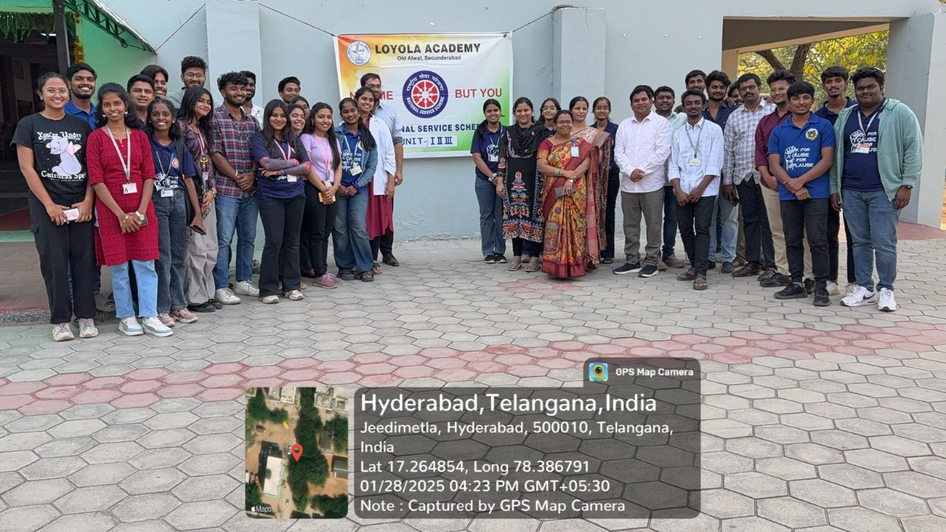
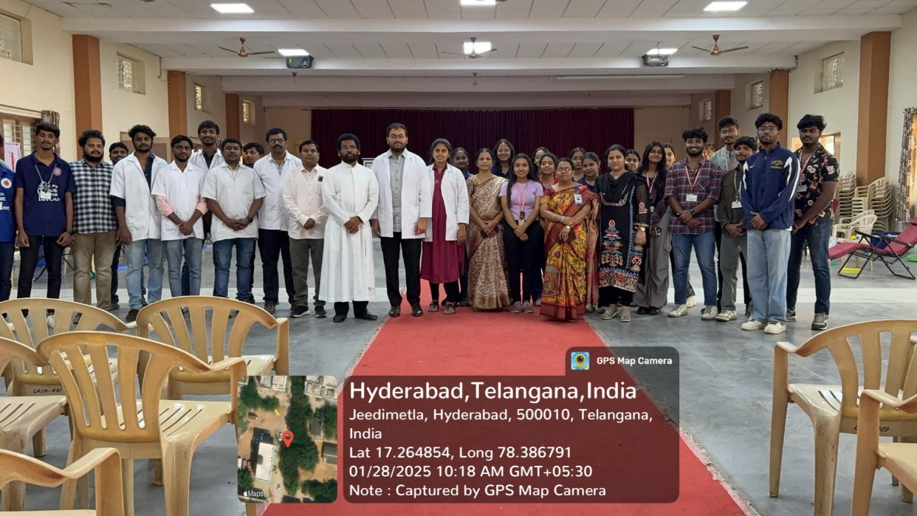

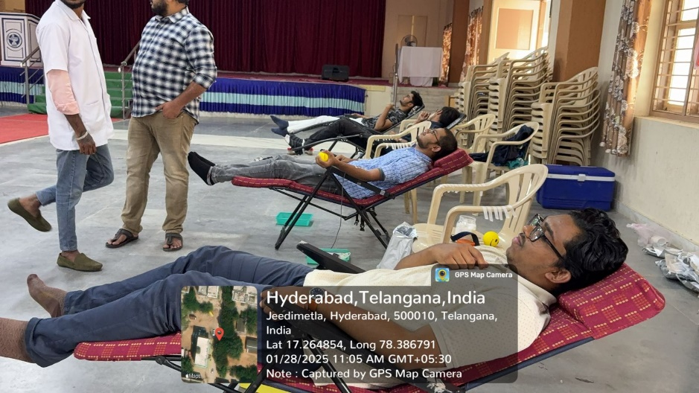
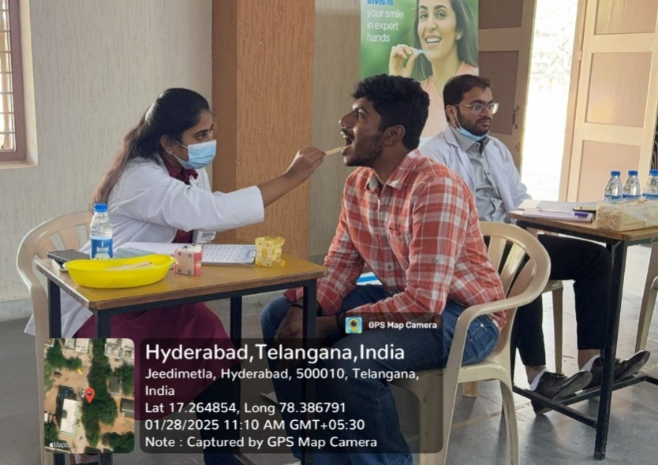
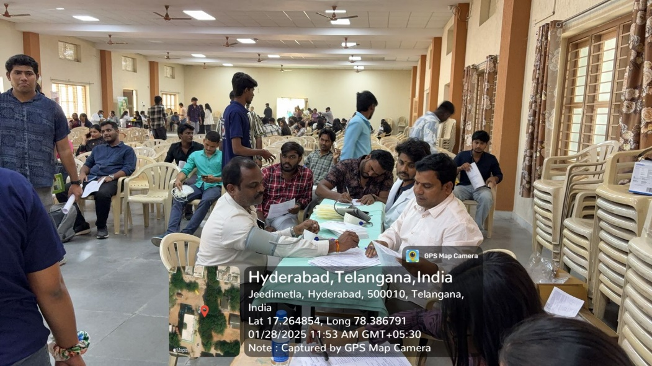
Review:Students enthusiastically donated blood and got their oral checkups done in the camp.

- Cleanliness Drive
Purpose:To create awareness about having a clean surrounding.
Report:The NSS Unit of Loyola Academy organized a cleanliness drive in the areas of RK Puram and Alwal Lake to promote environmental awareness and community responsibility. Volunteers actively participated in cleaning the surroundings, picking up litter, and clearing debris, ensuring a cleaner and greener environment. The initiative aimed to install a sense of environmental stewardship among the local community and students. By focusing on these key areas, the drive also highlighted the importance of preserving natural resources and maintaining public spaces. The event received enthusiastic support from both students and residents. It was a successful effort to foster cleanliness and environmental consciousness in the community.

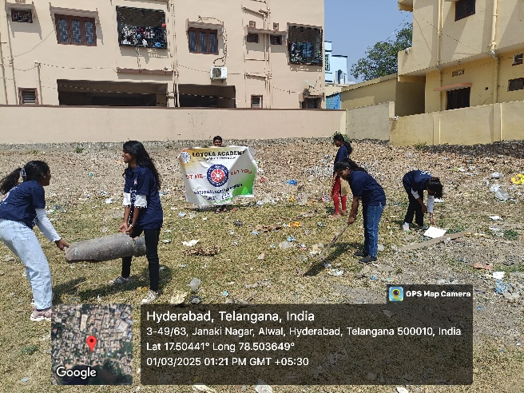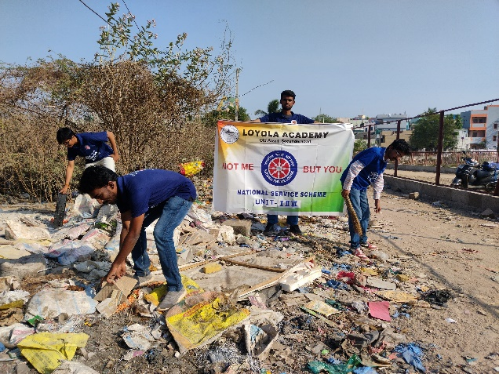
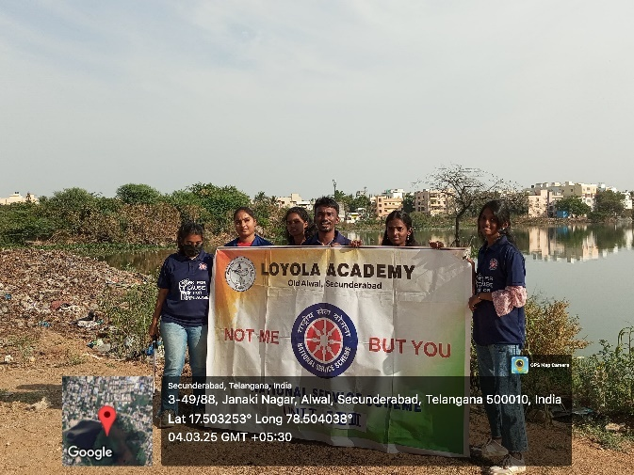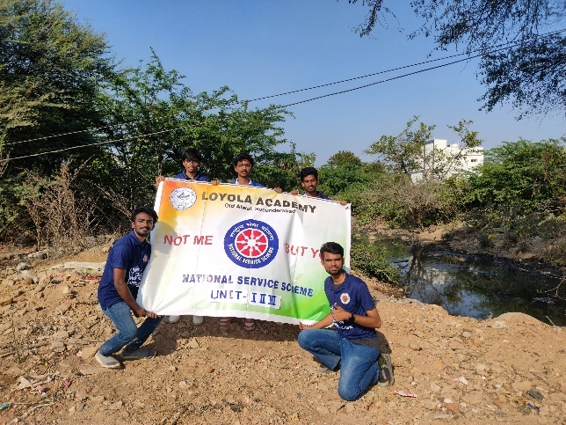

Review:Volunteers cheered the residents to have clean surroundings by sorting out the waste in that area.

- Women’s Day Celebrations
Purpose:To encourage women to give their best in everything they do.
Report:On International Women’s Day, the NSS Volunteers and NCC Cadets of Loyola Academy organized an empowering event in the adopted villages, focusing on women's empowerment and community well-being. They promoted the use of plastic-free cookware, encouraging sustainable living practices among the villagers. The volunteers also distributed sanitary pads to women, aiming to raise awareness about menstrual hygiene and health. To add joy to the occasion, games were conducted for women and children, fostering a sense of community spirit and fun. Additionally, thoughtful gifts were distributed to all the women, making them feel appreciated and valued. The event was a successful blend of advocacy, celebration, and community engagement, highlighting the importance of women’s health, empowerment, and environmental consciousness.
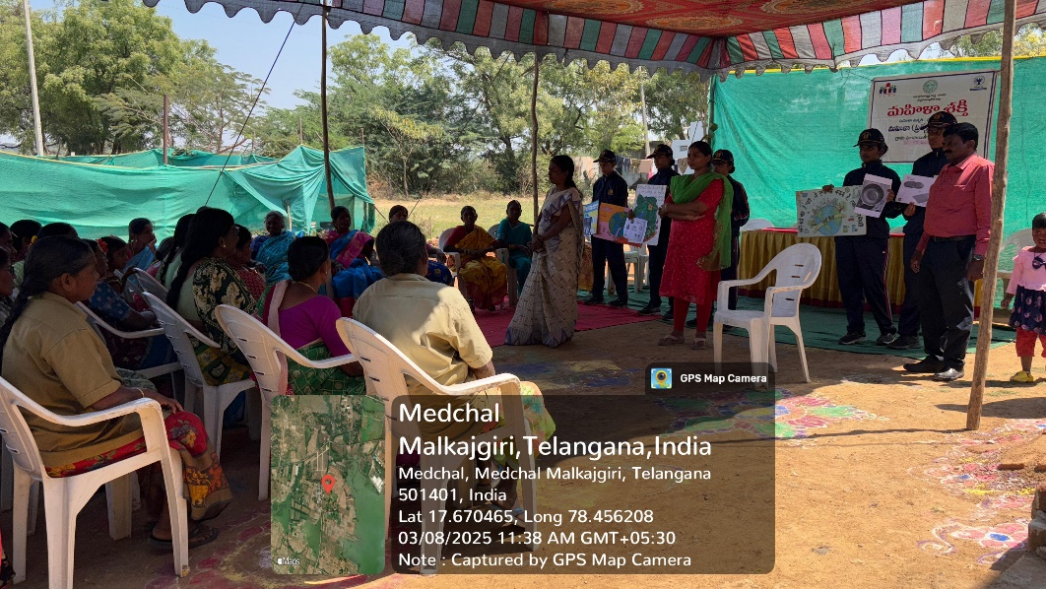
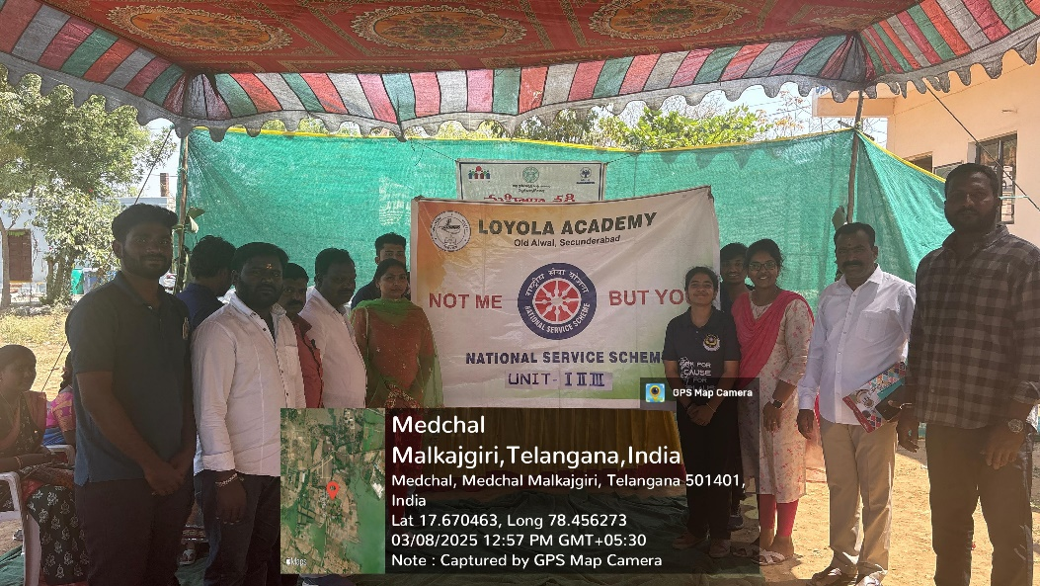

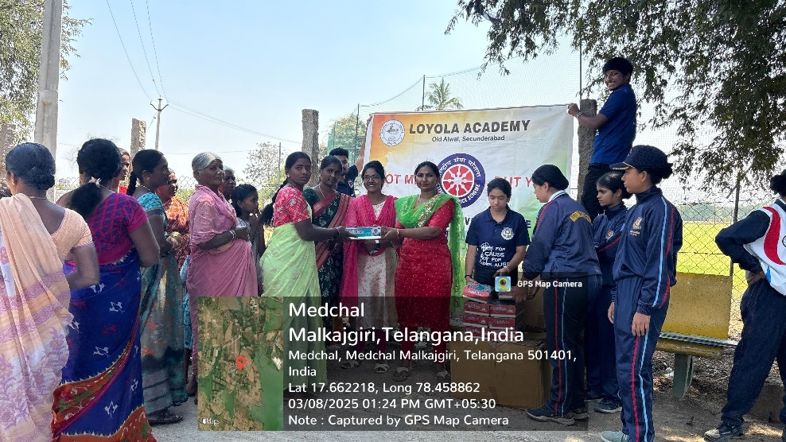
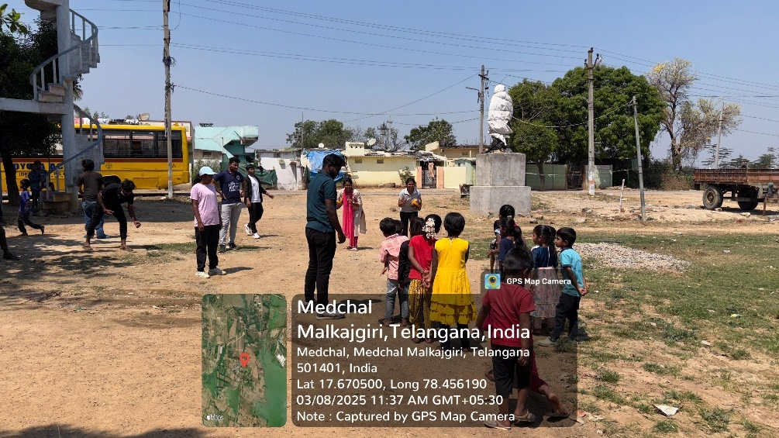
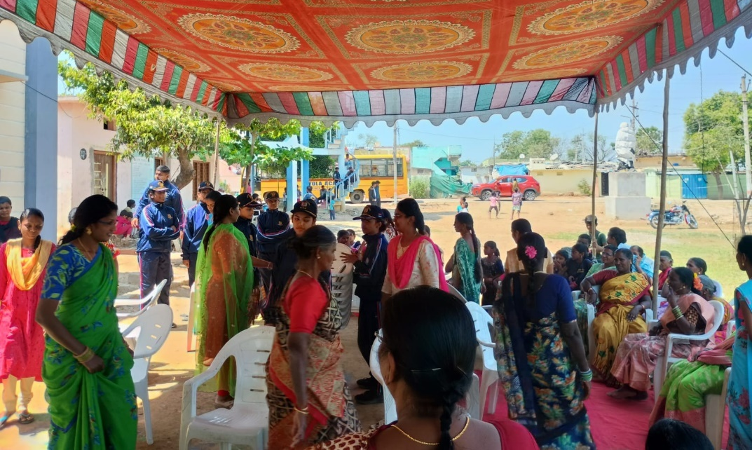
Review:Women were empowered to become more effective and efficient with their daily works.

