PLANET Report
Academic Year 2025-26

Event details:
- Date: March 10th, 2026
- Venue: Second Chance Foundation Old Age Home
- Organizer: B.Sc. Computer Science and Cybersecurity department, Loyola Academy Degree and PG College
- Resource person: Ms. Blessy
- Target audience: Old Age Home Residents, Volunteers and Students
Objectives of the event:
- To spend quality time with Old Age Home Residents and bring joy to their lives.
- To create awareness about social responsibility among students and volunteers.
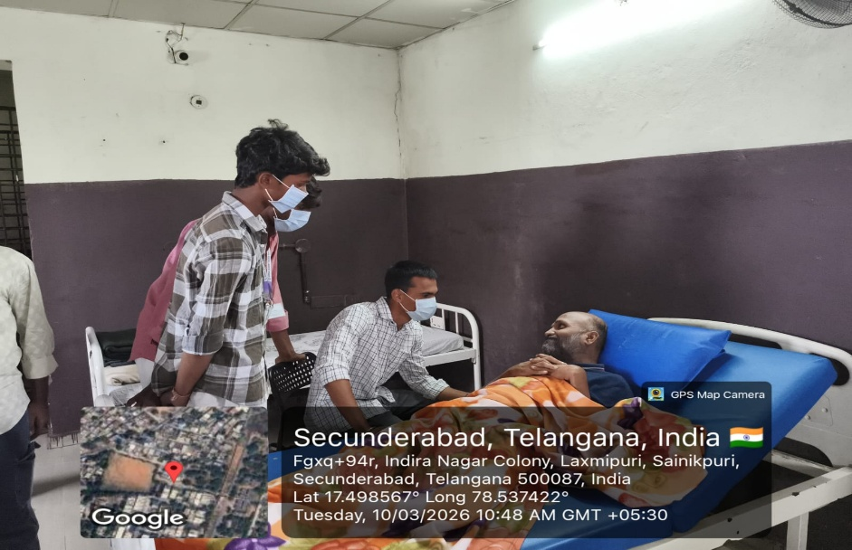
Participant details:
- Total participants: 50
- Demographics: Students, Volunteers, and Old age home residents
- Attendance percentage:100
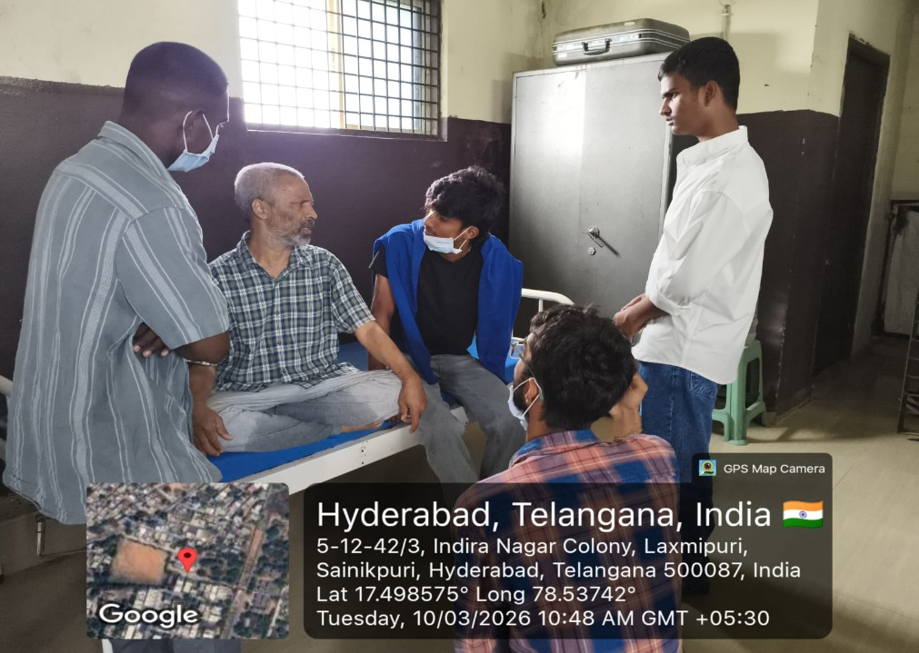
Content evaluation:
- Relevance of the Topic: Highly Relevant (addressing social responsibility and Empathy)

- Engagement of Participants: Highly Engaged (residents were thrilled with the interactions)
LEARNING OUTCOMES:
- Were the Learning Outcomes Met? Yes
- Key Takeaways for Participants:
- Understanding the needs and challenges of old age home residents.
- Value of social responsibility and community service.
- Importance of empathy and compassion towards elderly.
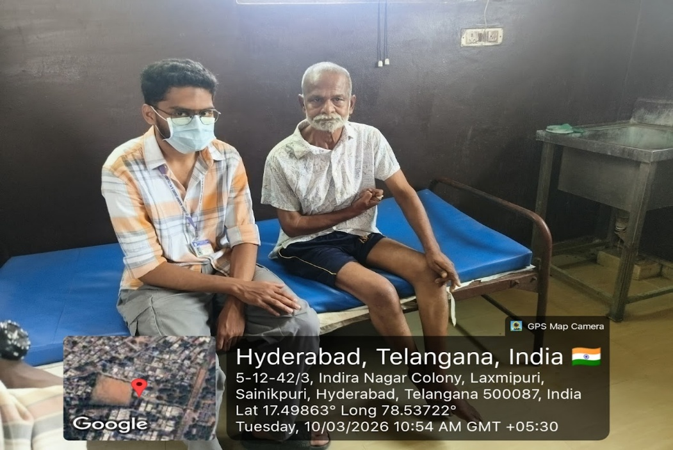
Feedback analysis:
- Method of Feedback Collection: Verbal feedback from residents and volunteers.
- Key Feedback from participants:
- Positives: Residents felt happy and cared for; volunteers felt fulfilled.
- Areas of Improvement: More frequent visits and activities suggested.
- Rating on a scale of 1-5: 4.8/5
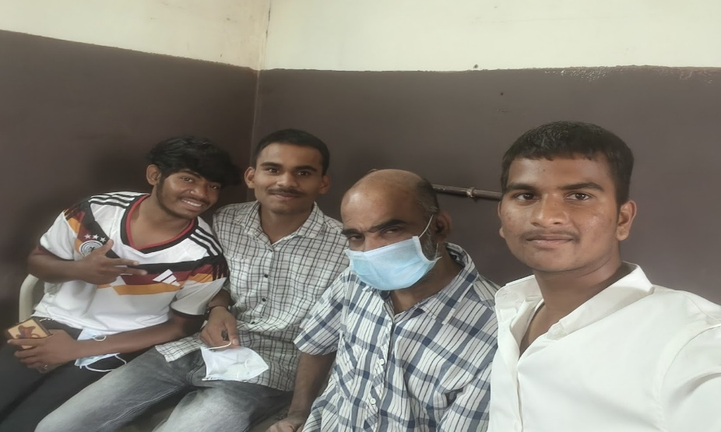
Impact on PARTICIPANTS:
- Impact on student learning: Increased empathy and sense of social responsibility.
- Impact on Residents: Residents felt valued and connected.
- Suggestions for future events: More visits, games, and cultural activities.

- Quantitative analysis:
- Performance Improvement: 95% of residents appreciated the visit and interactions.
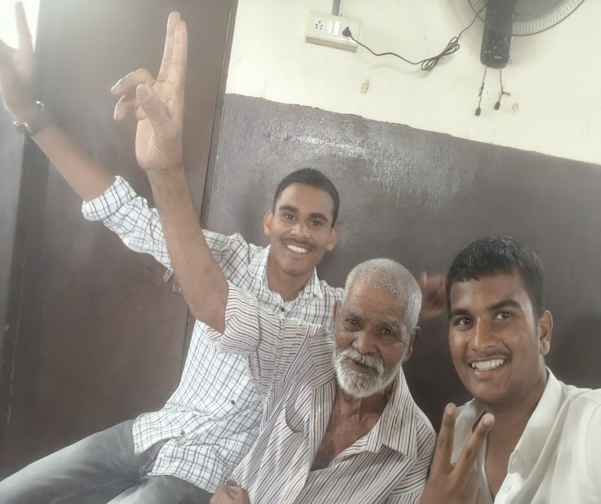
Recommendations:
- Future Improvements: More frequent visits and activities
- Recommended Topics for Future: Health talks, cultural events, and skill-sharing sessions
- Potential for Recurrence of the event: Health talks, cultural events, and skill-sharing sessions.
Conclusion:
The PLANET Program was a heartwarming success, spreading joy to old age home residents.
