LOYOLA ACADEMY
Old Alwal, Secunderabad – 500010, Telangana, India
(Autonomous and affiliated to Osmania University)
B.Sc. Computer Science & Artificial Intelligence
Academic Year: 2025–2026
WORKSHOP REPORT
On
Front End Development using HTML5 & CSS3
Date: 2nd February 2026 – 4th February 2026
Venue: Xavier Hall, Loyola Academy
Organized by:
School of Informatics, Department of B.Sc. Computer Science & Artificial Intelligence
In Collaboration with TASK (Telangana Academy for Skill and Knowledge) and IQAC

Objective
The objective of the three-day workshop was to introduce second-year B.Sc. Computer Science & Artificial Intelligence students to the fundamentals of Frontend Development using HTML5 and CSS3. The workshop aimed to provide hands-on training to help students build structured and styled web pages and enhance their practical web development skills.

Introduction
A three-day hands-on workshop on Front End Development using HTML5 & CSS3 was conducted from 2nd February to 4th February 2026 at Xavier Hall, Loyola Academy, for II-year B.Sc. Computer Science & Artificial Intelligence students.
The resource person for the workshop was Mrs. Rasgnya Under from TASK (Telangana Academy for Skill and Knowledge). She is an experienced technical trainer specializing in web technologies and skill development programs. With her strong expertise in frontend technologies, she guided students through practical web development concepts and real-time implementation.
During the inaugural session, the FR. DR.A.FRANCIS XAVIER SJ Correspondent addressed the students and highlighted the importance of skill-based education and industry-oriented training. He emphasized the role of TASK in bridging the gap between academia and industry by equipping students with practical and employable skills.
REV.FR.DR.N.B.BABU SJ Principal of Loyola Academy introduced TASK and explained its mission of empowering students with industry-relevant technical competencies. He encouraged students to actively participate and make the best use of such collaborative initiatives to improve their career readiness.

Day-wise Report
Day 1: Introduction to Frontend Development – HTML5 Basics
The first day focused on the fundamentals of HTML5.
Topics Covered:
- Introduction to Frontend Development
- Structure of an HTML document
- HTML Tags and Elements
- Headings and Paragraph tags
- Line break tag
- Adding images in HTML
- Image attributes
Students learned how to structure a basic web page using proper HTML syntax. The session was completely hands-on, allowing students to practice writing HTML code in real time.
Assignment:
Students were given an assignment to create a College Website using HTML. They were required to structure the webpage properly and include relevant content and images.
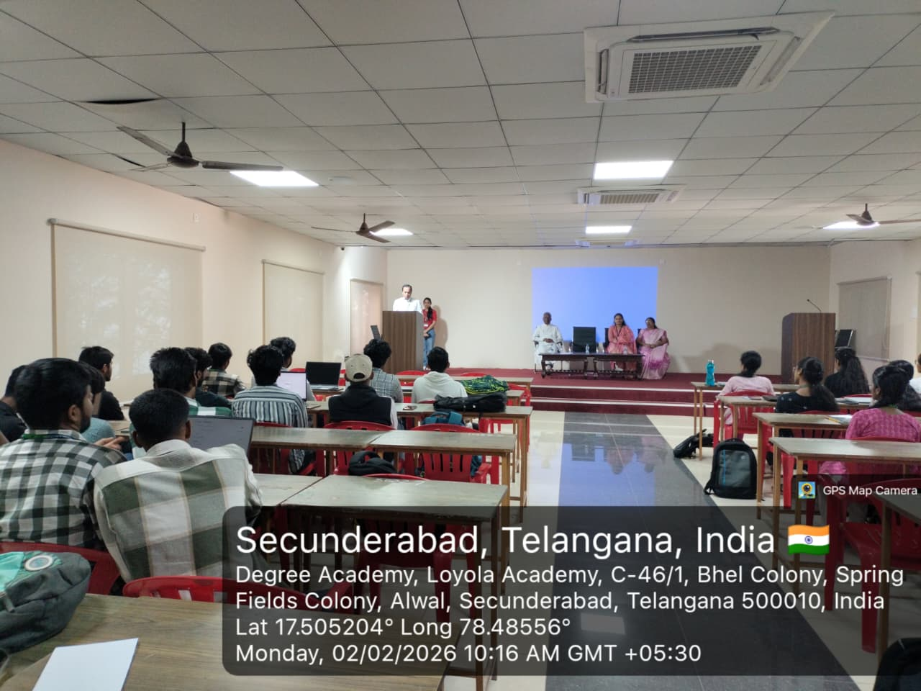

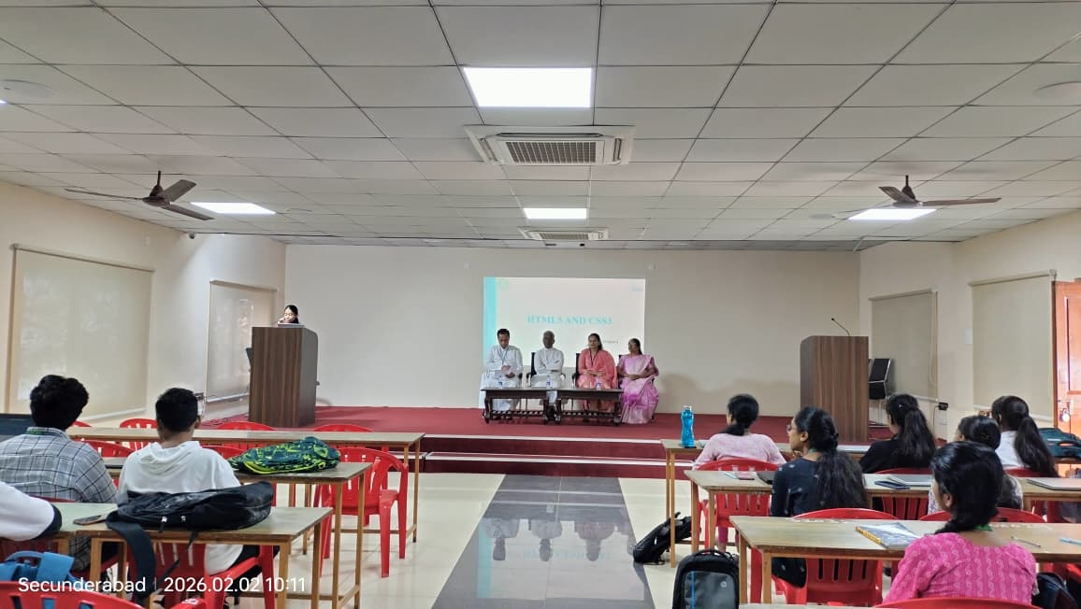
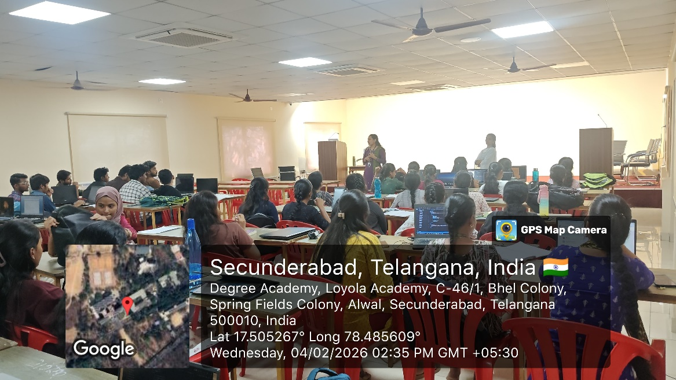

Day 2: Advanced HTML Elements
On the second day, students explored more advanced HTML concepts and webpage structuring elements.
Topics Covered:
- Audio and Video tags
- HTML Comments
- Different types of Lists (Ordered, Unordered, Description lists)
- Start attribute in lists
- HTML Tables and Table attributes
- Form tags
Students learned how to design structured web pages with multimedia content and user input forms.
Assignment:
Students were asked to create a TASK Website, which included:
- Information about the Founder of TASK
- Details about the IT Minister of Telangana
- General information about TASK initiatives
This activity enhanced their ability to structure informational websites effectively.

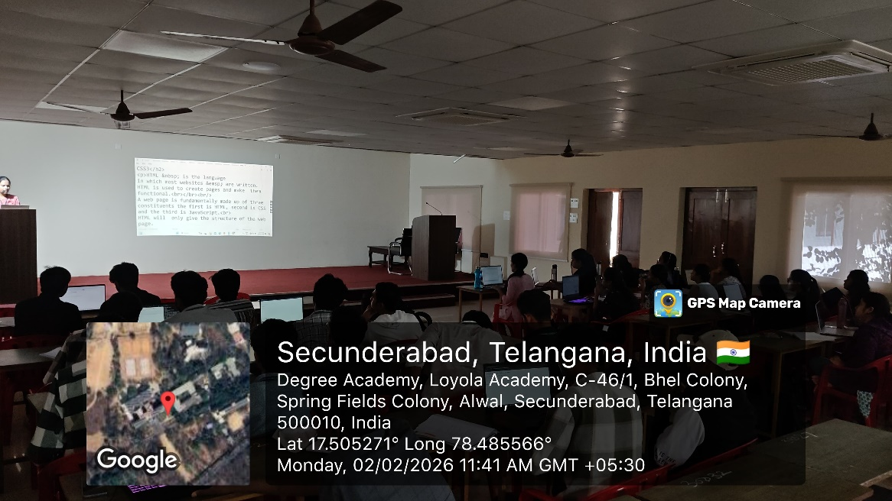
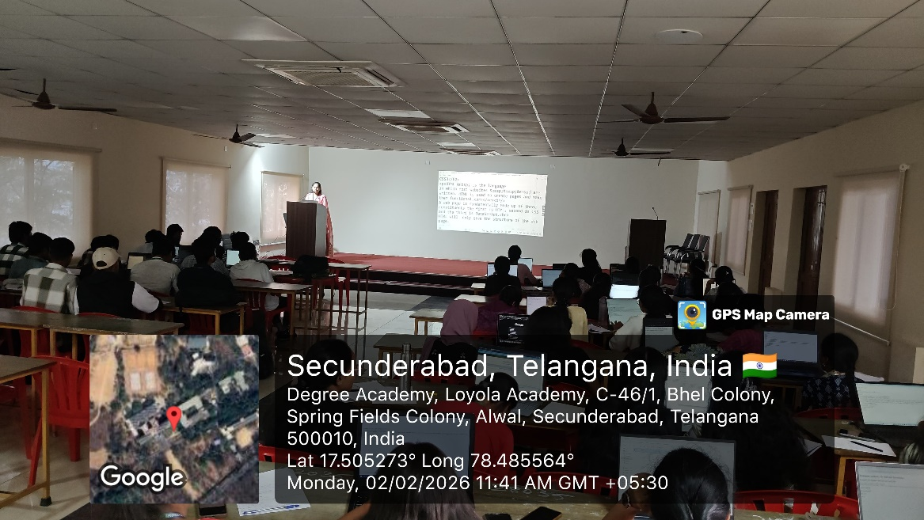

Day 3: Introduction to CSS3 and Website Styling
The third day focused on styling web pages using CSS3.
Topics Covered:
- Introduction to CSS
- Types of CSS (Inline, Internal, External)
- Priority of CSS
- CSS Selectors
- Padding and Content
- Shorthand text declaration properties
- Adding borders using CSS
- CSS Positions
- Usage of <span> and <div>
- Linking CSS to HTML
Students created a complete website and applied various CSS properties to enhance design and layout. They learned how to properly link CSS files and apply styling effectively.
The workshop was highly interactive and completely hands-on, giving students practical exposure to HTML5 and CSS3.

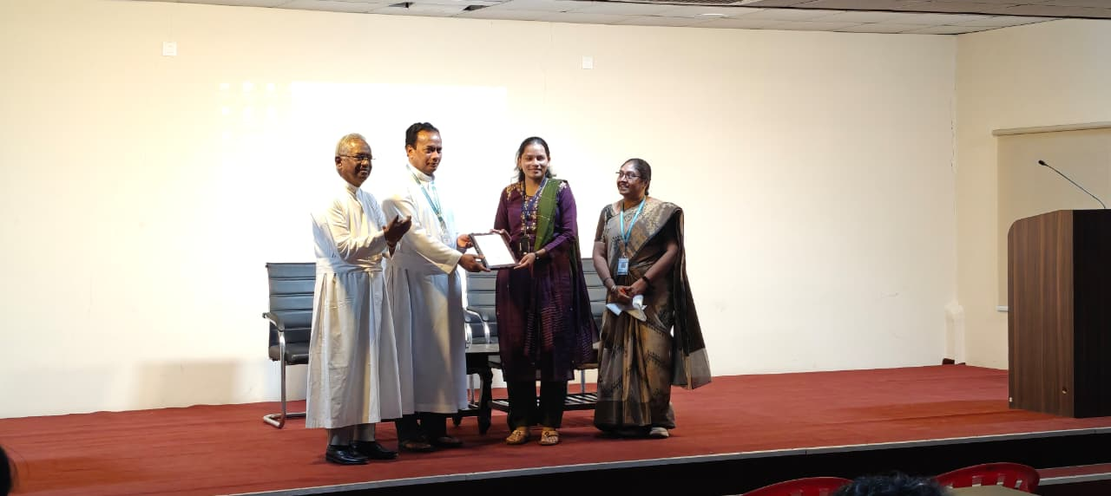
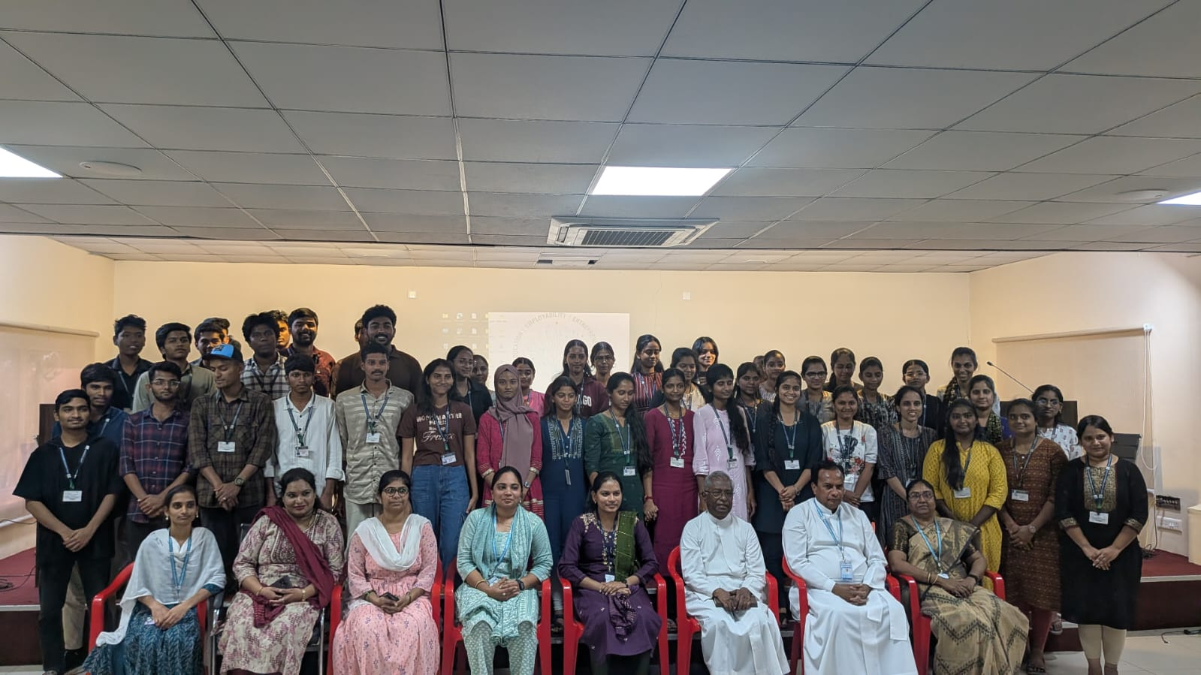
Outcomes of the Workshop
- Students gained a strong foundation in HTML5 and CSS3.
- They developed the ability to create structured and styled web pages independently.
- Students improved their practical coding skills through assignments and live practice.
- The workshop enhanced their understanding of frontend development concepts.
- Participants gained clarity on career opportunities in web development.
Feedback
The students actively participated throughout the three-day workshop. The sessions were interactive, engaging, and practice oriented. Students appreciated the clear explanations and hands-on approach of Mrs. Rasgnya Under.
Overall, the workshop successfully generated interest and curiosity among students toward web development technologies.
Conclusion
The three-day workshop on Front End Development using HTML5 & CSS3 successfully achieved its objectives. The collaboration between Loyola Academy and TASK provided students with valuable industry-relevant exposure. The hands-on training approach enabled students to confidently build and design web pages.
Such skill-based workshops play a significant role in preparing students for real-world technical challenges and enhancing their employability.

