DCSCS:
- Lakshmi Rajarani uid 111724039009, of class NCSCS begin awarded as the best outgoing CR for the Academic Year 2025-26.

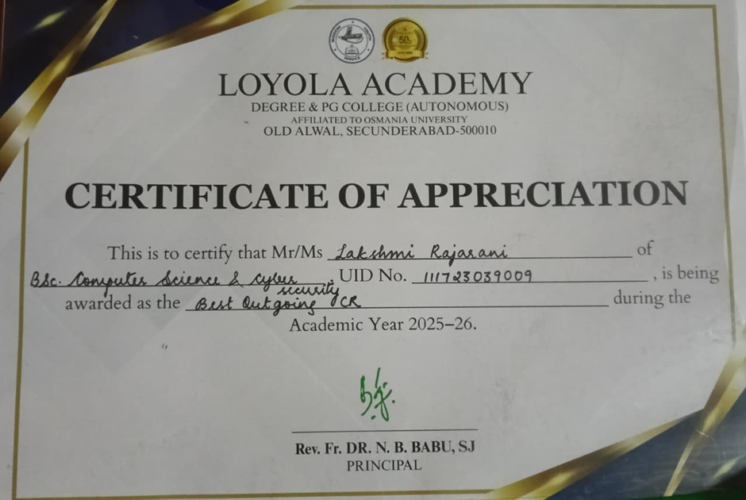

- J Sathish Uid 111723039028 of class NCSCS begin awarded as the best outgoing ACR for the Academic Year 2025-26.

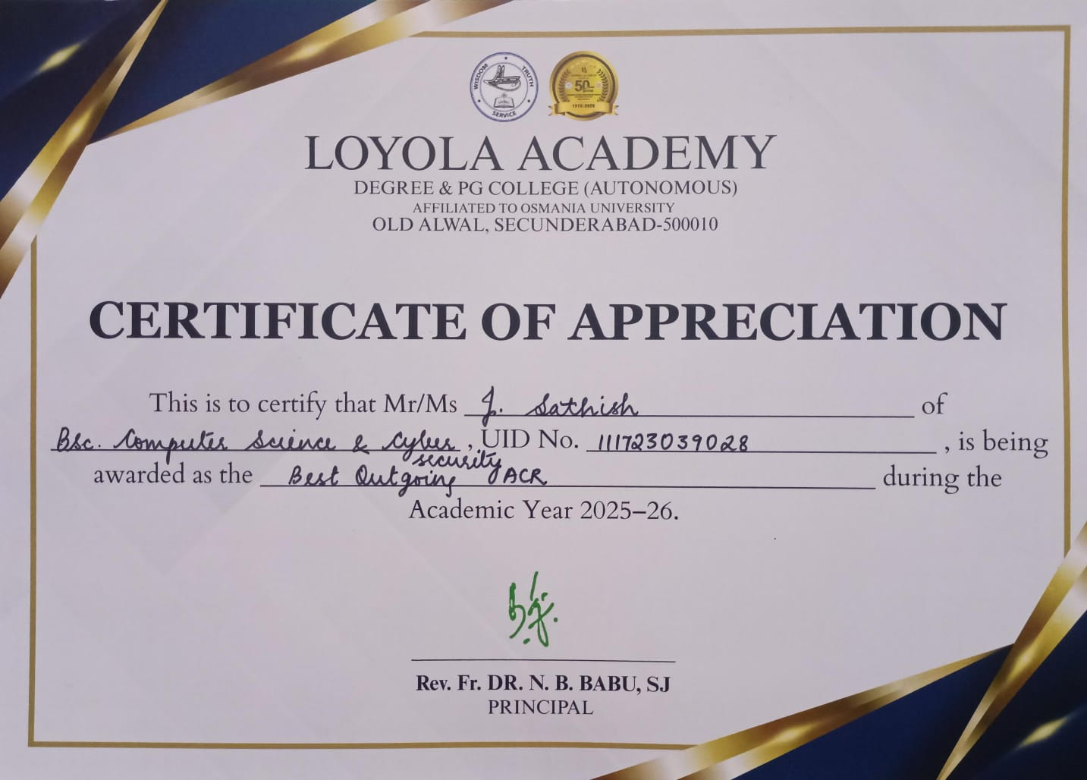

- BK Rishikesh Reddy uid 111723039021 of class DCSCS is being awarded as Website and Technical Head, the Student Council during the Academic Year 2025-26.
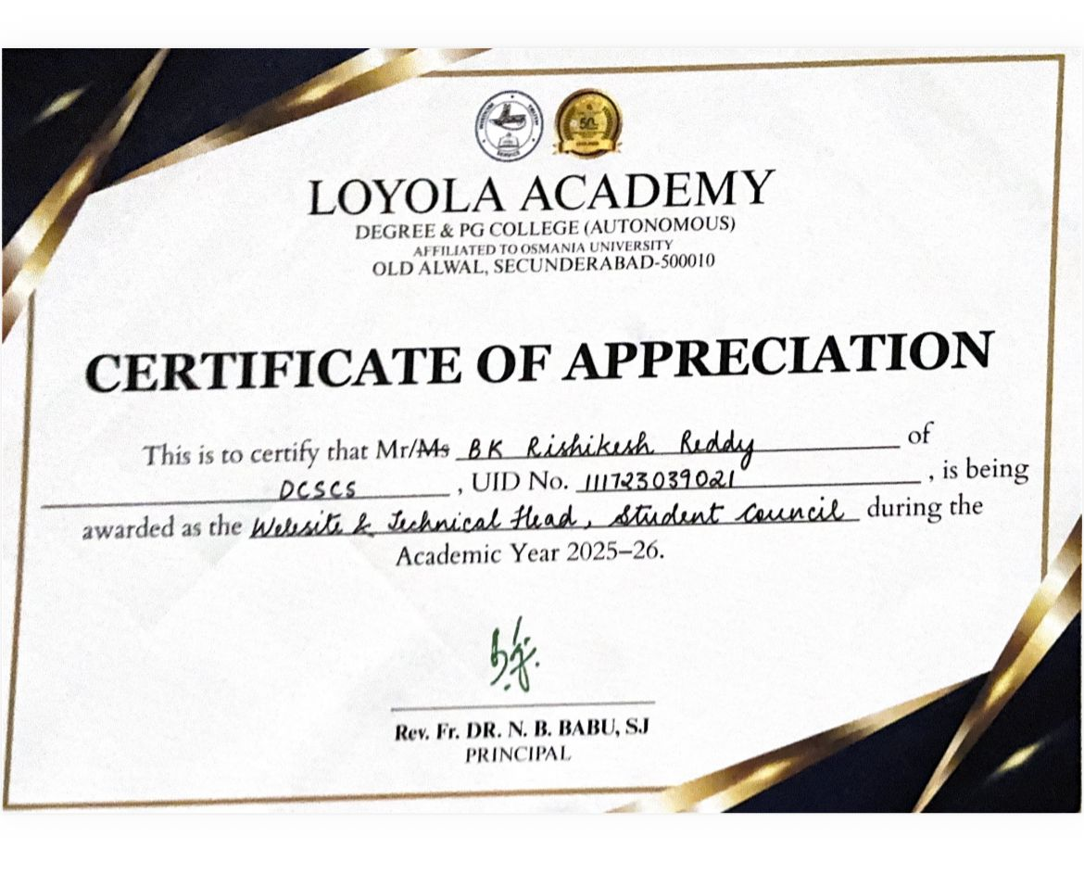

- Alice saloni uid 111723039005 of class DCSCS is being awarded as the Fine Arts Secretary student council during the academic year 2025-26.
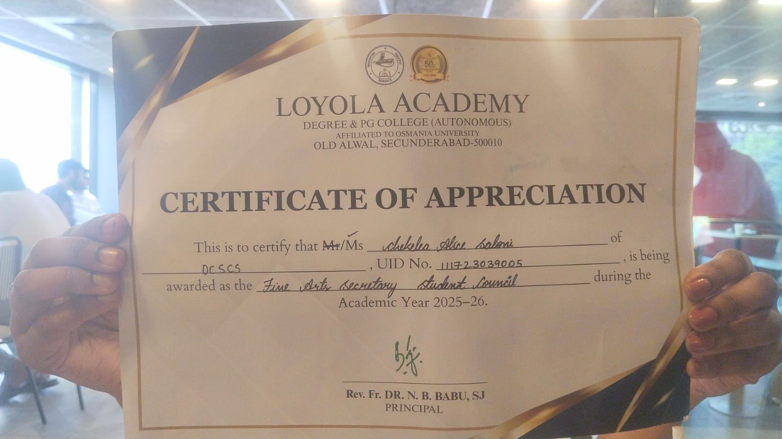

- Varshith Pasala uid 111723039040 of class DCSCS is being awarded as the Event Head, NSS during the Academic Year 2025-26.
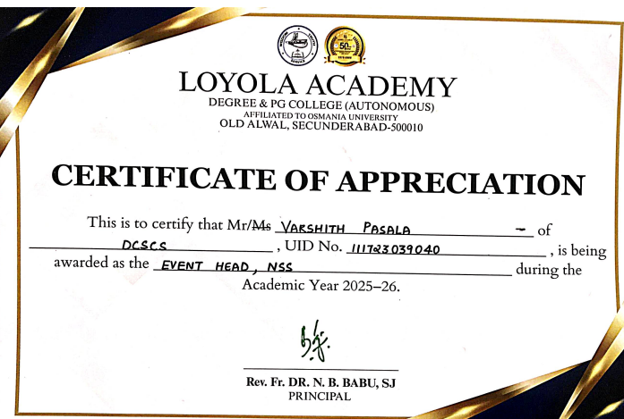

- S Lasya Reddy Uid 111723039014, class DCSCS is being awarded as the Regulation Head NSS, during the Academic Year 2025-26.

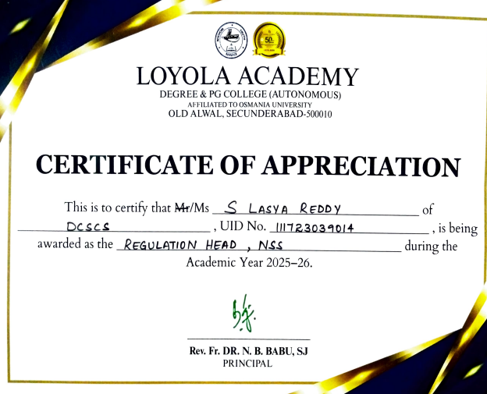

- K Varun Raju uid 111723039030, of class DCSCS is being awarded as the Extraordinary Student Achiever during the Academic year 2025-26.

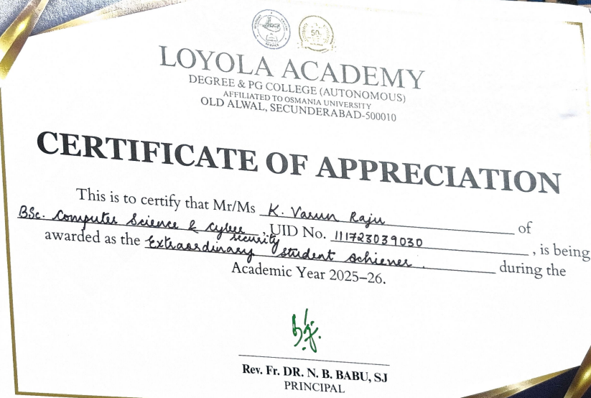

8. A Sowmya uid 111723039001 of class DCSCS is being awarded as the 1st Academic Topper for the Academic Year 25-26. 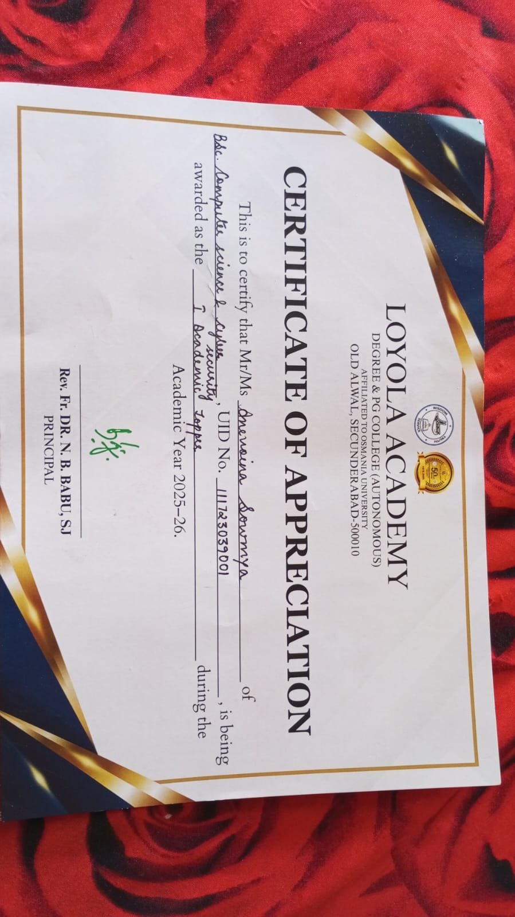

9. Alice Saloni Uid 111723039005 of class DCSCS is being awarded as the 3rd Academic Topper for the Academic Year 25-26.
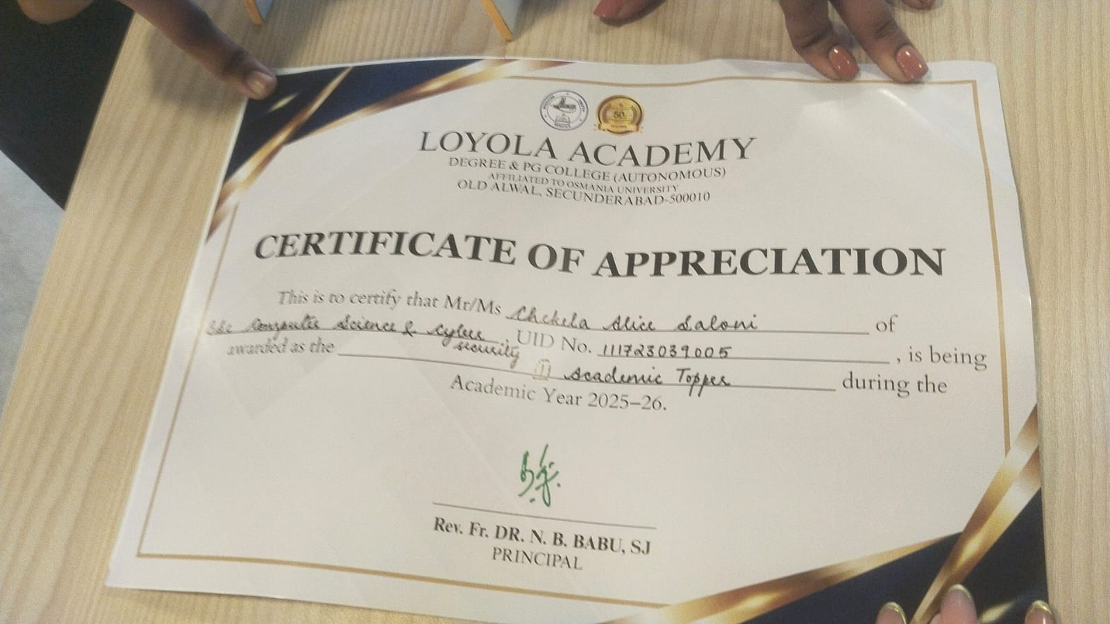

10. G Akshitha Uid 111723039007 of class DCSCS is being awarded as the 2nd Academic Topper for the Academic Year 25-26.
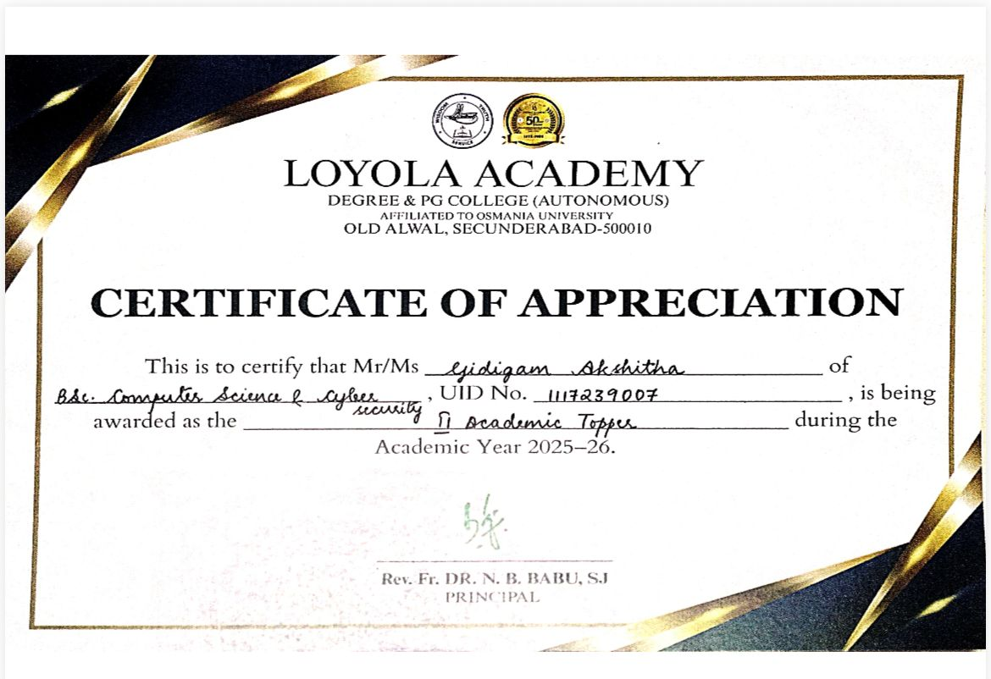

11. V Srujan Uid 111723039049 of Class DCSCS is awarded with continuous improvement in academics. 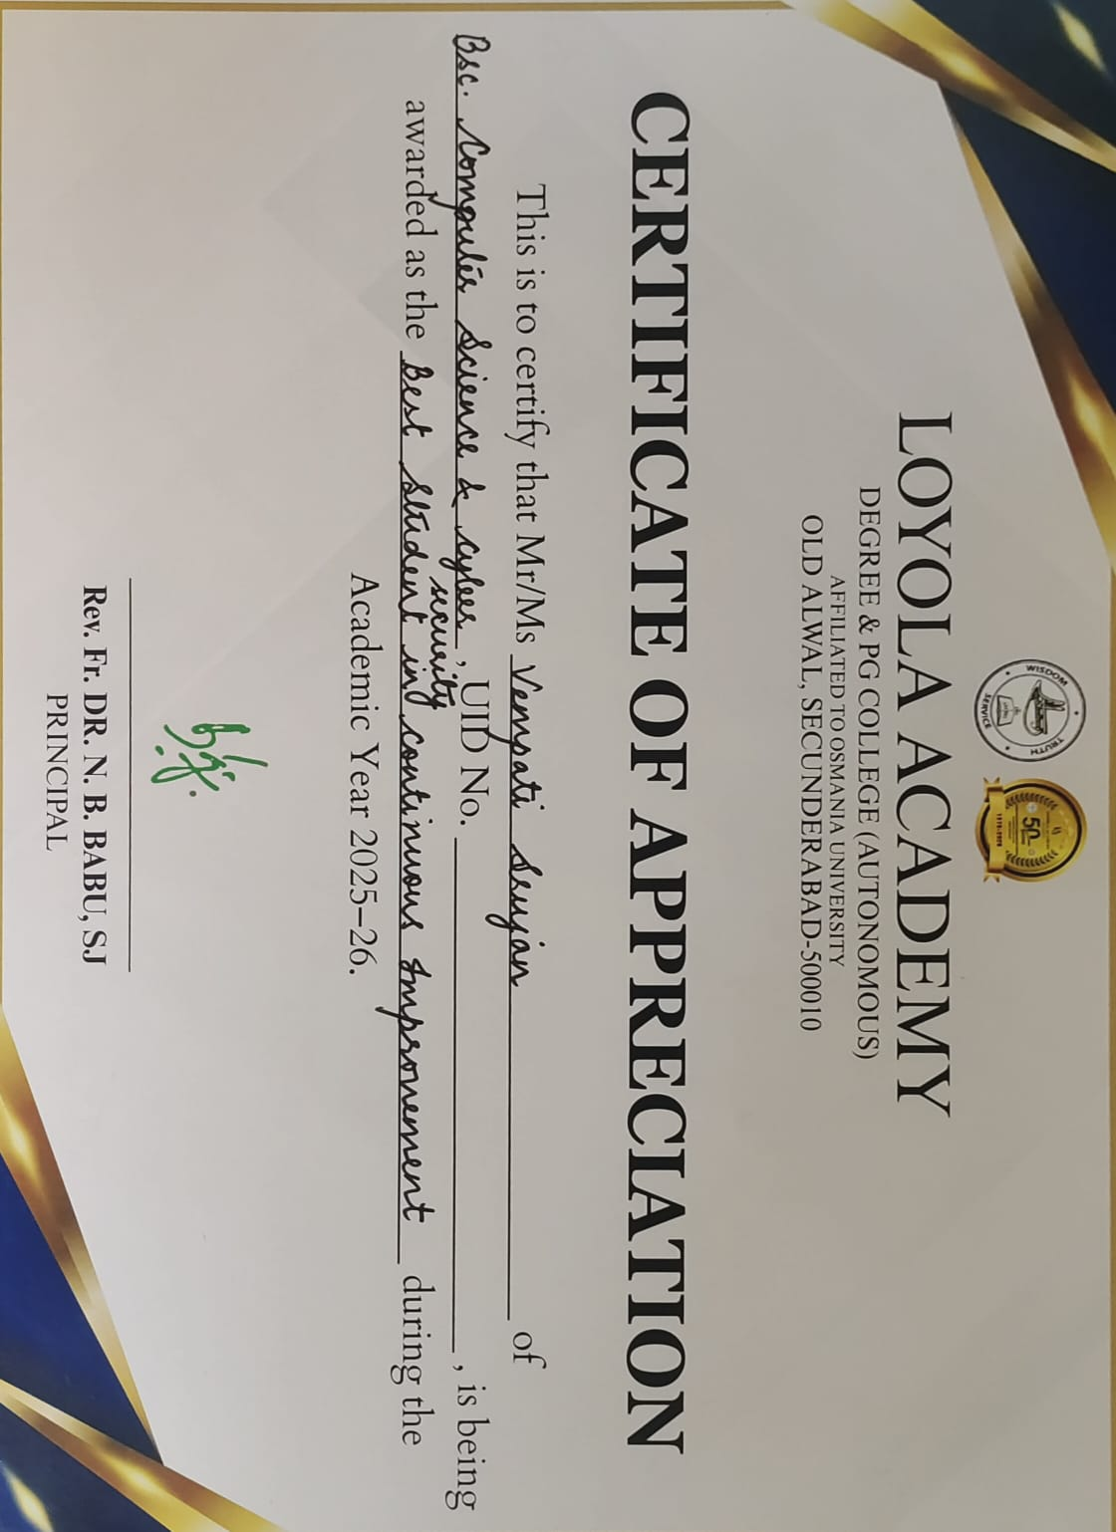
12.Hamad Saleh Mahfooz 111723039027 from DCSCS Secured 2nd place in Football, conducted by Department of Physical Education, Osmania University.
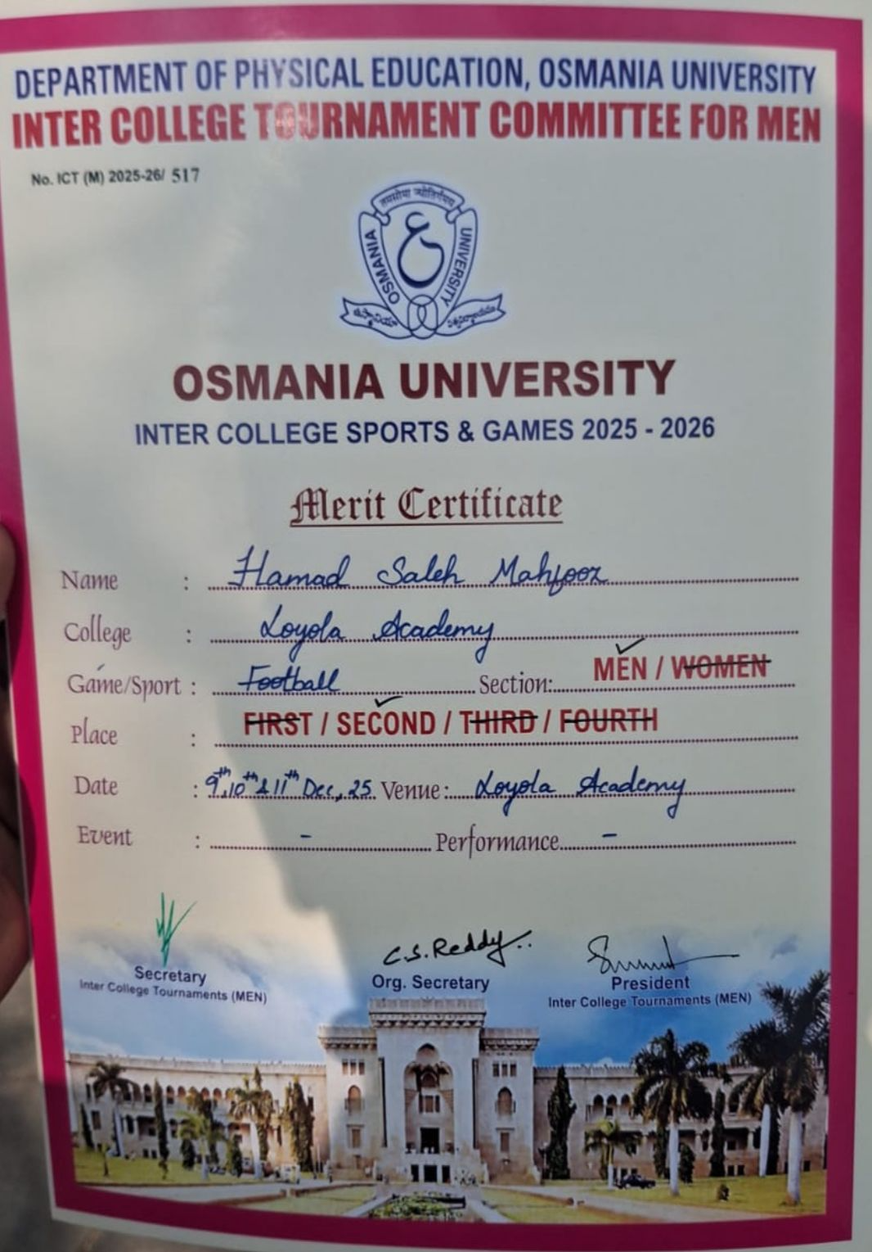

- P S Shiva Kumar uid 111723039043 of Class DCSCS
– Nau Sainik Camp (Inter-Group Competition)
A student from the department participated in the Inter-Group Competition conducted during the Nau Sainik Camp. The student competed in two events: Sailing and Service Subject Examination.
In the Sailing event, the student secured 4th place.In the Service Subject Examination, the student secured a Silver Medal (2nd place overall).
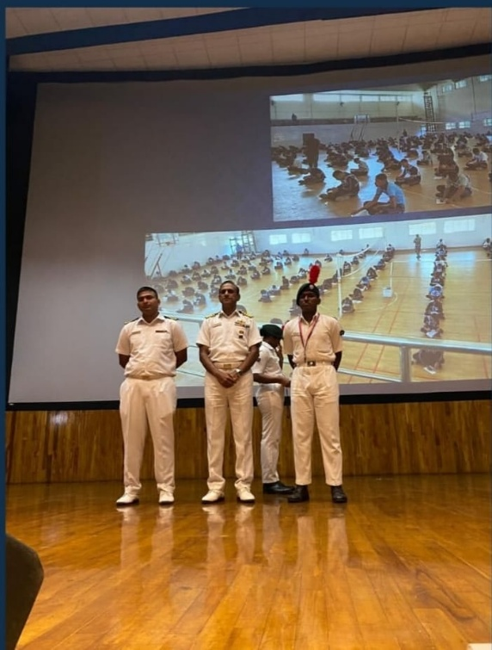

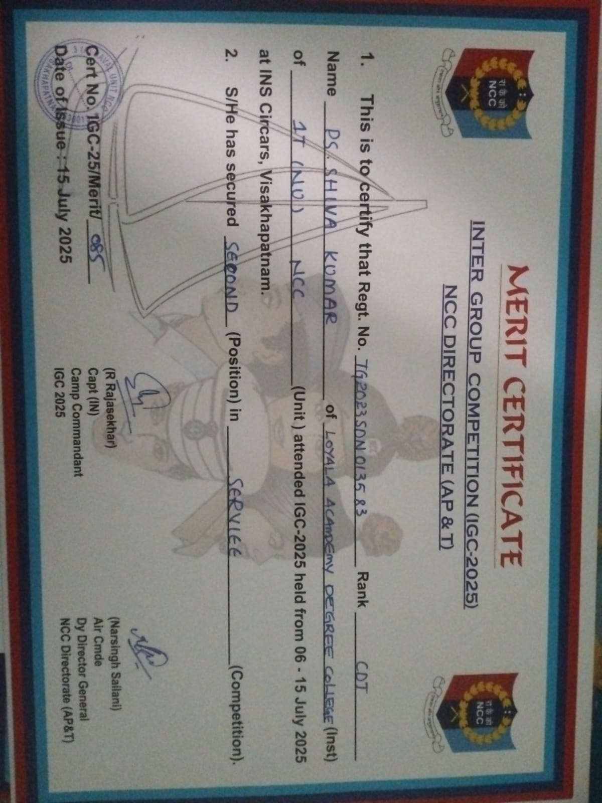

NCSCS:
1.G Yagna uid 111724039021 of class NCSCS Secured 3rd place for Essay Writing at RESONANCE- IGNISIA ,Loyola Academy.

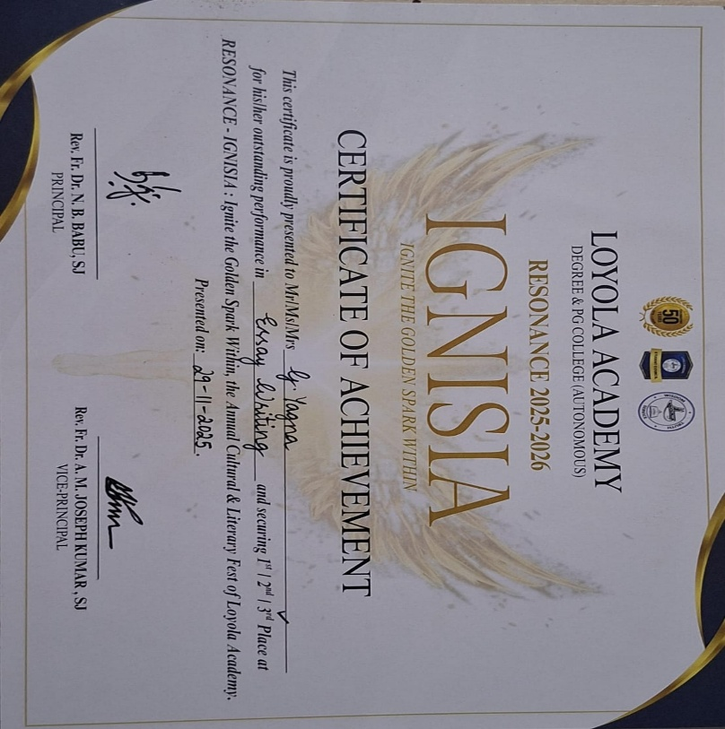
2.K Jayanth From NCSCS, Uid:111724039029 is awarded with 2nd Academic Topper.

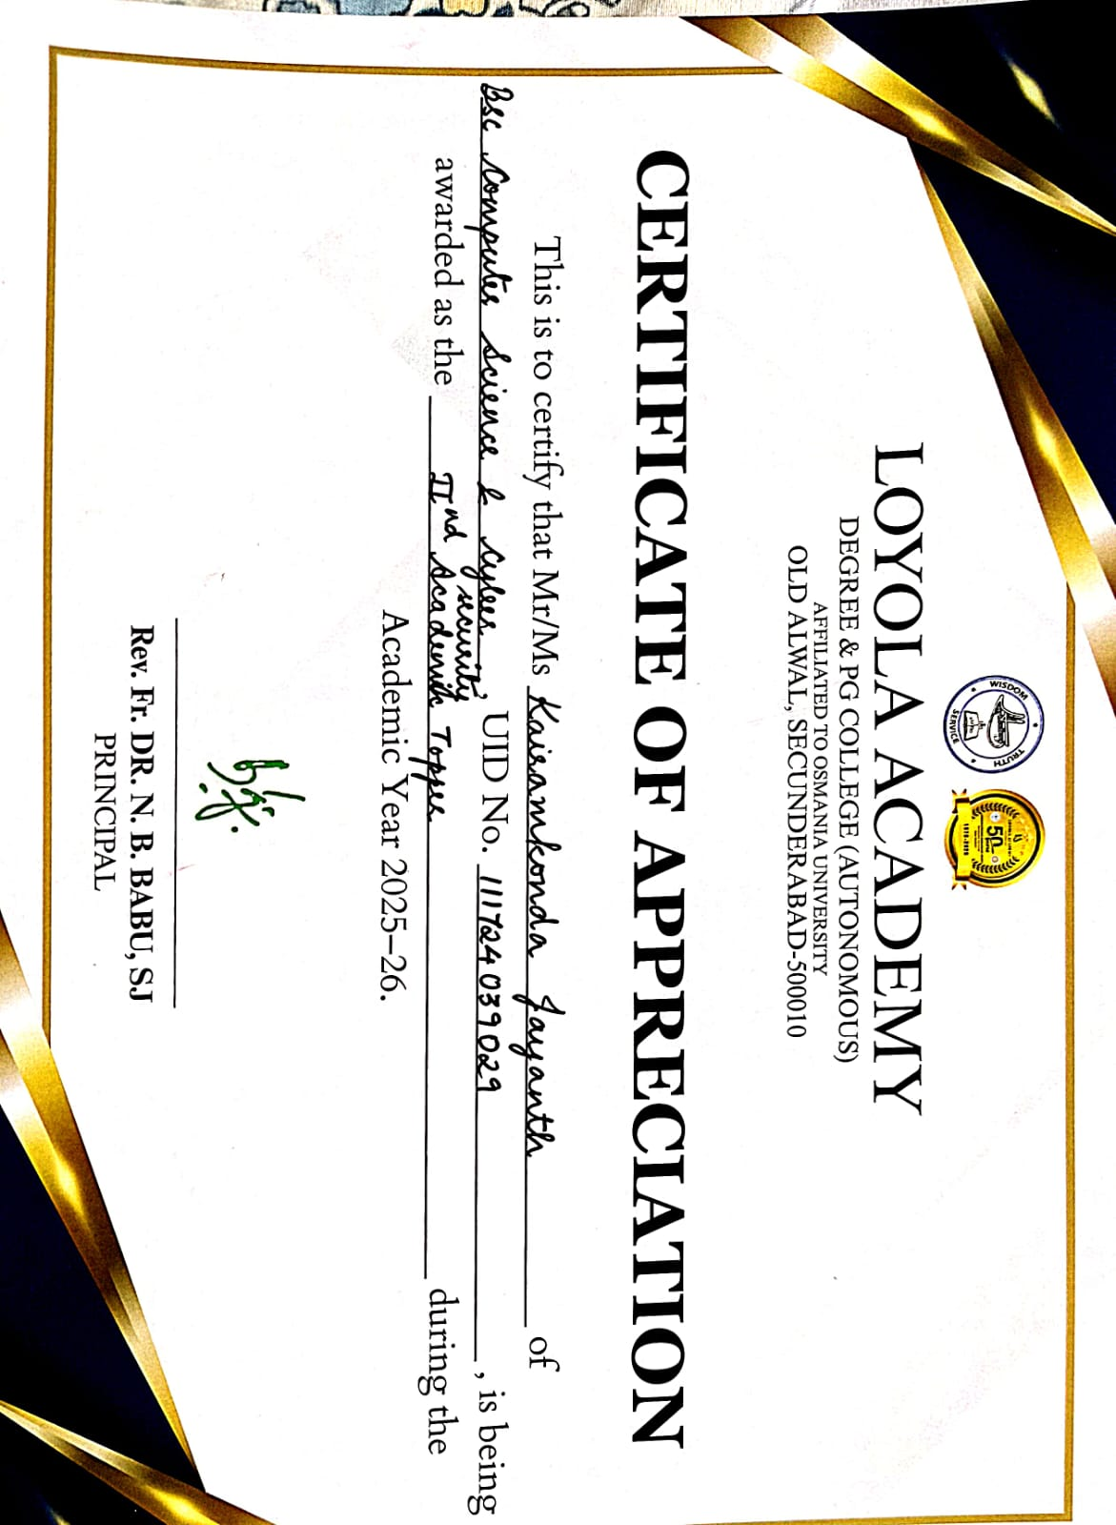

3. K Ashritha from NCSCS, UID 111724039011 has begin awarded as 1st academic topper for the Academic Year 2025-26.
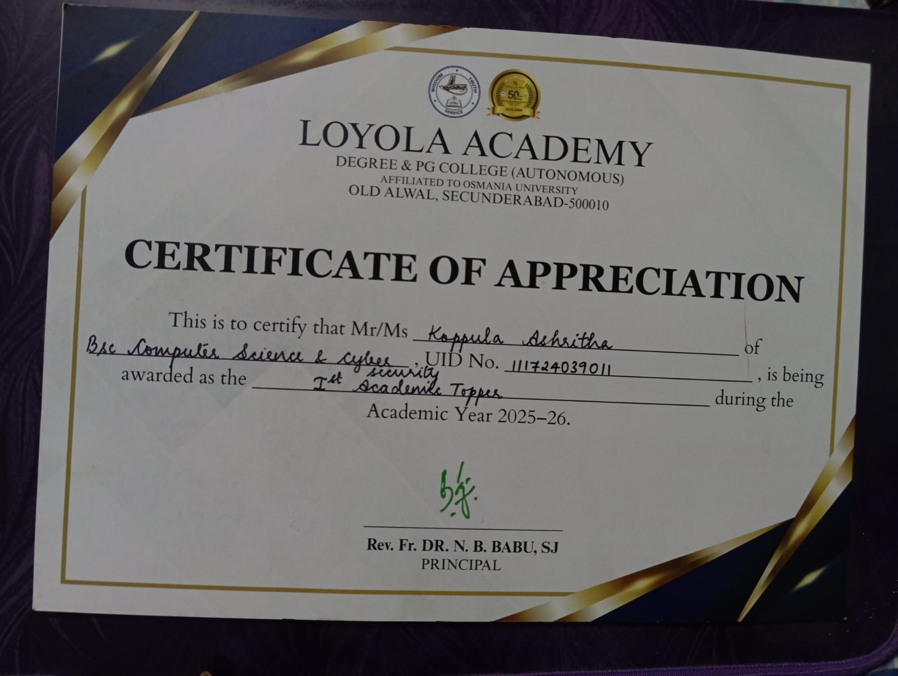

4. M . Sreenidhi Uid:111724039014, class NCSCS, is awarded 3rd academic topper for the academic year 2025-26.
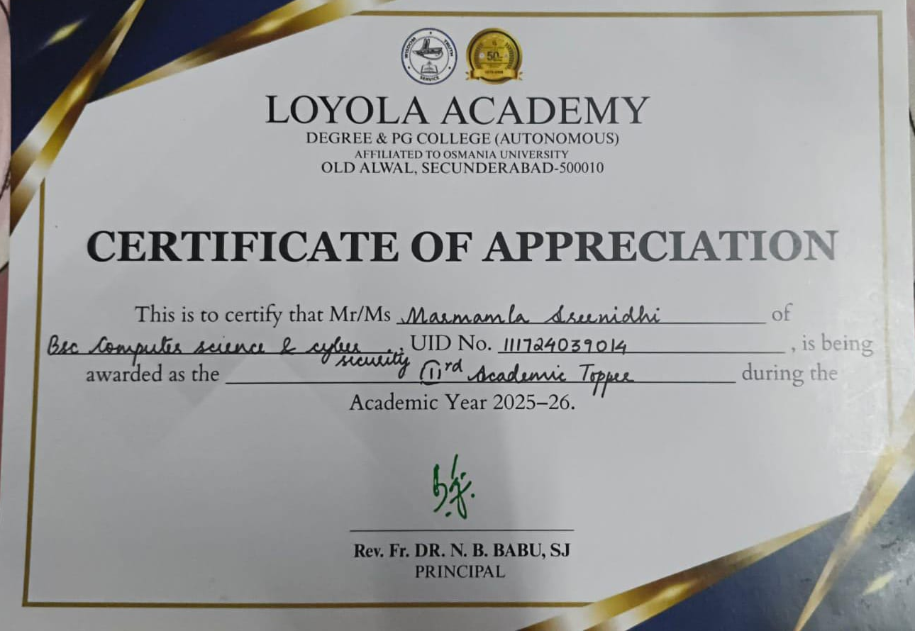
5. A Abivardhan Reddy UID 111724039050 Class ACSCS, has participated in Mind Sprint 2k25 By PSCMR Collage And Brain O Vision At Vijayawada.

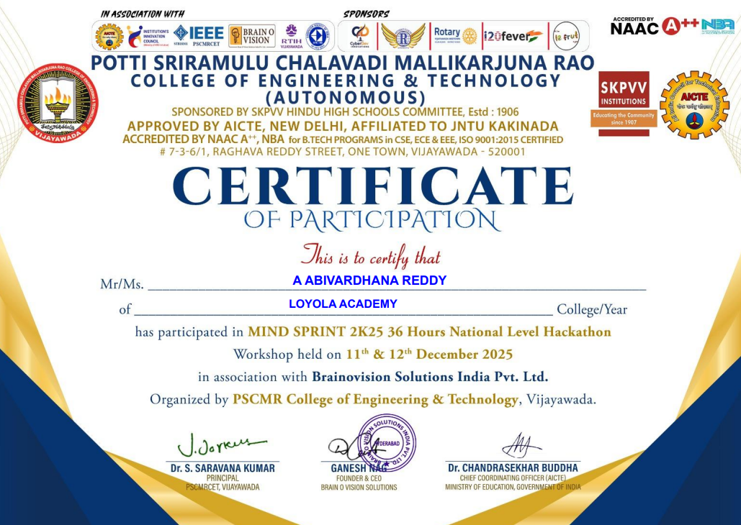

6. D NAGA CHAITANYA UID 11172439025 of Class ACSCS, has participated in Mind Sprint 2k25 By PSCMR Collage And Brain O Vision At Vijayawada.

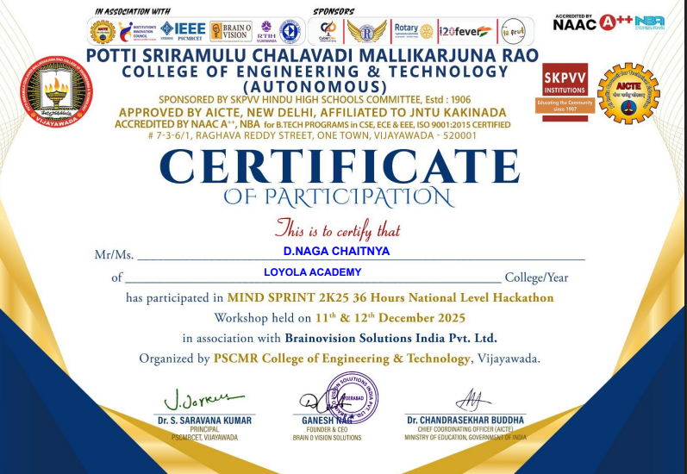

7. K JAYANTH UID 111724039029 Class ACSCS, has participated in Mind Sprint 2k25 By PSCMR Collage And Brain O Vision At Vijayawada.

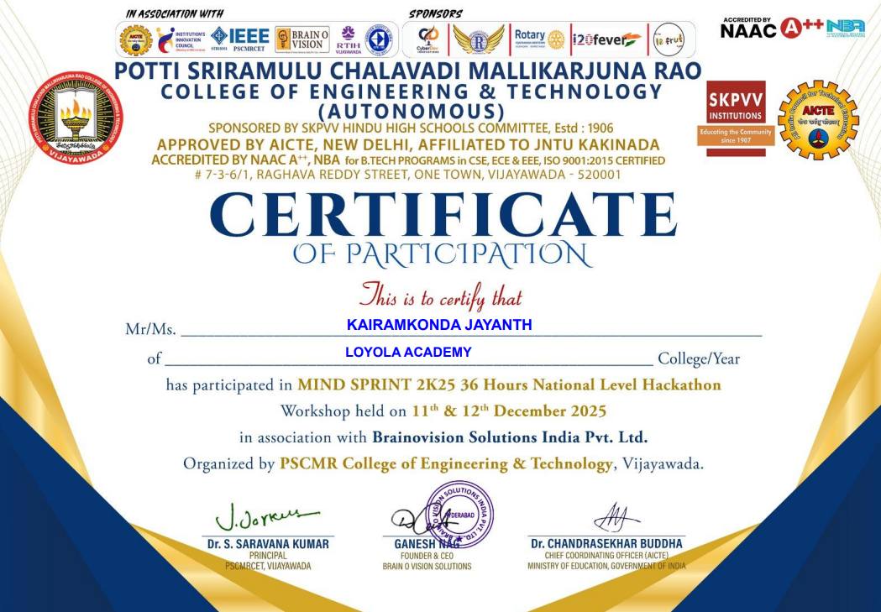

8.S Chaitanya UID 111724039046 of Class NCSCS Secured 1st prize and got 10K cash in CTF organized by DDC conducted by CBIT College
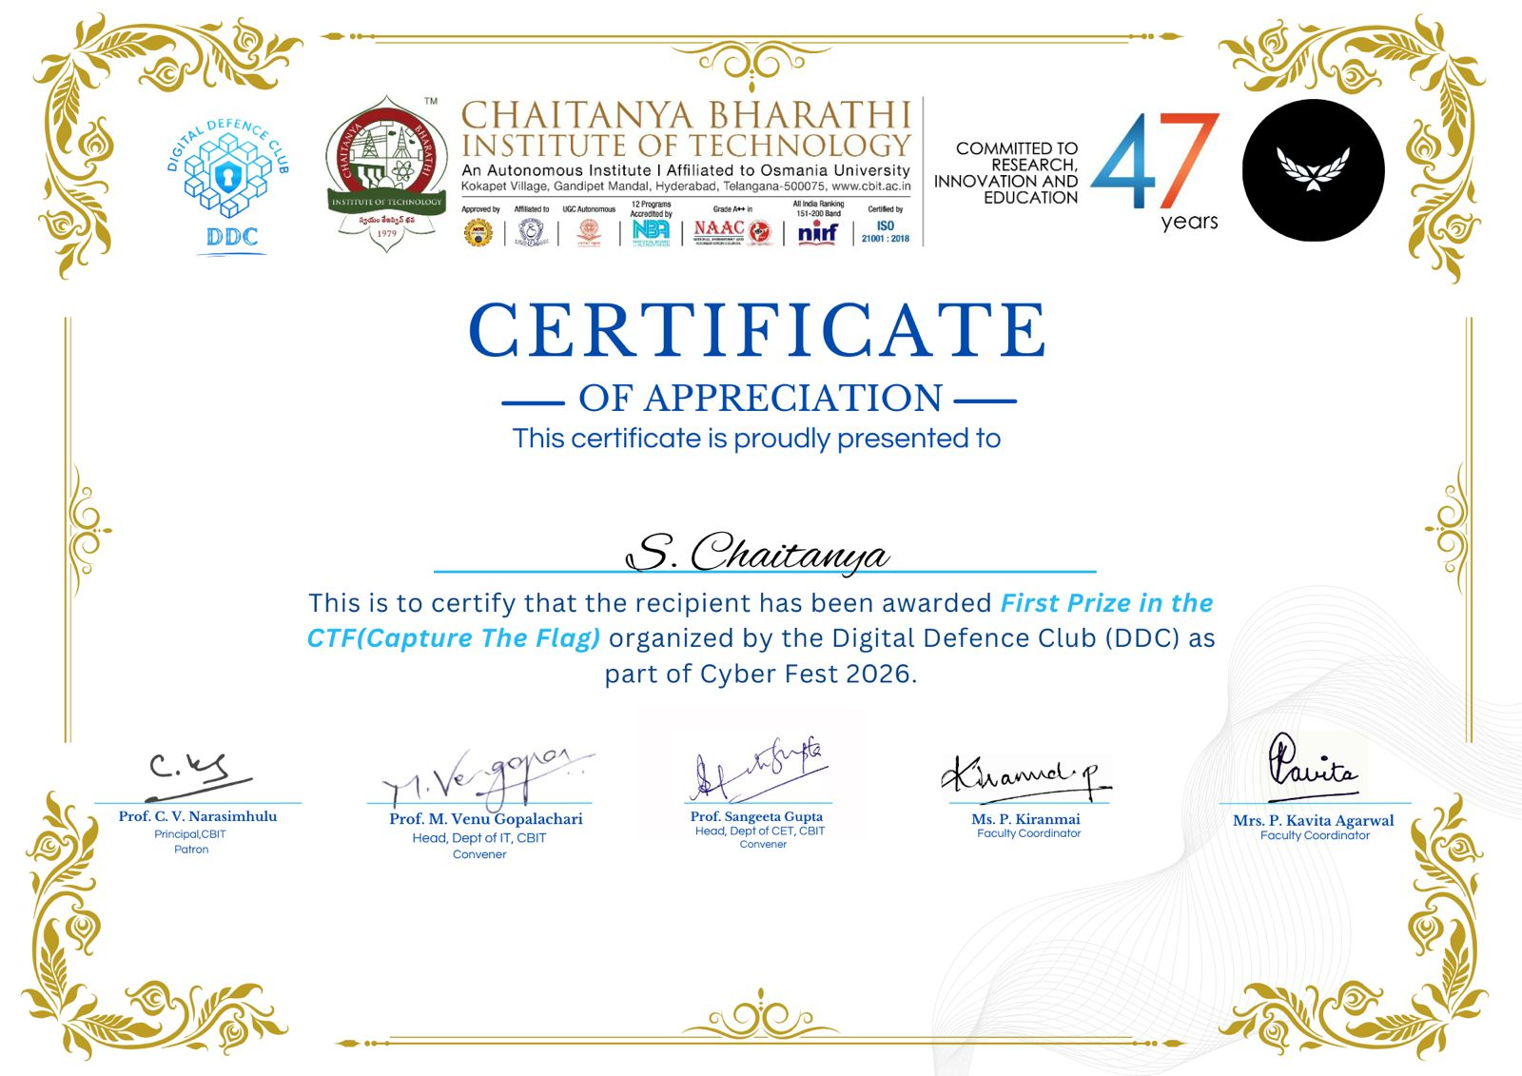
9. M Chethan Yadav uid 111724039033, of class NCSCS NCSCS Secured 1st prize and got 10K cash in CTF organized by DDC conducted by CBIT College
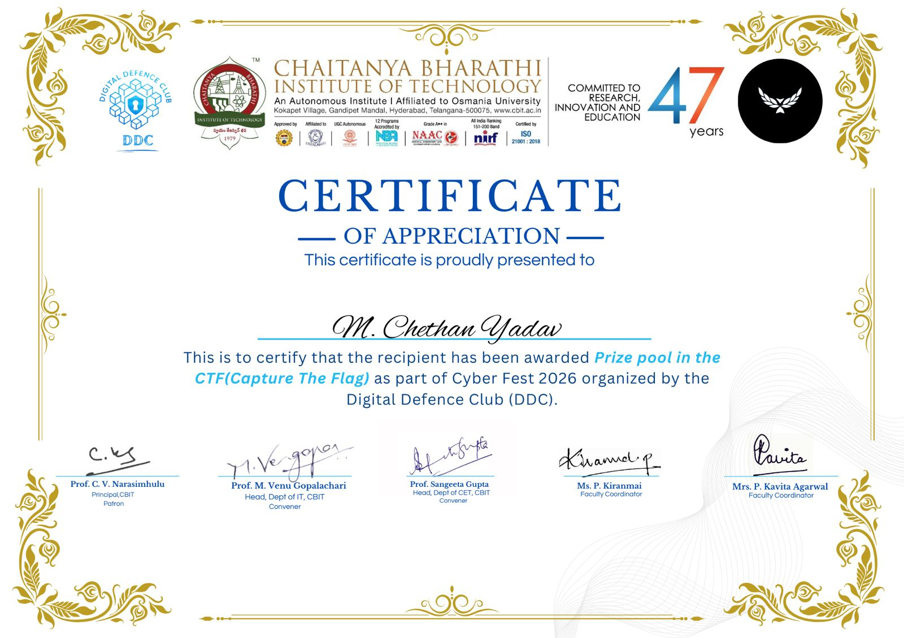

ACSCS:
- P. Bala Puneeth sujay, UID: 111725039044 of Class ACSCS has successfully awarded with 3rd prize, organized by the department of Bsc Computer Science and Artificial Intelligence in the month of July 2025,Loyola Academy.

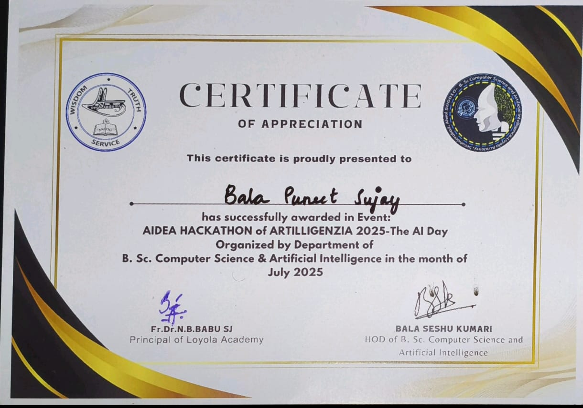

2. M. Raghunadan Sudarshan UID 111725039036 of Class ACSCS has successfully awarded with 3rd prize, organized by the department of Bsc Computer Science and Artificial Intelligence in the month of July 2025,Loyola Academy.

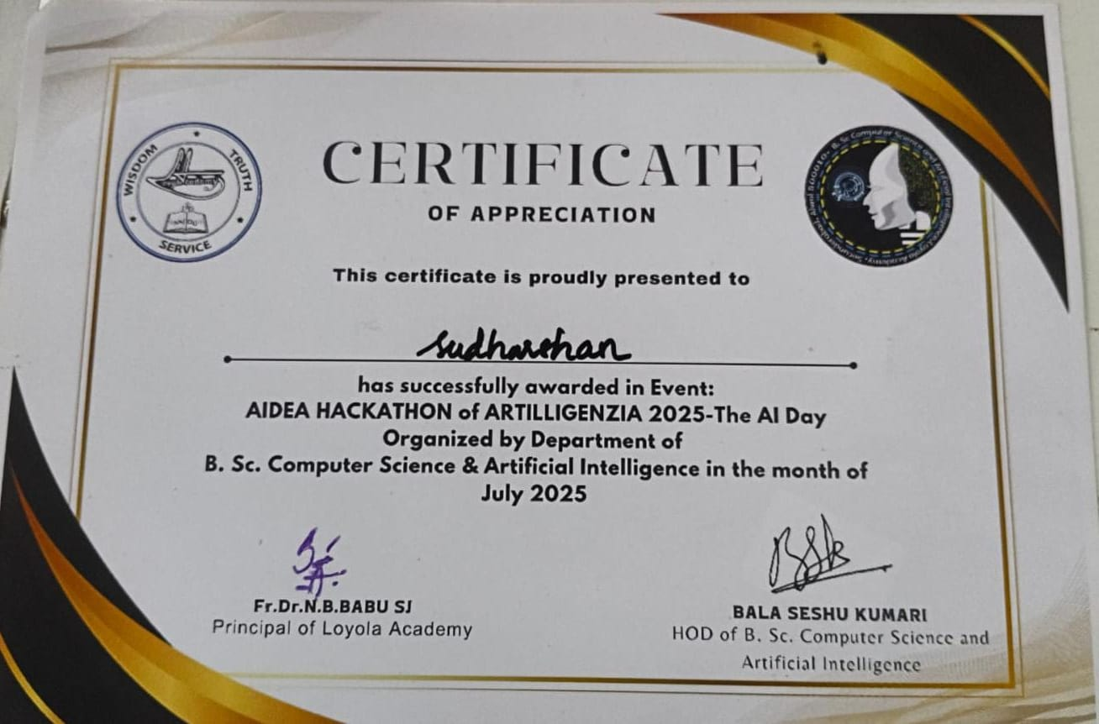

3.STUDENT NAME: RESHAM ARAVIND
UID: 111725039045
CLASS: ACSCS
EVENT: 10TH RANGAREDDY SUB JUNIOR AND JUNIOR DIST LEVEL SWIMMING CHAMPIONSHIP 2025
TYPE: 400MTRS FREESTYLE
POSITION: FRIST PRIZE
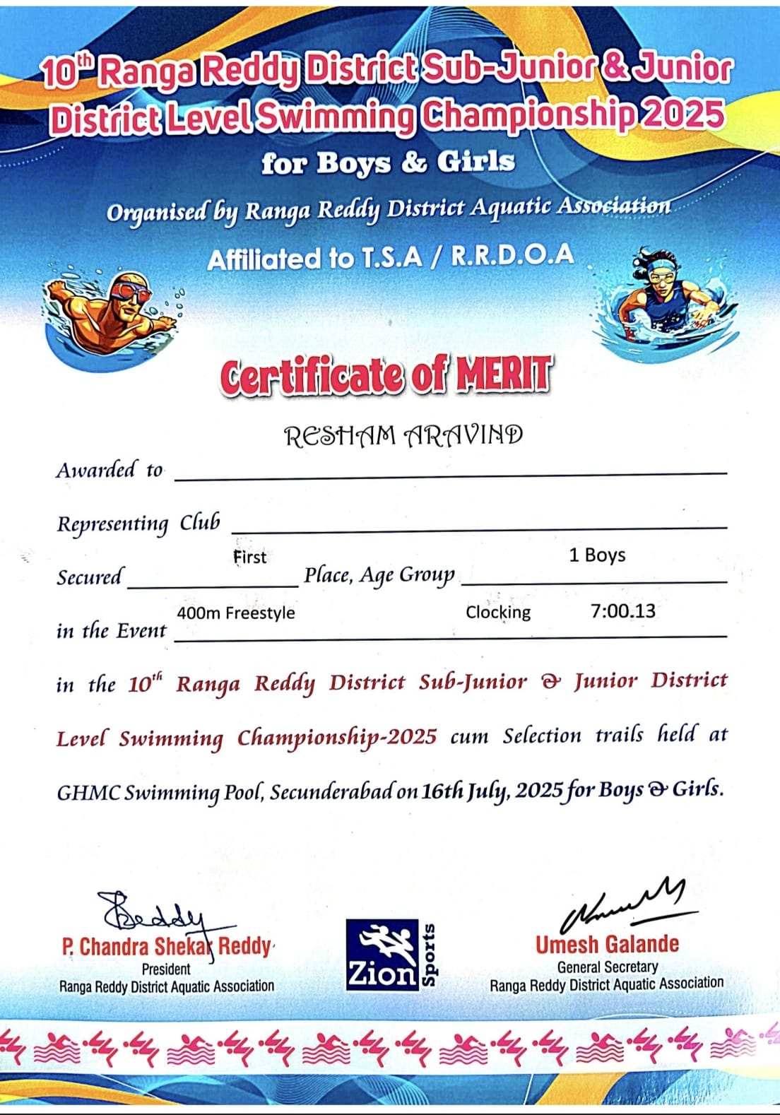

4.STUDENT NAME: RESHAM ARAVIND
UID: 111725039045
CLASS: ACSCS
EVENT: 10TH RANGAREDDY SUB JUNIOR AND JUNIOR DIST LEVEL SWIMMING CHAMPIONSHIP 2025
TYPE: 800 MTRS FREESTYLE
POSITION: FRIST PRIZE
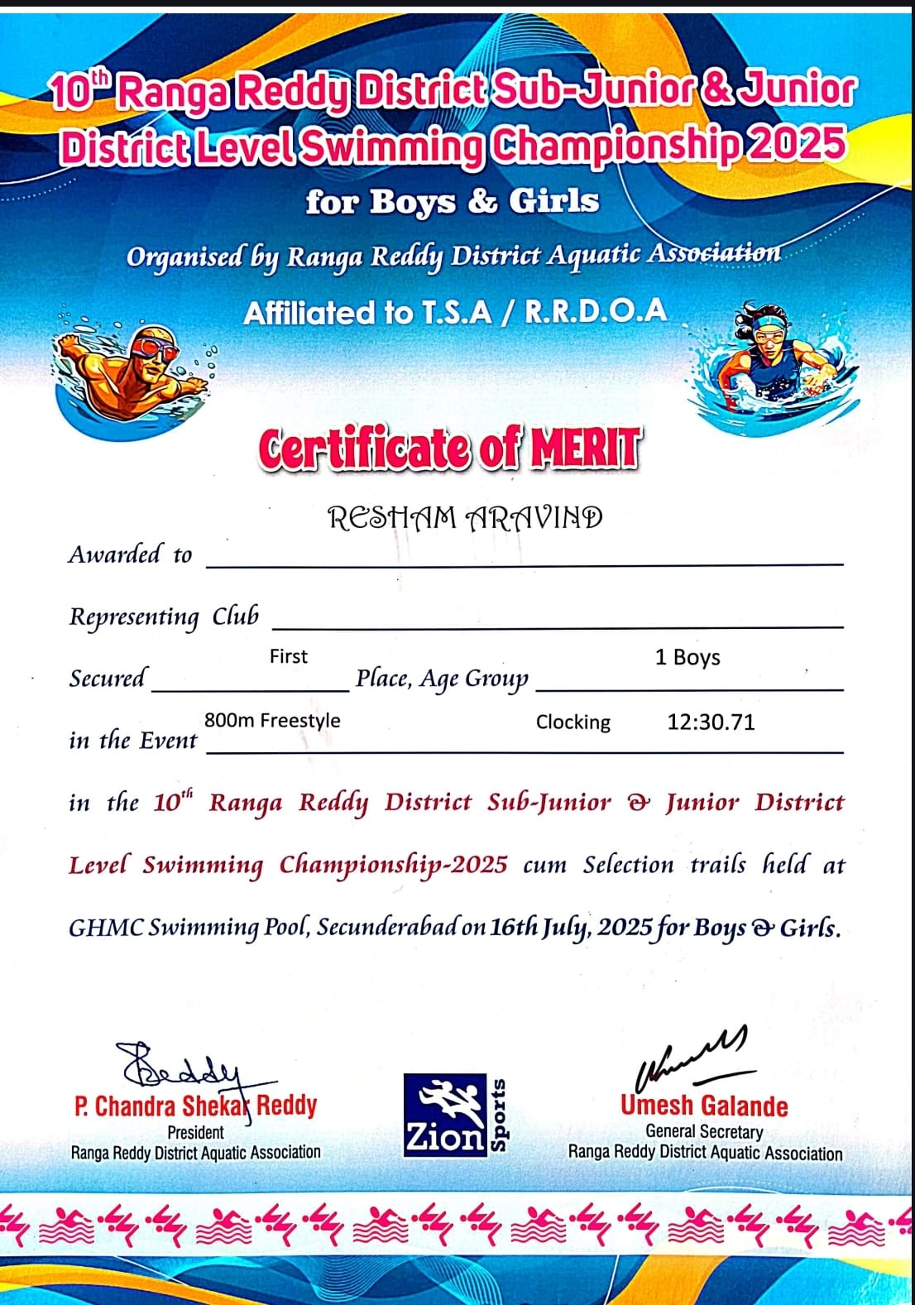

5.Student Name: R Aravind
UID: 111725039045
CLASS: ACSCS

EVENT: 10TH RANGAREDDY SUB JUNIOR AND JUNIOR DIST LEVEL SWIMMING CHAMPIONSHIP 2025
TYPE: 200 MTRS BACK
POSITION: SECOND PRIZE
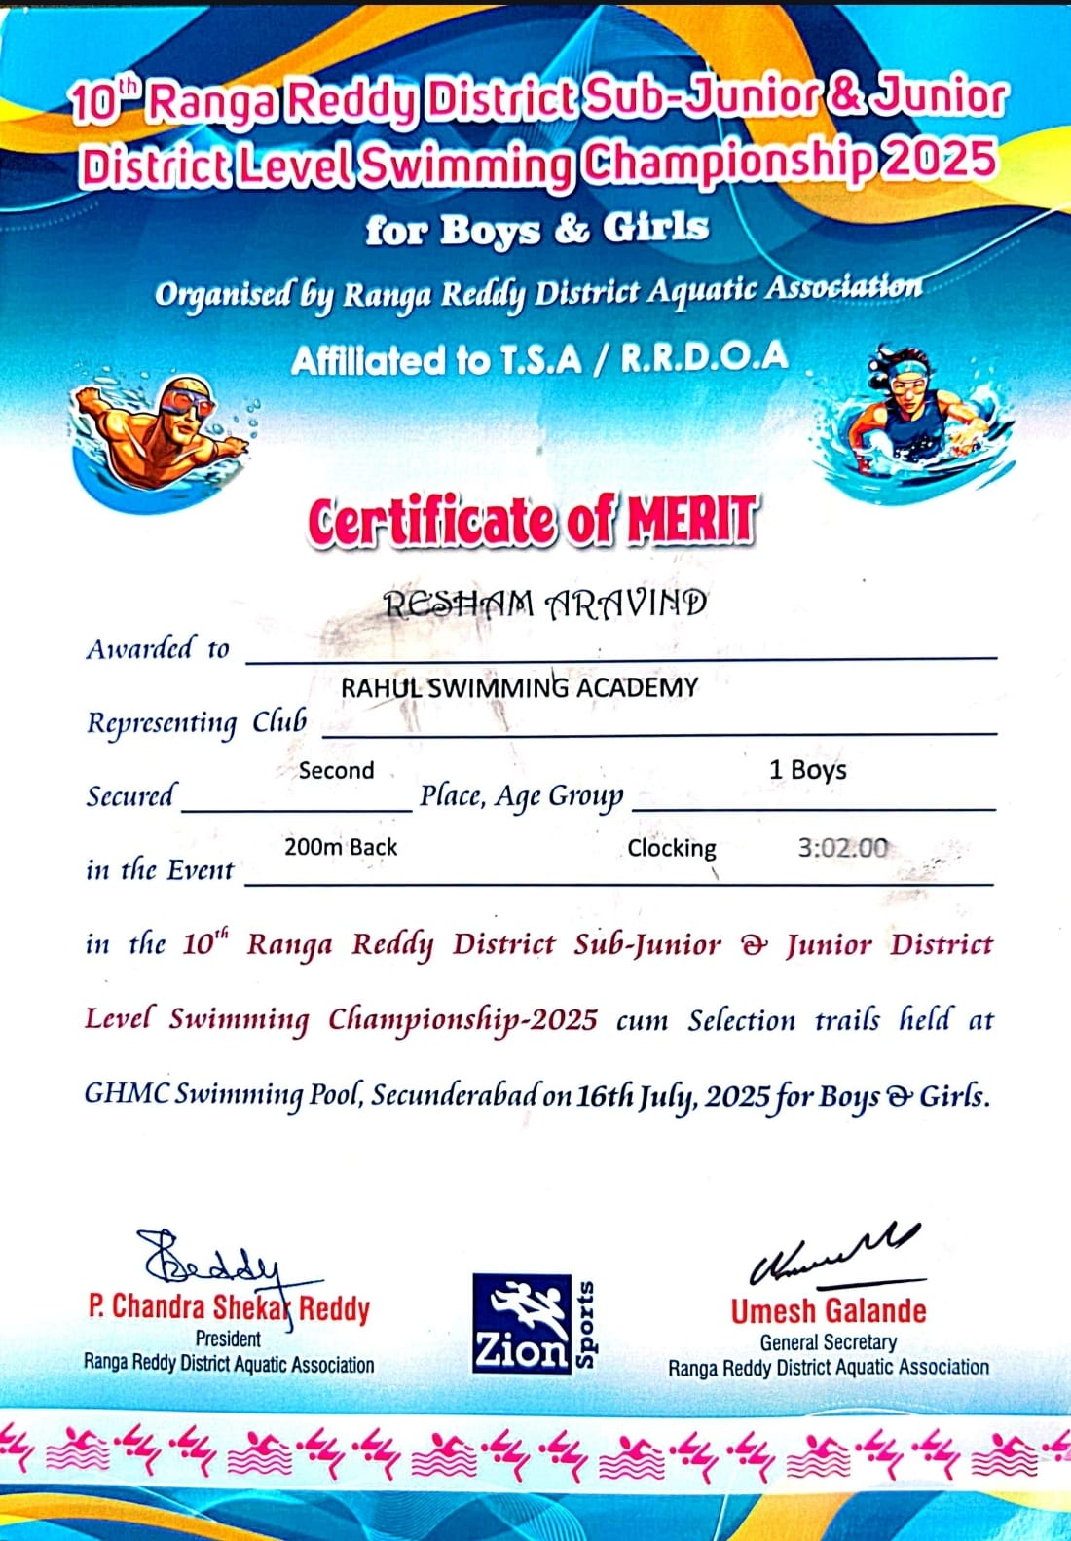

6.Student Name: R Aravind
UID: 111725039045
CLASS: ACSCS

EVENT: 10TH RANGAREDDY SUB JUNIOR AND JUNIOR DIST LEVEL SWIMMING CHAMPIONSHIP 2025
TYPE: 200 MTRS BREAST
POSITION: THIRD PRIZE
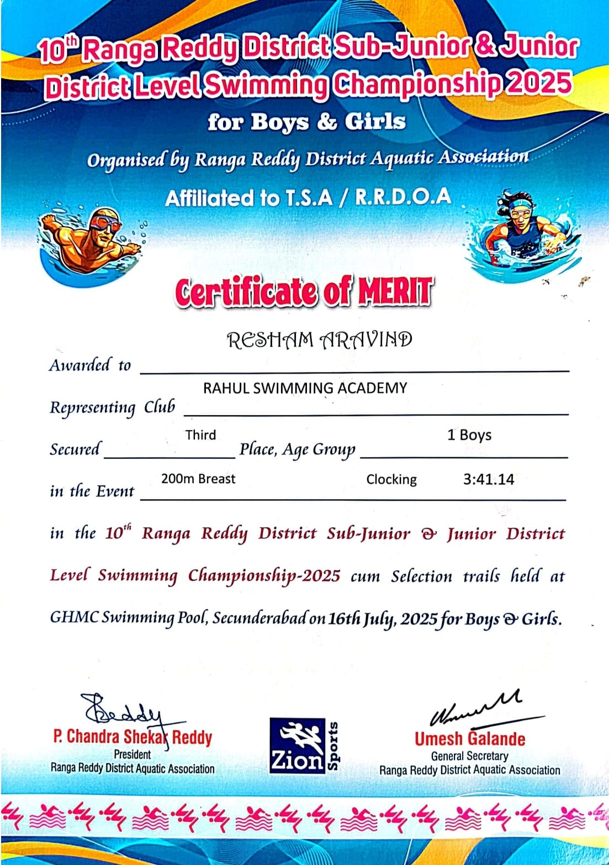

7.Student Name: R Aravind
UID: 111725039045
CLASS: ACSCS
EVENT: INTER COLLAGE TOURNAMANTE FOR MEN AND WOMEN OSMANIA UNIVERSITY SPORTS AND PHYSICAL EDUCATION 2025-2026
TYPE: SWIMMING
POSITION: SLIVER MEDAL
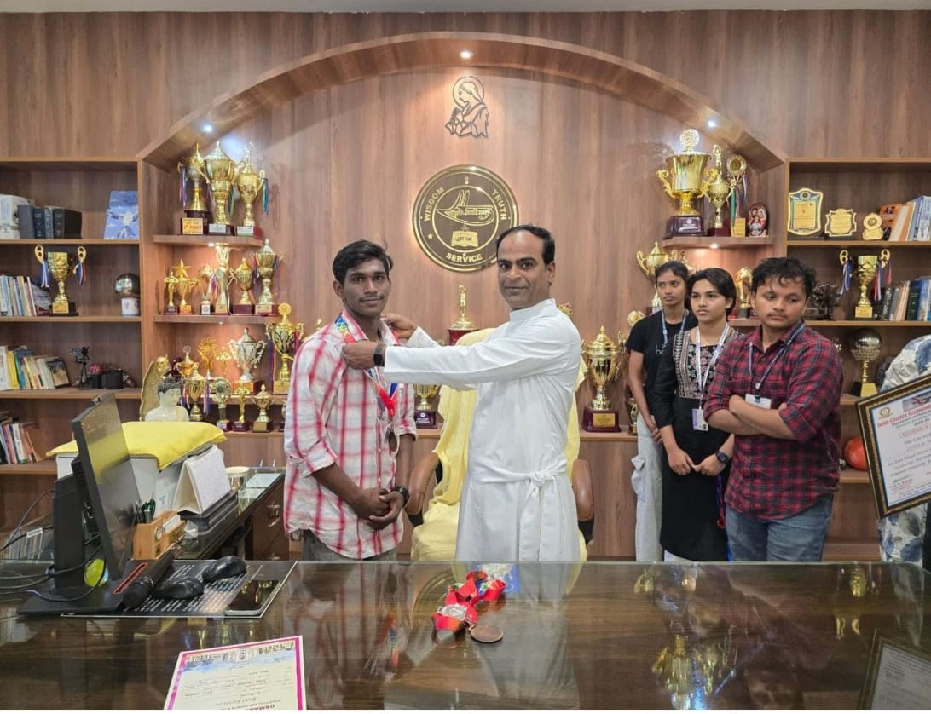

8.Student Name: R Aravind
UID: 111725039045
CLASS: ACSCS
EVENT: INTER COLLAGE TOURNAMANTE FOR MEN AND WOMEN OSMANIA UNIVERSITY SPORTS AND PHYSICAL EDUCATION 2025-2026
TYPE: SWIMMING
POSITION: BORNZE MEDAL
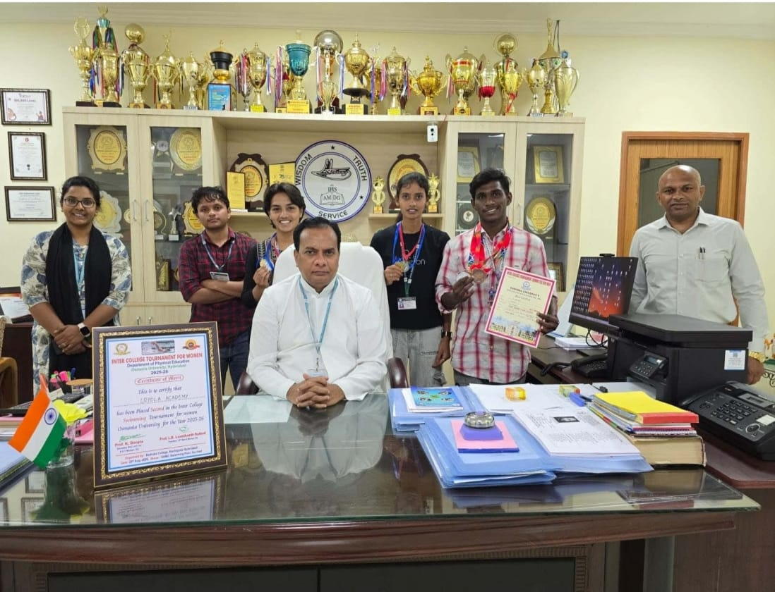

9.Student Name: R Aravind
UID: 111725039045
CLASS: ACSCS
EVENT: INTER COLLAGE TOURNAMANTE FOR MEN AND WOMEN OSMANIA UNIVERSITY SPORTS AND PHYSICAL EDUCATION 2025-2026
TYPE: SWIMMING
POSITION: BORNZE MEDAL
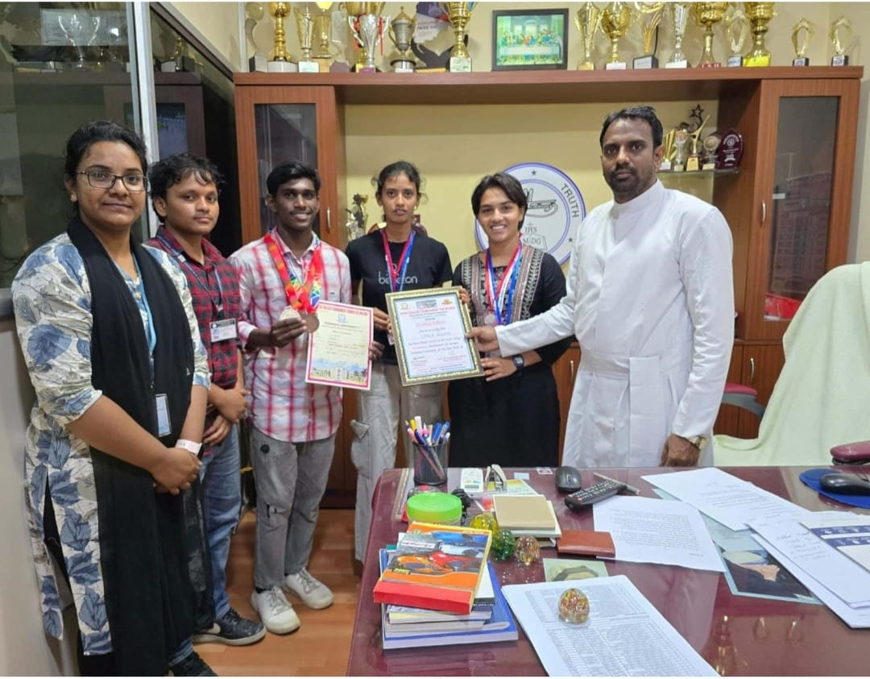
10.Deva Sai Deekshith Reddy 111725039028 of Class ACSCS, has participated in Mind Sprint 2k25 By PSCMR Collage And Brain O Vision At Vijayawada.
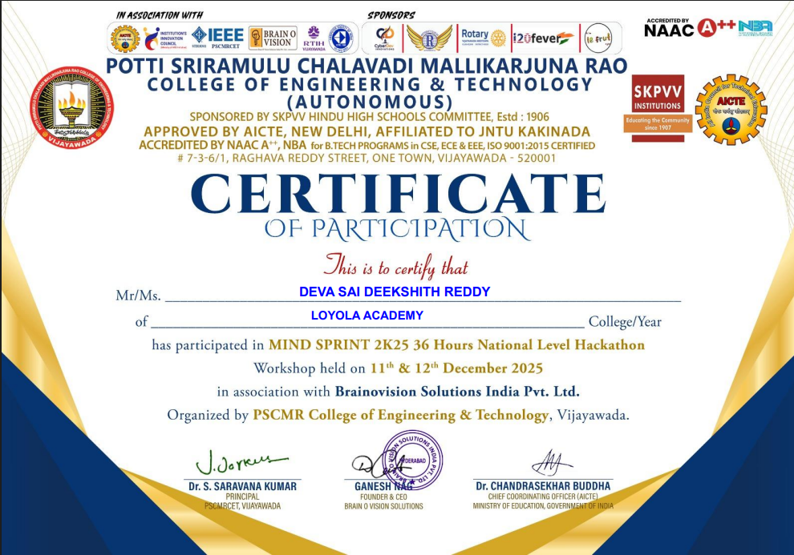

11.Pentareddy Bala Puneeth Sujay Reddy 111725039044 of class ACSCS has participated in Mind Sprint 2k25 By PSCMR Collage And Brain O Vision At Vijayawada.

