

LOYOLA ACADEMY DEGREE & PG COLLEGE

M.Sc. FOOD TECHNOLOGY AND MANAGEMENT

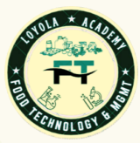

DEPARTMENT REPORT



Academic Year: 2024-2025

INDEX

S.NO | Particulars of the Department | Page number
 | Vision & Mission of the department | 2
 | List of Faculty | 5
 | List of Students | 7
 | Departmental Activities | 10
 | Guest Lecture | 11
 | International Conference | 16
 | Industrial Visit | 19
 | Educational Tour | 27
 | Food Expo | 30
 | Planet Program | 33
 | Earn While You Learn | 35
 | MSME- Training Program | 37
 | World Food Day
 | Career Development Program | 43
 | Faculty Achievements | 45
 | Student Achievements | 52
 | Parent-Teacher Meeting Report | 62
[16] | Mentor-Mentee List | 65
[17] | Student Scholarship | 68
[18] | NPTEL Data | 70
[19] | Placements | 73
[20] | Stipend List | 78
[21] | Result Analysis | 81

VISION
AND
MISSION
OF THE
DEPARTMENT

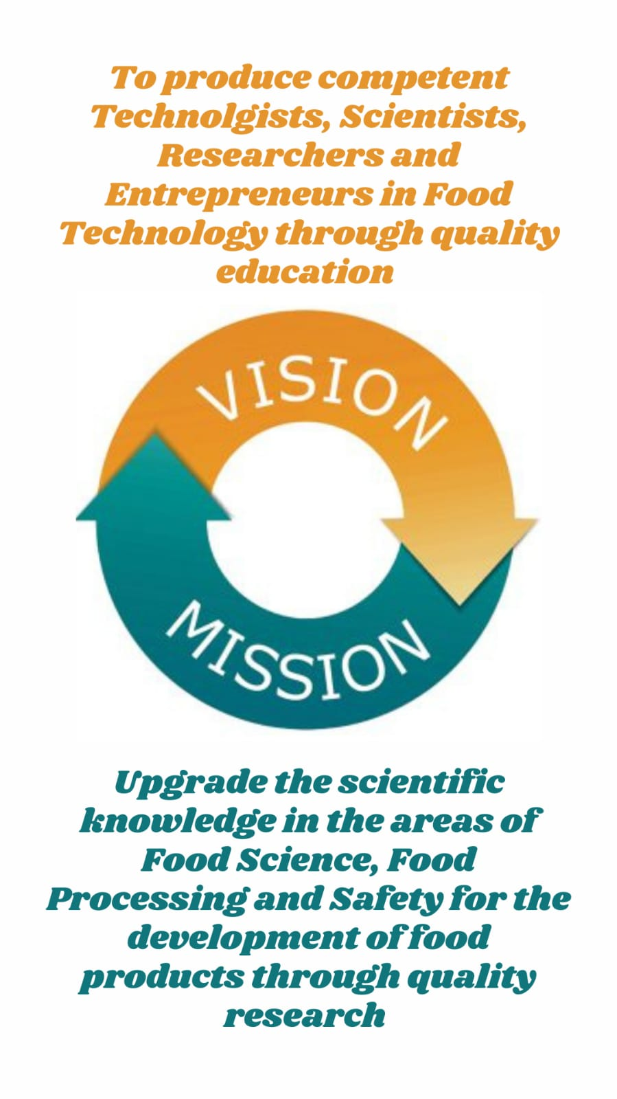

ABOUT THE DEPARTMENT
M.Sc. Food Technology and Management was set up in the academic year 2013, is solely aimed at training students to be expert as food technologist and entrepreneurs. Our department covers every aspect of food production, from manufacturing, preservation packaging and management, marketing, and entrepreneurship of food products. It involves an amalgamation of physical, chemical, or microbiological process and techniques of raw ingredients transformation into food and also other forms in Food Processing Industry. The popularity of our food department arises from the hands-on experience we give our students throughout. The highlight of our department which has laboratories and manufacturing plants, aided by the ministry of Food Processing Industries, Government of India, New Delhi and the UGC support. The main objective of the Food Technology Department is to create learned and skilled human resources to meet to the needs of the rapidly growing Food Processing Sector. There is a good scope of food technology which offers numerous Job Opportunities in various areas. Students learn skills such as food packaging, baking, confectionery, milling production through first-hand experience. Students manufacture as well as market chocolates, biscuits, ice creams, etc. The students prepare various products in these pilot plants and sell them in the college premises during break hours so that they not only gain hands-on experience but also earn money while they learn. This is one of the best practices adopted by the department which highlights the practical skills of the students. Students are allotted Industrial Projects in different companies like Coco Cola, Carlsberg, PepsiCo, etc. Our Food Technology Department is big on innovation and even bigger on initiative. The department shall organize guest lectures, seminars, and certificate programs on Internal Auditing in Food Industries and FSSAI to disseminate and gain knowledge in various competitions . Our department establishes sugar confectionary and manufacturing unit with CPE Grant. The well-being and productivity of the nation through the knowledge of the students.

LIST OF
FACULTY

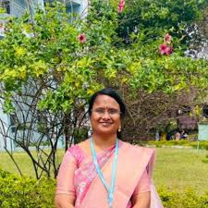
Dr. P. Kiran Kumari
Assistant Professor &
Head of Department
M.Sc., M. Tech,Ph.D
EMP ID: 22152
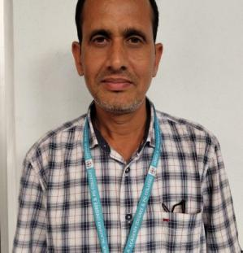
Dr. A. Ravinder
Assistant Professor
M. Tech, Ph.D
EMP ID: 04102


MRS. S. Jemmy Evangeline
Assistant Professor
B.Tech, M.Sc. (Ph.D)
EMP ID: 15207

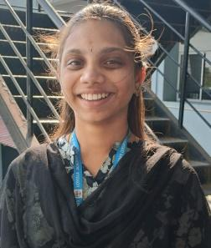
Mrs. K. Tejaeswini
Assistant Professor
M.Sc.
EMP ID: 23149

A.Pravalika Reddy
Assistant Professor
M.Sc.
EMP ID: 23149

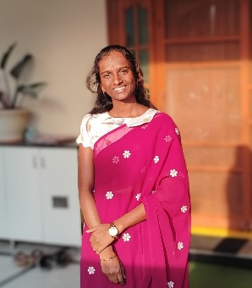


LIST OF STUDENTS

Academic Year:2024-2025 (Student List)
Class: AMFT
S.No | UID | Students name
1. | 111724620001 | YL Abhishek
2. | 111724620002 | Koriginjamanasa
3. | 111724620003 | Marapakavarshini
4. | 111724620004 | G harshitha
5. | 111724620005 | Thoompradeepthi
6. | 111724620006 | Koyyachaitanyaaparnareddy
7. | 111724620007 | Shaikshaheenbatul
8. | 111724620008 | Mogiligiddatrushna
9. | 111724620009 | Koyajayakrishna
10 | 111724620010 | C dheeksha
11. | 111724620011 | Chedubavivinaykumar
12. | 111724620012 | Chvinay
13. | 111724620013 | Anikeshilpa
14. | 111724620014 | Udugulaanil
15. | 111724620015 | Vanaparthygayathri
16. | 111724620016 | Bokkalasreeja
17. | 111724620017 | Madamollabhavyasri
18. | 111724620018 | Repakaaarthi
19. | 111724620019 | Gummularadhika
20. | 111724620020 | Pulimamidisanjaykumar
21. | 111724620021 | Dhokishashank
22. | 111724620022 | Kambhammahesh
23. | 111724620023 | Pitlavamshi
24. | 111724620024 | Edhasrinivasulugeethika
25. | 111724620025 | Alekhyanukapelly
26. | 111724620026 | Singamvenkatesh
27. | 111724620027 | Samson arul
28. | 111724620028 | Lethakulasruthi
29. | 111724620029 | Sandeep nannam
30. | 111724620030 | Arshiyajabeen
31. | 111724620031 | Faailajanis
32. | 111724620032 | Yallaturubeulah
33. | 111724620033 | Chinthalaanil
34. | 111724620034 | Motupallijayasri
35. | 111724620035 | Manda mounika
36. | 111724620036 | JamalpuriVaishanavi

Class:NMFT
S.No | UID | Students name
1. | 111723620001 | S. Vaishnvi
2. | 111722620002 | S. Akhila
3. | 111723620003 | C. Pooja
4. | 111723620004 | C. Pradeep
5. | 111723620005 | A. Pravallika
6. | 111723620006 | S. Gopal Sharma
7. | 111723620007 | ThanamMarysona
8. | 111723620008 | Alisha Hossain
9. | 111723620009 | T Pooja
10. | 111723620011 | C. Elanor Christopher
11. | 111723620012 | S. Imam Basha
12. | 111723620013 | MohitValtati
13. | 111723620014 | R. Pooja
14. | 111723620015 | D. Mukesh
15. | 111723620016 | B. Christopher
16. | 111723620017 | U. Prathibha
17. | 111723620018 | M. Sai VenkataSowjanya
18. | 111723620019 | MadasuSravyasri
19. | 111723620020 | Bavu Rani
20. | 111723620021 | C. Nikitha
21. | 111723620022 | P. Venkateswaran
22. | 111723620023 | Tanisha Patangay
23. | 111723620024 | K. Roshini
24. | 111723620025 | NerellaSathwika
25. | 111723620026 | O. Shiva Pavani
26. | 111723620027 | M. Nazeer Ahmad
27. | 111723620028 | Dusari Papa Nikitha
28. | 111723620029 | D SreedharJukanti
29. | 111723620030 | G. Vaisnavi
30. | 111723620031 | MamidiDivya
31. | 111723620032 | C. HarshaVardhan Reddy
32. | 111723620033 | Abdul Nadeem
33. | 111723620034 | DevellaAkshya
34. | 111723620035 | S. Swapna
35. | 111723620036 | Habeeba
36. | 111723620019 | Faizan Zaid Khan

DEPARTMENTAL ACTIVITIES



GUEST
LECTURE

Guest Lecture on Naturopathy Food Processing Techniques

- Concept:
Guest Lecture was organized by Loyola Academy for B. Sc& M. Sc. Food Technology and Management & Food Science and Nutritionon 3rd July 2024. It aims to emphasize knowledge on the symbiotic relationship between processing and nutrition in the food industry to promote health and well being.

- Purpose:
The main motto of this program is to enlighten and educate students to explore the intersection of food processing techniques and naturopathic principles, emphasizing their role in promoting health and wellness.

- Report:
The lecture was delivered by Dr. A. MalathiSyamala and provided valuable insights into the intersection of naturopathy and food technology. The potential for integrating traditional dietary practices with modern food processing techniques to improve health outcomes emphasized the importance of understanding traditional food processing methods that align with naturopathic principles, which focus on maintaining the natural integrity of food while maximizing its health benefits.Key insights of the lecture include Integration of Naturopathy with Food Science, Role of Diet in Managing Health Conditions, Practical Application of food processing techniques that preserve nutrients while adhering to naturopathic guidelines, promoting overall well-being.

- Review:
The guest lecture provided valuable insights into the intersection of naturopathy and food technology. It also highlighted the potential for integrating traditional dietary practices with modern food processing techniques to improve health outcomes.

- Photos:
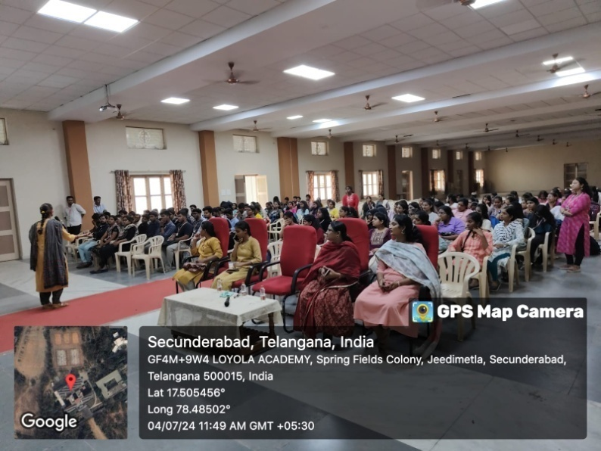
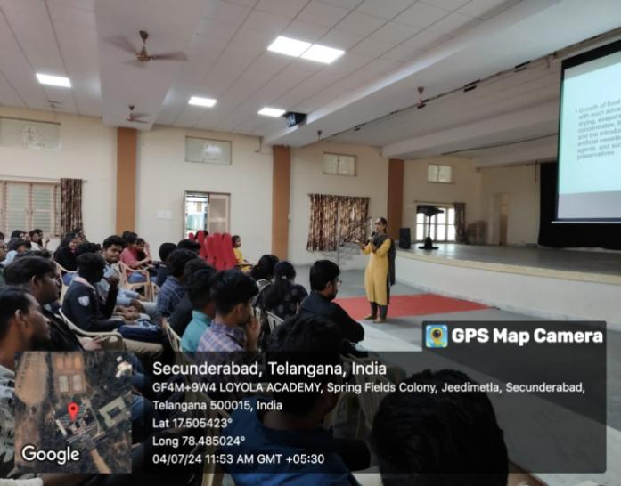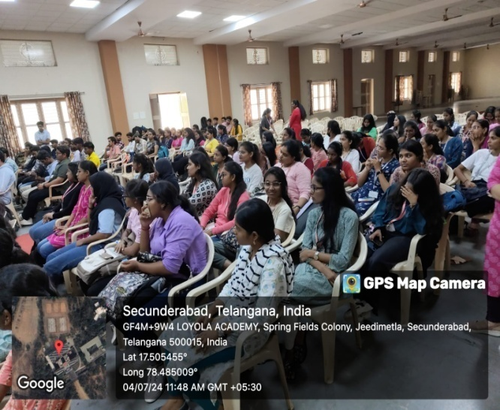

GUEST LECTURE ON CERTIFICATE FOR UNIQUE RECRUITMENT IN HEALTH CARE

- Concept:
Guest Lecture was organized by Loyola Academy for M. Sc. Food Technology and nutrition (1st year&2nd years) on 11th March, 2025 at PG PLACEMENT HALL, Loyola academy from 10.30 am to 12.20pm.
- Purpose:
To provide scholarship and aptitude test designed to enrol students into skill tyros 1-year advanced health care training programmes.

- Report:
The lecture was delivered by Dr P JAGADEESH, DEPARTMENT OF MEDICAL SCIENCES, who hails from the KIMS, CURE HOSIPITAL, Hyderabad. The lecture includes details about importance of student role in field of medical sciences by indulging the knowledge pertaining to food science and technology. Even the lecture was regarding the internship and placements to ensure bright future of students who were going to enter the competitive world.

- Review:
Students found this lecture very informative and inspired to excel in the field of food technology.
- Photos:

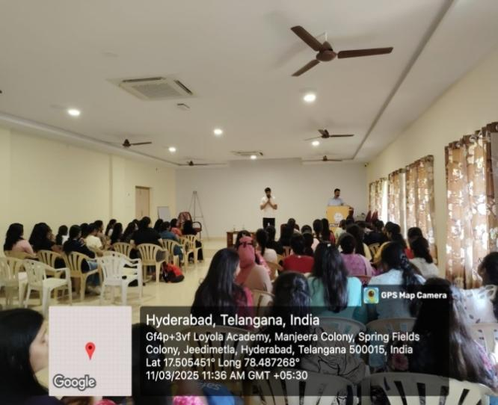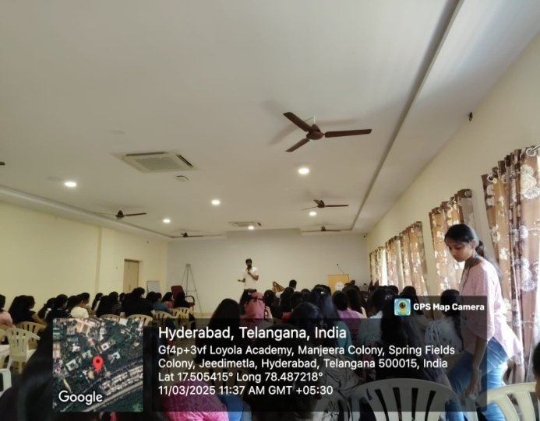
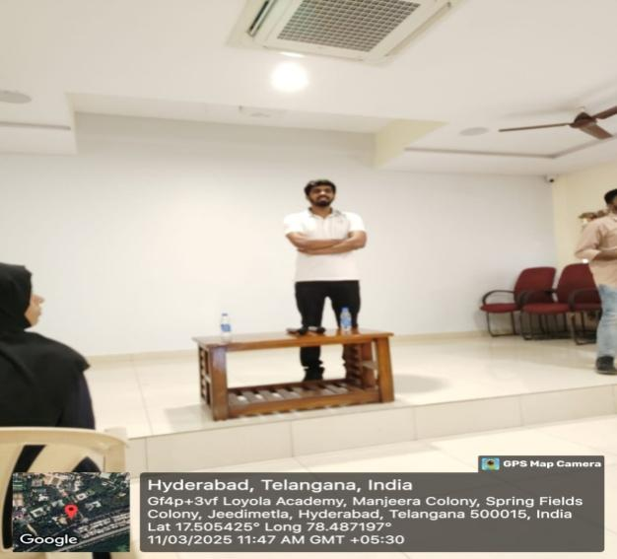



International Conference

National Symposium on “Synergizing Science for Sustainability: Clean Energy, Resilient Agriculture, and Circular Economy”, organized by the Department of Biosciences and Technology, MIT WPU, aligning with the theme of Earth Day 2025, “Our Power, Our Planet.”
- Concept:
On 25TH February 2025, first-year Food Technology and Management students, accompanied by faculty members, embarked on an educational visit to the Maharashtra Institute of Technology (MIT), Pune. This research institutional visit was an integral part of their curriculum. At MIT, a premier research institute, students gained insights into Synergizing Science of Sustainability, Clean Energy, Resilient Agriculture, and Circular Economy,” this conference aligned perfectly with the curriculum’s focus on sustainable development. The visit offered an interdisciplinary learning platform where students explored real-world applications of science and technology to solve global challenges. It highlighted emerging innovations and research in sustainability science, food systems, and renewable energy, enabling students to engage with experts, researchers, and policy advocate.
b. Purpose:
To enhance student understanding of sustainability-focused research and practices in clean energy, agriculture ,food systems, and circular economy .The visit aimed to bridge theoretical knowledge with practical insights , fostering critical thinking and global awareness.
c. Report:
This visit provided rich academic exposure through keynote addresses, poster presentations, and expert panels focused on climate resilience, food security, renewable technologies, and waste valorisation. Students learned how integrated, science-based solutions are essential for sustainable growth and given poster presentation based on themes and won prize for best poster presentation. The interaction with faculty, researchers, and practitioners deepened their appreciation for the interdisciplinary nature of sustainability, while also encouraging interest in applied research and innovation.
d. Review:
Students gained a broader understanding of how sustainable practices and clean technologies can support resilient communities and ecosystems. The event demonstrated the relevance of food technology and management in sustainable development and emphasized the importance of collaborative innovation. Major takeaways included:
    - Promoting clean and renewable energy for sustainable futures
    - Fostering resilient and sustainable agriculture systems
    - Supporting circular economy initiatives for resource efficiency
    - Integrating science, technology, and policy for impactful solutions

e. photos:
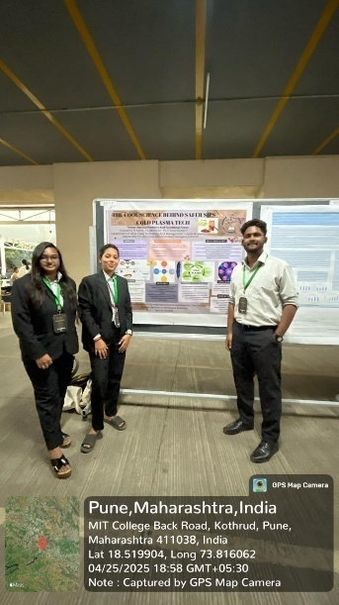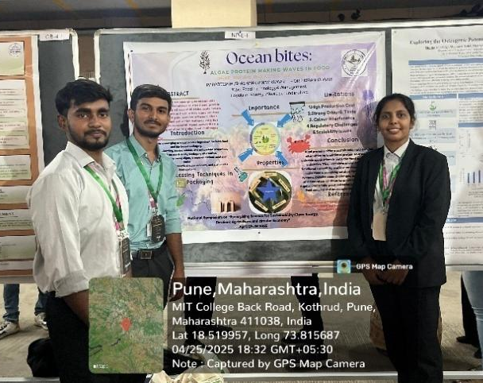

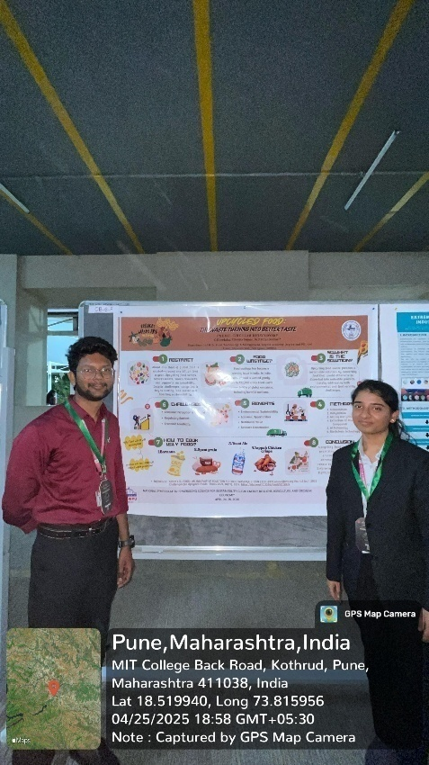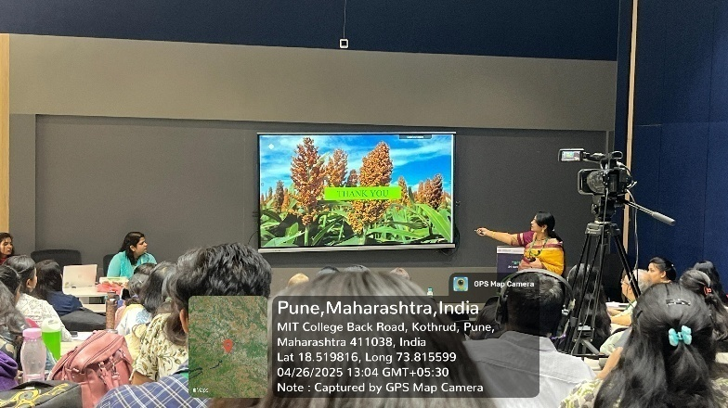

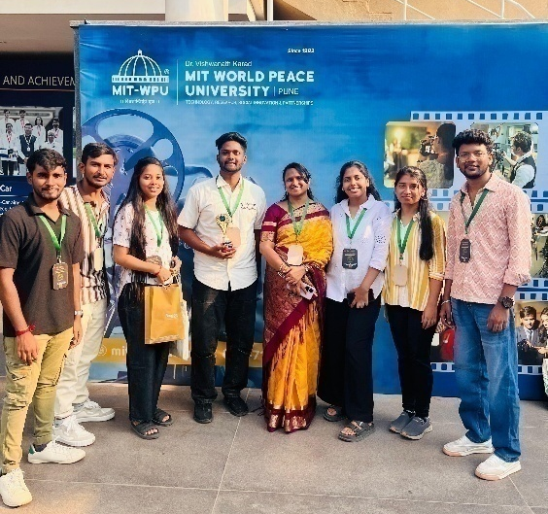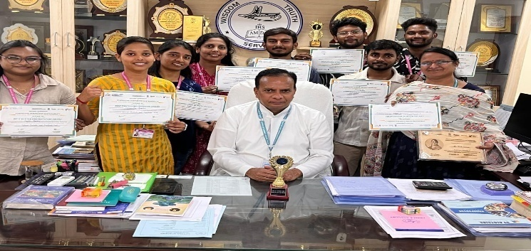



INDUSTRIAL
VISITS
A. OSHON DOLPHIN CHOCOLATE COMPANY
a. Concept:
M.Sc. Food Technology and Management (1st YEAR, 2023-25) have visited Oshon Dolphin Chocolate Company,Bramhanpally,Ragannaguda,Abdullapurmet Mandal, Hyderabad, a confectionery manufacturing industry along with the faculty on Saturday 20th July 2024, as a part of curriculum.
b. Purpose:
To understand and learn technical aspects employed in manufacturing of confectionery which includes toffees, candies, jellies, and various other chocolatesandaims to acquire practical insights and expertise in the technical aspects of confectionery manufacturing.
c. Report:
The industrial visit proved to be a highly enlightening experience for the students, providing them with invaluable knowledge in:
- Processing techniques for various types of chocolates
- Instrumentation used in chocolate manufacturing
- Quality control aspects in chocolate production
This hands-on learning experience not only broadened their understanding of the chocolate industry but also sparked their curiosity and enthusiasm for the field. The visit served as a perfect blend of theory and practice, equipping students with practical insights and expertise that will benefit them in their future careers.

d. Review:
Students have equipped with valuable insights into the meticulous processes involved in creating their beloved toffees, candies, jellies, and chocolates.

e. Photos:
First Year students of Batch 2023-2024
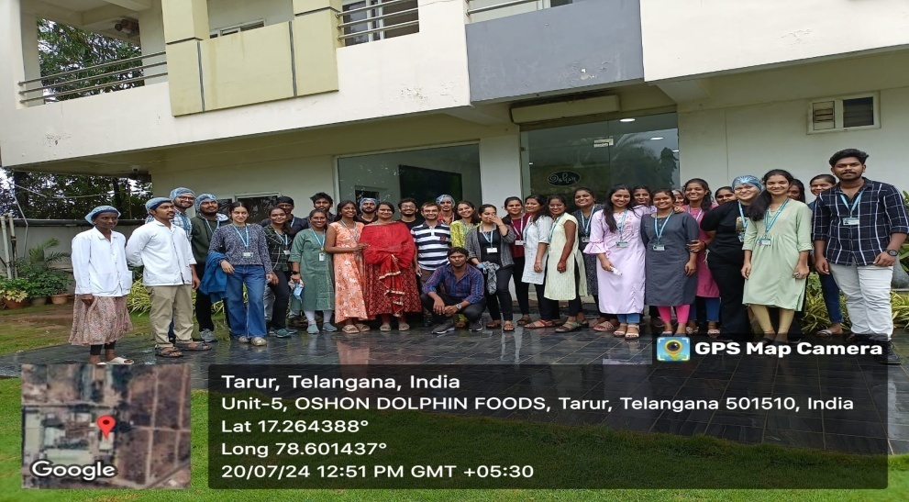

B. OSHON DOLPHIN CHOCOLATE COMPANY

- Concept:
M.Sc. Food Technology and Management(1st YEAR) have visitedDOLPHIN FOODS INDIA LIMITED, Hyderabad, an ice- cream manufacturing industry along with the faculty on 19TH December 2024, as a part of curriculum.

b. Purpose:
To understand and learn technical aspects employed in manufacturing of chocolate and confectionary products.
c. Report:
This Visit had helped students to equip knowledge in processing, instrumentation and quality aspects in processing of varied varieties ofchocolate and confectionary products. It was an industrial trip which enlightened the students immensely.

d. Review:
Students have equipped wider understanding about different processing techniques, equipment related to it, packaging of chocolate and confectionary products.

e. Photos:
First Year students of Batch 2024-2026
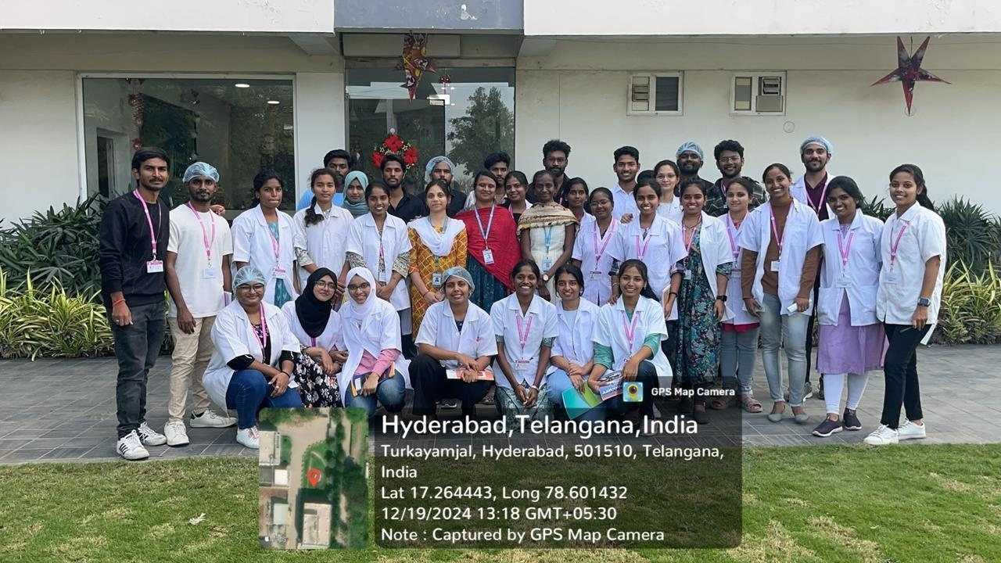
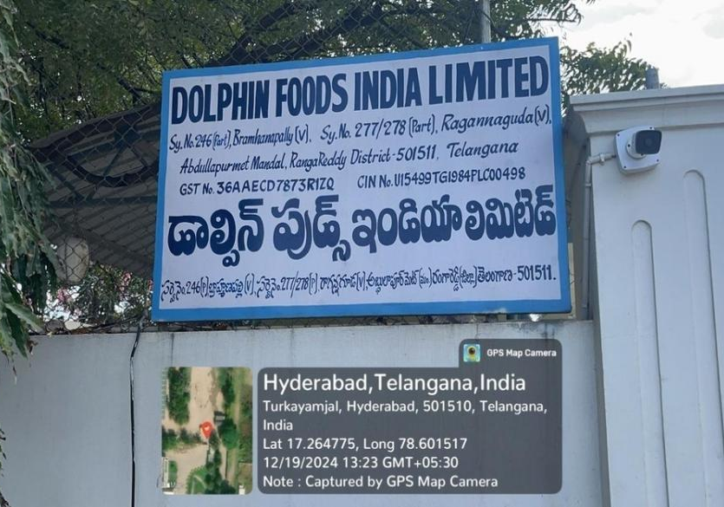

C. GAYATHRI SUGAR FACTORY
- Concept:
M.Sc.Food Technology and Management (I year) have visited “GAYATHRI SUGAR FACTORY”located in Markhal, Sangareddy along with the faculty on 20-02-2025.

- Purpose:
It helped to learn technical aspects employed to process and maintainproper hygienic conditions in the industry during production of different grading of sugars.

- Report:
This Visit had helped students to equip knowledge in processing, instrumentation and quality aspects in processing of raw sugarcane, production of sugar extraction, purification, crystallization, and packaging. Gayathri Sugar Factory is a well-established manufacturer and supplier of high-quality sugar, catering to various industries including confectionery, beverages, and pharmaceuticals.
The factory demonstrated crushing, juice extraction, clarification, evaporation, crystallization, centrifugation, and drying. The importance of maintaining optimum temperature, pH balance, and proper storage conditions was explained in detail by experienced professionals. It was an industrial trip which enlightened the students immensely.
d. Review:
Students have equipped wider understanding about different processing techniques, equipment related to it, packaging of sugar.

e. Photos:

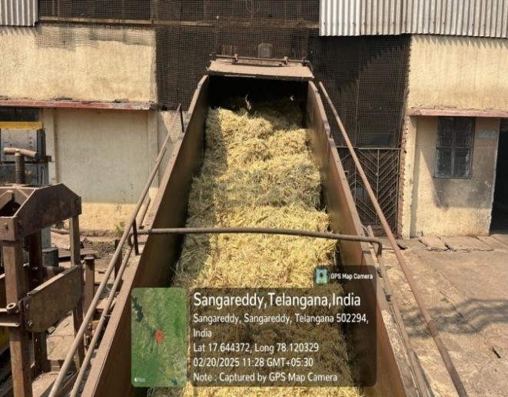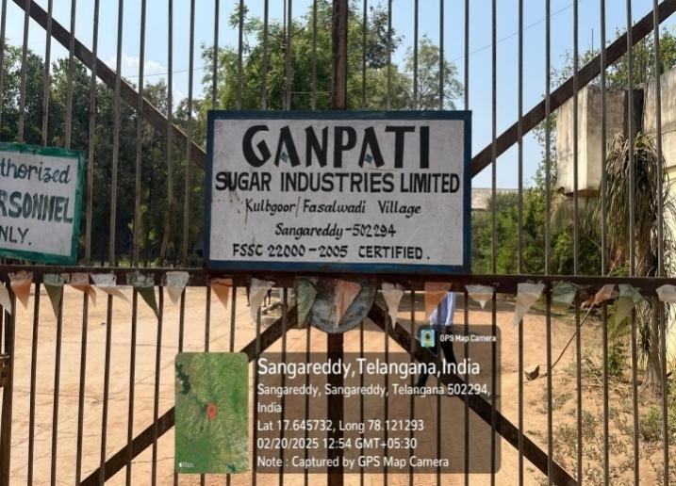

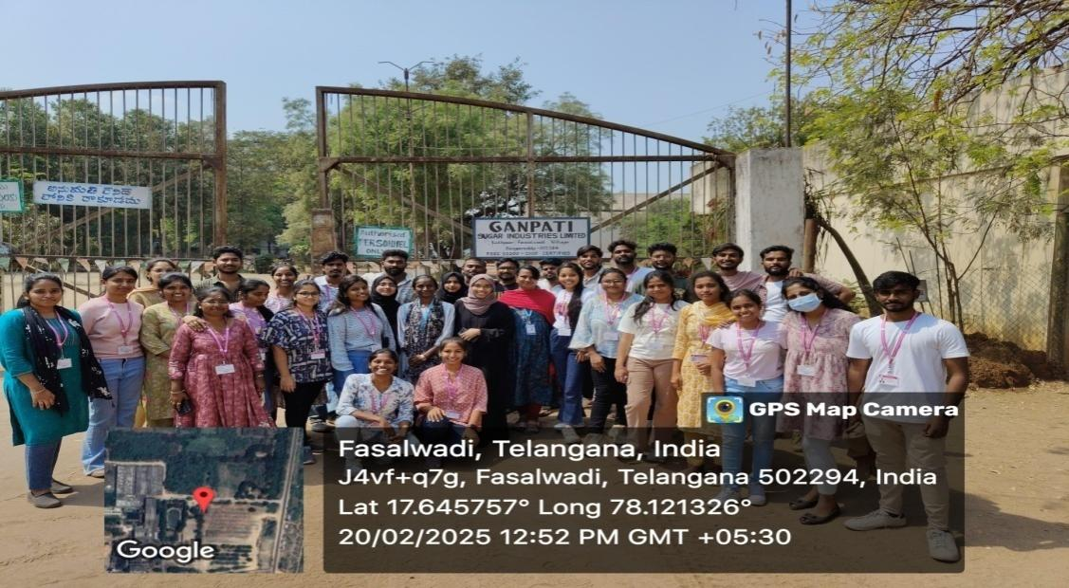

Institutional Visit
INDIAN INSTUTE OF MILLET RESEARCH ( IIMR )

- Concept:
On Friday, October 25, 2024, second-year (link unavailable) Food Technology and Management students, accompanied by faculty members, embarked on an educational visit to the Indian Institute of Millet Research (IIMR) in Rajendranagar, Hyderabad. This research institutional visit was an integral part of their curriculum. At IIMR, a premier research institute, students gained insights into cutting-edge millet cultivation and processing techniques, including the development of value-added products. The visit provided a unique opportunity for students to learn about innovative processing methods and explore the potential of millets in food technology.

b. Purpose:
To understand and learn technical and research aspects employed in cultivation and processing of millets.
c. Report:
This Visit had helped students to equip knowledge in processing, instrumentation and quality aspects in processing of varieties of millets. It was a research institutional trip which enlightened the students immensely and appreciate the role of food technology in driving sustainable development and improving livelihoods.
d. Review:
Students have equipped wider understanding about different processing techniques, equipment and research aspects of millets. The visit highlighted the significance of millets in addressing global challenges, such as:

- Reducing hunger and malnutrition
- Improving health and wellbeing
- Enhancing economic growth through value-added products
e. Photos:
Second Year students of Batch 2024-2025
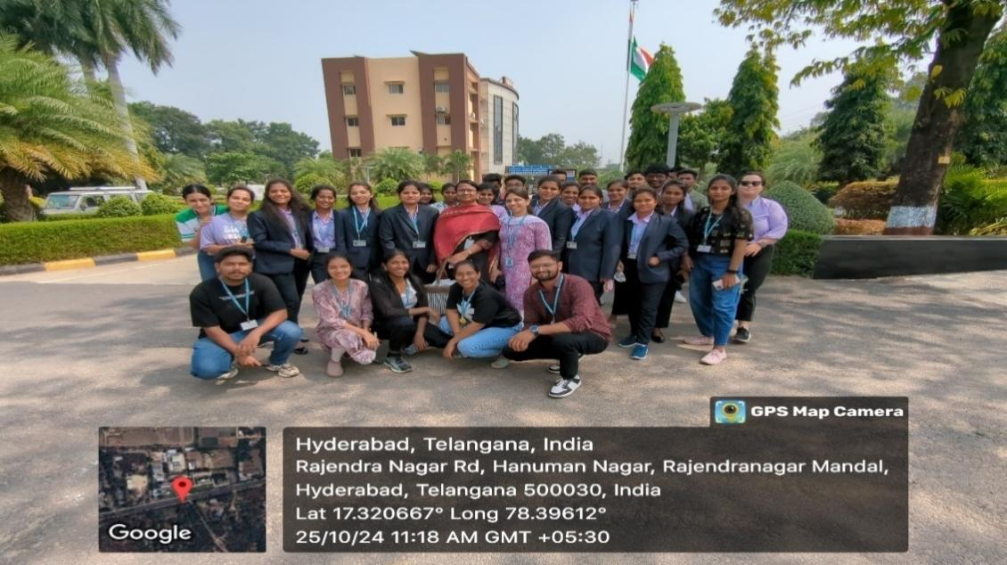
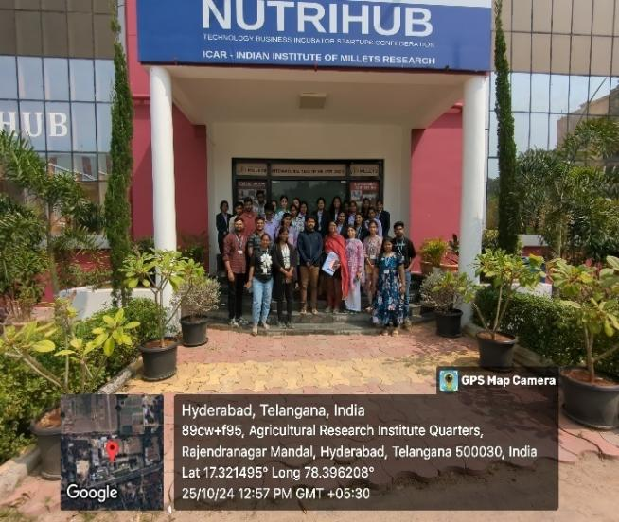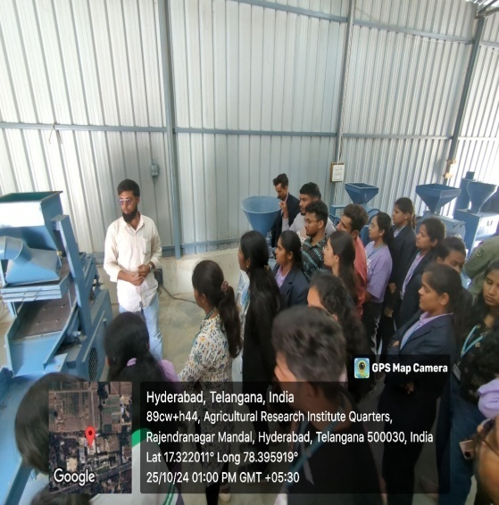

EDUCATIONAL
TOUR

EDUCATIONAL TOUR

- Concept:
The second-year students of M.Sc. Food Technology and Management embarked on an educational tour from September 23rd to 28th, 2024. The tour covered three prominent destinations in Karnataka:

- Coorg: Known for its lush green landscapes, coffee plantations, and spice estates.
- Mysore: Famous for its rich cultural heritage, historic palaces, and research institution.
- Chikkamagaluru: A hub for coffee production, surrounded by scenic hills and valleys.
This tour provided students with a unique opportunity to explore the cultural, geographical, and culinary diversity of Karnataka, while gaining valuable insights into the food industry and its connections to local agriculture, trade, and traditions.
- Purpose:
Educational tour is a part of academic activity organized to enlighten students by visiting different food industries located in different states along with site viewing. This is one of the key steps to help students understand and know about different food industries, their role and functions. This is indeed considered as fun learning technique to expand their knowledge.
- Report:
The students, accompanied by staff members, visited the following notable destinations:
- Coffee Plantation and Spice Cultivation in Coorg: Students gained hands-on experience and insight into the cultivation and processing of coffee and spices, witnessing firsthand the nuances of these industries.
- Central Food Technological Research Institute (CFTRI) in Mysore: This prestigious research institute, renowned for its groundbreaking work in food processing and value-added products, provided students with an opportunity to explore cutting-edge technologies and innovations transforming the food industry.
- Review:
Through this enriching experience, students acquired comprehensive knowledge on:
- Best practices in cultivation and processing
- Quality aspects and standards
- Novel innovations and technological advancements

Moreover, they gained insight into the cutting-edge techniques and methodologies being employed to transform the food industry, driving it towards unprecedented growth and excellence. This exposure empowered students to appreciate the synergy between traditional practices and modern innovations, preparing them to contribute meaningfully to the industry's future advancements.

- Photos:
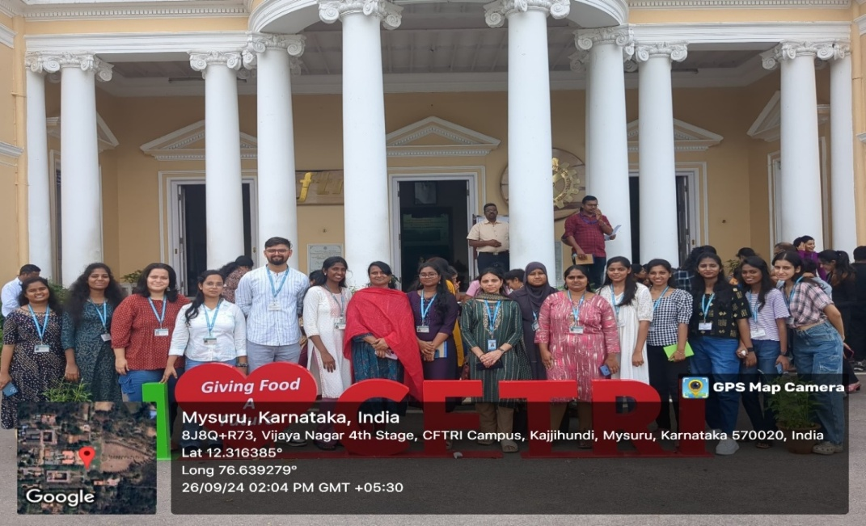
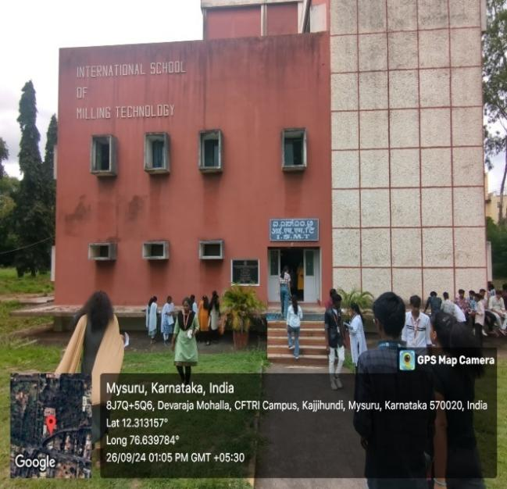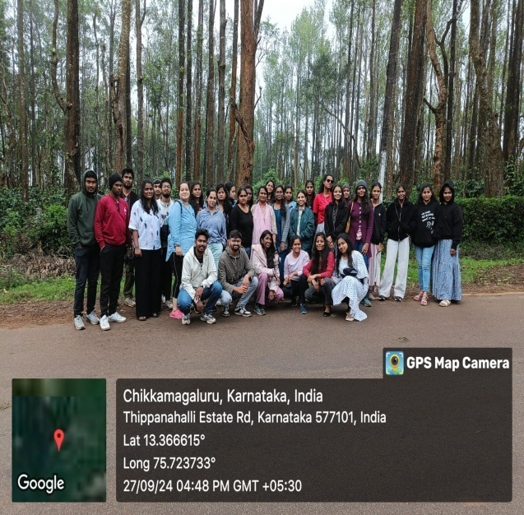

FOOD EXPO

FOOD EXPO

a. Concept:
M.Sc. Food Technology and Management & B.Sc. Food Technology and Management conducted a Food Expo i.e. “Tech Nutri Verse 2024: Where Technology Meets Nutrition” on September 20th and 21st, 2024.

b. Purpose:
The main motto of this program is to highlight advancements in food technology and nutrition. Enlighten and educate students about the importance of community, health, and environmental stewardship, it served as an engaging environment where attendees could:
- Explore groundbreaking advancements in food technology.
- Discover new nutritional insights.
- Witness how scientific research translates into practical applications.
The expo targeted researchers, food industry insiders, and health-conscious consumers, bridging the gap between science and culinary practices.

c. Report:
This Visit had helped students to equip knowledge in instrumentation and different projects, models withengaging workshops, and interactive demonstrations showcasing the models. This also featured guest lectures by esteemed scholars, who shared valuable insights on:
- Latest innovations in food technology
- Importance of healthy living and wellness.
-Food Safety and Labelling.
Attendees enjoyed hands-on activities and culinary delights from the local vendors.
d. Review:
Students thoroughly enjoyed this engaging platform, reveling in the opportunity to share and celebrate the diverse and vibrant world of food.
e. Photos:
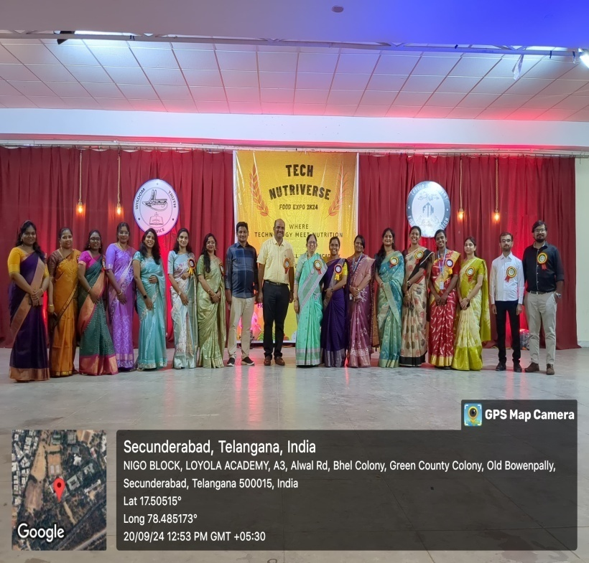
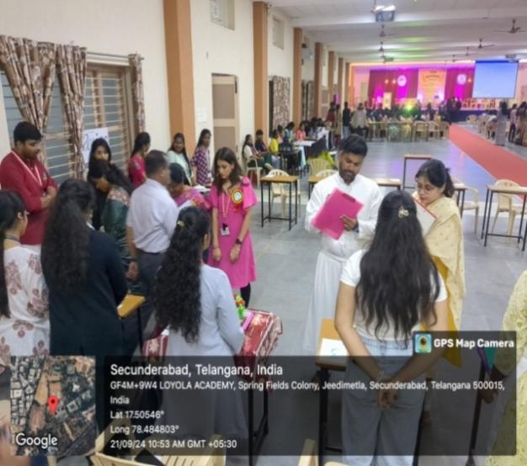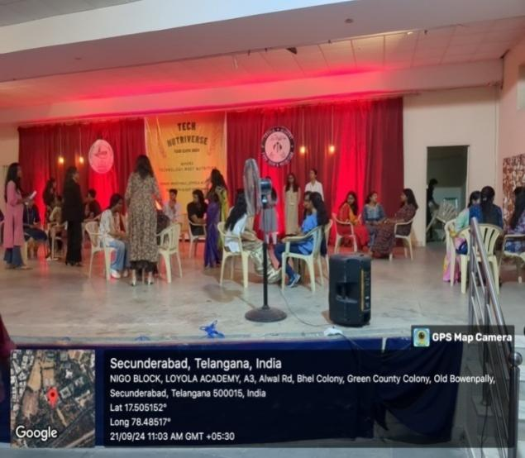

PLANET PROGRAM

PLANET: SOCIAL SERVICE OUT-REACH PROGRAM

  - Concept:
As a part of social service outreach program organized by Loyola Academy, I year students of the department of M.Sc. Food Technology & Management have actively participated in extending their heartful care and support to the needy and socially deprived people.
  - Purpose:
The purpose of our visit was to gain insight into the living conditions, programs, and support systems provided to the students of the Devnar school for blind.
  - Report:
On November 25, 2024, students of M.Sc food technology and managment had the privilege of visiting the Devnar school for blind dedicated to the rehabilitation and care of Visual Impairments. The purpose of our visit was to gain insight into the living conditions, programs, and support systems provided to the students of the Devnar school for blind.
  - Review:
One of the key aspects of support at Devnar School and College for the Blind is the focus on education and skill development. Students are provided with access to educational programs tailored to their unique needs and abilities. We were impressed by the dedication of the staff in fostering the academic and personal growth of the students. The well-being of the students is a top priority at the institution. Trained counsellors and social workers offer individual and group counselling sessions, addressing various challenges, including behavioral concerns, emotional well-being, and personal development. These support services play a crucial role in empowering students to overcome obstacles and achieve their full potential during their time at the school and college.
  - Photos:
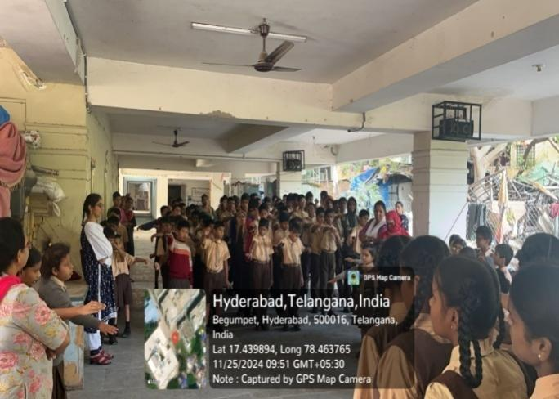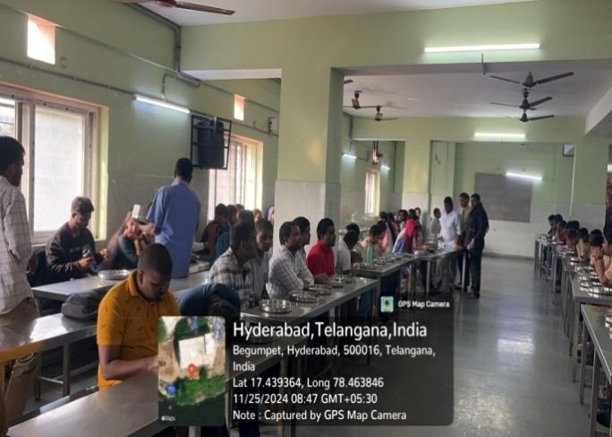

EARN WHILE YOU LEARN

EARN WHILE YOU LEARN PROGRAM
- Concept:
The students of M.Sc. Food Technology And Management have actively took a part in the event and initiated “Earn While Learn Programme” from 1st April 2025 to 5th May 2025, which gave hands on experience and confidence to the students to innovate, introduce and create new bakery products formulated on own.

- Purpose:
To provide a platform to the students to have hands on experience to develop new and innovative products and sell them in the market. This is a step to provide a positive impact in students with respect to facing the market and being an entrepreneur in the field of their study.

- Report:
It gave hands on experience and confidence to the students to innovate, introduce and create new products formulated on own and showcased in the event. This had created a positive impact on students to face the consumers with confidence and enabled them to face new challenges in the area of consumer acceptability of new products.

- Review:
Students and faculty had very good experience and had an opportunity to enlighten them in developing new products and sell them at market level.

- Photos:
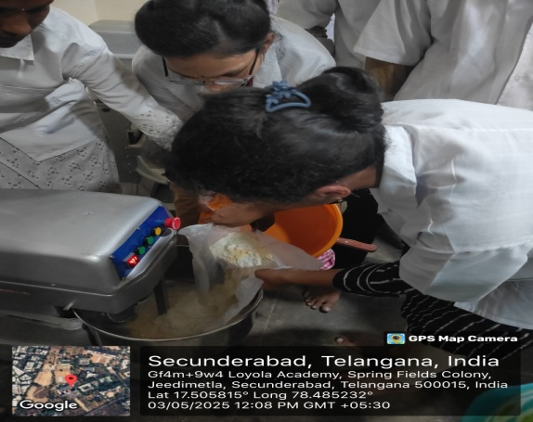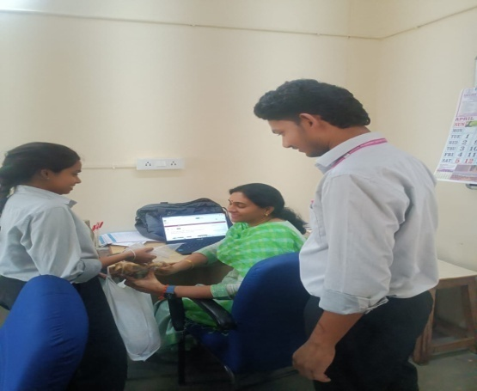

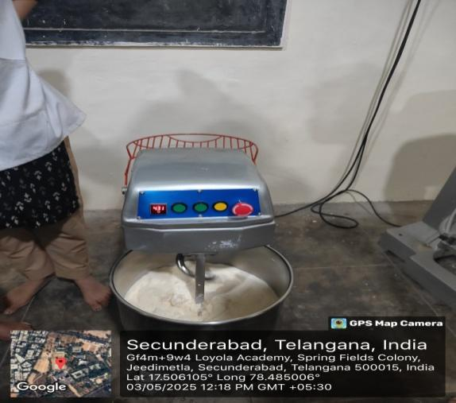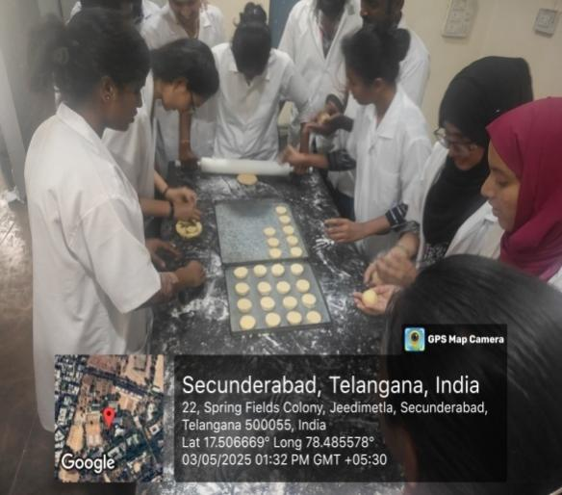

MSME – TRAINING PROGRAM

ENTREPRENEURSHIP DEVELOPMENT PROGRAM

a. Concept:
The Department of M.Sc. Food Technology and Management has actively participated in Entrepreneurship& Skill Development program on “ Craft Bakers ” organized my MSME- Ministryof small and Medium scale Enterprises in Yousufguda, Hyderabad from December 2nd, 2024 to January 6th,2025.

b. Purpose:
To impart knowledge in the field of Baking Science & Technology, and to encourage studentsto be an entrepreneur. This EDP is designed to help students to gain understanding aboutinnovative and advanced processing techniques to manufacture various baked products withcommercial importance.

c. Report:
The department of Food Technology and Management has actively participated in theEntrepreneurship Development program organized by MSME, on “Baking Technology”,educating students to understand the commercial importance and also the production of severalbaked products. This program also provided guidance to the students on how to start a smallscale enterprise and about the government bodies that provide funds/loans for the same.
d.Review:
Students and faculty had very good experience and had an opportunity to enlightenthemselves in the new technologies in the field of baking. Students also learnt about processingof a variety of commercially important bakery products. Over all the training was very informative and helpful.
e.Photos:

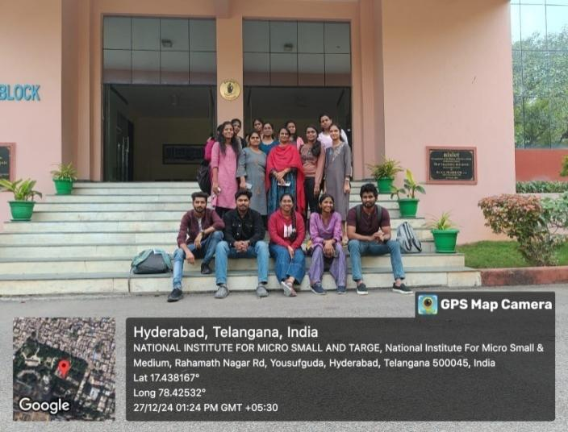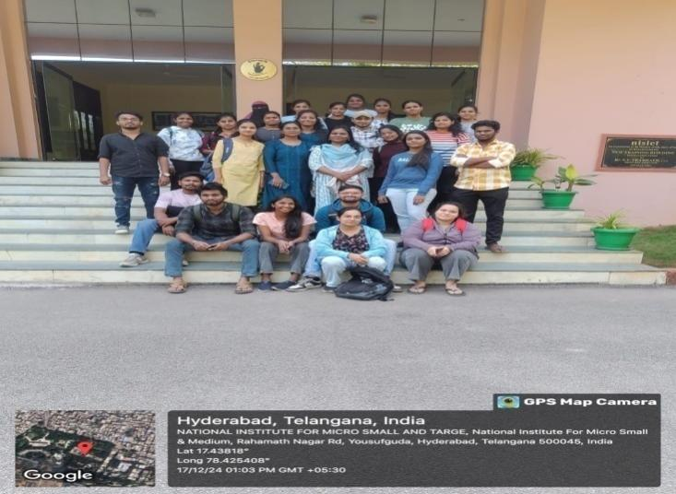

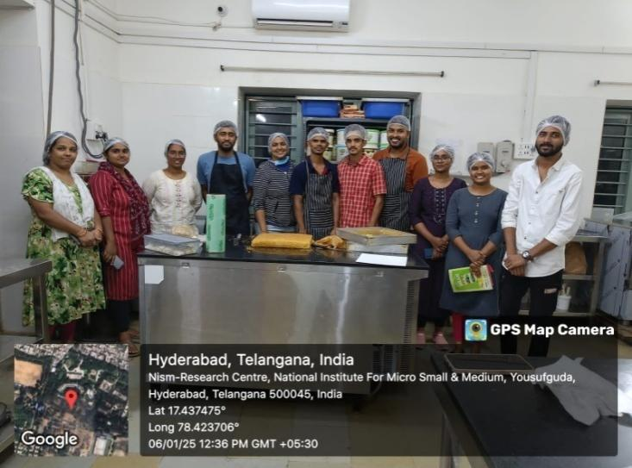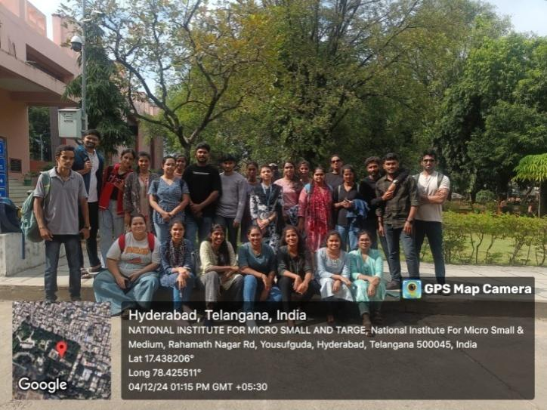

WORLD FOOD DAY

World Food Day
- Concept:
The Department of Food Technology and Nutrition at Loyola Academy, in collaboration with the Internal Quality Assurance Cell (IQAC), observed World Food Day on October16, 2024. The theme of the initiative was "Right to Food for a Better Life and a Better Future."
- Purpose:
The motto of this initiative is to serve the underprivileged with nutritious food on World Food Day, aligning with the global mission to eradicate hunger and malnutrition.

- Report:
To commemorate World Food Day, the students and faculty of the Food Technology and Nutrition department embarked on a philanthropic initiative, "Give to Feed," a grocery drive aimed at supporting vulnerable individuals. This altruistic endeavour highlighted the significance of food security and the fundamental right to nutritious food for all, inspiring students to tap into their innate compassion and generosity.

- Review:
Students successfully distributed basic food items to those in need, making a tangible difference in their community. This initiative not only shed light on the critical issue of food insecurity but also exemplified the department's steadfast commitment to social responsibility, community engagement, and selfless service.

- Photos:
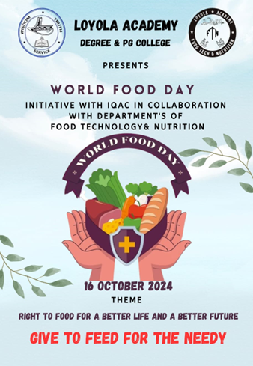
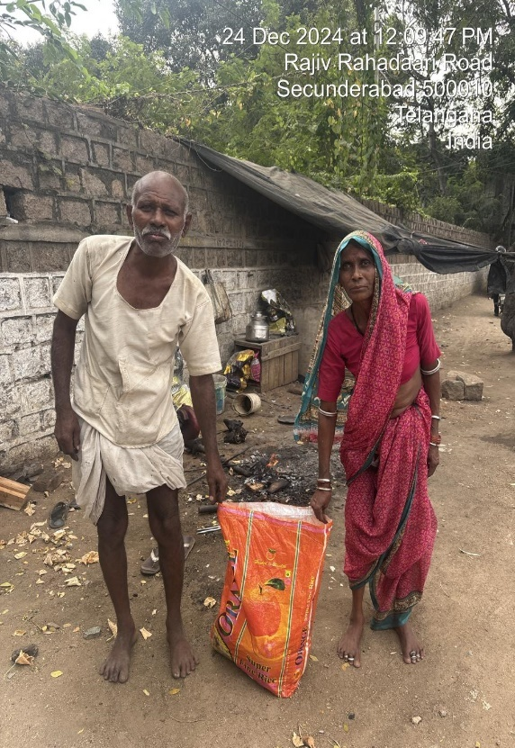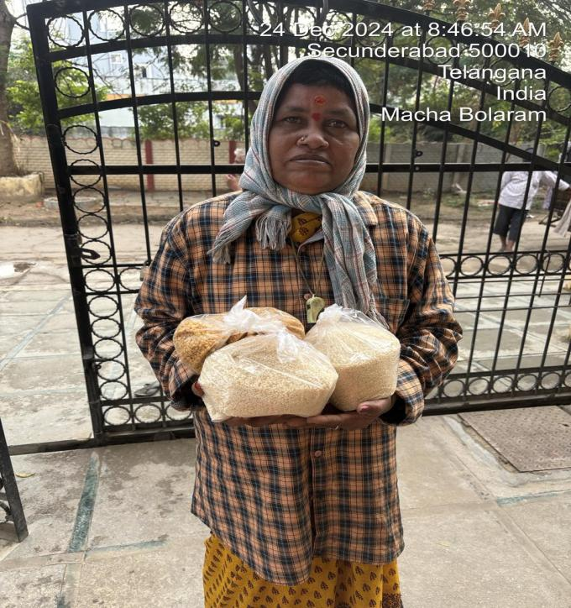

CAREER
DEVELOPMENT PROGRAM

Educational counselling “Educog”-Career development program
- Concept:
Career guidance programme was conducted under collaboration overseas educational counselling “Educog” organized by Loyola Academy for B.Sc& M.Sc. Food Technology and Management (II year) on 13th March 2025. To provide information to pursue their career in abroad. Sandeep Reddy Nagireddy, specialist in Educog was the speaker of the programme.

- Purpose:
The main motto of this program is to enlighten and educate students about the courses for pursuing Master’s in abroad and excel in their career.

- Report:
Sandeep Reddy Nagireddy, specialist in Educog was the speaker of the programme. He has provided students about the list of universities regarding Food technology related courses, entrance exams for different countries and marks to be scored for getting admission, the eligibility criteria, fee structure, scholarship, documents required, loan assistance for pursuing masters in abroad. The educog provide educational counselling, visa processing support and post course completion support for students.

- Review:
Students found this program very informative and inspired to pursue masters in abroad and excel in the field of food technology.

- Photos:
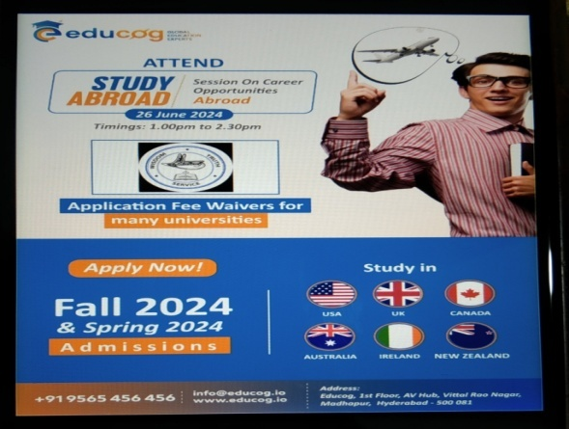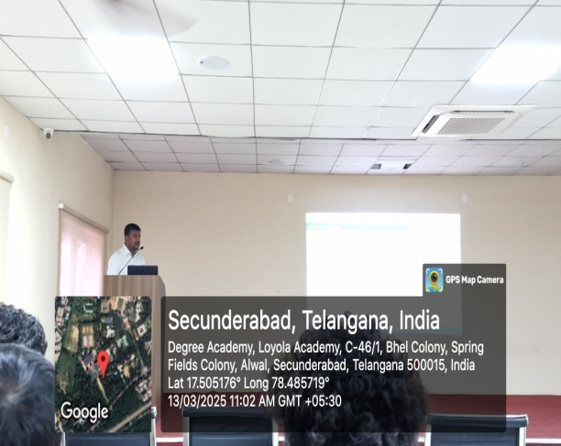
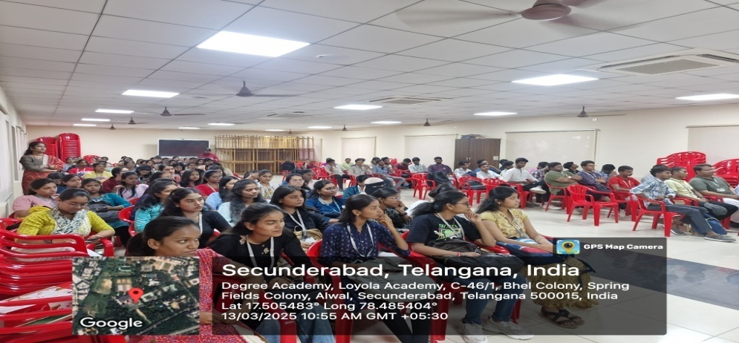

FACULTY
ACHIEVEMENTS

Dr.P.KiranKumari:
Invited speaker:
S. No | Delivered as the lead talk speaker | Event | organized | Month/Year | Place | Presented /participated | Proof
1 | Thematic area “Functional Foods and Natural Products” | National Symposiumon “Synergizing Science for Sustainability: Clean Energy, Resilient Agriculture, and Circular Economy”, | organized by Department of Biosciences and Technology, MIT WPU- Pune | 26th April 2025 | Pune | Speaker | 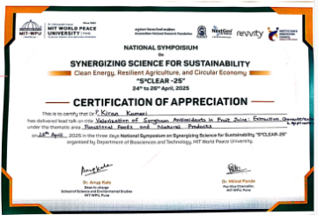
Journal Reviewer
S.No | Reviewed | Journal name | Publication | Month/Year of review | Presented /participated | Proof
2 | has received a certificate of excellence for outstanding contribution in reviewing articles | Journal of Pharmaceutical Research International | Web of Science | October -2024 | reviewer | 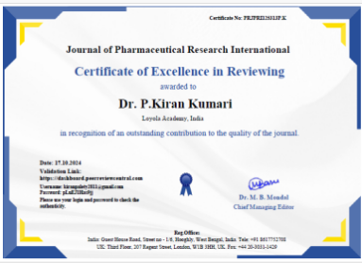
Publications
Book Chapter
S.No | Title | Book title | Month/year | Publication/Place | Proof
3 | Published a book chapter on "Antioxidants-Classifications, Mechanisms and their Uses"(chapter-1) | in the book” Food Processing and Technology | January 2025 | P.K. Publishers & Distributors New Delhi-110053,  ISBN: 978-81-19428-35-9. | 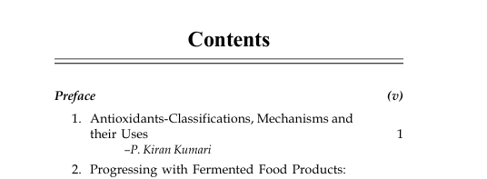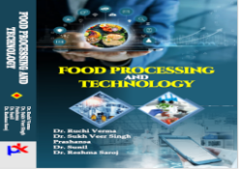

Orientation Program
S.No | Orientation Program | Organized | Month/Year | Presented /participated | Proof
4 | Completed the Orientation Program on “How to Get Ready for NAAC Binary Accreditation Systems” | by the accreditation ranking and certification network of India (ARCNET India) and CliMed Research Solutions, India, | on October 14^{th,} -2024. | Participated | 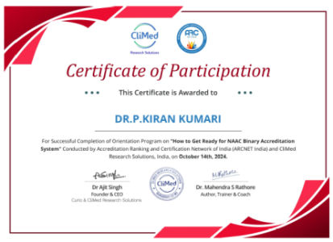
FDP attended
S.No | Title | Organization | Month/year | Participated/presented | Proof
5 | 5-day National level Faculty Development program on “Enhancing Quality Research through Patent Writing and IPR” | organized by Nirmala Memorial Foundation Collage of Commerce and Science, Maharashtra in collaboration with Loyola Academy (Autonomous), Telangana, from . | 11th February to 15th February 2025 | Participated | 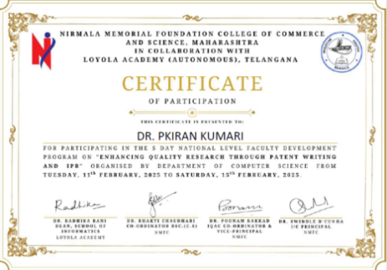
6 | 15 Days International Online Faculty Development Programme (FDP) on “MICROBIAL INSTRUMENTATION – AN OVERVIEW (Phase I)”.and has successfully completed with DISTINCTION | organized by the Department of Microbiology, Sacred Heart College (Autonomous), Tirupattur, Tamil Nadu, India in association with Biotechnology Society of Nepal (BSN) and Laboratory of Chemical and Biological Analysis (LAQB), Western Rio Janeiro State University (UEZO), Rio de Janeiro, Brazil | 27th January 2025 – 10th February 2025 . | Participated | 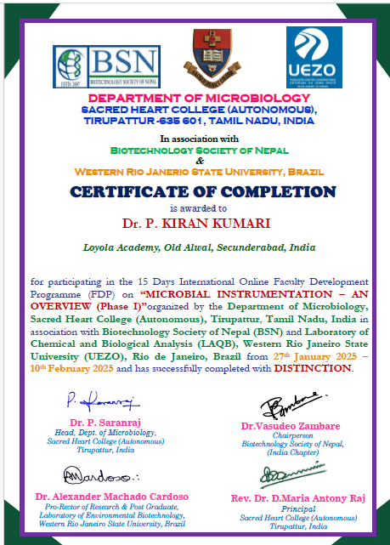
7 | Faculty Development Program on Advanced Techniques in Molecular Biology and Biotechnology | Organized by the Department of Biotechnology, Loyola Academy, Hyderabad | 29th November- 3rd December 2024. | Participated | 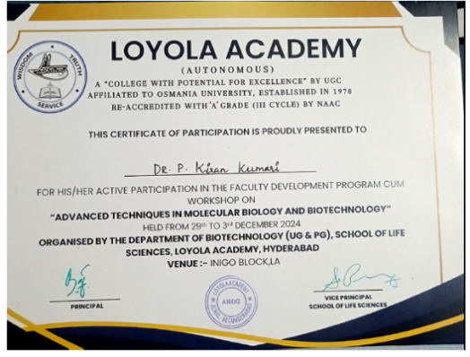
POSTER PRESENTATIONS
8 | Won best poster presentation for title “The Cool, Science Behind Safer Sips” Cold Plasma Tech,in the 3-day National Symposium on Synergizing Science for Sustainability S³ CLEAR-25”. under the thematic area “Natural products and functional foods” | organized by the Department of Biosciences and Technology, MIT World Peace University | held from 24th to 25th April 2025 | Presented | 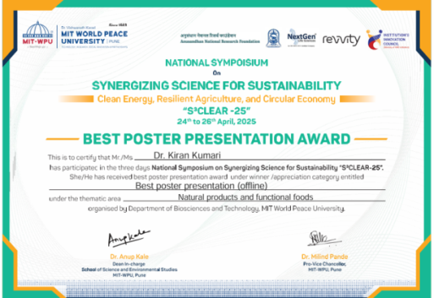
9 | Won best poster presentation for the title “Taste of Technology; Ai Ensuring Food Quality from Farms to Forkin the 3-day National Symposium on Synergizing Science for Sustainability S³ CLEAR-25”. under the thematic area “Natural products and functional foods” , | organized by the Department of Biosciences and Technology, MIT World Peace University | held from 24th to 25th April 2025 | Presented | 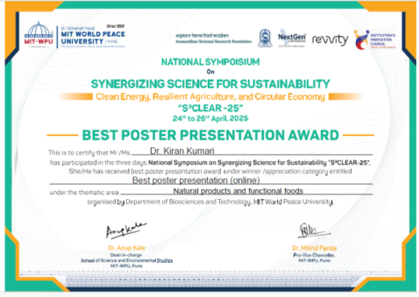
WORKSHOPS
10 | The two-day workshop on Essential AI for Teachers, Students and Researchers | Organized by the Department of Research &PublicationA2Z EduLearningHub | 8th and 9th July 2024. | Participated | 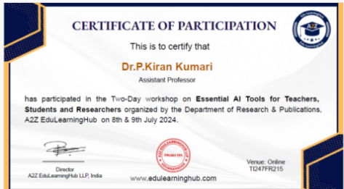
11 | Hands-onWorkshop on Molecular Docking, Genomics and AI/ML (Biocode 2025) | organized by the Department of Biosciences and Technology, MIT-World Peace University, Pune, | held on 21-22 March 2025 | Participated | 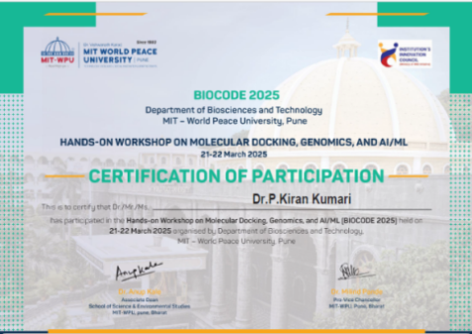
Webinar
12 | webinar on “Patents-How to File &ProtectYour Inventions” | organized by AIRA Academy (Registered with NITI Aayog, Government of India) | on 10th September 2024. | Participated | 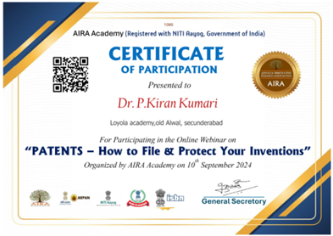
S.No | THEME | PLACE | INTERNATIONAL/NATIONAL/STATE | YEAR | RESOURCE/  PAPER | CERTIFICATE
1. | Advanced Techniques in Molecular Biology and Biotechnology | Loyola College | FDP | 2025 | Participated | 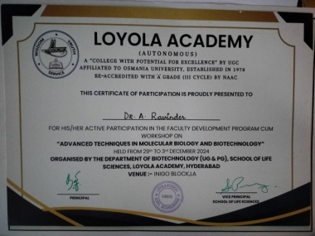
2. | Development and Quality evaluation of ready to eat value added products (Cake & Wafer) from composite flour (Moringa leaves powder, great millet & little millet). | International Journal of Food Science and Nutrition | International | October, 2024 | Paper Publication | 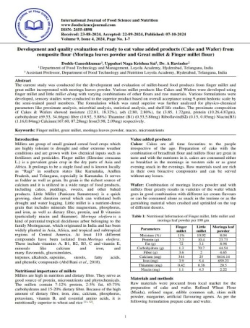
Dr. A. Ravinder

Mrs. S. Jemmy Evangeline
S.NO | NAME OF THE EVENT | THEME | ORGANIZED BY  National/International | MONTH/  YEAR | PLACE | PROOF
1. | Leveraging Artificial Intelligence for effective Educational work | Webinar | National | October 19, 2024 | A3 Minds, India. | 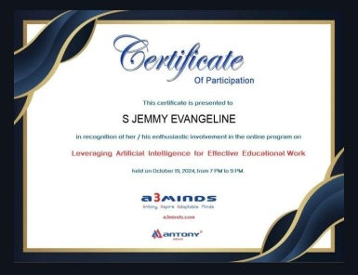
2 | Innovative Teaching and Learning Pedagogy | Faculty Development Program (FDP) - 5 days | National | July 23-27, 2024 | Research Foundation India & Council of academic research and educational Organization (RFI-CARE), India. | 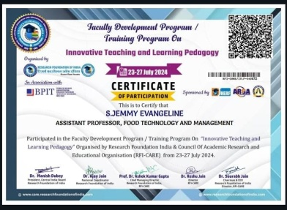
3 | Institutional Development plan (IDP) for Higher Educational Institutions | National Awareness program | National | March 2025 | Telangana Council of higher Education and Institution for Academic Excellence (IAE), Hyderabad. | 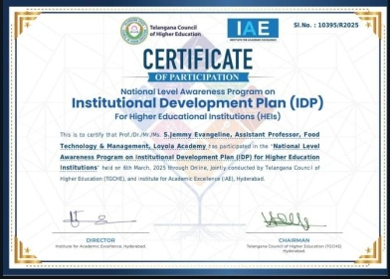
 | Paper Publication:
1 | Study integrating food integrity and consumer behaviour - a  Farm to fork approach for food supply and consumer  Confidence to purchase | Journal of Xi'an University of Architecture & Technology | International |  |  | 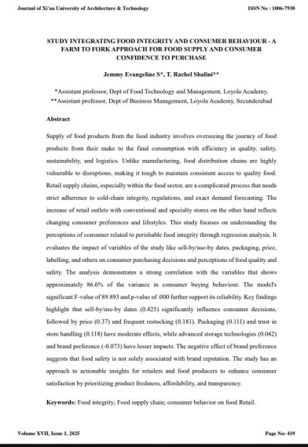

Mrs. K Tejaeswini
 | THEME | PLACE | INTERNATIONAL/NATIONAL/STATE | YEAR | RESOURCE/  PAPER | CERTIFICATE
1. | Advanced Techniques in Molecular Biology and Biotechnology | Loyola College | FDP | 2025 | Participated | 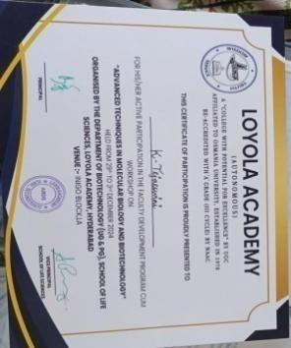
2. | Food Additives: Classification and their role |  | National | 2025 | Book Chapter | 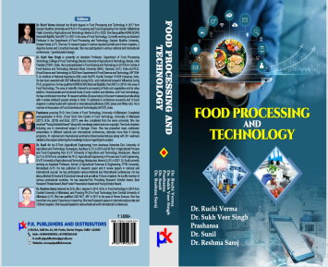

A.Pravalika Reddy
 | THEME | PLACE | INTERNATIONAL/NATIONAL/STATE | YEAR | RESOURCE/  PAPER | CERTIFICATE
1. | Advanced Techniques in Molecular Biology and Biotechnology | Loyola College | FDP | 2025 | Participated | 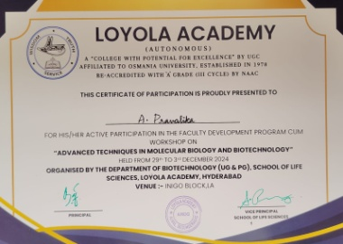

STUDENT ACHIEVEMENTS

S.No | UID No | Name of the student | Certificate
1 | 111722620019 | Faizan Zaid Khan | 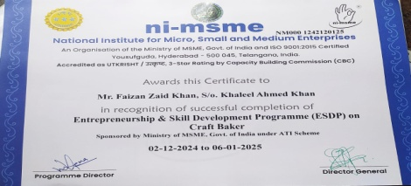
2 | 111723620001 | SreeramVaishnavi | 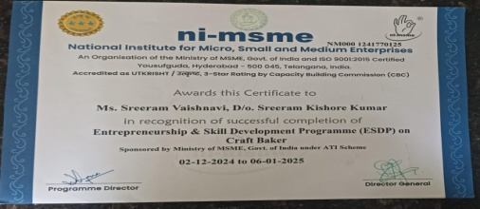
3 | 111723620002 | SudigaAkhila | 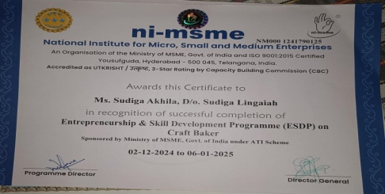
4 | 111723620003 | Chilukuri Pooja | 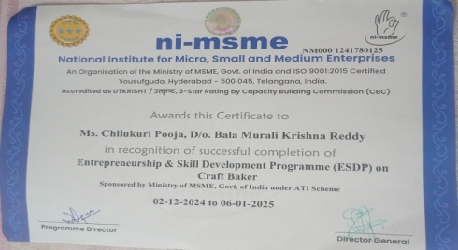
5 | 111723620004 | Chinthapelli Pradeep | 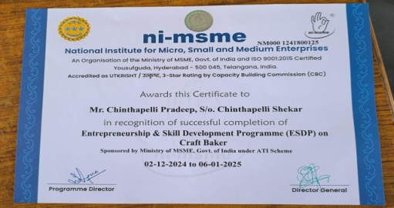
6 | 111723620005 | AddankiPravallika | 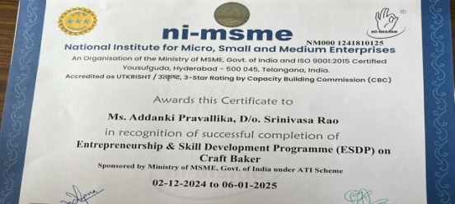
7 | 111723620006 | Shrinivas Gopal Sharma | 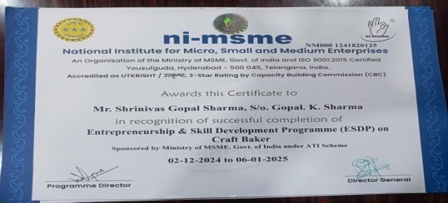
8 | 111723620007 | Thanam Mary Sona | 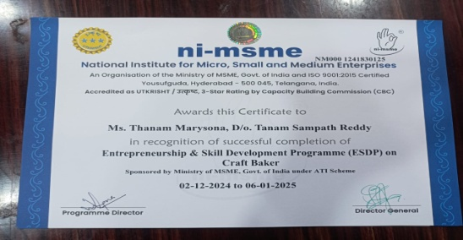
9 | 111723620008 | Alisha Hossain | 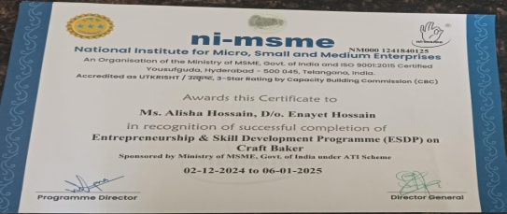
10 | 111723620009 | T Pooja | 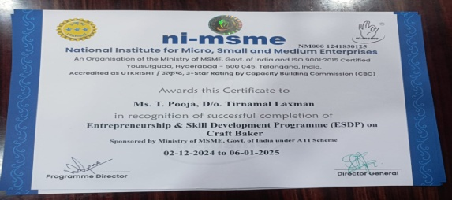
11 | 111723620011 | Connor Elanor Christopher | 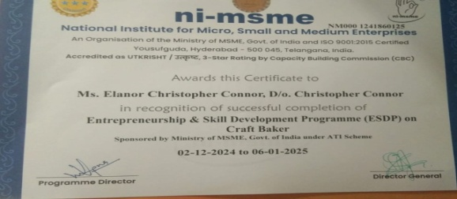
12 | 111723620012 | Shaik Imam Basha | 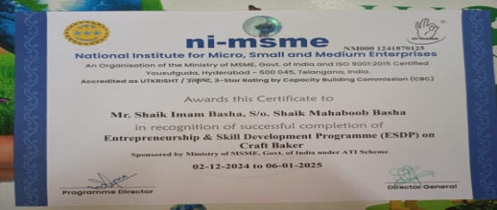
13 | 111723620013 | MohitValtati | 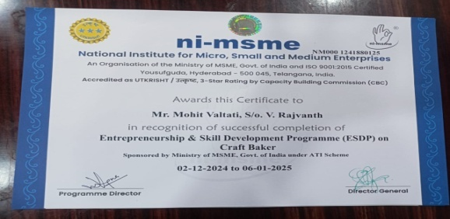
14 | 111723620014 | Rathod Pooja | 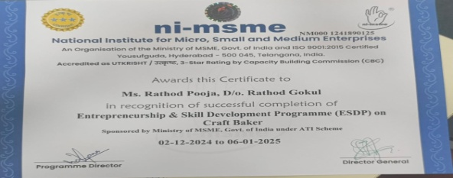
15 | 111723620015 | DasariMukesh | 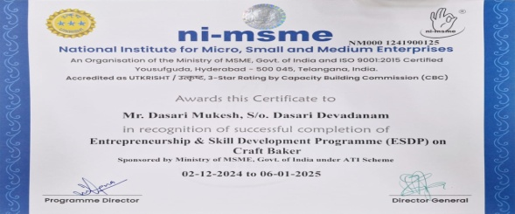
16 | 111723620016 | Banka Christopher | 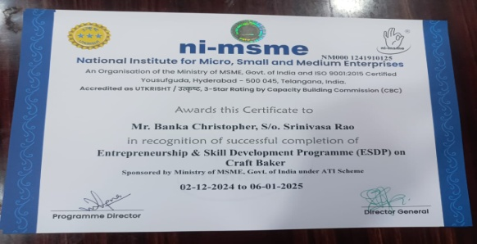
17 | 111723620017 | UlligaddalaPrathibha | 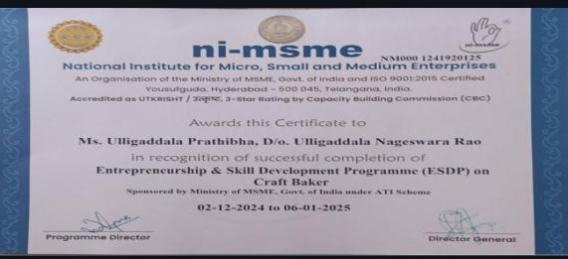
18 | 111723620018 | Manikonda Sai VenkataSowjanya | 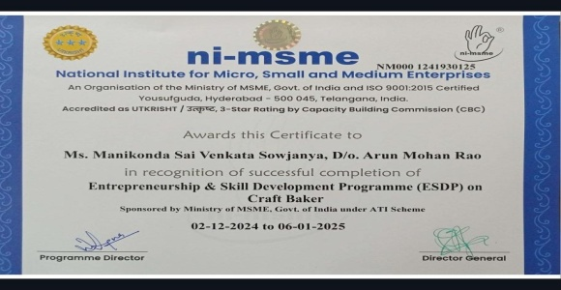
19 | 111723620019 | MadasuSravyasri | 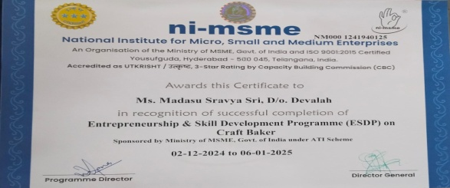
20 | 111723620020 | Bavu Rani | 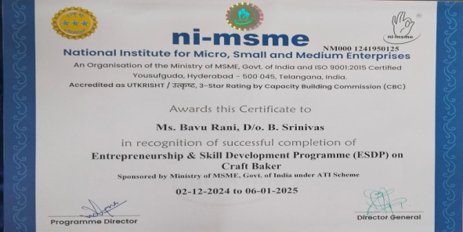
21 | 111723620021 | ChekkeraNikitha | 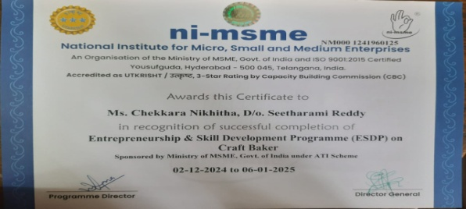
22 | 111723620022 | PrernaVenkateswaran | 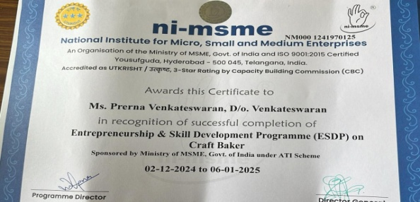
23 | 111723620023 | Tanisha Patangay | 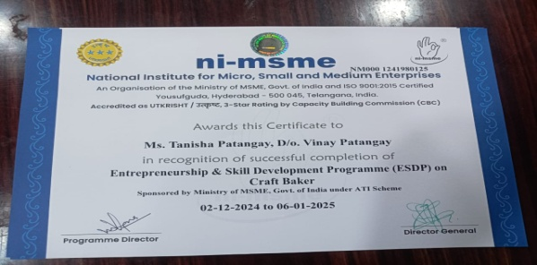
24 | 111723620024 | KompelliRoshini | 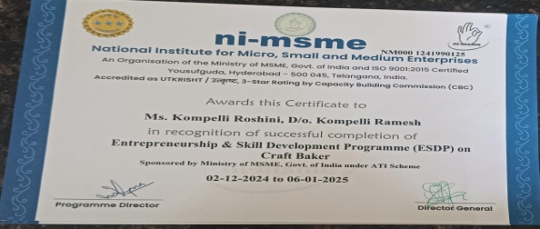
25 | 111723620025 | NerellaSathwika | 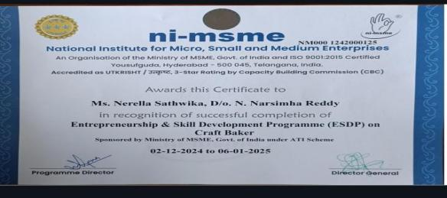
26 | 111723620026 | Oppula Shiva Pavani | 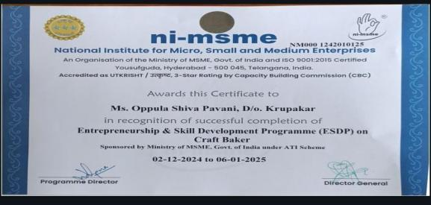
27 | 111723620027 | Mohammad Nazeer Ahmed | 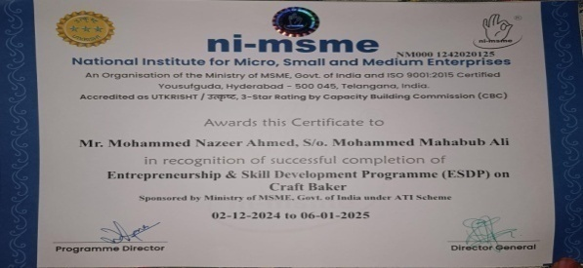
28 | 111723620028 | Dusari Papa Nikitha | 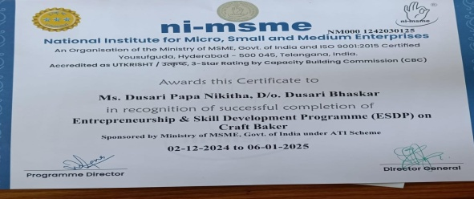
29 | 111723620029 | DhakshayiniSreedharJukanti | 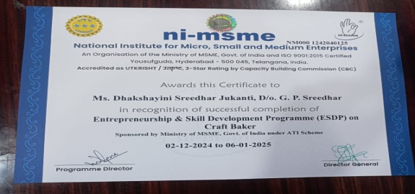
30 | 111723620030 | G Vaishnavi | 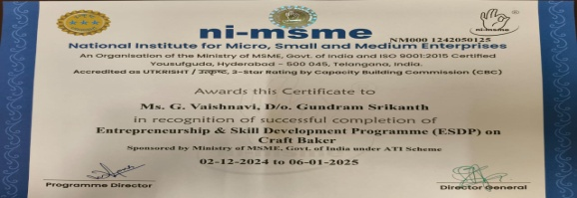
31 | 111723620031 | MamidiDivya | 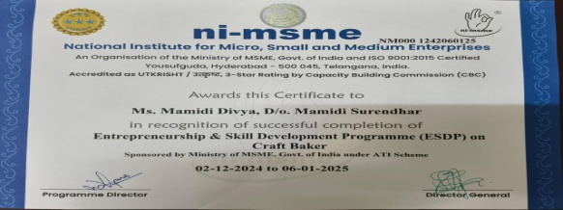
32 | 111723620032 | C HarshaVardhan Reddy | 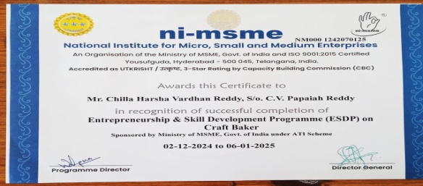
33 | 111723620033 | Abdul Nadeem | 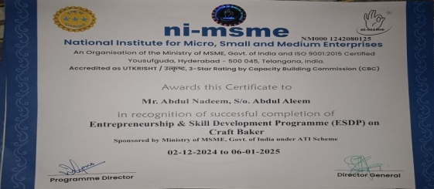
34 | 111723620034 | DevallaAkshaya | 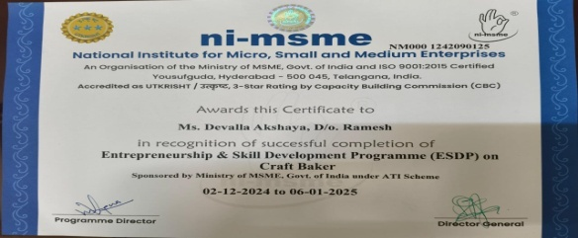
35 | 111723620035 | S Swapna | 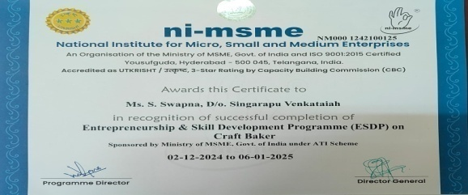
36 | 111723620036 | Habeeba | 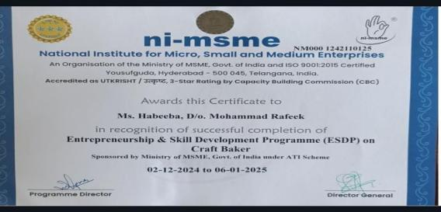

MIT Pune Conference- Offline Poster Presentation Winners
S.No | Name | UID No | Participation Certificate
1 | YL Abhishek | 111724620001 | 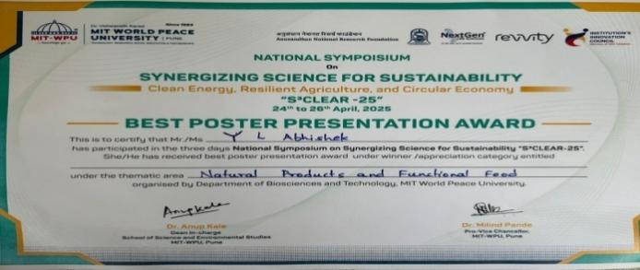
2 | VanaparthyGayathri | 111724620015 | 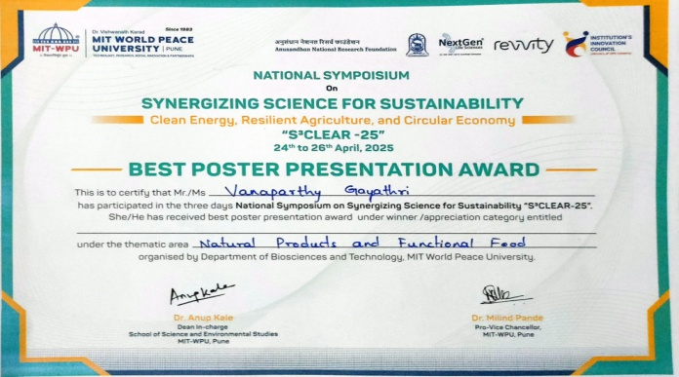
3 | RepakaAarthi | 111724620018 | 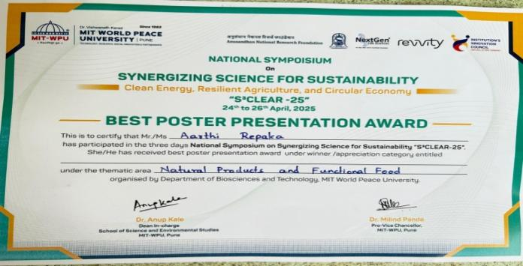

MIT Pune Conference- Online Poster Presentation Winners
S.No | Name | UID No | Participation Certificate
1 | Bokkala Sreeja | 111724620016 | 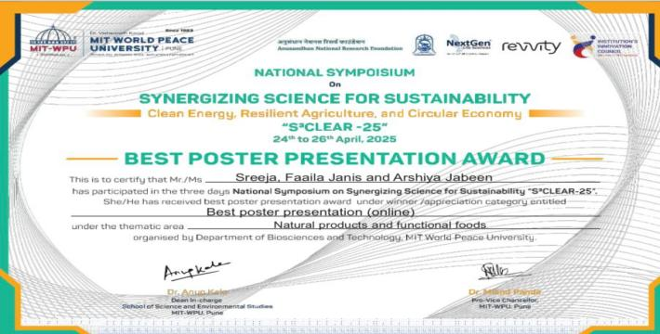
2 | Arshiya Jabeen | 111724620030
3 | Faila Janis | 111724620031

Sports : Winner
S.no | Name | UID No | Certificate
1 | YL Abhishek | 111724620001 | 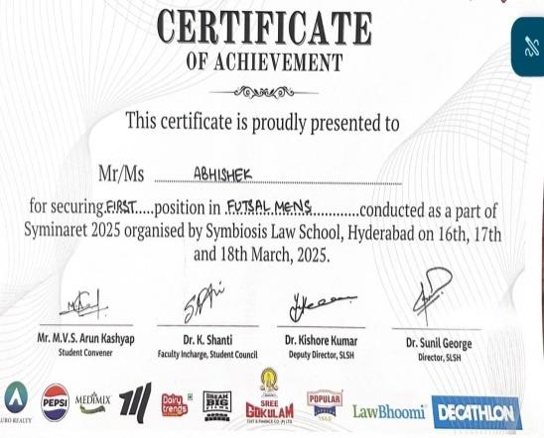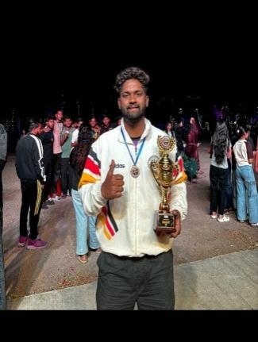

Poster Presentation Participation
S.No | Name | UID No | Participation Certificate
1 | YL Abhishek | 111724620001 | 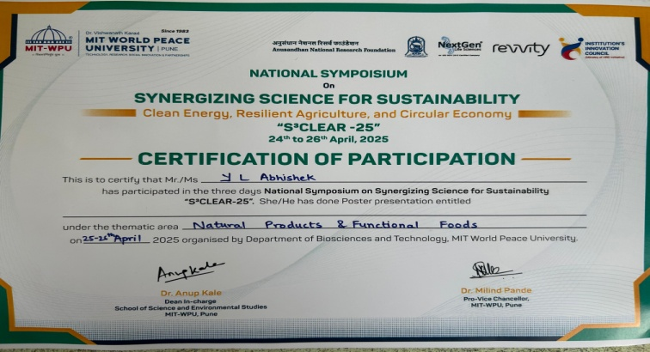
2 | ThoomPradeepthi | 111724620005 | 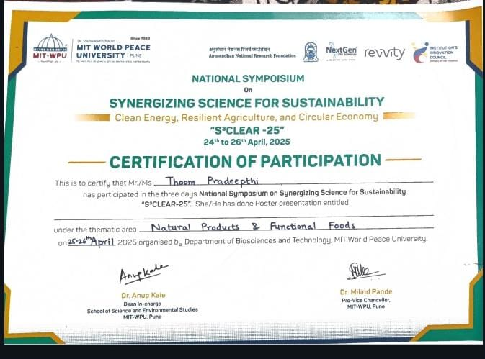
3 | C Dheeksha | 111724620010 | 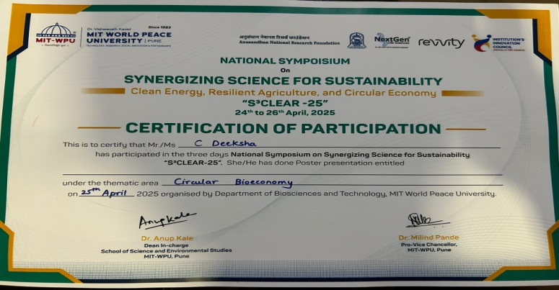
4 | Chedubavi Vinay Kumar | 111724620011 | 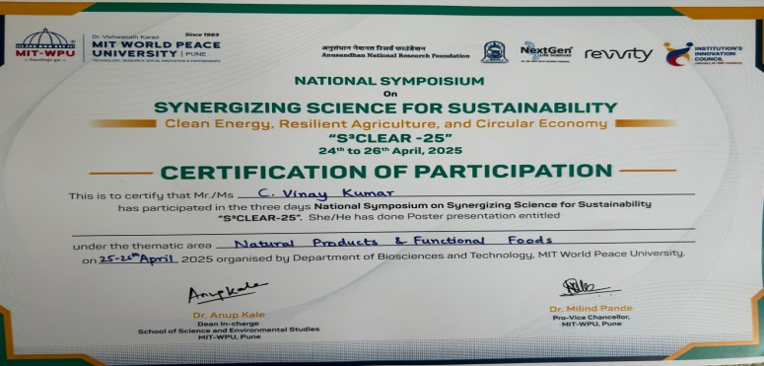
5 | VanaparthyGayathri | 111724620015 | 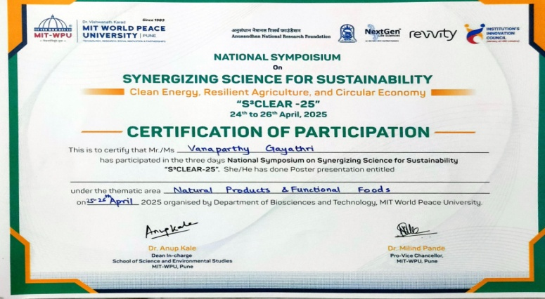
6 | RepakaAarthi | 111724620018 | 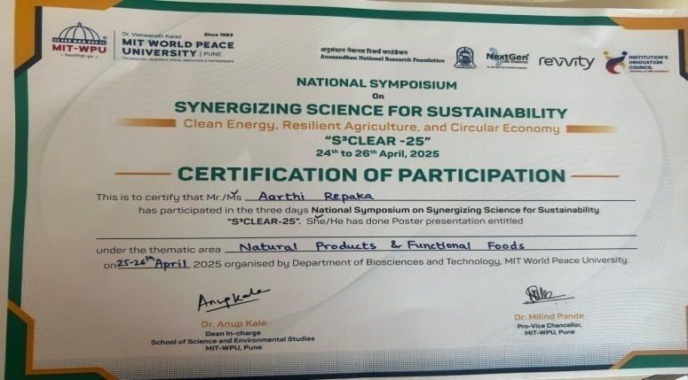
7 | Pulimamidi Sanjay Kumar | 111724620020 | 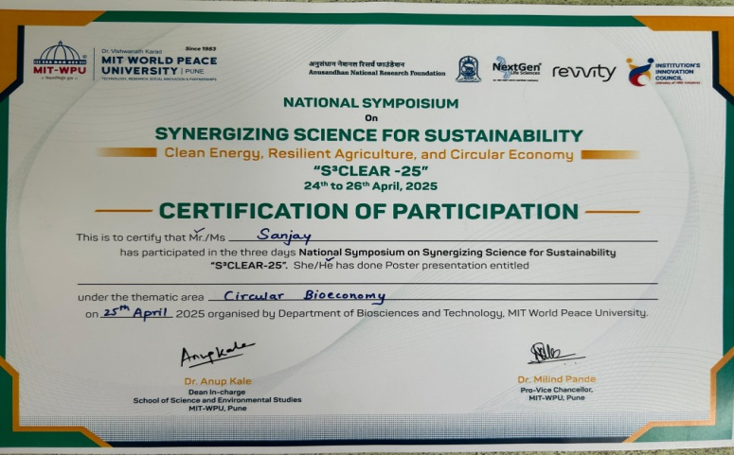
8 | DhokiShashank | 111724620021 | 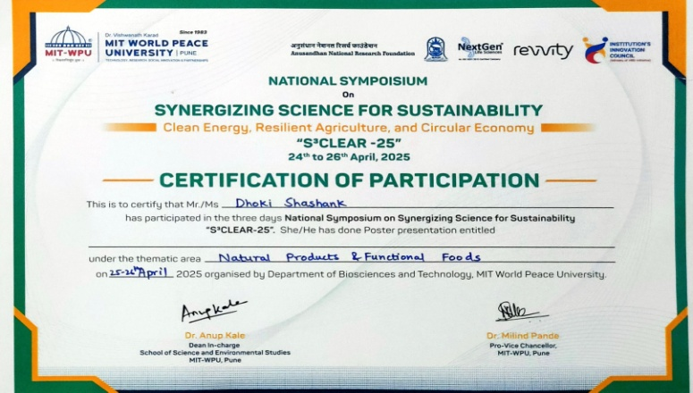

PARENT-TEACHER MEETING REPORT

PARENT-TEACHER MEETING
- Concept:
Parent Teacher Meeting for M.Sc. I year and II year students was conducted on22nd February 2025.
- Purpose:
To interact with parents and give feedback of the students and also get suggestions from them for the improvement of the department
- Report:
Parents and students met all the staff members on one to one basis.
- Reviews:
It is useful for the improvement of the students.

Agenda of the meeting:
- Interaction between parents and teachers to createahealthy teaching environment.
- To refresh the rules and regulations of Loyola Academy.
- To inform parents regarding detain Rules and Attendance Rules.
- To check and improve the academic performance of students.
- To improve the results of students by taking various actions.
- Feedback will be given by parents.
Highlights of Meeting:
- Parents are familiar with rules and Regulations of Loyola Academy.
- Parents have checked attendance and academic performance of their ward.
- Parents were known about their wards behaviour, Discipline and responsibility.
- Contact numbers of department faculties are provided to parents for better communication.
Suggestions given by the parents:

- Apart from teaching curriculum lecturers have to provide the information regarding the course and its importance.
- Department need to organise internships and projects to the students to improve the practical knowledge.
Feedback given by the parents:
Parents expressed their gratification towards the institution in enhancing the personality of the students under the able guidance of Principal. They also appreciated the efforts being made by the college for the overall development of their ward. Parents were very happy regarding the activities going on in the college.

Few of the student parents were not available for the meeting so for them an online session is being done. Proof for the following online session
e. Photos:

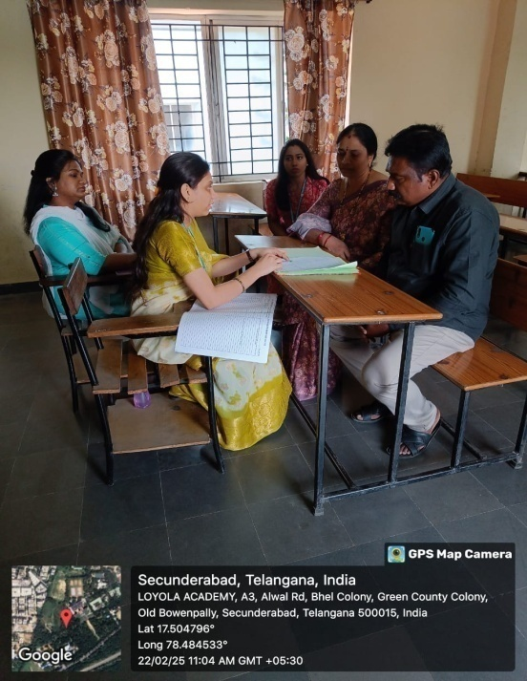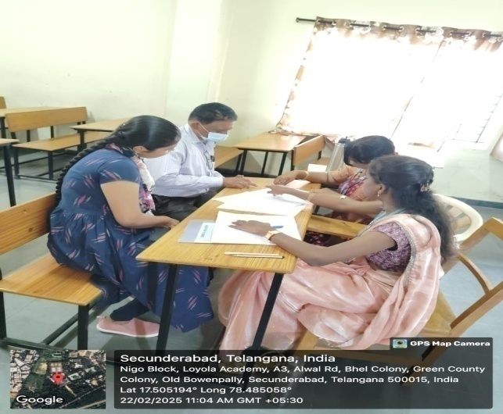

MENTOR-MENTEE LIST

MENTOR-MENTEE LIST 2024-25
S.No | Name of the Faculty | Class/No. of Students | UID. No. | Name of students | Total no of Students
1 | Dr.Palety Kiran Kumari | NMFT-6 | 111723620008 to 111723620014 | 8. ALISHA HOSSAIN  9. T. POOJA  11. C. ELANOR CHRISTOPHER  12. S. IMAM BASHA  13. MOHIT VALTATI  14. R. POOJA | 14
1 | Dr.Palety Kiran Kumari | AMFT-8 | 111724620015 to 111724620022 |  | 14
  15.VANAPARTHY GAYATHRI
  16.BOKKALA SREEJA
  17.MADAMOLLA BHAVYA SRI
  18.REPAKA AARTHI
  19.GUMMULA RADHIKA
  20.PULIMAMIDI SANJAY KUMAR
  21.DHOKI SHASHANK
  22.KAMBHAM MAHESH
2 | Dr. A. Ravinder | NMFT-7 | 111723620001 to 111723620007 | 1.S. VAISHNAVI  2. S. AKHILA  3. C. POOJA  4. C. PRADEEP  5. A. PRAVALLIKA  6. S. GOPAL SHARMA  7. THANAM MARYSONA | 14
2 | Dr. A. Ravinder | AMFT-7 | 111724620001 to 11172462007 |  | 14
  1. YL ABHISHEK
  2.KORINGINJA MANASA
  3.MARAPAKA VARSHINI
  4.G HARSHITHA
  5.THOOM PRADEEPTHI
  6.KOYYA CHAITANYA APARNA REDDY
  7.SHAIK SHAHEEN BATUL
3 | Mrs. S. Jemmy Evangeline | NMFT-7 | 111732620022 to 111732620028 | 22. P. VENKATESWARAN  23. TANISHA PATANGAY  24. K. ROSHINI  25. NERELLA SATHWIKA  26. O. SHIVA PAVANI  27. M. NAZEER AHMAD  28. DUSARI PAPA NIKITHA | 14
3 | Mrs. S. Jemmy Evangeline | AMFT-7 | 111724620008 to 111724620014 |  | 14
  8.MOGILIGIDDA TRUSHNA
  9.KOYA JAI KRISHNA
  10.C DEEKSHA
  11.CHEDUBAVI VINAY KUMAR
  12.CH VINAY
  13.ANIKE SHILPA
  14.UDUGULA ANIL
4 | Mrs. K Tejaeswini | NMFT-7 | 11123620015 to 11123620021 | 15. D. MUKESH  16. B. CRISHTOPHER  17. U. PRATHIBHA  18. M. SAI VENKATA SOWJANYA  19. MADASU SRAVYASRI  20. BAVU RANI  21. C. NIKITHA | 14
4 | Mrs. K Tejaeswini | AMFT-7 | 111724620023 to111724620029 |  | 14
  23.PITLA VAMSHI
  24.EDHA SRINIVASULU GEETHIKA
  25.ALEKHYA NUKAPELLY
  26.SINGAM VENKATESH
  27.SAMSON ARUL
  28.LETHAKULA SRUTHI
  29.SANDEEP NANNAM
5. | Ms. A. Pravalika Reddy | NMFT- 8 | 111723620029 to 111723620036 | 29. D SREEDHAR JUKANTIDHAKSHAYINI  30. G. VAISHNAVI  31. MAMIDI DIVYA  32. C. HARSHA VARDHAN REDDY  33. ABDUL NADEEM  34. DEVELLA AKSHYA  35. S. SWAPNA  36. HABEEBA | 15
5. | Ms. A. Pravalika Reddy | AMFT- 7 | 111724620030 to 111724620036 |  | 15
  30.ARSHIYA JABEEN
  31.FAAILA JANIS
  32.YALLATURU BEULAH
  33.CHINTHALA ANIL
  34.MOTUPALLI JAYASRI
  35.MANDA MOUNIKA
  36.JAMALPURI VAISHNAVI
Total Strength |  |  |  |  | 71

STUDENT SCHOLARSHIP

S.no | Uid no. | Name of the candidate | Name of the acc holder (parent) | Proposed amount
1. | 111723620021 | ChekkeraNikihitha | Chekkera Seetha Ramireddy | 12000
2 | 111723620029 | DhakshayiniSreedharJukanti | Gukanti Pandu Sreedhar | 5000
3 | 111723620036 | Habeeba | Hazibaba | 8000
4 | 111723620019 | M. Sravya Sri | M. Sujatha | 7500
5 | 111723620002 | SudigaAkhila | SudigaLingaiah | 5000
6 | 111723620024 | KompelliRoshini | Kompally Ramesh | 10000
7 | 111723620004 | CH. Pradeep | ChinthapallyShekar | 7500
8 | 111723620025 | NerellaSathwika | NerellaNarsimha Reddy | 5000

NPTEL DATA

S.no | UID No | NPTEL Roll no | Name of student | Title of the course | No of weeks | Percentage | Proof
1 | 111724620009 | NPTEL25AG14S347008008 | Jaya Krishna | Food Microbiology for Safe and Sustainable Food Systems | 8 weeks | 77% | 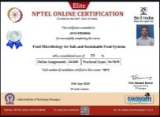
2 | 111724620012 | NPTEL25AG14S447003142 | Challagurgula Vinay | Food Microbiology for Safe and Sustainable Food Systems | 8 weeks | 60% | 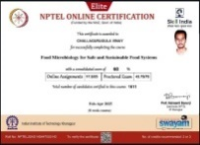
3 | 111724620013 | NPTEL25AG14S347002142 | AnikeShilpa | Food Microbiology for Safe and Sustainable Food Systems | 8 weeks | 73% | 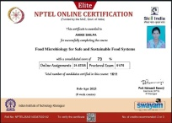
4 | 111724620019 | NPTEL25AG14S447007172 | Radhika | Food Microbiology for Safe and Sustainable Food Systems | 8 weeks | 69% | 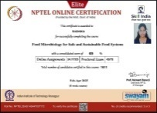
5 | 111724620024 | NPTEL25AG14S447008123 | EdhaSrinivasuluGeethika | Food Microbiology for Safe and Sustainable Food Systems | 8 weeks | 62% | 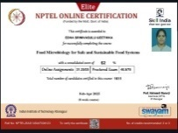
6 | 111724620036 | NPTEL25AG14S347007911 | Vaishnavi | Food Microbiology for Safe and Sustainable Food Systems | 8 weeks | 75% | 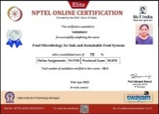

PLACEMENT

S.NO | Specialization | UID | Name of the student | Designation | Place of work | Salary/Annum | Proofs
1 | Food Technology | 111722620024 | VaddeVenkata Sai Kumar | Production Executive | Bakewell Industries PVT LTD | 1,80,000/- | 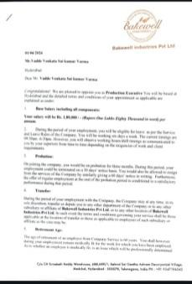
2 | Food Technology | 111722620004 | KollimallaBindurani | Quality Associate | Skyup Solutions | 2,02,500/- | 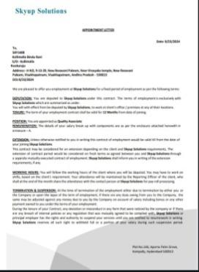
3 | Food Technology | 111722620008 | Bondaladinne Havilah Joy | Quality Associate | Skyup Solutions | 2,02,500/- | 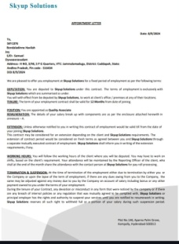
4 | Food Technology | 111722620013 | AnkannagariPravalika Reddy | Assistant professor | Loyola Academy | 4,20,000/- | 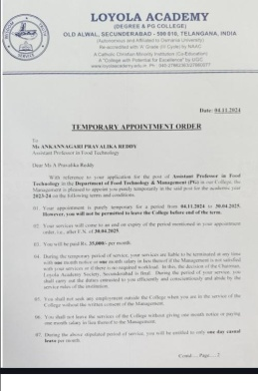
5 | Food Technology | 111722620015 | GangadhariSravaniKalyani | Executive Quality Assurance | Zeus Hygia Life Sciences | 2,18,400 | 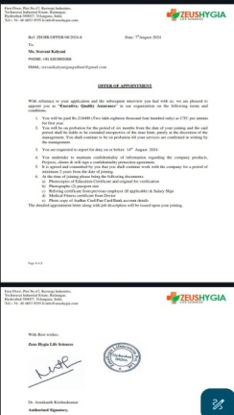
6 | Food Technology | 111722620035 | MarupakaRekha | Flavourist-Lab technician | Spectra Flavours and Emulsions | 1,80,000/- | 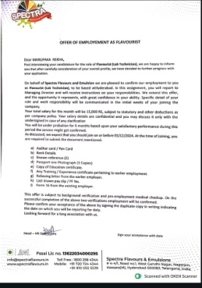
7 | Food Technology | 111722620007 | SrinidhiRamaraju | Flavourist-Lab technician | Spectra Flavours and Emulsions | 1,80,000/- | 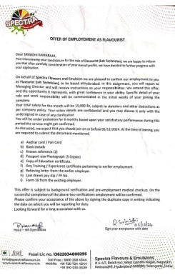
8 | Food Technology | 111722620036 | BlessyPrasidhi | Teacher | Rotterdam International school | 2,64,000/- | 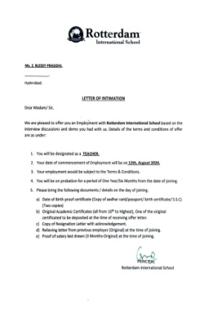
9 | Food Technology | 111722620034 | AkshayaManoj | Teacher | Rotterdam International school | 2,64,000/- | 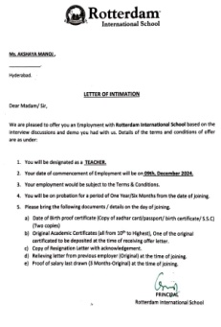
10 | Food Technology | 111722620018 | B. BhanuChanduPriya | Project Assistant | CSIR-CFTRI | 1,20,000/- | 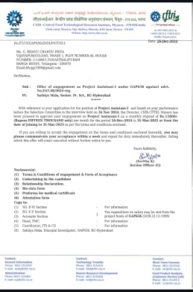
11 | Food Technology | 111722620030 | Josh Hycinth | Quality Associate | Cocofit | 2,40,000/- | 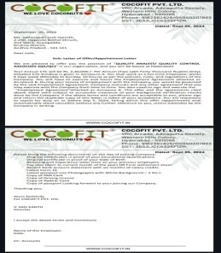
12 | Food Technology | 111722620022 | Suchitha | Executive- Technical & Sales support | Zeus Hygia Life Sciences | 1,92,000- | 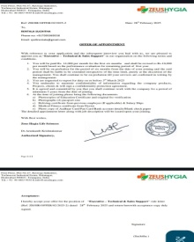
13 | Food Technology | 111722620028 | Sai Suma | R&D Executive | Zeus Hygia Life Sciences | 1,92,000- | 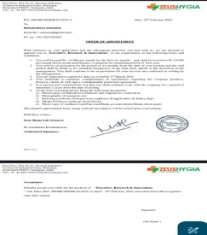
14 | Food Technology | 111722620003 | Anirudh | Ghanta Foods Pvt Ltd | Officer- Quality Control | 2,76,000 | 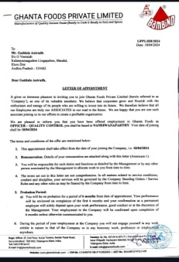

Stipend List of 2nd year M.Sc. Food Technology & Management

S.No | NAME | UID No | Certificate
1 | Chinthapelli Pradeep | 111723620004 | 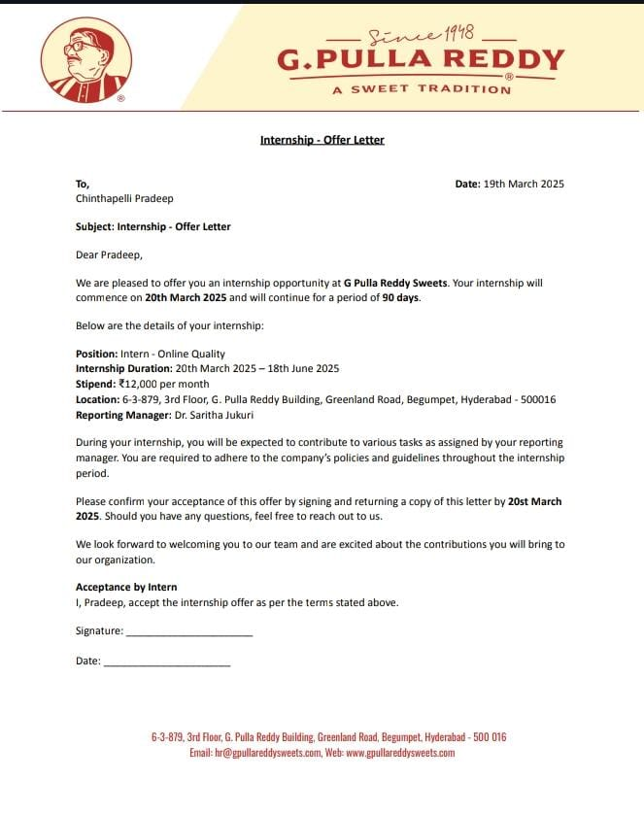
2 | Tanisha Patangay | 111723620023 | 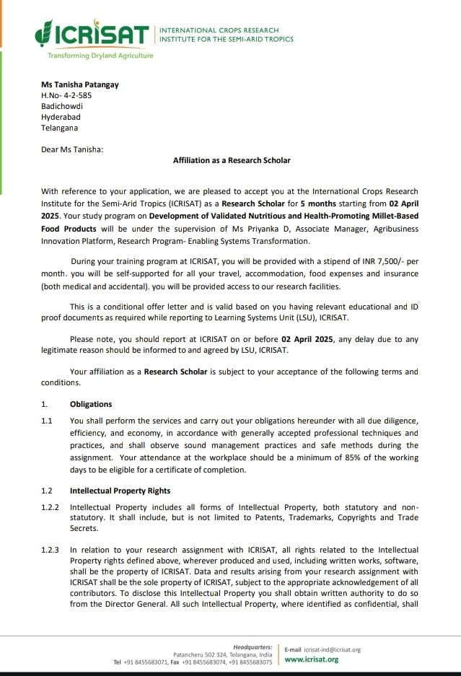
3 | Mohammad Nazeer Ahmed | 111723620027 | 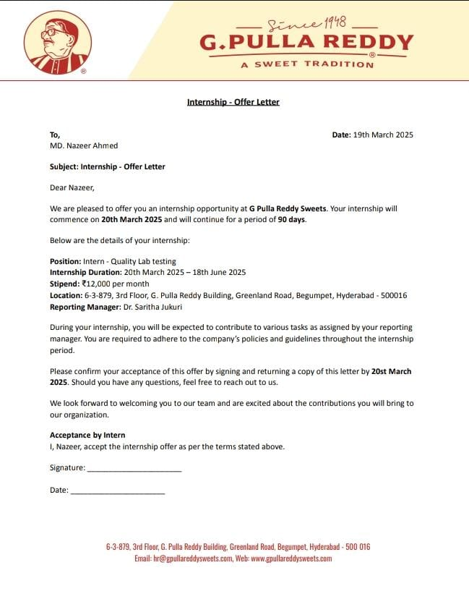
4 | DhakshayiniSreedharJukanti | 111723620029 | 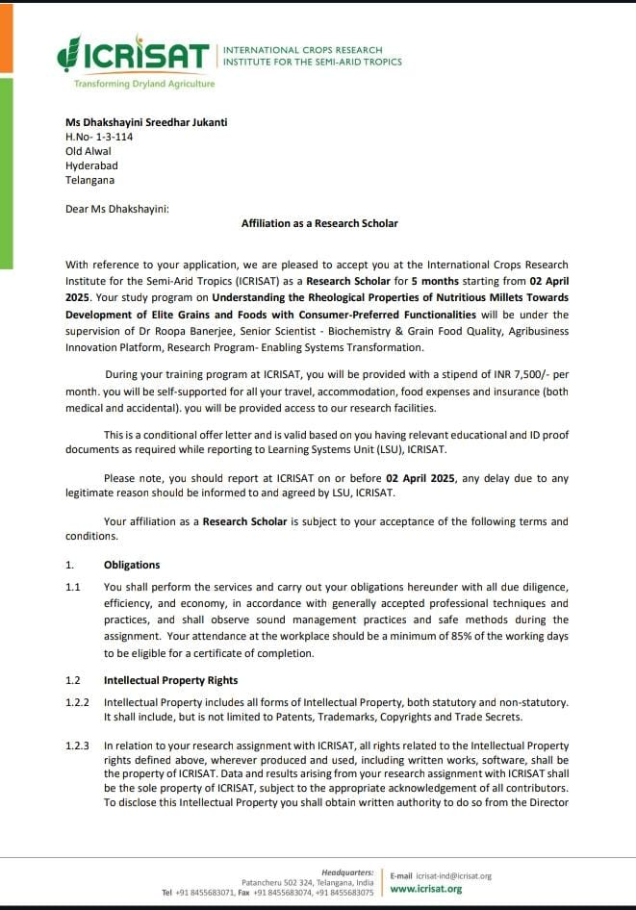
5 | Abdul Nadeem | 111723620033 | Rs 12000/-
6 | Shaik Imam Basha | 111723620012 | Rs 10000/-

RESULT
ANALYSIS

RESULT ANALYSIS:

Total 33students appeared in the 4thsemester end examinations, belonging to batch 2023-2025 all the 33 students have passed in the exams.

Passed Out Batch 2023-2025
Total 33students appeared in the Final semester end examinations and the pass percentage is 100%.
Ms. G. SRAVANI KALYANI bearing UID No:111722620015has won Gold Medal.

