Anti-Ragging Committee Report (2024–25)
Date of Meeting: January 6, 2025
Venue: Conference Hall
Chairperson: Rev Fr Dr AM Josph Kumar
Members Present:

Key Highlights
- Zero Reported Cases
The committee is pleased to report that no incidents of ragging were reported during the academic year 2024–25. This reflects the institution’s commitment to fostering a safe, inclusive, and respectful campus environment.
- Plan of Action for 2025–26
A comprehensive plan was discussed and finalized to strengthen preventive measures and enhance awareness among students. Key initiatives include:
  - Regular sensitization sessions
  - Peer mentoring programs
  - Anonymous reporting mechanisms
- Display of Anti-Ragging Boards
Anti-ragging boards have been prominently displayed across the campus, reinforcing the institution’s zero-tolerance policy and serving as a constant reminder to uphold respectful conduct.
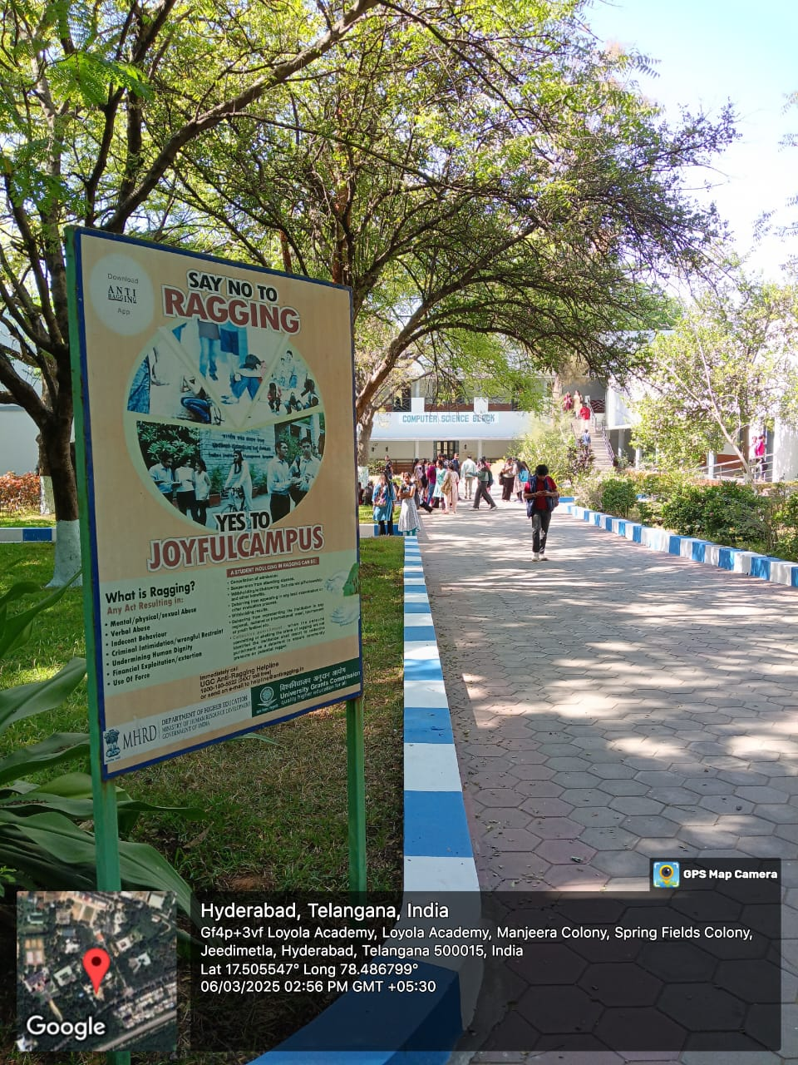 | 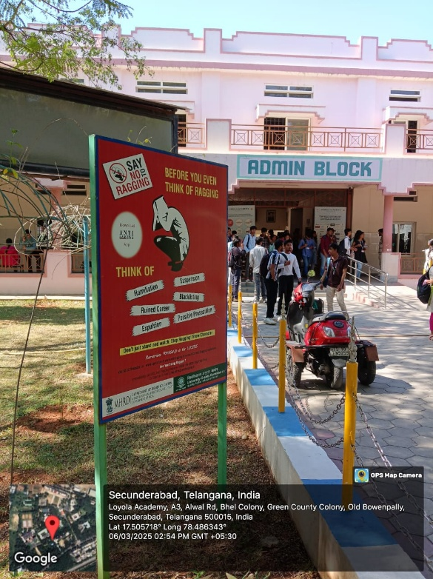
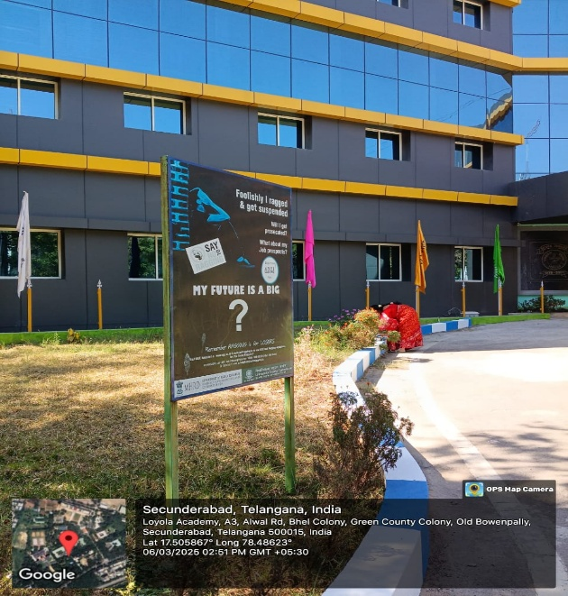 | 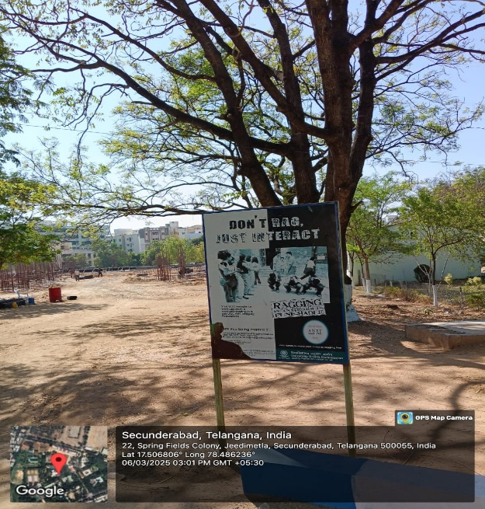

- Online Student Undertaking
In compliance with government directives, the committee resolved to implement online student undertakings from the academic year 2025–26. This will streamline documentation and ensure regulatory adherence.

Committee’s Commitment
The Anti-Ragging Committee reaffirms its dedication to maintaining a ragging-free campus. Through proactive engagement, continuous monitoring, and awareness-building, the committee aims to nurture a culture of mutual respect and safety.

Recommendations
- Continuous Monitoring: Regular review of anti-ragging measures and prompt action on any concerns.
- Awareness Programs: Organize workshops, seminars, and campaigns to educate students on the consequences of ragging.
- Policy Compliance: Ensure strict adherence to government regulations and institutional policies.

Conclusion
The committee expresses gratitude to all stakeholders—students, faculty, and staff—for their cooperation and vigilance. Together, we strive to create a secure and supportive academic environment that promotes both academic excellence and personal growth.

