- Publications by the staff and students:
Research papers:
- S.Lakshmi presented and published a paper on industry 5.0 o: Human centric Digital Transformation for sustainable Nation Building in national Level conference”VIGYAN-2K25 on 29th August 2025.

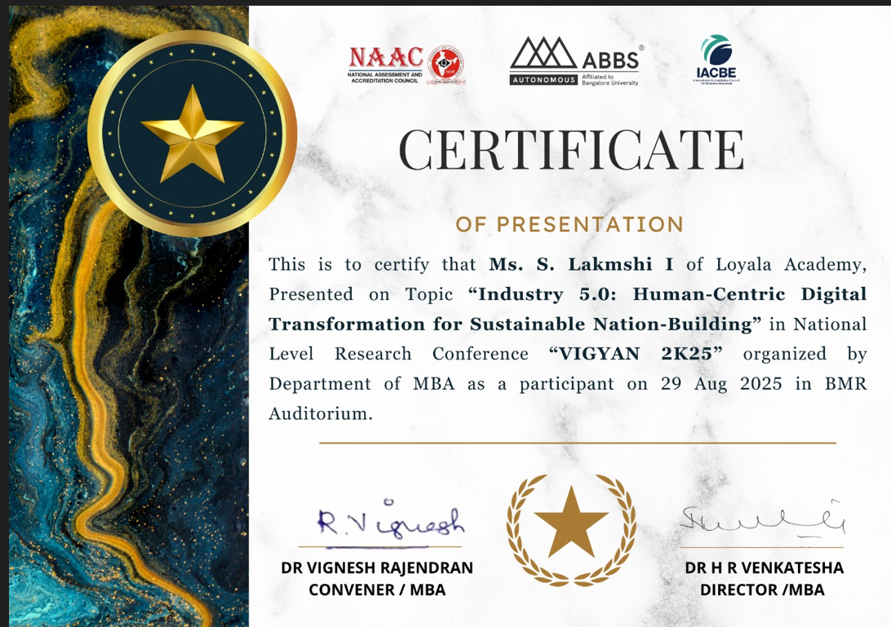

2.Special Activities of the Staff:
Faculty Exchange Program
Impact Analysis Report for Faculty Exchange Program – 2026
1. Event Details
Title of the Event: Faculty Exchange Program on Emerging Technologies (Agentic AI, Serverless & Edge Computing)

Dates:
- 5th March 2026 (For 1st Year Students – Agentic AI)
- 9th March 2026 (For 2nd Year Students – Serverless & Edge Computing)
Venue: Online Mode (Google Meet)
Organizer/Coordinator: Department Faculty (Faculty Exchange Initiative)
Speakers:
- Faculty Members from CHRIST College (AUTONOMOUS) Irinjalakuda, Kerala (Faculty Exchange Program)
Target Audience:
- 1st Year Students – Introduction to Agentic AI
- 2nd Year Students – Serverless & Edge Computing Concepts
2. Objectives of the Event
- To introduce students to emerging technologies such as Agentic AI, Serverless Computing, and Edge Computing.
- To enhance interdisciplinary learning through faculty exchange.
- To provide exposure to real-world applications and current industry trends.
- To encourage students to explore advanced technological domains early in their academic journey.
3. Participant Details
Total Participants:
- 1st Year: 50 (Estimated)
- 2nd Year: 51 (Estimated)
Demographics: Undergraduate engineering students
Attendance Percentage: 92%
4. Content Evaluation
Relevance of the Topic:
Highly Relevant (aligned with current advancements in AI and cloud technologies)
Depth of Knowledge Delivered:
Very Good (concepts explained with examples and practical insights)
Engagement of Participants:
Highly Engaged (interactive discussions, queries raised during sessions)

5. Learning Outcomes
Were the Learning Outcomes Met?: Yes
Key Takeaways for Participants:
- Understanding the concept of Agentic AI and its autonomous decision-making capabilities
- Fundamentals of Serverless Computing and its advantages in cloud architecture
- Insights into Edge Computing and its role in real-time data processing
- Awareness of industry applications and future scope of these technologies
Skills/Knowledge Gained:
- Conceptual clarity on emerging technologies
- Exposure to modern computing paradigms
- Improved analytical thinking regarding AI and distributed systems
6. Feedback Analysis
Method of Feedback Collection: Online feedback form (Google Form)
Key Feedback from Participants:
Positives:
- Informative and easy-to-understand sessions
- Real-world examples enhanced understanding
- Interactive teaching approach
Areas of Improvement:
- Request for more hands-on demonstrations
- Desire for longer session duration
Rating on a scale of 1-5:
- Content Quality: 4.6/5
- Speaker Effectiveness: 4.7/5
- Presentation Style: 4.5/5
7. Impact on Curriculum or Future Practices
Impact on Student Learning:
Students gained early exposure to cutting-edge technologies, improving their readiness for advanced subjects and industry demands.
Integration into Teaching Practices:
Faculty members plan to incorporate introductory modules on AI agents, serverless architecture, and edge computing into coursework.
Suggestions for Future Events:
- Conduct hands-on workshops and mini-projects
- Invite industry experts for deeper insights
- Organize follow-up sessions for advanced learning
8. Quantitative Analysis
Performance Improvement:
Approximately 80% of participants reported improved understanding of the topics after the sessions.
9. Recommendations
Future Improvements:
- Include practical demonstrations and coding sessions
- Provide pre-session and post-session materials
Recommended Topics for Future Events:
- Generative AI and LLMs
- Cloud-native application development
- IoT with Edge Computing
- AI in real-world problem solving
Potential for Recurrence of the Event:
Yes, faculty exchange programs should be conducted regularly to promote collaborative learning.
10. Conclusion
The Faculty Exchange Program conducted via Google Meet was successful in achieving its objectives. It provided valuable insights into emerging technologies like Agentic AI, Serverless Computing, and Edge Computing. The sessions enhanced student knowledge, encouraged active participation, and fostered academic collaboration between institutions.

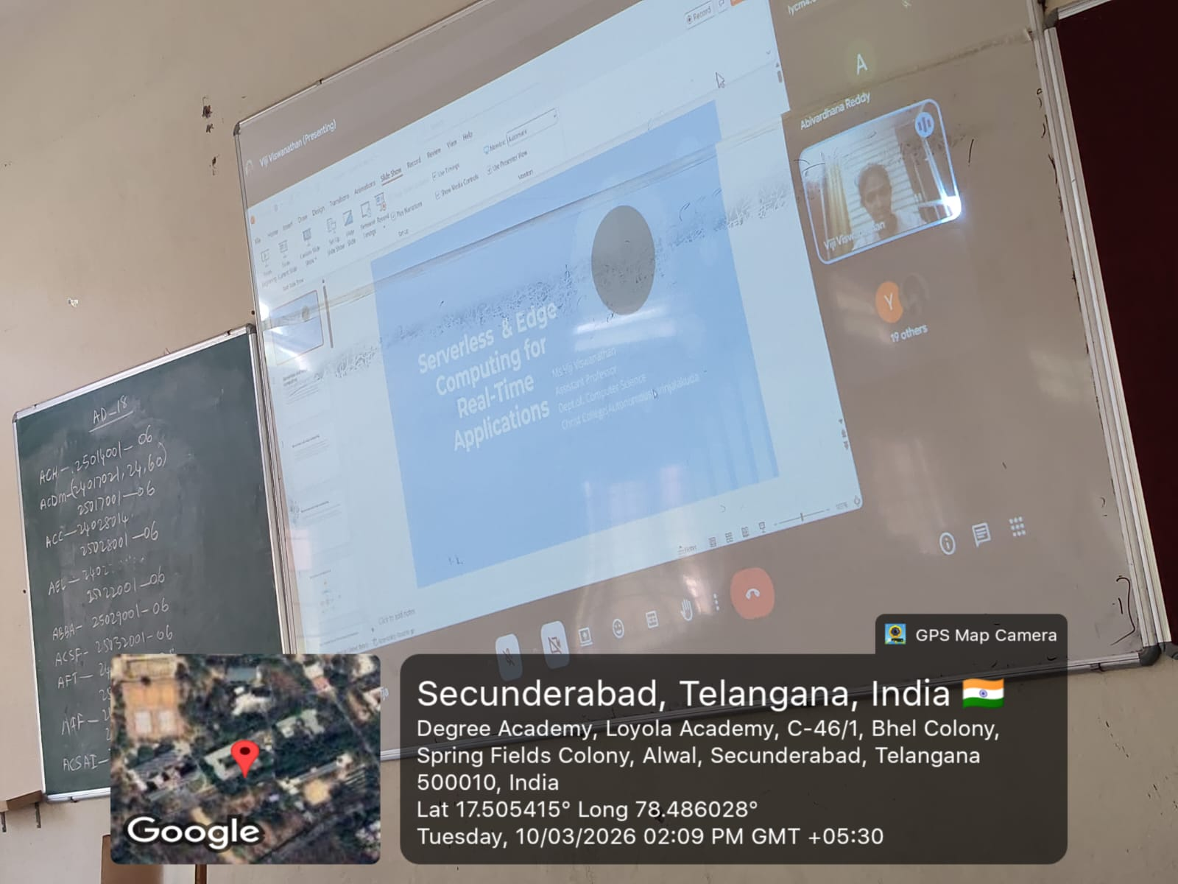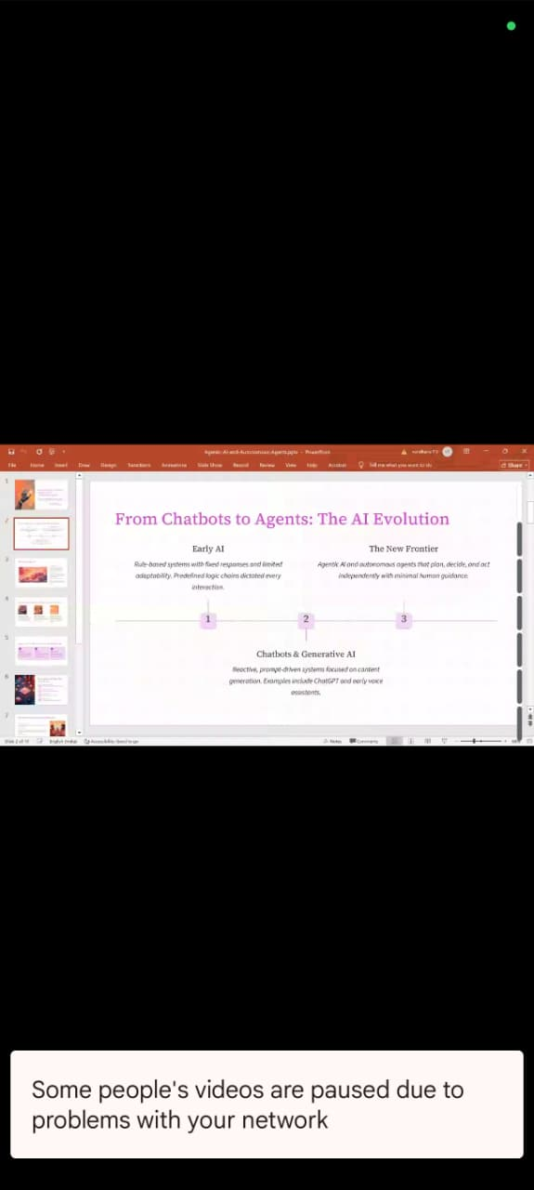
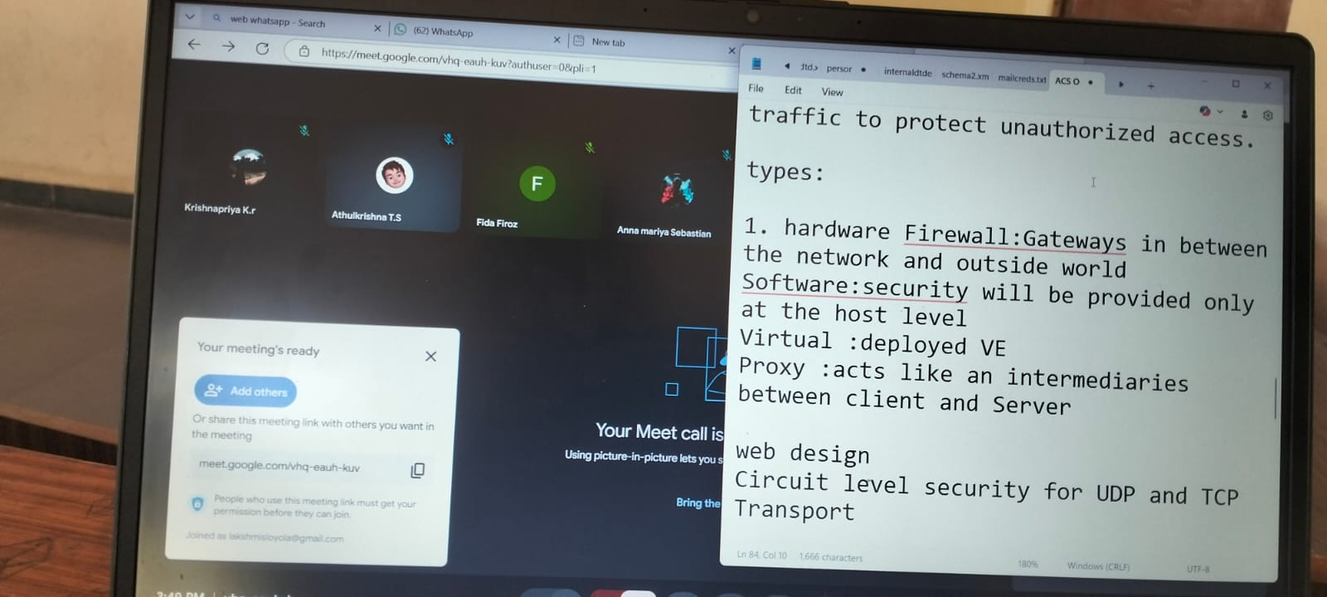
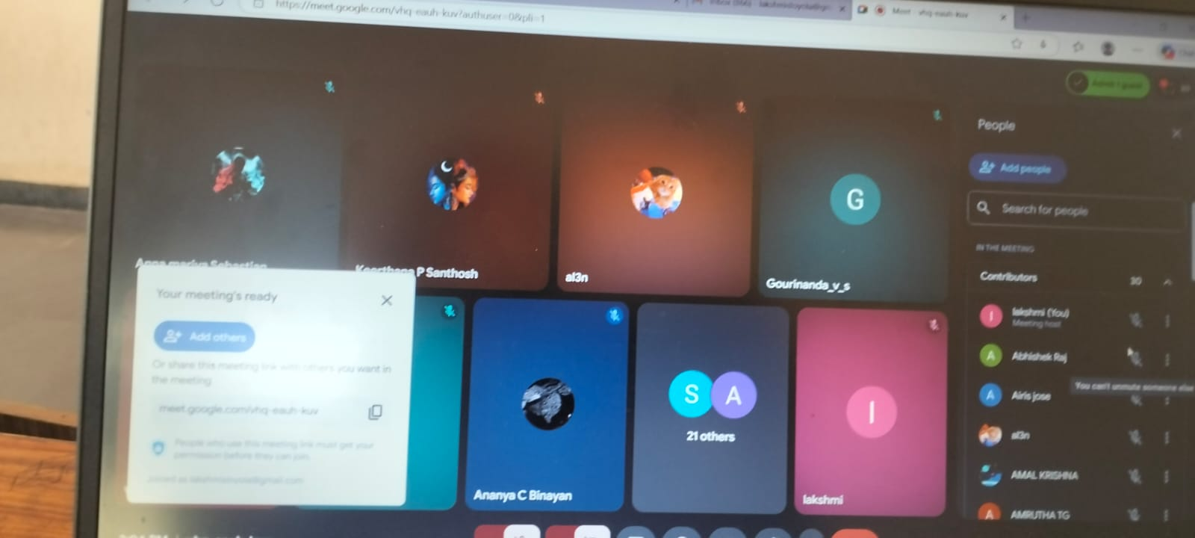

3.Staff ATTENDED SEMINARS/FDPS/WEBINARS:
1.S.Lakshmi participated in short term training program on Becoming a better teacher conducted by Malviya Mission Teacher Training center of UGC organized by The Maharaja Sayajirao university of baroda from 18th to 23rd August,2025.

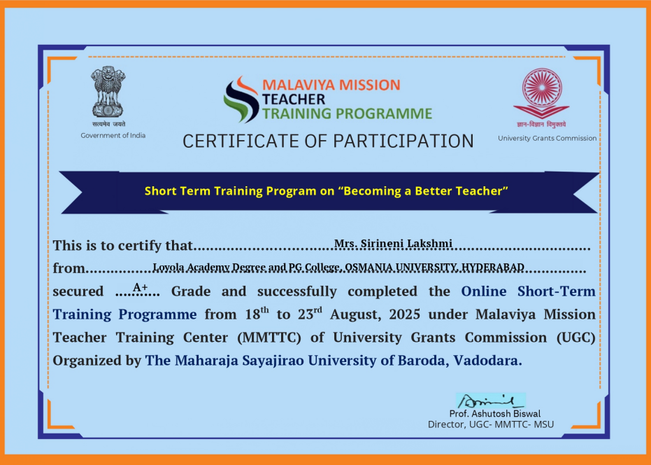
2. S.Lakshmi participated in 5-Day faculty development Program on GENERATIVE AI oraganized by Loyola Academy in collaboration with BrainoVision and AICTE from 4th to 8th August..

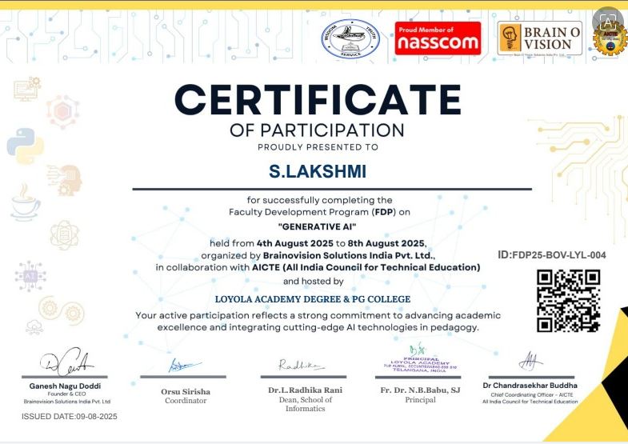

3. S.Lakshmi participated in 5-Day faculty development Program on Reimagining Education:AI,Pedagogical shifts and Research in the age of Data oraganized by Loyola Academy in collaboration with IQAC from 1st to 5th september,2025

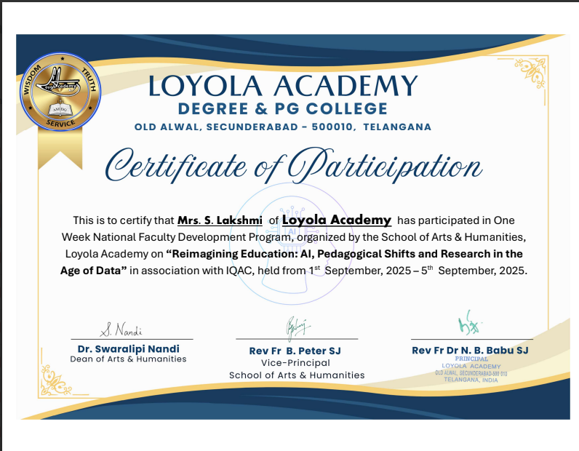
- S.Lakshmi participated in 5-Day faculty development Program on Emerging Trends in Practical Approach to Cyber oraganized by AICTE Training & Learning(ATAL) in collaboration with Vaagdevi Engineering College from 1st to 6th December,2025
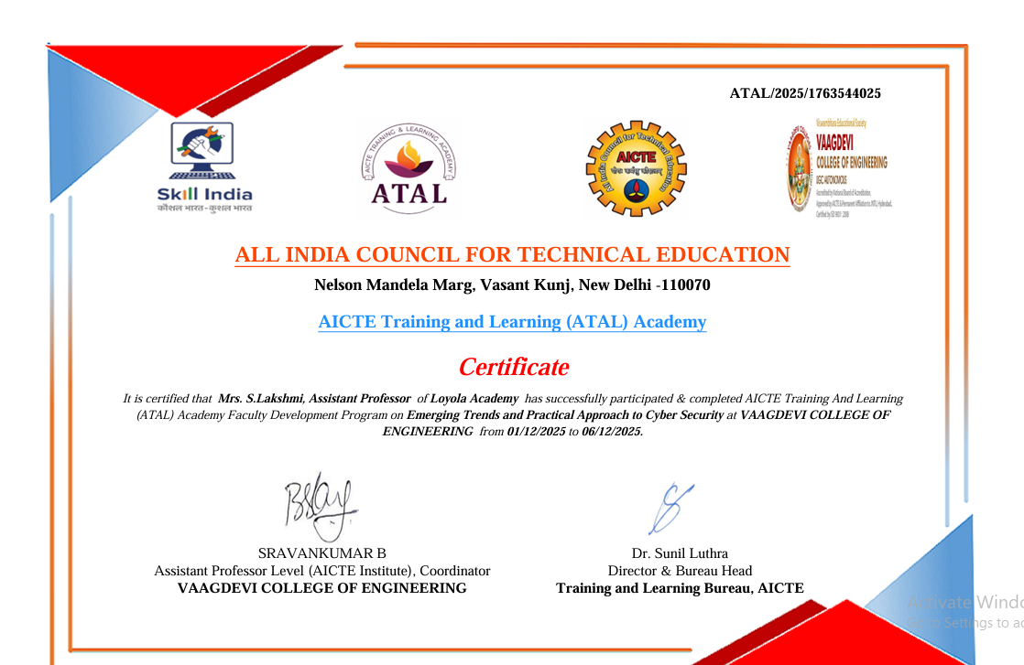
5. S.Lakshmi participated in 5-Day faculty development Program onQuantum Computing oraganized by Loyola Academy in collaboration with Vaagdevi Engineering College from 1st to 6th December,2025

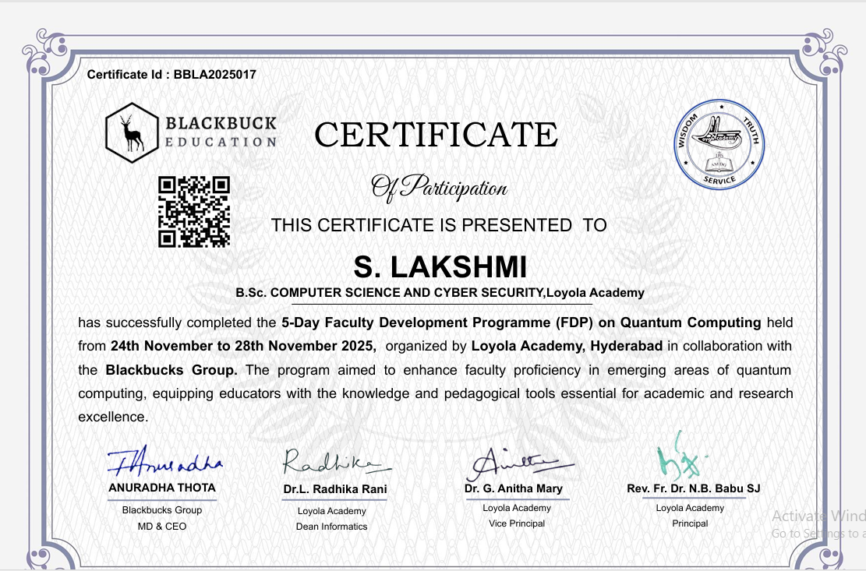
6. S.Lakshmi completed certificate course in cybersecurity Essentials under the Cyber Suraksha Pulse Program in August 2025.

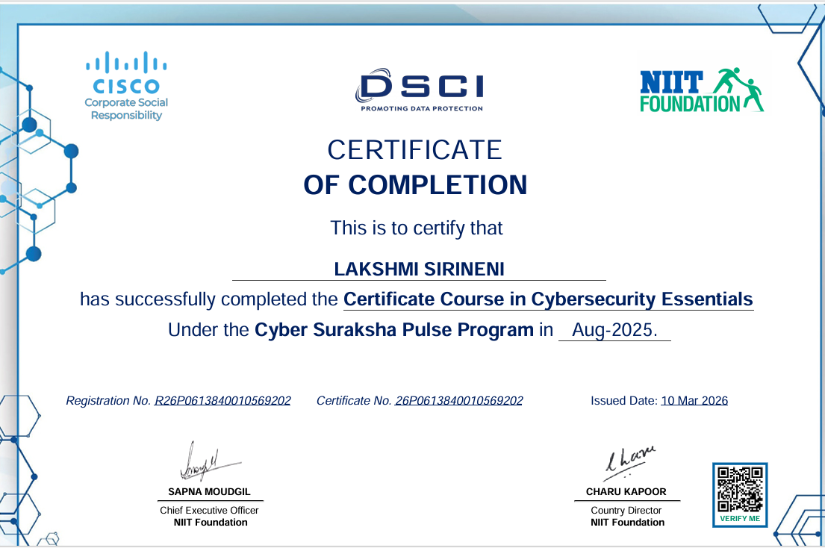

7. S.Kavitha participated in 5-Day faculty development Program on GENERATIVE AI oraganized by Loyola Academy in collaboration with BrainoVision and AICTE from 4th to 8th August..

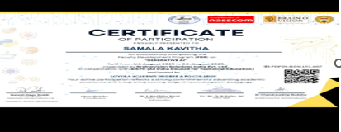
8. S.Kavitha participated in short term training program on Becoming a better teacher conducted by Malviya Mission Teacher Training center of UGC organized by The Maharaja Sayajirao university of baroda from 18th to 23rd August,2025.
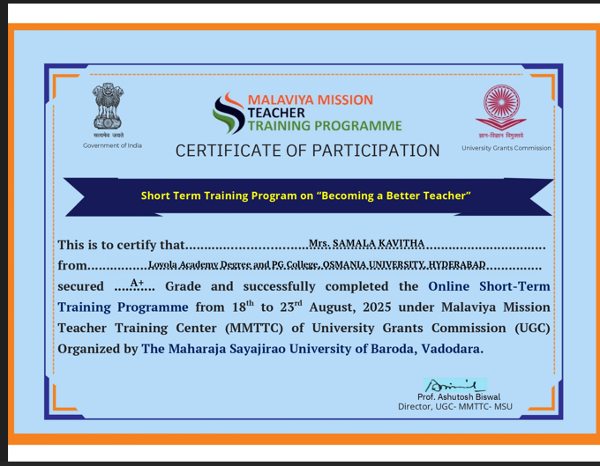
9. S.Kavitha participated in 5-Day faculty development Program on Emerging Trends in Practical Approach to Cyber oraganized by AICTE Training & Learning(ATAL) in collaboration with Vaagdevi Engineering College from 1st to 6th December,2025

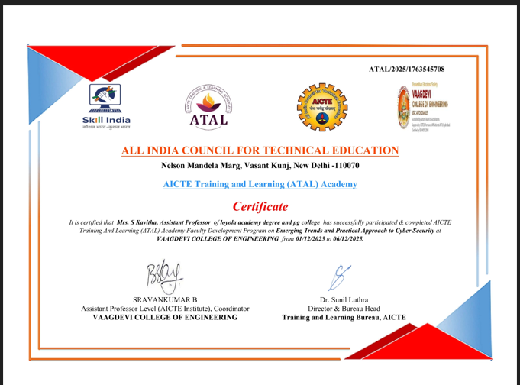
10. M. Supriya participated in 5-Day faculty development Program on Emerging Trends in Practical Approach to Cyber oraganized by AICTE Training & Learning(ATAL) in collaboration with Vaagdevi Engineering College from 1st to 6th December,2025

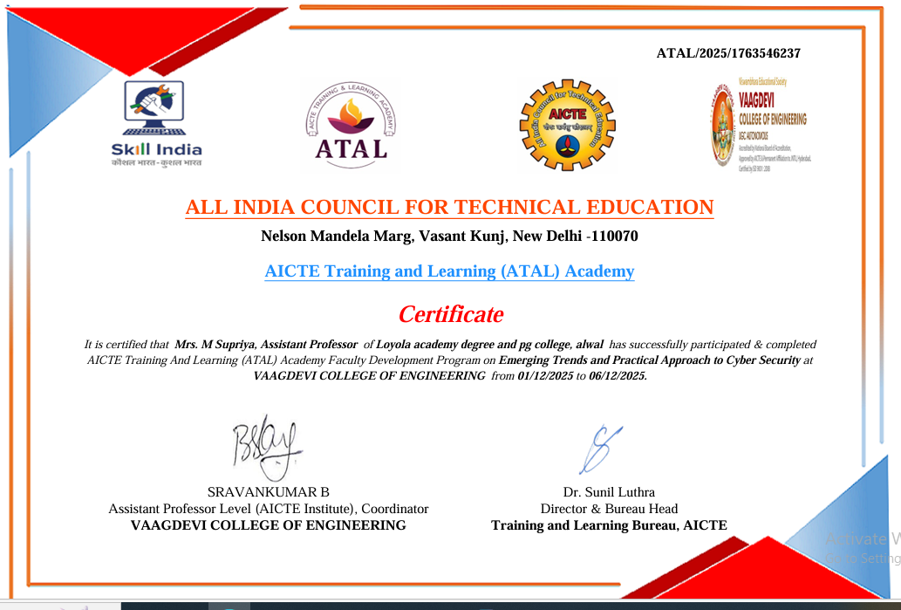
11. M. Supriya participated in short term training program on Leveraging Technology for Effective Teaching for Modern Era in Light of NEP-2020 by Malviya Mission Teacher Training center of UGC organized by The Maharaja Sayajirao university of baroda from 25th to 30th August,2025.
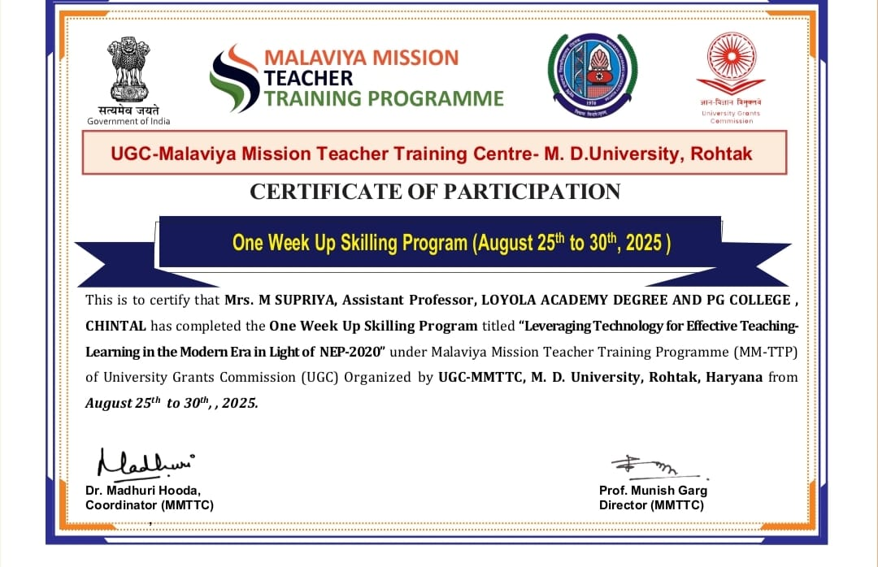

12. M.Supriya participated in 5-Day faculty development Program on GENERATIVE AI oraganized by Loyola Academy in collaboration with BrainoVision and AICTE from 4th to 8th August..
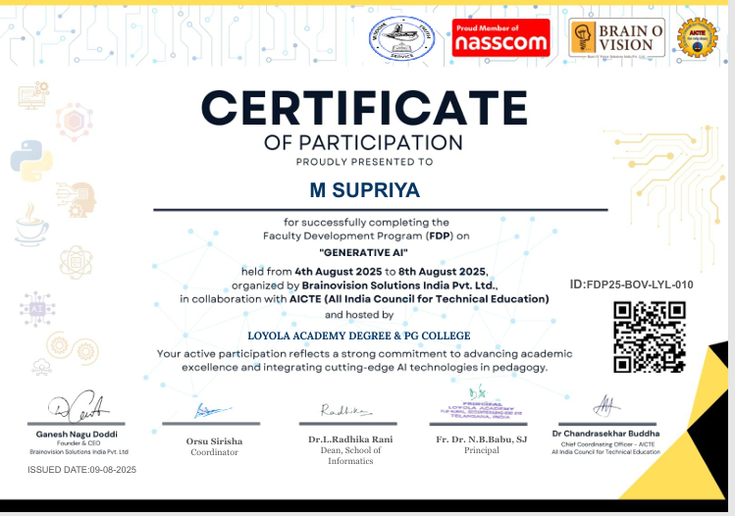
13. M.Supriya participated in 5-Day faculty development Program onQuantum Computing oraganized by Loyola Academy in collaboration with Vaagdevi Engineering College from 1st to 6th December,2025
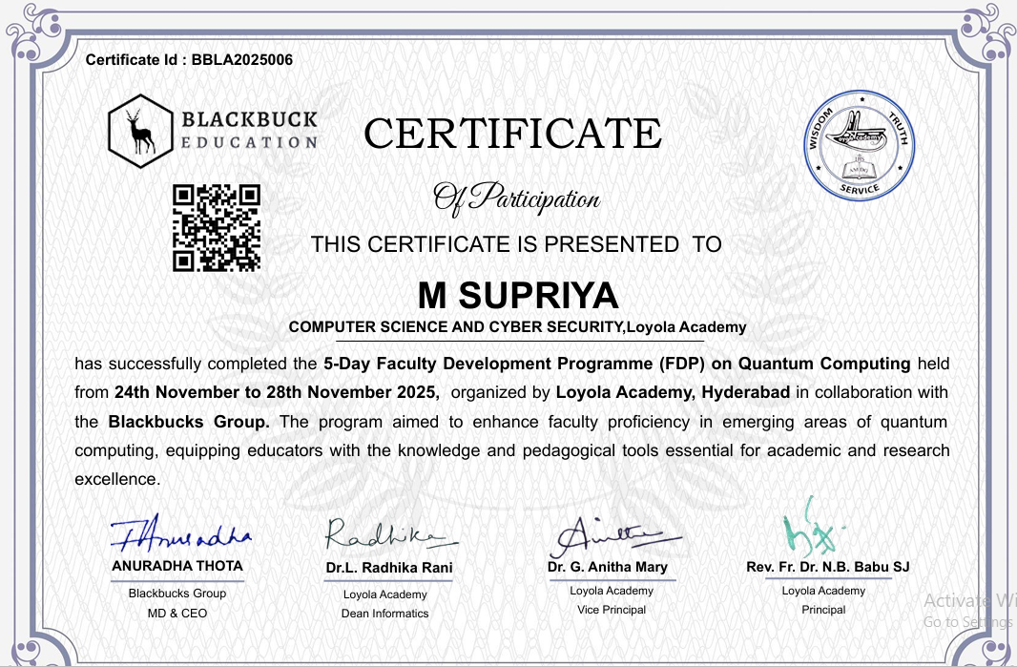
14.M.supriya participated in 5-Day faculty development Program on Empowering Educators for Digital Age in collaboration with Villa Marie Degree College for Women from 2nd June 2025 to 6th June 2025 in online mode.

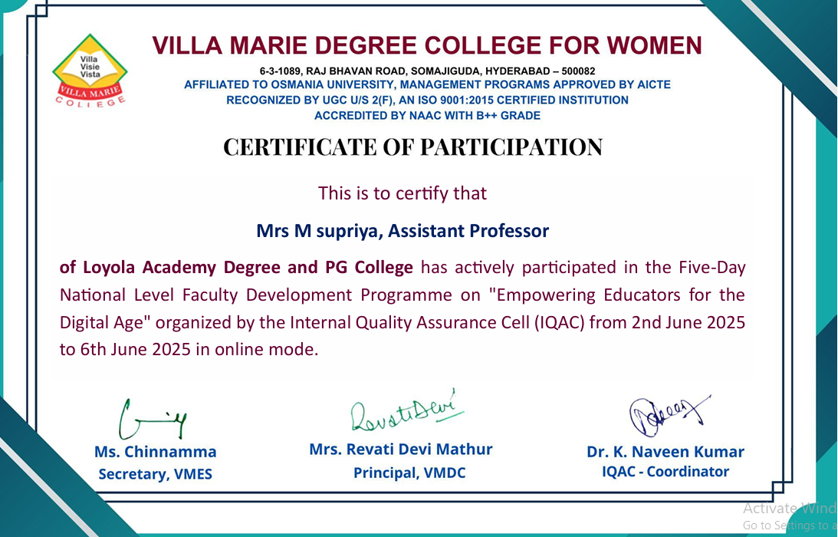

15.N. Manisha completed the Cybersecurity Analyst Job Simulation Program organized by Tata Group through Forage
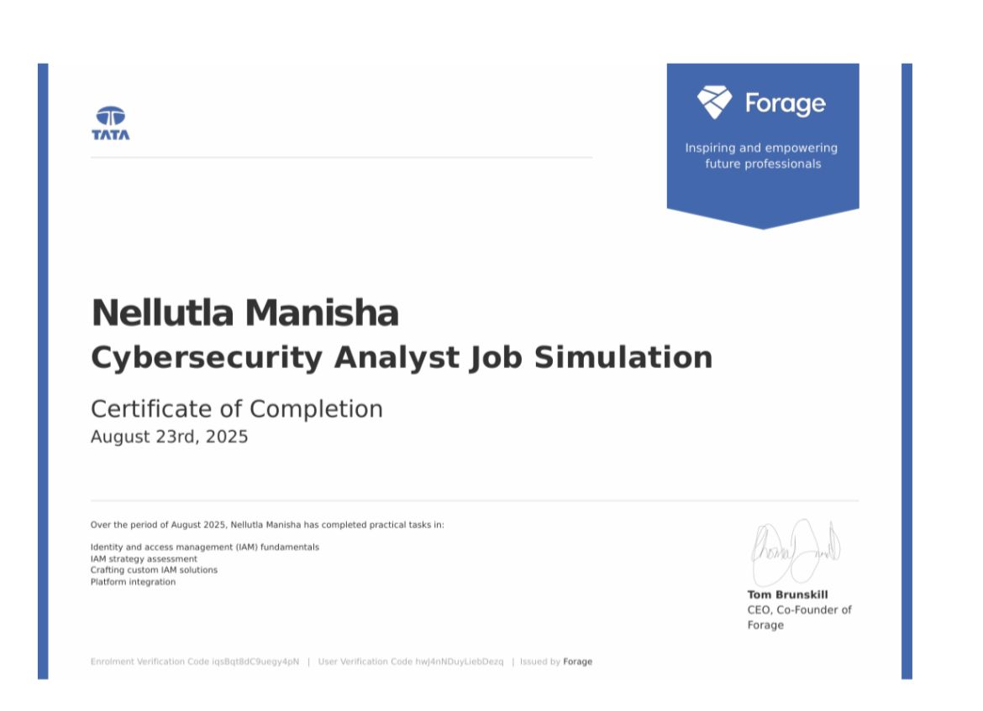

16. N. Manisha Successfully participated in the Faculty Development Program (FDP) on Generative AI, organized by Brainovision Solutions India Pvt. Ltd. in collaboration with AICTE (All India Council for Technical Education).
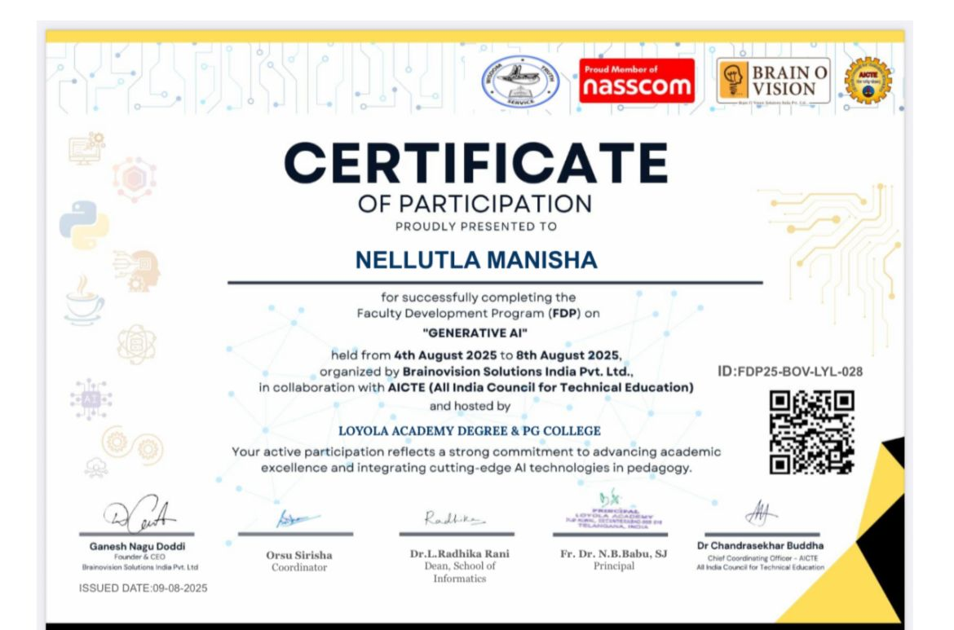

17. N. Manisha Completed the Cybersecurity Job Simulation Program provided by Datacom through the Forage platform.
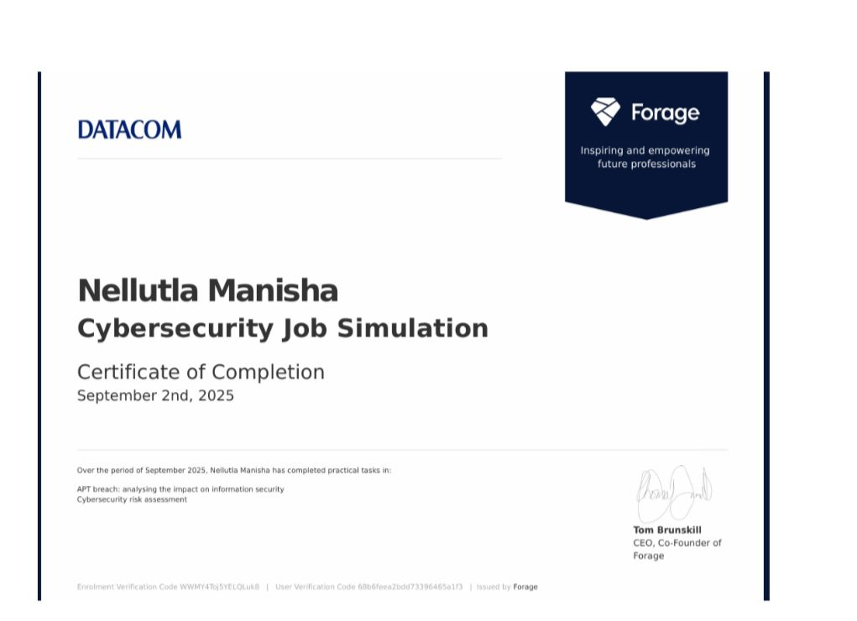

18. N. Manisha Successfully completed a Cyber Security Internship at Elevate Labs, demonstrating strong analytical and cybersecurity skills while contributing to real-world security projects
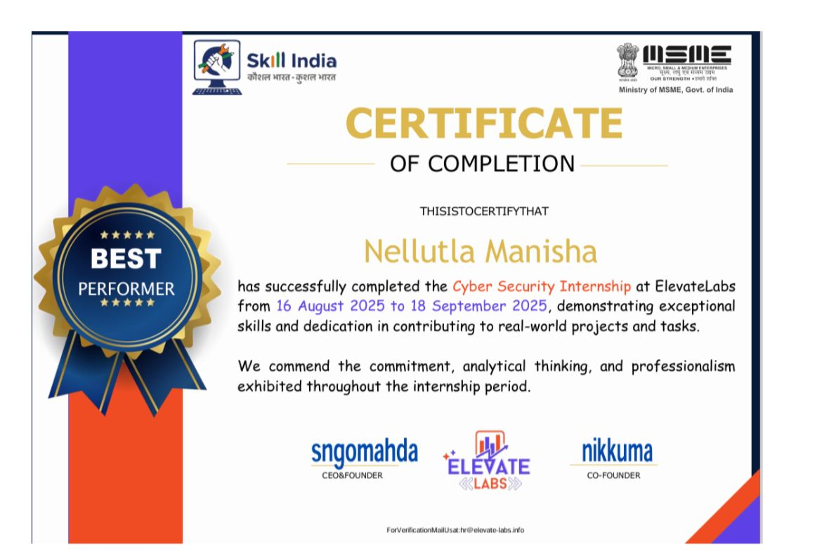
19. N. Manisha Participated in the AICTE Training and Learning (ATAL) Academy Faculty Development Program on Emerging Trends and Practical Approach to Cyber Security.

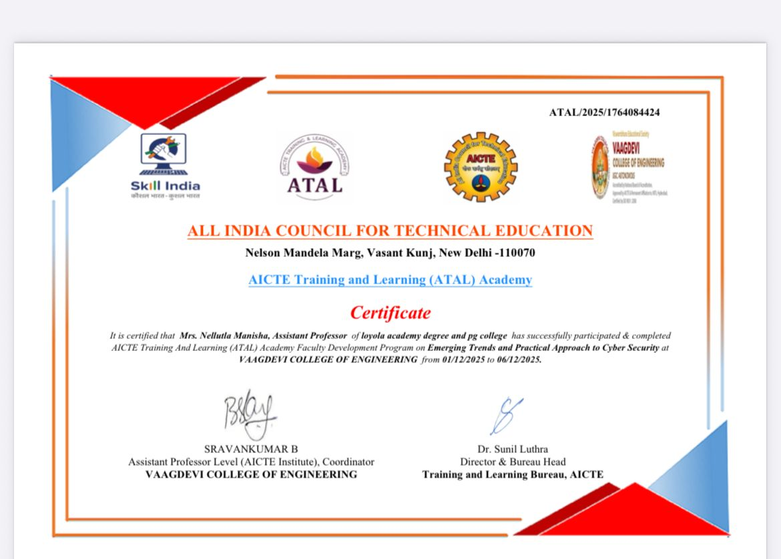

20. M.Vasudha participated in short Time program in use of AI in Higher Education from 18th November to 24th November,2026 conducted ny Malaviya Mission Teacher Training center.

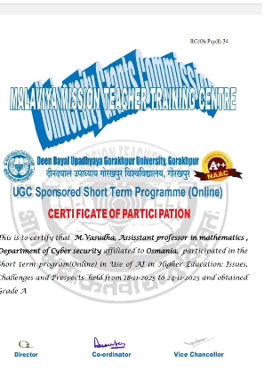

4.STUDENT ACHIEVEMENTS CLASS WISE(DCSCS/NCSCS/ACSCS)

DCSCS:
- Lakshmi Rajarani uid 111724039009, of class NCSCS begin awarded as the best outgoing CR for the Academic Year 2025-26.

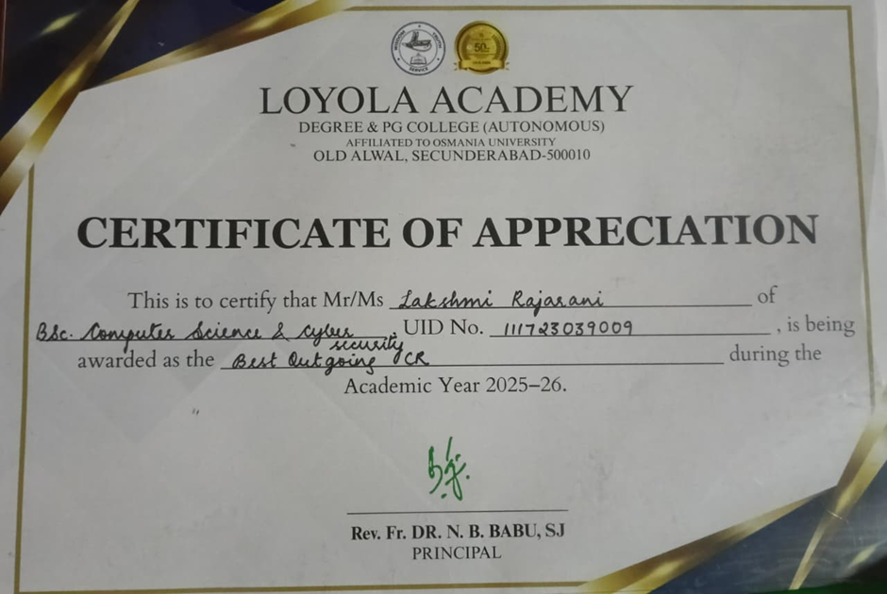

- J Sathish Uid 111723039028 of class NCSCS begin awarded as the best outgoing ACR for the Academic Year 2025-26.

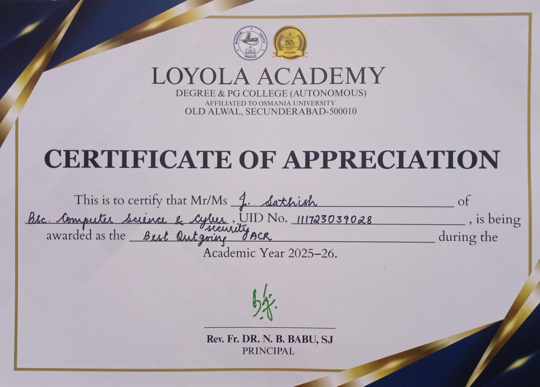

- BK Rishikesh Reddy uid 111723039021 of class DCSCS is being awarded as Website and Technical Head, the Student Council during the Academic Year 2025-26.
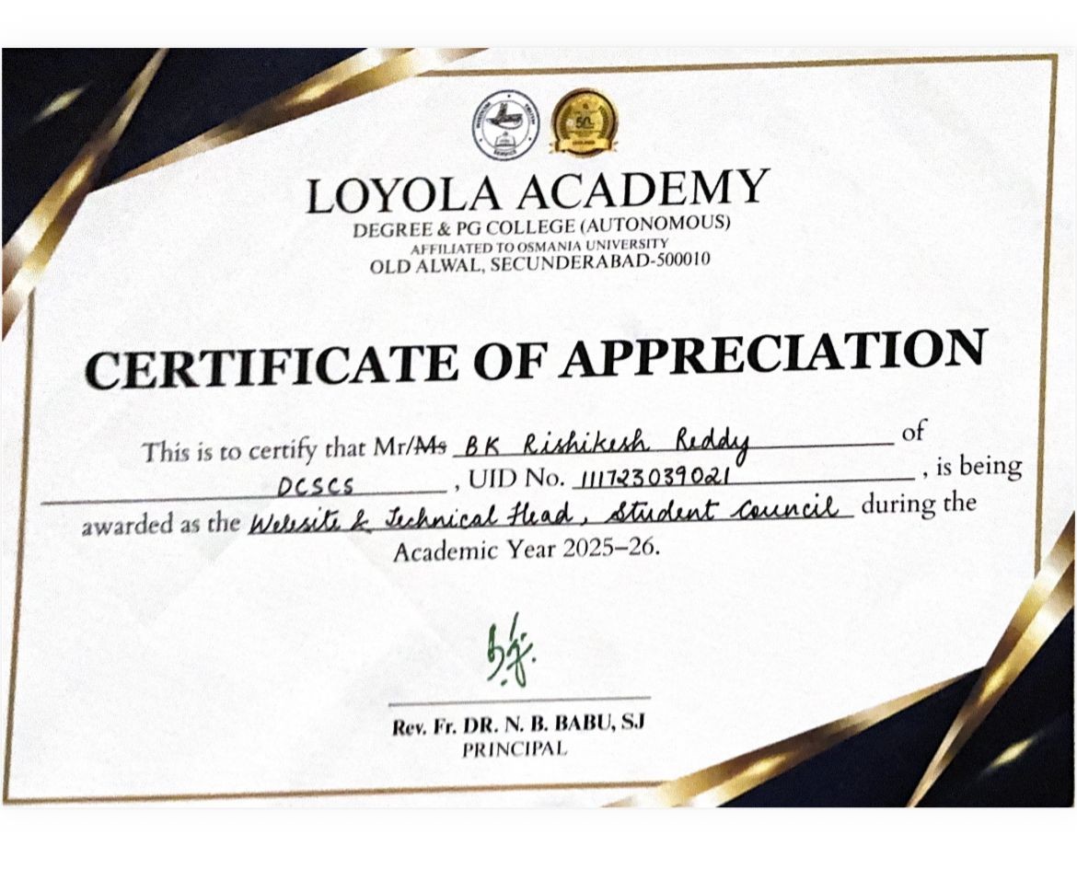

- Alice saloni uid 111723039005 of class DCSCS is being awarded as the Fine Arts Secretary student council during the academic year 2025-26.
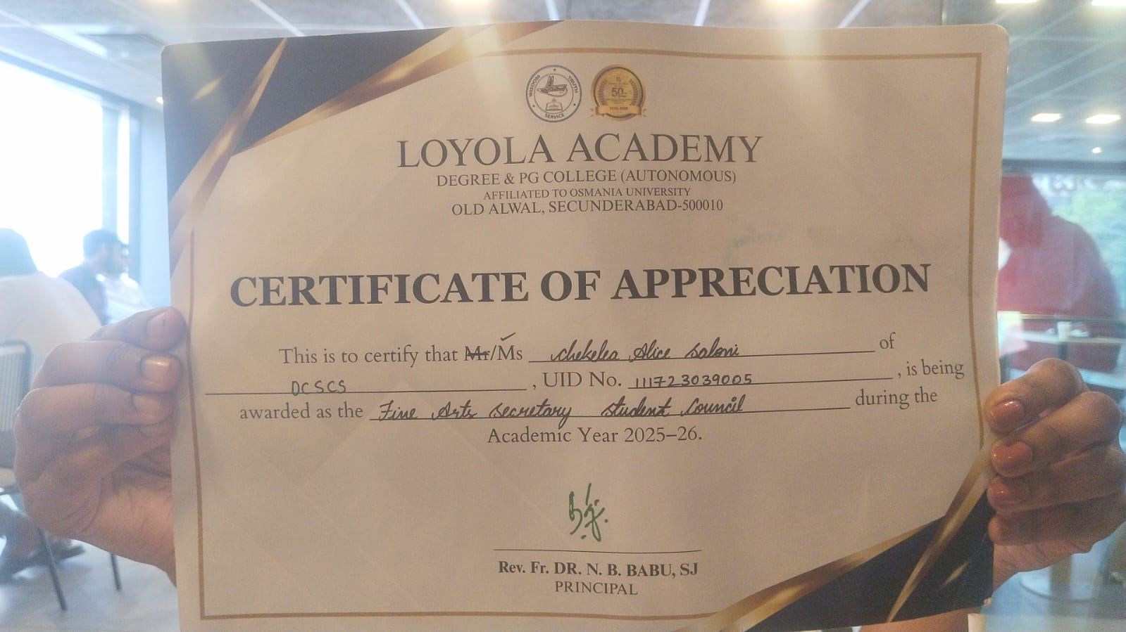

- Varshith Pasala uid 111723039040 of class DCSCS is being awarded as the Event Head, NSS during the Academic Year 2025-26.
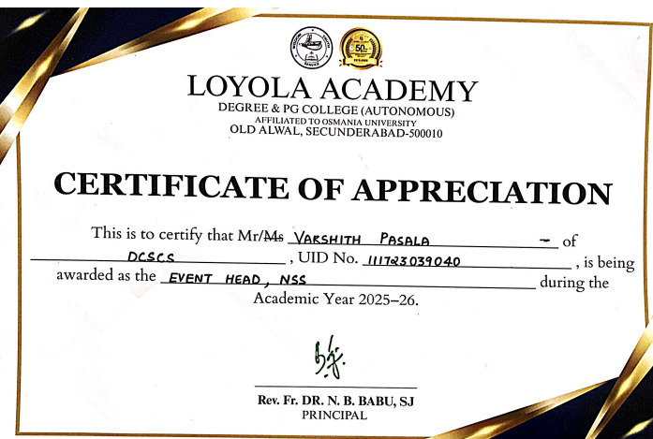

- S Lasya Reddy Uid 111723039014, class DCSCS is being awarded as the Regulation Head NSS, during the Academic Year 2025-26.

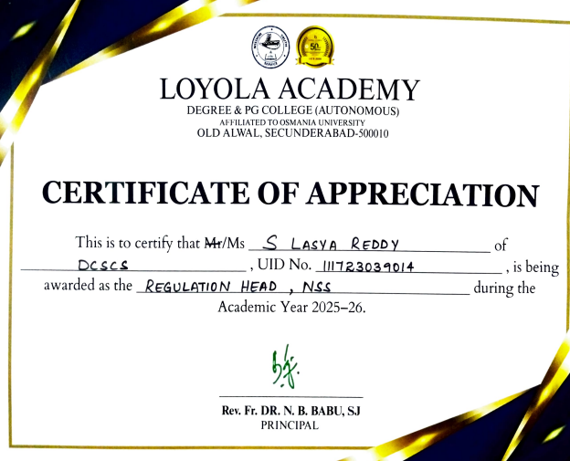

- K Varun Raju uid 111723039030, of class DCSCS is being awarded as the Extraordinary Student Achiever during the Academic year 2025-26.

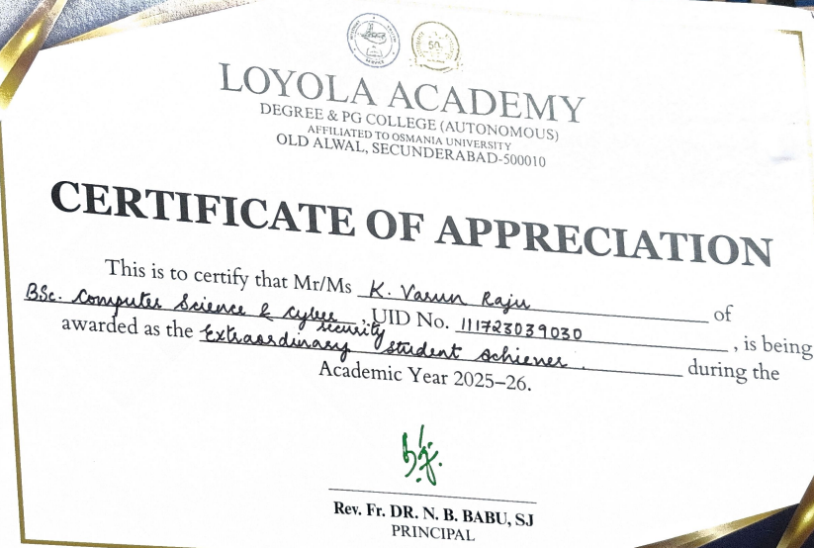

8. A Sowmya uid 111723039001 of class DCSCS is being awarded as the 1st Academic Topper for the Academic Year 25-26. 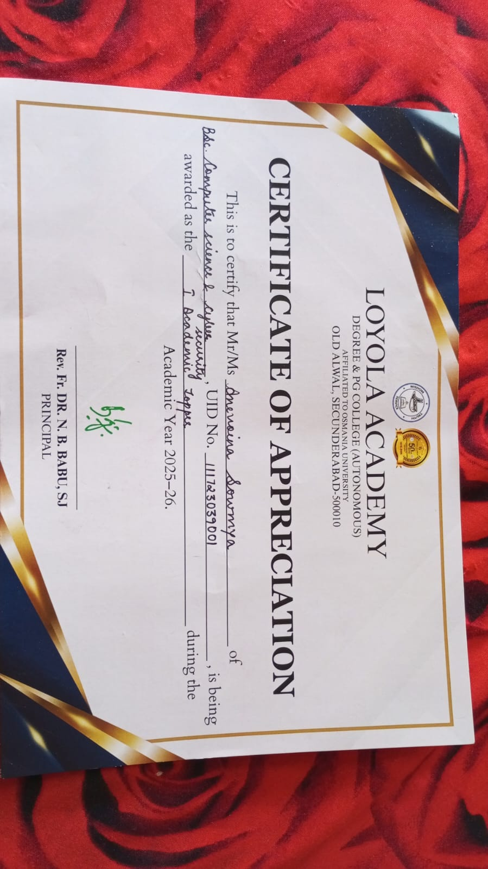

9. Alice Saloni Uid 111723039005 of class DCSCS is being awarded as the 3rd Academic Topper for the Academic Year 25-26.
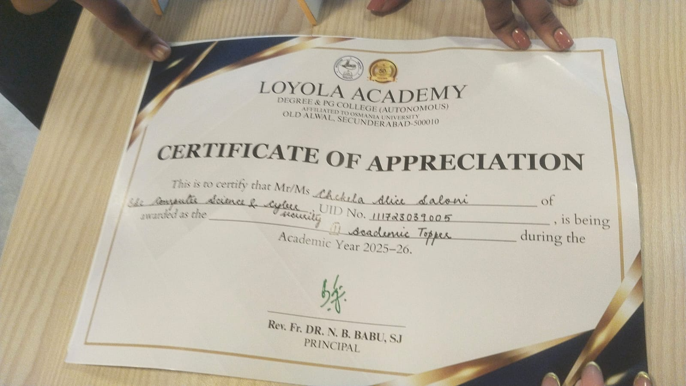

10. G Akshitha Uid 111723039007 of class DCSCS is being awarded as the 2nd Academic Topper for the Academic Year 25-26.
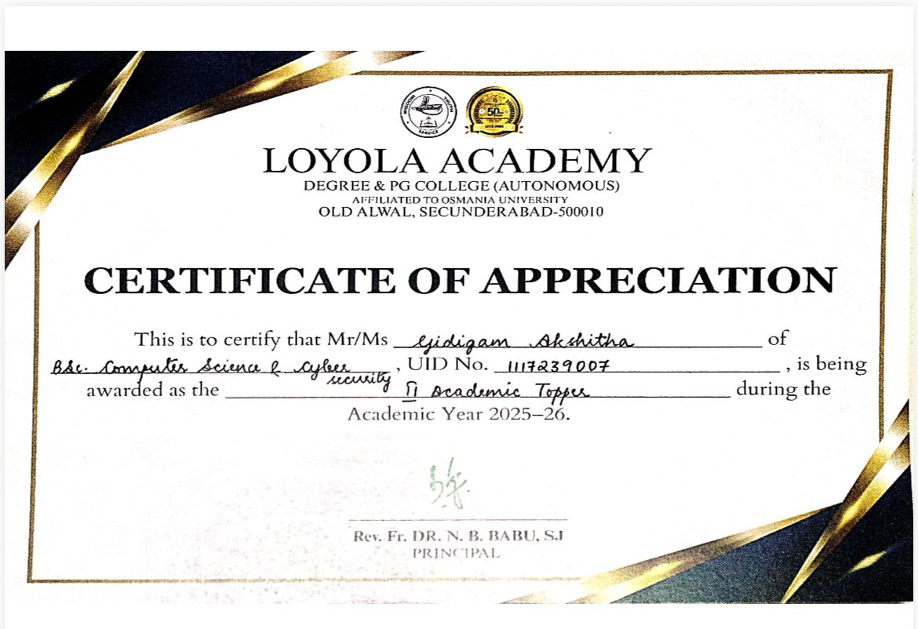

11. V Srujan Uid 111723039049 of Class DCSCS is awarded with continuous improvement in academics. 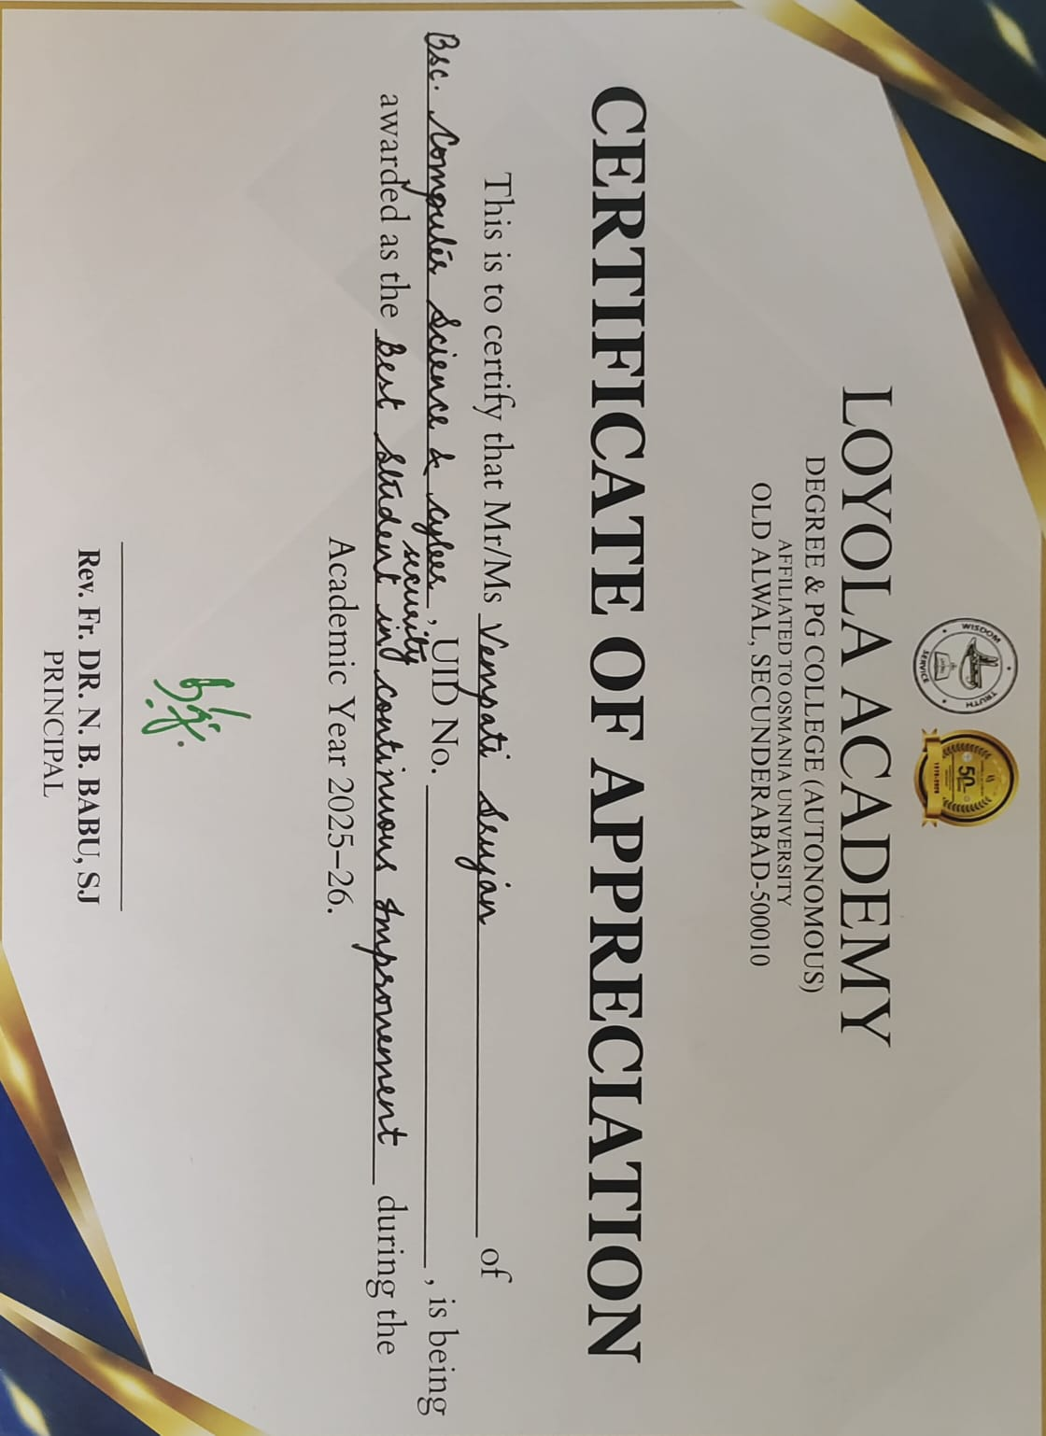

NCSCS:
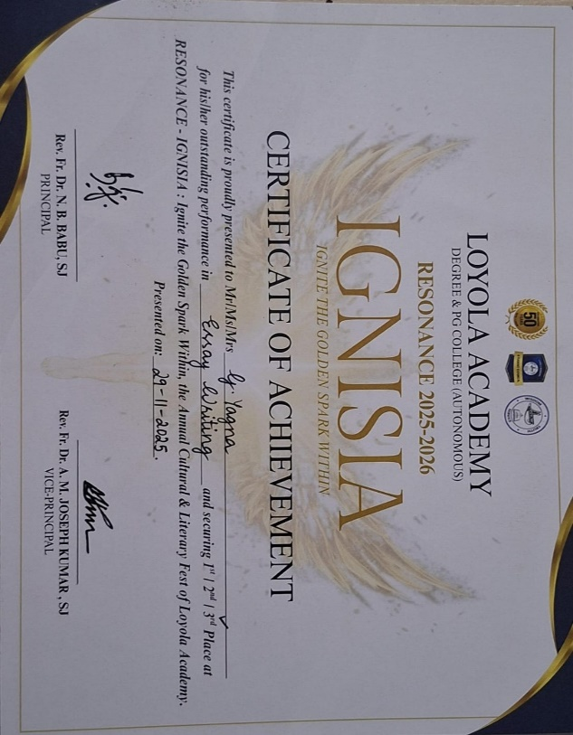
1.G Yagna uid 111724039021 of class NCSCS Secured 3rd place for Essay Writing at RESONANCE- IGNISIA ,Loyola Academy.

2.K Jayanth From NCSCS, Uid:111724039029 is awarded with 2nd Academic Topper.

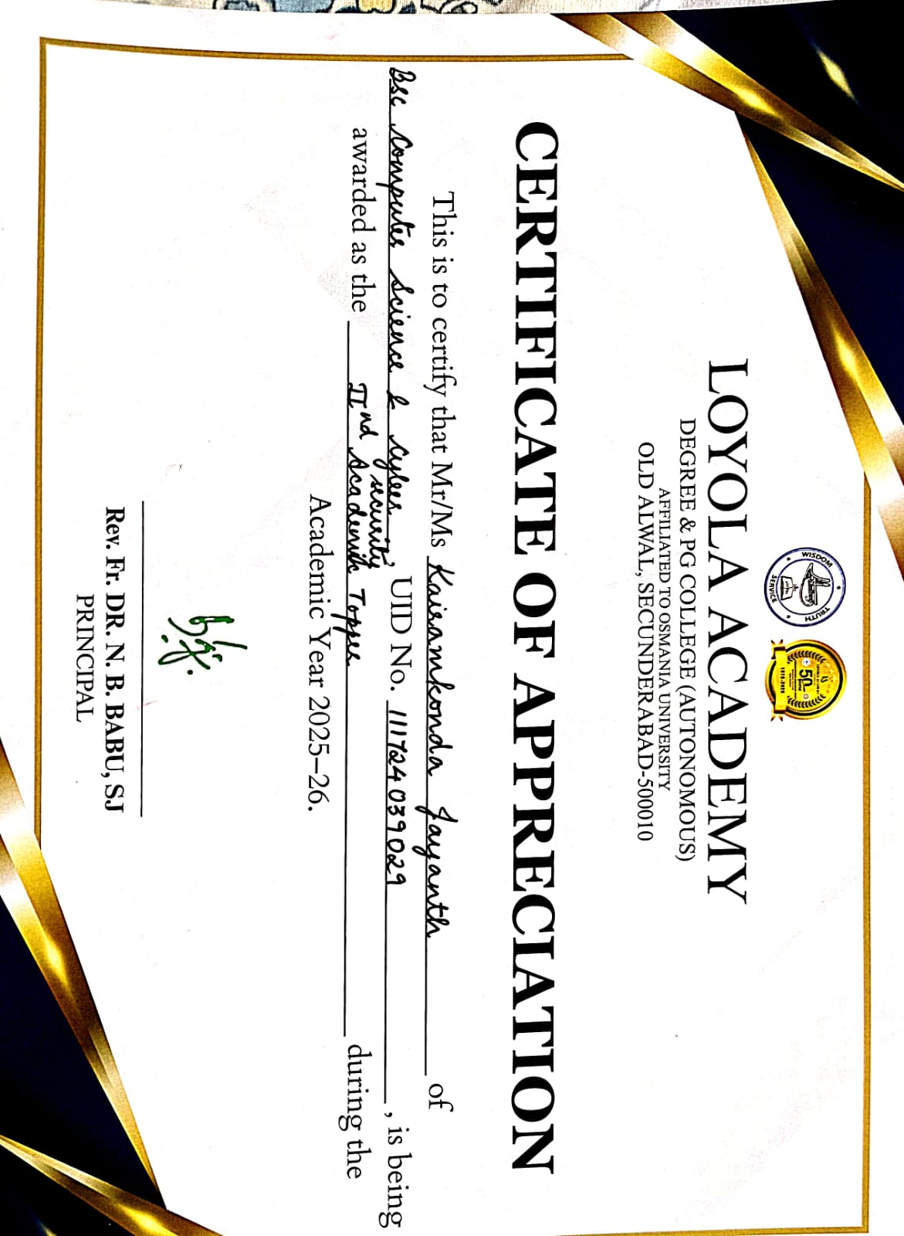

3. K Ashritha from NCSCS, UID 111724039011 has begin awarded as 1st academic topper for the Academic Year 2025-26.
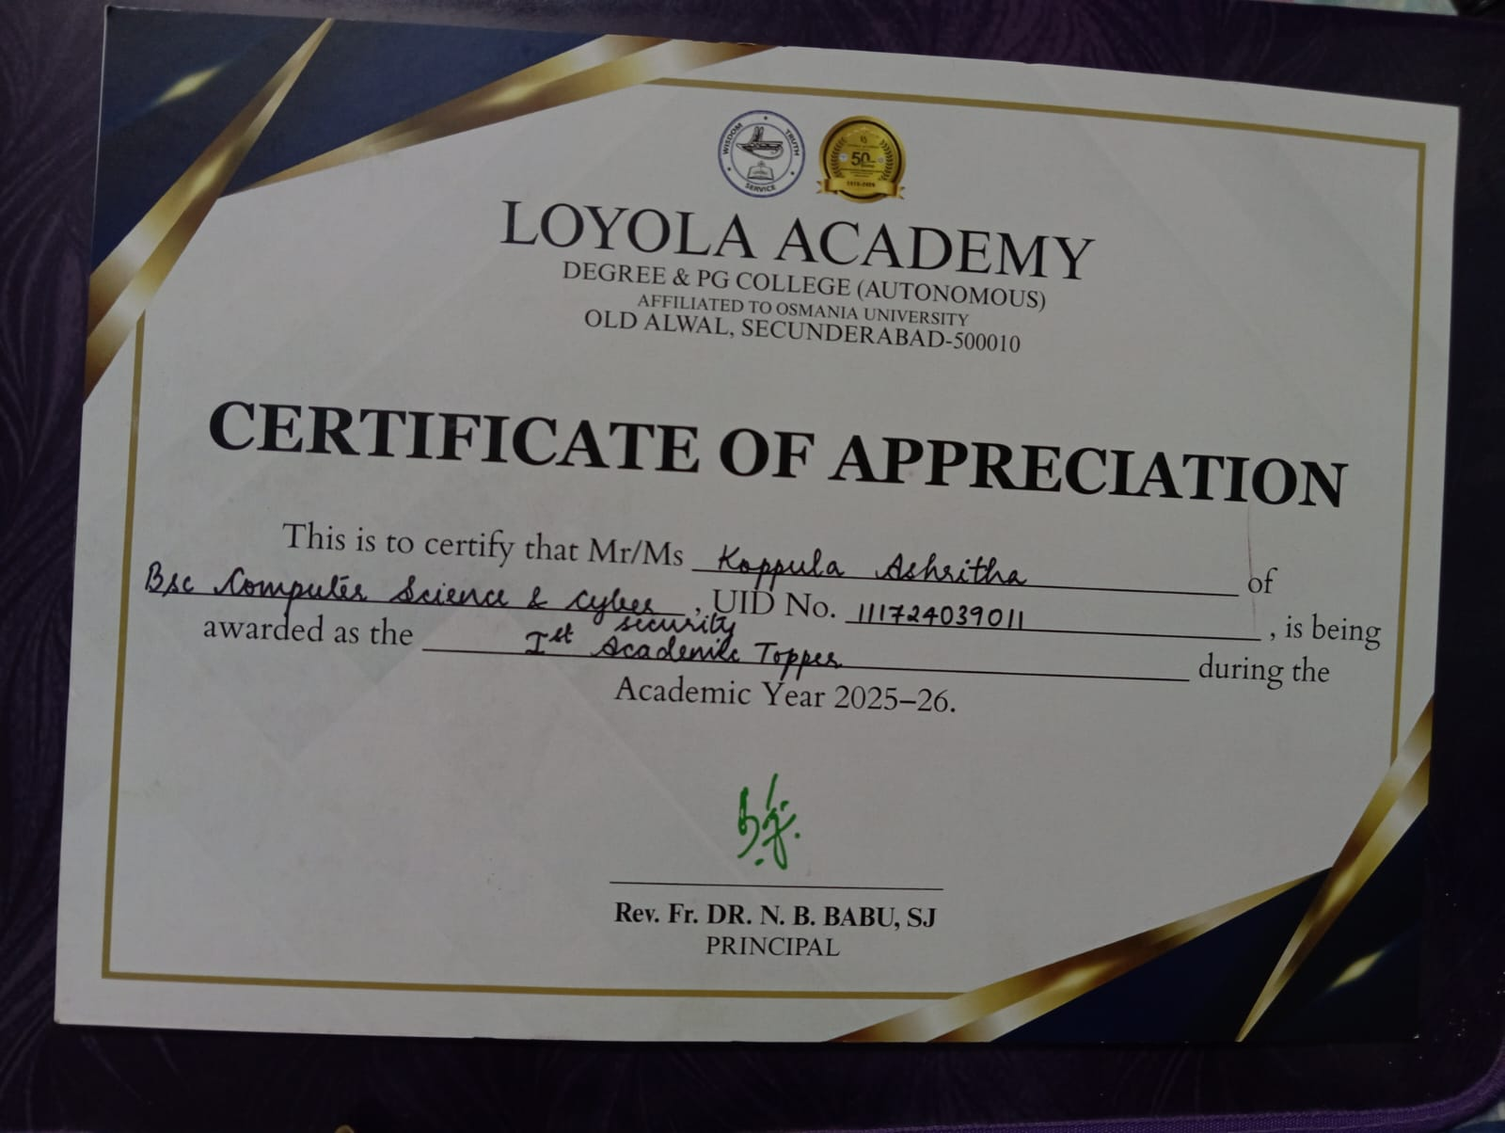

4. M . Sreenidhi Uid:111724039014, class NCSCS, is awarded 3rd academic topper for the academic year 2025-26.
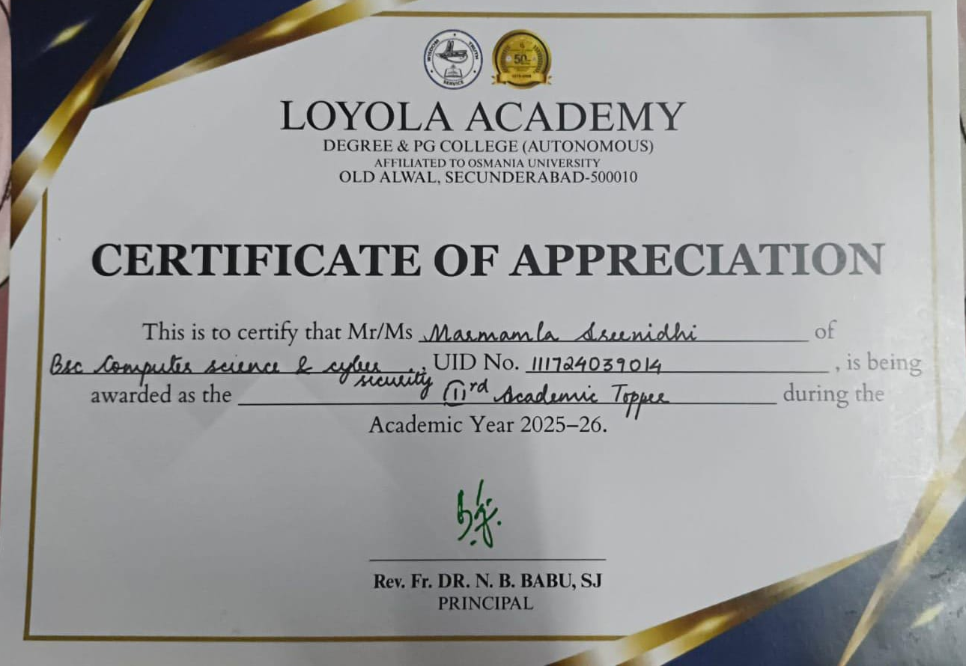
5. A Abivardhan Reddy UID 111724039050 Class ACSCS, has participated in Mind Sprint 2k25 By PSCMR Collage And Brain O Vision At Vijayawada.

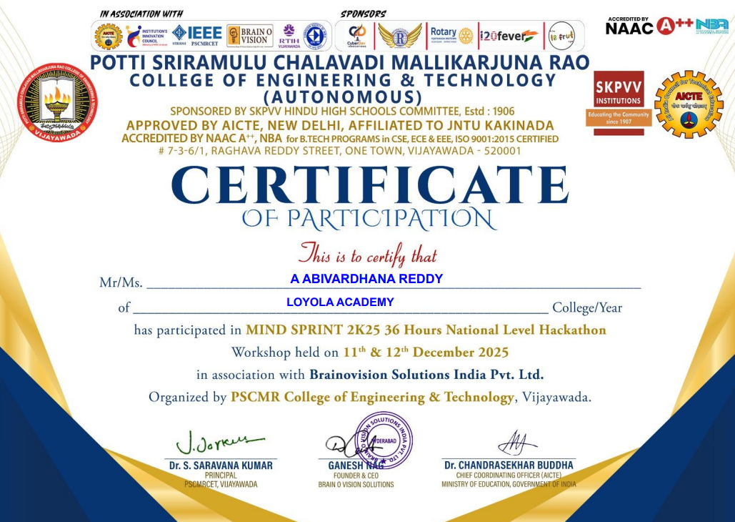

6. D NAGA CHAITANYA UID 11172439025 of Class ACSCS, has participated in Mind Sprint 2k25 By PSCMR Collage And Brain O Vision At Vijayawada.

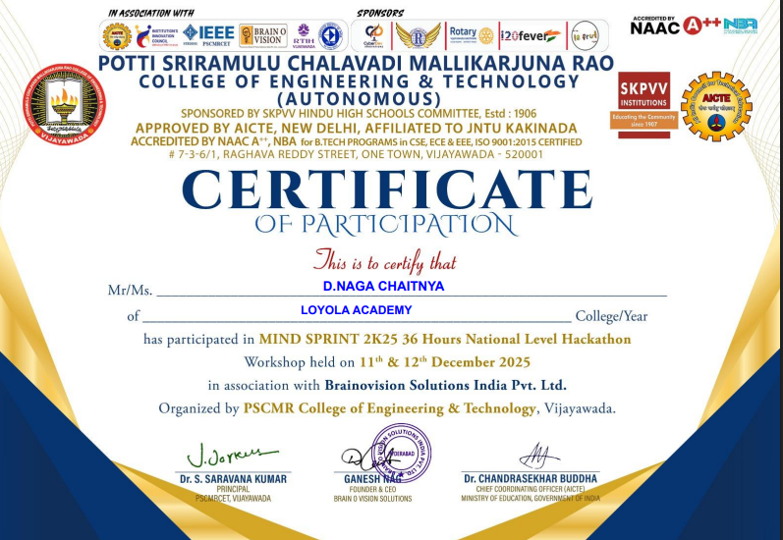

7. K JAYANTH UID 111724039029 Class ACSCS, has participated in Mind Sprint 2k25 By PSCMR Collage And Brain O Vision At Vijayawada.

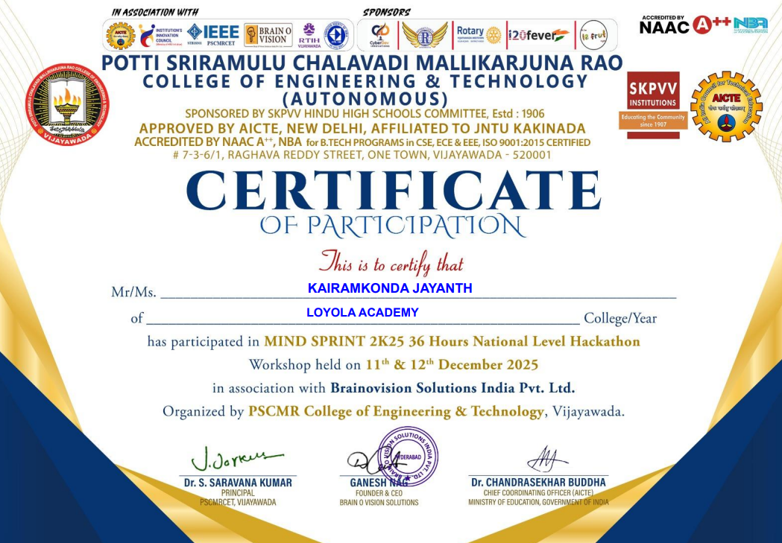

ACSCS:
- P. Bala Puneeth sujay, UID: 111725039044 of Class ACSCS has successfully awarded with 3rd prize, organized by the department of Bsc Computer Science and Artificial Intelligence in the month of July 2025,Loyola Academy.

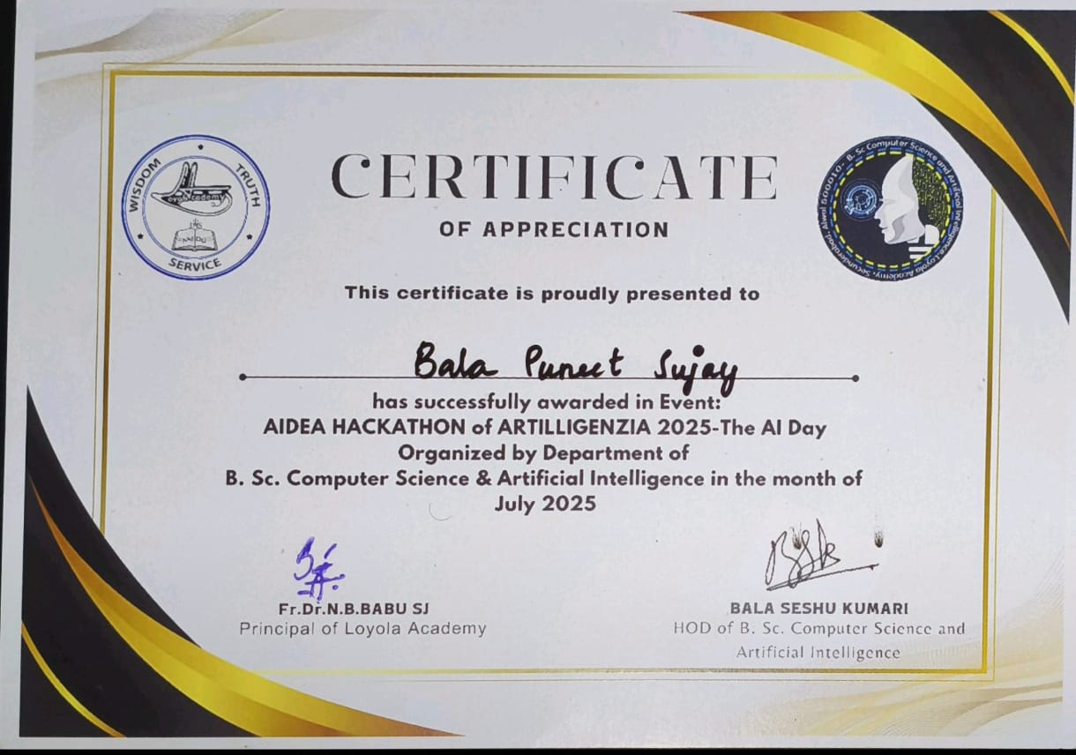

2. M. Raghunadan Sudarshan UID 111725039036 of Class ACSCS has successfully awarded with 3rd prize, organized by the department of Bsc Computer Science and Artificial Intelligence in the month of July 2025,Loyola Academy.

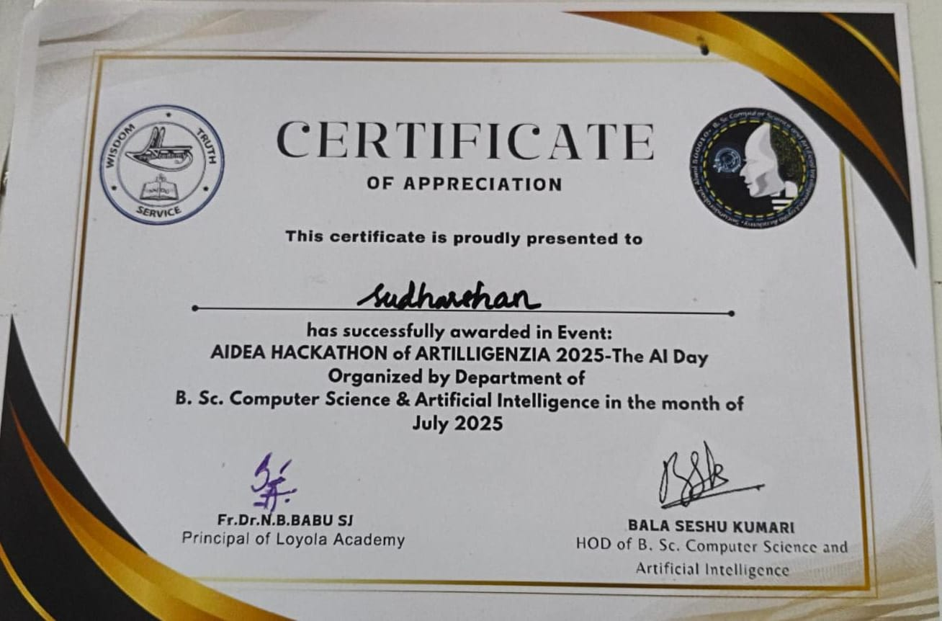

3.STUDENT NAME: RESHAM ARAVIND
UID: 111725039045
CLASS: ACSCS
EVENT: 10TH RANGAREDDY SUB JUNIOR AND JUNIOR DIST LEVEL SWIMMING CHAMPIONSHIP 2025
TYPE: 400MTRS FREESTYLE
POSITION: FRIST PRIZE
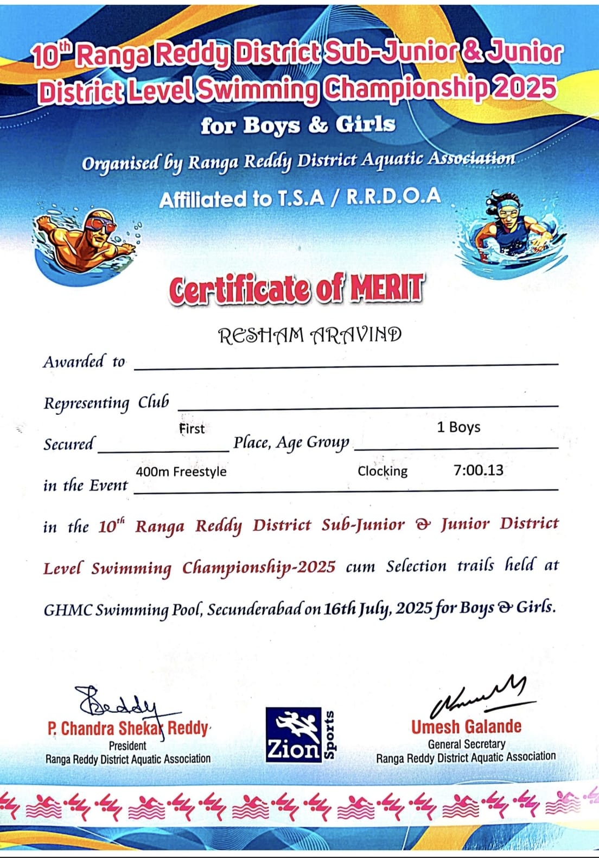

4.STUDENT NAME: RESHAM ARAVIND
UID: 111725039045
CLASS: ACSCS
EVENT: 10TH RANGAREDDY SUB JUNIOR AND JUNIOR DIST LEVEL SWIMMING CHAMPIONSHIP 2025
TYPE: 800 MTRS FREESTYLE
POSITION: FRIST PRIZE
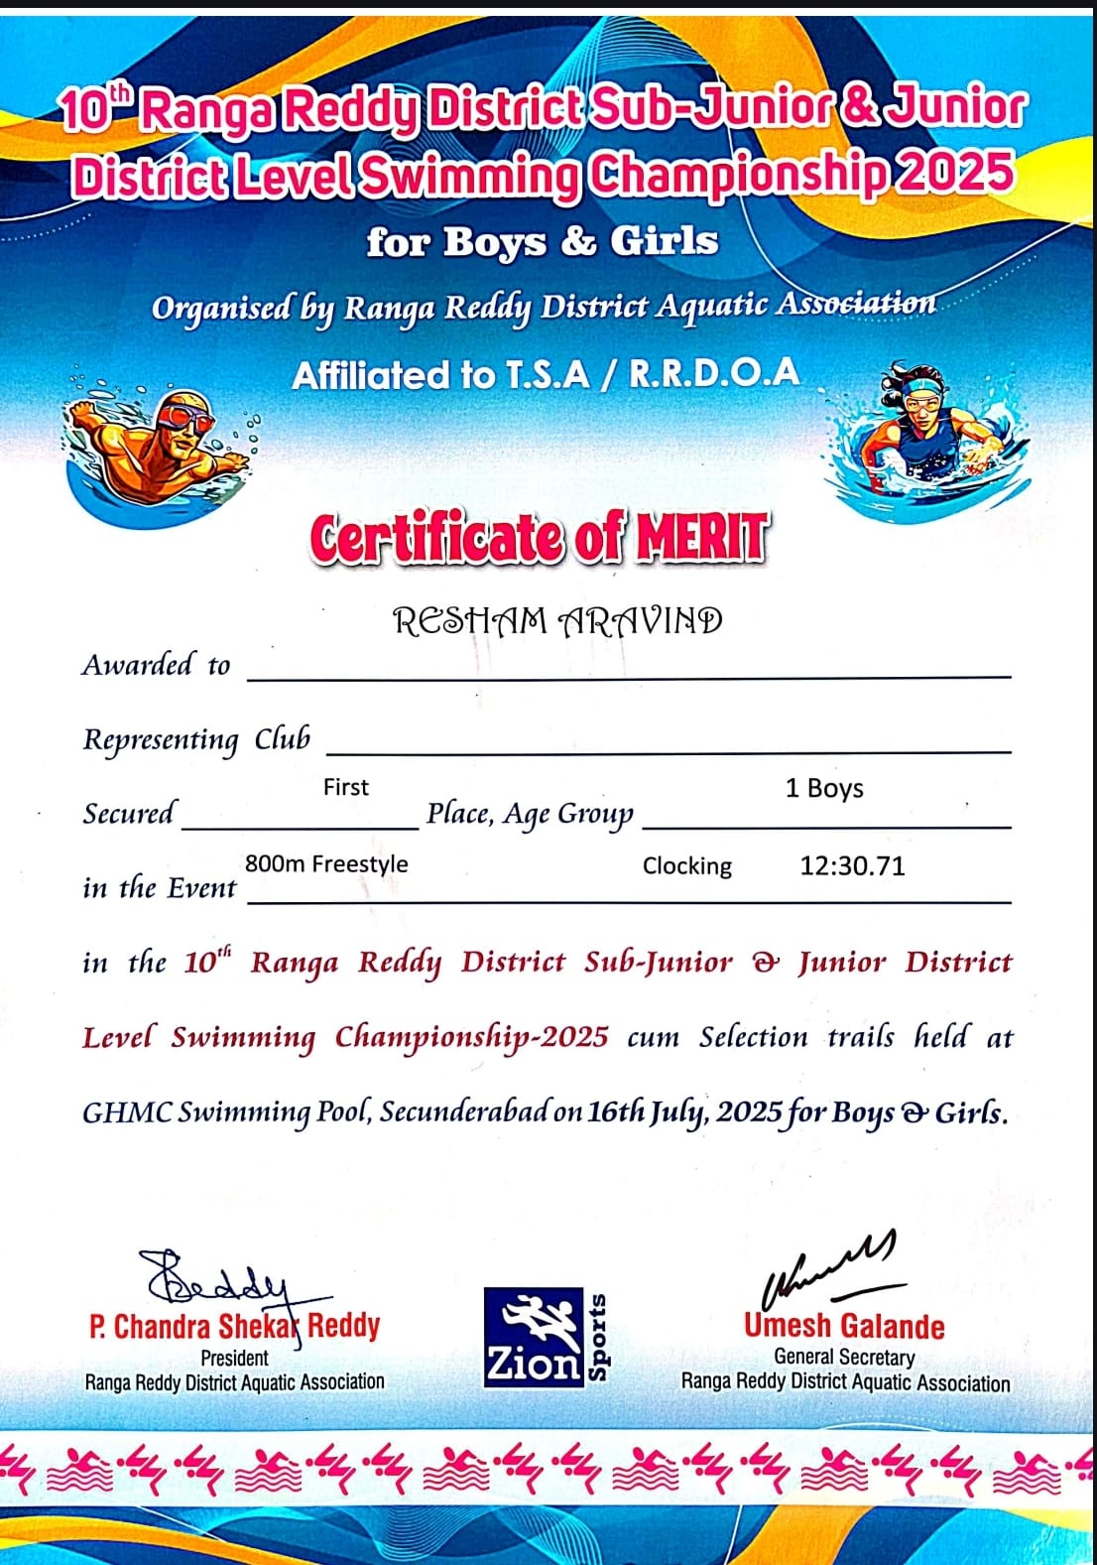

5.Student Name: R Aravind
UID: 111725039045
CLASS: ACSCS

EVENT: 10TH RANGAREDDY SUB JUNIOR AND JUNIOR DIST LEVEL SWIMMING CHAMPIONSHIP 2025
TYPE: 200 MTRS BACK
POSITION: SECOND PRIZE
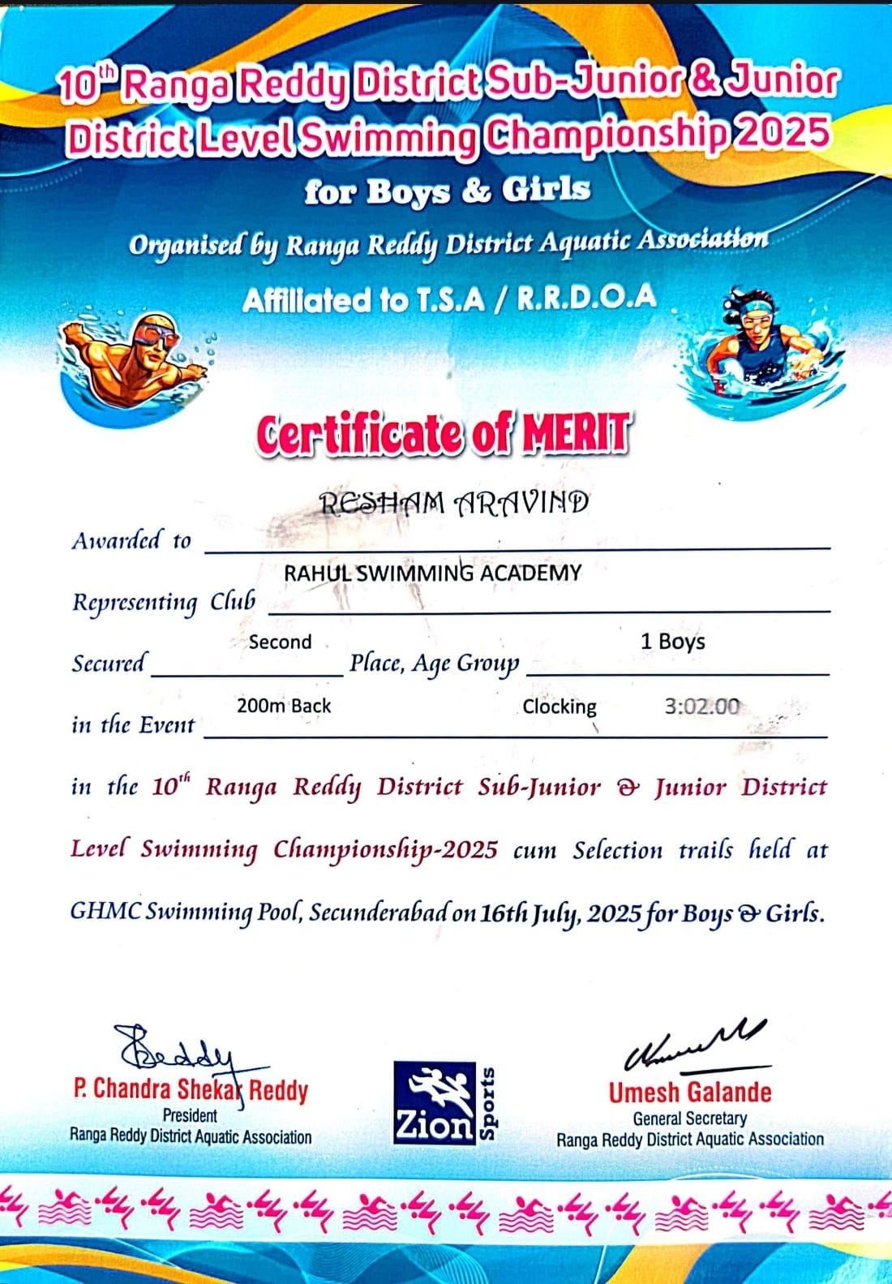
6.Student Name: R Aravind
UID: 111725039045
CLASS: ACSCS

EVENT: 10TH RANGAREDDY SUB JUNIOR AND JUNIOR DIST LEVEL SWIMMING CHAMPIONSHIP 2025
TYPE: 200 MTRS BREAST
POSITION: THIRD PRIZE
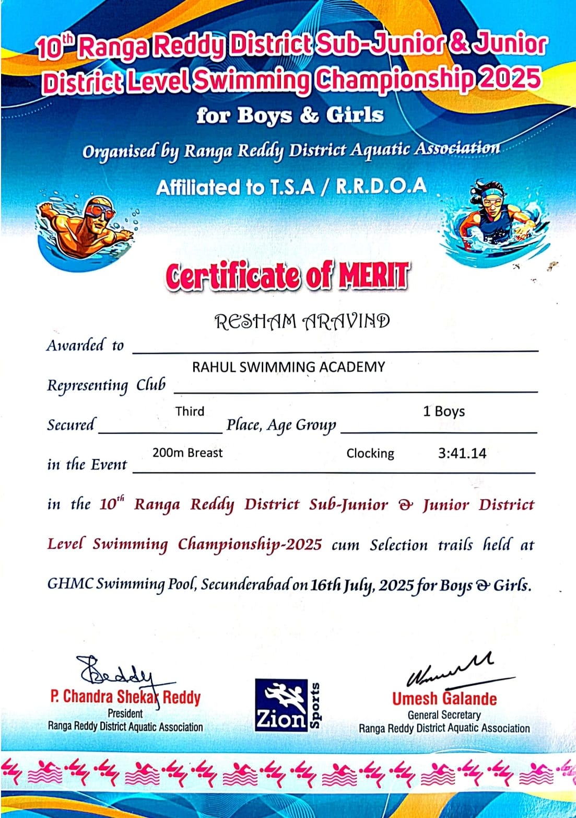

7.Student Name: R Aravind
UID: 111725039045
CLASS: ACSCS
EVENT: INTER COLLAGE TOURNAMANTE FOR MEN AND WOMEN OSMANIA UNIVERSITY SPORTS AND PHYSICAL EDUCATION 2025-2026
TYPE: SWIMMING
POSITION: BORNZE MEDAL
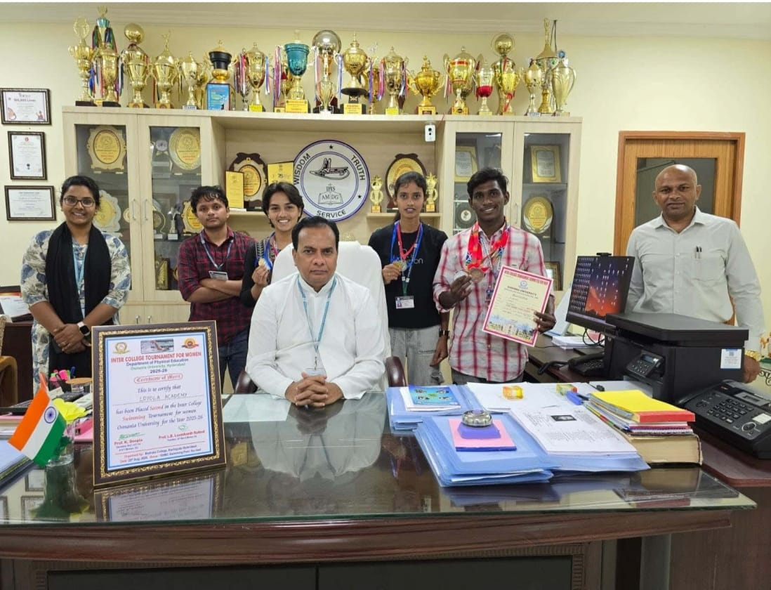

8.Student Name: R Aravind
UID: 111725039045
CLASS: ACSCS
EVENT: INTER COLLAGE TOURNAMANTE FOR MEN AND WOMEN OSMANIA UNIVERSITY SPORTS AND PHYSICAL EDUCATION 2025-2026
TYPE: SWIMMING
POSITION: BORNZE MEDAL
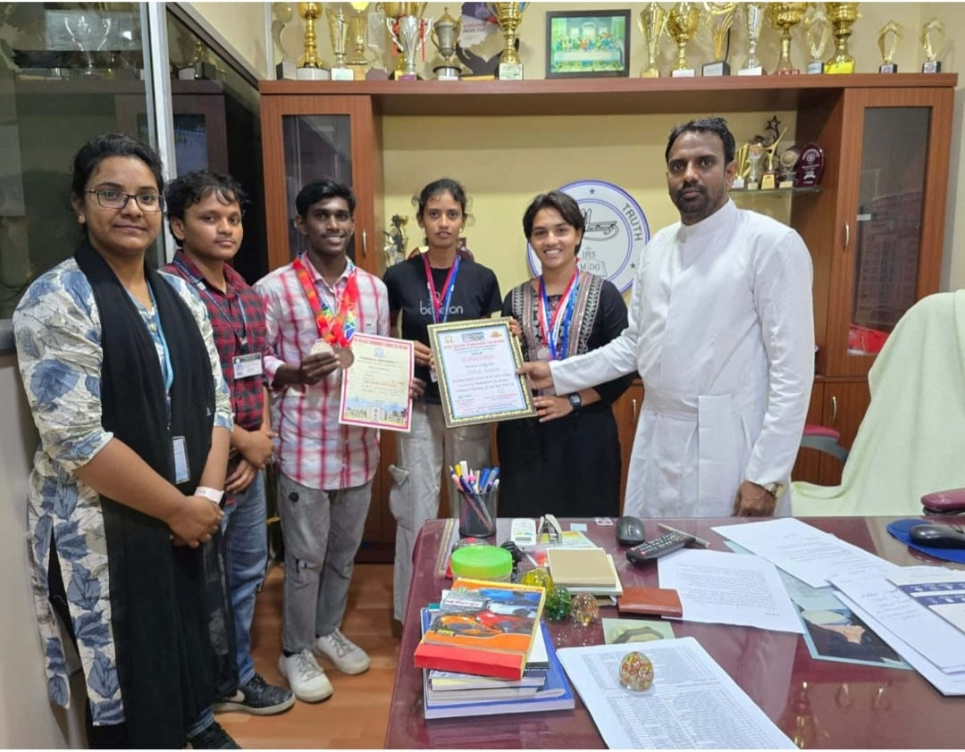
9.Deva Sai Deekshith Reddy 111725039028 of Class ACSCS, has participated in Mind Sprint 2k25 By PSCMR Collage And Brain O Vision At Vijayawada.
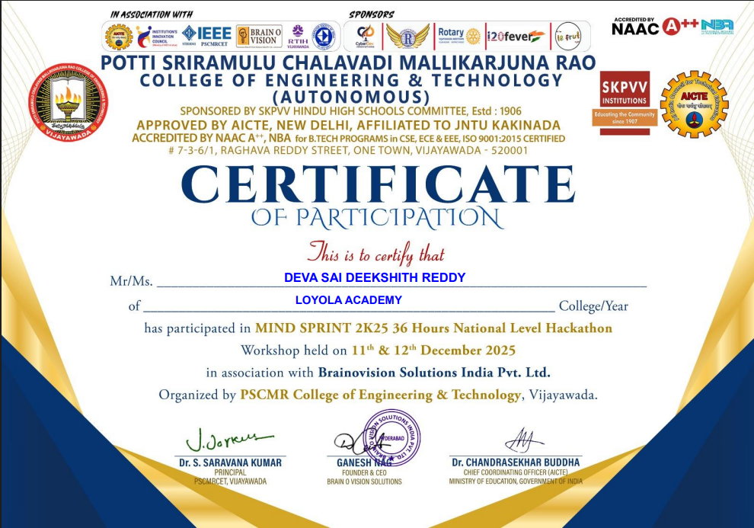

10.Pentareddy Bala Puneeth Sujay Reddy 111725039044 of class ACSCS has participated in Mind Sprint 2k25 By PSCMR Collage And Brain O Vision At Vijayawada.

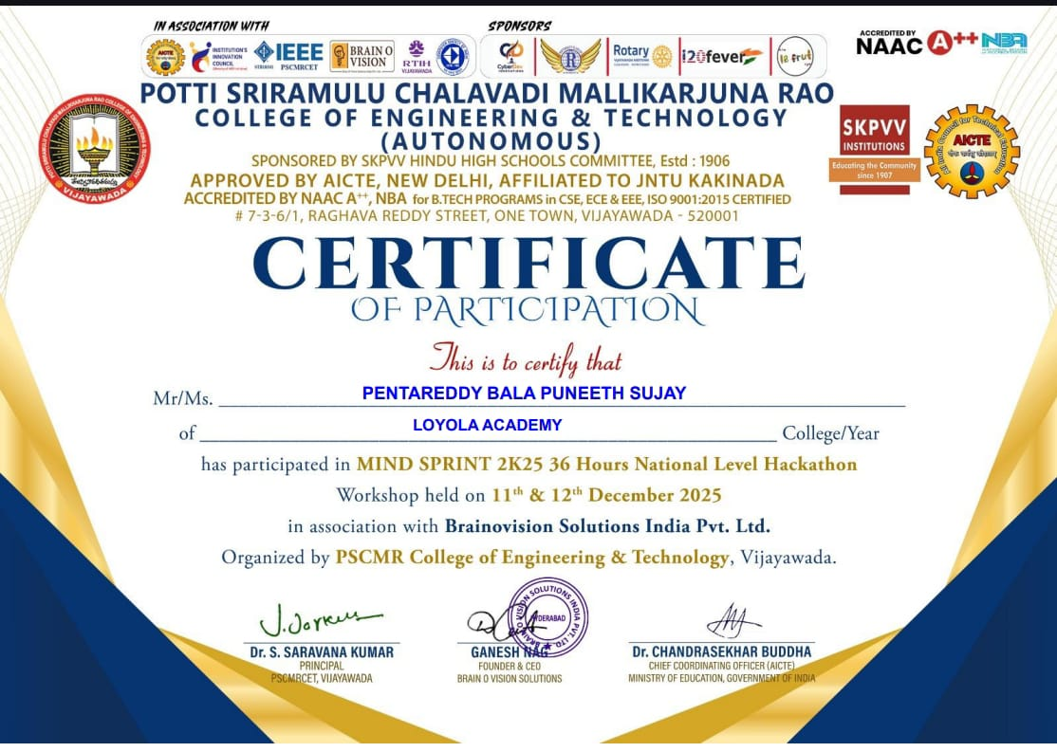

5.Special achievements of the students:
1. Hamad Saleh Mahfooz 111723039027 from DCSCS Secured 2nd place in Football, conducted by Department of Physical Education, Osmania University.
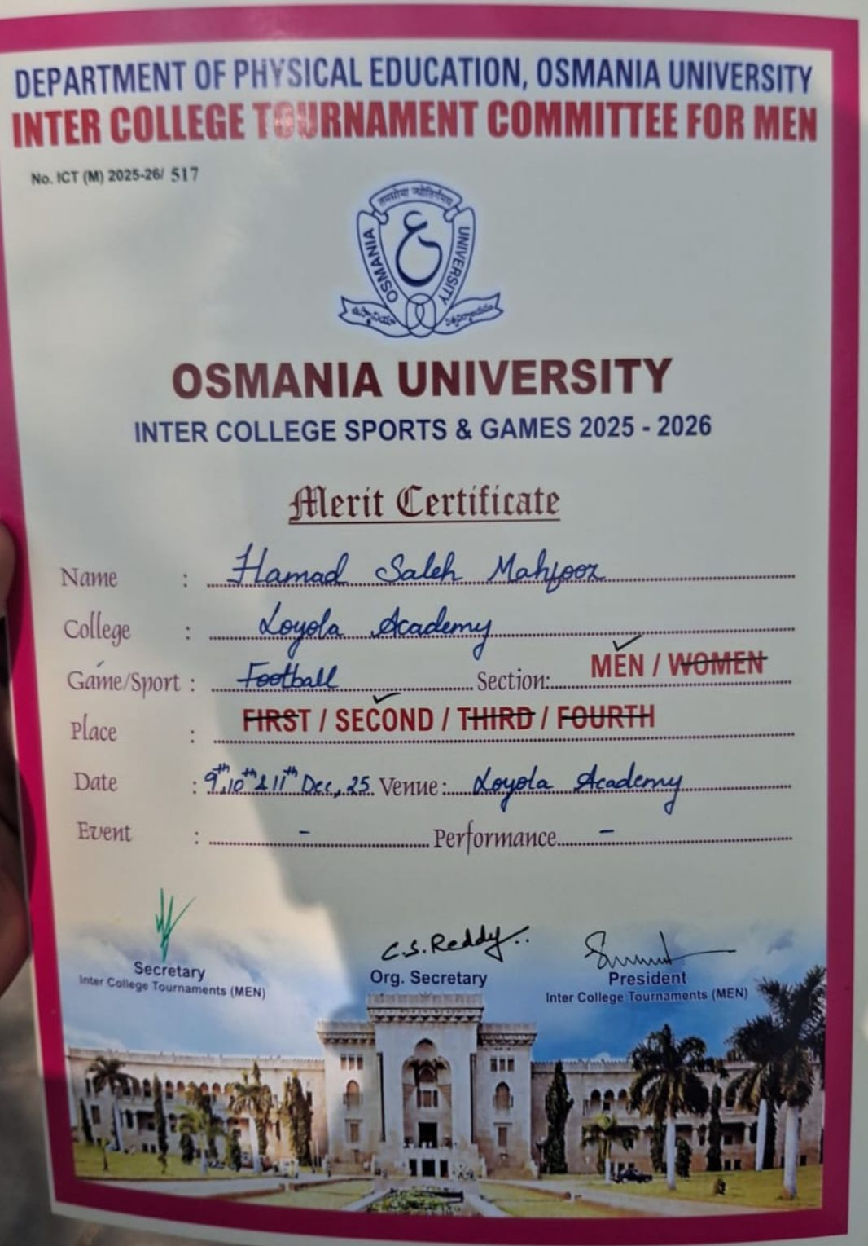

2.P S Shiva Kumar uid 111723039043 of Class DCSCS
– Nau Sainik Camp (Inter-Group Competition)
A student from the department participated in the Inter-Group Competition conducted during the Nau Sainik Camp. The student competed in two events: Sailing and Service Subject Examination.
In the Sailing event, the student secured 4th place.In the Service Subject Examination, the student secured a Silver Medal (2nd place overall).
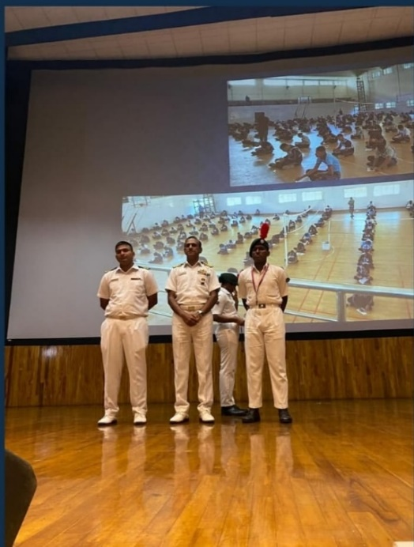
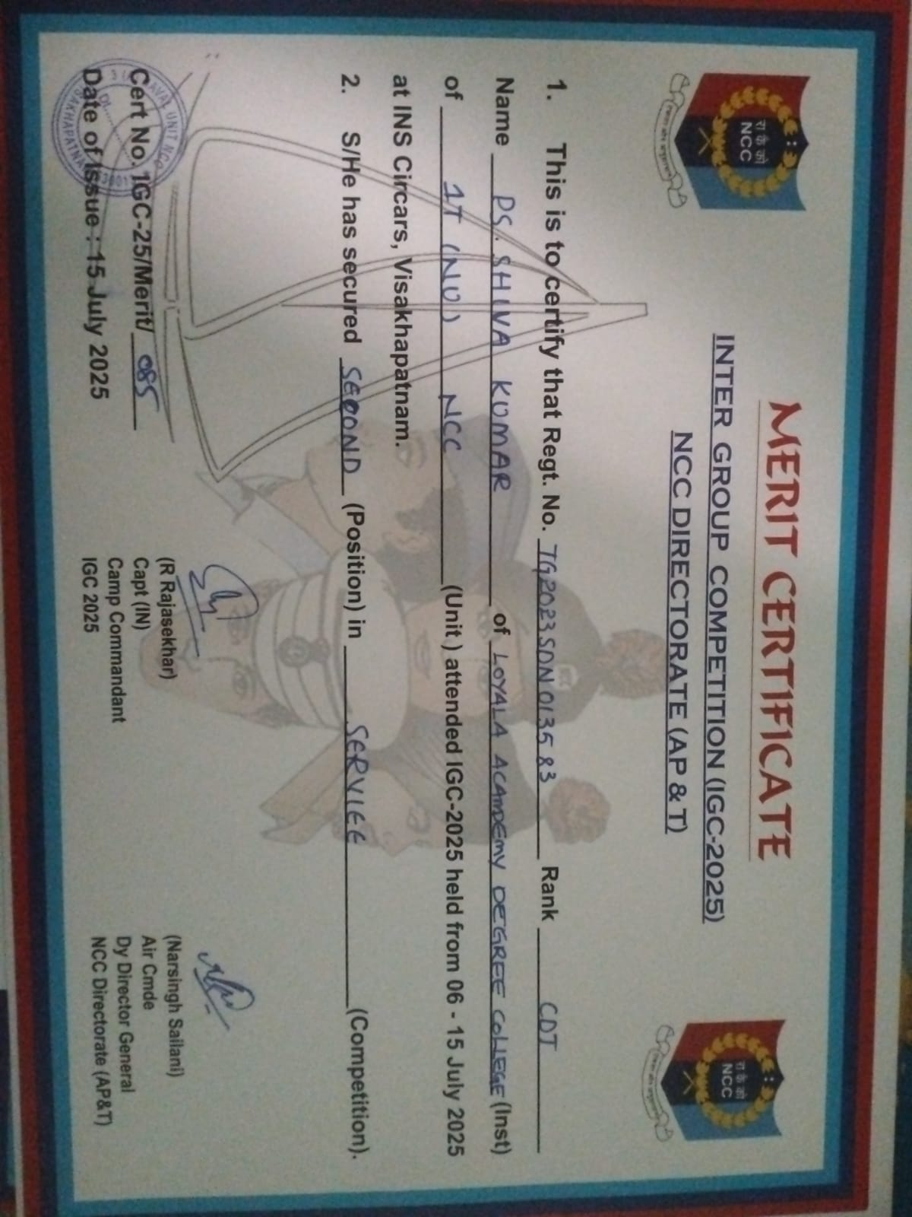

3.S Chaitanya UID 111724039046 of Class NCSCS Secured 1st prize and got 10K cash in CTF organized by DDC conducted by CBIT College

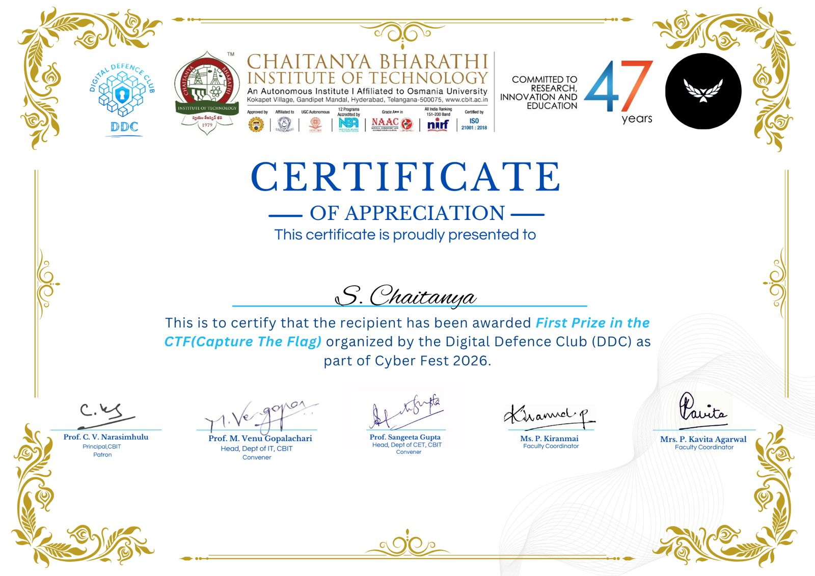

4. M Chethan Yadav uid 111724039033, of class NCSCS NCSCS Secured 1st prize and got 10K cash in CTF organized by DDC conducted by CBIT College
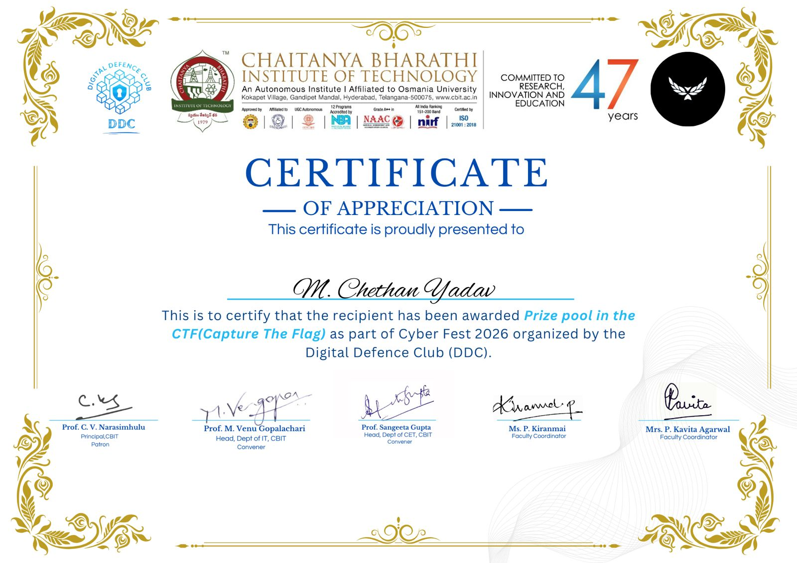

5.Student Name: R Aravind
UID: 111725039045
CLASS: ACSCS
EVENT: INTER COLLAGE TOURNAMANTE FOR MEN AND WOMEN OSMANIA UNIVERSITY SPORTS AND PHYSICAL EDUCATION 2025-2026
TYPE: SWIMMING
POSITION: SLIVER MEDAL
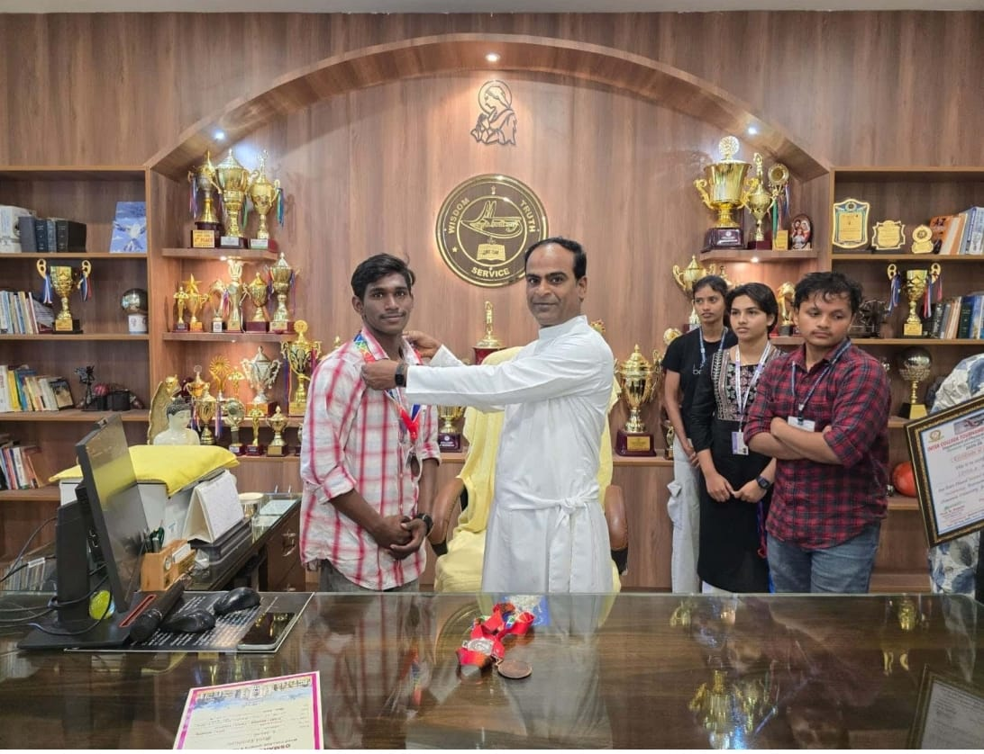

6 . Placements Data: Academic Year(2024-25)
sno | Name | Uid | Company Name | Package | on/off
1 | Divyanshi Budakoti | 111722039002 | CtrlS | 3LPA | On campus
2 | Gopishetty Santoshi | 111722039003 | Lti mindtree | 3.19 | On campus
3 | Gullapally Anusha Goud | 111722039004 | Lti mind tree | 3.19 | On campus
4 | Sreeja Manda | 111722039005 | LTI MINDTREE | 3.19 LPA | On Campus
5 | P Laxmi Priya | 111722039009 | Ctrls datacenter | 3LPA | on campus
6 | Pudota Josh Pravalika | 111722039010 | Cognizant | 2.8LPA | On Campus
7 | Pushayaamee Raj Boini | 111722039011 | JP Morgan Chase | 5.25 LPA | On Campus
8 | Veeragoni Likitha | 111722039012 | LTI MINDTREE | 3.19LPA | On campus
9 | Yarasani bala vaishnavi | 111722039014 | DELOTTIE | 3.25 LPA | On
10 | B Manav | 111722039018 | Teleperformance | 3.25 | On
11 | G Mehul Raj Yadav | 111722039020 | Cognizant | 2.80LPA | On campus
12 | Koppisetti Naveen Kumar | 111722039025 | Meta | 5lpa | Off
13 | K.Sree Varun Goud | 111722039026 | Sutherland | 2.40 - 2.70LPA | On campus
14 | N Revanth Samuel | 111722039030 | Deloitte | 3.25 | On
15 | Sambangi Rohit Sai Vardhan | 111722039034 | LTIMindtree | 3.2LPA | On campus
16 | Vattipally Phani Kumar Reddy | 111722039036 | Sagility | 2 | On
17 | PANYALA SAMEEKSHA | 111722039041 | LTI Mindtree | 3.19 | On Campus
18 | S Harshitha | 111722039047 | Cognizant | 2.8 LPA | On campus
Higher Education:
student name | uid | college joined | course
Mondrety Trailokya Vaishnavi | 111722039006 | CBIT | MCA
Navya Rajesh | 111722039008 | GISMA university, Berlin Germany | M.Sc Cybersecurity
V VARSHA | 111722039013 | Manipal University Jaipur | Msc Cyber Security
Mohammed Fawwaz khan | 111722039024 | Silicon business solution pvt ltd | Internship
N. Rahul | 111722039029 | Manipal university | Msc cyber security
PM Akshit | 111722039032 | Amity University Bengaluru | MSC Cyber Security
S Sir lakshmi | 111722039048 | ICBM business school | PGDM

7.DSE LIST:
S.No | UID | Name | SUBJECT
1 | 111723039003 | Bhavya unni | stegnography
2 | 111723039004 | Biyyani Rishikasri | stegnography
3 | 111723039006 | D. Jhansi | stegnography
4 | 111723039007 | Gidigam Akshitha | stegnography
5 | 111723039008 | Kore Mounika | stegnography
6 | 111723039011 | N.manasa | stegnography
7 | 111723039013 | Sk.rubeena | stegnography
8 | 111723039015 | Shamine Gloria | stegnography
9 | 111723039016 | Taj fatima | stegnography
10 | 111723039018 | Aditya kishore singh | stegnography
11 | 111723039019 | Aryan Gupta | stegnography
12 | 111723039020 | BATTHULA VAMSHI | stegnography
13 | 111723039024 | D.Durgaprasad | stegnography
14 | 111723039025 | Gabbula Sai teja | stegnography
15 | 111723039028 | Sathish | stegnography
16 | 111723039033 | Manoj | stegnography
17 | 111723039037 | M sampath | stegnography
18 | 111723039040 | Varshith Pasala | stegnography
19 | 111723039042 | P.Manikanta | stegnography
20 | 111723039044 | Rohith kumar singh | stegnography
21 | 111723039045 | R saikishor | stegnography
22 | 111723039046 | S John Vijay | stegnography
23 | 111723039047 | Raju Tirumani Kumar | stegnography
24 | 111723039050 | Bhanu preetham | stegnography

S.NO | uid | NAME | SUBJECT
1 | 111723039001 | Sowmya | secure ecommerce
2 | 111723039002 | B.Yamini Sri | secure ecommerce
3 | 111723039005 | Alice Saloni Chekelea | secure ecommerce
4 | 111723039009 | rajarani | secure ecommerce
5 | 111723039010 | MD. RAZIYA BANU | secure ecommerce
6 | 111723039012 | sudiksha | secure ecommerce
7 | 111723039014 | S Lasya Reddy | secure ecommerce
8 | 111723039017 | Abraham Wallace | secure ecommerce
9 | 111723039021 | B.K.RISHIKESH REDDY | secure ecommerce
10 | 111723039022 | Siril anush | secure ecommerce
11 | 111723039023 | Clemence kerron | secure ecommerce
12 | 111723039026 | Paul | secure ecommerce
13 | 111723039027 | Hamad Saleh Mahfooz | secure ecommerce
14 | 111723039030 | Varun Raju | secure ecommerce
15 | 111723039031 | K.Sampath | secure ecommerce
16 | 111723039034 | Yaswanth | secure ecommerce
17 | 111723039035 | Manikanta Reddy.A | secure ecommerce
18 | 111723039038 | Muzammil | secure ecommerce
19 | 111723039039 | N.Manikanta | secure ecommerce
20 | 111723039041 | Philip Paul James | secure ecommerce
21 | 111723039043 | P S SHIVA KUMAR | secure ecommerce
22 | 111723039048 | V Jason | secure ecommerce
23 | 111723039049 | Srujan vempati | secure ecommerce

S.NO | UID | Name | Subject
1 | 111723039002 | B.Yamini Sri | IoT
2 | 111723039003 | Bhavya unni | IoT
3 | 111723039004 | Biyyani Rishikasri | IoT
4 | 111723039006 | D. Jhansi | IoT
5 | 111723039007 | Gidigam Akshitha | IoT
6 | 111723039013 | Sk.rubeena | IoT
7 | 111723039016 | Taj fatima | IoT
8 | 111723039018 | Aditya kishore singh | IoT
9 | 111723039020 | BATTHULA VAMSHI | IoT
10 | 111723039022 | Siril anush | IoT
11 | 111723039024 | D.Durgaprasad | IoT
12 | 111723039028 | Sathish | IoT
13 | 111723039031 | K.Sampth | IoT
14 | 111723039035 | Manikanta Reddy.A | IoT
15 | 111723039037 | M sampath | IoT
16 | 111723039039 | N.Manikanta | IoT
17 | 111723039040 | Varshith Pasala | IoT
18 | 111723039042 | P.Manikanta | IoT
19 | 111723039043 | P S SHIVA KUMAR | IoT
20 | 111723039044 | Rohith kumar singh | IoT
21 | 111723039045 | R saikishor | IoT
22 | 111723039047 | Raju Tirumani Kumar | IoT
23 | 111723039050 | Bhanu preetham | IoT

S.No | UID | Name | Subject
1 | 111723039001 | Sowmya | Cloud computing
2 | 111723039005 | Alice Saloni Chekelea | Cloud computing
3 | 111723039008 | Kore Mounika | Cloud computing
4 | 111723039009 | rajarani | Cloud computing
5 | 111723039010 | MD. RAZIYA BANU | Cloud computing
6 | 111723039011 | N.manasa | Cloud Computing
7 | 111723039012 | sudiksha | Cloud Computing
8 | 111723039014 | S Lasya Reddy | Cloud computing
9 | 111723039015 | Shamine Gloria | Cloud computing
10 | 111723039017 | Abraham Wallace | Cloud computing
11 | 111723039019 | Aryan Gupta | Cloud computing
12 | 111723039021 | B.K.RISHIKESH REDDY | Cloud computing
13 | 111723039023 | Clemence kerron | Cloud computing
14 | 111723039025 | Gabbula Sai teja | Cloud computing
15 | 111723039026 | Paul | Cloud computing
16 | 111723039027 | Hamad Saleh Mahfooz | Cloud computing
17 | 111723039030 | Varun Raju | Cloud computing
18 | 111723039033 | Manoj | Cloud computing
19 | 111723039034 | Yaswanth | Cloud computing
20 | 111723039038 | Muzammil | Cloud computing
21 | 111723039041 | Philip Paul James | Cloud computing
22 | 111723039046 | S John Vijay | Cloud computing
23 | 111723039048 | V Jason | Cloud computing
24 | 111723039049 | Srujan vempati | Cloud computing

VI SEM

S.No | UID | NAME | SUBJECT
1 | 111723039002 | Banala Yaminisri | Blockchain and cryptocurrency
2 | 111723039003 | Bhavya unni | Blockchain and cryptocurrency
3 | 111723039004 | B . Rishika | Blockchain and cryptocurrency
4 | 111723039006 | D.Jhansi | Blockchain and cryptocurrency
5 | 111723039007 | Akshitha | Blockchain and cryptocurrency
6 | 111723039008 | Mounika | Blockchain and cryptocurrency
7 | 111723039010 | MD. Raziya Banu | Blockchain and cryptocurrency
8 | 111723039011 | Neerati Manasa | Blockchain and cryptocurrency
9 | 111723039012 | Sudhiksha Goud | Blockchain and cryptocurrency
10 | 111723039013 | Sk.Rubeena | Blockchain and cryptocurrency
11 | 111723039016 | Taj fatima | Blockchain and cryptocurrency
12 | 111723039017 | Abraham Wallace | Blockchain and cryptocurrency
13 | 111723039022 | Siril Anush | Blockchain and cryptocurrency
14 | 111723039031 | K sampath | Blockchain and cryptocurrency
15 | 111723039033 | Manoj | Blockchain and cryptocurrency
16 | 111723039039 | NALLA MANIKANTA | Blockchain and cryptocurrency
17 | 111723039047 | Raju Tirumani Kumar | Blockchain and cryptocurrency
18 | 111723039046 | S John Vijay | Blockchain and cryptocurrency
19 | 111723039005 | Alice | Blockchain and cryptocurrency
20 | 111723039035 | A Manikanta | Blockchain and cryptocurrency
21 | 111723039038 | Muzammil | Blockchain and cryptocurrency
22 | 111723039041 | Philip Paul James | Blockchain and cryptocurrency

S.No | uid | Name | Subject
1 | 111723039001 | Sowmya | Cyber Threat and Intelligence
2 | 111723039009 | L Rajarani | Cyber Threat and Intelligence
3 | 111723039014 | S Lasya Reddy | Cyber Threat and Intelligence
4 | 111723039018 | Aditya kishore singh | Cyber Threat and Intelligence
5 | 111723039019 | Aryan Gupta | Cyber Threat and Intelligence
6 | 111723039020 | Batthula Vamshi | Cyber Threat and Intelligence
7 | 111723039021 | B.K.RISHIKESH REDDY | Cyber Threat and Intelligence
8 | 111723039023 | Clemence Kerron | Cyber Threat and Intelligence
9 | 111723039024 | Durga prasad | Cyber Threat and Intelligence
10 | 111723039025 | Gabbula Sai teja | Cyber Threat and Intelligence
11 | 111723039026 | Paul Thomas | Cyber Threat and Intelligence
12 | 111723039027 | Hamad Saleh Mahfooz | Cyber Threat and Intelligence
13 | 111723039028 | Sathish | Cyber Threat and Intelligence
14 | 111723039030 | Varun | Cyber Threat and Intelligence
15 | 111723039034 | Yashwanth | Cyber Threat and Intelligence
16 | 111723039037 | M sampath | Cyber Threat and Intelligence
17 | 111723039040 | Varshith Pasala | Cyber Threat and Intelligence
18 | 111723039042 | P MANIKANTA | Cyber Threat and Intelligence
19 | 111723039043 | P S SHIVA KUMAR | Cyber Threat and Intelligence
20 | 111723039044 | rohith singh | Cyber Threat and Intelligence
21 | 111723039045 | R saikishor | Cyber Threat and Intelligence
22 | 111723039048 | V Jason | Cyber Threat and Intelligence
23 | 111723039049 | Srujan vempati | Cyber Threat and Intelligence
24 | 111723039050 | Bhanu preetham | Cyber Threat and Intelligence

8. REPORT ON REMEDIAL CLASS: Courses Name: Database Management System (B.Sc. NCSCS) –Mr. Ajay Koka
Date: 02-09-2025 to 24-09-2025
Objectives:
- To provide focused remedial coaching for Database Management Systems (DBMS) to address learning challenges and enhance student understanding.
- To support learning through interactive resources, including SQL simulators, video tutorials, database design tools, and virtual lab sessions, to help students effectively understand and apply key DBMS concepts.
- To reinforce foundational knowledge by revisiting the syllabus and conducting frequent short tests and quizzes to assess and improve student progress.
- To offer practical sessions on SQL, relational models, normalization, and database design, ensuring students gain hands-on experience.
- To conduct mentoring and personalized academic counseling, aimed at motivating students and guiding them through difficult topics in DBMS.
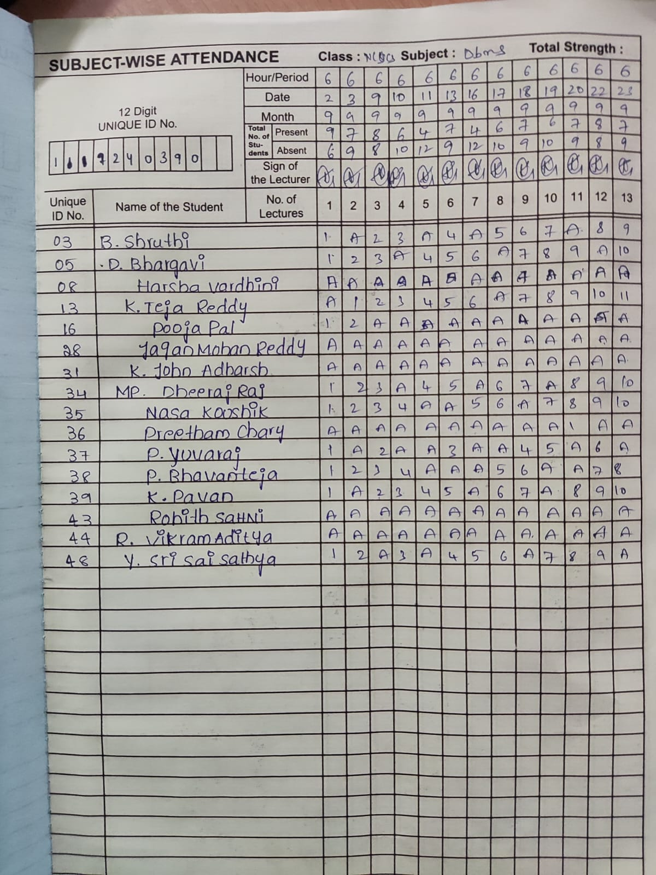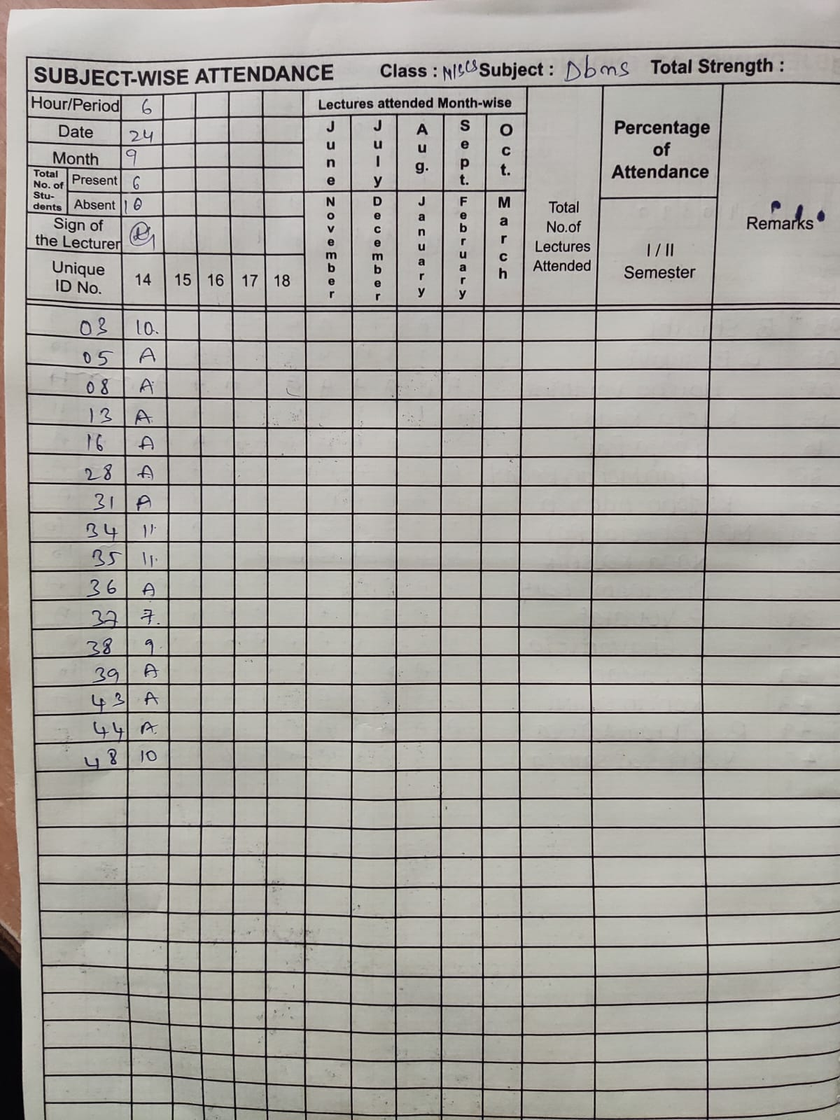
This report outlines the remedial measures undertaken to support students who did not achieve a passing grade in Database Management Systems (DBMS). The primary goal of the remedial program was to bridge learning gaps, reinforce foundational database concepts, and equip students with the necessary skills and confidence to succeed in future assessments.
The program focused on three key strategies:
- Inclusive Remedial Teaching
- Peer-Assisted Remedial Teaching
- Individualized Teacher Intervention
These methods were implemented in a structured and student-centered manner to address the diverse learning needs of the students.

1. Inclusive Remedial Teaching
Objective:
To create a supportive learning environment where all students, regardless of their prior performance, could participate actively and benefit equally from the DBMS remedial sessions.
Implementation:
- Diagnostic Assessment: Initial assessments were conducted to identify gaps in understanding of core DBMS concepts such as relational models, SQL queries, normalization, and transaction management.
- Flexible Grouping: Students were grouped heterogeneously to promote collaborative learning and reduce feelings of academic inadequacy.
- Differentiated Instruction: Teaching methods were adapted to various learning styles using visual aids (e.g., ER diagrams), real-world database examples, hands-on query exercises, and demo videos of database tools.
- Encouraging Participation: Sessions included interactive SQL labs, query-solving rounds, and open discussions on practical DBMS applications to increase engagement and comprehension.
Outcome:
Students demonstrated improved participation and conceptual clarity. Many reported a better understanding of database structures, query formulation, and normalization techniques in a collaborative, non-judgmental environment.

2. Peer-Assisted Remedial Teaching
Objective:
To leverage the strengths of high-performing students by facilitating collaborative learning and peer mentoring in DBMS.
Implementation:
- Selection of Peer Tutors: Proficient students with strong performance in DBMS and effective communication skills were chosen to guide their peers.
- Tutor Training: Peer tutors were oriented on tutoring techniques, including how to explain technical concepts like JOIN operations, subqueries, and schema design clearly and patiently.
- Small Group Sessions: Tutors worked in small groups (3–5 students), focusing on key DBMS areas such as writing SQL queries, understanding database schemas, and applying normalization rules.
- Feedback Mechanism: Continuous feedback was collected from both peer tutors and learners to ensure effectiveness and adapt as needed.
Outcome:
The peer-assisted method fostered a comfortable and productive learning atmosphere. Struggling students benefited from relatable explanations, while tutors developed leadership and teaching skills.

3. Individualized Teacher Intervention
Objective:
To provide targeted, one-on-one support tailored to each student's learning needs and challenges in DBMS.
Implementation:
- One-on-One Sessions: Personalized sessions were arranged for students needing intensive support, focusing on areas like complex query writing, relational algebra, and transaction concepts.
- Customized Study Plans: Individualized learning materials—including simplified notes, query-building worksheets, and sample database exercises—were provided to each student.
- Regular Monitoring: Teachers tracked progress using performance logs and adjusted instructional strategies based on ongoing student feedback and quiz results.
- Parental Involvement: In cases where sustained support was necessary, parents were kept informed and were encouraged to motivate consistent practice at home.
Outcome:
Students who received individualized attention showed noticeable improvement in writing accurate queries, understanding relational data, and solving DBMS-related problems. Personalized support helped build their confidence and reduced their anxiety towards technical database subjects.
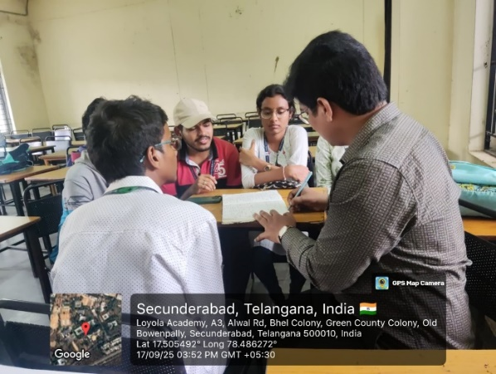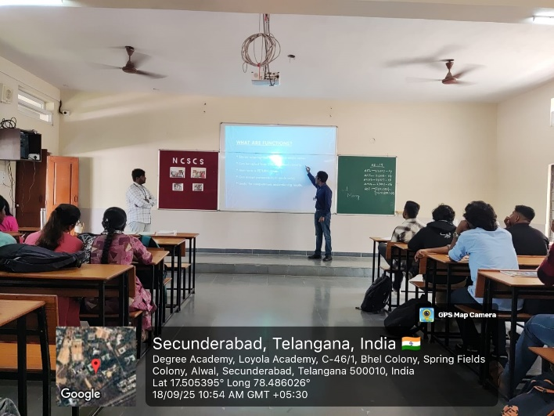

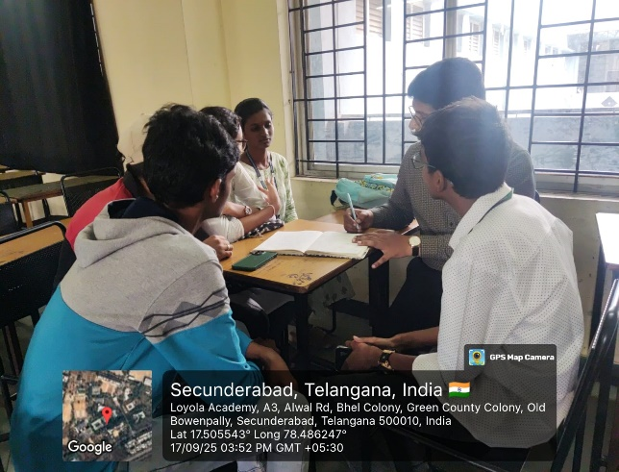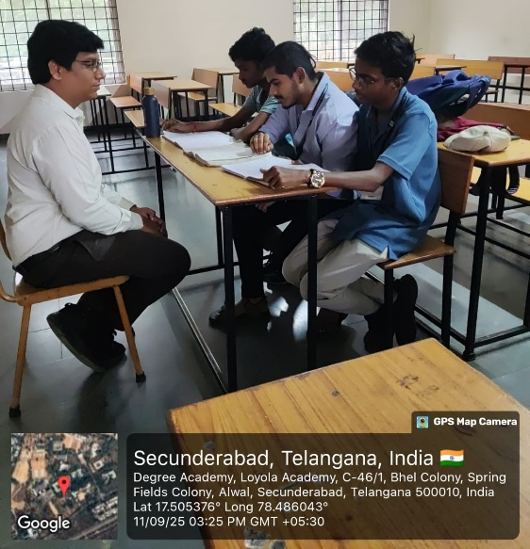

Students' Progress Evaluation
Baseline tests identified gaps in DBMS concepts. Weekly quizzes, assignments, and practical tasks tracked improvement. Teachers monitored progress and engagement, supported by peer and parental feedback. Comparison of initial and final assessments showed significant gains in SQL skills, normalization, and database design.

Recommendations
- Continue regular remedial sessions for at-risk students.
- Use interactive database tools to enhance learning.
- Train teachers and peer tutors to improve support methods.
- Encourage parental involvement and home practice.

Conclusion
The combined approach of inclusive, peer-assisted, and individualized teaching improved students’ DBMS performance, confidence, and interest, preparing them better for future challenges in Cyber Security.
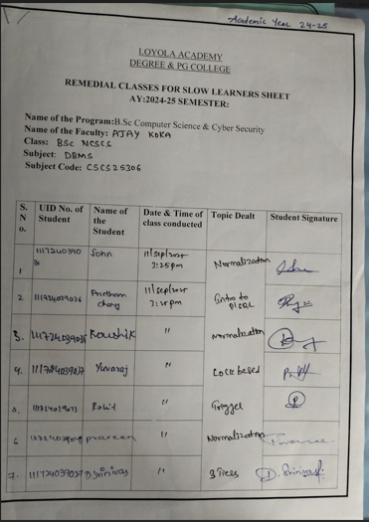
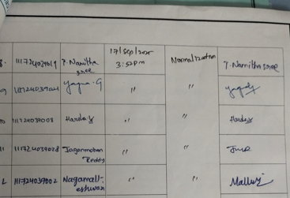
Remedial Teaching Report
Type of Remedial method: Individualized teacher interventions
Department: Cyber Security
CourseName: BSc Computer Science & Cyber Security
Date:25-03-2026

Objective: To strengthen basic mathematical concepts and fill learning gaps.To improve problem-solving skills through guided practice.To build confidence and reduce fear or anxiety toward mathematics.To provide individualized attention based on each student’s needs.To enhance overall academic performance in mathematics.
Registers pictures:
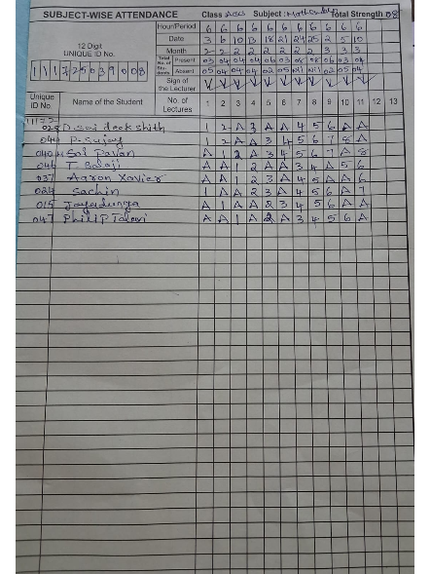

Remedial class photos:

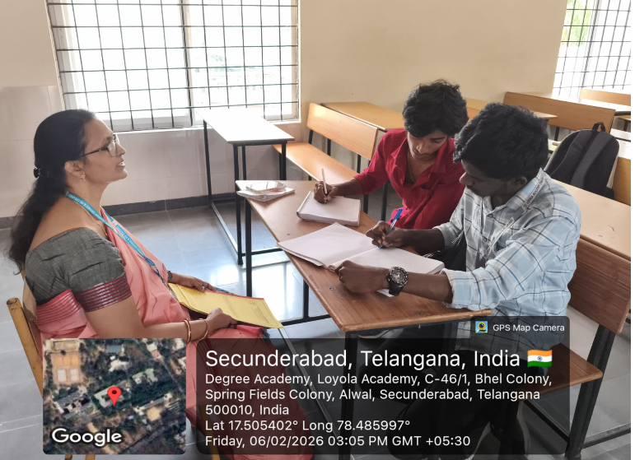
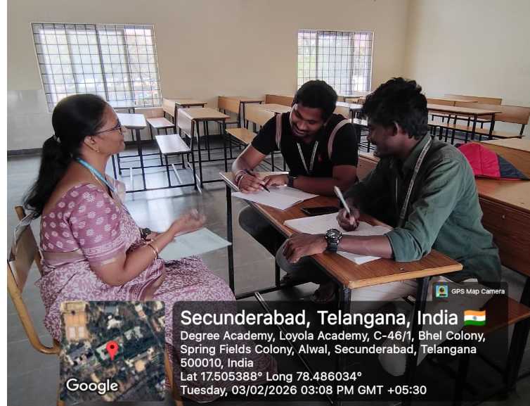

Signature sheets:
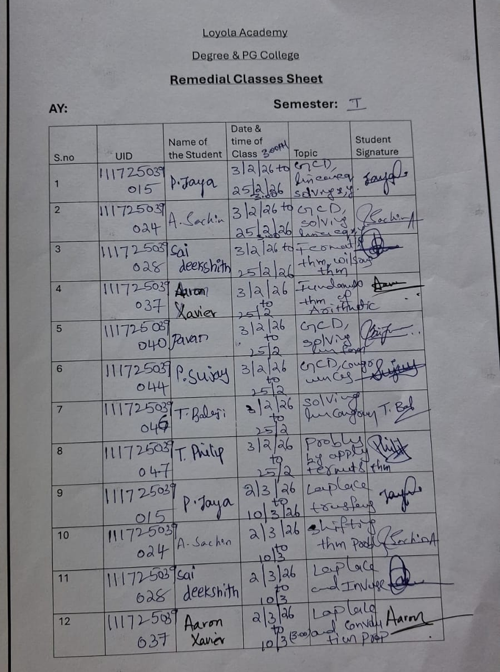

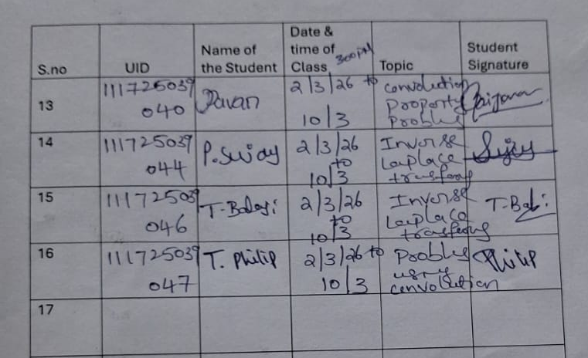
Students Progress Evaluation:
Students are improved in the differentiation chapter. They learned the process of differentiation and integration.20 percentage they improved from Mid1 to Mid2 examinations.
Conclusions Recommendations:
Total 8 students are attended for Remedial classes.

9.Slow & Advanced Learners:
Action Plan for Supporting Slow Learners in the Classroom
To effectively support slow learners and ensure they succeed academically, a structured action plan is necessary. This plan focuses on providing targeted support, creating an inclusive learning environment, and helping students build confidence in their abilities.

- Assess Individual Needs:
Identify each student’s learning challenges through assessments and individual consultations to create tailored learning plans.
- Provide Additional Learning Support:
Offer one-on-one or small group tutoring and access to extra resources for focused academic support.
- Foster a Positive and Supportive Environment:
Create an inclusive and encouraging classroom atmosphere where slow learners feel valued and confident.
- Regular Progress Monitoring and Feedback:
Track academic progress through regular assessments and provide timely, constructive feedback to guide improvement.
- Encourage Active Learning and Engagement:
Incorporate interactive activities and group work to keep slow learners actively involved in the learning process.
- Parental Involvement and Communication:
Engage parents in the learning process by keeping them informed of progress and providing suggestions for home support.
- Provide Emotional and Psychological Support:
Address emotional challenges by fostering a growth mindset and offering counselling when necessary.

DCSCS A.Y 2025-26 SLOW LEARNERS LIST
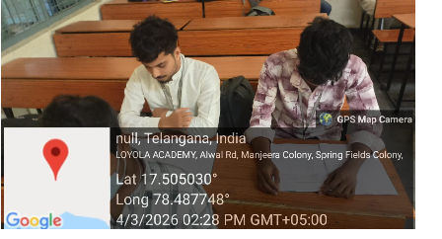

SNO | UID | NAME
1 | 111723039038 | Muzzamil
2 | 111723039037 | M.Sampath
3 | 111723039017 | Abhrahim

NCSCS AY : 2025-26
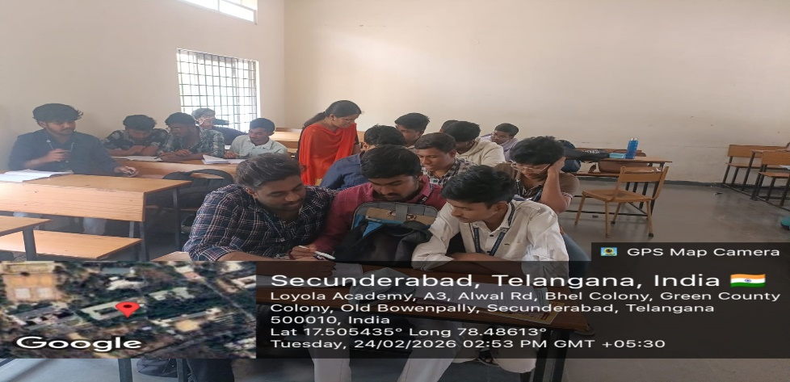

SNO | UID | NAME
1 | 111724039037 | Yuvaraj
2 | 111724039035 | Koushik
3 | 111724039030 | Prashanth
4 | 111724039034 | Dheeraj
5 | 111724039049 | Praveen

ACSCS A.Y 2025-26
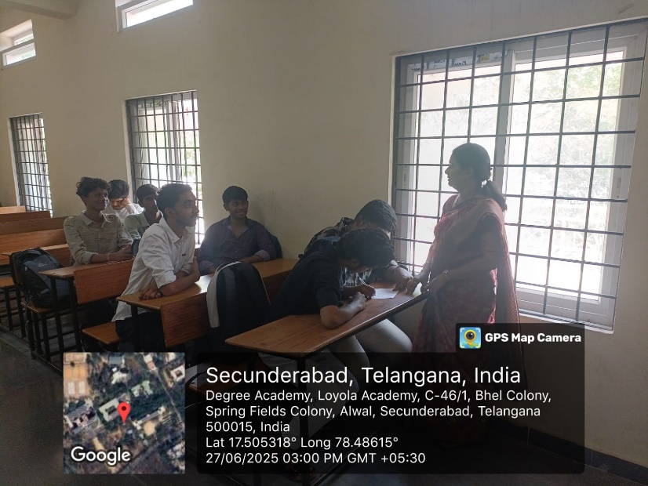
SLOW LEARNERS LIST
SNO | UID | NAME
1 | 111725039031 | Varshith
2 | 111725039036 | Sudarshan
3 | 111725039040 | Pavan
4 | 111725039038 | Gaurish
5 | 111725039037 | Aaron
6 | 111725039035 | Yesu

Action Plan for Supporting Advanced Learners in the Classroom
- Assess Individual Strengths and Interests:
Identify the unique strengths, skills, and academic interests of advanced learners to tailor challenges and opportunities that align with their needs.
- Offer Enrichment Opportunities:
Provide additional resources, projects, or assignments that go beyond the standard curriculum to challenge and engage advanced learners.
- Differentiate Instruction:
Modify lesson plans to include higher order thinking tasks, ensuring advanced learners are constantly pushed to think critically and solve complex problems.
- Provide Opportunities for Independent Study:
Encourage advanced learners to pursue independent research projects or explore topics of personal interest, allowing for deeper exploration and self-directed learning.
- Facilitate Peer Teaching and Mentoring:
Create opportunities for advanced learners to mentor or collaborate with peers, fostering leadership skills and reinforcing their own learning through teaching others.
- Provide Leadership and Problem-Solving Roles:
Involve advanced learners in leadership opportunities, such as leading group discussions, facilitating projects, or tackling real-world problems.
- Encourage Creativity and Innovation:
Give advanced learners open-ended assignments or challenges that encourage creative thinking and innovative solutions, allowing them to explore their interests.

DCSCS
DCSCS A.Y 2025-26 ADVANCED LEARNERS LIST
SNO | UID | NAME
1 | 111723039030 | Varun Raj | 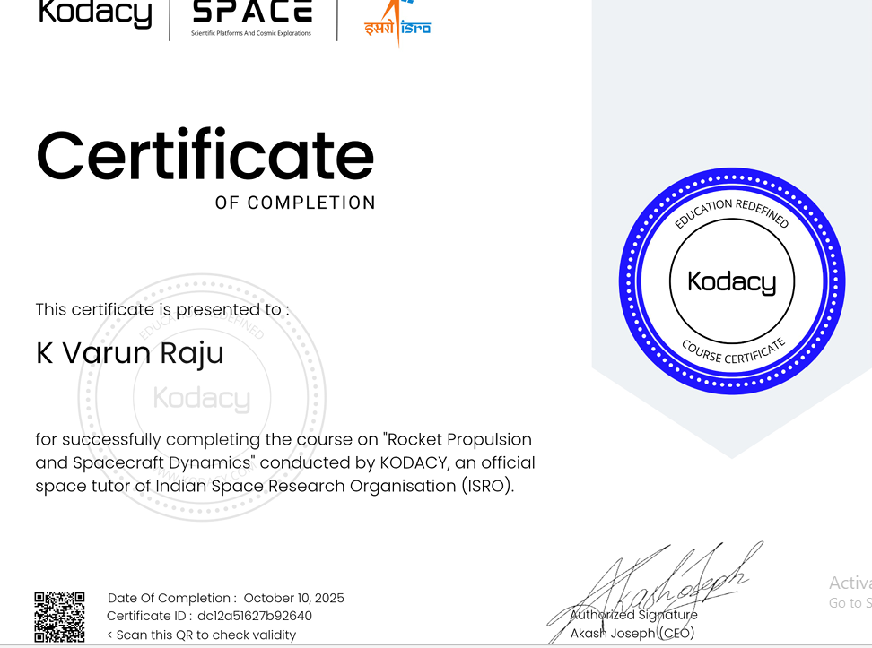
2 | 111723039007 | Akshitha | 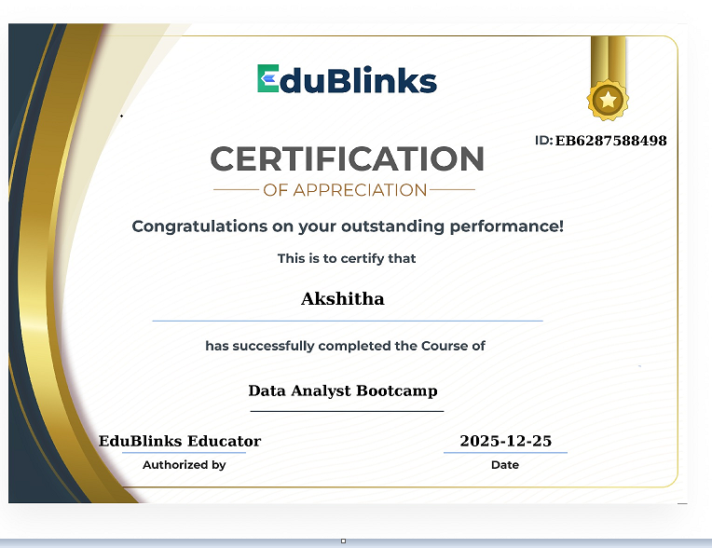
3 | 111723039031 | K Sampath | 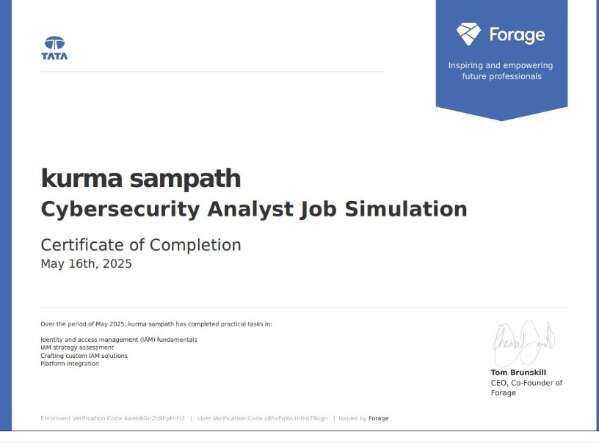
4 | 111723039007 | Akshitha | 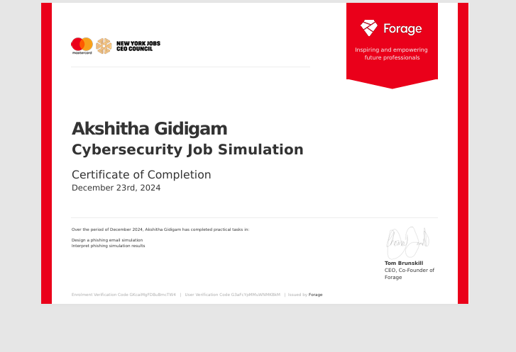
5 | 111723039007 | Akshitha | 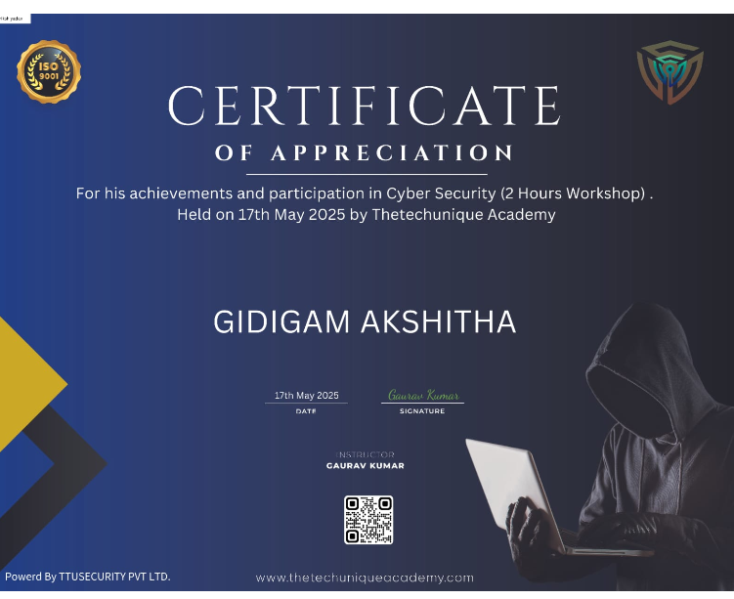

NCSCS
NCSCS A.Y 2025-26 ADVANCED LEARNERS LIST
SNO | UID | NAME
1 | 111724039033 | ChethanYadav | 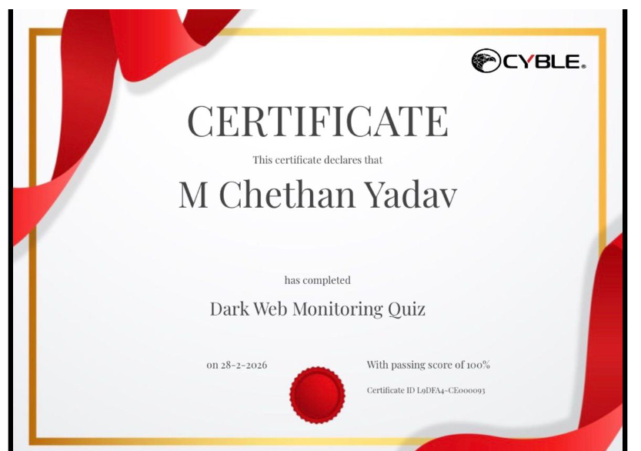
2 | 111724039033 | ChethanYadav | 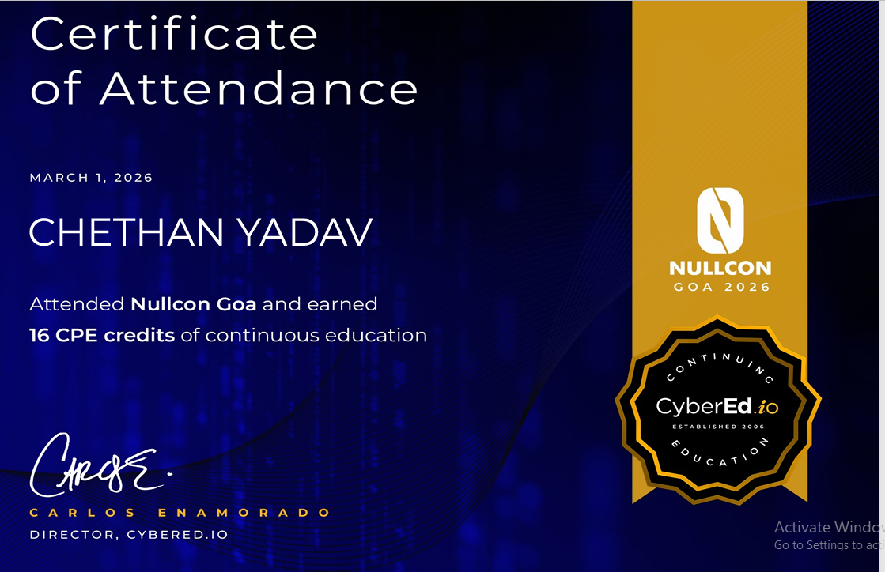
3 | 111724039034 | Dheeraj Raj | 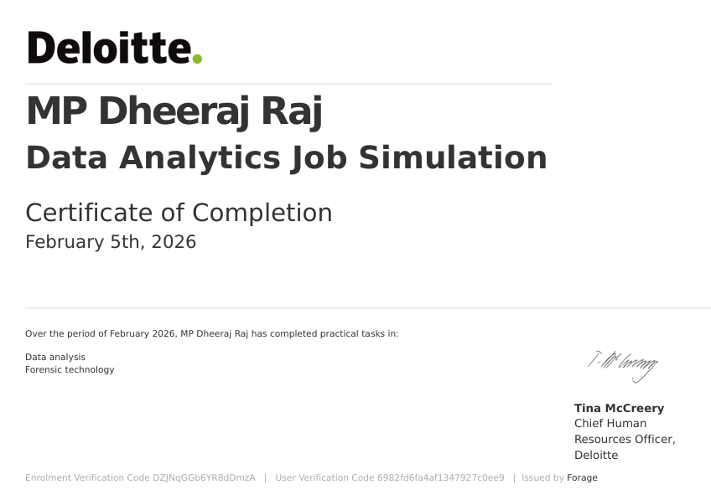
4 | 111724039044 | Aarshad | 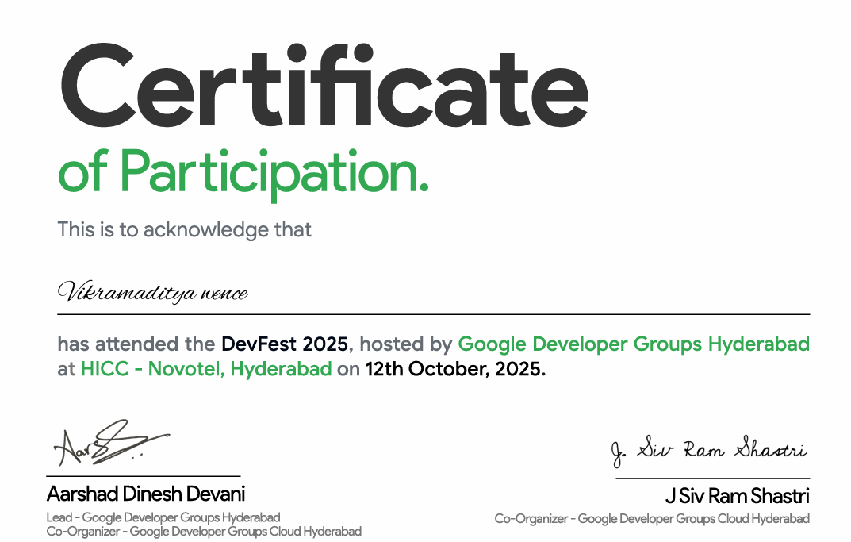

10.Student Centric Methods:

Student-Centric Methods Report (2025-26)
The traditional teacher-centric model of education is gradually evolving to make room for more participatory and engaging approaches that prioritize the learner’s needs, interests, and active involvement in the learning process. This shift has led to the development and adoption of student-centric teaching methods, which place students at the heart of the learning experience.
Student-centric methods are built on the principles of constructivism, where learners construct knowledge through experiences, reflection, and collaboration. These methods emphasize autonomy, collaboration, critical thinking, creativity, and personalized learning paths.

Objectives of Student-Centric Methods
- To enhance student engagement and motivation.
- To promote deep and meaningful learning.
- To develop 21st-century skills such as critical thinking, problem-solving, and collaboration.
- To cater to diverse learning styles and paces.
- To encourage lifelong learning habits.

Key Student-Centric Methods

1. Project-Based Learning (PBL)
Description:
Students work on real-world projects over an extended period, exploring and solving complex questions or challenges.
Implementation:
- Choose a relevant problem or theme.
- Guide students to research, collaborate, and present their findings.
- Assess both the process and the final product.
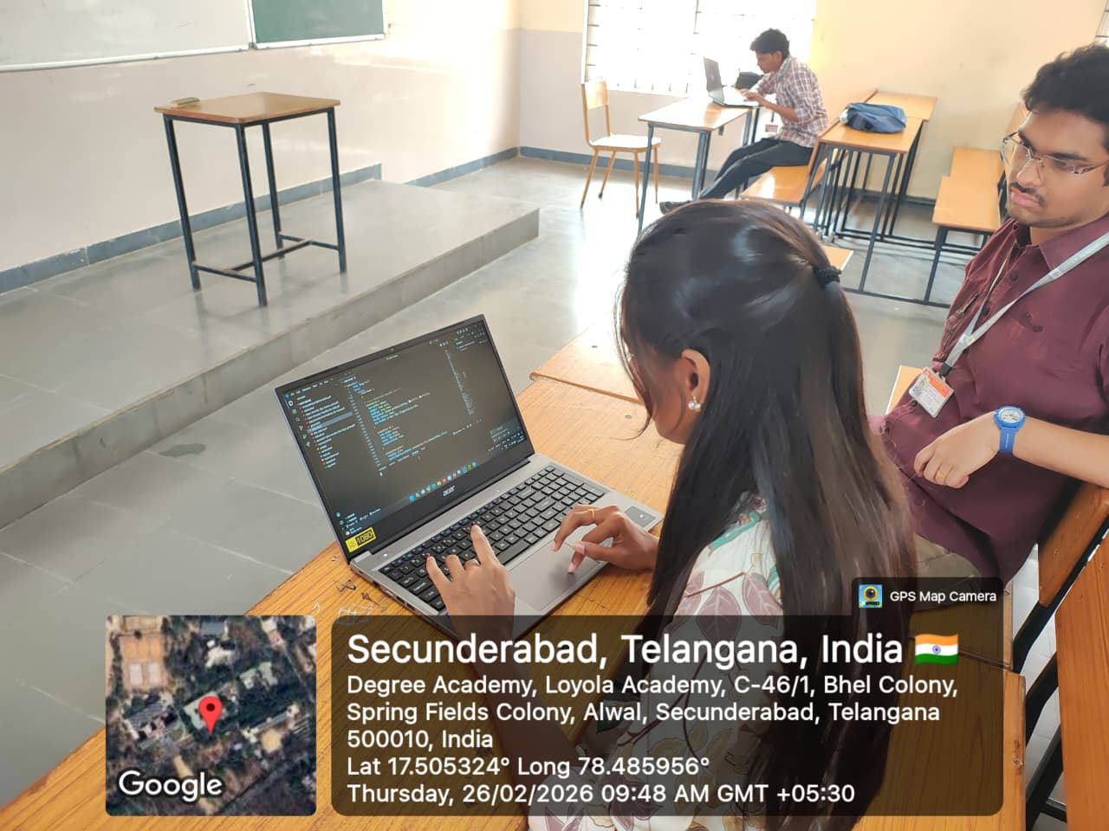
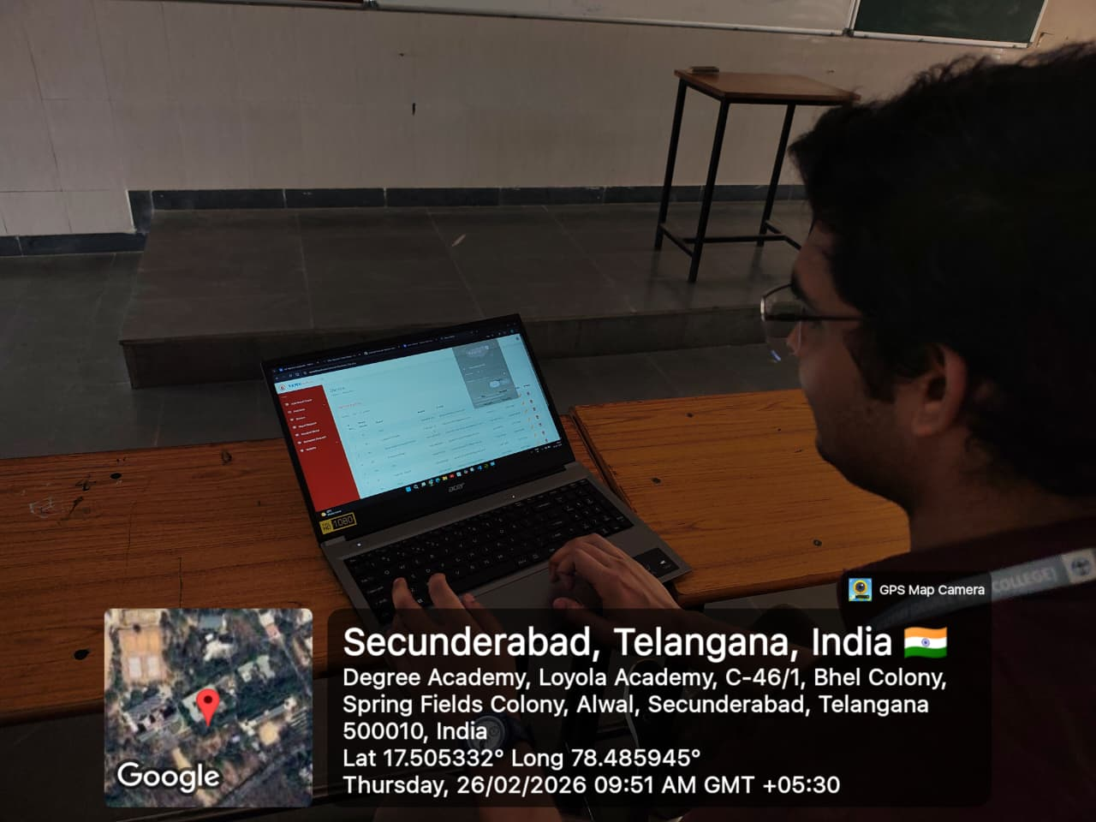

Benefits: Enhances problem-solving skills, teamwork, and real-world application of knowledge.

2. Inquiry-Based Learning
Description:
Students learn by posing questions, investigating solutions, and constructing new understandings.
Implementation:
- Encourage curiosity through open-ended questions.
- Facilitate research, experimentation, and exploration.
- Reflect and discuss findings in class.

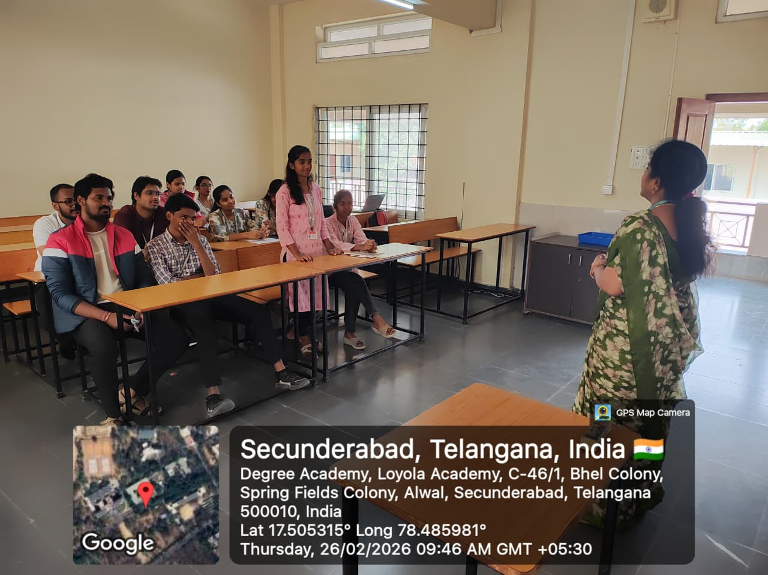
Benefits: Develops analytical thinking, independence, and curiosity.

3. Flipped Classroom
Description:
Students study instructional content (videos, readings) at home, and class time is used for discussions, problem-solving, and hands-on activities.
Implementation:
- Provide online content (videos, PDFs, simulations).
- Design classroom activities that reinforce and expand the content.
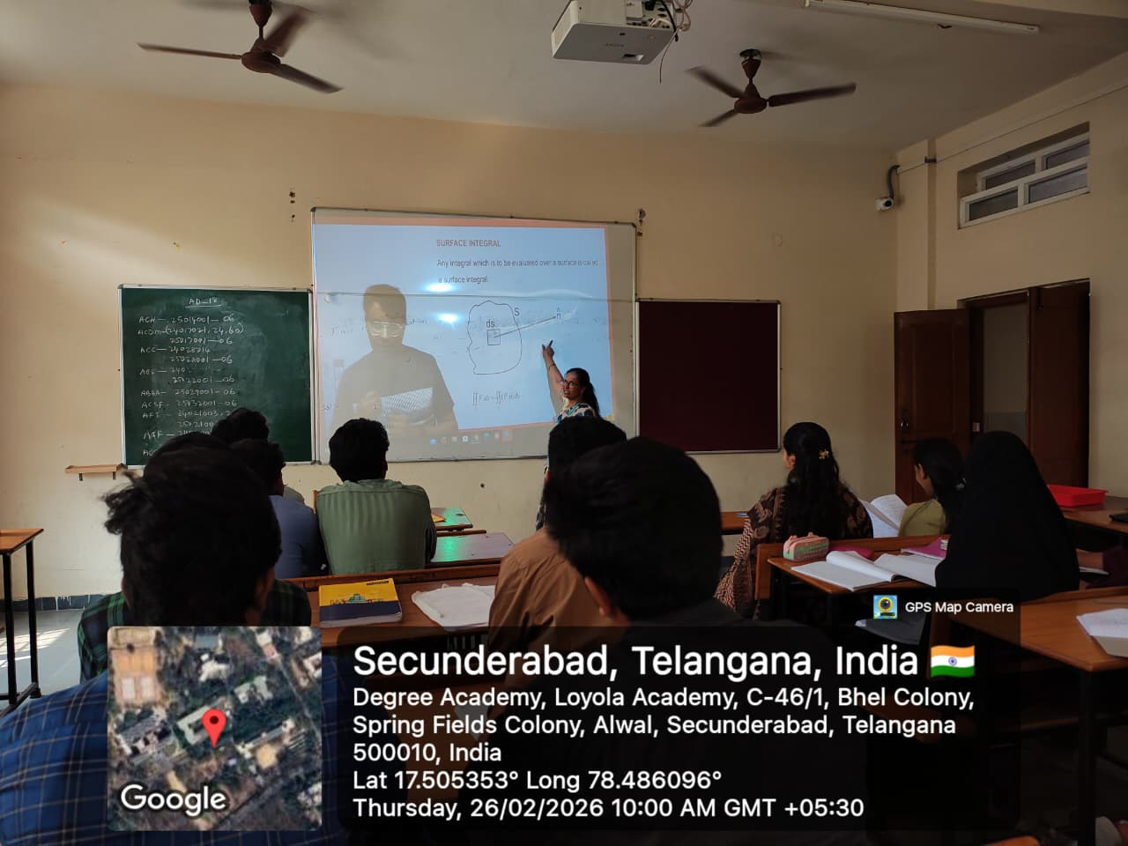
Benefits: Promotes self-paced learning and active classroom participation.

4. Collaborative Learning
Description:
Learning is conducted in small groups where students work together to achieve common learning goals.
Implementation:
- Assign group tasks, discussions, and peer assessments.
- Foster a collaborative classroom environment.

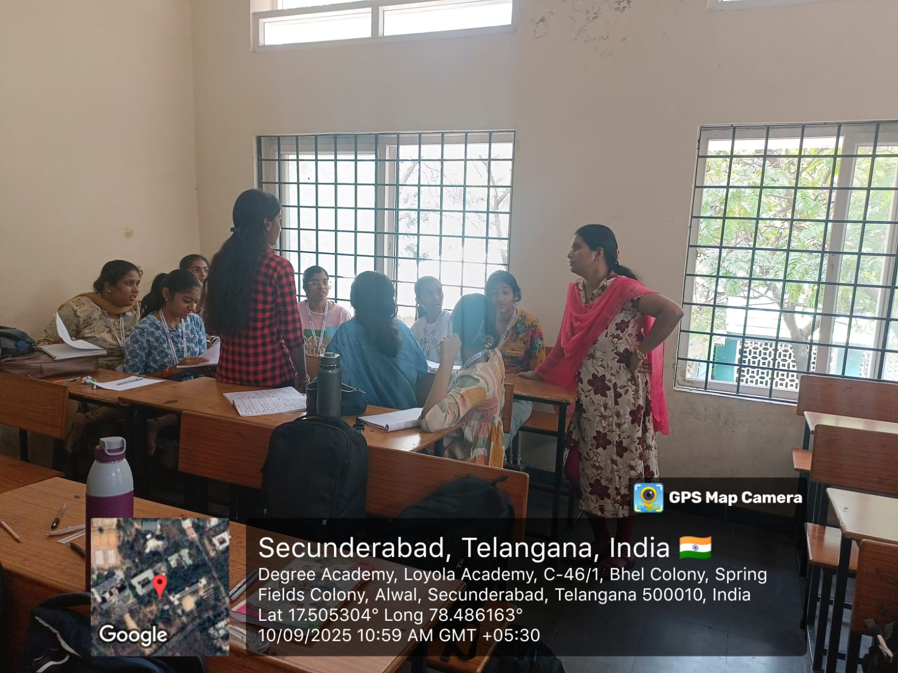
Benefits: Improves communication skills, accountability, and teamwork.

5. Experiential Learning
Description:
Learning through direct experience, reflection, and application.
Implementation:
- Organize field trips, experiments, role plays, simulations, or service-learning activities.
- Include reflective discussions and documentation.
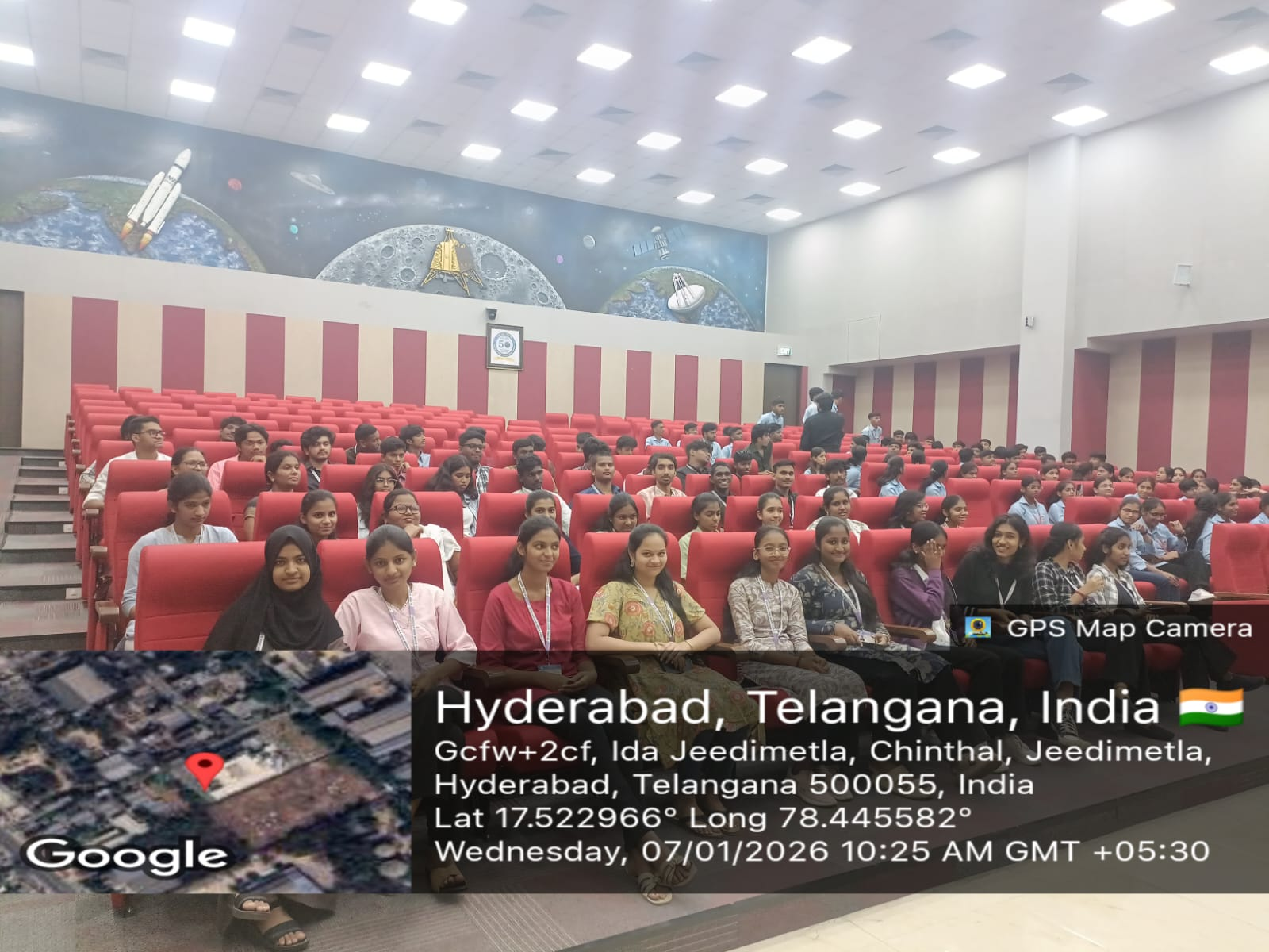

Benefits: Builds practical understanding, retention, and engagement.

6. Gamification
Description:
Use of game elements (points, badges, challenges) to enhance learning and motivation.
Implementation:
- Create quizzes, competitions, and interactive activities using gamified platforms.
- Reward progress and participation.
- Organized an hackathon on data security.
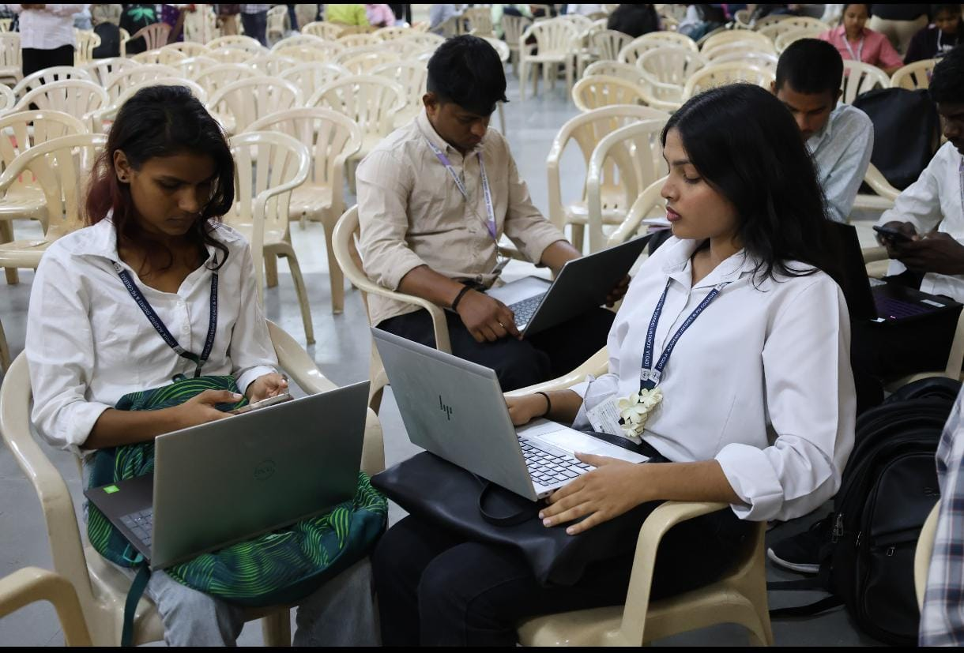
Benefits: Increases motivation, participation, and makes learning fun.

7. Personalized Learning
Description:
Tailoring learning experiences according to each student’s strengths, needs, and interests.
Implementation:
- Use adaptive learning tools and diagnostic assessments.
- Allow students to set goals and track their own progress.
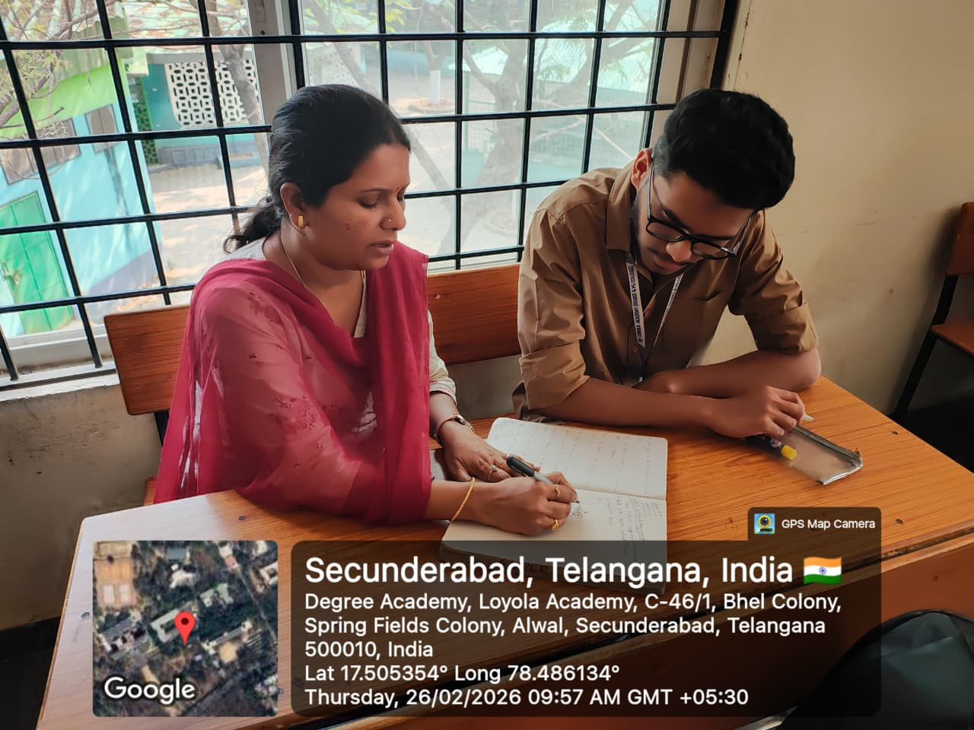
Benefits: Respects individual learning paces and needs, promoting self-regulated learning.

Benefits of Student-Centric Methods
- Higher Engagement: Students are more involved and motivated.
- Improved Retention: Active learning improves long-term retention.
- Development of Skills: Encourages communication, collaboration, and critical thinking.
- Empowerment: Students take ownership of their learning.
- Inclusivity: Accommodates various learning styles and backgrounds.

Challenges and Limitations
- Requires significant planning and preparation.
- Teachers need to shift roles from instructors to facilitators.
- Some students may struggle with autonomy or group work.
- Infrastructure or technology may be inadequate in some institutions.
- Assessment of student-centric activities can be subjective.

Conclusion
Student-centric methods represent a progressive shift in education, where learning becomes more dynamic, inclusive, and meaningful. Though these approaches may pose initial challenges, their long-term benefits far outweigh the limitations. Institutions and educators are encouraged to adopt a blended approach that gradually integrates student-centric strategies into the curriculum to foster holistic development and lifelong learning.

12.MINI/MAJOR PROJECT:
Major Project List: Total:25
Sno | UID |  | Name | Title |  | Address | Mentor | Signature
1 | 111723039001  111723039009 |  | A Sowmya  L RajaRani | Echo secure |  | Loyola Academy | S.Lakshmi
2 | 111723039002  111723039031 |  | B Yamini  k sampath | stegnography using captcha |  | Loyola Academy | N.Manisha
3 | 111723039003  111723039004 |  | Bhavya  B Rishika | Health Connect |  | Loyola Academy | M.Supriya
4 | 111723039005 |  | Alice Saloni | Web application based honeypot |  | Loyola Academy | S.Kavitha
5 | 111723039006  111723039010 |  | D Jhansi  Raziya Bhanu | Penteration testing |  | Loyola Academy | S.Lakshmi
6 | 111723039007  111723039012 | G Akshitha  R Sudhiksha |  | E attendance tracker | Loyola Academy |  | N.Manisha
7 | 111723039008  111723039014 | K Mounica  A Lasya Reddy |  | Android lock screen bypass | Loyola Academy |  | M.Supriya
8 | 111723039011 | N Manasa |  | Graphical authentication Project | Loyola Academy |  | S.Kavitha
9 | 111723039013  111723039016 | Rubeena  Taj Fatima |  | Fake login page detection system | Loyola Academy |  | S.Lakshmi
10 | 111723039017  111723039041 | Abraham Wallace  Philip Paul |  | simulating brute force attack | Loyola Academy |  | N.Manisha
11 | 111723039018  111723039048 | Aditya singh  V jason |  | File integrity checker | Loyola Academy |  | M.Supriya
12 | 111723039019  111723039027 | Aryan Gupta  Hamad Mahafooz |  | secure password manager | Loyola Academy |  | S.Kavitha
13 | 111723039020  111723039040 | B Vamshi  P Varshith |  | One time secret link generator | Loyola Academy |  | S.Lakshmi
14 | 111723039021  111723039023 | B Rishikesh  Clemence |  | Utilising deep learning approaches for text summarization | Loyola Academy |  | N.Manisha
15 | 111723039022  111723039033 | Siril  M Manoj |  | Privacy Leak detect | Loyola Academy |  | M.Supriya
16 | 111723039024  111723039042 | Durga Prasad  P Manikanta |  | NeoBank | Loyola Academy |  | S.Kavitha
17 | 111723039025  111723039028 | G Sai Teja  J Satish |  | Phish guard | Loyola Academy |  | S.Lakshmi
18 | 111723039026 | Paul Thomas |  | Automated Android Malware detection | Loyola Academy |  | N.Manisha
19 | 111723039030  111723039043 | K Varun  P Shiva kumar |  | AYYO!(Authentic Yummy Yatra Organization) | Loyola Academy |  | M.Supriya
20 | 111723039034  111723039045 | M Yashwanth  R Sai kishore |  | ePIC( encrypted picture ) | Loyola Academy |  | S.Kavitha
21 | 111723039035  111723039044 | A Manikanta  Rohith kumar singh |  | Screenshot organiser | Loyola Academy |  | N.Manisha
22 | 111723039037 | M Sampath |  | Expenses tracker app | Loyola Academy |  | M.Supriya
23 | 111723039038  111723039046 | Muzamil  S John |  | URL Integrity checker | Loyola Academy |  | S.Kavitha
24 | 111723039039  111723039047 | N Manikanta  T Raju |  | Online rehashed book store system | Loyola Academy |  | S.Kavitha
25 | 111723039049  111723039050 | V Srujan  Y Bhanu Preetham |  | Encrypted notes locker | Loyola Academy |  | M.Supriya

MINI PROJECT: Total :32

Sno | Uid | Team member  -Names | Project  Title | Mentor name | Address
1 | 111724039001 ,111724039006 | Ardhi Pravalika-  G.Ramya Mary- | Python-based programming with socket programming | S.Laxmii(HOD) | Loyola academy degree &Pg college
2 | 111724029002, 111724039018 | B.nagamalleshwari,  s.varshini | Shoulder surfing alert system using ai | N.manisha | Loyola academy degree &Pg college
3 | 111724039003, 111724039013 | Shruthi,  Tejareddy | Password strength checker | Supriya | Loyola academy degree &Pg college
4 | 111724039004, 111724039014 | Dandotkar Sanjana,  Marmamla Sreenidhi | PhishGuard | Kavitha | Loyola academy degree &Pg college
5 | 111724039005, 111724039017 | Bhargavi,  Harshini | Adaptive Password Deception using AI | S.Lakshmi | Loyola academy degree &Pg college
6 | 111724039007, 1117240390020 | Gujja Akhila ,Upputuri Venkata Lakshmi Sahiti | Mentoring book management system | N.manisha | Loyola academy degree &Pg college
7 | 111724039008, 1117240390021 | Harsha ,  Yagna Gurureddy | Network Monitoring+ Emergency Alert Tool | Supriya | Loyola academy degree &Pg college
8 | 111724039009,  111724039019 | J.Swethika,  T.Namitha sree | Business management application | S.Kavitha | Loyola academy degree &Pg college
9 | 111724039010,  111724039011 | Sravana Jyothi ,  Ashritha | Stegovault | Lakshmi | Loyola academy degree &Pg college
10 | 111724039012 | K.vedha | Honeypot setup | Manisha | Loyola academy degree &Pg college
11 | 111724039015,  111724039016, | tejaswini ,  Pooja pal , | AI based suspicious chat message detector | M. Supriya | Loyola academy degree &Pg college
12 | 111724039022,  111724039043 | Arshad ali ,  Rohit sahni, | Cyber Security Quizverse Adaptive Knowledge Website | Kavitha | Loyola academy degree &Pg college
13 | 111724039023 | Saisampath | Password generator | S.Lakshmi | Loyola academy degree &Pg college
14 | 111724039024,  111724039041. | BYVS. Pavan Kumar , P. Abhiram Adithya | Phishing E-Mail Detector. | Nellutla Manisha | Loyola academy degree &Pg college
15 | 111724039025,  111724039050 | D Naga Chaitanya ,  A Abivardhana Reddy | Pilgrimage management application | Supriya | Loyola academy degree &Pg college
16 | 111724039026,  111724039034 | Daya Shankar ,  Dheeraj Raj | Packet Vista | Kavitha | Loyola academy degree &Pg college
17 | 111724039027,  111724039036 | D.Srinivas, P.Preetham Chary | Payment remainder software | S.Lakshmi | Loyola academy degree &Pg college
18 | 111724039028 | Jagan Mohan Reddy | Simple LAN chat | Manisha | Loyola academy degree &Pg college
19 | 111724039029 | k. jayanth | blood bank and management system | Supriya | Loyola academy degree &Pg college
20 | 111724039030,  111724039049 | Prashanth ,Praveen | Screenshot Privacy Risk Scanner | Kavitha mam | Loyola academy degree &Pg college
21 | 111724039031 | John | Password Strength analyser | S.Lakshmi | Loyola academy degree &Pg college
22 | 111724039032 | Sharath | Browser forensic analyser | Manisha | Loyola academy degree &Pg college
23 | 111724039033 | M CHETHAN YADAV | AVEM: Adaptive Autonomous Vulnerability Exploitation Mitigation Engine | Supriya | Loyola academy degree &Pg college
24 | 111724039035,  111724039048 | N koushik ,  Y Satya Sreehari | Digital Forensic Tool for File System Analysis | Kavitha | Loyola academy degree &Pg college
25 | 111724039037 | Yuvaraj | Http header security Analyser | S Lakshmi | Loyola academy degree &Pg college
26 | 111724039038 | Bhavan Teja - | Smart crop advisor for small and marginal farmers | N.Manisha ma'am | Loyola academy degree &Pg college
27 | 111724039039 | Pavan Kumawat- | AI DISTRACTION FORECAST" | M. Supriya | Loyola academy degree &Pg college
28 | 111724039040,  111724039047 | P.Manicharan ,Vivek | Digital Footprint Shrinker | S.Kavitha | Loyola academy degree &Pg college
29 | 111724039042 | Pretam | Self destruction message portal | S.lakshmi | Loyola academy degree &Pg college
30 | 111724039044 | R Vikramaditya Wence - | Preorder | N.Manisha | Loyola academy degree &Pg college
31 | 111724039045 | Hemanth- | Dark web keyword alert system | Supriya | Loyola academy degree &Pg college
32 | 111724039046 | Chaitanya S - | Windows Forensic Tool | Kavitha Ma'am | Loyola academy degree &Pg college

12.CERTIFICATE COURSE & NPTEL LIST:

S.No | uid | name | CC Title | Instructor name
1 | 111724039001 | Ardhi Pravalika | Data science with machine learning | Vishal
2 | 111724039002 | Nagamalleshwari | Mutual funds | Sweta roa
3 | 111724039003 | B.shruthi | Ai and data science essentials | Shirisha Mam
4 | 111724039004 | Dandotkar Sanjana | Clay Modelling | Janardhan Naidu
5 | 111724039005 | D.Bhargavi | Embroidery | Bhavani reddy
6 | 111724039006 | G.Ramya mary | Data science with machine learning | Vishal
7 | 111724039007 | Gujja Akhila | Baking | Surekha
8 | 111724039008 | harsha vardhini | clay modeling | janardhan naidu
9 | 111724039009 | Janga swethika | Baking | Surekha mam
10 | 111724039010 | K.sravanajyothi | Clay modelling | Janardhan
11 | 111724039011 | Ashritha | Clay moulding | Janardhan Naidu
12 | 111724039013 | K.Teja Reddy | Embroidery | Bhavani Reddy
13 | 111724039014 | M. Sreenidhi | Clay Modelling | Janardhan Naidu P
14 | 111724039015 | P.Tejaswini | Nail art | Vanitha maam
15 | 111724039016 | Pooja pal | Nail art | Vanithakumar
16 | 111724039017 | Harshini | Photography | Vikram
17 | 111724039018 | S.Varshini | Mutual funds | Sweta Rao
18 | 111724039019 | T.Namitha sree | Nail art | Vanitha
19 | 111724039020 | Upputuri Venkata Lakshmi sahiti | Baking | Surekha
20 | 111724039021 | Yagna Gurureddy | Baking | Surekha
21 | 111724039022 | Arshad Ali | Digital marketing | Fahad Hasan
22 | 111724039023 | Saisampath | Photography | Vikram
23 | 111724039024 | BYVS. Pavan Kumar | Quantitative Techniques and Aptitude Reasoning | Dr. Shakira Sultana
24 | 111724039025 | Dasari Naga Chaitanya | App development | Shaik mudassir
25 | 111724039026 | DAYA SHANKAR | App development | Shaik Mudassir
26 | 111724039027 | DUBBAKA SRINIVAS | Data analytics | Myna
27 | 111724039028 | JEEDIMADLA JAGANMOHAN REDDY | Mobile phone technology &repair | Bipin Gondane
28 | 111724039029 | kairamkonda Jayanth | baking | Surekha
29 | 111724039030 | K.Prashanth | Art's and craft | A.Ramesh
30 | 111724039031 | John Adarsh | Human Rights | Dr. G.R. Vani
31 | 111724039032 | Sharath Chandra | Web programming | Srk cloud computing hod
32 | 111724039033 | M Chethan Yadav | Innovation and Startup Awareness | Vase Katriel
33 | 111724039034 | MP DHEERAJ RAJ | VISUAL EFFECTS | Sharath Chandra Raju
34 | 111724039035 | NASA KOUSHIK | App development | Shaik Mudassir
35 | 111724039036 | P.Preetham chary | Data analytics | Myna
36 | 111724039037 | Yuvaraj | Web programming | SRK sir
37 | 111724039038 | Bhavanteja | The hindustani flute | Balu sir
38 | 111724039039 | Pavan Kumawat | Vfx | Sharath chandra raju
39 | 111724039040 | P.Manicharan | Ai & Date Science Essincials | V. Shirisha
40 | 111724039041 | Potharaju Abhiram Adithya | Character designing | Ruhi mam
41 | 111724039042 | Pretambera | Visual effects | Sharath chandra raju
42 | 111724039043 | Rohit Sahni | Digital marketing | Fahad hassan
43 | 111724039044 | Vikram Adhitya | Web programming | Srk could hod
44 | 111724039045 | Hemanth reddy | Web programming | Srk could hod
45 | 111724039046 | S Chaitanya | web programming | SRK sir.
46 | 111724039047 | V.vivek | AI and data science essintials | V.Shirisha
47 | 111724039048 | Y Satya Srihari | Quantative Aptitude | Mrs.Shakira ma’am
48 | 111724039049 | Nandi Praveen | Arts and crafts | A.Ramesh
49 | 111724039050 | A Abivardhana Reddy | Baking | Surekha Mam
50 | 111723039032 | M.Sai Sathwik | Visual effects | Sharath chandra raju

NPTEL/TASK LIST:

13. MENTORING LIST:
PART – A : MENTOR ALLOCATION SUMMARY
S. No. | Name of the Faculty (Mentor) | Class / Section | UID Range | Total No. of Students
1 | S. LAKSHMI | ACSCS  NCSCS  DCSCS | 111725039001-111725039010  111724039001 - 111724039010  111723039001 - 111723039010 | 30
2 | N. MANISHA | ACSCS  NCSCS  DCSCS | 111725039011-111725039020  111724039011 - 111724039020  111723039011 - 111723039020 | 29
3 | M.Supriya | ACSCS  NCSCS  DCSCS | 111725039021-111725039030  111724039021 - 111724039030  111723039021 - 111723039030 | 29
4 | Mrs.S.Kavitha | ACSCS  NCSCS  DCSCS | 111725039031-111725039040  111724039031 - 111724039040  111723039031 - 111723039040 | 28
5 | M.Vasudha | ACSCS  NCSCS  DCSCS | 111725039041-111725039050  111724039041 - 111724039050  111723039041 - 111723039050 | 31
Total Strength of Programme / Class: B.Sc(CSCS)-ACSCS-50
B.Sc(CSCS)-(NCSCS)-51
B.Sc(CSCS)-DCSCS-46
Total strength:147
DETAILED MENTOR – MENTEE LIST of 1st, 2nd and 3rd year students.
Programme & Year: B.Sc Computer Science & Cyber security 1st Year
S. No. | Name of the Mentor | Class / Section | UID Number | Name of the Student
1 | S.LAKSHMI | ACSCS | 111725039001 | Pallavi
2 | S.LAKSHMI | ACSCS | 111725039002 | DAKSHAYANI
3 | S.LAKSHMI | ACSCS | 111725039003 | JOYCE CRYSTAL
4 | S.LAKSHMI | ACSCS | 111725039004 | SRI VIDYA
5 | S.LAKSHMI | ACSCS | 111725039005 | HANSIKA
6 | S.LAKSHMI | ACSCS | 111725039006 | RISHITHA
7 | S.LAKSHMI | ACSCS | 111725039007 | SAI SAHASRA
8 | S.LAKSHMI | ACSCS | 111725039008 | MADHURI
9 | S.LAKSHMI | ACSCS | 111725039009 | BHAVIKA
10 | S.LAKSHMI | ACSCS | 111725039010 | MEGHANA
11 | N. MANISHA | ACSCS | 111725039011 | ANKITHA
12 | N. MANISHA | ACSCS | 111725039012 | SHARANYA
13 | N. MANISHA | ACSCS | 111725039013 | SRAVANTHI
14 | N. MANISHA | ACSCS | 111725039014 | RUCHIKA
15 | N. MANISHA | ACSCS | 111725039015 | JAYADURGA
16 | N. MANISHA | ACSCS | 111725039016 | SUPRIYA
17 | N. MANISHA | ACSCS | 111725039017 | SHREENRENETA JOHSON
18 | N. MANISHA | ACSCS | 111725039018 | FATHIMA
19 | N. MANISHA | ACSCS | 111725039019 | AKSHITHA
20 | N. MANISHA | ACSCS | 111725039020 | DEBORAHJACIN
21 | M.SUPRIYA | ACSCS | 111725039021 | NETHANYA SIPPORA
22 | M.SUPRIYA | ACSCS | 111725039022 | VEENA MADHURI
23 | M.SUPRIYA | ACSCS | 111725039023 | DURGA PRASAD GOUD
24 | M.SUPRIYA | ACSCS | 111725039024 | SACHIN
25 | M.SUPRIYA | ACSCS | 111725039025 | DHAMI
26 | M.SUPRIYA | ACSCS | 111725039026 | NIRAZ GOUD
27 | M.SUPRIYA | ACSCS | 111725039027 | SAI SIDDARTH
28 | M.SUPRIYA | ACSCS | 111725039028 | SAI DEEKSHITH REDDY
29 | M.SUPRIYA | ACSCS | 111725039029 | LOKESH RAJU
30 | M.SUPRIYA | ACSCS | 111725039030 | ANIL GOUD
31 | S.KAVITHA | ACSCS | 111725039031 | OM SAI VARSHITH
32 | S.KAVITHA | ACSCS | 111725039032 | RAVITEJA
33 | S.KAVITHA | ACSCS | 111725039033 | SAI GANESH
34 | S.KAVITHA | ACSCS | 111725039034 | AKIHIL PRABHAS
35 | S.KAVITHA | ACSCS | 111725039035 | YESU PADHAM
36 | S.KAVITHA | ACSCS | 111725039036 | RAGHUNANDAN SUDARSHAN
37 | S.KAVITHA | ACSCS | 111725039037 | ARON XAVIER
38 | S.KAVITHA | ACSCS | 111725039038 | GAURISH
39 | S.KAVITHA | ACSCS | 111725039039 | FAWAZ KHAN
40 | S.KAVITHA | ACSCS | 111725039040 | SAI PAVAN
41 | M.VASUDHA | ACSCS | 111725039041 | VINEETH
42 | M.VASUDHA | ACSCS | 111725039042 | NICHOLOS JUDE
43 | M.VASUDHA | ACSCS | 111725039043 | P GOUTHAM
44 | M.VASUDHA | ACSCS | 111725039044 | BALA PUNEETH SUJAY
45 | M.VASUDHA | ACSCS | 111725039045 | ARAVIND
46 | M.VASUDHA | ACSCS | 111725039046 | BALAJI
47 | M.VASUDHA | ACSCS | 111725039047 | RATNAM PHILP
48 | M.VASUDHA | ACSCS | 111725039048 | SAIVED SINGH
49 | M.VASUDHA | ACSCS | 111725039049 | SRIRAM
50 | M.VASUDHA | ACSCS | 111725039050 | PAWANKUMAR
Programme & Year: B.Sc Computer Science & Cyber security 2nd Year

S.no | Name of the Faculty | Class | UID NUMBER | Name of the Student
 | S.LAKSHMI | NCSCS | 111724039001 | ARDHI PRAVALIKA
 | S.LAKSHMI | NCSCS | 111724039002 | BETHAPALLI NAGA MALLESWARI
 | S.LAKSHMI | NCSCS | 111724039003 | B SHRUTHI
 | S.LAKSHMI | NCSCS | 111724039004 | DANDOTKAR SANJANA
 | S.LAKSHMI | NCSCS | 111724039005 | DUDUKA BHARGAVI
 | S.LAKSHMI | NCSCS | 111724039006 | GUGGILAM RAMYA MARY
 | S.LAKSHMI | NCSCS | 111724039007 | GUJJA AKHILA
 | S.LAKSHMI | NCSCS | 111724039008 | INALA HARSHA VARDHINI
 | S.LAKSHMI | NCSCS | 111724039009 | JANGA SWETHIKA
 | S.LAKSHMI | NCSCS | 111724039010 | KONDAVEETI SRAVANAJYOTHI
 | N. MANISHA | NCSCS | 111724039011 | KOPPULA ASHRITHA
 | N. MANISHA | NCSCS | 111724039012 | KORIVI SRI SAI VEDHA
 | N. MANISHA | NCSCS | 111724039013 | KUNDURU TEJA REDDY
 | N. MANISHA | NCSCS | 111724039014 | MARMAMLA SREENIDHI
 | N. MANISHA | NCSCS | 111724039015 | PIMPDAE TEJASWINI
 | N. MANISHA | NCSCS | 111724039016 | POOJA PAL
 | N. MANISHA | NCSCS | 111724039017 | RYALI HARSHINI
 | N. MANISHA | NCSCS | 111724039018 | SILIVERI VARSHINI
 | N. MANISHA | NCSCS | 111724039019 | THANNIRU NAMITHA SREE
 | N. MANISHA | NCSCS | 111724039020 | UPPUTURI VENKATA LAKSHMI SAHITI
 | M.SUPRIYA | NCSCS | 111724039021 | YAGNA GURUREDDY
 | M.SUPRIYA | NCSCS | 111724039022 | ARSHAD ALI
 | M.SUPRIYA | NCSCS | 111724039023 | BHALLA SAI SAMPATH
 | M.SUPRIYA | NCSCS | 111724039024 | BOMMISETTY YOGI VENKATA SURYA PAVAN KUMAR
 | M.SUPRIYA | NCSCS | 111724039025 | DASARI NAGA CHAITANYA
 | M.SUPRIYA | NCSCS | 111724039026 | DAYA SHANKAR
 | M.SUPRIYA | NCSCS | 111724039027 | DUBBAKA SRINIVAS
 | M.SUPRIYA | NCSCS | 111724039028 | JAGANMOHAN REDDY
 | M.SUPRIYA | NCSCS | 111724039029 | KAIRAMKONDA JAYANTH
 | M.SUPRIYA | NCSCS | 111724039030 | KAMBHAM PRASHANTH
 | S.KAVITHA | NCSCS | 111724039031 | KANCHERLA JOHN ADARSH
 | S.KAVITHA | NCSCS | 111724039032 | KARNATI SHARATH CHANDRA .
 | S.KAVITHA | NCSCS | 111724039033 | M CHETHAN YADAV
 | S.KAVITHA | NCSCS | 111724039034 | MP DHEERAJ RAJ
 | S.KAVITHA | NCSCS | 111724039035 | NASA KOUSHIK
 | S.KAVITHA | NCSCS | 111724039036 | PADAKANTI PREETHAM CHARY
 | S.KAVITHA | NCSCS | 111724039037 | PALARAM YUVARAJ
 | S.KAVITHA | NCSCS | 111724039038 | PALLAMCHERU BHAVANTEJA
 | S.KAVITHA | NCSCS | 111724039039 | PAVAN KUMAVAT
 | S.KAVITHA | NCSCS | 111724039040 | PENDEM MANICHARAN
 | M.VASUDHA | NCSCS | 111724039041 | POTHARAJU ABHIRAM ADITHYA
 | M.VASUDHA | NCSCS | 111724039042 | PRETAM BERA
 | M.VASUDHA | NCSCS | 111724039043 | ROHIT SAHNI
 | M.VASUDHA | NCSCS | 111724039044 | R VIKRAMADITYA WENCE
 | M.VASUDHA | NCSCS | 111724039045 | SHIRAPU HEMANTH REDDY
 | M.VASUDHA | NCSCS | 111724039046 | SURAPANENI CHAITANYA
 | M.VASUDHA | NCSCS | 111724039047 | VOOSA VIVEK
 | M.VASUDHA | NCSCS | 111724039048 | YANAGADDA SATYA SREE HARI PHANEENDRA
 | M.VASUDHA | NCSCS | 111724039049 | NANDI PRAVEEN
 | M.VASUDHA | NCSCS | 111724039050 | Abhi Vardhan reddy
 | M.VASUDHA | NCSCS | 111723039032 | M.SATHWIK

Programme & Year: B.Sc Computer Science & Cyber security 3rd
Year
S.no | Name of the Mentor | CLASS | UID NUMBER | Name of the Student
 | S.LAKSHMI | DCSCS | 111723039001 | ANEVOINA SOWMYA
 | S.LAKSHMI | DCSCS | 111723039002 | BANALA YAMINISRI
 | S.LAKSHMI | DCSCS | 111723039003 | BHAVYA UNNI
 | S.LAKSHMI | DCSCS | 111723039004 | BIYYANI RISHIKASRI
 | S.LAKSHMI | DCSCS | 111723039005 | CHEKELEA ALICE SALONI
 | S.LAKSHMI | DCSCS | 111723039006 | DHAYYA JHANSI
 | S.LAKSHMI | DCSCS | 111723039007 | GIDIGAM AKSHITHA
 | S.LAKSHMI | DCSCS | 111723039008 | KORE MOUNIKA
 | S.LAKSHMI | DCSCS | 111723039009 | LAKSHMI RAJA RANI
 | S.LAKSHMI | DCSCS | 111723039010 | MOHAMMED RAZIYA BANU
 | N. MANISHA | DCSCS | 111723039011 | NEERATI MANASA
 | N. MANISHA | DCSCS | 111723039012 | RAIPOLE SUDHIKSHA
 | N. MANISHA | DCSCS | 111723039013 | SHAIK RUBEENA SULTHANA
 | N. MANISHA | DCSCS | 111723039014 | SHAMALA LASYA REDDY
 | N. MANISHA | DCSCS | 111723039016 | TAJ FATIMA
 | N. MANISHA | DCSCS | 111723039017 | ABRAHAM A WALLACE
 | N. MANISHA | DCSCS | 111723039018 | ADITYA KISHORE SINGH
 | N. MANISHA | DCSCS | 111723039019 | ARYAN GUPTA
 | N. MANISHA | DCSCS | 111723039020 | BATTHULA VAMSHI
 | N. MANISHA | DCSCS | 111723039021 | B K RISHIKESH REDDY
 | M.SUPRIYA | DCSCS | 111723039022 | CHINNA BATTINI SIRIL ANUSH
 | M.SUPRIYA | DCSCS | 111723039023 | CLEMENCE KERRON
 | M.SUPRIYA | DCSCS | 111723039024 | DASARAPALLI DURGA PRASAD
 | M.SUPRIYA | DCSCS | 111723039025 | GABBULA SAI TEJA
 | M.SUPRIYA | DCSCS | 111723039026 | GOWRIGARI PAUL THOMAS
 | M.SUPRIYA | DCSCS | 111723039027 | HAMAD SALEH MAHFOOZ
 | M.SUPRIYA | DCSCS | 111723039028 | JAMPANA SATHISH
 | M.SUPRIYA | DCSCS | 111723039030 | KOTHAKOTA VARUN RAJU
 | M.SUPRIYA | DCSCS | 111723039031 | KURMA SAMPATH
 | M.SUPRIYA | DCSCS | 111723039033 | MANDHA MANOJ KUMAR
 | S.KAVITHA | DCSCS | 111723039034 | MANDHA YASWANTH
 | S.KAVITHA | DCSCS | 111723039035 | MANIKANTA REDDY ANUGULA
 | S.KAVITHA | DCSCS | 111723039037 | MIRUDUDDI SAMPATH KUMAR
 | S.KAVITHA | DCSCS | 111723039038 | MUZAMMIL K M
 | S.KAVITHA | DCSCS | 111723039039 | NALLA MANIKANTA
 | S.KAVITHA | DCSCS | 111723039040 | PASALA VARSHITH
 | S.KAVITHA | DCSCS | 111723039041 | PHILIP PAUL JAMES
 | S.KAVITHA | DCSCS | 111723039042 | POTULA MANIKANTA
 | S.KAVITHA | DCSCS | 111723039043 | P S SHIVA KUMAR
 | S.KAVITHA | DCSCS | 111723039044 | ROHITH KUMAR SINGH
 | M.VASUDHA | DCSCS | 111723039045 | RUDRABOINA SAI KISHOR
 | M.VASUDHA | DCSCS | 111723039046 | SOURAPPA JOHN VIJAY
 | M.VASUDHA | DCSCS | 111723039047 | TIRUMANI RAJU
 | M.VASUDHA | DCSCS | 111723039048 | VADDEMANI JASON
 | M.VASUDHA | DCSCS | 111723039049 | VEMPATI SRUJAN
 | M.VASUDHA | DCSCS | 111723039050 | YADAGANI BHANUPREETHAM

14. PARENT/TEACHER REPORT:

Class | % of Parents attended the meeting Online | % of Parents attended the meeting Offline |  | Total % Attended PTM | UID No. Of absentees for PTM | Overall Remarks by Parents | Photographs
ACSCS | 16 | 84 |  | 100 | NIL | Parents are Very Happy.Parents are requested to conduct only one exam per day | 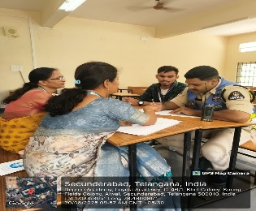
NCSCS | 04 | 96 |  | 100 | NIL | Parents are Happy. | 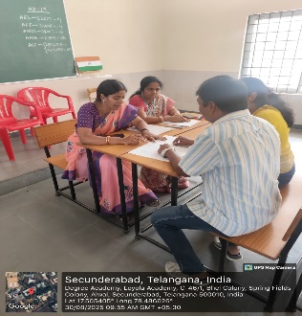
DCSCS | 20 | 80 |  | 100 | NIL | Parents are not happy with shifting of class rooms for each subjects. | 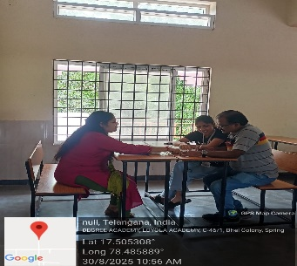
CONSOLIDATED REPORT ON PTM
Date: Saturday, 30 August, 2025 Venue: Loyola Academy
Time: 09.30 am to 03.00 pm
Name of the Program: B.Sc Computer Science &Cyber Security

CONSOLIDATED REPORT ON EVEN SEM PTM
Date: Saturday,14th February, 2026 Venue: Loyola Academy
Time: 09.30 am to 03.00 pm
Name of the Program: B.Sc Computer Science &Cyber Security
Class | % of Parents attended the meeting Online | % of Parents attended the meeting Offline | Total % Attended PTM | UID No. Of absentees for PTM | Overall Remarks by Parents | Photographs
ACSCS | 0 | 100 | 100 | NIL | Parents are happy with faculties and management. | 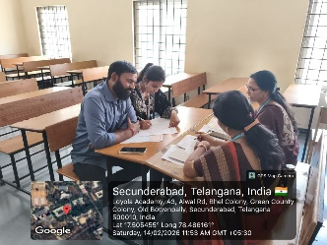
NCSCS | 10 | 90 | 100 | NIL | Parents are satisfied with the management and happy with the Faculty coordination. | 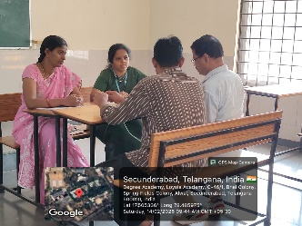
DCSCS | 40 | 60 | 100 | NIL | Parents have asked about the placements and internships in the same domain. | 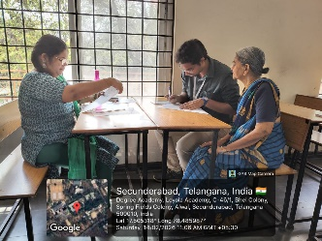

15. STUDENT SCHOLARSHIP DETAILS:
SNO | UID | STUDENT NAME | FATHER /MOTHERS OCCUPATION | M/F | ANNUAL INCOME | RELIGION | NAME OF BANK A/C HOLDER(PARENT) | AMOUNT PROPOSED | CHEQUE NUMBER | ACTUAL AMOUNT SANCTIONED | BANK | BANK A/C NO. | REMARKS
1 | 111725039001 | Adimulum Pallavi | Business | F | 1,85,000 | Hindu | Mrs.Admulume Sujatha | 15,000 | 3,22,001 | 7500 | State Bank of India | 39477507633 | The student comes from an economically weak background. The mother is the sole earning member of the family, and three family members depend on her income.
2 | 111725039011 | Mullaguri Ankitha | Cottage industry | F | 1,50,000 | Catholic | Millaguri Prabhakar | 15,000 | 3,22,002 | 10000 | State Bank of India | 62294100712 | Financially poor
3 | 111723039013 | Patta Sravanthi | Daily Wage earner | F | 1,90,000 | Hindu | Patta Naga laxmi | 15,000 | 3,22,003 | 9000 | State Bank of India | 38759498375 | Financially very poor
II YEAR (Selected)
SNO | UID | STUDENT NAME | FATHER /MOTHERS OCCUPATION | M/F | ANNUAL INCOME | RELIGION | NAME OF BANK A/C HOLDER(PARENT) | AMOUNT PROPOSED | CHEQUE NUM | AMOUNT SANCTIONED | BANK | BANK A/C NO. | REMARKS
1 | 111724039004 | Dandotkar sanjana | Garbage collector | F | 198000 | hindu | D.Vinod kumar | 20,000 | 322005 | 12000 | HDFC Bank | 50100838429343 | Her parent works as Garbage collector
2 | 111724039007 | Gujja Akhila | Tea stall | F | 130000 | hindu | Gujja Narsimlu | 20,000 | 3,22,008 | 6000 | Telangana Grameena Bank | 7186008393 | financially poor as his father runs tea stall , which is the only income
3 | 111724039014 | M.Sreenidhi | Daily wage worker | F | 188000 | hindu | M.santosh kumar | 15,000 | 3,22,012 | 7500 | State bank of India | 39808369948 | financially not good
4 | 111724039013 | Kunduru Teja Reddy | Farmer | F | 60,000 | Hindu | K.Eswar Reddy | 15,000 | 3,22,011 | 8,500 | State bank of India | 41389396549 | financially poor as her father is farmer
5 | 111724039017 | R.Harshini | Deceased | F | 80,000 | Hindu | Ryali Leela Venkata Satyavati | 20,000 | 3,22,013 | 8,000 | Union Bank | 126010011002208 | Income is less as her fathers health is not well
6 | 111724039018 | S.Varshini | Farmer | F | 130000 | Hindu | S.Venkatesh | 20,000 | 3,22,014 | 4000 | Andhra pradesh grameena vikas bank | 7316620087-2 | financially low as her father is farmer
7 | 111724039020 | Upputuri venkata lakshmi sahiti | Cooli(labour) | F | 199000 | Hindu | Upputuri Bramhaiah | 20,000 | 3,22,016 | 6000 | Union Bank | 131410027002634 | her father works as cooli
8 | 111724039030 | Kambham Prashanth | Driver | M | 180000 | Hindu | Kambham Jithender | 15,000 | 3,22,019 | 6000 | syndicate Bank | 30222250014123 | His father is driver with low income.
9 | 111724039032 | Karnati Sharath Chandra | Tailor | M | 190000 | Hindu | Karnati Chandra Shekar | 20,000 | 3,22,020 | 5000 | Union Bank | 64022010000824 | single parent as his mother is tailor and father expired
10 | 111724039035 | Nasa Koushik | Private employee | M | 186000 | Hindu | Nasa Jaya Kumar | 15,000 | 3,22,021 | 7500 | uco bank | 1140110033937 | financially not good
11 | 111724039003 | B.Shruthi | Plumber | F | 199000 | Hindu | B.Rama Krishna | 15,000 | 3,22,004 | 6000 | State bank of India | 38218969874 | financially not good
12 | 111724039019 | T.Namitha Sree | Labour | F | 198000 | Hindu | T.Malyadri | 20,000 | 3,22,015 | 6000 | HDFC Bank | 50100476128676 | Her father is labour
13 | 111724039005 | D.Bhargavi | Sweet corn vendor | F | 120000 | hindu | D.Parusharamulu | 15,000 | 3,22,006 | 5000 | Telangana Grameena Bank | 73061169747 | Her father runs sweetcorn vendor, which gives low income
14 | 111724039050 | A.Abivardhana reddy | Driver | M | 180000 | hindu | A.Rami Reddy | 15,000 | 3,22,022 | 6000 | State bank of India | 20181256194 | His father is driver with low income.
15 | 111724039025 | D.Chaitanya | Private employee | M | 120000 | hindu | D.Kiran kumar | 15,000 | 3,22,017 | 7500 | State bank of India | 20101759259 | he has single parent , on the income of mothers only, he is sudying
16 | 111724039006 | G. Ramya Mary | Hotel management | f | 120000 | Catholic | G.Naveen Kumar santos | 15,000 | 3,22,007 | 12000 | Indian overseas bank | 40501000043884 | financially low income
17 | 111724039011 | Koppula Ashritha | Private employee | F | 188000 | hindu | Narsimha Rao | 15000 | 322009 | 7500 | State Bank of India
18 | 111724039012 | K Sri Sai Vedha | Private employee | F | 198000 | hindu | K.Bharath Chandra | 15000 | 322010 | 7500 | Andhra Bank
19 | 111724039029 | Kairamkonda Jayanth | Private employee | M | 199000 | hindu | Kairamkonda Venkatesh | 15000 | 322018 | 7500 | State Bank of India
III YEAR ( Selected)
SNO | UID | STUDENT NAME | FATHER /MOTHERS OCCUPATION | M/F | ANNUAL INCOME | RELIGION | NAME OF BANK A/C HOLDER(PARENT) | AMOUNT PROPOSED | CHEQUE NUM | AMOUNT SANCTIONED | BANK | BANK A/C NO. | REMARKS
1 | 111723039001 | Anevoina Sowmya | private employee | F | 1,99,000 | Hindu | Anevoina Pentamma | 15,000 | 3,22,023 | 7500 | central bank of India | 3039473799 | The student comes from an economically weak background. The father is the sole earning member of the family, and four family members depend on his income.
2 | 111723039008 | kore Mounika | Driver | F | 1,20,000 | Hindu | kore Mallikarjun | 15,000 | 3,22,026 | 8000 | State Bank of India | 62253176010 | Financially poor father is a driver
3 | 111723039009 | L. Rajarani | Employee | F | 1,80,000 | Hindu | laxmi polibabu | 15,000 | 3,22,027 | 9000 | Bank of India | 862410110007001 | Financially poor
4 | 111723039011 | N manasa | Farmer | F | 1,25,000 | Hindu | neerati thirupathi reddy | 10,000 | 3,22,028 | 6000 | State Bank of India | 62136281361 | Her father, a farmer, is the only earning member of the family,
5 | 111723039024 | D.Durga Prasad | pt teacher | M | 60,000 | Roman Catholic | DASARAPALLI RAJYA LAKSHMI | 20,000 | 3,22,029 | 8,000 | Union Bank of India | 111910100157590 | father is a PT teacher with basic salary, poor financial condition
6 | 111723039031 | K. Sampath | Farmer | M | 1,40,000 | Hindu | KURMA NARSIMLU | 18,000 | 3,22,030 | 4000 | State Bank of India | 31210882652 | Financially poor
7 | 111723039039 | NALLA MANIKANTA | Farmer | M | 1,20,000 | Hindu | NALLA PUSHPALATHA | 10,000 | 3,22,031 | 10000 | the Karimnagar district co-operative central bank | 204422010001198 | economically poor background
8 | 111723039048 | Vaddemani Jason | Private Employee | M | 1,81,000 | Christian | Vaddemani Raj Kumar | 20,000 | 3,22,032 | 12000 | ICICI Bank | 68001520177 | he is merit student, and financially poor
9 | 111723039049 | Vempati Srujan | Farmer | M | 98,000 | Catholic | Vempati GopiKrishna | 20,000 | 3,22,034 | 10,000 | HDFC | 50100536762941 | He is a brilliant student. Recently, his mother passed away. His father is a farmer and the sole earning member of the family.
10 | 111723039050 | Y. Bhanu preetham | salesman | M | 1,60,000 | Hindu | Yedavi Venkatesh | 12,000 | 3,22,033 | 5000 | State Bank of India | 52126231576 | Financially poor
11 | 111723039002 | B. Yamini sri | Driver | F | 198000 | Hindu | B. Ramana | 10,000 | 322024 | 3000 | State Bank Of India | 62293828017
12 | 111723039004 | B Rishika sri | Cab druver | F | 199000 | Hindu | B srinivas | 10,000 | 322025 | 4000 | State Bank of India | 20192980329

16. RESULT ANALYSIS

ACSCS(Sem-I)-Over All Pass Percentage-80%
S.No | Faculty Name | Subject | No. of Students |  |  | Percentage
S.No | Faculty Name | Subject | Appeared | Passed | Failed | Percentage
1 | M.Vasudha | ELEMENTARY NUMBER THEORY & LAPLACE | 50 | 41 | 8+1(MP) | 83%
2 | M.Supriya | COMPUTER NETWORKS | 50 | 47 | 2 | 95.92%
3 | S.Kavitha | COMPUTER FUNDAMENTALS | 50 | 50 | 0 | 100%
4 | S.LAKSHMI | PROBLEM SOLVING & PROGRAMMING IN C | 49 | 48 | 1 | 97.95%
5 | ASHA JOHN | GENERAL ENGLISH-I | 50 | 50 | NIL | 100%
6 | Mr.M.L.Thomas | VALUE EDUCATION & PERSONALITY DEVELOPMENT | 50 | 50 | NIL | 100%
7 | S.Kavitha | OFFICE AUTOMATION (PR) | 50 | 50 | NIL | 100%
8 | E.Srivani | COMPUTER NETWORKS(PR) | 50 | 50 | NIL | 100%
9 | S.LAKSHMI | C PROGRAMMING (PR) | 50 | NIL | 100% | 50

NCSCS(Sem-III)-Over All Pass Percentage-89.58
S.No | Faculty Name | Subject | No. of Students |  |  | Percentage
S.No | Faculty Name | Subject | Appeared | Passed | Failed | Percentage
1 | MR.S.BALACHANDER | EVS | 50 | 50 | 0 | 100%
2 | N.MANISHA | ETHICAL HACKING | 50 | 50 | 0 | 100%
3 | Y.Ratna Deepthi | PYTHON PROGRAMMING | 51 | 50 | 1 | 98.4%
4 | K.Ajay | Database Management System | 50 | 49 | 1 | 98%
5 | S.LAKSHMI | CRYPTOGRAPHIC ALGORITHMS | 50 | 50 | 0 | 100%
6 | N.MANISHA | ETHICAL HACKING  (PR) | 51 | 51 | 0 | 100%
7 | Y.Ratna Deepthi | PYTHON PROGRAMMING  (PR) | 51 | 51 | 0 | 100%
8 | N.MANISHA | Database Management System (PR) | 50 | 50 | 0 | 100%

DCSCS(Sem-V)-Over All Pass Percentage-79.63
S.No | Faculty Name | Subject | No. of Students |  |  | Percentage
S.No | Faculty Name | Subject | Appeared | Passed | Failed | Percentage
1 | N.MANISHA | STEGANOGRAPHY | 23 | 23 | NIL | 100
2 | M.Supriya | SECURE E-COMMERCE | 23 | 23 | NIL | 100
3 | SITARAMA SASTRY | IOT | 23 | 23 | NIL | 100
4 | S.KAVITHA | CLOUD COMPUTING | 23 | 23 | NIL | 100
5 | M.SUPRIYA | GO LANG PROGRAMMING | 46 | 46 | 0 | 100
6 | DR.B.RAJANI | MACHINE LEARNING FOR CYBER SECURITY | 46 | 46 | 0 | 100
7 | S.LAKSHMI | DATABASE TECHNOLOGIES | 46 | 45 | 1 | 97.83
8 | N.MANISHA | DISASTER RECOVERY AND RISK MANAGEMENT | 46 | 45 | 1 | 97.83
9 | M.SUPRIYA | GO LANG(PR) | 46 | 46 | 0 | 100
10 | DR.B.RAJANI | MACHINE LEARNING FOR CYBER SECURITY(PR) | 46 | 46 | 0 | 100
11 | S.LAKSHMI | DATABASE TECHNOLOGIES(PR) | 46 | 46 | 0 | 100

17. REPORT ON BRIDGE,ADD-ON & SELF STUDY Course:

BRIDGE COURSE REPORT:
The Department of Computer Science & Cyber Security has scheduled a bridge course from 1/07/2025 to 30/08/25 in an effort to make the applicants' academic experiences more convenient. Despite receiving excellent scores on the Higher Secondary Exam, pupils took a long break starting in April. Therefore, the bridge course turns out to be the finest chance for the students to acclimatize to Security Fundamentals. The students will gain the knowledge and confidence needed to take on difficulties as future graduates throughout this three-week interaction with the professionals and their peers. One of the stepping stones towards their eventual objective is a well-designed course.

Objectives:
- To give kids enough time and a place to transition from school to graduation.
- To bridge the gap between subjects studied at the pre-university level and those they would be studying at graduation. To improve the interpersonal skills of every student.
- Provides pupils with the self-assurance and abilities to successfully adjust to college and new coursework.
- To clarify the basic concepts of Computer Fundamentals
Brief look of Bridge course:
Students participated in the classes with tremendous enthusiasm and a keen interest in learning about computers because they were so enticing. With a brand-new bridge course, the students were eagerly introduced to the department's environment. The committee members intended to use activity-based learning and knowledgeable faculty lecturers for the current bridge course.
Faculty: N. Manisha discussed the significance of Security Fundamentals in the classroom.
OutComes:
• Students gain understanding of their diverse fields, their advancements, and the capacity to use newly learned information.
• Classmate and expert interaction continued to be excellent.
• Students have learned new information and have begun to address their issues.
• It made students feel more assured and prepared when they begin their studies by giving them better preparation for enrolling in college-level scientific courses.
• It served as a support system for new students, giving them the resources and information necessary to graduate with a degree in cyber security.

SECURITY FUNDAMENTALS
(BRIDGE COURSE)

Code: 039B
No. of hrs: 15
Objectives:
- To learn able to basic security fundamentals.
- To get acquainted with IT
Outcomes: Students would be able to install windows 10, work with control panel, manage different applications and practice safe browsing techniques.

- Introducing to windows 10
- Overview of deploying windows 10 auto pilot mode, normal mode
- Windows 10 User Experience
- Security in windows 10
- Configure devices and drives
- Perform post installation configuration task
- Managing apps in window
- Windows 10 networking
- Virtualization and remote access
- Windows 10 on phones and tablets
- Installation of Ubuntu operating system
- Working with Ubuntu
- Safe browsing techniques of internet
- Best security practices in using social media platform

Essential Readings:
Ed Bott, “ Introducing Windows 10 for IT Professionals”, Microsoft Press, 2020.

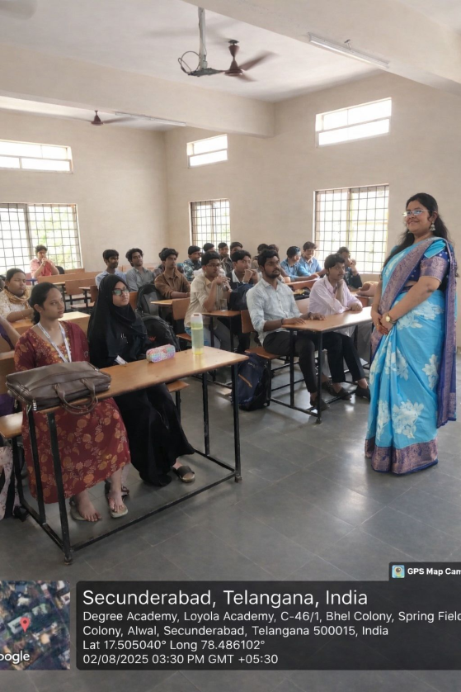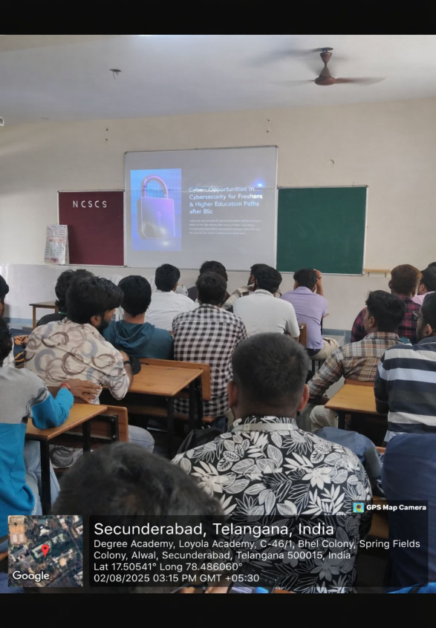

Marks List of Bridge Course in Security Fundamentals conducted on 29/7/2025

SNO | UID | NAME OF THE STUDENT | BEFORE |  | MARKS | AFTER MARKS
1 | 111725039001 | ADIMULUM PALLAVI |  |  | 23 | 30
2 | 111725039002 | AKULA DAKSHAYANI |  |  | 20 | 25
3 | 111725039003 | AMARLAPUDI JOYCE CRYSTAL |  |  | 17 | 27
4 | 111725039004 | AMBIL SRI VIDYA HARSHINI |  |  | 26 | 46
5 | 111725039005 | DINTAKURTHY HANSIKA |  |  | 17 | 27
6 | 111725039006 | ENDRAKANTI RISHITHA |  |  | 14 | 31
7 | 111725039007 | GURRAM SAI SAHASRA |  |  | 12 | 32
8 | 111725039008 | ISAKAVARAPU MADHURI |  |  | 12 | 22
9 | 111725039009 | KASAPURAM BHAVIKA |  |  | 18 | 28
10 | 111725039010 | KUNCHARAPU MEGHANA |  |  | 14 | 34
11 | 111725039011 | MULLAGURI ANKITHA |  |  | 23 | 33
12 | 111725039012 | PABBA SHARANYA |  |  | 23 | 35
13 | 111725039013 | PATTA SRAVANTHI |  |  | 19 | 31
14 | 111725039014 | PENTAREDDY VELANGANI RUCHIKA |  |  | 20 | 37
15 | 111725039015 | PITTALA JAYA DURGA |  |  | 22 | 27
16 | 111725039016 | PONNAM SUPRIYA |  |  | 17 | 21
17 | 111725039017 | SHAREEN RENETA JOHNSON |  |  | 25 | 34
18 | 111725039018 | TANVEER FATIMA |  |  | 14 | 31
19 | 111725039019 | THUMMA AKSHITHA |  |  | 11 | 29
20 | 111725039020 | T J DEBORAH JACIN |  |  | 20 | 28
21 | 111725039021 | TANDALE NETHANYA SIPPORA |  |  | 22 | 25
22 | 111725039022 | YARAKARAJU VEENA MADHURI |  |  | 25 | 48
23 | 111725039023 | ANGADIPETA DURGAPRASAD GOUD |  |  | 22 | 30
24 | 111725039024 | ANUKA SACHIN |  |  | 21 | 25
25 | 111725039025 | BAMDEV DHAMI |  |  | 24 | 34
26 | 111725039026 | CHINNALINGU NIRAJ GOUD |  |  | 22 | 43
27 | 111725039027 | CHIVAGARI SAI SIDDHARTH |  |  | 20 | 22
28 | 111725039028 | DEVA SAI DEEKSHITH REDDY |  |  | 18 | 28
29 | 111725039029 | ERROM LOKESH RAJU |  |  | 32 | 42
30 | 111725039030 | GOTTIMUKKULA ANIL GOUD |  |  | 25 | 35
31 | 111725039031 | GUNNAM OM SAI VARSHITH |  |  | 13 | 23
32 | 111725039032 | JUTTIKA RAVITEJA |  |  | 20 | 40
33 | 111725039033 | KANDUKURI SAI GANESH |  |  | 31 | 33
34 | 111725039034 | KASIREDDY AKHIL PRABHAS |  |  | 24 | 41
35 | 111725039035 | KUNDANPALLY YESU PADHAM |  |  | 23 | 33
36 | 111725039036 | MAMILLAPALLI RAGHUNANDHAN SUDHARSHAN |  |  | 15 | 35
37 | 111725039037 | MC AARON XAVIER |  |  | 20 | 30
38 | 111725039038 | MENTA GAURISH |  |  | 21 | 31
39 | 111725039039 | MOHAMMED FAWAZ KHAN |  |  | 18 | 38
40 | 111725039040 | MUDAPALLI SAI PAVAN |  |  | 15 | 30
41 | 111725039041 | MURALA VINEETH |  |  | 19 | 31
42 | 111725039042 | NICHOLAS JUDE |  |  | 13 | 33
43 | 111725039043 | PAKKI GOUTHAM |  |  | 21 | 31
44 | 111725039044 | PENTAREDDY BALA PUNEETH SUJAY |  |  | 30 | 35
45 | 111725039045 | RESHAM ARAVIND |  |  | 17 | 27
46 | 111725039046 | TALAGAMA BALAJI |  |  | 15 | 35
47 | 111725039047 | TALARI RATNAM PHILIP |  |  | 22 | 35
48 | 111725039048 | THAKUR SAI VED SINGH |  |  | 10 | 30
49 | 111725039049 | TULA SRI RAM |  |  | 22 | 32
50 | 111725039050 | VEDANTHAM PAWAN KUMAR |  |  | 15 | 35

ATTENDANCE SIGNING SHEET
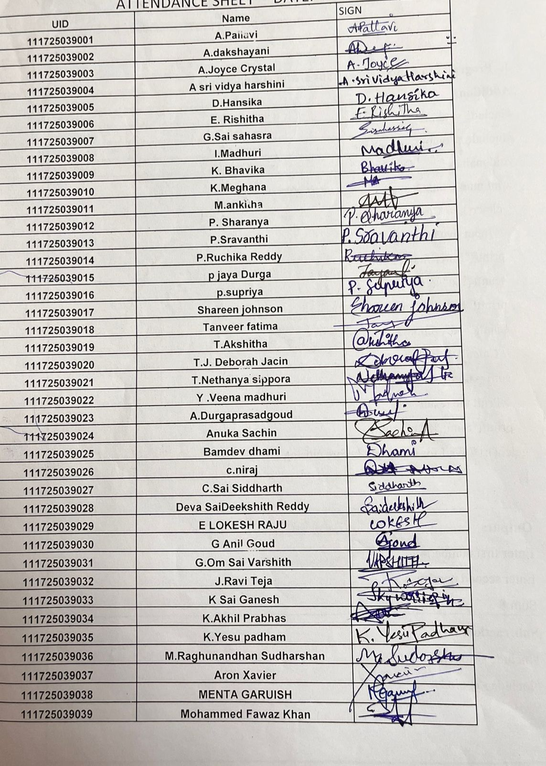

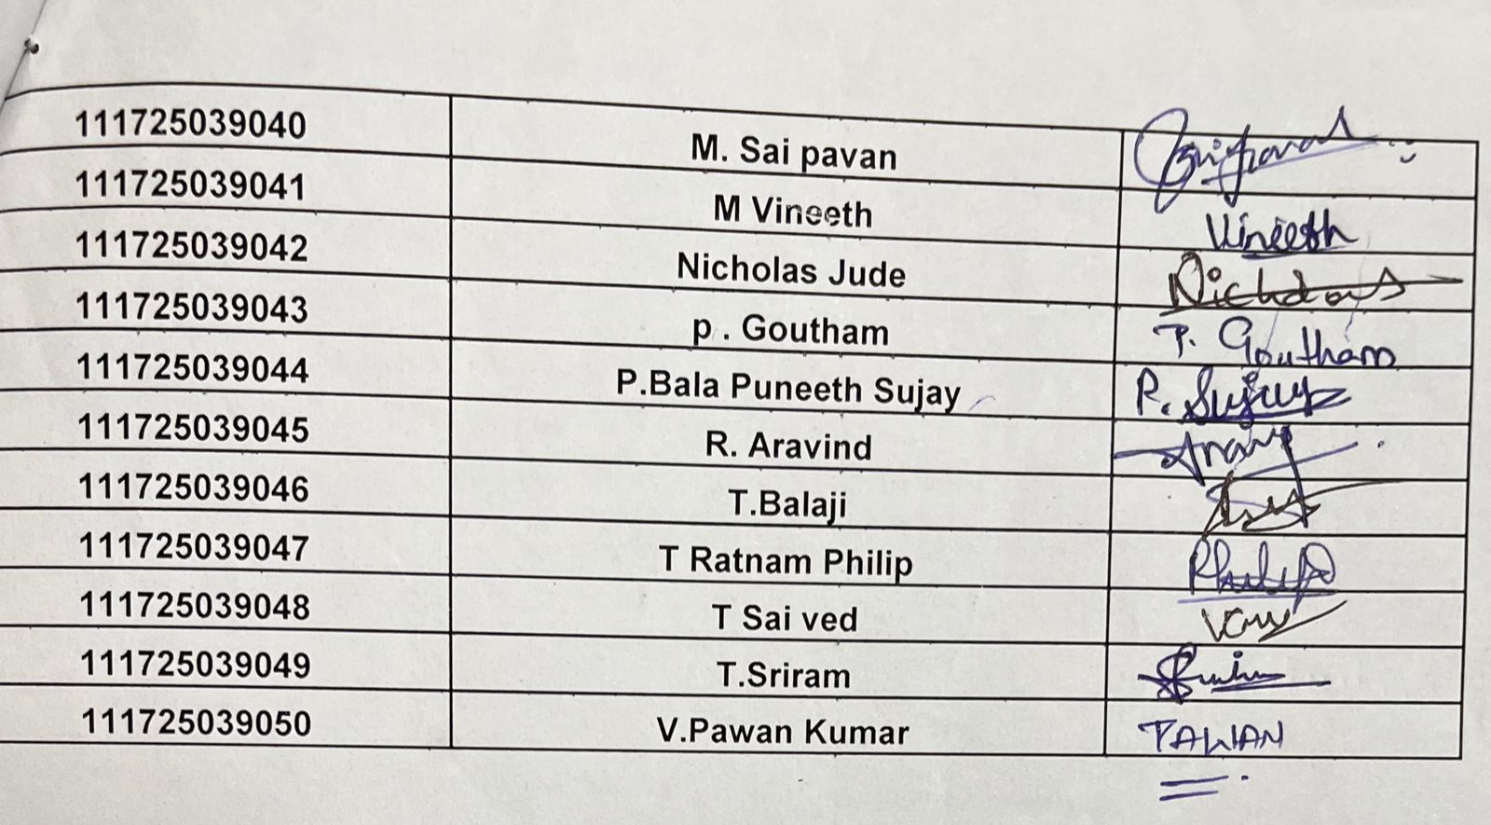

Add on Course Report-UNIX Shell Programming

The Department of B.Sc(Computer Science & Cyber Security)offered Add-on course for the third year students,titled as UNIX Shell Programming taught by Faculty Mrs. S. Kavitha .This is an additional course to the students which will be helpful to them to create files.
Objective:
The main objective of this program is to enhance the skills of how to create the files & Directories.
We have conducted the Course on every week 6th hour.
• The following topics have been covered:
1. Overview of UNIX
2. Basic Commands of UNIX
3. Working with Files & Directories
4. Implementing the various programs using Mathematical Functions & Strings

• We have given the Information and knowledge regarding these topics.The students performed tasks which is given to them. They have shown the Keen interest in learning the subject and doing the tasks. The performance of the students was quite impressive.
Outcome:
• Students are able to write a sample program like creating and working with some basic commands & simple programs on control statements like if and for.

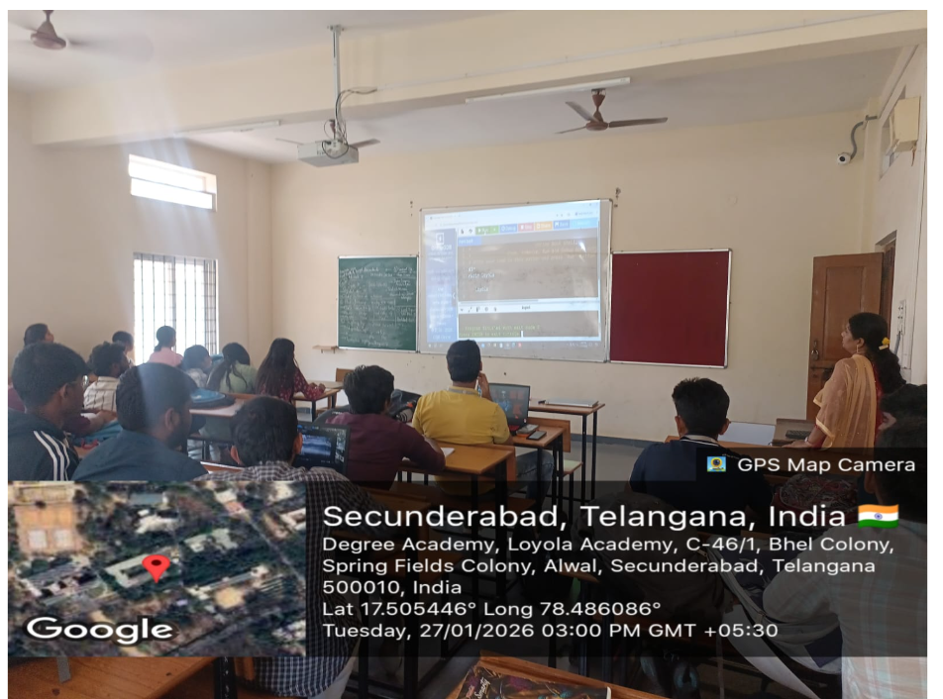

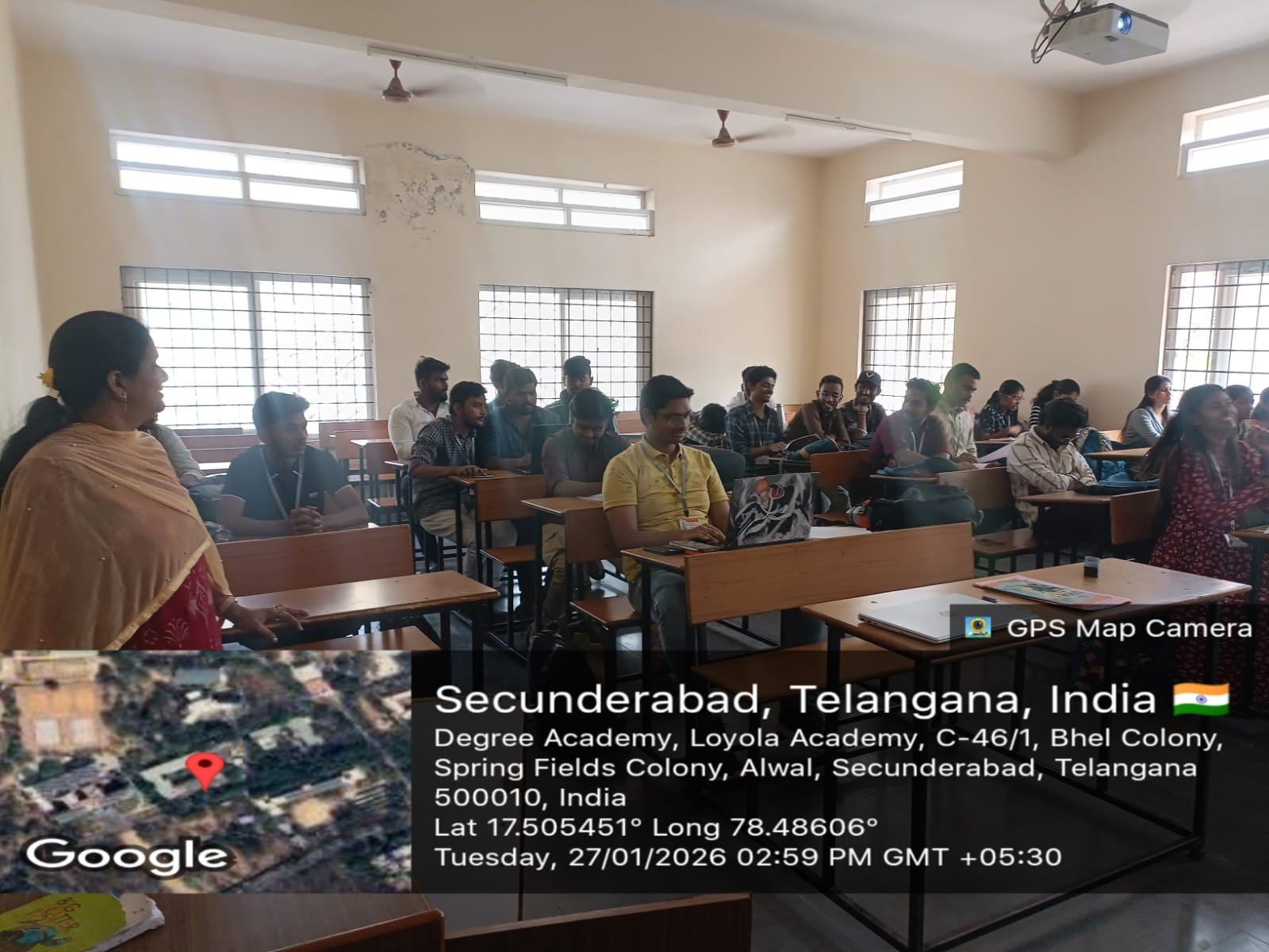

ATTENDANCE SIGNING SHEET

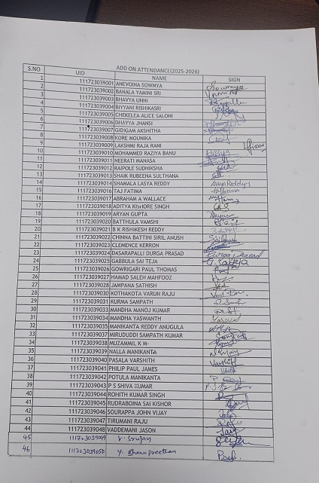

Add On Marks
S.NO | UID | NAME | MARKS
1 | 111723039001 | ANEVOINA SOWMYA | 49
2 | 111723039002 | BANALA YAMINI SRI | 38
3 | 111723039003 | BHAVYA UNNI | 40
4 | 111723039004 | BIYYANI RISHIKASRI | 38
5 | 111723039005 | CHEKELEA ALICE SALONI | 40
6 | 111723039006 | DHAYYA JHANSI | 28
7 | 111723039007 | GIDIGAM AKSHITHA | 42
8 | 111723039008 | KORE MOUNIKA | 43
9 | 111723039009 | LAKSHMI RAJA RANI | 40
10 | 111723039010 | MOHAMMED RAZIYA BANU | 39
11 | 111723039011 | NEERATI MANASA | 42
12 | 111723039012 | RAIPOLE SUDHIKSHA | 38
13 | 111723039013 | SHAIK RUBEENA SULTHANA | 39
14 | 111723039014 | SHAMALA LASYA REDDY | 40
15 | 111723039016 | TAJ FATIMA | 42
16 | 111723039017 | ABRAHAM A WALLACE | 22
17 | 111723039018 | ADITYA KISHORE SINGH | 32
18 | 111723039019 | ARYAN GUPTA | 42
19 | 111723039020 | BATTHULA VAMSHI | 39
20 | 111723039021 | B K RISHIKESH REDDY | 35
21 | 111723039022 | CHINNA BATTINI SIRIL ANUSH | 30
22 | 111723039023 | CLEMENCE KERRON | 40
23 | 111723039024 | DASARAPALLI DURGA PRASAD | 39
24 | 111723039025 | GABBULA SAI TEJA | 40
25 | 111723039026 | GOWRIGARI PAUL THOMAS | 36
26 | 111723039027 | HAMAD SALEH MAHFOOZ | 40
27 | 111723039028 | JAMPANA SATHISH | 39
28 | 111723039030 | KOTHAKOTA VARUN RAJU | 30
29 | 111723039031 | KURMA SAMPATH | 31
30 | 111723039033 | MANDHA MANOJ KUMAR | 30
31 | 111723039034 | MANDHA YASWANTH | 30
32 | 111723039035 | MANIKANTA REDDY ANUGULA | 34
33 | 111723039037 | MIRUDUDDI SAMPATH KUMAR | 28
34 | 111723039038 | MUZAMMIL K M- | 30
35 | 111723039039 | NALLA MANIKANTA | 33
36 | 111723039040 | PASALA VARSHITH | 30
37 | 111723039041 | PHILIP PAUL JAMES | 30
38 | 111723039042 | POTULA MANIKANTA | 38
39 | 111723039043 | P S SHIVA KUMAR | 30
40 | 111723039044 | ROHITH KUMAR SINGH | 39
41 | 111723039045 | RUDRABOINA SAI KISHOR | 34
42 | 111723039046 | SOURAPPA JOHN VIJAY | 29
43 | 111723039047 | TIRUMANI RAJU | 28
44 | 111723039048 | VADDEMANI JASON | 40
45 | 111723039049 | VEMPATI SRUJAN | 41
46 | 111723039050 | YADAGANI BHANUPREETHAM | 41

Self Study Report:

The Department of B.Sc(Computer Science and Cyber Security ) offered Self Study course for the Second year students, titled as Intrusion Detection Systems .This is an additional course to the students which will be helpful to them to learn about Intrusion Detection Systems.
Overview and Features of Intrustion Detection Systems:
An IDS continuously analyzes network packets, system logs, and user activities to detect potential security threats such as hacking attempts, malware infections, or abnormal behavior.
Features of IDS:
- Real-Time Monitoring :IDS continuously monitors network traffic and system activities in real time to identify suspicious behavior or possible attacks.
- Intrusion Detection :It detects different types of intrusions such as Unauthorized access,Malware activity,Network attacks,Policy violations.
- Alert and Notification System :When suspicious activity is detected, IDS generates alerts or warnings to inform system administrators so they can take action.
- Log and Event Recording :IDS keeps detailed logs of all network events and security incidents, which helps in investigation and auditing.
- Signature-Based Detection:It compares network traffic with a database of known attack signatures to detect previously identified threats.
- Anomaly Detection:IDS can identify abnormal behavior by comparing current activity with normal network patterns.
- Traffic Analysis :It analyzes network packets and data flow to detect malicious activities like scanning or suspicious communication
- Integration with Security Tools :IDS can integrate with other security technologies such as Security Information and Event Management (SIEM) systems, firewalls, and other monitoring tools.
- Forensic Support :The collected logs and alerts help in investigating security incidents and understanding how an attack occurred.
Objective:
- Identify users or attackers trying to access systems or data without permission.
- Continuously watch network traffic and system operations for suspicious behavior.
- Detect attacks such as malware, hacking attempts, or unusual activities.
- Notify system administrators when a potential intrusion or attack is detected.
- Help prevent unauthorized users from stealing or modifying important information.
- Ensure that system files and configurations are not altered by attackers.
- Log activities and incidents for analysis, investigation, and auditing.
- Provide information that helps security teams respond quickly to attacks.
- Help organizations understand vulnerabilities and strengthen their security systems.
Outcome:
It helps the students to understand how computer systems and networks are protected from cyber attacks. Students gain knowledge about detecting unauthorized access, monitoring network activities, and identifying security threats. This understanding improves their awareness of cybersecurity concepts and teaches them how security tools work in real-world environments. Learning IDS also helps students develop analytical and problem-solving skills related to network security. As a result, students become better prepared for careers in cybersecurity, network administration, and information security, and they learn how to design and manage secure systems.

A.Y 2025-2026
SELF STUDY COURSE
COURSE: INTRUSION DETECTION SYSTEM
DATE OF EXAM : 09-03-2026
Max.Marks: 50
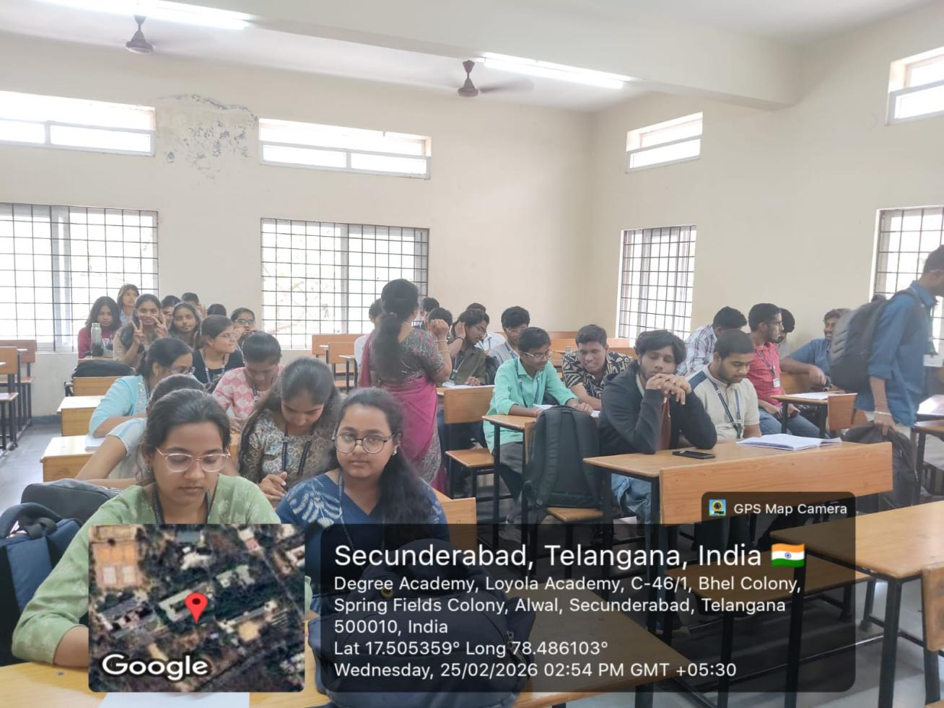
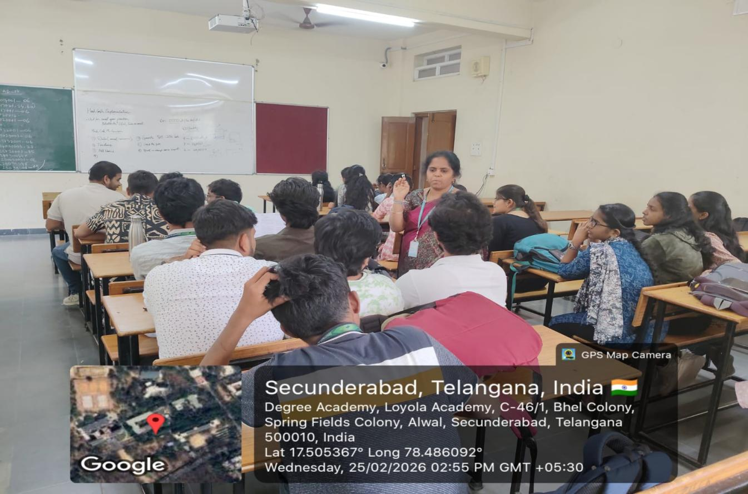

UID | Name | Marks
111723039032 | Sathwik | 20
111724039001 | ARDHI PRAVALIKA | 27
111724039002 | BETHAPALLI NAGA MALLESWARI | 26
111724039003 | B SHRUTHI | 31
111724039004 | DANDOTKAR SANJANA | 31
111724039005 | DUDUKA BHARGAVI | 31
111724039006 | GUGGILAM RAMYA MARY | 43
111724039007 | GUJJA AKHILA | 41
111724039008 | INALA HARSHA VARDHINI | 31
111724039009 | JANGA SWETHIKA | 38
111724039010 | KONDAVEETI SRAVANAJYOTHI | 38
111724039011 | KOPPULA ASHRITHA | 34
111724039012 | KORIVI SRI SAI VEDHA | 40
111724039013 | KUNDURU TEJA REDDY | 45
111724039014 | MARMAMLA SREENIDHI | 36
111724039015 | PIMPDAE TEJASWINI | 37
111724039016 | POOJA PAL | 30
111724039017 | RYALI HARSHINI | 34
111724039018 | SILIVERI VARSHINI | 40
111724039019 | THANNIRU NAMITHA SREE | 40
111724039020 | UPPUTURI VENKATA LAKSHMI SAHITI | 39
111724039021 | YAGNA GURUREDDY | 31
111724039022 | ARSHAD ALI | 31
111724039023 | BHALLA SAI SAMPATH | 28
111724039024 | BOMMISETTY YOGI VENKATA SURYA PAVAN KUMAR | 38
111724039025 | DASARI NAGA CHAITANYA | 29
111724039026 | DAYA SHANKAR | 35
111724039027 | DUBBAKA SRINIVAS | 21
111724039028 | JEEDIMADLA JAGANMOHAN REDDY | 25
111724039029 | KAIRAMKONDA JAYANTH | 34
111724039030 | KAMBHAM PRASHANTH | 34
111724039031 | KANCHERLA JOHN ADARSH | 28
111724039032 | KARNATI SHARATH CHANDRA | 35
111724039033 | M CHETHAN YADAV | 28
111724039034 | M P DHEERAJ RAJ | 37
111724039035 | NASA KOUSHIK | 40
111724039036 | PADAKANTI PREETHAM CHARY | 28
111724039037 | PALARAM YUVARAJ | 31
111724039038 | PULLAMCHERU BHAVANTEJA | 21
111724039039 | PAVAN KUMAVAT | 28
111724039040 | PENDEM MANICHARAN | 35
111724039041 | POTHARAJU ABHIRAM ADITHYA | 36
111724039042 | PRETAM BERA | 28
111724039043 | ROHIT SAHNI | 36
111724039044 | R VIKRAMADITYA WENCE | 28
111724039045 | SHIRAPU HEMANTH REDDY | 37
111724039046 | SURAPANENI CHAITANYA | 28
111724039047 | VOOSA VIVEK | 35
111724039048 | YANAGADDA SATYA SREE HARI PHANEENDRA | 32
111724039049 | NANDI PRAVEEN | 34
111724039050 | A ABIVARDHANA REDDY | 37

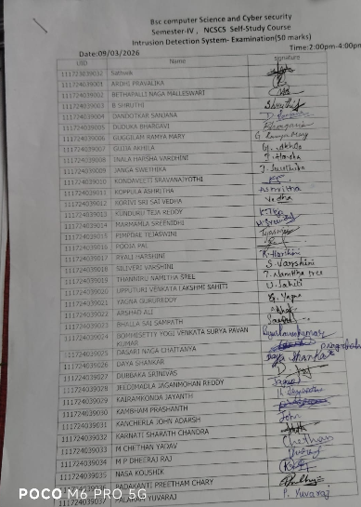

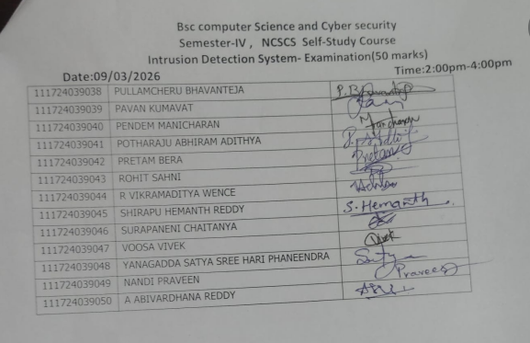

18.PLANET
Event details:
- Date: March 10th, 2026
- Venue: Second Chance Foundation Old Age Home
- Organizer: B.Sc. Computer Science and Cybersecurity department, Loyola Academy Degree and PG College
- Resource person: Ms. Blessy
- Target audience: Old Age Home Residents, Volunteers and Students
Objectives of the event:
- To spend quality time with Old Age Home Residents and bring joy to their lives.
- To create awareness about social responsibility among students and volunteers.
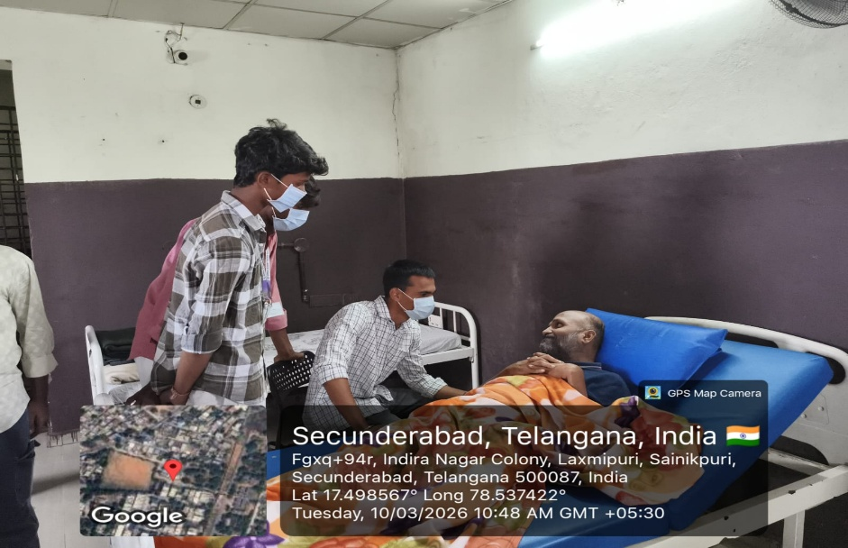
Participant details:
- Total participants: 50
- Demographics: Students, Volunteers, and Old age home residents
- Attendance percentage:100
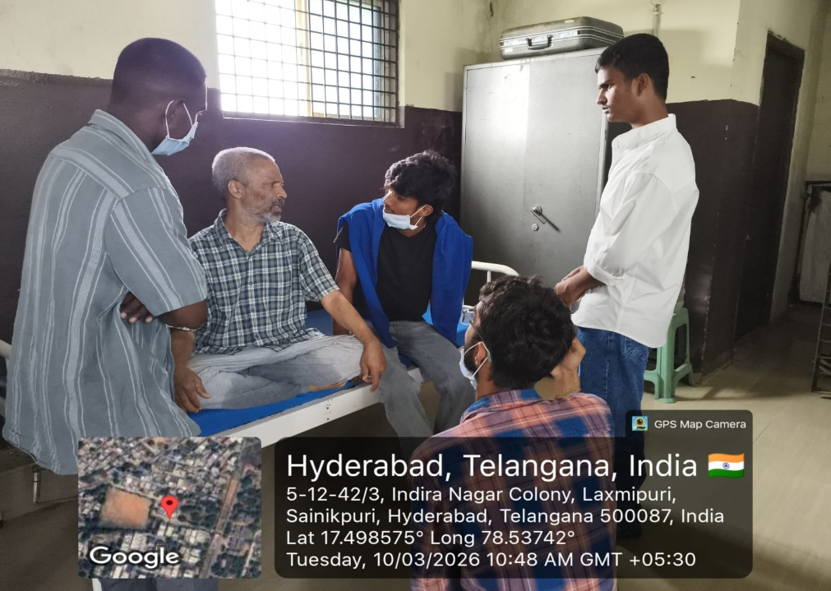
Content evaluation:
- Relevance of the Topic: Highly Relevant (addressing social responsibility and Empathy)

- Engagement of Participants: Highly Engaged (residents were thrilled with the interactions)
LEARNING OUTCOMES:
- Were the Learning Outcomes Met? Yes
- Key Takeaways for Participants:
- Understanding the needs and challenges of old age home residents.
- Value of social responsibility and community service.
- Importance of empathy and compassion towards elderly.
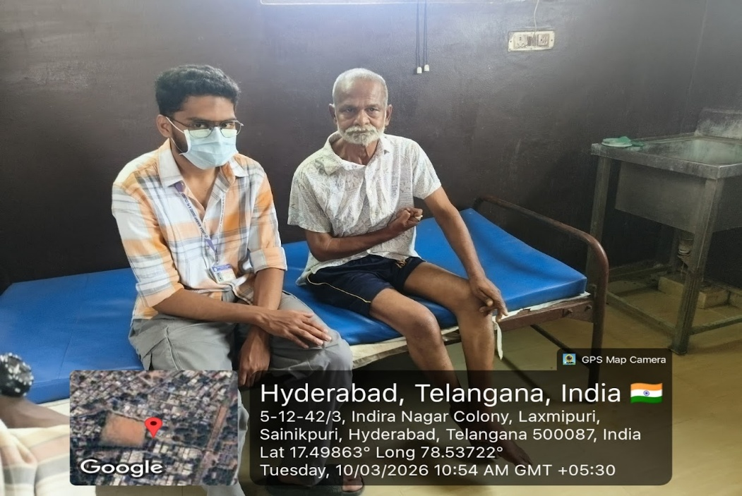
Feedback analysis:
- Method of Feedback Collection: Verbal feedback from residents and volunteers.
- Key Feedback from participants:
- Positives: Residents felt happy and cared for; volunteers felt fulfilled.
- Areas of Improvement: More frequent visits and activities suggested.
- Rating on a scale of 1-5: 4.8/5
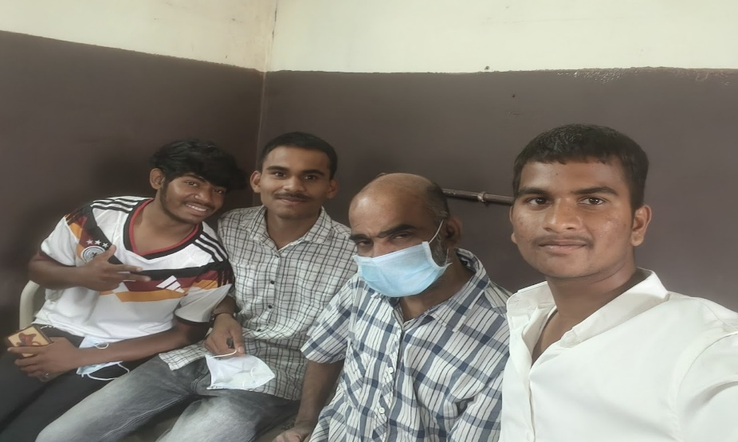
Impact on PARTICIPANTS:
- Impact on student learning: Increased empathy and sense of social responsibility.
- Impact on Residents: Residents felt valued and connected.
- Suggestions for future events: More visits, games, and cultural activities.

- Quantitative analysis:
- Performance Improvement: 95% of residents appreciated the visit and interactions.
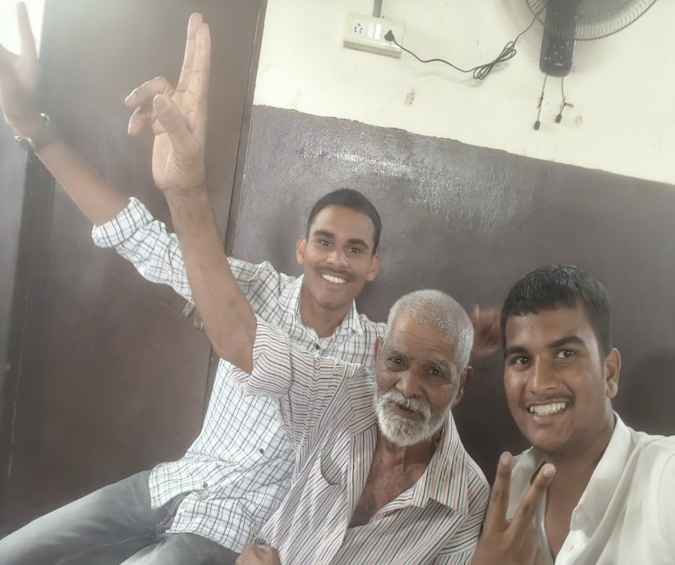
Recommendations:
- Future Improvements: More frequent visits and activities
- Recommended Topics for Future: Health talks, cultural events, and skill-sharing sessions
- Potential for Recurrence of the event: Health talks, cultural events, and skill-sharing sessions.
Conclusion:
The PLANET Program was a heartwarming success, spreading joy to old age home residents.
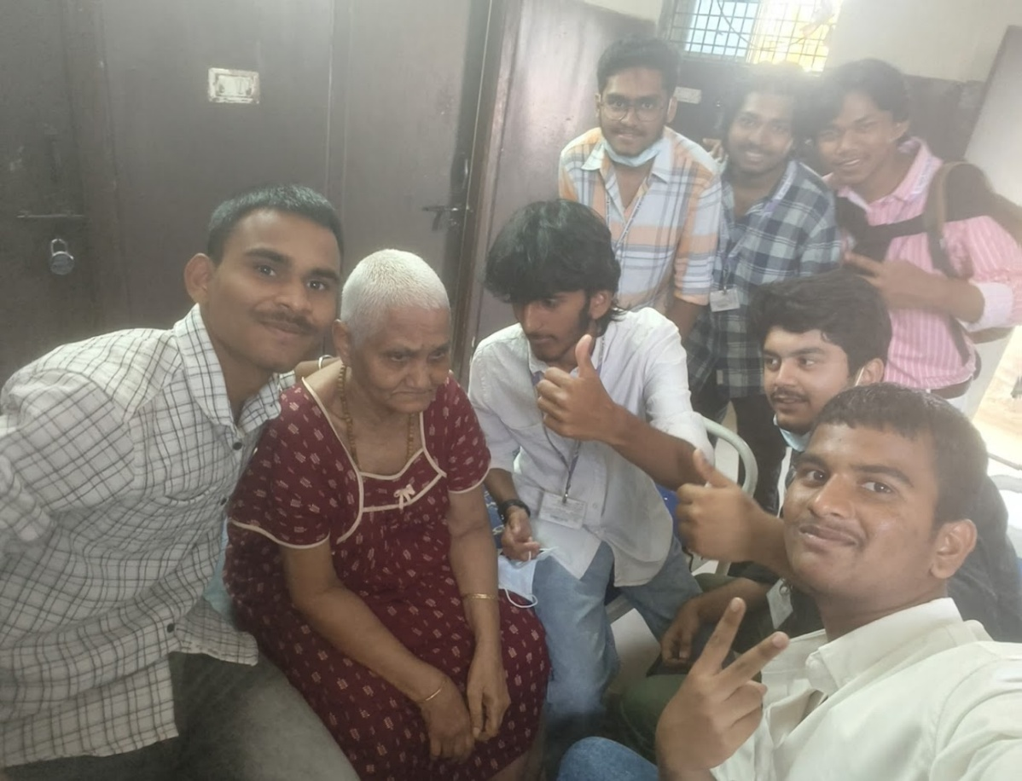
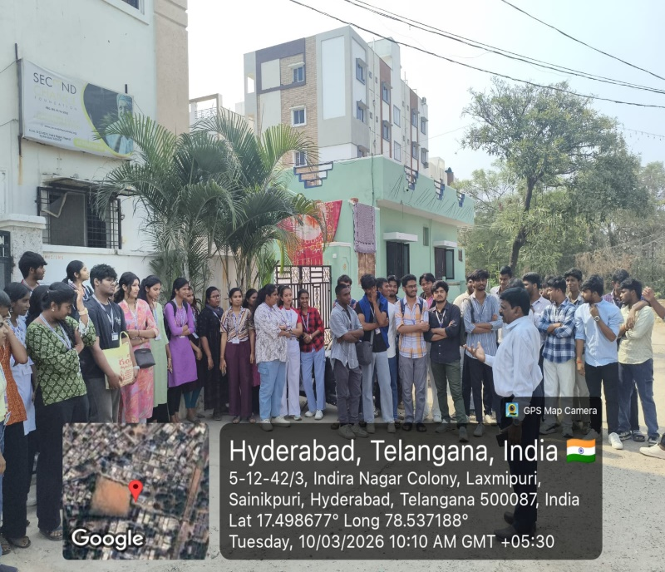

19.INDUSTRIAL VISITS:

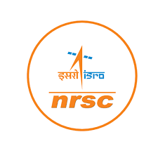
Industrial visit to NRSC ISRO

Event details:
DATE: 7th January 2025
VENUE: NRSC ISRO
ORGANIZED BY: B.Sc. Computer Science and Cybersecurity Department, Loyola Academy Degree and PG College
RESOURCE PERSON: Educators of NRSC
TARGET AUDIENCE: Students and faculty members of Loyola Academy Degree and PG College, particularly those enrolled in the B.Sc. Computer Science and Cybersecurity program.
OBJECTIVES OF THE EVENT:
- To provide hands on
- exposure to space technology and applications.
- To understand the working of NRSC ISRO and its contributions to space research.
PARTICIPANT DETAILS:
TOTAL PARTICIPANTS: 52
DEMOGRAPHICS: Students and faculty members of Loyola Academy Degree and PG College.
ATTENDANCE PERCENTAGE: 100%
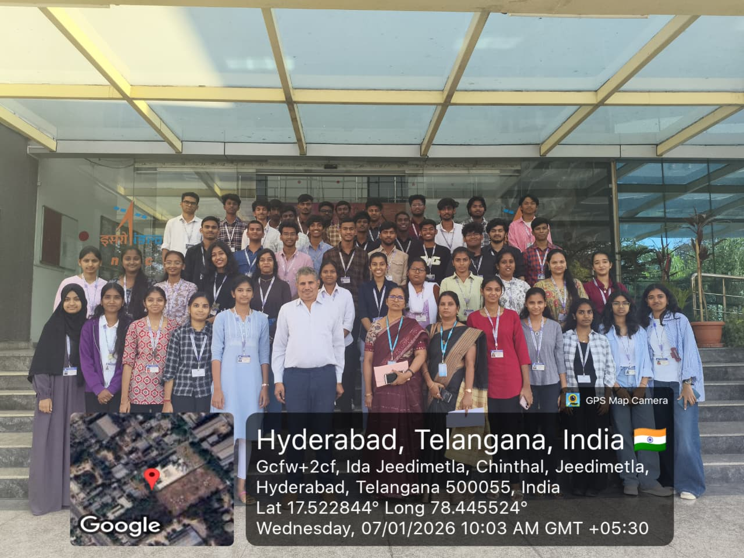
CONTENT EVALUATION:
RELEVANCE OF THE TOPIC: Highly Relevant.
DEPTH OF KNOWLEDGE DELIVERED: Excellent
ENGAGEMENT OF PARTICIPANTS: Highly engaged
LEARNING OUTCOMES:
- Were the Learning Outcomes met?Yes
- Key Takeaways for Participants:
- Understanding of rockets, satellites, and space applications
- Insights into ISRO's work and research
Skills/Knowledge Gained: Practical knowledge of space technology and applications
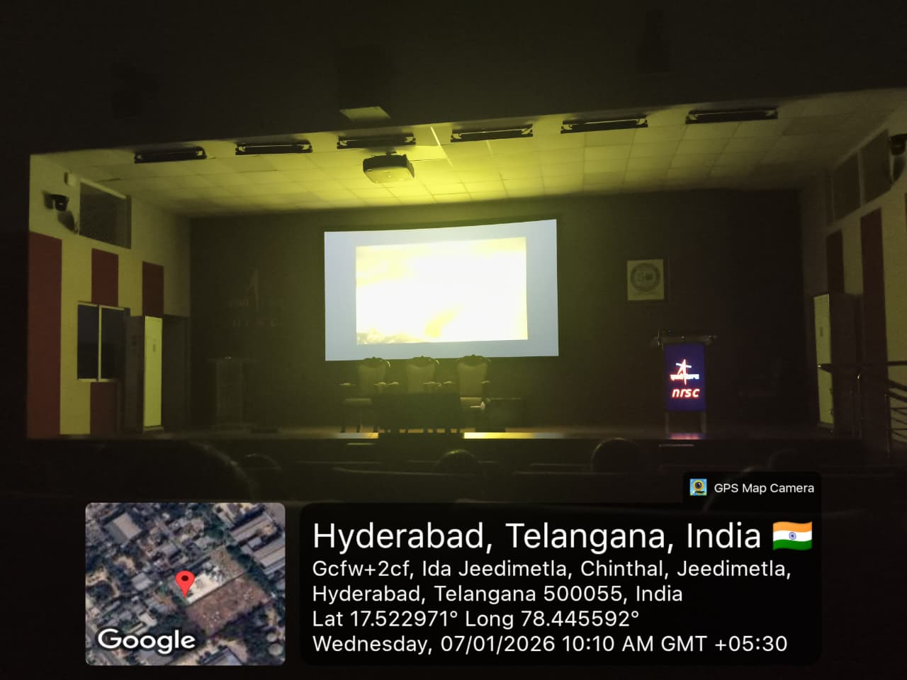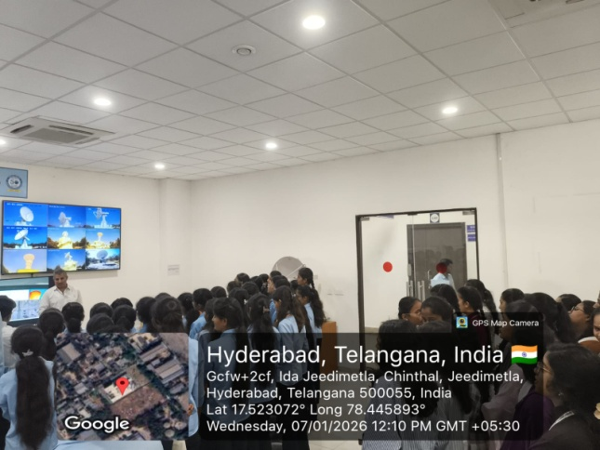

FEEDBACK ANALYSIS:
- Method of Feedback Collection: Oral feedback post-event
- Key Feedback from Participants:
- Positives: Interactive sessions, informative exhibition
- Areas of Improvement: More hands-on activities suggested
- Rating on a scale of 1-5:
- Content Quality:4.6/5
- Resource Person Effectiveness: 4.8/5
- Presentation Style: 4.7/5
IMPACT ON CURRICULAM OR FUTURE PRACTICES:
- Impact on Student Learning: Enhanced understanding of space technology, applicable to projects and academics.
- Integration into Teaching Practices: Faculty members can incorporate space tech concepts into teaching..
QUANTATAIVE ANALYSIS:
- Performance Improvement:90% of participants reported increased understanding of space applications.
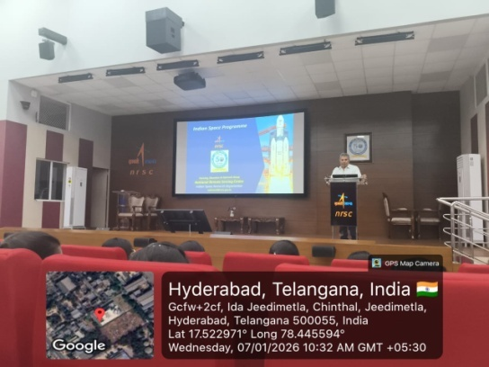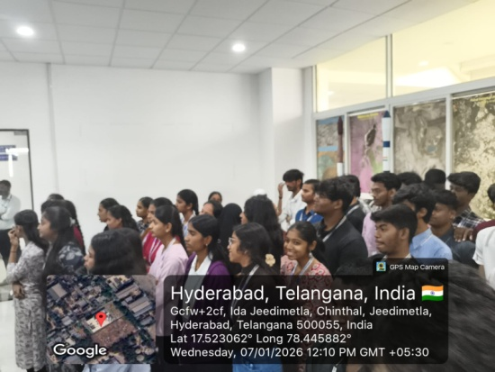

RECOMMENDATIONS:
- Future Improvements: Include more interactive sessions and hands-on activities. Recommended Topics for Future Events: Cloud security, threat analysis, and incident response.
- Potential for Resource of the Event: Yes, recommended for future batches. CONCLUSION:
The industrial visit to NRSC ISRO was a success, providing valuable insights into space technology and applications.

Report on Industrial Visit to t-Hub

1. Event Details
Title of the Event: Industrial Visit to T-Hub, Hyderabad
Organized by: Department of B.Sc Computer Science and Cyber Security, Loyola Academy
Participants: II Year and III Year Cyber Security Students
Venue: T-Hub, Hyderabad
Date: 26th February, 2026

2. Objectives of the Visit
- To provide industry exposure to students in the field of Cyber Security.
- To understand real-time cybersecurity applications in startups and enterprises.
- To bridge the gap between academic curriculum and industry requirements.
- To encourage innovation and entrepreneurial thinking among students.

3. Participant Details
Total Participants: 51
Attendance Percentage: 100%
Accompanying Faculty:
- Ms. S.Lakshmi HoD, Department of Cyber Security
- Ms. Manisha, Assistant Professor

4. Content Evaluation & Seminar Atmosphere
The sessions conducted at T-Hub were highly informative and aligned with current industry trends such as AI-driven cybersecurity, cloud security, and startup innovation models.
The seminar atmosphere was professional, innovative, and technology-oriented. The modern infrastructure, collaborative workspaces, and incubation centers provided students with exposure to a dynamic startup ecosystem.

5. Learning Outcomes
- Enhanced understanding of real-time cyber threat management.
- Awareness of industry tools and cybersecurity frameworks.
- Exposure to startup culture and entrepreneurship opportunities.
- Improved analytical and risk assessment skills.

6. Feedback Analysis
Method of Feedback Collection: Online Google Form
Overall Rating: 4.8/5
Students appreciated the interactive sessions and real-world exposure. Suggestions included conducting more hands-on workshops and extended interaction sessions.

7. Impact on Curriculum & NAAC Relevance
The industrial visit significantly contributed to experiential learning, industry-academia interaction, and skill enhancement aligned with NAAC quality indicators.
Faculty members plan to integrate case studies, industry practices, and startup-based learning modules into the existing curriculum.

8. Conclusion
The Industrial Visit to T-Hub, Hyderabad was successful in achieving its objectives. It strengthened students’ practical knowledge, enhanced industry readiness, and supported institutional quality initiatives under NAAC guidelines.

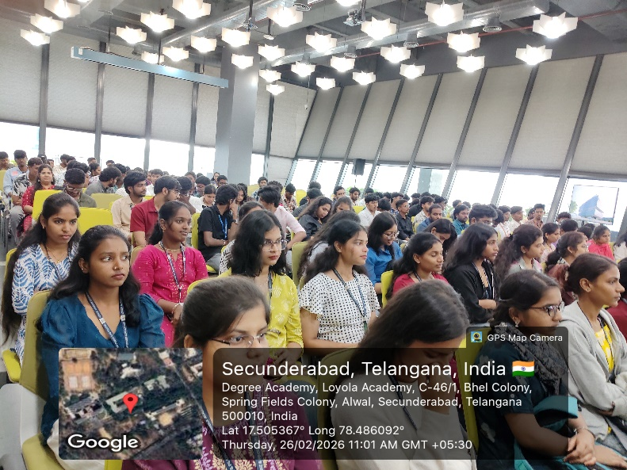

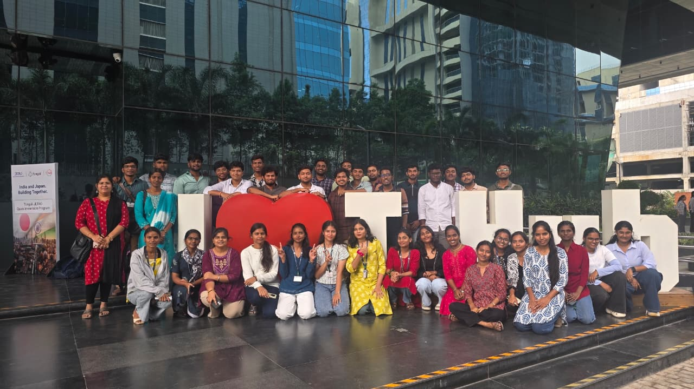

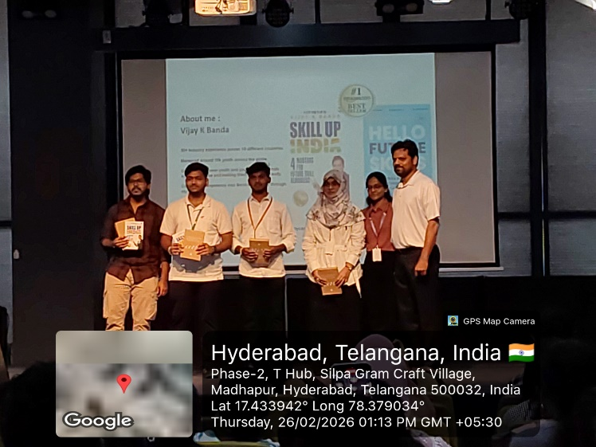

20. Students List:

ACSCS
UID | Name | Email-Id | Contact Number
111725039001 | A.Pallavi | pallaviadhimulam.2007@gmail.com | 9573017123
111725039002 | A.dakshayani | dakshayani3038@gmail.com | 6304332679
111725039003 | A.Joyce Crystal | joycecrystal127@gmail.com | 8247095021
111725039004 | A sri vidya harshini | ambilsrividayharshini@gmail.com | 7013621930
111725039005 | D.Hansika | hansikadintakurthy@gmail.com | 6300811868
111725039006 | E. Rishitha | sunithaendrakanti123@gmail.com | 7989615577
111725039007 | G.Sai sahasra | sahasrasathish2008@gmail.com | 9390295356
111725039008 | I.Madhuri | isakavarapumadhuri655@gmail.com | 9392112901
111725039009 | K. Bhavika | bhavikakasapuram@gmail.com | 7036742351
111725039010 | K.Meghana | meghanakuncharapu@gmail.com | 9392772061
111725039011 | M.ankitha | mullahuriankitha@gmail.com | 9441714779
111725039012 | P. Sharanya | pabbasharanya1610@gmail.com | 9381816494
111725039013 | P.Sravanthi | sravanthi171 | 8247749869
111725039014 | P.Ruchika Reddy | reddyruchikareddy@gmail.com | 6304850025
111725039015 | p jaya Durga | ammujaya1802@gmail.com | 9573547985
111725039016 | p.supriya | goudsupriya0@gmail.com | 9381816494
111725039017 | Shareen johnson | johnsonshareen006@gamik | 7075524226
111725039018 | Tanveer fatima | tanveerfatima3101@gmail.com | 9058125812
111725039019 | T.Akshitha | thummaakshitha42@gmail.com | 9849669458
111725039020 | T.J. Deborah Jacin | jacindeborah0614@gmail.com | 9966081656
111725039021 | T.Nethanya sippora | sipporanethanya@gmail.com | 6304197237
111725039022 | Y .Veena madhuri | veenam298@gmail.com | 9052108591
111725039023 | A.Durgaprasadgoud | angadipetadurgaprasadgoud@gmail.com | 9502924748
111725039024 | Anuka Sachin | anukasachin@gmail.com | 9100978343
111725039025 | Bamdev dhami | bamdevdhami798@gmail.com | 8801509441
111725039026 | c.niraj | chinnalinguniraj@gmail.com | 7993663823
111725039027 | C.Sai Siddharth | chivagarisiddharth@gmail.com | 6302961316
111725039028 | Deva SaiDeekshith Reddy | Saideekshith6699@gmail.com | 9558440000
111725039029 | E LOKESH RAJU | elokeshraju4@gmail.com | 9000261072
111725039030 | G Anilgoud | anilgoudgottimukula@gmail.com | 6302049752
111725039031 | G.Om Sai Varshith | varshiths455@gmail.com | 9154785369
111725039032 | J.Ravi Teja | j.raviteja6600@gmail.com | 9949077670
111725039033 | K Sai Ganesh | skyworrier777@gmail.com | 7794815095
111725039034 | K.Akhil Prabhas | kasireddyakhil1320@gmail.com | 7680999488
111725039035 | K.Yesu padham | kundanpallyyesupadham@gmail.com | 8688130512
111725039036 | M.Raghunandhan Sudharshan | ragsnandhu@gmail.com | 9030952826
111725039037 | Aaron Xavier | Mcaaronx@gmail.com | 9110564918
111725039038 | MENTA GARUISH | mentagaurish@gmail.com | 9652057166
111725039039 | Mohammed Fawaz Khan | mohdfawaz927@gmail.com | 9100593067
111725039040 | M. Sai pavan | mudapallisaipavan@gmail.com | 7013848039
111725039041 | M Vineeth | vineethmurala@gmail.com | 9100149736
111725039042 | Nicholas Jude | 9cnicholasjude@gmail.com | 9963421693
111725039043 | p . Goutham | pakkigowtham410@gmail.com | 8885352925
111725039044 | P.Bala Puneeth Sujay | balapuneethsujay27@gmail.com | 7013137010
111725039045 | R. Aravind | reshamaravind81@gmail.com | 8522033270
111725039046 | T.Balaji | talagamabalaji544@gmail.com | 8247099220
111725039047 | Ratnam Philip | booooyaahh17@gmail.com | 9063774766
111725039048 | T Sai ved | saivedthakur@gmail.com | 9154187383
111725039049 | T.Sriram | tulasriram32@gmail.com | 7032606514
111725039050 | V.Pawan Kumar | pawankumarc662007@gmail.com | 9246163869

Total Strength:50
Girls:22
Boys:28

NCSCS
Uid | Name | Contact number | Username
111723039032 | Manchippa sai sathwik | 9550905538 | saisathwik26@gmail.com
111724039001 | ARDHI PRAVALIKA | 9937974864 | pravalikaardhi@gmail.com
111724039002 | B.Nagamalleswari | 9392283784 | nagamalleshwarib9@gmail.com
111724039003 | B.shruthi | 9059488948 | bandashruthi6@gmail.com
111724039004 | Dandotkar Sanjana | 7075531499 | dandotkarsanjana@gmail.com
111724039005 | D.Bhargavi | 7995589576 | bhargavid745@gmail.com
111724039006 | G.Ramya mary | 9515582375 | guggilamramyamary3@gmail.com
111724039007 | Gujja Akhila | 6300991458 | akhilagujja87@gmail.com
111724039008 | harsha vardhini | 9063507375 | harshainala15@gmail.com
111724039009 | Janga Swethika | 9989075588 | jangaswethika@gmail.com
111724039010 | K.sravanajyothi | 9704625479 | sravanajyothikondaveeti@gmail.com
111724039011 | Ashritha | 9063684760 | ashrithakoppula43@gmail.com
111724039012 | K.sri sai vedha | 7386117239 | vedhakorivi25@gmail.com
111724039013 | K.Teja Reddy | 9381196757 | ktejareddy275@gmail.com
111724039014 | Marmamala Sreenidhi | 9346003094 | sreenidhishetty2007@gmail.com
111724039015 | P.Tejaswini | 7075084227 | pimpdaetejaswini@gmail.coml
111724039016 | Pooja pal | 9652037674 | poojapalcrpf12345@gmail.com
111724039017 | R.Harshini | 7670819416 | harshini2k6ryali@gmail.com
111724039018 | S.Varshini | 8639591110 | varshinigoud18@gmail.com
111724039019 | Thanniru namitha sree | 9398307153 | thannirunamithasree@gmail.com
111724039020 | Upputuri Venkata Lakshmi Sahiti | 7671089698 | upputurilakshmisahiti@gmail.com
111724039021 | Yagna Gurureddy | 8125172444 | yagnagurureddy.dai@gmail.com
111724039022 | Arshad Ali | 8271873872 | aa8268559@gmail.com
111724039023 | Saisampath | 9398651388 | bhallasaisampath4261@gmail.com
111724039024 | BYVS. Pavan Kumar | 9494761846 | byvspavankumar@gmail.com
111724039025 | D.Naga chaitanya | 6300075756 | dasarinagachaitanya@gmail.com
111724039026 | DAYA SHANKAR | 76750 77564 | dayasinghrajput96@gmail.com
111724039027 | Dubbaka Srinivas | 9059911540 | dubbakasrinivas2006@gmail.com
111724039028 | J.Jaganmohan Reddy | 9133070159 | jaganmohanreddy4229@gmail.com
111724039029 | kairamkonda Jayanth | 9603249432 | kairamkondajayanth10@gmail.com
111724039030 | K.Prashanth | 7075286555 | kambhamprashanth3@gmail.com
111724039031 | John Adarsh | 9492437960 | johnadarshkancherla@gmail.com
111724039032 | Sharath Chandra Karnati | 9700198981 | karnati.sharath619@gmail.com
111724039033 | M Chethan Yadav | 7801033194 | chethanyadav456@gmail.com
111724039034 | MP Dheeraj Raj | 9000287492 | dheerajraj7218@gmail.com
111724039035 | NASA KOUSHIK | 6303981733 | koushiknasa0@gmail.com
111724039036 | P.PREETHAM CHARY | 8008039154 | preethamchary1432@gmail.com
111724039037 | Yuvaraj | 7386658933 | yuvarajpalaram@gmail.com
111724039038 | Bhavanteja | 9121022839 | pullamcherubhavanteja22@gmail.com
111724039039 | Pavan Kumawat | 9182606570 | pavankumawatt1@gmail.com
111724039040 | P.Manicharan | 7671034085 | pendammanicharan123@gmail.com
111724039041 | Potharaju Abhiram Adithya | 9177374030 | kavithasatyam222@gmail.com
111724039042 | Pretam | 9704177570 | berapretam@gmail.com
111724039043 | Rohit Sahni | 9398892813 | rohittinbox@gmail.com
111724039044 | R Vikramaditya Wence | 8074301351 | wencevikram3536@gmail.com
111724039045 | Hemanth reddy | 7032349528 | hemahemanth863@gmail.com
111724039046 | S. Chaitanya | 6301123500 | chaitanyasurapaneni06@gmail.com
111724039047 | Voosavivek | 8977427160 | voosavivek16@gmail.com
111724039048 | Satya Srihari Y | 971410184 | satyasrihariy@gmail.com
111724039049 | Nandi Praveen | 8790400303 | nandip854@gmail.com
111724039050 | A Abivardhana Reddy | 9392712277 | annapureddy.ramireddy65@gmail.com

Total strength:51
Boys:30
Girls:21

DCSCS:

UID | Name | Contact No | Email Id
111723039001 | Sowmya | 7569550527 | sowmyaanevoina@gmail.com
111723039002 | YAMINISRI | 7207053545 | nehayamini1828@gmail.com
111723039003 | Bhavya Unni | 6301341642 | bhavyaunni1212@gmail.com
111723039004 | Biyyani Rishikasri | 9347590485 | applerishika865@gmail.com
111723039005 | Chekelea Alice Saloni | 9182662678 | alicesalonichekelea@gmail.com
111723039006 | D. Jhansi | 7013408302 | dhayyajhansi@gmail.com
111723039007 | Gidigam Akshitha | 7981275245 | akshithagidigam@gmail.com
111723039008 | Kore Mounika | 8143963441 | mounikakore5106@gmail.com
111723039009 | L. Rajarani | 8309228154 | Rajarani.lakshmi17@gmail.com
111723039010 | MD. Raziya Banu | 111723039010 | reachoutraziya@gmail.com
111723039011 | Neerati Manasa | 6281145211 | neeratimanasareddy@gmail.com
111723039012 | Sudhiksha Goud | 8520830728 | sudhikshagoud33r@gmail.com
111723039013 | Shaik rubeena sulthana | 8897327683 | rubinasulthana225@gmail.com
111723039014 | S Lasya Reddy | 7330951024 | slasyareddy.11@gmail.com
111723039016 | Taj fatima | 8341103799 | 10556.tajfatima@gmail.com
111723039017 | Abraham A Wallace | 9908824342 | abraham.a.wallace03@gmail.com
111723039018 | Aditya kishore singh | 8919749292 | adityakishoresinghrajput@gmail.com
111723039019 | Aryan Gupta | 7702394693 | aryanramangupta@gmail.com
111723039020 | BATTHULA VAMSHI | 9908761850 | vamshibatthula9@gmail.com
111723039021 | B.K.RISHIKESH REDDY | 9493403085 | rishikeshreddy187@gmail.com
111723039022 | Siril Anush | 7995447333 | sirilanush13@gmail.com
111723039023 | Clemence Kerron | 8496958282 | Clemencekerron@gmail.com
111723039024 | D DURGA PRASAD | 7780348791 | durgaprasadak.69@gmail.com
111723039025 | Gabbula Sai Teja | 9849545988 | saitejagabbula@gmail.com
111723039026 | G Paul Thomas | 9000987733 | paulthomas@gmail.com
111723039027 | Hamad Saleh Mahfooz | 9515943921 | hamadsm21@gmail.com
111723039028 | J sathish | 9959397835 | j.sathishvarma7@gmail.com
111723039030 | K Varun Raju | 7093772474 | varunraju@gmaul.com
111723039031 | Kurma sampath | 9908643029 | Sampath11172@gmail.com
111723039033 | Manoj kumar | 9182385636 | mandhamanoj2004@gmail.com
111723039034 | Yaswanth | 7780196969 | Yashwanthm22@gmail.com
111723039035 | Manikanta Reddy Anugula | 9988588523 | anugulamanikantareddy23@gmail.com
111723039037 | M sampath | 9603323419 | sm6112125@gmail.com
111723039038 | K Muzzamil kopal | 7207866924 | muzamil@gmail.com
111723039039 | NALLA MANIKANTA | 7893167417 | manikantapatel111@gmail.com
111723039040 | P Varshith | 8688157167 | pasalavarshith@gmail.com
111723039041 | Philip Paul James | 7075594186 | phillippauljames@gmail.com
111723039042 | P MANIKANTA | 9133291469 | p7207393@gmail.com
111723039043 | P S SHIVA KUMAR | 7013412271 | shivalamalone56789@gmail.com
111723039044 | rohith kumar singh | 7799888586 | rohithkumarsingh05@gmail.com
111723039045 | R saikishor | 7794917606 | kishorsai925@gmail.com
111723039046 | S John Vijay | 9573383076 | johnvijju@gmail.com
111723039047 | Raju Tirumani Kumar | 7995179825 | rtk.388@gmail.com
111723039048 | Vaddemani Jason | 7702889296 | jasonjeric17@gmail.com
111723039049 | Srujan Vempati | 9032395048 | srujan8575@gmail.com
111723039050 | Yadagani bhanu preetham | 6304977490 | preethamvanjari1001@gmail.com

Total Strength:46
Girls:15
Boys:31

21.Best practices of the Department:

1. Event Details
- Title of the Event: Best Practices of Cyber Security
- Date: 18th July 2025
- Venue: ZPHS, Kompally
- Organizer/Coordinator: B.Sc. Computer Science & Cyber Security department , Loyola Academy
- Speakers: A. Sowmya, Lasya, Alice saloni, L. Rajarani, Rishikesh, Srujan, Paul Thomas, Sai teja.
- Target Audience: Kids who are new to technology and vulnerable young users.

2. Objectives of the Event
- To spread awareness about cyber safety practices
- Educate kids about online safety and digital citizenship
- Recognize online risks (cyberbullying, phishing, malware)
- Develop safe online habits (strong passwords, safe browsing)
- Promote digital literacy and critical thinking
- Empower kids to protect themselves and report incidents

3. Participant Details
- Total Participants: 140
- Demographics: Students(between 12yrs-16yrs)

4. Content Evaluation
- Relevance of the Topic: Highly Relevant ( given the growing need for cyber safety awareness)
- Depth of Knowledge: Basic (Topics covered include the fundamentals of cybersecurity for online protection.)
- Participant Engagement: Highly engaged (participants showed interest, asked questions, and actively participated in practical activities.)

5. Learning Outcomes
- Were the Learning Outcomes Met?: Yes
- Key Takeaways for Participants:
1. Reflection on the significance of digital security.
2. Understanding password management and the implications of social media exposure.
3. Insights into the necessity of safeguarding personal information for cyber security.
- Skills/Knowledge Gained: Improved understanding of cyber safety practices and how to apply them

6. Feedback Analysis
- Method of Feedback Collection: verbal offline feedback.
- Key Feedback from Participants:
- Positives: Interesting and different from the regular class
- Areas of Improvement: Improved strategies for crowd management.
- Rating on a scale of 1-5:
- Content Quality: 4.8/5
- Speaker Effectiveness: 4.9/5
- Presentation Style: 4.7/5

7. Impact on Curriculum or Future Practices
- Impact on Student Learning: Increased awareness of cyber safety practices and their importance

8. Recommendations
- Future Improvements: incorporate more practical content
- Recommended Topics for Future Events: Digital footprint and Cybersecurity in artificial intelligence
- Potential for Recurrence of the Event: Yes, similar events can be organized in the future to continue spreading cyber safety awareness

9. Conclusion
The "Best Practices of Cyber Security" event was successful in achieving its objectives, providing participants with valuable knowledge and insights into cyber safety practices. The event demonstrated the department's commitment to serving the cyber security needs of society while upholding human values.

Attachments:
