CLUB REPORT
2023-2024

CLUB REPORT
2023-2024
MONTHLY EVENT DOCUMENT
CLUB REPORT
Sl.  No | Month & Date | Title of the Event | Report | Budget | Submitted to
 |  |  |  |  | Department | Dean | IQAC
1 | 3rd July- 10th October’2023  &  8th January- 2nd April 2024 | Club 2023-24 | Club report | - |  |  | Yes

Name of the event: Club 2023-24
Date: 3rd July- 10th October’2023 &
8th January- 2nd April 2024

Number of Students participated:
Odd Sem 750 students (UG-school of life sciences, informatics and agriculture)
Even Sem 1030 students (UG- school of commerce, management and arts)
Number of faculty participated: 26 faculty members
Marks: 25
Term: 1st and 2nd Semester (2023-24)

CLUBS (2023-2024)

Clubs play a vital role in college life, offering students a unique opportunity to explore their interests, make new friends, and develop valuable skills outside the classroom. College clubs are essentially student-led learning modules that cater to a wide range of hobbies, passions, and activities. Here's an introduction to clubs at Loyola Academy:

- Diverse Interests: College clubs are incredibly diverse and cover a wide spectrum of interests. From academic and professional clubs related to specific majors or career goals to recreational and hobby-based clubs, there's likely a club for everyone. Whether you're into arts and culture, sports, technology, volunteering, or almost anything else, you can find a club that aligns with your interests.

- Student-Led: Clubs are run by a lecturer in charge along with students’ active participation, with members taking on various leadership roles. This allows students to gain valuable leadership, organizational, and teamwork skills. It also provides a sense of ownership and responsibility, as members are responsible for the club's success and activities.

- Social and Networking Opportunities: Joining a club is an excellent way to meet like-minded individuals who share your interests. It can help you forge new friendships and build a supportive social network. Additionally, club events and activities often provide opportunities for networking and making connections that can be valuable in your future career.

- Skill Development: Many college clubs focus on specific skills or areas of expertise, giving members the chance to develop and hone their talents. Whether it's public speaking, event planning, coding, or creative writing, clubs often offer workshops, training, and hands-on experiences to help you grow and learn.

- Community Engagement: Several clubs engage in community service or advocacy work. These clubs provide an avenue for students to give back to their communities, promote social causes, and make a positive impact on society.

- Personal Growth: College clubs can be a place for personal growth and self-discovery. They challenge you to step out of your comfort zone, take on leadership roles, and develop qualities such as communication, time management, and teamwork.

- Balance and Well-Being: Participating in clubs can help students strike a healthy balance between academic and extracurricular activities. It's essential to manage your time effectively, but being involved in a club can contribute to your overall well-being and help reduce stress.

- Resume Enhancement: Involvement in clubs can be a valuable addition to your resume. It showcases your commitment, leadership, and the skills you've acquired, which can be attractive to future employers or graduate programs.

- Access to Resources: Many college clubs receive funding, resources, and support from the university or student government. This can enable them to organize events, bring in guest speakers, or undertake projects that may not be possible on an individual basis.

- Fun and Enjoyment: Ultimately, college clubs are a source of fun and enjoyment. They allow you to pursue your passions, explore new interests, and create lasting memories with fellow students.

VISION
The vision of our club is clear and inspiring: we aim to cultivate excellence by helping each member uncover and nurture their unique talents. Our goal is to empower everyone to achieve their fullest potential, fostering an environment where growth and success are within everyone’s reach. We’re committed to supporting you on this exciting journey of personal and collective achievement.

MISSION
The mission of our club is to promote skill-based learning and foster a deep understanding of social responsibilities. We are committed to honing your inner talents, enabling you to lead a purposeful and impactful life. Through our activities and programs, we aim to enrich your skills and broaden your perspective, preparing you to make meaningful contributions to society.

ABOUT
The club sessions for the academic year 2021-2022 placed special emphasis on providing students with engaging and enriching experiences. These sessions were conducted both online and offline on the 6th, 7th, 8th, 10th, 11th, 12th, and 13th of January 2022, ensuring a structured yet flexible schedule. This arrangement allowed participants to engage seamlessly, irrespective of the day order. With a total of 20 hours of interactive sessions, the initiative fostered meaningful participation and active learning throughout the program.
Mandatory attendance for club activities significantly enriched the overall club experience by ensuring active participation from all members. Attendance records were meticulously managed and seamlessly integrated into the college's Enterprise Resource Planning (ERP) system, promoting transparency, accountability, and efficient tracking.
To Qualify for the club involvement a student must surpass at least a minimum of 12 marks and a maximum of 25 marks. These marks were allocated to the students based on their overall performance within the club, performance in the examinations, assignments and other relevant activities.

CLUBS ORIENTATION

Date:
Venue: Inigo Hall
Time: 3:00pm to 4:15pm
Objective: To introduce students to the clubs, clubs in charges and heads

Report:
Loyola Academy conducted Clubs’ Orientation for first-year students on 12th and 13th December 2023. The orientation was addressed by Rev. Fr. Dr. L. Joji Reddy (Principal), Rev. Fr. Arul Jyothi (Vice Principal, UG), Mrs. Saras Chandra (Dean of Student Affairs), Staff Club Coordinators, Student Club Heads, and Student Club Coordinators.
On 12th December, an orientation session was conducted for first-year students of the School of Commerce, Arts, and BBA, with around 700 students in attendance. Staff Club Coordinators explained the significance of clubs and how club sessions differ from regular classes. Student Club Heads provided an overview of each club, offering students clarity on club activities.
On 13th December, a similar orientation was held for students of the School of Life Sciences, Informatics, and Agriculture, along with BBA Retail Operations Management students. Club registrations took place on 19th and 20th December through Google Forms. Approximately 1,600 students from all departments registered, and club allocation was done to ensure equal opportunities, with each club accommodating 110 students. The overall club activities for the academic year were conducted in two phases: from 3rd July to 10th October 2023 and from 8th January to 2nd April 2024. A total of 750 students from the UG School of Life Sciences, Informatics, and Agriculture participated in the odd semester, while 1,030 students from the UG School of Commerce, Management, and Arts participated in the even semester.

There are various clubs in our curriculum. They include
- Drama club
- Music Club
- Finance Club
- Idea Club
- IPR Club
- Photography Club
- Fashion Club
- Rj & Vj Club
- Debate Club
- Magic youth & AICUF Club
- Yoga Club
- Tourism Club
- Green Club
- Art Club
- Knowledge Club
- Vlogging and blogging Club
- Dance Club
- Literature and book Club

CULTURAL
CLUBS

REPORT OF DRAMA CLUB

Syllabus for Drama Clubs:
UNIT 1
Theatre arts

UNIT 2
Acting and Basics of Acting

UNIT 3
Mime

UNIT 4
Navarasa - Shringara, Hasya, Karuna, Roudra, Veera, Bhayanaka, Bibhatsa, Adbhutha, Shantha
Over the past semester, Drama Club actively engaged in a variety of activities:
- Dumb Charades: We organized fun and challenging games of dumb charades to improve non-verbal communication skills and encourage quick thinking.
- Spot Enaction: Members participated in spot enaction exercises, testing their improvisation and acting abilities by spontaneously enacting given scenarios.
- Navarasas: We delved into the world of Navarasas, exploring the nine fundamental emotions in classical Indian drama, which deepened our understanding of emotional expression.
- Improvisation Exercises: Regular sessions of improvisation exercises helped members think on their feet, enhance their creativity, and build confidence in their acting skills.
The Drama Club has been a source of personal growth and enjoyment for its members. Through their participation, students have:
- Enhanced their acting and communication skills.
- Developed a deeper appreciation for the dramatic arts, especially Shakespearean works.
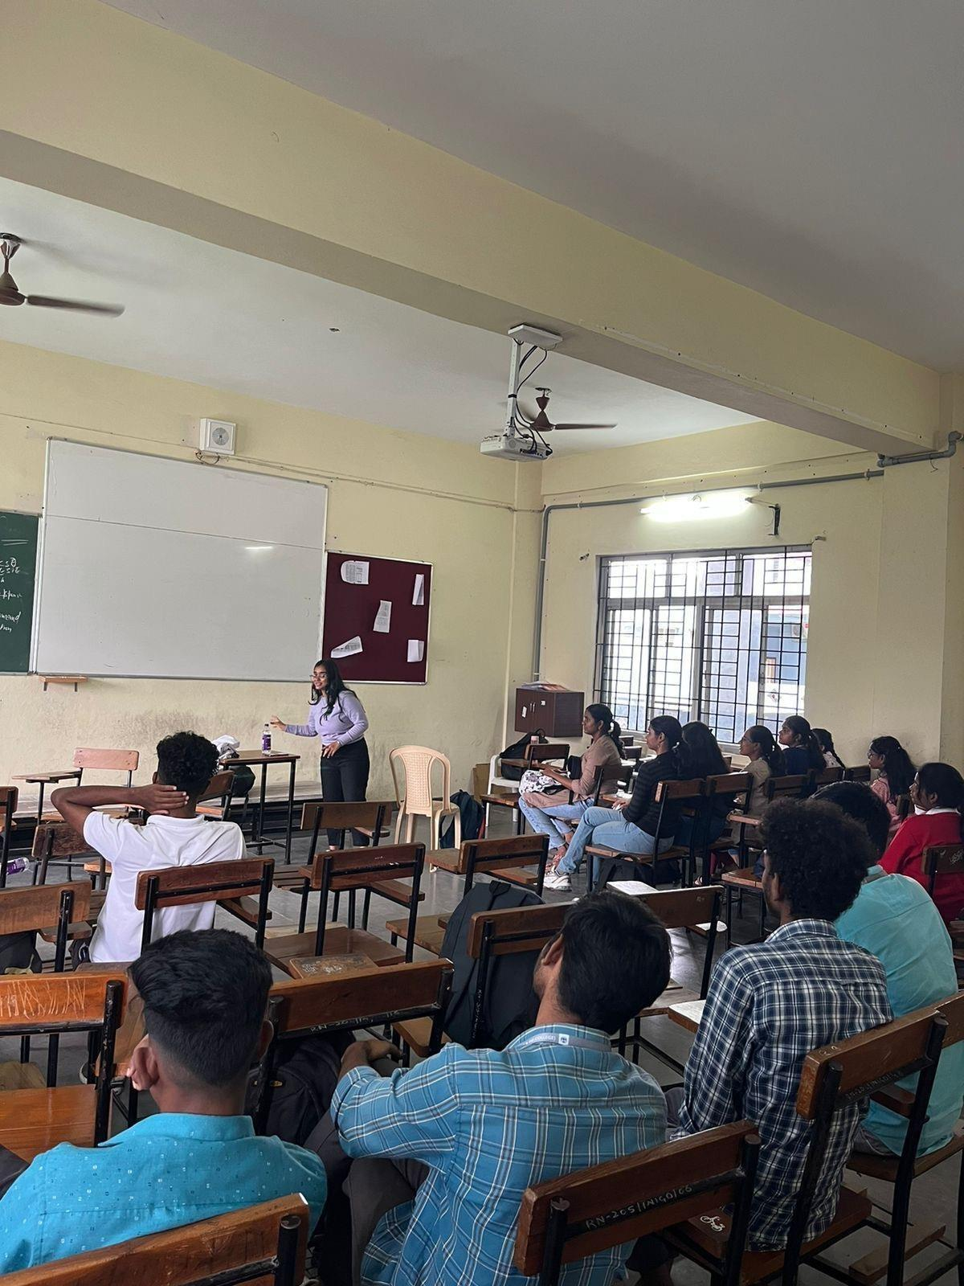
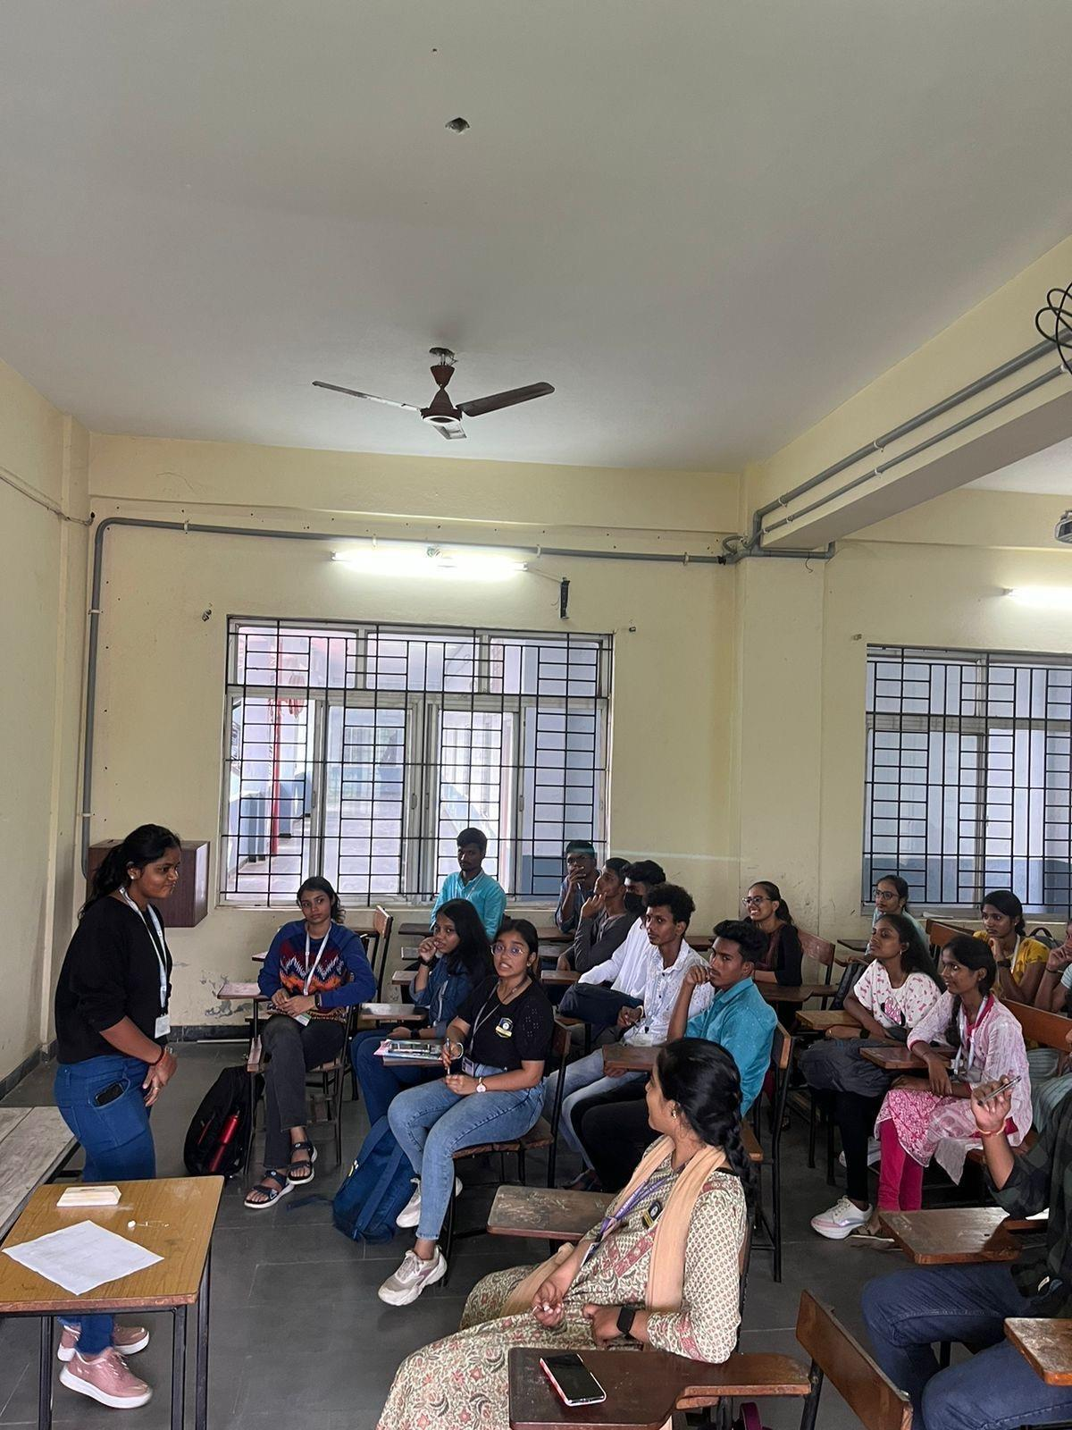
- Built camaraderie and a strong sense of teamwork within the club.

REPORT OF MUSIC CLUB
SYLLABUS

UNIT 1
Guessing an instrument by its sound

UNIT 2
Basics of music

UNIT 3
Elements of song

UNIT 4
Stages of song making

REPORT OF MUSIC CLUB
Instrumental Workshops: Members engaged in workshops tailored to enhance their proficiency in various musical instruments, providing them with valuable skills and techniques.
Vocal Training: Vocal training sessions were meticulously crafted to refine members' singing abilities and cultivate their unique vocal styles.
Band Performances: The club orchestrated electrifying band performances, fostering collaboration and camaraderie among members while honing their stage presence and ensemble skills.
Open Mic Sessions: Open mic sessions provided a platform for members to shine individually, allowing them to express themselves freely and showcase their talents to an appreciative audience.
Music Appreciation Sessions: Delving deep into the cultural significance of music, these sessions enriched members' understanding and broadened their musical horizons, fostering a deeper connection with the art form.

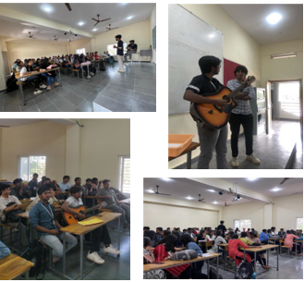

REPORT OF DANCE CLUB

SYLLABUS

UNIT 1
Introduction

UNIT2
Styles of dance

UNIT 3
Choreographing of a song

UNIT 4
Dance battles

- Cyphers
- Mirroring technique
- Balance and core strengthening
- Group interactions
- Choreographies for Hip-hop, Folk and Bollywood routines were taught in the sessions ● Introduced forms like Afro and Semi-classical

Outcome of the club:

The Dance club has encouraged the students to develop and manage their skill in various forms. The foundation laid for them can help the students keep building their interest from the many dance forms that they've engaged in. Apart from this, they've shown active participation, great teamwork and immense attentiveness. Overall, the students have learnt to channel their creativity through dance and foster belief in oneself.

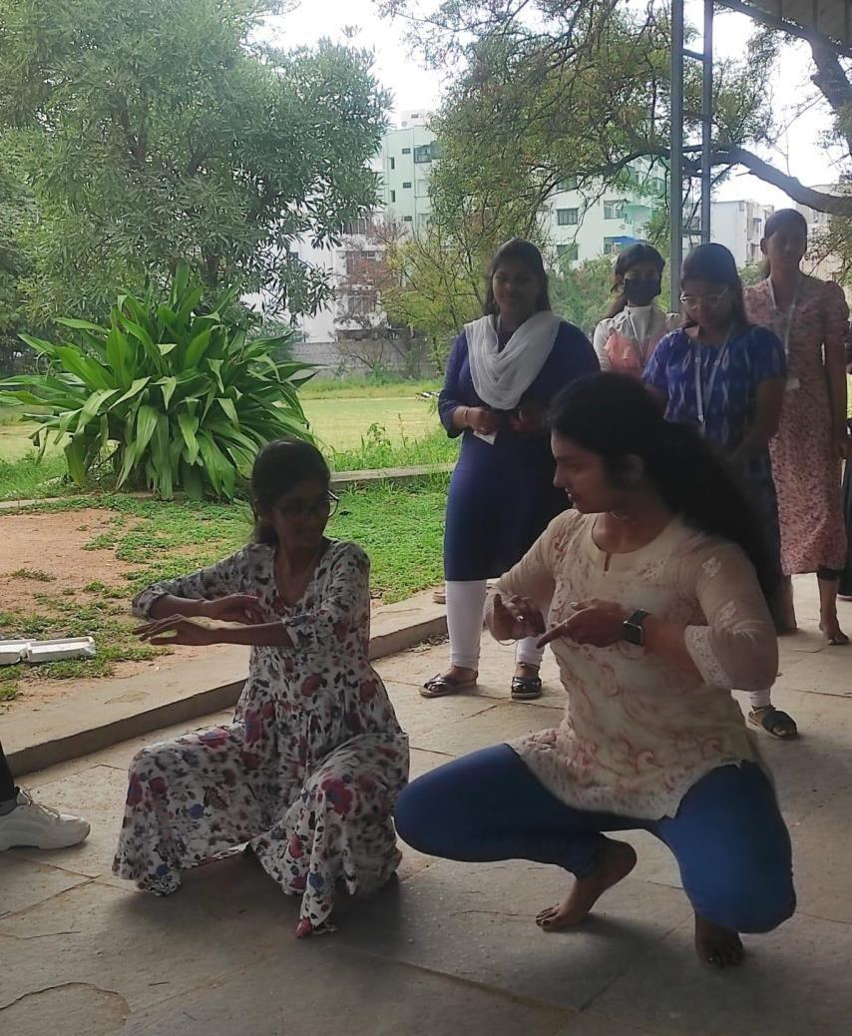
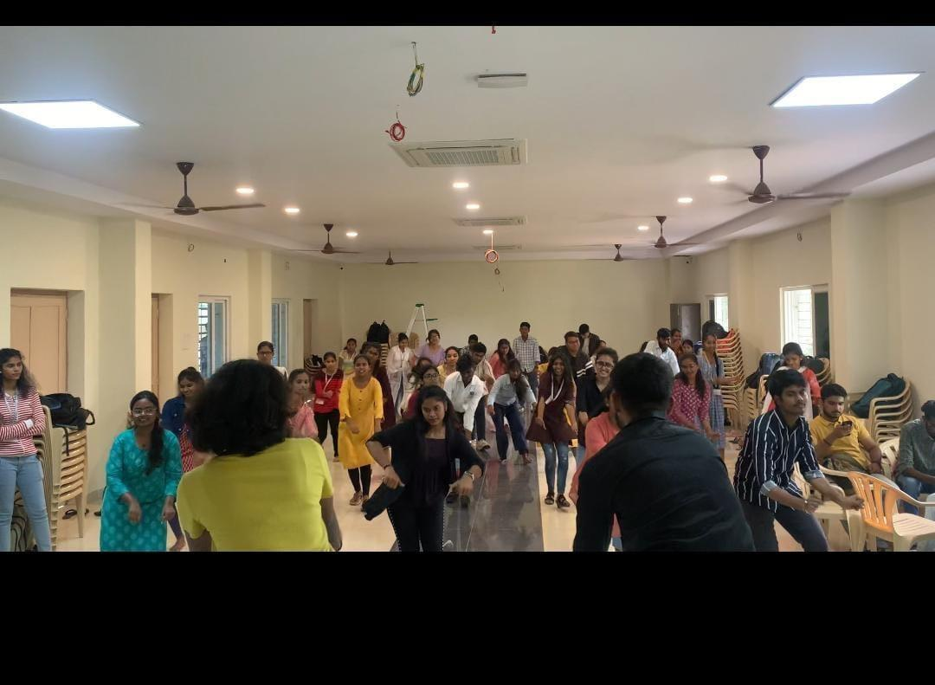

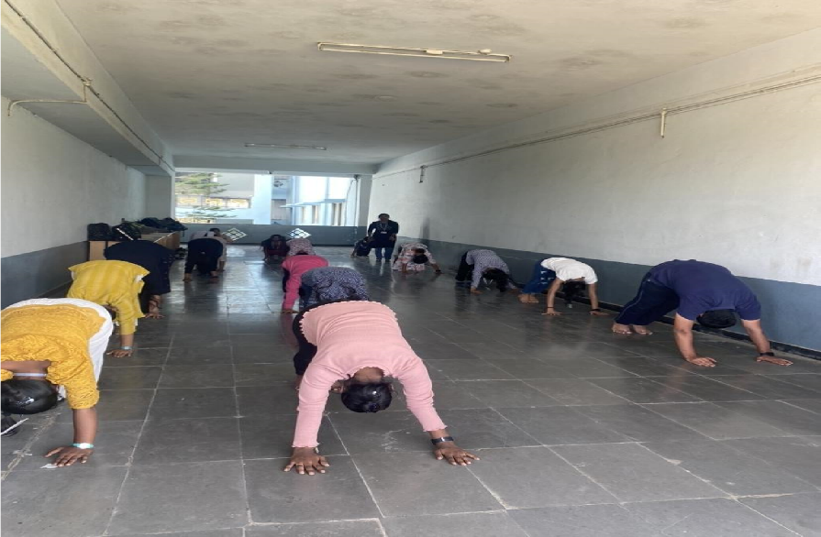

Yoga Club
The members of the club find refuge from life's daily pressures, fostering a state of equilibrium and serenity. Through the yoga club's efforts, a culture of togetherness and encouragement flourishes, enabling individuals to delve into their inner selves and pursue personal growth. This environment serves as a sanctuary where participants can navigate their paths toward self-awareness and enhancement.
Within their study of meditation, the club has explored a profound state where worldly distractions dissolve, leaving behind only a profound sense of existence. In this transcendental experience, all else fades away, leaving only the essence of pure being. It's a state where the traditional boundaries between observer and observed cease to exist, eliminating the urge for the mind to engage with external desires and actions.
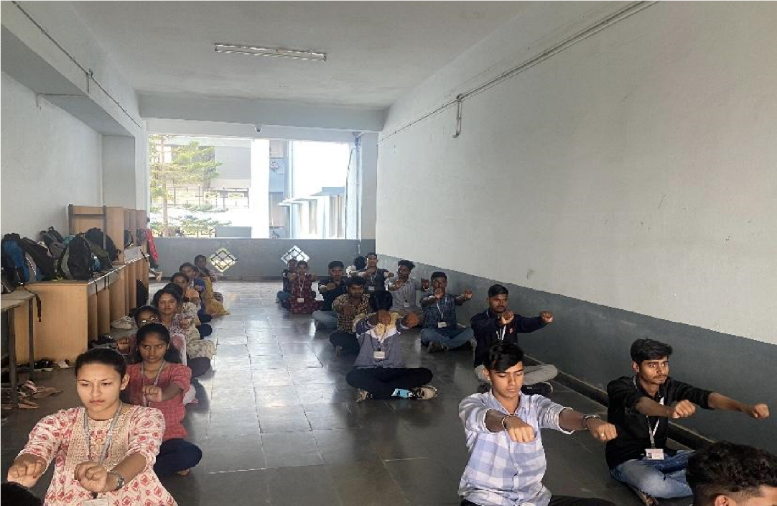
FASHION CLUB
Planned an outline of how to conduct a runway show and gave the insights on how to continue further with the designs and themes of the students. We’ve selected models and taught them how to Walk professionally on a runway show. We gave the students plenty of time to create their designs and to execute production well.Club activity that we’ve planned with corresponding club heads and planned a club activity runway show on 2nd of April 2024 that is Tuesday in 4th, 5th and 6th hours. We’ve set up a Backdrop required for the models and conducted rehearsals. And successfully we’ve conducted the club activity inviting dean of student affairs Mrs. K Saraschandra ma’am and vice principal Arul Jyothi Fr.
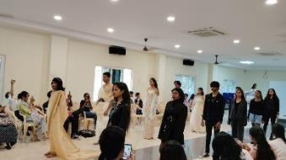
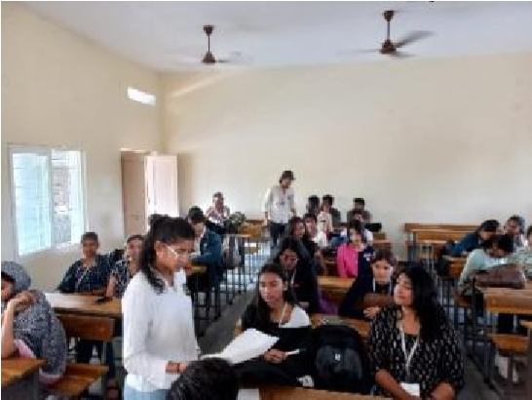

DOMAIN CLUBS

Debate and Elocution Club

SYLLABUS
UNIT1
Introduction to debate
Unit 2
Research skills
UNIT 3
Public speaking
UNIT 4
Mock Debates

The purpose of this debate club programme is to empower undergraduate students with the information and abilities needed for productive discussion. Students will participate in numerous debate formats, develop their research, critical thinking, and public speaking skills, and foster a deeper comprehension of crucial subjects.

Research Skills
- Effective research techniques.
- Evaluating sources.
- Constructing a persuasive argument.

Public Speaking
- Public speaking tips and techniques.
- Practice speeches and feedback.

Mock Debates
- In-class debates.
- Feedback and improvement.

Contemporary Issues
- Debating current events and relevant topics.
- Ethical considerations in debating.
REPORT OF FINANCE CLUB

SYLLABUS

UNIT 1
Basic terminologies

UNIT 2
Concept of finance

UNIT 3
Group Discussions

UNIT 4
Case Studies
Over the past semester, the club actively engaged in a variety of activities:
- Group Discussions: Finance Club conducts group discussions on various finance topics, fostering knowledge exchange and networking among members. It's a dynamic forum for learning and collaboration.
- Case Studies: In the Finance Club, the students analyze real-world financial case studies to apply theoretical knowledge to practical scenarios, enhancing our problem-solving skills and understanding of financial decision-making.
- Stock Analysis: In the Finance Club's stock analysis activity, members analyze and evaluate stocks, applying fundamental and technical analysis to make informed investment decisions and gain practical experience in the world of finance and analyzed the stock prices of a company from the nifty index over a period of 5 years and performed trend analysis.
Membership in the Finance Club has proven to be a transformative experience for its participants. Through their involvement, students have:

- Strengthened their financial acumen, mastering key concepts such as budgeting, investing, and financial planning.
- Gained a profound appreciation for the intricacies of the financial world, including the dynamics of markets, risk management, and economic trends.
- Fostered a spirit of collaboration and teamwork, working together on projects, case studies, and investment simulations
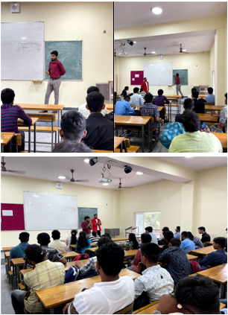

REPORT OF GK CLUB
SYLLABUS

UNIT 1
History

UNIT 2
Climate Change

UNIT 3
Social Media

UNIT 4
Current Affairs
GK Stands for GENERAL KNOWLEDGE
Activities of the Club:

Debates: Members engage in debates on social and political issues to refine critical thinking and communication skills, encouraging understanding of diverse perspectives.

Elocution: Sessions focus on helping students articulate ideas effectively, improving pronunciation, articulation, and overall speaking skills.

Research Training: Students learn to differentiate between reliable and unreliable sources, enhancing their ability to find evidence-based information.

Quizzes: Regular quiz sessions reinforce knowledge, promote active learning, and provide immediate feedback to enhance retention and understanding.

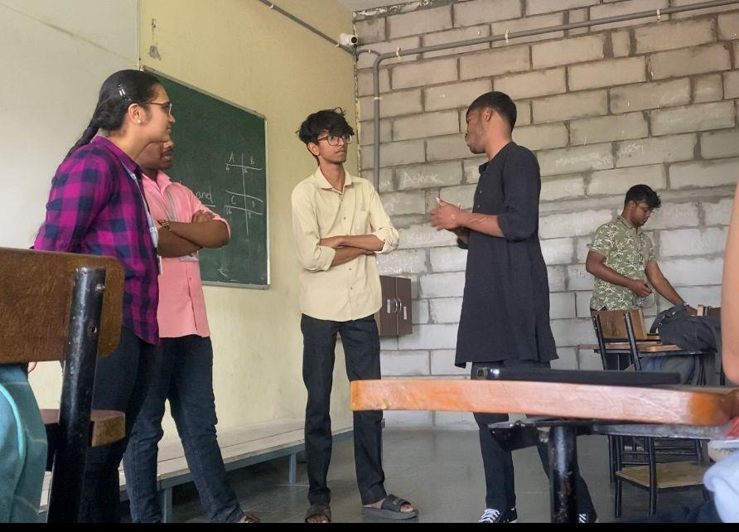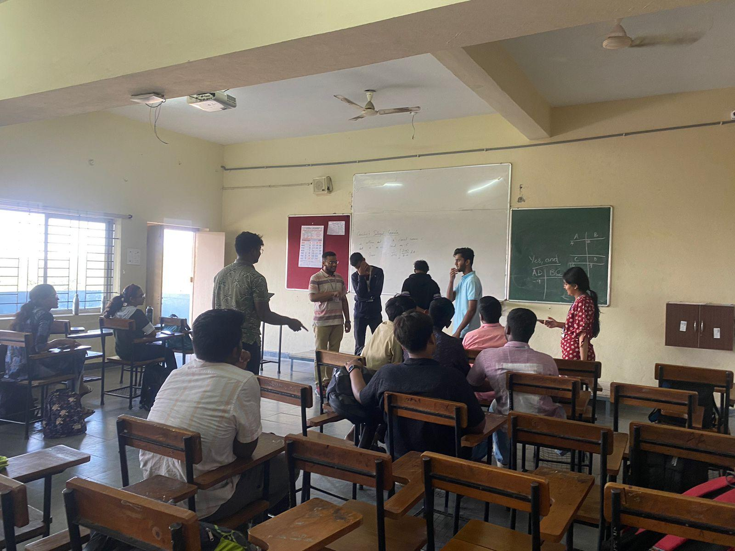

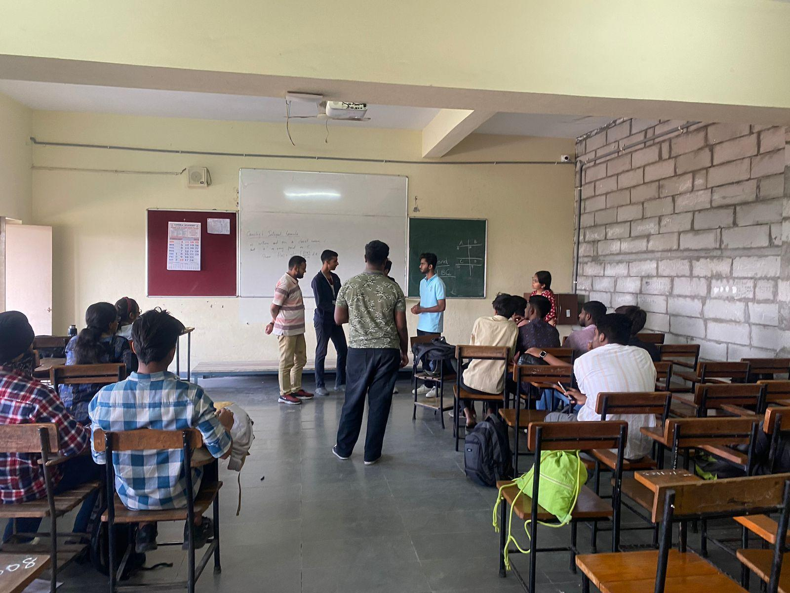

REPORT OF LITERARY & BOOK CLUB

SYLLABUS

UNIT 1
Introduction

UNIT 2
Story Writing

UNIT 3
Making of Bookmarks

UNIT 4
Movie Reviews

Encouraged students to join in fun activities about books and stories. Members could write their own stories and poems, talk about books they liked, choose random books to discuss, and chat about literature and characters. Our club was a friendly place for students who enjoyed reading and talking about stories. We made sure everyone could take part in these exciting literary activities. These activities went beyond just reading books. They inspired us to be creative, think deeply, and share our love for literature.
The outcomes of our Literature and Book Club were truly enriching. Through our activities, we witnessed several positive results:
-Enhanced storytelling capabilities.
-Participants broadened their literary horizons, exploring a wide range of books and genres they might not have encountered otherwise.
-Engaging in group discussions and debates cultivated critical thinking skills, enabling members to analyse books and express their opinions thoughtfully.
-Members developed effective communication skills through lively discussions and thoughtful conversations about literature.
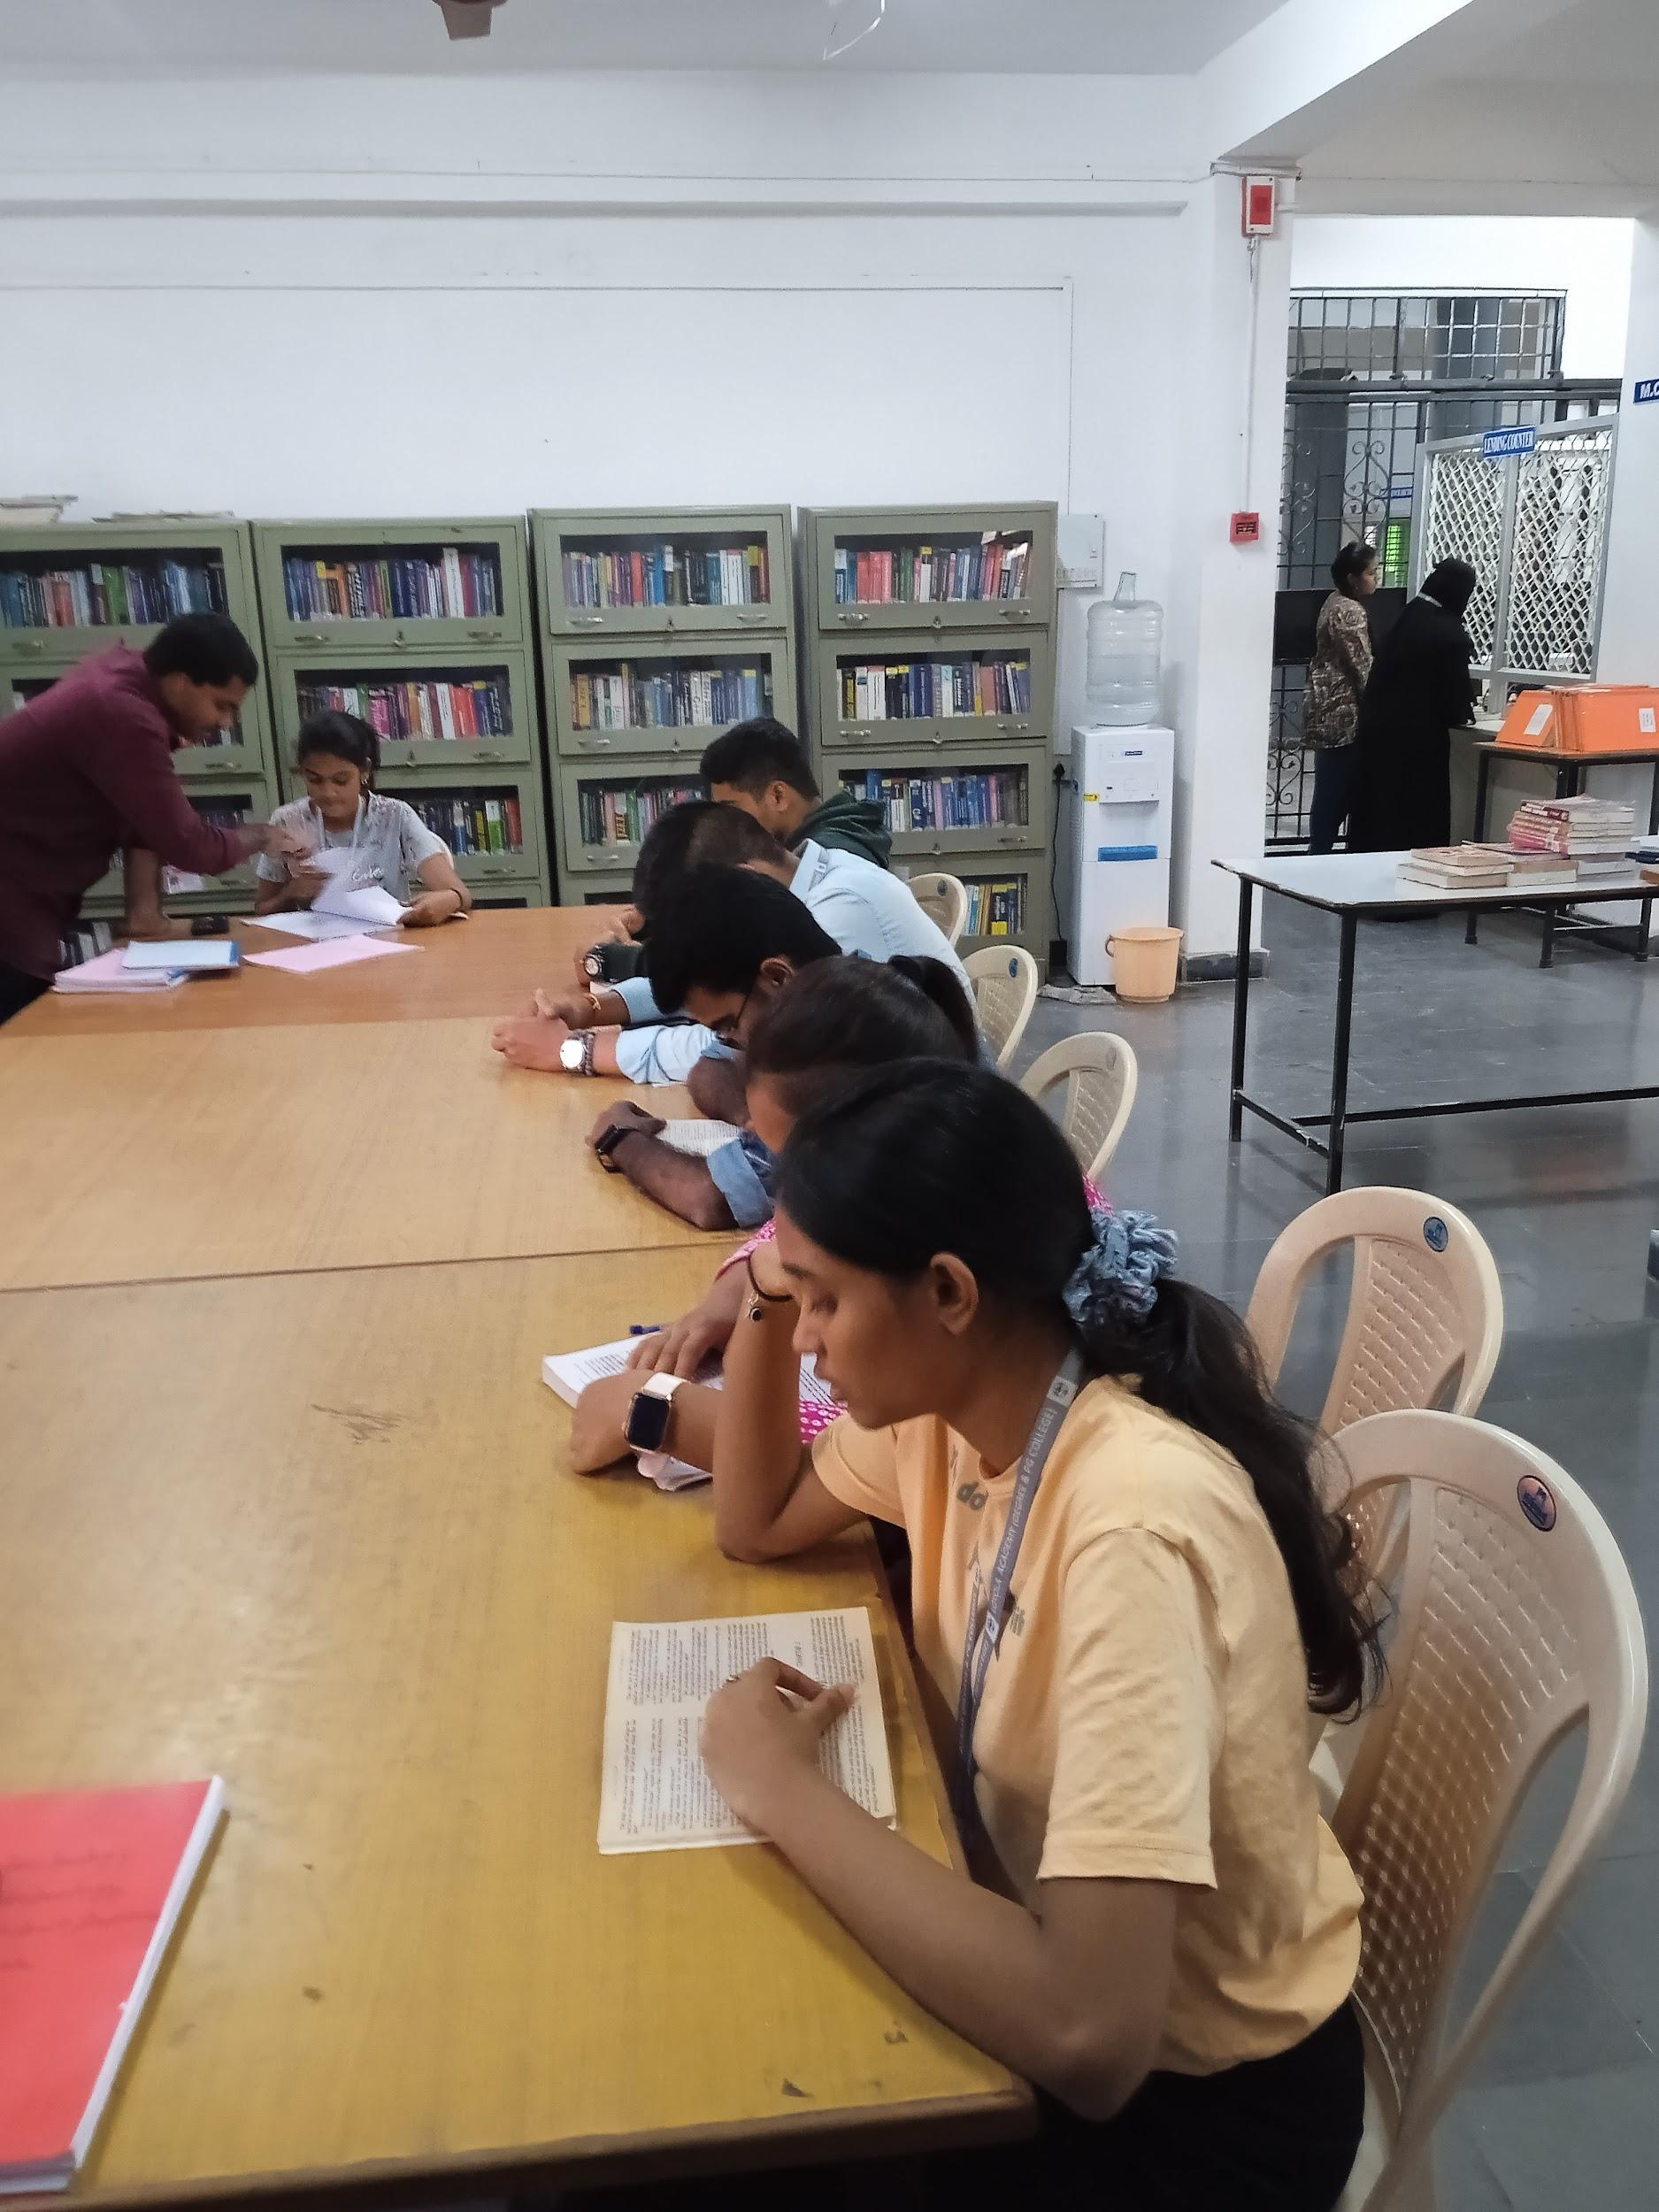

REPORT OF ART CLUB

SYLLABUS

UNIT1
Art and perspective drawing

Unit 2
Sketching and doodling

UNIT 3
Drawing skills of human figures

UNIT 4
Landscape and cityscape drawings

Art Club
Throughout the semester, the Art Club organized a variety of activities to cater to different interests and skill levels:

1. Drawing and Sketching Sessions: Regular sessions were held where students practiced drawing and sketching under the guidance of experienced artists.
2. Painting Workshops: Workshops on painting techniques such as watercolor, acrylic, and oil painting were conducted to introduce students to different styles and mediums.
3. Crafting Sessions: Students had the opportunity to unleash their creativity through crafting sessions where they learned to make various art and craft items using materials like paper, clay, fabric, and recycled materials.
4. Art Appreciation Discussions: The club also organized discussions and presentations on art history, famous artists, and contemporary art movements.

Gallery:
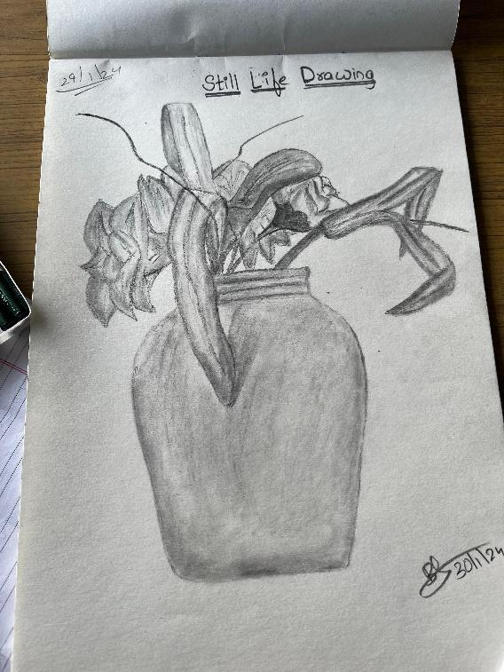

REPORT ON IDEA CLUB
The club aim is to improve the student’s creative ideas with hand-picking the ideas that will change their life. The club helps them to improve their shared vision that can enliven with an objective to create an idea sparks and awareness among the students, to frame difficult ideas with proper manner, Developing the ideas being assertive, to evaluate the strength and weaknesses of the ideas, to be able to handle difficult ideas with proper manner.

The Idea Club engaged in a wide range of stimulating activities, including:
- Brainstorming Sessions: We conducted regular brainstorming sessions where members could freely share and develop their ideas on various topics.
- Innovation Challenges: We organized innovation challenges that tasked members with solving real-world problems, encouraging them to think creativily.
The Idea Club has been instrumental in nurturing creativity and critical thinking among its members. As a result of their participation, students have:
- Cultivated their ability to generate and develop innovative ideas.
- Gained valuable problem-solving and design thinking skills.
- Developed a deeper appreciation for the power of innovation in various fields.

REPORT ON IPR CLUB
IPR stands for INTELLECTUAL PROPERTY RIGHTS
Intellectual property rights are the cornerstones of any modern economy. They're vital to the success of businesses, but they can cause legal problems when people don't know how to protect their ideas and inventions. The Intellectual Property Rights Club intends to spread knowledge and dive into the world of inventions, patents, copyrights etc.

- Regular Meetings: The club organises frequent meetings where members gather to discuss the rights of the property and share experiences, and plan activities.
- Workshops and Training Sessions: Scheduled workshops cover various topics such as trade marks , copy rights, patents etc….
- Critique Sessions: Conducting critique sessions where members present their work for feedback, facilitating constructive criticism and improvement.

Outcome of the club -
- Personal Growth: Members gain knowledge regarding the rights of the property and also how it helps in their personal life it also helps to achieve their success.
- Professional Development: Workshops, lectures, and demonstrations enhance members' knowledge of the rights of the property and tools, aiding in their professional development.
- Inspiration: Exposure to create a new things and invention of the new product which helps to approaches in their creative work.

ENTERTAINMENT
CLUBS

REPORT OF PHOTOGRAPHY AND FILM CLUB
SYLLABUS
UNIT1
History of Photography

UNIT 2
Types of cameras

UNIT 3
Lighting techniques, photo editing

UNIT 4
Portrait photography, Landscape Photography

- Regular Meetings: The club organises frequent meetings where members gather to discuss upcoming events, share experiences, and plan activities.

- Workshops and Training Sessions: Scheduled workshops cover various topics such as camera techniques, composition, lighting, and editing software, providing hands-on learning experiences.

- Critique Sessions: Conducting critique sessions where members present their work for feedback, facilitating constructive criticism and improvement.

- Photo walks: Organising photo walks to scenic locations present in the campus for practical photography sessions, encouraging members to apply their skills in realworld settings.

- Film Screenings: Hosting screenings of classic and contemporary films, followed by discussions to analyse cinematic techniques and storytelling

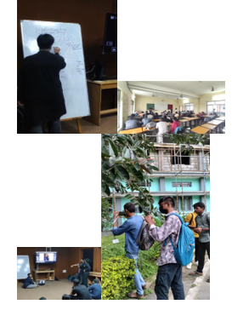

REPORT OF RJ & VJ CLUB

SYLLABUS
UNIT 1
Radio new Script
UNIT 2
Concepts and story Building
UNIT 3
Online Radio Channel Content
UNIT 4
Announcements and Notices
Over the past semester, RJ &VJ Club actively engaged in various activities:
- Radio Scripts: We gave a fun task to improve the verbal and writing skills of the students to enhance the creative thinking and vocabulary.
- Vox Pop: It helps in taking spontaneous interviews of unknown public which boosts your confidence and shy away the fear of camera. It inculcates good communication skills.
- Voice Modulation Activities: The tone of your voice is one of the most important aspects of a RJ. We did an activity imitating your favorite host, where the student gets to understand it in practical.
- Interviews and Advertisements: Students learnt how to research a particular topic before an interview and how to prepare a questionnaire to interview any person. They also learnt various advertising strategies and how to attract audience in a creative sense specifically in “Radio Commercials”.
- Activities to Improve Spontaneity: It creates an atmosphere of quick thinking and how to respond immediately with a witty response. We had activities like Chits, Folded Story, Finishing the Last Lines etc.
- 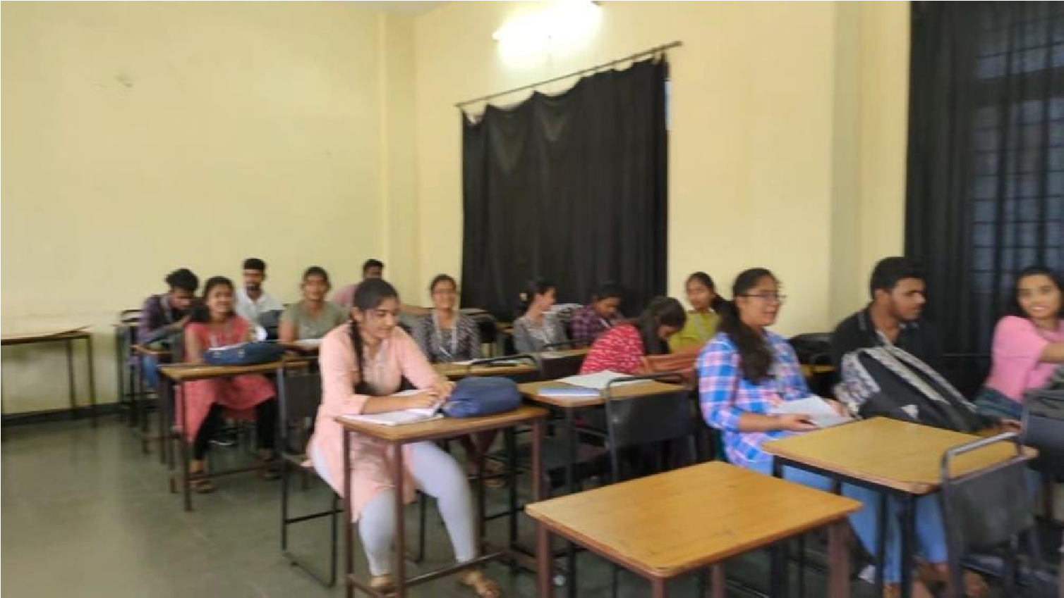
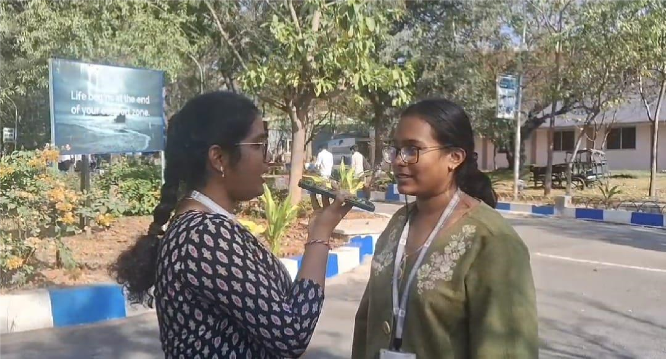

VLOGGING AND BLOGGING CLUB

Over the past semester, the vlogging & blogging Club actively engaged in a variety of activities: 1. How vlogging & blogging is important: Vlogging and blogging play crucial roles in today's digital landscape for several reasons:
- Expression of Creativity: Vlogging and blogging serve as powerful outlets for individuals to express their creativity, allowing them to share unique perspectives, ideas, and talents with a global audience.
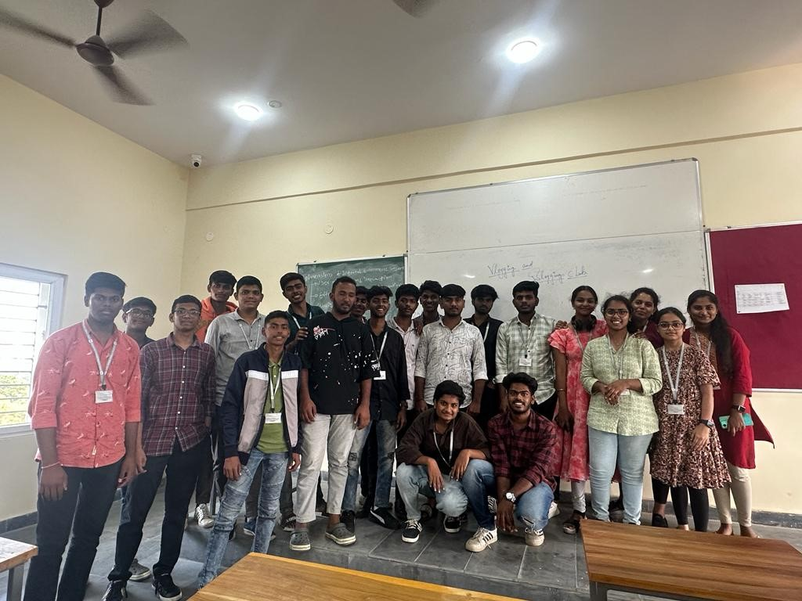
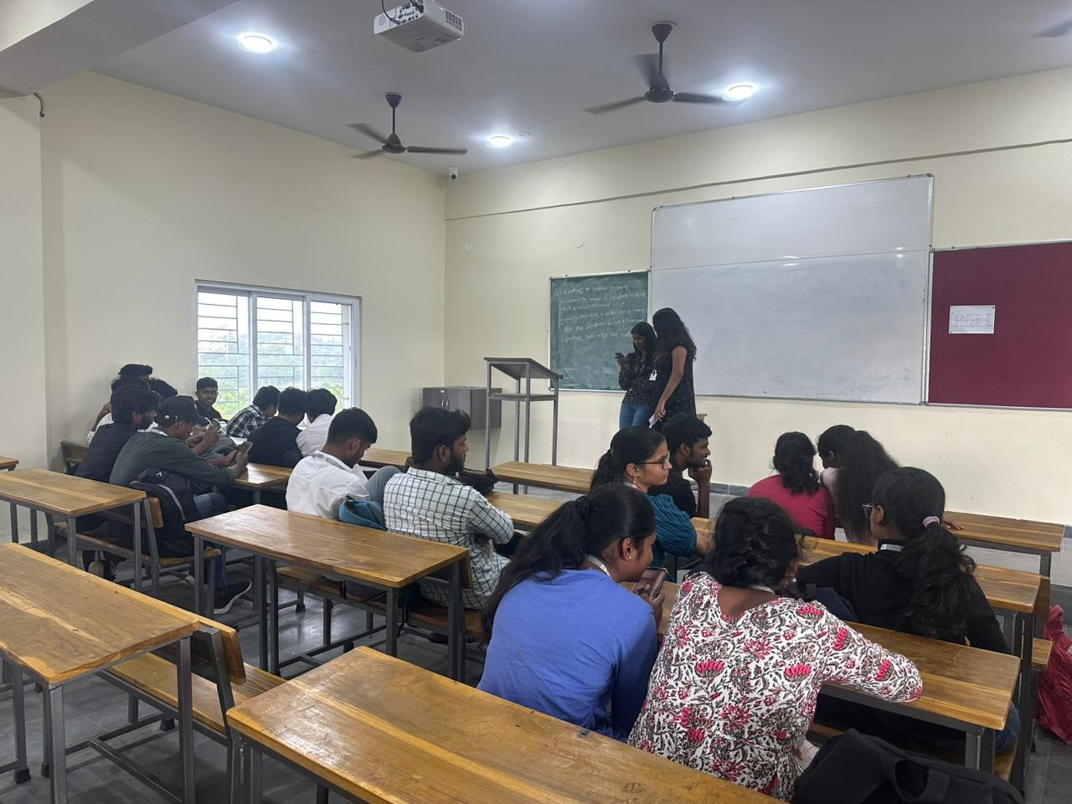
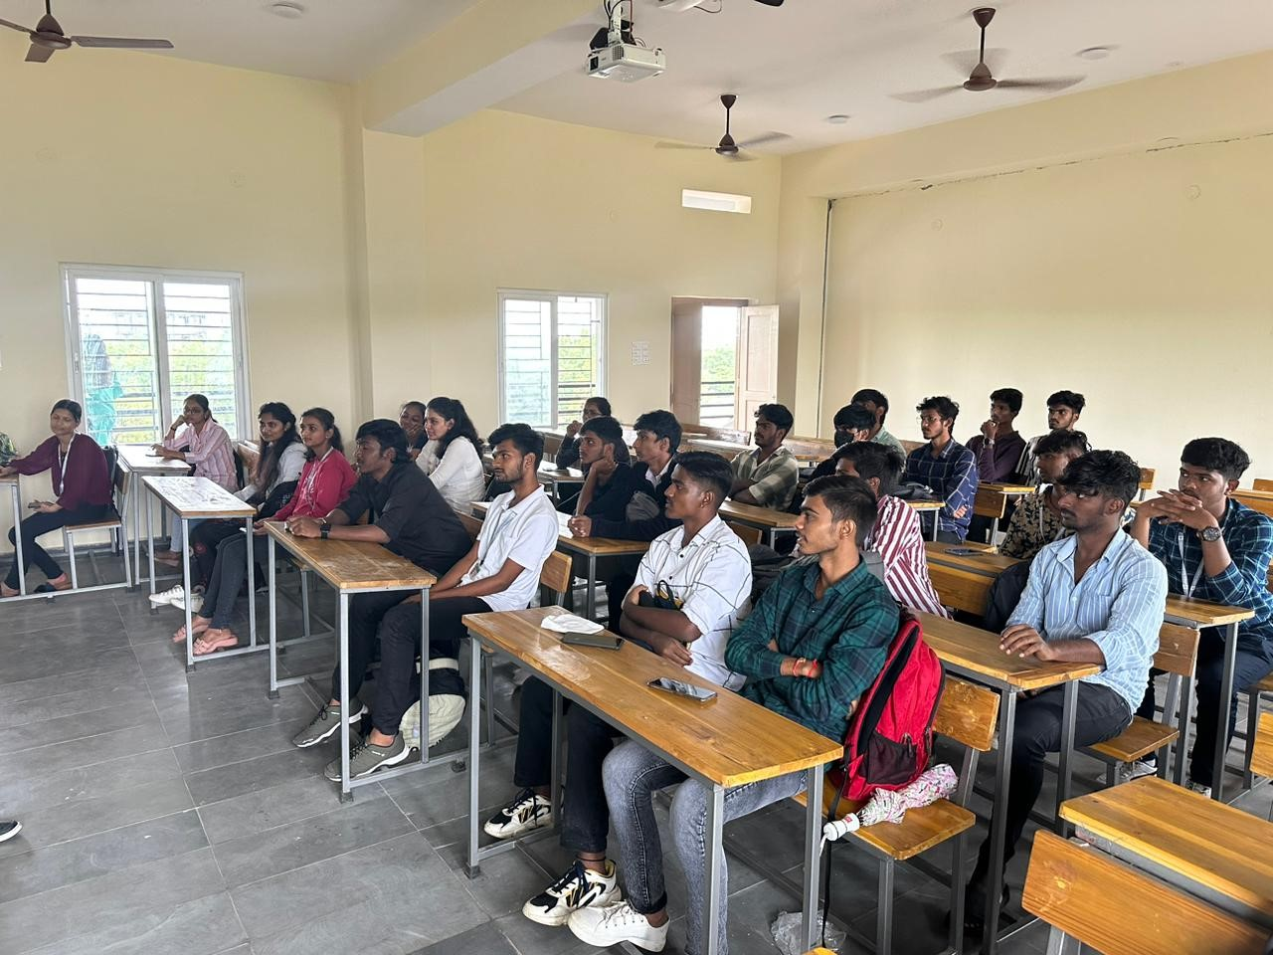
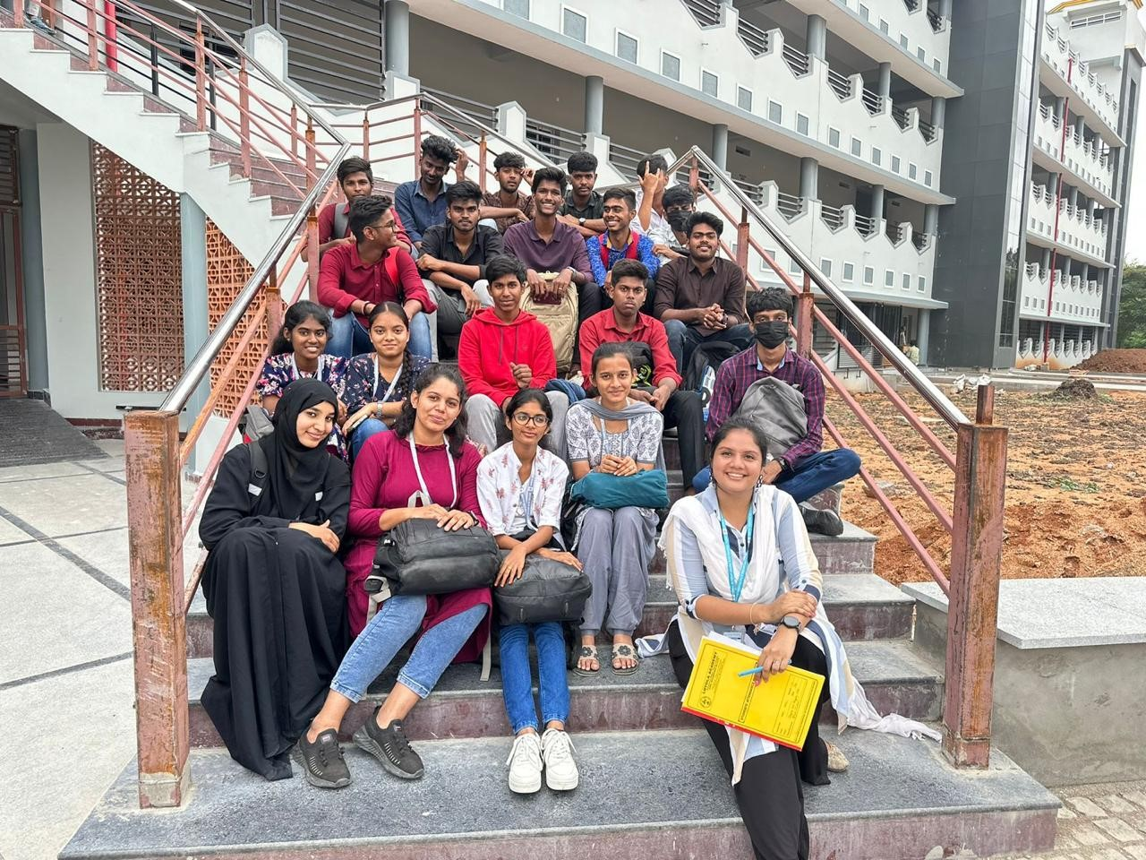
- Information Dissemination: Both mediums are effective channels for disseminating information, whether it's news, tutorials, personal experiences, or expert insights. They contribute to the democratization of information.

- Community Building: Vlogs and blogs foster communities around shared interests. Creators can connect with like-minded individuals, building supportive networks and fostering discussions on various topics.
- Personal Branding: through YouTube & Instagram Vlogging and blogging enable individuals to build personal brands. Consistently creating valuable content establishes authority and credibility in specific niches, attracting audiences and potential collaborations.
- Career Opportunities: Successful vloggers and bloggers often attract attention from businesses and brands. This can lead to partnerships, sponsorships, and other opportunities, turning a passion into a sustainable career.

TOURISM CLUB
The most important outcome
is the introduction of Travel and Tourism among the learners and to get the knowledge and understanding of the overall phenomena of Travel and Tourism, by defining, understanding meaning, concept and historical developments and introducing various types and forms of Tourism. To understand the meaning and typologies of
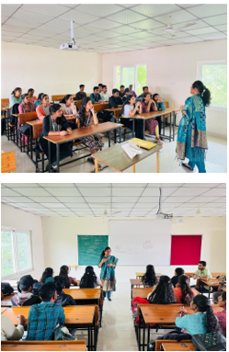
Tourist, definitions and meaning of Traveller, Excursionist, Visitor and Transient. As the tourism is highly seasonal activity so it is very essential to understand the concept of Demand and Supply in Tourism and the factors affecting the same. One of the major outcomes is getting proper understanding of Tourism Product as product is essential part.
SOCIAL CLUB

REPORT OF GREEN CLUB
SYLLABUS

UNIT 1
Natural Resources - their conservation and management

UNIT 2
Ecology and Biodiversity

UNIT 3
Environmental pollution and control

UNIT 4
Nature Photography

- In adherence to the Central Government's SwachhtaPakhwadainitiative, the club spearheaded a successful cleanliness drive within our college on September 15th, aligning with official guidelines.
- Additionally, to foster student interaction and knowledge exchange, we organized a captivating Treasure Hunt event. This educational quest featured hints related to scientific tree names and greenery quotes, encouraging participants to expand their ecological awareness.
- Furthermore, our club facilitated discussions among students, addressing pertinent environmental issues and collectively brainstorming eco-friendly solutions. These initiatives reflect our commitment to promoting environmental consciousness and sustainability within our institution.
Outcome of the club
- The Green Club’s efforts have yielded positive outcomes, fostering greater environmental awareness and responsibility within the college community. Through initiatives like SwachhtaPakhwada, Treasure Hunt, and constructive discussions, we’ve not only contributed to a cleaner campus but also inspired students to think and act in eco-friendly ways. Moreover, the regular environmental classes conducted by our dedicated faculty coordinator have enriched students’ understanding of the environment and its species, further nurturing a culture of sustainability. Overall, the Green Club’s impact is evident in the increased environmental consciousness and eco-friendly practices embraced by our college.

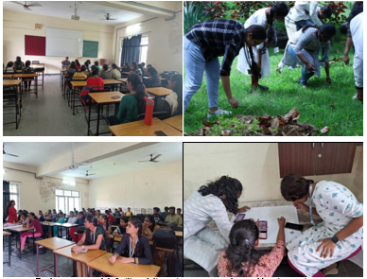

REPORT OF MAGIC YOUTH CLUB

SYLLABUS

UNIT1
Introduction to Magic youth and AICUF

UNIT 2
Developing empathy and compassion

UNIT 3
Outreach and community engagement

UNIT 4
Introduction to Social issues and Social Justice

Over the past semester, the MAGIC Youth and AICUF Club actively engaged in a variety of activities, mentioned as follows:
- (a) Introduction to MAGIC Youth and AICUF: its functioning and activities
(b) Introduction to Social Issues, Social Justice and Social Activism (through Debate):
  - Understanding various social issues prevalent in society
  - Exploring the root causes and impacts of these issues
  - Exploring different forms of activism: advocacy, protests, petitions and community organizing
- Developing empathy and compassion:
  - Cultivating empathy through interactive activities and discussions
  - Learning to see the world through the eyes of others
  - Emphasizing the importance of compassion in creating positive social change
- Outreach and community engagement:
  - Planning and organizing community outreach events
  - Collaborating with local organizations and initiatives
  - Participating in service projects to address specific community needs
- Life in the Margins:
  - Examining the lived experiences of the marginalized individuals and communities
  - Learning about their resilience, strengths and unique perspectives
  - Exploring issues such as poverty, homelessness, discrimination and inequality
