CLUB REPORT
2024-2025

REPORT ON CLUB
2024-2025
MONTHLY EVENT DOCUMENT
CLUB REPORT
Sl.  No | Month & Date | Title of the Event | Report | Budget | Submitted to
 |  |  |  |  | Department | Dean | IQAC
1 | September-03, 04, 05, 09, 10, 11, 12, 16, 17, 18, 19, 23, 24, 25, 26, 30.  October- 01, 03, 15, 16, 17, 21, 22, 23, 24. | Club 2024-25 | Club report | - |  |  | Yes

Name of the event: Club 2024-25
Date: September-03, 04, 05, 09, 10, 11, 12, 16, 17, 18, 19, 23, 24, 25, 26, 30.
October- 01, 03, 15, 16, 17, 21, 22, 23, 24.
Number of Students participated-odd semester: 704 students (UG-school of life sciences, informatics and agriculture)
Number of faculty participated: 23 faculty members
Marks: 25
Term: 1st semester (2024-25)

Orientation: 16th August 2024, in Inigo hall.
Clubs play a vital role in college life, offering students a unique opportunity to explore their interests, make new friends, and develop valuable skills outside the classroom. College clubs are essentially student-led learning modules that cater to a wide range of hobbies, passions, and activities. Here's an introduction to clubs at Loyola Academy:

- Diverse Interests: College clubs are incredibly diverse and cover a wide spectrum of interests. From academic and professional clubs related to specific majors or career goals to recreational and hobby-based clubs, there's likely a club for everyone. Whether you're into arts and culture, sports, technology, volunteering, or almost anything else, you can find a club that aligns with your interests.

- Student-Led: Clubs are run by a lecturer in charge along with students’ active participation, with members taking on various leadership roles. This allows students to gain valuable leadership, organizational, and teamwork skills. It also provides a sense of ownership and responsibility, as members are responsible for the club's success and activities.

- Social and Networking Opportunities: Joining a club is an excellent way to meet like-minded individuals who share your interests. It can help you forge new friendships and build a supportive social network. Additionally, club events and activities often provide opportunities for networking and making connections that can be valuable in your future career.

- Skill Development: Many college clubs focus on specific skills or areas of expertise, giving members the chance to develop and hone their talents. Whether it's public speaking, event planning, coding, or creative writing, clubs often offer workshops, training, and hands-on experiences to help you grow and learn.

- Community Engagement: Several clubs engage in community service or advocacy work. These clubs provide an avenue for students to give back to their communities, promote social causes, and make a positive impact on society.

- Personal Growth: College clubs can be a place for personal growth and self-discovery. They challenge you to step out of your comfort zone, take on leadership roles, and develop qualities such as communication, time management, and teamwork.

- Balance and Well-Being: Participating in clubs can help students strike a healthy balance between academics and extracurricular activities. It's essential to manage your time effectively, but being involved in a club can contribute to your overall well-being and help reduce stress.

- Resume Enhancement: Involvement in clubs can be a valuable addition to your resume. It showcases your commitment, leadership, and the skills you've acquired, which can be attractive to future employers or graduate programs.

- Access to Resources: Many college clubs receive funding, resources, and support from the university or student government. This can enable them to organize events, bring in guest speakers, or undertake projects that may not be possible on an individual basis.

- Fun and Enjoyment: Ultimately, college clubs are a source of fun and enjoyment. They allow you to pursue your passions, explore new interests, and create lasting memories with fellow students.

There are various clubs in our curriculum. They include

● Drama club
- Music Club
- Finance Club
- Photography Club
- Fashion Club
- Rj & Vj Club
- Debate Club
- Magic youth & AICUF Club
- Tourism Club
- Green Club
- Art Club
- Knowledge Club
- Vlogging and blogging Club
- Dance Club
- Literature and book Club

DRAMA CLUB
Drama Club is a vibrant community where students come together to explore the world of theater through acting, improvisation, and storytelling. It provides a supportive space for members to enhance their creativity, build confidence, and develop strong communication skills. Through a variety of activities, from scriptwriting to performance, participants not only refine their craft but also form lasting friendships and learn the value of teamwork. Whether on stage or behind the scenes, the Drama Club celebrates the art of expression and the joy of bringing stories to life.
The aim of a drama club is to foster creativity and self-expression through theatrical performance. It provides a supportive environment for members to develop acting skills, explore various aspects of theater, collaborate on productions, and build confidence and teamwork. Ultimately, it seeks to enhance appreciation for the arts and engage the community through performances.

Activities Conducted by the Club:
Over the past semester, Drama Club actively engaged in a variety of activities:
- Theater games - We started our sessions with fun theater games, including Dumb Charades and various guessing games, to help students feel comfortable and build fellowship.

- Mime - Students were introduced to the art of mime through group activities. They explored non-verbal communication, allowing them to express emotions and tell stories without words. This experience was not only fun but also a great exercise in creativity.

- Navarasa -We explored the concept of Navarasa, The 9 emotions in acting. This also was incorporated with a task of enactment where each person was given an Emotion & A Role which they had to showcase in their act.

- Script writing - We covered the fundamentals of scriptwriting, focusing on key components. Students were given detailed notes and were given assignments to craft their own scripts, fostering their storytelling skills and creativity.

Outcome of the Club:
The Drama Club has been a source of personal growth and enjoyment for its members. Through their participation, students have not only enhanced their acting and communication skills but also fostered a strong sense of teamwork within the club. Through collaborative exercises and shared experiences, participants learned to support each other, building trust and camaraderie that enriched their creative journey.

Gallery:
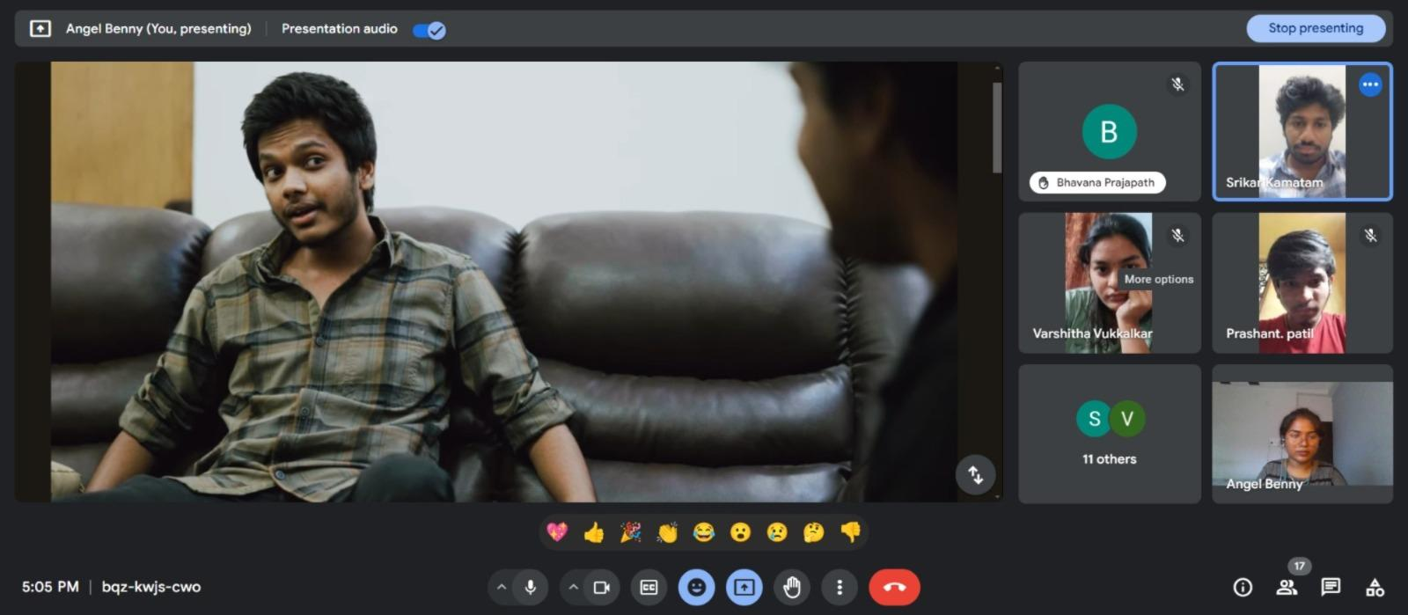
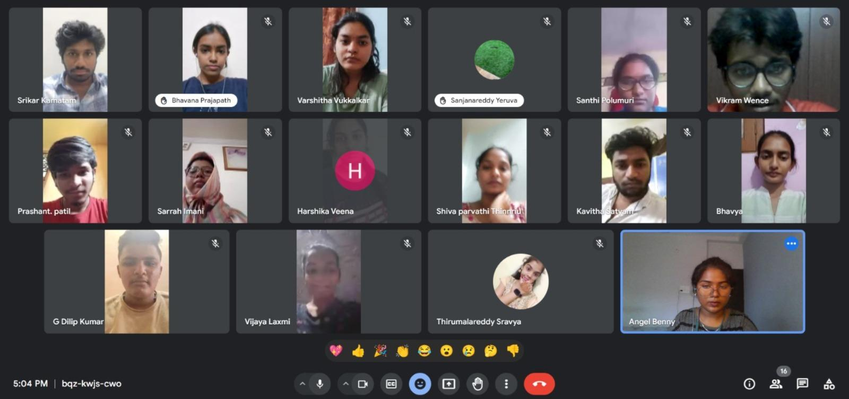
MUSIC CLUB
The MUSIC club organizes various activities like singing competitions, workshops, jamming sessions etc. Students are given stage practice for overcoming stage fear and improving solo singing and group singing. To Provide opportunities of singing and to give theoretical and practical knowledge on music. Music clubs can also encourage students to participate in music-related events on and off campus, it also helps to build confidence and become more passionate about music.
The aim of a music club is to enhance the Music talent among the students. To encourage the students to actively participate in various music-based events conducted within the campus and outside the campus. To showcase the talents of the students in singing, playing, various classical and modern equipment, learning about history and evolution of music in various fields.

Activities Conducted by the Club:
Over the past semester, the club engaged in a variety of enriching activities:
- GUESS THE INSTRUMENT: We conducted a session in which the students’ knowledge is tested by playing a song and guessing the instrument played in it which will improve the listening skills and make everyone to participate actively

- COMPOSE A SONG: We hosted engaging sessions where members try to write a song on their own with any tune and present it in front of everyone this helps in showcasing their creativity skills and overcome stage fear

- MASHUP SONGS: A session where the unity among all the students is checked, It is conducted where the students have to divide into groups and make a mashup of 2-3 songs in which the tune has to match by remixing it correctly finally all together have to present it.

- GUESS THE SONG: Members participated in rich discussions where a part of tune of a song is played for 10sec and then everyone has to guess the name of the song by the tune played which will improve their ability to think and know new songs
- JAM SESSIONS: A lively activity where participants are given 2-3 minutes of times where they must speak about thew knowledge they have on music and why they are very interested into music by which they improve communication skills and overcome stage fear

- PARTS IN SINGING: A knowledge sharing session is conducted where all the musicians who have very good idea about music shares about music and parts of music by which everyone gets a clarity on what scale they can sing and their vocal range also some tips were given to improve their breathe control while singing

- PLAYING INSTRUMENTS: A Joyful session is conducted where all the instrumentalists showcase their talents by playing instruments and also as an encouragement all the vocalists were guessing and singing the songs along with the instrumentalist which improve their team work and building coordination with their co-singers

Outcome of the Club:
Skill development: Members can develop their skills in singing, playing instruments, composing, and producing music.
Creative expression: Members can explore different genres, styles, and emotions through music.
Collaboration: Members can work together to create music, form bands, and support each other.
Performance opportunities: Members can showcase their talent at events within and outside the university.
Music appreciation: Members can learn about music theory, history, and cultural significance.
Organizational skills: Members can develop organizational skills by creating bands and managing concerts.

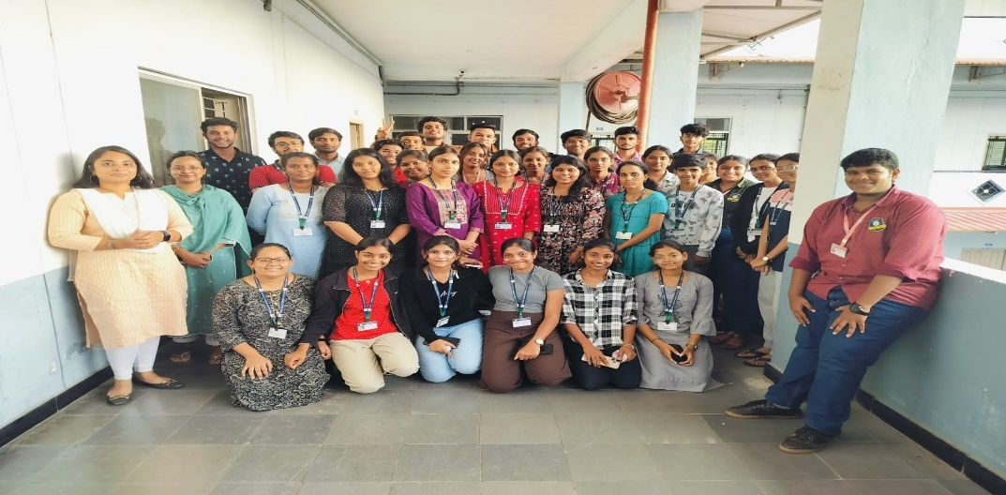
Gallery:
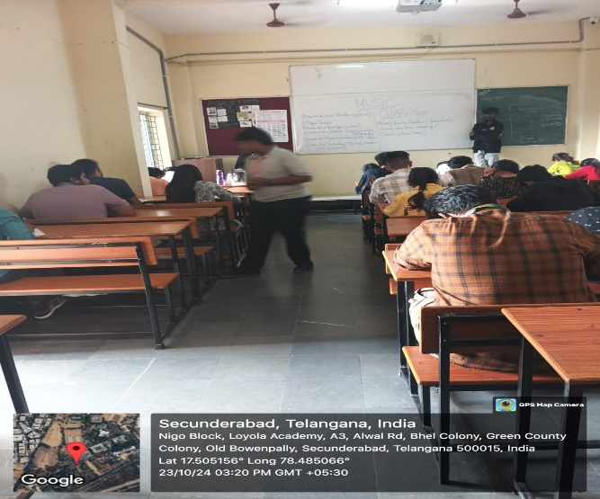

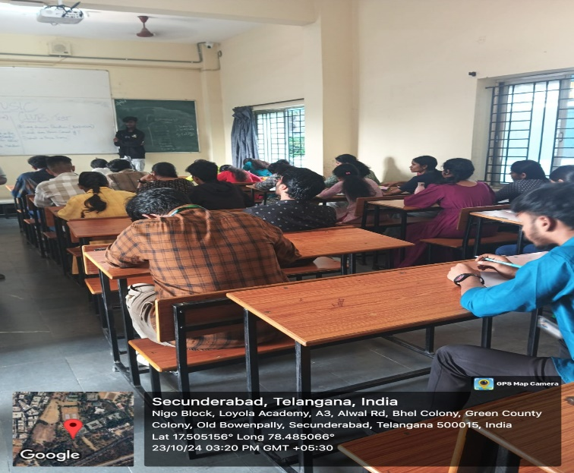
FINANCE CLUB
A Finance Club is typically an extracurricular organization, often found in high schools, colleges, and universities, that is designed to engage students with the world of finance and investment. It serves as a space for individuals interested in developing their financial literacy, networking with industry professionals, and learning more about financial markets, investment strategies, and the broader financial industry.
The aims and objectives of a Finance Club are to enhance members' financial literacy, provide practical experience in investment and financial markets, and prepare them for careers in finance. The club fosters leadership, teamwork, and ethical decision-making, while offering networking opportunities with industry professionals. It also promotes real-world financial research, community engagement, and personal development through workshops, simulations, and competitions.

Activities Conducted by the Club:
Over the past semester, Drama Club actively engaged in a variety of activities:
- Group Discussions: Finance Club conducted group discussions on various finance topics. It’s a dynamic forum for learning and collaboration.

- Basic terminologies: Students have learned the terms that are foundational to understand financial markets, personal finance and business operations.

- Case Study: Students solved real-world business or financial problems by analyzing financial data, market trends, and company strategies.

Outcome of the Club:
The Finance Club has been a source for the students from non-commerce backgrounds to gain insights in finance, investing and analysis. Helping to promote financial literacy and education within the community. By offering a mix of educational, practical activities the club provides a comprehensive platform for members to develop their knowledge, skills within the world of finance.

Gallery:

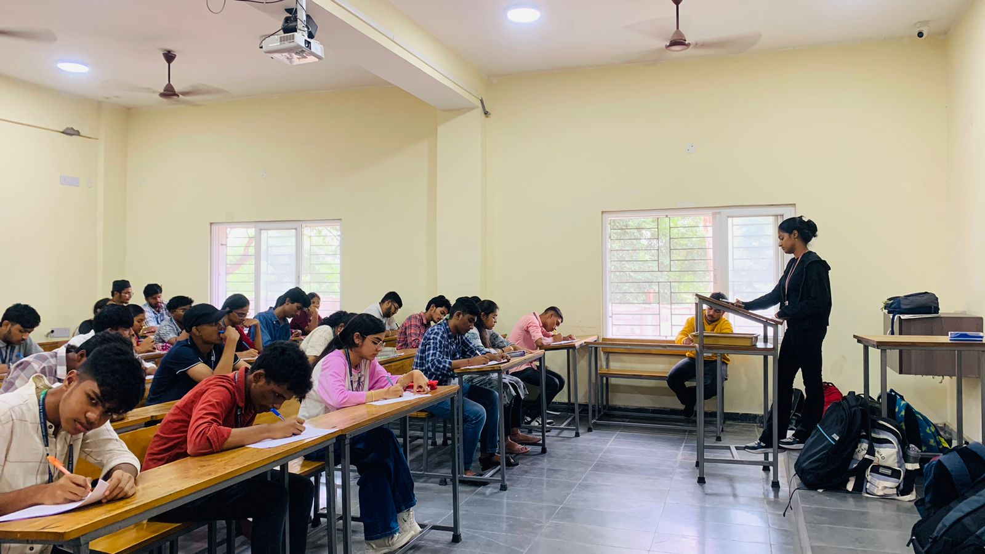
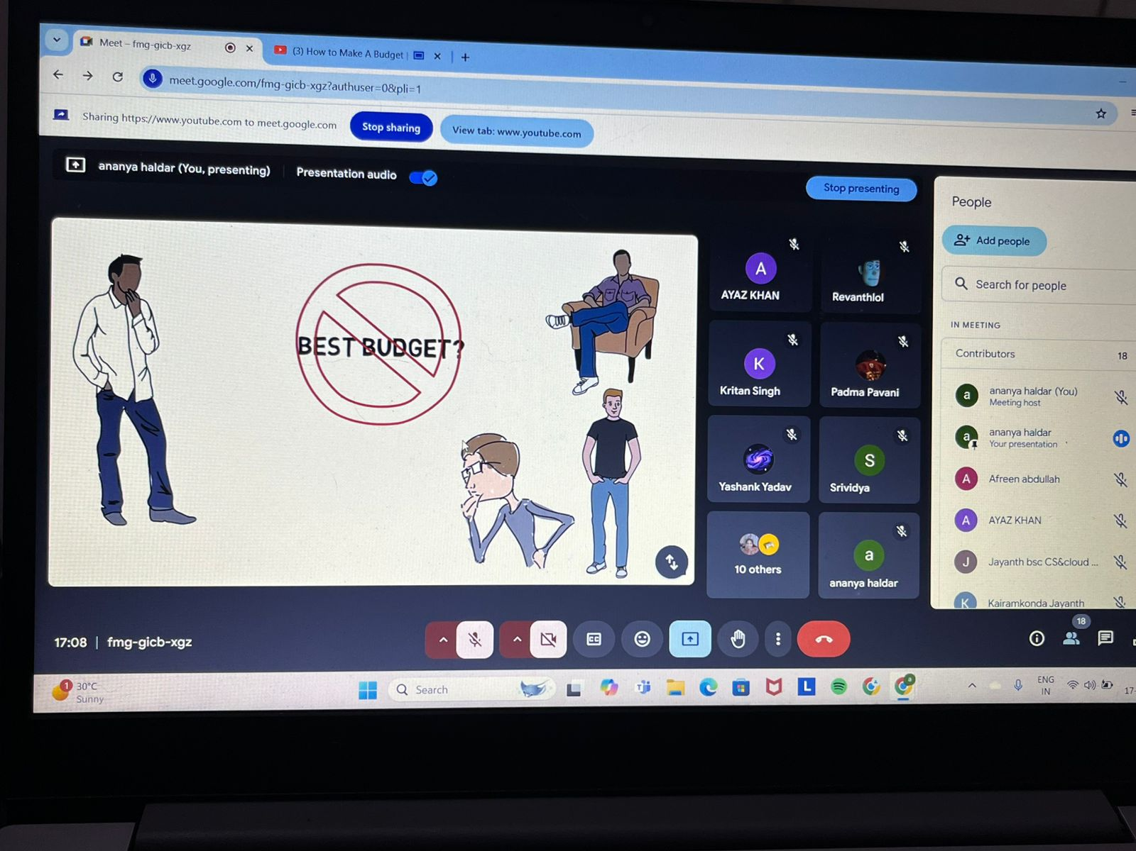

PHOTOGRAPHY CLUB
A photography club is a group of individuals who share a passion for photography. Members come together to learn and enhance their skills, share tips and techniques, and participate in various activities such as photo walks, workshops, and exhibitions. The club fosters creativity and collaboration, providing a supportive environment for photographers of all levels to express themselves and showcase their work.
The aim of a photography club is to cultivate a passion for photography among its members. It provides a platform for individuals to improve their skills, share knowledge, and explore different styles and techniques. The club encourages creativity, offers opportunities for collaboration, and often organizes outings and exhibitions to showcase members' work and engage with the community.

Activities Conducted by the Club:
Over the past semester, the club engaged in a variety of enriching activities:
- Landscape Photography: Members delved into the art of capturing stunning natural landscapes, focusing on composition, perspective, and visual storytelling techniques to convey the beauty of the outdoors.
- Short Film Review: We hosted engaging sessions where members reviewed a variety of short films, discussing narrative techniques, cinematography, and the director's artistic vision, fostering deeper appreciation for the medium.
- Film Discussion (Subjectivity in Cinema): Members participated in rich discussions about the subjective nature of cinema, exploring how personal perspectives influence interpretations and emotional responses to films.
- Guessing the Protagonist: A lively activity where participants guess the protagonists of popular films, testing their cinematic knowledge and understanding of character traits, while having fun in a competitive atmosphere.
- Portrait Photography: Members honed their skills in portrait photography, focusing on capturing expressions, mood, and framing techniques to create compelling and evocative images that tell a story.
- Theme-Based Photography: An imaginative exercise where participants captured images centered around a specific theme, allowing them to express their unique perspectives and creativity through the lens of their cameras.

Outcome of the Club:
Skill Development: Members improve their technical skills in photography, including composition, lighting, and editing techniques.
Creativity and Expression: Participants enhance their creative abilities, learning to express their unique perspectives through photography.
Community Building: The club fosters a sense of camaraderie among members, encouraging collaboration and the sharing of ideas.
Critical Thinking: Members develop a critical eye through discussions, reviews, and constructive feedback, helping them analyze both their work and that of others.

Gallery:
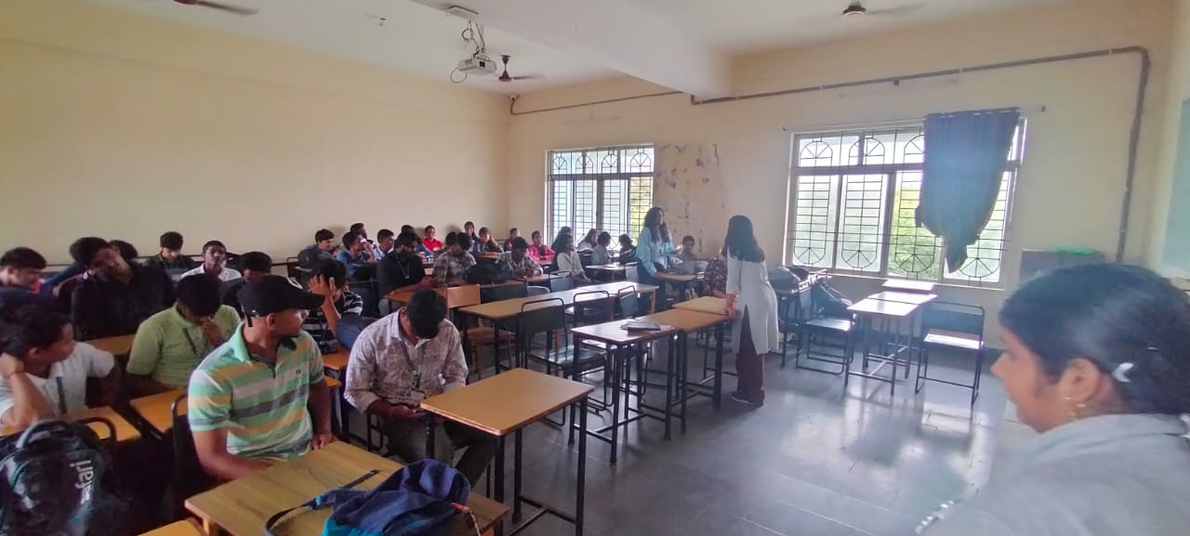
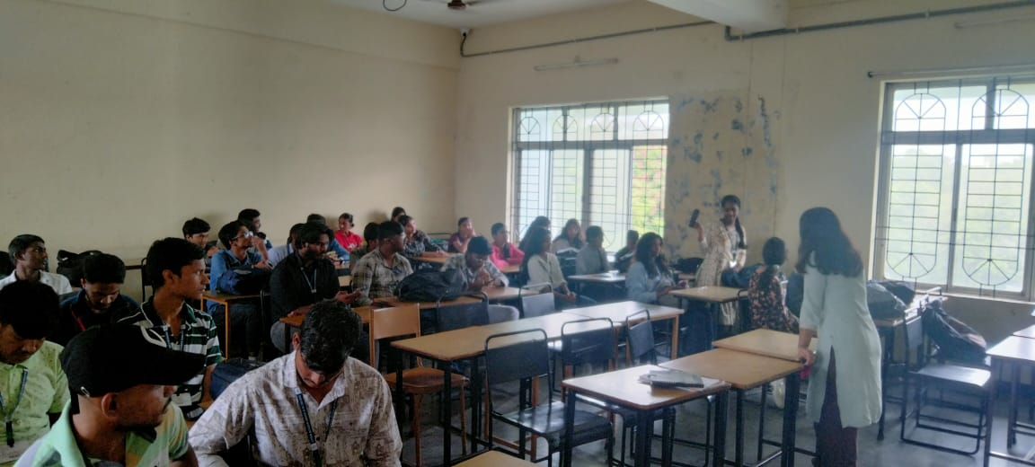

FASHION CLUB
Fashion club is a group of individuals who are fascinated towards fashion activities. It gives an opportunity for everyone to sketch and design unique and personality-based jewelry and outfits. Fashion club helps in acquainting students in getting a grip on designing, production and other various aspects that play a crucial role in modelling. It provides a platform for every individual in improving their skills in designing outfits. Fashion club can be a great choice to understand the background work that happens behind fashion events.
The aim of fashion club is to uplift and inspire the students in fashion activities which are trend based like enchanting adornments, DIY fashion projects, masquerade…etc and to give every individual a chance to showcase their talents in best possible ways.

Activities Conducted by the Club:
1.Designers spree: An opportunity for everyone to sketch and design an outfit in a limited time. Students have learnt and sketched various outfits, jewellery in unique ways.
2.Masquerade: A costume play event where students will be given a chance to dress as their comfy cartoon character, celebrities and Pinterest inspired outfits. Students got dressed up as their favorite actors and recreated Pinterest inspired outfits.
3.DIY fashion projects: Creative ways to make your own clothes, accessories where students customized t-shirts by dyeing and bow theme fashion projects etc.
4.Whimsical wardrobe: An activity which involves designing elements of universe. Students were given a chance to create using all available resources and equipment’s.
5.Enchanting adornments: A jewellery designing activity where students sketched personality and theme-based jewellery.
6.Hair model: A hairstyle creation activity where students sketched theme appropriate hairstyles.
7.Glam glimpse: A mega ramp walk that took place at the very end of the club in which students were divided into teams and given roles like models, designers, makeup artists, production heads etc., to create their own costumes, hairstyles, makeup and budget as well to participate in the mega ramp walk event.

Outcome of the Club:
Skill Development: Members improve their technical skills in fashion including designing, production and other various aspects that play a crucial role in modelling.
Creativity and Expression: Participants enhance their creative abilities, learning to express their unique perspectives through fashion club.
Community Building: The club fosters a sense of camaraderie among members, encouraging collaboration and sharing of ideas.
Critical Thinking: Members develop a critical eye through discussions, reviews, and constructive feedback, helping them analyse both their work and that of others.
Increased Appreciation for art: Participants gains a deeper understanding and appreciation for their work as an art form, enhancing their overall engagement with visual culture.
Gallery: -
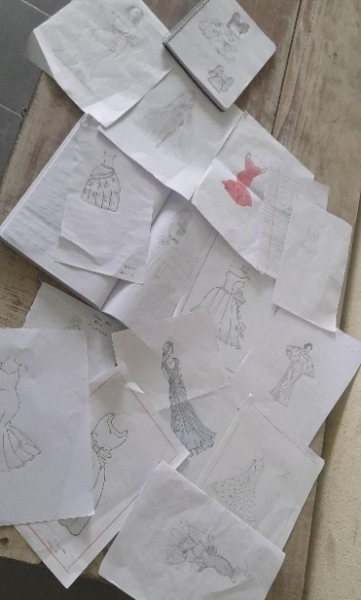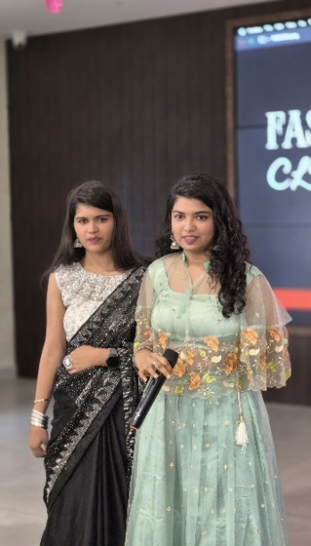
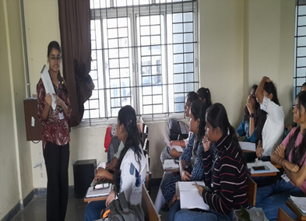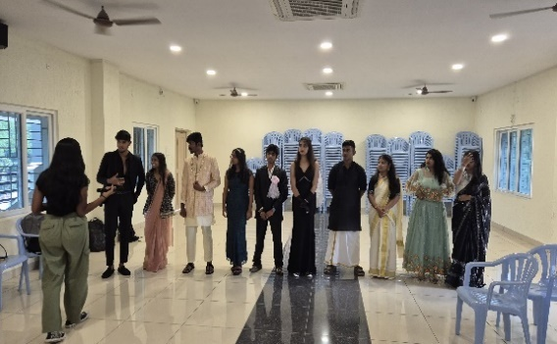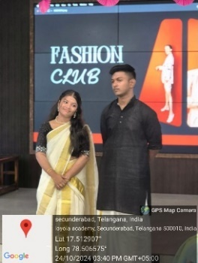

RJ & VJ CLUB
RJ is a space focused on radio personalities (RJs) who play music, host talk shows, conduct interviews, and engage listeners in discussions. RJs often create a connection with the audience through their voice, humour, and content on radio stations. VJ is space or event where VJs—TV hosts for music videos and entertainment shows—curate music playlists, introduce music videos, and interact with fans. VJs may also host live events, interviews, and provide entertainment through television or online platforms.
The aim of an RJ Club and VJ Club is to provide a platform for Radio Jockeys (RJs) and Video Jockeys (VJs) to entertain and engage audiences through music, talk shows, interviews, and interactive content. These clubs aim to foster a connection between the media personalities and their fans, creating an entertaining and dynamic environment while promoting music, culture, and conversation.

Activities Conducted by the Club:
*Live RJ sessions
*Live video hosting
*Audience Engagement
*Audience Polls and Requests

Outcome of the Club:
The outcome of an RJ and VJ club is to create an engaging and interactive environment where audiences can connect with radio and TV personalities. It fosters entertainment, music appreciation, and cultural exchange, while providing a platform for creative expression. These clubs help build loyal communities of listeners and viewers, boost fan interaction, and promote artists, music, and entertainment events. They also contribute to the growth of media personalities’ careers by increasing their visibility and fanbase.

Gallery:
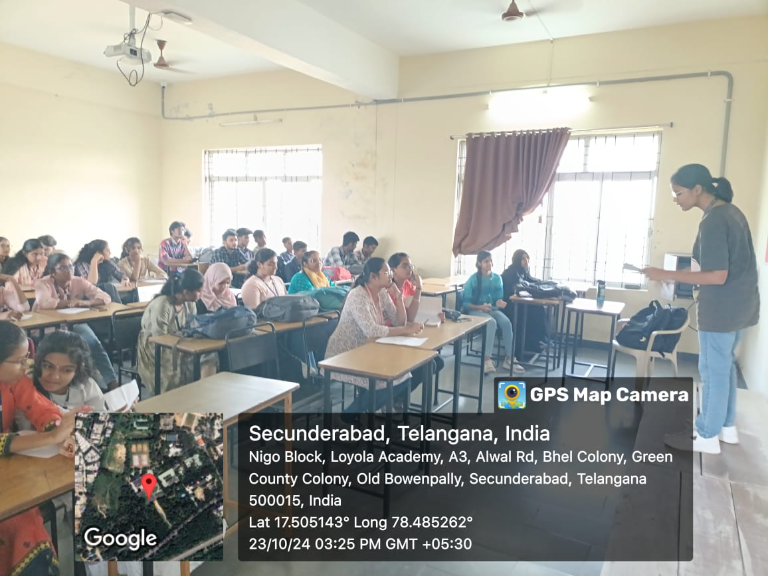
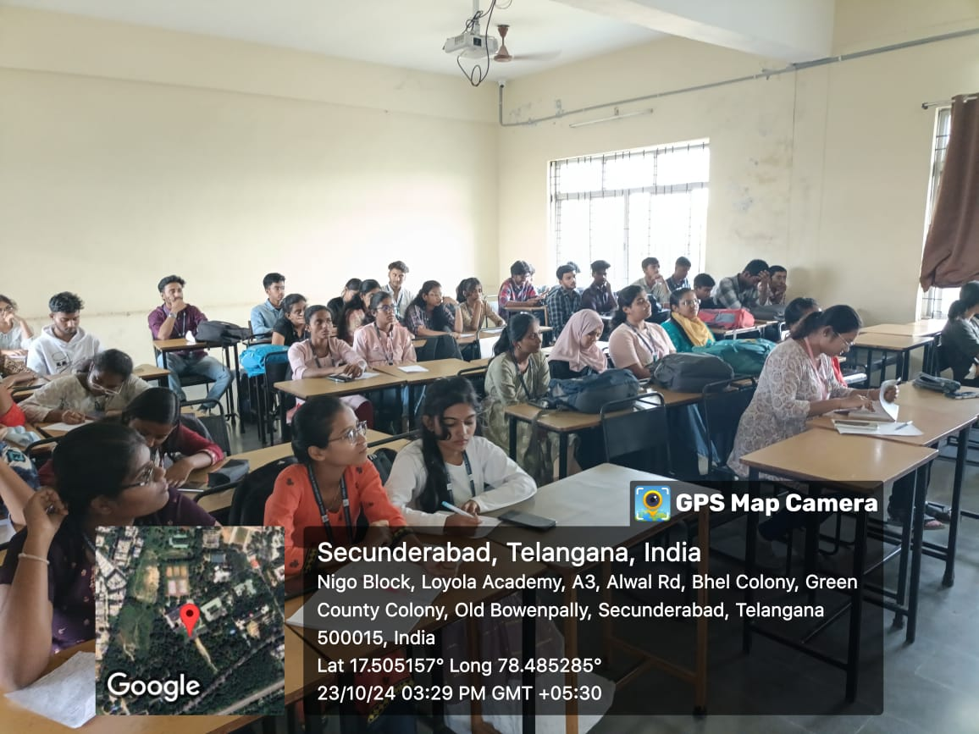
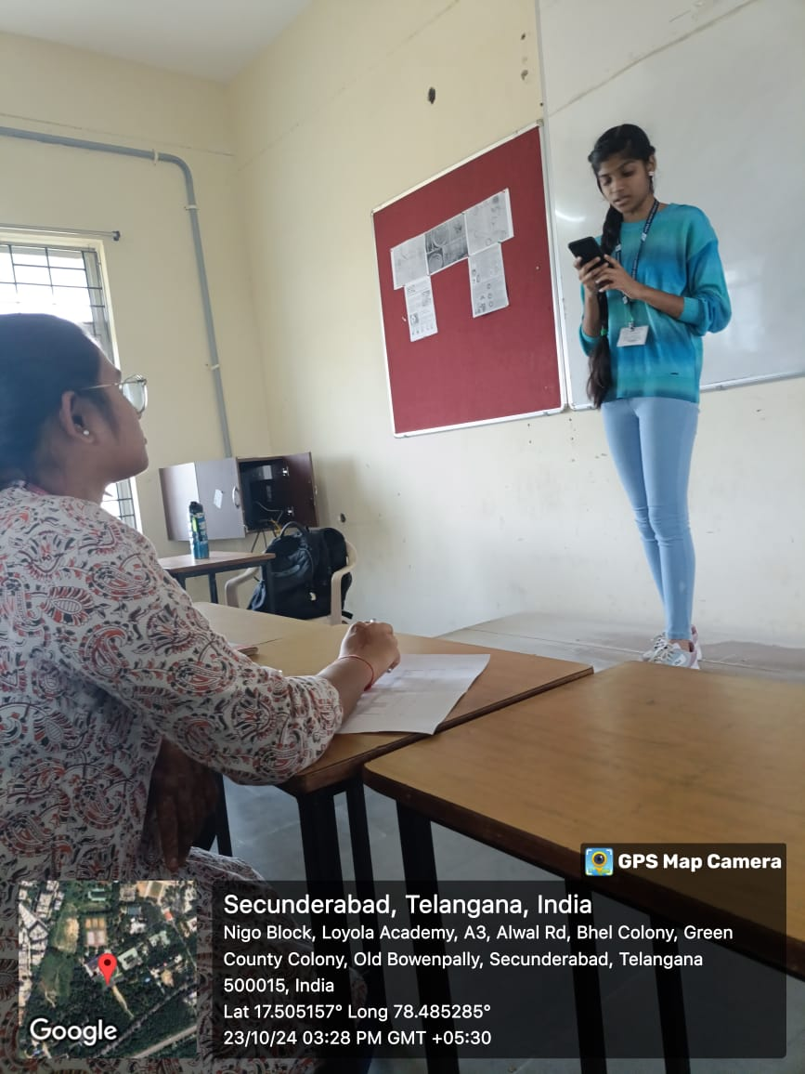
Debate and Elocution Club
The Debate and Elocution Club is a platform where students refine their public speaking skills, critical thinking, and persuasive abilities through structured debates and elocution sessions. The club provides a supportive environment where members practice argumentation, research, and presentation, preparing them to express and defend viewpoints on a range of topics effectively.
The club’s aim is to foster effective communication, critical thinking, and respectful discourse among members. Through structured debates and discussions, students build essential skills in public speaking, research, and persuasion. Additionally, the club promotes open-mindedness and empathy, encouraging members to appreciate diverse perspectives and engage in informed dialogues on real-world issues.

Activities Conducted by the Club:
1.Debates: Organizing and participating in debates on a wide range of topics, with members taking on different roles, such as affirmative and negative sides, to argue for or against a proposition.
2.Research and Preparation: Teaching members how to research and gather evidence to support their arguments, as well as how to construct well-reasoned and persuasive cases.
3.Impromptu Speaking: Practicing impromptu speeches where members are given a topic on the spot and have a short amount of time to prepare and deliver a speech.
4.Extemporaneous Speaking: Developing the ability to speak spontaneously on a given topic, often with a limited amount of time for preparation.

Outcome of the debate club:
●Improved Communication Skills: Members develop strong communication skills, including effective public speaking, articulation, and clarity in expressing their ideas.
●Critical Thinking: Debate club encourages critical thinking and the ability to analyze and evaluate information and arguments, making members more intellectually agile.
●Research Skills: Members learn to research and gather evidence to support their arguments, which is a valuable skill for academic and professional pursuits.
●Persuasion and Argumentation: Participants become skilled in constructing persuasive arguments and counterarguments, a valuable skill in various contexts, from business negotiations to public advocacy.

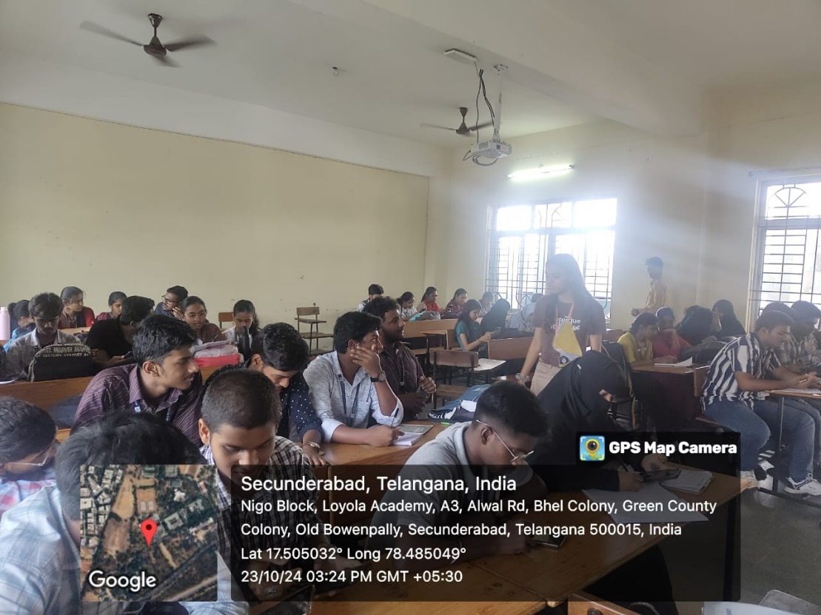
Gallery:

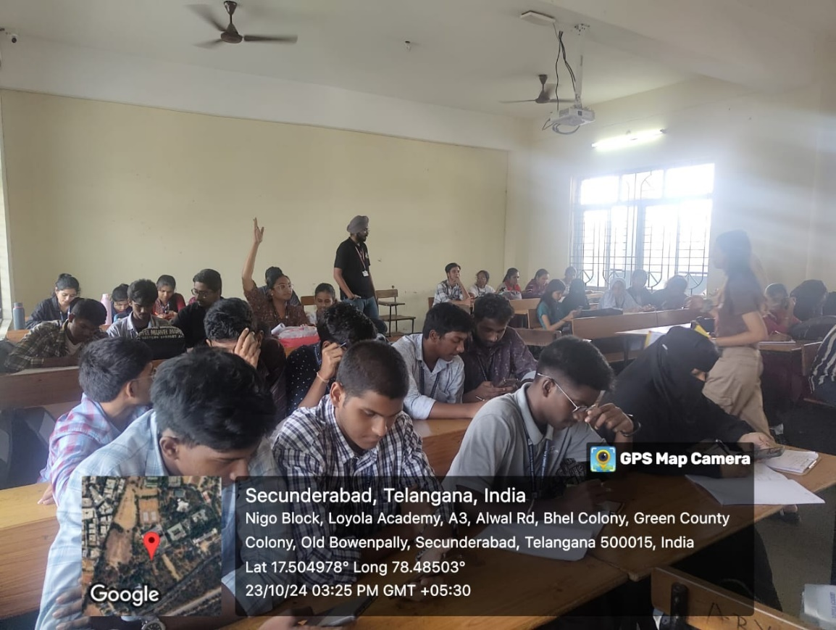

MAGIC Youth and AICUF Club
The MAGIC Youth and AICUF Club at Loyola Academy is a vibrant community where young minds unite with a shared vision of creating a better world. We strive to leave a legacy of compassion, understanding, and transformation. Committed to making a positive impact in society, we organise regular outreach programs to old age homes and orphanages, spreading joy and engaging in interactive activities.
MAGIC stands for "Men and Women Aiming Greater Initiatives for Change," and AICUF stands for "All India Catholic Universities Federation." Both are student wings of YES-J (Youth Empowering Service - Jesuits). This club introduces students to committee activities, offering them a glimpse into the club's functioning while instilling values and perspectives essential for positive progression.

Activities Conducted by the Club:
Throughout the past semester, the MAGIC Youth and AICUF Club actively engaged in various activities, including:
1. Introduction to MAGIC Youth and AICUF
2. Introduction to Social Issues, Social Justice, and Social Activism (through Debate):
3. Developing Empathy and Compassion:
4. Outreach and Community Engagement:
5. Life in the Margins:
6. Social Work, Camps, and Campaigns:

Outcome of the Club:
The MAGIC Youth and AICUF Club aims to empower students to engage in social service, outreach, and advocacy while fostering empathy and understanding for marginalised communities.

Gallery:

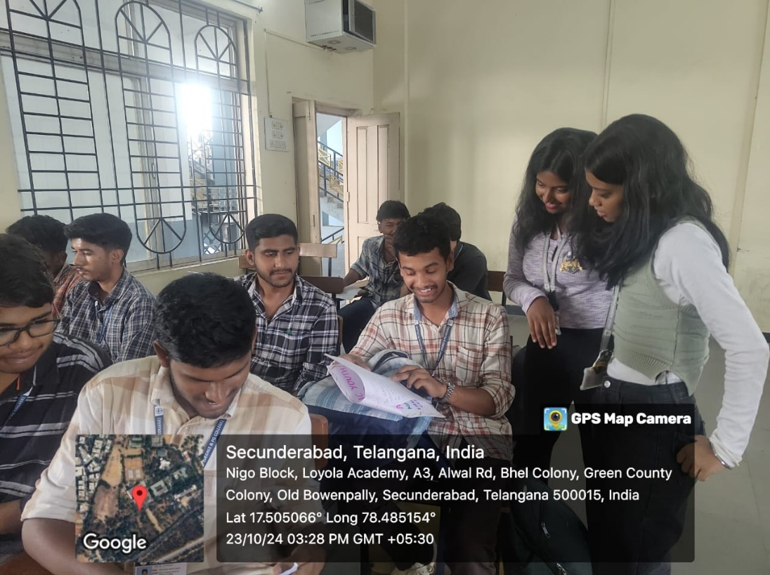

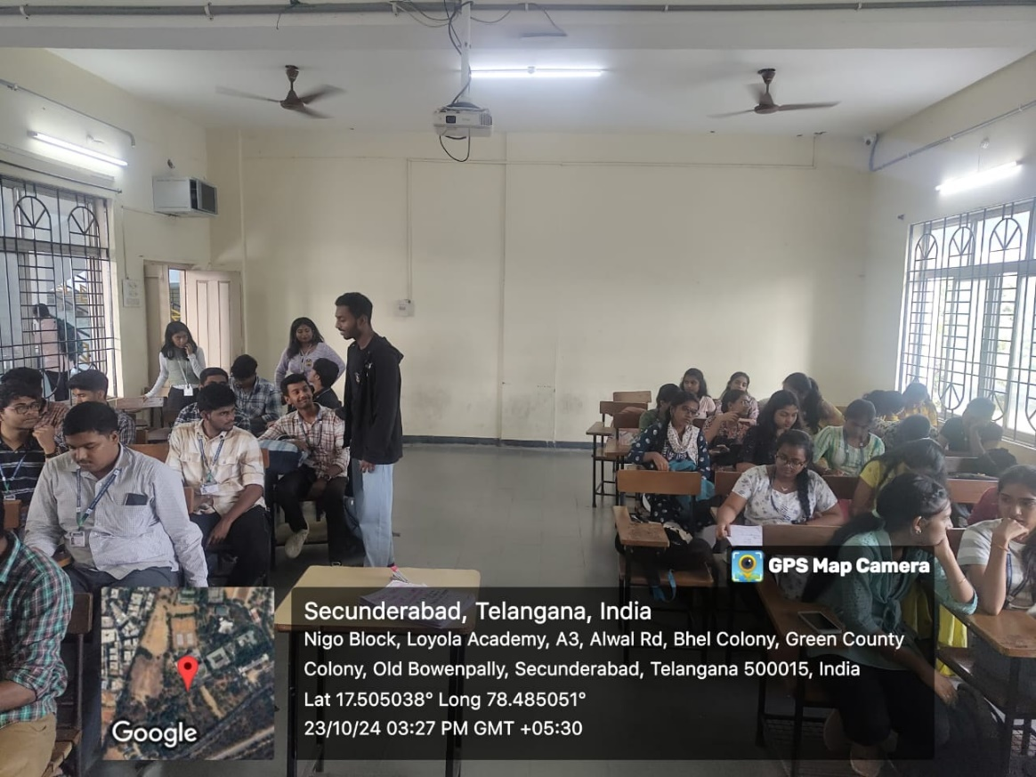

TOURISM CLUB
A tourism club is typically an organization or group dedicated to promoting travel, cultural exchange, and exploration. Members often engage in activities such as organizing trips, hosting events, offering travel advice, and learning about different destinations. These clubs may be found in schools, universities, or as independent entities, and they aim to foster a love for travel while encouraging social interactions and broader cultural understanding.
The objective of a tourism club is to promote travel and cultural awareness by organizing events, trips, and activities that encourage members to explore new destinations, share travel experiences, and learn about diverse cultures. The club aims to foster a sense of adventure, broaden members' perspectives, and create opportunities for social interaction and educational growth through travel-related experiences.

Activities Conducted by the Club:
*Travel Discussions and Planning Sessions
*Dream destination Description
*Presentations

Outcome of the Club:
The outcome of a tourism club includes increased cultural awareness, enhanced travel knowledge, stronger social connections, personal growth, and a sense of adventure. It also provides networking opportunities, promotes sustainable tourism, and encourages community engagement, ultimately broadening members' perspectives and enriching their travel experiences.

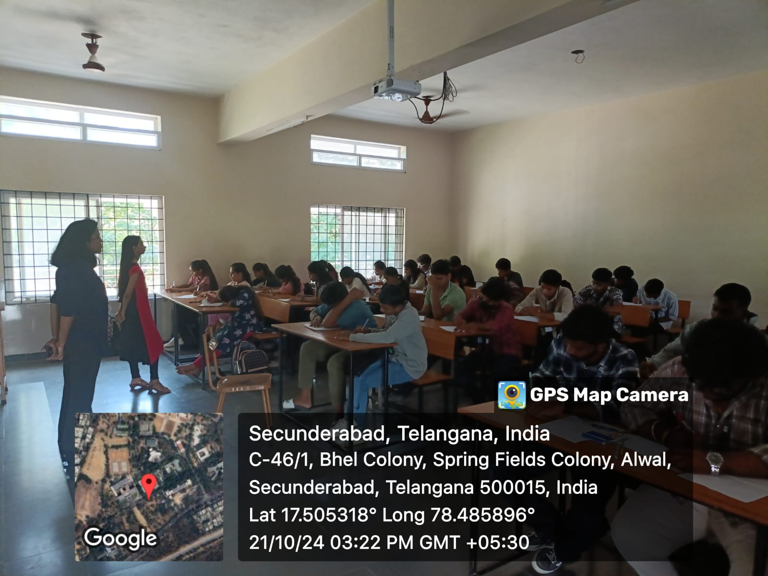
Gallery:

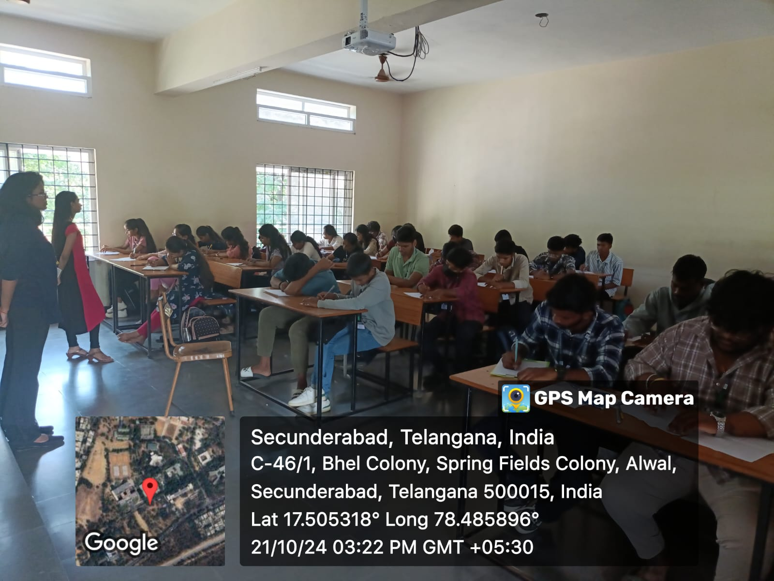

GREEN CLUB
Green club is a group of individuals who are fascinated with environmental activities. It gives an opportunity for everyone to learn about various medicinal and aromatic plants, protests and the importance of a sustainable environment. Green Club gives an opportunity for every individual to write and design essays and posters and helps in better way of eco designing.
The aim of green club is to uplift and inspire the students in green and eco-friendly activities. It helps in acquainting the importance and uses of various plant species.

Activities Conducted by the Club:
1. BYOP: An activity like Haritha haram in which green club students planted their favorite ornamental or flower saplings/plants and explained few important aspects and uses.
2. Eco-designing: An opportunity to design sustainable environment charts and crafts from plastic waste, students designed colorful posters promoting sustainable environment.
3. Green-wear or eco threads: An activity where you can make any part of your outfits or jewellery by using plants, flowers etc., students were given a limited period to create bracelets using flowers and plant parts.
4. Nature photography: students took pictures of the nature and greenery in college premises.
5. Exchange of insights on medicinal and aromatic plants: students were acquainted about various medicinal and aromatic plants.
6. Green themed Essay and poetry competition: students wrote poetries and essays.

Outcome of the Club:
Skill Development: Members improve their technical skills in green including eco-designing and other various aspects that play a crucial role in sustainable environment.
Creativity and Expression: Participants enhance their creative abilities, learning to express their unique perspectives through green club.
Community Building: The club fosters a sense of greenery among members, encouraging collaboration and sharing of ideas.
Critical Thinking: Members develop a critical eye through discussions, reviews, and constructive feedback, helping them analyse both their work and that of others.

Gallery:
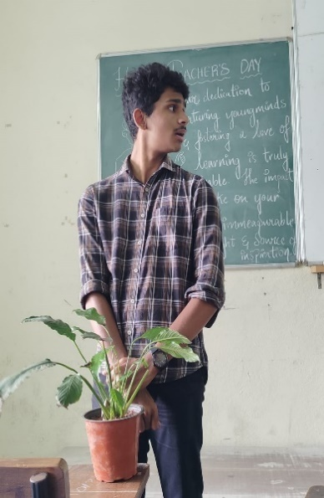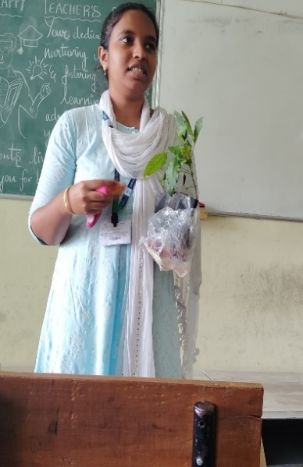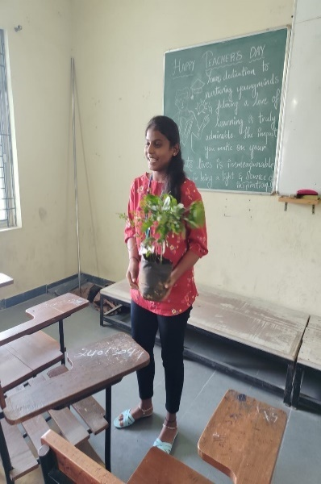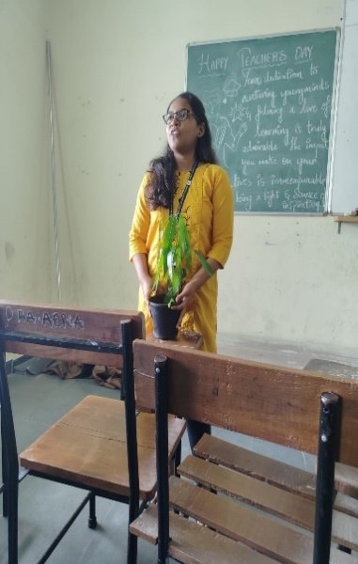
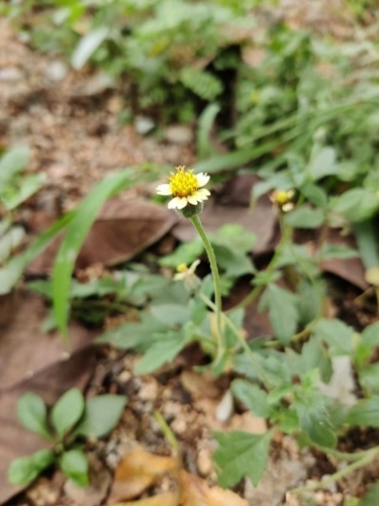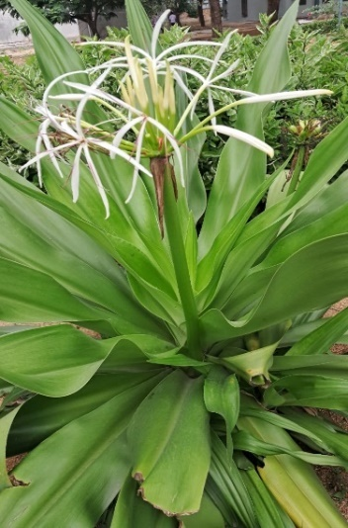

ART CLUB
An Art Club is a group for individuals who share a passion for art and crafts. It is the expression of ideas and emotions through a physical medium, like painting, sculpture, film, dance, writing, photography, or theatre. It helps in participating and learning different techniques like shading, live painting, pencil arts, 3D object creations, Shadow techniques etc. and exhibit their talents by showcasing them in a gallery or exhibitions. The club fosters creativity and collaboration, providing a supportive environment for artists of all levels to express themselves and showcase their work
The aim of an art club is to cultivate a passion for artistic talents among its members. It provides a platform for individuals to improve their skills, share knowledge, and explore different styles and techniques. The club encourages creativity, offers opportunities for collaboration, and often organizes art galleries and exhibitions to showcase members’ work and engage with the community.

Activities Conducted by the Club:
Over the past semester, the club engaged in a variety of enriching activities:
- SHADING TECHNIQUES: We hosted and engaged the session on process of adding layers of medium to create different tones and contrasts to create the illusion of light, space, and forms and worked on Darker areas, Lighter ares, Light patterns, powder shading etc. Techniques.
- GRID ART: Provided knowledge on technique that uses a grid to help them draw images with correct proportions and accuracy. They divide the reference image and their drawing surface into a grid of equal squares.
- OP ART: Activity where participants do a painting that uses shapes, colors, and patterns to create illusions of movement or blurring. This helped them to evoke perceptual illusions, ambiguities, and contradictions in their vision.
- SKETCH ART: A Fun activity on technique that involves creating quick, informal drawings to capture the essence of a subject or idea.
- PENCIL ART: Students have done their assessment in creating drawings made with a pencil, which is a tool made of graphite in a wooden casing.
- OIL PASTELS ART: Learned drawing medium form which consists of pigment mixed with a binder mixture of wax crayons in contrast to other pastel sticks which are made without oil, Creating a Live Portrait.

Outcome of the Club:
Skill Development: Members improve their skills in art and craft, including different techniques like shading, shadow, and blending mixing in creating wonderful visual drawings
Creativity and Expression: Participants enhance their creative abilities, learning to express their unique perspectives through art.
Community Building: The club fosters a sense of camaraderie among members, encouraging collaboration and the sharing of ideas.
Critical Thinking: Members develop a critical eye through discussions, reviews, and constructive feedback, helping them analyze both their work and that of others.
Gallery:
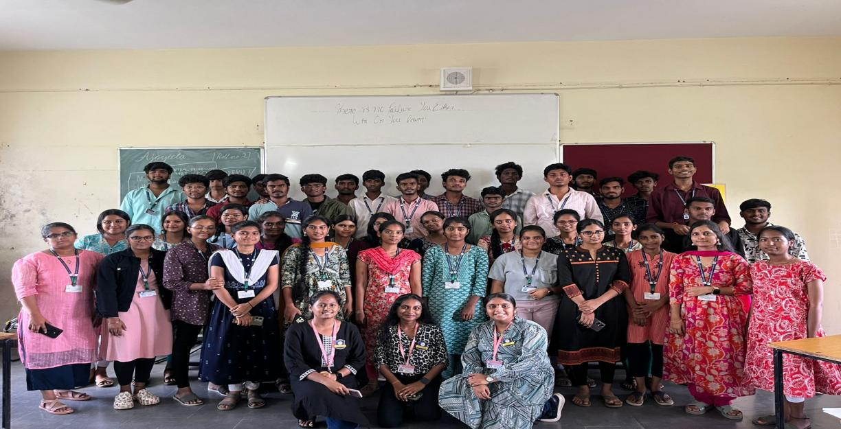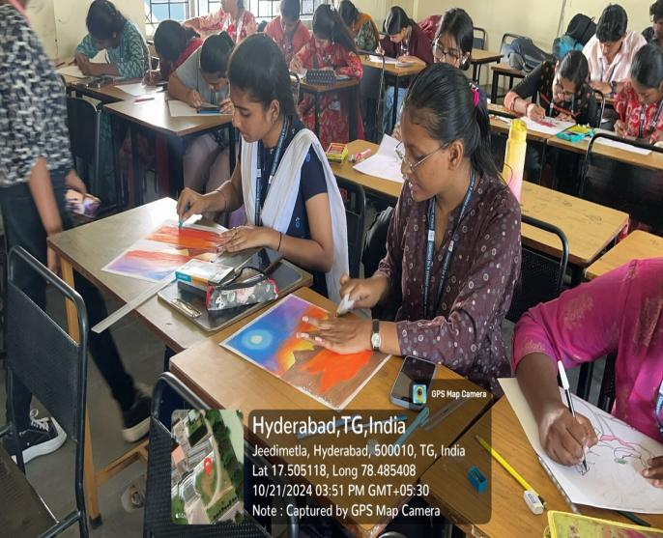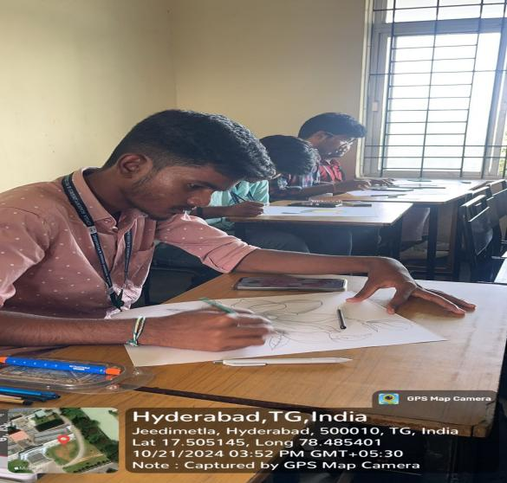

KNOWLEDGE CLUB
The Knowledge Club encourages the exchange of ideas and information among members, promoting critical thinking and discussion. The club fosters networking and collaboration among like-minded individuals and supports personal growth by exposing members to new concepts and ideas. Additionally, it aims to build a sense of community and camaraderie among those who share a passion for knowledge. Guest speakers and seminars are also part of the club's objectives to enhance members' understanding.
The objective of the Knowledge Club is to foster intellectual growth and learning. It aims to expand students' understanding of various relevant concepts in fields such as sociology, politics, environmental science, and technology.

Activities Conducted by the Club:
Debate: Club members engaged in debates on various social and political issues, with coordinators facilitating sessions to help individuals refine their critical thinking and communication skills. The debates encouraged understanding of diverse perspectives, providing a safe space for constructive disagreement.
Elocution: Elocution sessions were held on various topics to help students structure their ideas cohesively. These sessions also aimed to improve pronunciation, articulation, and overall speaking skills, enhancing students' ability to communicate effectively.
Research Training: At the start of each session, students researched the day's topic, learning to differentiate between reliable and unreliable sources and to gather valid, evidence-based information.
Quizzes: Several quiz sessions on current affairs and popular topics were conducted to assess students' knowledge. These sessions reinforced learning, promoted active engagement, and provided immediate feedback, enhancing topic retention and understanding.
Model United Nations (MUN): MUN sessions were organized to cater to students' interest in diplomacy, simulating real-world scenarios. This activity helped students gain a more comprehensive understanding of ongoing issues and develop skills in public speaking, critical thinking, and problem-solving.

Outcome of the Club:
The Knowledge Club provides a conducive environment for growth and learning, facilitating the exchange of diverse ideas and perspectives. It offered a positive space for students to explore complex real-world issues and develop their own informed opinions. Through club activities, students engaged in critical thinking and learned tools to objectively analyze and interpret various concepts and ideas.
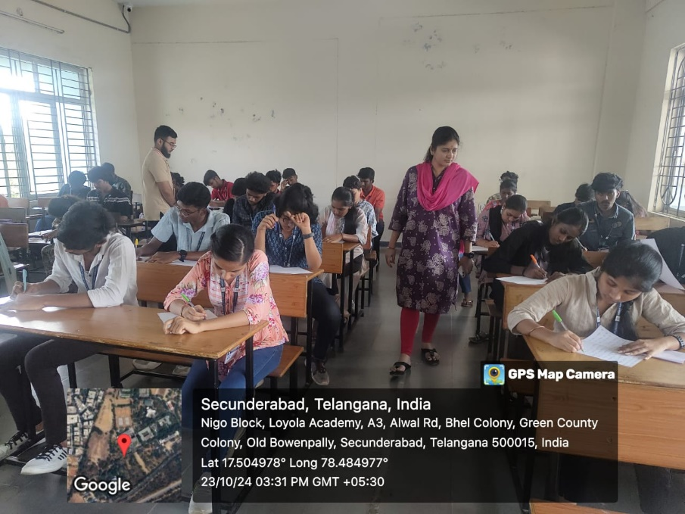
Gallery:
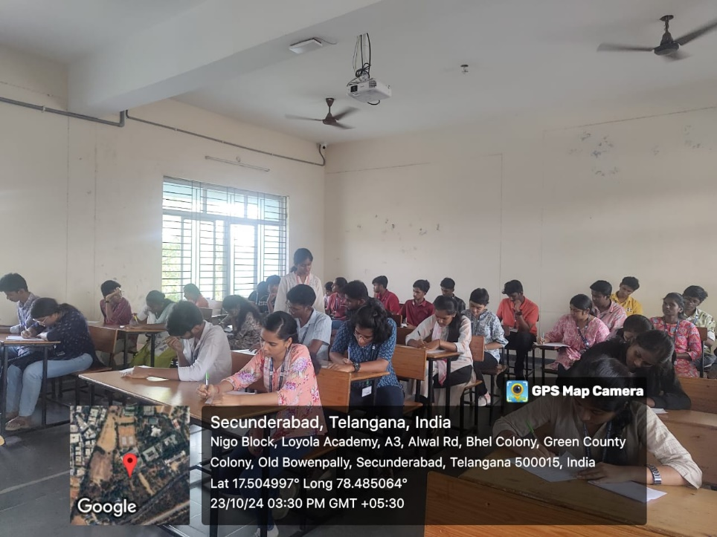
VLOG & BLOG CLUB

Vlog & Blog Club is an extracurricular organization that focuses on creating and sharing digital content through both video blogs (vlogs) and written blogs. It provides a platform for members to explore content creation, storytelling, digital marketing, and multimedia production. Whether it's about sharing personal experiences, discussing a specific niche (e.g., lifestyle, tech, finance, entertainment), or educating others on subjects, the club helps members develop their creative and technical skills.
The aims and objectives of a Vlog Club are focused on helping members develop their skills in content creation, digital storytelling, video production, and social media engagement. The club provides a platform for individuals to express their creativity, collaborate with peers, and gain practical experience in the digital media space.

Activities Conducted by the Club:
- Expression of Creativity
- Career Opportunities
- Community Building
- Blog Writing

Outcome Of the Club:
The outcome of a Vlog Club is that students develop strong skills in video production, editing, and storytelling, while also building a personal brand and online presence. They gain hands-on experience in content creation, enhance their communication and presentation abilities, and learn to engage with audiences through social media. Additionally, the club fosters collaboration, networking opportunities, and the potential for monetizing content, helping members prepare for careers in digital media, marketing, and entertainment.

Gallery:
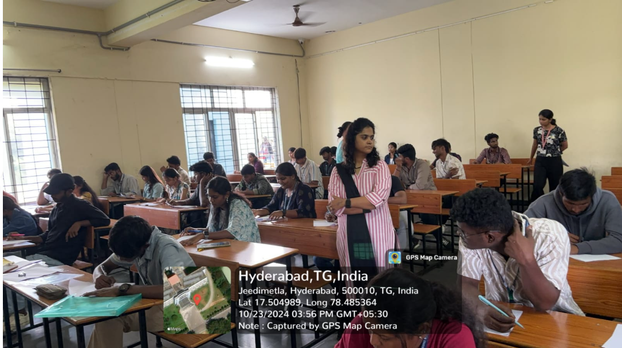
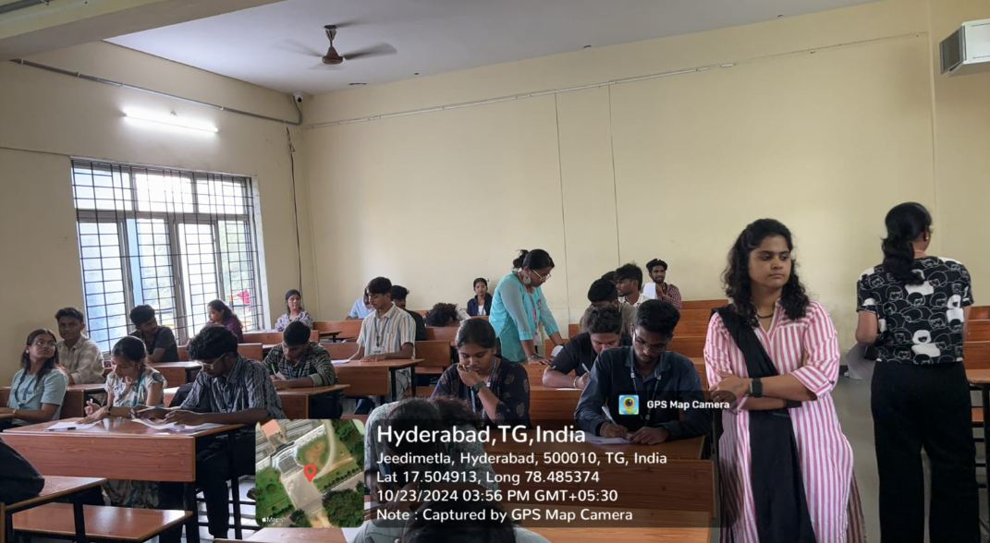
DANCE CLUB

A dance club is a venue or establishment where people gather to socialize, enjoy music, and dance. Dance clubs typically feature a DJ or live music and may focus on a variety of genres, such as electronic dance music (EDM), hip-hop, pop, or even salsa, depending on the theme or target audience. They can range in size from small, intimate venues to large, multi-floor clubs with impressive sound and light systems.
The aim of a dance club is to provide an enjoyable and energetic space for socializing, dancing, and entertainment. It seeks to create a vibrant atmosphere through music and performances, foster social connections, and promote cultural or artistic expression. Additionally, dance clubs aim to generate revenue while offering a safe, inclusive environment for all patrons.

Activities Conducted by the Club:
*Dance battle
*Dance Showcase
*Choreography Challenge
*Different Dance Forms

Outcome of the Club:
The outcome of a dance club is a lively, engaging social environment where people can enjoy music, dance, and connect with others. It fosters a sense of community, promotes cultural and artistic expression, and contributes to the local nightlife scene. Additionally, dance clubs generate revenue, support emerging talent, and provide a platform for creative experiences.

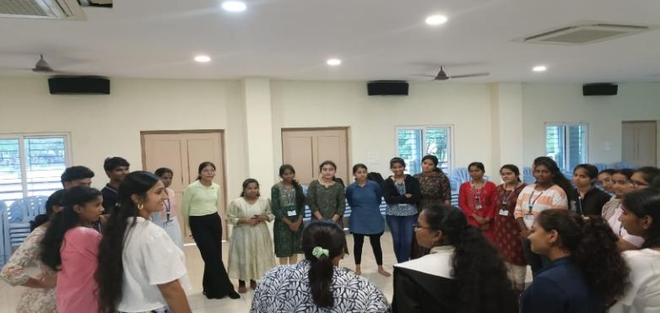
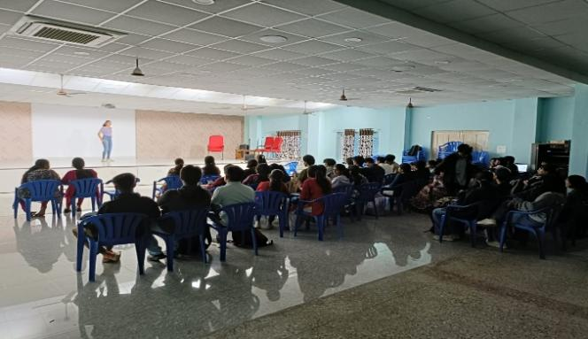
Gallery:
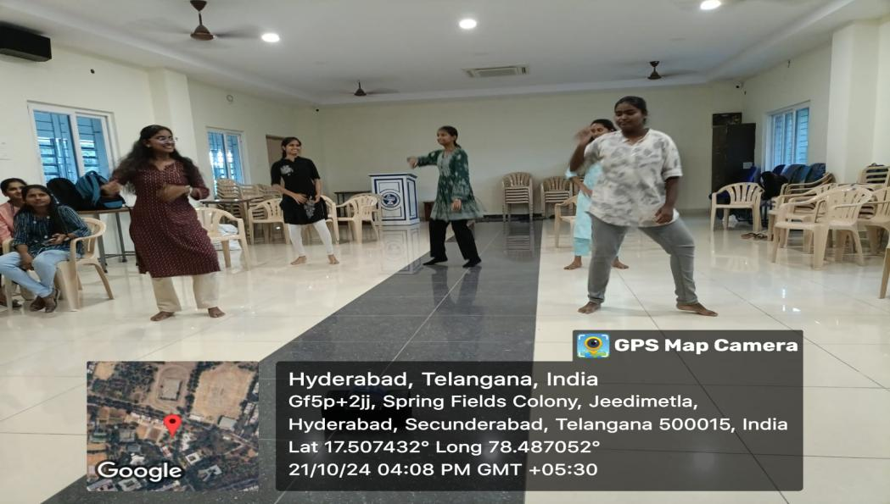

LITERATURE & BOOK CLUB
The Literature and Book Club is a group of students who come together to explore various literary works and enhance their reading and analytical skills. This club organizes discussions, book readings, and other interactive activities for students across departments, aiming to deepen their understanding and appreciation of literature. It cultivates a thoughtful and talented group of students with a wide knowledge of different literary genres and themes.
The aim of the Literature and Book Club is to foster a love for reading, encourage critical thinking, and stimulate curiosity about different cultures, perspectives, and ideas. The main objective is to broaden literary awareness and improve students’ analytical abilities. The club intends to empower students with knowledge through engaging in meaningful discussions and exploring diverse literary works. It strives to introduce something fresh and thought-provoking with each session.

Activities Conducted by the Club:
Over the past semester, the club engaged in a variety of enriching activities:
Bookmark Making: The students were given themes based on which they were asked to make bookmarks. Their bookmarks conveyed various messages.
Anime Quiz: Students were divided into groups and challenged to frame questions related to popular anime. They later asked each other these questions, and the group with the most points won.
Story writing: The students were asked to write their favorite characters and divided into teams. Then they were asked to write a story using the characters of their teammates
Charades: This was a fun activity that was conducted through which students learned new words. They were divided into teams and asked to act out certain words that the other team guessed through their actions.
Aspire to Inspire: It was a fun public speaking activity that was conducted in which the students wrote something inspirational on chits then these chits were distributed and the selected person had to convey something about the chit that he or she received
Movie Review: Students were given various genres to choose from after which they gave movie reviews as a group in a creative and inspirational way.

Outcome of the Club:
Academic achievements: -Students can improve their academic achievements by integrating literary club activities into the curriculum
Leadership skills: -Students can develop their leadership skills and learn to organize academic, social, and cultural events
Logical thinking: -Students can learn to think logically through activities like book reviews and quiz competitions
Analytical and creative thinking: -Students can learn to analyze and appreciate different types of literature
Communication skills: -Students can improve their ability to express themselves through group discussions, debates, and other activities

Gallery:
