A. CONCEPT OF TWINNING PROGRAMME
The Twinning Programme concept is yet another innovation of the Pondicherry University’s Directorate of Distance Education. It envisages a tie-up between the Directorate of Distance Education, Pondicherry University and another College/ Institution of repute. In this mode, the University enters MoU with prestigious Institutions endowed with human and physical resources and having excellent learning ambience.
These partner Institutions/ Colleges are referred as TWINNING CENTRES of the Directorate of Distance Education, Pondicherry University. The Twinning Centres organize all the important tasks on behalf of the University including admissions, conduct of classes during week-ends, semester examinations and liaisoning with the University in a more structured fashion under the strict supervision and guidance of the Pondicherry University.
The marked difference between the conventional Distance Education Programmes and the Twinning Programme is that classes in the former mode are conducted for Eight days in a semester (Personal Contact Programme) while classes are conducted more frequently during the evening hours and week-ends throughout the semester in the latter mode at the Twinning Centres
11. Loyola Academy
(Established in the Year 1978)
PUDDE – Twinning Programme
Old Alwal, Secundrabad – 500010
Mobile No. 08309244661 E-mail: twinning@loyolaacademy.edu.in
Director : Rev.Fr .Dr A.M Josph Kumar SJ, Vice Principal. Schol of Management

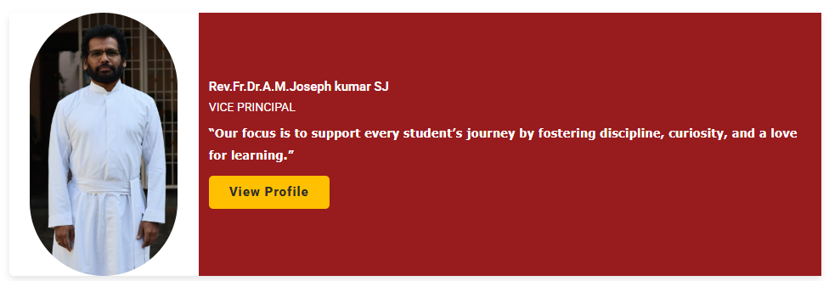

Coordinator : Dr Narasimha Raju Chevula
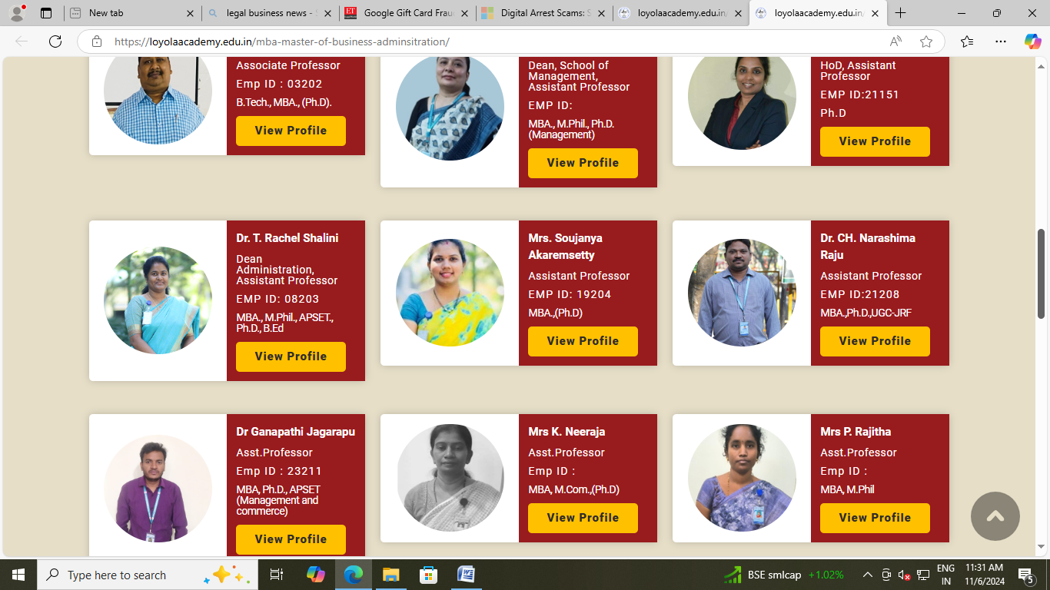

S.No. | Academic Year | No. of Admissions
1 | 2022-2024 | 55
2 | 2023-2025 | 37
3 | 2024-2026 | 49
4 | 2025-2027 | 48

I st batch started in 2021 July (2021-2023)
Total no students admitted in 2021 July : 55
SNO | FORM NUMBER | Enrolment no | PROGRAMME NAME | NAME OF THE APPLICANT
1 | PUDDE22002588 | 6822390001 | MBA HRM | AMARNATH REDDY LAVANURU
2 | PUDDE22008289 | 6822390002 | MBA HRM | POOJA
3 | PUDDE22009137 | 6822390003 | MBA HRM | NIHARIKA
4 | PUDDE22009099 | 6822390004 | MBA HRM | SHULAMITHI GUNDE
5 | PUDDE22009069 | 6822390005 | MBA HRM | SK SHAHEEN
6 | PUDDE22009024 | 6822390006 | MBA HRM | KV JITEESH NAMBIAR
7 | PUDDE22008892 | 6822390007 | MBA HRM | RUDRAVALAMBI TEJASVI
8 | PUDDE22007947 | 6822390008 | MBA HRM | MATSA SIVA
9 | PUDDE22007780 | 6822390009 | MBA HRM | M SUSHMA
10 | PUDDE22007311 | 6822390010 | MBA HRM | P PHANI SANKAR POGARU
11 | PUDDE22005394 | 6822390011 | MBA HRM | KAKI GUNAVARDHINI
12 | PUDDE22008828 | 6822390012 | MBA HRM | SUJATA
13 | PUDDE22008801 | 6822390013 | MBA HRM | STEFFI FLORENCE
14 | PUDDE22009388 | 6822390014 | MBA HRM | THUMMA JOSHVA
15 | PUDDE22009578 | 6822390015 | MBA HRM | YERUVA HRUDAY KUMAR REDDY
16 | PUDDE22010207 | 6822390016 | MBA HRM | JUKANTI SAI SRINAVAS
17 | PUDDE22010201 | 6822390017 | MBA HRM | S JOSEPH
18 | PUDDE22010355 | 6822390018 | MBA HRM | KANTHALA AJAY REDDY
19 | PUDDE22007066 | 6822370001 | MBA FM | KATRAPATY RAMA KRISHNA
20 | PUDDE22009121 | 6822370002 | MBA FM | AKANA ABHILASH JEDIDIAH
21 | PUDDE22009113 | 6822370003 | MBA FM | BINSON MATHEW
22 | PUDDE22009098 | 6822370004 | MBA FM | REDDY GIRISHMA
23 | PUDDE22008164 | 6822370005 | MBA FM | AKBAR ALI K
24 | PUDDE22007615 | 6822370006 | MBA FM | SIRI MANVITHA
25 | PUDDE22002129 | 6822370007 | MBA FM | RAJU RATLAVAT
26 | PUDDE22000581 | 6822370008 | MBA FM | ANIL KUMAR PACHCHAVA
27 | PUDDE22008416 | 6822370009 | MBA FM | KADHA SEKHAR
28 | PUDDE22000006 | 6822370010 | MBA FM | SOURABH KUMAR THAKUR
29 | PUDDE22007337 | 6822370011 | MBA FM | RAMAKRISHNA SSVS ADDANKI
30 | PUDDE22009464 | 6822370012 | MBA FM | THOKALA SAI REDDY
31 | PUDDE22009431 | 6822370013 | MBA FM | YERUVAPAULPREETHAM
32 | PUDDE22009685 | 6822370014 | MBA FM | BODDUNA MARY MALA
33 | PUDDE22009929 | 6822370015 | MBA FM | DEEPAK KUMAR SINGH
34 | PUDDE22010036 | 6822370016 | MBA FM | YALLAPU SHANMUKHA KUMAR
35 | PUDDE22010144 | 6822370017 | MBA FM | ASHA JYOTHI MUPPIRISETTI
36 | PUDDE22010236 | 6822370018 | MBA FM | MANOJ KUMAR
37 | PUDDE22010245 | 6822370019 | MBA FM | THIRUMALAREDDY PRAVALIKA
38 | PUDDE22008960 | 6822360001 | MBA MM | LEEPHALIN MARY KAAVYA
39 | PUDDE22007801 | 6822360002 | MBA MM | SHAIK MOHAMMED FARAZ MAHABOOB
40 | PUDDE22007758 | 6822360003 | MBA MM | M V SURYA PAVN
41 | PUDDE22009887 | 6822360004 | MBA MM | RAMYA PUDARI
42 | PUDDE22010037 | 6822360005 | MBA MM | KEROOR SHIVA KUMAR
43 | PUDDE22008403 | 6822380001 | MBA IB | NAVYA SREE
44 | PUDDE22009977 | 6822380002 | MBA IB | ROJA
45 | PUDDE22008962 | 6822430001 | MBA GENERAL | ASHOK KUMAR PILLA
46 | PUDDE22008236 | 6822430002 | MBA GENERAL | MOHAMMED MUHSIN K P
47 | PUDDE22009264 | 6822430003 | MBA GENERAL | TATA KEERTHANA
48 | PUDDE22009382 | 6822430004 | MBA GENERAL | ASWIN ASHOK
49 | PUDDE22009723 | 6822430005 | MBA GENERAL | SAAD
50 | PUDDE22009670 | 6822430006 | MBA GENERAL | SANKU THRIMURTHULU
51 | PUDDE22009009 | 6822470001 | MBA SCM | KONDRA NEERAJ KUMAR
52 | PUDDE22008243 | 6822470002 | MBA SCM | CHANDA BHANUJA
53 | PUDDE22007543 | 6822470003 | MBA SCM | UDITYENDU MAHAPATRA
54 | PUDDE22004970 | 6822470004 | MBA SCM | KANDURI PAVAN KUMAR
55 | PUDDE22004875 | 6822470005 | MBA SCM | KALYANA CHAKRAVARTHI JAMMULA

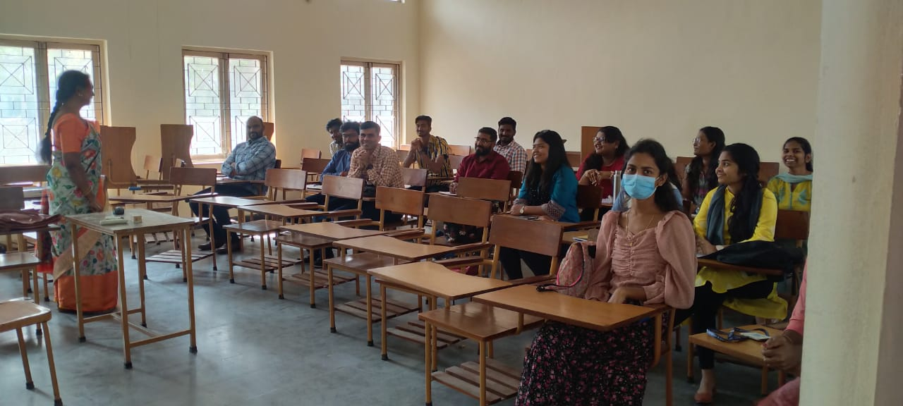

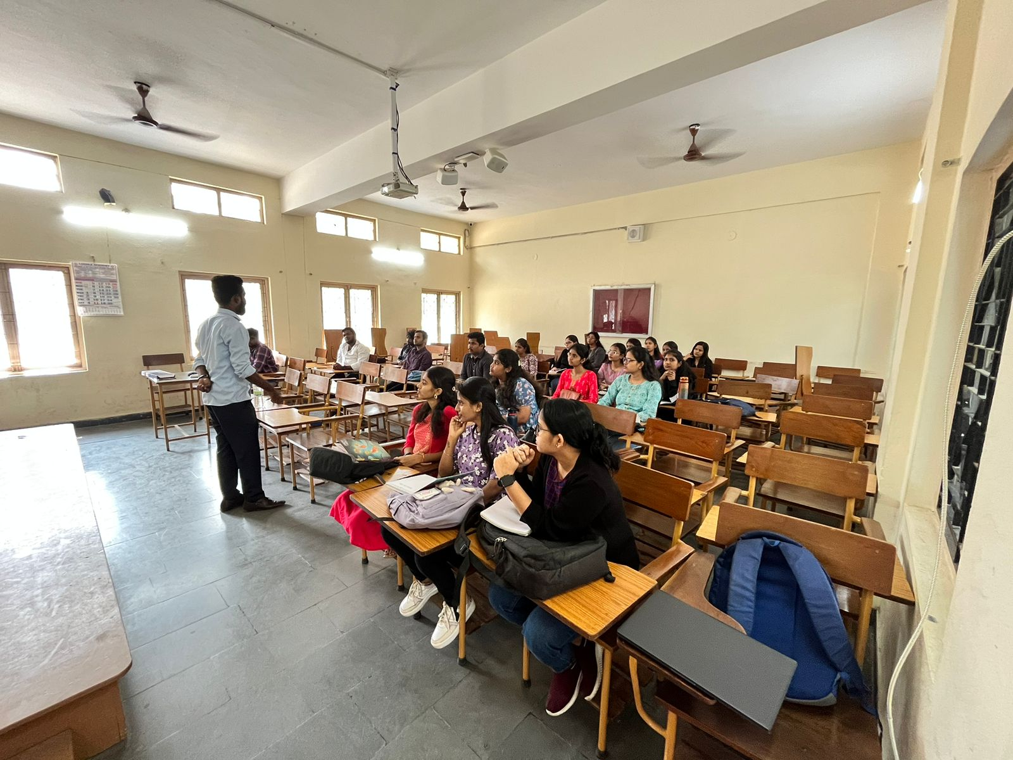
2 nd batches started in 2021 July (2023-2025)
Total no students admitted in 2023 July : 37
SNO | FORM NUMBER | ENROLMENT NUMBER | PROGRAMME | NAME OF THE APPLICANT
1 | PUTWN230006297 | 6823360001 | MBA MARKETING | DOWRI AMBIKA
2 | PUTWN230006813 | 6823360002 | MBA MARKETING | PARNANDI SAI VAMSHI SHARMA
3 | PUTWN230006977 | 6823360003 | MBA MARKETING | KAVALA STALIN
4 | PUTWN230007119 | 6823360004 | MBA MARKETING | ALWAL DHEERAJ
5 | PUTWN230007124 | 6823360005 | MBA MARKETING | P SOWMYA
6 | PUTWN230007358 | 6823360007 | MBA MARKETING | BYRHI AKSHAYA BANU
7 | PUTWN230007396 | 6823360006 | MBA MARKETING | RINKU CHOUDARY
8 | PUTWN230007453 | 6823360008 | MBA MARKETING | VANITHA CHINTALA
9 | PUTWN230002069 | 6823370002 | MBA FINANCE | ACHUKATLA SHAIKSHABI
10 | PUTWN230004691 | 6823370001 | MBA FINANCE | AREM ANKITHA
11 | PUTWN230005091 | 6823370003 | MBA FINANCE | DEVARAKONDA SAI VIHARI
12 | PUTWN230003461 | 6823370005 | MBA FINANCE | KOTTALA MAHITHA
13 | PUTWN230004500 | 6823370004 | MBA FINANCE | KALASIKAM SAI GEETHA
14 | PUTWN230006562 | 6823370007 | MBA FINANCE | GOWRIYAGARI PAVANI REDDY
15 | PUTWN230006563 | 6823370006 | MBA FINANCE | ETIKALA ARUN REDDY
16 | PUTWN230006812 | 6823370008 | MBA FINANCE | D V NIHARIKA
17 | PUTWN230006921 | 6823370009 | MBA FINANCE | R SANJANA
18 | PUTWN230007146 | 6823370010 | MBA FINANCE | SONALI KUMARI SINGH
19 | PUTWN230007182 | 6823370011 | MBA FINANCE | LAKKI REDDY SUPRIYA
20 | PUTWN230007232 | 6823370012 | MBA FINANCE | BHAVANA
21 | PUTWN230006919 | 6823370014 | MBA FINANCE | GADDAM SUPRIYA
22 | PUTWN230007275 | 6823370013 | MBA FINANCE | BANDI. UDAY KUMAR
23 | PUTWN230007445 | 6823370015 | MBA FINANCE | SREE VARSHA
24 | PUTWN230007683 | 6823370016 | MBA FINANCE | MD MUZEEB PASHA
25 | PUTWN230007789 | 6823370017 | MBA FINANCE | JOSEPH EMMANUEL FINNY JOSHUA
26 | PUTWN230007072 | 6823380001 | MBA FINANCE | VERAVELLY NAVYA SRI
27 | PUTWN230002214 | 6823390001 | MBA HRM | MANDAPATI VIJAYA RIYONA REDDY
28 | PUTWN230005892 | 6823390003 | MBA HRM | PREETHI SWAMY
29 | PUTWN230005916 | 6823390002 | MBA HRM | SINGI REDDY BHAVANI REDDY
30 | PUTWN230000542 | 6823390004 | MBA HRM | LAGISHETTY SAMYUKTHA
31 | PUTWN230007149 | 6823390006 | MBA HRM | AYESHA SIDDIQA
32 | PUTWN230007162 | 6823390005 | MBA HRM | SHAIK SEEMAN SULTHAN
33 | PUTWN230007173 | 6823390007 | MBA HRM | BHIMATHATI KEERTHANA
34 | PUTWN230007304 | 6823390008 | MBA HRM | MANSI KUMARI
35 | PUTWN230007425 | 6823390010 | MBA HRM | KALLA VINAY
36 | PUTWN230007444 | 6823390009 | MBA HRM | NARLA SRIKANTH
37 | PUTWN230007853 | 6823390011 | MBA HRM | VADDARAJU SAI KRISHNA RAJU
