Report on Remedial Classes
2023-2024

Loyola Academy (Autonomous) A “College with Potential For Excellence” by UGC
Affiliated to Osmania University Established in 1978
Old Alwal,Secunderabad-500010


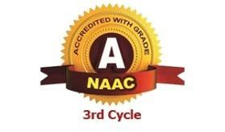


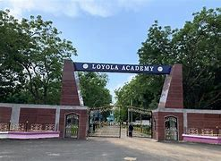
INDEX

SNO | REMEDIAL DATA | PAGENOS
1 | Objectives of Remedial classes | 3-4
2 | Department wise Classes Conducted and Reports | 5-43
3 | Department wise total number of students attended strength | 10-42
4 | Department wise faculty list who took the remedial classes | 58-60
5 | Remedial classes result | 44-45
6 | Conclusion | 60

Remedial report 2023-24
Report on How the Institution Assesses Learning Levels of Students and Organises Special Programs for Advanced Learners and Slow Learners

The institution focuses on assessing learning levels of students and thereby, identify those that are advanced learners and those that are slow learners. Following this, special programs are organised for advanced learners and slow learners to help utilise their potential.

It has been a practice of the department to train students in the areas of communication skills, personality development, time management and organise motivational sessions every year. Furthermore, to motivate both the advanced and slow learners, workshops are organised aiming to enhance the students’ skills. Moreover, guest lectures are arranged for the students to help them gain industrial and practical knowledge from experts.

The assessment of learning levels is primarily based on students’ performance in internal assessment exams, university examinations and classroom involvement and interaction. Based on this assessment, the institution takes steps to organise special programs for advanced learners and slow learners. This is further elaborated below.
Objectives
Slow Learners:
For slow learners, remedial coaching is given under personal mentoring. Remedial teaching involves re-teaching concepts to students using techniques and methods that would facilitate understanding. The students are also motivated with extra care and special initiatives. Further, the students’ performance is monitored and is communicated to parents along with their attendance. They are also given personal attention from faculty to help them overcome any difficulty they might be facing academically. Also, the students are provided with course notes, especially for the slow learners and those at the verge of dropping out due to arrear subjects. The faculty also provide them with a university question bank and discuss with them the ways in which they can present answers in the examination, to help the students score better.

Among slow learners, students who belong to a rural background and had Telugu as the medium of instruction so far, are made to sit closer to the front and special attention is given to them. They are also given assignments on different topics, instructed to refer books and finally submit a written report on the topics. Moreover, faculty members ensure revision of topics of difficulty as per students’ requisition.Additionally, extra classes are conducted to clarify students’ doubts and critical topics are re-explained to facilitate understanding. Besides, appropriate counselling with additional teaching is undertaken, which eventually results in students’ regular attendance of classes. In addition, mutual helpfulness among students is encouraged so that they can help each other learn.

Advanced Learners:
When students are identified as advanced learners, they are encouraged to take part in workshops, seminars, group discussions and quiz to help them develop their analytical and problem-solving abilities. Advanced learners are also encouraged to participate in other institutions in all academic competitions like quiz, case study analysis, preparation of business models etc. In addition, students also actively participate in various clubs such as innovation and incubation clubs. Furthermore, students also present papers and write articles for department journals. Also, the students are provided with opportunities to develop their creativity through organising and participating in intercollegiate seminars and conferences. They are also encouraged to take up NPTEL courses to gain additional knowledge.
Students who are interested in pursuing higher education approach,the respective subject lecturers will provide guidance in preparing for entrance exams for higher educational institutions. In addition, students are guided to attend various seminars, workshops, motivated to present papers and posters at various events. Advanced learners are also encouraged to take competitive exams and they are helped to prepare for the same.

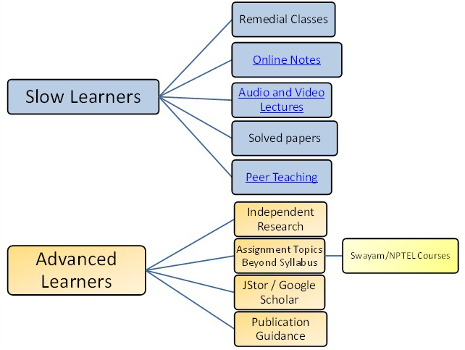

The following is an account of certain departments pertaining to assessment of learning levels and organising programs for advanced learners and slow learners:

Department of B.Com - International Accounting and Finance (IAF):

The department of B.Com International Accounting and Finance conducts an orientation program regarding the ACCA course and its framework by ISDc Hyderabad for the first year students. This dept implemented individual based teaching and skill based teaching for better understanding of students.

Advanced Learners:
Advanced learners are encouraged to take the ACCA online exam and clear the F-level papers. In order to help them prepare for the same, the department conducts 60 hour tutorial classes where ACCA professionals teach and guide the students. Additionally, several mock tests are conducted in the college campus itself to facilitate preparation for those appearing for the ACCA online exam. In addition to the above, the students are also encouraged to take competitive exams like GATE, GRE, TOEFL, IELTS, CAT, PGCET etc. Additionally, students who are interested in pursuing higher education approach, the respective subject lecturers will provide guidance on preparing for entrance exams for higher educational institutions, especially provide coaching for ICAR (Indian Council of Agricultural Research) M.Sc. entrance exams.

Slow Learners:
The faculty of the department tries to build confidence in students who are slow learners to take the ACCA online exam. Such students are given regular class tests to help improve their performance in the university exam. They are also given assignments on different topics and instructed to refer books and finally submit a written report on the topics. These topics are also discussed in practical classes to facilitate better understanding. Moreover, regular slip tests are conducted to assess the students’ performance. Following the declaration of the results of the Semester-end examination, remedial coaching is provided during the sixth hour for the students who have failed, besidesto help preparing students to answer a variety of questions.They are provided with previous years question papers and made to practice answers to the questions. Furthermore, parents are also notified regarding students’ performance and asked to take special care wherever needed.

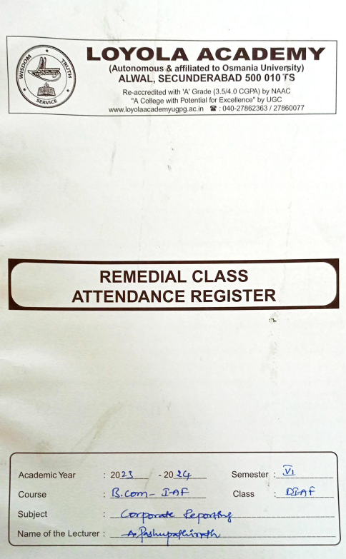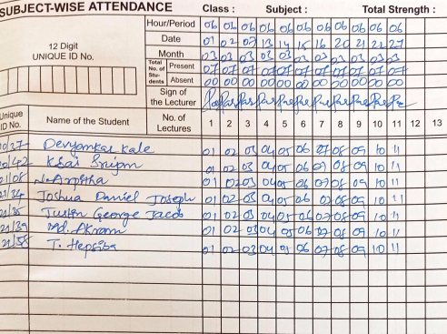

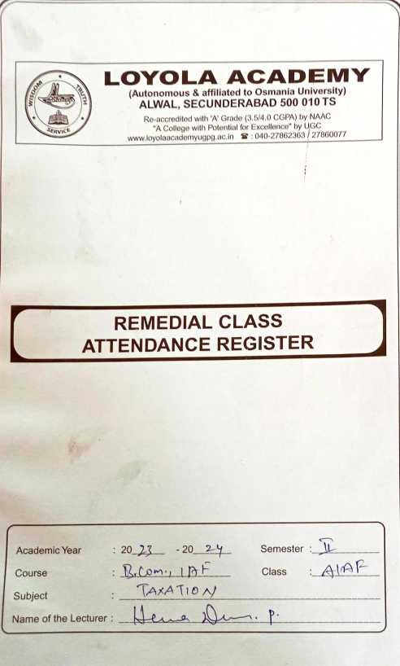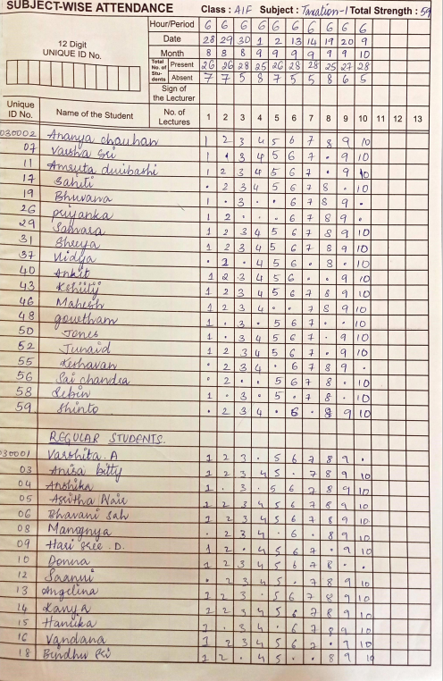
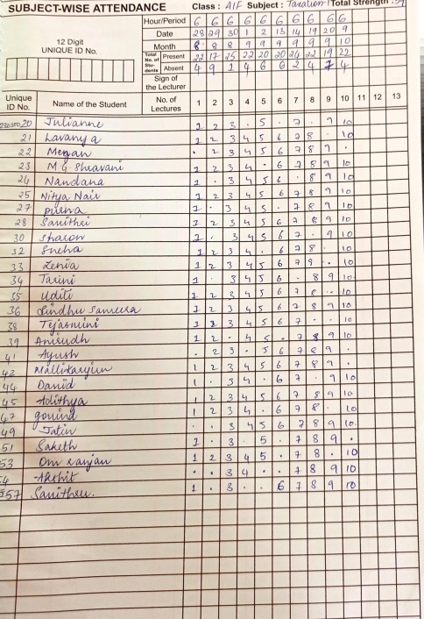
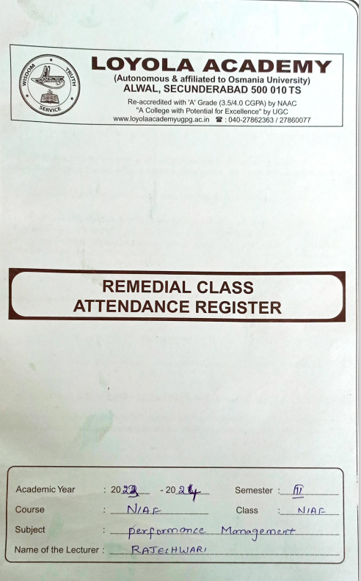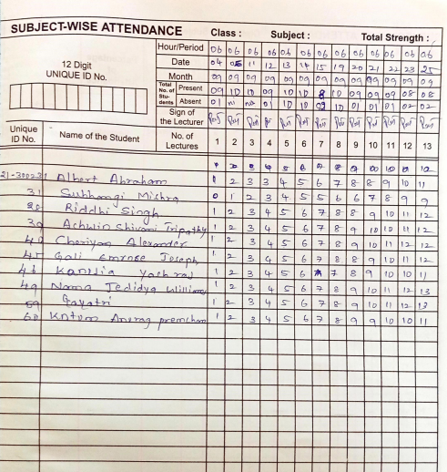

Department of B.Sc - Computer Science and Engineering:

Computer Science and Engineering (CSE) is a field of study that combines principles and practices of both computer science and engineering to develop innovative solutions for a wide range of technological problems. The field is concerned with the design, development, and implementation of software and hardware systems that enable the efficient and effective processing of information.
This dept implemented individual based teaching and for better understanding of students.

Slow Learners:
The department assists slow learners by re-explaining the important topics from the syllabus in an easier manner. Remedial teaching is the use of activities, techniques, and practices to help students overcome any sort of difficulty they might be facing, that could be prohibiting their academic progress and giving them personal attention for better academic performance.

Advanced Learners:
The department helps advanced learners hone their abilities and helping the students by giving additional material, encouraging students to develop web sites, and designing coding on graphic environment using programming languages.

DCS
Department of B.Sc Computer Science and Engineering has Conducted Remedial Classes for the students of DCS on Web Technology and Advanced Java subjects in the year of 2023-24,semester-V, for better understanding

Total number of students attended for these classes are 15 students
Outcome: All the students got 100%results

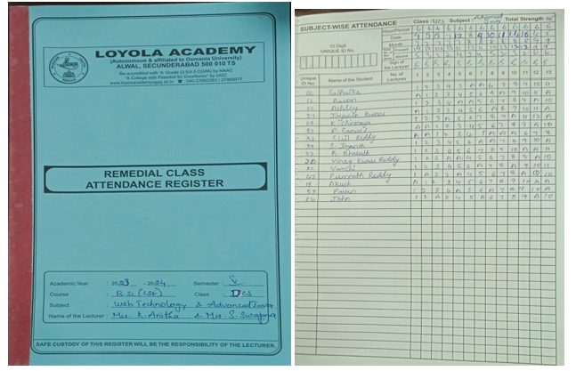
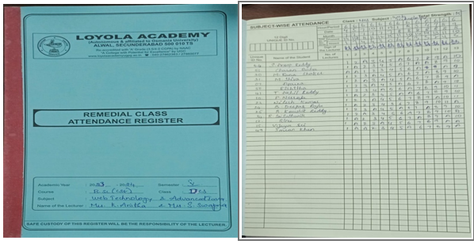
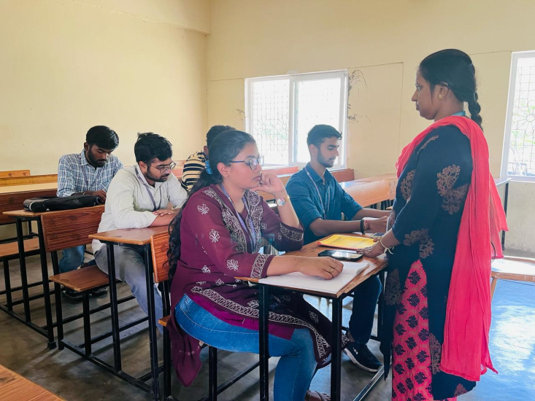
NCS
Department of B. Sc Computer Science and Engineering has Conducted Remedial Classes for the students of NCS on Operating Systems ( SEM III) , ECM(SEM III) and DBMS (SEM IV) , Computer Organization (SEM IV)subjects in the year of 2023-24 for better understanding

Total number of students attended for these classes are 15 students
Outcome: All the students got 100%results

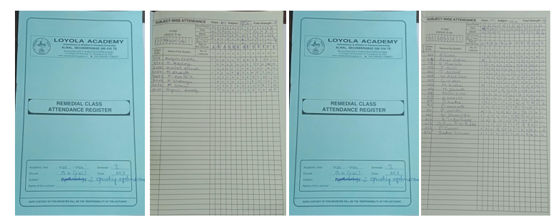
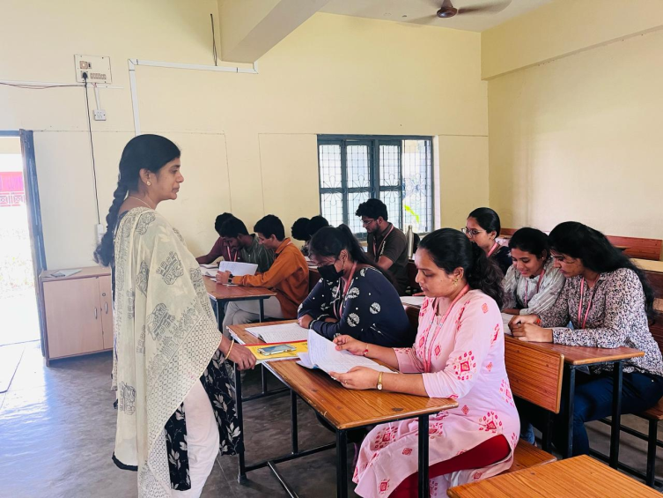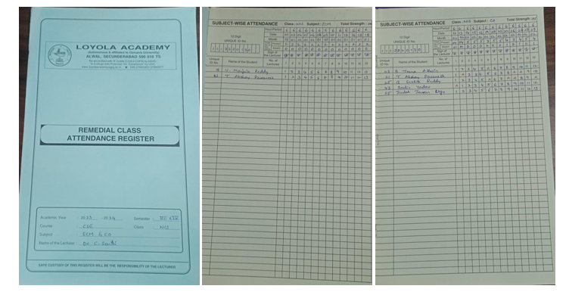
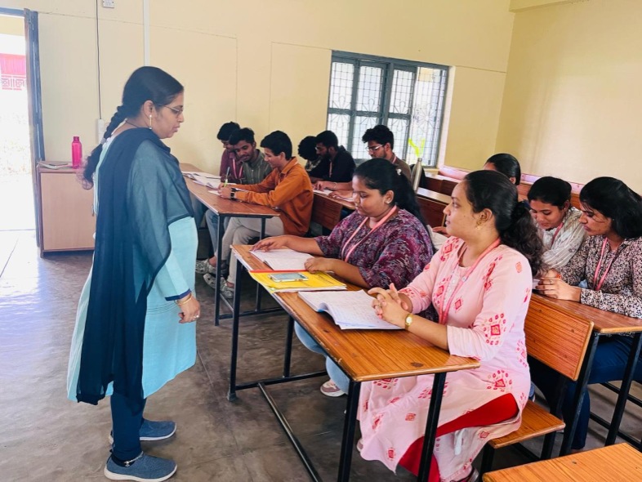
ACS
Department of B. Sc Computer Science and Engineering has Conducted Remedial Classes for the students of ACS on EDC,MATHS ,C and ENGLISH subjects in the year of 2023-24,Semesters-I , for better understanding.

Total number of students attended for these classes are 13 students

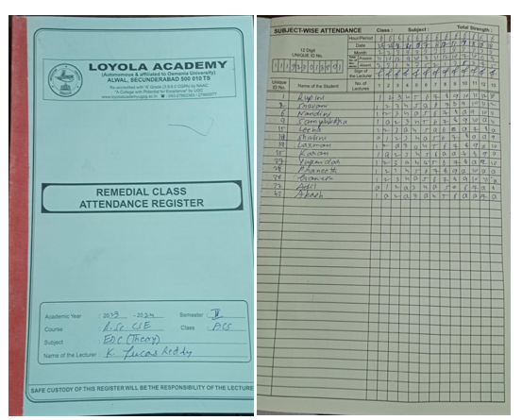

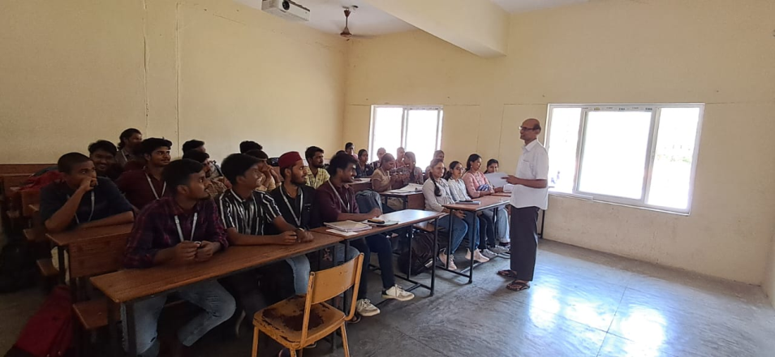

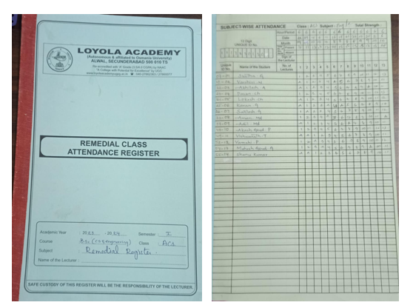

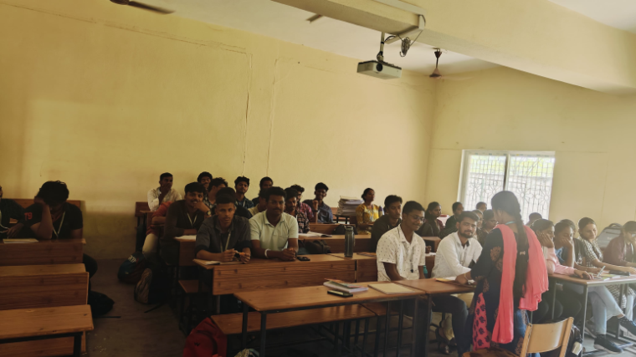
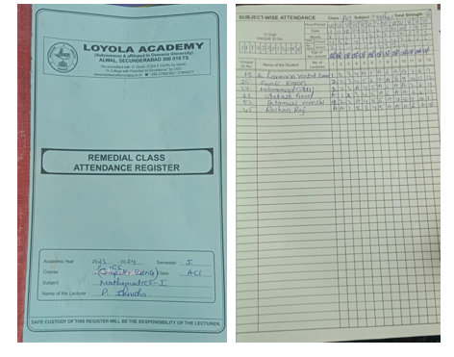
Department of B.Com - Business Process Management:

Business Process Management (BPM) is a management approach that involves the analysis, design, implementation, and optimization of business processes within an organization. It aims to improve the efficiency and effectiveness of an organization's operations by identifying and eliminating redundant activities, improving communication and collaboration among employees, and enhancing the overall quality of products and services.
BPM involves a cyclical process of identifying business processes, analyzing and redesigning them for efficiency, implementing the changes, monitoring and measuring performance, and continuously improving the processes over time.
This dept implemented individual based teaching and skill based teaching for better understanding of students.

Slow Learners:
Slow learners are provided with remedial coaching in areas of difficulty. Further, the sessions are made more interactive to increase student interaction and thereby, facilitate understanding. Students are also encouraged to help each other and through this, understand concepts better.

Advanced Learners:
Advanced learners are encouraged to take up independent research that permits them to know and understand a topic in depth. The department also encourages students to do research on autobiography of famous Entrepreneurs. Additionally, the faculty encourage students to take Professional exams like CA and CMA.

DATA ANALYSIS CONTEST: The department of B.Sc. Computer Data Science & Data Analytics Engineering had conducted a contest on ‘Data Analysis on Covid-19 Dataset’ from 13 June 2020 to 28 June 2020 in association with Data Computing. The key objective of the contest is to bring self-awareness among the students on the dangerous increase and impacts of covid-19 pandemic. The students would find how this pandemic is increasing in an alarming way by applying data visualisation on the covid-19 dataset. A dataset and an example reference were given by the department so that the students could come up with their own ideas.

In these ways, the institution tries to assess learning levels of students. Understanding these, students are identified as advanced learners and slow learners. Following this, it is a practice to organise programs for students to provide them the help they need. This helps them achieve academic success and brings them closer to being able to utilise their full skill and potential.

Department of B.Sc Agricultural Science:

The Department of Agriculture in college is an academic department that focuses on the study of agriculture and related fields. It offers degree programs, courses, and research opportunities related to plant and animal sciences, soil and water conservation, food production, and agricultural business management. Students in this department may learn about the latest techniques and technologies in farming, explore the impact of agriculture on the environment and society, and develop practical skills for working in the agricultural industry. The department may also collaborate with local farms and businesses to provide hands-on learning experiences for students.
This dept implemented Peer based teaching and skill based teaching for better understanding of students.

Slow Learners:
Slow learners are provided with remedial coaching in areas of difficulty. Further, the sessions are made more interactive to increase student interaction and thereby, facilitate understanding. Students are also encouraged to help each other and through this, understand concepts better.

Advanced Learners:
Advanced learners are encouraged to take up independent research that permits them to know and understand a topic in depth. The department also encourages students to do research on autobiography of famous Entrepreneurs. Additionally, the faculty encourage students to take Professional exams like AO and AEO.
The following remedial classes were conducted during the academic year 2023-24 for the betterment of students in various subjects

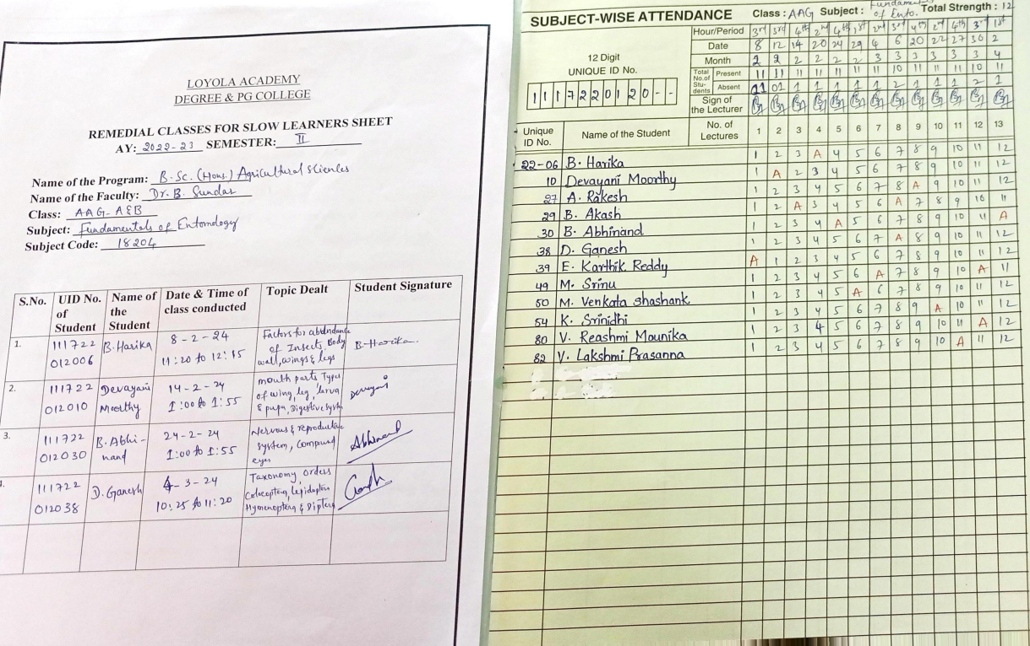

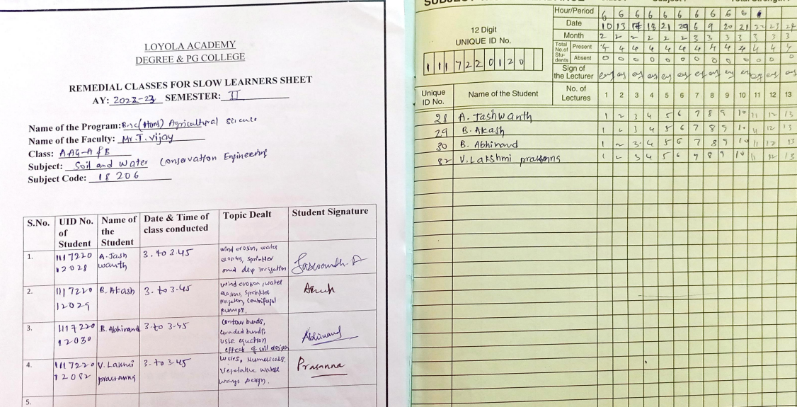

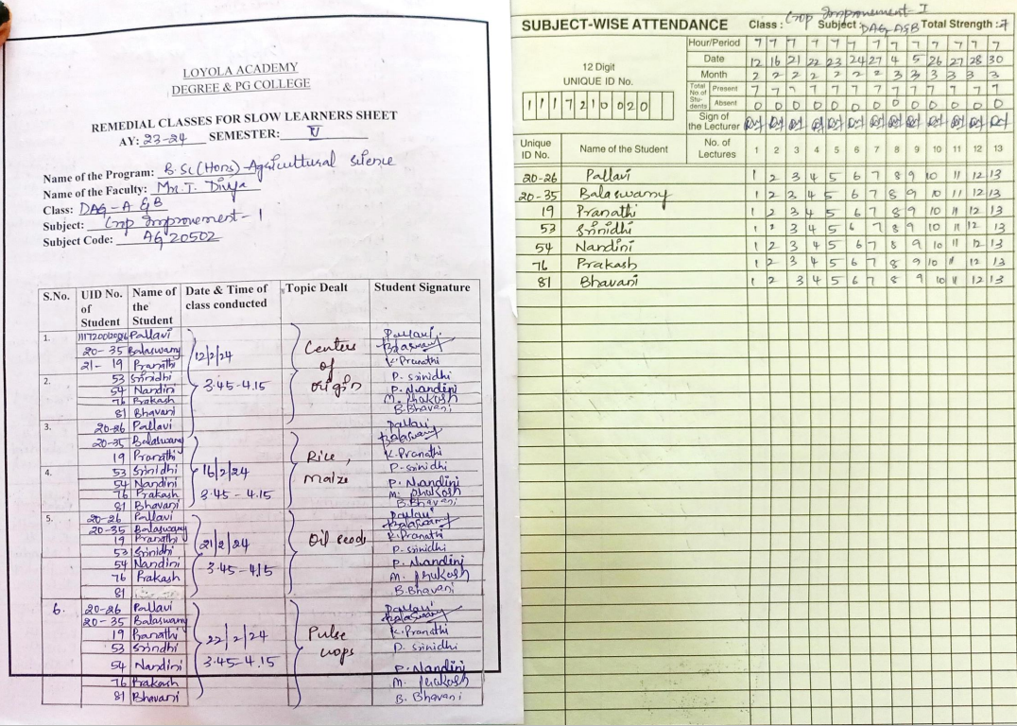

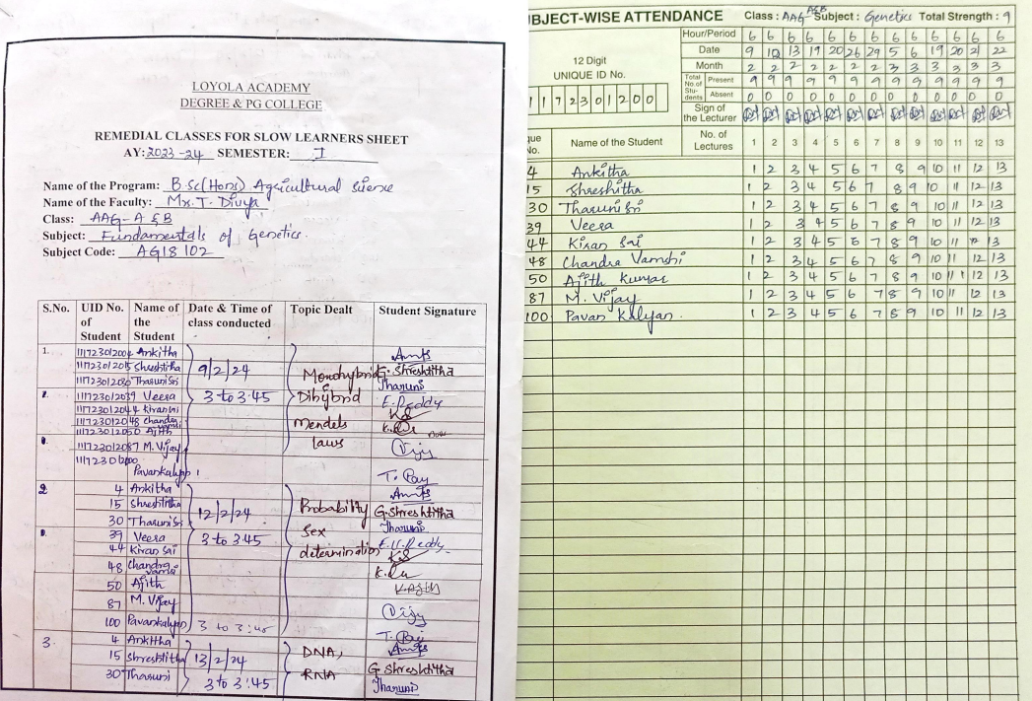

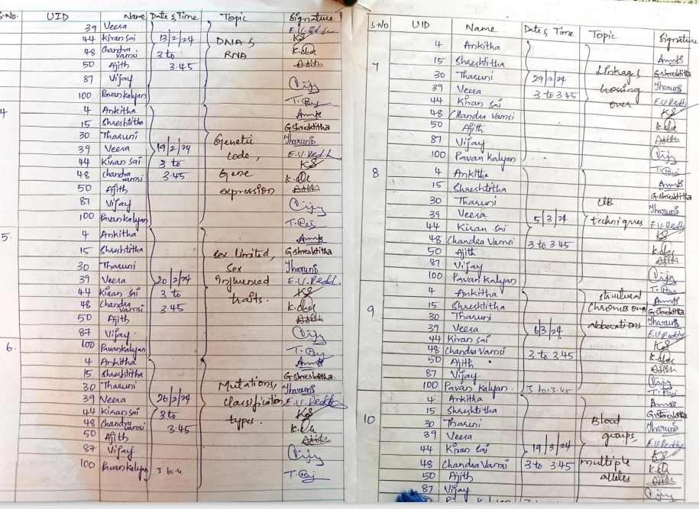

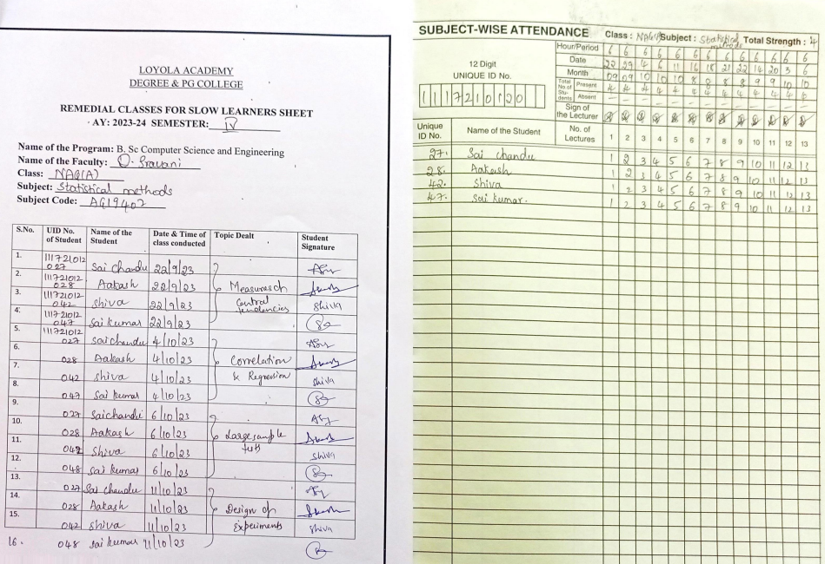
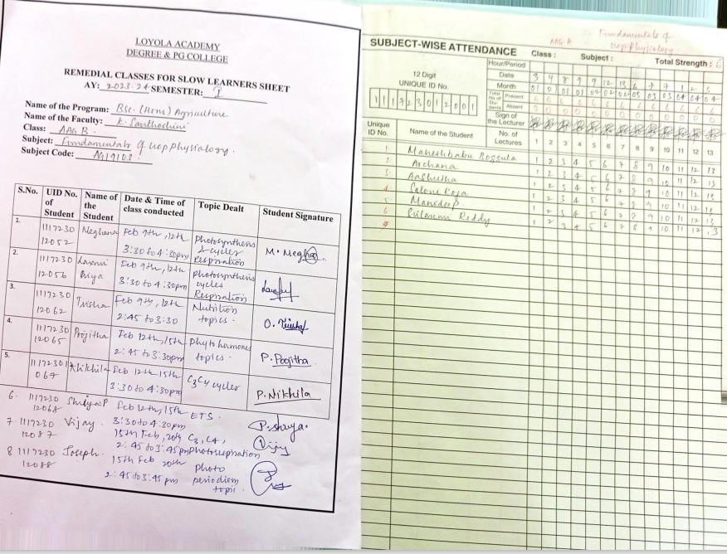

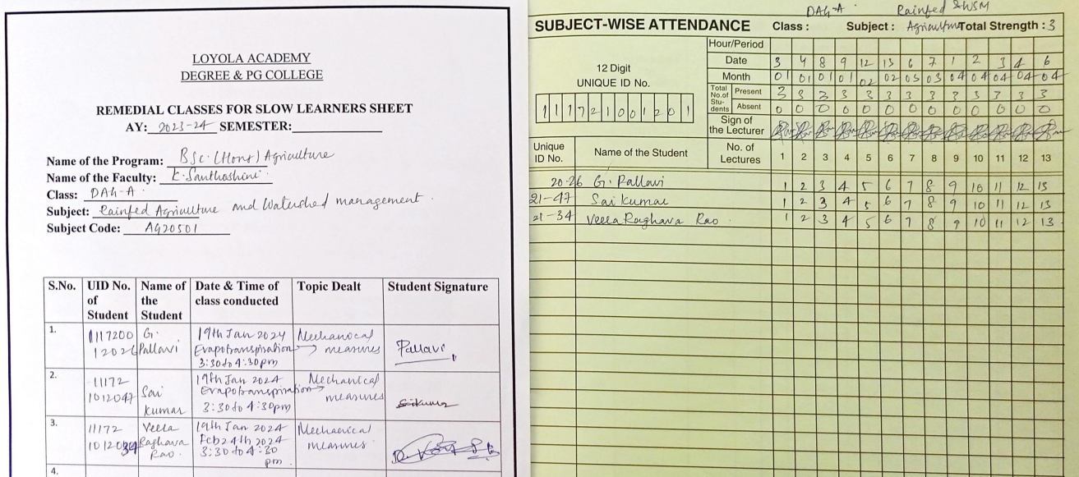

Department of CDS:

The Computer Data Science Department is an academic department that focuses on the study of data science and computer technologies. It offers degree programs, courses, and research opportunities related to data analytics, artificial intelligence, machine learning, and other related fields. Students in this department may learn about the latest techniques and technologies in data processing, analysis, and visualization, explore the ethical and legal considerations related to data management and privacy, and develop practical skills for working in the data science industry. The department may also collaborate with businesses, government agencies, and other organizations to provide real-world projects and internships for students.

Slow Learners:
Slow learners are provided with remedial coaching in areas of difficulty. Further, the sessions are made more interactive to increase student interaction and thereby, facilitate understanding. Students are also encouraged to help each other and through this, understand concepts better.

Advanced Learners:
Advanced learners are encouraged to take up independent research that permits them to know and understand a topic in depth. The department also encourages students to do research on autobiography of famous Entrepreneurs. Additionally, the faculty encourage students to take Professional exams.

Department of CS and Cyber security:

Computer Science is an academic discipline that focuses on the study of computers, computation, and related technologies. It covers a wide range of topics, including computer programming, algorithms, software design and development, computer hardware, computer networking, databases, and artificial intelligence. Students in Computer Science programs may learn about the theoretical foundations of computing, develop practical programming and problem-solving skills, and gain an understanding of how computer systems are designed and used in various contexts. Graduates of Computer Science programs may pursue careers in a variety of fields, including software engineering, information technology, data analysis, computer security, and research and development.
This dept implemented individual based teaching and skill based teaching for better understanding of students.

Slow Learners:
Slow learners are provided with remedial coaching in areas of difficulty. Further, the sessions are made more interactive to increase student interaction and thereby, facilitate understanding. Students are also encouraged to help each other and through this, understand concepts better.

Advanced Learners:
Advanced learners are encouraged to take up independent research that permits them to know and understand a topic in depth. The department also encourages students to do research on autobiography of famous Entrepreneurs. Additionally, the faculty encourage students to take Professional exams.
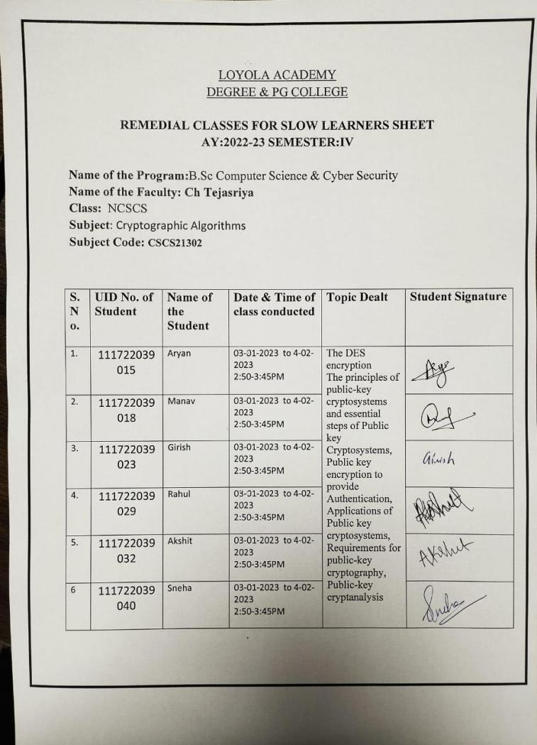

OBJECTIVES
- Remedial coaching has been initiated for subjects: Cryptography algorithms, Computer fundamentals.
- ICT enabled learning material is provided for Cryptography algorithms, Computer fundamentals.
- Revision of syllabus was done again and frequent tests are conducted for improvement
- Various practical oriented sessions were taken for better understanding.
Trough mentoring, personal counselling is done for these students
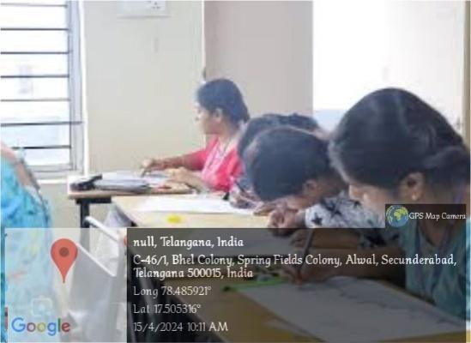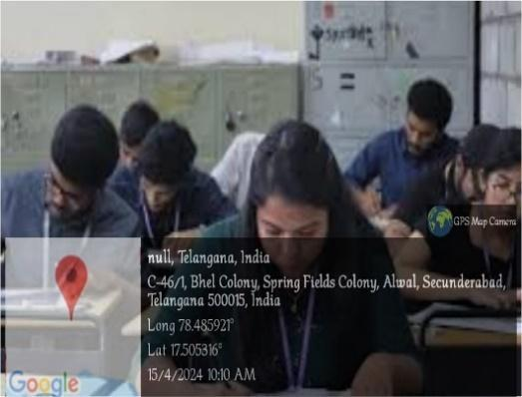
OUTCOMES
- Students have improved in every aspect in cryptographic tools. They have appeared for every test and showed the betterment in each class.
- They have given seminars in order to understand the concepts well.
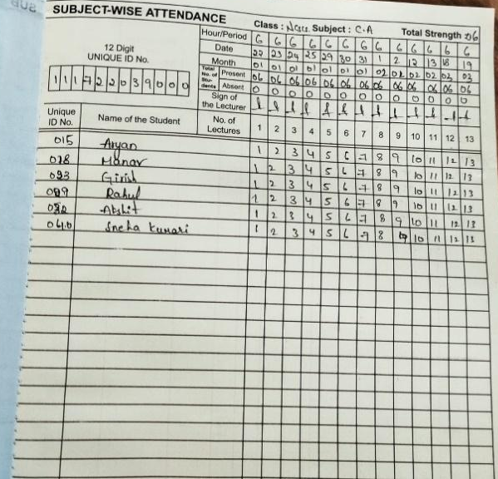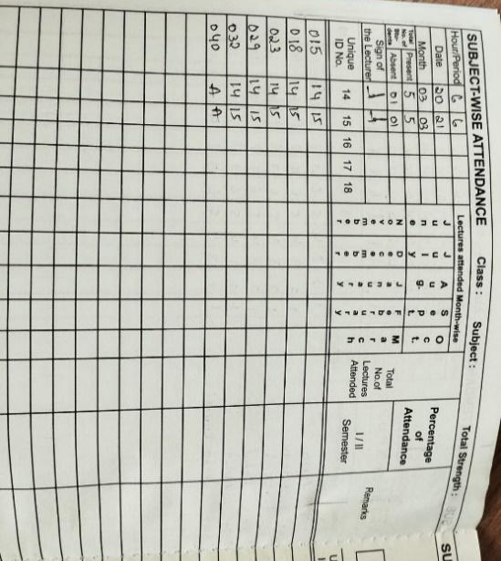

Department of Bachelors of Business Administration:

BBA programs typically cover a range of topics, including accounting, finance, marketing, operations management, organizational behavior, and entrepreneurship. Students in BBA programs may develop skills in problem-solving, critical thinking, communication, and teamwork, as well as gain an understanding of business concepts and practices. BBA graduates may pursue careers in a variety of fields, including business management, marketing, finance, human resources, and consulting. Some graduates may also go on to pursue further education in fields such as business, law, or entrepreneurship.

Slow Learners:
Slow learners are provided with remedial coaching in areas of difficulty. Further, the sessions are made more interactive to increase student interaction and thereby, facilitate understanding. Students are also encouraged to help each other and through this, understand concepts better.

Advanced Learners:
Advanced learners are encouraged to take up independent research that permits them to know and understand a topic in depth. The department also encourages students to do research on autobiography of famous Entrepreneurs. Additionally, the faculty encourage students to take Professional exams.
REPORT ON REMEDIAL PROGRAM OF NBBA - 2023-2024

Subject: Research Methodology
Date: Feb- March 2023
Number of Hours Conducted: 15 Hours
Faculty: Mrs M Sunanda
Class: NBBA
Total Students Appeared: 05

A remedial program is conducted by the faculty of the department for the students who needed help and guidance for the betterment of their performance. A short and focused remedial program is conducted by the faculty of the department in order to guide and teach students who require extra care to improve their performance.

The sessions are scheduled by the faculty after the class hours, to help the students who are facing difficulty in understanding and performing well in certain subjects. During the sessions, various topics are revising done again to create a strong foundation about the basics of the subject. Aiming to make the student comfortable with the subject and perform well in the upcoming examination. The remediation program is planned out in such a way that the students are able to grasp the subject at their own pace.
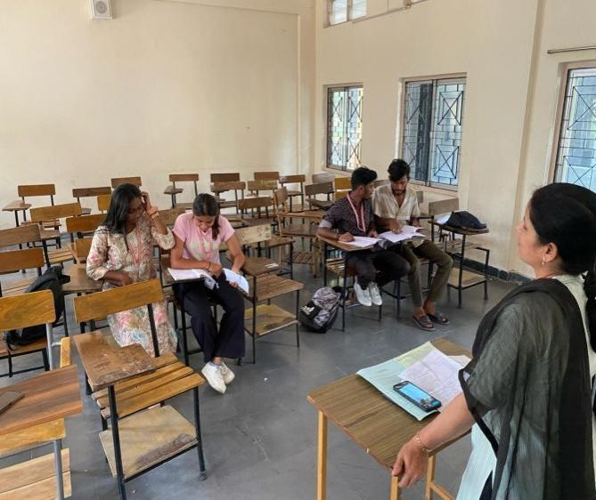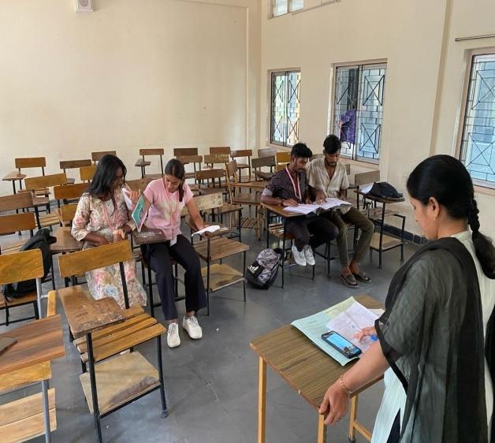
OBJECTIVES OF THE PROGRAM
- Create a strong foundation about the basics of the subject.

- Improvement in the performance of the students in the upcoming examinations.
- To eliminate any gaps or drawbacks in the comprehension and application of knowledge by the students.
- Make the students comfortable and confident regarding the subject.

CONCLUSION
Remedial classes are a crucial component of the education system, offering a lifeline to slow learners and students with academic backlogs. They not only provide academic support but also contribute to more inclusive, successful, and equitable educational institutions. In essence, remedial class’s area corner stone of inclusive education, enabling students to overcome academic challenges, build a strong foundation, and ultimately achieve their educational and career aspirations.

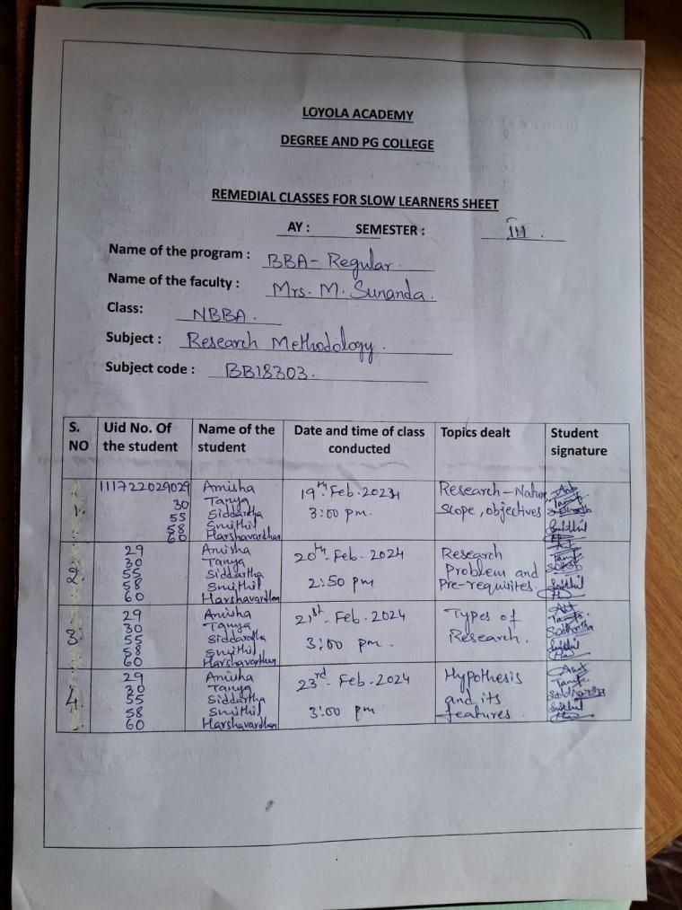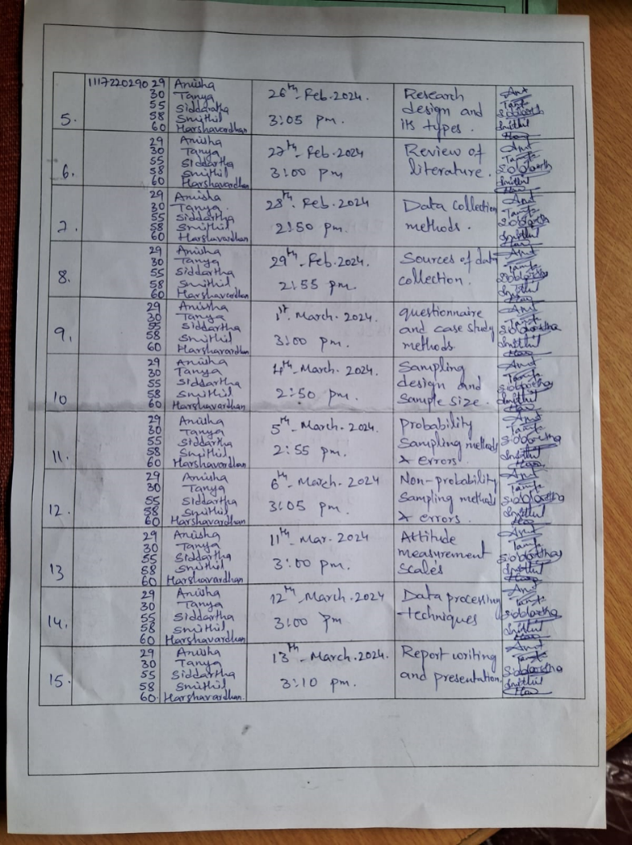
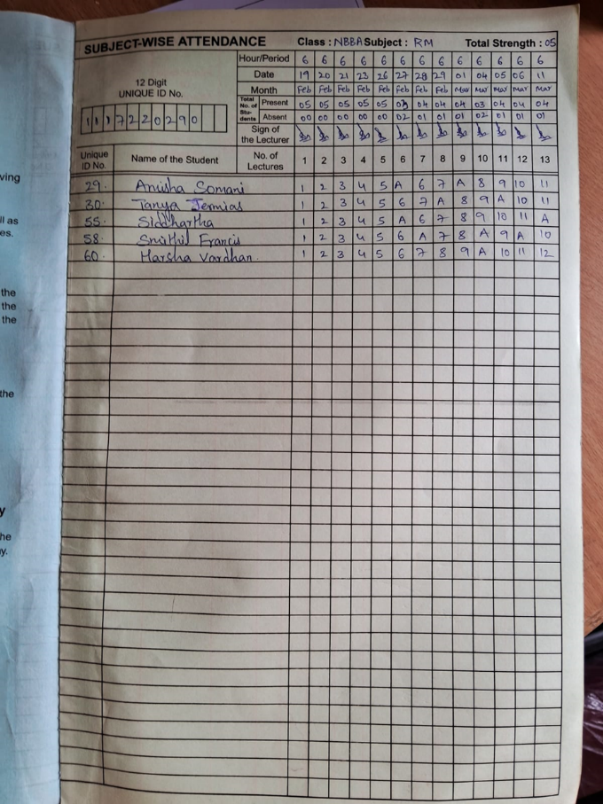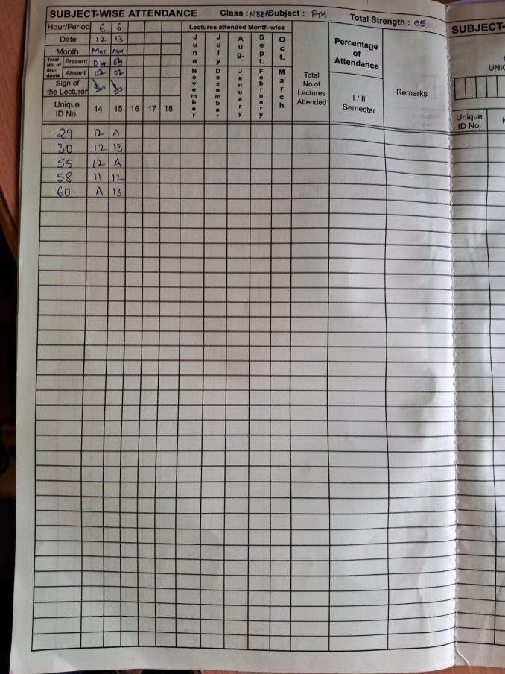

Department of Bachelors of Business Administration- Tourism:
Subject: Business English
Date: Feb- March 2023
Number of Hours Conducted: 8 Hours
Faculty: Sritama Maitra
Class: ABBA_Tourism
Total Students Appeared: 03

The remedial program was conducted by the English faculty for the slow learners students who were faring consistently poorly in the paper and were found to have poor listening and speaking skills, alongside a very definite deficit of attention. It was conducted to provide help, guidance, writing practice, and examination strategies to the students for the betterment of their performance.
The sessions were scheduled by the faculty after the class hours to help the students who were facing difficulty in understanding and performing well in the English paper. During the sessions, various topics were revised to create a strong foundation on the subject for the poor learners, and also to equip them to prepare independently for the examination. The remediation program was planned out in such a way that the students were able to grasp the subject at their own pace, and the faculty could address their queries, and help them solve exercises based on writing skills which they particularly lacked.

OBJECTIVES OF THE PROGRAM
• Equipping the students with basic English writing, listening, and comprehension skills which they lacked.
• Helping students improve their performance in the upcoming examinations.
• Eliminate any gaps or drawbacks in the comprehension and application of knowledge by the students.
• Make the students comfortable and confident regarding the subject.
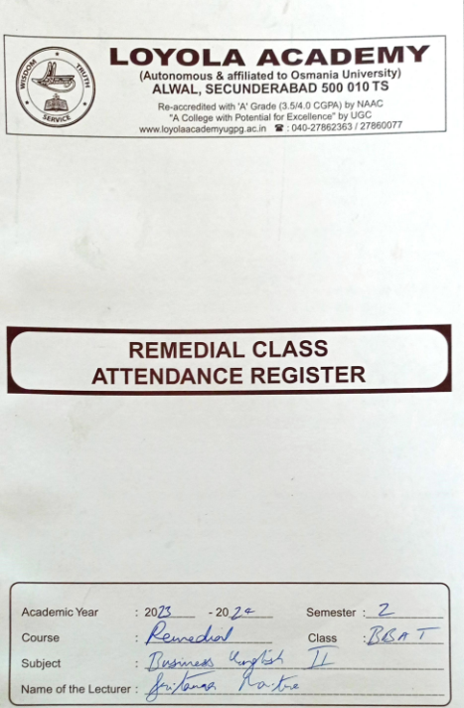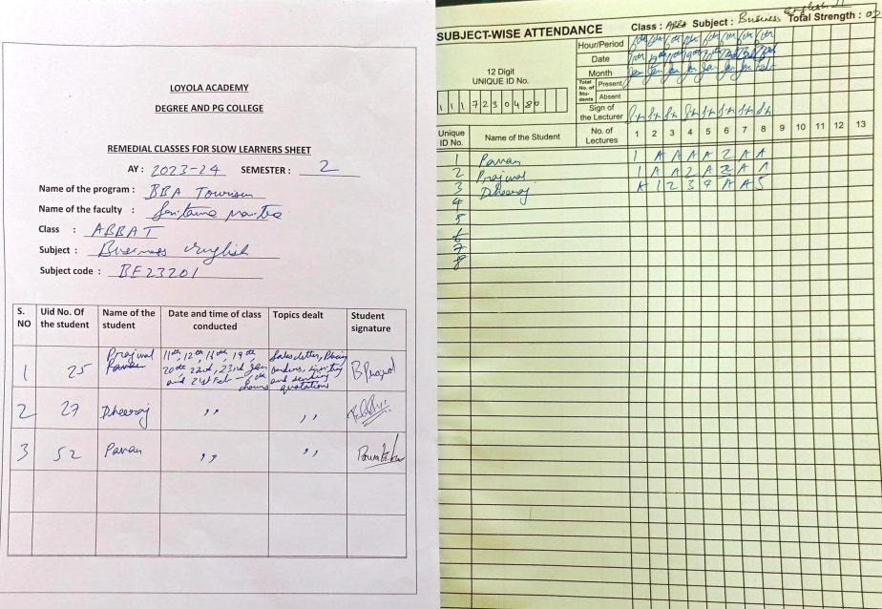

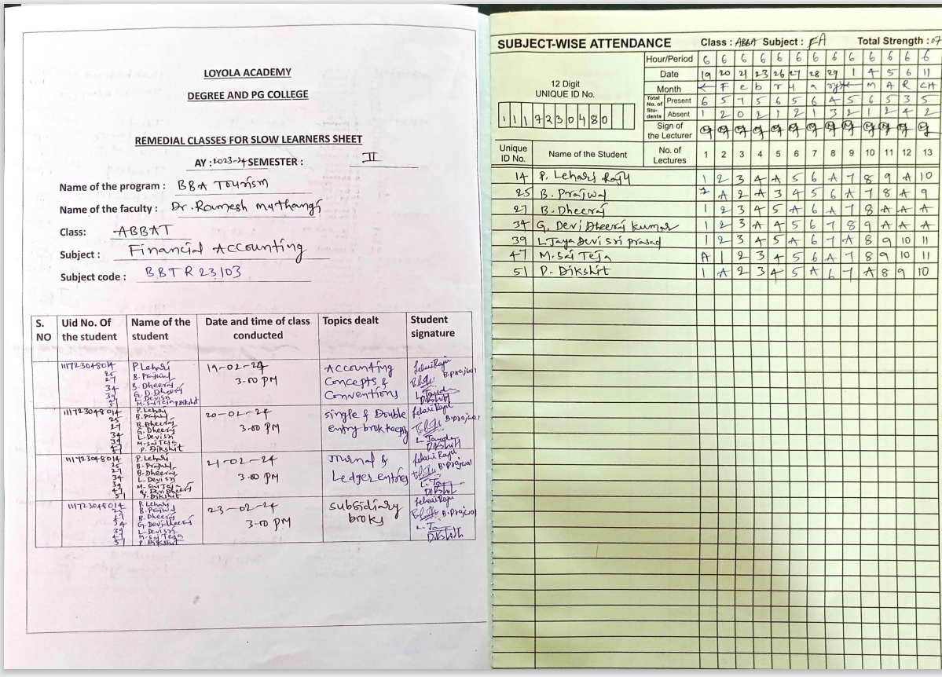
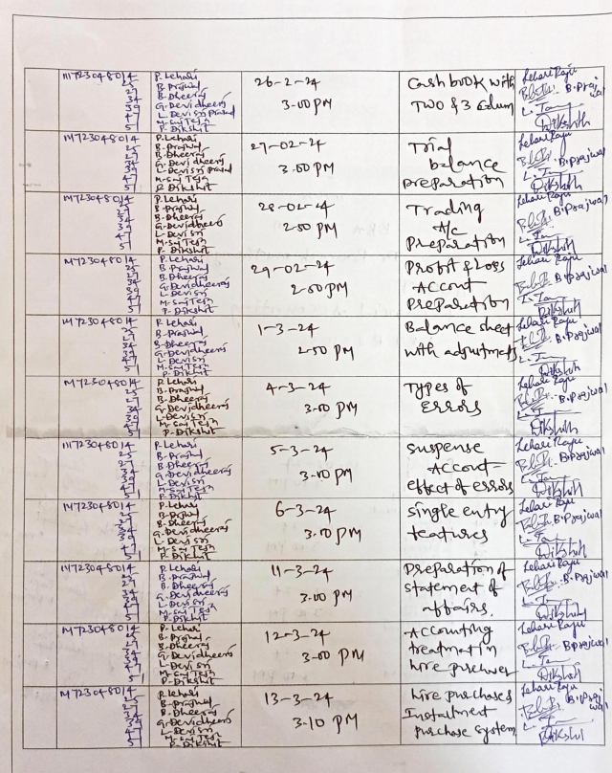

Department of Bachelors of Business Administration- ED:

REPORT ON REMEDIAL CLASS OF ABBA-ED 2023-2024
TEACHER INCHARGE: V. KALYAN GOUD, K. NANDHINI
SUBJECT OF REMEDIATION: FINANCIAL ACCOUNTING, FUNDAMENTALS OF IT
STUDENTS UNDER REMEDIATIN:
V. Sahasra, Manish Yadav, K. Kavish
OBJECTIVES:
The objective of remedial teaching strategies is to help students who are struggling with a particular subject or skill to overcome their difficulties and improve their academic performance.
REMEDIAL PROGRAM:
A remedial program is conducted by the faculty of the department for the students who needed help and guidance for the betterment of their performance. The sessions were held after the class hours by the faculty in order to give special attention for the students who are facing troubles in particular subjects. The sessions involved one on one interactions to tap on the weaknesses of each student in detail and help them score better in their upcoming examinations. Topics that were already taught in the class were reviewed and revised until the content and concept is obtained by the students. OBJECTIVES: The objective of remedial teaching strategies is to help students who are struggling with a particular subject or skill to overcome their difficulties and improve their academic performance. REMEDIAL PROGRAM: A remedial program is conducted by the faculty of the department for the students who needed help and guidance for the betterment of their performance. The sessions were held after the class hours by the faculty in order to give special attention for the students who are facing troubles in particular subjects. The sessions involved one on one interactions to tap on the weaknesses of each student in detail and help them score better in their upcoming examinations. Topics that were already taught in the class were reviewed and revised until the content and concept is obtained by the students.

OBJECTIVES/RESULTS OF THE PROGRAM:
• Better understanding of the concepts and information.
• Simplifying the subject for greater comprehension by the students.
• Overall betterment in the performance of the students both in the class and Examinations.
• Reviewing the weakness of the students in different areas.
OUTCOME:
• Improved academic performance.
• Increased confidence in the subject area.
• Better understanding of key concepts.
CONCLUSION:
The program concludes with a focus on the student’s improved academic performance, increased confidence, and readiness to continue their educational journey. Throughout the program, progress is regularly monitored to assess the student’s growth and adjust instruction as needed. The program aims to help students develop a solid foundation in the subjects they are struggling with, so they can succeed in their future studies.
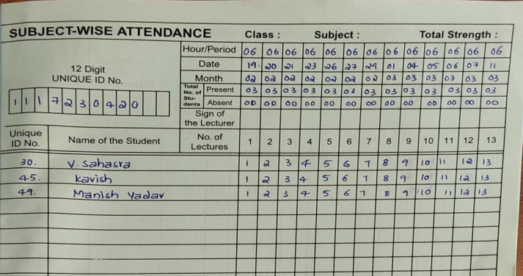

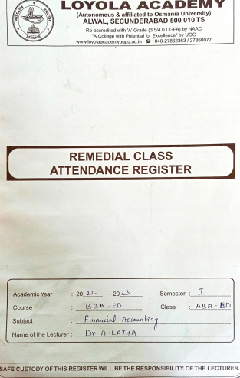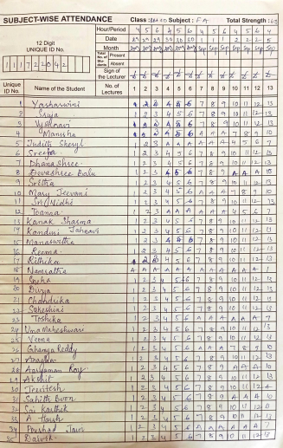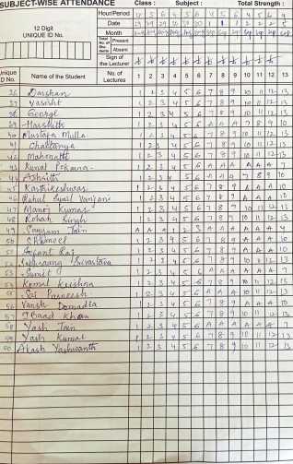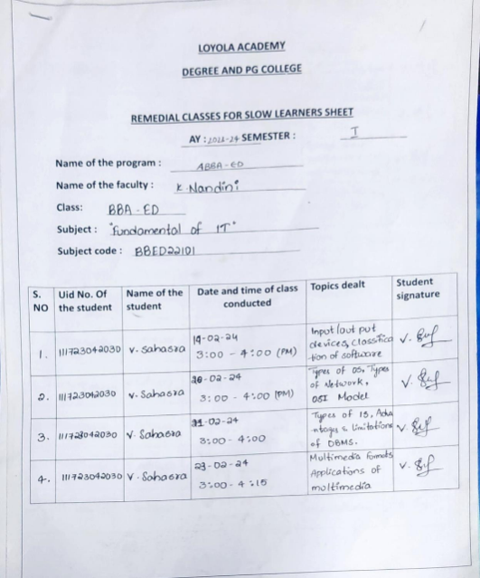
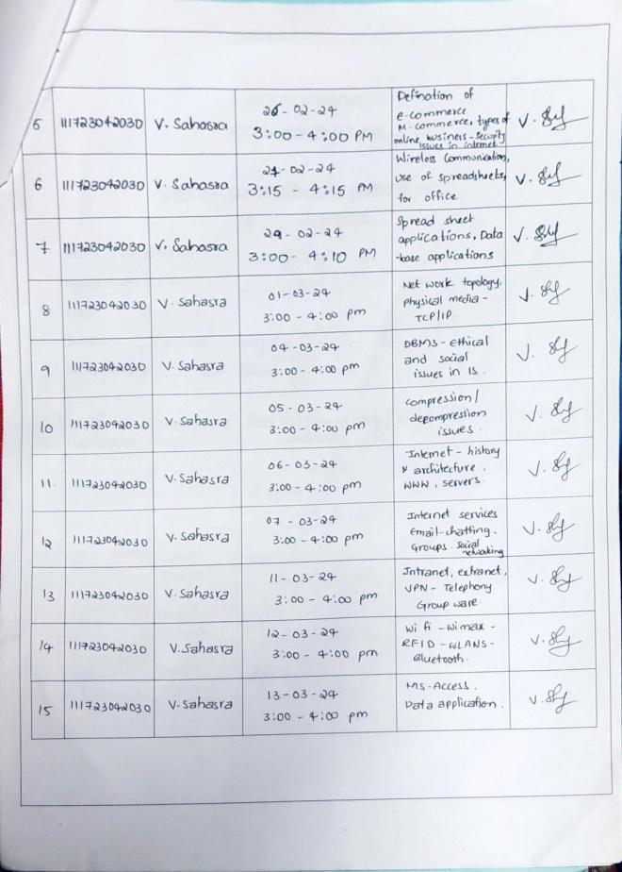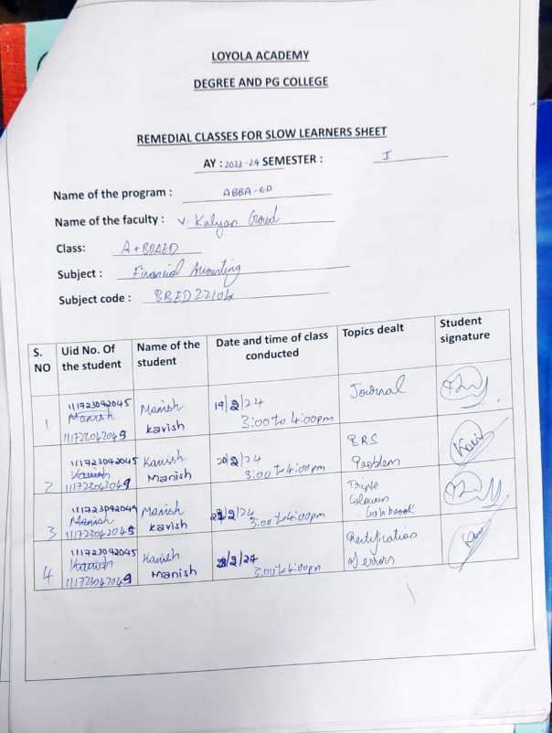
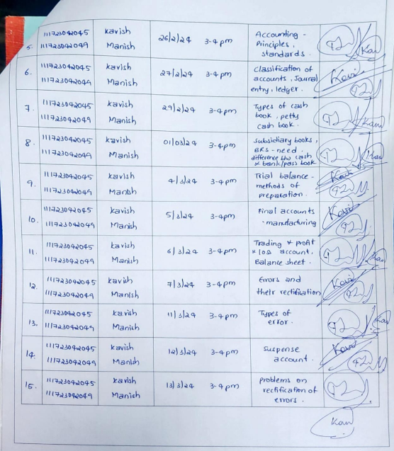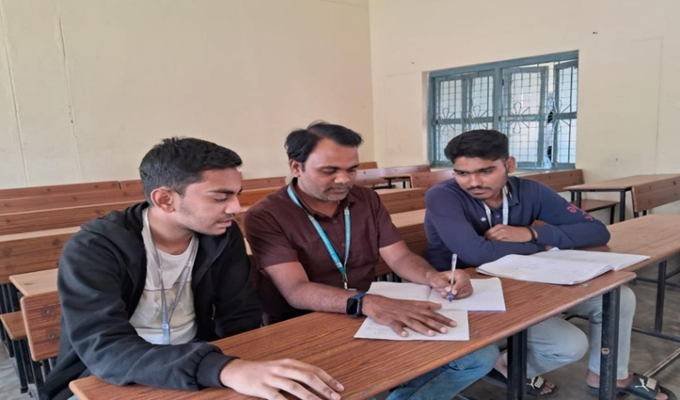

REPORTONREMEDIALPROGRAMOFNBBA-ED2023-2024

TEACHERINCHARGES:B.SUNANDHA, SWETHARAOMA’AM

SUBJECTOFREMEDIATION:FinancialAccounting,FinancialManagement

STUDENTSUNDERREMEDIATION: GeorgeThankachan,SumitMishra

REMEDIATION:Aremedialprogramisconducted bythefacultyofthedepartment forthe students who needed help and guidance for the betterment oftheir performance. A short and focused remedialprogramis conducted bythe facultyofthe department in orderto guide and teach students who require extra care to improve their performance
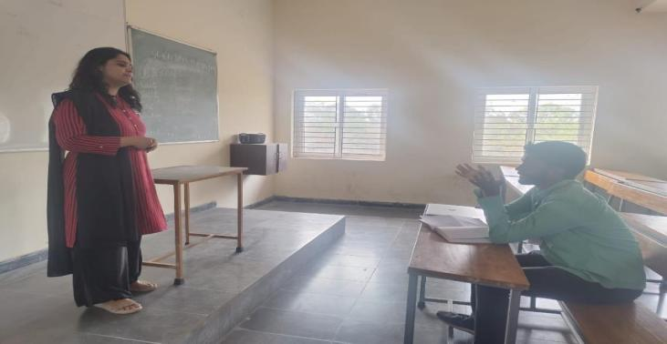
The sessions are scheduled bythe facultyafter the class hours, to help the students who are facing difficulty in understanding and performing well in certain subjects. During the sessions, varioustopicsarerevisedonceagainto createastrongfoundationaboutthebasics ofthe subject. aiming to make the student comfortable withthe subject and performwell in the upcoming examination. The remediation program is planned out in such a waythat the students are able to grasp the subject at their own pace

- Createastrong foundationaboutthebasicsofthe subject.
- Improvementinthe performanceofthestudentsintheupcomingexaminations.
- Toeliminateanygapsordrawbacks inthecomprehensionandapplicationof knowledge by the students.
- Makethestudentscomfortableandconfidentregardingthesubject.
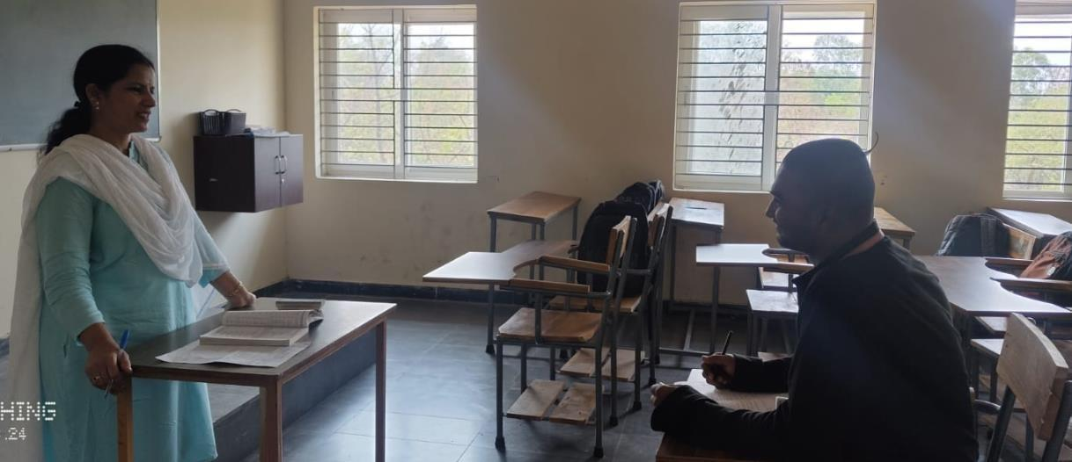
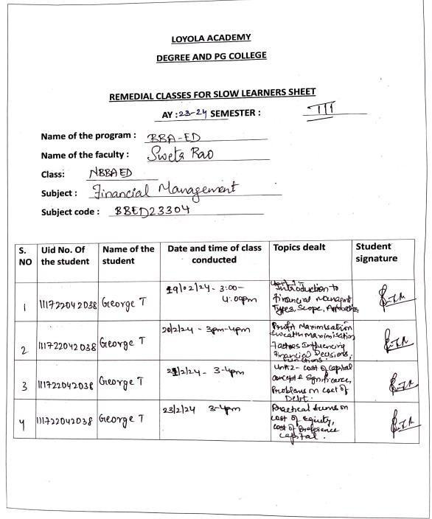
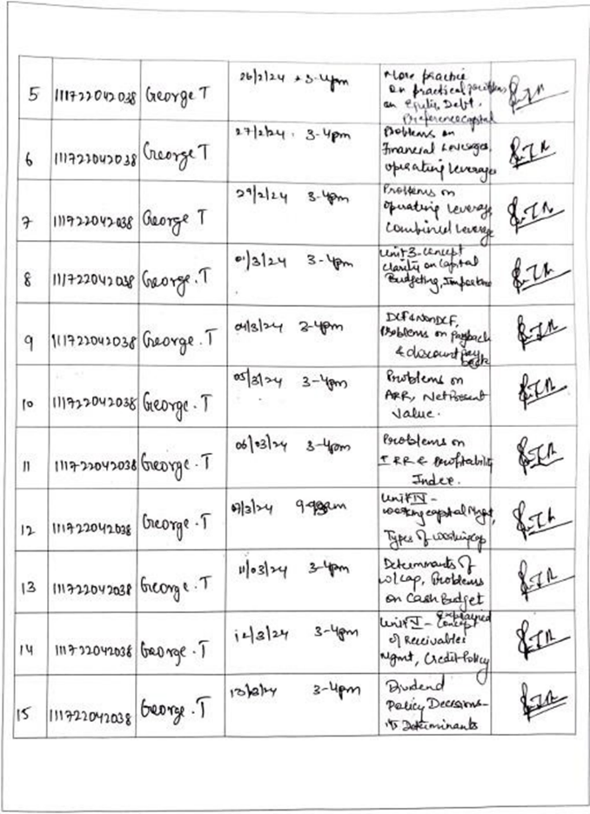
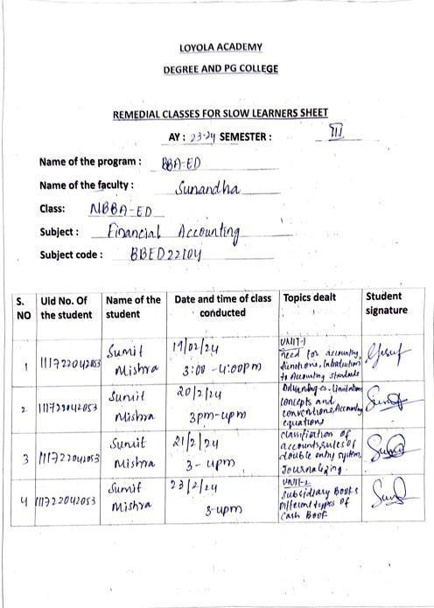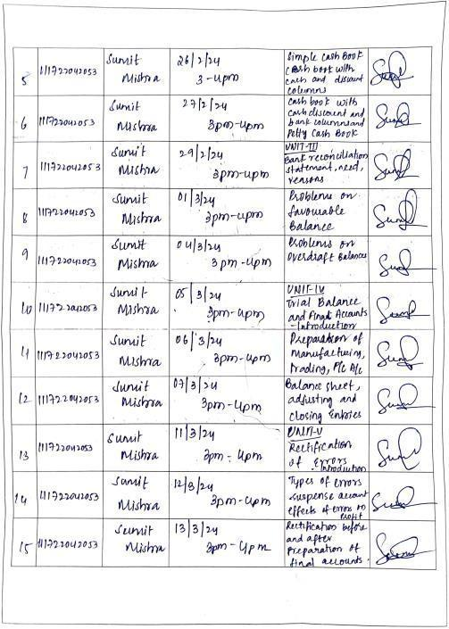
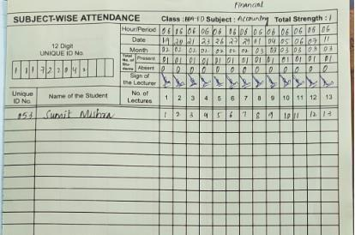
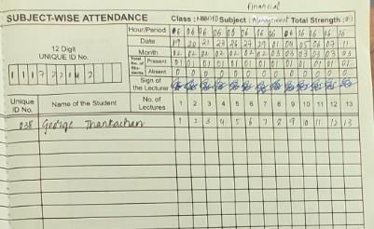

Department of Computer Science Artificial Intelligence:

Computer Science and Artificial Intelligence, which is a field of study that combines the principles of computer science with the concepts of artificial intelligence. It involves the development of algorithms and techniques for creating intelligent machines and systems that can perform tasks that normally require human intelligence. CSAI covers a wide range of topics, including machine learning, natural language processing, computer vision, robotics, and cognitive computing. Students in CSAI programs may learn about the theoretical foundations of artificial intelligence, develop programming and problem-solving skills for building intelligent systems, and gain an understanding of how artificial intelligence can be applied in various contexts.

Slow Learners:
Slow learners are provided with remedial coaching in areas of difficulty. Further, the sessions are made more interactive to increase student interaction and thereby, facilitate understanding. Students are also encouraged to help each other and through this, understand concepts better.

Advanced Learners:
Advanced learners are encouraged to take up independent research that permits them to know and understand a topic in depth. The department also encourages students to do research on autobiography of famous Entrepreneurs. Additionally, the faculty encourage students to take Professional exams.

Department of cognitive systems
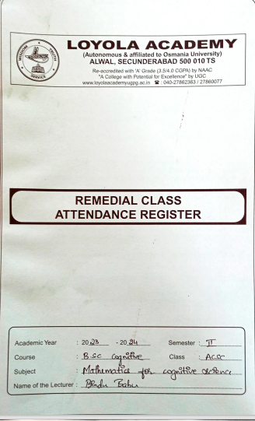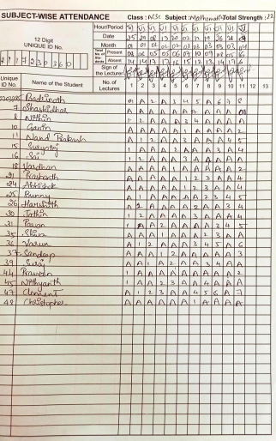
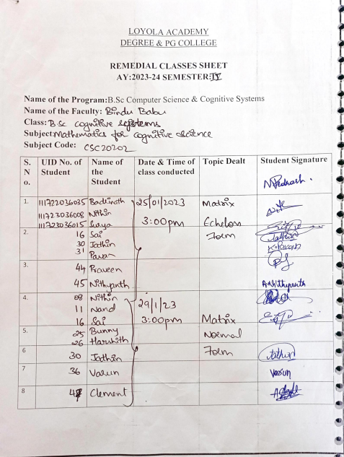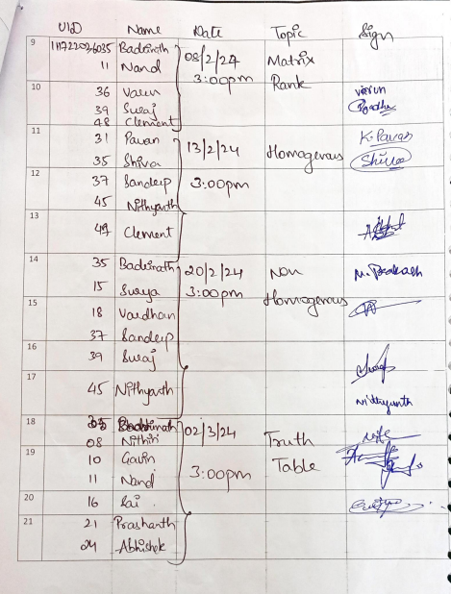
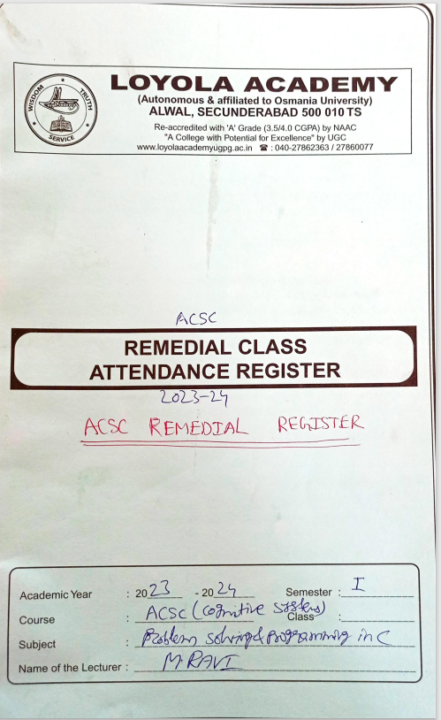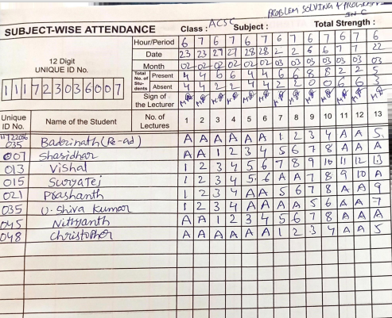
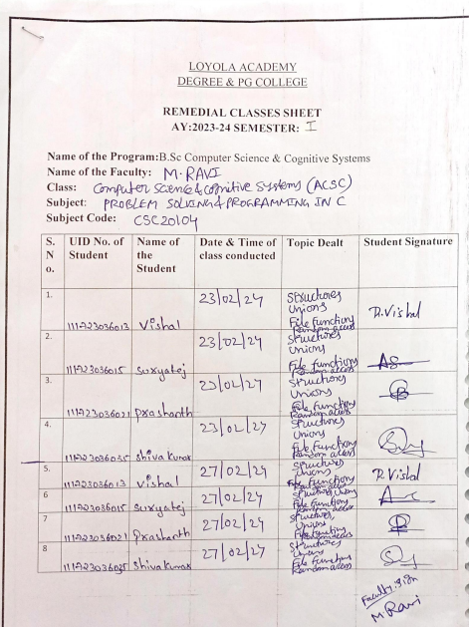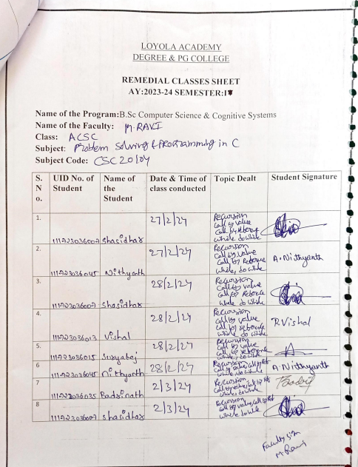

DEPARTMENT OF B.A. PSYCHOLOGY, ENGLISH & JOUNRALISM

Class: AEL

Semester 1

S.NO | Subject | Faculty In-Charge
1 | English-I | Dr Mamatha
2 | Introduction to Psychology-I | Dr Sudeep Chandra
3 | Introduction to English Language and Literary Genres I | Dr Swaralipi Nandi
4 | Introduction to Communication and Journalism | Ms D Elsita

Semester 2

S.NO | Subject | Faculty In-Charge
1 | English-II | Dr Mamatha
2 | Introduction to Psychology-II | Dr Sudeep Chandra
3 | Introduction to English Language and Literary Genres II | Mr Ajay
4 | Middle English and Elizabethan Age | Ms Sritama Maitra
5 | Indian Print Journalism | Ms D Elsita

Class: NEL

Semester 3

S.NO | Subject | Faculty In-Charge
1 | Enhancing Psychological Competencies-I | Ms Sandhria
2 | Statistics in Psychology | Dr Sudeep Chandra
3 | Age of Milton Dryden and Pope | Dr Shivali Sharma
4 | Newspaper Management | Ms D Elsita

Semester 4

S.NO | Subject | Faculty In-Charge
1 | Enhancing Psychological Competencies-II | Ms Sandhria
2 | Personality Theories and Assessment | Dr Sudeep Chandra
3 | The Victorian Age | Dr Shivali Sharma
4 | New Literatures in English | Dr Swaralipi Nandi

Class: DEL

Semester 5

S.NO | Subject | Faculty In-Charge
1 | Abnormal Psychology | Dr Sudeep Chandra
2 | Romantic Age | Dr Swaralipi Nandi
3 | Indian Writing in English | Mr Ajay

Semester 6

S.NO | Subject | Faculty In-Charge
1 | Social Psychology & Developmental Psychology | Ms Shreya Joanna
2 | Literature of the Modern Age | Mr Ajay
3 | Popular Literature | Dr Swaralipi Nandi
4 | Gender & Literature | Dr Shivali Sharma

Objective:
- To aid and assist the students who need help in certain difficult and hard areas, the Department of Psychology, English and Psychology identified the students and scheduled classes for them
- To help the students to perform much better in their upcoming exams
- To make them moreself assured and self confident in presenting the learned contents/topics

ABOUT THE CLASSES:
Most of the classes were conducted in the 6th hours, while a few of the classes were online. The basic aim of these classes is to enable and enhance learning by focusing more attention on the candidate by identifying the areas of difficulty and emphasising on strengthening the fundamentals. It’s not always that the student is not good at his subject topics, reasons can be sundry, some may be in NCC, sports, personal problems or critical health issues, but all these certainly contribute to slow learning. So, the classes are designed in such away to cover all the topics taught in that particular semester. They learn and interpret the topics and clear their doubts if any, in the specified classes. A test will be conducted in the beginning of the classes and at the end to make them realise the difference they had made in understanding and analysing the topics. A minimum of 4 to 5 classes were conducted for each paper.
Outcome:
- Students have shown good improvement in the II Mid Examination after they had attended classes regularly following their I Mid results.
- It also helped them to read and write the answers prepared by them.
- The remedial classes helped the students to critically analyse and question.
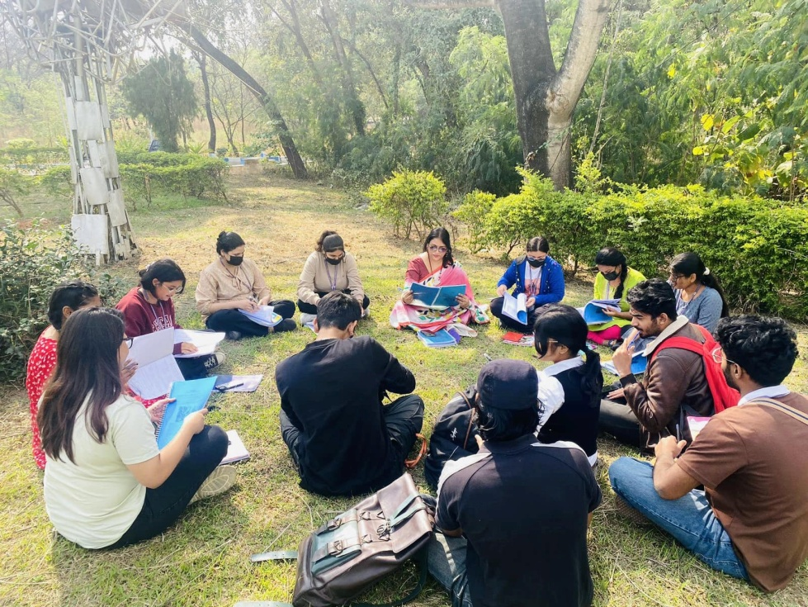

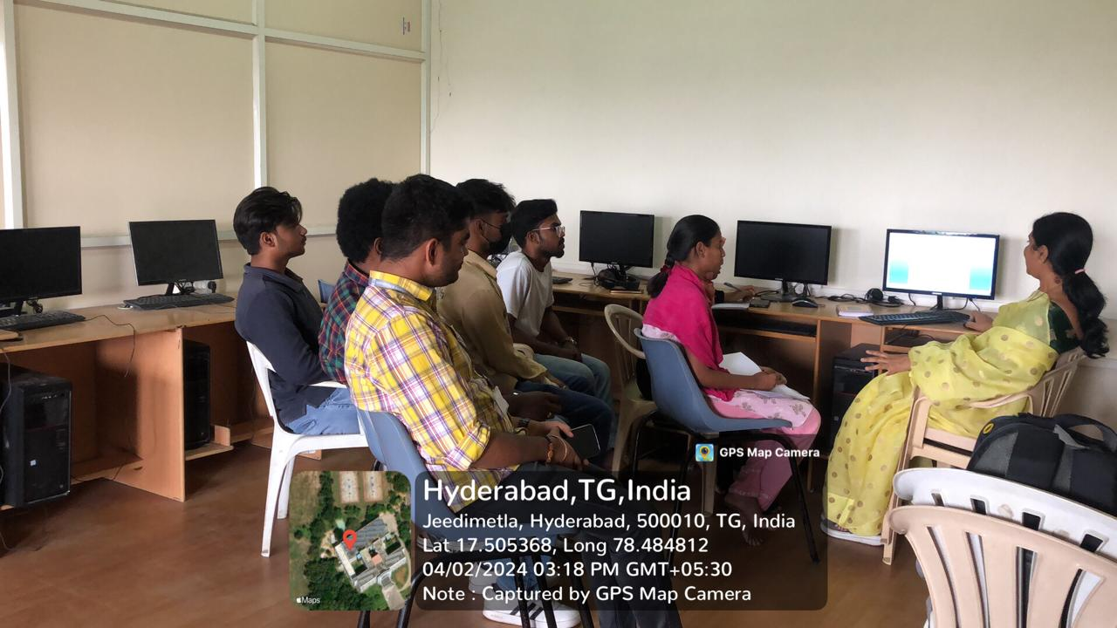
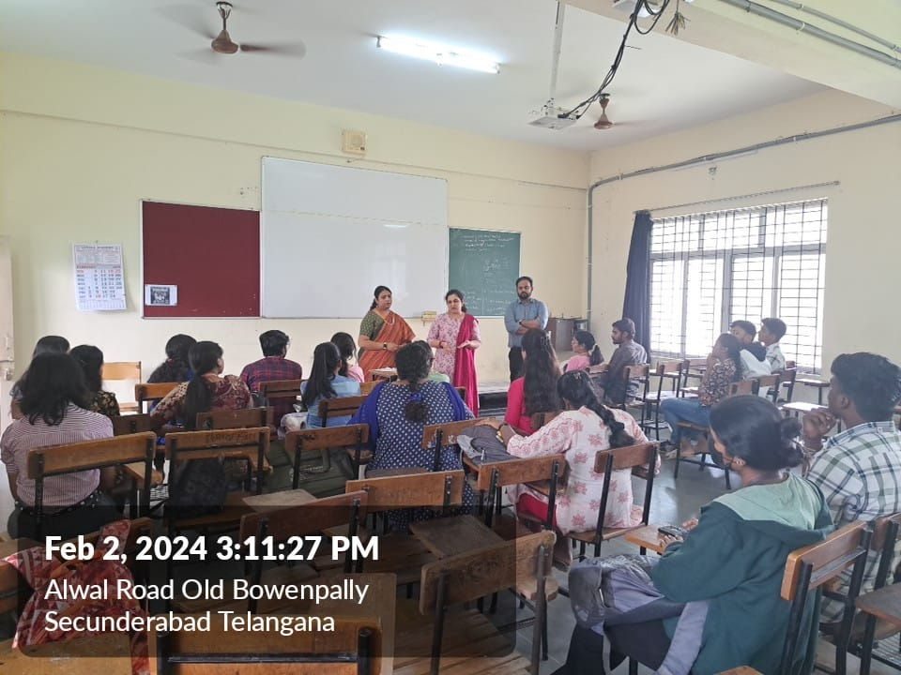

B.Com Information Systems

SlowLearners:
Duringthecourseofstudy,groupofstudentsareassignedtoafacultyforcounselling.Thecounsellorsmonitor academic performance and interact frequently to understand and assist any student with issues that affect their ability to learn or impede their academic success. The staff communicates performance and attendance of students to parents regularly. Care is taken by faculty in monitoring the performance of slow learners. Faculty members do periodic interaction with parents about the performance of slow learners.

Department conducts remedial classes, provide course notes for students especially the slow learners. Further faculty members revise the tough topics as per the students requisition and provide question bank and discuss the way of presenting the answers in the exam to score marks. Extra lab sessions are conducted. Additional library books are provided to bring improvement in slow learners. Extra classes are organized to clarify doubts. Criticaltopicsarere-explainedforbetterunderstandingbythestudents.Appropriatecounsellingwithadditional teaching is done which eventually results in students attending the classes regularly.

The slow learners are made to attend special sessions designed for them by their respective faculty to nurture theirsubjectiveandgeneralaptitudeknowledgeandtoenhancetheirthoughtprocesstoinculcatethehabitsof focus and attentiveness to further help them in the day-to-day classes.
As a part of the special sessions, recently a quiz session was organized by the Head of the Department (HOD) Mr. Rajkumar Reddy P. The topic of the quiz was based on the fundamentals of Stock Market which also included in-depth understanding and functionality of Stock Markets. The quiz turned out to be a proactive sessionwereinallthestudentsactivelytookpartinansweringthequestionsandalsograsptheconceptofStock Markets as much as they can. With the conclusion of the special session all the students had a strong understanding on the topic of session i.e., Stock Markets.

AdvancedLearners:
Highperforming studentsareidentifiedon thebasis ofinternal assessment.
- Advisingtoparticipateingroupdiscussions,technicalquizzestodevelopanalyticalandproblem- solving abilities in them and thereby to improve their presentation skills.
- Variousclubactivitiesareconductedbyallthedepartmentsintherespectiveareastomouldthestudents in corresponding field.
- Studentsarealsoprovidedopportunitiestodeveloptheircreativitybyparticipatingandorganizing intercollegiate events.
- Brightanddiligent studentsaremotivated andinspiredto getuniversity ranks.
- Studentsareencouragedtotakeupcompetitive exams.
The advanced learners are encouraged to attend the weekly sessions designed for them by their respective facultytoenhancetheirskill-set,tocounselthemabouttheircareerswhileconcurrentlyengaginginspreading healthy knowledge about the current trends and flow of the markets.
Asapartoftheadvancedlearner’ssessions,recentlyadebatesessionwasorganizedbytheAssistant Professor of the department, Mrs. Aparna K. The topic of the debate was based on the GST & Its Implications in India.
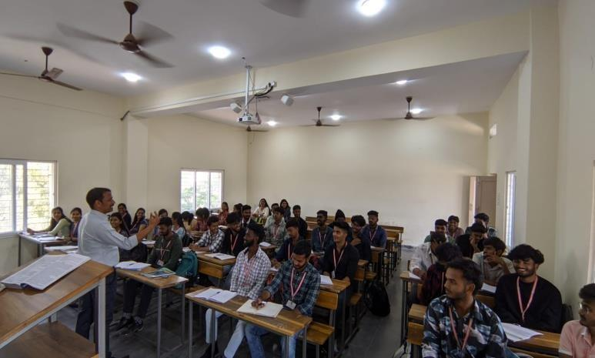
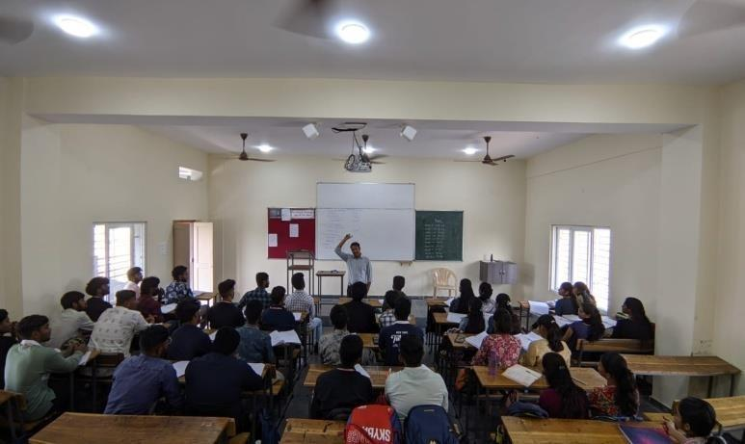
Thedebatefiredhealthydiscussionsbetweenthefacultyandstudentmembers wereinallthestudentsputtheir partsouttothegathering andexplainedtheirpoint-of-views.Asthesessionconcludedallthestudent members along with the faculty had a comprehensive knowledge on GST & Its implication in India.
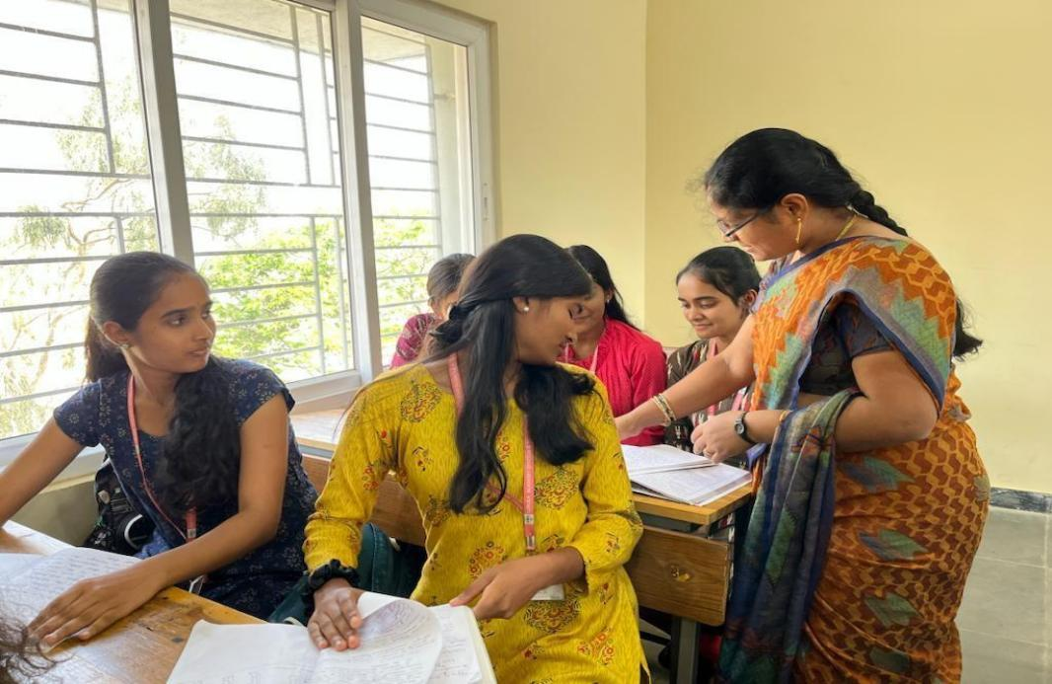
Department of B. Com. Information Systems has Conducted Remedial Classes for the students of NCIS onAdvancedAccountingsubjectintheyearof2023-24,Semester-III,forbetterunderstandingofbasic concepts in Accounting.

TotalnumberofstudentsattendedtheremedialclassesofAdvancedAccounting are15.

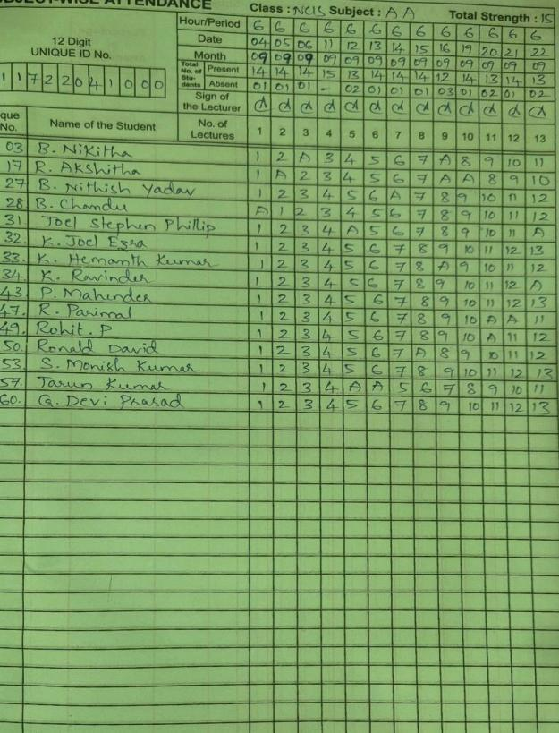
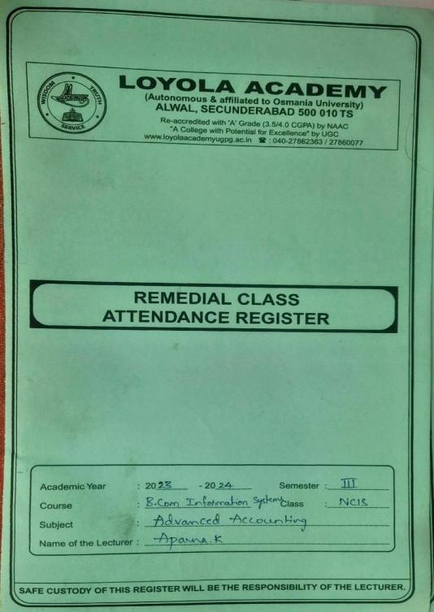

Department ofB. Com. Information Systems has Conducted RemedialClasses for the students of NCIS onDirectTaxessubjectintheyearof2023-24,Semester-IV,forbetterunderstandingofbasicconcepts in Taxation.

Total number of students attended the remedial classes of DirectTaxes are 15.

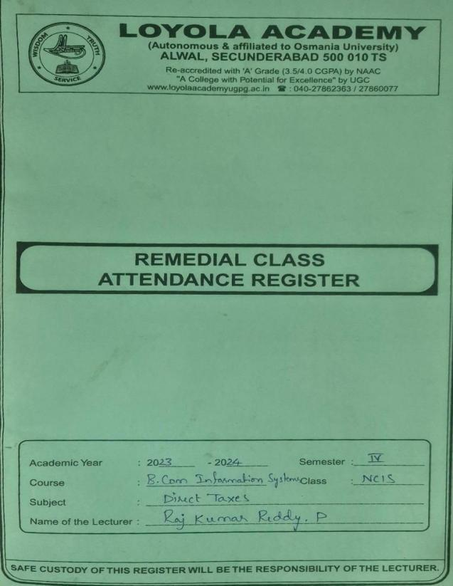
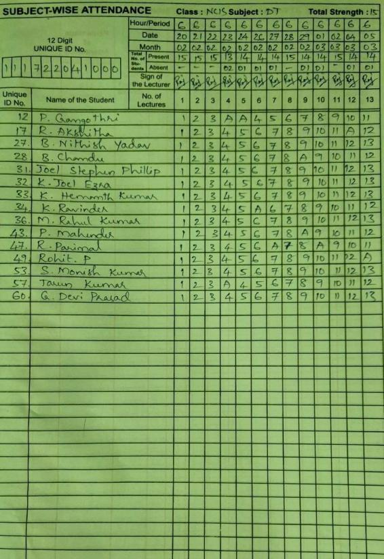

REMEDIAL RESULT
S. NO. | UID | NAMEOFTHE STUDENT | MID SEM MARKS (BEFOREREMEDIAL) MAX.MARKS=50 MINI. MARKS=20 | EXTERNALMARKS (AFTERREMEDIAL) MAX. MARKS=60 MINI. MARKS=24
1 | 111722041003 | BNIKITHA | 22 | 32
2 | 111722041017 | RASOORIAKSHITHA | 14 | 31
3 | 111722041027 | BATHEJNITHISHYADAV | 16 | 35
4 | 111722041028 | BOORSCHANDU | 21 | 29
5 | 111722041031 | JOELSTEPHENPHILLIP | 11 | 28
6 | 111722041032 | KOLLABATHINIJOELEZRA | 15 | 32
7 | 111722041033 | KOTLAHEMANT KUMAR | 19 | 29
8 | 111722041034 | KUMMARIRAVINDER | 15 | 33
9 | 111722041043 | PAMPARI MAHENDER | 19 | 38
10 | 111722041047 | RANGAMPETPARIMAL | 18 | 39
11 | 111722041049 | ROHITPULLANCHERI | 16 | 35
12 | 111722041050 | RONALDDAVID | 21 | 29
13 | 111722041053 | SMONISHKUMAR | 11 | 28
14 | 111722041057 | TARUN KUMAR | 15 | 32
15 | 111722041060 | GDEVIPRASAD | 19 | 29

S. NO. | UID | NAMEOFTHE STUDENT | MID SEM MARKS (BEFOREREMEDIAL) MAX.MARKS=50 MINI. MARKS=20 | EXTERNALMARKS  (AFTERREMEDIAL)  MAX. MARKS=60  MINI. MARKS=24
1 | 111722041012 | PGANGOTHRI | 22 | 32
2 | 111722041017 | RASOORIAKSHITHA | 14 | 31
3 | 111722041027 | BATHEJNITHISHYADAV | 16 | 35
4 | 111722041028 | BOORSCHANDU | 21 | 29
5 | 111722041031 | JOELSTEPHENPHILLIP | 11 | 28
6 | 111722041032 | K.JOELEZRA | 15 | 32
7 | 111722041033 | KOTLAHEMANT KUMAR | 19 | 29
8 | 111722041034 | KUMMARIRAVINDER | 15 | 33
9 | 111722041036 | MADASRAHULKUMAR | 19 | 38
10 | 111722041043 | PAMPARI MAHENDER | 18 | 39
11 | 111722041047 | RANGAMPETPARIMAL | 16 | 35
12 | 111722041049 | ROHITPULLANCHERI | 21 | 29
13 | 111722041053 | SMONISHKUMAR | 11 | 28
14 | 111722041057 | TARUN KUMAR | 15 | 32
15 | 111722041060 | GDEVIPRASAD | 19 | 29

B.com Business Studies
Slow Learners:
During the course of study, group of students are assigned to a faculty for counseling. The counsellors monitor academic performance and interact frequently to understand and assist any student with issues that affect their ability to learn or impede their academic success. The staff communicates performance and attendance of students to parents regularly. Care is taken by faculty in monitoring the performance of slow learners. Faculty members do periodic interaction with parents about the performance of slow learners.
Department conducts remedial classes, provide course notes for students especially the slow learners. Further faculty members revise the tough topics as per the students requisition and provide question bank and discuss the way of presenting the answers in the exam to score marks. Extra lab sessions are conducted. Additional library books are provided to bring improvement in slow learners. Extra classes are organized to clarify doubts. Critical topics are re-explained for better understanding by the students. Appropriate counselling with additional teaching is done which eventually results in students attending the classes regularly.
The slow learners are made to attend special sessions designed for them by their respective faculty to nurture their subjective and general aptitude knowledge and to enhance their thought process to inculcate the habits of focus and attentiveness to further help them in the day-to-day classes.
As a part of the special sessions, recently a quiz session was organized by the Head of the Department (HOD) Dr. Ramesh M. The topic of the quiz was based on the fundamentals of Stock Market which also included in-depth understanding and functionality of Stock Markets. The quiz turned out to be a proactive session were in all the students actively took part in answering the questions and also grasp the concept of Stock Markets as much as they can. With the conclusion of the special session all the students had a strong understanding on the topic of session i.e., Stock Markets.
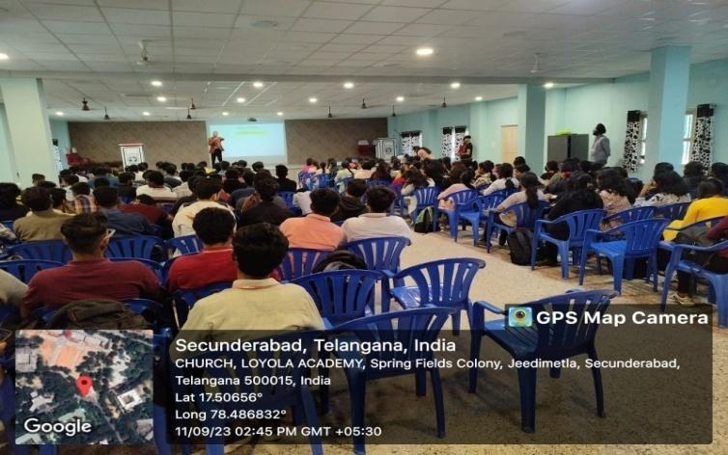

Advanced Learners:
High performing students are identified on the basis of internal assessment.
• Advising to participate in group discussions, technical quizzes to develop analytical and problemsolving abilities in them and thereby to improve their presentation skills.
• Various club activities are conducted by all the departments in the respective areas to mould the students in corresponding field.
• Students are also provided opportunities to develop their creativity by participating and organizing intercollegiate events.
• Bright and diligent students are motivated and inspired to get university ranks.
• Students are encouraged to take up competitive exams.
The advanced learners are encouraged to attend the weekly sessions designed for them by their respective faculty to enhance their skill-set, to counsel them about their careers while concurrently engaging in spreading healthy knowledge about the current trends and flow of the markets.
As a part of the advanced learner’s sessions, recently a debate session was organized by the Assistant Professor of the department, Mrs. G. Pooja. The topic of the debate was based on the banking regulation & Its Implications in India. The debate fired healthy discussions between the faculty and student members were in all the students put their parts out to the gathering and explained their point-of-views. As the session concluded all the student members along with the faculty had a comprehensive knowledge on banking regulation & its implication in India.
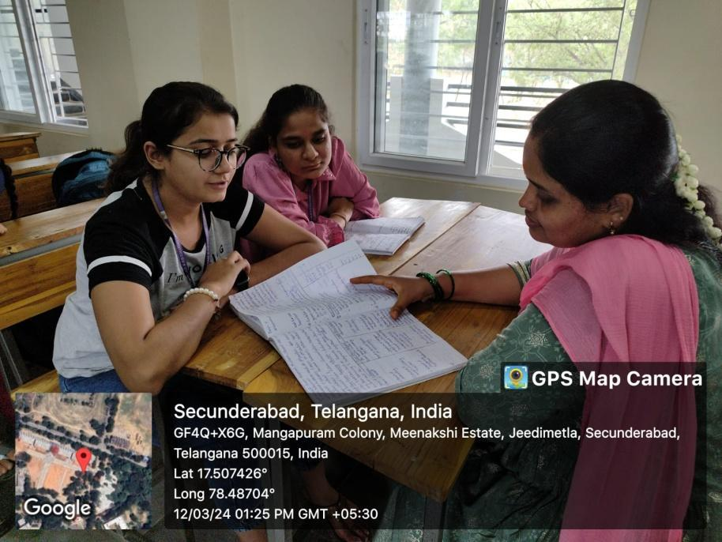

Department of B. Com. Business Studies has Conducted Remedial Classes for the students of ACBS on Micro Economics subject in the year of 2023-24, Semester - I, for better understanding of basic concepts.
Total number of students attended the remedial classes of Micro Economics are 60
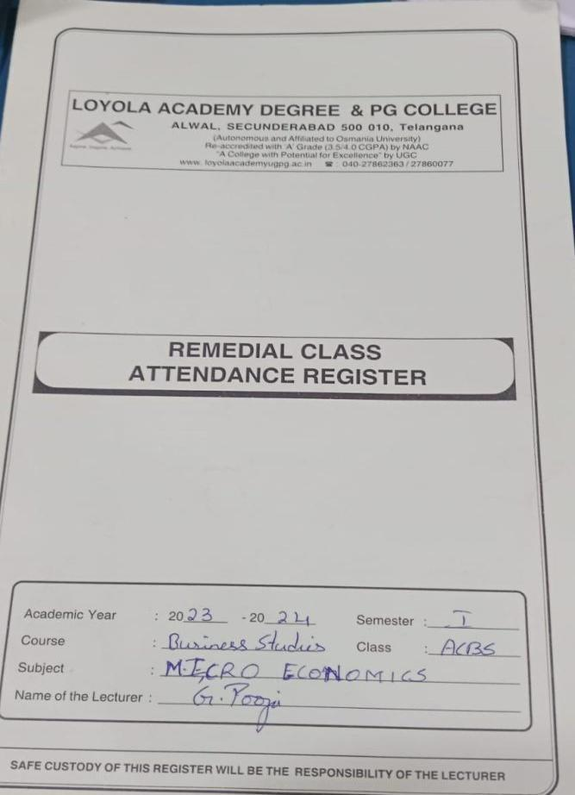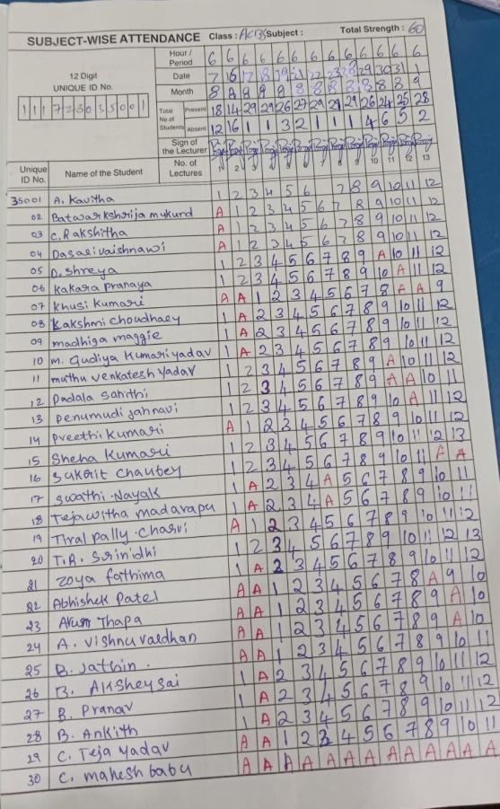
Department of B. Com. Business Studies has Conducted Remedial Classes for the students of NCBS on Company Law-II subject in the year of 2023-24, Semester - III, for better understanding of basic concepts.
Total number of students attended the remedial classes of Company Law-II are 57
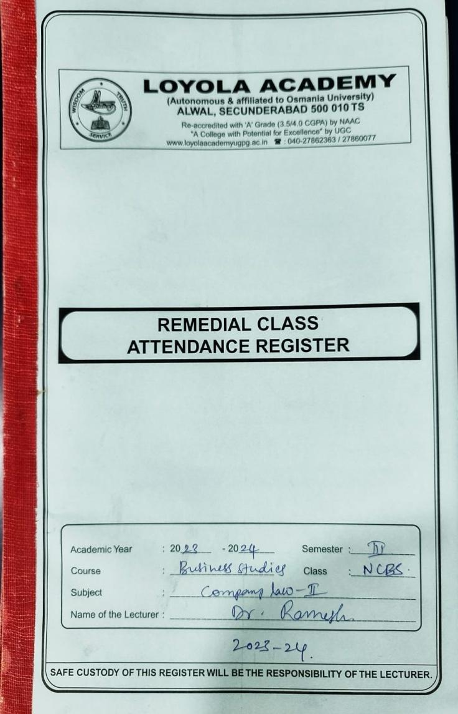 | 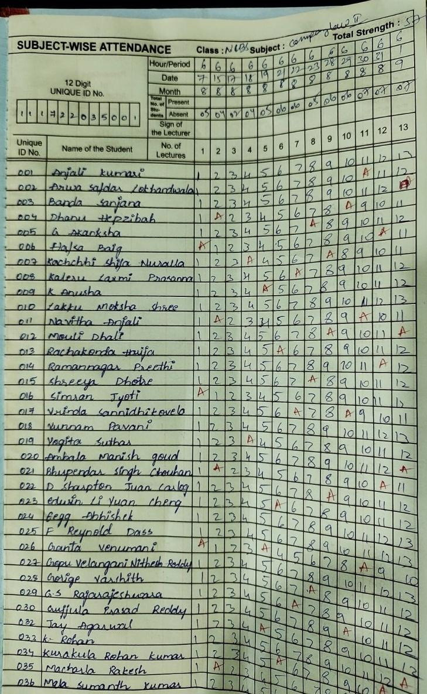

Department of B. Com. Business Studies has Conducted Remedial Classes for the students of DCBS on Marketing Management subject in the year of 2023-24, Semester - V, for better understanding of basic concepts.
Total number of students attended the remedial classes of Marketing Management are 55.
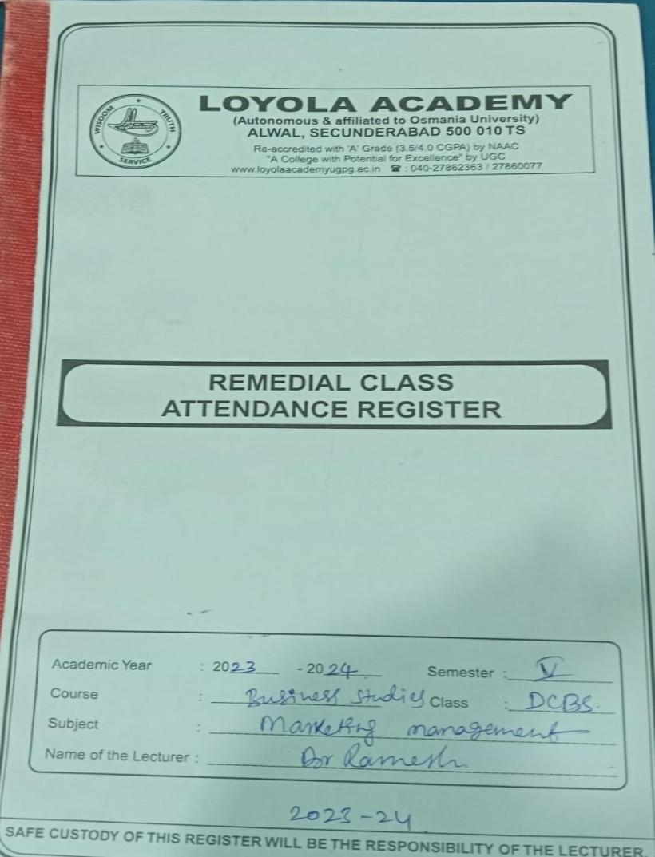 | 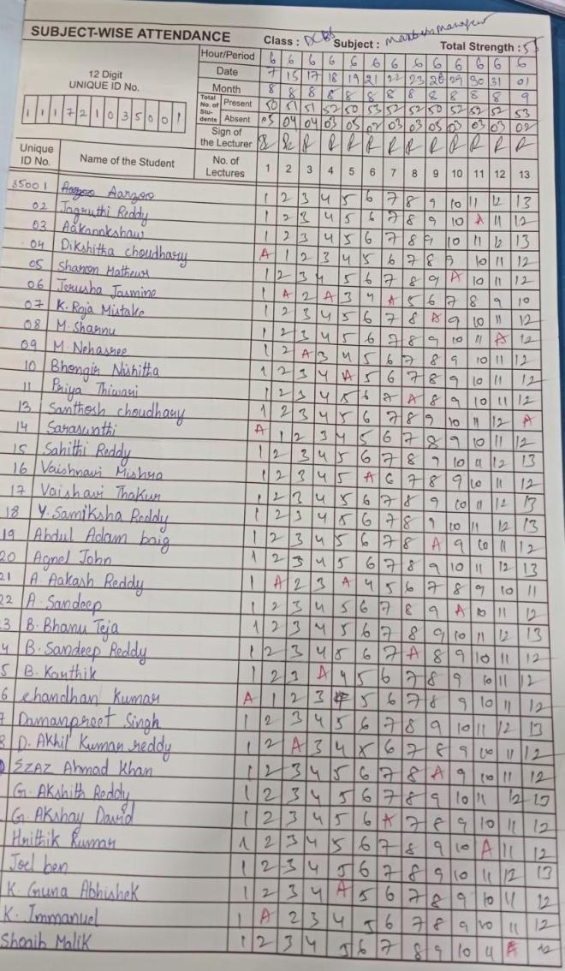

Department of B.Sc Biotechnology, Chemistry & Genetics
Remedial Class Report 2023-2024

Department of B.Sc Biotechnology has Conducted Remedial Classes for the students of ABT on Chemistry -III subject in the year of 2023-24,semester-III for better understanding of basic concepts in chemistry.

Total number of students attended for these classes are 10
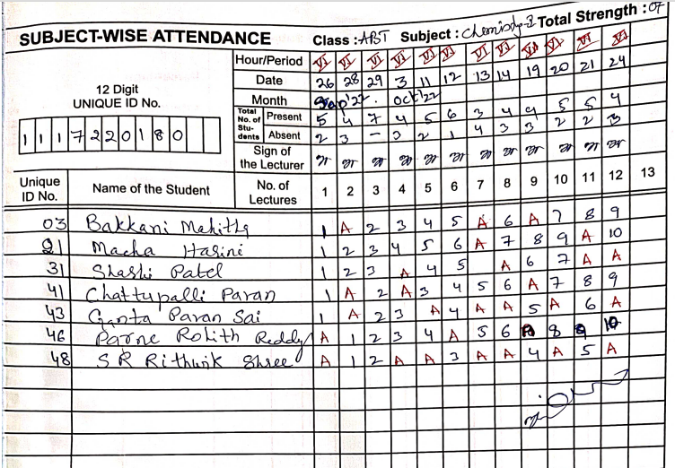

Food Science & Nutrition
FOOD MICROBIOLOGY (Remedial class) 2023-2024
Name of the Lecturer: G.GNANA SHEEBA
Department: B.sc Food science, Nutrition and Dietetics
Subject: FOOD MICROBIOLOGY (Remedial class)
Subject code: FS21201
Class: AFSN
Semester: II
Year:I
I G.Gnanasheeba faculty for UG, Department of Food science, Nutrition and Dietetics have conducted Remedial classes on the subject “FOOD MICROBIOLOGY" from 12th February 2024 to 24 th March 2024
No. Of students present-11
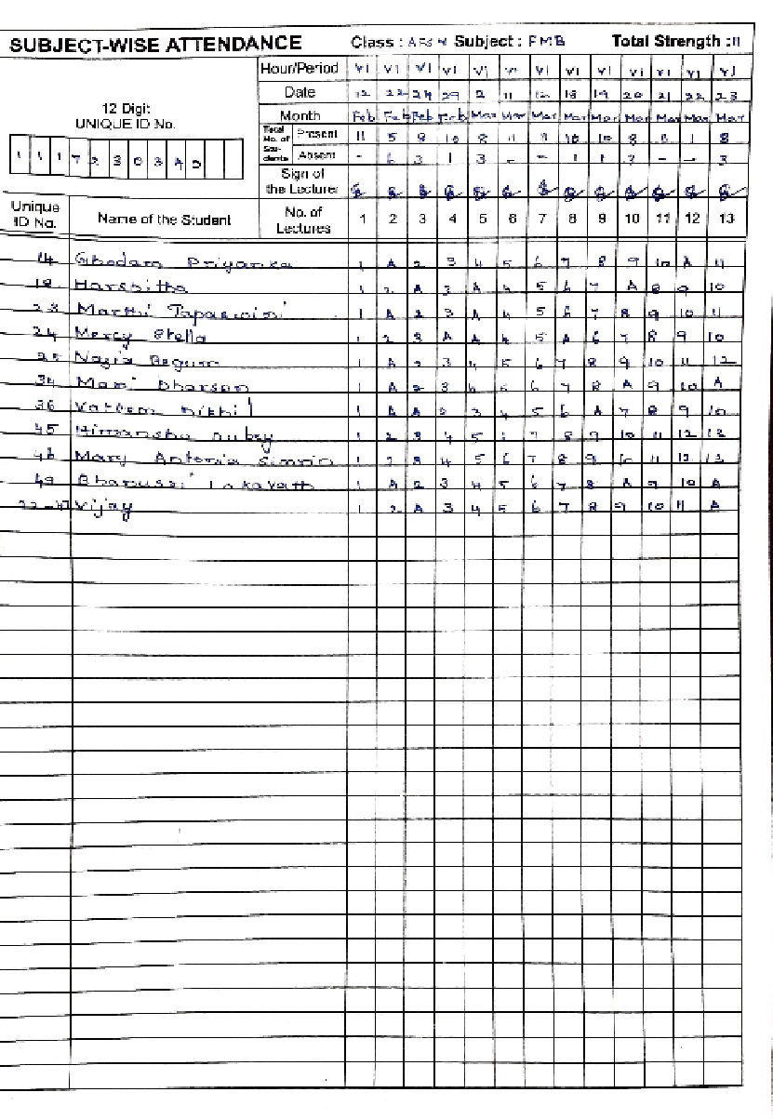

UID NUMBER | NAME OF THE STUDENT | MARKS OF MID TERM I | MARKS OF MID TERM II
111723034014 | Ghadam Priyanka | 32 | 41
111723034018 | Harshitha | 22 | 34
111723034023 | Marthi Tapaswini | 33 | 35
111723034024 | Mercy Stella | 32 | 30
111723034025 | Nazia Begum | 41 | 38
111723034034 | Mani Dharsan | 30 | 36
111723034036 | Vattem Nikil | 38 | 30
111723034045 | Himanshu Dubey | 38 | 34
111723034046 | Mary Antonia simrin | 36 | 48
111723034049 | Bhanusri Lakavath | 34 | 40
1117220340 | Vijay | ab | ab
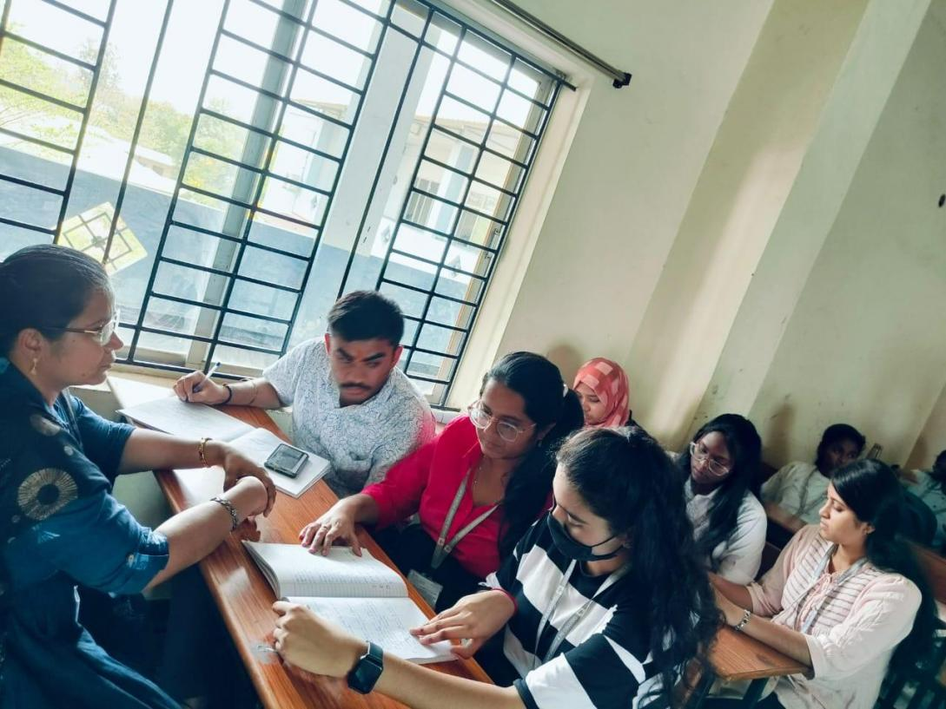
Conclusion :The remedial class conducted for the first year student for the subject food Microbiology had a good impact in the marks in the second mid-term exam. Academic improvement was observed in the students who attended remedial classes.

Name of the Lecturer: D. Krushitha
Department: B.sc Food science, Nutrition and Dietetics
Subject: (Remedial classes)
Class: AFSN Year: Istyear Semester: II
I krushitha faculty for UG, Department of Food science, Nutrition and Dietetics have conducted Remedial classeson the subject “Basic Dietetics" from 7 January 2023
No. Of students present-12
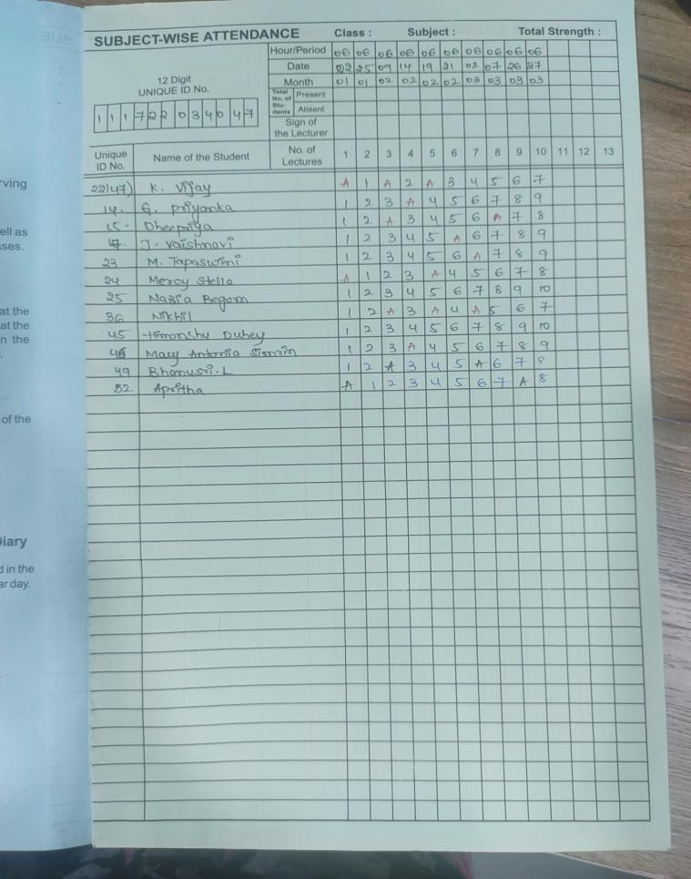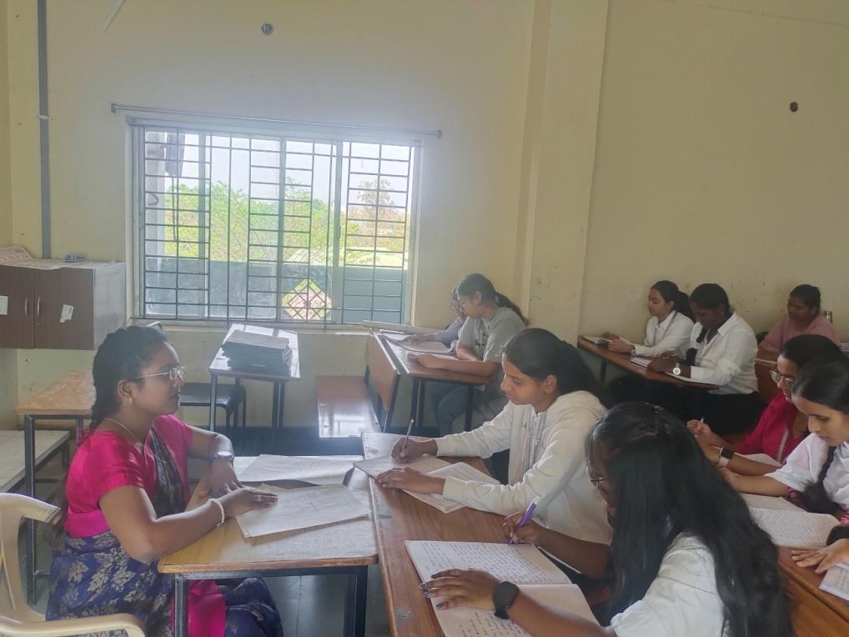
UID NUMBER | NAME OF THE STUDENT | MARKS OF MID TERM I | MARKS OF MID TERM II
111723034014 | Ghadam Priyanka | 25 | 30
111723034018 | Harshitha | 25 | 32
111723034023 | Marthi Tapaswini | 23 | 35
111723034024 | Mercy stella | 22 | 33
111723034025 | Nazia begum | 25 | 28
111723034015 | Dheepriya | 25 | 30
111723034036 | Nikhil | 25 | 30
111723034045 | Himanshydubey | 21 | 25
111723034046 | Mary Antonia simrin | 25 | 39
111723034049 | Bhanusri | 25 | 30
111722034047 | Vijay | Ab | Ab
111723034031 | Apritha | 23 | 42

Conclusion :The remedial class conducted for the first year student for the subject Family meal management had a better impact in the marks in the second mid-term exam. Academic improvement was observed in the students who attended remedial classes

Food Science and Technology
REPORT ON REMEDIAL CLASSES FOR APPLIED MATHEMATICS , 2023 – 2024

Name of the Lecturer: MUSKAN GOYAL
Department : BSc Food Technology and Management
Subject: Applied Mathematics

Class : NFT Year : II Semester : IV

MUSKAN GOYAL, faculty in the department of mathematics have conducted remedial classes toB.Sc Food Technology and Management on the subject of Applied Mathematic” for 2nd year students.

No. of students enrolled: 25
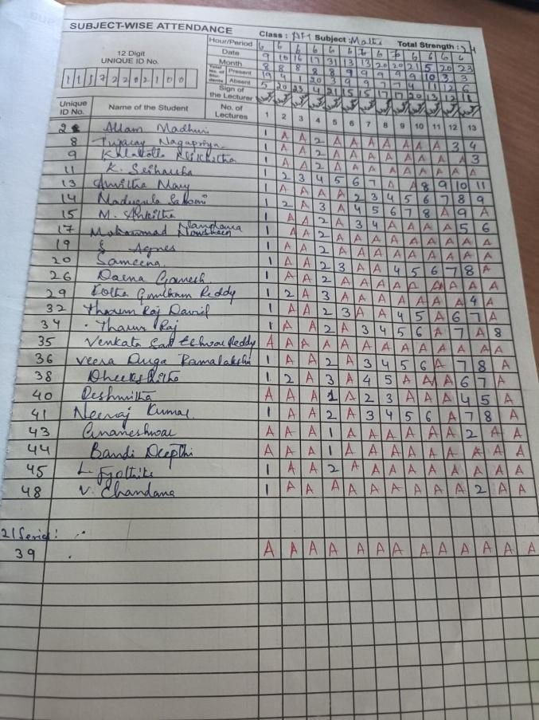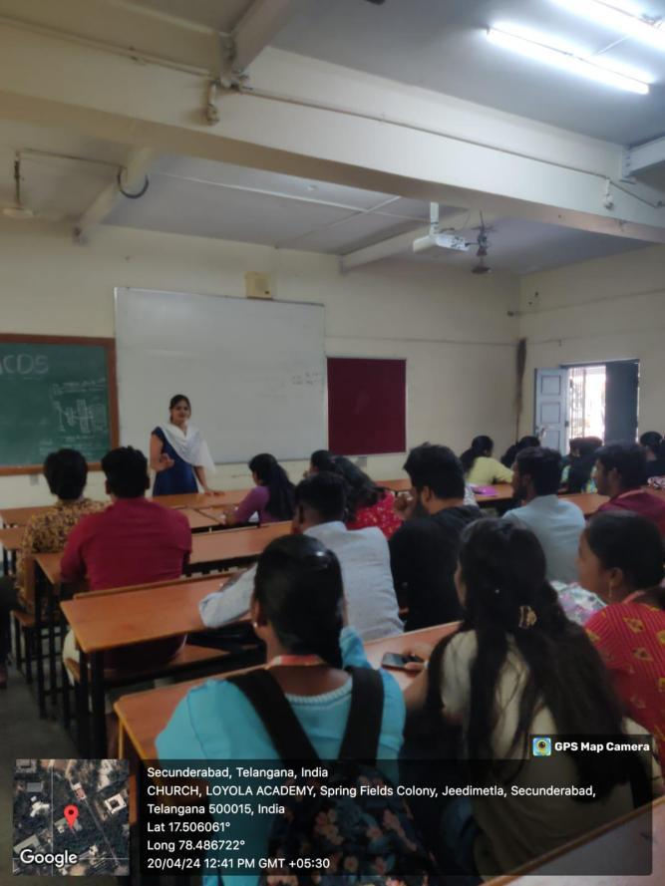
REPORT ON REMEDIAL CLASSES FOR FOOD CHEMISTRY , 2023 – 2024

Name of the Lecturer: V Jyothi N V S V Priya
Department : BSc Food Technology and Management
Subject: Food Chemistry

Class : AFT Year : I Semester : II

I V Jyothi N V S V Priya , faculty in the department of BSc Food technology and Management have conducted remedial classes on the subject of “Food chemistry” for 1st year students.

No. of students enrolled: 18

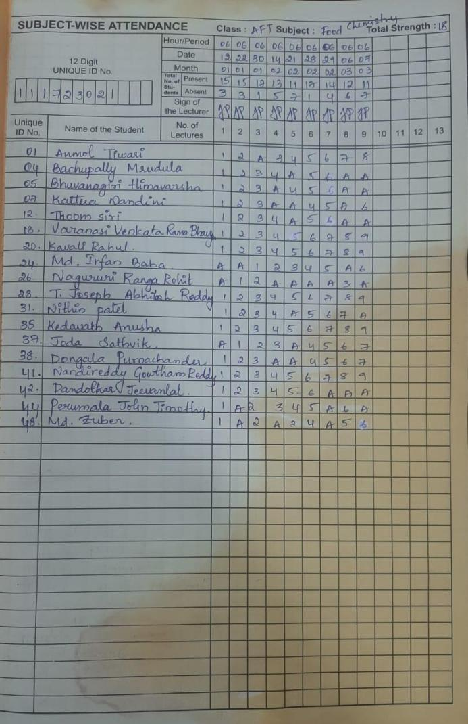
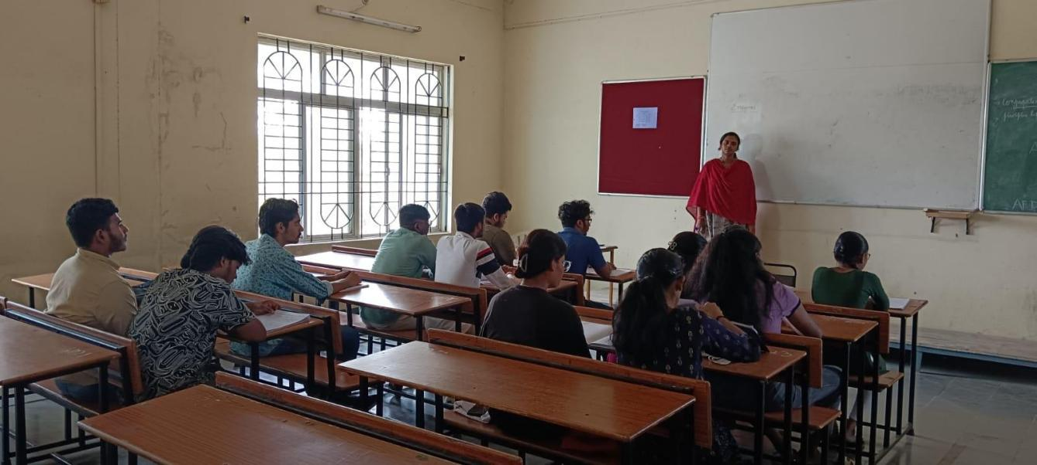

REPORT ON REMEDIAL CLASSES FOR FOOD PROCESS ENGINEERING II , 2023 – 2024

Name of the Lecturer: V Jyothi N V S V Priya
Department : BSc Food Technology and Management
Subject: Food Process Engineering II

Class : NFT Year : II Semester : IV

I V Jyothi N V S V Priya , faculty in the department of BSc Food technology and Management have conducted remedial classes on the subject of “Food Process Engineering II” for 2nd year students.
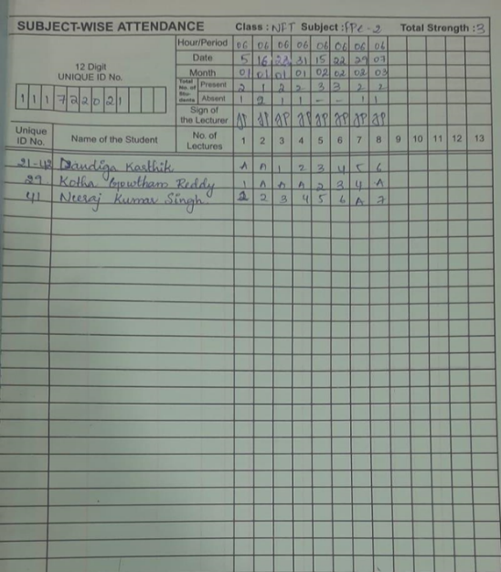
No. of students enrolled: 3
FACULTIES DATA WHO CONDUCTED REMEDIAL CLASSES

S.No | Name of the Department& class | Name of the Faculty conducted Remedial | Subject
1 | NIAF | Rajeshwari | Performance management
2 | AIAF | Hema devi | Taxation
3 | DIAF | - Pashupathinath | Corporate reporting
4 | BBAT | Sritama maitra | Business English-2
5 | ACSC | M. Ravi | Problem sloving & programming in C
6 | ACSC | Bindu Babu | Mathematics
7 | ABBA-ED | Dr. A. Latha | Financial acoounting
8 | ABBAT | Dr. Ramesh Muthangi | Financial acoounting
9 | AFSN | G. Gnana Sheeba | Food Microbiology
10 | AFSN | D. Krushitha | Family meal management
11 | NBBA | Mrs. M. Sunanda | Research Methodology
12 | DCS | Mrs. K. Ankitha | Web Technology
13 | DCS | Mrs. S. Swapna | Advanced Java
14 | NCS | Dr. C. Santhi | ECM&CO
15 | NCS | S. Swapna | Operating systems
16 | NCS | K. Himabindu | DBMS
17 | ACS | Lucas Reddy | EDC
18 | ACS | Shrisha | Mathematics-1
19 | NBBA-ED | Sunanda | Financial Accounting
20 | NBBA-ED | Sweta rao | Financial Management
21 | ACS | Asha John | English
22 | ACS | S.Swapna | C Programming
23 | ABBA-ED | K. Nandini | Fundamentals of IT
24 | ABBA-ED | V. Kalyan Goud | Financial Accounting
25 | NCSCS | Ch. Teja sriya | Cryptographic algorithms
26 | AAG-A&B | Mrs. T. Divya | Fundamentals of Genetics
27 | DAG-A&B | Mrs. T. Divya | Crop Improvement-1
28 | AAG-A&B | Mrs. K. Santhoshini | Fundamentals of Crop Physiology
29 | DAG-A&B | Mrs. K. Santhoshini | Rainfed Agriculture and Water shed Management
30 | AAG-A &B | T. Vijay | Soil water conservation Engineering
31 | NAG-A&B | D. Sravani | Statistical methods
32 | AAG-A &B | Dr. B. Sundar | Fundamentals of Entomology
33 | NCIS | Aparna K | Advanced accounting
34 | NCIS | P. Rajkumar Reddy | Direct Taxes
35 | NFT | V Jyothi N V S V Priya | Food Process Engineering-2
36 | AFT | V Jyothi N V S V Priya | Food Chemistry
37 | NFT | Muskan Goyal | Applied Mathematics
38 | NBT | N. Kavitha | Chemistry-3
39 | NCBA | V. Anusha | Fundamentals of Business Analytics
40 | ACBA | K. Rajitha | Financial Accounting-2

Conclusion:-

Remedial classes play a crucial role in Loyola Academy by providing additional support and assistance to students who are struggling academically.Students with varying learning needs and abilities can benefit from these classes, as they cater to their specific requirements. By offering targeted interventions, remedial classes ensure that no student is left behind due to their academic challenges. This inclusive approach fosters a sense of belonging and encourages students to actively engage in the learning process, boosting their self-confidence and motivation.

Remedial data link

https://docs.google.com/spreadsheets/d/1f0heFuHM8X_W3q2aZXQIuISCM86EldtdxDMqOprKJUg/edit?usp=sharing

K.HIMABINDU

