
TITLE OF THE EVENT | ANTI DRUG PLEDGE
DATE | 24th June 2025/ 26th June 2025
VENUE | INIGO HALL/ XAVIER HALL
ORGANIZER, COORDINATOR | - Rev. Fr. Dr. A.M. Joseph Kumar, SJ, Vice-Principal.  - Mr Thimmappa, Inspector, Alwal, Police Station.  - Mr Raghavender Reddy, Sub-Inspector, Alwal Police Station.  - Ms Geetha, Sub-Inspector, Alwal Police Station.  - Dr G Anitha Mary, Lay Vice-Principal.  - Ms Saras Chandra, Dean, Student Affairs.
SPEAKERS/ RESOURCE PERSONS | Rev. Fr. Dr A M Joseph Kumar, SJ.
TARGET AUDIENCE | UG students.
OBJECTIVES OF THE EVENT:

PARTICIPANTS DETAILS:
Faculty, student volunteers and students.
TOTAL PARTICIPANTS |  | 800
DEMOGRAPHICS |  | Faculty and first and final year students of UG.
ATTENDANCE PERCENTAGE |  | 100%
DETAILS OF THE ACTIVITY:
Loyola Academy in collaboration with Telangana’s Largest Youth-Led Anti-Drug Movement organized an ANTI-DRUG PLEDGE on 24th June 2025 for the first and final year UG students of the School of Arts, Humanities and Life Sciences and the first, second and third year students of the School of Informatics on 26th June 2025. Rev. Fr. Dr. A. M. Joseph Kumar, SJ, Vice-Principal, School of Management spoke on the effects of drugs on lay man especially youth. He told them to be miles away from them as they ruin their contented life. He inspired them through real life stories for having a life away from all these anti-social elements. Mr Thimmappa, Inspector and Mr Raghavender Reddy, Sub-Inspector exhorted on the importance of overcoming obstacles and they also encouraged them to reach out to their their families and departments whenever a need arises. They showed PPTs and videos to present the details of the campaign. All the students along with faculty took a pledge that they would promise to follow a drug-free lifestyle and will also ensure that no one is under the influence of them.
OUTCOME:
The session helped the students to take a decision to fight against the drugs and prepared themselves to save all the victims by spreading awareness.
FEEDBACK ANALYSIS:
Students conveyed that such programmes would create awareness among the youngsters to safeguard their lives from these dangerous habits. The first year students are of the opinion that such initiatives from the college and government would certainly enhance the chance of creating a drug-free society.
METHOD OF FEEDBACK COLLECTION: Offline
EVENT PHOTOS:
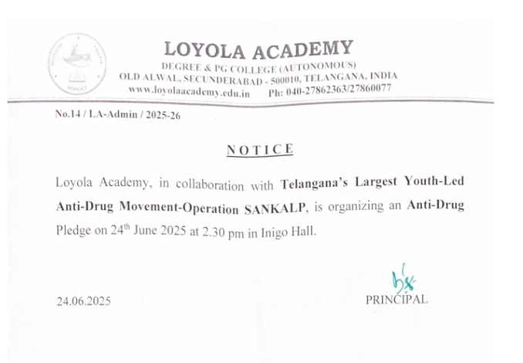
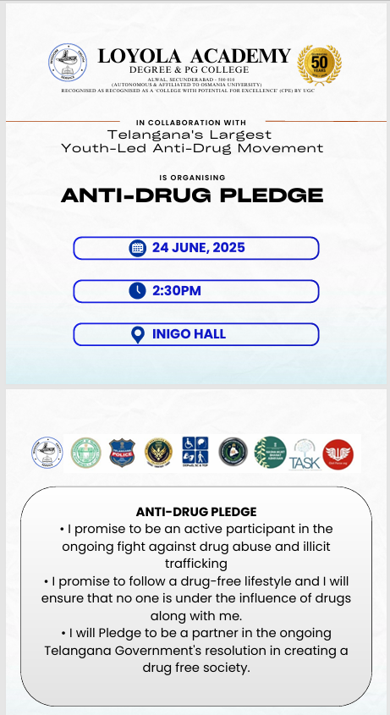 |  | 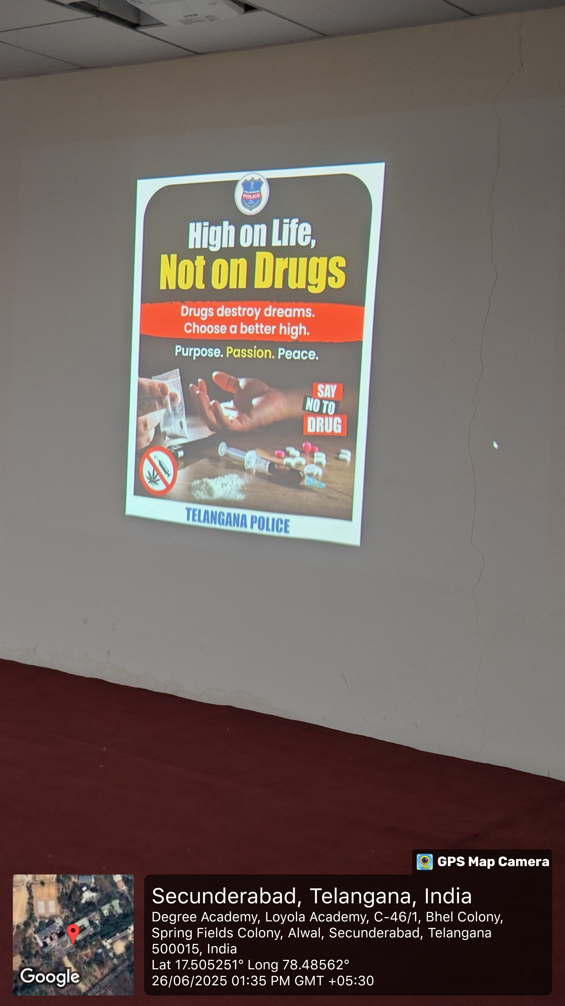
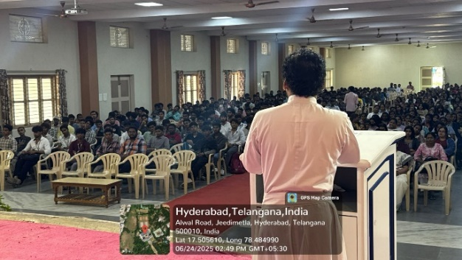 |  | 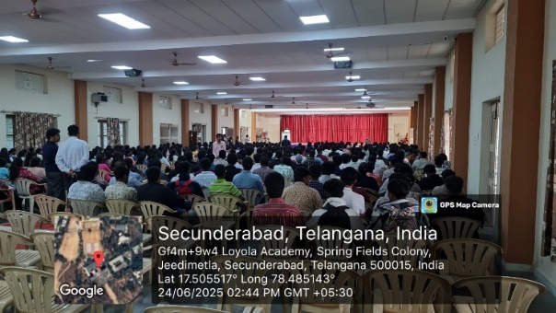
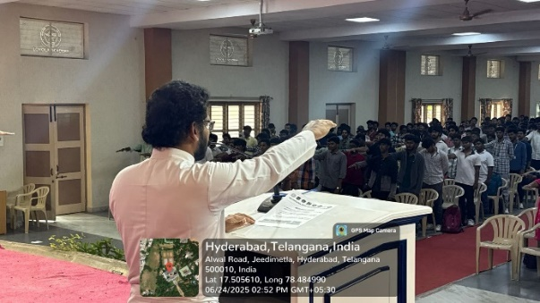 |  | 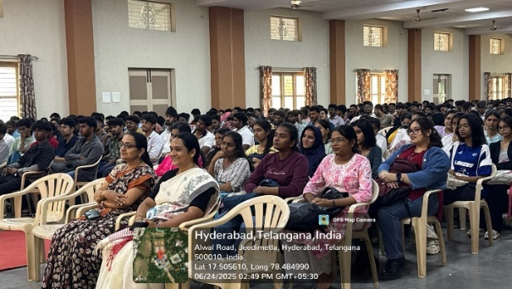
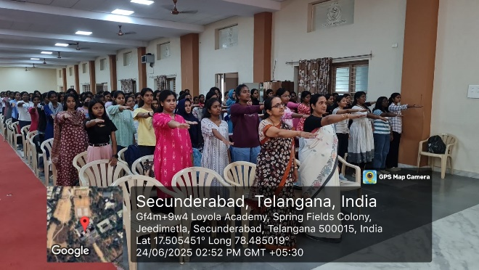 |  | 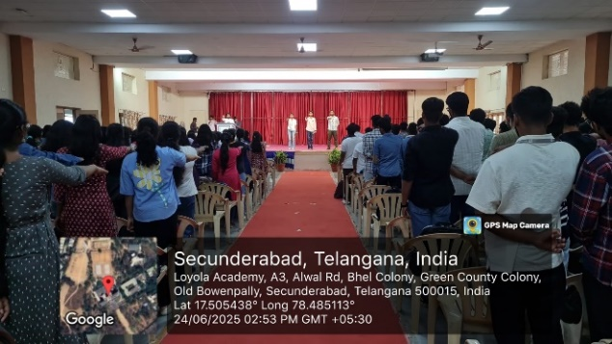
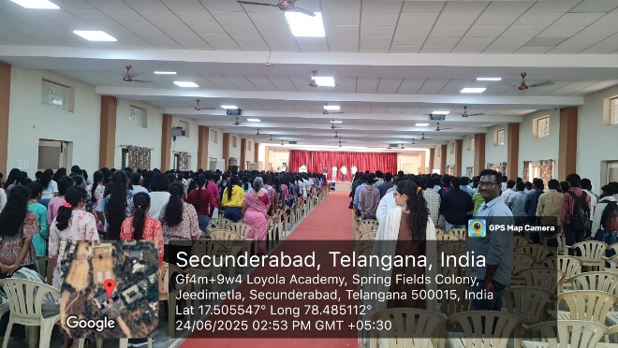 |  | 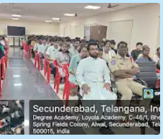
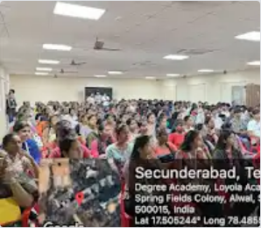 |  | 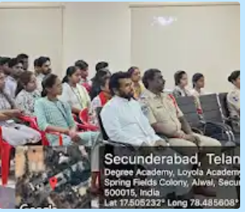
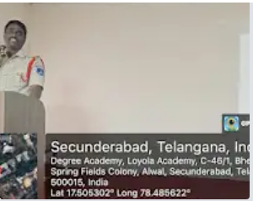 |  | 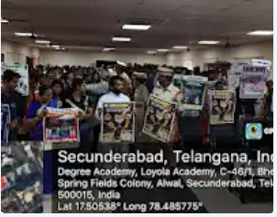
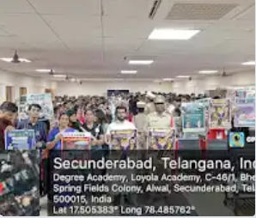 |  | 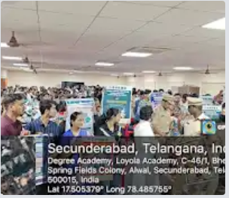
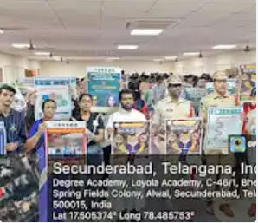 |  | 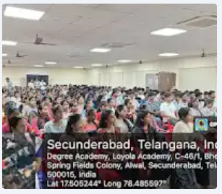
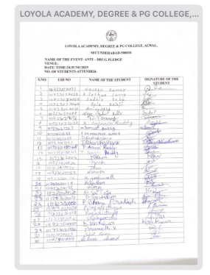 |  | 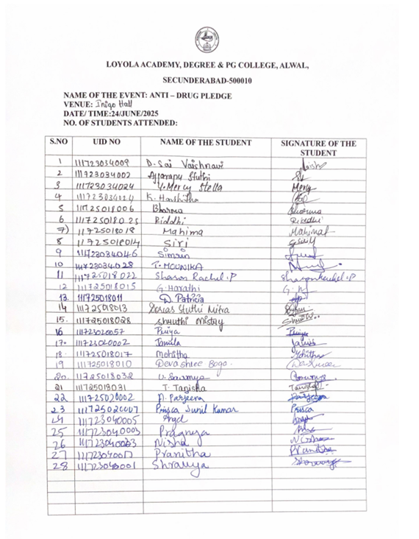
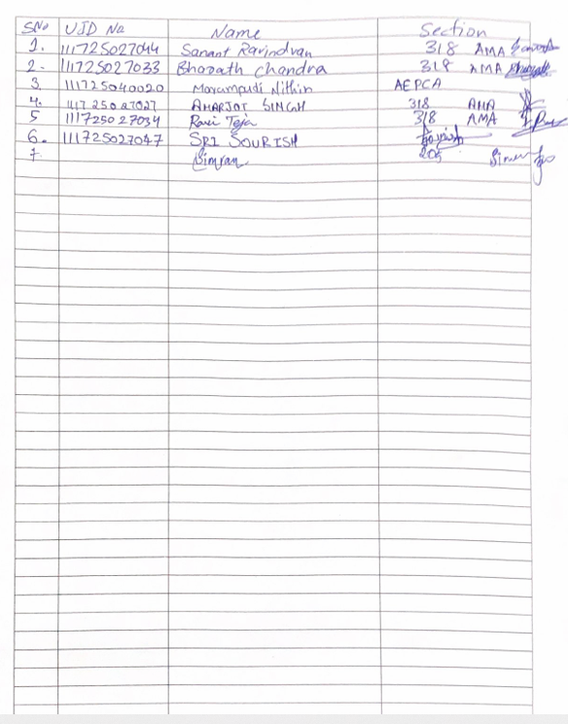 |  | 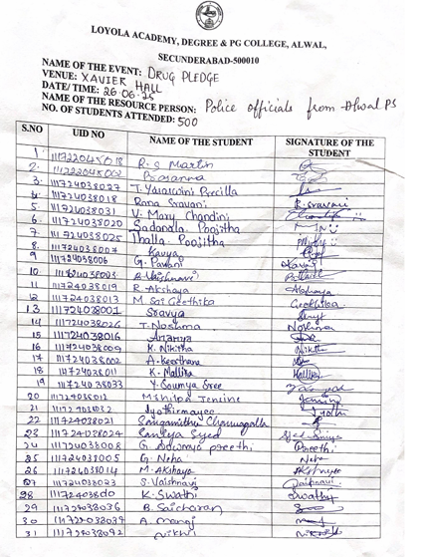
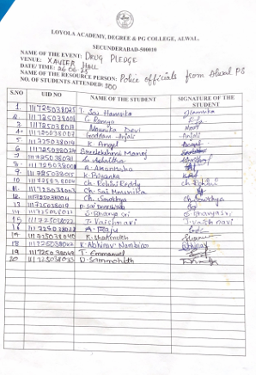
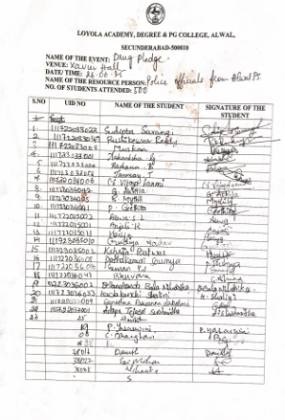 |  | 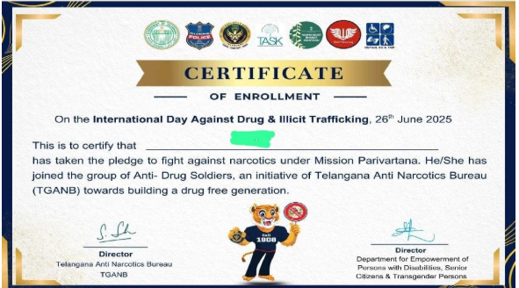

Ms Saras Chandra Rev. Fr. Dr. A.M. Joseph Kumar, SJ
Dean, Student Affairs Vice-Principal

