

TITLE OF THE EVENT | Mental Health Awareness session
DATE | 26th November , 2025
VENUE | CS Block – ASCIT
ORGANIZER, COORDINATOR | Counselling Cell, Ms. Sahithya Guduru
SPEAKERS/ RESOURCE PERSONS | Ms. Sahithya Guduru
TARGET AUDIENCE | Students
OBJECTIVES OF THE EVENT:
To promote positivity , self-love and mental wellness within our community.
PARTICIPANTS DETAILS:
TOTAL PARTICIPANTS |  | 39
DEMOGRAPHICS |  | Students
ATTENDANCE PERCENTAGE |  | 75%
CONTENT EVALUATION:
RELEVANCE OF THE TOPIC:
To equip students with more knowledge on mental health and the measures that they can take in case of an emergency.

DEPTH OF KNOWLEDGE DELIVERED:
During the session, I walked the students through simple techniques they can use when they feel overwhelmed, like the 5-4-3-2-1 grounding method and box breathing. We also had an open conversation about the everyday issues they struggle with. The goal was to help them understand what they’re feeling and give them a few practical tools they can use anywhere, anytime.

ENGAGEMENT OF PARTICIPANTS:
The students were encouraged to talk about the regular mental health challenges that they face like anxiety, peer pressure, academic stress.
LEARNING OUTCOMES:
Students learned practical calming techniques like grounding and box breathing to manage stress. They also gained a better understanding of their everyday struggles and how to respond to them in healthier ways.
KEY TAKEAWAYS FOR PARTICIPANTS:

- Learned quick calming tools like grounding and box breathing.
- Understood their daily life stressors better and felt heard.
- Gained practical ways to manage overwhelming moments.

SKILLS/KNOWLEDGE GAINED:
- Grounding techniques

- Emotional Well-being & Stress Management
- Goal Setting
- Supportive Community & Growth
FEEDBACK ANALYSIS:
METHOD OF FEEDBACK COLLECTION: Offline

POSITIVES:
- Boosted Mood & Positivity
- Self-Reflection & Awareness
- Encouragement & Motivation
- Sense of Connection & Agreement
- Emotional Impact & Meaningful Experience
RATING ON A SCALE of 1-5:4 CONTENT QUALITY: 4
SPEAKER EFFECTIVENESS: 4
PRESENTATION STYLE: 4
QUANTITATIVE ANALYSIS AND FUTURE PRACTICES:

SUGGESTIONS FOR FUTURE EVENTS:
- Better Crowd Management
- Enhance Engagement & Fun Activities
- Include more hands-on activities or mini role-plays.
FEEDBACK FORMS:
https://docs.google.com/spreadsheets/d/1PBiuAmzmYKqvzQPD5sBQ9rndd_p2BI2-2UEJ2W--VwI/edit?usp=sharing
EVENT PHOTOS:

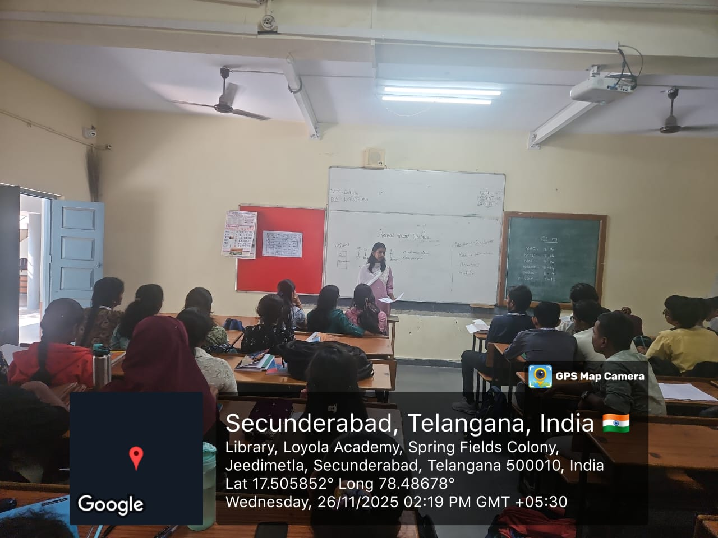

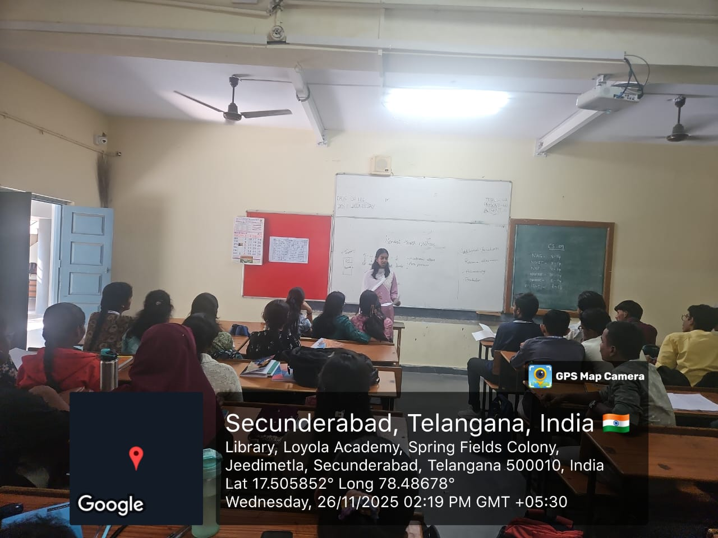

ATTENDANCE SHEET:

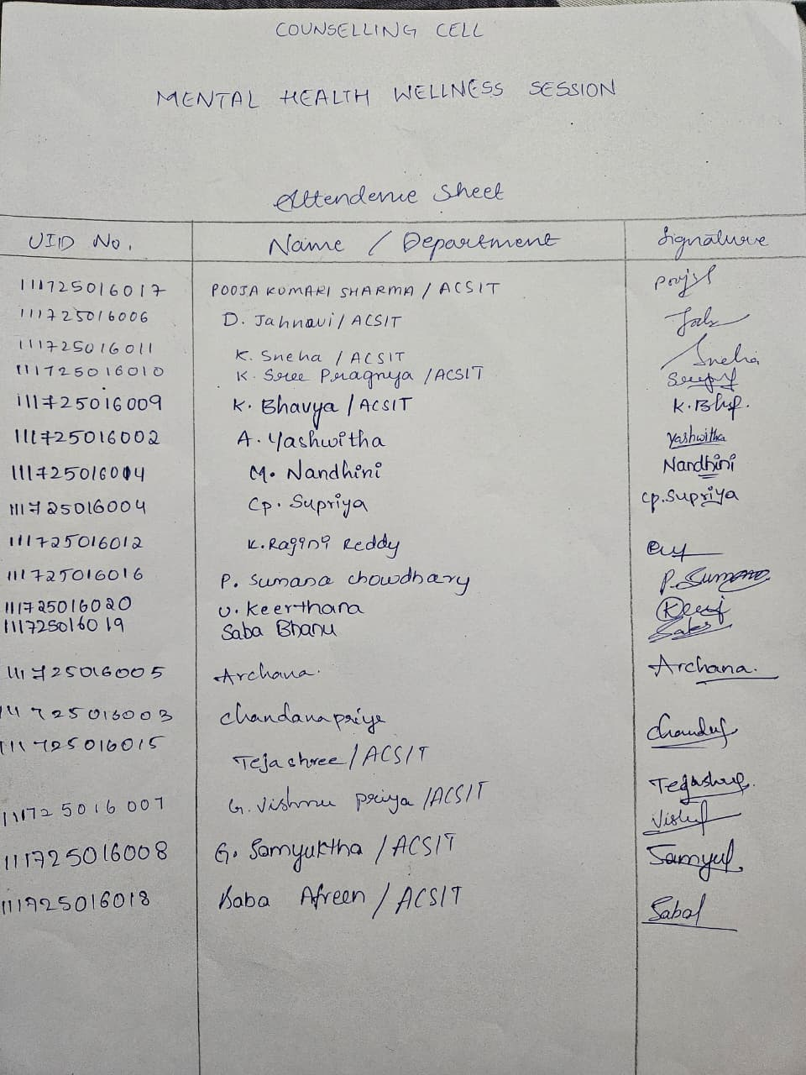
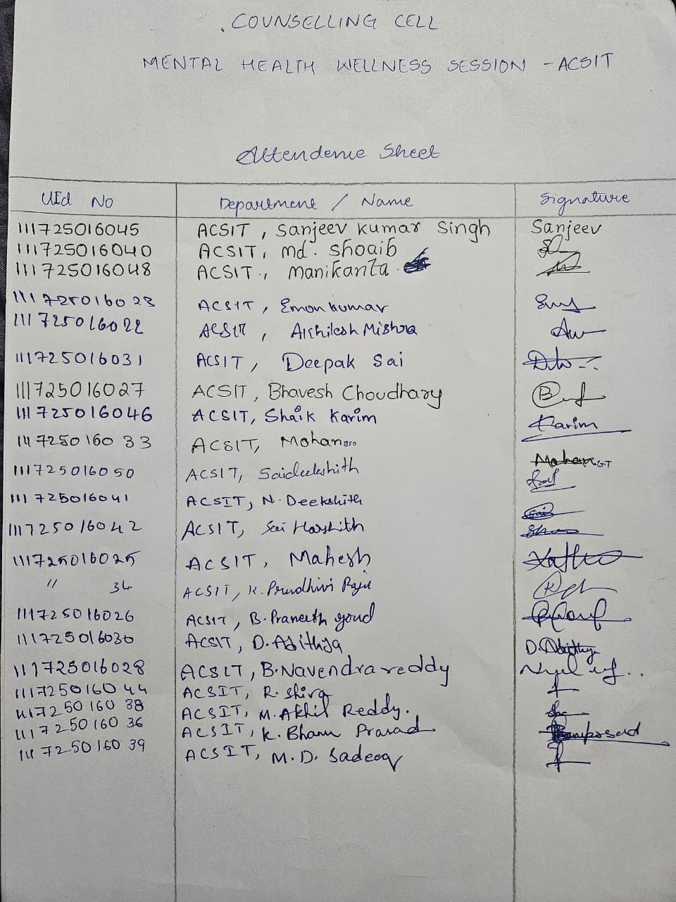

Offline Feedback

