LOYOLA ACADEMY 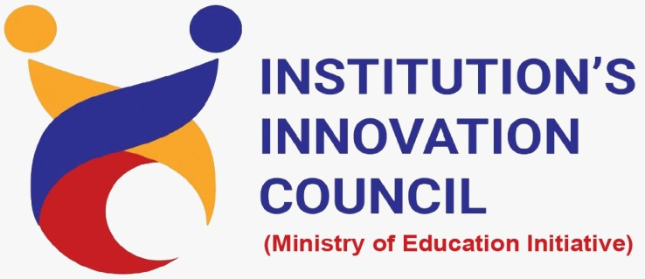 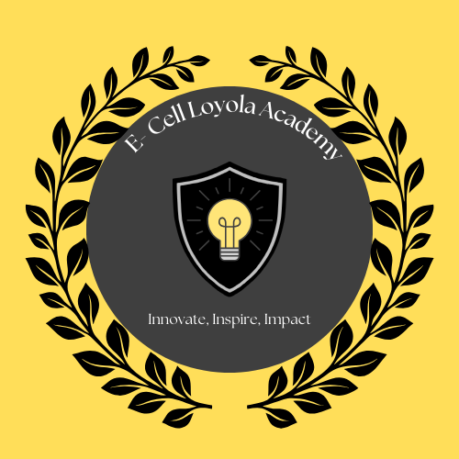

(Autonomous)
Degree & P.G. College

Institution’s Innovation Council in collaboration with Entrepreneurship cell
Name of the Event: Way Forward to Innovation and Entrepreneurship
Date: 05-03-2025
Time: 9.30 AM to 12.15 PM
No. of Students participated: 141
No. of Faculty Participated: 02
Venue: Loyola Hall
Resource Persons: 1. Mr. Mainak Basu, Director of Technology at Sobus,
2. Mr. Rishi Prakash, Core Team Member at Sobus

Objective:
To inspire and guide aspiring entrepreneurs by providing insights into innovation, business incubation, and the steps to transform ideas into successful ventures.

Report:
On March 5, 2025, the Institution’s Innovation Council, in collaboration with the Entrepreneurship Cell of Loyola Academy, organized an insightful session titled "Way Forward to Innovation and Entrepreneurship." The event aimed to inspire and guide aspiring entrepreneurs by fostering a deeper understanding of innovation, business incubation, and the essential steps in transforming ideas into successful ventures.
The session commenced with a warm welcome extended to the esteemed Chief Guests, Mr. Mainak Basu, Director of Technology at Sobus, and Mr. Rishi Prakash, Core Team Member at Sobus. Their presence enriched the event, bringing valuable insights from their vast experience in technology, finance, and entrepreneurship. The dignitaries were felicitated as a token of appreciation for their invaluable contributions. Rev. Fr. Dr. N. B. Babu, SJ, Principal of Loyola Academy, along with Vice Principals Rev. Fr. Dr. A. M. Joseph Kumar, SJ, Rev. Fr. M. Arul Jothi, SJ, and Rev. Fr. Anthony Prabhu, SJ, graced the occasion with their presence, further emphasizing the institution's commitment to fostering entrepreneurship and innovation.
Following the felicitation, the session transitioned into an engaging and interactive discussion led by the distinguished speakers. Mr. Mainak Basu, a technology expert with over 22 years of experience, shared insights on innovation, digital transformation, and sustainability in business. He emphasized the importance of leveraging technology and strategic leadership in entrepreneurship. Mr. Rishi Prakash, a seasoned investment banker, provided valuable perspectives on financial planning, business scaling, and the incubation process for startups. He encouraged students to develop an open mindset and refine their ideas to align with market needs.
The event was highly interactive, with both speakers engaging directly with students through Q&A sessions and informal discussions. Students were encouraged to present their business ideas, receiving constructive feedback and morale support. The speakers also elaborated on the incubation process, guiding students on how to turn their entrepreneurial aspirations into viable business models. Their one-on-one interactions with students post-session reflected their dedication to nurturing young innovators and fostering a culture of entrepreneurship within the institution.
The event concluded with a vote of thanks, expressing gratitude to the Chief Guests, Jesuit Fathers, faculty members, and students for their enthusiastic participation. The session served as an eye-opener for aspiring entrepreneurs, equipping them with the knowledge and motivation needed to embark on their entrepreneurial journey. The Institution’s Innovation Council and the Entrepreneurship Cell of Loyola Academy look forward to hosting more such initiatives, further strengthening the institution's role in fostering innovation and business leadership among students.

Outcome:
Students gained valuable knowledge, received constructive feedback on their business ideas, and were motivated to embark on their entrepreneurial journey with a deeper understanding of the industry.

Pictures:
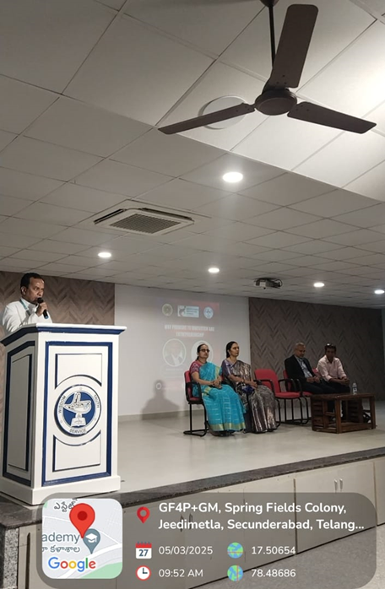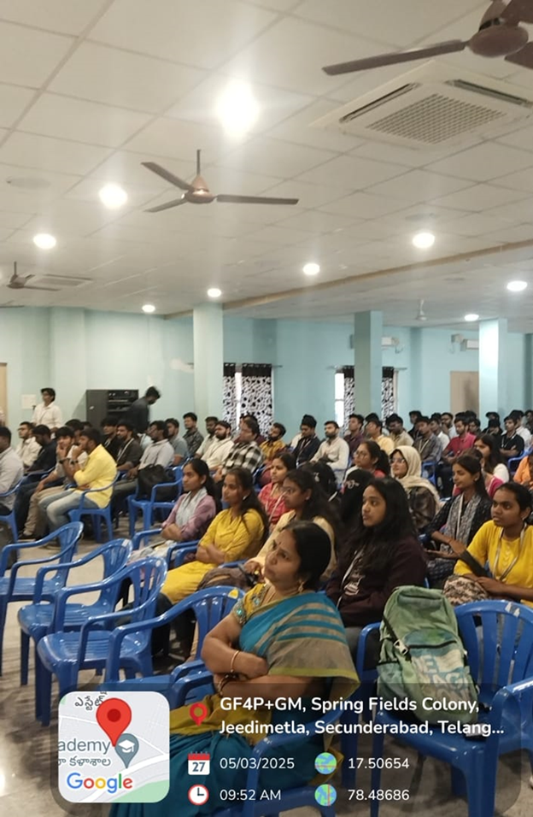
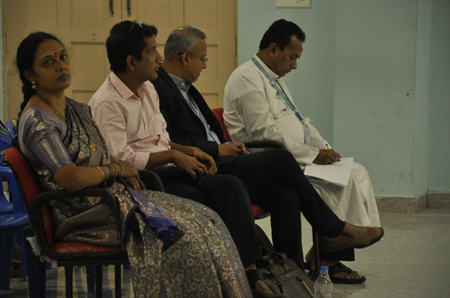

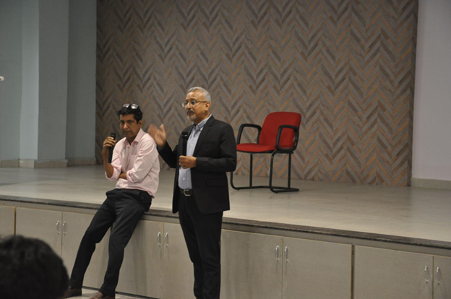

Notice

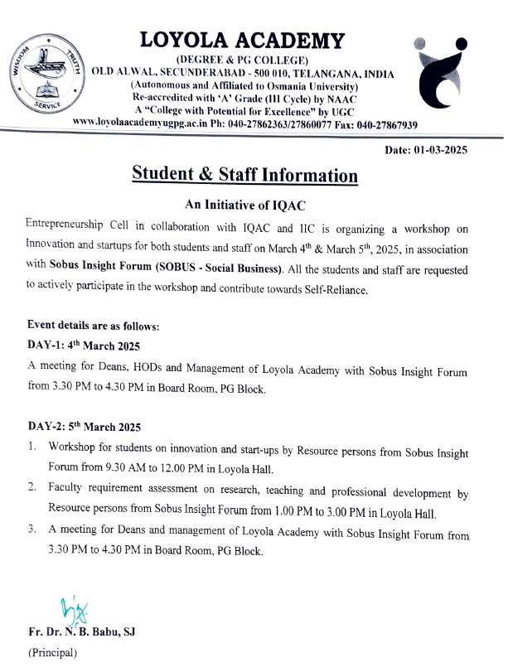

Students List
Name of the Event: Way forward to Innovation and Entrepreneurship
Date: 05-03-2025 Time: 9.30 AM to 12.15 PM (1,2,3 Hours)
S.No | NAME | UID | DEPARTMENT
1 | Arvin Joseph | 111724030031 | AIF
2 | Angelina Joseph | 111724030017 | AIF
3 | Joshua Robert | 111724030041 | AIF
4 | Mark Rabinson | 111723037048 | ncba
5 | Samuel Anthony | 111723037056 | ncba
6 | Merlin Santhosha | 111723018022 | NBT
7 | Gaberial Peters | 111723035033 | NCBS
8 | Ajay Singh | 111723033023 | NBPM
9 | Jagdish Suthar | 111723033023 | NBPM
10 | Jatin D Kalwami | 111723030049 | NIF
11 | D.Sai Saatwik | 111722040032 | ECPA
12 | Burahanuddin.R | 111722017022 | DCM
13 | Vasudeva Murthy .A | 111724720007 | AMDS
14 | Madhu.G | 111724720030 | AMDS
15 | Raghav .K | 111724720033 | AMDS
16 | Joel | 111724720027 | AMDS
17 | Vivek Mishra | 111722043041 | DCSSC
18 | Thumma Satvika | 111722043038 | DCSSC
19 | Sanketh Naidu | 111722043033 | DCSSC
20 | U.Nikhil | 111722043039 | DCSSC
21 | Johann Geroge | 111724022033 | AEL
22 | M.Santosh | 111724033018 | B.com BPM
23 | K.Clinto | 111724032047 | ACSF
24 | Siddesh | 111723013047 | NCS
25 | D.Thanush Reddy | 111723028045 | NCC
26 | G.Karan Sri | 111723013025 | NCS
27 | D.LakshmiKanth | 111723049037 | NCSML
28 | A.Rithvik Raina | 111723045004 | NCSIOT
29 | Kashvika Reddy | 111723031036 | B.SC Computer Data science
30 | Ujjwal Agarwal | 111722029059 | DBBA
31 | Roshan Raj | 111723013045 | NCS
32 | N.Ajay | 111723013039 | NCS
33 | Amit Phadnis | 111723012031 | B.SC Agriculture
34 | Aron | 111724024012 | AMSC
35 | M.Siddarth | 111723032051 | NCSF
36 | Caleb Narayam | 111724049035 | ACSML
37 | Syed Omur Farooq Hussain | 111724049044 | ACSML
38 | Bhavesh | 111723032053 | NCSF
39 | Swosti Prasad Rout | 111724049043 | ACSML
40 | Praveen Kumawat | 111723036012 | NCSC
41 | p. Manoj Kumar | 111728011027 | DCT
42 | Abdual Kareem | 111722040019 | ECPA
43 | Abhay Raj Singh | 111722040042 | ECPA
44 | P.Lakshmi Nivas | 111723039113 | NMCA
45 | Mohammed Ameen | 111723039128 | NMCA
46 | K.Joshan | 111722011017 | DCT
47 | T.Jitesh | 111722011023 | DCT
48 | K.Jayanth | 111724039029 | ACSCS
49 | D.Chaitanya | 111724039025 | ACSCS
50 | Koushik | 111724039035 | ACSCS
51 | Shrinwas Sharma | 111723620006 | NMFT
52 | M. Abhiram | 111723021021 | NFT
53 | Dhayn Bhatt | 111723032040 | NCSF
54 | Bibek Das | 111723032036 | NCSF
55 | Vishnu | 111723032039 | NCSF
56 | M.Sai Kumar | 111724031042 | BSC.DATA SCIENCE
57 | T.Venu | 111723024037 | NMSCS
58 | Tyseen | 111723024036 | NMSCS
59 | p. Manoj Vamshi | 111723024049 | NMSCS
60 | Dilip Suthar | 111723038029 | NCSAI
61 | M.Sai Kiran | 111723038038 | NCSAI
62 | G.DILIP kumar | 111724045010 | ACSIOT
63 | Prashanth Patil | 111724045016 | ACSIOT
64 | P.Amritha Rao | 111724020022 | BA.Mass Comunication
65 | B.Hitha | 111724020001 | BA.Mass Comunication
66 | Shanaya | 111724020005 | BA.Mass Comunication
67 | Tripti | 111724020007 | BA.Mass Comunication
68 | Meghana Yeshala | 111723038024 | NCSAI
69 | Meghana Bejagama | 111723038004 | NCSAI
70 | R.Naga Aishwarya | 111723038018 | NCSAI
71 | Kundanika | 111724022036 | AEL
72 | Alesha | 111724022004 | AEL
73 | Aleena | 111724022003 | AEL
74 | G.Indhira Smnthi | 111724033003 | B.com BPM
75 | Gyaneshwari | 111724033009 | B.com BPM
76 | Sreya Samanta | 111722028031 | DCC
77 | Prateeksha | 111722028014 | DCC
78 | Pranavi | 111722028009 | DCC
79 | A. Varshitha | 111723030001 | NIF
80 | K.Bindhu sri | 111723030018 | NIF
81 | G.Sahithi | 111723030017 | NIF
82 | Ektha Verma | 111723032007 | NCSF
83 | V.Tanvi | 111723032027 | NCSF
84 | Nitya Nair | 111723030025 | NIF
85 | Gungun Rajora | 111724024004 | NIF
86 | T.Mary Sona | 111723620007 | NMFT
87 | Dhakshyani | 111723620029 | NMFT
88 | Sowjanya | 111723620018 | NMFT
89 | Diksha Pandey | 111722017002 | DCM
90 | Sneha | 111724017012 | ACDM
91 | Harshavardhini | 111723049009 | NCSML
92 | Aishwarya | 111724031001 | BSC.DATA SCIENCE
93 | Beulah | 111723031010 | B.SC Computer Data science
94 | Sai Khyathy | 111724021015 | B.SC Food tech and management
95 | Satvika | 111724021005 | B.SC Food tech and management
96 | Sneha Sabat | 111723021010 | NFT
97 | M.Vijaya | 111722011004 | DCT
98 | Priyanka Pradhan | 111724016014 | ACSIT
99 | Pawni Kashyap | 111724016012 | ACSIT
100 | sk.saniya | 111723040027 | ECPA
101 | Ritu | 111723036006 | NCSC
102 | D.Taj Firoz | 111722043003 | DCSSC
103 | U.Sahithi | 111724039020 | ACSCS
104 | G.Akhila | 111724039007 | ACSCS
105 | Sonali Neemkar | 111724036010 | ACSCS
106 | Pasvi Akanksha | 111724036009 | ACSCS
107 | G.Suchana | 111723034040 | Food Science nutrition and dietics
108 | T.Abhinava | 111723034031 | Food Science nutrition and dietics
109 | Saleha | 111723034027 | Food Science nutrition and dietics
110 | Deepshika | 111723034033 | Food Science nutrition and dietics
111 | Jasnavi Goud | 111723045003 | NCSIOT
112 | Bavitha | 111723045033 | NCSIOT
113 | S.Farha Sulthana | 111723016017 | NCSIT
114 | Ameena | 111723016021 | NCSIT
115 | B.Tejaswi | 111723016001 | NCSIT
116 | C.Meghana | 111723012009 | BSc.Agri
117 | Y.Harshitha | 111723012082 | NAGB
118 | P.Sruthi | 111723012066 | NAGB
119 | M.Pooja | 111723012058 | NAGB
120 | Ananya Chauhan | 111723030002 | NIF
121 | Savithru Kulkarni | 111723030057 | NIF
122 | Shinto | 111723030059 | NIF
123 | Asuri Srida | 111723040007 | ECPA
124 | Abraham Augustine | 111723042047 | NBBED
125 | Kevish Nehhana | 111723042045 | NBBED
126 | Veena | 111723042031 | NBBED
127 | Abdul Rahaman | 111723014048 | NCH
128 | Zaniab Siddiqui | 111723029034 | NBBA
129 | Kanak Sharma | 111722042013 | DBBAED
130 | Adrian Aryan | 111721030025 | DIAF
131 | Sally Graham | 111722029026 | DBBA
132 | Megham Varshitha | 111722029016 | DBBA
133 | V.Shiny | 111722029033 | DBBA
134 | Karthikeshwar Pabba | 111722042045 | DBBAED
135 | Sahithi Dinavahi | 111723017006 | NCM
136 | M.Sri Nidhi | 111723029020 | NBBA
137 | K.Laasyavi | 111723029012 | NBBA
138 | Veena Veepala | 111722042025 | NBBAED
139 | Akshit Yabaloori | 111722042045 | DBBAED
140 | Joel Mathew | 111723017058 | NCM
141 | Teja.Ch | 111723041034 | B.Com information systems

