LOYOLA ACADEMY, ALWAL, SECUNDERABAD.
INSTITUTION’S INNOVATION COUNCIL
ANNUAL REPORT 2024-25

Loyola Academy (LA), founded by Rev.Fr. T.J. Balaiah in 1976, is a spacious campus of about 132 acres of land with state-of-the laboratories and exposure to sports. In 2008, UGC awarded LA a rare status known as "College with Potential for Excellence" (CPE), appreciating the achievements and qualitative pursuit of higher educational needs. In addition to this, the National Assessment and Accreditation Council (NAAC) accredited Loyola Academy with an "A grade" continuously for three cycles, that is, in 2005, 2011, and 2019, respectively, and granted an extension of an autonomous status for another five years. In the NIRF college stands between the ranks of 151 and 200 for the academic year 2024–25.
The college has 33 UG programs and 7 PG Programs and every department organises entrepreneurial and innovation activities like workshops, Boot camps, seminars, Conferences, Guest lectures etc. Apart from these there are Research and IPR Committee, Incubation cell, Innovation and Entrepreneurship Cell, Skill enhancement cell and two clubs Idea club and Intellectual property rights club to organize activities of Institution’s innovation Council.
Loyola Academy registered for the Institutions Innovation Council in the academic year 2020–21, received 3 stars for the academic year 2023–24, and is continuing by organizing activities for the academic year 2024–25.
Loyola Academy emphasizes entrepreneurship and innovation. Every quarter, a council meeting is held to discuss the activities to be organized. A quarterly plan is prepared and implemented. A total of 10 faculty members completed Innovation Ambassador Training for the academic year 2021–22. In the academic year 2022-23, 3 Faculty members completed advanced level Innovation Ambassador Training and 3 Completed foundation level Innovation Ambassador Training. A policy is designed for start-ups as per the guidelines of the NISP. Applied for the ARIIA (ATAL Ranking of Institutions on Innovation Achievements) ranking and obtained the participation certificate.

VISION:
The vision of Institution’s Innovation Council is to create a thriving innovation ecosystem within the institution, serving as a catalyst for entrepreneurship and fostering a culture of continuous innovation and creativity.

MISSION:
Facilitate interactions with entrepreneurs, investors, and professionals in order to expose and promote innovative thinking by organizing workshops, field visits, idea contests, seminars, and networking with the local entrepreneurship development agencies.

Functions of IIC
- To conduct various innovation, IPR, and entrepreneurship-related activities prescribed by MIC in a time-bound fashion.
- Identify and reward innovations, and share success stories.
- Organize periodic workshops, seminars, and interactions with entrepreneurs, investors, and professionals, and create a mentor pool for student innovators.
- Network with peers and national entrepreneurship development organizations.
- Create an institution’s innovation portal to highlight innovative projects carried out by the institution’s faculty and students.
- Organize hackathons, idea competitions, mini-challenges, etc. with the involvement of industries.

Institution’s Innovation Council of Loyola Academy
Fr. Dr. N.B. Babu SJ - President
Dr.C. Santhi - Vice President,
Dr. K. Rama- ARIIA Coordinator
Dr. Ragini Modi – Convenor
Dr. V. Kalyan Goud – Internship Activity Coordinator
Dr.A.Bhavani – Entrepreneurship cell Coordinator
Dr. Kavitha Joshi - IPR Activity Coordinator
Dr. M. Ramesh - Innovation Activity Coordinator
Mrs. K. Saras Chandra - Social Media Activity Coordinator
Dr.K. Sudha Sundari - Start up Activity Coordinator

EXTERNAL MEMBERS
1. Dr. Nandita Sethi- Founder & MD of The Entrepreneur Zone (TEZ)
2. P S N Murthy-Consulting Expert, Microfinance * Financial Inclusion * MSME * CSR
3.Sathish Yellanki – Managing Director- Skyess Techno solutions.

MEMBERS
Dr. Suchitra Naidu- Dean of Academics
Dr.G. Ratna Vani – Dean of Arts
A.Anjani Kumari- Coordinator,Skill development Cell
Dr. L. Radhika Rani – Dean Informatics
Mrs. K. B. Sravanthi - Member
Mrs. P Y. Radhika - Member
Dr. Zakir Hussain – Dean R&D
Dr. Reshma Lakra - Member
Dr. Vani Gandham - - Member
Mrs. M. H. Mary Patricia - - Member
Dr. Shakira Sultana - - Member
Dr. Rachel Shalini – Dean Administration
Dr. P. Swapna - Member
Ms. S. Lakshmi - Member
Dr. Sofia Ahmed Sait - Member
Dr. M. Veera Swamy – Dean of Commerce
Mrs. Hilda Margaret - Member
Ms. A. Hima Bindu - Member
Mr. K. Praveen Kumar - Member
Ms. M. Carine - Member
Mrs. N. Sailaja - Member
Mr. Sujeeth Sujay - Member

INFRASTRUCTURAL FACILITIES
Horticulture Research Station
The Horticulture Research Station was established on 15 acres to give hands-on experience to agriculture students in 2017. This research centre is used by the Departments of Agriculture, Science, and Biotechnology.

Food Technology and Management
Started in 2004, the department of Food Technology and management has well-established and equipped labs. The department has food analysis, food processing, a food microbiology lab, a bakery, and ice cream and milling pilot plants financed by the ministry of food processing.

Electronics Instrumentation Lab
Started in 1993, the department has two well-equipped labs: the basic electronics lab and the digital microprocessor lab. Electronics Instrumentation lab is used by the Electronics, Artificial Intelligence, Internet of Things and Computer Science Faculty. This lab is fully equipped with Computers, Aurdino boards, Sensors and actuators as hardware equipment and Xilinx, MATLAB etc as Software resources to promote research work for both students and faculty. Workshops on Design thinking were organized to provide hands-on experience to students. In house projects were done by students with the help of faculty.

Computational Research Lab
The Computational Research lab takes care of the IT related requirements of all the Departments. It maintains labs to provide centralized computing facilities to all students and research Scholars of various departments. This lab is equipped with latest software SPSS, Mathematica, Java, MS Office 365, R , Python.

Central Research Lab
This Lab is used by The Department of B.Sc.Chemical Technology, M.Sc. Organic Chemistry and UG and PG departments of Biotechnology.

INSTITUTIONS INNOVATION COUNCIL ACTIVITIES
An orientation program is organized for all the students at the college at the beginning of the year by inviting various entrepreneurs and startup founders to create awareness among them. All the days like Constitution Day, National Education Day, National Pollution Control Day, National Energy Conservation Day, National Start-Up Day, National Science Day, World Creativity and Innovation Day, World Intellectual Property Day, World Environment Day, AI Day, National Handloom Day, National Commerce Day, and World Entrepreneurs Day were celebrated by the Institutions Innovation Council in the years 2024–25. A total of 32 IIC calendar Activities, MIC driven activities and self-drivenactivities organised for the year 2024-25.
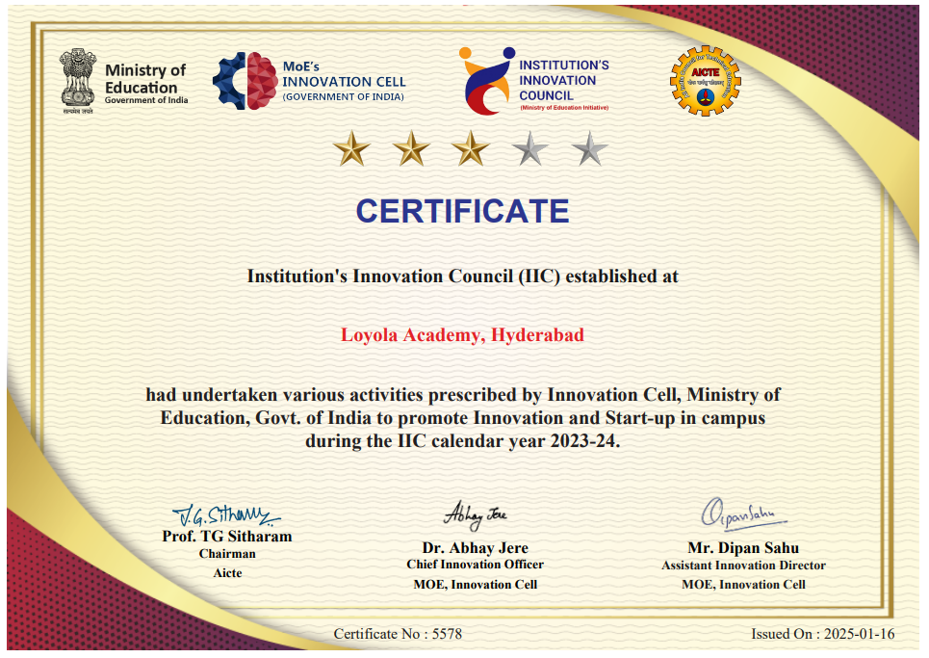
IIC- Rating Certificate 2023-24

ALUMNI NETWORK
Loyola Academy has a strong student and alumni network to support in ideation. The Alumni Relations Team engages in various initiatives to connect with the alumni at various platforms such as –
Mentorship Programs: Building a strong mentor connect between alumni and interns to help the interns in the organizations.
Alumni connect drives: Connecting with alumni during various drives and taking their feedback to grow further.
Guest Lectures: Inviting industry experts to share knowledge with students.
Alumni Meets: Every year on the second Saturday of November Management organizes alumni meet to develop strong bond with them.

ENTREPRENEURIAL ACTIVITIES

- MOVERS PROGRAM WORKERS
Loyola Academy's Entrepreneurship Cell hosted a successful Movers Programme Workshop on September 25th, 2024. The event aimed to equip 118 students with entrepreneurial skills and foster sustainable development goals. Speaker Ansh Bansal, a Mover's Ambassador, guided students through interactive sessions focusing on self-awareness, brainstorming business ideas using SWOT analysis, and understanding marketing fundamentals. The workshop emphasized the importance of innovation, creativity, and leadership. Students participated in group activities, learned about the Five Ps of Marketing, and reflected on their career paths. The interactive nature of the session, engaging presentation style, and real-life experiences shared by the speaker were highly appreciated by the participants.

The workshop concluded with a closing speech emphasizing the importance of an entrepreneurial culture at Loyola Academy. The event was a great success, inspiring students and providing them with valuable insights into the world of entrepreneurship.

- EUREKA PITCH
On October 1st, 2024, Loyola Academy’s Entrepreneurship Cell hosted the Eureka Pitch, a business idea pitch competition offering students the opportunity to advance to the Eureka! Zonal Round. A total of 30 students participated, presenting their innovative ideas to esteemed judges Ms. Sravani and Mrs. K.B. Sravanthi. The event featured compelling presentations, followed by Q&A sessions and interactive discussions.
Notable participants included Ansh Bansal (The Indian Conclave), Chiranjiv Jangid (ApnaDecor.Com), Swathi Devendra Nakrani (Each One Teach Ten), Asuri Srida (Jean Revolution), Akshit Yabaloori & Veena Veerapalli (Sponsor Connect), Kanak Sharma (Loyola Carpool), and Sai Sampath et al. (InstaEyewith AI). The competition culminated in first place being awarded to Akshit Yabaloori and Veena Veerapala (Sponsor Connect), with Ansh Bansal (The Indian Conclave) and Swathi Devendra Nakrani (Each One Teach Ten) securing second place. The event provided participants with valuable feedback, networking opportunities, and potential avenues for funding, fostering the development of entrepreneurial talent.

- WORKSHOP ON “WAY FORWARD TO INNOVATION AND ENTREPRENEURSHIP”
On March 5, 2025, the Institution’s Innovation Council, in collaboration with the Entrepreneurship Cell of Loyola Academy, organized an insightful session titled "Way Forward to Innovation and Entrepreneurship." The event aimed to inspire and guide aspiring entrepreneurs by fostering a deeper understanding of innovation, business incubation, and the essential steps in transforming ideas into successful ventures.
The session commenced with a warm welcome extended to the esteemed Chief Guests, Mr. Mainak Basu, Director of Technology at Sobus, and Mr. Rishi Prakash, Core Team Member at Sobus. Their presence enriched the event, bringing valuable insights from their vast experience in technology, finance, and entrepreneurship. The dignitaries were felicitated as a token of appreciation for their invaluable contributions. Rev. Fr. Dr. N. B. Babu, SJ, Principal of Loyola Academy, along with Vice Principals Rev. Fr. Dr. A. M. Joseph Kumar, SJ, Rev. Fr. M. Arul Jothi, SJ, and Rev. Fr. Anthony Prabhu, SJ, graced the occasion with their presence, further emphasizing the institution's commitment to fostering entrepreneurship and innovation.

INCUBATION CELL ACTIVITIES

- FACULTY DEVELOPMENT PROGRAM ON DRONE TECHNOLOGY:
The Faculty Development Program (FDP) on Drone Technology was conducted from 27th November to 4th December 2024 at the Incubation Centre, targeting faculty members from the Electronics and IoT departments. This program aimed to equip participants with a comprehensive understanding of drone technology, emphasizing its design, operational aspects, regulatory frameworks, and safety protocols.
The program was led by Rev. Fr. Xavier SJ, Correspondent, and Rev. Fr. Dr. N. B. Babu SJ, Principal, who highlighted the significance of adopting advanced technologies in academia to stay relevant in the evolving technological landscape. The sessions were facilitated by Mr. Mohammed Hamed Raza, an Embedded Software Engineer from Hyderabad, known for his expertise in drone technology and prior contributions to similar programs.

- WORKSHOP ON ROBOTICS:
On 21th and 22nd February 2025, a workshop on ROBOTICS was conducted for the students of 2nd year at Incubation Lab(Commerce Block,1CB04), focusing on the significance and practical applications of robotics. The event was inaugurated by the esteemed dignitaries of our institution, including Rev. Fr. Dr.Francis Xavier SJ Correspondent, Rev.Fr.Dr. N. B. Babu SJ, Principal,Dr. G. Anitha Mary, Lay Vice Principal, Dr. L. Radhika Rani, Dean of Informatics and Dr. C. Santhi, Coordinator of Incubation cell and Mr.Abdul Khadar, Head of Department Computer Science and Internet of Things.
Mr. Mohammed Hamed Raza, an Embedded Software Engineer, AR Design Services from Hyderabad, who shared his expertise and guided the students throughout the sessions. Software for developing Robotic applications and integrating them for different applications was demonstrated and engaging the students with hands-on experience bridging the gap between theory and practical’s.

TESTIMONIALS:
1. I’m indeed very glad to acknowledge the invaluable services rendered by the IIC to our Institution. Ever since it’s inception, the cell under the able and dedicated guidance of Dr. C. Santhi, has been a beacon of light to many aspiring Entrepreneurs and Researchers. The increase in ideation and creativity is the witness to their hard work. I wish them many more success in the years to come.-Fr. Arul Jothi, Vice principal, Loyola Academy.
2. I want to extend my sincere appreciation to the entire team behind the IIC, including the dedicated faculty members, mentors, and administrators who have worked tirelessly to make this initiative a resounding success. I look forward to witnessing the continued growth and impact of the Institution's Innovation Council as it continues to inspire and empower the next generation of innovators and change-makers.-Dr.K. Rama, IQAC Coordinator, Loyola Academy.
3.The Institution's Innovation Council of Loyola Academy has undoubtedly played a pivotal role in shaping our institution into a hub of creativity, entrepreneurship, and progress.
Prof. Kavitha Waghray, Dean, School of food Technology and Management.
4. Though I am new to the field of innovation and entrepreneurship, I was amazed at the transformation and innovative thinking and I have acquired knowledge. I look forward to the upcoming activities that help to create awareness, and inculcate a culture of innovation amongst the students. We can dare to come up with any idea, with a possibility of transforming it into a business plan later.-Dr. Veera swamy Marri. Dean, School of Commerce, Loyola Academy
5. As an Innovation Ambassador (IA), trained by the Prestigious institutes like UnionMinistry of Education’s Innovation Cell and AICTE’s Institution Innovation Council(IIC) I feel privileged and blessed .This orientation has empowered and enabled meto show the path to my students to be the Innovators with the limited resources thatthey have, so I Extend my gratitude from the Inner core of my heart to both Institutesfor their Initiative.- Dr. G. Ratna Vani, Dean School of Arts. Innovation Ambassador.
6.I had the incredible opportunity to witness firsthand the power of innovation and incubation at Loyola Academy College, and I must say it was a transformative experience. This institution truly understands the importance of fostering creativity, nurturing entrepreneurship, and pushing the boundaries of traditional education. I cannot speak highly enough of the role Loyola Academy College played in shaping my mindset and providing me with the skills and resources to pursue my own entrepreneurial journey. The education I received there wasn't limited to textbooks and lectures; it extended to cultivating an entrepreneurial mindset and fostering a passion for innovation that I carry with me to this day. - Dr. G.Anitha Mary, Dean, School of Informatics, Loyola Academy.
7.Through various programs, workshops, and mentorship opportunities, the IIC has been instrumental in inspiring the next generation of innovators and entrepreneurs - Dr.Rachel Shalini, Dean, School of Management, Loyola Academy.
8. The IIC's commitment to research and development is commendable. Its support for faculty research projects, funding opportunities, and access to state-of-the-art resources has significantly enriched our research endeavors in the Faculty of Sciences..- Dr.P.Thirupathi, Dean School of Sciences, Loyola Academy.
9.IIC is an excellent initiative to create a vibrant local innovation ecosystem and start-up supporting mechanisms in Higher Education Institutions. The IIC has a wide variety of activities to encourage students and research scholars to make start-ups. IIC is an excellent platform for Industry Institute Interaction. It is a great opportunity to be a part of Loyola Academy’s IIC. It is a good platform for students to develop their ideas into start-ups. It is a great path for future innovations and a great initiative from our institution. - Mrs. G. Sirisha, Additional Controller of Examinations, Loyola Academy, Secunderabad
10.In the era of globalization, innovation is the need of the hour and plays an important role in holistic development. As one of the coordinators of IIC, I explore every opportunity to innovate and guide students to innovate and safeguard their intellectual property.
– Dr.Zakir Hussain, IPR Activity Coordinator
11.The IIC has cultivated a vibrant culture of innovation within our institution. Through workshops, seminars, and various programs, it has instilled a sense of curiosity and a passion for innovation among students and faculty alike.– Dr.P.Suresh Kumar, Head, Department of M.Sc.Bio Technology.

Photo Gallery
