MONTHLY EVENT DOCUMENT

Name of the Cell: INTER FAITH FORUM
Sl.  No | Month & Date | Title of the Event | Report | Budget | Submitted to
 |  |  |  |  | Dept | Dean | IQAC
1. | 28th August 2023 | Onam Celebrations | Attached | NA | -- | -- | Yes
2. | 8th & 9th December 2023 | Spiritual celebrations | Attached | Rs. 1,49,000/- | -- | -- | Yes
3. | 23rd December 2023 | Christmas celebrations | Attached | Rs. 2,50,000/- | -- | -- | Yes
4. | 12th January 2024 | Sankranthi celebrations | Attached | NA | -- | -- | Yes
5. | 28th March 2024 | Ramzan celebrations | Attached | NA | -- | -- | Yes
Total |  |  |  | 3,99,349/-

Kindly Note: Report should contain the following points:
- Title
- Objective of the Event
- Resource person’s Credentials
- Resource Person’s message relevant to the title.
- Outcome of the Event from student’s point of view
- Geo tagged Photo & Video (Do not drag the photo or resize it)

ONAM CELEBRATIONS
Onathilakkam-2023
Date: 28-8-23
Venue: Inigo block and Commerce block
Time: 3:00 pm to 5:00 pm
Objective: To celebrate the festival of Onam, a festival of togetherness and love with games,
dances and a lot of laughter.
Report:
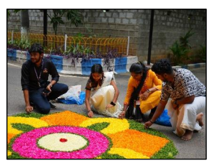
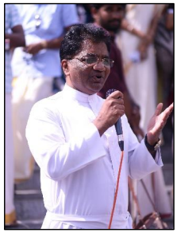
“Unity in Diversity” is what Loyola Academy believes and promotes. Loyola Academy in collaboration with the Student Council and Interfaith Forum celebrated the festival of Onam, ‘Onathilakkam’. Onam is one of the most celebrated festivals of Kerala. It is a vibrant and culturally rich celebration that brings communities together. The Lectures, Student council and all the Malayalis of Loyola Academy were dressed in Kasavu sari and Mundu symbolising the Keralite tradition. The students also decorated the college campus with Pookalam a traditional floral art form from kerala made during Onam that involves intricate and colourful patterns using various flower petals and leaves. The event commenced with Rev. Fr. Dr L Joji Reddy SJ, Principal Loyola Academy, President Xavier’s Board addressing the gathering. The students then performed Thiruvathira an elegant and traditional dance form from Kerala where women form a circle and move in an intricate pattern clapping their hands to the rhythm of the music.
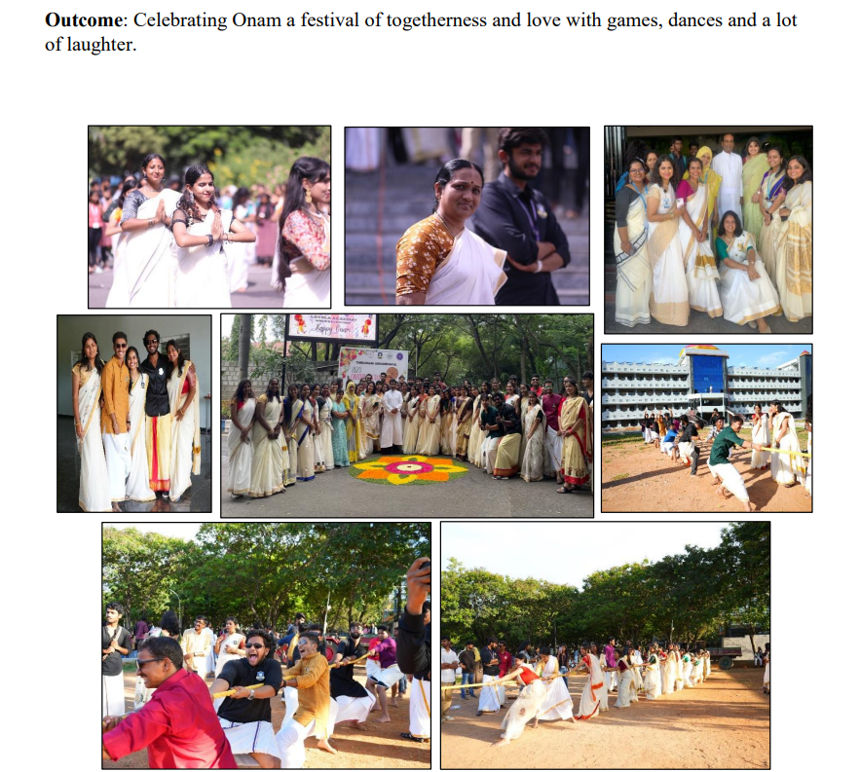
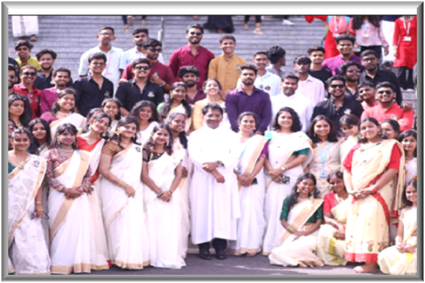
The event then continued at commerce block where Rev. Fr. M Arul Jothi SJ, Vice Principal addressed the gathering sharing his thoughts on the celebration. The students then performed to some catchy numbers as the crowd cheered for them. There were also fun games like Tug-O-war and Lemon and the Spoon that were conducted for the students to take part in the celebration and enjoy. The Onam celebration was conducted with great enthusiasm and highlighted the richness of Kerala. It brought students and faculty of various cultures and backgrounds together to celebrate and to share love and happiness. Through traditional customs, art, fun activities and food, this event successfully embodied the true essence of Onam a festival that unites people in love and togetherness among all .
SPIRITUAL CELEBRATIONS 2023-24

Date: 8-12-2023 & 9-12-2023
Venue: Loyola Hall, Xavier Hall, Inigo Hall, Loyola Academy.
Timings: Day 1:- 9:30 am to 3:00pm
Day 2:- 9:30 am to 12:15pm.
Theme: “Fostering Peace & Reconciliation”
Objective: To foster a spirit of peace and reconciliation among the students, hence shaping their future ordeals that contribute to their overall development.
REPORT:
The Spiritual celebrations were held on 8th and 9th December 2023, with the overarching theme of promoting peace and reconciliation among Catholics, Christians, Muslims, and Hindus within the campus community.
The offline sessions were organized separately for Catholics, Christians, and Muslims at designated venues within the campus. Hindu students joined online via Google Meet and YouTube Live streaming.
Each day featured two speaker sessions, ensuring a diverse range of perspectives and insights for attendees.
Catholics
Invited Speakers: Organizing Committee:
All Jesus Fr. Anthony Prabhu,
Rev. Fr. Ravi SVD & Team Mr. Kiran Kumar,
Mrs D. Elsita
Christians
Invited Speakers: Organizing Committee:
- Rev. Milton Raj , (16th Dec 22) Dr. G. Ratna Vani,
Youth Pastor,
New life Assembly of God church Mr. T. Hanok,
- Mrs. Santha Kumari Merigala (17th Dec 22) Dr. T. Rachel Shalini,
(Mondithoka)
Academic Dean Of Hitha & Mr. Vikram kumar
Faculty In Theology
Ms. Evangeline
Hindus
Invited Speakers: Organizing Committee:
- Mrs. Anjali (16th Dec 22) Mrs. Saraschandra,
Art of living
- Mr. Raja Rao A Mrs V. Naga Lakshmi,
- H.G.Leela Parayana das
Iskcon South Bharat(India) Dr. V. Harsha Sastry,
Divisional Council Member
(Iskcon-Sidc Member) Mr. R. K. Raman
Temple Secretary & Chief P.R.O
Iskcon Temple Mr. Sharath Chandra Raju

- Mrs. Shubha Bhardwaj(17th Dec 22) Dr. Mahendar
Assistant professor SoftSkills
Senior Art of Living Teacher Mr. Anil kumar (Asst prof in Agronomy)

Muslims
Invited Speakers: Organizing Committee:
- Mohammed Amer Ali (16th Dec 22) Dr. Shakira Sultana
Founder, Zikra High School
Dr. Zakir Hussain

- Md. Khair Ul Mubeen Ahmed (17th Dec 22) Ms. Farheen Asif (Ph.D.)
Founder & Chief Educator
IAS Coach Ms. Mehrunnissa (Attendance incharge)
IAS Educational Academy

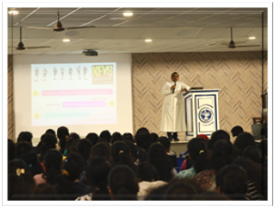
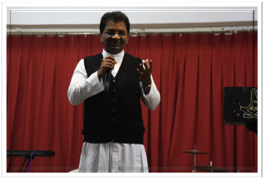
Organizational Details for Each Faith Group:Catholics: Sessions held at Loyola Hall with Rev. Fr. Ravi SVD as the invited speaker.
Fr. Ravi enlightened the event with discussions on fostering peace and reconciliation and how they are always important, especially within communities like the Catholic Church where unity and understanding are key values.
Christians: Sessions held at INIGO Hall featuring Mr. Ebenezer Devaraj from Youth for Christ & Team.
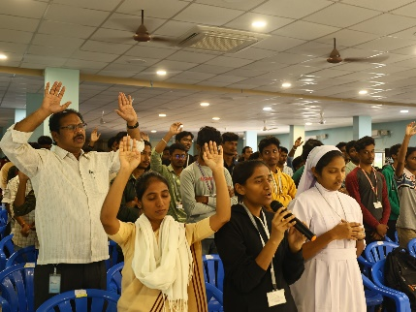
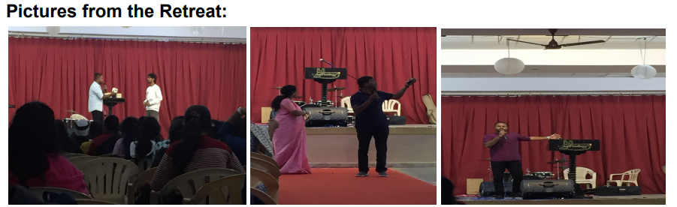The retreat took to its start with cheerful worship and hymns. The EAMCEEs for the event then introduced our first speaker for the day, Mr. Elebenezar Devaraj, the Director of YFC-Hyderabad, who gave the students an insightful message on what it means to serve God with a spirit of oneness and brotherhood among fellow students. The retreat then continued with another worship session led by Prayer Army, Loyola Academy where the students sang their hearts out, praising the almighty.
This was followed by another captivating message by Mr. George and Mr. Santosh, the sub directors of YFC-Hyderabad both of whom spoke on how our duty towards God lay on how well we would serve our fellow individuals and the pursuit of life.

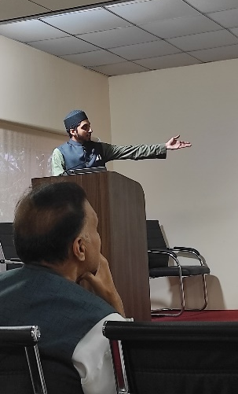
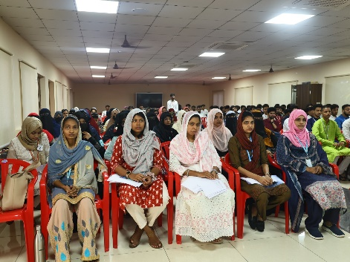
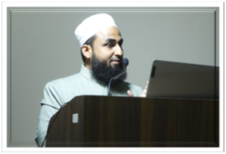
Muslims: Sessions held at Xavier Hall with Syed Haleem Hussaini and Dr. Mufti Azam Nadwi as Invited Speakers.

Both the esteemed speakers spoke about how Islam preaches peace, elucidating fundamental Islamic concepts such as Islam, Iman, Muslim, and Momin, offering illuminating examples that underscored the omnipotence and benevolence of Allah. Their explanations regarding the workings of the universe under Allah's guidance instilled a deep sense of awe and reverence among students.
Hindus: Online sessions with speakers on Hindu Dharmam and related topics:
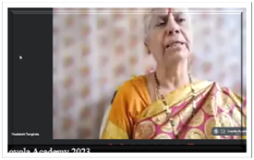
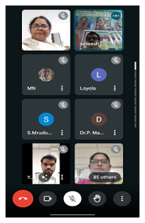
Mrs. Anjali, an Art of Living practitioner, offered wisdom on the transformative power of the Art of Living practices. Her session likely delved into techniques for achieving inner peace, mindfulness, and holistic well-being.
Mr. Raja Rao A, a prominent figure in the spiritual community, brought his expertise to the event, captivating the audience with his deep understanding of spiritual principles and practices.
H.G. Leela Parayana das, representing Iskcon South Bharat, brought a unique perspective to the students as a Divisional Council Member and Temple Secretary. His insights into the spiritual traditions of Iskcon likely offered attendees a glimpse into the rich cultural heritage and profound teachings of the Bhakti tradition.

OUTCOME:
The Interfaith Forum laid out comprehensive Spiritual Celebrations 2023-24, emphasizing inclusivity, dialogue, and mutual respect among diverse religious communities within the campus. The arrangements made reflect a commitment to fostering understanding and harmony among students and staff of different faith backgrounds.

CHRISTMAS CELEBRATIONS
Date: 23-12-2023
Venue: Inigo Hall, Loyola Academy.
Objective: To organize and execute a memorable Christmas celebration at Loyola Academy that fosters a sense of community, spreads joy, and promotes cultural inclusivity.
REPORT:
Christmas was celebrated in the Loyola Academy on 23rd December 2023. To embark the celebration the college campus was decorated with great lightings and colours. The students were rejoiced with festive mood various programs were held along with students, faculty and non-teaching staff singing Christmas carols.Faculty were given Lunch, and all the students enjoyed the cake and sweets that were distributed on Christmas eve.
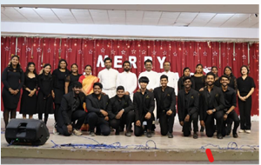
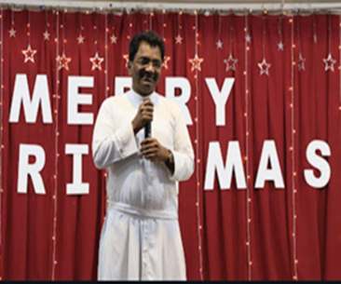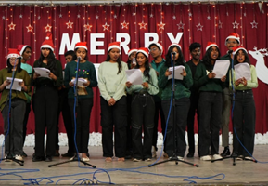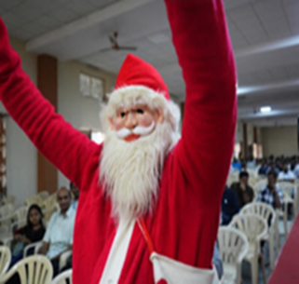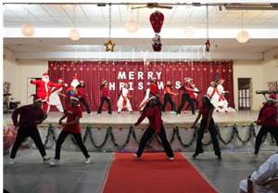
Outcome: Christmas celebrations at Loyola Academy brought together students, faculty, staff, and their families in a spirit of unity and festivity. Through a variety of activities such as carol singing, festive performances, and sharing of traditional holiday foods, attendees will experience the joy and warmth of the season while appreciating the diversity of cultural traditions. The event enhanced the sense of belonging and camaraderie within the Loyola Academy community, leaving participants with cherished memories of a meaningful and enjoyable Christmas celebrations.

RAMZAN CELEBRATIONS
AHLAN YA RAMADAN 2023-24
Date: 28-3-2024
Venue: Near Management Block, Loyola Academy.
Objective: The objective of the Ramzan celebrations at Loyola Academy is to commemorate and reinforce the significance of the holy month Ramadan and the five pillars of Islam.
Report:
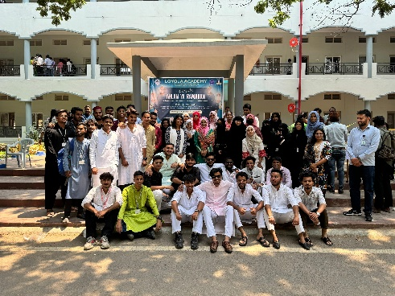
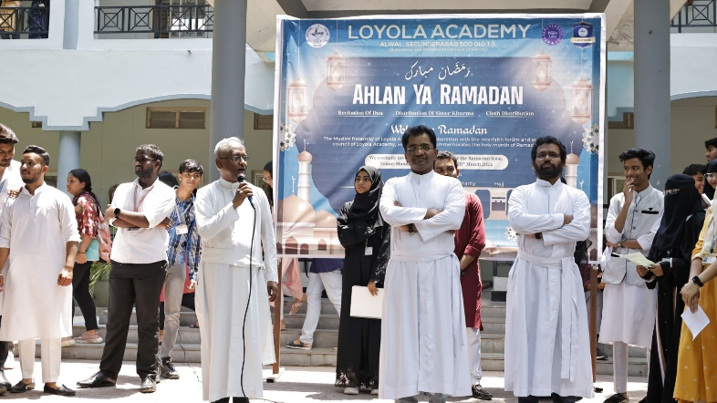
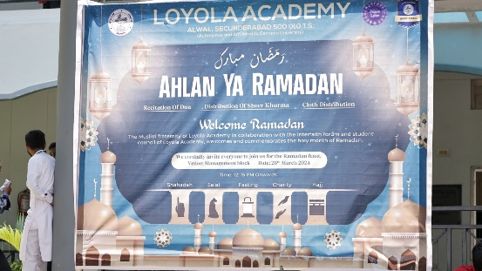
Ramadan celebrations began with address of Rev. Fr. Dr. L. Joji Reddy, Rev. Father Francis Xavier, Rev. Fr. Joeseph kumar who congratulated the students on the occasion of Ramzan. Students spoke about the importance of the festival and explained the Central to faith and practice in Islam are the five pillars outlined in the Hadith of Gabriel, recorded in Sahih Muslim: witnessing (shahadah), the five daily prayers (salat), almsgiving (zakat), fasting during the month of Ramadan (sawm), and the hajj pilgrimage Followed by sarees distribution to Ayyammas and Sweet : Sheer Khurma distribution to students and staff who truly enjoyed the delicious sweet.
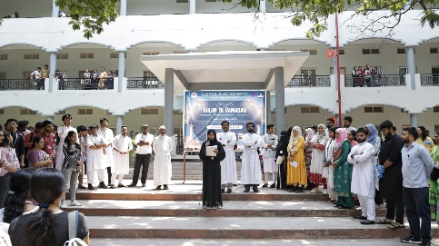
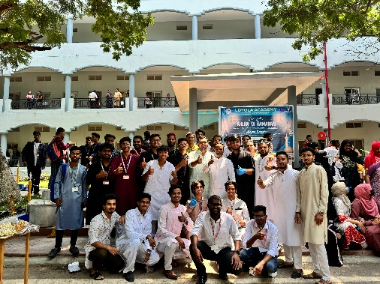
Outcome: Students gained a deeper understanding of the five pillars of Islam, emphasizing the pillar of almsgiving (zakat), the event included initiatives to support charitable causes and encourage acts of kindness and compassion.

