

Mentoring cell

INDEX OF ACTIVITIES/EVENTS 2025-2026

S.no | Title of the Event | Semester | Date | Page no
1 | ORIENTATION PROGRAM ON MENTORING | Odd Semester | 9th July,  10th July,11th July | 3
2 | MENTORING ,SKILL ENHANCEMENT,MOU IQAC ORIENTAION | Odd Semester | 23 June 2025 | 4

Introduction
The mentoring system in the institution is designed to ensure the holistic development of students by providing continuous academic, personal, and career guidance. Each faculty member takes responsibility as a mentor, guiding students through structured interactions and supporting them in navigating both academic and personal challenges. The initiative reflects the institution’s commitment to student-centric learning and well-being
Goals and Objectives
The goal of mentoring is to help students reach their full potential through guidance and constructive feedback.
Adolescence is an age often marked by extreme emotions and impulsive behavior, thereby necessitating a greater level of involvement of the teachers as mentors in the students’ lives. Loyola Academy ensures mechanisms are in place in order to address mental health concerns of the students. Given the diversity of issues faced by the students, it becomes imperative for Mentors to take time out, to help identify the problem and offer suitable solutions.
The objective of the mentoring program is to provide guidance and support to the student as soon as they enter the portals of this institution. The mentor instructs their mentee with specific skill development techniques, coaches them and serves as a model of positive behavior. As opposed to a student, a mentee takes ownership of their learning as they receive constructive feedback from their mentors.
The process of Mentoring
A student is assigned a mentor as soon as they set foot in this college. The Mentor meets them at least once a month, or more, if required. They can choose to speak to their mentees either on a one to one basis or in a group mentoring session. Mentors help create an open and safe environment for healthy self-disclosure. Mentors are empathetic in their communication and demonstrate active listening. Mentors help mentees create goals and follow up with them. They are also available to address academic queries of the students. Given their rich experience, Mentors are able to effectively guide students in their preparation for their prospective careers. Additionally, Mentors refer mentees to the college Counsellor as and when deemed necessary.
Documentation of Mentoring
Every student is given a student mentoring book as soon as they join this college. The student is oriented about how the book is supposed to be filled and the importance of regular updating. This book is to be maintained by the student till their final year. Some of the sections of the book pertain to their personal information, attendance percentages and marks for all semesters, their personal goals, details on internship and projects etc. Additionally, the student is instructed to get this form duly signed by their mentor at every meet and also by their parent at every parent teacher meet.
The mentor is expected to document their meetings in the mentoring register. It includes the details of the name, UID of the mentee and a brief description of the issue addressed. The mentee signs against their name after every mentor- mentee meet.
MENTORING ACTIVITIES

MENTORING - SKILL ENHANCEMENT,MOU IQAC ORIENTAION

The mentoring Coordinator Mrs. Larissa reinforced the vision and the structured framework of mentoring at Loyola Academy ensuring each department uniformly implements, monitors, and evaluates mentoring activities, and streamline documentation procedures for internal audits and NAAC requirements. The meeting facilitated the HODs in guiding their faculty toward maintaining updated and verifiable records.
Key Components Discussed
1. Goals of Mentoring at Loyola Academy: To help students in their holistic development, i.e. academic, emotional, psychological, and career-oriented support and strengthen the teacher-student relationship. The mentor should identify and support slow and advanced learners by creating a structured feedback mechanism thereby tracking students' progression and performance consistently.
2. Institutional Documentation: Documentation ensures accountability and transparency and provides evidence for internal/external audits and accreditation.
3. How to Document Mentoring Effectively: Use of standard mentoring format provided by the Mentoring Cell. Maintain individual mentoring files for each faculty member. Ensure mentoring is done once a month for each student and documented. Record details of academic progress, behavioural concerns, career goals, and follow-up actions. Ensure digital and hard copies are in sync and ready for verification.
4. Follow-Up and Monitoring: HODs to monitor the mentoring progress of their departments monthly. Periodic internal review meetings to assess the effectiveness of mentoring. Timely reminders should be given to faculty for documentation and uploading.
5. Submission of Mentoring Reports:
All student data should be duly filled in the mentoring books and the mentoring books should be kept with the Hods by the end of each Semester. The mentoring books of the students who passed out their VI/ VIII semester should be submitted to the IQAC duly filled. Mentoring books should not be given to the students for fear of misplacing the books.
Each department must submit a consolidated mentoring report at the end of each semester and annually along with the Mentor-Mentee allocation list and Monthly Mentoring Interaction Registers. The Report should include the summary of key issues addressed, follow-up actions taken, reflection and analysis, and the success stories of the students.
Consolidated Departmental Mentoring Report should be submitted annually to the Mentoring Coordinator and IQAC office.

ORIENTATION PROGRAM ON MENTORING

- Mrs. Larissa, the Mentoring Coordinator, emphasized the vision and structured framework of mentoring at Loyola Academy, ensuring that each department consistently implements, monitors, and evaluates mentoring activities while streamlining documentation processes to meet internal audit and NAAC requirements. The meeting guided faculty members in maintaining updated and verifiable records.
- The primary aim is to support students’ holistic development—including academic, emotional, psychological, and career guidance—while strengthening the teacher-student relationship. Mentors are tasked with identifying both slow and advanced learners through a structured feedback mechanism to consistently track student progress and performance.
- Proper documentation is vital for accountability, transparency, and providing verifiable evidence for both internal and external audits, as well as accreditation processes.
- Faculty should utilize the standardized mentoring formats provided by the Mentoring Cell and maintain individual mentoring files. Mentoring sessions should be conducted at least once a month per student and thoroughly documented, including academic progress, behavioural issues, career objectives, and follow-up actions. Both digital and hard copies must be synchronized and readily available for verification.
- Faculty are responsible for monthly monitoring of their students’ mentoring progress. Periodic internal review meetings will assess mentoring effectiveness, and timely reminders will be issued to ensure documentation and report uploads are completed.
- All student data must be accurately recorded in mentoring books, which are to be held by the Heads of Departments (HODs) at the end of each semester. For students who have completed their VI or VIII semesters, the mentoring books should be submitted to the IQAC office. Mentoring books should not be given to students to prevent loss.
Each department is required to submit a consolidated mentoring report at the end of each semester and annually, along with the Mentor-Mentee allocation list and Monthly Mentoring Interaction Registers. Reports should summarize key issues addressed, follow-up actions, reflections, analyses, and success stories.
The annual consolidated departmental mentoring report must be submitted to the Mentoring Coordinator and IQAC office.
- The session fostered active sharing of existing mentoring practices and concerns among faculty, raising awareness of their collaborative role in ensuring meaningful and well-documented mentoring. The IQAC team highlighted the critical role of thorough documentation in quality assurance and institutional accreditation

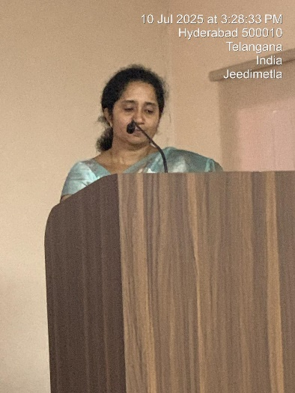
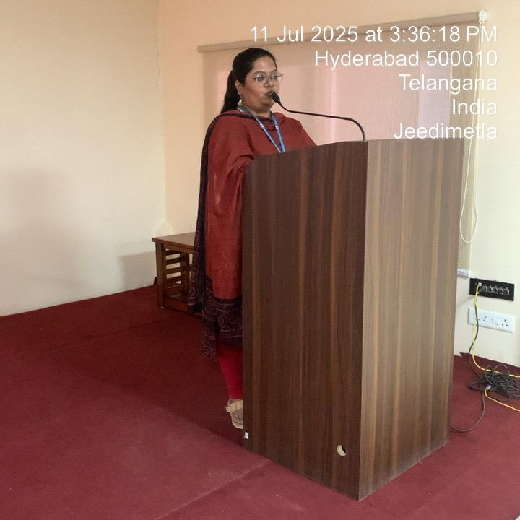

Progress and Achievements
The mentoring program is hugely successful because of the time and effort that is invested in the lives of the mentees. In the case of Mentoring, a mark of progress is the achievement of the personal goals of the students. As evidenced through oral interactions with students and testimonials, the goals of the mentoring program have been achieved to a large extent. Following are the testimonials of students across the various schools in the college.

Student Testimonials
“Mentoring not just helped academically but also emotionally. We had ample time with our mentors to discuss what was going on. Every session with our mentor was so refreshing and illuminating.”
-T.B, UG Student, School of Commerce
“Having a mentor can be an incredibly enriching experience. Through this relationship, I have gained insights into various factors, developed new skills, and ultimately grew both personally and professionally”.
-A.J.A, UG student, School of Arts
“My mentor provided me with a education that equipped me with the skills and knowledge I needed to succeed academically and professionally. She served as a positive role model, showing me what it means to be a lifelong learner and to strive for excellence and learn a lot of life lessons along the way. Moreover, she has always created a supportive, inclusive learning environment, where I felt valued and heard. Her mentorship and guidance helped me navigate the challenges of college.”
-S.A, UG student, School of Arts
“Mentoring classes helped me adjust my time management and relay my issues to the appropriate in-charges. It helped me clarify my doubts about my future academic plans.”
-V.S, UG student, School of Sciences

Challenges, as ascertained through feedback from mentors and mentees

Feedback from Mentors
- Mentors expressed satisfaction in guiding students and contributing to their growth.
- They found mentoring to be a meaningful experience that strengthened their connection with students.
- Mentors observed noticeable improvement in student confidence, participation, and clarity of goals.
- They felt fulfilled in supporting students through academic and personal challenges.
- Mentors also highlighted the importance of continuous interaction for better outcomes.

Feedback from Mentees
- Students felt comfortable discussing academic and personal concerns in mentoring sessions.
- Many reported improved clarity about their strengths, weaknesses, and career goals.
- Mentoring helped them stay focused and manage academic responsibilities effectively.
- Students felt motivated to participate in class activities and co-curricular events.
- Overall, mentees expressed that mentoring contributed positively to their confidence, growth, and decision-making abilities.

Challenges Faced
- Irregular participation of some students due to academic workload
- Time constraints for both mentors and mentees
- Initial hesitation among students to openly share concerns
- Difficulty in maintaining consistent follow-up for all students

Conclusion
The mentoring system has proven to be an effective and impactful initiative in supporting students’ academic and personal development. It has strengthened the relationship between faculty and students, created a supportive learning environment, and contributed significantly to the overall growth of learners.
With continued efforts and structured improvements, the mentoring programme will further enhance student engagement, well-being, and success.

