Report on the Faculty Mentoring event: “Mentoring for Success”

Report on the Faculty Mentoring event: “Mentoring for Success” was organised by the mentoring committee in collaboration with the IQAC on 10th Nov,2023 from 3.30pm to 4.30pm in the Xavier Hall. The resource person for the session was Mr. Santhosh Vennamala, a renowned expert in the field of mental health and education.
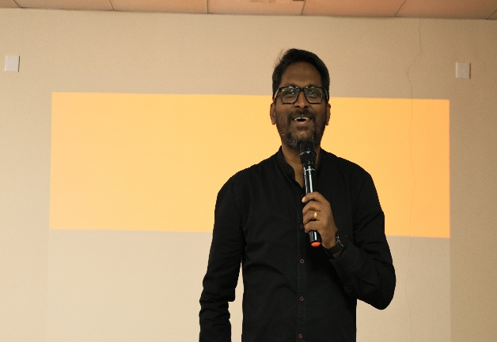
The purpose of this session was to provide our faculty with valuable knowledge and strategies to create a supportive and inclusive environment, by understanding the mental health challenges faced by our students and to better equip ourselves to provide the necessary guidance and support. The session aimed to explore various aspects of mentoring and understanding the student's perspective, exploring mentoring styles, facilitating learning, delving into learning cycles, examining types of mentoring, and identifying stages of mentoring. Additionally, the session covered key attributes that make a mentor effective.

Mr. Vennamala defined mentoring as a powerful tool for personal and professional development, contributing significantly to individual success. He also explained that mentoring is a dynamic relationship where an experienced individual (mentor) guides and supports a less experienced person (mentee) to help them achieve their goals. It is a fundamental aspect of personal and professional growth. Sir elaborated the Importance of Mentoring in knowledge transfer, skill development, Career advancement, networking, increased self-confidence, motivation, personal growth and leadership development.
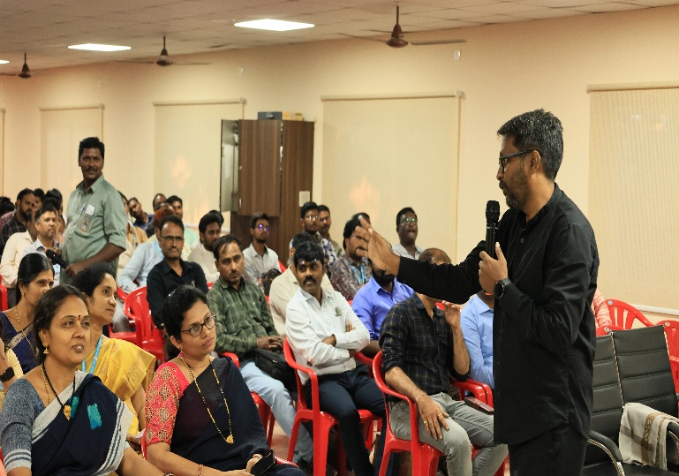

Below are the key attributes of the session:
Identifying students Perspective: Emphasis was placed on understanding the mentee's viewpoint, acknowledging their needs, aspirations, and challenges to create a supportive mentoring environment.
Mentoring Styles: Different mentoring styles were explored, ranging from directive (providing specific guidance) to facilitative (encouraging self-discovery), highlighting the importance of adapting the style to the mentee's developmental stage and goals.
Facilitating Learning: Strategies for effectively facilitating learning were discussed, emphasizing active listening, constructive feedback, and creating opportunities for mentees to reflect on their experiences.
Learning Cycles: The session introduced the concept of learning cycles, emphasizing the iterative process of setting goals, taking action, reflecting on outcomes, and adjusting strategies, promoting continuous improvement.
Types of Mentoring: Various mentoring types, such as peer mentoring, group mentoring, and reverse mentoring, were explored, demonstrating the flexibility of mentoring approaches to suit diverse contexts.
Stages of Mentoring: The session outlined the stages of mentoring, including initiation, cultivation, separation, and redefinition, providing insights into the evolving nature of the mentor-mentee relationship.
What Makes a Good Mentor: Key attributes of a good mentor were discussed, encompassing qualities like empathy, effective communication, patience, adaptability, and a commitment to fostering the mentee's growth. In conclusion, the "Mentoring for Success" session provided valuable insights into the multifaceted world of mentoring, equipping faculty with the knowledge and skills needed to cultivate successful mentor-mentee relationships.
