Report on Remedial Classes
2024-2025
Loyola Academy (Autonomous)
A “College with Potential For Excellence” by UGC
Affiliated to Osmania University Established in 1978
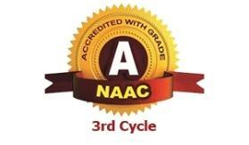

Old Alwal,Secunderabad-500010

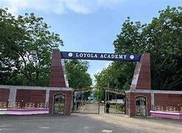

ADMINISTRATION
REV FR CHILUVURU AMARA RAO SJ-VICE CHAIRMAN &RECTOR
REV FR.DR.A.FRANCIS XAVIER SJ-
REV FR.DR.N.B. BABU SJ
REV FR.DR.A.M.JOSEPH KUMAR SJ
REV FR.DR.M.ARUL JOTHI SJ
DR.K.RAMA IQAC COORDINATOR

INDEX

SNO | REMEDIAL DATA | PAGENOS
1 | Objectives of Remedial classes | 3
2 | Department wise Classes Conducted and Reports | 4-7
3 | Department wise total number of students attended strength | 4-7
4 | Department wise faculty list who took the remedial classes | 4-7
5 | Remedial classes result | 27
6 | Conclusion | 27

Odd Semester Report

Loyola Academy started the Remedial teaching which is an educational programme for increasing the academic performance of poorly performing students in a curriculum. Remedial teaching is finding specific learning difficulties in low achieving learners who are lagging behind in academics and providing them with necessary support and guidance to bring their academic performance closer to the required standard and to prevent them from occurring in future.

Remedial classes are conducted in different Subjects to support the Students in clearing their backlogs. Students shown lot of interest .Faculty gave tips as well as material for the students. More than 60% of the students who have attended got benefit and they passed in the exams.

To increase attendance for the classes a brief motivation lecture is organized with the key note address by HODs of their departments.

Objectives of Remedial classes:

- Remedial classes can help students to improve their academic performance, including their grades and test scores.

- Remedial classes can help students build confidence by helping them to understand subjects that were previously difficult.

- Remedial classes can provide personalized attention to help students address difficulties in particular subjects.
Principles of Remedial Teaching followed by Lecturers:

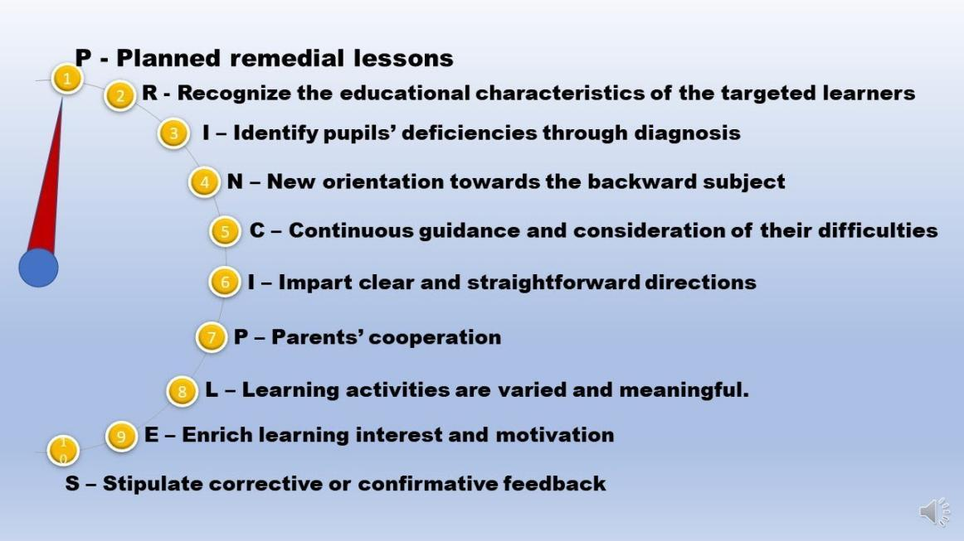

Total Number of Departments and Faculty who took Remedial
classes:

 | School | Deptartments | FACULTY NAMES | Total number of  classes | Total number of students
1 | SCHOOL OF INFORMATICS | B.SC(COMPUTER SCIENCE & ENGINEERING) | M.Kirankumar  R.Deepthi  S.swapna  K.Anitha  Y.R.Deepthi  K.Himabindu | 10  15  15  15  15  12 | 15  8  14  18  18  1
1 | SCHOOL OF INFORMATICS | B.SC(COMPUTER SCIENCE &INFORMATION TECHNOLOGY) | Mary  Praneetha  Praneetha | 15  15  15 | 13  11  24
1 | SCHOOL OF INFORMATICS | B.SC(COMPUTER DATA SCIENCE & DATA ANALYTICS) | Sailaja  Rekha  Hiranya  NCDS-M.Sailaja  NCDS-V.Hiranya  NCDS-T.Rekha  NCDS-T.Vijaya  DCDS-M.Sailaja  DCDS-T.Rekha  DCDS -V.Hiranya  DCDS-T.Vijaya  DCDS-T.Vijaya  DCDS-Rekha | 15  15  15  4  4  5  5  5  3  3  3  6  6 | 10  10  25  13  13  13  13  16  16  16  16  10  7
1 | SCHOOL OF INFORMATICS | B.SC(COMPUTER SCIENCE & ARTIFICIAL INTELLIGENCE) | Bala seshu kumari  S.Sarashri  Ruchika Murthy  Mr.M.Ashwin kumar  Bindu Babu  Ruchika Murthy-ACSAI  S.Sarashri-ACSAI  Bindu Babu-ACSAI  Bala Seshu Kumari-Python  Ashwin Kumar-Machine learning-NCSAI  K.Himabindu-Deep Learning | 12  13  12  13  6  10  10  15  10  12  6 | 11  8  13  14  11  4  5  4  4  4  13
1 | SCHOOL OF INFORMATICS | B.SC(COMPUTER SCIENCE & COGNITIVE SYSTEMS) | A.Varalakshmi  M.RAVI,  K NANDINI  HEBSEBHA  sirisha  M.Ravi-ACSC(C-LANG)  M.Ravi-NCSC(SL),  NCSC-P.Sirisha  ACSC-Hebsiba  ACSC-Hebsiba  NCSC-Python programming  ACSC-Sirisha | 4  5  3  2  15  12  14  13  13  7  10  13 | 12  11  8  5  28  4  13  17  13  6  3  11
1 | SCHOOL OF INFORMATICS | B.SC( COMPUTER SCIENCE&CYBER SECURITY) | Manisha  Venu gopal  Muskan Goyal | 15  15  13 | 11  12  11
1 | SCHOOL OF INFORMATICS | B.SC(MATHS,STATISTICS &COMPUTERSCIENCE)
1 | SCHOOL OF INFORMATICS | B.SC(COMPUTER SCIENCE &CLOUD COMPUTING) | Naveen raj  V jaya krishna  - Siva rama krishna  Sirisha  Jagadhish.v | 15  15  15  15  15 | 16  18  19  16  15
1 | SCHOOL OF INFORMATICS | B.SC(COMPUTER SCIENCE & INTERNET OF THINGS) | V.Manogna Sai  P. Sushma  Muskaan Goyal  Dr. K. Rama P.Sushma  - Sirisha  - Dr.C.Shanti  NCSIOT-Dr.K.Rama | 5  5  5  5  10  5  10  18 | 6  7  10  9  8  10  10  32
1 | SCHOOL OF INFORMATICS | B.SC(COMPUTER SCIENCE & MACHINE LEARNING) | Dr C. Santhi  - Kavya  - Naveen  P. Sirisha | 15  15  15  15 | 6  8  7  11
2 | SCHOOL OF AGRICULTURE | B.SC(HONS),(AGRICULTURE) | P.Sarada  D. Anil kumar  Uday Bhargav  Dr. Borkar Sundar | 4  4  4  4 | 07  09  14  8
3 | SCHOOL OF SCIENCES | B.SC(BIOTECHNOLOGY,GENETICS & CHEMISTRY)
3 | SCHOOL OF SCIENCES | B.SC(CHEMICAL TECHNOLOGY)
4 | SCHOOL OF FOOD TECHNOLOGY & NUTRITION | B.SC(FOOD SCIENCE ,NUTRITION&DIETICS) | G.Gnanasheeba  Krushitha  Onix Tryphosa  AFSN-GnanaSheeba | 12  10  11  11 | 34  16  11  12
4 | SCHOOL OF FOOD TECHNOLOGY & NUTRITION | BSC(FOOD TECHNOLOGY & MANAGEMENT)
5 | SCHOOL OF ARTS | B.SC(MULTIMEDIA & ANIIMATION)
5 | SCHOOL OF ARTS | B.A(MASS COMMUNICATION) | FR.Prabhu  Rajeshwari  Elisita | 15  15  15 | 18  21  12
5 | SCHOOL OF ARTS | B.A (PSYTCHOLOGY,ENGLISH & JOURNLISM)
5 | SCHOOL OF ARTS | B.A(ECONOMICS,PUBLIC &COMPUTER APPLICATIONS) | AEPCA-Dr.Shafiq Ahmed -DDET  Ajay koka -’c’ language  NEPCA-Dr.Shafiq Ahmed-State Admin  Ajay Koka -Java Programming  DEPCA- Dr.Shafiq Ahmed-Financial &marketing mgmt  Ajay Koka-DBMS | 4  3  3  6  3  4 | 29  29  60  50  60  60
6 | SCHOOL OF COMMERCE | B.COM(BUSINESS STUDIES) | Dr.Ramesh  Rajesh  G.Pooja | 15  15  15 | 27  24  16
6 | SCHOOL OF COMMERCE | B.COM(HONOURS)
6 | SCHOOL OF COMMERCE | B.COM(MARKETING) | Y Anjani Kumari  Ch Krishna Priya | 6  6 | 16  16
6 | SCHOOL OF COMMERCE | B.COM(COMPUTER APPLICATIONS) | Shivaranjini | 15 | 20
6 | SCHOOL OF COMMERCE | B.COM(HONS)(STRATEGIC FINANCE) | SAILAJA | 15 | 33
6 | SCHOOL OF COMMERCE | B.COM(INFORMATION SYSTEMS) | ACIS-K.Padma  ACIS-Nagaraju  NCIS-S.Shobha | 12  10  10 | 12  11  13
6 | SCHOOL OF COMMERCE | B.COM(BUSINESS PROCESS MANAGEMENT) | Mahindar  N.Sujitha  Swetha Rao | 15  15  15 | 8  3  2
6 | SCHOOL OF COMMERCE | B.COM(BUSINESSS ANALYTICS)) | K. Rajitha  Mrs.Harika  Dr. Sofia Ahmed | 15  15  15 | 10  10  10
6 | SCHOOL OF COMMERCE | B.COM(IAF) | S. Shobha Rani  S. Shobha Rani  P. Raj Kumar Reddy  AIF-A.Pasupathinath-FA-I  AIF-A.Pasupathinath-FA-II  NIF-k.padmapriya-Advanced accounting  Hemadevi-Taxation | 10  10  10  8  10  13  12 | 13  5  32  3  3  18  13
 |  | B.COM(FINTECH) | Ms. Anusha,  Ms. Jasimine,  Dr. vikas,  Dr. sunitha | 7  8  7  8 | 32  32  32  32
7 | SCHOOL OF MANAGEMENT | BBA(REGULAR) | M.Sunanda  B.Srinivas  ABBA-FA-II  ABBA-ME  NBBA-Sunanda  NBBA-Swetha  NBBA-Kareema | 15  15  8  7  5  4  4 | 16  12  8  8  8  8  8
7 | SCHOOL OF MANAGEMENT | BBA(ENTREPRENEURSHIP DEVELOPMENT) | MR.Seinivas, MS.Hema  ABBAED-Y.Narsimhulu  ABBAED-K.Naveenraj  NBBAED-Muskan goyal  NBBAED-M.Srilatha  NBBAED-P.Jayabharathi | 15  15  15  13  15  15  15 | 2  1  4  4  4  2  1
7 | SCHOOL OF MANAGEMENT | BBA(TOURISM) | U Suresh  Dr. Sangeeta Peer  N Sujita  ABBATR-U.Suresh  ABBATR-Praveenkumar  NBBATR-Praveenkumar  NBBATR-N,Sujith  ABBATR-Sangeetha | 15  15  15  15  16  15  14  14  14  15 | 22  34  10  22  10  8  4  8  35
7 | SCHOOL OF MANAGEMENT | BBA(ROM) | V.KALYAN GOUD  P.RAVALI  KAREEMA SHAIK | 15  15  15 | 13  9  8
 |  |  | TOTAL NUMBER OF STUDENTS | 609

Departments Remedial classes timetables,report and photos
classes
- SCHOOL OF INFORMATICS

- B.SC(COMPUTER SCIENCE & ENGINEERING)-
Computer Science and Engineering (CSE) is a field of study that combines principles and practices of both computer science and engineering to develop innovative solutions for a wide range of technological problems. The field is concerned with the design, development, and implementation of software and hardware systems that enable the efficient and effective processing of information.
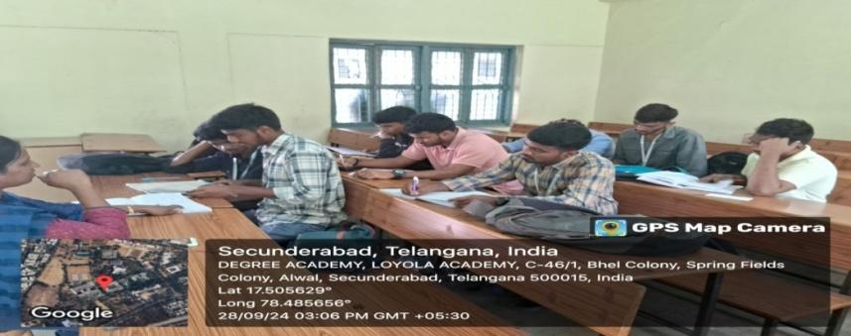
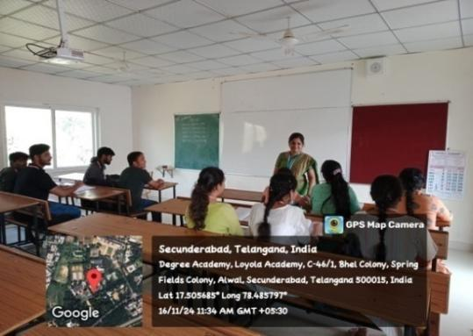
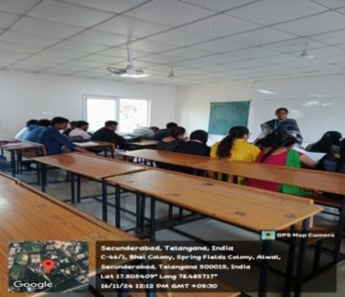

https://docs.google.com/document/d/1UA7qL_OckNXr_j1TkMCnVm9ntx1c3_TohHygAcMRREedit?usp=sharing
- B.SC(COMPUTER SCIENCE &INFORMATION TECHNOLOGY)
Computer Science is an academic discipline that focuses on the study of computers, computation, and related technologies.Slow learners are provided with remedial coaching in areas of difficulty. Further, the sessions are made more interactive to increase student interaction and thereby, facilitate understanding. Students are also encouraged to help each other and through this, understand concepts better.

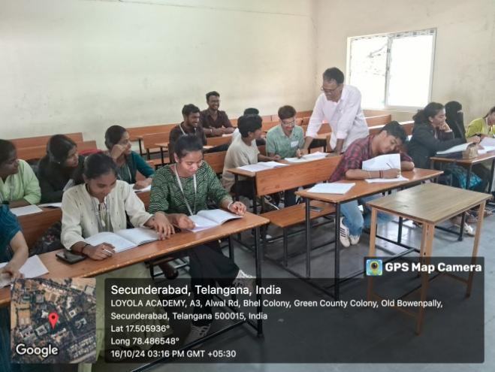
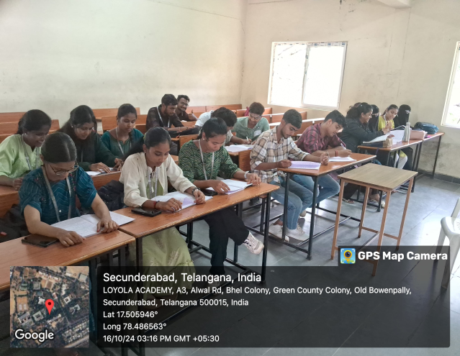
https://docs.google.com/document/d/1FIVAXpMBC27JJMc2v4r1n6EI-3ylz4OC/edit?usp=sharing&ouid=118272580490156293192&rtpof=true&sd=true

- B.SC(COMPUTER DATA SCIENCE & DATA ANALYTICS)

The course B.Sc. Computer Data Science and Data Analytics Engineering has been introduced by Loyola Academy in the academic year 2016-17 as an answer to the ever rising need for analytical skills. Data Science relevant subjects such as Big Data using Hadoop, Python and R Programming play a vital role in shaping students as Data Scientists in these fields.This course conducted remedial classes for slow learners ,clear the doubts for students to increase their percentage in subjects and to get good score .

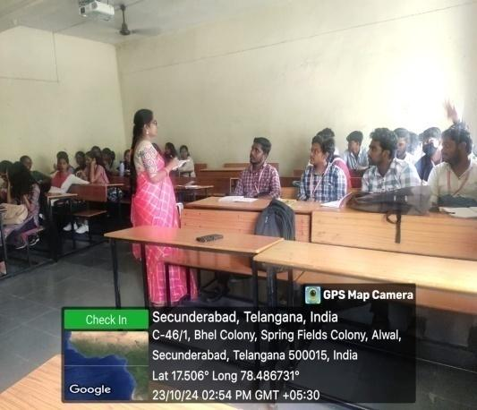
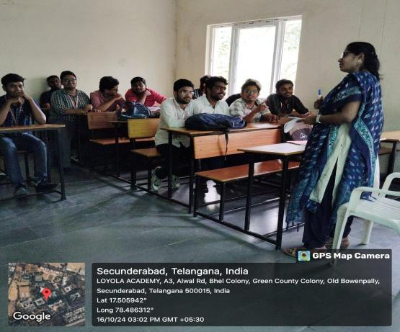

https://docs.google.com/document/d/1k342wNt16ggHS-9eILSnI9LK7vokJjcS/edit?usp=sharing&ouid=118272580490156293192&rtpof=true&sd=true

- B.SC(COMPUTER SCIENCE & ARTIFICIAL INTELLIGENCE)
Computer Science and Artificial Intelligence, which is a field of study that combines the principles of computer science with the concepts of artificial intelligence. It involves the development of algorithms and techniques for creating intelligent machines and systems that can perform tasks that normally require human intelligence.This course conducted remedial classes for slow learners ,clear the doubts for students to reduce difficultiess in concern subjects and make them perfect to get scored in subjects.
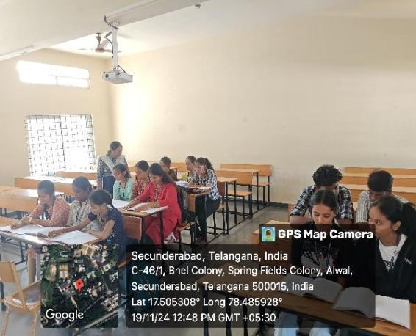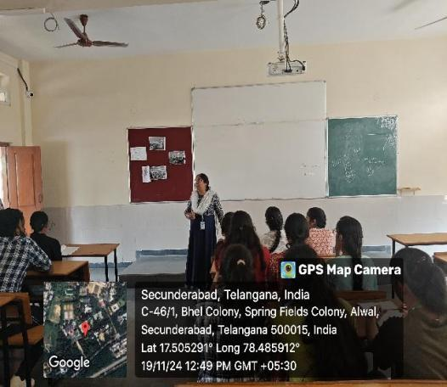

https://docs.google.com/document/d/1CGany4kWwuyqZxHjHZ-ma5VRCvPVxUUs/edit?usp=sharing&ouid=118272580490156293192&rtpof=true&sd=true

- B.SC(COMPUTER SCIENCE & COGNITIVE SYSTEMS)
Computer Science and Cognitive Systems, which is a field of study that combines the principles of computer science with the concepts of Machine Learning.Slow learners are provided with remedial coaching in areas of difficulty. Further, the sessions are made more interactive to increase student interaction and thereby, facilitate understanding.
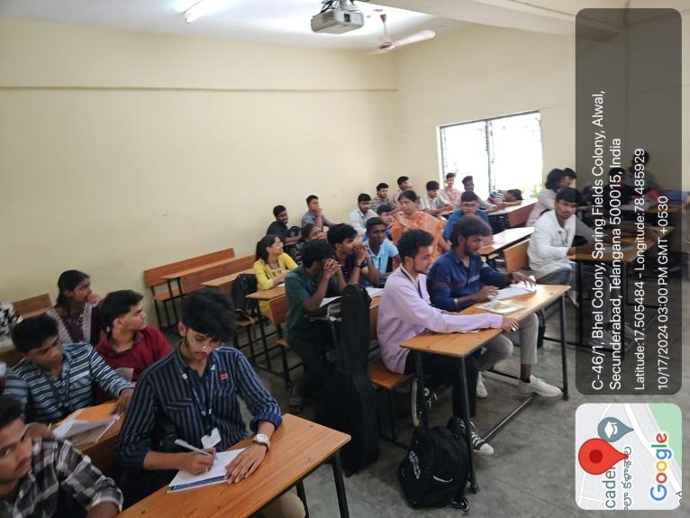

https://docs.google.com/document/d/1lNCkdUyEXl-6vtZnUzqLKcXqgzUVHKh/edit?usp=sharing&ouid=118272580490156293192&rtpof=true&sd=true
- B.SC( COMPUTER SCIENCE&CYBER SECURITY)
Computer Science and Cyber Security, which is a field of study that combines the principles of computer science with the concepts of Security techniques .Slow learners are provided with remedial coaching in areas of difficulty. Further, the sessions are made more interactive to increase student interaction and thereby, facilitate understanding.This course conducted remedial classes for slow learners ,clear the doubts for students to reduce difficultiess in concern subjects and make them perfect to get scored in subjects.
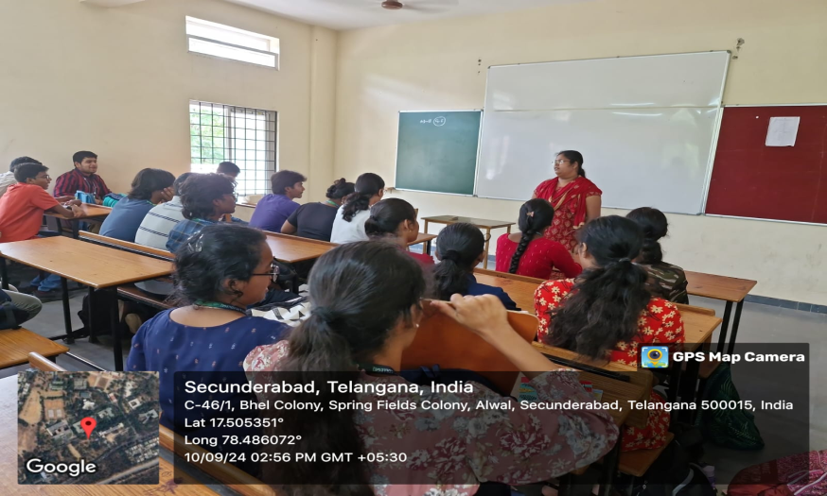

https://docs.google.com/document/d/1M-IeYQMVb5elQ0zllzB3HP9eTG9yNGy5/edit?usp=sharing&ouid=118272580490156293192&rtpof=true&sd=true

- B.SC(MATHS,STATISTICS &COMPUTERSCIENCE)

B.Sc. Mathematics, Statistics & Computer Science where the student community has access to different disciples namely Mathematics, statistics and computer Science which are in high demand in market. This course conducted remedial classes for slow learners ,clear the doubts for students to increase their percentage in subjects and to get good score .

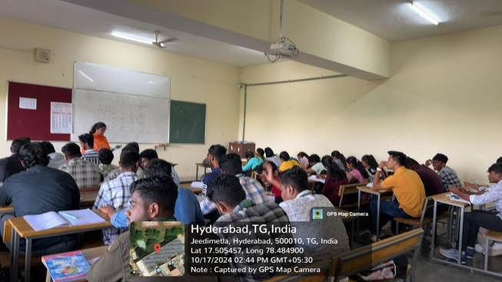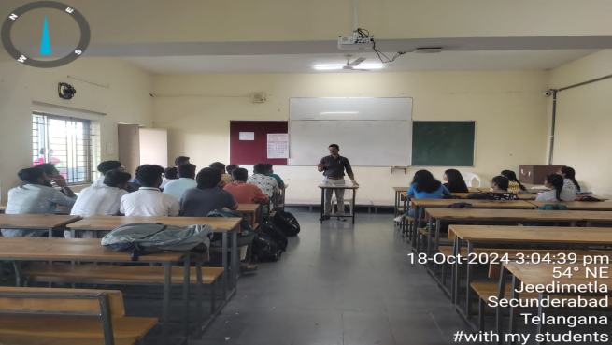

- B.SC(COMPUTER SCIENCE &CLOUD COMPUTING)

The Computer Science & Cloud Computing degree Program gives students education in different areas of computer technology, such as programming, networks, software design and Students gain an understanding of cloud management principles and knowledge of latest cloud computing trends.low learners are provided with remedial coaching in areas of difficulty. Further, the sessions are made more interactive to increase student interaction and thereby, facilitate understanding.
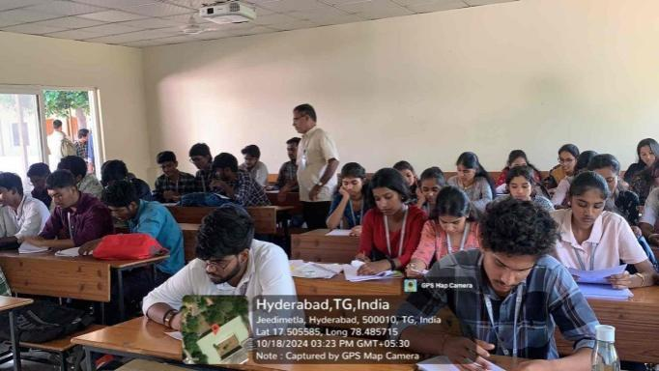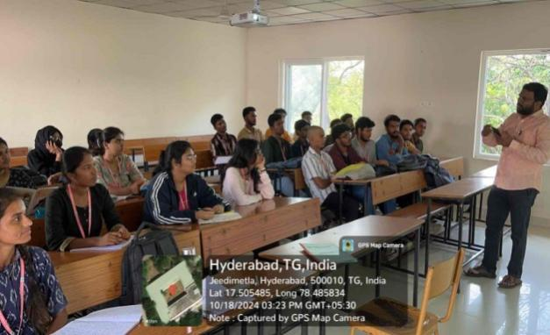

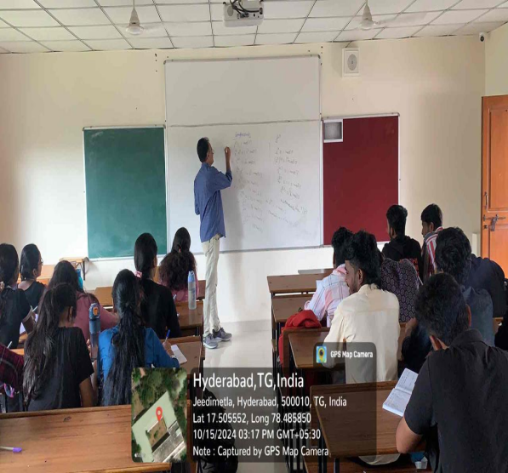
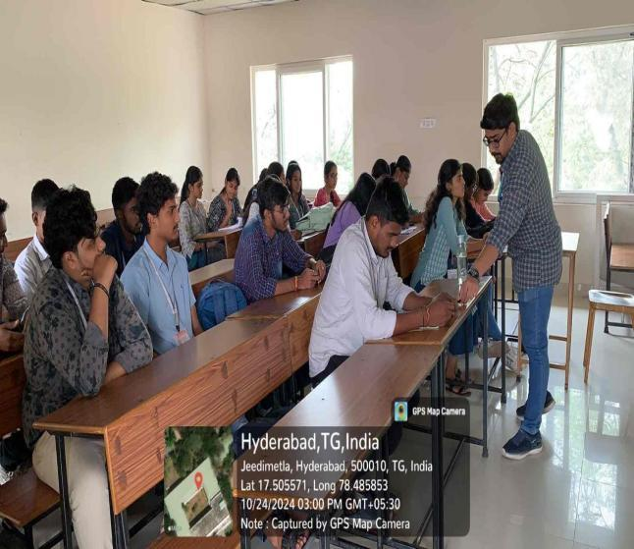
https://docs.google.com/document/d/1FIVAXpMBC27JJMc2v4r1n6EI-3ylz4OC/edit?usp=sharing&ouid=118272580490156293192&rtpof=true&sd=true

- B.SC(COMPUTER SCIENCE & INTERNET OF THINGS)
A distinct department called the “Department of Computer Science IoT” was established to carry out the program’s academic and research operations. Students in this programme will learn how to create smart applications that use microcontroller-based development boards, sensors, actuators, interface modules, and more to execute cloud operations through mobile apps, simulation tools, prototype devices, etc.This course conducted remedial classes for slow learners ,clear the doubts for students to increase their percentage in subjects and to get good score .
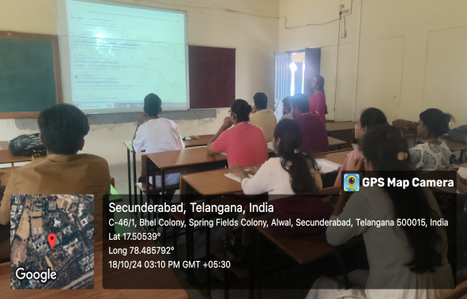
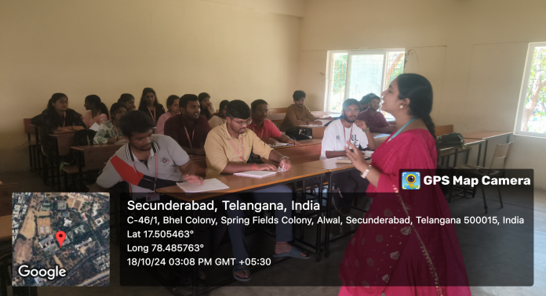
https://drive.google.com/file/d/1gqkMJ3XcgDuRJblwECHHB_ViE26m0REy/view?usp=sharing

- B.SC(COMPUTER SCIENCE & MACHINE LEARNING)
The B.Sc. Computer Science and Machine Learning (CSML) degree program combines the fundamentals of computer science with the principles of machine learning. Students will gain an in-depth understanding of topics such as algorithms, data structures, artificial intelligence, programming, databases, and software engineering.

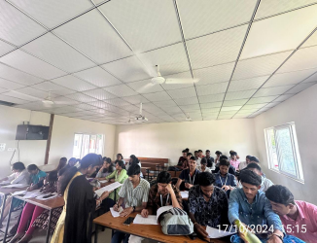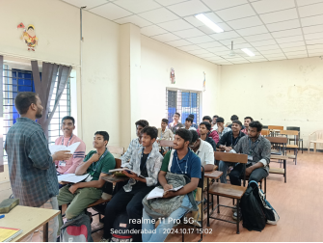

Report link-
https://drive.google.com/file/d/1AAm8veggtm3jAV27VtmfPDjL-BPP4qB2/view?usp=sharing

2.SCHOOL OF AGRICULTURE

- B.SC(HONS),(AGRICULTURE)

The Department of Agriculture in college is an academic department that focuses on the study of agriculture and related fields. Slow learners are provided with remedial coaching in areas of difficulty. Further, the sessions are made more interactive to increase student interaction and thereby, facilitate understanding. Students are also encouraged to help each other and through this, understand concepts better.

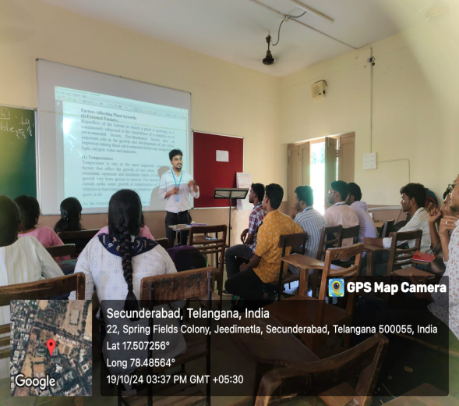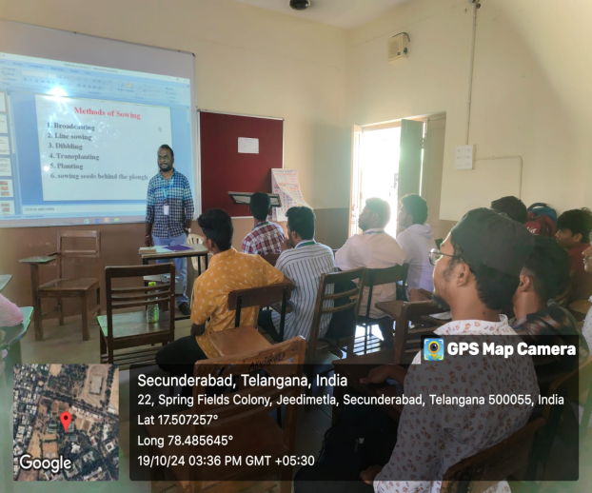

https://drive.google.com/file/d/12RnQxkk9JQNQHmD4eQeVU4gG-DOakFr5/view?usp=sharing

- SCHOOL OF SCIENCES

- B.SC(BIOTECHNOLOGY,GENETICS & CHEMISTRY)
Department of B.Sc Biotechnology has Conducted Remedial Classes for the students of for better understanding of basic concepts in chemistry.Slow learners are provided with remedial coaching in areas of difficulty and clear the doubts for students to reduce difficultiess in concern subjects and make them perfect to get scored in subjects.

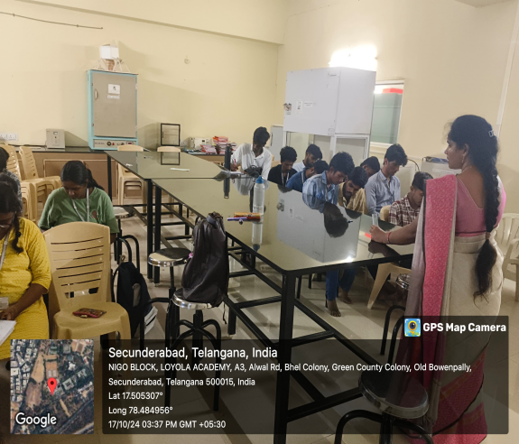
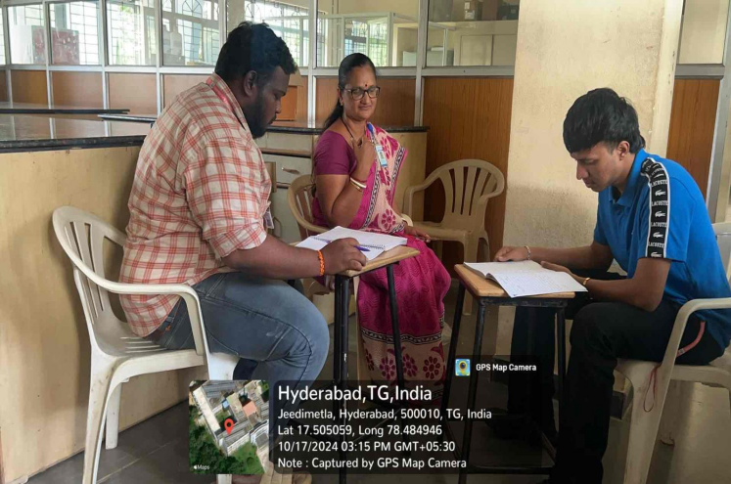

4.SCHOOL OF FOOD TECHNOLOGY & NUTRITION

1.B.SC(FOOD SCIENCE ,NUTRITION&DIETICS)
Department of Food Science, Nutrition and Dietetics is a multidisciplinary departmentwho have been actively engaged in imparting quality teaching of the courses in Food Science, Nutrition and Dietetics for graduating science students.
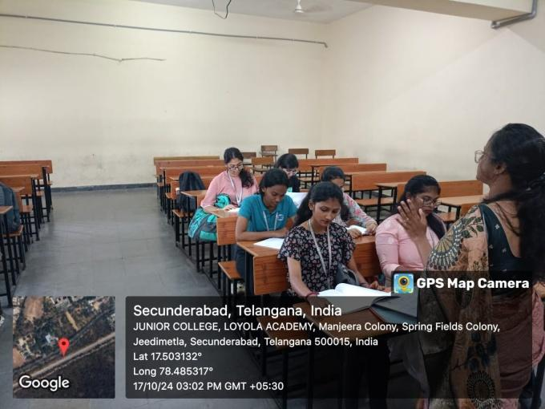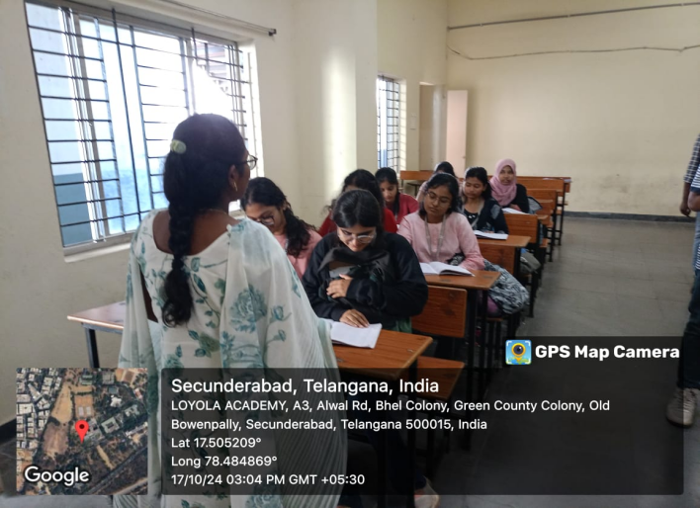
https://docs.google.com/document/d/1ZGOvMKFCtBeWLWexU3NIL-v89df4KLE9H81_lcR5bXQ/edit?usp=sharing

- B.SC(FOOD TECHNOLOGY & MANAGEMENT)
The department was set up in the academic year of 2004, the Department of Food Technology & Management is solely aimed at training students to be expert food technologists and entrepreneurs.Slow learners are provided with remedial coaching in areas of difficulty and clear the doubts for students to reduce difficultiess in concern subjects and make them perfect to get scored in subjects and also practical doubts.

5.SCHOOL OF ARTS

1.B.SC(MULTIMEDIA & ANIIMATION)

The programme of Multimedia and Animation has since then become one of the most popular courses in the Academy owing to the rarity of the under graduate Animation course in the city and the comprehensive way in which we tackle it. Our aim is to train students in every technological advancement in the field of animation so that they can put their creativity to lucrative use.This course conducted remedial classes for slow learners ,clear the doubts for students to increase their percentage in subjects and to get good score .

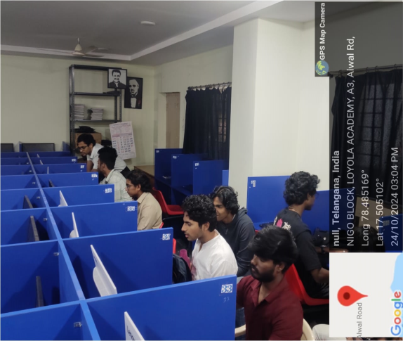
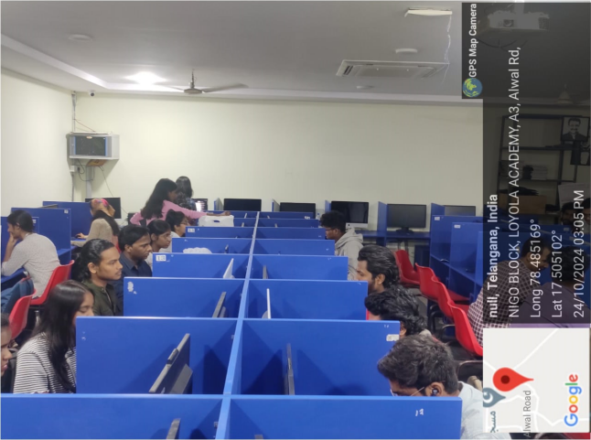

- B.A(MASS COMMUNICATION)
The Department of B.A. Mass Communication with the motto “Educate, Empower, and Enlighten” to meet the challenges and demands of the booming media industry.Slow learners are provided with remedial coaching in areas of difficulty and clear the doubts for students to reduce difficultiess in concern subjects and make them perfect to get scored in subjects and also practical doubts.

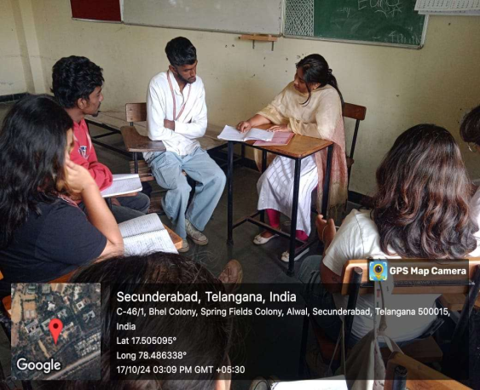
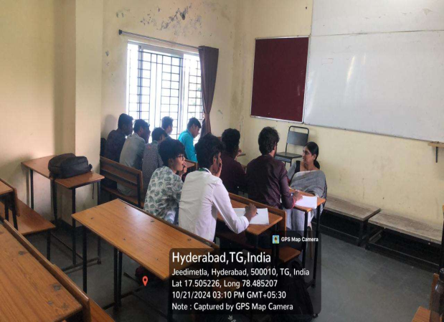
https://drive.google.com/file/d/1EvxbSmnaykYq33VqZ13EngA3REkpu4gx/view?usp=sharing

- B.A(ECONOMICS,PUBLIC &COMPUTER APPLICATIONS)
The programme has been designed with an interdisciplinary approach with an overall goal for holistic development of student. The programme fulfills needs of the present job market.

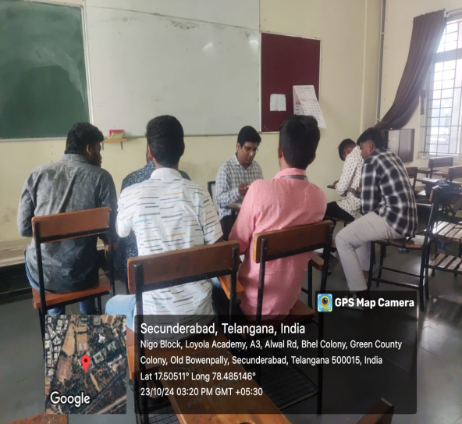
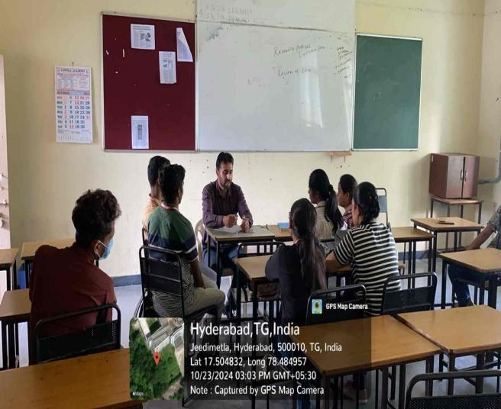

- B.A( PSYCHOLOGY,ENGLISH LITERATURE &JOURNALISM)

The department of B A Psychology, English Literature & Journalism was started in the year 2006.Staff conducts remedial classes, provide course notes for students especially the slow learners. Further faculty members revise the tough topics as per the students requisition and provide question bank and discuss the way of presenting the answers in the exam to score marks. Extra lab sessions are conducted

.
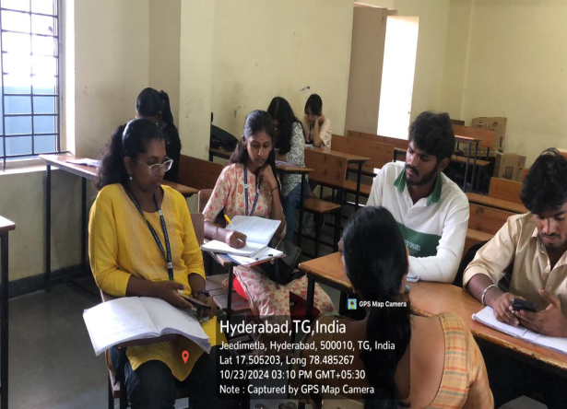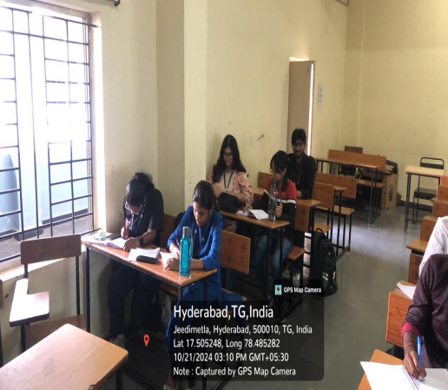

SCHOOL OF COMMERCE

1.B.COM(BUSINESS STUDIES)
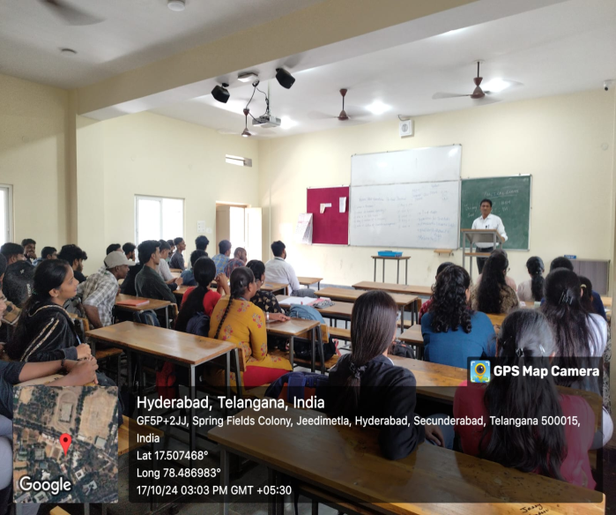
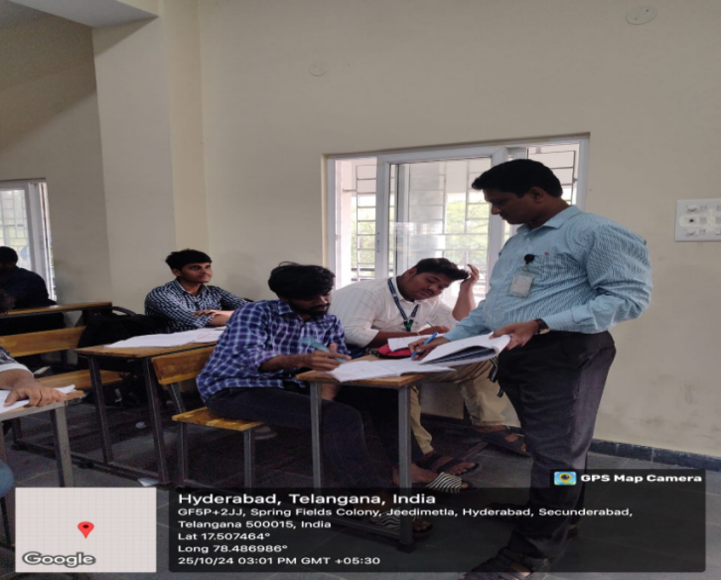
The Department conducts remedial classes, provide course notes for students especially the slow learners. Further faculty members revise the tough topics as per the students requisition and provide question bank and discuss the way of presenting the answers in the exam to score marks. Extra lab sessions are conducted. Additional library books are provided to bring improvement in slow learners. Extra classes are organized to clarify doubts. Critical topics are re-explained for better understanding by the students. Appropriate counselling with additional teaching is done which eventually results in students attending the classes regularly.

https://docs.google.com/document/d/1oeAMv9g_Etn_rbQN6BpltZ6-gShFBccq/edit?usp=sharing&ouid=118272580490156293192&rtpof=true&sd=true

2.B.COM(HONOURS)
The course also helps students to take up professional courses like CA, CS, CMA, CPA, CFA and many other courses of such stature. Also, the course aims at providing both theoretical and practical knowledge with the help of e-commerce labs, AV rooms, and the best faculty for the students. Extra classes are organized to clarify doubts. Critical topics are re-explained for better understanding by the students. Appropriate counselling with additional teaching is done which eventually results in students attending the classes regularly.

3.B.COM(MARKETING)
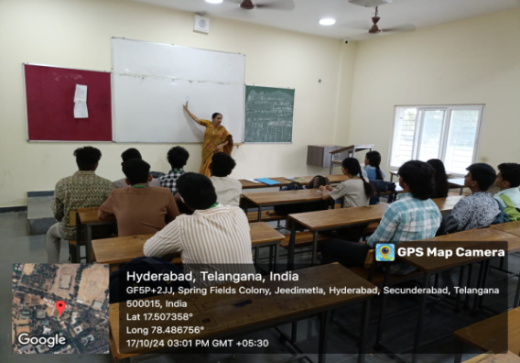
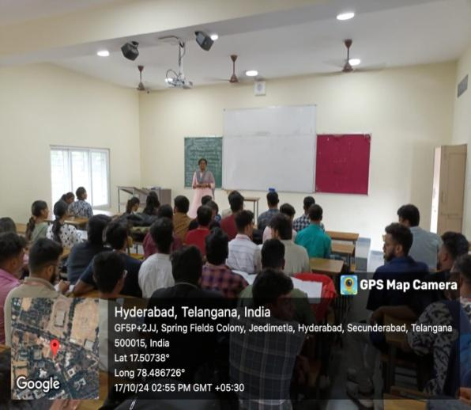
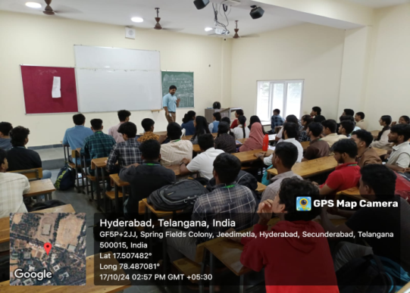
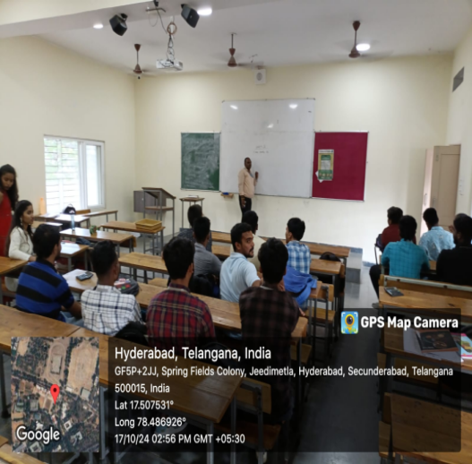
Thiscourse offered Advertising and Marketing using various resources. Further faculty members revise the tough topics as per the students requisition and provide question bank and discuss the way of presenting the answers in the exam to score marks. Extra lab sessions are conducted.

https://docs.google.com/document/d/1KwJrVuSWzgTu9HWsImhZBjXTV2SwemB3sudYD4Lg9AQ/edit?usp=sharing

- B.COM(COMPUTER APPLICATIONS)
This programme takes advantage of the inextricable link between commercial success and IT in today’s world. We provide the right blend of Commerce and Computer Sciences to give students the analytical & technical skills required in an increasingly competitive workplace.This dept conducted remedial classes for slow learners to clear backlogs and to score good marks in further semesters.
https://docs.google.com/document/d/1wFHT4emxYSJjnE3uU1OSEYx_sc77uDE/edit?usp=sharing&ouid=118272580490156293192&rtpof=true&sd=true

- B.COM(HONS)(STRATEGIC FINANCE)
B.Com. (Hons) Strategic Finance. The students of this department gain foundational expertise in management accountancy combined with professional knowledge in Accountancy, Finance, Decision Making, Planning etc., making them industry-ready, not only in India but also abroad. Critical topics are re-explained for better understanding by the students. Appropriate counselling with additional teaching is done which eventually results in students attending the classes regularly.
https://docs.google.com/document/d/1eEsKjTfh-dHFpS-AmwIQbQY8thku0LEb/edit?usp=sharing&ouid=118272580490156293192&rtpof=true&sd=true

6 B.COM(BUSINESS PROCESS MANAGEMENT)
Business Process Management (BPM) is a management approach that involves the analysis, design, implementation, and optimization of business processes within an organization. It aims to improve the efficiency and effectiveness of an organization's operations by identifying and eliminating redundant activities, improving communication and collaboration among employees, and enhancing the overall quality of products and services.This dept conducted remedial classes for slow learners to clear backlogs and to score good marks in further semesters.
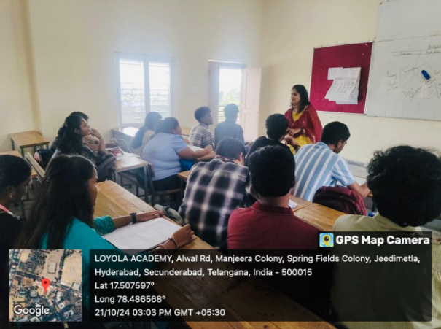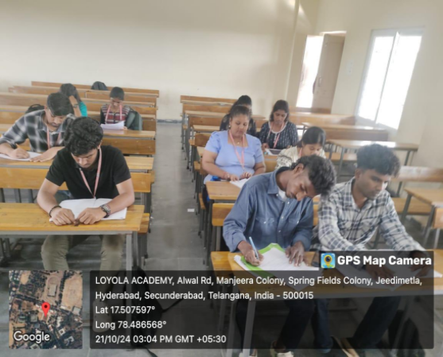

https://docs.google.com/document/d/1Q_nZir_2Cam3W1Xb9DCQ4JqZVr-9KzodEE_r-nFjUZA/edit?usp=sharing

7..B.COM(BUSINESSS ANALYTICS)

B. Com in Business Analytics is a six-semester learning program designed for students who wish to make a career in the areas of Digital Business, E-Commerce, and other related areas. Students will gain a good understanding of business practices, processes, design, and strategies relevant for success in digital businesses. This dept conducted remedial classes for slow learners to clear backlogs and to score good marks in further semesters.
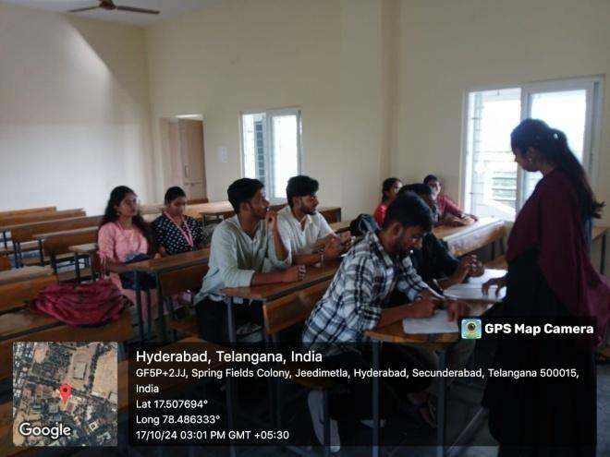
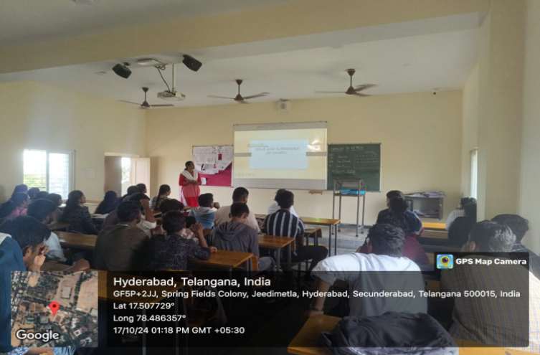
https://docs.google.com/document/d/1_r7C9hWJDYbWOuCVVQVDYvCd6eRYuKUM/edit?usp=sharing&ouid=118272580490156293192&rtpof=true&sd=true

8..B.COM(INFORMATION SYSTEMS)
The Programme B.Com. Information Systems imparts knowledge, skills through innovative-interactive methods of learning and aims at maintaining academic excellence to equip students with the skills necessary to face challenges of the current business world.This dept conducted remedial classes for slow learners to clear backlogs and to score good marks in further semesters.
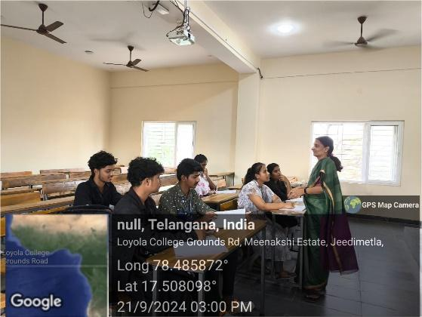
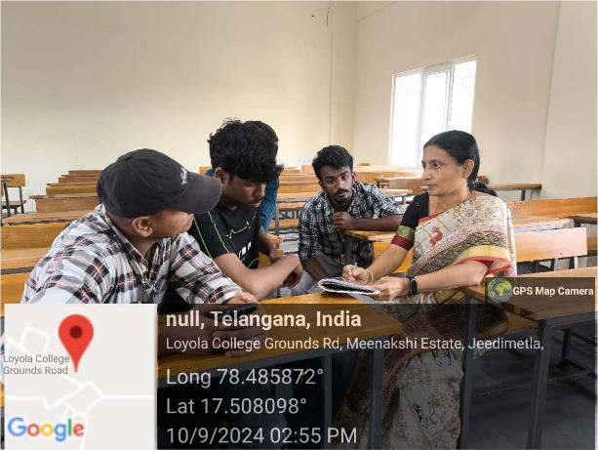
https://docs.google.com/document/d/1uZnCHAl5dp49lsPnWNHbbZTiFMcq5iysKYAJcDze-D0/edit?usp=sharing

9..B.COM(FINTECH)
This department combines traditional commerce subjects with courses focused on technological advancements in finance.This dept conducted remedial classes for slow learners to clear backlogs and to score good marks in further semesters.
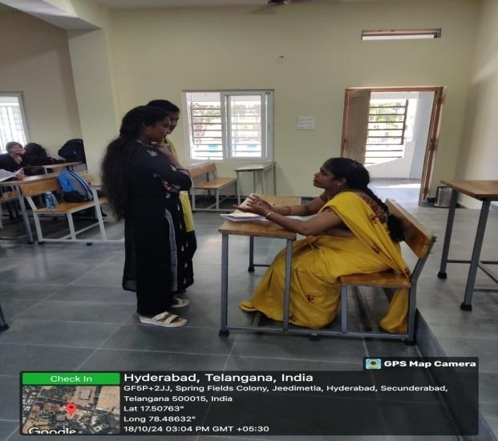
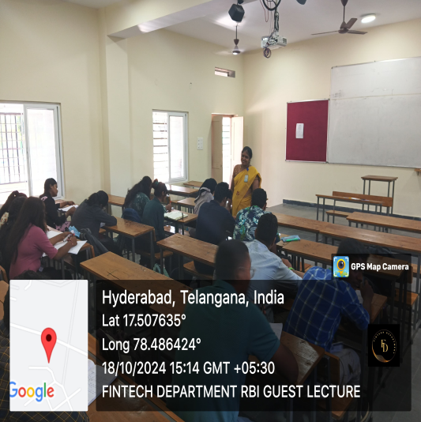
https://docs.google.com/document/d/13F7gdU4mKDQfSWhFMBH5RiF5Nb6YoZWyZmBS4ae3Vn4/edit?usp=sharing

10.B.COM(IAF)-
This department combines traditional Accounting subjects with courses focused on technological advancements in finance.This dept conducted remedial classes for slow learners to clear backlogs and to score good marks in further semesters.

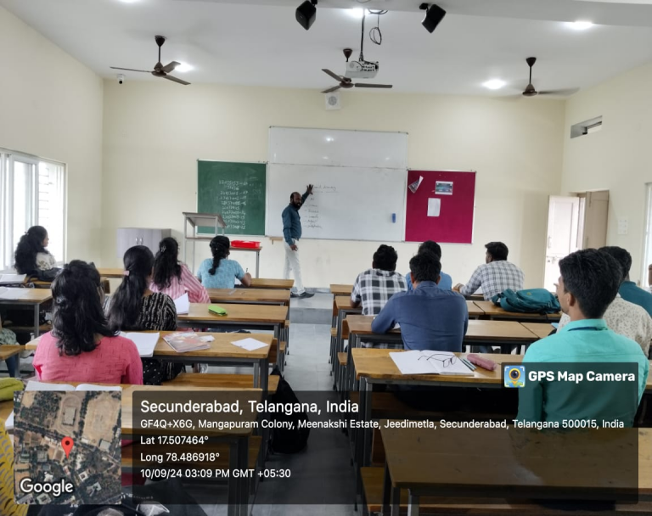
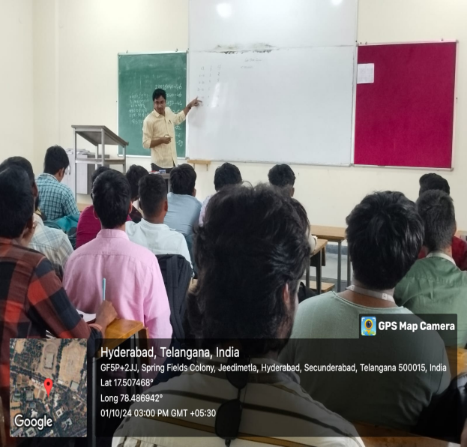
https://docs.google.com/document/d/1cLVj8NliYiKQQo_Sad44w5leEeDyiVyI/edit?usp=sharing&ouid=118272580490156293192&rtpof=true&sd=true

SCHOOL OF MANAGEMENT

- BBA(REGULAR)
BBA programs typically cover a range of topics, including accounting, finance, marketing, operations management, organizational behavior, and entrepreneurship. Slow learners are provided with remedial coaching in areas of difficulty. Further, the sessions are made more interactive to increase student interaction and thereby, facilitate understanding. Students are also encouraged to help each other and through this, understand concepts better.
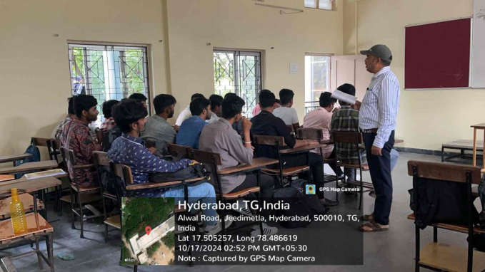
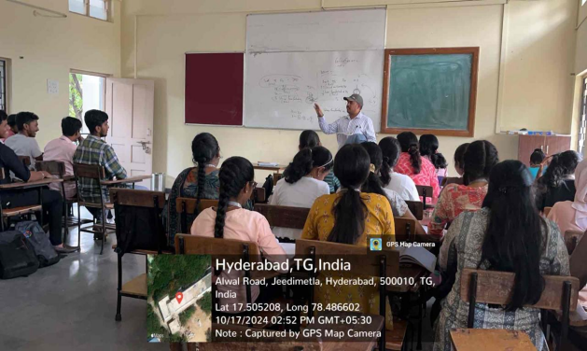
https://docs.google.com/document/d/16XD6qgf6kB0mT4QhXojpMLWxk7eUtowv/edit?usp=sharing&ouid=118272580490156293192&rtpof=true&sd=true

- BBA(ENTREPRENEURSHIP DEVELOPMENT)
This course enables the candidates to be a righteous entrepreneur. This program helps them in gaining knowledge to convert innovations into economically viable goods and services. Slow learners are provided with remedial coaching in areas of difficulty. Further, the sessions are made more interactive to increase student interaction and thereby, facilitate understanding. Students are also encouraged to help each other and through this, understand concepts better.

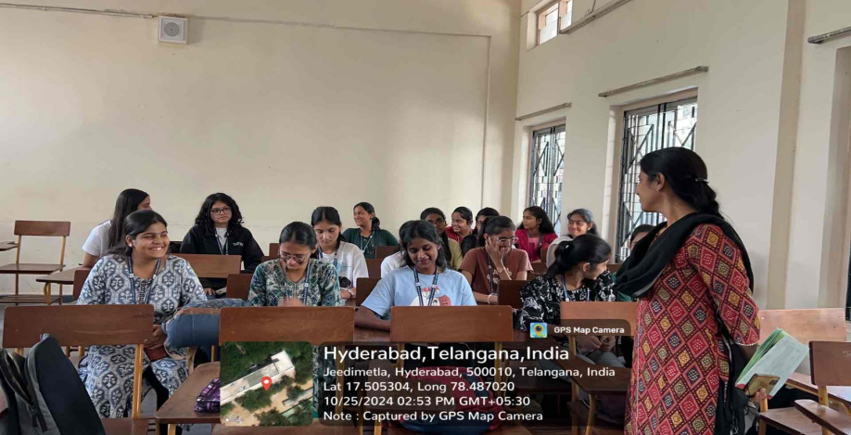

https://docs.google.com/document/d/158xQBOCUHHZYGgb5Zy1E9qf9j52ZK5Nb/edit?usp=sharing&ouid=118272580490156293192&rtpof=true&sd=true

- BBA(TOURISM)

The three year Under Graduate Programme at LA focuses on creating and disseminating knowledge in the field of Tourism and Business by offering courses on of Tourism and Management.Slow learners are provided with remedial coaching in areas of difficulty. Further, the sessions are made more interactive to increase student interaction and thereby, facilitate understanding.
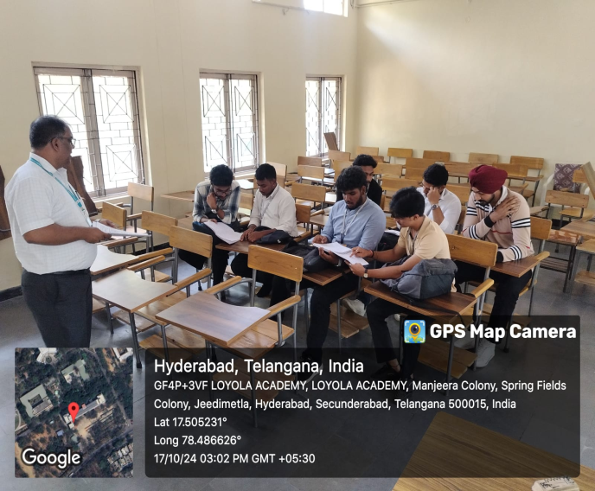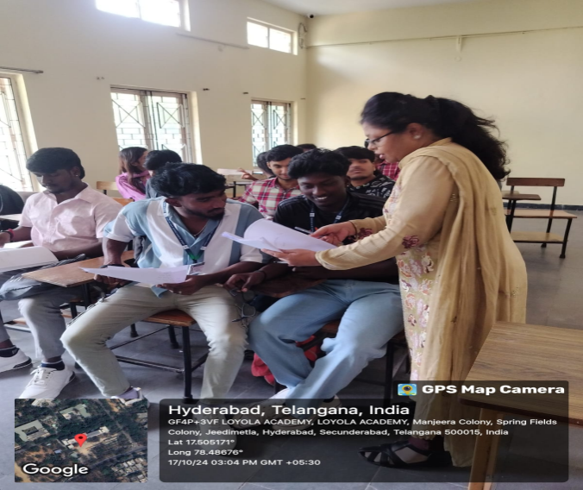
https://docs.google.com/document/d/1doeVzbLh40JjYLwB6fvuYSP9zrVem8FT/edit?usp=sharing&ouid=118272580490156293192&rtpof=true&sd=true

- BBA(ROM)

The course covers all the basic aspects of the retail industry and provides a student with the necessary knowledge and skill-set to succeed in the retail industry.Slow learners are provided with remedial coaching in areas of difficulty. Further, the sessions are made more interactive to increase student interaction and thereby, facilitate understanding to get good score in further exams.

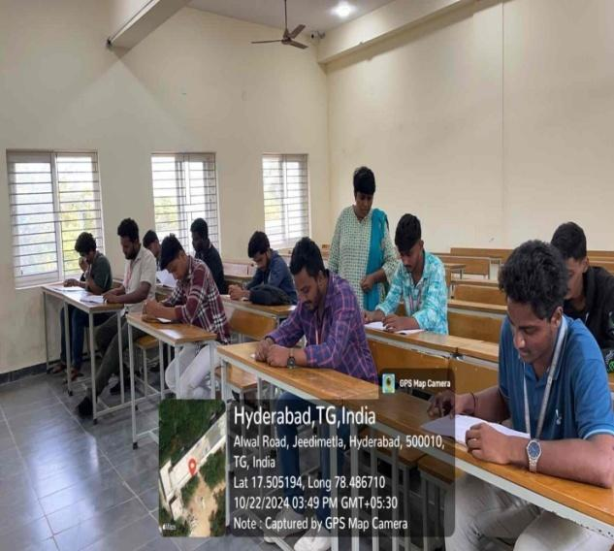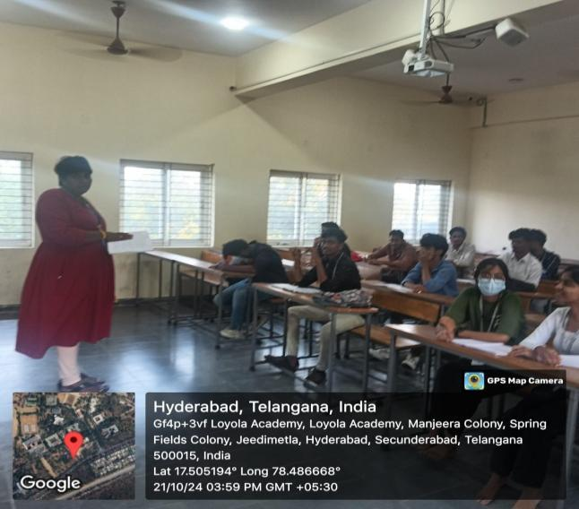

https://docs.google.com/document/d/1-6v9aYvHbWeIru8l2jUbWs1wZQPecp0L/edit?usp=sharing&ouid=118272580490156293192&rtpof=true&sd=true

Conclusion:-

Remedial classes play a crucial role in Loyola Academy by providing additional support and assistance to students who are struggling academically.Students with varying learning needs and abilities can benefit from these classes, as they cater to their specific requirements. Total 609 students attended for the remedial odd & even semester classes.By offering targeted interventions, remedial classes ensure that no student is left behind due to their academic challenges. This inclusive approach fosters a sense of belonging and encourages students to actively engage in the learning process, boosting their self-confidence and motivation.

RESULT LINK
https://docs.google.com/spreadsheets/d/1R27-fZU9lgb4iqUFkLsQsNMsX9z5saj6q6y9CgMf3AU/edit?usp=sharing


K.HIMABINDU

